
Monitoring report form for CDM programme of activities
(version 01.0)
Complete this form in accordance with the Attachment “Instructions for filling out the monitoring report form for CDM programme of activities” at the end of this form.
MGM Innova note: The CDM template is being used for this Gold Standard project as suggested by the DOE. Gold Standard specific monitoring aspects as a supplement to the CDM monitoring report.
Monitoring report
Title of the programme of activities (PoA) | Programme for the application of advanced hull coatings to reduce shipping fuel consumption (PAHSF)
UNFCCC reference number of the PoA | Gold Standard ref: GS 3492 (VPA1, GS 2767)
Version number(s) of the PoA-DD(s) applicable to this monitoring report | 5 (25/08/2015)
Coordinating/managing entity (CME) | International Paint Ltd., a company in the AkzoNobel Group
Version number of this monitoring report | 4 (correcting for a problem with one ship “Cruise Europa”)
Completion date of this monitoring report | 05/03/2018
Monitoring period number and dates covered by this monitoring report | Second monitoring period. From 1/7/2015 to 30/6/2016.
Monitoring report number for this monitoring period | One (a single monitoring report covers all ships included in the monitoring period)
Host Party(ies) | Host Party(ies) of the PoA | Is this a host Party to a specific-case CPA covered in this monitoring report?(yes/no)
Host Party(ies) | Not applicable (not CDM project)
Sectoral scope(s) | Sectoral scope 7. Transport
Selected methodology(ies) | Gold Standard methodology: Reducing Vessel Emissions Through the Use of Advanced Hull Coatings (version 2)
Selected standardized baseline(s) | N.A.
Total amount of GHG emission reductions or net GHG removals by sinks for all specific-case-case CPAs in the PoA covered in this monitoring report | GHG emission reductions or net GHG removals by sinks reported up to 31 December 2012 | GHG emission reductions or net GHG removals by sinks reported from 1 January 2013 onwards
 | None (also not relevant since this is not a CDM project) | 44,264 tCO₂
PART I - Programme of activities
- Description of PoA
  - Brief description of the PoA
>>
The Programme of Activities (PoA) consists of improved hull coatings intended to reduce hydrodynamic drag in ships. The Programme Coordinating Entity is the manufacturer of the advanced coating products, International Paint Ltd. The three main advanced products are denominated Intersleek 1100SR, Intersleek 900 family (comprising Intersleek 960 and Intersleek 970) and Intersleek 700 family (specifically Intersleek 757). All references to Intersleek 900 and Intersleek 700 in this document generally refer to the respective family of products.

The type of coating most commonly used on ships is a self-polishing copolymer (SPC) which slowly releases a biocidal antifouling agent. Biocidal antifouling coatings contain bioactive materials intentionally added to control the growth of organisms; biocidal coatings have a higher toxicity rating to both the environment and humans compared to the Intersleek systems. Intersleek products are substantially lower in toxicity compared to biocidal system. Intersleek 900 is a fluoropolymer foul-release coating while Intersleek 700 is a silicone foul-release coating. Intersleek 1100SR is a fluoropolymer-based system and is a modification of Intersleek 900. The fluoropolymer is developed from that used in Intersleek 900 by addition of particular chemical groups in order to enhance the slime resistance and slime release properties. Besides lower toxicity, the use of Intersleek 1100SR, Intersleek 900 and Intersleek 700 reduce hull friction and hydrodynamic drag, reducing fuel consumption. Since ships typically use fossil fuels, reduced fuel consumption would reduce CO₂ emissions. Therefore all projects within the PoA would both reduce greenhouse gas (GHG) emissions as well as reduce contamination of seawater by avoiding the release of any biocidal antifouling agent.

- Generic CPA(s)
Title, identification/reference number and/or version number of the generic CPA(s) of the PoA | Sectoral scope(s) | Applied methodology(ies) or combination of methodologies and/or standardized baseline(s)
Generic VPA included within the PoA cited above | 7. Transport | As above, since Generic VPA included within the PoA cited above
- Specific-case CPA(s) covered in this monitoring report
Reference number of the specific-case CPA included in the PoA as of the end of this monitoring period | Title, identification/ reference number and version number of the generic CPA to which the specific-case CPA applies | Crediting period dates of the specific-case CPA | Is this specific-case CPA covered in this monitoring report? (yes/no)
GS 2767 | PAHSF (Programme for the application of advanced hull coatings to reduce shipping fuel consumption) Project 1 | A single 10-year crediting period, from 28/02/2010 (limited by Gold Standard conditions on retroactive crediting to 14/08/2013) to 27/02/2020 (to be limited by the last date on which any ship included in the VPA to be recoated). | Yes

A.2. Contact information of the coordinating/managing entity (CME) and/or responsible persons(s)/entity(ies)
>>
Dr Richard Towns
International Paint Ltd.
Stoneygate Lane, Felling, Gateshead
Tyne and Wear
NE10 0JY
United Kingdom
+44(0) 191 402 2627
richard.towns@akzonobel.com

- Implementation of PoA
  - Implementation of the management system of the PoA
>>
The Coordinating/Managing Entity (CME) of the PoA is International Paint Ltd., the manufacturer of the advanced hull coatings.

As CME, the responsibilities of International Paint Ltd. include a management plan for the inclusion of ships for each VPA.

The headings (and associated footnotes) in blue below are taken from Paragraph 19 of the CDM “Standard for demonstration of additionality, development of eligibility criteria and application of multiple methodologies for programme of activities.”

(a) A clear definition of roles and responsibilities of personnel involved in the process of inclusion of CPAs, including a review of their competencies;

The person responsible for administering the tasks within the management plan is the Foul Release Segment Manager, Marine Marketing, International Paint Ltd. This position is currently held by Dr. Richard Towns. In certain technical aspects, the Manager will be supported by PoA/VPA development consultants. For the PoA and VPA 1, this consultancy is being undertaken by FReMCo and MGM Innova.

There are two major steps in the selection of ships for inclusion in a VPA. The comprise “Initial selection of ships for inclusion in VPA” and “Data analysis for confirming the inclusion of ships in the VPA.” Each major step is discussed below.

Initial selection of ships for inclusion in VPA

The sequence of tasks is shown below.

- International Paint Ltd. invites ship owners and operators to a presentation, on the Intersleek product line and the benefits of participating in the Gold Standard Programme of Activities. The most recent presentation took place in London, United Kingdom, on 29th April, 2014. A copy of the presentation is attached [14342 CC Customer Revision 01_master.pdf].
- Discussions with individual ship owners and operators on specific ships under consideration. See details in attached file: Carbon Credit Process Steps.pdf
- Initial screening of ships by International Paint Ltd. to determine if each ship qualifies or not. For ships that pass the initial screening, MGM Innova undertakes a detailed evaluation of each ship in a VPA that is part of the PoA. The evaluation procedure is detailed in Sec. B.5 of the Generic VPA, below.
- International Paint Ltd. informs the ship owners/operators of ships that do not qualify, for not meeting one or more of the eligibility criteria, and which ships could be included in a VPA within the PoA.
- The final list of ships is included in the VPA.

Data analysis for confirming the inclusion of ships in the VPA

Data covering the baseline period, i.e. the docking cycle with the baseline hull coating, are analyzed by MGM Innova on behalf of International Paint Ltd. The analysis includes a regression analysis of fuel consumption rate versus average speed, and other parameters. For a ship to be included in a VPA associated with this PoA, regression results should be considered satisfactory in terms of standard error of estimate, the t-value of the coefficients estimated and R². If the regression results are not satisfactory for a given ship, the ship cannot be included in the VPA.

All ships included in each VPA would have already been coated with the advanced hull coating, in order to have baseline data needed for analysis and inclusion in the VPA. Depending on the ships included in the VPA, and the data collected prior to the submission of each VPA, there will be some “post” data included with the VPA-DD. The data parameters measured would be the same as for the baseline data. This limited post data would be analyzed to determine fuel savings and emission reduction using the procedure outlined in the methodology. This limited post data analysis, extrapolated to the estimated duration of the docking cycle with the advanced hull coating, would be the basis for ex-ante estimates of emissions reduction.

International Paint Ltd. would continue to collect data from ship owners/operators for ships that are included in each VPA. Periodically, the post data would be analyzed by MGM Innova on behalf of International Paint Ltd. to determine fuel savings and emissions reduction. Emissions reduction would be accumulated for certain periods, e.g. calendar years, until the hull of each ship is recoated.

(b) Records of arrangements for training and capacity development for personnel;

Internal training on carbon credits and vessel eligibility is an on-going process with the sales team within International Paint Ltd. The following table lists training programme run in 2014, with training events during the period covered by the second monitoring period (mid 2015 to mid 2016), shown in blue at the bottom of the table:

Date | Location | Attendees | Topics | Trainer
10/04/2014 | Webinar | 45 Attendees from Sales teams from Far East and Middle East | Carbon Credits introduction | Trevor Solomon
10/04/2014 | Webinar | 17 attendees from Sales teams from Europe and Americas | Carbon Credits introduction | Trevor Solomon
04/06/2014 | Webinar | 35 attendees from Sales teams from North and South America | Carbon Credits introduction | Trevor Solomon
10/06/2014 | Dubai | 6 sales team members | Carbon Credits – use with customer | Trevor Solomon
10/06/2014 | Germany | 10 sales team members from Germany and Netherlands | Carbon Credits – use with customer | Michael Hindmarsh
26/06/2014 | China | 35 sales team from China, Japan, Hong Kong and Taiwan | Carbon Credits – use with customer | Trevor Solomon
01/07/2014 | South Korea | 40 sales team from Korea and East Russia | Carbon Credits – use with customer | Trevor Solomon
15/07/2014 | North America | 10 sales team from North America | Carbon Credits – use with customer | Michael Hindmarsh
16/09/2014 | Singapore | 30 sales team from Singapore, Malaysia, Vietnam, Australia, Indonesia and India | Carbon Credits – use with customer | Trevor Solomon
Date | Location | Attendees | Topics | Trainer
15/09/2015 | WebEx hosted from Singapore | Approximately 30 Sales personnel from Australia, New Zealand, Indonesia, Singapore, Malaysia, Vietnam, India, Thailand. | Carbon Credits - a simplified explanation for use with customers. | Chris Ryan
16/09/2015 | UK | Marine Sales Development Programme (MSDP) - 20 Sales personnel from USA, Japan, South Korea, China, Hong Kong, UK, Netherlands, Germany, Norway, Qatar, Turkey, Brazil, Vietnam, India, Australia, Malaysia and Indonesia. | Carbon Credits – use with customer | Trevor Solomon
09/2015 | London | “Maritime Nation” publicity video to 50 customers and stakeholders | Carbon Credits – Use with customer | Trevor Solomon
09/2015 | London | Fathom Conference joint with GS to 150 customers and stakeholders | Carbon Credits – Use with customer | Trevor Solomon
09/2015 | Singapore | GloMEEP IMO meeting to IMO delegates from 20 countries | Carbon Credits – Use with customer | Trevor Solomon
27/01/2016 | Singapore | Marine Sales Development Programme (MSDP) - 19 Sales personnel from South Africa, Netherlands, Indonesia, Hong Kong, Greece, Japan, Russia, India, China, Australia, Mexico, Greece, Malaysia and. | Carbon Credits – Use with customer | Trevor Solomon
30/03/2016 | WebEx hosted from Singapore | Approximately 30 Sales personnel from Australia, New Zealand, Indonesia, Singapore, Malaysia, Vietnam, India, Thailand. | Carbon Credits - a simplified explanation for use with customers. | Chris Ryan

(c) A procedure for technical review of inclusion of CPAs;

As noted in (a) above, MGM Innova undergoes the data analysis to determine if each ship qualifies under the PoA. FReMCo performs a technical review of the analysis and ensures that methodology applicability conditions and other eligibility conditions for inclusion of VPA in the PoA are met.

(d) A procedure to avoid double counting (e.g. to avoid the case of including a new CPA that has already been registered either as a CDM project activity or as a CPA of another PoA);

The procedure is specified in Sec. B.5 of the Generic VPA below.

(e) Records and documentation control process for each CPA under the PoA;

Screening and evaluation of individual ships for inclusion in a VPA require that International Paint Ltd collect data from ship owners/operators. The details are specified in “General Vessel Data Collection Method” (filename: Data Collection method.pdf).

(f) Measures for continuous improvements of the PoA management system;

The PoA management system will require revision under the following circumstances:
- A methodology revision which affects the applicability conditions and/or eligibility conditions for inclusion of a ship in a VPA and of the VPA in the PoA;
- International Paint Ltd selects other consultants, instead of those currently involved (MGM Innova and FReMCo.

In such case, the management plan described here, including references to Sec. B.5 of the Generic VPA and the document “General Vessel Data Collection Method” may need to be modified.

(g) Any other relevant elements.

No other elements are believed to be relevant.

  - Implementation of single sampling plan(s)
>>
There is no sampling involved in the Projects within the PoA.

- Post-registration changes to the PoA (including the generic CPA(s))
  - Corrections
>>
There were no post-registration changes to the PoA including the generic VPA.

  - Inclusion of a monitoring plan to the registered PoA-DD (including its generic CPA-DD(s)), if a monitoring plan was not included at the time of registration
>>
A monitoring plan was included in the PoA DD, including the generic VPA.

  - Permanent changes to the monitoring plan as described in the registered PoA-DD, applied methodology, or applied standardized baseline
>>
There were no permanent changes to the monitoring plan as described in the registered PoA DD.

  - Changes to the programme design of the registered PoA-DD (including corresponding changes to project design of the generic CPA-DD(s)) and updates to the eligibility criteria for inclusion of specific-case CPAs in the PoA
>>
There were no changes to the programme design with respect the registered PoA, including the generic VPA.

  - Types of changes specific to afforestation and reforestation activities
>>
Not applicable

PART II - Specific-case component project activity(ies)
- Description of specific-case CPA(s)
>>
See section D.1.
  - Brief description of implemented specific-case CPA(s)
>>
The VPA comprises the application of advanced hull coatings to reduce fuel consumption to ships. The advanced coatings applied comprise Intersleek 1100SR, Intersleek 900 family (comprising Intersleek 960 and Intersleek 970) and Intersleek 700 family (specifically Intersleek 757).

The set of 17 ships in the VPA is identified in the table below, which also includes the ship type and the “Intersleek” advanced hull coating applied. Some of the ships have been removed from the present Monitoring Report, which corresponds to the second monitoring period. The ships not included in the present (second) monitoring report are identified in red. Besides the two ships not included in the First Monitoring Report (Eurocargo Malta and Cruise Barcellona), six other ships were excluded from the Second Monitoring Period: Eurocargo Cagliari, Eurocargo Livorno, Cruise Roma, Catania, Sorrento (all from the Grimaldi Group) and Argenta from Lykiardopoulo & Co. The reasons for exclusion were: ship hull had been recoated (hence project life for that ship ended), ship was damaged, ship data was not available, or ship data was of too poor quality to provide realistic results on emissions reduction.

 | Ship Id: IMO number | Ship name | Ship type | Intersleek

Shipping company: Grimaldi Group
1 | 9465514 | Eurocargo Malta | Ro-Ro Cargo | 700
2 | 9465552 | Eurocargo Venezia | Ro-Ro Cargo | 700
3 | 9465540 | Eurocargo Alexandria | Ro-Ro Cargo | 700
4 | 9471068 | Eurocargo Cagliari | Ro-Ro Cargo | 700/1100SR
5 | 9471056 | Eurocargo Ravenna | Ro-Ro Cargo | 700/1100SR
6 | 9471070 | Eurocargo Livorno | Ro-Ro Cargo | 700/1100SR
7 | 9351476 | Cruise Roma | Ro-Ro Passenger | 700
8 | 9351488 | Cruise Barcellona | Ro-Ro Passenger | 700
9 | 9351490 | Cruise Europa | Ro-Ro Passenger | 700
10 | 9261554 | Catania | Ro-Ro Passenger | 900
11 | 9264312 | Sorrento | Ro-Ro Passenger | 700
12 | 9030864 | Spes | Pure Car Carrier | 700/1100SR
13 | 9030852 | Fides | Pure Car Carrier | 700
14 | 9143702 | Grand Bretagne | Pure Car Carrier | 700/1100SR
15 | 9138393 | Grande Mediterraneo | Pure Car Carrier | 700/1100SR
16 | 9204568 | Festos Palace | Ro-Ro Passenger | 700
17 | 9204063 | Knossos Palace | Ro-Ro Passenger | 700

Shipping company: Lykiardopoulo & Co
18 | 9289726 | Argenta | Crude Oil Tanker | 900

  - Geographical references or other means of identification of the location of the specific-case CPA(s)
>>
Each VPA within the PoA comprises a set of ships, identified by the ship names and their unique ship identification numbers according to the International Maritime Organisation (IMO). The names and IMO numbers of the ships within this VPA are listed in the table in section D.1.

- Post-registration changes to specific-case CPA(s)
  - Temporary deviations from registered monitoring plan, applied methodology or applied standardized baseline
>>
A number of ad hoc changes were made with respect to the registered monitoring plan in the calculation procedures used to determine emissions reduction. These changes resulted from discussions with the Gold Standard during the Verification Review process. The changes relate to the data analysis procedure, and were introduced to make the estimations of emissions reduction more conservative for some of the ships included in the VPA. These changes were applied to the first monitoring period, and are described in “VPA 1 GS2767 Monitoring Report ver 6 21jan16.docx”. These modified procedures have also been considered for the current monitoring report, which covers the second monitoring period.
  - Corrections
>>
During the Verification process, it was noted that the baseline coating date was incorrect for two of the ships included in VPA 1.

Ship name | Baseline coating date as originally reported in VPA | Correct baseline coating date
Grand Bretagna | 15/08/2007 | 15/08/2010
Festos Palace | 12/04/2011 | 15/01/2010

As a result, the results of baseline data regression changed, which in turn affected the fuel savings and emissions reduction obtained. The corrected Excel files for the two ships are:
- Grand Bretagna analysis corrected 24jun17.xls
- Festos palace analysis corrected 27jun17.xls

  - Changes to the start date of the crediting period of the specific-case CPA(s)
>>
The start date of the crediting period was determined by Gold Standard rules and was set at 14/08/2013.

  - Inclusion of a monitoring plan into the specific-case CPA(s) that was not included at registration
>>
Not applicable, since a monitoring plan was included at the time of registration.

  - Permanent changes to the monitoring plan as described in the registered specific-case CPA-DD(s), applied methodology or standardized baseline
>>
There were no permanent changes to the monitoring plan.

  - Changes to project design of the specific-case CPA(s)
>>
There were no changes in project design for the VPA.

  - Types of changes specific to afforestation and reforestation specific-case CPA(s)
>>
Not applicable.

- Description of the monitoring system of specific-case CPA(s)
>>
The following text is copied from the VPA-1 DD. See file: Hull_coating_VPA_PDD_Proj_1_25Aug15 clean.pdf.

The monitoring plan comprises the collection and analysis of data recorded in ship logs. Data needed are date and/or voyage, and data that would allow a determination of average ship speed (e.g. recorded ship speed or voyage distance and time) and average fuel consumption rate for each day or voyage.

Monitoring data, shown in tables in previous pages, covering both baseline and project periods, are best recorded and analyzed in Excel workbooks. An example is given in “Eurocargo Venezia analysis_19oct14.xlsx”.

Data in the project period should cover the entire docking cycle following the application of the advanced hull coating. Data for each monitoring and reporting period (for the purpose of claiming carbon credits) could be a fixed period for all ships, e.g. a calendar year, and would cover project data as noted above. However, the monitoring and reporting period for each ship for carbon credit purposes ends at the end of the docking cycle, when the hull of that ship is recoated.

Data should be recorded for the entire docking cycle following the application of the advanced hull coating. Data should be stored for at least two years following the end of the crediting period or last issuance of VERs.

- Data and parameters
  - Data and parameters fixed ex ante, at registration, inclusion or renewal of crediting period

Note: the following data tables are identical to those in Section B.6.2 of the PoA-DD. Thus, no additional data or parameters are needed ex ante for this or any other VPA.

Data / Parameter | i = Residual fuel oil
Unit | TJ/Gg = GJ/tonne
Description | Net calorific value of the fuel type i = Residual fuel oil
Source of data | IPCC, 2006, Volume 2, Table 1.2
Value(s) applied | 40.4
Choice of data  or  Measurement methods and procedures | None
Purpose of data | Calculation of baseline and project emissions
Additional comment | Standard fuel, hence IPCC data used. Alternatively, IMO data may be used, see below.

Data / Parameter | i = Marine diesel
Unit | TJ/Gg = GJ/tonne
Description | Net calorific value of the fuel type i = Marine diesel
Source of data | IPCC, 2006, Volume 2, Table 1.2
Value(s) applied | 43.0
Choice of data  or  Measurement methods and procedures | None
Purpose of data | Calculation of baseline and project emissions
Additional comment | Standard fuel, hence IPCC data used. Alternatively, IMO data may be used, see below.

Data / Parameter | i = Low sulphur heavy fuel oil
Unit | TJ/Gg = GJ/tonne
Description | Net calorific value of the fuel type i = Low sulphur heavy fuel oil
Source of data | IPCC, 2006, Volume 2, Table 1.2 for residual fuel oil
Value(s) applied | 40.4
Choice of data  or  Measurement methods and procedures | None
Purpose of data | Calculation of baseline and project emissions
Additional comment | Standard fuel, hence IPCC data used. Alternatively, IMO data may be used, see below.

Data / Parameter | i = Liquefied natural gas
Unit | TJ/Gg = GJ/tonne
Description | Net calorific value of the fuel type i = Liquefied natural gas
Source of data | IPCC, 2006, Volume 2, Table 1.2 for natural gas
Value(s) applied | 48.0
Choice of data  or  Measurement methods and procedures | None
Purpose of data | Calculation of baseline and project emissions
Additional comment | Standard fuel, hence IPCC data used. Alternatively, IMO data may be used, see below.

Data / Parameter | i = Residual fuel oil
Unit | kg/GJ
Description | CO₂ emission factor of fuel type i = Residual fuel oil
Source of data | IPCC, 2006, Table 3.5.2
Value(s) applied | 77.4
Choice of data  or  Measurement methods and procedures | None
Purpose of data | Calculation of baseline and project emissions
Additional comment | Standard fuel, hence IPCC data used. Alternatively, IMO data may be used, see below.

Data / Parameter | i = Marine diesel
Unit | kg/GJ
Description | CO₂ emission factor of fuel type i = Marine diesel
Source of data | IPCC, 2006, Table 3.5.2
Value(s) applied | 74.1
Choice of data  or  Measurement methods and procedures | None
Purpose of data | Calculation of baseline and project emissions
Additional comment | Standard fuel, hence IPCC data used. Alternatively, IMO data may be used, see below.

Data / Parameter | i = Low sulphur heavy fuel oil
Unit | kg/GJ
Description | CO₂ emission factor of fuel type i = Low sulphur heavy fuel oil
Source of data | IPCC, 2006, Table 3.5.2 for residual fuel oil
Value(s) applied | 77.4
Choice of data  or  Measurement methods and procedures | None
Purpose of data | Calculation of baseline and project emissions
Additional comment | Standard fuel, hence IPCC data used. Alternatively, IMO data may be used, see below.

Data / Parameter | i = Liquefied natural gas
Unit | kg/GJ
Description | CO₂ emission factor of fuel type i = Liquefied natural gas
Source of data | IPCC, 2006, Table 3.5.2 for natural gas
Value(s) applied | 56.1
Choice of data  or  Measurement methods and procedures | None
Purpose of data | Calculation of baseline and project emissions
Additional comment | Standard fuel, hence IPCC data used. Alternatively, IMO data may be used, see below.

  - Data and parameters monitored

Note: the data tables listed in this section are identical to those listed in the PoA-DD. The data, however, would correspond to the ships included in each VPA, and would therefore be different for each ship within each VPA.

General comments on all the data tables in this section:
- Emissions reduction is determined from a regression analysis of baseline fuel consumption and from daily measurements during the project period. Hence, for each of the variables below, the row “Data applied” is not applicable, since all the data tables are needed to determine emissions reduction. In some cases, data are needed to disqualify ships from participating in the VPA or to limit the period over which emissions reduction may be credited. Hence in all tables below, the row “Data applied” is filled in as “N.A.” (not applicable).
- Emissions reduction is determined by comparing fuel consumption for each day in the project fuel consumption with the fuel that the ship would have consumed under similar conditions in the baseline period (determined by regression analysis of data over the entire baseline period). Hence the table row “Purpose of data” cannot be separated into items needed for the determination of baseline and project emissions. Hence in all tables below, the row “Purpose of data” is filled in as “N.A.” (not applicable).

For each participating ship in the VPA record the data shown in the following tables:

Data / Parameter | j
Unit | None
Description | Ship identification number for the jth ship in the project activity. Also name of ship.
Source of data | Ship owner / or coating manufacturer
Value(s) applied | N.A. (see Notes above tables)
Measurement methods and procedures | None
Monitoring frequency | Once, when the ship is coated.
QA/QC procedures | None
Purpose of data | N.A. (see Notes above tables)
Additional comments | This is a record of the ships where the advanced coating product is applied.

Data / Parameter | Date_prev(j)
Unit | Date
Description | Date on which the previous coating application was finished on ship j.
Source of data | Ship owner and / or coating manufacturer
Value(s) applied | N.A.
Measurement methods and procedures | Recorded at the dry dock where the coating is applied.
Monitoring frequency | Once, when the ship is coated.
QA/QC procedures | None
Purpose of data | N.A.
Additional comments | Corresponds to baseline scenario

Data / Parameter | Previous coating material (j)
Unit | -
Description | Previous coating material on ship j.
Source of data | Ship owner and / or coating manufacturer
Value(s) applied | N.A.
Measurement methods and procedures | Recorded at the dry dock where the coating is applied.
Monitoring frequency | Once, when the ship is coated.
QA/QC procedures | None
Purpose of data | N.A.
Additional comments | Corresponds to baseline scenario

Data / Parameter | Hull cleaning (underwater) in baseline period (j)
Unit | Date
Description | Hull cleaning date during baseline coating cycle on ship j.
Source of data | Ship owner and / or dry dock operator
Value(s) applied | N.A.
Measurement methods and procedures | Recorded at the dry dock where hull is cleaned.
Monitoring frequency | As needed
QA/QC procedures | None
Purpose of data | N.A.
Additional comments

Data / Parameter | Date_adv(j)
Unit | Date
Description | Date on which the advanced coating application is finished on ship j.
Source of data | Ship owner and / or coating manufacturer
Value(s) applied | N.A.
Measurement methods and procedures | Recorded at the dry dock where the coating is applied.
Monitoring frequency | Once, when the ship is coated.
QA/QC procedures | None
Purpose of data | N.A.
Additional comments | Corresponds to project scenario

Data / Parameter | Advanced coating material (j)
Unit | -
Description | Advanced coating material on ship j.
Source of data | Ship owner and / or coating manufacturer
Value(s) applied | N.A.
Measurement methods and procedures | Recorded at the dry dock where the coating is applied.
Monitoring frequency | Once, when the ship is coated.
QA/QC procedures | None
Purpose of data | N.A.
Additional comments | Corresponds to project scenario

Data / Parameter | Main engine fuel (j)
Unit | -
Description | Main engine fuel in ship j.
Source of data | Ship operator
Value(s) applied | N.A.
Measurement methods and procedures | None
Monitoring frequency | N.A.
QA/QC procedures | Fuel type should be confirmed with fuel purchase invoices.
Purpose of data
Additional comments | Corresponds to both baseline and project scenarios. Any changes from baseline to project scenario should be noted.

Data / Parameter | Auxiliary engine fuel (j)
Unit | -
Description | Main engine fuel in ship j.
Source of data | Ship operator
Value(s) applied | N.A.
Measurement methods and procedures | None
Monitoring frequency | N.A.
QA/QC procedures | Fuel type should be confirmed with fuel purchase invoices.
Purpose of data | N.A.
Additional comments | Corresponds to both baseline and project scenarios. Any changes from baseline to project scenario should be noted.

Data / Parameter | Engine or other modifications undertaken at the same time as the application of advanced hull coating
Unit | -
Description | Any other measures that would reduce fuel consumption
Source of data | Ship operator with documentation from third party (where applicable), e.g. Dry Dock Work Scope
Value(s) applied | N.A.
Measurement methods and procedures | See list of other measures in methodology Appendix D.
Monitoring frequency | Once at time of hull coating
QA/QC procedures | N.A.
Purpose of data | N.A.
Additional comments | Ship would not be eligible for carbon credits, if there were any other energy efficiency measures applied

Data / Parameter | Change in fuel at the same time as the application of advanced hull coating
Unit | -
Description | Engine or other modifications to allow for a different fuel to be used
Source of data | Ship operator with documentation from third party (where applicable)
Value(s) applied | N.A.
Measurement methods and procedures | None
Monitoring frequency | Once at time of hull coating
QA/QC procedures | None
Purpose of data | N.A.
Additional comments | Ship would not be eligible for carbon credits, if there were any other energy efficiency measures applied

For long voyages, ships are at sea between ports, and certain data are recorded in ship logs. These are normally called “Noonday data”, since the data are recorded at noon of each day. For ships operating in long routes, for each day of both the baseline and the project period, each of the following data variables should be recorded. For ships operating on shorter voyages, typically lasting less than a couple of days, “Voyage data” need to be recorded, as described further below.

Data / Parameter | Date
Unit | -
Description | Calendar date
Source of data | Ship operator
Value(s) applied | N.A.
Measurement methods and procedures | None
Monitoring frequency | Daily
QA/QC procedures | None
Purpose of data | N.A.
Additional comments

Data / Parameter | Daily distance (nautical miles)
Unit | Nautical miles
Description | Distance travelled in last day, since last daily record
Source of data | Ship operator supplemented by charter party agreements, (as applicable)
Value(s) applied | N.A.
Measurement methods and procedures | AIS / GPS
Monitoring frequency | Daily
QA/QC procedures | None
Purpose of data | N.A.
Additional comments

Data / Parameter | Daily steaming time (hours)
Unit | Hours
Description | Hours of sailing since last daily record
Source of data | Ship operator
Value(s) applied | N.A.
Measurement methods and procedures | None
Monitoring frequency | Daily
QA/QC procedures | None
Purpose of data | N.A.
Additional comments

Data / Parameter | V
Unit | Knots
Description | Average daily speed through water since last daily record
Source of data | Ship operator
Value(s) applied | N.A.
Measurement methods and procedures | Calculated from previous two data variables.
Monitoring frequency | Daily
QA/QC procedures | None
Purpose of data | N.A.
Additional comments

Data / Parameter | Sea state (Beaufort scale)
Unit | Beaufort number
Description | Sea state, noted at the time of daily data recording
Source of data | Ship operator
Value(s) applied | N.A.
Measurement methods and procedures | Observation
Monitoring frequency | Daily
QA/QC procedures | None
Purpose of data | N.A.
Additional comments

Data / Parameter | Vessel condition
Unit | Ballast/Loaded, or displacement
Description | Loading condition of ship at the time of data recording
Source of data | Ship operator
Value(s) applied | N.A.
Measurement methods and procedures | Ship logs will indicate vessel loading condition
Monitoring frequency | Daily. However, value will not change significantly during any voyage
QA/QC procedures | None
Purpose of data | N.A.
Additional comments

Data / Parameter | FC(ME)
Unit | Tonnes
Description | Fuel consumption of the main engine since last daily record
Source of data | Ship operator
Value(s) applied | N.A.
Measurement methods and procedures | Fuel flow meter
Monitoring frequency | Daily
QA/QC procedures | Calibration of fuel flow meter, periodic dip test on tanks
Purpose of data | N.A.
Additional comments | When same tank supplies for than one engine, or other non-engine equipment, the dip test can only be compared with the sum of all flow meters

Data / Parameter | FC(AE)
Unit | Tonnes
Description | Daily fuel consumption of the auxiliary engine(s) since last daily record
Source of data | Ship operator
Value(s) applied | N.A.
Measurement methods and procedures | Fuel flow meter
Monitoring frequency | Daily
QA/QC procedures | Calibration of fuel flow meter, periodic dip test on tanks
Purpose of data | N.A.
Additional comments | When same tank supplies for than one engine, or other non-engine equipment, the dip test can only be compared with the sum of all flow meters

For ships that operate mostly on shorter distances, “Voyage data” are recorded in ship logs. The objective is the same as in the case of Noonday data, to determine the rate of fuel consumption and average speed, in this case per voyage, instead of per 24-hour period. For ships operating in shorter routes, for each voyage of both the baseline and the project period, each of the following data variables should be recorded.

Data / parameter: | Date of voyage start and end
Data unit: | -
Description: | Calendar date
Source of data: | Ship operator
Measurement  procedures (if any): | None
Monitoring frequency: | Per voyage
QA/QC procedures: | None
Any comment:

Data / parameter: | Distance between departure port and arrival port
Data unit: | Nautical miles
Description: | Distance between departure port and arrival port
Source of data: | Ship operator supplemented by charter party agreements, (as applicable)
Measurement  procedures (if any): | Ship log data on distance actually travelled.
Monitoring frequency: | Per voyage
QA/QC procedures: | None
Any comment: | If actual distance along sea route for the voyage is unavailable, a typical distance between departure and arrival ports (from other voyage records) may be used.

Data / parameter: | Voyage time
Data unit: | Hours
Description: | Hours of navigation between departure and arrival ports
Source of data: | Ship operator
Measurement  procedures (if any): | Ship log data on departure and arrival times, preferably from when ship leaving port starts navigation to when ship stops navigation at arrival port.
Monitoring frequency: | Per voyage
QA/QC procedures: | None
Any comment: | If data not available, total voyage time may be used.

Data / parameter: | V
Data unit: | Knots
Description: | Average navigation speed during voyage
Source of data: | Ship operator
Measurement  procedures (if any): | Calculated from previous two data variables.
Monitoring frequency: | Per voyage
QA/QC procedures: | None
Any comment: | In some cases, the ship log may record the average speed directly. Preference will be given to data based on distance and time, since these are likely to be primary data.

Data / parameter: | Sea state (Beaufort scale)
Data unit: | Beaufort number
Description: | Sea state
Source of data: | Ship operator
Measurement  procedures (if any): | Observation, recorded in ship log
Monitoring frequency: | Per voyage
QA/QC procedures: | None
Any comment:

Data / parameter: | Vessel condition
Data unit: | Ballast/Loaded, or displacement
Description: | Loading condition of ship at the time of data recording
Source of data: | Ship operator
Measurement  procedures (if any): | Ship logs will indicate vessel loading condition
Monitoring frequency: | Per voyage
QA/QC procedures: | None
Any comment: | Loading condition is only relevant for certain ship categories, such as bulk loader, tanker, etc.

Data / parameter: | FC (ME)
Data unit: | Tonnes
Description: | Fuel consumption of the main engine for navigation part of voyage
Source of data: | Ship operator
Measurement  procedures (if any): | Fuel flow meter
Monitoring frequency: | Per voyage
QA/QC procedures: | Calibration of fuel flow meter, periodic dip test on tanks
Any comment: | If fuel consumption for the navigation part of the voyage is not available separately, total fuel consumption in voyage may be used. However, the data should be consistent for the entire analysis period, including baseline and project. When same tank supplies more than one engine, or other non-engine equipment, the dip test can only be compared with the sum of all flow meters.

Data / parameter: | FC (AE)
Data unit: | Tonnes
Description: | Fuel consumption of the auxiliary engine(s) for navigation part of voyage
Source of data: | Ship operator
Measurement  procedures (if any): | Fuel flow meter
Monitoring frequency: | Per voyage
QA/QC procedures: | Calibration of fuel flow meter, periodic dip test on tanks
Any comment: | If fuel consumption for the navigation part of the voyage is not available separately, total fuel consumption in voyage may be used. However, the data should be consistent for the entire analysis period, including baseline and project. When same tank supplies more than one engine, or other non-engine equipment, the dip test can only be compared with the sum of all flow meters

If there are additional underwater hull cleanings following the application of the advanced hull coating, the following data tables should be filled out.

Data / Parameter | Hull cleaning (underwater) in project period (j)
Unit | Date
Description | Hull cleaning date following application of advanced coating on ship j.
Source of data | Ship owner and / or dry dock operator.
Value(s) applied | N.A.
Measurement methods and procedures | Recorded at the dry dock where hull is cleaned.
Monitoring frequency | As needed
QA/QC procedures | None
Purpose of data | N.A.
Additional comments | If hull was cleaned in the baseline period, a hull cleaning is allowed in the project period as well, i.e. carbon credits are not affected.  Note that all hull cleaning would be underwater.

At the time of presentation of the PoA and the first VPA, there were no regulations limiting carbon credits from project activities covered by the Programme. Nor were there any regulations during the period covered by the Monitoring report covering the first monitoring period (see VPA 1 GS2767 Monitoring Report ver 6 21jan16.docx). A monitoring of IMO regulations needs to be undertaken. Note that there were no new regulations affecting additionality in the second monitoring period (this report).

  - Implementation of specific-case CPA level sampling plan
>>
There is no sampling in this VPA nor any other VPA within the PoA.

- Calculation of GHG emission reductions or net GHG removals by sinks
  - Calculation of baseline emissions or baseline net GHG removals by sinks
>>
The methodology specifies the procedure for determining project, baseline and leakage emissions, as well as emissions reductions, as summarized below.

Project and baseline emissions are each directly proportional to the respective fuel consumption (as given by Eq. (1) and (2) of the methodology). Baseline emissions are determined in a dynamic manner for each Voyage / Noonday of project data.
  - Calculation of project emissions or actual net GHG removals by sinks
>>
As noted in section H.1, project emissions are determined from fuel consumption for each Voyage / Noonday of project data. Emissions reduction is determined from a regression analysis of baseline fuel consumption and from measurements for each Voyage / Noonday during the project period.

Emissions reduction are determined as follows, as noted in the Monitoring Report for the first monitoring period.

As noted in VPA DD, Sec. D.6.1:

The fuel savings for each day of ship operation following the application of the advanced hull coating are determined as specified in the methodology:

“Note that project fuel consumption together with average speed is measured and recorded on a daily basis for “Noonday” data or per-voyage (or a combination of the two). The relationship between baseline power and average speed (or adjusted speed) is determined using regression analysis of baseline data of daily power (or voyage power) and average speed (or adjusted speed), except for days (voyages) in which the measured ship speed is outside the range of validity, as explained above. This relationship, combined with measured daily (or voyage) average speed in the project scenario, i.e. with the advanced hull coating, is used to estimate baseline fuel consumption for each day (or voyage) in the project scenario.”

“Fuel savings are determined as the difference between estimated baseline fuel use and actual project fuel use for each valid day/voyage of project voyages. Valid data may exclude stormy and incomplete days/voyages, as well as days/voyages with anomalous data, following the same rules as were used to filter data in the baseline period. The process is illustrated in the table below. The data columns shown in italics are determined by calculation. The shaded row indicates a day excluded by the filters (i.e. stormy, incomplete or with anomalous data).”

Date/Voyage | Project power of all ship engines,  measured | Average speed over ground, V  (or average adjusted speed, AV) | Vessel condition, L, = 0 for ballast, 1 for loaded | Baseline power, from regression | Fuel savings, (Baseline power less Project power) X 24 hours (for daily data), or  X voyage duration (voyage data)
1
2
3

For each ship, data such as that shown in the table above should be recorded. Once fuel savings have been estimated for each day, total savings may be determined by summing over the days in each year.

As per VPA DD, Section D.7.1, and repeated in Section G.2 above, the following data parameters should be monitored and recorded, for ships that record “Noonday” data:

Calendar date
Daily distance (nautical miles)
Daily steaming time (hours)
Average daily speed through water since last daily record
Sea state (Beaufort scale)
Vessel condition (Loading condition of ship at the time of data recording - Ballast/Loaded, or displacement)
Fuel consumption of the main engine since last daily record
Daily fuel consumption of the auxiliary engine(s) since last daily record

For ships that record “Voyage” data, the following parameters should be monitored and recorded:

Date of voyage start and end
Distance between departure port and arrival port (nautical miles)
Voyage time (Hours of navigation between departure and arrival ports)
Average navigation speed during voyage
Sea state (Beaufort scale)
Vessel condition (Loading condition of ship at the time of data recording - Ballast/Loaded, or displacement)
Fuel consumption of the auxiliary engine(s) for navigation part of voyage (tonnes)
Fuel consumption of the main engine for navigation part of voyage (tonnes)

Further, as noted in VPA DD, Section D.7.2:

“Monitoring data, shown in tables in previous pages, covering both baseline and project periods, are best recorded and analyzed in Excel workbooks.”

An example was given in the file “Eurocargo Venezia analysis_19oct14.xlsx”, attached to the VPA-DD. For the Monitoring Report covering the first monitoring period, the spreadsheet was updated with more recent data in “Eurocargo Venezia analysis_31aug15final.xlsx”.

Data analysis for some of the ships were revised during the Verification and Issuance Review process of the first monitoring period. The final excel file names and the tab names for all the ships for the first monitoring period are listed in the table below.

 |  |  | First Monitoring Report
 | Ship Id: IMO no. | Ship name | Final Excel file name | Tab name with revised ER
 | Shipping co. | Grimaldi Group[1]
1 | 9465514 | Eurocargo Malta | [Eliminated from list[2]]
2 | 9465552 | Eurocargo Venezia | Eurocargo Venezia analysis 21jan16 no D.xlsx | Project no D
3 | 9465540 | Eurocargo Alexandria | Eurocargo Alexandria analysis 20jan16.xls | Project ratchet D
4 | 9471068 | Eurocargo Cagliari | Eurocargo Cagliari analysis 21jan16.xlsx | Project (2)
5 | 9471056 | Eurocargo Ravenna | Eurocargo Ravenna analysis 20jan16.xlsx | Project no D
6 | 9471070 | Eurocargo Livorno | Eurocargo Livorno analysis 20jan16.xlsx | Project (2)
7 | 9351476 | Cruise Roma | Cruise Roma analysis 29sep15.xlsx | Project (2)
8 | 9351488 | Cruise Barcellona[3] | [Eliminated from list]
9 | 9351490 | Cruise Europa | Cruise Europa Analysis no D 19jan16.xlsx | Project no D
10 | 9261554 | Catania | Catania analysis original no D 13jan16.xlsx | Project no D
11 | 9264312 | Sorrento | Sorrento analysis 20jan16.xlsx | Project no D
12 | 9030864 | Spes | Spes analysis 6jan16 no D.xlsx | Project no D
13 | 9030852 | Fides | Fides analysis no D 21jan16.xlsx | Project no D
14 | 9143702 | Grand Bretagne | Grand Bretagna analysis 22nov15.xls | Project (2)
15 | 9138393 | Grande Mediterraneo | Grande Mediterraneo analysis 20jan16.xls | Project (2)
16 | 9204568 | Festos Palace | Festos palace analysis 20jan16.xls | Project no D
17 | 9204063 | Knossos Palace | Knossos Palace analysis 20jan16.xlsx | Project (3)
 | Shipping co. | Lykiardopoulo & Co[4]
18 | 9289726 | Argenta | Argenta analysis 20jan16.xls | Project (2)

The Excel workbooks for the first monitoring period as listed above were the starting point for data analysis for the second monitoring period. For each ship, additional tabs were added to the right of the earlier workbook. The Excel file names and the tab name where emissions reduction was determined are listed in the table below for the second monitoring period. Besides the two ships not included in the First Monitoring Report (Eurocargo Malta and Cruise Barcellona, see grey cells in table above), six other ships were excluded from the Second Monitoring Period: Eurocargo Cagliari, Eurocargo Livorno, Cruise Roma, Catania, Sorrento (all from the Grimaldi Group) and Argenta from Lykiardopoulo & Co. The reasons for exclusion were: ship hull had been recoated (hence project life for that ship ended), ship was damaged, ship data was not available, or ship data was of too poor quality to provide realistic results. For the remaining ships, emissions reductions for the second monitoring period, from 1/7/2015 to 30/6/2016 are listed in the table below, broken down by calendar year, and summed at the bottom of the columns.

The table below was corrected in Version 2 of this Monitoring Report, taking into account corrections in the baseline coating dates for two ships, noted during the Verification process. In version 3 the one-year monitoring period (1/7/2015 to 30/6/2016) was broken down by calendar year, 1/7/2015 to 31/12/2015 and 1/1/2016 to 30/6/2016. Moreover, we note that the emissions reduction is inclusive of the start and end dates.

Emissions reductions for second monitoring period
Source: VPA_1 Claim 2 summary for monitoring report 23jan18 corr 5mar18.xlsx
 |  |  | Second Monitoring Period, from 1/7/2015 to 30/6/2016
 | Ship Id: IMO no. | Ship name | Emissions Reduction |  |  | Excel file name |  | Tab name with ER
 | Shipping co. | Grimaldi Group | 01/07/2015 to 31/12/2015 | 01/01/2016 to 30/06/2016 | Total
1 | 9465514 | Eurocargo Malta
2 | 9465552 | Eurocargo Venezia | 2670 | 547 | 3218 | Eurocargo Venezia analysis 21jan16 no D update 1dec16.xlsx |  | 2CP Project no D
3 | 9465540 | Eurocargo Alexandria | 1379 | 3025 | 4404 | Eurocargo Alexandria analysis 20jan16 update 1dec16.xls |  | 2MP Project ratchet D
4 | 9471068 | Eurocargo Cagliari
5 | 9471056 | Eurocargo Ravenna | 1555 | -530 | 1025 | Eurocargo Ravenna analysis 20jan16 update 6dec16.xlsx |  | 2MP project
6 | 9471070 | Eurocargo Livorno
7 | 9351476 | Cruise Roma
8 | 9351488 | Cruise Barcellona
9 | 9351490 | Cruise Europa | 4840 | 580 | 5420 | Cruise Europa Analysis no D 19jan16 update 11dec16 cor 5mar18.xlsx |  | 2MP Project corr 5mar18
10 | 9261554 | Catania
11 | 9264312 | Sorrento
12 | 9030864 | Spes | 1490 | 1146 | 2637 | Spes analysis 6jan16 no D update 18dec16.xlsx |  | 2MP project no D
13 | 9030852 | Fides | 321 | 1930 | 2251 | Fides analysis no D 21jan16 update 30dec16.xlsx |  | 2MP Project no D
14 | 9143702 | Grand Bretagne | 1179 | 245 | 1424 | Grand Bretagna analysis corrected 24jun17.xls |  | 2MP Project
15 | 9138393 | Grande Mediterraneo | 515 | 230 | 746 | Grande Mediterraneo analysis 20jan16 update 12jan17.xls |  | 2MP Project
16 | 9204568 | Festos Palace | 6274 | 6280 | 12553 | Festos palace analysis corrected 27jun17.xls |  | Project 2MP
17 | 9204063 | Knossos Palace | 6125 | 4462 | 10586 | Knossos Palace analysis 20jan16 update 3jan17.xlsx |  | 2MP Project
 | Shipping co. | Lykiardopoulo & Co
18 | 9289726 | Argenta
 | TOTAL |  | 26349 | 17916 | 44264

  - Calculation of leakage
>>
As noted in the methodology: “Since the project activity comprises the use of one coating product instead of another, no leakage effects are expected.” Therefore no leakage emissions need to be considered.

  - Summary of calculation of GHG emission reductions or net GHG removals by sinks

The format of the table below, taken from the CDM monitoring report form is not the best choice for VPAs within the PoA for the following reasons:
- Baseline and project emissions are not determined separately.
- Emissions reduction “up to 31/12/2012” and “01/01/2013” are relevant for CDM because of key dates of the Kyoto Protocol, but not relevant for Gold Standard.
- The current monitoring report covers the second monitoring period, from 01/07/2015 to 30/06/2016.

Emissions reduction for the second monitoring period, of one year, from 1/7/2015 to 30/6/2016, is the total of the previous table, of 44,264 tCO₂.

Specific-case CPA reference number | Baseline emissions or baseline net GHG removals by sinks  (tCO₂e) | Project emissions or actual net GHG removals by sinks  (tCO₂e) | Leakage  (tCO₂e) | GHG emission reductions or net GHG removals by sinks  (tCO₂e) achieved in the monitoring period
 |  |  |  | Up to 31/12/2012 | From 01/01/2013 | Total amount
….
Total

  - Comparison of GHG emission reductions or net GHG removals by sinks with estimates in the included CPA-DD(s)

Once again, the CDM format of the table below is not the best choice for comparison with ex ante estimates. A better way is to compare the annual ex estimates reported in the VPA DD with the actual one-year estimates determined in the analysis for this second monitoring period, as shown in the table further below.

Specific-case CPA reference number | Value estimated in ex ante calculation in the included CPA-DD(s) | Actual values achieved by the specific-case CPA(s) during this monitoring period
….
Total

Comparison of ex-ante annual estimates with the emissions reduction (tCO₂) for the one-year interval comprising the second monitoring period.
Ship name | Ex ante estimated annual ER [1] | Actual for second monitoring period [2]
Eurocargo Venezia | 5966 | 3218
Eurocargo Alexandria | 766 | 4404
Eurocargo Cagliari | 465
Eurocargo Ravenna | 465 | 1025
Eurocargo Livorno | 465
Cruise Roma | 3139
Cruise Barcellona | 4911
Cruise Europa | 11428 | 5420
Catania (pass and cargo) | 3944
Sorrento (ferry) | 4510
Spes | 108 | 2637
Fides | 108 | 2251
Grand Bretagne | 1635 | 1424
Grande Mediterraneo | 1409 | 746
Festos Palace | 7975 | 12553
Knossos Palace | 11310 | 10586
 | 58604 | 44264
Sources:
            - From sheet "ER 25aug15" of "VPA_1 Reg results and ER 25aug15.xlsx". Reported in VPA DD: Hull_coating_VPA_PDD_Proj_1_25Aug15 clean.pdf
            - From table in Section H.2 above, “Emissions reductions for second monitoring period”
  - Remarks on difference from the estimated value in the included CPA-DD(s)
>>
The actual ERs are similar to ex ante estimates for many of the ships. It should be noted that the ex ante ER estimates were made from whatever project data that were available at the time of submission of the VPA-1, while the actual ER are for a full one-year period substantially later.

- Contact information of coordinating/managing entity and/or responsible persons/entities

CME and/or responsible person/ entity | X CME  Responsible person/ entity for application of the selected methodology(ies) and, where applicable, the selected standardized baseline(s) to the PoA
Organization | International Paint Ltd
Street/P.O. Box | Stoneygate Lane, Felling, Gateshead
Building
City | Tyne and Wear
State/Region
Postcode | NE10 0JY
Country | United Kingdom
Telephone | +44(0)191-469 6111
Fax | +44(0)191-495-2003
E-mail | richard.towns@akzonobel.com
Website | http://www.international-marine.com/
Contact person
Title | Foul Release Segment Manager
Salutation | Dr.
Last name | Towns
Middle name
First name | Richard
Department | Worldwide Marine Marketing
Mobile
Direct fax | +44(0)191-495-2003
Direct tel. | +44(0) 191 402 2627
Personal e-mail | richard.towns@akzonobel.com

CME and/or responsible person/ entity | CME  X Responsible person/ entity for application of the selected methodology(ies) and, where applicable, the selected standardized baseline(s) to the PoA
Organization | The FReMCo Corporation Inc.
Street/P.O. Box | 2470 No. 1 Side Road
Building
City | Burlington
State/Region | Ontario
Postcode | L7P 0S2
Country | Canada
Telephone | 1-905-336-3704
Fax
E-mail | amorris@fremco.com
Website | www.fremco.com
Contact person
Title | Senior Business Manager
Salutation | Mrs.
Last name | Morris
Middle name | Marie
First name | Alison
Department
Mobile
Direct fax
Direct tel. | 1-905-320-8181
Personal e-mail | amorris@fremco.com

CME and/or responsible person/ entity | CME  X Responsible person/ entity for application of the selected methodology(ies) and, where applicable, the selected standardized baseline(s) to the PoA
Organization | MGM Innova
Street/P.O. Box | 2 South Biscayne Blvd. Suite 2160
Building
City | Miami
State/Region | Florida
Postcode | 33131
Country | United States
Telephone | 1.786.975.2188
Fax
E-mail | gdutt@mgminnova.com
Website | www.mgminnova.com
Contact person
Title | Vice President, Science and Technology
Salutation | Dr.
Last name | Dutt
Middle name | Shankar
First name | Gautam
Department | -
Mobile
Direct fax
Direct tel. | +54.11.4767.3796
Personal e-mail | gdutt@mgminnova.com

Supplement to the CDM Monitoring Report to include Gold Standard requirements

Sustainable development monitoring

In the Sustainable Development matrix listed in the VPA Passport, the following items were given a positive score:

- Air Quality
- Water Quality and Quantity
- Soil Condition
- Other Pollutants
- Biodiversity
- Quality of Employment
- Human and Institutional Capacity
- Technology Transfer and Technological Self-reliance.

In some items there are sub-parameters. The monitoring procedures in each case are summarised in the table below.

Parameter | Sub-parameter | Monitoring procedure. For details, see VPA Passport
1. Air Quality | 1a. VOCs (kg) | Determined from data recorded in the “Dataplan report” corresponding to the application of advanced coating on each vessel, and assumptions in the report Eco Efficiency Assessment
 | 1b. NOx | Not quantified
 | 1c. SOx | Not quantified
2. Water Quality and Quantity | Biocide content (kg) | Calculation procedure which forms the basis of the Eco-Efficiency report on each vessel
3. Soil Condition | 3a. Paint volume (litres) | Calculation procedure which forms the basis of the Eco-Efficiency report on each vessel
 | 3b. Waste tins (kg) | Calculation procedure which forms the basis of the Eco-Efficiency report on each vessel
4. Other Pollutants | Acidification potential | Not quantified
5. Biodiversity | Biocide content | Calculation procedure which forms the basis of the Eco-Efficiency report on each vessel
6. Quality of Employment | Labour conditions (job related health and safety) | Project Proponent has software that determinates a number of sustainability parameters. The output of the software appears as an Eco-Efficiency Report. Such reports would be generated for each ship and provide information related to VOCs avoided through the use of the advanced hull coatings.
7. Human and Institutional Capacity | Training and education | Project Proponent will track and monitor the sessions offered, number/type of attendees, other training materials provided (see below).
8. Technology Transfer and Technological Self-reliance | Number and types of events attended and/or press releases published | Project Proponent will track and monitor the sessions attended together with attendee type. In addition, any press releases or other publications made available in a given period for each VPA shall be monitored (see below).

Three of the (sub-) parameters (NOx, SOx, Acidification potential) are not measured (identified above in dark red).

The last two items in the list above require detailed data, and are considered later in this report.

For six of the parameters/sub-parameters listed above (in blue), the monitoring procedure is the Eco Efficiency Assessment. The parameters are the same for two pairs of parameters:

- For both “Water Quality and Quantity” and “Biodiversity” the sub-parameter is “Biocide content”

- Similarly “VOC emissions” is an indicator of both “Air quality” as well as “Quality of Employment”

Thus there are four parameters to be monitored using the Eco-Efficiency Assessment procedure: VOC (kg), Biocide content (kg), Paint volume (litres), and Waste tins (kg).

Section G “Sustainability Monitoring Plan” of the document “International Paint First VPA Gold Standard Passport v6 3sep15.doc” stated (in blue):

Note: International Paint has software for the determination of a number of sustainability parameters. The output of the software appears as an Eco-Efficiency Report. Such reports would be generated for each ship and provide information such as those listed below.

The Eco-Efficiency reports for each ship were submitted with the Monitoring Report for the first monitoring period. The file names are listed in the table below. The ships excluded from this report, covering the second monitoring period, are marked in red below.

 | Ship Id: IMO no. | Ship name | File name (all are PDF)
 | Shipping co. | Grimaldi Group
1 | 9465514 | Eurocargo Malta | [Eliminated from list]
2 | 9465552 | Eurocargo Venezia | 20150710-Grimaldi Eurocargo Venezia Summary
3 | 9465540 | Eurocargo Alexandria | 20150710-Grimaldi Eurocargo Alexandria Summary
4 | 9471068 | Eurocargo Cagliari | 20150710-Grimaldi Eurocargo Cagliari Summary
5 | 9471056 | Eurocargo Ravenna | 20150710-Grimaldi Eurocargo Ravenna Summary
6 | 9471070 | Eurocargo Livorno | 20150710-Grimaldi Eurocargo Livorno Summary
7 | 9351476 | Cruise Roma | 20150710-Grimaldi Cruise Roma Summary
8 | 9351488 | Cruise Barcellona | 20150710-Grimaldi Cruise Barcellona Summary
9 | 9351490 | Cruise Europa | 20150710-Grimaldi Cruise Europa Summary
10 | 9261554 | Catania | 20150710-Grimaldi Catania Summary
11 | 9264312 | Sorrento | 20150710-Grimaldi Sorrento Summary
12 | 9030864 | Spes | 20150710-Grimaldi Spes Summary
13 | 9030852 | Fides | 20150710-Grimaldi Fides Summary
14 | 9143702 | Grand Bretagne | 20150710-Grimaldi Gran Bretagna Summary
15 | 9138393 | Grande Mediterraneo | 20150710-Grimaldi Grande Mediterraneo Summary
16 | 9204568 | Festos Palace | 20150710-Grimaldi Festos Palace Summary
17 | 9204063 | Knossos Palace | 20150710-Grimaldi Knossos Palace Summary
 | Shipping co. | Lykiardopoulo & Co
18 | 9289726 | Argenta | 20150710-Lykiardopolou Argenta Summary

The Eco-Efficiency Reports listed above generate life-cycle analyses involving a number of docking cycles over a 15-year period. Since the GS methodology allows a single docking cycle following the application of the advanced coating and, moreover, the monitoring period covers a part of the docking cycle with the advanced hull coating, the Eco-Efficiency analysis was revised to take this into consideration.

The key monitored parameters for the determination of the key environmental parameters in the Eco-Efficiency Analysis are the Underwater hull area (m²), and the volume of tiecoat (litres), volume of finish (advanced hull coating, litres) used. From the latter two parameters, the total paint volume (litres) and the weight of waste tins (kg) can be determined. The VOC content of the different paints are known. Therefore the VOC emissions can be determined from the paint volumes. Since the advanced hull coating contains no biocides, the biocide content is zero. The monitored parameters and the derived environmental parameters are summarized in the table below for each ship in VPA-1. This corresponds to the project scenario. The table below is identical to that presented in the Monitoring Report for the first monitoring period, except for the use of the colour red to indicate ships excluded in the monitoring report covering the second monitoring period.

Key monitoring parameters for the determination of the four key environmental parameters: VOC (kg), Biocide content (kg), Paint volume (litres), and Waste tins (kg). Project scenario. Ships excluded from VPA-1 and the first monitoring report are shown in red, with cells marked in grey. Ships excluded from the second monitoring report are marked in red, and the values are not shown.
Ship IMO no. | Ship name | Underwater Area, m² | Volume of Tiecoat, litres | Volume of Finish, litres | Total paint volume, litres | Weight of waste tins, kg | Weight of biocide (kg) | VOC emitted (kg)
Shipping co. | Grimaldi Group
9465514 | Eurocargo Malta
9465552 | Eurocargo Venezia | 5832 | 1360 | 1620 | 2980 | 327.8 | 0 | 769.6
9465540 | Eurocargo Alexandria | 5892 | 1340 | 1520 | 2860 | 314.6 | 0 | 740.0
9471068 | Eurocargo Cagliari
9471056 | Eurocargo Ravenna | 5883 | 1400 | 1640 | 3040 | 334.4 | 0 | 785.6
9471070 | Eurocargo Livorno
9351476 | Cruise Roma
9351488 | Cruise Barcellona
9351490 | Cruise Europa | 6728 | 1460 | 1830 | 3290 | 361.9 | 0 | 848.0
9261554 | Catania
9264312 | Sorrento
9030864 | Spes | 5900 | 1380 | 1500 | 2880 | 316.8 | 0 | 746.4
9030852 | Fides | 5900 | 1280 | 1500 | 2780 | 305.8 | 0 | 718.4
9143702 | Grand Bretagne | 7384 | 2025 | 2210 | 4235 | 465.9 | 0 | 1,097.4
9138393 | Grande Mediterraneo | 7400 | 1760 | 2080 | 3840 | 422.4 | 0 | 992.0
9204568 | Festos Palace | 6762 | 1700 | 1960 | 3660 | 402.6 | 0 | 946.4
9204063 | Knossos Palace | 6762 | 1600 | 1960 | 3560 | 391.6 | 0 | 918.4
Shipping co. | Lykiardopoulo & Co.
9289726 | Argenta | 8674 | 1840 | 2490 | 4330 | 476.3 | 0 | 1,112.8

Since information on the baseline situation is not available in all cases to the project proponent (International Paint), which manufactures the advanced hull coating, the corresponding values for the baseline situation needs to be calculated from experience and assumptions, documented in the sheet “Environmental parameters” of the workbook “VPA 1 Monitoring environmental data parameters rev 19jan16.xlsx”. This workbook was submitted with the Monitoring Report covering the first monitoring period, and is resubmitted with this report covering the second monitoring period as “VPA 1 2MP Environmental data parameters_26jan17 .xlsx.”

The following four sections list the baseline situation, the project case and the reduction, for the key environmental parameters.

Parameter 1. Air quality. Sub-parameter 1a. VOCs.
(Also for Parameter 6. Quality of Employment. Sub-parameter: Labour conditions (job related health and safety))

VOCs are emitted when the paint is applied. These emissions, listed above, were accounted for in the Monitoring Report covering the first monitoring period. Since no paint is applied during the second monitoring period, there are no VOC emissions from paint application in either the baseline or project scenarios, hence no reduction in the project scenario, and no VOC emissions in project scenario.

Parameter 2. Water Quality and Quantity. Sub-parameter: Biocide content (kg)
(Also for Parameter 5. Biodiversity. Sub-parameter: Biocide content)

Biocides are present in the baseline hull coating and are released over time. The project coating contains no biocides. The reduced biocide content is listed in the table below. Values for ships excluded in the second monitoring period are shown as blank.
Biocide content (kg): Baseline, Project, and Reduction through project activity
Ship IMO no. | Ship name | Baseline | Project | Reduction
Shipping co. | Grimaldi Group
9465514 | Eurocargo Malta
9465552 | Eurocargo Venezia | 3,165.9 | 0 | 3,165.9
9465540 | Eurocargo Alexandria | 3,198.5 | 0 | 3,198.5
9471068 | Eurocargo Cagliari
9471056 | Eurocargo Ravenna | 3,193.6 | 0 | 3,193.6
9471070 | Eurocargo Livorno
9351476 | Cruise Roma
9351488 | Cruise Barcellona
9351490 | Cruise Europa | 3,652.3 | 0 | 3,652.3
9261554 | Catania
9264312 | Sorrento
9030864 | Spes | 3,202.9 | 0 | 3,202.9
9030852 | Fides | 3,202.9 | 0 | 3,202.9
9143702 | Grand Bretagne | 4,008.5 | 0 | 4,008.5
9138393 | Grande Mediterraneo | 4,017.1 | 0 | 4,017.1
9204568 | Festos Palace | 3,670.8 | 0 | 3,670.8
9204063 | Knossos Palace | 3,670.8 | 0 | 3,670.8
Shipping co. | Lykiardopoulo & Co
9289726 | Argenta

Parameter 3. Soil Condition. Sub-parameter 3a. Paint volume (litres)

Paint is applied at the start of the baseline and project cycles. Since the current monitoring report covers the second monitoring period, during which no paint is applied, paint volumes are zero for the baseline and project scenarios, and there are no reductions in the project scenario.

Parameter 3. Soil Condition. Sub-parameter 3b. Waste tins (kg)

As above, waste paint tins are not relevant for the second monitoring period, so that this parameter is zero for the baseline and project scenarios, and there is no reduction in the project scenario.

The total for all ships, for each of the four environmental parameters listed above, for the baseline and project scenarios, and the reduction through the project activity are listed below. As noted above, the only relevant parameter is the biocide content in the paint.

Total for all ships included in the second monitoring period of environmental parameters determined above.
Monitoring parameter | Baseline | Project | Reduction
VOCs (kg) | 0 | 0 | 0
Biocide content (total) | 39,692 | 0 | 39,692
Paint volume (litres) | 0 | 0 | 0
Waste tins (kg) | 0 | 0 | 0

Parameter 2 and 5 (Biocide release) as a function of monitoring period

Less VOCs are released, and less waste tins are produced if the project coating is used instead of the baseline coating. Since the paint is applied at the start of the docking cycle, during which the VOC is released and waste tins produced, the environmental improvement takes place at the start of each docking cycle. As noted above, there is no negative environmental impact in the second monitoring period covered in this monitoring report.

The advanced hull coating does not contain any biocides, as noted above. The baseline coating contains biocides, which would be released over the baseline docking cycle. It would be released into the water while in service, or at the time of the following hull coating.

In all except four ships in VPA-1 (the exceptions are highlighted in yellow in the table below), the duration of the first monitoring period with the project coating exceeded the baseline docking cycle. This is because the advanced hull coating deteriorates slower than with the baseline coating. For these cases, in the baseline scenario, all of the biocides would have been released. Indeed, more biocides would be released during an additional docking cycle with the baseline hull coating, since the hull would need to be recoated if the baseline hull coating were applied instead of the advanced hull coating. The second monitoring period covers one year, from 1/7/2015 to 30/6/2016. We estimate the biocide release in the baseline scenario considering a rate of release over the baseline period listed in the table.

For four ships, the first monitoring period up to 30/6/2015 was shorter than the baseline docking cycle. For these cases, we also consider that the biocide release in the baseline scenario considering a rate of release over the baseline period listed in the table..

The formula for determining biocide release is thus the same for all ships remaining in the second monitoring period. For the ships excluded from the second monitoring period, the biocide release is not considered. The results and total are shown in the table below, with details of the calculations provided in the sheet “Biocide release” of “VPA 1 2MP Environmental data parameters_26jan17 .xlsx.”

Duration of first monitoring period, baseline docking cycle, and reduced biocide release in second monitoring period
 | Ship Id: IMO no. | Ship name | Project hull coating application | End of first monitoring period | Duration of first monitoring period, days | Baseline docking cycle, days | Reduced biocide during second monitoring period (kg)
Shipping co. |  | Grimaldi Group
1 | 9465514 | Eurocargo Malta
2 | 9465552 | Eurocargo Venezia | 25/08/2012 | 30/06/2015 | 1039 | 513 | 2,252.57
3 | 9465540 | Eurocargo Alexandria | 28/08/2012 | 30/06/2015 | 1036 | 574 | 2,033.90
4 | 9471068 | Eurocargo Cagliari | 03/09/2013 | 30/06/2015 | 665 | 475
5 | 9471056 | Eurocargo Ravenna | 20/08/2013 | 30/06/2015 | 679 | 566 | 2,059.50
6 | 9471070 | Eurocargo Livorno | 28/08/2013 | 30/06/2015 | 671 | 453
7 | 9351476 | Cruise Roma | 14/02/2011 | 30/06/2015 | 1597 | 1080
8 | 9351488 | Cruise Barcellona
9 | 9351490 | Cruise Europa | 23/12/2010 | 30/06/2015 | 1650 | 448 | 2,975.68
10 | 9261554 | Catania | 08/03/2011 | 30/06/2015 | 1575 | 1027
11 | 9264312 | Sorrento | 15/01/2011 | 30/04/2015 | 1566 | 836
12 | 9030864 | Spes | 01/09/2013 | 30/06/2015 | 667 | 1535 | 761.59
13 | 9030852 | Fides | 27/08/2011 | 30/06/2015 | 1403 | 1089 | 1,073.50
14 | 9143702 | Grand Bretagne | 26/09/2013 | 30/06/2015 | 642 | 2234 | 654.92
15 | 9138393 | Grande Mediterraneo | 10/09/2013 | 30/06/2015 | 658 | 1458 | 1,005.66
16 | 9204568 | Festos Palace | 08/01/2013 | 30/06/2015 | 903 | 637 | 2,103.36
17 | 9204063 | Knossos Palace | 20/12/2012 | 30/06/2015 | 922 | 762 | 1,758.32
Shipping co. |  | Lykiardopoulo & Co
18 | 9289726 | Argenta | 28/02/2010 | 08/02/2015 | 1806 | 1811
 | Total |  |  |  |  |  | 16,679

Parameter 4 (Acidification potential). Not quantified

Parameter 5 (Biocide content). Same as Parameter 2.

Parameter 6. Same as Sub-parameter 1.a. VOCs.

Parameter 7. Human and Institutional Capacity (Training and Education)

Internal training on carbon credits and vessel eligibility is an on-going process with the sales team within International Paint. The following training programmes were held during the second monitoring period of VPA #1 (1/7/2015 to 30/6/2016):

Date | Location |  | Attendees | Topics | Trainer
15/09/2015 | WebEx hosted from Singapore | Approximately 30 Sales personnel from Australia, New Zealand, Indonesia, Singapore, Malaysia, Vietnam, India, Thailand. |  | Carbon Credits - a simplified explanation for use with customers. | Chris Ryan
16/09/2015 | UK | Marine Sales Development Programme (MSDP) - 20 Sales personnel from USA, Japan, South Korea, China, Hong Kong, UK, Netherlands, Germany, Norway, Qatar, Turkey, Brazil, Vietnam, India, Australia, Malaysia and Indonesia. |  | Carbon Credits – use with customer | Trevor Solomon
09/2015 | London | “Maritime Nation” publicity video to 50 customers and stakeholders |  | Carbon Credits – Use with customer | Trevor Solomon
09/2015 | London | Fathom Conference joint with GS to 150 customers and stakeholders |  | Carbon Credits – Use with customer | Trevor Solomon
09/2015 | Singapore | GloMEEP IMO meeting to IMO delegates from 20 countries |  | Carbon Credits – Use with customer | Trevor Solomon
27/01/2016 | Singapore | Marine Sales Development Programme (MSDP) - 19 Sales personnel from South Africa, Netherlands, Indonesia, Hong Kong, Greece, Japan, Russia, India, China, Australia, Mexico, Greece, Malaysia and. |  | Carbon Credits – Use with customer | Trevor Solomon
30/03/2016 | WebEx hosted from Singapore | Approximately 30 Sales personnel from Australia, New Zealand, Indonesia, Singapore, Malaysia, Vietnam, India, Thailand. |  | Carbon Credits - a simplified explanation for use with customers. | Chris Ryan

Training materials provided include: Carbon Credits Webinar Revision 02.pdf; Carbon Credit.pdf; Carbon Credit Process Steps.pdf; all uploaded to the GS Registry.

Parameter 8. Technology Transfer and Technological Self-reliance

Sub-parameter: Number and types of events attended and/or press releases published.

Technology transfer in the second monitoring period comprised media coverage as well company press releases, as listed below (with copies and screenshots included further below.

Events

April 14-15, 2016 - Gold Standard Conference 2016: Grow to Zero, held in Zurich

Trevor Solomon, AkzoNobel, spoke on the Panel entitled “Gaining brand value from climate action + sustainability” and profiled the advanced hull coatings project.

Media coverage

The Sustainable Shipping Initiative
http://www.ssi2040.org/wp-content/uploads/2016/09/AkzoNobel-Carbon-Credits-case-study-07092016.pdf

Propeller International
http://propeller-international.com/2016/06/30/first-ship-operators-receive-multiple-benefits-from-carbon-credits/

AkzoNobel press

July 6, 2015 http://www.international-marine.com/NewsMedia/Documents/AkzoNobel-carbon-credits-methogology-wins%20environmental-award.pdf

September 8, 2015 http://www.international-marine.com/NewsMedia/Documents/AkzoNobel%E2%80%99s_Intersleek_and_Carbon_Credits_methodology_feature_in_A_Maritime_Nation.pdf

February 25, 2016
http://www.international-marine.com/NewsMedia/Documents/MR_CarbonCreditsIssueFinal2.pdf

May 11, 2016 http://www.international-marine.com/NewsMedia/Documents/Press_Release_Carbon_Credits.pdf

June 23, 2016 http://www.international-marine.com/NewsMedia/Documents/Press_Release_Environmental_Leader_Final.pdf

http://www.ssi2040.org/wp-content/uploads/2016/09/AkzoNobel-Carbon-Credits-case-study-07092016.pdf
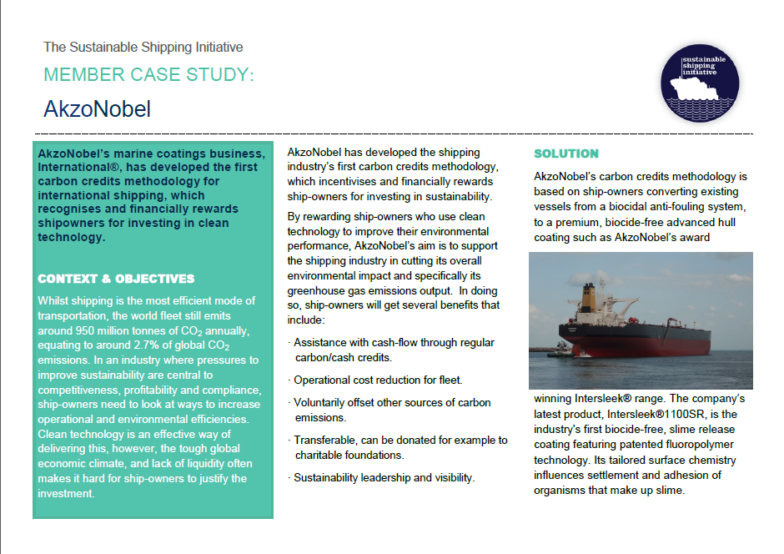
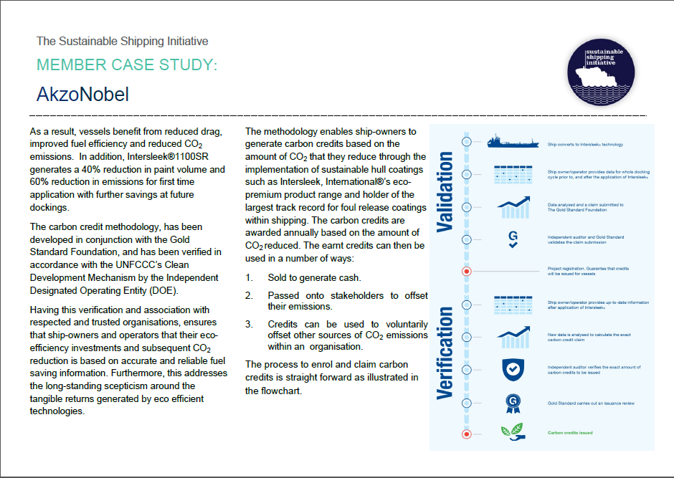

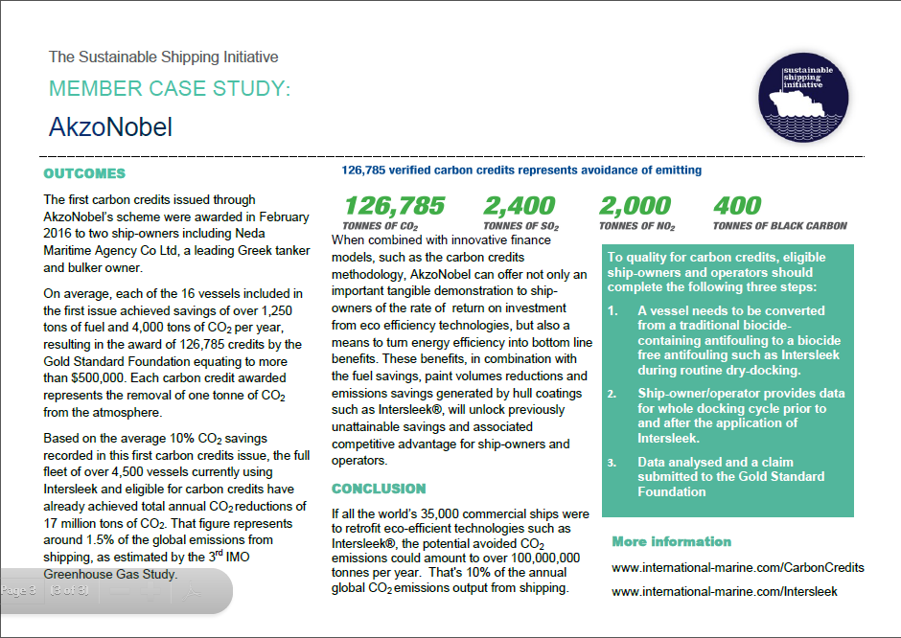

http://propeller-international.com/2016/06/30/first-ship-operators-receive-multiple-benefits-from-carbon-credits/
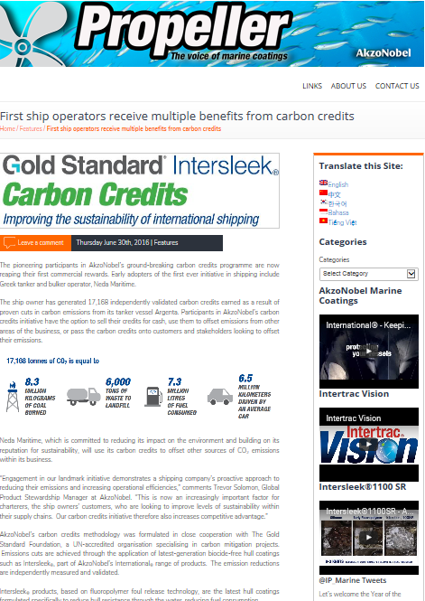

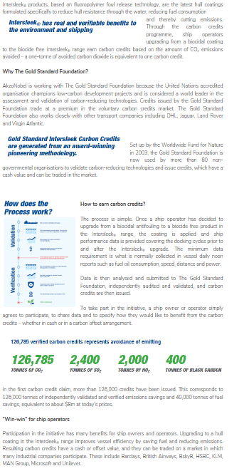
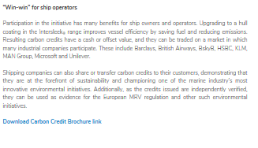

http://www.international-marine.com/NewsMedia/Documents/AkzoNobel-carbon-credits-methogology-wins%20environmental-award.pdf
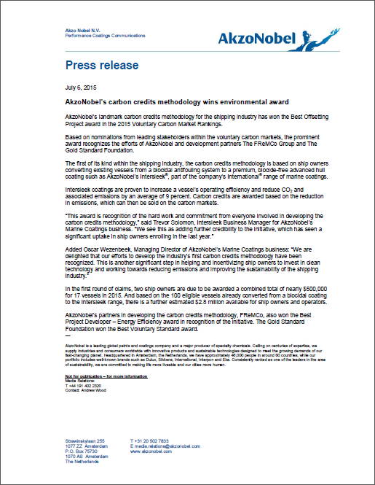

http://www.international-marine.com/NewsMedia/Documents/MR_CarbonCreditsIssueFinal2.pdf

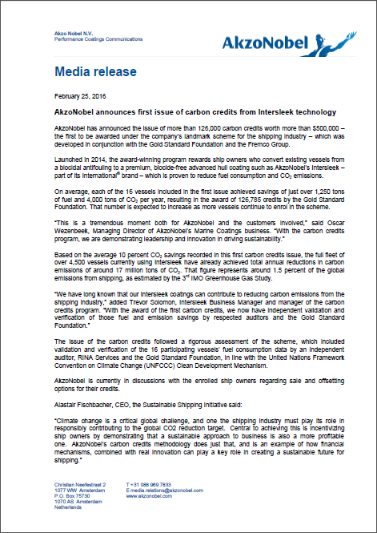

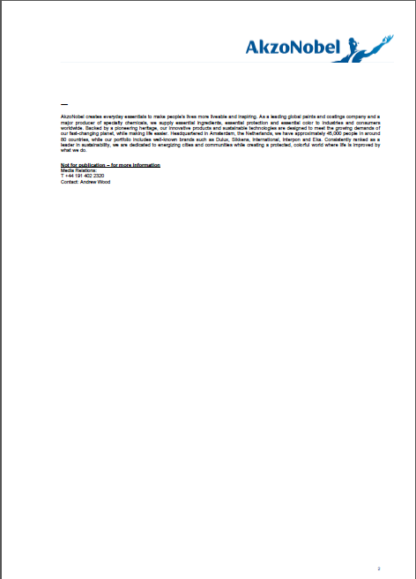

http://www.international-marine.com/NewsMedia/Documents/Press_Release_Carbon_Credits.pdf
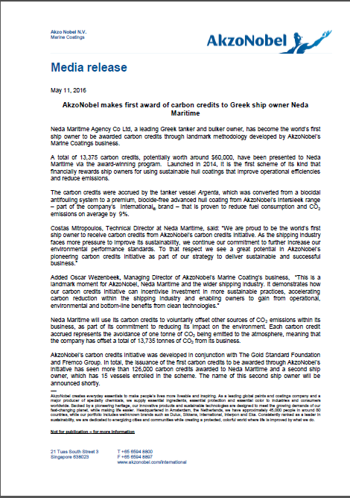

http://www.international-marine.com/NewsMedia/Documents/Press_Release_Environmental_Leader_Final.pdf
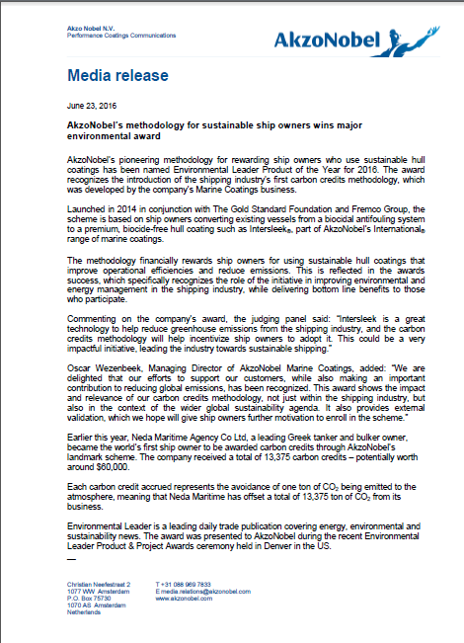

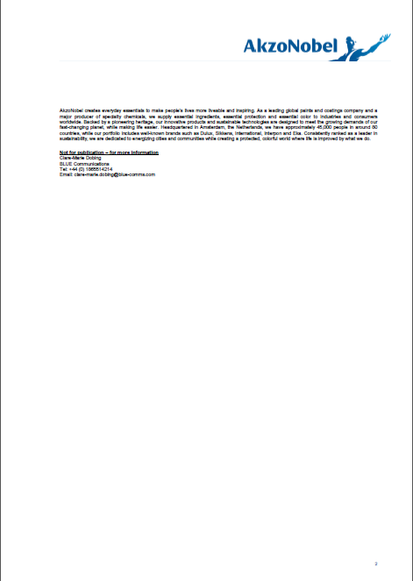

The Intersleek family of advanced hull coatings include some sub-brands. The file “Intersleek family of products.pdf” provides the full list.
It is not necessary to specify the names of personnel, but the descriptions of functions are required.
Improvements may include addition or restructuring of functions/posts for which prior approval by the Board is not required as long as the CME is able to demonstrate to the DOE that the deliverables of the management system specified in the registered PoA-DD are fully met.
Including Minoan Lines
The initial list in VPA DD version 1 included this ship. Data for this ship does not meet the requirements for the revised Gold Standard methodology, as approved by e-mail by Gold Standard on 9 Sep. 2014. Hence this ship is not included in this version. However, in order not to change the serial numbers, the row is not deleted.
“Lykiardopoulo is a shipping company founded in Kefalonia… The company still operates from UK and from Greece as Neda Maritime Agency Co. Ltd.” (http://en.wikipedia.org/wiki/Lykiardopoulo)
The text is identical in Passport, version 7, “Hull_coating_VPA_PDD_Proj_1_ver. 6 22Sep15 redacted.pdf”, where one shipping company and the ship names and IMO numbers were redacted, for reasons of confidentiality.
Including Minoan Lines

