
Monitoring report form
(Version 04.0)
MONITORING REPORT
Title of the project activity | Aqua Clara Water Filtration Program in Kenya
Reference number of the project activity | GS 1078
Version number of the monitoring report | Version 09
Completion date of the monitoring report | 15th December 2016
Registration date of the project activity | 26/12/2013
Monitoring period number and duration of this monitoring period | Monitoring Period 2  Duration: 22/7/2014 – 18/02/2016
Project participant(s) | Aqua Clara Foundation
Host Party(ies) | Kenya
Sectoral scope and selected methodology(ies), and where applicable, applied standardized baseline(s) | Methodology: Technologies and Practices to Displace Decentralized Thermal Energy Consumption”
Estimated amount of GHG emission reductions or net anthropogenic GHG removals by sinks for this monitoring period in the registered PDD | The estimated amount of GHG is 121,582.83 tCO2 from the project technologies. This amount is estimated in accordance to the registered PDD.  The total ex-ante estimations have been determined for the period between 22nd July 2014 and 18th February 2016 for the Biosand and the Household Hollow Fibre filters combined. Individually, the BSF total estimated emission reduction was 108,749.81TCO2, while that of the HHFF was 12.833Tco2. This has been proven in the ‘Ex-ante estimated ERs’ tab in the Emission reduction spread sheets for the BSF and the HFF. These documents have been submitted as supporting documents.
Actual GHG emission reductions or net anthropogenic GHG removals by sinks achieved in this monitoring period | 36,353 tCO2
Actual GHG emission reductions or net anthropogenic GHG removals by sinks achieved during the period up to 31 December 2012(if applicable) | N/A
Actual GHG emission reductions or net anthropogenic GHG removals by sinks achieved during the period from 1 January 2013 onwards (if applicable). | 36,353 tCO2

SECTION A. Description of project activity

A.1. Purpose and general description of project activity
>>The Aqua Clara Water Filtration Program in Kenya hereinafter called the ‘project activity’, seeks to introduce the Aqua Clara Foundation’s flagship products to the market in Kenya; the ACF Bio Sand Filter (BSF) and the Household Hollow Fibre filter (formerly referred to as the Household Sand and Membrane filters(SAM)). These ACF water purifiers (hereinafter described as the project technology) displace the use of firewood fuel traditionally used to boil water for domestic consumption and in the alternative offer an affordable, long-term solution for households that typically consume raw water from turbid sources.

The project BioSand filter can purify up to 36 litres per day, while the household Hollow Fibre filter (HHFF) has capacity to filter up to 15 litres per day on average. However, these capacities can be scaled up, with proper maintenance and use of the filter. Proper maintenance of the filters in this project activity is ensured through the PP’s visit to the households as a follow-up initiative to check on the household utilization of the water filters. BioSand Filters are proved to give 12-18 litres of water in an hour. With this efficiency of 36 to 40 litres per day, coupled with a 10-year lifespan, both project technologies can provide enough water to meet and exceed the World Health Organization recommended domestic water consumption rate of 7.5 litres per capita per day.

The project technologies offer an affordable, clean, efficient and easy-to-use alternative for water purification within the rural area that the project activity seeks to operate in. In addition, the project activity will actively reduce CO2 emissions and diminish the associated risks of Indoor Air pollution.

To date the PP has installed a total of 3,389 Bio Sand and 316 HHFF units used for domestic use in the project boundary.

(a)Relevant Dates of Project Activity

- Start date of project activity i.e., it is the date on which distribution of water filter under the proposed project activity began. – 26th June 2009
- Annual BSF Filter sales since start date of the project:
July 2009 to June 2010: 400 filters
July 2010 to June 2011: 617 filters
July 2011 to June 2012: 1010 filters
July 2012 to June 2013: 790 filters
July 2013 to June 2014: 349 filters
July 2014 to June 2015: 115 filters
July 2015 to January 2016: 108 filters

- Annual HFF filters sales start date of the project:
1st Nov 2013 to 31st Oct 2014: 110 filters
1st Nov 2014 to 31st Oct 2015: 181 filters
1st Nov 2015 to 18th Feb 2016: 25

- Project registration date was 26th December 2013.
- Start Date of Monitoring Survey 18th February 2016

(b) Total GHG emission Reductions or net anthropogenic GHG removals by sinks achieved in this monitoring period
The total GHG emission reductions achieved in this monitoring period (between 22nd July 2014 and February 2016) is 36,353 tCO2 for both project technologies.

A.2. Location of project activity
>>The project activity targets to operate within 23 counties within the terrestrial limits of the Republic of Kenya listed below.

Host Parties:
Kenya

Region/State/Province:
The project will operate across the 23 counties listed below:

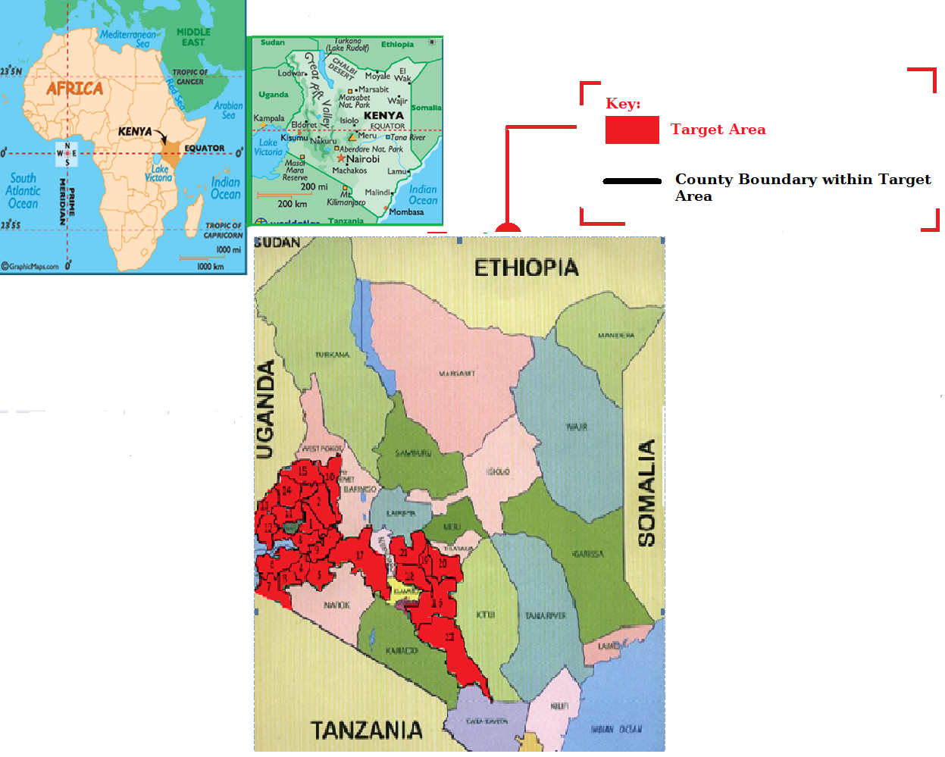

County | Coordinates | County | Coordinates | County | Coordinates | County | Coordinates
Nandi, | 00.1666670, 035.1500000 | Bomet | -00.8000000, 035.2333000 | Kericho, | 35.3000000, -000.3666667 | Busia, | 34.1500000, 000.4333333
Uasin Gishu, | 00.5166670, 035.2833000 | Homa Bay, | -00.6833330, 034.4500000 | Elgeyo, | 35.5086111, 000.9483333 | Bungoma, | 34.5833333,  000.5833333
Kisii, | -00.6666670, 034.7500000 | Migori, | 34.8333333, -000.6666667 | Kakamega, | 34.7500000, 000.2833333 | Trans Nzoia, | 34.5833333000.5833333
Nyamira, | -00.7500000, 035.0000000 | Kisumu, | 34.9167000, -000.2500000 | Siaya, | 34.7500000, 000.2833333 | Machakos, | 7.2500000, 001.5000000
Nakuru, | -00.5000000, 036.0000000 | Kirinyaga, | 37.2833333, -000.500000 | Nyeri, | 36.9500000, -000.4166667 | Nairobi | 36.8166667,  001.2833333
Muranga, | -00.7500000, 037.1166667 | Embu, | : 37.4500000,- 000.533333 | Makueni. | 37.6166667, -001.8000000 | Nairobi | 36.8166667,  001.2833333

City/Town/Community:
The project will operate in various towns and villages in the following 23 counties: Nandi, Uasin Gishu,Kisii, Nyamira, Nakuru, Muranga, BometHoma Bay, Migori, Kisumu, Kirinyaga, Embu, Kericho, Elgeyo, Kakamega, Siaya, Nyeri, Makueni.Busia, Bungoma, Trans Nzoia, Machakos, Nairobi

A.3. Parties and project participant(s)
Party involved  ((host) indicates  a host Party) | Private and/or public entity(ies) project participants  (as applicable) | Indicate if the Party involved wishes to be considered as project participant  (Yes/No)
The Republic of Kenya (host) | Aqua Clara Foundation | No

A.4. Reference of applied methodology and standardized baseline
>>The project is eligible under the GS methodology: Technologies and Practices to Displace Decentralized Thermal Energy Consumption

Other Gold Standard tools and annexes included in the project development include:
- Gold Standard Tool Kit Version 2.2
- Guidelines for carrying out usage surveys for projects implementing household water filtration technologies

A.5. Crediting period of project activity
>>The fixed 10-year crediting period started on 28/12/2011. This marks the second round of annual monitoring for this project which began on 22nd July 2014 to 18th February 2016.

A.6. Contact information of responsible persons/ entities
>>Viability Energy Limited (Viability Africa, LLC) is responsible for completing this CDM-MR-FORM and is not a project participant.

Carbon Asset Consultant:
Name: Natasha Georgete
Organization: Viability Energy Limited (Viability Africa, LLC)
Contacts: natasha.georgete@viabilityafrica.com

SECTION B. Implementation of project activity

B.1. Description of implemented registered project activity
>>The Aqua Clara Water Filtration Program in Kenya, aims to distribute three project technologies in the described project boundary in section A.2 of this monitoring report. The flagship product, the bio-sand filter is a plastic gravitation based slow sand filtration technology which is applicable for point of use water treatment in households and can treat up to 36 litres of water per day. The Hollow fibre filters (for households) operate by combining slow sand filtration and reverse osmosis to achieve low cost high quality water treatment solutions.

The project proponent started commercial distribution of the Biosand project technologies in 2009 for the Biosand filters and 2013 for the house hold HFF units. The company has since then built its distribution network in a system that involves the use of Community Development Officers (CDOs) and Community Health Promoters (CHPs) who work within the various communities under which Aqua Clara serves. These micro-entrepreneurs distribute and market filters after receiving training from the project proponent. This distribution model has proved to be pivotal to Aqua Clara’s success because the 6 Community Health Persons and 15 filter installers have ready access to these households which allows for constant feedback and follow up on customers after initial installations.

- The project Proponent, Aqua Clara Foundation contracted Viability Africa as the carbon asset consultant for the project activity. Since the start of the carbon asset development process, the following has been achieved: The Local Stakeholder Consultation (LSC) was hosted on May 7th 2011. An LSC report with signed participants’ lists has been uploaded verifying this date. The LSC report was submitted on 20th September 2011. LSC Report listed on GS Registry – 2nd January 2012. The LSC report is already uploaded on Markit with its timestamp recorded
- Voluntary Emissions Reductions Purchase Agreement Executed on 13th December 2011
The VERPA has been uploaded to the registry and submitted to the DOE however the PP requests that same are not made publicly available.
- Contract to commence Validation was executed February 29th 2012
The PP has uploaded the executed contract between the DOE and the PP on the project registry and submitted the same to the DOE.
- GS Passport submitted to Gold Standard Foundation (uploaded on GS Registry). – 19th March 2012
- Validation work plan uploaded on GS registry. – 27th August 2013
- Request for Registration submitted to Gold Standard Foundation – 11th November 2013
- The project was registered on 26th December 2013.

To date, the a total of 3,389 Bio Sand filters has been installed for domestic use, and 316 HHFF units for domestic use. At the time of installations of these project technologies, households are issued with receipts and each filter is assigned a unique identification number to avoid double counting. The Project Proponent then keeps record of all sales which are then accumulated as the Total Sales Record for each technology type.

The Project Technology
1. The Biosand Filter

Several point-of-use water purification technologies are available in Kenya including boiling, chlorination, solar disinfection (using sunlight), flocculent-disinfectants and chlorination. The average efficiency of a BSF is 95-99% elimination of microbial contaminants. However, this figure varies based on the design and operating properties.

The Aqua Clara Foundation Purifier has incorporated a granulated brass disinfectant into one of the filter layers which not only improves the filter performance but also adds a residual cleaning effect.

Maintenance of the ACF BSF is relatively simple as it only requires that the consumer to clean the filter once or twice a year depending on the turbidity of the water. Highly turbid sources of water tend to clog the filter hence reducing the flow rate. However, the user can increase the flow rate by simply adding 10 litres of water to the BSF unit, swirling the top 4-6 cm of sand up into the water with a stick, taking all sediments into suspension, pausing to allow sand grains to settle out and then scooping and dumping the water out. This simple procedure will guarantee the consumer continued filtration throughout the lifespan of the BSF unit of 10 years. The first maintenance check is done by the installer of the BSF unit, who has received training from ACF, followed by a demonstration of the maintenance.

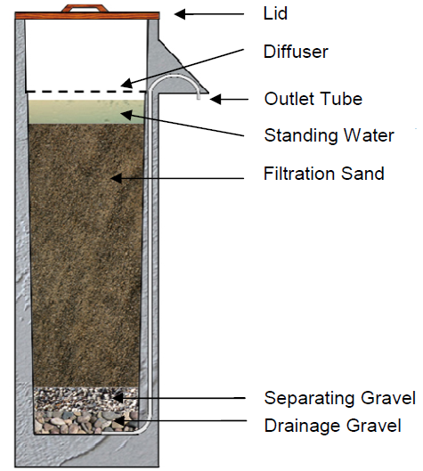
Figure 1: Simple Cross-Section of Bio Sand Filter

2. The ACF Hollow fibre membrane

The ACF Hollow Fiber membrane filter is based upon hollow-fiber membrane technology, which, for decades, has been used in medical, water, food, and industrial applications for high-precision ultra-filtration. Improved manufacturing processes now make the technology economical for humanitarian projects. Hollow micro-tubes are created of polysulphone plastic. The walls of the tubes are permeated with tiny holes not greater than 0.1 microns in diameter. Water enters the filter elements on the outside of the tubes. Since bacteria are larger than 0.1 micron, they cannot flow through the holes in the tubes. Only water can get through the holes. Bacteria and debris are left on the outside of the tubes. Pure water is collected as it flows on through the filter elements. The filters are easily and quickly back-flushed to wash away the impurities that collect in the filter elements. The filtration process is completely mechanical. No biological or chemical processes are involved.
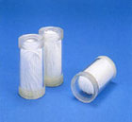
Figure 7: Hollow Fibre Membranes

These filters are designed to be used in both in domestic set ups (households, apartments, etc), institutions such as schools, and restaurants as well as commercial facilities such as restaurants and hotels. This round of annual monitoring only focused on HFF units that were used for domestic applications only.
The filters were designed and engineered by Aqua Clara in their laboratories at the BioEconomic Institute of Michigan State University, in Holland, Michigan, USA.

Specifications and performance
- Nominal flow rate of standard model: first liter out of a full 5-gallon filter in 60 seconds.
- Scalability: Half-liter-per-minute for small households
- Installation: 1 hour training in hygiene and maintenance; then pick up and carry home.
- Weight: <5 pounds
- Start-up: no start-up process required; filter can be used immediately.
- Pause time: no pause time is required between fill-ups.
- Portability: full portability without disrupting filter processes.

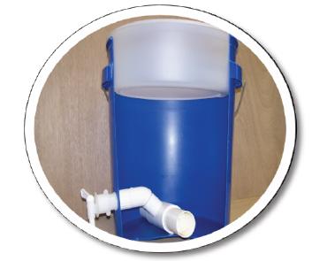
Figure 8: Cross Section of Hollow Fibre Membrane Filter

B.2. Post registration changes

B.2.1. Temporary deviations from registered monitoring plan, applied methodology or applied standardized baseline
>>N/A

B.2.2. Corrections
>>N/A

B.2.3. Permanent changes from registered monitoring plan, applied methodology or applied standardized baseline
>> The PP proposes 2 permanent changes to the registered monitoring plan:
1. Cj Factor fixed ex-ante:
The Cj factor that was previously a monitored parameter is now fixed ex-ante. This is in compliance with the registration review FAR that stated:

“The PP shall conduct a post registration baseline survey/water boiling tests prior to 2nd issuance considering in a representative way the target population in the project boundary and considering households prior to adopting the project technology”

The PP conducted the baseline testing in accordance to the Gold Standard methodology. The Household Cj factor is 18%, fixed ex-ante.

2. Biennial Monitoring of the Water Consumption per filter end user per day:
The registered PDD refers to the frequency of conducting the WCFT as annually. The PP would like to amend this frequency to every other year (biennially). The methodology employed for this project, i.e. ‘Technologies and Practices to Displace Decentralized Thermal Energy Consumption - 11/04/2011’ states:

‘For each baseline scenario and project scenario the BFT and PFT is updated every two years,
Respectively’,

At registration, the PP had chosen a conservative approach of annually monitoring this parameter, however, the PP now wishes to conduct this as per the methodological threshold of once every 2 years. Seeing as the PP has conducted this exercise the past 2 monitoring periods back to back, the parameters related to this exercise would remain fixed in the next verification should the Gold Standard Foundation approve this permanent deviation.

B.2.4. Changes to project design of registered project activity
>>The Project design now includes the inclusion of institutions to the project boundary. This design change was validated and approved by the Gold Standard Foundation. There were no institutions included in this round of monitoring.

B.2.5. Changes to start date of crediting period
>>N/A

B.2.6. Types of changes specific to afforestation or reforestation project activity
>> N/A

SECTION C. Description of monitoring system
>>
- Monitoring Procedure
A total sales record and a project database was maintained continuously and stored on an electronic database maintained by both Viability Africa and Aqua Clara Foundation for both the BSF and the HHFF units.

Total Sales Record
An accurate and complete sales record has been maintained by the project proponent and backed up electronically by the Viability Energy Limited, the carbon asset development consultant. As illustrated in the Total Sales record used in this monitoring exercise, which is attached as appendix to this monitoring report, it is developed in accordance with the selected baseline and monitoring methodology which is required the following data:

- Date of sale
- Geographic area of sale
- Model/type of project technology sold
- Quantity of project technologies sold
- Name and telephone number and address:
- Mode of use: domestic, commercial or other:
- Unique Filter serial number

Project Database

This has been developed from the total sales record.

- On-going Monitoring Studies
The monitoring exercise was a combination of the usage survey, monitoring survey and the Water Consumption Tests.
- Monitoring Survey- Completed annually, beginning 1 year after project registration. The project participant has conducted the annual monitoring surveys which were used to investigate annual changes in the project scenario. The monitoring surveys cover the duration from 22nd July 2014 to February 2016. This was based on an approval from the GS allowing the monitoring exercise to be pushed to early 2016.

- Usage Survey- Completed annually, or more frequently, and in all cases on time for any request of issuance. The usage survey in this monitoring exercise provides a single usage parameter based on drop off rates that are representative of the age distribution for project technologies in the total sales record. The usage parameter in the usage survey shall be based on users who completely abandon use of the ACF filter and those that do not properly use or maintain the filter so as to affect the quality of water treated. This survey was carried out using closed questionnaires and spot checks. The usage survey was carried out from 18th February to 25th April 2016.

- Project Field Test Update- Completed biennially, this is an extension of the project PFT and provides a water consumption assessment representative of project technologies currently every year. Hence the PFT update accounts for changes in the project scenario over time as project technologies age and new customers are added, also as new models and designs are introduced.

Water Consumption Field Test Protocol (WCFT):

The PP employed the following WCFT protocol:

The protocol employed field exercises based on the Kitchen Project Test (KPT) guidelines in Annex 4 of the approved methodology ‘Technologies and Practices to Displace Decentralized Thermal Energy Consumption’. The protocol was executed over a four-day period per household with the first day targeted at usage and sustainable development questionnaires and the remaining three days dedicated to WCFT exercises. The entire process began on the 19th February and ended on the 28th of April 2016.

The four day WCFT per household was not carried out over either a National Holiday or over the weekends (Saturday/Sunday) to ensure conservative quantification of water consumption per household per day. Therefore, there were no WCFT exercises done on 25th and 28th March as these days fell on Easter Holiday.

Day 0: Training of field enumerators
The PP carried out training exercise with the enumerators who would then proceeded to carry out the WCFT. A total of 14 people were trained and were responsible for carrying out the monitoring exercise.

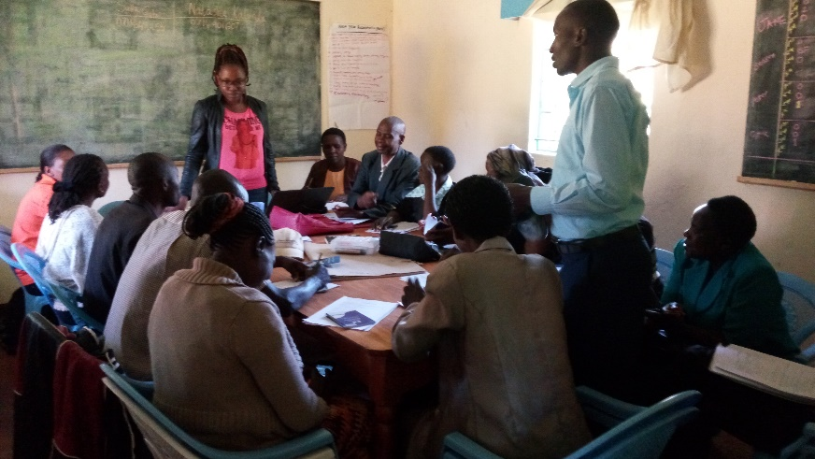
Enumerators being trained for the WCFT protocol and annual monitoring

The PP went over the survey questions to be asked during WCFT exercise as well as did mock examples of real WCFT with the enumerators to ensure they understood what would take place in a real world situation in the field. 8-liter water buckets were issued to each of the enumerators which they would use in the field in measuring the water volume consumed in a day per household. Enumerators were expressly told to ensure maximum accuracy in measuring water using the buckets.

The PP explained the parameters Q,p,y, Q,p cleanboil, and Q,p,raw boil. The enumerators were to enquire of the households on the day of the surveys what the household water treatment method was – Boiling raw water, filtering raw water only, or filtering raw water then boiling the clean filtered water. This was to account for parameters Q,p,rawboil, Q,p,y, Q,p,cleanboil respectively. The PP also enquired from the households how many times a day they purified their water so as to know when to go for the measuring of water.

For households that boil raw water, the PP explained that the enumerator was to measure the water the household would consume that day before the water was put in the boiling pot and record that volume. (Qp,raw,boil)

For the households who consume raw water, no testing was to be done in such a household.

For households who filter raw water only, the enumerator was instructed to measure the water that would be used in a day before this water was poured into the filter. (Qp,y)

For water that was filtered and thereafter boiled filtered water, the enumerator was instructed to measure the volume of filtered water before it was poured into the boiling pot (Qp,clean,boil)

The PP also stressed to the enumerators that they were to ask the households the number of people living in the house on each of the 3 days the exercise would be conducted.

All feedback that was obtained from the households was carefully recorded in the WCFT surveys and analysed.

Day 1 - Surveys and Introduction

The PP executed Usage surveys, Sustainable Development (SD) assessments and other non-field exercise surveys for the same sampling units as the WCFT for the monitored project technology (Household BSF units and Household Hollow Fibre Filter- HHFF). The PP then informed households of the three day WCFT exercise informing them that they were to treat water as they normally do year round.

Day 2 - 4. WCFT exercise

Based on the schedule of respective households’ water treatment habits, enumerators conducted a volumetric assessment for safe water used in the household as explained above. This assessment was conducted using standardized volumetric 8 litre water buckets.

Paramters Qpy, Qp,rawboil and Qpclean boil are aggregated from the mean of safe water consumed per day, over a 3 day period. Safe water in this case implies water filtered from the project technologies (Qpy), raw water boiled (Qp,rawboil) and/or filtered water boiled.

The PP, in accordance to the methodology has eliminated all outliers before calculating the parameters mentioned above.

To determine parameter Np,y, (number of persons per household using the project technology), the PP included in the WCFT survey a question on number of persons per household. The PP determined this parameter by first excluding any and all outliers as well as those deemed to be non-users of the project technology, and thereafter, calculating the aggregate mean of number of persons per household over the 3-day period for the entire sample frame.

The outcome of the WCFT have been summarised in the monitoring survey summary.

- Water Quality Tests

The PP collected samples of water from each household which had been selected as sampling units from the technology specific sampling frame. Each water sample was labelled to show which sample was from the filtered water and which was from the raw water and from which household the sample was collected. The samples were then stored in cool packs. At a central field laboratory all the samples were tested and results recorded for each individual sample. This ensured that the PP’s water quality testing was representative and robust. Field laboratory testing was selected because it allows for near immediate testing without contamination or any other distortion from the transportation to laboratories. The drinking standard doesn’t specifically approve or endorse either method of water testing but rather specifies quantified limits that determine the quality of the water. The use of field laboratory tests is approved in the methodology and is a commonly accepted international approach.

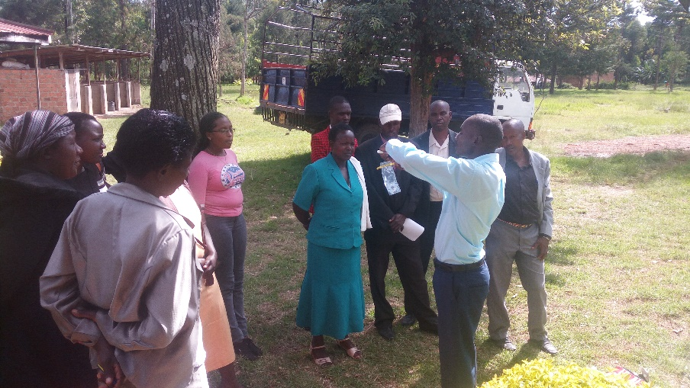
Picture showing enumerators being trained in how to operate water quality test kits

- Leakage Assessment

As demonstrated in section B.6.3 of the PDD, there are no perceived leakage risks for this parameter.

- Non Renewable Biomass Assessment Update

The NRB assessment update will not occur for the project given its fixed baseline and the fact that the project scale is not large enough to affect the national NRB fraction.

SECTION D. Data and parameters

D.1. Data and parameters fixed ex ante or at renewal of crediting period

Data/Parameter: | Wb,y
Unit: | Tonnes/litre
Description: | Quantity of fuel in tons required to treat 1 litre of water using technologies representative of baseline scenario b
Source of data: | Baseline water Boiling test
Value(s) applied): | 0.000549
Purpose of data: | The value provided above was derived from water boiling tests as recommended by the methodology. The value selected is the mean value derived from 144 individual tests. The purpose of the data is calculation of Baseline Emissions
Additional comment: | The Water Boiling tests were conducted in August 2015 in response to the FAR raised in the GS 6-week review. A total of 144 households that had no access to the project technology were interviewed. A baseline survey summary has been provided as a supporting document.

Data / Parameter: | EFb,fuel,CO2
Unit: | tCO2/TJ
Description: | CO2 emission factor of the wood fuel
Source of data: | IPCC Default emission factor
Value(s) applied): | 112
Purpose of data: | Calculation of baseline and Project emissions
Additional comment: | N/A

Data / Parameter: | NCV_{b}
Unit: | TJ/ton
Description: | Net calorific value of wood fuel used in the baseline
Source of data: | IPCC default value
Value(s) applied): | 0.015
Purpose of data: | Calculation of baseline and Project emissions
Additional comment: | N/A

Data / Parameter: | EFb,fuel,CH4
Unit: | tCH₄/TJ
Description: | CH₄ emission factor of the wood fuel
Source of data: | IPCC Default emission factor
Value(s) applied): | 0.300
Purpose of data: | Calculation of baseline missions
Additional comment: | N/A

Data / Parameter: | EFb,fuel, N₂O
Unit: | t N₂O/TJ
Description: | N₂O emission factor of the wood fuel
Source of data: | IPCC Default emission factor
Value(s) applied): | 0.004
Purpose of data: | Calculation of baseline emissions
Additional comment: | N/A

Data / Parameter: | GWP
Unit: | Fraction
Description: | Global Warming Potential of CH4
Source of data: | IPCC Third Assessment Report: Climate Change 2001
Value(s) applied): | 25
Purpose of data: | Calculation of baseline emissions
Additional comment: | N/A

Data / Parameter: | GWP
Unit: | Fraction
Description: | Global Warming Potential N₂O
Source of data: | IPCC Third Assessment Report: Climate Change 2001
Value(s) applied): | 298
Purpose of data: | Calculation of baseline emissions
Additional comment: | N/A

Data / Parameter: | Cj
Unit: | %
Description: | Expressed as a percentage, this is the portion of users of the project technology j who in the baseline were already consuming safe water without boiling it
Source of data: | Baseline Surveys
Value(s) applied: | 18%
Purpose of data: | Calculation of baseline emissions, Calculation of Project emissions
Additional comment: | The PP carried out Baseline Surveys over 8 out of the 23 counties. The households selected were not owners of the project technology. A total of 144 households were randomly selected for the baseline survey. This baseline survey was done to comply with the GS FAR in the GS Registration review that stated:  “The PP shall conduct a post registration baseline survey/water boiling tests prior to 2nd issuance considering in a representative way the target population in the project boundary and considering households prior to adopting the project technology”  The PP has provided as supporting documents the baseline survey summary for review.

D.2. Data and parameters monitored
Data / Parameter: | Qp,y_{BSF}
Unit: | Litres per person per day
Description: | Quantity of safe water in litres consumed in the project scenario p and supplied by BSF project technology per person per day
Measured/  Calculated /  Default: | Measured
Source of data: | Water Consumption Field Tests
Value(s) of monitored parameter: | 6.78
Monitoring equipment: | Calibrated Buckets for measuring water
Measuring/  Reading/  Recording frequency: | Biennially, 3 consecutive days of the monitoring exercise with exception of holidays
Calculation method  (if applicable): | The Water Consumption Field Test results were collected for three consecutive days in each household included in the sample frame. An average of this was then obtained. The figure was then divide by the average number of people in the household.
QA/QC procedures: | The enumerators were provided with calibrated buckets to ensure they took accurate measurements during the WCFT protocol. To ensure accuracy, the enumerators were advised to read calibrated units less of top most numbers which could be easily read.
Purpose of data: | Calculation of baseline emissions.
Additional comment: | N/A

Data / Parameter: | Qp,y_{HHFF}
Unit: | Litres per person per day
Description: | Quantity of safe water in litres consumed in the project scenario p and supplied by HHFF units
Measured/  Calculated /  Default: | Measured
Source of data: | Water Consumption Field Tests
Value(s) of monitored parameter: | 2.44
Monitoring equipment: | Calibrated Buckets for measuring water
Measuring/  Reading/  Recording frequency: | Biennially, 3 consecutive days of the monitoring exercise with exception of holidays
Calculation method  (if applicable): | The Water Consumption Field Test results were collected for three consecutive days in each household included in the sample frame. An average of this was then obtained. The figure was then divide by the average number of people in the household.
QA/QC procedures: | The enumerators were provided with calibrated buckets to ensure they took accurate measurements during the WCFT protocol. To ensure accuracy, the enumerators were advised to read calibrated units less of top most numbers which could be easily read.
Purpose of data: | Calculation of baseline emissions.
Additional comment: | N/A

Data / Parameter: | Qp,y_{FHFF}
Unit: | Litres of safe water produced per day from project technology
Description: | Quantity of safe water supplied in the project scenario p using the Large Scale Community SAM Filter
Measured/  Calculated /  Default: | Measured
Source of data: | No SAM filters has been sold during this monitoring period, So this parameter is not monitored
Value(s) of monitored parameter: | No SAM filters has been sold during this monitoring period
Monitoring equipment: | No SAM filters has been sold during this monitoring period
Measuring/  Reading/  Recording frequency: | No SAM filters has been sold during this monitoring period
Calculation method  (if applicable): | No SAM filters has been sold during this monitoring period
QA/QC procedures: | No SAM filters has been sold during this monitoring period
Purpose of data: | Calculation of baseline emissions.
Additional comment: | N/A

Data / Parameter: | Qp, clean,boil,y_{BSF}
Unit: | Litres per person per day
Description: | Quantity of safe water boiled in the project scenario p per person per day
Measured/  Calculated /  Default: | Calculated
Source of data: | Water Consumption Field Test
Value(s) of monitored parameter: | 0
Monitoring equipment: | Calibrated Buckets for measuring water
Measuring/  Reading/  Recording frequency: | Biennially
Calculation method  (if applicable): | The amount of filtered water boiled was obtained for the three consecutive days during the water consumption field test before the water was poured into the boiling pot. An average of this amount was then obtained and divided by the average number of people in the household.
QA/QC procedures: | The enumerators were trained how to accurately measure this parameter using calibrated buckets. The households were advised not to boil the water before the enumerators measured it.
Purpose of data: | Calculation of project emissions
Additional comment: | N/A

Data / Parameter: | Qp, clean,boil,y_{HHFF}
Unit: | Litres per person per day
Description: | Quantity of safe water boiled in the project scenario p per person per day
Measured/  Calculated /  Default: | Calculated
Source of data: | Water Consumption Field Test
Value(s) of monitored parameter: | 0.23655914
Monitoring equipment: | Calibrated Buckets for measuring water
Measuring/  Reading/  Recording frequency: | Biennially
Calculation method  (if applicable): | To be conservative and to assume a statistically accurate measurement for this metric against all households in the TSR, it was decided to develop and apply a ration that would then determine the average consumption for all households in the TSR who boil water even after filtration. This in effect would mean that the households who do this practice still have an impact on the total ER calculations. To this effect, the PP took the total value of water boiled from the HHF units from the two households and divided it by 31 (Total sample size excluding the non-users). This provided the ratio of the number of people using this practice in the sample frame which could then be extrapolated to define the total number of people who do this in the total TSR of HHF end users.  The step-wise approach taken by the PP is as follows:  Step 1: The PP determined the average filtered water per person per day in the 2 households that reported this behaviour  Step 2: Determine the quantity of filtered water boiled per household  Step 3: Determine the proportion of the project scenario end users that would likely practice Qp,cleanboil,y. This is by dividing the 2 households that practice Qp, cleanboil,y by the 31 households in the sample frame.  Step 4: Determine the number of households in the project scenario that boil filtered water. This is a function of the proportion of households practicing boiling of filtered water and the population size of the TSR (316 households)  Step 5: Determine the quantity of filtered water boiled in the project scenario. This is done by multiplying the households that boil filtered water by the quantity of filtered water boiled per household  Step 6: Finally, determine how much filtered water is boiled per person per day. This is done by dividing the total amount of filtered water boiled(step5) by the total number of persons in the project scenario (i.e. 7 persons per household*316 households)
QA/QC procedures: | The enumerators were trained how to accurately measure this parameter using calibrated buckets. The households were advised not to boil the water before the enumerators measured it.
Purpose of data: | Calculation of project emissions
Additional comment: | N/A

Data / Parameter: | Qp, rawboil,y_{BSF}
Unit: | Litres per person per day
Description: | Quantity of raw water boiled in the project scenario p per person per day
Measured/  Calculated /  Default: | Calculated
Source of data: | Water Consumption Field Test
Value(s) of monitored parameter: | 0
Monitoring equipment: | Calibrated Buckets for measuring water
Measuring/  Reading/  Recording frequency: | Biennially
Calculation method  (if applicable): | The amount of raw water boiled was obtained for the three consecutive days during the water consumption field test before the water was poured into the boiling pot. An average of this amount was then obtained and divided by the average number of people in the household. (There were no households boiling water in the project scenario)
QA/QC procedures: | The enumerators were trained how to accurately measure this parameter using calibrated buckets. The households were advised not to boil the water before the enumerators measured it.
Purpose of data: | Calculation of baseline emissions and calculation of project emissions
Additional comment: | N/A

Data / Parameter: | Qp, rawboil,y_{HHFF}
Unit: | Litres per person per day
Description: | Quantity of raw water boiled in the project scenario p per person per day
Measured/  Calculated /  Default: | Calculated
Source of data: | Water Consumption Field Test
Value(s) of monitored parameter: | 0
Monitoring equipment: | Calibrated Buckets for measuring water
Measuring/  Reading/  Recording frequency: | Biennially
Calculation method  (if applicable): | The amount of raw water boiled was obtained for the three consecutive days during the water consumption field test before the water was poured into the boiling pot. An average of this amount was then obtained and divided by the average number of people in the household.
QA/QC procedures: | The enumerators were trained how to accurately measure this parameter using calibrated buckets. The households were advised not to boil the water before the enumerators measured it.
Purpose of data: | Calculation of baseline emissions and calculation of project emissions
Additional comment: | N/A

Data / Parameter: | Np,y _{BSF}
Unit: | Person.days
Description: | Number of persons consuming water supplied by project scenario p through year y
Measured/  Calculated /  Default: | Calculated
Source of data: | Water Consumption Field Test
Value(s) of monitored parameter: | 1978
Monitoring equipment: | Open ended questionnaires in monitoring surveys
Measuring/  Reading/  Recording frequency: | Biennially
Calculation method  (if applicable): | Households were asked the number of people living in their household for that particular day in the three consecutive days during the water consumption field test. An average of this number was then obtained for each household and an average of total obtained. The figure was multiplied by 365 days in a year to obtain the figure.
QA/QC procedures: | The number of people living in a household for the three consecutive days during the water consumption field test was obtained to capture the differences in the household number of people throughout the year.
Purpose of data: | Calculation of baseline emissions
Additional comment: | N/A

Data / Parameter: | Np,y _{HHFF}
Unit: | Person.days
Description: | Number of persons consuming water supplied by project scenario p through year y
Measured/  Calculated /  Default: | Calculated
Source of data: | Water Consumption Field Test
Value(s) of monitored parameter: | 2555
Monitoring equipment: | Open ended questionnaires in monitoring surveys
Measuring/  Reading/  Recording frequency: | Biennially
Calculation method  (if applicable): | Households were asked the number of people living in their household for that particular day in the three consecutive days during the water consumption field test. An average of this number was then obtained for each household and an average of total obtained. The figure was multiplied by 365 days in a year to obtain the figure.
QA/QC procedures: | The number of people living in a household for the three consecutive days during the water consumption field test was obtained to capture the differences in the household number of people throughout the year.
Purpose of data: | Calculation of baseline emissions
Additional comment: | N/A

Data / Parameter: | Up,y _{BSF}
Unit: | Percentage
Description: | Usage rate in project scenario p during year y. This data will be used to account for households which discontinue use of the filters from the monitored sample frame and thereafter be extrapolated across the total sales record.
Measured/  Calculated /  Default: | Calculated
Source of data: | Usage Survey
Value(s) of monitored parameter: | 2014 = 68.31%  2015 = 68.52%  2016 = 69.29%
Monitoring equipment: | Monitoring Surveys
Measuring/  Reading/  Recording frequency: | Annually
Calculation method  (if applicable): | The PP has provided excel based calculations that demonstrate the calculation of the usage parameter. The PP followed methodological requirements to determine the weighted average in a step-wise approach demonstrated in the sample frame excel document for the BSF filters.
QA/QC procedures: | The guidance questions in section 4 of the usage survey clearly determined the operational and non-operational filters in the project scenario.
Purpose of data: | Calculation of total emission reductions
Additional comment: | N/A

Data / Parameter: | Up,y _{BSF(waterquality)}
Unit: | Percentage
Description: | Usage rate based solely on water quality
Measured/  Calculated /  Default: | Calculated
Source of data: | Water Quality test analysis
Value(s) of monitored parameter: | Users = 98.35%  Non-users = 1.65%
Monitoring equipment: | Water Quality Results Analysis
Measuring/  Reading/  Recording frequency: | Annually
Calculation method  (if applicable): | There were 182 water quality tests carried out for the BSF filters, with 178 samples demonstrating safe water standards. To determine usage rate, the PP divided the number of safe water samples with the total number of samples collected.
QA/QC procedures: | The PP has followed the Gold Standard guidance on the approach used to determine this usage parameter as well as its applications in determing the emission reductions.
Purpose of data: | Calculation of total emission reductions
Additional comment: | N/A

Data / Parameter: | Up,y_{HHFF}
Unit: | Percentage
Description: | Usage rate in project scenario p during year y. This data will be used to account for households which discontinue use of the filters from the monitored sample frame and thereafter be extrapolated across the total sales record.
Measured/  Calculated /  Default: | Calculated
Source of data: | Usage Survey
Value(s) of monitored parameter: | 2014 = 72.73%  2015 = 71.55%  2016 = 71.49 %
Monitoring equipment: | Monitoring Surveys
Measuring/  Reading/  Recording frequency: | Annually
Calculation method  (if applicable): | The PP has provided excel based calculations that demonstrate the calculation of the usage parameter. The PP followed methodological requirements to determine the weighted average in a step-wise approach demonstrated in the sample frame excel document for the HFF filters
QA/QC procedures: | The guidance questions in section 4 of the usage survey clearly determined the operational and non-operational filters in the project scenario.
Purpose of data: | Calculation of total emission reductions
Additional comment: | N/A

Data / Parameter: | Up,y_{HHFF(waterquality)}
Unit: | Percentage
Description: | Usage rate based solely on water quality
Measured/  Calculated /  Default: | Calculated
Source of data: | Water Quality test analysis
Value(s) of monitored parameter: | Users = 100%  Non-users = 0%
Monitoring equipment: | Water Quality Results Analysis
Measuring/  Reading/  Recording frequency: | Annually
Calculation method  (if applicable): | There were 34 water quality tests carried out for the BSF filters, with 34 samples demonstrating safe water standards. To determine usage rate, the PP divided the number of safe water samples with the total number of samples collected.
QA/QC procedures: | The PP has followed the Gold Standard guidance on the approach used to determine this usage parameter as well as its applications in determine the emission reductions.
Purpose of data: | Calculation of total emission reductions
Additional comment: | N/A

Data / Parameter: | Quality of the treated water_{BSF}
Unit: | N/A
Description: | Performance of the project technologies shall be based on percentage reduction of E.Coli examined through field tests in the project boundary .
Measured/  Calculated /  Default: | Measured
Source of data: | Water Quality Tests
Value(s) of monitored parameter: | Results of the water quality tests are provided in the monitoring summary sheet
Monitoring equipment: | Field Laboratory Tests
Measuring/  Reading/  Recording frequency: | Annually
Calculation method  (if applicable): | N/A
QA/QC procedures: | The water test results are compared against values provided from the product specifications
Purpose of data: | Sustainable development Monitoring; Methodological Requirement
Additional comment: | The water quality tests were conducted using 3M Petrifilm Plate instructions. Water samples were collected from raw water and water filtered using the project technologies to determine coliform levels in both water samples. A description of the water testing method is described in the section below.

Data / Parameter: | Quality of the treated water _{HHFF}
Unit: | N/A
Description: | Performance of BSF filters shall be based on percentage reduction of E.Coli in the HFF Filters examined through field tests in the project boundary .
Measured/  Calculated /  Default: | Measured
Source of data: | Water Quality Tests
Value(s) of monitored parameter: | Results of the water quality tests are provided in the monitoring summary sheet.
Monitoring equipment: | Field Laboratory Tests
Measuring/  Reading/  Recording frequency: | Annually
Calculation method  (if applicable): | N/A
QA/QC procedures: | The water test results are compared against values provided from the product specifications
Purpose of data: | Sustainable development Monitoring; Methodological Requirement
Additional comment: | The water quality tests were conducted using 3M Petrifilm Plate instructions. Water samples were collected from raw water and water filtered using the project technologies to determine coliform levels in both water samples. A description of the water testing method is described in the section below.

Data / Parameter: | Water Treatment Practices in the baseline scenario
Unit: | Treatment Descriptions
Description: | This parameter will be collated so as to describe water treatment practices in the baseline scenario.
Measured/  Calculated /  Default: | N/A
Source of data: | Monitoring surveys
Value(s) of monitored parameter: | N/A
Monitoring equipment: | Monitoring survey
Measuring/  Reading/  Recording frequency: | Annually
Calculation method  (if applicable): | Households were asked their baseline water treatment before they obtained the water filter. Appropriate answers were then put in the surveys.
QA/QC procedures: | Multiple options in an open ended questionnaire so as to eliminate any possibility of bias.
Purpose of data: | Calculation of baseline emissions
Additional comment: | This question was used to determine suppressed demand. Where households informed they didn’t treat water before getting the water filter, the enumerators asked them their likely treatment option of the barrier was removed. Appropriate answers were then provided for in the monitoring survey.

Data / Parameter: | LEp,y
Unit: | t_CO2e per year
Description: | Leakage in project scenario p during year y
Measured/  Calculated /  Default: | N/A
Source of data: | Literature Review
Value(s) of monitored parameter: | 0
Monitoring equipment: | Monitoring Surveys
Measuring/  Reading/  Recording frequency: | Biennially
Calculation method  (if applicable): | N/A
QA/QC procedures: | There are no perceived monitoring requirements for leakage perceived for this project as has been demonstrated in section B.6.3 of this PDD.
Purpose of data: | Calculation of total emission reductions
Additional comment: | N/A

Gold Standard Sustainable Development Indicators

As outlined in the Gold Standard passport, the following parameters were monitored:
Data / Parameter: | Water quality and quantity: + Positive score
Unit: | %
Description: | This is the quality of filtered water with regards to presence of coliforms in the water. Water quality was assessed by comparing the levels of coliforms in water from raw water and filtered water of the same sample.
Measured/  Calculated /  Default: | Measured and then calculated
Source of data: | Water quality testing
Value(s) of monitored parameter: | Out of the 180 tests done for BSF filters, and 34 tests for HHFF units:  BSF:  180 tests were conducted. Out of these, 168 samples (93%) had percentage reduction of E. coli that was greater than 95% reduction of E. coli, while 12 samples (7%) had percentage reduction of E. coli that is less than 95% removal.  HHFF:  34 water quality tests were conducted out of the sample frame of 40 households because 6 of the 40 households had abandoned their water filters. Out of the 34, 32 (94%) water samples had percentage reduction of E. coli that was greater than 95% removal, while 2 samples (6%) had percentage removal less than 95% removal.
Monitoring equipment: | 3M Petrifilm
Measuring/  Reading/  Recording frequency: | Annually
Calculation method  (if applicable): | The total samples showing reduction/increment/no change in coliform levels divided by the total number of samples in the sample frame, multiplied by 100.
QA/QC procedures: | The PP ensured the enumerators were well trained to ensure they didn’t contaminate water for the water quality testing. They were provided with cooling jars which were collected from the field within six hours of collection of the samples and then tested with the 3M plates to ensure quality results.
Purpose of data: | Determine if sustainable development has been achieved, with regards to supply of safe drinking water.
Additional comment: | N/A

Data / Parameter: | Quality of Employment+ Positive score
Unit: | N/A
Description: | Improvement in the skill level of the community members within the project boundary
Measured/  Calculated /  Default: | N/A
Source of data: | Training Manual, Training participant lists, Pictures showing trainings in progress
Value(s) of monitored parameter: | N/A
Monitoring equipment: | N/A
Measuring/  Reading/  Recording frequency: | Monitored biennially for the first monitoring period, and annually in subsequent monitoring periods.
Calculation method  (if applicable): | N/A
QA/QC procedures: | The trainees from the community are trained by highly skilled personally on various aspects of the project e.g. sales, assembly of the project technology, etc.
Purpose of data: | To ensure that the project has actually brought about sustainable development in the form of better quality of employment.
Additional comment: | N/A

Data / Parameter: | Livelihood of the poor + Positive score
Unit: | Percentage
Description: | The parameter refers to the number of people in the project activity whose livelihoods had improved in terms of savings of money used to get fuel and the time used to collect firewood. Households in the sample frame were asked these questions to attesting the same.
Measured/  Calculated /  Default: | Calculated
Source of data: | Monitoring Surveys
Value(s) of monitored parameter: | 75% of the households interviewed from the HFF users reported to have had a reduction in the amount of time spent in acquiring fuel since they began using the water filters, while 25% of the households using the same filters reported having seeing no change in the amount of time spent in acquiring fuel.  On the other hand, 94% of the BSF users reported that they noticed a reduction in the amount of time spent in collecting fuel, 6% reported that they did not notice any change in the expenditure of time in gathering or acquiring fuel.
Monitoring equipment: | N/A
Measuring/  Reading/  Recording frequency: | Monitored annually
Calculation method  (if applicable): | Households were asked if there was reduction of time used to acquire fuel in the project scenario. If yes, the answer was recorded and same if the household indicated no on the same. Percentages were obtained from the answers provided.
QA/QC procedures: | N/A
Purpose of data: | To ensure that the project has actually brought about sustainable development in the form of improvement of the livelihood of the poor.
Additional comment: | N/A

Data / Parameter: | Livelihood of the poor + Positive score
Unit: | Percentage
Description: | The parameter refers to the number of people in the project activity whose livelihoods had improved in terms of savings of money used to get fuel.  Households in the sample frame were asked these questions to attesting the same.
Measured/  Calculated /  Default: | Calculated
Source of data: | Monitoring Surveys
Value(s) of monitored parameter: | BSF:  6% reported no change in the amount of money spent to acquire fuel, while 94% reported that the amount of money spent on the same reduced since they started using the water filter.  HFF:  24% of those interviewed reported that the amount of money spent on getting household fuel didn’t change since they started using the filter, while 76% of the households interviewed said the amount of money reduced to acquire household fuel.
Monitoring equipment: | N/A
Measuring/  Reading/  Recording frequency: | Monitored annually
Calculation method  (if applicable): | Households were asked if there was reduction of time and money used to acquire fuel in the project scenario. If yes, the answer was recorded and same if the household indicated no on the same. Percentages were obtained from the answers provided.
QA/QC procedures: | N/A
Purpose of data: | To ensure that the project has actually brought about sustainable development in the form of improvement of the livelihood of the poor.
Additional comment: | N/A

Data / Parameter: | Access to affordable and clean energy services + Positive score
Unit: | N/A
Description: | This parameter refers to the number of people who have had access to affordable and clean energy services in the project scenario.
Measured/  Calculated /  Default: | N/A
Source of data: | Total Sales Record.
Value(s) of monitored parameter: | 3,389 households BSF units and 316 HHFF units
Monitoring equipment: | N/A
Measuring/  Reading/  Recording frequency: | Monitored annually in this monitoring period.
Calculation method  (if applicable): | N/A
QA/QC procedures: | The PP tracks the number of filters sold in the project boundary. This data is kept in form of hard copies which are then transferred into an electronic sheet. The PP then submits these data sheets to the carbon asset development consultant whom then verifies the information to make sure the data meets the carbon asset standards.
Purpose of data: | Measure sustainable development indicator in terms of access to affordable and clean energy services in the project boundary.
Additional comment: | N/A

Result:

The PP has provided the Totals Sales Record.

WATER QUALITY TESTING
- Water Quality Testing Approach
Water quality testing was conducted through the 3M Petrifilm instructions manual. The 3M Petrifilm plate contains Violet Red Bile (VRB) nutrients, a cold-water-soluble gelling agent, an indicator of glucuronidase activity, and an indicator that facilitates colony enumeration. Most E. coli (about 97%) produce beta-glucuronidase which produces a blue precipitate associated with the colony. The top film traps gas produced by the lactose fermenting coliforms and E. coli. About 95% of E. coli produce gas, indicated by blue to red-blue colonies associated with entrapped gas on the Petrifilm EC plate (within approximately one colony diameter). It is therefore relatively easy to detect presence or absence of any population of the E. coli during water quality testing.
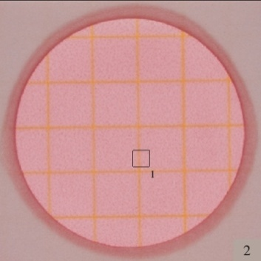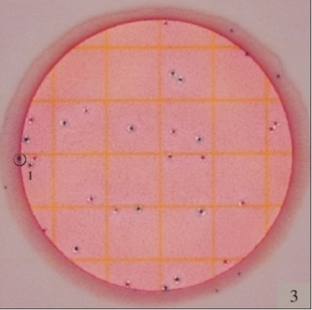
No growth = 0 E. coli count = 13
Figure 1: Diagrams showing presence and absence of E.coli in a sample of water using the 3M Petrifilm plates
- 3rd Party Endorsements
- CAWST
CAWST – Centre for Affordable Water and Sanitation Technology - a Canadian humanitarian not-for-profit organization that provides education, training and technical consulting in water and sanitation to organizations working with the poor in developing countries.
“The WHO Guidelines cover microbiological, chemical and physical qualities. However, it is stressed that microbiological quality is the most important since this is biggest cause of illness and death around the world.
The water quality tests endorsed by CAWST are primarily simplistic in nature. Historically, conventional laboratories were mainly used to carry out water quality testing. Now there is a wide variety of good testing kits and products available in the commercial market that allows you to conduct water quality testing on your own without relying on a laboratory. A significant advantage of field analysis is that tests are carried out on fresh samples whose characteristics have not been contaminated or otherwise changed as a result of being stored and transported over long distances. In rural and remote communities, it is more convenient to carry out water testing on site. However, in practice, it is difficult to transport samples in a way that does not affect their bacteriological quality. Setting up a small laboratory to provide a clean and controlled environment is highly recommended.
Laboratory testing is preferred when carrying out technology verification and preparing water quality guidelines. UNICEF recommends that some complex chemicals such as antimony, barium, cadmium, mercury, molybdenum, selenium and uranium should be tested by a laboratory to achieve a reliable result. However, testing specifically for these chemicals is not usually a concern for the majority of HWTS projects”.
3M Petri film is one of the kits recommended by CAWST.

3M Petri film:
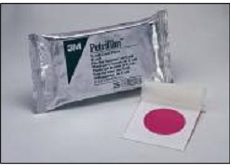

There are two procedures for water testing using Petrifilm, but neither are approved international methods. The first procedure recommends the water be filtered through a cellulose acetate filter and the filter be placed on the Petrifilm. This would allow a 100 ml sample to be tested. The filter paper is not included. For this procedure, the gel needs to be prepared ahead of time adding a few extra hours on to the procedure time. If the water sample was really contaminated it could be a challenge to count all the bacteria colonies and the sample may have to be diluted. The second procedure (used by Robert Metcalf) tests a 1 ml sample by placing the sample directly on the Petrifilm. This procedure does not require that the gel be prepared ahead of time. The challenge with this procedure is that sample size is very small and discrepancy is very likely. With any sample larger than 1 ml the water leaks off the film.

- A PRACTICAL METHOD FOR RAPID ASSESSMENT OF THE BACTERIAL QUALITY OF WATER
In this statement the UN recognizes the need for safe drinking water in communities to avoid disease-causing microbes, such as bacteria and viruses. It recognizes that a new generation of testing E.Coli has been introduced that can be performed in any setting with minimal training. The tests are being used in the most advanced water and food testing labs in developed countries, but they can also be used in remote villages.
The endorsed tests, which include the 3M plates are effective in detecting the presence of E.Coli which is a bacterium that indicates faecal contamination. Its presence in water indicates recent faecal contamination, and the possibility that microbes may also be in the water.
The endorsement explains how to use the Petrifilm test and the expected results.
The Petrifilm tests correlate with the relative risk of disease from drinking-water (WHO Guidelines for Drinking Water, 2nd Edition). The table below shows how this risk assessment is done.
If there are no blue colonies with gas bubbles on the Petrifilm, the risk of disease is low, if the Petrifilm remains clear, the risk is moderate and if between 1 and 10 blue colonies with gas appear on the Petrifilm, the risk is high.
The E.Coli count Petrifilm is a reliable, sample ready medium system for enumerating E.Coli and Coliforms. E.Coli Count Petrifilm contains:
- Violet red bile nutrients, which includes lactose. The bile salts and crystal violet in the medium inhibit gram positive bacteria.
- A cold water soluble gelling agent.
- A glucuronidase indicator (BCIG, 5-bromo-4 chloro-3 indolyl-beta D Glucuronide) to identify E.Coli(the same enzyme which hydrolyzes MUG in the Coli rent test.
- A tetrazolium indicator which Gram negative bacteria reduce to a red colour to enhance colony visualization.
All coliform indicator ferment lactose to produce gas bubbles. The bubbles are trapped around the coliform colony. This will distinguish coliform bacteria from other gram negative bacteria which do not produce gas bubbles from lactose.
In addition, glucuronidase produced by most E.Coli, will hydrolyze the Glucuronide from BCIG. The BCI produces a blue colony allowing visual identification of E.Coli coliform colonies which are red with gas bubbles.

- Testing Approach Appropriateness

The 3M Petrifilm water testing approach has an informative technology which produces productivity, consistency, easy to use and producing best results.

Benefits of 3M Petrifilm
- 80 % productivity.
- Greater consistency
- Longer Shelf life
- 85% confirmed coliform result in 24 hours.
- Effective in coliform count
The 3m Plates perform similar to standard water testing requirements as found in
- ISO 6222
- ISO 9308
- The U.S FDA Bacteriological Analytical Manual(BAM)
- APHA Standard methods for the examination of Water and waste water.

- Water quality testing results
The PP has used the manufacturer specifications to determine the acceptable efficiency of the E.coli removal capacity of the Biosand filter. The minimum percentage removal of E. coli is given as 95%. From the water quality testing conducted,98.35% of the samples showed E.coli removal of greater than 95%, while 100% of the HFF samples have water quality E.coli removal of greater than 95%. . All the filters that failed to meet the 95% E. coli removal standard have been deemed as non-users and stricken from the Emission reduction calculations.

The PP has provided the water quality testing results in the monitoring survey data summary attached as an appendix to this monitoring report.

Below are examples of water quality test results from some households water samples tested:

HFF Filter:

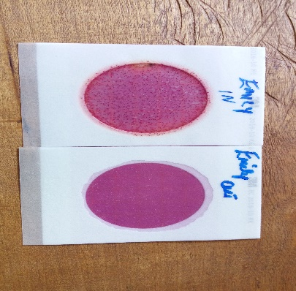
Household Name – Emily Chemutai
Filter Number - HF15P-419
Raw water quality (IN) – Too Numerous to count (TNTC)
Filtered water quality (OUT)– 0 cfu

BSF Filter:

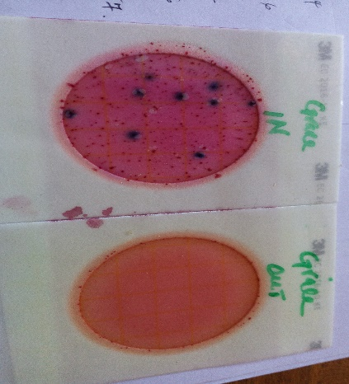
Household Name: Grace Buchaberi
Filter Number - B15-127
Raw water quality (IN) – 9cfu
Filtered water quality (OUT)– 0 cfu

D.3. Implementation of sampling plan
>>
- Description of Implemented Sampling Design

As outline in the PDD, Simple Random Sampling method was used to determine the random test subjects from the total sales record. The total sales record outlined the counties in the project boundary with the operational BioSand Filters and household hollow fibre filters which are the only project technologies monitored during this monitoring exercise.

Sample Size Determination:
A total of 231 households for the Bio Sand Filters and 40 households for the household HHFF were initially selected for this monitoring period.

The following method was used to determine the 231 sampling units for BSF and the 40 HHF sampling units.

- A list of the geographical regions in the total sales record and the total number of filters sold in these regions was determined.
- Cumulative sum of all the BSF filters Household HHFF filters sold was determined which summed to 3389 BSF Filters and 316 HHFF installed in households.
- A sample size of 231 BSF and 40 Household HFF was determined as illustrated above.
- The total number of filters sold in the respective age groups was then divided by the sample size chosen for that particular age group. This result determined the Sample Interval.
- A random number was determined between 1 and the Sample Interval was which gave the Random Start.
- Sample units were then determined as
- SU1=RS
- SU2=RS+S1
- SUN=RS+(n-1)SI

- The identified sample units were then identified with corresponding household in the Total Sales Record which provided the name of the household and the details of the location of the household.

However, the sample size utilized for analysis of this monitoring period for BSF has increased from 231 to 308 and that of HFF has increased from 40 to 46. This is because approximately 77 households were substituted in the BSF sample frame and 6 households in the HHFF sample frame (based on random selection) due to unavailability of the intended households during the monitoring exercise. Instead of discounting the 77 and 6 households replaced as non-users, from the BSF and HHFF sample frames respectively, the PP made follow-up calls to these households to ascertain that the household still resides in the project boundary and utilizes the filter. The feedback obtained was 11 of these households using BSF filters and one household using the HHFF maintained they are still using the filters and reside within the project boundary. However, 66 households in the original BSF sample frame and 5 households in the original HHFF sample frame could still not be traced. The PP can therefore not ascertain whether these filters from the original 231 households are users or non-users. The PP has opted to discount these households as not applicable due to their availability. Counting them as non-users automatically would be as inaccurate as automatically counting them as users. Therefore, these households that cannot be traced have not been included in the final sample frame. The sample size and calculations have been provided as supporting documentation.

The Total sales record provided as a supporting document gives the total sample size per vintage year with the additional households.

Procedures for Administering Data Collection and Minimising Non Sampling Errors

- Procedures for Data Collection

The Carbon Asset Development Consultant, Viability Africa, conducted trained the enumerators on the monitoring questionnaire administration and the water filed testing protocol. A key emphasis was given on the usage survey where enumerators were supposed to have observational units with the household members and also conduct spot checks on the project technologies. The enumerators were also informed, where household members present were children under the age of 12 years, a revisit was to be done to interview older respondent and if none was available at all, the survey was treated as nonapplicable.
- Data Collected

- The data collected from the field exercise included the following information:
- Basic Information of the Household
- Usage survey information
- Sustainable Development Indicators
- Water Consumption Field Test
- Water Quality Results

The enumerators submitted the questionnaires from the field in hard copies to the project proponent. They were also supposed to collect water samples from the household, store them in unique transportation bags and collect them at the field lab within a period of 6 hours to ensure qualitative results.
The project Proponent, ACF, conducted the water quality testing using the water samples collected by the enumerators. They then filled in the results in the appropriate section in the monitoring survey.
The monitoring surveys were then submitted to Viability Africa in hard copies and then stored electronically. A summary of the data collected has been submitted as an appendix to this monitoring report.

Quality Control/Quality Assurance

To ensure quality control and quality assurance, the following was implemented;

- Viability Africa, the carbon asset development consultant conducted random in house checks on the survey team to ensure adherence to the set protocol in interviewing the project technologies end users and conducting the water quality tests.
- Data entry and evaluation was conducted by Viability Africa within 24 hours of sample exercise collection
- Data was controlled and Managed solely by Viability Africa to avoid erroneous entries.
- The water quality tests were conducted at controlled lab tests to avoid contamination and ensure consistency of results. Every survey team member collected the sample water sachets in every household, stored them in unique transportation bags and collected them at the lab test within a period of 6 hours to ensure qualitative results.

Data Analysis

Data was analysed solely by the Carbon Asset development consultant Viability Africa LLC. Data analysis is presented in the second tab of the summary data.

SECTION E. Calculation of emission reductions or GHG removals by sinks

E.1. Calculation of baseline emissions or baseline net GHG removals by sinks
>> Baseline Emissions are calculated as follows:

In accordance to Gold Standard requirements on Global warming potentials for project activities, all monitoring, verifications and requests for issuance from Gold Standard Certified Emission Reductions (GS CERs) and GS VERs that fall within the second commitment period (form 1stJinuary 2013) will be calculated using the revised GWPs. Projects emission reductions accrued before 1st January 2013 will use the former GWP values.

Consequently, the PP has divided the monitoring period from 28th Dec 2011 to 31st December 2012 to use GWP values from the IPCC’s 2nd Assessment Report for CH4 and N2O. From 1st January 2013 henceforth, the PP has employed the revised values for the GWP for CH4 and N20.

Fuel used to Treat water Bby

BSF Filters:
Bb,y = (1 - Cj) * Nj,y * Wb,y * ( Qj,y + Q j,rawboil,y )

Where:
Nj,y Number of person.days consuming water supplied by project scenario p through year y
Cj Expressed as a percentage, this is the portion of users of the project technology j who in the baseline were already consuming safe water without boiling it
Bb,y Quantity of fuel consumed in baseline scenario b during the year y in tons
Qp,y Quantity of safe water in litres consumed in the project scenario p and supplied by project technology per person per day
Qp, raw,boil,y Quantity of raw water boiled in the project scenario p per person per day
Wb,y Quantity of fuel in tons required to treat 1 litre of water using technologies representative of baseline scenario b during project year y, as per Baseline Water Boiling Test.
Therefore;

Nj,y= 5.42*365=1978
Cj= 18%
Wby= 0.000549
Qp,y= 6.78
Qp, rawboil,y=0

Bb, y is therefore calculated as:

= (1-0.18)*1978*0.000549*(6.78+0)
=6.053 tonnes

HHFF Filters:

Bb,y = (1 - Cj) * Nj,y * Wb,y * ( Qj,y + Q j,rawboil,y )

Where:
Nj,y Number of person.days consuming water supplied by project scenario p through year y
Cj Expressed as a percentage, this is the portion of users of the project technology j who in the baseline were already consuming safe water without boiling it
Bb,y Quantity of fuel consumed in baseline scenario b during the year y in tons
Qp,y Quantity of safe water in litres consumed in the project scenario p and supplied by project technology per person per day
Qp, raw,boil,y Quantity of raw water boiled in the project scenario p per person per day
Wb,y Quantity of fuel in tons required to treat 1 litre of water using technologies representative of baseline scenario b during project year y, as per Baseline Water Boiling Test.
Therefore;

Nj,y= 7*365=2555
Cj= 18%
Wby= 0.000549
Qp,y= 2.44
Qp, rawboil,y=0

Bb, y is therefore calculated as:

= (1-0.18)*2555*0.000549*(2.44+0)
=2.81 tonnes

Baseline Emissions BSF filters:

Vintage Year 2014
BEy= Bby*(fNRB,b,y* EFb,fuel,CO2)+( EFb,fuel,CH4+ Efb,fuel,N2O)* NCV bfuel

fNRB, b, y=0.92
EFb, fuel, CO2=112
EFb, fuel, CH4=7.5(0.3*25)
Efb, fuel, N2O=1.192 (0.004*298)
NCVb, fuel=0.015

=10.144 tCO₂e (per filter, per year)

Vintage Year 2015
BEy= Bby*(fNRB,b,y* EFb,fuel,CO2)+( EFb,fuel,CH4+ Efb,fuel,N2O)* NCV bfuel

fNRB, b, y=0.92
EFb, fuel, CO2=112
EFb, fuel, CH4=7.5(0.3*25)
Efb, fuel, N2O=1.192 (0.004*298)
NCVb, fuel=0.015

=10.1446 tCO₂e (per filter, per year)

Vintage Year 2016:
BEy= Bby*(fNRB,b,y* EFb,fuel,CO2)+( EFb,fuel,CH4+ Efb,fuel,N2O)* NCV bfuel

fNRB, b, y=0.92
EFb, fuel, CO2=112
EFb, fuel, CH4=7.5(0.3*25)
Efb, fuel, N2O=1.192 (0.004*298)
NCVb, fuel=0.015

=10.1446 tCO₂e (per filter, per year)

Baseline Emissions HHFF filters:

Vintage Year 2014
BEy= Bby*(fNRB,b,y* EFb,fuel,CO2)+( EFb,fuel,CH4+ Efb,fuel,N2O)* NCV bfuel

fNRB, b, y=0.92
EFb, fuel, CO2=112
EFb, fuel, CH4=7.5(0.3*25)
Efb, fuel, N2O=1.192 (0.004*298)
NCVb, fuel=0.015

=4.704 tCO₂e (per filter, per year)

Vintage Year 2015
BEy= Bby*(fNRB,b,y* EFb,fuel,CO2)+( EFb,fuel,CH4+ Efb,fuel,N2O)* NCV bfuel

fNRB, b, y=0.92
EFb, fuel, CO2=112
EFb, fuel, CH4=7.5(0.3*25)
Efb, fuel, N2O=1.192 (0.004*298)
NCVb, fuel=0.015

=4.704 tCO₂e (per filter, per year)

Vintage Year 2016:
BEy= Bby*(fNRB,b,y* EFb,fuel,CO2)+( EFb,fuel,CH4+ Efb,fuel,N2O)* NCV bfuel

fNRB, b, y=0.92
EFb, fuel, CO2=112
EFb, fuel, CH4=7.5(0.3*25)
Efb, fuel, N2O=1.192 (0.004*298)
NCVb, fuel=0.015

=4.704 tCO₂e (per filter, per year)

E.2. Calculation of project emissions or actual net GHG removals by sinks
>>Project Emissions are calculated as follows:

Where:
Np, y Number of person.days consuming water supplied by project scenario p through year y
Cj Expressed as a percentage, this is the portion of users of the project technology j or who in the baseline were already consuming safe water without boiling it
Bp, y Quantity of fuel consumed in project scenario p during the year y in tons
Qp, rawboil, y Quantity of raw water boiled in the project scenario p per person per day
Qp, cleanboil,y Quantity of safe water boiled in the project scenario p per person per day
Wp,y Quantity of wood fuel or fossil fuel in tons required to treat 1 litre of water using technologies representative of the project scenario p during project year y

Therefore;

Project Scenario Fuel Consumption BSF Filters:

Nj, y= 5.42 *365=1978
Cj= 18%
Wby= 0.000549
Qp, clean boil, y= 0
Qp, rawboil, y=0

Bp,y is therefore calculated as:

= (1-0.18)*1978*0.000549*(0+0)
=0 tonnes

Project Scenario Fuel Consumption HHFF Filters:
Nj, y= 7*365=2555
Cj= 18%
Wby= 0.000549
Qp, clean boil, y= 0.2366
Qp, rawboil, y=0
Bp, y is therefore calculated as:

= (1-0.18) *2555*0.000549*(0+0.2366)
= 0.2721 tonnes

Project Emissions BSF Filters:

Vintage Year 2014

PE,y= Bp,y*(fNRB,b,y*EFb,fuel,CO2)+(EFb,fuel,CH4+Efb,fuel,N2O)*NCVbfuel

fNRB, b,y=0.92
EFb, fuel,CO2=112
EFb, fuel, CH4=7.5(0.3*25)
Efb, fuel, N2O=1.192 (0.004*298)
NCVbfuel=0.015

=0 tCO₂e (per filter, per year)

Vintage Year 2015

PE,y= Bp,y*(fNRB,b,y*EFb,fuel,CO2)+(EFb,fuel,CH4+Efb,fuel,N2O)*NCVbfuel

fNRB, b,y=0.92
EFb, fuel,CO2=112
EFb, fuel, CH4=7.5(0.3*25)
Efb, fuel, N2O=1.192 (0.004*298)
NCVbfuel=0.015

=0 tCO₂e (per filter, per year)

Vintage Year 2016

PE,y= Bp,y*(fNRB,b,y*EFb,fuel,CO2)+(EFb,fuel,CH4+Efb,fuel,N2O)*NCVbfuel

fNRB, b,y=0.92
EFb, fuel,CO2=112
EFb, fuel, CH4=7.5(0.3*25)
Efb, fuel, N2O=1.192 (0.004*298)
NCVbfuel=0.015

=0 tCO₂e (per filter, per year)

Project Emissions HHFF:

Vintage Year 2014

PE,y= Bp,y*(fNRB,b,y*EFb,fuel,CO2)+(EFb,fuel,CH4+Efb,fuel,N2O)*NCVbfuel

fNRB, b,y=0.92
EFb, fuel,CO2=112
EFb, fuel, CH4=7.5(0.3*25)
Efb, fuel, N2O=1.192 (0.004*298)
NCVbfuel=0.015

= 0.4560tCO₂e (per filter, per year)

Vintage Year 2015

PE,y= Bp,y*(fNRB,b,y*EFb,fuel,CO2)+(EFb,fuel,CH4+Efb,fuel,N2O)*NCVbfuel

fNRB, b,y=0.92
EFb, fuel,CO2=112
EFb, fuel, CH4=7.5(0.3*25)
Efb, fuel, N2O=1.192 (0.004*298)
NCVbfuel=0.015

= 0.4560tCO₂e (per filter, per year)

Vintage Year 2016

PE,y= Bp,y*(fNRB,b,y*EFb,fuel,CO2)+(EFb,fuel,CH4+Efb,fuel,N2O)*NCVbfuel

fNRB, b,y=0.92
EFb, fuel,CO2=112
EFb, fuel, CH4=7.5(0.3*25)
Efb, fuel, N2O=1.192 (0.004*298)
NCVbfuel=0.015

= 0.456 tCO₂e (per filter, per year)

E.3. Calculation of leakage
>>Leakage = 0
As demonstrated in section B.6.3 of the PDD as well as this monitoring report, there are no perceived leakage risks for this parameter

E.4. Summary of calculation of emission reductions or net anthropogenic GHG removals by sinks

BSF Filters:

- Item | Baseline emissions or baseline net GHG removals by sinks  (t CO₂e)  (per filter, per year) | Project emissions or actual net GHG removals by sinks  (t CO₂e)  (per filter, per year) | Leakage  (t CO₂e)  (per filter, per year) | Emission reductions or net anthropogenic GHG removals by sinks  (t CO₂e)  (per filter, per year)
- Total | 10.1446 Tco2(Year 2014)  10.1446 Tco2 (Year 2015)  10.1446 Tco2 (Year 2016) | 0 Tco2 (Year 2014)  0 Tco2 (Year 2015)  0 Tco2 (Year 2016) | 0 | 6.82 Tco2 (Year 2014)  6.836 TCO2 (Year 2015)  6.91 TCO2 (Year 2016)

HHFF Filters:

- Item | Baseline emissions or baseline net GHG removals by sinks  (t CO₂e)  (per filter, per year) | Project emissions or actual net GHG removals by sinks  (t CO₂e)  (per filter, per year) | Leakage  (t CO₂e)  (per filter, per year) | Emission reductions or net anthropogenic GHG removals by sinks  (t CO₂e)  (per filter, per year)
- Total | 4.704 Tco2(Year 2014)  4.704 Tco2 (Year 2015)  4.704 Tco2 (Year 2016) | 0 Tco2 (Year 2014)  0 Tco2 (Year 2015)  0 Tco2 (Year 2016) | 0 | 3.0891 Tco2 (Year 2014)  3.039 TCO2 (Year 2015)  3.03 TCO2 (Year 2016)

Overall GHG were calculated as follows:

Usage Rate Calculation:

A total of 75 entries in the BSF sample frame and 13 entries for HHFF filters have been disqualified as non-users due to not meeting the requirements in the usage survey and secondly because filtered water in some cases did not meet the standard for safe drinking water. More specifically, 72 households using BSF units have been discounted for not meeting success rate in the usage survey and 3 households for not meeting safe water standards. The weighted Usage parameter has been calculated across the vintage years as shown below:

Step 1: The non-users and users per vintage in each sample frame was determined from the sample frame.
Step 2: The PP then determined the usage rate per vintage using the following calculation:
Upy vn = (Users /Total Filters in the sample in Vintage year 1)*100
This is done for all vintages
Step 3: The PP then determined the useable filters in each vintage in the Total sales record using the percentage usage rate per vintage.
Usable Filters vn = Usage rate in vintage * Total number of filters sold in that vintage year in the Total sales record.
Step 4: The weighted Usage parameter is achieved by:
= (Total Usable filters in all the vintages/Total filters sold in the project for the respective vintage years) *100

Where:
Vn = Vintage year N

Calculations:

:

BSF:

Vintage Year | Age Group | Number of Non-users | Samples per Vintage | Total Filters sold in the vintage year | usage rate | Usable Filters
July 2009-June 2010 | 7 | 14 | 35 | 400 | 0.6 | 240
July 2010 - June 2011 | 6 | 15 | 38 | 617 | 0.605263158 | 373.4473684
July 2011 - June 2012 | 5 | 10 | 35 | 1010 | 0.714285714 | 721.4285714
July 2012 - June 2013 | 4 | 8 | 36 | 790 | 0.777777778 | 614.4444444
July 2013 - June 2014 | 3 | 14 | 36 | 349 | 0.611111111 | 213.2777778
July 2014 - June 2015 | 2 | 9 | 35 | 115 | 0.742857143 | 85.42857143
July 2015 - June 2016 | 1 | 2 | 28 | 108 | 0.928571429 | 100.2857143
TOTAL |  | 72 | 243 | 3389 |  | 2348.312448

Installation |  | Age Group | Year 2011 | Year 2012 | Year 2013 | Year 2014 | Year 2015 | Year 2016
 |  | 7 | 617 | 1010 | 790 | 349 | 115 | 108
 |  | 6 | 400 | 617 | 1010 | 790 | 349 | 115
 |  | 5 |  | 400 | 617 | 1010 | 790 | 349
 |  | 4 |  |  | 400 | 617 | 1010 | 790
 |  | 3 |  |  |  | 400 | 617 | 1010
 |  | 2 |  |  |  |  | 400 | 617
 |  | 1 |  |  |  |  |  | 400
Total Filter Sales |  |  | 1017 | 2027 | 2817 | 3166 | 3281 | 3389
Weighted Avg Usage rate |  |  | 60.32% | 65.85% | 69.20% | 68.31% | 68.52% | 69.29%

HHFF:

Vintage Year | Age Group | Number of Non-users | Samples per Vintage | Total Filters sold in the vintage year | usage rate | Usable Filters
November 2013 - October 2014 | 3 | 6 | 22 | 110 | 0.727272727 | 80
November 2014 - October 2015 | 2 | 7 | 24 | 181 | 0.708333333 | 128.2083333
November 2015 - October 2016 | 1 | No sampling was done | No sampling was done | 25 | 0.708333333 | 17.70833333
TOTAL |  | 13 | 46 | 316 |  | 226.1534091

Installation |  | Age Group | Year 2014 | Year 2015 | Year 2016
 |  | 3 | 110 | 181 | 25
 |  | 2 |  | 110 | 181
 |  | 1 |  |  | 110
Total Filter Sales |  |  | 110 | 291 | 316
Weighted Avg Usage rate |  |  | 72.73% | 71.55% | 71.49%

The difference of the Baseline emissions and the project emissions is multiplied by the usage rate to get the Emission reductions per filter in each vintage year.

Summary of ERs Accrued in this monitoring period:

BSF Filters:

Period | Emission Reduction (tCO2e)
22/07/2014 – 31/12/2014 | 9755
1/1/2015-31/12/2015 | 22466
1/1/2016-18/2/2016 | 3144
Total | 35,365

HHFF:

Period | Emission Reduction (tCO2e)
22/07/2014 – 31/12/2014 | 138
1/1/2015-31/12/2015 | 725
1/1/2016-18/2/2016 | 125
Total | 988

E.5. Comparison of actual emission reductions or net anthropogenic GHG removals by sinks with estimates in registered PDD

BSF Filters:

Item | Values estimated in ex-ante calculation of registered PDD | Actual values achieved during this monitoring period
Emission reductions or GHG removals by sinks (t CO₂e) | 108,749.81 tCO2e | 35,365

HHFF:
Item | Values estimated in ex-ante calculation of registered PDD | Actual values achieved during this monitoring period
Emission reductions or GHG removals by sinks (t CO₂e) | 12,833 tCO2e | 988

E.6. Remarks on difference from estimated value in registered PDD
>> The values estimated in the ex-ante calculations were higher than the actual values achieved during this monitoring period. The reason for this difference in numbers is:

1. The annual filter sales estimated per annum in the ex-ante scenario were higher than the filter in the monitoring period. As a result, the emission reductions in the ex-ante projections were higher than the emission reductions in this monitoring period.

2. The usage rate was estimated to be 100% in the ex-ante, but because of various reasons, the usage rate was less than 100% as demonstrated in this monitoring report and monitoring survey summary.

3. The Cj Factor was determined in the ex-ante as 4% but in the post registration baseline studies in the year 2015 revealed a higher Cj factor of 18%.

E.7. Actual emission reductions or net anthropogenic GHG removals by sinks during the first commitment period and the period from 1 January 2013 onwards

BSF Filters:

- Item | Actual values achieved up to 31 December 2012 | Actual values achieved from 1 January 2013 onwards
Emission reductions or GHG removals by sinks (t CO₂e) | 0 tCO2e | 35,365 tCO2e
HHFF Filters:

- Item | Actual values achieved up to 31 December 2012 | Actual values achieved from 1 January 2013 onwards
Emission reductions or GHG removals by sinks (t CO₂e) | 0 tCO2e | 988 tCO2e

- - - - -
- Contact information of project participants and responsible persons/ entities
Project participant and/or responsible person/ entity | Project participant  Responsible person/ entity for completing the CDM-MR-FORM
Organization name | AquaClara Foundation
Street/P.O. Box | Howard Avenue
Building | Michigan State University Bioeconomy Institute
City | Holland
State/Region | Michigan
Postcode | 49424
Country | United States of America
Telephone | + 1 616 540 4094
Fax | + 1 616 774 8017
E-mail | hsknopke@sbcglobal.net
Website | http://aquaclara.org/
Contact person
Title | President
Salutation | Dr. (Ph.D.)
Last name | Knopke
Middle name | J
First name | Harry
Department | Management
Mobile | -
Direct fax | -
Direct tel. | + 1 616 540 4094

Document information
Version | Date | Description
04.0 | 25 June 2014 | Revisions to:  - Include the Attachment: Instructions for filling out the monitoring report form (these instructions supersede the "Guideline: Completing the monitoring report form" (Version 04.0));  - Include provisions related to standardized baselines;  - Add contact information on a responsible person(s)/ entity(ies) for completing the CDM-MR-FORM in A.6 and Appendix 1;  - Change the reference number from F-CDM-MR to CDM-MR-FORM;  - Editorial improvement.
03.2 | 5 November 2013 | Editorial revision to correct table in page 1.
03.1 | 2 January 2013 | Editorial revision to correct table in section E.5.
03.0 | 3 December 2012 | Revision required to introduce a provision on reporting actual emission reductions or net anthropogenic GHG removals by sinks for the period up to 31 December 2012 and the period from 1 January 2013 onwards (EB70, Annex 11).
02.0 | 13 March 2012 | Revision required to ensure consistency with the "Guidelines for completing the monitoring report form" (EB 66, Annex 20).
01 | 28 May 2010 | EB 54, Annex 34. Initial adoption.
Decision Class: Regulatory
Document Type: Form
Business Function: Issuance
Keywords: monitoring report

http://www.cawst.org/resources/biosand-filter
http://www.who.int/water_sanitation_health/diseases/WSH03.02.pdf
CDM Gold Standard: http://www.cdmgoldstandard.org/wp-content/uploads/2011/10/GS_110411_TPDDTEC_Methodology.pdf
http://www.cdmgoldstandard.org/wp-content/uploads/2012/06/GSv2.2_Toolkit.pdf
http://www.goldstandard.org/wp-content/uploads/2011/09/Rule-Update-Guidelines-for-carrying-out-water-usage-surveys.pdf
Bio-filtration as an Air Pollution Control Technology for the Removal of Volatile Organic Compounds: http://www.scribd.com/doc/49833275/Biofiltration-as-an-Air-Pollution-Control-Technology-for-the-Removal-of
Page 22 of the referenced methodology
http://www.who.int/water_sanitation_health/resourcesquality/wqmchap6.pdf
2006 Guidelines, Vol. 2, Ch. 2, Table 2.5
2006 Guidelines, Vol. 2, Ch. 2, Table 2.5
2006 Guidelines, Vol. 2, Ch. 2, Table 2.9
http://www.ipcc.ch/publications_and_data/ar4/wg1/en/ch2s2-10-2.html
http://www.ipcc.ch/publications_and_data/ar4/wg1/en/ch2s2-10-2.html
GS 1078_Sample Frame_Nov2016
GS 1078_HFF Sample Frame_Nov2016
http://www.rdic.org/CAWST-Intro-to-Drinking-Water-Quality-Testing.pdf
http://mirror.unhabitat.org/pmss/getElectronicVersion.aspx?nr=3056&alt=1
http://vimeo.com/28951486
http://www.goldstandard.org/wp-content/uploads/2011/09/Global-Warming-Potentials-for-Gold-Standard-Project-Activities-2013.pdf

