Monitoring Report

PUBLICATION DATE 14.10.2020
VERSION v. 1.1
RELATED SUPPORT - TEMPLATE GUIDE Monitoring Report v. 1.1

This document contains the following Sections
Key Project Information
SECTION A - Description of project
SECTION B - Implementation of project
SECTION C - Description of monitoring system applied by the project
SECTION D - Data and parameters
SECTION E - Calculation of SDG Impacts
SECTION F - Safeguards Reporting
SECTION G - Stakeholder inputs and legal disputes

KEY PROJECT INFORMATION

Key Project Information
GS ID (s) of Project (s) | GS 634
Title of the project (s) covered by monitoring report | AY-YILDIZ 15 MW WPP
Version number of the PDD/VPA-DD (s) applicable to this monitoring report | 12
Version number of the monitoring report | 05
Completion date of the monitoring report | 07/11/2022
Date of project design certification | 05/07/2010
Date of Last Annual Report | -
Monitoring period number | 05
Duration of this monitoring period | 12/04/2019 to 11/04/2022 (inclusive of both dates)
Project Representative | Akenerji Elektrik Üretim A.Ş.
Host Country | Turkey
Activity Requirements applied | Community Services Activities  Renewable Energy Activities  Land Use and Forestry Activities/Risks & Capacities  N/A
Methodology (ies) applied and version number | ACM0002 - “Grid connected electricity generation from renewable sources” – Version 17.0
Product Requirements applied | GHG Emissions Reduction & Sequestration  Renewable Energy Label  N/A

Table 1 - Sustainable Development Contributions Achieved
Sustainable Development Goals Targeted | SDG Impact | Amount Achieved | Units/ Products
SDG 7- Ensure access to affordable, reliable, sustainable and modern energy for all | MWh of renewable energy generated | 250,817.01 | MWh
SDG 8- Promote sustained, inclusive and sustainable economic growth, full and productive employment and descent work for all | Number of Trainings and employment generated through project | 32 Training & 15 employments generated | Number
SDG 13- Take urgent action to combat climate change and its impacts | Emission reductions | 142,695 | tCO₂e- GSVER’s

Table 2 – Product Vintages
Start Dates | End Dates | SDG 7 | SDG8 | SDG13
12/04/2019 | 31/12/2019 | 55,483.00  MWh | 23 Training & 15 employments generated | 31,565  tCO₂e
01/01/2020 | 31/12/2020 | 88,982.10 MWh | 6 Training & 15 employments generated | 50,624 tCO₂e
01/01/2021 | 31/12/2021 | 84,477.195 MWh | 3 Training & 15 employments generated | 48,061 tCO₂e
01/01/2022 | 11/04/2022 | 21,874.71 MWh | 0 Training & 15 employments generated | 12,445 tCO₂e

SECTION A. DESCRIPTION OF PROJECT

A.1. General description of project

The Ay-Yıldız Wind Power Project is located within the boundaries of Bandırma District of Balıkesir province of Turkey. Project has been commissioned in 01/09/2009 with 5 turbines, each having 3 MWe capacity and 15MWe total installed capacity. In 20/01/2017, request for upgrading installed capacity to 28.2 MW has been approved by Ministry of Energy and Natural Resources (#EÜ/973-2/739) and extended part was commissioned in 27/01/2017. Thus, addition of four new turbine each having 3.3MW capacity has been approved and permission for increasing total installed capacity to 28.2 MWe has been granted. Construction of the new turbines has started in 2016 and commissioning of new turbines has been approved in January 2017. In final layout of the project, total number of turbine installed has been 9 turbines (5×3MWe+4×3.3MWe) with total installed capacity of 28.2 MWm/MWe. Total expected generation has increased from 51.32 GWh to 98.7 GWh after extension. With this extension, expected total emission reduction has increased from 30,997 tCO₂e to 56,176 tCO₂e. Project areas has been rented from Bandırma Municipality for 30 years via the agreement dated 29/04/2016. The land is grassland owned by Municipality and total area of the land is 6,320,357.09 m², out of which around 100,830 m² has been allocated to the project which corresponds to total boundary of the turbine. Actual land use is limited to turbine basements and access roads for new turbines and thus remaining land is accessible by locals for grazing activities.

Specific goals of the Ay-Yıldız Wind Power Project include followings:
- Utilization of the wind potential of Turkey in order to meet increasing electricity demand and guarantee the energy security.
- Increase share of WPPs in electricity generation mix of Turkey and reduction of GHG emissions.
- Contribute to the national economic development by creating direct and indirect job opportunities during construction and operation phases.
- Reduce import dependency of fossil fuel dominated electricity sector and diversify generation mix through use of local resources.
- Enabling and promoting agricultural activity in the region through newly built irrigation channels and thus contributing to economic development both locally and nationwide.
In terms of sustainable development project not only contributes to emission reduction through use of renewable resources, but also creates new job opportunities and contributes to local economy through supply of equipment and needs from the region. This is also in compliance with the Government Policy and MDG goals of Turkey and contributes to reducing poverty and providing better conditions for local people. Assessment of project activities in terms of sustainable development has been carried out according to GS Transition Annex and PDD. In terms of environmental impact, project is considered to have positive impact on air quality due to avoided NOx, PM and SOx emissions whereas no negative impact on water quality other pollutants and biodiversity has been identified.

Moreover, in first verification, a FAR has been opened for interference with radar signals. For project, a site visit has been conducted by military experts as stated during previous verification. During previous monitoring period, no progress or change has occurred about this issue. However, written permission and approval of General Staff was taken during the current monitoring period.

Relevant Dates for the Project Activity

Table 1. Ay-Yıldız Project Milestones

Date | Milestone
09/11/2006 | License Issuance
10/06/2008 | Carbon Certification Agreement
23/10/2008 | License Amendment
05/11/2008 | Equipment Purchase Contract
01/03/2009 | Start of Construction
19/09/2008 | LSC Meeting
01/09/2009 | Commissioning Date/Start of 1st Crediting Period
23/01/2017 | Ministry approval for capacity extension
20/01/2017 | License Issuance for capacity extension
27/01/2017 | Commissioning of extension part
31/08/2016 | End date of 1st crediting period
23/11/2017 | Start date of 2nd crediting period
22/11/2024 | End date of 2nd crediting period

Total emission reductions achieved in this monitoring period are 142,695 tCO₂e.

A.2. Location of project

Ay-Yıldız Wind Power Plant Project is located at Ayyıldız Hill near the town of Bandırma in the province of Balıkesir.

Table 2. Turbine Coordinates
Turbine No. | E | N
T1 | 574.923 | 4.467.686
T2 | 575.171 | 4.467.514
T3 | 575.482 | 4.468.079
T4 | 575.774 | 4.467.996
T5 | 576.023 | 4.467.825
T6 | 574.655 | 4.467.279
T7 | 575.542 | 4.468.554
T8 | 576.049 | 4.468.376
T9 | 576.361 | 4.468.359

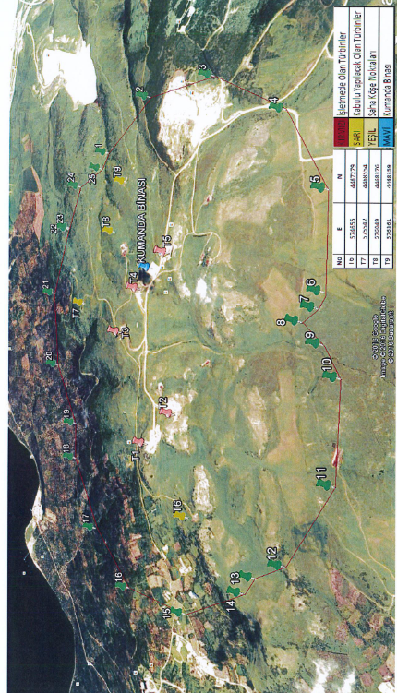
Figure 1. Project Location

A.3. Reference of applied methodology

The United Nations approved consolidated baseline methodology applicable to this project is ACM0002 “Consolidated methodology for grid-connected electricity generation from renewable sources”, Version 17.0. ACM0002 refers to the following tools:
- “Tool for the demonstration and assessment of additionality”, Version 7, and
- ‘‘Tool to calculate the emission factor for an electricity system’’, Version 6
- “Assessment of the validity of the original/current baseline and update of the baseline at the renewal of the crediting period”, Version 03.0.1

A.4. Crediting period of project

Project uses renewable crediting period. Crediting period of the project is 7 years between 01/09/2009 and 31/08/2016 (1st crediting period) and 23/11/2017 to
22/11/2024 (2nd crediting period). This is the fifth monitoring period in general meanwhile it is the first monitoring period of second crediting period.

SECTION B. IMPLEMENTATION OF PROJECT

B.1. Description of implemented project

Akenerji Elektrik Üretimi A.Ş., has installed and commissioned a 15 MW wind power plant with 5 Vestas make V90 wind turbines, each having a capacity of 3.0 MW. Subsequently beyond the first crediting period 4 Vestas make V112 wind turbines, each having a capacity of 3.3 MW, have also been commissioned. The project is located at Ayyıldız Hill near the town of Bandırma, Balıkesir Province, in Turkey (hereafter referred as “Ayyıldız WPP”). The purpose of the project is to generate electricity and to feed it into the Turkish national grid. This has been checked during the on-site visit. The first crediting period start date of the project is 01/09/2009, corresponding to the commissioning of the first set of turbines with choice of renewable crediting period.

Table 3. Technical Details of Wind Turbines

 | Turbine Type
 | Vestas V90/3000kW | Vestas V112/3300kW
Rotor
Diameter | 90 m | 112 m
Swept Area | 6362 m² | 9852 m²
Speed, Dynamic Operation Range | 8.6 – 18.4 | 6.2-17.7
Number of Blades | 3 | 3
Tower
Hub Height | 80 m/105 m | 84 m/94 m
Operational Data
Cut-in Wind Speed | 4m/s | 3 m/s
Nominal Wind Speed | 15 m/s | 15 m/s
Cut-out Wind Speed | 25 m/s | 25 m/s
Generator
Type Description | Double fed asynchronous with wound rotor and slip rings | Asynchronous with cage rotor
Rated Power | 3.0 MW | 3500 kW
Frequency | 50 Hz | 0-100 Hz

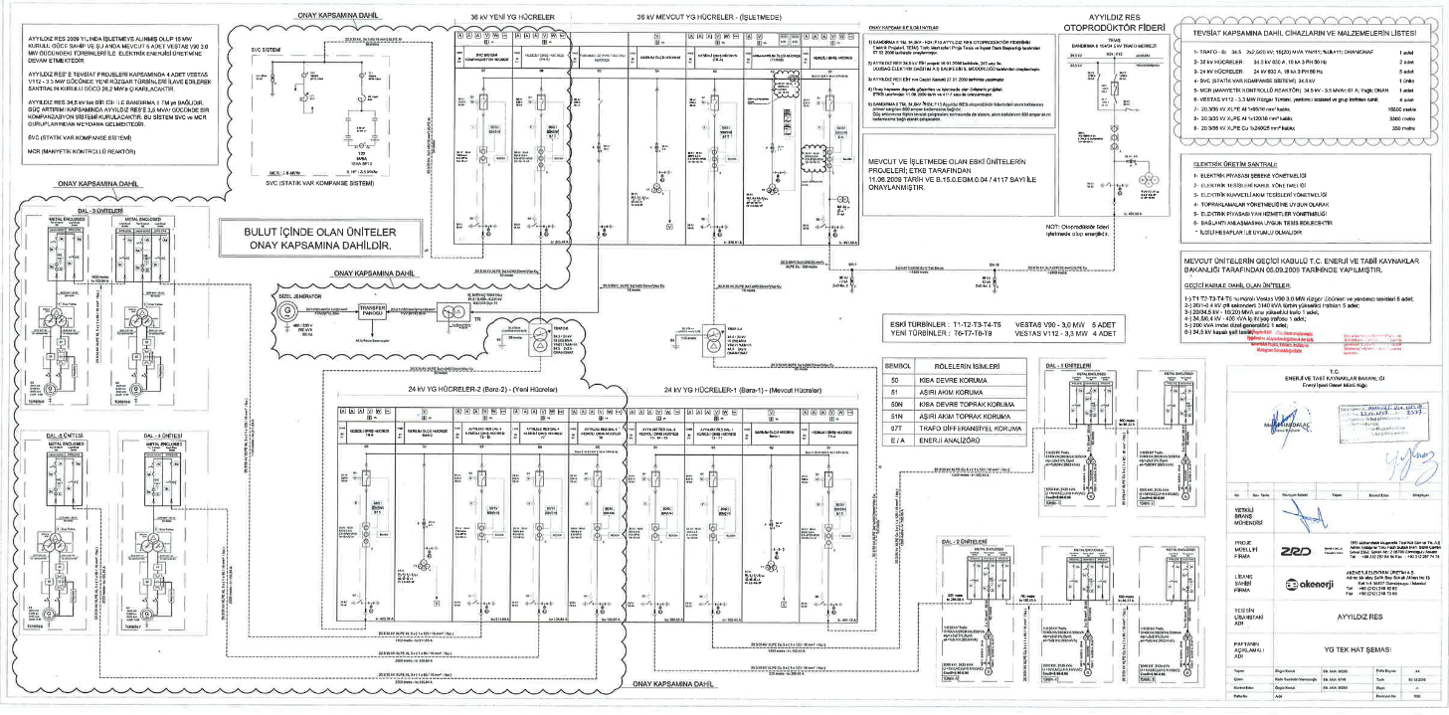
Figure 2. Single Line Diagram of Project

B.1.1 Forward Action Requests

Forward Action Request # 1: Verifying DOE to clarify the monitoring equipment of the project activity with respect to the registered electricity meter specifications and the locations.
Response: Since the installed capacity of the power plant was increased, current transformers were changed and the main counter was replaced with a spare counter. The main counter has become a spare counter and its internal multiplier has been changed and continues from the indexes on it. These comments can be seen from the attached meter change report officially created by Uludağ Elektrik Dağıtım A.Ş. on 04.11.2016 under the "Explanations" section."

B.2. Post-Design Certification changes

Not applicable.

B.2.1. Temporary deviations from the approved Monitoring & Reporting Plan, methodology or standardized baseline

During the current monitoring period, a gap has been identified from (23/11/2017 to 10/04/2019) between the two Monitoring periods, due to delay in subsequent site visits by the VVB’s for more than 3 years from the previous site visit date, thus as a non-force measure, the project owner has considered a monitoring period of 3 years back from the present site visit date, accordingly the VVB has selected the option to verify a period of maximum 3 years prior to current site visit date. Further as a result of above deviation, the SDG impacts during the current monitoring period are not overestimated and a conservative approach has been followed.

B.2.2. Corrections

Not applicable.

B.2.3. Changes to start date of crediting period

Not applicable.

B.2.4. Permanent changes from the Design Certified monitoring plan, applied methodology or applied standardized baseline

Not applicable.

B.2.5. Changes to project design of approved project
The project underwent a design change wherein inclusion of four new turbines which had resulted in capacity increase of the project to 28.2 MW which had been approved by GS in 2017.

SECTION C. DESCRIPTION OF MONITORING SYSTEM APPLIED BY THE PROJECT

Monitoring is a key procedure to verify the real and measurable emission reductions from the project activity. To guarantee the project′s real, measurable and long-term GHG emission reductions, the monitoring plan is established.
In order to demonstrate the emission reduction, the only required data is the net electricity delivered to the grid by the project activity and internal combustion for the auxiliary diesel generator. Data for the carbon content of the diesel fuel has been calculated from Türkiye Elektrik İletim A.Ş. (TEIAS) web page.
Net electricity generation has been measured and recorded by both TEIAS. Generation data collected during crediting period has been submitted to EKI Energy Services Ltd. which is be responsible for calculating the emission reduction subject to verification.
The monitoring system organization chart is shown in Figure below, in which the authority and responsibility of project management are defined.

Team Members include;

Plant Manager: Overall responsibility of compliance with monitoring plan
Electrical Engineer: Responsible for day to day running of plant, recording and monitoring of relevant data and periodic reporting
Accounting Manager: Responsible for keeping data about power sales, invoicing and purchasing.
EKI Energy Services Ltd.: Responsible for emission reduction calculations, preparing monitoring report and periodical verification process.
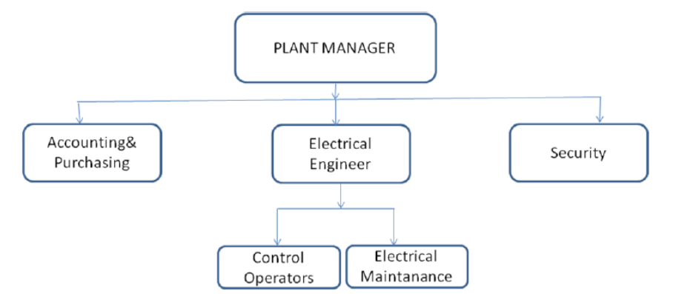

Figure 3. Operational structure of Ay-Yıldız WPP

Installation of meter and data monitoring has been carried out according to the regulations by TEIAS. Two metering devices (one of them used as spare) have been used for monitoring the electricity generated by the power plant. Data from metering devices are being recorded by TEIAS monthly and form the basis for invoicing. In addition to the two metering devices, generation of the Ay-Yıldız WPP has been cross checked from TEIAS – PMUM web site(http://pmum.teias.gov.tr) which is accessible using a password provided to electricity generation companies.

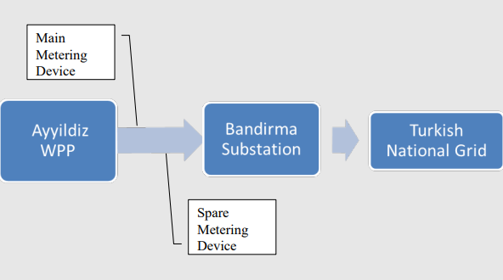
Figure 4. Electricity Generation Monitoring & Transmission Plan

The net electricity fed to the grid is measured continuously and recorded monthly by the TEIAS and plant staff. For consistency, recorded data has been compared with PMUM records and the most conservative data set has been used for emission reduction calculations. Calibration of the metering devices having meter serial numbers as 53064316 (main meter) & 53064340 (backup meter) has been made by TEIAS and sealed during first operation of the plant. However, the previous set of meters had been replaced with new ones by TEIAS which have remote reading feature on 28/12/2015 and later 04/11/2016. Also, the metering devices are kept in sealed glass containers, which prevent outside interventions apart from TEIAS. Details regarding meters and meter changes can followed from the table below.

Table 4. Meter Details
Date of Change (Meter Installation Date) | Meter ID | Serial Number | Accuracy | Factory Calibration Date | Calibration Entity
Initial Meters | Main  (ACTERIS SL700) | 53064316 | 0.5S | 07/10/2010 | TEIAS
Initial Meters | Back-Up  (ACTERIS SL700) | 53064340 | 0.5S | 07/10/2010 | TEIAS
28/12/2015 | Main (LANDIS+Gyr E550) | 51222783 | 0.5S | 10/08/2015 | TEIAS
28/12/2015 | Back-Up (ACTERIS SL700) | 53064340 | 0.5S | 07/10/2010 | TEIAS
04/11/2016 | Main (LANDIS+Gyr E650) | 51255642 | 0.2S | 10/08/2015 | TEIAS
04/11/2016 | Back-Up (LANDIS+Gyr E550) | 51222783 | 0.5S | 10/08/2015 | TEIAS

Currently, Main (LANDIS+Gyr E650-51255642) and Back-Up (LANDIS+Gyr E550-51222783) are installed in the plant. They have been installed on 04/11/2016 and their factory calibration date is 10/08/2015, which has 10 years validity until 09/08/2025. The detail of meters in use during current monitoring period can be found in Appendix-1.

SECTION D. DATA AND PARAMETERS

D.1. Data and parameters fixed ex ante or at renewal of crediting period

Relevant SDG Indicator | SDG 7.2.1 Renewable energy share in the total final energy consumption
Data/Parameter | EG_{y}
Unit | MWh
Description | Net Electricity delivered to the grid by the Ay-Yıldız WPP in year y
Source of Data | For gross generation, imported values, internal consumption and net generation which not including low-cost/must run power plants in year y followed documents are used which can be checked via shared link:  https://www.teias.gov.tr/  “Türkiye Brüt Elektrik Enerjisi Üretiminin Üretici Kuruluşlar ve Birincil Enerji Kaynaklarına göre Yıllar İtibariyle Gelişimi (2006-2015)”  “Türkiye Elektrik Enerjisinin Üretim-İthalat-İhracat ve Brüt Talebinin Yıllar İtibariyle Aylık Dağılımı (2003-2015)”  “Türkiye Elektrik Enerjisi Üretim Tüketim ve Kayıplarının Yıllar İtibariyle Gelişimi (1993-2015)”
Value(s)applied | For 2013: 171,166,713  For 2014: 198,349,070  For 2015: 178,430,451  547,946,234 MWh net electricity generation between 2013-2015
Choice of data or Measurement methods and procedures | Data from Grid Operator has been used
Purpose of data | Calculation of baseline emissions or baseline net GHG removals by sinks
Additional comment | -

Relevant SDG Indicator | 13.3.2 Number of countries that have communicated the strengthening of institutional, systemic and individual capacity-building to implement adaptation, mitigation and technology transfer, and development actions” and following target
Data/Parameter | EF _{CO2, i,y}
Unit | tCO₂/GJ
Description | CO₂ emission factor of fossil fuel type i in year y
Source of Data | For EF of fossil fuels, IPCC values at the lower limit have been used.
Value(s)applied
  FUEL SOURCE | (tCO₂/Tj)
  Coal | 89.5
  Lignite | 90.9
  Fuel Oil | 75.5
  Diesel | 72.6
  LPG | 61.6
  Naphtha | 69.3
  Natural Gas | 54.3
Choice of data or Measurement methods and procedures | TEIAS, the Turkish Electricity Transmission Company is the official source for the related data, thus providing the most up-to-date and accurate information available.
Purpose of data | Calculation of project emissions or actual net GHG removals by sinks
Additional comment | According to the applied tool, IPCC default values at lower limit of 95% confidence interval can be used. Although, the actual emission reduction is expected to be higher due to high EF of fuels consumed in existing power plants, IPCC values have been used for conservativeness as requested by the methodology.

Relevant SDG Indicator/Safeguarding Principle | SDG 7.2.1 Renewable energy share in the total final energy consumption
Data/Parameter | FC_{i,j,y}
Unit | Tons or 1000 m³ for gases
Description | Amount of fuels consumed by thermal power plants for electricity generation in terms of fossil fuel type i in year y
Source of Data | TEIAS Statistics
Value(s)applied
  Fuel Type | 2013 | 2014 | 2015 | Total 2013-2015
  Fuel Type | Ton or 1000 m³ (for gas)
  Hard Coal | 12,105,930 | 14,501,934 | 16,629,492 | 43,237,356
  Lignite | 47,120,306 | 57,696,139 | 49,940,131 | 154,756,576
  Fuel Oil | 573,534 | 754,283 | 516,912 | 1,844,729
  Diesel Oil | 129,359 | 119,988 | 238,388 | 487,735
  LPG | 0 | 0 | 0 | 0
  Naphtha | 0 | 0 | 0 | 0
  Natural Gas | 22,909,746 | 25,426,014 | 20,914,868 | 69,250,628
Choice of data or Measurement methods and procedures | Data from Grid Operator has been used
Purpose of data | Calculation of project emissions or actual net GHG removals by sinks
Additional comment | -

Relevant SDG Indicator/Safeguarding Principle | 13.3.2 Number of countries that have communicated the strengthening of institutional, systemic and individual capacity-building to implement adaptation, mitigation and technology transfer, and development actions” and following target
Data/Parameter | NCV _{i,y}
Unit | GJ/t or GJ/m³ (for gas)
Description | Net calorific value (energy content) of fossil fuel type i in year y
Source of Data | Own calculation based on data source from National Electricity Transmission Company (TEIAS) Statistics
Value(s)applied
  Fuel Type | NCV (GJ/t or GJ/m³ (for gas))
  Hard Coal | 23.95
  Lignite | 7.17
  Fuel Oil | 42.53
  Diesel Oil | 43.79
  LPG | 0
  Naphtha | 0
  Natural Gas | 37.48
Choice of data or Measurement methods and procedures | Data has been calculated from Grid Operator’s (TEIAS) statistics. The calculation is done by dividing heating values of the fuel type i consumed over its quantity. Heating value of fuel consumed: https://www.teias.gov.tr/  Türkiye Termik Santrallarında Kullanılan Yakıtların Isı Değerlerinin Üretici Kuruluşlara Dağılımı (2006-2015) Quantity of fuel consumed: https://www.teias.gov.tr/  Türkiye Termik Santrallarında Kullanılan Yakıt Miktarlarının Üretici Kuruluşlara Dağılımı (2006-2015)
Purpose of data | Data used for OM and BM calculation
Additional comment | -

D.2 Data and parameters monitored

Relevant SDG Indicator/Safeguarding Principle | SDG 7.2.1 Renewable energy share in the total final energy consumption
Data/Parameter | EG_{facility,y}
Unit | MWh
Description | Net Electricity generated and delivered to the grid by the project in year y
Source of Data | Metering devices used in power plants, monthly records signed by TEIAS and plants manager and invoices are used.
Value(s)applied | 250,817.01
Measurement methods and procedures | Generation data are being recorded continuously by two energy meters whose serial numbers are 51255642 (main meter) and 51222783 (auxiliary meter). These records provide the data for the monthly invoicing to TEIAS. Generation is being recorded via remote reading system. The quantity of electricity supplied by the project plant/unit to the grid (UEVM) and the quantity of electricity delivered to the project plant/unit from the grid (UECM) is being measured. Net generation is being calculated via subtracting energy delivered by the project activity to the grid and internal consumption by the project activity.
Monitoring frequency | Continuous measurement / Monthly recording
QA/QC Procedures | The calibration of the metering devices (located at the project site) had been made on 10/08/2015 and sealed by Başkent Elektrik Dağıtım A.Ş. The latest date of calibration of meters was 10/08/2015 and thus the validity of calibration will be for a period of 10 years, so until 09/08/2025. In case of significant difference between two devices, maintenance will be done before waiting for periodical maintenance according to regulations of TEIAS. No maintenance/calibration has been required during monitoring period. Meters used in the plant are of accuracy class of 0.2 s (main) and 0.5 s (spare) class. As per the regulations, meters should not require calibration before 10 years.
Purpose of data | Calculation of baseline emissions or baseline net GHG removals by sinks
Additional comment | -

Relevant SDG Indicator/Safeguarding Principles | 8.5.2. Unemployment rate, by sex, age and persons with disabilities
Data/Parameter | Number of employments
Unit | Number
Description | Number of people permanently working for the operation of the project
Source of Data | Social Security System (SGK)
Value(s)applied | 15
Measurement methods and procedures | Social Security System (SGK) records
Monitoring frequency | Once for each monitoring period
QA/QC Procedures | SGK records of employees are provided during each monitoring period.
Purpose of data | To monitor SDG 8 Contributions
Additional comment | -

Relevant SDG Indicator/Safeguarding Principle | 8.6.1 Proportion of youth (aged 15-24 years) not in education, employment or training
Data/Parameter | Number of trainings
Unit | Number
Description | Number of trainings sessions held
Source of Data | Training certificates or training attendance records
Value(s)applied | 32 training conducted
Measurement methods and procedures | Training certificates or training attendance records
Monitoring frequency | Once for each monitoring period
QA/QC Procedures | Training certificates or training attendance records are provided during each monitoring period.
Purpose of data | Monitoring the trainings to justify contribution to SDG 8.
Additional comment | -

Relevant SDG Indicator/Safeguarding Principles | 13.3.2. Number of countries that have communicated the strengthening of institutional, systemic and individual capacity-building to implement adaptation, mitigation and technology transfer, and development actions
Data/Parameter | ER_{y}
Unit | tCO₂e
Description | Emission reductions by the project activity in year y (t CO₂/yr). In accordance with ACM0002, baseline emissions include CO₂ from electricity generation in power plants that are displaced due to the project activity. And baseline emissions correspond to emission reductions and are calculated as the net electricity generated by the project activity, multiplied with combined margin CO₂ emission factor for grid connected power generation in year y.
Source of Data | Both measured and calculated Emission reductions are calculated as considering the EPIAS records for the net electricity generated and the emission factor for the grid, 0.5690 tCO₂/MWh, calculated using the TEIAS annual data.
Value(s)applied | 142,695
Measurement methods and procedures | Refer actual ER Sheet for the same
Monitoring frequency | Not Applicable
QA/QC Procedures | Please check section B.7.3 in the registered PDD for the monitoring plan.
Purpose of data | Calculation of combined margin CO₂ emission factor and thus the baseline emissions-to demonstrate contribution to SDG Target 13.3: Improve education, awareness-raising and human and institutional capacity on climate change mitigation, adaptation, impact reduction and early warning.
Additional comment | -

D.3. Comparison of monitored parameters with last monitoring period

Not Applicable because the project is a non-community-based project.

D.4. Implementation of sampling plan

Not Applicable.

SECTION E. CALCULATION OF SDG IMPACTS

E.1. Calculation of baseline value or estimation of baseline situation of each SDG Impact

0 MWh for SDG 7
0 tCO₂ for SDG 13
0 employment for SDG 8

E.2. Calculation of project value or estimation of project situation of each SDG Impact

For SDG 13
As per the approved methodology ACM0002, Version 17.0 CDM Sectoral Scope: 01, baseline emissions for the project activity are calculated by multiplying the net quantity of electricity supplied by this project activity (EG_{PJ, y}) with the CO₂ baseline emission factor for the electricity displaced due to the project (EF_{grid,CM.y}) as follows:

BE_{y} = EG_{PJ,y} x EF_{grid,CM,y}

where;
EF_{grid,CM,y} | = | Combined margin CO₂ emission factor for grid connected power generation in year y calculated using the latest version of “TOOL07: Tool to calculate the emission factor for an electricity system” (tCO₂/MWh)
EG_{PJ,y} | = | Net electricity supplied to the Turkish grid (MWh)
BE_{y} | = | Baseline emissions in year y (tCO₂e)

Baseline emissions (BE_{y}) = EG_{PJ,y} x EF_{grid,CM,y}
= 250,817.01 * 0.569
= 142,695 tCO2e

Thus, Emission Reductions = BE_{y} - PE_{y} = 142,695 – 0 = 142,695 tCO₂e
For SDG 7
Clean energy generated of 250,817.01 MWh for the current monitoring period. Electricity generation data are being recorded continuously by two metering energy meters. These records provide the data for the monthly invoicing to TEIAS. Generation is being recorded via remote reading system. The quantity of electricity supplied by the project plant/unit to the grid (UEVM) and the quantity of electricity delivered to the project plant/unit from the grid (UECM) is being measured. Net generation is being calculated via subtracting energy delivered by the project activity to the grid and internal consumption by the project activity.
For SDG 8
Employment opportunities created for 15 people and 32 trainings were given.

E.3. Calculation of leakage

No leakage emissions are to be considered as per applied methodology ACM 0002 Version 17.0. The emissions potentially arising due to activities such as power plant construction and upstream emissions from fossil fuel use (e.g. extraction, processing, transport etc.) are neglected.

E.4. Calculation of net benefits or direct calculation for each SDG Impact
SDG | SDG Impact | Baseline  estimate | Project  estimate | Net  benefit
13 | Take Urgent action to climate change and its impacts | 0 tCO₂e | 142,695 tCO₂e | 142,695 tCO₂e
7 | Ensure access to affordable, reliable, sustainable and modern energy for all | 0 MWh | 250,817.01 MWh | 250,817.01 MWh
8 | Promote sustained, inclusive and sustainable economic growth, full and productive employment and decent work for all | 0 | 15 employment and 32 trainings | 15 employment and 32 trainings

E.5. Comparison of actual SDG Impacts with estimates in approved PDD
SDG | Values estimated in ex ante calculation of approved PDD  for this monitoring period | Actual values achieved during this monitoring period
13 | 168,682 tCO₂e | 142,695 tCO₂e
7 | 296,370.41 MWh | 250,817.01 MWh
8 | - | 15 employments and 32 trainings

E.5.1. Explanation of calculation of value estimated ex ante calculation of approved PDD for this monitoring period

SDG 7: Affordable and clean Energy

The annual estimated power generation for the project activity is 98,700 MWh, thus considering number of days covered during present monitoring period to be 1096, the estimated power generation will be 296,370.41 MWh.

SDG 13: Climate Action
The annual estimated emission reduction for the project activity is 56,176 tCO₂e, thus considering number of days covered during present monitoring period to be 1096, the estimated emission reduction contributing towards SDG 13 will be 168,682 tCO₂e.

SDG 8: Decent Work and Economic Growth

The project is estimated to provide employment to at least 10 people and minimum 1 training per year.

E.6. Remarks on increase in achieved SDG Impacts from estimated value in approved PDD

Not applicable since there is no increase in achieved SDG impacts.

SECTION F. SAFEGUARDS REPORTING

There are no safeguarding principles that are to be included in the monitoring plan or hold any relevance to the project activity. Also, there are no any impact (positive/negative/slightly) for any mitigation measures, being applicable to any of the safeguarding principles. Hence, this section is not relevant.

SECTION G. STAKEHOLDER INPUTS AND LEGAL DISPUTES

G.1. List all Inputs and Grievances which have been received via the Continuous Input and Grievance Mechanism together with their respective responses/mitigations.

As a part of continuous feedback from stakeholders, the grievances register is placed at project site and is being continuously monitored and addressed through the grievances cell on regular basis and maintained in a register at site office. The contact information of Company Executive of the company was given to mukhtar (head of the village) of Ayyıldız Village so that the local stakeholders are able to reach company executive whenever they have any complaints, suggestions, or ideas about the project. Since mukhtar is the head of the village, he is the main contact person between the project owner and the local stakeholders. Mukhtar made sure that there is continuous communication between the two parties. Moreover, logbook was delivered to the head of Ayyıldız Village. This logbook is being checked at regular intervals to see whether there have been any complaints from the local stakeholders.

Three people from the local community, two male and one female, were interviewed during the field visit including village head of Ayyıldız Village. Name of the people are given below:

1) Ali Derman (muhtar)
2) Şaban Çoban (Male)
3) Davut Gezer (Male)
4) Fatma Gölcük (Female)

Further, no major grievances were being reported during the current monitoring period.

G.2. Report on any stakeholder mitigations that were agreed to be monitored.

Not Applicable for the current monitoring period.

G.3. Provide details of any legal contest that has arisen with the project during the monitoring period

Not Applicable for the current monitoring period.

Appendix 1- Meter Calibration schedule

Specification | Main Meter | Spare Meter
Type | GYR E650 | GYR E550
Year of Manufacture | 2015 | 2015
Serial Number | 51255642 | 51222783
Date of Calibration | 10/08/2015 | 10/08/2015
Due Date of Calibration | 09/08/2025 | 09/08/2025
Date of Meter Installation | 04/11/2016 | 04/11/2016
Manufacturing standard / Class | 0.2 s | 0.5 s

Revision History

Version | Date | Remarks
1.1 | 14 October 2020 | Hyperlinked section summary to enable quick access to key sections  Improved clarity on Key Project Information  Section for POA monitoring  Forward action request section  Improved Clarity on SDG contribution/SDG Impact term used throughout  Clarity on safeguard reporting  Clarity on design changes  Leakage section added for VER/CER projects  Addition of Comparison of monitored parameters with last monitoring period  Provision of an accompanying Guide to help the user understand detailed rules and requirements
1.0 | 10 July 2017 | Initial adoption

https://registry.goldstandard.org/projects/details/1100
https://cdm.unfccc.int/methodologies/DB/XP2LKUSA61DKUQC0PIWPGWDN8ED5PG
Renewed Generation Licence, page 5
http://cdm.unfccc.int/UserManagement/FileStorage/CDMWF_AM_71ZC14NVE4V5DHA3TUT3896PFLPVGG
https://cdm.unfccc.int/methodologies/PAmethodologies/tools/am-tool-01-v5.2.pdf
https://cdm.unfccc.int/methodologies/PAmethodologies/tools/am-tool-07-v1.1.pdf/history_view
https://cdm.unfccc.int/methodologies/PAmethodologies/tools/am-tool-11-v3.0.1.pdf
PMUM: Market Financial Settlement Center, operator of Turkish Electricity Market controlled by Turkish Electricity Transmission Company(TEIAS)
http://www.ipcc-nggip.iges.or.jp/public/2006gl/pdf/2_Volume2/V2_2_Ch2_Stationary_Combustion.pdf
https://teias.gov.tr/
PDD pg.32
Whenever emission reductions are capped, both the original and capped values used for calculations must be transparently reported. Use brackets to denote original values.

