CDM-PDD-FORM
FSTEP 3
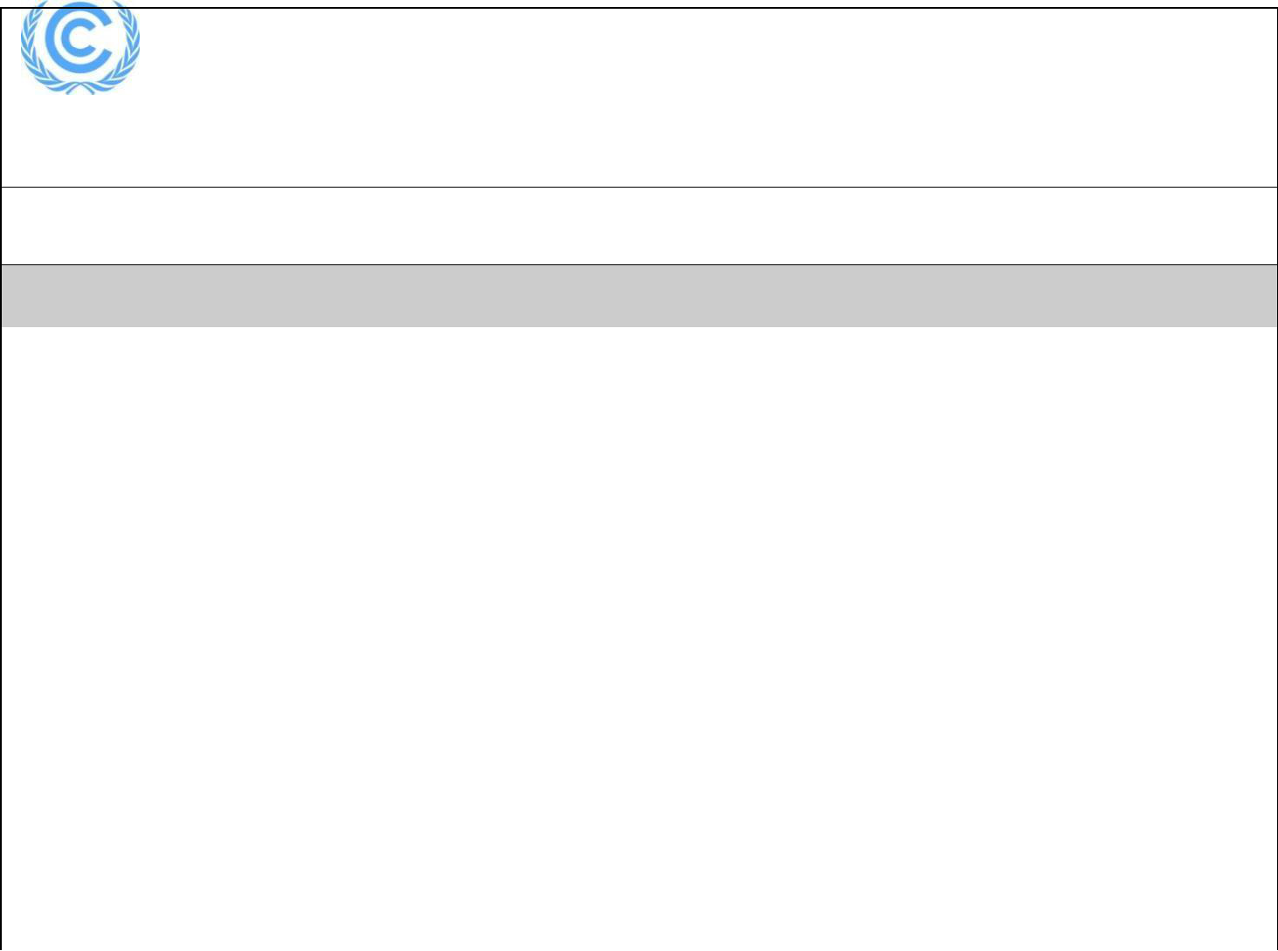

Project design document form for

CDM project activities

(Version 06.0)

Complete this form in accordance with the Attachment “Instructions for filling out the project design document form for CDM project activities” at the end of this form.

PROJECT DESIGN DOCUMENT (PDD)

 | Title of the project activity | CANTA WPP
 | Version number of the PDD | 09
 | Completion date of the PDD | 09/07/2020
 | Project participant(s) | Boydak Enerji Üretim ve Ticaret Anonim (Project Owner)
 |  | GTE Carbon (Project Developer)
 | Host Party | TURKEY
 | Sectoral scope and selected | Sectoral scope 1: Energy Industries (Renewable-/non-
 | methodology(ies), and where | renewable sources)
 | applicable, selected standardized | Methodology: ACM0002 “Grid-connected electricity generation
 | baseline(s) | Methodology: ACM0002 “Grid-connected electricity generation
 | baseline(s) | from renewable sources ”, version 13. 0
 | Estimated amount of annual average | 96,072 tonnes CO2
 | GHG emission reductions | 96,072 tonnes CO2

Version 06.0 Page 1 of 56

CDM-PDD-FORM

SECTION A. Description of project activity

A.1. Purpose and general description of project activity

The proposed project is a large scale wind power plant project located within the boundaries of Silivri District of Istanbul province. The project is licensed on 18/08/2011 as 45MWe and completed as 45MWe/47.5 MWm. In 27/08/2015, license has been upgraded to 50MWe/54.7MWm by Energy Market Regulatory Authority (EMRA). Purpose of the proposed project is to generate electricity by utilizing the renewable energy potential to meet increasing electricity demand and thus reduce fossil fuel consumption.

The initial phase of the proposed project involves installation of 19 turbines each having 2.5 MW capacity (Total capacity is 47.5 MWm and 45MWe). Total output capacity ise 163.2 GWh.After expansion, number of turbines will be 21 and expected output will be 175 GWh. Turbine output is transmitted to the switchyard area via underground cabling. Total land used for the project is estimated as 1,900 m2 for turbines, 350m2 for office and facility buildings and about 150m2 for switchyard area. Electricity generated at project is fed to the national grid via Silivri substation. Length of transmission line is around 11.5 km.

Final project layout includes 19 ×2.5MWe Nordex N100/2500kW R100 turbines and 2×3.6MMWm/1.25 MWe turbines which results in 175 GWh annual generation. In the first registered PDD of the project (completion date: 09/06/2014) estimated annual output has been stated as 163.2 GWh corresponding emission reduction was 96.072 tCO2 annually. After capacity addition (design change) annual electricity generation capacity will increase to 175 GWh as indicated in amended licence. However, as it could be understood from the GS team response on deviation request document, application of the inclusion of capacity addition was not approved. Therefore, project will go on by subtracting the electricicty generation date due to capacity addition and considered the 96,072 tCO2 through GS certification and claims for GS-VER certificates . Calculation approach for the difference in electricity generation to be caused by the increase in capacity and subtract it from the total production is explained separately in the monitoring plan section.

Average lifetime of turbines are assumed as 25 years as per the tool applied.

Main goals of the Proposed Projects include;

- Utilization of the renewable energy potential of Turkey in order to meet rapidly increasing electricity demand and contribute achieving energy security.

- Increase share of WPPs in electricity generation mix of Turkey and reduction of GHG emissions.

- Contribute to the national economic development by creating direct and indirect job opportunities during construction and operation phases.

- Reduce import dependency of fossil fuel dominated electricity sector and diversify generation mix through use of local resources.

- Contribution to sustainable development through supporting local community and local economy.

Project not only contributes to emission reduction through use of renewable resources and creating job opportunities and thus contribute sustainable development. In terms of environmental impact, project is considered to have positive impact on air quality due to avoided NOx, PM and SO2 emissions whereas no negative impact on water quality other pollutants and biodiversity has been identified. As per the national regulations, a project introductory file (PIF) has been prepared for the project to assess the environmental impacts. In addition to national requirements, an Environmental and Social Action Plan (ESAP), Non-Technical Summary of the Project, Gap Analysis Report and Stakeholder Engagement Plan have been prepared for the project for compliance with international standards.

According to the research conducted by State Planning Organization (SPO) on socio-economic level of Districts in Turkey, Silivri District is ranked as 60th among 872 Districts in Turkey in terms of development level and classified in second (out of six) group. About 46.6% of the population works on agriculture and 37.5% works on service sector whereas 15.9% works on industry. Despite the high percentage of population working in industry, unemployment is still high due to high population increase (33.19%) in Silivri mainly due to migration from rural areas.

In addition to contribution to local economy, project also contributes use of local and renewable resources to meet the increasing energy demand of Turkey and reduce dependency on fossil fuels. According to Turkish Electricity Transmission Company (TEIAS) statistic, in 2011 about 74.8% of the electricity has been generated via thermal power plants whereas 45.4% was from natural gas (NG) power plants which is fully imported and 21.6 bn m3 NG has been consumed. In terms of fuel dependency, proposed project is expected to replace about NG and other fossil fuel import and consumption and thus contribute to balance of payments and increase air quality.

Milestone |  | Date
Preliminary EIA |  | January 2009
EIA Decision |  | 13/02/2009
License Issuance |  | 18/08/2011
Board Decision |  | 01/11/2011
Carbon Certification Agreement |  | 01/01/2012
EM Equipment Purchase Contract* |  | 26/03/2012
LSC Meeting |  | 16/04/2012
License Revision |  | 18/04/2012
Bankable Report |  | 13/06/2012
Forest Permission |  | 25/06/2012
Grid Connection Agreement |  | 03/10/2012
Loan Proposal |  | 21/10/2012
Construction Start Date⁷ |  | 01/03/2013
Agreement on construction of transmission line, |  | 13/09/2013
wind park, assembly and test operation (ABB)
Subcontractor Agreement | for Substation | 22/02/2013
Construction (Bilmer)
Subcontractor Agreement for basement and |  | 22/02/2013
Construction (Bilmer)
Commissioning Date |  | 24/07/2014
Capacity Extension License | Approval | 27/08/2015
Table 1. Milestones for Canta WPP

*Date of investment decision

As it can be seen from the Table above, the Board took a decision on 01/11/2011 to integrate into carbon revenues into the project financial feasibility. In line with the CDM-EB-41, investment decision date has been selected as the equipment purchase contract as it is dated as the earliest contract indicating a concrete proof of the project owners realisation of the project.

The load factor of the project is calculated as 39% (before the capacity addition) based on the Bankable Report of the project for the initial phase of the project. The project area consists of private land and Treasury land used as meadow and agricultural land, and, besides unused land.

A.2. Location of project activity

A.2.1. Host Party

Host country is Turkey. Although Turkey, the host Country, passed legislation in Parliament on 05/02/2009 to ratify the Kyoto Protocol - Turkey does not have a quantitative emission reduction limit yet and it is likely that it will not have a quantitative emission reduction limit. In terms of Kyoto Protocol’s 2nd commitment period, Turkey has not yet ratified the Amendment. Furthermore, Turkey does not have a quantitative emission reduction in the amended Kyoto Protocol.

As such, Turkey
participation in the carbon emission reduction will be a voluntary basis.

A.2.2. Region/State/Province etc.

Project is located within boundaries of Silivri District of İstanbul Province of Turkey.

A.2.3. City/Town/Community etc.

Nearest settlement to the project boundaries is Canta village which is about 650 m from the project nearest türbine.

A.2.4. Physical/Geographical location

Zone(35S) | Y | X | Zone(35S) | Y | X
T1 | 588962.66 | 4551829.82 | T11 | 587786.26 | 4554771.83
T2 | 589777.07 | 4552521.47 | T12 | 588329.00 | 4553037.87
T3 | 588300.79 | 4555674.25 | T13 | 588008.00 | 4554405.00
T4 | 589467.97 | 4552896.92 | T14 | 587605.00 | 4555205.00
T5 | 589203.81 | 4553173.74 | T15 | 588444.80 | 4555276.18
T6 | 588751.61 | 4553173.50 | T16 | 588649.29 | 4551930.17
T7 | 589008.37 | 4553837.01 | T17 | 588308.91 | 4551986.34
T8 | 589221.71 | 4554592.04 | T18 | 589425.02 | 4551827.16
T9 | 588982.15 | 4554889.46 | T19 | 589885.99 | 4551989.56
T10 | 588578.19 | 4553777.76 | Switchyard | 589572.25 | 4553327.41
T20* | 589375.00 | 4552292.00 | T21* | 587774.00 | 4553622.00
Table 2. Coordinated of the Turbines (* for new turbines)

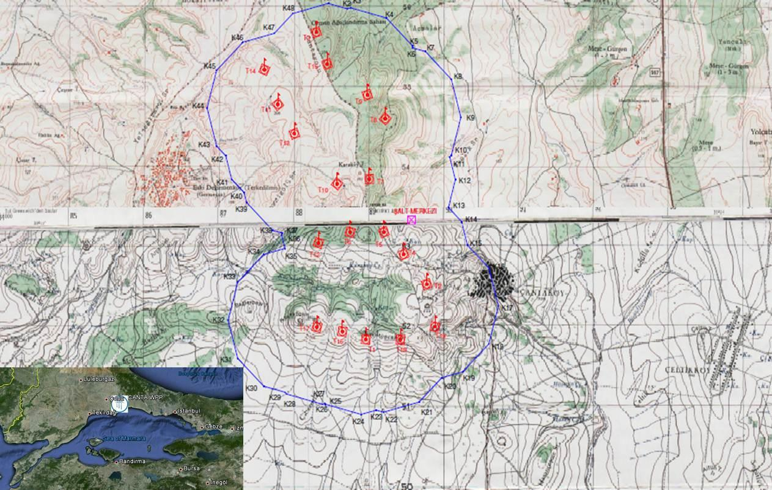

Figure 1. Layout of Tur
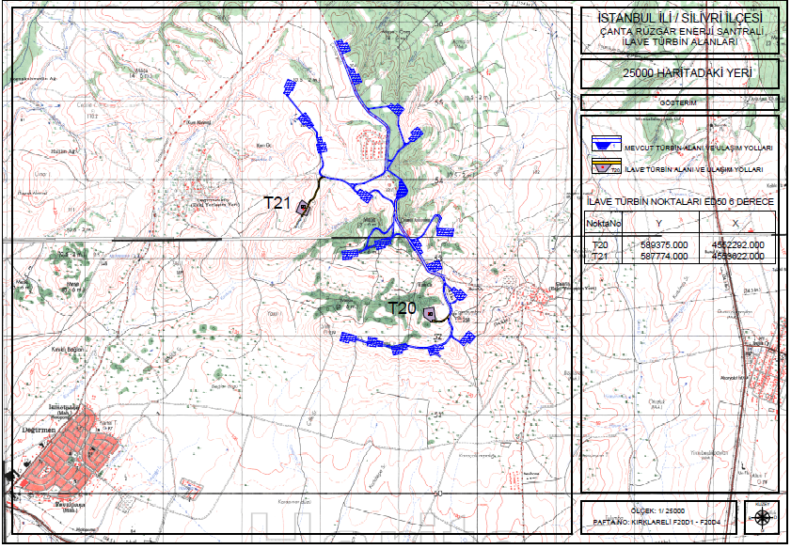bine

Figure 1. Lay out of Turbines

A.3. Technologies and/or measures

Wind Power Plants use wind energy converters (WEC), called wind turbines to convert the wind energy into electrical energy. The project uses 19 WEC’s of Nordex N100/2500kW R100 MW and two 3.6 MWm/1.25 MWe turbines. Mechanical capacity will be 54.7 MWm however electrical output is limited to 50 MWe. The annual electricity generation from these turbines are estimated to be 175 GWh. This energy is converted at the site switchyard and fed to the national grid.

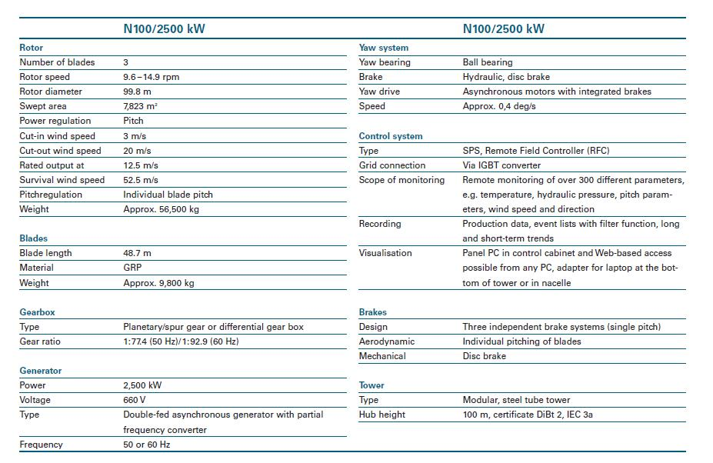

Table 3. Characteristics of the turbine used.

A.4. Parties and project participants

Party involved | Private and/or public entity(ies) | Indicate if the Party involved
(host) indicates host | project participants | wishes to be considered as
Party | (as applicable) | project participant (Yes/No)
 | Boydak Enerji Üretim ve Ticaret
Turkey | Anonim Şirketi (Boydak).- (Project | No
Turkey | Owner-Private Entity) | No

A.5. Public funding of project activity

No public funding is used for the project.

SECTION B. Application of selected approved baseline and monitoring methodology and standardized baseline

B.1. Reference of methodology and standardized baseline

The UNFCCC approved baseline and monitoring methodology ACM0002, version 13.0.0¹valid from 11/05/2012 was applied for the project activity.

ACM0002 refers to the following tools:

- “Tool for the demonstration and assessment of additionality”, Version 07.0.0,and,

- ‘‘Tool to calculate the emission factor for an electricity system’’, Version 3.0

“Tool for the demonstration and assessment of additionality”, is used as it is an imperative by the methodology which is not new.

‘‘Tool to calculate the emission factor for an electricity system’’ is applied:

- to estimate the OM, BM and/or CM when calculating baseline emissions for a project activity that substitutes grid electricity that is where a project activity supplies electricity to a grid the emission factor for the project electricity system is calculated for grid power plants only

B.2. Applicability of methodology and standardized baseline

The project activity qualifies as a large-scale activity. The capacity of the project activity is 50 MWe (54.7 MWm) which is above the small scale limit. Project is a Type I activity and complies with eligibility rules during the full crediting period.

The choice of methodology ACM0002, is justified as the project activity meets its applicability criteria:

- The proposed project activity is a greenfield, grid connected renewable electricity generation project,

- The project activity is the installation of wind power plant

- The project does not involve capacity addition, a retrofit of (an) existing plant(s) or a replacement of (an) existing plant(s)Project activity does not involve switching from fossil fuels to renewable energy sources at the site of project activity

- The project does not involve combined heat and power generation activity

- The geographic and system boundaries for the relevant electricity grid can be clearly identified and information on the characteristics of the grid is available.

Since there exists no delineation of project electricity system or connected electricity systems by DNA, following criteria has been used to determine the existence of significant transmission constraints:

- In case of electricity systems with spot markets for electricity: there are differences in electricity prices (without transmission and distribution costs) of more than 5 percent between the systems during 60 percent or more of the hours of the year.

- The transmission line is operated at 90% or more of its rated capacity during 90% percent or more of the hours of the year.

Since the project output is fed to the Turkish electricity grid which does not involve any distinct electricity systems that applies different price, first criteria defined above is not applicable. Also, since the transmission line between the proposed projects and nearest substation is built within the scope of the project and there exist no information on grid capacity utilization, second criteria

is also inapplicable. Based on assessment above, it is difficult to conclude with a significant transmission constraint or grid boundary. Since there is no dispatch grid system in Turkey, the project boundary is considered as the National Electricity Grid of Turkey according to applied tool. The geographical and physical boundaries of the Turkish grid and location of the power plants are well identified as given diagram below.
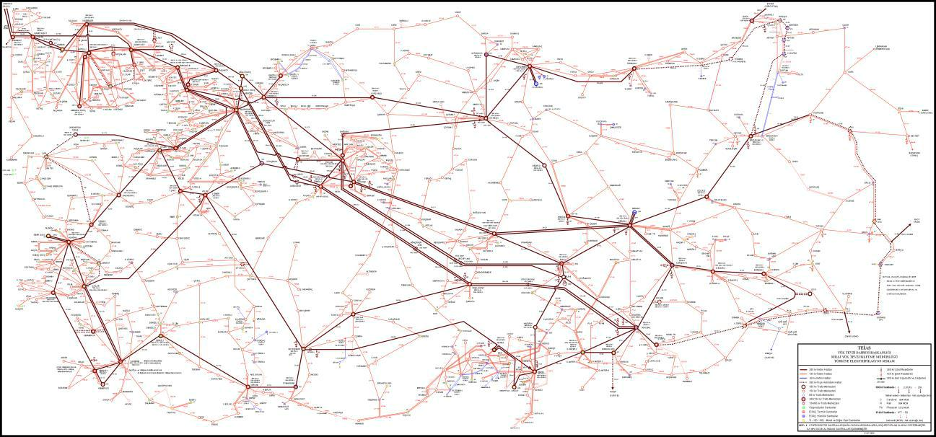

Figure 2. Turkish Electricity Grid

B.3. Project boundary

The project boundary is considered as the National Electricity Grid of Turkey according to applied tool. The spatial extent of the project boundary includes the project power plant and all power plants connected physically to the electricity system that the power plant is connected to.

The flow diagram of the project boundary is illustrated below:

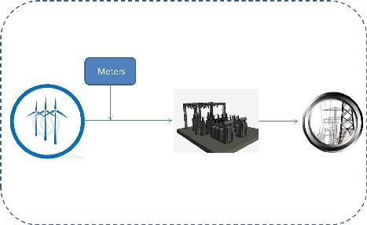

 |  | Source |  |  | GHGs |  | Included? |  | Justification/Explanation
 | scenario |  | Electricity |  | CO2 |  | Yes |  | Major emission Source
 | scenario |  | Generation
 | scenario |  | Generation |  | CH4 |  | No |  | Minor emission Source. Excluded for
 | scenario |  | by the grid |  | CH4 |  | No |  | Minor emission Source. Excluded for
 | scenario |  | by the grid |  |  |  |  |  | simplification
 | scenario |  | connected |  |  |  |  |  | simplification
 | scenario |  | connected |  | N2O |  | No |  | Minor emission Source. Excluded for
 | scenario |  | power |  | N2O |  | No |  | Minor emission Source. Excluded for
 | Baseline |  | power |  | N2O |  | No |  | Minor emission Source. Excluded for
 | Baseline |  | power |  |  |  |  |  | simplification
 | Baseline |  | plants |  |  |  |  |  | simplification
 |  |  | Project |  | CO2 |  | No |  | Zero emission electricity generation from
 | scenario |  | Scenario |  |  |  |  |  | renewable resources. Emissions from diesel
 | scenario |  |  |  |  |  |  |  | generator are excluded for simplification as it is a
 | scenario |  |  |  |  |  |  |  | minor emission source.
 | scenario |  |  |  | CH4 |  | No |  | Zero emission electricity generation from
 | Project |  |  |  | CH4 |  | No |  | Zero emission electricity generation from
 | Project |  |  |  |  |  |  |  | renewable resources.
 | Project |  |  |  | N2O |  | No |  | Zero emission electricity generation from
 | Project |  |  |  |  |  |  |  | renewable resources.

B.4. Establishment and description of baseline scenario

According to the methodology baseline scenario has been identified as “the electricity delivered to the grid by the project activity that otherwise would have been generated by the operation of grid-connected power plants and by the addition of new generation sources”.

Turkish electricity generation is mainly composed of thermal power plants and the share of renewable resources; especially hydroelectric power plants have decreased significantly in recent years whereas share of wind power plants are still very low. Since Turkey is an advanced developing country, there is an increasing demand for electricity which is fully expected to continue in the foreseeable future.

The trend in Turkey to date and given historically slow development of alternative energy resources is to build an increasing number of thermal power plants in the future to satisfy the annual growth in energy consumption demand. Turkey as an advanced developing nation has looked at dealing with energy security by developing and constructing high capacity coal and natural gas power plants. The development of thermal power plants has been also encouraged by the large natural resource availability in Turkey, especially the abundance of economically accessible lignite.

In the absence of the proposed project activity, the same amount of electricity is required to be supplied via either the current power plants or by increasing the number of thermal power plants thus increasing GHG emissions.

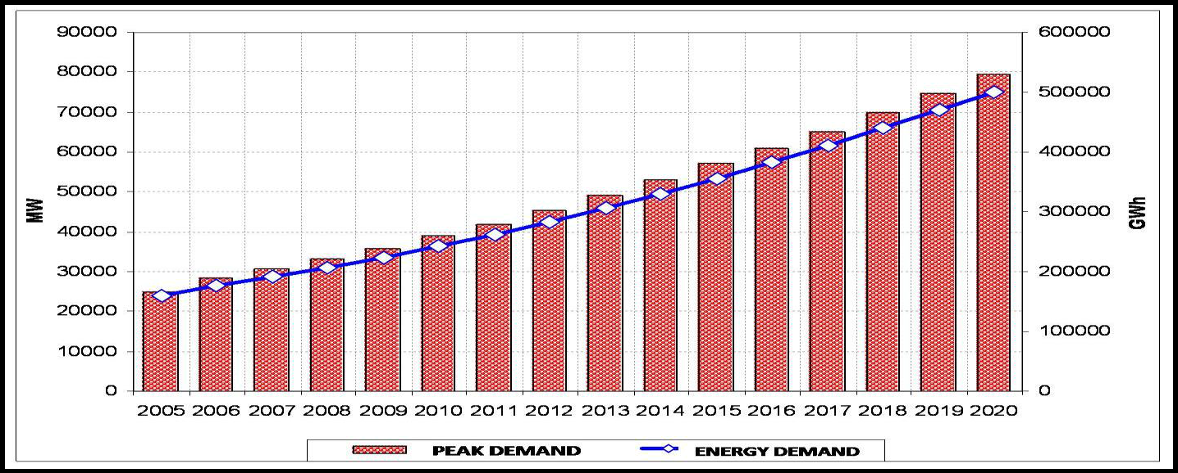

Figure 3. Peak Load and consumption projection for Turkish electricity system between 2005-2020

According to the TEIAS statistics, share of WPPs together with geothermal power plants could hardly reach 1.68% in 2010 whereas share of thermal power plants is around 74-80% in recent years. When we look at the annual development of Turkey’s gross generation in recent years we see that grid is dominated by thermal power plants and which is boosted by increasing energy demand in parallel to increase population and per capita income. Hence, baseline of Turkey’s electricity grid will continue to be dominated by fossil fuel power plants which is seen as the quickest solution in short term to meet the demand and enable energy security in supply side.

90

80

70

60

50

40

30

20

10

CDM-PDD-FORM
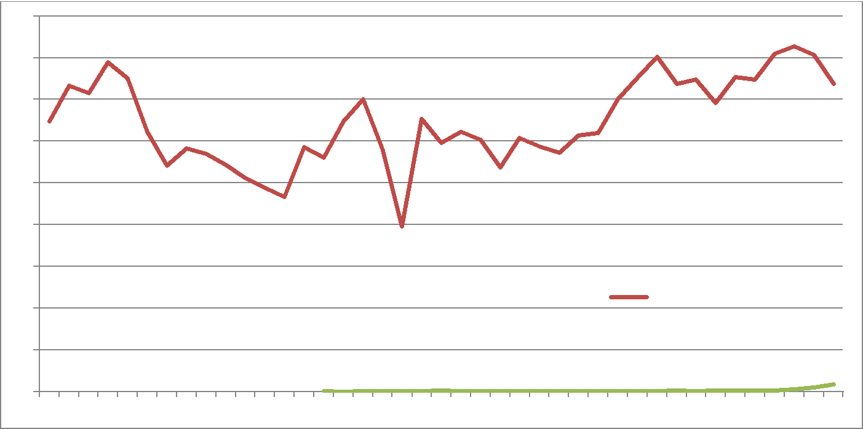

THERMAL

0

1970 1974 1978 1982 1986 1990 1994 1998 2002 2006 2010

Figure 4. Annual Development of Turkey's Gross Generation Capacity¹⁴

B.5. Demonstration of additionality

“Tool for the demonstration and assessment of additionality”, Version 07.0.0 is utilized as per the methodology.

According to the applied methodology (ACM0002) the baseline scenario for the project has been defined as “generation of equal amount of electricity by the power plants connected to the grid”. Emission factor for the baseline scenario has been calculated according to the combined margin approach as defined by the selected methodology. Within this framework, the project is expected to generate about 175 GWh electricity and reduce about 96,072 tCO2 emissions through replacing the electricity that would need to be supplied via the National grid in the absence of the project activity. Additionality of the proposed project has been assessed according to the applied tool for demonstration of additionality as shown in following steps.

Step 1 - Identification of Alternatives to the project activity consistent with current laws and regulations

Sub-step 1a - Define alternatives to the project activity:

The most realistic and reliable alternatives to the project activity are:

- Proposed project not undertaken as a VER project activity

- Continuation of the current situation-supply of equal amount of electricity by the newly built grid connected power plants

The first alternative, which is the implementation of the project without carbon revenue is not financially attractive as discussed in investment analysis section below. The Second alternative (Scenario 2) is the baseline scenario and implementation of the proposed project as a VER activity would be additional to this scenario.

Outcome of Step 1a

Continuation of the current situation is not considered as a realistic alternative due to increasing electricity demand therefore new power plants should be constructed which includes mainly thermal power plants. Implementation of the project is additional to the baseline scenario which is alternative 2 above and therefore reduces the emissions.

Sub-step 1b. Consistency with mandatory laws and regulation

The following applicable mandatory laws and regulations have been identified:

- Electricity Market Law
- Law on Utilization of Renewable Energy Resources for the Purpose of Generating Electricity Energy
- Energy Efficiency Law
- Forest Law
- Environment Law

The resultant alternatives to the project as outlined in Step (1a) are in compliance with the applicable laws and regulations.

Outcome of Step 1b

Mandatory legislation and regulations for each alternative are taken into account in sub-step 1b. Based on the above analysis, the proposed project activity is not the only alternative amongst the project participants that is in compliance with mandatory regulations. Therefore, the proposed VER project activity is considered as additional.

Step 2 - Investment analysis

The investment analysis has been done in order to make an economic and financial evaluation of the project. No public funding or ODA are available in Turkey for finance of this type of projects. A preliminary loan agreement has been signed for the project activity. However, the project construction was completed based on 100% equity, thus, the project IRR is considered equal to the equity IRR for the financial analysis .

Sub-step 2a - Determine appropriate analysis method

There are three options for the determination of analysis method which are:
- Simple Cost Analysis
- Investment Comparison Analysis and
- Benchmark Analysis

Since Project generates economic benefits from sales of electricity, the simple cost analysis is not applicable. Also, since the baseline of the project is generation of electricity by the grid, no alternative investment is considered at issue. So, it has been decided to use benchmark analysis for evaluation of the project investment. A preliminary loan agreement has been signed for the project activity. However, the project construction was completed based on 100% equity, thus, the project IRR is considered equal to the equity IRR for the financial analysis.

Sub-step 2b: Option III. Apply benchmark analysis

For benchmark analysis, figure defined by World Bank for similar project types have been used which has been given as 15% by a report generated in May 2009. For the proposed project, in order to reach this project IRR values, average electricity tariff must be above 12 $c/kWh in the absence of carbon revenue and assuming that initial investment figures are realized so that the investment becomes reasonable.

Sub-step 2c. Calculation and comparison of financial indicators

Parameters | Unit | Data Value
Installed Capacity | (MWm) MWe | (54.7) 50.0 (previous capacity was 45 MWe, before capacity extension)
Grid Connected Output | GWh | 163.2 (for between 2014 and July of 2020 which is the expected two ne turbines commissioning date) and 175.0 (after capacity extension from July 2020 to 2033) details are present in IRR calc. document cash flow sheet
Capital Investment | Million $ | 97.6 (113.4 after capacity extension)
Income tax rate | % | 20
Depreciation | Years | 25 for electromechanical equipment
 |  | 40 for other facilities
Exchange rate | € / $ | 1.32
Expected Tariff | $ Cents/kWh | 7.3
Expected VERs price | $/ tons CO2e | 6.5²⁸
Operation&Maintenance | $/Year | 1,301 (for between 2014 and July of 2020 which is the expected two ne turbines commissioning date) and 1,362 (after capacity extension from July 2020 to 2033) details are present in IRR calc. document cash flow sheet.
Cost

Table 4. Main financial parameters used for investmentanalysis (*capacity extension)
Equity IRR has been calculated according to the tool as stated in the applied methodology and CDM-EB73-A08 Clarification Version 01.0, for 20 years, where says “if project participants choose a renewable crediting period and if the technical lifetime of the CDM project activity is more than 20 years, the investment analysis shall be conducted for 20 years and include the fair value of the project activity assets at the end of the assessment period.”. Electricity tariff has been used as $7.3 Cent/kWh... Investment decision date has been identified as the date of equipment purchase agreement. For depreciation calculations, expected life of construction and electromechanical equipment are determined as 40 year and 25 year, respectively.³⁰ Calculation and estimations have been made conservatively therefore project IRR value represents the most optimistic scenario in terms of capital investment and electricity generation. On the other hand electricity tariff is expected to increase so that the investment becomes attractive however as given below, expectations have not been realized yet due to the market conditions. For proposed project, project IRR has been calculated as 5.35% after extension in the absence of carbon revenue for license period and ignoring expropriation etc cost. The project does not use any credits and use solely equity. When we include the carbon revenue in the cash flow, project IRR increases to 5.97% and the project becomes more attractive and viable for the investors as coupled with the view that energy sale prices that can be achieved from the project is likely to increase in future years. Expectation that the electricity prices will increase is the risk for investors whereas realization of this expectation will the premium. Carbon revenue has a significant affect in this respect in terms of decreasing the period for return on investment and risk of investment decision.

Following figure is given in order to reflect the actual electricity prices realized obtained from monthly reports of Market Settling and Balancing Center between 01/12/2009-01/01/2012. It should be considered that these prices are highest prices obtained and power plants which sell electricity through bilateral agreements have lower income. Figure shows that the actual prices have even been lower than guaranteed price in some cases therefore assumption of 7.3 $cents per kWh (or 73 $/MWh) is a realistic scenario as demonstrated below
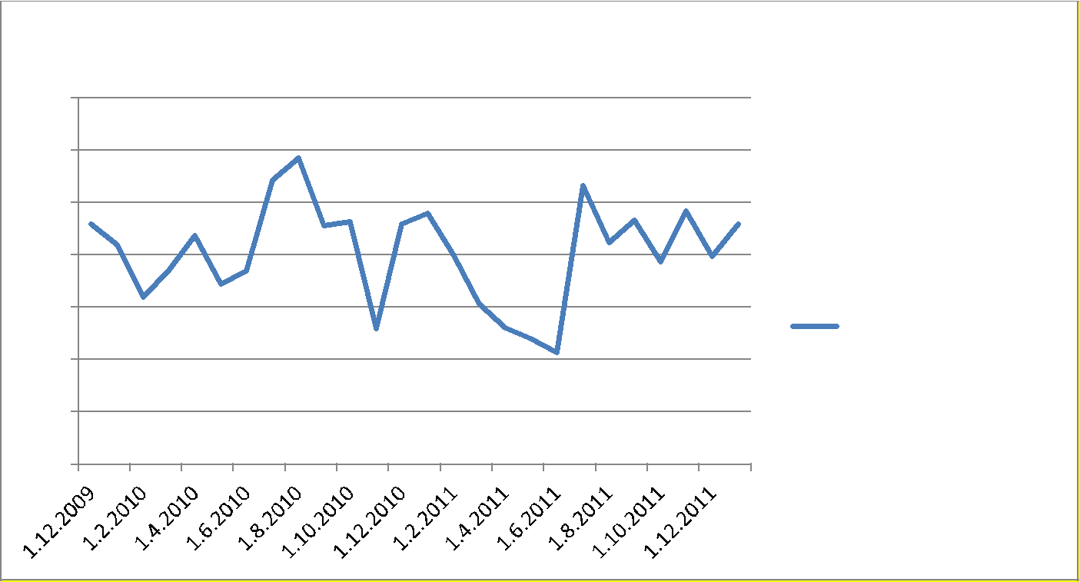

Average Monthly Price

14,0

12,0

10,0

8,0

6,0
Average Monthly Price

4,0

2,0

0,0

Figure 4. Highest tariffs observed between 01/12/2009-31/01/2012 ($ cents/kWh)

This equity IRR value represents the most optimistic scenario in terms of capital investment and electricity generation whereas electricity tariff is expected to increase due to increasing electricity demand so that the investment becomes attractive.

Expected return on investment for these types of projects should be above 15% as per WB document. For the proposed project, in order to reach this equity IRR values, average electricity tariff must be above 12 $ c/kWh so that the investment will become reasonable. Considering that control wind power plants on generation period is limited, and plant is operational for about five years (i.e. purchase guarantee will end by end of 10th year) the risk for investors will be higher whereas realization of this expectation will increase the premium. Carbon revenue has a significant affect in this respect in terms of decreasing the period for return on investment and minimizing investment risk.

Sub-step 2d - Sensitivity Analysis

Sensitivity analysis has been carried out for three main parameters identified which constitute all income and expenses of project effecting project return;
- Investment Cost

- Operating Cost
- Electricity Sales revenue

For a range of ±10% fluctuations in investment (construction and EM equipment) cost, operating cost and ±20% fluctuation in electricity income, table below has been obtained. Parameters have been selected as per the Guidelines on Investment analysis which are defined as construction and EM equipment costs.

 | -10.00 | -5 | -2.5 | 0 | 2.5 | 5 | 10
Investment
Cost | 6.59 | 5.94 | 5.64 | 5.35 | 5.07 | 4.79 | 4.28
Operating Cost | 5.22 | 5.28 | 5.32 | 5.35 | 5.38 | 5.41 | 5.48
 | -20.00 | -10 | -5 | 0 | 5 | 10 | 20
Electricity
Income | 3.11 | 4.20 | 4.77 | 5.35 | 5.94 | 6.55 | 7.81

Table 5. Sensitivity analysis for proposed project without carbon revenue

Outcome of Step 2:

The investment and sensitivity analysis shows that the VER revenues will improve the financial indicators of the Project remarkably. Considering that figures above are based on a higher price rather than the government guaranteed floor price, optimistic estimations for yearly generation and that those figures do not reflect the risk for investment, role of carbon income is a most significant number to enable the project to proceed.

According to local regulations, electricity price is determined daily according to Market Financial Settlement Center (MFSC) as defined in the regulations and there exists three tariffs during day, peak and night hours. Thermal power plants and HEPPs with storage facilities have flexibility to schedule their generation at peak hours when the tariff is high. However, Wind power plants do not have storage facility therefore may not be able to benefit from high prices realized at when demand is high. According to MFSC figures, electricity tariff fluctuated between 4.3 $c/kWh and 10.2 $c/kWh between 01/12/2009 and 31/01/2012 whereas the weighted average of the tariff has been calculated as 8.1$c/kWh in this period³³. Since this value shows the spot price at the time of selected investment decision date, it does not provide any guarantee about the actual selling price as the control on generation period and tariff is limited and it may not be possible to generate and sell electricity during peak tariff periods. Also, considering that fluctuation in water resources is high and fact that a part of the electricity can be sold through bilateral agreements to free consumers with a discount rate over market price, guarantee price has been taken as reference in investment analysis which also provides input for evaluation of financing institutions.

Another important parameter affecting equity IRR is investment cost. However, since the agreements have been made and costs are realized as given in financial model, there is no chance to expect a decrease in the investment cost. Operating costs can also affect the equity IRR however, its impact is not significant and does not cause any significant change in equity IRR and the fluctuation percentage to reach the benchmark is very high and not likely.

Based on the above information, it is seen that project is not the most attractive option. Therefore project is considered as additional to the baseline scenario.

Step 3. Barrier analysis

This step is not applied as the additionality is demonstrated in previous steps.

Step 4. Common Practice Analysis

According to the “Tool for demonstration and assessment additionality (Version 07.0.0)”, the common practice shall provide an analysis of any other activities that are similar to the Project Activity. Projects are considered similar if they are in the same country/region and/or rely on a broadly similar technology, are of a similar scale, and take place in a comparable environment with respect to regulatory framework, investment climate, access to technology, access to financing etc.

According to latest statistics published by General Directorate of Energy Affairs, there are 33 wind power projects developed or had additional capacity in 2018³⁴.

For the common practice analysis, the geographical boundary is also selected as the Turkish Electricity Grid to be in line with the methodology. The justification for the selection and details of the system is provided under Section B.2.

Step 1:Calculate applicable output range as +/-50% of the design output or capacity of the proposed project activity.

The initial design capacity of the proposed project was 45 MWe. After capacity extension capacşty becomes 50 MWe. Therefore, the applicable output range is from 25 MWe to 75 MWe as per the initial capacity subject to registration.

Step 2: identify similar projects (both CDM and non-CDM) which fulfil all of the following conditions:

(a)The projects are located in the applicable geographical area;
(b)The projects apply the same measure as the proposed project activity;
(c)The projects use the same energy source/fuel and feedstock as the proposed project activity, if a technology switch measure is implemented by the proposed project activity;
(d)The plants in which the projects are implemented produce goods or services with comparable quality, properties and applications areas (e.g. clinker) as the proposed project plant;
(e)The capacity or output of the projects is within the applicable capacity or output range calculated in Step 1;
(f) The projects started commercial operation before the project design document (CDM-PDD) is published for global stakeholder consultation or before the start date of proposed project activity, whichever is earlier for the proposed project activity.

Applicable geographical area has been selected as the whole host country (Turkey) as per paragraph 1 of Guidelines on Common Practice version 03.1. Projects which apply the same measure as the proposed project have been determined and wind energy projects are selected as the same energy source type of projects. All of the selected plants deliver the same service which is the electricity generation. Applicable output range has been determined and all of the power plants are taken from year 2018 since project capacity extension contruction started in 2018 (considered as start date of project activity of design change). Therefore all of the compared power plants have been operational before the implementation of the project activity

Table 6. Operational wind power plants (2018 investments)

NAME OF THE PLANT | INSTALLED CAPACITY (MWe) | ANNUAL GENERATION (GWh)
TİRE RES | 23,80 | 175,00
GÖKDAĞ RES | 1,67 | 35,00
DATÇA RES | 12,00 | 72,00
SEFERİHİSAR RES | 4,00 | 47,40
ÇAMSEKİ RES | 9,40 | 67,00
ELMALI RES | 6,00 | 31,50
AKDAĞ RES | 7,25 | 75,00
ÇAMSEKİ RES | 14,10 | 0,00
HAMZABEYLİ RES | 1,50 | 20,72
ÇAMSEKİ RES | 9,40 | 0,00
KALFAKÖY RES | 10,00 | 39,40
ÇAMSEKİ RES | 9,40 | 0,00
AKHİSAR RES | 11,25 | 192,50
KINIK RES | 2,00 | 165,00
KURTİNİ RES | 3,50 | 46,60
ARDIÇLI RES | 8,12 | 140,16
SEYİT ONBAŞI RES | 4,00 | 32,90
SARPINCIK RES | 2,00 | 109,84
EBER RES | 18,00 | 120,80
BAĞLAR RES | 13,20 | 280,32
POYRAZGÖLÜ RES | 6,00 | 147,00
BERGAMA RES | 7,20 | 88,20
KAYADÜZÜ RES | 11,50 | 199,28
ALİBEY RES | 9,60 | 105,00
CERİT RES | 14,40 | 299,59
DİLEK RES | 3,50 | 70,00
GAZİ RES | 2,50 | 17,50
GERİŞ RES | 11,20 | 39,24
ARZU RES | 3,00 | 30,00
SAKARBAYIR RES | 0,30 | 10,50
YENİHİSAR RES | 2,40 | 75,00
KAPIDAĞ RES | 4,00 | 121,98
AKBÜK RES | 4,80 | 29,61

Power plants which are in the applicable range of Omerli WPP (i.e. 25 MW to 75 MW) are highlighted (counted as 5). Details are given in common practice analysis submitted to DOE and GS.

PLANT NAME | INSTALLED CAPACITY Mwe | ELECTRICITY GENERATION (GWh) | VER Reference
ARDIÇLI WPP | 50,00 | 140,2 | -
Alibey WPP | 30,00 | 105,0 | https://registry.goldstandard.org/projects/details/668
CERİT WPP | 57,60 | 299,6 | https://registry.goldstandard.org/projects/details/142
Eber RES | 36,00 | 120,8 | https://registry.goldstandard.org/projects/details/933
Bergama WPP | 25,00 | 88,2 | -

Step 3: within the projects identified in Step 2, identify those that are neither registered CDM project activities, project activities submitted for registration, nor project activities undergoing validation. Note their number Nall. Properties of the power plants are also indicated in this excel sheet. After excluding the VER projects, there exist only 2 power plants being operated in Turkey (ARDIÇLI WPP and BERGAMA wpp). VER reference of the other projects are given in common practice excel document in detail.

Therefore;

Nall = 2

Step 4: within similar projects identified in Step 3, identify those that apply technologies that are different to the technology applied in the proposed project activity. Note their number Ndiff

There is no different scale and different to the technology project therefore Ndiff=0

Step 5: calculate factor F=1-Ndiff/Nall representing the share of similar projects (penetration rate of the measure/technology) using a measure/technology similar to the measure/technology used in the proposed project activity that deliver the same output or capacity as the proposed project activity.

F=1-Ndiff/Nall=1-(0/2) = 1 (> 0.200)
Nall – Ndiff = 2 – 0 = 2

According to “Tool for Common practice”, Version 03.1, if the factor F is greater than 0.2 and Nall-Ndiff is greater than 3, then the proposed project is a “common practice”.

For the proposed project, F=1 but Nall-Ndiff=2, therefore, the proposed project is not a common practice within the applicable geographical area. Hence, the proposed project is additional.

B.6. Emission reductions

B.6.1. Explanation of methodological choices

Emission factor has been calculated in a conservative as requested by the methodology. Basic assumptions made are;

- Emission factor will remain same over the crediting period,

- Emission factor of fuels sources is “0” or the lowest value in the references when there is no information.

For calculation of the emission factor of Turkish Grid, “Tool to Calculate the Emission Factor for an Electricity System”, has been used.

Since the share of low-cost / must-run sources is below 50%, method (d) is eliminated. Also due to insufficient data available, methods (b) and (c) are not considered and thus (a) simple OM method is used in calculations. The following table is used for demonstrating the share of low cost/must run resources.

 |  | ANNUAL DEVELOPMENT OF GENERATION IN TURKEY
 |  |  |  |  |  |  | GENERATION
 |  |  |  |  |  |  |  |  |  |  | % Low Cost
 |  | YEARS | THERMAL |  | HYDRO |  | GEOTHERM.WIND |  | TOTAL(GWh) |  | Must Run
 |  | 1970 | 5590.2 |  | 3032.8 |  | 0 |  | 8623.0 |  | 35%
 |  | 1971 | 7170.9 |  | 2610.2 |  | 0 |  | 9781.1 |  | 27%
 |  | 1972 | 8037.7 |  | 3204.2 |  | 0 |  | 11241.9 |  | 29%
 |  | 1973 | 9821.8 |  | 2603.4 |  | 0 |  | 12425.2 |  | 21%
 |  | 1974 | 10121.2 |  | 3355.8 |  | 0 |  | 13477.0 |  | 25%
 |  | 1975 | 9719.2 |  | 5903.6 |  | 0 |  | 15622.8 |  | 38%
 |  | 1976 | 9908.0 |  | 8374.8 |  | 0 |  | 18282.8 |  | 46%
 |  | 1977 | 11972.3 |  | 8592.3 |  | 0 |  | 20564.6 |  | 42%
 |  | 1978 | 12391.3 |  | 9334.8 |  | 0 |  | 21726.1 |  | 43%
 |  | 1979 | 12218.3 |  | 10303.6 |  | 0 |  | 22521.9 |  | 46%
 |  | 1980 | 11927.2 |  | 11348.2 |  | 0 |  | 23275.4 |  | 49%
 |  | 1981 | 12056.7 |  | 12616.1 |  | 0 |  | 24672.8 |  | 51%
 |  | 1982 | 12384.8 |  | 14166.7 |  | 0 |  | 26551.5 |  | 53%
 |  | 1983 | 16004.1 |  | 11342.7 |  | 0 |  | 27346.8 |  | 41%
 |  | 1984 | 17165.1 |  | 13426.3 |  | 22.1 |  | 30613.5 |  | 44%
 |  | 1985 | 22168.0 |  | 12044.9 |  | 6.0 |  | 34218.9 |  | 35%
 |  | 1986 | 27778.6 |  | 11872.6 |  | 43.6 |  | 39694.8 |  | 30%
 |  | 1987 | 25677.2 |  | 18617.8 |  | 57.9 |  | 44352.9 |  | 42%
 |  | 1988 | 19030.8 |  | 28949.6 |  | 68.4 |  | 48048.8 |  | 60%
 |  | 1989 | 34041.0 |  | 17939.6 |  | 62.6 |  | 52043.2 |  | 35%
 |  | 1990 | 34314.9 |  | 23148.0 |  | 80.1 |  | 57543.0 |  | 40%
 |  | 1991 | 37481.7 |  | 22683.3 |  | 81.3 |  | 60246.3 |  | 38%
 |  | 1992 | 40704.6 |  | 26568.0 |  | 69.6 |  | 67342.2 |  | 40%
 |  | 1993 | 39779.0 |  | 33950.9 |  | 77.6 |  | 73807.5 |  | 46%
 |  | 1994 | 47656.7 |  | 30585.9 |  | 79.1 |  | 78321.7 |  | 39%
 |  | 1995 | 50620.5 |  | 35540.9 |  | 86.0 |  | 86247.4 |  | 41%
 |  | 1996 | 54302.8 |  | 40475.2 |  | 83.7 |  | 94861.7 |  | 43%
 |  | 1997 | 63396.9 |  | 39816.1 |  | 82.8 |  | 103295.8 |  | 39%
 |  | 1998 | 68702.9 |  | 42229.0 |  | 90.5 |  | 111022.4 |  | 38%
 |  | 1999 | 81661.0 |  | 34677.5 |  | 101.4 |  | 116439.9 |  | 30%
 |  | 2000 | 93934.2 |  | 30878.5 |  | 108.9 |  | 124921.6 |  | 25%
 |  | 2001 | 98562.8 |  | 24009.9 |  | 152.0 |  | 122724.7 |  | 20%
 | 2002 |  |  | 95563.1 |  | 33683.8 |  | 152.6 |  | 129399.5 |  | 26%
 | 2003 |  |  | 105101.0 |  | 35329.5 |  | 150.0 |  | 140580.5 |  | 25%
 | 2004 |  |  | 104463.7 |  | 46083.7 |  | 150.9 |  | 150698.3 |  | 31%
 | 2005 |  |  | 122242.3 |  | 39560.5 |  | 153.4 |  | 161956.2 |  | 25%
 | 2006 |  |  | 131835.1 |  | 44244.2 |  | 220.5 |  | 176299.8 |  | 25%
 | 2007 |  |  | 155196.2 |  | 35850.8 |  | 511.1 |  | 191558.1 |  | 19%
 | 2008 |  |  | 164139.3 |  | 33269.8 |  | 1008.9 |  | 198418.0 |  | 17%
 | 2009 |  |  | 156923.4 |  | 35958.4 |  | 1931.1 |  | 194812.9 |  | 19%
 | 2010 |  |  | 155827.6 |  | 51795.5 |  | 3584.6 |  | 211207.7 |  | 26%
 | 2011 |  |  | 171638.3 |  | 52338.6 |  | 5418.2 |  | 229395.1 |  | 25%

Table 7. Breakdown by source of the electricity generation,

The methodology has been applied in a conservative manner. Tools addressed by the applied methodology have been used to calculate baseline, project and leakage emissions. The equations used are ;

- ^{FC}i, y * ^{NCV}i, y * ^{EF}CO₂ ,i. y

• |  | EF | = | i,m
 |  | grid,OMsimple,y |  |  | EG_{y}
• |  | EFgrid, BM, y | = ∑EG,m,y . EFEL,m,y / ∑EG,m,y
• |  | EFgrid, CM, y | = wOM* EFgrid, OM, y + wBM* EFgrid, BM, y
• | =−− |  |  |  | ( )

• BEy = EGy x EFy

- PD = CapPJ − CapBL/ (APJ − ABL)

Table 8. Equations used for baseline calculations

B.6.2. Data and parameters fixed ex anteData / Parameter | FCi,y
Unit | Tons or 1000 m³ for gases
Description | Amount of fuels consumed by thermal power plants for electricity
 | generation in terms of fossil fuel type i in year y
Source of data | TEIAS web page
 | http://www.teias.gov.tr/T%C3%BCrkiyeElektrik%C4%B0statistikleri/istati
 | stik2011/yak%C4%B1t46-49/47.xls
Value(s) applied | See Annex 4
 | Data from Grid Operator has been used
Choice of data | Data from Grid Operator has been used
or
Measurement
methods and
procedures
 | Data used for OM calculation
Purpose of data | Data used for OM calculation
Additional comment | -

 | Data / Parameter |  |  | EGy,
 | Unit |  |  | GWh
 | Description |  |  | Net electricity generated and delivered to the grid by all power sources
 |  |  |  | serving the | system, not including low-cost/must run power plants in
 |  |  |  | year y
 | Source of data |  |  | For gross generation electricity generated and delivered to the grid by
 |  |  |  | all power sources serving the system, not including low-cost/must run
 |  |  |  | power plants in year y :
 |  |  |  | http://www.teias.gov.tr/T%C3%BCrkiyeElektrik%C4%B0statistikleri/ist
 |  |  |  | atistik2011/kgucunkullan%C4%B1m(13-21)/13.xls
 |  |  |  | For net generation and imported electricity
 |  |  |  | http://www.teias.gov.tr/T%C3%BCrkiyeElektrik%C4%B0statistikleri/ist
 |  |  |  | atistik2011/uretim%20tuketim(22-45)/23.xls
 |  |  |  | http://www.teias.gov.tr/T%C3%BCrkiyeElektrik%C4%B0statistikleri/ist
 |  |  |  | atistik2011/uretim%20tuketim(22-45)/33(84-11).xls
 | Value(s) applied |  |  | 2009 |  | 150,333
 |  |  |  | 2010 |  | 149,750
 |  |  |  | 2011 |  | 162,713
 |  |  |  | 462,796 GWh between 2009-2011. (References provided above)
 | Choice of data |  |  | Data from Grid Operator has been used
 | or
 | Measurement methods
 | and procedures
 | Purpose of data |  |  | Data used for emission reduction calculation (for calculation of OM,
 |  |  |  | Net-to-Gross electricity ratio and share of low-cost must-run sources)
 | Additional comment |  | -

 |  |  |  |  |  | CDM-PDD-FORM
 | Data / Parameter |  | EFCO2, i, y i
 | Unit |  | tCO2/TJ
 | Description |  | CO2 emission factor of fossil fuel type “i” in year “y”
 | Source of data |  | -For EF of fossil fuels, IPCC values at the lower limit have been used.
 | Value(s) applied |  |  | Fuel Source |  | EF(tCO2/Tj
 |  |  |  |  | )
 |  |  |  | Coal |  | 89.5
 |  |  |  | Lignite | 90.9
 |  |  |  | Fuel Oil |  | 75.5
 |  |  |  | Diesel | 72.6
 |  |  |  | LPG |  | 61.6
 |  |  |  | Naphtha | 69.3
 |  |  |  | Natural Gas |  | 54.3
 | Choice of data |  | According to the applied tool, IPCC default values at lower limit of 95%
 | or |  | confidence interval can be used. Although, the actual emission reduction
 | Measurement |  | is expected to be higher due to high EF of fuels consumed in existing
 | methods and |  | power plants, IPCC values have been used for conservativeness as
 | procedures |  | requested by the methodology.
 | Purpose of data |  | EF calculations
 | Additional comment | -
 | Data / Parameter |  | ɳ m,y
 | Unit | -
 | Description |  | Average net energy efficiency of power unit m in year y
 | Source of data |  | Default values provided Annex I of the “Tool to calculate the emission
 |  |  | factor for an electricity system. -.
 | Value(s) applied |  | See Annex 4
 | Choice of data |  | Data source is selected as per the applied tool.
 | or
 | Measurement
 | methods and
 | procedures
 | Purpose of data |  | Data used for BM calculation
 | Additional comment | -

Data / |  | NCVi,y
Parameter
Unit |  | Tj/kt
Description |  | Net caclorific value (energy content) of fossil fuel type i in year y
 |  | TEIAS web page
Source of
data |  | (http://www.teias.gov.tr/T%C3%BCrkiyeElektrik%C4%B0statistikleri/istatistik2
 |  | 011/yak%C4%B1t46-49/47.xls )
Value(s) |  | See Annex 4
applied
 |  | Data has been calculated from Grid Operator’s(TEIAS) statistics
Choice of
data
or
Measurement
methods and
procedures
 |  | Data used for OM and BM calculation
Purpose of
data
Additional | -
comment

B.6.3. Ex ante calculation of emission reductions

As per the tool, the following six steps for calculation of emission reductions have been applied:

Step 1: Identify the relevant electricity systems

According to the ‘‘Tool to calculate the emission factor for an electricity system’’, Version 03, a project electricity system has to be defined by the spatial extent of the power plants that are physically connected through transmission and distribution lines to the project activity, and that can be dispatched without significant transmission constraints. Therefore, in this project activity the project electricity system includes the project site and all power plants attached to the Interconnected Turkish National Grid.

For imports from connected electricity systems located in another host country (ies), the emission factor is taken as “0” tCO2/MWh as requested by the methodology.

Step 2: Choose whether to include off-grid power plants in the project electricity system (optional)

Option I has been chosen by the project developer hence only grid power plants are included in calculations.

Step 3: Select a method to determine the operating margin (OM)

The Simple Operating Margin (OM) emission factor (EFgrid, OM, y) is calculated as the generation-weighted average CO2 emissions per unit net electricity generation (tCO2/MWh) of all the generating plants serving the system, excluding low-cost/must-run power plants. As electricity generation from solar and low cost biomass facilities is insignificant and there are no nuclear plants in Turkey, the only low cost /must run plants considered are hydroelectric, wind and geothermal facilities.

The tool gives two options for the calculation of EFgrid, OM, y;

- Ex-ante option

A 3-year generation-weighted average, based on the most recent data available at the time of submission of the VER-PDD to the DOE for validation, without the requirement to monitor and recalculate the emissions factor during the crediting period, or

- Ex-post option

The year in which the project activity displaces grid electricity, with the requirement that the emissions factor to be updated annually during monitoring.

For this project the ex- ante approach is selected. Data for calculating the three year average is obtained from the period 2009 – 2011, the most recent data available at the time of PDD submission to the DOE.

Step 4. Calculate the operating margin emission factor according to the selected method

The simple OM emission factor is calculated as the generation-weighted average CO2 emissions per unit net electricity generation (tCO2/MWh) of all generating power plants serving the system, not including low-cost / must run plants / units. The Simple OM has been calculated using option B which is based on Based on the total net electricity generation of all power plants serving the system and the fuel types and total fuel consumption of the project electricity system. Option B has been selected since;

- Generation and CO2 data for individual power units are not available
- Only renewable are considered as low cost/must run resources
- Off-Grid power plants are not included in calculations.

As fuel consumption and average efficiency data for each power plant / unit are not available, Option B is used for simple OM calculation. Under Option B, the simple OM emission factor is calculated based on the net electricity supplied to the grid by all power plants serving the system, not including low-cost / must run power plants / units, and based on fuel type(s), and total fuel consumption of the project electricity system, as follows:

where:

EFgrid, OM, y

FCi, y

NCVi, y

EFCO2, i,
EGy

i

y

EFGrid,OM simple,y =∑FCi,y*NCVi,y*EFCO2,i,y/EGy | (1)
Simple operating margin CO2 emission factor in year “y” (tCO2/GWh)

Amount of fossil fuel type “i” consumed in the project electricity system in year “y” (mass or volume unit)

Net calorific value (energy content) of fossil fuel type “i” in year “y” (GJ / mass or volume unit)

CO2 emission factor of fossil fuel type “i" in year “y” (tCO2/GJ)

Net electricity generated and delivered to the grid by all power sources serving the system, not including low-cost / must run power plants / units, in year “y” (MWh)

All fossil fuel types combusted in power sources in the project electricity system in year “y”

Either the 3 most recent years for which data is available at the time of submission of the CDM-PDD to the DOE for validation (ex-ante option) or the applicable year during monitoring (ex post option), following the guidance on data vintage in step 2

For the calculation of the Simple OM, the amount of fuel consumption (FCi, y) and heating values of fuels are taken from website of TEIAS the official source of related data. Fuel consumption values for the relevant years are given in table below:

Table 9. Fuel Consumption in thermal power plants

 |  | FCi,y unit [Ton, except for Natural Gas (NG) (1000 m³)]
 | Fuel Type | 2009 | 2010 | 2011 | Total
 | Hard Coal | 6,621,177 | 7,419,703 | 10,574,434 | 24,615,314
 | Lignite | 63,620,518 | 56,689,392 | 61,507,310 | 181,817,220
 | Fuel Oil | 1,594,321 | 891,782 | 531,608 | 3,017,711
 | Diesel Oil | 180,857 | 20,354 | 15,047 | 216,258
 | LPG | 111 | 0 | 0 | 111
 | Naphtha | 8,077 | 13,140 | 0 | 21,217
 | Natural
 | Gas | 17,034,548 | 20,457,793 | 21,607,635 | 59,099,976

The NCV of the fuels consumed have been calculated using data from the TEIAS web page. The emission factors required for calculation of CO2 emission coefficient have been obtained through IPCC 2006 guidelines for GHG inventories for fuels. Details of the data used for the calculations are given in Section B.2.

Table 10. Calculation of emission factors for fuels

COEF | Total fuel | Total
COEF | Consumption | Emissions
(tCO2/kt) | Consumption | Emissions
(tCO2/kt) | (tons or 1000m³) | (tCO2)
Coal
2,013 | 24,615,314 | 49,554,106
Lignite
631 | 181,817,220 | 114,711,446
Fuel Oil
3,039 | 3,017,711 | 9,169,812
Diesel Oil
3,085 | 216,258 | 667,131
LPG
2,863 | 111 | 318
Naphtha
2,589 | 21,217 | 54,933
Natural Gas
2,021 | 59,099,976 | 119,432,554
Total Emissions |  | 293,590,299

Net electricity generated and supplied to the Grid by thermal plants has been calculated using data obtained from the TEIAS web page. The ratio between gross and net generation has been calculated first, and assuming that the same ratio is valid for thermal plants; gross generation by thermal power plants has been multiplied by this ratio in order to find net generation by thermal plants. The calculation of EFgrid,OM, y requires the inclusion of electricity imports with an emission factor of 0 tCO2/GWh. By including the imports in the electricity production this requirement is fulfilled. Summing up this with the imported electricity, total supply excluding low cost / must run sources are determined as given in table below.

Year | Gross Gen. | Internal | Net Gen. | Import | Total Supply to the
Year | Thermal | Consumption | Thermal | Import | Grid (GWh)
2009 | 156,923 | 4.2% | 150,333 | 812 | 151,145
2010 | 155,828 | 3.9% | 149,750 | 1,144 | 150,894
2011 | 171,638 | 5.2% | 162,713 | 4,556 | 167,269
 | Total Net Thermal
 | Gen. |  | 462,796 | 6,512 | 469,308

Table 11Gross/Net electricity generation by Turkish Grid

Having calculated the total fuels emissions and net generation by thermal power plants as given in previous

two tables, The EFgrid, OM ,y, is calculated by simply dividing total emission by total net thermal electricity generation as defined in equation (1) above;

EFgrid, OM, y = 293,590,299 tCO2 / 469,308,686 MWh
= 0.626 tCO2/MWh.

In calculating the EFgrid, OM ,y, data for NCV has been calculated using weighted average values for each fuel.

Step 5. Calculate the build margin (BM) emission factor

In terms of vintage of data, project participants can choose between one of the following two options to calculate EFgrid,BM,y:

Option 1. For the first crediting period, calculate the build margin emission factor ex-ante based on the most recent information available on units already built for sample group m at the time of CDM-PDD submission to the DOE for validation. For the second crediting period, the build margin emission factor should be updated based on the most recent information available on units already built at the time of submission of the request for renewal of the crediting period to the DOE. For the third crediting period, the build margin emission factor calculated for the second crediting period should be used. This option does not require monitoring the emission factor during the crediting period.

Option 2. For the first crediting period, the build margin emission factor shall be updated annually, ex post, including those units built up to the year of registration of the project activity or, if information up to the year of registration is not yet available, including those units built up to the latest year for which information is available. For the second crediting period, the build margin emissions factor shall be calculated ex ante, as described in Option 1 above. For the third crediting period, the build margin emission factor calculated for the second crediting period should be used.

In this PDD, Option1 is chosen to calculate the build margin emission factor. The sample group of power units m used to calculate the build margin should be determined as per the following procedure, consistent with the data vintage selected above:

- Identify the set of five power units, excluding power units registered as CDM project activities, that started to supply electricity to the grid most recently (SET5-units) and determine their annual electricity generation (AEGSET-5-units, in MWh);

Since data is not available anymore showing the commissioning dates of the plants, those were not tabulated. However, when we look at the plants commissioned in 2011, we see that even we choose the five plants with highest capacity; still total capacity of AEGSET 5 is less than 20% of the AEG total.

List of five plants with largest |  | Commissioning | Generation Capacity
capacity commissioned in 2011 | Type of Fuel | Date | (MWh)
BEKIRLI TES (ICDAS). | COAL | 2011 | 4,320
ALKUMRU | HEPP | 2011 | 828
CENGIZ | Natural Gas | 2011 | 985
AKSA SAMSUN | Natural Gas | 2011 | 980
NUH ENERJI | Natural Gas | 2011 | 900
 |  |  | 8,013

- Determine the annual electricity generation of the project electricity system, excluding power units registered as CDM project activities (AEGtotal, in MWh). Identify the set of power units, excluding power units registered as CDM project activities, that started to supply electricity to the grid most recently and that comprise 20% of AEGtotal (if 20% falls on part of the generation of a unit, the generation of that unit is fully included in the calculation) (SET≥20%) and determine their annual electricity generation (AEGSET-≥20%, in MWh);

The list of the most recent capacity additions to the grid and their average and actual generation capacities are available at the TEİAŞ web page , .For determination of plants that comprise 20% of the system's generation, gross generation in year 2011 which is 229,365.1 GWh has been taken as reference and its 20%

CDM-PDD-FORM

has been determined as about 42,726 GWh after excluding 15,762.8 GWh generation from plants benefiting from VER revenue. As the most recent data available is 2011, plants commissioned in 2011 was fully included in the calculations. Thus, total capacity included in BM calculation has increased to 54,546 GWh.

- From SET5-units and SET≥20% select the set of power units that comprises the larger annual electricity generation (SETsample); Identify the date when the power units in SETsample started to supply electricity to the grid. If none of the power units in SETsample started to supply electricity to the grid more than 10 years ago, then use SETsample to calculate the build margin. In this case ignore steps (d), (e) and (f).

SET≥20% is selected as (SETsample) because the set of power units that comprises the larger annual electricity generation. There is no power units in SETsample started to supply electricity to the grid more than 10 years ago. Therefore the steps (d), (e) and (f) are ignored.

The Build Margin emission factor EFgrid, BMs, y is calculated as the generation-weighted average emission factor of a sample of power plants “m” for a specific year, as follows:

 |  | EFgrid, BM, y = ∑EG,m,y . EFEL,m,y / ∑EG,m,y | (2)
Where:
EFgrid,BM,y | = Build margin CO2 emission factor in year “y” (tCO2/MWh)
EGm,y | = Net quantity of electricity generated and delivered to the grid by power unit “m” in year ”y” (MWh)
EFEL,m,y | = CO2 emission factor of power unit “m” in year “y” (tCO2/MWh)
m | = Power units included in the build margin
y | = Most recent historical year for which power generation data is available

“Tool to Calculate the Emission Factor for an Electricity System” has been used for plant efficiency data although this approach is very conservative. Since tool does not contain any specific data for plants with LPG, Naphtha etc. all of the plants consuming liquid fuels have been considered as open cycle plants. Plants using lignite and coal have been assumed as using subcritical technology, whereas natural gas plants have been assumed as combined cycle plants. The assumptions have been based on TEIAS statistics which gives heating values of fuels consumed in thermal power plants and corresponding electricity generation which shows that values used are very conservative compared to actual situation.

 | EF CO2 | Generation | EF
 | (tCO2/Tj) | Efficiency | (tCO2/MWh)
Coal | 89.50 | 39.0% | 0.826
Lignite | 90.90 | 39.0% | 0.839
Fuel Oil | 75.50 | 39.5% | 0.688
Diesel | 72.60 | 39.5% | 0.662
LPG | 61.60 | 39.5% | 0.561
Naphtha | 69.30 | 39.5% | 0.632
Natural Gas | 54.30 | 60.0% | 0.326

Table 12 Calculation of emission factor from most recent power plants

The build margin emission factor has been determined for the most recent capacity additions as shown in table below. The Build margin emission factor in the last column has been determined by multiplying each EF value with the corresponding electricity generation value for that fuel and dividing it by the total generation by the most recent capacity additions.

 |  | EF -
 | Generation- MWh | tCO2/MWh | Emissions(tCO2)
Coal | 15,323.3 | 0.826 | 12,659
Lignite | 184.0 | 0.839 | 154
Fuel Oil | 1,485.0 | 0.688 | 1,022
Diesel | 0.0 | 0.662 | -
LPG | 0.0 | 0.561 | -
Naphta | 0.0 | 0.632 | -
Natural
Gas | 37,553.8 | 0.326 | 12,235
 |  | Total | 26,071

Table 13 Most recent capacity additions by fuel source
Finally, by summing up the weighted EF values, overall build margin emission factor have been calculated as:

EFgrid, BM, y =26,071 tCO2 / 54,546 MWh
= 0.478 tCO2/MWh
STEP 6 - Calculate the combined margin (CM) emission factor

As per the , weighted average baseline emission factor is calculated as follows;

 | EFgrid, CM, y = wOM* EFgrid, OM, y + wBM* EFgrid, BM, y |  |  | (3)
Where:
EFgrid,BM,y |  | = Build margin CO2 emission factor in year “y” (tCO2/MWh) as calculated from equation
 |  | (2) above.
EFgrid,OM,y |  | = Operating margin CO2 emission factor in year “y” (tCO2/MWh) as calculated from
 |  | equation (1) above.
wOM |  | = Weighting of operating margin emissions factor (%)
wBM |  | = Weighting of build margin emissions factor (%)

The default values of the weights, wOM and wBM, as recommended by the selected methodology are 0.5 for both components. These default values have been used in calculating CM emission factor together without

rounding the values of EFOM and EFBM.

Based on the formula above (3), baseline emission factor is calculated as;

EFgrid, CM, y = 0.75 *0.626 + 0.25 * 0.478 = 0.589

The combined margin emission factor is therefore 0.589 tCO2/MWh. Emission factor will remain same during the first crediting period as recommended by the methodology.

The ex-ante emission reductions (ERy) are calculated as follows:
ERy = Emission reductions in year y

BEy = Baseline emissions in year y
PEy = Project Emissions in year y
LEy = Leakage emissions in year y(

Baseline emissions

Baseline emission is calculated according to the formula
BEy = EGy x EFy
Where:

EGy = Net electricity delivered to the grid by the project activity in year y excluding transmission losses of the grid.
EFy = Emission factor calculated according to selected methodology

Baseline emissions

Baseline emission is calculated according to the formula

BEy = EGy x EFy

Where:

EGy = Net electricity delivered to the grid by the project activity in year y excluding transmission losses of the grid.

EFy = Emission factor calculated according to selected methodology

Project emissions

The proposed project activity involves the generation of electricity by a wind power plant which has does not cause any significant emissions. Therefore project emissions are considered as “0”.

PEy = 0
Leakage

The energy generating equipment is not transferred from or to another activity. Therefore leakage is also considered as “0”.

LEy = 0
As a result: Total Emission Reduction is;

ERy = BE y

B.6.4. Summary of ex ante estimates of emission reductions

 |  |  |  | Baseline |  |  | Project |  |  | Leakage |  |  |  | Emission
 | Year |  |  | emission |  |  | emission |  |  | (t |  |  |  | reduction
 | Year |  |  | s |  |  | s |  |  | CO2e |  |  |  | s
 |  |  |  | (t CO2e) |  |  | (t CO2e) |  |  | ) |  |  |  | (t CO2e)
2014 (01/10/2014- |  |  | 24,018 |  |  | 0 |  |  | 0 |  |  | 24,018
31/12/2014)
2015 |  |  | 96,072 |  |  | 0 |  |  | 0 |  |  | 96,072
2016 |  |  | 96,072 |  |  | 0 |  |  | 0 |  |  | 96,072
2017 |  |  | 96,072 |  |  | 0 |  |  | 0 |  |  | 96,072
2018 |  |  | 96,072 |  |  | 0 |  |  | 0 |  |  | 96,072
2019 |  |  | 96,072 |  |  | 0 |  |  | 0 |  |  | 96,072
2020 |  |  | 96,072 |  |  | 0 |  |  | 0 |  |  | 96,072
2021 (01/01/2021- |  |  | 72,054 |  |  | 0 |  |  | 0 |  |  | 72,054
30/09/2021)
 | Total |  | 672,504 |  |  | 0 |  |  | 0 |  |  | 672,504
 | Total number of |  | 7
 | crediting
 | years
 | Annual |  | 96,072 |  |  | 0 |  |  | 0 |  |  |  | 96,072
 | average
 | over the
 | crediting
 | period

B.7. Monitoring plan

B.7.1. Data and parameters to be monitored

Data / Parameter | EGPJ,grid,i,y
Unit | MWh/yr
Description | Quantity of electricity generated and supplied by the project power
 | plant to the grid in year y excluding latest two turbines.
Source of data | Gross generation and monthly internal consumption figures that are provided by EPİAS records, which are the online source for national electricity transmission company’s (TEIAS) remote reading system will be used as primary source. These records are belonged invoices also. Moreover, approach for elimination of electricity generation of two new turbines is defined in “values applied” and “measurement methods and procedures” parts of this parameter in detail.
Values applied | 163,200 MWh/year (Electricity generation from latest two turbines have been exlcuded from GS certification and claims for GS-VER certificates will be made only for initial turbines. This exclusion will be done by via taking proportion ratio between the previous annual output (indicated in first registered PDD) and present annual output (indicated in latest amended licence). Emission reduction data of the project will be Interpreted by regarding the mentioned proportion ratio. Hence previous annual output is used as applied value in this part)
Measurement | Electricity meters installed at the grid interface for electricity export to grid
methods and | will be used for total generation.
procedures
 | The quantity of electricity supplied by the project plant/unit to the grid; and
 | the quantity of electricity delivered to the project plant/unit from the grid
 | will be monitored. Net electricity fed to the grid (Excluding two new
 | turbines) will be used in calculations. This exclusion will be done by via taking proportion ratio between the previous annual output (indicated in first registered PDD) and present annual output (indicated in latest amended licence). Generation data will be recorded by
 | two metering devices continuously. These records will provide the data
 | for the monthly invoicing to TEIAS. Generation will be recorded via remote
 | reading system. The quantity of electricity supplied by the project
 | plant/unit to the grid (ISVM) and The quantity of electricity delivered to the
 | project plant/unit from the grid (EUCM) will be measured. Two calibrated
 | meters will back-up each other. ISVM (Electricity fed to the grid) and
 | UECM (Electricity consumed from the grid) data given in EPIAS records
 | will be used for emission reduction calculations which is accessible using
 | a password provided to electricity generation companies. Crosscheck of
 | EPIAS records will be done by using the records of project site.
 | Meter | Main meter | Back-up meter
 | Serial number | 004710642012 | 004710662012
 | Type/ accuracy | Elster A 1500/ 0,5S | Elster A 1500/ 0,5S
 | Calibration date | 26/03/2014 | 26/03/2014
Monitoring frequency | Continuous measurement and at least monthly recording


QA/QC procedures
In cases where electricity meters are regulated (e.g. the electricity is supplied to the electric grid), the electricity meter will be subject to regular maintenance and testing in accordance with the stipulation of the meter supplier and/or as per the requirements set by the grid operators or national requirements. The calibration of meters, including the frequency of calibration, should be done in accordance with national standards or requirements set by the meter supplier or requirements set by the grid operators. The accuracy class of the meters should be in accordance with the stipulation of the meter supplier and/or as per the requirements set by the grid operators or national requirements.

Calibration of the meters were done in 30/05/2015 as it is stated in first index protocol which is provided to DOE. Hence, this calibration will be valid till 2025 (for ten years) according to regulations related with metering devices. Accuracy class of the meters are also proper (0.5S) within the conditions which are stated in the same law. Accuracy class of the meters can be checked from product specification documents provided to DOE.

Any comment | -

B.7.2. Sampling plan

No sampling plan will be necessary

B.7.3. Other elements of monitoring plan

Project capacity extension studuies have been initiated in 2017 via turbine agreement however, construction could be started in end of 2018. Since application to GS could not be made within one year of project start date, extension part of the project was not eligible for GS certification. Therefore, generation from latest two turbines have been exlcuded from GS certification and claims for GS-VER certificates will be made only for initial turbines. This exclusion will be done by via taking proportion ratio between the previous annual output (indicated in first registered PDD) and present annual output (indicated in latest amended licence). Emission reduction data of the project will be Interpreted by regarding the mentioned proportion ratio.

Net electricity generation will be measured and recorded via EPIAS records which are using for billing purposes therefore no new additional protocol will be needed for monitoring emission reduction. Power Plant Manager will be responsible for the electricity generated, gathering all relevant data and keeping the records.

Generation data collected during crediting period will be submitted to GTE Carbon who will be responsible for calculating the emission reduction subject to verification. Generation data will be used to prepare monitoring reports which will be used to determine the vintage from the project activity. These reports will be submitted to the duly authorized and appointed Designated Operational Entity ‘DOE’ before each verification period.

The monitoring system organization chart is shown in Figure below, in which the authority and responsibility of project management are defined.
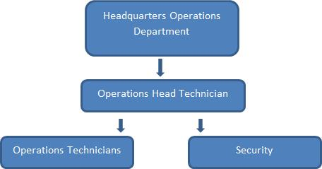

VER Team Members is expected to include the following staff:

Plant Manager (Operations Head Technician): Operations head technician has been assigned as the overall responsible of compliance with VER monitoring plan. He is responsible for day to day running of plant, recording and monitoring of relevant data. Operation technicians will be assisting him with the gathering and reporting of the data.

Accounting Management (Headquarters Operations Department): Since the company is a part of larger group, financial matters are managed from the headquarters. Operations Department is responsible for accounting, handling data about power sales, social security documents, invoicing and other personnel affairs.

GTE Carbon: Responsible for emission reduction calculations, preparing monitoring report and periodical verification process.

EPİAS records will be used as the primary source of data for electricity generation since the billing is based on the EPİAS records. Generation of the plant can monitored from EPIAS web platform which is accessible using a password provided to electricity generation companies. ISVM (Electricity fed to the grid) and UECM (Electricity consumed from the grid) data given in EPIAS records will be used for emission reduction calculations. Electricity generation of the Canta WPP will be cross checked by using the records of metering devices at project site. Two metering devices (one of them used as spare) will be used for monitoring the electricity generated by the power plant

All data will be kept for at least two years after the crediting period for QA/QC purposes.

The calibration and maintenance of the meters will be carried out in line with the by law on Metering and Metering Devices. Accordingly, the meters are calibrated and sealed by TEIAS before the commissioning of the power plant. The meters will be calibrated by TEIAS when there is an inconsistency between two devices.

B.8. Date of completion of application of methodology and standardized baseline and contact information of responsible persons/ entities

Date of completion of the study on application of the selected methodology:

01/08/2019 Responsible entities: Please refer to Appendix 1.

SECTION C. Duration and crediting period

C.1. Duration of project activity

C.1.1. Start date of project activity

Start date of project activity is determined as 26/03/2012, date of turbine agreement.

C.1.2. Expected operational lifetime of project activity

- The operational lifetime of the project is about 49 years as per the license issued. According to the technical lifetime of turbines which is given as 25 years as per the tool and also estimated as 20 years by experts, turbines will be renovated or replaced and project will continue to be operated by the project owner until end of the license period. Project will be delivered to government authority at no cost at the end of license period.

C.2. Crediting period of project activity

C.2.1. Type of crediting period

Project will use two times renewable crediting period, and this is the first crediting period.

C.2.2. Start date of crediting period

Start date of crediting period is chosen as 01/10/2014.

C.2.3. Length of crediting period

First crediting period will be valid for 7 years and 0 month. 01/10/2014 – 30/09/2021

SECTION D. Environmental impacts

D.1. Analysis of environmental impacts

Environmental impacts of the project have been assessed as per the regulations and a preliminary EIA has been prepared for the project. The file has been assessed by relevant authorities and assessed as sufficient as the impacts of the project is not seen as significant. Project owner has also carried out an ESIA report on top of the pre-EIA report at international standards for better assessment and evaluation of the project and measures required. Also, ornithology report has been prepared for the project for the by academicians.

Within the scope of the ESIA study, all potential impacts of the project including air quality, noise, waste disposal, landscape, visual impacts, H&S issues have been assessed and measures identified has been given in the document prepared.Also, more detailed ornitology reports have been has been prepared study for the project after commissioning.

D.2. Environmental impact assessment

As per the project type and location, no significant impact has been identified during assessment and stakeholder consultations.

Within the scope of the studies and analysis given above, environmental impacts have been identified together with measures planned to be implemented.

SECTION E. Local stakeholder consultation

E.1. Solicitation of comments from local stakeholders

Local Stakeholder Meeting for 45 MW Çanta Wind Power Plant (WPP) project was held at Çanta Village Coffee House on 16/04/2012 in Silivri District at Istanbul Province in Turkey. The meeting was organized in line with the Gold Standard requirements. The stakeholders and the list of invitation are identified accordingly. The meeting covered all agenda items recommended by the Gold Standard.

Agenda

14:30-14:45 Opening and Introduction of the Çanta Wind Power Plant Project

14:45 -15:00 Climate Change and Carbon Markets, Global Tan Energy

15:00 -15:20 Explanation of Grievance Mechanisms and Blind SD Exercise and discussion on monitoring

15:20-15:50 Q &A

15:50- 16:00 Evaluation and feedback session
Closure

Five females attended to the meeting.

E.2. Summary of comments received

Meeting was organized at the village coffee house on 16/04/2012 with more than 100 locals attendance. There were five females at the meeting.

To start with, Kemal Demirkol Managing Director form GTE gave a brief opening speech explaining the aim of the meeting and introduced project representatives Sezgin Baktır and Serhat Çakır from Boydak Enerji Üretim A.Ş. and Yusuf Pehlivan from Almer Environmental Consultancy. Sezgin Baktır briefed the locals about the about project and company. After that GTE gave information about climate change and its effects, carbon certification and the Gold Standard process. Also Kemal Demirkol explained the grievance rule of the Gold Standard stressing that the meeting was just the beginning of a process for at least 7 years. It was highlighted that the GS was also considerate about the social and environmental impacts of the projects and required continuous feedback from the stakeholders, especially of locals. Then, it was explained that a grievance notebook would be placed at a secure and easily accessible place, such as the muhktar’s, where they could fill in whenever there was a complaint or request which would be regularly checked by the project manager. As a result of consultation with the locals, it was decided that the notebook would be debited on the muhktar. During this part of the meeting, the contact details of the project owner, project proponent and the GS Regional Manager’s were shared with the muhktar and the participants. As following, Yusuf Pehlivan gave brief explanation on about project’s environmental and social impact. After that the questions from villagers were answered. Questions and answers are below.

Local from Değirmen Village: What are the effects of the project on human health and occupational areas?

Yusuf Pehlivan: We have tried to explain the impacts directly related to human health and envirionment. So far, no negative impact of turbines on human health has been detected. This is the 1/25000 map of the area and the locations of the turbines. We can try to give further detail if you have any question.

Local Participant: What is the minimum distance to the settlement so that the people will not be affected from the turbines? What is the minimum distance to the turbines that the people can build house?

Yusuf Pehlivan: the most important impact of the project is the noise problem. There is a safety distance around the turbines.

Mehmet Has(Silivri Municipality): Will you expropriate the land or apply easement for lands used?

Sezgin Baktır: There are many different type of ownerships in the project area including private land,

grassland and forest area. Ownership of the switchyard area is belongs to our companys. Therefore,

we’ll only use land turbine basements and try to use existing or cadastral road as much as possible.

Mayor of Silivri: There are many project near Silivri including 3rd Airport, railway and Canal Istanbul. There is also significant agricultural activity in this region and fertility of the land is high. We should protect agricultural land and also meet energy demand. From our perspective, there are three main issues which are ownership of the lands, impact on agricultural production and grassland. There may be other concerns of locals, we’ll make our decision after having locals’ opinion about the project. We should first listen what locals are thinking?

Şenol Köroğlu:How/Why did you choose Çanta/Değirmenköy?

Head of Chamber of Agriculture: Will this project impact the studies on development plan for this region? There will be a safety distance also. Are we going to be able to build barns near the turbines?

Sema Kurt(Silivri Municipality): There are four tumulus in this region and there should be at least 100m safety distance. Have you considered this in your layout?

Local Participant: There is a grassland here. EPDK has made an attempt to change the status of the grassland. EPDK should also be here.

Sezgin Baktır: The location of the projects are determined according to several factors including grid capacity, wind efficiency, status of the land and existing structures. We have considered the tumulus in layout and cancelled location of several turbines considering safety distances. For development plan issue, you’ll be able to build your barns. As per the regulations, you can only use and expropriate the area you really need for the project. Our boundaries and coordinates are given in the generation license. We have to stay within these boundaries. We have informed and invited EPDK to this meeting. But they said they’d come to the site later when the expropriation process is initiated. Before issuance of license, 18 institution has been consulted and their opinions have been collected.

Local Participant: After you implement the project, will it prevent zoning of this region for construction? Agricultural income is not very high and expectation of many farmers is allowing construction in this area.

Local Participant: There is a forest area in the backyard of Degirmenkoy. There is no agricultural land or grassland. Why don’t you built it there? Will you use all the land between the turbines? How will you mange the expropriation process? If our land is partially remains within the project site, will you expropriate all of it?

Sezgin Baktır: This is up to government agencies. We’ll only be using the land allocated for the project and try to minimize area used. Location and boundaries are determined by the license. We’ll not be using all the land within the boundary, just the turbine locations will be used . Rest of the land will still be accessible by others. If after expropriation, a small amount which is not feasible to cultivate remains, you may request and we may expropriate the remaining land also.

After that section, the sustainability blind test was held which was challenging as the locals explicitly declared that the issues were difficult to discuss for them.

E.3. Report on consideration of comments received

 |  | Stakeholder comment |  |  | Was comment taken into | Explanation |  |  | (Why?
 |  |  |  |  | account (Yes/ No)? | How?)
 |  |  |  |  |  | During | the |  |  | construction
 | Question on contribution |  |  |  |  | phase | constant |  |  |  | feedback
 |  |  |  |  | Yes | will be collected from the
 | to the village |  |  |  | Yes
 |  |  |  |  |  | village | to | address |  |  |  | their
 |  |  |  |  |  | needs.
 | Question on the progress of |  |  |  |  | The project is expected to
 |  |  |  |  | Yes | start by end of 2014/early
 | the project |  |  |  | Yes
 |  |  |  |  |  | 2015
 |  |  |  |  |  | Even though the company
 | Question on origins of the |  |  |  |  | provides its best effort to
 |  |  |  |  | Yes | use domestic equipment,
 | equipment |  |  |  | Yes
 |  |  |  |  |  | there | isn’t |  |  | any |  | rotor
 |  |  |  |  |  | production in Turkey
 |  |  |  |  |  | Project | will |  |  | use |  | new
 |  |  |  |  |  | turbines which have |  |  |  |  |  | less
 |  |  |  |  |  | noise compared to previous
 |  |  |  |  |  |  |  |  |  | generation
 | Question on Noise |  |  |  | Yes | turbines. |  |  |  |  |  | Also,
 |  |  |  |  |  | measurements |  |  |  |  | will | be
 |  |  |  |  |  | carried | out |  |  | at | nearest
 |  |  |  |  |  | settlements |  | to |  |  | determine
 |  |  |  |  |  | risks | and |  |  |  | implement
 |  |  |  |  |  | measure if necessary.
 | Question |  | on | Local |  | Locals will have priority in
 |  |  | on | Local | Yes | recruitment if they have
 | Recruitment |  |  |  | Yes
 |  |  |  |  |  | relevant skills.

Stakeholder Feedback Round

During the local stakeholder meeting, the participants have been informed about the feedback round and its importance on following up the project activities, as well as addressing their potential issues. Since, no significant concern has appeared during LSC meeting SFR was not conducted as a live meeting.

In order to prepare for the feedback round, a summary of the consultation report prepared in Turkish was sent to the identified stakeholders and participants through mail or local authorities. International offices of Helios International, Mercy Corps and local representative of GS were included in the feedback round also.

Soft copies of the project documents were available on the web site of GTE (www.gtecarbon.com). Hard copies of the LSC Report and/or Passport will be available during the 2-month long feedback round for those who do not have internet access.

SFR for Canta WPP was initiated on 11/10/2013 and is finalized on 13/01/2014. Feedbacks collected are supportive of the project. For the documents related to the organization of the SFR and the feedbacks, please, see the Gold Standard Passport. During the stakeholder consultation meeting, no significant issues have been raised by the participants that would make a revisit required for the sustainable development.

SECTION F. Approval and authorization

Project is developed as a GS-VER project. Since Turkey does not have a cap and trade system or issue approval letter, no authorization or approval is needed.
>>

Appendix 1. Contact information of project participants and

 | responsible persons/ entities
Project participant |  | Project participant
and/or responsible |  | Person/entity responsible for completing the CDM-MR-FORM
person/ entity |  | Person/entity responsible for completing the CDM-MR-FORM
Organization name |  | BOYDAK ELEKTRİK URETiM SANAYi VE TiCARET AS
Street/P.O. Box |  | Ziya Gökalp Mahallesi
Building |  | No:3
City |  | İstanbul
State/region |  | -
Postcode |  | 34306
Country |  | Turkey
Telephone |  | +90 216 267 42 06
Fax |  | +90 216 267 42 09
E-mail |  | Serhat.sert@boydak.com
Website |  | www.boydak.com
Contact person
Title |  | Mr
Salutation |  | Sert
Last name |  | -
Middle name |  | Serhat
First name |  | Business Development
Department |  | Management
Mobile |  | -
Direct fax |  | +90 216 267 42 06
Direct tel. |  | +90 216 267 42 09
Personal e-mail |  | Serhat.sert@boydak.com
Project participant |  | Project participant
and/or responsible |  | Responsible person/ entity for application of the selected methodology (ies)
person/ entity
person/ entity |  | and, where applicable, the selected standardized baselines to the project
 |  | activity
Organization name |  | GTE CARBON
Street/P.O. Box |  | Ehlibeyt Mah 1259. Sokak
Building |  | 7/2
City |  | Ankara
State/Region |  | -
Postcode |  | 06520
Country |  | Turkey
Telephone |  | +90 312 472 35 00
Fax |  | +90 312 472 33 66
E-mail |  | gte@gtecarbon.com
Website |  | www.gtecarbon.com
Contact person |  | Mehmet Kemal Demirkol
Version 06.0 |  | Page 61 of 56



CDM-PDD-FORM

Title | Director
Salutation | Mr.
Last name | Demirkol
Middle name | Kemal
First name | Mehmet
Department | Management
Mobile | -
Direct fax | +90 312 472 35 00
Direct tel. | +90 312 472 33 66
Personal e-mail | kemal@gte.com.tr

Appendix 2. Affirmation regarding public funding

No public funding is used for the project activity

Appendix 3. Applicability of methodology and standardized baseline

Applicability of project activity is given in Section B.2

Appendix 4. Further background information on ex ante calculation of emission reductions

Data used in calculation of OM for Turkish Electricity Grid

Table 9 Values used in calculation of OM

Fuel Type | NCV (Gj/t) | EF | COEF
Fuel Type | (1000m³ for gas) | (tCO2/Gj) | (tCO2/t)
Coal | 24.0 | 0.0895 | 2.15
Lignite | 7.1 | 0.0909 | 0.65
Fuel Oil | 41.8 | 0.0755 | 3.16
Diesel Oil | 44.2 | 0.0726 | 3.21
LPG | 0.0 | 0.0616 | 0.00
Naphtha | 0.0 | 0.0693 | 0.00
Natural Gas | 37.2 | 0.0543 | 2.02

Version 06.0 Page 62 of 56

CDM-PDD-FORM

Table 10 Amount of fuels used for electricity generation

 |  |  |  |  | Total | Fuel | Total Emission
 | 2012 | 2013 |  | 2014 | Consumption |  | Total Emission
Fuel Type | 2012 | 2013 |  | 2014 |  |  | 2012-2014
Fuel Type |  |  |  |  | 2012-2014 |  | 2012-2014
 |  |  | Ton or 1000 m3 (for gas)
Hard Coal | 12,258,462 | 12,105,930 |  | 14,501,934 | 38,866,326 |  | 83.535.700
Lignite | 55,742,463 | 47,120,306 |  | 57,696,139 | 160.558.908 |  | 103.966.359
Fuel Oil | 564,796 | 573,534 |  | 754,283 | 1.892.613 |  | 5.976.176
Diesel Oil | 176,379 | 129,359 |  | 119,988 | 425.726 |  | 1.365.288
LPG | 0 | 0 |  | 0 | 0 |  | 0
Naphtha | 0 | 0 |  | 0 | 0 |  | 0
Natural | 23,090,121 | 22,909,746 |  | 25,426,014 | 71.425.881 |  | 144.285.518
Gas

Data used in calculation of BM for Turkish Electricity Grid

Table 11 Net calorific values, generation efficiency and emission factor data used in calculations

 | A | B | D | E
 | NCV | EF CO2 |  | (=3.6/D/1000*B)
 | (Gj/t or m³ for gas) | (tCO2/Gj) | Generation Efficiency | EF
 |  |  |  | tCO2/GWh
Coal | 24.0 | 0.0895 | 39.0% | 0.826
Lignite | 7.1 | 0.0909 | 39.0% | 0.839
Fuel Oil | 41.8 | 0.0755 | 39.5% | 0.688
Diesel | 44.2 | 0.0726 | 39.5% | 0.662
LPG | 0.0 | 0.0616 | 39.5% | 0.561
Naphtha | 0.0 | 0.0693 | 39.5% | 0.632
Natural Gas | 37.2 | 0.0543 | 60.0% | 0.326

Version 06.0 Page 63 of 56

CDM-PDD-FORM

Table 12 Most recent capacity additions corresponding to 20%

 |  | Electricity |  | Emission | Share in Total
 |  | Generated |  | Factor of | Generation
 |  | (EGm,y) |  | Power Unit
Fuel Type |  |  |  | (EF EL,m,y)
Fuel Type | 2013 | 2014 (MWh) | TOTAL | tCO2/MWh | %
 | (MWh) |  |  |  | %
Coal | 0.0 | 19,702 | 19,702 | 0.826 | 43.8%
Lignite | 0.0 | 394.0 | 394.0 | 0.839 | 0.9%
Fuel Oil | 0.0 | 0.0 | 0.0 | 0.688 | 0.0%
Diesel Oil | 0.0 | 0.0 | 0.0 | 0.662 | 0.0%
LPG | 0.0 | 0.0 | 0.0 | 0.561 | 0.0%
Naphtha | 0.0 | 0.0 | 0.0 | 0.632 | 0.0%
Natural Gas | 10,226.8 | 8,755.1 | 18,982.0 | 0.326 | 42.2%
Renewable
(Biomass, | 1,341.0 | 4,578.0 | 5,919.1 | 0.826 | 13.2%
wastes,
Hydro, wind,
geothermal)
Total | 11,567.9 | 33,429.6 | 44,997.0 |  | 100.0%

Appendix 5. Further background information on monitoring plan

N/A

Appendix 6. Summary of post registration changes

N/A

Version 06.0 Page 64 of 56

CDM-PDD-FORM

Appendix 7. Generation Licence

Version 06.0 Page 65 of 56

CDM-PDD-FORM
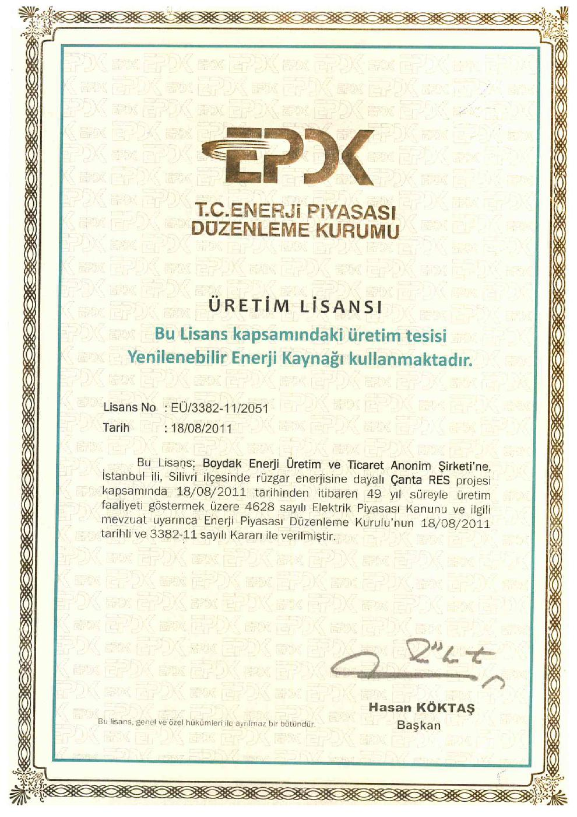

Version 06.0 Page 66 of 56

CDM-PDD-FORM

Version 06.0 Page 67 of 56

CDM-PDD-FORM

Appendix 8. EIA-Exemption Letter

Version 06.0 Page 68 of 56

CDM-PDD-FORM
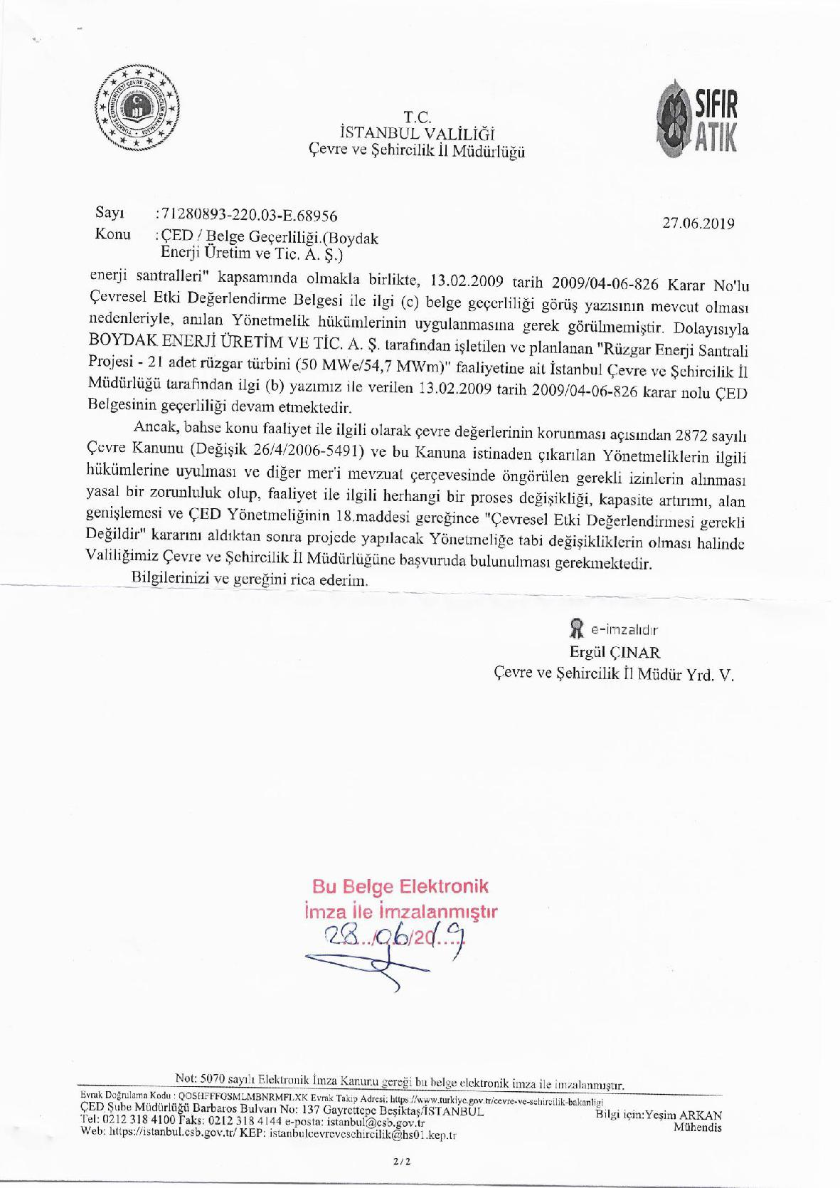

Version 06.0 Page 69 of 56

CDM-PDD-FORM

- - - - -

Version 06.0 Page 70 of 56

CANTA WPP PRE-EIA Report page 15
Grid Connection Agreement
http://cdm.unfccc.int/methodologies/PAmethodologies/tools/am-tool-10-v1.pdf
http://www.dpt.gov.tr/DocObjects/Download/3159/ilce.pdf (Page 174)
http://www.teias.gov.tr/T%C3%BCrkiyeElektrik%C4%B0statistikleri/istatistik2011/uretim%20tuketim(22-45)/44.xls
http://www.teias.gov.tr/T%C3%BCrkiyeElektrik%C4%B0statistikleri/istatistik2011/yak%C4%B1t46-49/47.xls
http://cdm.unfccc.int/EB/041/eb41rep.pdf
Calculation provided in the Financial Analysis Excel.
http://cdm.unfccc.int/methodologies/DB/UB3431UT9I5KN2MUL2FGZXZ6CV71LT
http://cdm.unfccc.int/methodologies/PAmethodologies/tools/am-tool-01-v7.0.0.pdf/history_view
http://cdm.unfccc.int/methodologies/PAmethodologies/tools/am-tool-07-v3.0.0.pdf/history_view
http://www.teias.gov.tr/apkuretimplani/veriler.htm
http://www.teias.gov.tr/T%C3%BCrkiyeElektrik%C4%B0statistikleri/istatistik2010/front%20page%202010-%C3%A7i%C3%A7ek%20kitap/uretim%20tuketim(22-45)/36.xls
http://cdm.unfccc.int/methodologies/PAmethodologies/tools/am-tool-01-v7.0.0.pdf/history_view
Law number 4628, enactment date 03/03/2001 http://www.epdk.gov.tr/english/regulations/electricity.htm
Law number 5346, enactment date 18/05/2005 http://www.epdk.gov.tr/documents/10157/4b360128-53aa-4174-8104-a6c10434ac9c
Law number 5627, enactment date 02/05/2007 http://www.eie.gov.tr/english/announcements/EV_kanunu/EnVer_kanunu_tercume_revize2707.doc
Law number 6831, enactment date 31/08/1956
Law number 2872. Published in official gazette No. 18132 on 11/08/’83
http://wwwwds.worldbank.org/external/default/WDSContentServer/WDSP/IB/2009/05/11/000333037_200905110307
Amended Generation License (after capacity extension). Previous capacity is 45 MWe
http://www.istanbulymmo.org.tr/_dosya/MaliPlatform/30.%205520%20sayili%20kurumlsr%20vergisi%20ka nunu%20ac%C4%B1klamalari.pdf, page 6
Tulletprebon newsletter
http://www.tcmb.gov.tr/
http://www.enerji.gov.tr/mevzuat/5346/5346_Sayili_Yenilenebilir_Enerji_Kaynaklarinin_Elektrik_Enerjisi_Uretimi_ Amacli_Kullanimina_Iliskin_Kanun.pdf, available at (I Sayılı Cetvel)
https://rapor.pmum.gov.tr/analytics/saw.dll?PortalPages (please, choose the stated dates to obtain the report)
https://rapor.pmum.gov.tr/analytics/saw.dll?PortalPages
https://pmum.teias.gov.tr/UzlasmaWeb/
https://www.eigm.gov.tr/tr-TR/Sayfalar/Enerji-Yatirimlari
http://www.teias.gov.tr/T%C3%BCrkiyeElektrik%C4%B0statistikleri/istatistik2011/kgucunkullan%C4%B1 m(13-21)/13.xls
http://www.ipcc-nggip.iges.or.jp/public/2006gl/pdf/2_Volume2/V2_2_Ch2_Stationary_Combustion.pdf
http://www.teias.gov.tr/T%C3%BCrkiyeElektrik%C4%B0statistikleri/istatistik2011/yak%C4%B1t46-49/47.xls
http://www.teias.gov.tr/T%C3%BCrkiyeElektrik%C4%B0statistikleri/istatistik2011/yak%C4%B1t46-49/49.xls
http://www.teias.gov.tr/T%C3%BCrkiyeElektrik%C4%B0statistikleri/istatistik2011/uretim%20tuketim(22-45)/29(06-2011).xls
http://www.teias.gov.tr/T%C3%BCrkiyeElektrik%C4%B0statistikleri/istatistik2011/uretim%20tuketim(22-45)/29(06-2011).xls
http://www.teias.gov.tr/T%C3%BCrkiyeElektrik%C4%B0statistikleri/istatistik2011/uretim%20tuketim(22-45)/33(84-11).xls
http://www.teias.gov.tr/T%C3%BCrkiyeElektrik%C4%B0statistikleri/istatistik2011/uretim%20tuketim(22-45)/33(84-11).xls
http://www.teias.gov.tr/T%C3%BCrkiyeElektrik%C4%B0statistikleri/istatistik2011/kguc(1-12)/8.xls
http://www.teias.gov.tr/KAPASITEPROJEKSIYONU2012.pdf
http://www.teias.gov.tr/T%C3%BCrkiyeElektrik%C4%B0statistikleri/istatistik2011/yak%C4%B1t46-49/49.xls
http://cdm.unfccc.int/methodologies/PAmethodologies/tools/am-tool-07-v3.0.0.pdf
http://www.mevzuat.adalet.gov.tr/html/21179.html
http://cdm.unfccc.int/methodologies/PAmethodologies/tools/am-tool-10-v1.pdf

