Stakeholder Consultation Report

PUBLICATION DATE 05.05.2022
VERSION v. 2.0
RELATED SUPPORT

TEMPLATE GUIDE Stakeholder Consultation Report v.2.0

This is a report template to be used for filling the information pertaining to Local Stakeholder Consultation and Stakeholder Feedback Round conducted in line with the Stakeholder Consultation and Engagement Requirements.

This document contains the following Sections
Key Project Information
Grouped Consultation Information
SECTION A - Information made available to Stakeholders
SECTION B - Invitations made to Stakeholders
SECTION C - Report of the Consultation Process
SECTION D - Continuous input / Grievance mechanism
SECTION E - Stakeholder Feedback Round

KEY PROJECT INFORMATION
GS ID of Project | GS7154
Title of Project | Chanju I Hydro Electric Project
Version number of this Report | 01
Completion date of version | 26/09/2022
Time of First Submission Date | -
Start Date of the Project | 23/07/2011
Date of Meeting (s) | 17/01/2009
Project Cycle: | Regular  Retroactive

INFORMATION MADE AVAILABLE TO STAKEHOLDERS
        - Preliminary agenda for the meeting
The stakeholder consultation meeting was being organized in order to take into consideration the inputs/ feedbacks/ grievances about the project activity from the local stakeholders who might be affected directly or indirectly by the project activity. Therefore the physical meeting was being planned in order to take due consideration of the above points.
Also as a part of continuous feedback mechanism, a grievance register has been placed at project site wherein even after the meeting the stakeholders can mention their feedbacks or grievances about the project activity which will be taken care of in case it is found to be genuine.
The project is a large- scale project is to generate power from harnessing the water to meet the ever-increasing demand for power in India with total installed capacity of 36 MW. The purpose of the project activity is to generate energy electricity by the utilization of renewable hydro power and further selling the generated energy to the Indian Grid. In this process there is no consumption of any fossil fuel and hence the project does not lead to any greenhouse gas emissions. Thus, electricity would be generated through sustainable means without causing any negative impact on the environment.
        - A non–technical summary of the project
The objective of the proposed project is to generate power from harnessing the water to meet the ever-increasing demand for power in India. The generated power will be exported to the NEWNE grid (Now Indian Grid) via the sub-station at Kurthala. The project will replace anthropogenic emissions of greenhouse gases (GHG’s) estimated to be approximately 142,582 tCO₂e per year, thereon displacing 156,272 MWh/year amount of electricity from the generation-mix of power plants connected to the INDIAN Electricity grid, which is mainly dominated by thermal/ fossil fuel based power plant
        - Contact details to get further technical detail and project information
>> Mr. Goyal Kumar Shravan I.A. Energy Ph- Message +91-7714288019
email:- skgoyal@goelgroup.co.in
        - Summary of economic, social and environmental impacts of the Project
>>
Sustainable Development Goals Targeted | SDG Impact  (defined in) | Estimated Annual Average | Units or Products
SDG 13- Take urgent action to combat climate change and its impacts | Emission reductions | 142,582 | GS-CER
SDG 7– Ensure access to affordable, reliable, sustainable and modern energy for all | MWh of renewable  energy generated | 156,272 | MWh
SDG 8 – Promote sustained, inclusive and sustainable economic growth, full and productive employment and descent work for all | Number of trainings and employment generated through project | 1 training/annum and employment to 5 persons | Number of trainings and Employment generated through project

Contribution to sustainable development

Ministry of Environment and Forests, has stipulated economic, social, environment and technological well-being as the four indicators of sustainable development. The project contributes to sustainable development using the following ways.

Social well-being: The project would help in generating employment opportunities during the construction and operation phases. The project activity will lead to development in infrastructure in the region like development of roads and also may promote business with improved power generation.

Economic well-being: The project is a clean technology investment in the region, which would not have been taken place in the absence of the carbon credit benefits the project activity will also help to reduce the demand supply gap in the state.

Technological well-being: The successful operation of project activity would lead to promotion of hydro power generation and would encourage other entrepreneurs to participate in similar projects.

Environmental well-being: Wind being a renewable source of energy, it reduces the dependence on fossil fuels and conserves natural resources which are on the verge of depletion. Due to its zero emission the Project activity also helps in avoiding significant amount of GHG emissions
        - Other relevant information to help stakeholders understand the project
>> Prior to the implementation of the project activity the electricity distribution system was supplied by at least one fossil fuel fired generating unit. The baseline scenario is the same as the scenario existing prior to the start of implementation of the project activity.

The proposed project is a run-of-river hydro-electric power plant with a design discharge of 16.85 m³/sec and design head of 236.67 m. The hydro power plant has an installed capacity of 36 MW (3x12) and is capable of producing 157,850 MWh of power per year in a 90% dependable year with 95% machine availability and operating at a plant load factor of 50.05%. The catchment area at the diversion site is 307 km².

The salient features of the Chanju I Hydro Electric Project are:

Parameter | Value
Net Head | 236.67 m
Type of power house | Surface
Design discharge per unit | 5.62m³/sec
Type of switchgear | 132kV air insulated switchgear
Speed of turbine | 750 rpm
Generation voltage | 11kV
Transmission voltage | 132kV
GSU transformer | 25/20 MVA 3 phase, 11/132 kV

The main components of the project are:

  - A 54m wide gated weir
  - A side intake comprising of two segments
  - Twin desilting basins to provide flexibility in operation in case one is out of operation
  - A 5328 m pressure flow head race tunnel
  - A 140.4m long, 2.3m diameter surface penstock
  - A surface power house to house three vertical axis Francis units of 12MW each
  - A tail race channel with a reverse slope that will discharge into the river in the direction of the river flow
  - A surface switchyard 100m x 50m which shall house the generator transformer, station transformer and the feeder bays
  - 132 kV DC line from Kurthala to Bathri for evacuation of power

The project comprises of a diversion weir across Chanju nallah at about 100 m downstream of the confluence of Chanju and Bhararu nallahs, twin intakes, twin feeder/ connecting tunnels, twin desilting basins approximately 83 m long each, a headrace tunnel approximately 4580 m concrete lined and 748 m steel lined. A 528 m long construction adit, which acts as a surge gallery has been provided at Naredh nallah crossing. Tail water is proposed to be discharged into Chanju nallah through an open channel. A 132 kV switchyard is proposed on the upside of the power house. The Full Reservoir Level (FRL) and Minimum Draw Down Level are proposed to be kept at El. 1,440 m and El. 1,432.75 m respectively. The live storage works out to be 130,700 m³ which is adequate to provide two hours of peaking twice a day at full installed capacity of 36MW. The energy storage capacity of the hydro electric plant during peak period is 50.07GWh.
The turbine characteristics would be selected such that the optimum efficiency falls close to the rated output of the unit at rated head. A pumping station will be provided to supply an adequate quantity of water from the tailrace for cooling of the turbine generator bearings, generator air coolers and selected plant services.

Each synchronous generator would be vertical shaft, salient pole type, 3 phase, 50Hz directly coupled to the turbine. It would be rated for a continuous output of 25/20 MVA at a power factor of 0.85 and a rated voltage of 11kV.

The power from the proposed project activity has been planned to be injected at Nakrod by LILO arrangement in to 132 kV D/C line under construction between 132kV Kurthala sub-station and existing 132kV Bathri and 220/132kV Chamba sub-stations. The line length up to Nakrod shall be about 6 kms.

INVITATIONS MADE TO STAKEHOLDERS
        - Invitation tracking table

Category Code | Stakeholder Type/Organisation (if relevant) | Name of invitee | Male/  Female | Method of invitation | Date of invitation  (>30 days before Meeting)
A |  | All Local people of the villages Lesui, Bhaghiagarh and Tikrigarh, Tehsil Churah, District- Chamba, Himachal Pradesh including the members of local government bodies i.e. village panchayat and representatives of few local NGOs | Male and Female | Through Public Notice | 17/01/2009
B | Winrock International, India | Mr. Debajit Das | Male | E-mail | 02/02/2019
C | NCDMA India | Sharad Sapra/ Sharad Negi | Male | E-mail | 02/02/2019
D | Mysore Spastic Society | Representatives | N/A | E-mail | 02/02/2019
E | Non-conventional Energy and Rural Development (NERD) society  Development Alternatives-Social Enterprise | Representatives | N/A | E-mail | 02/02/2019
F | Gold Standard representative | help@goldstandard.org | N/A | E-mail | 02/02/2019
G | Asha for Autism | info@ashaforautism.com | N/A | E-mail | 02/02/2019

The Invitation given for the Local stakeholder meeting includes basically people who
are directly affected by the project activity such as villagers, NGOs, which includes
participants of all age, also the participant of both gender are welcomed
          - Appropriateness of methods
>> A physical meeting has been conducted for the Stakeholder Consultation and it is an appropriate method for the conduction of the Stakeholder Consultation.
          - Gender Sensitivity
>> The project developer ensured that the gender issues are fully factored into the
comprehensive social and environmental impact assessments and that equal and
effective participation of both women and men in stakeholder consultation is ensured.
The project also meets all the guidelines mentioned in the GOLD STANDARD FOR THE
GLOBAL GOALS GENDER EQUALITY REQUIREMENTS & GUIDELINES Version 1.1
          - Evidence proving invites took place as stated
>> The text for the public Notice for conducting the Local Stakeholder Meeting is provided below

Invitation letters to local bodies
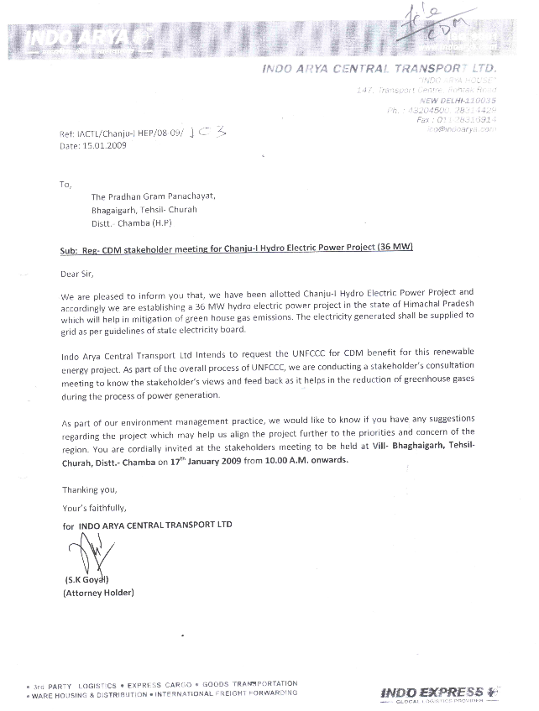

          - Sample content of invites (for each Method above)
>> The stakeholders have been invited via public notice which has been mentioned in the section B.1.3.
          - Description of other Means and methods to provide feedback for those who are not able to join the consultation meeting
>> The invitation for the local stakeholder meeting has been sent via public notice. All the interested participants attended the meeting. Hence the feedback mechanism for those who are not able to join the consultation meeting was not required.
Stakeholders those who are not able to join the consultation meeting can provide their inputs/feedbacks in the grievance register placed at the site office.

The process for the SFR is as follows;
- E mail and Invitations sent to relevant stakeholders
- The non-technical summary of project activity along with Registered PDD, web link of UNFCCC web page for the same registered project in CDM, draft GS4GG PDD submission to relevant stakeholders, GS Public view section web link.
- Grievance Mechanism Feedback/Questions from Stakeholders
- Answers for questions received from stakeholders during online SFR process.
Identification of Stakeholders:

The Stakeholder feedback round was conducted to consider and receive feedback from the possible stakeholders to the project, i.e. NGOs. Apart from these, the stakeholders as identified by Gold Standard Board, i.e. Gold Standard partnered NGOs in India and DNA of India (MoEFCC).

Invitations to Stakeholders:

The Stakeholder feedback round was done online method. Email invitations were sent to GS partnered NGO’s and MoEFCC. The relevant documents of project activity like GS4GG PDD, project Technical summary were made available during Stakeholder feedback round.
The list of invites to whom the SFR e mail has been sent is given below, .
For local stakeholders, public notice has been put at project site. Also SFR process are mainly to cover the issues raised during local stakeholder consultation and there were no any negative comments raised during initial physical local stakeholder consultation.
Thus public notice put at project site village and requested the feedback for this project activity as a part of SFR was sufficient and meets the requirement as per GS4GG. This public notice covers all local stakeholders for feedback during SFR process. The public notice has mentioned different feedback methods like the grievance register, telephone access, internet access so that local stakeholders can give their feedback for the project activity.

REPORT OF THE CONSULTATION PROCESS
        - Date of Meeting
>>17/01/2009

          - Justification of why consultation took place after the project start date (retroactive projects only)
>> The project activity is a CDM Registered project having UNFCCC number as 10153 with a crediting period of 26/07/2017 to 25/07/2024 (renewable).
The local population is considered the major stakeholder for the proposed project activity. A notice was published on 14/01/2009 for seeking EIA clearance and carbon credits in three local newspapers – Dainik Jagran, The Tribune and Dainik Tribune followed by stakeholder meeting on 17/01/2009.

The project start date is 23/07/2011, i.e. award of first civil work. The consultation took place on 17/01/2009 which is prior to the start date of the project activity.

          - List of participants
Date and Time | 17/01/2009:  10:00 AM | Location | Village VIII Bhaghaigarh, Tehsil Churah, Dist Chamba, Himachal Pradesh

Category  Code | Name of  participant | Age | Sex(M/F) | Occupation | Village | Signature/RTI
A | Man Dei |  | F | Village Head, Bhaghaigarh | Bhaghaigarh | -
A | Ram Das |  | M | Village Deputy Head, Bhaghaigarh | Bhaghaigarh | -
A | Chatro Ram |  | M | Village Head, Tikrigarh | Tikrigarh | -
A | Khemraj |  | M | Village Head, Leisui |  | -
A | Rahul Chofla |  | M | Villager | Tikrigarh | -
A | Dhinuram |  | M | Villager | Tikrigarh | -
A | Chain Lal Sharma |  | M | Villager | Bhaghaigarh | -
A | Man Singh |  | M | Villager | Tikrigarh | -
A | Surat Ram |  | M | Villager | Tikrigarh
A | Jeet Singh |  | M | Villager | Tikrigarh
A | Govind |  | M | Villager | Tikrigarh
A | Shivram |  | M | Villager | Leisui
A | Dhunichand |  | M | Villager | Leisui
A | Bhumi Ram |  | M | Villager | Tikrigarh
A | Mor Singh |  | M | Villager | Bhaghaigarh
A | Dharu Ram |  | M | Villager | Bhaghaigarh
A | Jitendra Gupta |  | M | Villager | Leisui
A | Satish Sharma |  | M | Villager | Tikrigarh
A | Baldev Thakur |  | M | Villager | Bhaghaigarh
A | Natvar Singh |  | M | Villager | Bhaghaigarh
A | Jai Raj Goswami |  | M | Indo Arya (Project Proponent Side)
A | S K Goyal |  | M | Indo Arya (Project Proponent Side)

          - Pictures from the physical meeting(s) (best practice)
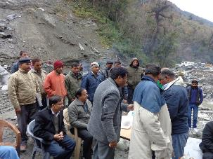 | 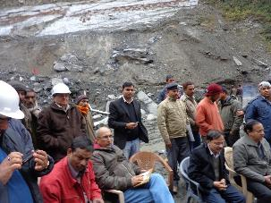
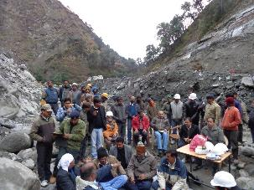 | 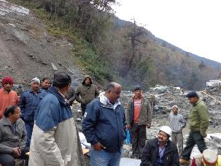

        - Minutes of physical meeting(s)
>>
The minutes of meetings for the stakeholder consultation meeting is given below:
The stakeholders gathered at the venue, as per the scheduled time. The meeting was opened by the site representative with a welcome remark.

The meeting was outlined towards making aware stakeholder & local community people, about the Hydel project activity & how does it leads to reduction of the GHG gases emission. Identification of the stake holders was done as local community stakeholders like villagers, farmers, local school faculties and the representatives of vulnerable groups, Local NGOs representatives, technology suppliers and government executives. Details regarding the proposed project cycle & also the role of local stakeholders in the project was outlined.
Explanation about the main purpose of the project activity i.e. 'to generate electrical energy through green energy generation resource & to utilize the generated output for selling it to the state electricity utility' was narrated. Furthermore, it was elaborated that the said project also conceives the following: -

- Indian economy is highly dominated by generation of electricity using fossil fuel, & coal is majorly used in thermal power plants to generate energy & for production processes, yet the basic necessity of large section is not being met. Use of renewable form of energy generation will change consumption pattern & will mitigating the immense stress on the environment.
- Spread of the commercialization of the Hydropower projects in the region.
- Contribute to sustainable development of the region, socially, environmentally & economically.
After the detailed discussion, some of the stakeholders raised questions on the Hydro energy-based power project to clear their doubts. The comments asked during the session are about the project implementation, employment, development and effect of the project at the local areas. The question summarized are as follows

Common queries and responses are listed below: (meeting dated 17/01/2009)

S.No. | Queries Raised | Reply
 | To whom the employment will be given in construction of project? | The preference will be given to the local villagers only, so that maximum people can get employment opportunities due to this project. Depending upon the capability & education qualification of the people, employment will be given in the form of Skilled & Unskilled.
 | Will this project spoil the soil of surrounding area? | Unlike the coal based power plant project, will affect the surrounding environment but in our project since water will use as renewable source for power generation which is clean and environment friendly hence there is no chances of spoil of surrounding area.
 | Local transport vehicles will use for construction of project | Management has decided to use local transport vehicles so as to get indirect work from company rather than outside agency during the construction of project.
 | How this project will help in development of local area? | As per CSR activity we will incur expenditure @ 2% of the net profit in development of local area in the form of pakka road, borewell, samuhik bhawan, health medical checkup camps, vocational training, skill development etc.

          - Minutes of other consultations
>>Not Applicable
        - Assessment of comments from all consultations above
Gender of Stakeholder | Stakeholder  comment | Was comment taken into account (Yes/ No)? | Explanation/  Justification (Why? How?)
Male | Should preference be given to the local people especially to the project affected area | Yes | The project will provide employment opportunities to the local people
Female | Are there any safety practices to be adopted for this project | Yes | Yes, all the risk associated mitigation measures will be implemented.
Male | Will the project help in improving the electricity supply to the villagers or neighborhood areas | Yes | Yes, the project will help in improving the electricity condition in the adjoining areas.
Male | What steps to be undertaken for the land sliding due to construction activity | Yes | The proponent/representative of the hydel project informed that they will take immediate necessary steps for stabilizing the area.

Name | Man Dei
Gender – Male/Female: | Female
What is your impression of the meeting? | Meeting was very informative
What do you like about the project? | - Environment friendly
What do you not like about the project? | -
Signature
          - Evaluation forms (best practice)

Name | Ramdas
Gender – Male/Female: | Male
What is your impression of the meeting? | Meeting was informative and interactive
What do you like about the project? | Job opportunities
What do you not like about the project? | -
Signature

Name | Chatro Ram
Gender – Male/Female: | Male
What is your impression of the meeting? | Meeting was quite helpful in explaining the project and its benefits
What do you like about the project? | The Project is environmentally friendly and provides jobs for local people
What do you not like about the project? | -
Signature

Name | Khemraj
Gender – Male/Female: | Male
What is your impression of the meeting? | The meeting was informative. We learned many things about the project.
What do you like about the project? | Clean energy
What do you not like about the project? | -
Signature

Name | Rahul Chofla
Gender – Male/Female: | Male
What is your impression of the meeting? | Good Project
What do you like about the project? | Job opportunities/Environment Friendly
What do you not like about the project? | -
Signature

        - Summary of alterations based on comments
>>All participants were satisfied and were in support of the project activity.

CONTINUOUS INPUT / GRIEVANCE MECHANISM
 | Method Chosen (include all known details e.g. location of the book, phone, number, identity  of mediator) | Justification of Choice  (best practice)
Continuous Input / Grievance Expression Process Book (mandatory) | Grievance Register to be  maintained at office of PP and  O&M site office at Project  location | The project activity site office is  appropriate publicly accessible  location at which local stakeholders  can provide their feedback on the  project. This location is also  conducive to continuous and  regular checks for stakeholder  comments. Also Grievance Register  has been kept at PP office so that  any stakeholder can give their  comments to PP
GS Contact (mandatory) | help@goldstandard.org
Telephone access (optional)
Internet/email access (optional)
Nominated Independent Mediator (optional)
Other

STAKEHOLDER FEEDBACK ROUND

Please check this box if the project is retroactive and has done only 1 consultation with a physical meeting integrated into the SFR.
        - Length of the Feedback Round

Stakeholder Feedback Round |  | Planned | Actual
Start Date | 02/02/2019
End Date | 01/04/2019

        - Summarise how all stakeholders were/will be invited to provide feedback
>> All the stakeholders were invited via public notice and the feedback was recorded in a register
        - Summarise Feedback received, including if any changes in project design were made
>>Although, there were no any major negative comments received. The comments have been properly addressed and resolved and there were no any design changes made for the project activity

Revision History

Version | Date | Remarks
1.2 | 5 May 2022 | Addition of grouped consultation info, preliminary agenda and section to justify retroactive consultation took place.  Minor edits to text.
1.1 | 14 October 2020 | Inclusion of Key Project Information  Restructure, new headings and reorder to better match the steps a developer will follow in consultations.  Removal of some non-mandatory template tables (Blind Sustainable Development Assessment). Clarification of best practice steps that are non mandatory processes, clarification of mandatory discussion points. Clarification regarding publishing names and that original evaluation forms (optional) and attendance lists (mandatory) should be separate documents.  Improved clarity on Stakeholder Feedback round section and procedures for retroactive projects  Provision of an accompanying Guide to help the user understand detailed rules and requirements
1.0 | 14 August 2017 | Initial adoption

https://cdm.unfccc.int/Projects/DB/TUEV-SUED1431953233.8/view
The stakeholder consultation took place on 17/01/2009 and the invitation was published on 14/01/2009. The stakeholder consultation took place much before the publication of GS guidelines which says that the date of invitation should be >30 days before Meeting. To make the participation of maximum stakeholders the project proponent published the notice in 3 newspapers along with invitations to local bodies.

