Key Project Information & Programme Design Document (PoA-DD)

PUBLICATION DATE 14.10.2020
VERSION v. 1.1
RELATED SUPPORT
- TEMPLATE GUIDE Key Project Information & PoA Design Document v.1.1

This document contains the following Sections
Key Project Information

SECTION A – General description of PoA
SECTION B - Management System and Inclusion Criteria
SECTION C – Demonstration of additionality
SECTION D – Duration of PoA
SECTION E – Safeguarding principles assessment
SECTION F - Outcome of Stakeholder Consultations

Appendix 1 – Contact information of coordinating/managing entity and responsible person(s)/ entity(ies)

KEY PROJECT INFORMATION
GS ID of Programme | 10963
Title of Programme: | UpEnergy – Social and Climate Impact Programme
Start Date of POA | 07/01/2021
Date of Design Certification | 09/12/2021
POA Period Start Date | 01/01/2021
Version number of the PoA-DD | 5
Completion date of the PoA-DD | 12/01/2022
Coordinating/managing entity | UpEnergy Group
Project Participants and any communities involved | UpEnergy Group
Host Country (ies) | Batch -1:  Madagascar Tanzania Liberia Mozambique Rwanda Batch-2:  Uganda Ethiopia  Democratic Republic of the Congo  Batch-3:  Togo Nigeria Malawi Batch-4: Zambia  Batch-5:  Bangladesh Laos  Batch-6: Myanmar Cambodia Batch-7: Mexico  El Salvador
Activity Requirements applied | Community Services Activities  Renewable Energy Activities  Land Use and Forestry Activities/Risks & Capacities  N/A
Other Requirements applied | Not Applicable
Methodology (ies) applied and version number | - Technologies and Practices to Displace Decentralized Thermal Energy consumption (TPDDTEC), version 03.1  - Emission reduction from safe drinking  water supply-version 1.0
Product Requirements applied | GHG Emissions Reduction & Sequestration  Renewable Energy Label  N/A

General description of PoA
        - Purpose and general description of the PoA

>>
The purpose of the Gold Standard Programme of Activities (PoA) is to provide residential/institutions/commercial users with energy- efficient cooking technologies and water purification systems (WPS) such as Institutional water treatment (IWT) and Household Water Treatment (HWT) technologies with the aim to reduce greenhouse gas (GHG) emissions from the burning of non-renewable woody biomass and/or charcoal for cooking and water treatment to make it safe for consumption.

More than 2.6 billion people in world lack access to clean cooking facilities, relying instead on solid biomass, kerosene or coal as their primary cooking fuel. Developing Asia is home to almost 65% of the global population without access, with 1.6 billion people lacking clean cooking facilities. The lack of access to clean cooking remains very acute in sub-Saharan Africa. The vast majority of people in sub-Saharan Africa rely on gathering biomass for cooking, in particular in rural areas, which dramatically damages health and impairs productivity improvements. In Bangladesh, access to improved sources of drinking water is almost universal in both urban (99%) and rural (98%) areas. Only 1 in 10 households treat their drinking water using an appropriate method. Tube wells and boreholes are the major source of improved drinking water for rural (97%) as well as urban (73%) households. In Mexico, it is estimated that over six million households use firewood as primary or secondary fuel source to cook, and are affected by indoor air pollution. The procurement and consumption of these fuels define the character of everyday life in many developing countries. About 2.2 billion people currently do not have access to safely managed drinking water. Majority of the people boil the water to make it safe for consumption which leads to consumption of considerable amount of fuel and time.

Therefore, the target group of beneficiaries are those that use inefficient conventional biomass fueled stoves for cooking and inefficient traditional and improved cookstoves for boiling water, in the pre-project scenario. Improved Cookstoves (ICS) improve heat transfer efficiency as compared to the baseline conventional stoves, thereby reducing both the amount of fuel used by ICS and GHG emissions from the burning of non- renewable woody biomass and/or charcoal. Water purification systems (WPS) provide safe drinking water (along with water that can be used by the household for basic sanitation/hygiene) at affordable cost by providing HWT and IWT technologies to avoid heating in traditional and improved cookstoves thereby eliminating the use of fuel for boiling raw water in the baseline and thus reducing GHG emissions from the burning of non-renewable woody biomass and/or charcoal for boiling the water.

The PoA will be coordinated by UpEnergy Group (UpEnergy/UPE) which is the Coordinating and Managing Entity (CME) of the PoA. To ensure access to maximum number of communities, the programme will be implemented in partnership with several partners such as micro-entrepreneurs, NGOs, financial institutions, local distribution partners. UpEnergy would ensure the last-mile distribution/installation of the energy efficient/clean energy technologies to the beneficiaries. The programme will be implemented in multiple countries across different continents (Africa, Asia and South America).

The CME confirms that the PoA, and all actions taken as part of it, are voluntary and coordinated.
        - Physical/ Geographical boundary of the PoA
>>
All voluntary project activities (VPAs) included in the PoA will be implemented within the geographic country borders of the following:
- Batch-1:
a. Madagascar: 18.7669° S, 46.8691° E
b. Tanzania: 6.3690° S, 34.8888° E
c. Liberia: 6.4280° N, 9.4294° W
d. Mozambique: 18.6656° S, 35.5295° E
e. Rwanda: 1.9403° S, 29.8739° E
- Batch-2:
a. Uganda: 1.3733° N, 32.2903° E
b. Ethiopia: 9.1450° N, 40.4897° E
c. Democratic Republic of the Congo (DRC): 4.0383° S, 21.7587° E
- Batch-3:
a. Togo: 8.6195° N, 0.8248° E
b. Nigeria: 9.0820° N, 8.6753° E
c. Malawi: 13.2543° S, 34.3015° E
4. Batch-4: Zambia: 13.1339° S, 27.8493° E
- Batch-5:
a. Bangladesh: 23.6850° N, 90.3563° E
b. Laos: 19.8563° N, 102.4955° E
- Batch-6:
a. Myanmar: 21.9162° N, 95.9560° E
b. Cambodia: 12.5657° N, 104.9910° E
- Batch-7:
a. Mexico: 23.6345° N, 102.5528° W
b. El Salvador: 13.7942° N, 88.8965° W
        - Technologies/measures and eligibility under Gold Standard
>>
The PoA will include following clean energy products (CEPs) -
- Improved cookstoves:- Residential and Institutional
The programme will replace conventional biomass/charcoal stoves, with high efficiency improved stoves (biomass/charcoal/Electric cooking) (Figure 1, 2a & 2b). The baseline stoves are “3 stone / traditional firewood / traditional charcoal stoves”. Improved cookstoves are more efficient than conventional biomass stoves as they reduce heat loss and improve heat transfer and/or combustion efficiency.
Few examples of products to be distributed under the PoA-DD are as follows:
- Electric Models
The below examples are just indicative, the actual model specification can be different than below. New electric cookstove models can be introduced at any time during project implementation based on end-user response, however all models will meet the requirements of the applied methodologies.
Model: SmartHome Electric pressure cooker
- Capacity: 6 liters
- Power: 1000-1190 watt
- Voltage: 220-240V 50/60 Hz
- Size: 38 x 34 x 33 cm
- Weight: 5.9 kg
- Time and Power savings: 70% faster than conventional cooking
- Inner Pot: Aluminum non-stick pot
- Average Lifespan: 5 years
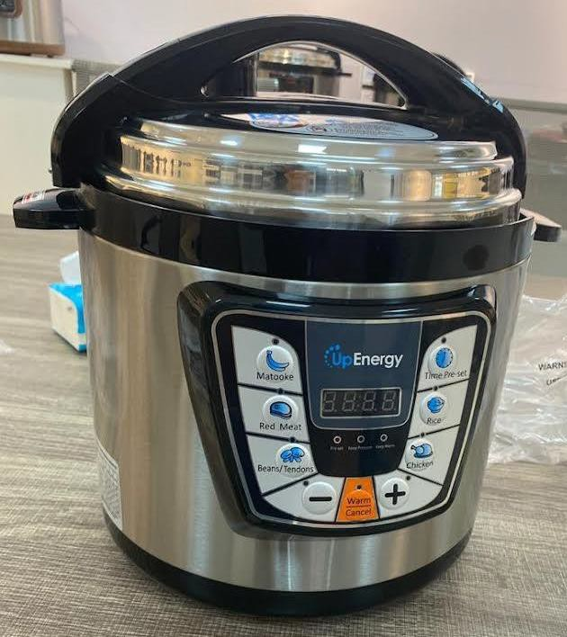

Figure 1: SmartHome EPC
- Improved cookstove (biomass)
The improved cookstoves reduce fuel consumption through use of a ceramic liner that increases combustion efficiency and retains heat. The stoves consist of a metal frame (called cladding) with interior ceramic liner for thermal insulation. The ICS has a provision that allows ash collection at the base. A thin layer of cement is placed between the cladding and the liner to bind the two. During use, a single pot rests at the top the stove. The fixed/inbuilt types are finished with either selected bricks, tiles or stainless steel. The movable types are of metallic stainless-steel cladding. The insulations include of pumice, mica, vermiculite and are bonded with ordinary cement. The smoke extracts through the chimney pipes which are metallic. The fitting stainless steel saucepans are of the thickness 3mm bottom and 2mm sides. The average lifespan of the improved cookstoves with residential use is 5 years.
      - Examples of residential improved cookstoves are given below
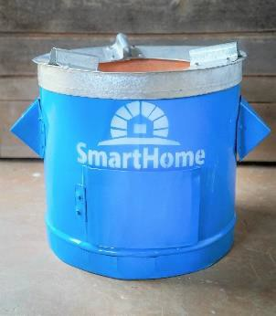
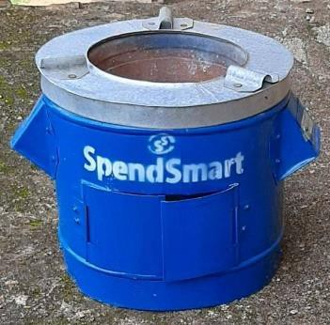
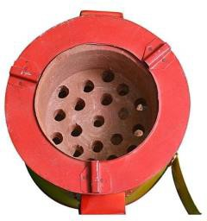
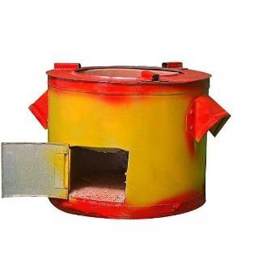

Figure 2a: Residential
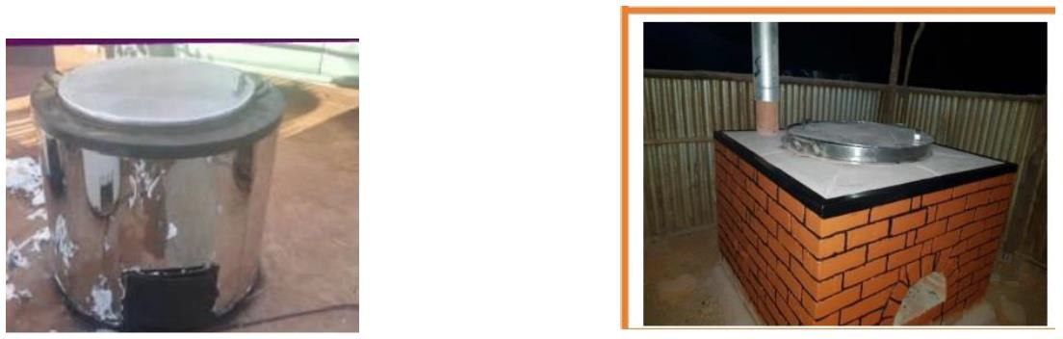
      - Examples of institutional/commercial improved cookstoves are given below

Figure 2b: Institutional/commercial
The technical specification of few models is shown in below table. The other model’s specifications for both residential and commercial which will be distributed in the PoA given over the course of its crediting period.
Product Model | Dimension | Avg. unit weight, kg | Thermal Efficiency, % | Average  life, years | Fuel Type
Smart Home Pro | (Ø 28 x 26 H) | 12 | 37.90 | 5 | Charcoal
RH Stove | (Ø 26.5 x 22  H) | 12 | 36.30 | 5 | Charcoal
TG Stove | (Ø 27 x 23.5  H) | 12.50 | 35.90 | 5 | Charcoal
SpendSmart Stove (SST) | (Ø 23.9 x 24.4  H) | 6.87 | 36.30 | 5 | Charcoal
EE Stove | (Ø 23.93 x  24.43 H) | 8.4 | 33.0 | 5

Other models for all cooking technologies for both residential/institutional/commercial may also be distributed in the PoA, over the course of its crediting period.

- Water Purification System:- Residential and Institutional
The Programme will include distribution of water purification systems (WPS) such as Institutional water treatment (IWT) and Household Water Treatment (HWT) technologies to institutional and residential users respectively. Water filtration takes place by gravity process through the carbon impregnated ceramic candle which acts as a filtering medium. The programme will primarily replace conventional treatment systems of boiling using traditional biomass/charcoal stoves in the baseline or consumption of unsafe water in the baseline scenario. As per the methodology, there will be no suppressed demand claim for large scale projects. As per GS4GG principles and requirements, application of suppressed demand baseline is limited to Small scale activities. The water purification treatment options will be selected to ensure that they provide safe and hygienic potable water. The chosen technologies will be in compliance with the host country norms.

Examples of a Water filters that shall be included in this programme is provided below.

UpEnergy JH-19B Gravity Water filter
- Dimension: (31 x 31x62)cm
- Weight: 3.05 Kilograms
- Capacity: 19 Liters
- Flow Rate: 1 Liter per hour.
- Material: Plastic
- Recommended water type: Municipal Tap Water
- Certification: ce, EMC, RoHS
- Filter life/Capacity: 2400 Liters
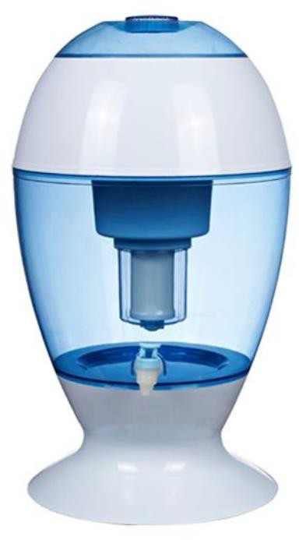

UpEnergy PEHF521 Gravity Water Filter
- Dimension: (25 x 25 x 60) cms
- Weight: 2.1 kilograms
- Flow Rate: 2 Liters/Hour
- Material: Polypropylene plastic
- Filter Life/ Capacity:5000 Liters (Best case)
- Recommended Water Type: Municipal Tap Water
- Certification: CNAL, US EPA, SGS
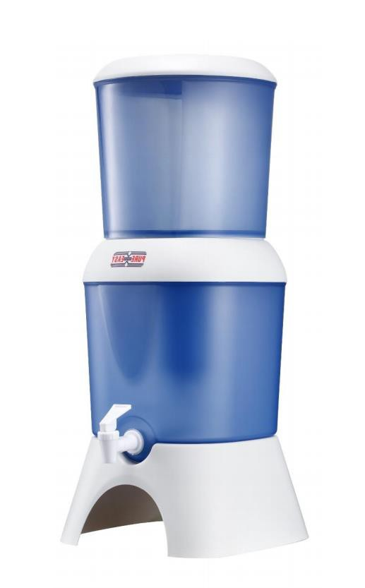

Other water filtration products and technologies like water kiosks, chemical treatment, chlorine tablets etc. may also be introduced in the PoA over the course of its crediting period.
As per section 3.1.1 of GS4GG Principles & Requirements, compliance with relevant Eligibility criteria is demonstrated below:
Eligibility Criteria Category | Eligibility criterion - Required condition | Justification
1. Types of Project | Eligible projects shall include physical action/implementation on the ground. Pre-identified eligible project types are identified in the Eligibility Principles and Requirements section. | PoA is already implemented since 30/11/2020. Project is already one of the pre identified types as per section 3.1.1 (b) and automatically eligible for Gold Standard Certification as per  section 4.1.3 of GS4GG Principles & Requirements.
2. Location of Project | Projects may be located in any part of the world. | Location of the PoA is the host country mentioned in KPI
3. Project Area, Project Boundary and Scale | The Project Area and Project Boundary shall be defined.  Projects may be developed at any scale although certain rules, requirements and limitations may apply under specific Activity Requirements, Impact Quantification Methodologies and Products Requirements. In order to avoid double counting the Project shall not be included in any other voluntary or compliance standards programme unless approved by Gold Standard (for example through dual certification). Also, if the Project Area overlaps with that of another Gold Standard or other voluntary or compliance standard programme of a similar nature, the Project shall demonstrate that there is no double counting of impacts at design and performance certification (for example use of similar technology or practices through which the potential arises for double counting or misestimation of impacts amongst projects) | The boundary for the PoA in terms of a geographical area is defined as the territorial boundary of the host country. All voluntary programme activities (VPAs) associated with this PoA will be implemented within the geographical boundary of the PoA.  To avoid inclusion of any stove which is a part of another registered carbon project/ programme, all ICS/ WPS under this programme shall have a unique ID number / Tag number, either inscribed on the stove or retained by the buyer, to uniquely identify the ICS/WPS avoiding any double counting and trace its user, later during monitoring and verification.
4. Host Country Requirements | Projects shall be in compliance with applicable Host Country’s legal, environmental, ecological and social regulations. | The PoA complies with host countries legal, environmental and ecological and social regulations.
5. Contact Details | As part of the Project Documentation the Project  Developer shall provide (i) name and (ii) contact details of all  Project Participants; AND in case of an organisation (iii) the legal registration details and (iv) documentation by the governing jurisdiction that proves that the entity is in good standing (defined as being a legal or other appropriate entity registered in or allowed to operate within the required jurisdiction and with no evidence of insolvency or legal/criminal notices placed against it or any of its Directors). Gold Standard retains the right (at its own discretion) to refuse use of the Standard where reputational concerns are  highlighted. | Name and Contact details of Project Participants is given in the Appendix 1.  Legal registration details: UpEnergy Group is duly incorporated under the provisions of the Companies Act 2001 as Category 1 Global Business Company by Republic of Mauritius on 7th May, 2013. Company Registration No: C116159. Relevant document is submitted
6. Legal  Ownership | Full and uncontested legal ownership of any Products that are generated under Gold Standard Certification, (for example carbon credits) shall be demonstrated. Where such ownership is transferred from project beneficiaries this must be demonstrated transparently and with full, prior and informed consent (FPIC). Note that for certain Project types there is a requirement for full and uncontested legal land title/tenure to be demonstrated. These are contained within specific Activity or Product Requirements. All projects shall immediately report to Gold Standard any land title/tenure disputes arising. | Criteria for transfer of carbon credit ownership:  - For regular cycle VPA, this shall be ensured through relevant provisions for example disclaimer on warranty/information cards, stove packaging, customer agreements / sales receipts / consent form or may be collected via monitoring app etc. or collecting stakeholder feedback on this issue during local stakeholder consultation (LSC)  - For retroactive VPA, this shall be ensured through relevant provisions for example disclaimer on warranty cards, stove packaging, customer agreements / sales receipts/ consent form or may be collected via monitoring app, etc. or stakeholder feedback collected during Stakeholder Feedback Round (SFR).
7. Other Rights | As well as legal title and ownership, the Project Developer shall also demonstrate where | Not applicable
8. Official Development Assistance (ODA) Declaration | All Project Developers applying for project activities located in a country named by the OECD Development Assistance Committee’s ODA recipient list and seeking Gold Standard Certification for carbon credits shall declare the Official Development Assistance (ODA) support. The Project Developer shall follow the GHG Emissions Reduction & Sequestration Product Requirements and submit the declaration at the time of  Design Certification. | No ODA is involved in the PoA. A declaration is being submitted.

As per section 3 of GS4GG Community Services Activity (CSA) Requirements, Eligibility criteria is defined below:
Eligibility Criteria Category | Eligibility criterion -  Required condition | Justification
- Eligible Project Types | Para 3.1.1: All CSA Projects shall lead to climate change mitigation and/or adaptation by providing or improving access to services/resources at the household or community or institution level. Eligible services include electricity and energy, water and sanitation, waste management, housing, etc. | The goal of the proposed VPAs is to distribute ICS and WPS in residential/institutional/commercial users within the boundaries described in section A.2 of the PoA.
- GENERAL ELIGIBILITY CRITERIA – Project Area, Boundary and scale | Para 3.1.2: Project Area and Boundary shall be defined in line with the applicable Impact Quantification Methodologies and Product Requirements | The project area is point location of ICS and WPS beneficiaries in the host country of the VPA. The project boundary will be limited to the geographical boundary of the host country
- GENERAL ELIGIBILITY CRITERIA – Suppressed Demand | Para 3.1.3: Certain Impact Quantification methodologies allow projects to account Suppressed Demand scenario when establishing a baseline. In such cases, the application of Suppressed Demand baseline is limited to Small Scale and Microscale Projects. | The scale of this VPA is small scale and therefore is eligible under the CSA requirements while applying suppressed demand scenario.
- GENERAL ELIGIBILITY CRITERIA – Legal Ownership | Para 3.1.4:  - Projects involving the distribution of a large number of devices for services such as heating, cooking, lighting, electricity generation, water treatment technology such as water filter, etc. shall provide a clear description of the ownership of the Products that are generated under Gold Standard Certification all along the investment chain. In line with the FPIC requirement, the proofs that end-users are aware of and willing to give up their rights on Products shall be provided.  - The transfer of Product ownership shall be discussed during local stakeholder consultations for projects. | The CEP owners will be transferring their rights on ownership of carbon credits to CME via the end user agreement /consent form via monitoring app etc  The same will be discussed during stakeholder consultations.

The PoA might choose to add other technologies under end-use energy efficiency improvement activities and Clean Energy activities. Gold Standard requirements on multiple technologies as stated in the PoA requirements will be followed.

        - Target/Indicator for each of the minimum three SDGs targeted by the POA
>>

Sustainable Development Goals Targeted | Most relevant SDG Target | SDG Impact
Sustainable Development Goals Targeted | Most relevant SDG Target | Indicator (Proposed or SDG Indicator)
13 Climate Action  (mandatory) | N/A | Emission Reductions
1 No Poverty | 1.4 By 2030, ensure that all men and women, in particular the poor and the vulnerable, have equal rights to economic resources, as well as access to basic services, ownership and control over land and other forms of property, inheritance, natural resources, appropriate new technology and financial services,  including microfinance | Percentage of users reporting money savings due to reduction in purchased fuel consumption in project
3 Good Health and Well-being | 3.9 By 2030,  substantially reduce the number of deaths and illnesses from hazardous chemicals and air, water and soil pollution and  contamination | Percentage of users reporting reduction in smoke/PM after shifting to ICS in project
3 Good Health and Well-being | 3.3 By 2030, end the epidemics of AIDS, tuberculosis, malaria and neglected tropical diseases and combat hepatitis, water-borne  diseases and other | Percentage of households confirming access to safe water using clean technology
5: Gender Equality | 5.4 Recognize and value unpaid care and domestic work through the provision of public services, infrastructure and social protection policies and the promotion of shared responsibility within the household and the family as nationally  appropriate | Percentage of user reporting time saving associated with cooking/boiling and fuel collection/access to safe water
6: Clean Water and Sanitation | 6.1 By 2030, achieve universal and equitable access to safe and affordable  drinking water for all | Number of beneficiaries
7: Affordable and Clean Energy | 7.1 By 2030, ensure universal access to affordable, reliable and modern energy  services | Number of beneficiaries with operational clean technology
8: Decent Work and Economic Growth | 8.3 Promote development-oriented policies that support productive activities, decent job creation, entrepreneurship, creativity and innovation, and encourage the formalization and growth of micro-, small- and medium- sized enterprises, including through access to financial  services | Total no of jobs created
12: Responsible Consumption and Production | 12.2 By 2030, achieve the sustainable management and efficient use of natural resources | Reduction in use of non-renewable biomass per household
12: Responsible Consumption and Production | 12.2 By 2030, achieve the sustainable management and efficient use of natural resources | Percentage of users confirmed less use of fuel for boiling
15: Life on Land | 15.2 By 2020, promote the implementation of sustainable management of all types of forests, halt deforestation, restore degraded forests and substantially increase afforestation and reforestation globally | Reduction in use of non-renewable biomass
15: Life on Land | 15.2 By 2020, promote the implementation of sustainable management of all types of forests, halt deforestation, restore degraded forests and substantially increase afforestation and reforestation globally | Percentage of user reporting fuelwood equivalent savings in the project scenario

        - Coordinating/managing entity
>>
UpEnergy Group is the coordinating and managing entity of the PoA and is the focal point for all communications with Gold Standard.

        - Funding sources of PoA
>>
There is no public funding for the PoA. No ODA funding shall be used within the PoA, as confirmed by signed ODA Declarations to be made at the VPA level.

MANAGEMENT SYSTEM AND INCLUSION CRITERIA
        - Management System
>>
Following key elements of the management system will be taken into account for the PoA:
- A clear definition of roles and responsibilities of personnel involved in the process of inclusion of VPAs, including a review of their competencies.
The Coordinating Managing Entity (CME) of this PoA will be UpEnergy Group, Inc. (UPE). UPE, a company incorporated in Mauritius, is a social enterprise, whose founders have on the ground experience in Sub-Saharan since 2006. UPE fights poverty, improves health, and protects forests by making clean energy technologies available to more people in the developing world through carbon-financed distribution channels. UPE works with technology manufacturers and local partners to deliver high quality products such as efficient cookstoves to poorly served households at affordable prices.
UPE responsibilities, as CME, will include:
- ensuring that the proposed VPA(s) are in compliance with PoA eligibility criteria,
- managing PoA-DD and VPA-DDs documentation
- collecting documents and supporting evidence required for PoA-DD and VPA-DD validation,
- hiring GS-VVB to conduct validation and verification,
- communicating with the host country local authorities (as required) and Gold Standard,
- hiring consultant(s)/expert(s) for regular monitoring and reporting, if needed,
- finding buyers for VERs
- management and distribution of VERs revenues
To implement this programme, UPE works with VPA Implementing Entities. The organization structure is given in below figure 3.

End Users

End Users

End Users
Distribution Networks such as NGOs, Retailers, Financial Institutions

VPA Y

VPA X

UpEnergy Group (CME)

Figure 3: Organizational structure of PoA

The CME (UPE) will be responsible for overall programme management and will appoint Gold Standard Validation and Verification Bodies (GS-VVBs) for validation and/or verification and will be responsible for the inclusion of VPA into the PoA, as well as for ensuring, either directly or through project partners, that end-users sign the User Agreement, transferring all rights to emission reductions to the CME (UPE).

For the overall management of the programme there will be an established programe level Unit at UPE led by a Programme Leader. The UPE Programme Unit will be supported by a Programme Unit of the VPA Partner Organization. The Unit will be responsible for overall programme management, quality control, and physical spot checks as well as making corrective actions at national, sub-national, and district level. The national Unit will manage the regional support units of UPE and VPA Partner Organization, which will be responsible for technical aspects of the programme. Regional support units will be responsible for promotion, training, monitoring, data management, quality control, and providing after sale services in the form of stove repair and replacement. There will also be district support units to provide technical assistance to local partner organizations.

Micro-entrepreneurs may be employed by local partner organization for marketing and distribution of clean energy products.
The district support units will be responsible for smooth operation of the PoA activities in respective districts, technical support to LPOs, and monitoring along with coordination with district line agencies.

The Programme will perform quality assurance testing on any clean energy product (CEP) to be included in the programme. Demand for CEPs will be created through awareness, publicity campaign, promotion and marketing, orientation or demonstration through the existing local network of community-based organizations, other rural development programs.

Partner organizations (POs) will include region or district level NGOs, business entities, etc. Local Partner Organizations (LPOs) will market CEPs through their own sales channels.

LPOs or Regional Partner Organizations (RPOs) will be selected on the basis of criteria such as past experience in energy product sales, availability of competent human resources, outreach of services, etc. These organizations will be responsible for social mobilization, communication, and education for raising awareness, capacity building activities at local level, internal monitoring of project activities, and coordinating activities with local stakeholders.

- Records of arrangements for training and capacity development for personnel;
The CME is responsible for ensuring that the User Agreement record for ICS sold will be correct and complete. Training will be given to all PoA partner organizations on the management system to be put in place as part of the PoA. Training will include:
- Details of the data to be recorded in the VPA CEP Sales Database
- User Agreement and/or invoicing processes (including how to ensure unique identification of each CEP through the serial numbers and how to record the other required details, procedures to ensure that end-users transfer their title to the emission reductions to the CME, etc.)
- Details of where to send copies of the project documentation
- Monitoring procedures
- Procedures for dealing with a change in serial number, address of the CEP owner, etc.
A record of all trainings will be kept, and will include the date, training agenda, and a list of participants. This will be used to confirm that training has been completed. All information will be provided to the GS-VVB upon request.

- A procedure for technical review of inclusion of VPAs;
The CME shall ensure that all VPAs included under the PoA meet the eligibility criteria outlined in section B.3 of the PoA-DD and that the records of the technical review process are maintained. The technical review process for each VPA shall ensure that the criteria outlined in Section B.3 are met by the VPA. Prior to the start of the inclusion process for a new VPA under the PoA, the proposed VPA- DD will undergo a technical review by the Carbon Programme Manager of the CME or by a team of reviewers. The technical review shall check if the VPA-DD is drafted following the eligibility criteria stated in POA DD Section B.3. The reviewer(s) shall also check that the proposed VPA is neither registered or being registered under another PoA, nor registered or being registered as a standalone Gold Standard or CDM Project Activity. The CME will also verify that no individual project activity bearing the same name and covering the same scope as the proposed VPA is neither registered, nor requesting registration. In order to ensure that the competencies of the personnel conducting the technical review remain current, the reviewers shall be trained related to Gold Standard procedures and VPA eligibility. The training and capacity development of the personnel involved in the technical review will be documented in the CME Manual.

For each proposed VPA the findings of the technical review will be summarized in a short memo or report and submitted to CME management for final approval. In the event that the conclusions of the technical review are not positive, the VPA Partner Organization will have to carry out the requested changes in its proposed VPA before re-submitting the project document for inclusion into PoA. Provisions and procedures related to pre-inclusion due diligence shall be included in the CME Manual.

- A procedure to avoid double counting (e.g. to avoid the case of including a new VPA that has already been registered either as a Gold Standard project activity or as a VPA of another PoA)
Procedures to assert legal rights of the carbon credits generated and to avoid double counting and appropriate records and documentation control process for each VPA under the PoA have been set up as described in this section below.

The operation of the CEP is carried out by the user, and training on how to use and maintain the CEP will be given by the LPOs, through the CEP promoters. The CEP will be tracked according to the monitoring plan and procedures, by its unique Serial ID to verify that it was sold as part of the PoA and to confirm which are still in use, so the appropriate emission reductions are claimed.

Before the sale of the ICS/SWS product, the user shall be informed that carbon finance is being used to fund the CEP, and the user shall agree to transfer the rights to the emission reductions to the CME (or via and intermediary in the case of CME partners), and to cooperate with the LPO and the CME for monitoring purposes as per the User Agreement. The User Agreement shall comprise all the obligations of both parties and provisions regarding the transfer of emission reduction ownership and benefits. It will also ensure that CEP users are aware of and have agreed that their activity is transferring Emissions Reductions to the CME (or intermediary) for the purposes of generating emission reductions.

The User Agreement also contains the following information:
- Name of customer and contact details (address & phone number if applicable)
- Name of the district and region
- Date & location of CEP purchase
- Information on the type of CEP model sold
- Information on the type of primary fuel used in the baseline scenario
- Unique identification number of the CEP sold
- Information on the type of CEP replaced (unimproved traditional stove)
- Name of seller/distributor
- Transference of emission reductions from buyer to CME

A suitable coding system is introduced in order to identify the stoves disseminated. For that, all CEP distributed will be marked with a unique identification number which will be engraved in the body of CEP as a means of uniquely identifying each CEP and ensuring that each CEP is not double counted. PO staff will monitor a representative sample of installed stoves continuously to ensure the stoves are in use. The information collected by the PO will be shared with the CME.

The District support unit will verify the data and compile monthly or quarterly installation sales data which will be passed on to the regional support unit. All monitored data and information will be stored both electronically and in paper (if paper records exist) by regional support unit.

The Programme Unit of UPE will overview, control and cross check the sales registry transmitted by the VPA Implementing Entities through regularly random sampled quality assurance and monitoring of the installation. Any deviations will be subject to penalties. It will allow CME to check periodically the materiality accuracy of the claimed sales, verify the number of CEPs sold and therefore avoid double accounting.

The PoA Distribution and Monitoring Database, as well as the VPA CEP Sales Database will help in identifying the CEPs that have reached the expected years of operational life (estimated lifetime of CEPs as per manufacturer specifications). The VPA CEP Sales Database will contain all the sales information listed above including the actual sales data. The VPA CEP Sales Database will be a key component of the annual monitoring report, since the actual installation sales date is used to calculate the emission reductions achieved by the sold CEPs. Any deviations such as CEP users switching fuels will be monitored through the annual or biennial monitoring surveys and any such deviations will be appropriately discounted in the Emission Reduction calculation.

All records of POs will be reviewed by the CME together with cross-checks of the CME’s own randomly sampled field monitoring to confirm that the VPA CEP Sales Database is authentic and that no double-counting occurs. The VPA Partner Organization will use its sales data to update the VPA CEP Sales Database and to ensure no double counting occurs for VPAs. The database will restrict entry of repeat serial numbers and/or user name, contact details. The serial number together with the name and contact details of the user will constitute the unique identification of the system.

- Records and documentation control process for each VPA under the PoA;
For every CEP sold, records will be kept on retailer, and wherever possible, on end user information and other inventory data. These records will enable the GS-VVB to verify that sales have indeed occurred and stoves are used in the households of the specific areas targeted by VPAs. The VPA Partner Organization will be responsible for the establishment and maintenance of an extensive VPA CEP Sales Database for each VPA, which it will transfer to CME as needed.

The CME will provide guidance on record keeping while providing quality control through supervision and spot checks. The CME will ensure that no PO is conducting a similar activity as a stand-alone Gold Standard or CDM project activity or as another VPA/CPA within another PoA. The VPA Partner Organization will prepare periodic reports summarizing CEP Sales Data under each VPA, together with results of annual monitoring surveys. CME will support the process of data collection by analysis of annual reports and co-operation with regard to preparation of annual reports for submission to the verifying GS-VVB. CME will also be responsible for the commissioning of annual and/or biennial monitoring surveys by a credible third party consultant. All data collected will be kept for the whole crediting period of the VPA and an additional two years.

- Measures for continuous improvements of the PoA management system;
Periodic meetings of all PoA partners, which may be combined with broader UPE Meetings, will be held under the supervision of CME in which the following topics will be addressed:
- A review of the previous monitoring period and the latest developments,
- Recurring issues related to the inclusion process,
- Comments provided by the members of the VPA inclusion technical reviewers and CME,
- Feedback from the VPA POs, and
- Potential improvements to be implemented for the next period.

The CME, in close consultation with POs, shall continually improve the effectiveness of the PoA management system through the use of the quality policy, quality objectives, audit results, data analysis, and corrective and preventive actions with an appropriate management review system.

- The CME will also capture GPS locations through mobile applications and/or capturing photos of serial numbers during sale/installation of products. These will be recorded in the CME database.
        - Application of methodologies
>>
- Technologies and Practices to Displace Decentralized Thermal Energy Consumption, version 3.1
- Emission reduction from safe drinking water supply-version 1.0

          - Multiple technologies/measures
>>
To avoid cross-effects between the woody biomass consumption/savings in the same household as a result of using ICS/SWS. The baseline scenario study for SWS considers both Improved cooking and Traditional cooking. There are no cross-effects anticipated as cooking and boiling water is separate activity. The SWS methodology allows improved cookstove as baseline technology.
        - Eligibility criteria for inclusion of a VPA in the PoA
No. | Eligibility Criterion | Description/  Required condition | Means of Verification/Supporting evidence  for inclusion
1 | Location of the VPA | The VPA is located within the geographical boundary of one of the countries included in the PoA. | The host country and location of each VPA will be specified in each VPA- DD including a statement from CME confirming the geographical boundary of the VPA and that it within the boundary of the PoA.
2 | Type of project | Projects will involve the distribution of energy- efficient cooking technologies and safe drinking water systems (HWT and IWT technologies) to residential/institutions/  co mmercial users. | The VPA-DD specifies the target end-user group and the technology being distributed.  A single VPA will not include both the technologies  Supporting evidence:  Sales database
3 | No Double  counting of CEPs and VPAs within this PoA and across other PoAs | A unique numbering or identification system for the CEP installed is applied. This shall ensure no double counting of stoves within the PoA and ensure that stoves can be identified as belonging to this PoA and not to a PoA managed by any other CME. | The unique numbering stamped on each CEP supported by the individual distribution record matching such information is included in the specific VPA-DD and consistent with the PoA DD.  Supporting Evidence:  CEP Sales Receipts in Total Sales Record including VPA assignment and end user details (i.e. name, address). Additionally, the unique id displayed on the CEP itself. The unique numbering or identification regime is included in the specific VPA-DD and will be verifiable by the GS-VVB. Relevant agreements with manufacturers/ project partners or a master database will be provided at the time of verification.
4 | No Double counting of VPA | The VPA is exclusively bound to the PoA. The VPA shall not be proposed as an individual Gold Standard or CDM project and/or as a part of any other CDM PoA and/or any other mechanism to avail climate change mitigation benefits.  A statement shall be included in the VPA-DD that the specific VPA will not be part of another single Gold Standard or CDM project activity or VPA under another PoA and confirmed by the Partner Organization (PO) implementing the VPA. | A statement by the CME is included in the VPA-DD that the specific VPA will not be part of another single Gold Standard or CDM project activity or VPA under another PoA.  Supporting Evidence: This shall be cross-checked and verified by the CME with the UNFCCC, Gold Standard, VERRA and other voluntary programs.
5 | Awareness and agreement of those operating a VPA on PoA subscription | Contractual provisions to ensure that those operating the VPA are aware and have agreed that their activity is being subscribed to the PoA.  In the case that the CME is not responsible for implementing the VPA, the organization responsible for VPA implementation has signed a contractual agreement with the CME to participate in the PoA. This agreement:  Defines the ownership of the carbon emission reduction rights  - Covers the distribution and monitoring related responsibilities of the parties involved  - Confirms that the CEPs to be distributed under the VPA have not and will not be distributed under any other carbon project (CDM project, PoA or Gold Standard project)  - Cedes the rights to the carbon credits generated from VPAs under the PoA to the CME. | Contractual agreement from VPA operators as part of their contract with the CME, stating that they are aware and have agreed that their activity is being subscribed to the PoA.  Supporting Evidence: Signed contractual agreement.
6 | Non-diversion of ODA in case of public funding | The CME and the VPA operator (in case of being different from the CME) shall confirm that there is no public funding or in the case of public funding, the annex I party will confirm that funding is not a diversion of Official Development Assistance. | A statement is included in the VPA-DD informing whether the specific VPA is funded with Annex I country funding.  If Annex I country funding is used, then the following document will be provided by each funding party (the donor/s):  Signed statement by the Annex I country donor party confirming that funding from Annex I country is not a deviation  of ODA funding.
7 | VPA Crediting Period | VPA crediting period not to exceed the PoA end date and the starting date of the crediting period of a VPA shall be on or after:  (i) the VPA crediting period start date is either the VPA Start Date or two years prior to the date of Design Certification whichever is later. | A statement is included in the VPA-DD specifying the crediting period starting date and that the crediting period will not exceed the PoA end date (this is 20 years after the date of registration of the PoA).
8 | Approval of VPA by CME | CME approves each VPA to be included into its registered PoA. | Statement of CME in each VPA-DD giving approval for the VPA to be included into its registered PoA.
9 | Methodology Requirement | Each ICS VPA will comply with the applicability criteria of the applied methodology TPDDTEC, version 03.1 and Safe drinking water VPA will comply with the applicability criteria of methodology emission reduction from safe drinking water supply-  version 1.0 | The VPA-DD shall include information on how it complies with all applicability criteria of TPDDTEC, version 03.1 and emission reduction from safe drinking water supply-version 1.0
10 | Additionality | Option-1: Projects located in LDC, LLDC, SIDS according to 4.1.9 (b) of ‘Community Services Activity Requirements’.  Option-2: All VPAs to be included under the PoA will be in compliance with item 1.1.3 of Annex B – positive list mentioned in the ‘Community Services Activity Requirements’, Version 1.2. All VPAs will be solely composed of isolated units (CEPs) where the users of the technology/ measure are households or communities or institutions and where  each unit results in  <= 600 MWh/1.8 GWth  of thermal energy savings per year or  <= 600 tonnes emission reduction per year | The VPA DD will either follow option which is located LDC/LDC/SIDS or option 2 by confirming the thermal energy savings per year. The VPA-DD to confirm that the thermal energy savings per year at a unit level (i.e. per CEP) are clearly below 600 MWh/1.8 GWhth of thermal energy savings per year or 600 tonnes emission reduction per year and to be outlined in the ER calculation sheet.
11 | Scale of the VPA | VPAs included under the PoA can be either small or large scale.  In case of large scale VPAs, CME shall confirm that there is no suppressed demand claim. In case of small-scale threshold of 60,000 tCO2/crediting year for safe water VPAs and 180 GWhth for ICS VPAs will be adhered. | VPA-DD will be either small or large scale.  In case of large scale VPA will not make any claim for suppressed demand. Small scale VPAs will threshold of 60,000 tCO2/crediting year for safe water VPAs and 180 GWhth for ICS VPAs will be adhered.  Evidence:  Emission reduction calculation/Statement by CME
12 | Project Technology | Specification of technology or measures, such as the level and type of service, as well as performance specification based on, intra alia,  testing/certification | Project technology along with technical specifications is outlined in section A.3 above
13 | Sampling | Sampling approaches are set out in each VPA and will follow the TPDDTEC v3.1 and emission reduction from safe drinking water supply- version 1.0 methodology. For safe water cross-VPA sampling a maximum of 10 VPAs can be grouped. | Sampling method is described in VPA-DD as per applied methodology requirements.
14 | Multi-country PoA | In accordance with 17.1.2 “Programme of Activity Requirements”, an exception is approved for the development multi- country PoA. The VPA-DD developed should be part of this approved deviation request (Deviation reference- “POA-17.003”) batching. As per 17.1.4 of “PoA Requirements”, one VPA shall be submitted at the time of design certification and subsequent VPAs for other countries shall be included at a later stage. | VPA-DD has been submitted for the host country is part of the approved deviation request “POA-17.003”. New country may be added by applying PoA level design change request.
15 | SDG Outcomes | A minimum of two SDG outcome to be included in addition to SDG-13 | All VPA-DDs will include a minimum of three SDG impact assessment including SDG-13. SDG targets and impact are described in section A.4 of  the document

DEMONSTRATION OF ADDITIONALITY
>>
PoA is a voluntary activity and the host countries where the projects are implemented doesn’t have mandatory policy/regulation or would lead to greater enforcement of the existing mandatory/policy regulation.

VPAs part of the PoA would not be possible to implement without carbon finance planned to be achieved through Gold Standard certification.
VPA level additionality are proven using one of the following options:
Option-1: Projects located in LDC, LLDC, SIDS according to 4.1.9 (b) of ‘Community
Services Activity Requirements’

Option 2: In accordance with item 1.1.3 of Annex B – positive list mentioned in the ‘Community Services Activity Requirements’, Version 1.2, projects that meet any of the following criteria are considered as deemed additional and therefore are not required to prove Financial Additionality at the time of Design Certification:
Project activities solely composed of isolated units where the users of the technology/measure are households or communities or institutions and where each unit results in –
ICS: <= 600 MWh/1.8 GWhth of energy savings per year or WPS: <=600 tonnes of emission reductions per year.
The VPAs will use either or both options to demonstrate the additionality

DURATION OF POA
        - Date of first submission of PoA to Gold Standard
>>
07/01/2021
        - Duration of the PoA
>>
20 years

SAFEGUARDING PRINCIPLES ASSESSMENT
        - Justification for Safeguarding Principles Assessment at PoA level
>>
N.A. since Safeguarding assessment will be done at VPA level.
        - Assessment of safeguarding principles, if undertaken at PoA level
>>
N.A. since Safeguarding assessment will be done at VPA level

OUTCOME OF STAKEHOLDER CONSULTATIONS
        - Justification for stakeholder consultation at PoA Level only
>>
N.A since local stakeholder consultation will be done at VPA level.
        - Summary of stakeholder mitigation measures at POA Level
>>
N.A since local stakeholder consultation will be done at VPA level.
        - Final Continuous Input / Grievance Mechanism at POA Level
>>
N.A since local stakeholder consultation will be done at VPA level. Nevertheless, UpEnergy has ensured grievance mechanism is in place, the details can be found below.

Method | Include all details of Chosen Method (s) so that they may be understood and, where relevant, used by readers.
Continuous Input / Grievance Expression Process Book (mandatory) | Continuous input / Grievance Expression process book is available at the office at the following address: Up Energy (Uganda) Limited Plot 3848 Rwakiseta Road (Off Kironde Road) P.O. Box 24480  Muyenga, Kampala Uganda
GS Contact (mandatory) | help@goldstandard.org
Other | Customer Care: +256 393-  516-685  Email: info@upenergygroup.co m

Appendix 1 - Contact information of coordinating/managing entity and responsible person(s)/ entity(ies)
CME and/or responsible person/ entity | CME  Responsible person/ entity for application of the selected methodology(ies) and, where applicable, the selected standardized baseline(s) to the PoA
Organization | 19 Cybercity
Street/P.O. Box | 10th Floor, Raffles Tower
Building | Ebene
City | Ebene
State/Region
Postcode | Mauritius
Country | +230-404-6000
Telephone | anantha@upenergygroup.com www.upenergygroup.com  Anantha Karthik Rajagopalan
E-mail
Website | Mr
Contact person | Rajagopalan
Title | Karthik
Salutation | 19 Cybercity
Last name | 10th Floor, Raffles Tower
Middle name | Ebene

Revision History

Version | Date | Remarks
1.1 | 14 October 2020 | Hyperlinked section summary to enable quick access to key sections  Improved clarity on Key Project Information  Inclusion criteria table added  Clarification on POA level LSC and Safeguard Principles Assessment  Improved Clarity on SDG contribution/SDG Impact term used throughout  Clarity on Stakeholder Consultation information required  Provision of an accompanying Guide to help the user understand detailed rules and requirements
1.0 | 10 July 2017 | Initial adoption

In accordance with para 17.1.1 of “Programme of Activity Requirements” version 1.2 which allows project developers to submit request for an exception to not submit VPA-DDs for all countries in the PoA’s geographic boundary. This deviation request is approved by GS on 6th January, 2021 segregating countries in different batches.
IEA (2020), SDG7: Data and Projections, IEA, Paris https://www.iea.org/reports/sdg7-data-and-projections
https://dhsprogram.com/pubs/pdf/FR344/FR344.pdf
https://www.unwater.org/publications/world-water-development-report-2020/
As per deviation request approved for implementation of Multi-country PoA, this batch is numbered as Batch-8.
This is an indicative list of products, other models may be added during the implementation of programme
The lifetime of the ICS depends on usage rates and maintenance and may go beyond 5 years to a maximum of 7 years. Replacement of ICS can be offered to the same household during the crediting period of the VPAs beyond its maximum operational life.
The lifetime of the ICS depends on usage rates and maintenance and may go beyond 5 years to a maximum of 7 years. Replacement of ICS can be offered to the same household during the crediting period of the VPAs beyond its maximum operational life.
The efficiency value for TG stove is considered as the median from which +-5% is calculated
This is an indicative list of products; other models may be added during the implementation of VPA.

