PoA Design Consultation Report

PUBLICATION DATE 14.10.2020
VERSION v. 1.1

KEY PROJECT INFORMATION

GS ID of PoA | 11009
Title of PoA | TASC Clean Cooking PoA
GS ID (s) of C/VPA (s) submitted at PoA  Preliminary Review | GS11145
Version number of the DCR | 1.1
Completion Date of version | 20/04/2021
Time of First Submission Date | 23/03/2021
Tentative Implementation date of the Programme | 26/08/2020 (this is the start date of the first VPA of the PoA, which is retroactive)
Design Consultation Start and End Date | 23/02/2021  04/03/2021
Date of any Physical Meeting (s) | None

SECTION A. DESIGN OF STAKEHOLDER CONSULTATION

A.1. Description of the consultation methods used

A design consultation (DC) was conducted at the PoA level for Zambia and Zimbabwe and involved contacting stakeholders virtually, via email and phone. A local stakeholder consultation (LSC) was also included in the feedback mechanism for both countries. The consultation involved inviting reviews/feedback from various stakeholders’ including, but not limited to the following:
- Local people impacted by the project
- Representatives of private institutions / Corporate houses involved in the VPAs
- Local NGOs, Self Help Groups, MFIs involved in the VPAs
- Host country DNA
- Gold Standard Representatives
- GS NGO Supporters

As part of DC / LSC, a key-project information note was circulated to all stakeholders along with two feedback questionnaires: one for the DC and one for the LSC. The key-project information note included:
- A non-technical summary of the PoA
- A summary of sustainable development impacts
- An implementation framework of the programme
- The Geographic boundaries
- ICS technology details
- Target audience
- Grievance mechanism and feedback
- Contact details of the CMER and VPAIs

Due to the COVID-19 pandemic, the consultation of local stakeholders was only possible via electronic means, in accordance with the Gold Standard COVID 19: Interim Measures.

VPAs are in development for each Host Country (Zambia and Zimbabwe) which were originally planned to be included in the CDM PoA 6864. LSC meetings were held for each VPA under the CDM rules.

A. 2. Information Made Available to Stakeholders
Non-Technical Summary of the PoA

The “TASC Clean Cooking PoA” is a voluntary initiative taken by The African Stove Company Ltd. (TASC), an organization with a mission of financing and developing high-impact climate mitigation projects. TASC is originating and developing a global portfolio of carbon projects under a range of different methodologies. TASC generates carbon credits each year for sale on the international carbon market. TASC has been working on carbon projects in sub-Saharan Zambia and Zimbabwe for over 10 years.

The purpose of this PoA is to disseminate energy efficient improved cookstoves (ICS), using either wood and/or charcoal as fuel, in domestic households and communities in Zambia and Zimbabwe.

The ICS disseminated under the PoA may include a variety of models. The intention of the PoA is to enable developers of individual voluntary project activities (VPAs) included in the PoA to gain access to market mechanisms for carbon finance. TASC wishes to encourage the uptake of ICS in Zambia and Zimbabwe by making it as simple as possible for project developers to benefit from finance and incentives available via carbon markets. Carbon finance will serve to mitigate one of the main barriers – price per ICS - for end users in adopting ICS on a large scale.

TASC and the VPA implementers will source the best available technologies for dissemination under the PoA. The market for ICS manufacturing has matured significantly in recent years and ICS model selection at the VPA level will be based on key attributes, such as: thermal efficiency, durability and cultural acceptability. The PoA will therefore ensure that best available ICS models are accessible to stakeholders in this PoA.

Traditional cooking methods prevalent across Zambia and Zimbabwe today result in greenhouse gas (GHG) emissions due to inefficient combustion of fuel. The use of unsustainably sourced, non-renewable biomass (NRB) in host countries is a major driver of deforestation. Widespread usage of NRB for cooking reduces the ability of forests in host countries to sequester carbon, thereby increasing net GHG emissions.

Furthermore, the use of solid biomass fuels (e.g. wood & charcoal) in inefficient traditional stoves and on open fires – whilst meeting domestic household and community level needs - releases large amounts of particulate matter (PM) into the local environment, creating toxic levels of indoor air pollution (IAP). IAP – generated largely by inefficient and poorly ventilated stoves burning biomass fuels such as wood, crop waste and dung, or coal – is responsible for the deaths of an estimated 1.6 million people annually. More than half of these deaths occur among children under five years of age. In developing countries with high mortality rates overall, IAP ranks fourth in terms of the risk factors that contribute to disease and death (World Health Organization).

ICS typically have a significantly higher thermal efficiency than traditional cooking appliances, or open fires. The incremental thermal efficiency drives a reduction in fuel use, which depending on the model of ICS employed, may exceed 50%. The ICS result in better heat transfer and improved fuel combustion (reducing smoke, black soot and PM) compared with traditional cookstoves or open fires thereby contributing significantly to reduction in household IAP and GHG emissions.

The PoA is seeking registration under the Gold Standard for the Global Goals (GS4GG) to enable it to quantify and verify the GHG emissions reductions and correspondingly accrue carbon credits. Carbon credits may be purchased by individuals, companies, governments and any other organizations that wish to offset their own GHG emissions. This has created a market for reducing GHGs by attributing a cost to polluting the atmosphere. Each carbon credit represents one tonne of carbon dioxide either removed from the atmosphere or saved from being emitted.

A record of stoves distributed, and the associated end-user information (as possible), shall ensure that the VPA implementer can monitor project stoves over lifetime and ensure that carbon credits are generated as the stoves are being used.

TASC will own the carbon credits that are generated by the stoves in the project and it will use this revenue to pay back the project costs that are incurred. End users will benefit by receiving best-in-class technology at no cost, or at a subsidized, below-market sales price. In this way, end users benefit from the carbon revenue in advance of its accrual and at no risk to themselves.
Initial VPAs are planned for Zambia and Zimbabwe:
- In Zambia, some stoves have already been distributed since August 2020 by TASC.
- In Zimbabwe, stoves will be distributed under a VPA implemented by The My Trees Trust.
Summary of Sustainable Development Goals (SDG) Impacts
GOAL 1: No Poverty
1.4 By 2030, ensure that all men and women, in particular the poor and the vulnerable, have equal rights to economic resources, as well as access to basic services, ownership and control over land and other forms of property, inheritance, natural resources, appropriate new technology and financial services, including microfinance. | Relevance:  Through installation and dissemination of ICS, the PoA/VPA will avoid cooking on traditional stoves or open fires (the ‘baseline appliance’). Thus, the PoA/VPA results in increased access to basic services (clean cooking), new technology (ICS) as well as reduces poverty by reducing purchased fuel consumption, or reduced time for fuel collection.  Target Indicator - 1.4.1 Proportion of population living in households with access to basic services
GOAL 3: Good Health and Well-being
3.9 By 2030, substantially reduce the number of deaths and illnesses from hazardous chemicals and air, water and soil pollution and contamination. | Relevance:  Through installation and dissemination of ICS, the PoA/VPA will result in reduction in exposure to IAP (CO, polycyclic aromatic hydrocarbons, PM etc.) associated with biomass fuel based traditional cooking.  Target Indicator - 3.9.1 Mortality rate attributed to household and ambient air pollution
GOAL 5: Gender Equality
5.4 Recognize and value unpaid care and domestic work through the provision of public services, infrastructure and social protection policies and the promotion of shared responsibility within the household and the family as nationally appropriate. | Relevance:  In the poorest communities, the burden of collecting and/or purchasing fuel, often firewood, typically falls on women and children. By reducing fuel collection and cooking time, the PoA/VPA provides women in project households with more time to invest in other productive economic development activities.  Target Indicator – 5.4.1 Proportion of time spent on unpaid domestic and care work, by sex, age and location
GOAL 7: Affordable and Clean Energy
7.1 By 2030, ensure universal access to affordable, reliable and modern energy services | Relevance:  The PoA/VPA involves installation and dissemination of efficient, clean technologies for cooking.  Target Indicator – 7.1.2 Proportion of population with primary reliance on clean fuels and technology
GOAL 8: Decent Work and Economic Growth
8.5 By 2030, achieve full and productive employment and decent work for all women and men, including for young people and persons with disabilities, and equal pay for work of equal value | Relevance:  The PoA/VPA will generate employment for marketing / sales and distribution / technical / other employees.  Target Indicator - 8.5.1 Average hourly earnings of female and male employees, by occupation, age and persons with disabilities
GOAL 12: Responsible Consumption and Production
12.2 By 2030, achieve the sustainable management and efficient use of natural resources | Relevance: ICS included in the PoA/VPA will reduce the consumption of non-renewable biomass in participant households by as much as 50%, depending on stove model.  Target Indicator – 12.2.2 Domestic material consumption, domestic material consumption per capita, and domestic material consumption per GDP
GOAL 13: Climate Action
13.2 Integrate climate change measures into national policies, strategies and planning | Relevance:  The PoA/VPA reduces GHG emissions from replaced of fossil fuel / non-renewable biomass-based cooking.  Amount of CO₂e emissions reduced by the project per year.

The Project is deemed to have no significant direct impact on the following SDGs:
GOAL 2: Zero Hunger
GOAL 4: Quality Education
GOAL 6: Clean Water and Sanitation
GOAL 9: Industry, Innovation and Infrastructure
GOAL 10: Reduced Inequality
GOAL 11: Sustainable Cities and Communities
GOAL 14: Life Below Water
GOAL 15: Life on Land
GOAL 16: Peace and Justice Strong Institutions
GOAL 17: Partnerships to achieve the Goal

Implementation framework of the programme

TASC shall be the coordinating/managing entity (CME) for this PoA. The proposed PoA is a voluntary action by the CME.

VPA implementers will be encouraged to participate in the PoA. The participation of VPA implementers shall be decided and approved by the CME. Participation will depend, amongst other things, upon the VPA's compliance with PoA eligibility criteria and any mutual or commercial agreement between CME and VPA implementer on the management of the project.

The model of ICS distributed in the VPA must be approved by the CME during the VPA design stage. Upon the distribution of each ICS, VPA implementers must collect monitoring data, including (where possible):
- name of end user
- physical address or location (GPS position)
- contact phone number
- date of installation
- unique stove serial number
This information will be retained in a monitoring database. Recipients of cookstoves will waive their rights to claiming the emissions reductions generated by the stove during its usage. TASC will finance the PoA via the sale of carbon credits and so must claim the emissions reductions from stove usage itself.
TASC will provide training to the VPA implementer on proper ICS usage, distribution and end user data collection procedures. Maintenance and servicing of the ICS will be performed by local technicians trained by the VPA implementers.
The PoA is being developed under the GS4GG and programme implementation started in Zambia in August 2020.

Geographic Boundaries of the project

The boundary of the PoA is defined by the first two VPAs as the countries of Zambia and Zimbabwe. All VPAs associated with this PoA will be implemented within the geographical boundary of the PoA. The PoA may extend to other countries in the future.
The determination of baseline and additionality assessment shall be carried out at the VPA level (or group of VPAs).
Each VPA will be unique in nature and will not interact with other similar cookstove projects in the Host Countries. Distribution data will ensure that households only receive a cookstove if their existing cooking technology is not improved and the fuel source is biomass (wood or charcoal), as per the description below. GPS data captured at distribution will ensure households fall within the project boundary.

ICS Technology Details

The PoA will implement ICS technologies which are based on the principle of improving heat transfer from combustion chamber to the cooking pot, saving cooking fuel and time.
ICS consider maximize temperature, the combustion chamber shape, fuel amount, and air flow in order to use the available thermal energy in the most efficient manner possible. Specific stove geometry and configuration choices have been made in the ICS models, including reducing stove thermal mass and minimizing heat loss through the sides and bottom of the ICS. The other element is correctly positioning the cooking surface in relationship to the ICS. This is essential to establish a correct gas flow path needed for optimum heat transfer.
Stove models may have a grate provided at the base of the ICS for placing fuel. The clearance between the grate and the floor provides for natural draft of air into the combustion chamber resulting in improved combustion as compared to traditional cook stoves where such natural draft is absent resulting in incomplete combustion of fuel. Usually, the combustion chamber has a refractory lining that reduces heat loss from the walls of the ICS.
The ICS distributed under this PoA shall have thermal efficiencies of at least 20%.

As an example, the first VPA in the PoA envisages distribution of the Kuniokoa wood fuel cookstove manufactured by Burn Manufacturing LLC. This ICS, manufactured in Nairobi, Kenya, delivers a thermal efficiency of 41.6% according to an independent lab report from the Kenya Industrial Research and Development Institute (KIRDI) of 19th November 2017:
Burn Kuniokoa  model cookstove | 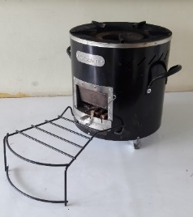
Charcoal cookstove models will also be considered for distribution under the PoA.

Target audience for the use of technology

The purpose of the proposed PoA/VPA is the installation of energy efficient ICS in domestic households and communities in Zambia and Zimbabwe. The primary target population of the distributed technology is those who use traditional cooking methods and are exposed to IAP health hazards as a result.

Grievance Mechanism & Feedback

The CME and each VPA implementer will set up a formal input, feedback and grievance mechanism. This will include the provision of PoA or VPA based contact details for direct feedback to be received by project management teams. A PoA level email address is provided for any stakeholder to provide feedback over the lifetime of the PoA. At the VPA level, a continuous input and grievance expression process book shall be made available at an agreed location that is accessible to local stakeholders.

At a minimum, Continuous Input and Grievance Expression Process Book shall be made available at an agreed location. For more information, please contact the representatives listed below. Feedback is now sought based on this non-technical summary and may be provided via the forms set out in Annex 1 and 2 of this document.

Contact Details

In case of any queries or need for further technical detail and project information, please contact:
International | Zambia | Zimbabwe
Nick Marshall  Director  TASC Ltd.  17a York Street  Jersey JE2  Email: cookstoves@tasc.je | George Barlow  Managing Director  TASC Zambia  Email: george@tasc.je | James Egremont-Lee  My Trees Trustee  Email:  james@zambezielephantfund.org  Nick De Swardt  My Trees Trustee  Email: ndeswardt@riftvalley.com

A.3. Invitation/consultation tracking table
Invitation tracking tables were retained as excel spreadsheets for each Host Country and are submitted with this report. To follow are snapshots of each individual table:
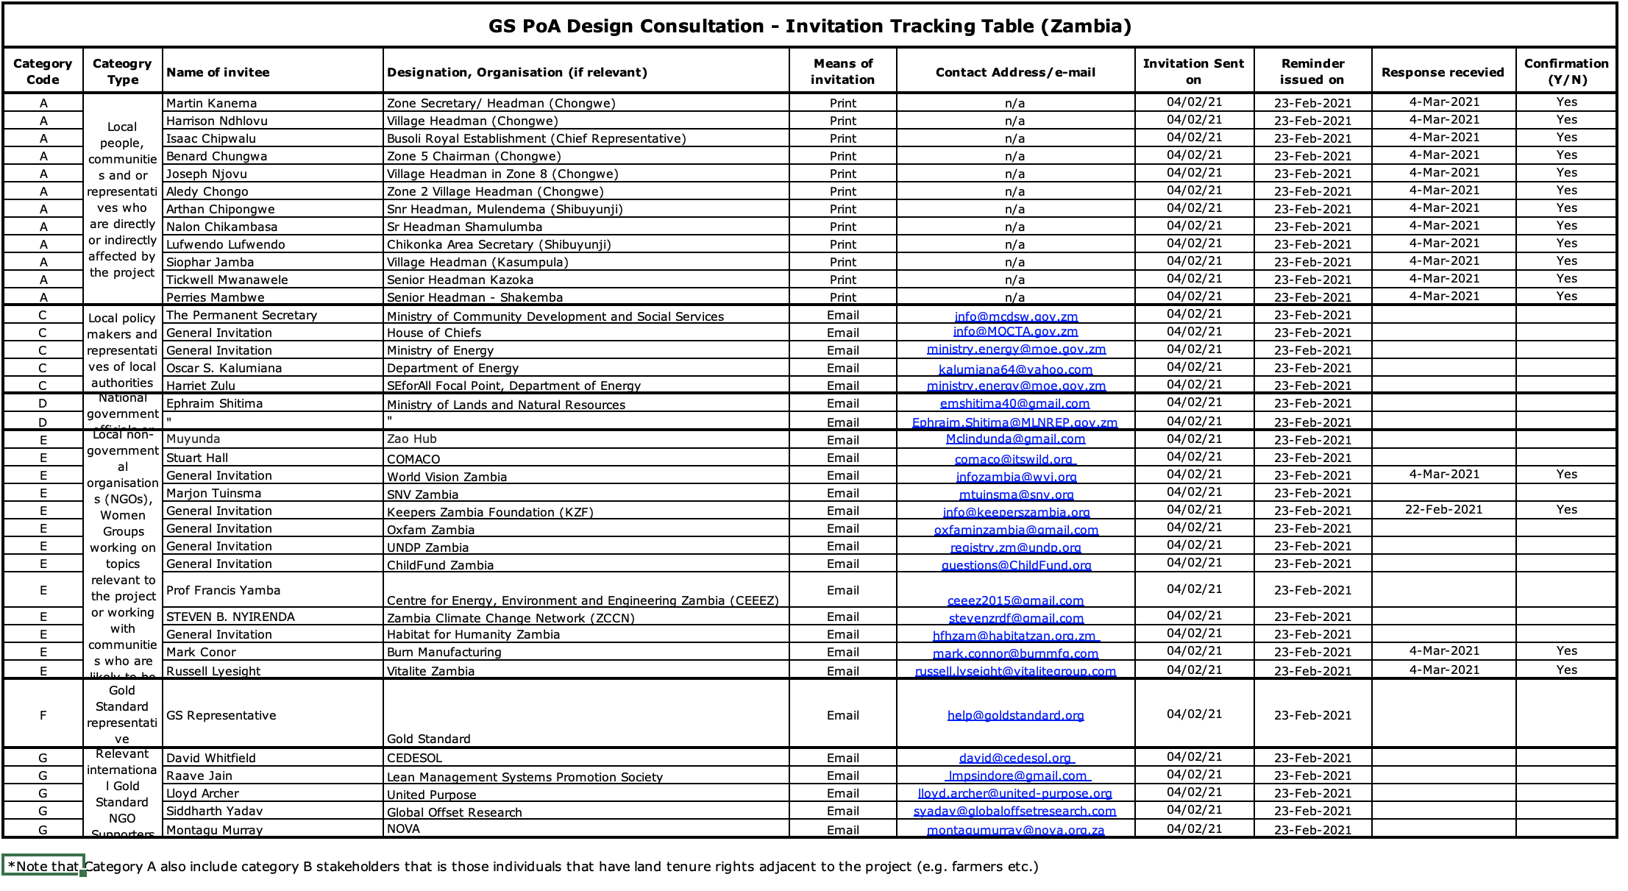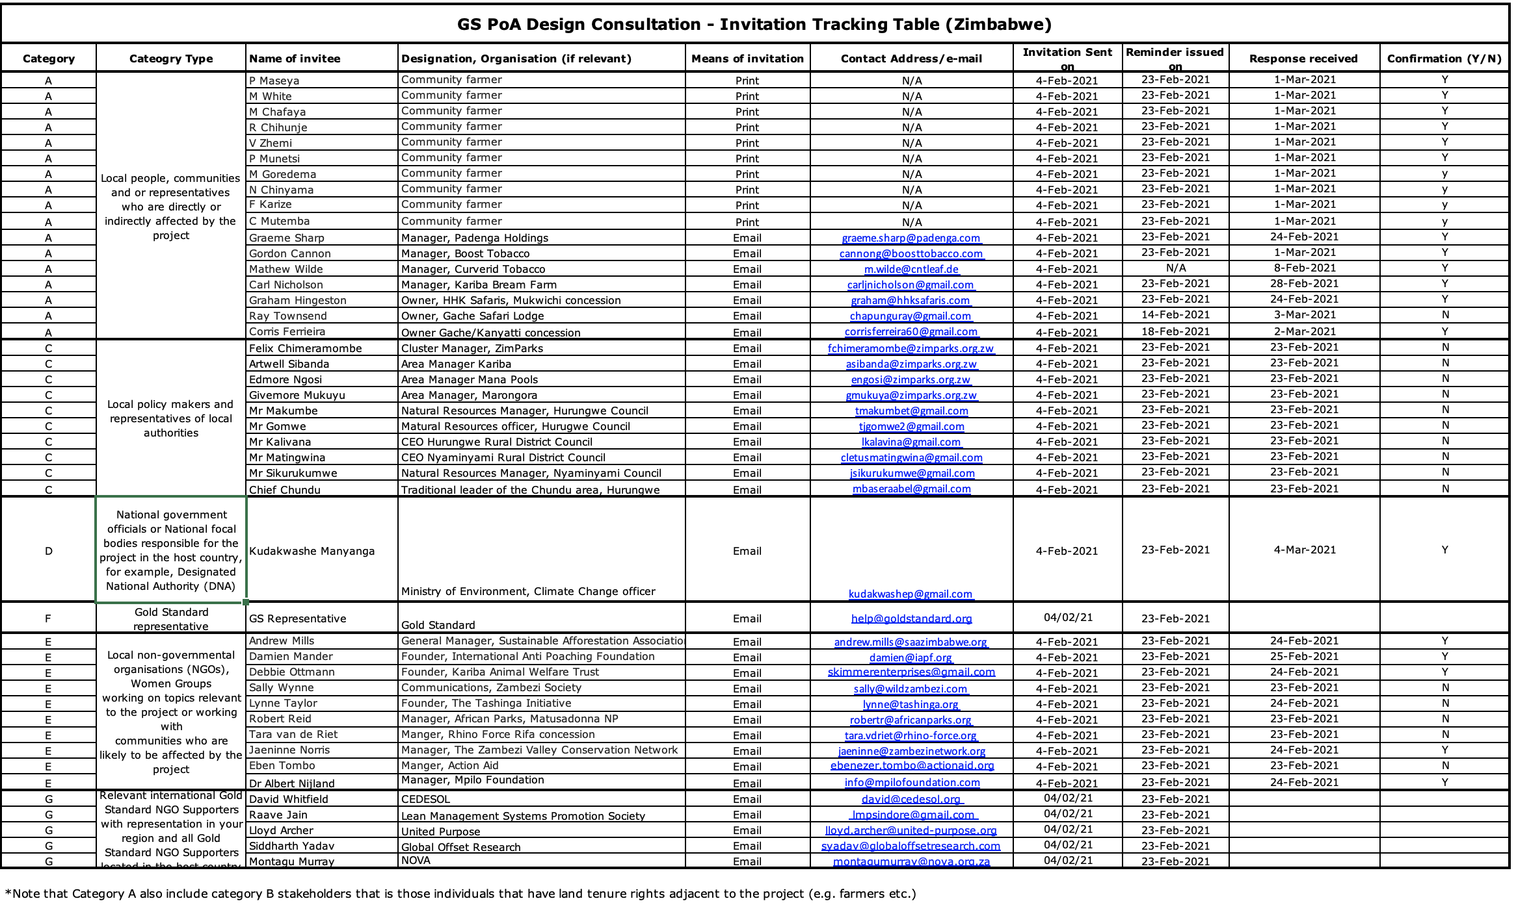

SECTION B. OUTCOME OF THE CONSULTATION PROCESS

B.1. Assessment of comments received
Overall the comments received were overwhelmingly positive. The following comments were selected as they may be construed as “constructive criticism”:
Organization | Stakeholder comment | Was comment taken  into account (Yes/ No)? | Explanation (Why? How?)
Zimbabwe
MTC | There should be more involvement of people in education e.g. teachers and heads of schools. | Yes | The stove distribution will include numerous ‘sensitization meetings’, where the project concept is presented at the local/community level.  The VPAI, My Trees, has a pipeline education program within primary schools (incl conservation clubs), where the project could be presented.
MTC | This (consultation) should be done after every 3 months at activity level. | Yes | The stove distribution will include numerous ‘sensitization meetings’, where the project concept is presented at the local/community level
NT | Local government should be brought in at implementation stage to improve the scope of the programme. | Yes | The stove distribution will include numerous ‘sensitization meetings’, where the project concept is presented at the local/community level
NT | An awareness campaign using print media will help program rollout | Yes | This will be considered during the distribution phase.
Premier | The targeted audience has to be females. | Yes | SDG Gola 5 is a target indicator.
Boost Africa | The use of national radio will help inform people at implementation stage | Yes | This will be considered during the distribution phase.
Local health worker | Local community leaders should be encouraged to be involved with implementation. | Yes | The stove distribution will include numerous ‘sensitization meetings’, where the project concept is presented at the local/community level
Zambezi Valley Conservation Network | A viable logistics plan will be important to consider to meet the current model of distribution, considering poor road access in designated rural areas etc. | Yes | A detailed logistics plan will be developed at the VPA level during the distribution phase.
Zambia
Senior Headman Kazoka | The system is okay, but maybe not involving the headmen enough | Yes | Stove distributions in Zambia have included numerous ‘sensitization meetings’, where the project concept is presented at the local/community level and engagement with community leaders has been paramount
SNV | SNV strongly discourages the free distribution of ICS to avoid market distortion. Instead, at maximum, ICS can be discounted at the value of the carbon price to ensure that a market for ICS continues to develop in a sustainable manner. The market for ICS in Zambia is immature. Therefore, the technical assistance and capacity building for local ICS companies/VPA is key and should be expanded. The need for support on reporting procedures should not be underestimated, to ease verification processes. | No | The target ‘market’ for efficient stoves may be different:  - Rural communities where a woodfuel stove is required are at the base of the economic pyramid and do not have access to the market for the stoves, nor the resources to afford them. Also wood is collected for free, so there is no economic incentive.  - Urban communities may have more access to markets and disposable income, plus if using charcoal, have an economic incentive to use an improve charcoal stove.  TASC is therefore confident that its activities do not distort the market, as the market for woodstoves does not exist.  TASC is, however, exploring the option for a market-based distribution of charcoal stoves in urban areas.
SNV | VPA level to ensure full feedback and inclusion of relevant field-level feedback. | Yes | Stove distributions in Zambia have included numerous ‘sensitization meetings’, where the project concept is presented at the local/community level and engagement with community leaders has been paramount

B.2. Report on Level of consultations
Many comments were received responding to the ‘Level of Consultation’ indicating that consultations should take place at the community/local/activity level. This will be considered during the implementation of the VPAs and the local stakeholder consultations done at VPA level.

The PoA stove distribution process will include numerous ‘sensitization meetings’, where the project concept and technology is presented at the local/community level.

These activities have already started in Zambia for the first VPA proposed under the PoA:

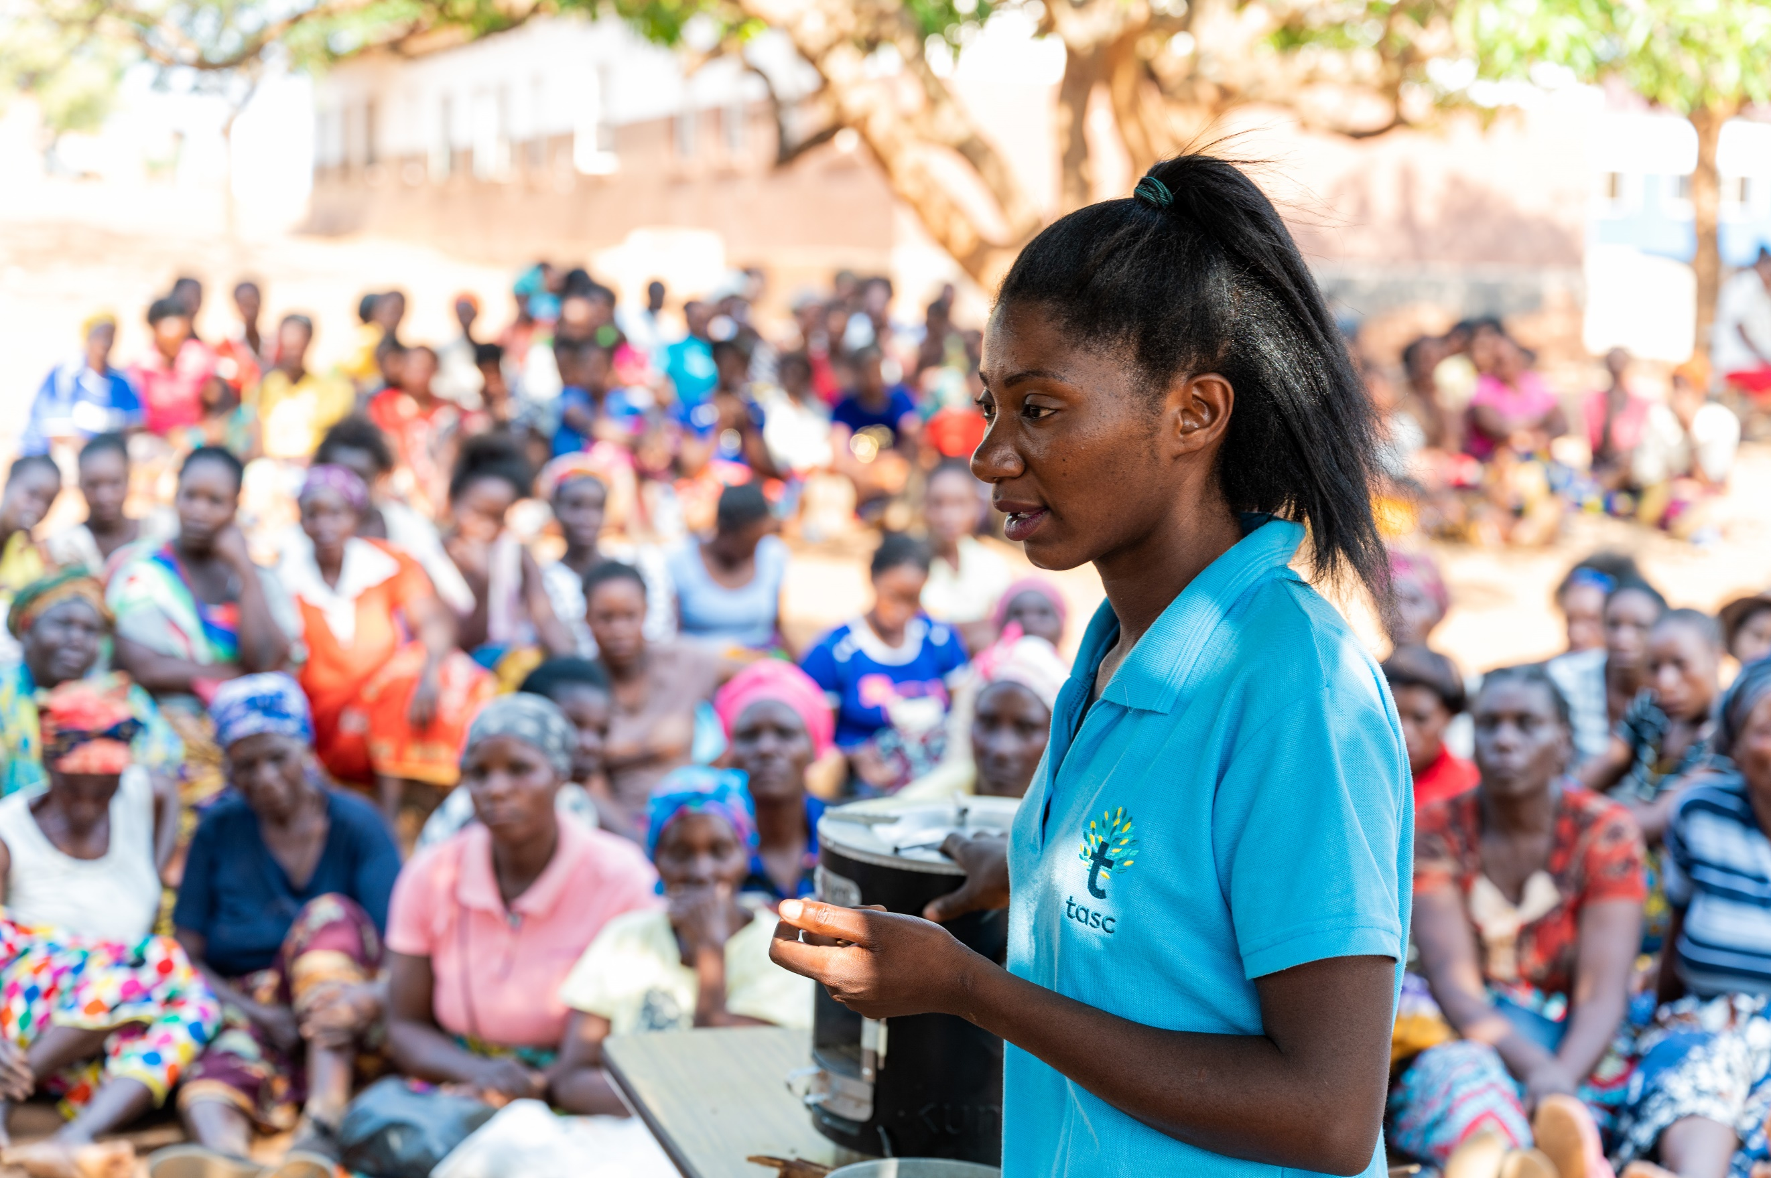
TASC Community Sensitization Meeting (Chongwe)
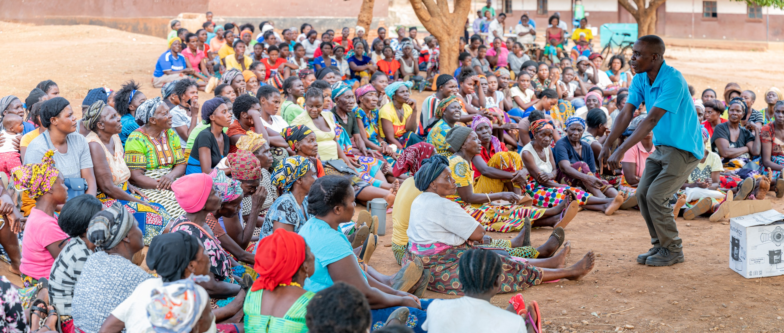
TASC Community Sensitization Meeting (Chongwe)

B.3. Summary of changes to the Programme design based on stakeholder feedback received.
There are no changes required in the current programme design. Stakeholder comments were considered and did not require any changes.

There are similarities with other cookstoves project being implemented in the Host Countries, where project boundaries are overlapping. However, the considerations for avoiding double-counting of stoves ensure that there are no conflicts.

Revision History

Version | Date | Remarks
1.1 | 14 October 2020 | Addition of version history table  Removal of Section A which repeats information in the POA-DD  Clarification on reporting information made available for stakeholders  Clarity on minimum period for invitation and consultation and that follow up is necessary for e-consultations  Clarity that a GS representative should be invited
1.0 | 10 July 2017 | Initial adoption

https://www.who.int/heli/risks/indoorair/indoorair/en/

