  CO₂ storage following the application of Limenet technology | Document information  001 - A | Date  July 2024
 |   Delivered to | Rev. 01 / 2024

METHODOLOGY
CO₂ storage following the application of Limenet technology

This document is developed in collaboration with:
 | 

Abstract
This methodology outlines the procedure to count the avoidance and removal, based on the origin of the CO₂ stored (see chapter 6 “DEFINITIONS”) of GHG emissions for the activity of CO₂ storage following the application of Limenet technology. The distinction between removed and avoided CO₂ depends on the origin and type of CO₂:
- in the case of CO₂ taken from the atmosphere or biogenic, this refers to removed CO₂;
- in the case of fossil CO₂, this refers to avoided CO₂.

This methodology is related to the only storage phase. It includes the monitoring system (calculation and measurement approach) and any uncertainty present in the ocean alkalinity enhancement system to permanently remove CO₂.

METHODOLOGY Information
BASIC INFORMATION
Methodology Name | METHODOLOGY  CO₂ storage following the application of Limenet technology
Version | 001 – A
Date of Issue | 30/05/2024
Sector | CO₂ storage into the sea as dissolved calcium bicarbonates and Ocean Alkalinity Enhancement
Author | Federico Comazzi, Stefano Cappello, Sebastian Rivera, Nicola Lanari, Valentina Malipiero, Ilaria Pugliese, Saverio Rocchi
Owner | Limenet s.r.l. Benefit  Via Filanda Maggiore 5, Galbiate  23851  +39 3287355618  info@limenet.tech
Contact | federico.comazzi@limenet.tech  stefano.cappello@limenet.tech  nicola.lanari@egeniasrl.it  valentina.malipiero@egeniasrl.it  ilaria.pugliese@egeniasrl.it  s.delvalle@aither.com  saverio.rocchi@limenet.tech

Summary
Abstract 2
METHODOLOGY Information 2
Acronyms 4
1 INTRODUCTION 5
2 INTERESTED PARTIES 6
2.1 Presentation of the project proponent and its activities 6
2.2 Interested parties in the application of the project 8
3 PURPOSE 9
4 SOURCES 9
4.1 Normative References 11
5 SUMMARY DESCRIPTION OF THE PROJECT 13
5.1 Phases 13
5.1.1 CO₂ storage phase 14
5.2 Location 15
5.3 Duration of installation 15
6 DEFINITIONS 16
6.1 Definitions related to ISO 14064-2 16
6.2 Definitions related to this methodology 19
7 APPLICABILITY CONDITIONS 23
7.1 Limitations of the Calculation Methodology 25
7.2 Carbon Leakage Risk Assessment 25
8 DETERMINING THE GHG BASELINE 26
9 MODULE BOUNDARY 27
9.1 Block diagram 28
9.2 Leakages 29
9.3 IDENTIFICATION OF RELEVANT GHG SSR 32
9.4 GHG SSR RELEVANT TO INTERESTED PARTIES, CASE 1 33
9.5 GHG SSR RELEVANT TO INTERESTED PARTIES, CASE 2 33
10 QUANTIFICATION OF REMOVAL OF GHG EMISSIONS 33
10.1 Monitoring 33
10.1.1 Data from inventories/suppliers 34
10.1.2 Measured data 38
10.1.3 Calculated data 41
10.2 Calculation of removed CO₂ 43
10.3 Measuring Instruments 50
11 DATA STORAGE 52
12 VALIDATION OF THE GHG PROJECT 52
13 PROJECT REPORT ON THE GHG 53
14 Annexes 54

Acronyms
- DAC: Direct Air Capture
- ETS: Emission Trading System
- GHG: Greenhouse gas
- TRL 6: Technology Readiness Level 6
- TRL 8: Technology Readiness Level 8
- VVBs: Validation and Verification Bodies
- PDD: Project Design Document
- LCOE: Levelized Cost Of Energy

INTRODUCTION
The following table describes the key elements of the methodology:

Table 1: Methodology key elements
Brief project description | The project requires the installation of the Limenet mixing plant able to store CO₂ into a calcium bicarbonates solution.  The Limenet plant must be located in a coastal area, because it requires the use of seawater. Permits must be obtained to discharge alkaline seawater.  The project also needs a CO₂ stream obtained from an external company (biogenic or fossil CO₂) or internal biomass gasification (biogenic CO₂) and/or internal limestone calcination (fossil CO₂), an electricity connection (preferably renewable) and the supply of calcium hydroxide.
Type of GHG emissions mitigation action | Capture and/or supply with subsequent permanent storage of CO₂ in seawater in the form of dissolved calcium bicarbonates. The mitigation action can be classified both CO₂ removal or avoidance depending on the source of CO₂ stored during the Limenet process:  • If CO₂ is removed from the atmosphere with any kind of process (e.g. DAC or biomass) and then permanently stored with Limenet process, this refers to negative emission or removal.  • If CO₂ is obtained from a fossil source (e.g. energy production, industrial hard to abate processes) and then permanently stored with Limenet process, this refers to emission avoidance.

INTERESTED PARTIES

Presentation of the project proponent and its activities
Limenet S.r.l. is a deep tech Benefit Company that boasts industrial collaborations and international partnerships; Limenet has developed a technology to permanently store carbon dioxide (CO₂) in the sea as dissolved calcium bicarbonates (Ca²⁺ + 2HCO₃⁻) which have the co-benefit of increasing the alkalinity of the ocean.
This method replicates and accelerates the natural process of aging carbonate rocks caused by rainfall, which has always led to the removal of CO₂ from the atmosphere and to the storage as bicarbonates in the oceans on geological time scales. Dissolved calcium bicarbonate Ca(HCO₃)₂ is already a natural component of the seas; bicarbonate is the main form in which carbon is present in the sea and is essential for the formation of the skeletons of calcifying organisms (corals, shells, phytoplankton, etc.).
The artificial increase of calcium bicarbonates in seawater increases the alkalinity and is scientifically considered a natural method to counteract the negative effects of ocean acidification, linked to the increase of atmospheric CO₂ concentration.
This new approach was developed to have a balanced alkaline solution before adding it to the ocean. This facilitates the measurement of CO₂ transformed into bicarbonate, drastically reducing uncertainties in comparison to removal techniques based on models and estimations.
The goal is to maximise the operational capacity of CO₂ storage, reaching over the years a storage plant capacity in the order of 100.000 tonnes of stored CO₂.
Limenet already tested its technology with a the TRL6 pilot plant. It has been built in 2023 in La Spezia (Italy) and is characterized by:
- maximum production of decarbonised calcium hydroxide of 1 kg/h;
- maximum CO₂ storage capacity of 1kg/h in the form of dissolved calcium bicarbonates;
- total production of approximately 250 kg/a of decarbonised calcium hydroxide which has been used to regenerate and produce the first negative CO₂ emissions (approx. 150kg). This plant has been used to analyze the chemical stability of calcium bicarbonates over time and their qualitative effect on marine biota (plankton and benthos) naturally present in sea water.

The following plant that will be build will reach TRL7 level. This pilot aims to demonstrate the effectiveness of the technology at a bigger scale with a storage capacity of 200 kg/h. This will be composed of three different phases:
- Dissolution plant demonstration
- Calciner to produce calcium oxide [1] which is hydrated to obtain calcium hydroxide[2]:

$${CaCO}_{3 (s)}\underset{→}{900°C<T<1000°C} {CaO}_{(s)}+{CO}_{2 (g)} [1]$$

$${CaO}_{(s)} +{H_{2}O}_{(l)}→{{Ca(OH)}_{2}}_{(s)} [2]$$

- Gasifier where organic feedstock, containing biogenic carbon, is processed in an oxy-combustion gasifier to generate a syngas used in calciner as heat source as pure stream of biogenic CO₂ (that will be stored).

This methodology is related to the first phase, the “dissolution plant demonstration”.

The TRL8 plant is in the design phase, will reach a productivity of 4000 tons CO₂ of negative emissions per year. Limenet, for this plant, will use proprietary and market available components:
- Proprietary technology:
  - Indirect vertical hybrid calciner capable of working with 100% electricity and with biomass oxy combustion.
  - Buffer reactors in which slaked lime and CO₂ are dissolved in seawater and calcium bicarbonate is formed.
- Market available components:
  - Gasifier for oxy combustion
  - Pumps, sensors, tubes, etc.
For TRL8, it is planned to produce biogenic CO₂ from a proprietary gasifier using certified sustainable biomass and biomass residues that would otherwise have decomposed and released CO₂ into the atmosphere.

Limenet plants could operate with 2 different solutions for CO₂ permanent storage:
- Electrical solution: applies when you have a low LCOE (Levelized cost of energy) and a low energy carbon footprint; in this case the CO₂ is recovered from third sources like companies (CO₂ avoidance or CO₂ removal).
- Biomass solution: applies when you have a high LCOE and a high or medium carbon footprint; in this case CO₂ is recovered from biomass (CO₂ removal).
The purpose of the two solutions is to be the more flexible as possible and adapt to territories where costs of electricity and raw materials could vary. The multiple energy sourcing helps to reduce costs related to:
- Calcination electrical energy
- CO₂ procurement, allowing to internally produce biogenic CO₂

Limenet plants will be hybrid fuelled and will have the possibility to operate both electric and biomass depending on the economic convenience.

Interested parties in the application of the project
The parties interested in the application of this methodology are:
- Companies present within the ETS will be interested in reducing their emissions by applying this methodology, as delivering part of the emissions produced, can reduce the number of emissions declared each year.
There might be a possibility to deduct emissions if proposals already foreseen in the M15 revision of Directive 2003/87/EC are implemented:
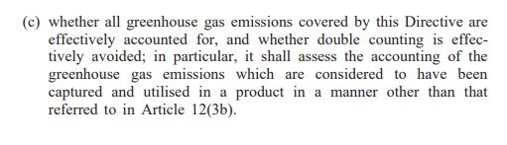
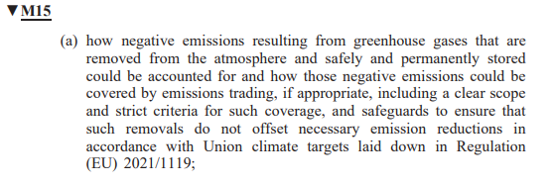
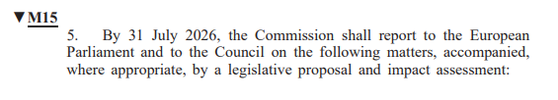
- Art. 30 paragraph 5 a) and c)
- Companies that realize the sustainability or neutrality balance every year, or aim to obtain similar certifications, which will be interested in reducing their emissions by applying this methodology, since delivering part of the emissions produced, may reduce the number of emissions reported each year;
- Limenet, which stores CO₂ by removing it from atmosphere or avoid its emission.

PURPOSE
The purpose of this methodology is to describe the requirements, principles and calculation of the only storage phase of CO₂ removal or avoidance of Limenet process in compliance with UNI EN ISO 14064-2: 2019: project requirements, validation and verification procedure and the steps for calculating the removal or avoidance of GHG emissions.

SOURCES
The following have informed the development of the module:
- “The GHG Protocol for Project Accounting”, World Business Council for Sustainable Development (WBCSD) and the World Resources Institute (WRI).

- “A Greenhouse Gas Accounting Framework for Carbon Capture and Storage Projects”, Centre for Climate and Energy Solutions.

- “Methodology for the quantification, monitoring, reporting and verification of greenhouse gas emissions reductions and removals from carbon capture and storage projects, Version 1.1., published by the American Carbon Registry

- “Guidelines for Carbon Capture, Transport and Storage”, WRI.

- “Carbon Capture and Sequestration Protocol under the Low Carbon Fuel Standard”, California Air Resources Board.

This methodology is also based on the following scientific papers:
- Renforth, P., and G. Henderson (2017),Assessing ocean alkalinity for carbonsequestration,Rev. Geophys.,55,636–674, doi:10.1002/2016RG000533.

- Riebesell, U., Basso, D., Geilert, S., Dale, A. W., and Kreuzburg, M.: Mesocosm experiments in ocean alkalinity enhancement research, in: Guide to Best Practices in Ocean Alkalinity Enhancement Research, edited by: Oschlies, A., Stevenson, A., Bach, L. T., Fennel, K., Rickaby, R. E. M., Satterfield, T., Webb, R., and Gattuso, J.-P., Copernicus Publications, State Planet, 2-oae2023, 6, https://doi.org/10.5194/sp-2-oae2023-6-2023, 2023.

- Moras, C. A., Bach, L. T., Cyronak, T., Joannes-Boyau, R., and Schulz, K. G.: Ocean alkalinity enhancement – avoiding runaway CaCO3 precipitation during quick and hydrated lime dissolution, Biogeosciences, 19, 3537–3557, https://doi.org/10.5194/bg-19-3537-2022, 2022.

- Hartmann, J., Suitner, N., Lim, C., Schneider, J., Marín-Samper, L., Arístegui, J., Renforth, P., Taucher, J., and Riebesell, U.: Stability of alkalinity in ocean alkalinity enhancement (OAE) approaches – consequences for durability of CO2 storage, Biogeosciences, 20, 781–802, https://doi.org/10.5194/bg-20-781-2023, 2023.

- Oschlies, A., Stevenson, A., Bach, L. T., Fennel, K., Rickaby, R. E. M., Satterfield, T., Webb, R., and Gattuso, J.-P. (Eds.): Guide to Best Practices in Ocean Alkalinity Enhancement Research, Copernicus Publications, State Planet, 2-oae2023, https://doi.org/10.5194/sp-2-oae2023, 2023.

- Middelburg, J. J., Soetaert, K., &Hagens, M. (2020). Ocean alkalinity,buffering and biogeochemical processes.Reviews of Geophysics,58,e2019RG000681. https://doi.org/10.1029/2019RG000681

- W. M. Balch, A. J. Plueddeman, B. C. Bowler and D. T. Drapeau (2009) doi:10.1029/2008JC004902

- Bernard P. Boudreau, Olivier Sulpis, Alfonso Mucci (2019) https://doi.org/10.1016/j.gca.2019.09.037

- Sijia Dong, Adam V. Subhas, Nick E. Rollins, John D. Naviaux, Jess F. Adkins, William M. Berelson (2018) https://doi.org/10.1016/j.gca.2018.07.015

- Sijia Dong, William M. Berelson, Nick E. Rollins, Adam V. Subhas, John D. Naviaux, Aaron J. Celestian, Xuewu Liu, Nitya Turaga, Nathaniel J. Kemnitz, Robert H. Byrne, Jess F. Adkins (2019) https://doi.org/10.1016/j.epsl.2019.03.016

- John D. Naviaux, Adam V. Subhas, Nick E. Rollins, Sijia Dong, William M. Berelson, Jess F. Adkins (2018) https://doi.org/10.1016/j.gca.2018.11.037

- John D. Naviaux, Adam V. Subhas, Sijia Dong, Nick E. Rollins, Xuewu Liu,
Robert H. Byrne, William M. Berelson, Jess F. Adkins (2019) https://doi.org/10.1016/j.marchem.2019.103684

- Adam V. Subhas, Nick E. Rollins, William M. Berelson, Sijia Dong, Jonathan Erez, Jess F. Adkins (2015) http://dx.doi.org/10.1016/j.gca.2015.08.011

- Dieter A. Wolf-Gladrow, Richard E. Zeebe, Christine Klaas, Arne Körtzinger, Andrew G. Dickson (2007) http://dx.doi.org/10.1016/j.marchem.2007.01.006

- Richard E. Zeebe, D.A. Wolf-Gladrow, H. Jansen (1999) https://doi.org/10.1016/S0304-4203(98)00092-9

- Richard E. Zeebe, Peter Westbroek (2003) doi:10.1029/2003GC000538

- Shamsher Ali and Azhar Ali S (2013) DOI: 10.4172/2161-0398.1000116

- Hari Krishna Bharadwaj, Joo-Youp Lee, Xin Li, Zhouyang Liu, Tim C. Keener (2013) http://dx.doi.org/10.1016/j.jhazmat.2013.02.009

- Yolanda A. Criado, Mó nica Alonso and J. Carlos Abanades (2020) dx.doi.org/10.1021/ie404246p

- John Blamey, Ming Zhao, Vasilije Manovic, Edward J. Anthony, Denis R. Dugwell, Paul S. Fennell (2016) http://dx.doi.org/10.1016/j.cej.2016.01.086

- Philip K. Gbor, Charles Q. Jia (2004) doi:10.1016/j.ces.2004.01.047

- Harald Justnes, Carlos Escudero-Oñate, Øyvind Aaberg Garmo and Martin Mengede doi:10.3390/ma13214926

- Hongwei Li, Zhigang Tang, Xiao Xing, Dong Guo, Longpeng Cui, Xian-zhong Mao (2018) https://doi.org/10.1016/j.energy.2018.09.066

- OLEG S. POKROVSKY and JACQUES SCHOTT (2002) doi:10.1016/S0016-7037(03)00238-2

- Marcelo V.C. SáClaude E. Boyd (2017) http://dx.doi.org/10.1016/j.aquaculture.2016.11.033

- Marcelo Vinicius do Carmo e SáDavi de Holanda CavalcanteFrancisco Roberto dos Santos Lima (2018) DOI: 10.1111/are.14039

Normative References
The reference standard for this project is UNI EN ISO 14064-2: 2019: the standard specifies the principles and requirements and provides guidance, at the project level, for quantification, monitoring, and reporting on activities to reduce greenhouse gas emissions and increase their removal. It includes requirements to plan a greenhouse gas project, to identify and select sources, absorbers, and reservoirs of greenhouse gases (SSRs) relevant to the project and the reference scenario, to monitor, quantify, document, and report the performance of effect gas projects and manage data quality. The UNI EN ISO 14064 standard series is neutral with respect to greenhouse gas methodologies. If an applicable gas methodology, its requirements are additional to those of the UNI EN ISO 14064 series of standards.
Mention should also be made of COMMISSION IMPLEMENTING REGULATION (EU) 2018/2066 of 19 December 2018, on the monitoring and reporting of greenhouse gas emissions pursuant to Directive 2003/87/EC of the European Parliament and of the Council and amending Commission Regulation (EU) No 601/2012.

SUMMARY DESCRIPTION OF THE PROJECT
The methodology will be structured in 4 singular modules.

Phases
- CO₂ sources UNDER DEVELOPMENT
- CO₂ capture UNDER DEVELOPMENT
- CO₂ transport UNDER DEVELOPMENT
- CO₂ storage, filename: “LM_V1_Methodology_Storage”

The methodology described in this document concerns the only storage phase; the further phases (CO₂ source, CO₂ capture and CO₂ transport) will be treated later.
The whole Limenet process consists of a plant with 3 main processes:
- The Limenet process starts with the sources of CO₂ and energy. Through the gasification of biomass (formula 1, fig. 1), the syngas is obtained that works both as biogenic CO₂ source and energy source.
- The syngas is later used in a syngas-fired calciner to calcinate the limestone (formula 2, fig. 1). This process output is calcium oxide and CO₂ (with also a flow of water necessary for technical reasons, this is re-used in the process). The calcium oxide is hydrated to obtain calcium hydroxide (formula 3, fig. 1) and then diluted with water to produce slaked lime (formula 3.1, fig. 1). Both the CO₂ coming from syngas combustion and limestone calcination is captured to be stored. Then the CO₂ need to be then transported to the storage module. The CO₂ stream is conditioned to be transported using the various methods specified in the transport module (CO₂ transport module, UNDER DEVELOPMENT) to the storage site.
- Finally, the storage process begins, offering two modes of CO₂ storage: offshore and onshore. The CO₂ is stored in seawater in the form of calcium bicarbonates. This last phase comprises 2 stages where CO₂ is initially injected into seawater (formula 4, fig. 1) to generate a slightly acid solution that is later buffered using calcium hydroxide (formula 5, fig. 1) to obtain the calcium bicarbonates solution.
The process of a plant with an annual storing capacity of 100.000 tons of CO₂ per year is here detailed:
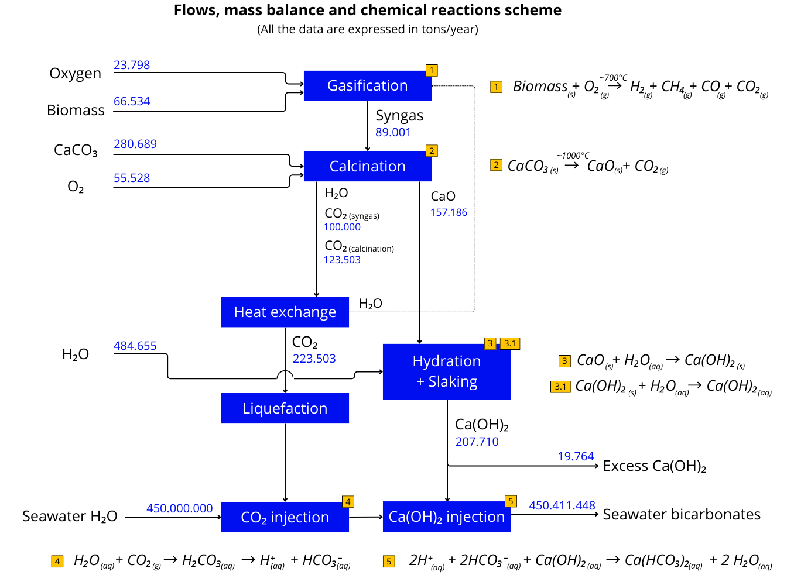
figure 1: Flows, mass balance and chemical reactions scheme

CO₂ storage phase
In this document the focus will be the storage phase. The dissolution plant is able to store the CO₂ into the sea as calcium bicarbonates. The raw materials for this plant, CO₂ and calcium hydroxide, must be externally supplied if the storage phase is not coupled with the gasifier and the calciner.
Otherwise, the raw materials would be internally supplied. From the calcination module the calcium oxide and calcium hydroxide and, from the gasifier the biogenic syngas that is later combusted to obtain energy and biogenic CO_{2.}
The storage phase corresponds only to the formulas 4 and 5 of figure 1. A more detailed image of the process is reported in figure 2. The individual stages of the process are here reported:
- The process starts with the pumping of seawater into the circuit with the use of a submergible pump. The flow rate is measured through a Magnetic Flow Meter.
- CO₂ is injected into the circuit and mixed with the water through the use of a static mixer.
- The complete reaction 4 takes place into dissolution module 1 in the order of few seconds.
- A second static mixer, installed into the dissolution module 1, is used to mix the calcium hydroxide slurry pumped from the hydroxide tanks.
- The complete chemical reaction is completed within dissolution module 2.
- Once the bicarbonates solution is formed, it is injected into the sea.

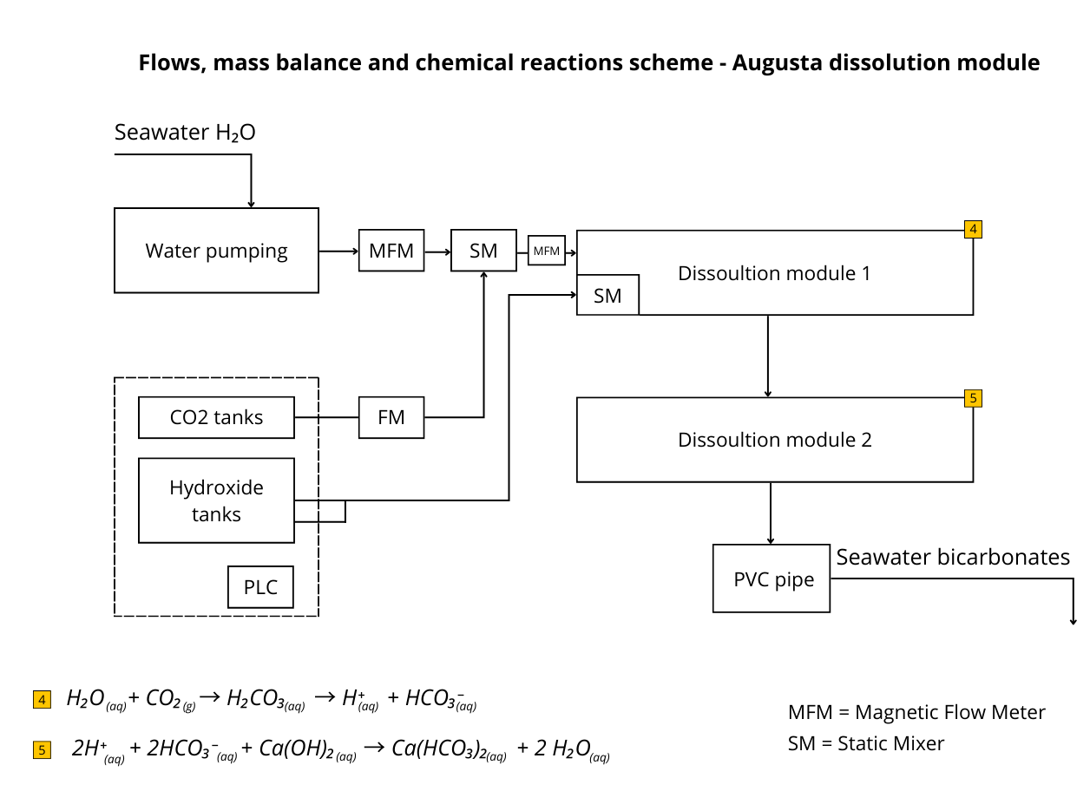
figure 2: Augusta demonstration plant and chemical reactions
More specific details regarding the specific mass flows will be reported in the specific PDDs of each project.

Location
The location of the project must be close to coastal areas. This is necessary since seawater is one of the raw materials of the dissolution phase. The area must be chosen through an optimization process that takes in consideration parameters related to economic factors like suppliers’ closeness, raw material prices and sustainability factors like impact on environment (presence of protected areas) and local communities (visual and acoustic impact).

Duration of installation
The duration of installation must be defined accordingly to the necessary time to store a certain amount of CO₂. During this period the plants could operate and generate the bicarbonates solution. The specific duration must be reported in the PDD.

DEFINITIONS
The following definitions apply to this module:

Definitions related to ISO 14064-2
- Greenhouse gas (GHG)
A gaseous constituent of the atmosphere, both natural and anthropogenic, that absorbs and emits radiation at specific wavelengths within the spectrum of infrared radiation emitted by the Earth’s surface, atmosphere and clouds.
The main greenhouse gases resulting from anthropic activity, as indicated in the Kyoto Protocol (implementing instrument of the Convention) are carbon dioxide (CO₂), methane (CH₄), nitrous oxide (N₂O), hydrofluorocarbons (HFCs), perfluorocarbons (PFC) and Sulfur Hexafluoride (SF₆); also, as you can view in the "Accounting and Reporting Standard Amendment" of February 2013, from the GHG Protocol realized, the nitrogen trifluoride (NF₃) has been included in the National Inventories under the United Nations Framework Convention on Climate Change (UNFCCC), as it has been considered a powerful contributor to climate change.
- SSR (sources, sinks and reservoirs)
- GHG source: process that releases a GHG into the atmosphere.
- GHG sink: process that removes a GHG from the atmosphere.
- GHG reservoir: component, other than atmosphere, that has the capacity to accumulate GHGs, and to store and release them.
Oceans, soils and forests are examples of components that can act as reservoirs.
- GHG emission
Release of a GHG into the atmosphere.
- GHG removal
The withdrawal of a GHG from the atmosphere by GHG sinks.
- GHG emission reduction
Quantified decrease in GHG emissions between a baseline scenario and the GHG project.
- GHG removal enhancement
Quantified increase in GHG removals between a baseline scenario and the GHG project.
- GHG emission factor
Coefficient relating GHG activity data with the GHG emission.
- GHG removal factor
Coefficient relating GHG activity data with the GHG removal.
A GHG removal coefficient might include an oxidation component.

- Affected GHG SSR
GHG source, GHG sink and GHG reservoir influenced by a GHG project, through changes in market demand or supply for associated products or services, or through physical displacement.
They are almost always offsite. Emission reductions or removal improvements due to the SSRs concerned are often referred to as "losses".
- Controlled GHG SSRs
GHG source, GHG sink and GHG reservoir where the operation is under the direction and influence of the GHG project proponent through financial, politicy, management or other instruments.
These SSRs are generally on-site.
- Related GHG SSRs
GHG source, GHG sink and GHG reservoir that has material or energy flows into, out of or within the GHG project.
They are generally upstream or downstream of the project, may be on-site or off-site, and may be present before or after the project, for example during the design, construction and decommissioning phases of a project.
- Global Warming Potential (GWP)
Index, based on the radiative properties of GHGs, measuring the radiative forcing following a pulse emission of a unit mass of a given GHG in present day atmosphere integrated over a chosen time horizon, relative to that of carbon dioxide (CO₂).
- Carbon dioxide equivalent (CO_{2eq})
Unit for comparing the radiative forcing of a GHG to that of carbon dioxide.
- GHG statement
Factual and objective declaration that provides the subject matter for the verification or validation.
- GHG information system
Policies, processes and procedures to establish, manage, maintain and record GHG information.
- GHG project
Activity or activities that alter the conditions of a GHG baseline and which cause GHG emission reductions or GHG removal enhancements.
- GHG report
Standalone document intended to communicate an organization’s or GHG project’s GHG- related information to its intended users.

- GHG baseline
Quantitative reference of GHG emissions and/or GHG removals that would have occurred in the absence of a GHG project and provides the baseline scenario for comparison with project GHG emissions and/or GHG removals.
- Baseline scenario
Hypothetical reference case that best represents the conditions most likely to occur in the absence of a proposed GHG project.
- Uncertainty
Parameter associated with the result of quantification that characterizes the dispersion of the values that could be reasonably attributed to the quantified amount.
- Intended user
Individual or organization identified by those reporting GHG-related information as being the one who relies on that information to make decisions.
- GHG project proponent
Individual or organization that has overall control and responsibility for a GHG project.
- Interested party
Person or organization that can affect, be affected by, or perceive itself to be affected by a decision or activity.
Example: Person or organization that is affected by or interested in the development or implementation of a GHG project.
- GHG programme
Voluntary or mandatory, international, national or sub-national system or scheme that registers, accounts or manages GHG emissions, GHG removals, GHG emission reductions or GHG removal enhancements outside the organization or GHG project.
- Level of assurance
Degree of confidence in the GHG statement.
- Verification
Process for evaluating a statement of historical data and information to determine if the statement is materially correct and conforms to criteria.
- Validation
Process for evaluating the reasonableness of the assumptions, limitations and methods that support a statement about the outcome of future activities.
- Verifier
Competent and impartial person with responsibility for performing and reporting on a verification.
- Validator
Competent and impartial person with responsibility for performing and reporting on a validation.

Definitions related to this methodology
- Accuracy
The proximity between the result of a measurement and the actual value of the quantity or a reference value empirically determined using internationally recognized calibration materials and standard methods, taking into account random and systematic factors.
- Atmospheric carbon dioxide
Carbon dioxide in the atmosphere at their respective concentrations (concentration may vary during the day, month and year. For indicative purposes, the global monthly average in August 2020 was 409.50 ppm according to NOAA (2020))
Lot: a quantity of sampled material and characterized in a representative way and transferred as a shipment or continuously for a specific period of time.
- Bicarbonate
A salt characterized by the presence of anion HCO₃. Bicarbonate includes calcium bicarbonate (Ca (HCO₃)₂), magnesium bicarbonate Mg (HCO₃)₂.
- Blockchain
Blockchain is a technology that allows you to save digital information (defined as blocks) safely and totally transparent through a decentralized computer system. It is like an "immutable" public register that offers the certainty of the information entered.
- Calibration
The set of operations that establishes, under specific conditions, the relationships between the values indicated by a measuring instrument or a measuring system, or the values represented by a material measure, or a reference material and the corresponding values of a quantity produced by a reference standard.
- Carbon dioxide removal (CDR)
Refers to anthropogenic activities that seek to remove CO₂ from the atmosphere and store it permanently in geological, terrestrial or oceanic tanks or products. CO₂ is removed from the atmosphere by improving biological or geochemical carbon deposits or by directly capturing CO₂ from air and storage (DAC+S).
- Carbonate minerals
Minerals characterized by the presence of carbonate ion (CO₂⁻³) in their structure. Carbonate minerals include calcite (CaCO₃), aragonite (CaCO₃), magnesite (MgCO₃), siderite (FeCO₃), ancherite (Ca (Fe,Mg,Mn)(CO₃)₂) and dolomite (CaMg(CO₃)₂).
- CO₂ capture
The capture of CO₂ from a process stream or atmosphere to produce a CO₂ stream capable of conversion or storage.
- CO₂ storage
Storage of CO₂ at sea in the form of bicarbonates.
- CO₂ loss
The term means any release of CO₂ from the storage complex and/or injection facility after the last monitoring point.
- CO₂ flow
The flow of concentrated CO₂ in gaseous or liquid form (liquefied or dissolved in water) resulting from a CO₂ capture process.
- Continuous measurement
A set of operations that aim to determine the value of a quantity by periodic measurements, applying both the measurement in the exhaust pipe and other parts of the designs with a measuring instrument. This is in line with Regulation (EU) 2018/2066.
- Emission source
The term means a separately identifiable part of an installation or process within an installation from which the relevant greenhouse gases are emitted.
- Energy balance method
A method for estimating the amount of energy used as fuel in an oven, calculated as the sum of the usable heat and all energy losses relevant for radiation, transmission, and effluent gas.
- ETS
The Emissions Trading System (ETS) is the EU’s CO₂ emissions trading system.
- Fugitive emissions
Irregular or unintentional emissions from sources that are not located or are too diverse or too small to be monitored individually.
- TSC ID
Identity Document Tracking Smart Contract is the internal tool able to write chain information on the specific lot of material used. It can associate the batch of material with the specific LCA analysis.
- Monitoring
The quantification of GHG entering or leaving the project perimeter (CO₂ capture and storage). Provides data and parameters to be monitored for the duration of the continuous storage period.
- Monitoring period
Period assessed to verify that CDR has been produced in accordance with the methodology.
- Process emissions
Emissions of greenhouse gases other than combustion emissions from intentional and unintentional reactions between substances or their transformation, including chemical or electrolytic reduction of metallic minerals, the thermal decomposition of substances and the formation of substances to be used as a product or raw material.

- Project Operator
One of these (Direct Aerial Capture Operator, Transport Operator, Storage Operator) or a combination of two or three of them.
- Duration of installation
The (estimated) duration of the storage process facilities.
- Tons of CO_{2eq}
Metric tons of CO₂ or CO_{2eq}.
- CO₂ Conditioning
The process of treatment of an incoming CO₂ stream to achieve the required conditions for transport and/or injection and storage of the CO₂ in a CCS project activity. It may include various processes including but not limited to refrigeration, dehydration, desulphurization, deoxygenation, and compression.
- Sea Reservoir
Carbon dioxide (CO₂) ocean storage, also referred to as "ocean carbon sequestration" or "ocean carbon capture," is a proposed method for mitigating climate change by removing CO₂ from the atmosphere and storing it in the world's oceans. This concept involves capturing CO₂ from industrial processes or power generation and then intentionally releasing or injecting it into the ocean.
The idea behind CO₂ Ocean storage is to take advantage of the oceans' natural capacity to absorb and store carbon dioxide.
- Intermediate Storage
Intermediate storage includes the processes and equipment on a site that enables temporary storage of CO₂ in transit, during the transfer of CO₂ from one mode of transport to another (e.g., transfer of CO₂ from a pipeline to transport by ship)
- Non-condensable Gas
Non-condensable gases are gases that do not condense into the liquid phase within a system's operating temperature. They are relevant for geothermal power/heat plants.
- Non-Limenet-CO₂
The CO₂ captured outside the project boundary of a CCS project activity that is conditioned, transported, or stored using (some of) the facilities of the registered CCS project.
- Storage Facility
Any facility used for storage of CO₂.
- Carbon emission reduction
Carbon reduction is an action that decreases the amount of greenhouse gas emissions, compared to prior practices.
- Carbon emission avoidance
Carbon avoidance is an action that prevents a carbon-emitting activity from happening. Carbon would have been re-emitted in the atmosphere if the project was not implemented.
- Carbon emission removal
Carbon removal is the process of removing carbon dioxide from the atmosphere and locking it away for decades, centuries, or millennia.

APPLICABILITY CONDITIONS
Limenet S.r.l. has identified, considered, and subsequently applied the relevant criteria and procedures for the storage phase of the greenhouse gas removal project, from the identification of the scope of this removal project through the determination of the relevant SSRs (sources, wells and greenhouse gas tanks) to the quantification of GHG emission removal.
The following are the requirements identified to ensure that the methodology for reporting removal and avoidance GHG emissions related to the use of Limenet technology is applicable, transparent and rigorous and avoids double counting or omissions.
The conditions for the applicability of the proposed reduction are:
- The presence of:
  - Seawater;
  - Electricity connection (preferably renewable) with enough power to run a plant able to store the predefined amount of CO₂
  - Supply of Ca(OH)₂ in a quantity enough to store the predefined amount of CO₂.
  - External supply of biogenic CO₂.
  - Port area: the choice is due to the need for a useful place for the intake and discharge of sea water and calcium bicarbonates respectively, also it must not have any special features except presenting a useful and sufficient area to accommodate the Limenet plant.
- For each plant that will be built Limenet will have to obtain permits to discharge alkaline water according to current environmental regulations, as already done for its existing prototype plant, for which they had to interface with the Italian environmental agency. At present, the discharge of alkaline water at pH 8 into the sea in Europe is not considered harmful to the environment by European Directive 91/271/EEC. The necessary permits is the AUA to inject the bicarbonates solution.
- The project activity must use a safety system to verify the correct formation of calcium bicarbonates during the storage phase.
- The project activity should use a containment tank into which to discharge the calcium bicarbonates that have not been formed correctly. Here the chemical-physical characteristics must be verified before being discharged with consequent storage at sea.
- The project activity must rely on modelling for downstream monitoring of calcium bicarbonates into the sea water to understand the saturation condition level of calcium carbonates by studying the omega aragonite/calcite parameter using software. This is necessary to avoid bicarbonates precipitation due to different chemical and physical characteristics specific of the seawater used.
- The CO₂ that is received from external companies must be accompanied by a certificate or declaration for the origin of CO₂: CO₂ of biogenic origin (CO₂ removed) or CO₂ of fossil origin (CO₂ avoided).

- The electricity emission factor, relating to the amount of electricity needed to operate the storage site and resulting, at least in part, from fossil fuels, can be found in two different ways:
- Market based, divided in turn:
  - The emission factor of the company supplying the electricity to the storage site is used, which may be present in the bill or in the sustainability report of the supplier company, or which may be requested directly from that company.
  - If the electricity supplier has not calculated its own emission factor, this factor must be calculated by making a weighted average through the energy mix of the supplier (usually present in the bill) and the national emission factors for each different primary source used to produce electricity (Table 2.26a of the ISPRA Report 363/2022 and subsequent updates).
- Location based:
If none of the above options can be applied, it should use:
  - the emission factors present in the most recently updated ISPRA annual report, if the storage site is in Italy,
  - the emission factors relating to the use of low-voltage electricity consumed in the EU, as set out in Commission Implementing Regulation (EU) 2022/996 of 14 June 2022 and above if the storage site is located in Europe.

The emission factor is expressed in g CO₂eq/kWh. Note that if electricity is produced entirely from renewable sources, the emission factor will be 0 gCO_{2eq}/kWh (this in the case where only the generation of electricity is considered, and not the distribution of the same electricity).

Limitations of the Calculation Methodology

Please note that for the preparation of this version (First emission) of the methodology for calculating the CO₂ stored, following the application of Limenet technology, carbon emissions not considered are those related to:
- emissions from the construction and disposal of the installation are amortised over the life of the installation, estimated at 25/30 years; they are therefore considered negligible;
- the stages of production and disposal of the machinery used to carry out the process, since the useful life of such machinery is estimated to be 25/30 years, and therefore emissions from the production and disposal stages re-proportioned over that period have a low impact;
- energy consumed to produce raw materials from third-party sources: since such raw materials are not produced specifically for the realization of this process, this step within the boundaries of the methodology is not considered;
- Process emissions related to the production of materials used in the Limenet storage process.
However, the emissions from these phases could have an impact on the calculated removals, that is currently under assessment and a new revision of the methodology will be issued if the impact will result significant.

Carbon Leakage Risk Assessment
The risk aspect of the Carbon Leakage related to the implementation of the project under examination was considered: this risk was found to be non-existent since the storage of CO₂ at sea (and the consequent removal and avoidance of emissions) does not lead to the relocation of GHG emissions to other countries.

DETERMINING THE GHG BASELINE
The starting baseline is the GHG emissions that would have occurred in the absence of the application of the CO₂ storage project at sea.
For this methodology, which is related to the only storage phase of the Limenet project, the baseline is all CO₂ that arrives at the Limenet storage facility, which will then be stored as calcium bicarbonate inside the sea.
The emissions related to the transportation of CO₂ for which the supplier of the CO₂ is responsible are not accounted as project activity emissions.

Table 2: GHG sources included or excluded in baseline scenario
Baseline | Source | GAS | Included? | Justification/Explanation
Baseline | External companies that supply biogenic CO₂ or capture CO₂ from the atmosphere | CO₂ | Yes | Limenet is involved in the removal of CO₂ emissions
Baseline |  | CH₄ | No | Limenet is not capturing CH₄
Baseline |  | N₂O | No | Limenet is not capturing N₂O
Baseline |  | Other | No | Limenet is not capturing other gases
Baseline | External companies providing fossil CO₂ | CO₂ | Yes | Limenet is involved in the avoidance of CO₂ emissions
Baseline | External companies providing fossil CO₂ | CH₄ | No | Limenet is not capturing CH₄
Baseline | External companies providing fossil CO₂ | N₂O | No | Limenet is not capturing N₂O
Baseline | External companies providing fossil CO₂ | Other | No | Limenet is not capturing other gases
Baseline | Limenet biomass gasification | CO₂ | Yes | Limenet is involved in the removal of CO₂ emissions
Baseline | Limenet biomass gasification | CH₄ | No | Limenet is not capturing CH₄
Baseline | Limenet biomass gasification | N₂O | No | Limenet is not capturing N₂O
Baseline | Limenet biomass gasification | Other | No | Limenet is not capturing other gases
Baseline | Limenet capturing CO₂ from the atmosphere | CO₂ | Yes | Limenet is involved in the removal of CO₂ emissions
Baseline | Limenet capturing CO₂ from the atmosphere | CH₄ | No | Limenet is not capturing CH₄
Baseline | Limenet capturing CO₂ from the atmosphere | N₂O | No | Limenet is not capturing N₂O
Baseline | Limenet capturing CO₂ from the atmosphere | Other | No | Limenet is not capturing other gases

MODULE BOUNDARY
The module boundary includes all the facilities and equipment at the storage site, including the injection and monitoring points and all related equipment. The included processes are shown in figure 3 within the red dotted line.
The processes of the project within the storage phase are:
- Intermediate/final storage of CO₂ received
- Intermediate/final compression and/or conditioning of CO₂ before injection into the pipes
- Injection pipelines, piping, valves, and monitoring instrumentation
- SCADA, communication equipment and PLC monitoring
- CO₂, Ca(OH)₂ and H₂O pumps
- CO₂ compression with interstage cooling (valve/seal losses, and electricity consumption or fuel use)
- the transport of raw materials necessary for the production process (excluding the transport of captured CO₂)

The physical boundary of the module is shown in Figure 3.
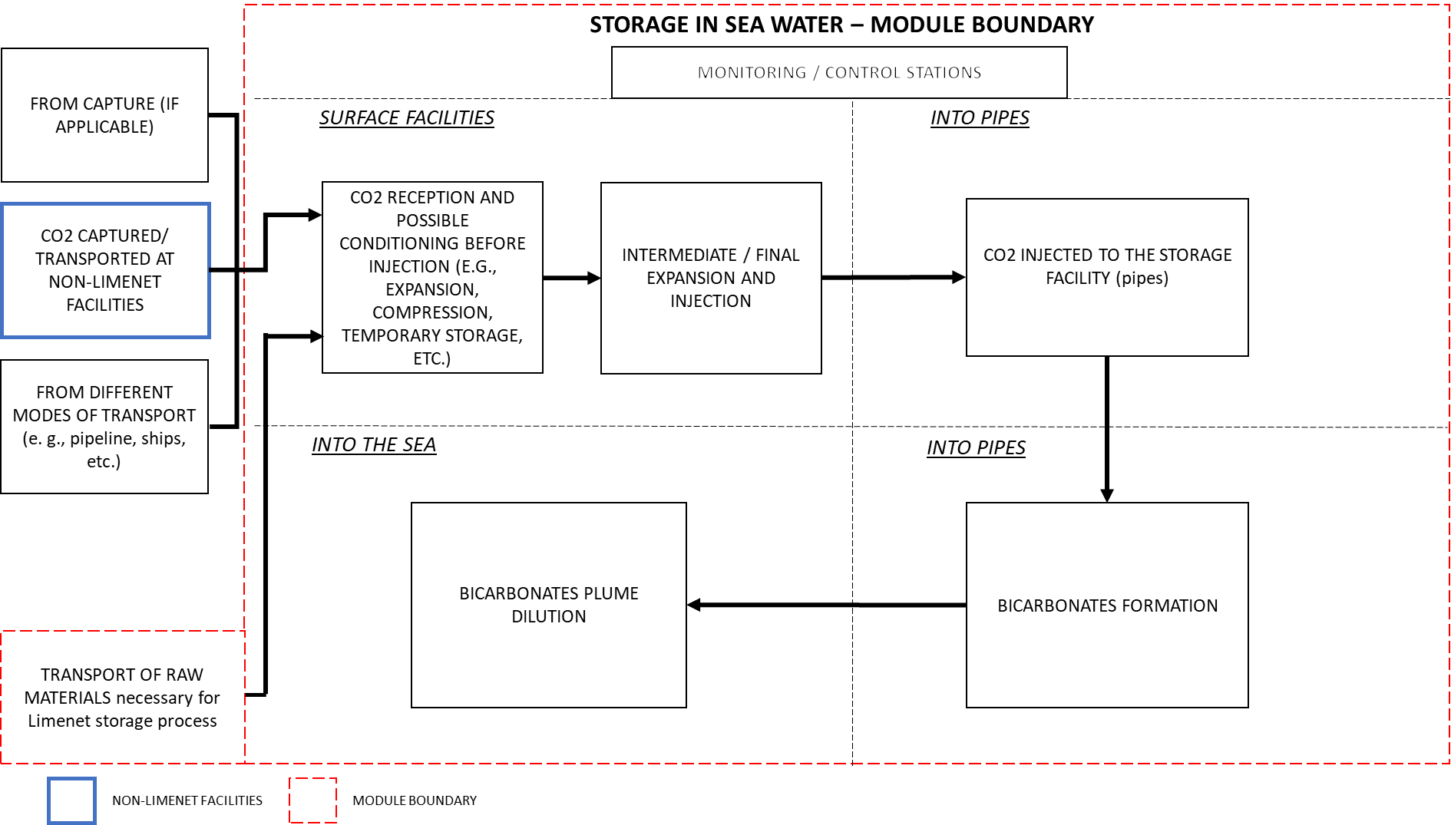
Figure 3: Module boundary for CO2 storage in seawater

Block diagram

- CO₂ CAPTURE FACILITIES: The capture facility includes mainly the CO₂ separation and capture process (e.g., by absorption, adsorption, membrane, electro-chemical or cryogenic process) and typically a CO₂ conditioning process. A capture facility may consist of several independent capture units applying the same or different processes. Such units may share some auxiliary equipment but the main CO₂ separation and the capture process (e.g., the absorber column) would not be shared.
- CO₂ CAPTURED AT NON-LIMENET FACILITIES: The CO₂ captured outside the project boundary of a project activity registered under LIMENET that is conditioned, transported, or stored using (some of) the facilities of the registered project activity.

- MODE OF TRANSPORT: Refers to how CO₂ can be moved from an entry point (e.g., a capture site) to a point of delivery (e.g., other modes of transport or storage). This typically includes CO₂ transport by pipelines, ships/barges, rail and/or trucks.

- CO₂ CONDITIONING: The process of treatment of an incoming CO₂ stream to achieve the required conditions for transport and/or injection and storage of the CO₂ in CCS project activity.

- STORAGE FACILITY: Any facility used for storage of CO₂.

- BICARBONATES FORMATION: free slaked lime is used to store CO₂ from external sources in the form of calcium bicarbonates.

Emission sources, including both primary and secondary effects included in this module are shown in Figure 4.
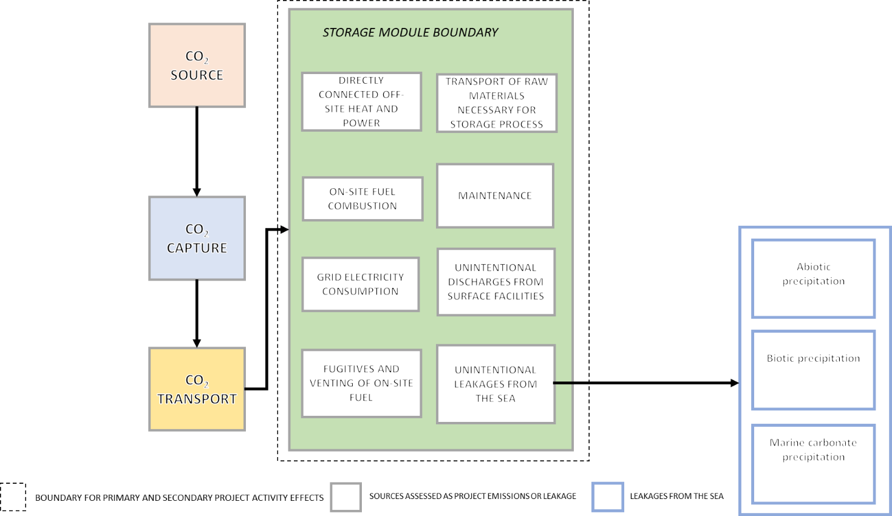
figure 4: Boundary for Primary and Secondary Project Activity Effects

Leakages
- UNINTENTIONAL DISCHARGES FROM SURFACE FACILITIES: The potential emission sources for unintentional discharges of CO₂ include but are not limited to:
- Components (such as valves, connectors, open-ended pipes, pressure relief valves, flanges, meters and instruments);
- Pipelines. (such as pipe fittings)
- UNINTENTIONAL LEAKAGE FROM THE SEA:

- ABIOTIC PRECIPITATION: The abiotic precipitation of calcium bicarbonates in seawater refers to the chemical process by which calcium bicarbonate (Ca(HCO₃)₂) compounds form as a result of physical and chemical factors, rather than through biological processes involving marine organisms like corals. Here's an explanation of the abiotic precipitation of calcium bicarbonates.
In seawater, there are naturally calcium ions (Ca²⁺) and bicarbonate ions (HCO₃⁻). Calcium carbonate (CaCO₃) minerals, such as calcite and aragonite, are also present in marine sediments and rocks. Carbon dioxide (CO₂) from the atmosphere can dissolve in seawater and it combines with water (H₂O) to form carbonic acid (H₂CO₃), which can further dissociate into bicarbonate ions (HCO₃⁻) and carbonate ions (CO₃²⁻). As more CO₂ dissolves in seawater, the concentration of bicarbonate ions (HCO₃⁻) and carbonate ions (CO₃²⁻) increases. This increase in bicarbonate ions raises the alkalinity of seawater.
When the alkalinity of seawater is sufficiently high, it can react with the calcium ions (Ca²⁺) present in seawater to form calcium bicarbonate compounds Ca²⁺+ 2HCO₃⁻ ⇌ Ca(HCO₃)₂.
The calcium bicarbonate compounds can further react and precipitate as solid calcium carbonate minerals. These minerals may form crystals or precipitate onto surfaces, such as rocks, shells, or other substrates in the marine environment. The abiotic precipitation of calcium bicarbonates in seawater occurs due to the interplay of chemical reactions driven by factors like alkalinity, temperature, pressure, and the concentration of dissolved ions.
- BIOTIC PRECIPITATION: The biotic precipitation of calcium bicarbonates is crucial for the formation and growth of ecosystems such as coral reefs. However, it is important to note that these organisms are sensitive to environmental conditions, such as ocean acidification caused by increased atmospheric carbon dioxide, which can negatively affect their calcification ability and survival. The biotic precipitation of calcium bicarbonates in seawater is a process involving marine organisms, in particular corals and other calcifying organisms, in the formation of calcium carbonate (CaCO₃): these absorb bicarbonate ions (HCO₃⁻) and calcium ions (Ca²⁺) from the surrounding seawater through their tissues, within which the bicarbonate ions are converted into carbonate ions (CO₃²⁻). Once bicarbonate ions have been converted into carbonate ions inside the organisms, they react with calcium ions present within the tissues to form solid calcium carbonate: Ca²⁺+ CO₃²⁻ -> CaCO₃. Organisms use the solid calcium carbonate to build their skeletons or calcareous structures.
- MARINE CARBONATE PRECIPITATION: Calcium bicarbonates in seawater are known to last between 10k and 100k years. It is also known that, if Ωar in seawater is kept below 5-7, no marine carbonate precipitation will occur: the storage of CO₂ in the form of calcium bicarbonates in marine waters can be considered a stable deposition of carbon. This uncertainty can be considered negligible.

The GHGs included or excluded from the module boundary are detailed in Table 3.

Table 3: GHG Sources Included or Excluded in the Project Boundary
CO_{2eq.} STORAGE
SOURCE | GAS | INCLUDED? | JUSTIFICATION/EXPLANATION
Electricity consumption | CO₂ | Yes | Major emission source
Electricity consumption | CH₄ | No | Excluded for simplicity, emissions are considered negligible.
Electricity consumption | N₂O | No | Excluded for simplicity, emissions are considered negligible.
Electricity consumption | Other | No | Excluded for simplicity, emissions are considered negligible.
Fuel consumed in transport | CO₂ | Yes | Major emission source
Fuel consumed in transport | CH₄ | No | Excluded for simplicity, emissions are considered negligible.
Fuel consumed in transport | N₂O | No | Excluded for simplicity, emissions are considered negligible.
Fuel consumed in transport | Other | No | Excluded for simplicity, emissions are considered negligible.
CO₂ Stream processing | CO₂ | Yes | Any loss of CO₂ due to fugitive or venting emissions during bicarbonates formation will be limited and near to zero thanks to a correct operativity of the plant.
CO₂ Stream processing | CH₄ | No | Excluded for simplicity, emissions are considered negligible.
CO₂ Stream processing | N₂O | No | Excluded for simplicity, emissions are considered negligible.
CO₂ Stream processing | Other | No | Excluded for simplicity, emissions are considered negligible.
Leaks of CO₂ from the storage site (intentional and unintentional discharge from surface and subsurface) | CO₂ | Yes | Minimal emission source
 | CH₄ | No | Excluded for simplicity, emissions are considered negligible.
 | N₂O | No | Excluded for simplicity, emissions are considered negligible.
 | Other | No | Excluded for simplicity, emissions are considered negligible.

IDENTIFICATION OF RELEVANT GHG SSR
Sources, Sinks and Reserves (SSRs) of GHG have been selected on the basis of the guidelines provided by the decision diagram in annex 1 – SSR identification taken from ISO 14064-2.
The SSRs involved in the project are the Sources and Sinks (for the type of project under consideration there are no Reserves), and have been divided into the following categories:
Table 4: Relevant GHG SSR
AFFECTED | CONTROLLED | RELATED
 | Instrumentation and various machines used inside the plant | Sea/Ocean
 | CO₂ emissions from the plants of the various companies that will transport the CO₂ produced to the storage site
 | CO₂ collected through capture instruments from Limenet
 | CO₂ emissions due to the transport of raw materials necessary for the production process (excluding the transport of captured CO₂)

All the SSRs relevant to the project are:
- all the instruments and machines used in the various phases, powered by electricity, necessary to achieve the storage of CO₂ at sea;
- the CO₂ produced by companies representing stakeholders will be captured/conveyed and transported to the storage site;
- the CO₂ collected through capture instruments, such as Gasifiers or DAC systems and from flue gases, which will then be fed into the plant and finally stored at sea. Gasifier generate a syngas (H₂, CH₄, CO, CO₂) that can be used as combustible in the calciner, after the combustion a pure flow of CO₂ is obtained;
- the sea/ocean, as they are the tanks that will accumulate and store for tens of thousands of years the CO₂ stored in the form of calcium bicarbonates;
- the CO₂ produced by transport of raw materials necessary for the production process (excluding the transport of captured CO₂).

In the following paragraphs, the SSRs were broken down according to the stakeholders in the project.

GHG SSR RELEVANT TO INTERESTED PARTIES, CASE 1
If the interested parties to the methodology are companies in the ETS or companies that carry out their annual sustainability or neutrality report, the relevant SSRs are the same as in the previous paragraph, without considering the CO₂ collected through capture instruments from Limenet.
SSRs are then divided into:
- those relevant to the baseline scenario, which are:
  - the CO₂ produced by companies representing stakeholders will be captured/conveyed and transported to the storage site;
- those relevant to the CO₂ storage phase, which are:
  - all the instruments and machines used in the various phases, powered by electricity, necessary to achieve the storage of CO₂ at sea;
  - the sea/ocean, as they are the tanks that will accumulate and store for tens of thousands of years the CO₂ stored in the form of calcium bicarbonates;
  - the CO₂ produced by transport of raw materials necessary for the production process (excluding captured CO₂ transportation).

GHG SSR RELEVANT TO INTERESTED PARTIES, CASE 2
If the interested party to the methodology is Limenet, the relevant SSRs shall be divided into:
- those relevant to the baseline scenario, which are:
  - the CO₂ collected through capture instruments, which will then be fed into the plant and finally stored at sea;
- those relevant to the CO₂ storage phase, which are:
  - all the instruments and machines used in the various phases, powered by electricity, necessary to achieve the storage of CO₂ at sea;
  - the sea/ocean, as they are the tanks that will accumulate and store for tens of thousands of years the CO₂ stored in the form of calcium bicarbonates;
  - the CO₂ produced by transport of raw materials necessary for the production process (excluding captured CO₂ transportation).
In this case, the CO₂ emissions produced by external companies are not taken into account, as the interested party is Limenet.

QUANTIFICATION OF REMOVAL OF GHG EMISSIONS

Monitoring
This monitoring plan lists all the parameters that need to be measured and monitored to correctly calculate the "CO₂ storage following the application of Limenet Technology".
Equations from 1 to 6 in section 10.2 identify how these parameters are used in project calculations of saved emissions.
During the monitoring the project activity must use a safety system to verify the correct formation of calcium bicarbonates during the storage phase.

The project activity has four mandatory monitoring points (control stations) as shown in figure 3:
  - The first is pre-/upstream-bicarbonates formation, which is “surface facilities” (CO₂ reception and conditioning and intermediate/final expansion and injection);
  - The second is pre-/upstream-bicarbonates formation, which is “Into Pipes” (CO₂ injected into the storage facility);
  - The third is during bicarbonates formation, which is “Into Pipes” (bicarbonates formation);
  - The fourth is post-/downstreamg-bicarbonates formation, which is “Into the sea” (bicarbonates plume dilution).

Data from inventories/suppliers
Table 5: CO₂ Molar mass description
Parameter | $${CO}_{2} Molar mass$$
Parameter type | Data from inventories/suppliers
Unit of measurement | g/mol
Description | Molar mass of CO₂
Equation in which it is present | Equations 2, 3
Data source | Periodic table
Value applied | 44,0095
Justification for the choice of data or description of measurement methods and procedures applied | A chemical constant
Frequency of acquisition | This data is acquired once
QA/QC procedures to be applied | N.A.

Table 6: Global Warming Potential description
Parameter | GWP
Parameter type | Data from inventories/suppliers
Unit of measurement | t CO_{2eq}/ t GHG
Description | Global Warming Potential
Equation in which it is present | Equations 5.1, 5.2
Data source | Sixth assessment report of IPCC - AR6 or subsequent updates
Description of the measurement/calculation methods and procedures to be applied | N.A.
Frequency of acquisition | This data is acquired once or any time is updated by IPCC
QA/QC procedures to be applied | Parameters must be derived from the most recent published versions available

The GWP values used for the various equations derive from the Sixth Assessment Report of the IPCC - AR6 and are shown in the table 7 below.
Table 7: Global Warming Potential of GHGs
GHG | Chemical formulation | GWP (100 years)
Carbon dioxide | CO₂ | 1
Methane of fossil origin | CH₄ | 29,8
Nitrous oxide | N₂O | 273

Table 8: Electric energy Emission Factor description
Parameter | $${EF}_{ e.e.}$$
Parameter type | Data from inventories/suppliers
Unit of measurement | t_{CO2} /kWh
Description | Emission factor linked to electric energy (e.e.) consumption
Equation in which it is present | Equation 4
Data source | from e.e. Supplier Sustainability Report or from ISPRA reports
Description of the measurement/calculation methods and procedures to be applied | Get the value from the data source
Frequency of acquisition | This data is acquired once or every time an electricity supplier change or every year
QA/QC procedures to be applied | The parameter must be derived from the most recent published versions available

Table 9: transport emission factor description
Parameter | $${e.f.}_{ trasp,GHG}$$
Parameter type | Data from inventories/suppliers
Unit of measurement | g GHG/km or t GHG/TJ
Description | Emission factor relating to means used for the transport of raw materials
Equation in which it is present | Equations 5.1, 5.2
Data source | Inventories or similar documents
Description of the measurement/calculation methods and procedures to be applied | Emission factor inventories for transport emissions in Italy (source ISPRA) (from the most recent published versions available)
Frequency of monitoring | This data is acquired once
QA/QC procedures to be applied | The parameter must be derived from the most recent published versions available

Table 10: transport emission factor of GHGs
GHG | Chemical formulation | $${e.f.}_{ trasp}$$ | U.O.M
Carbon dioxide | $$e.f._{trasp, CO2}$$ | 73,952 | tCO₂/TJ
Methane of fossil origin | $$e.f._{trasp, CH4}$$ | 0,000538 | tCH₄/TJ
Nitrous oxide | $$e.f._{trasp, N2O}$$ | 0,00412 | tN₂O/TJ

Table 11: fuel consumption_{k} description
Parameter | $${fuel consumption}_{k}$$
Parameter type | Data from inventories/suppliers
Unit of measurement | L/km
Description | Average consumption of means used to transport raw material k to the storage site
Equation in which it is present | Equation 5.2
Data source | Data sheets or similar documents
Description of the measurement/calculation methods and procedures to be applied | Taken from data sheets of the means of transport used
Frequency of monitoring | This data is monitored every time a discharge occurs
QA/QC procedures to be applied | N.A.

Table 12: Density of fuel used (ρ_{k}) description
Parameter | $$ρ_{k}$$
Parameter type | Data from inventories/suppliers
Unit of measurement | kg/L
Description | Density of fuel used mission factor relating to means used for the transport of raw materials
Equation in which it is present | Equation 5.2
Data source | Inventories or similar documents
Description of the measurement/calculation methods and procedures to be applied | Taken from Commission Implementing Regulation (EU) 2022/996 of 14 June 2022  and subsequent updates
Frequency of monitoring | This data is acquired once
QA/QC procedures to be applied | The parameter must be derived from the most recent published versions available

Table 13: Lower Heating Value (LHV_{k}) description
Parameter | $${LHV}_{ k}$$
Parameter type | Data from inventories/suppliers
Unit of measurement | GJ/t
Description | Lower heating value of fuel used
Equation in which it is present | Equation 5.2
Data source | Inventories or similar documents
Description of the measurement/calculation methods and procedures to be applied | Taken from Commission Implementing Regulation (EU) 2022/996 of 14 June 2022  and subsequent updates
Frequency of monitoring | This data is acquired once
QA/QC procedures to be applied | The parameter must be derived from the most recent published versions available

Table 14: Molar volume standard description
Parameter | $${VM}_{std}$$
Parameter type | Data from inventories/suppliers
Unit of measurement | L/mol
Description | The standard molar volume is the volume occupied by a mole of gas at standard temperature and pressure
Equation in which it is present | Equations 2, 3
Data source | Inventories or similar documents
Description of the measurement/calculation methods and procedures to be applied | Taken from Encyclopedia Britannica (22,4)
Frequency of monitoring | This data is acquired once
QA/QC procedures to be applied | N.A.

Measured data

Table 15: CO₂ injected description
Parameter | $${CO}_{2, in}$$
Parameter type | Measured data
Unit of measurement | Nm³/h
Description | The volume flow is measured by mass flow meter
Equation in which it is present | Equations 2, 3
Data source | Readings of a flow meter
Description of the measurement/calculation methods and procedures to be applied | Mass flow rates must be determined by commercially available devices that measure the mass flow rate of a fluid flowing through a measurement channel.
Frequency of monitoring | Monitored continuously
QA/QC procedures to be applied | The metering equipment must be installed and calibrated in accordance with either the specifications of local/national standards or the manufacturer's specifications. If local/national standards or the manufacturer specification is not available, international standards (e.g., IEC, ISO) must be followed.

Table 16: Electric Energy consumption description
Parameter | $${E.E.}_{consumption}$$
Parameter type | Measured data
Unit of measurement | kWh
Description | Amount of electric energy consumed
Equation in which it is present | Equation 4
Data source | Measuring instrument or electricity bill
Description of the measurement/calculation methods and procedures to be applied | The electricity consumption is determined by the values measured by the electricity meter, or taken directly from the electricity bills, where there are data of monthly or bimonthly consumption
Frequency of monitoring | One measurement at least every two months
QA/QC procedures to be applied | The metering equipment must be installed and calibrated in accordance with either the specifications of local/national standards or the manufacturer's specifications. If local/national standards or the manufacturer specification is not available, international standards (e.g., IEC, ISO) must be followed.

Table 17: Number of journeys for "k" raw material description
Parameter | $$N_{k}$$
Parameter type | Measured data
Unit of measurement | -
Description | Number of journeys required for the transport of each raw material k
Equation in which it is present | Equations 5.1, 5.2
Data source | Reading of the discharge register
Description of the measurement/calculation methods and procedures to be applied | The number of journeys of raw material k at the storage site is recorded
Frequency of monitoring | This data is monitored every time a delivery occurs
QA/QC procedures to be applied | The delivery register shall be updated whenever the raw materials are discharged at the site

Table 18: Number of kilometres travelled for "k" raw material description
Parameter | $${km}_{k}$$
Parameter type | Estimated
Unit of measurement | km
Description | Number of kilometers traveled per journey to transport the raw material k at the storage site
Equation in which it is present | Equations 5.1, 5.2
Data source | Estimated
Description of the measurement/calculation methods and procedures to be applied | Estimated considering the route traveled through geolocation sites
Frequency of monitoring | This data is monitored every time a discharge occurs
QA/QC procedures to be applied | N.A.

Table 19: seawater input pH description
Data | $$pHin$$
Data type | Calculated data
Unit of measurement | -
Description | pH level, measure of acidity of a solution
Equation in which it is present | Equation 3
Data source | Readings of the pH-meter
Justification for the choice of data or description of measurement methods and procedures applied | The value is read from the pH-meter that measures the pH of the pumped sewater
Frequency of calculation | Monitored continuously
QA/QC procedures to be applied | N.A.

Table 20: output pH description
Data | $$pHout$$
Data type | Calculated data
Unit of measurement | -
Description | pH level, measure of acidity of a solution
Equation in which it is present | Equation 3
Data source | Readings of the pH-meter
Justification for the choice of data or description of measurement methods and procedures applied | The value is read from the pH-meter that measures the pH of the marine solution after the calcium hydroxide addition and before its injection
Frequency of calculation | Monitored continuously
QA/QC procedures to be applied | N.A.

Table 21: CO₂ tank description
Parameter | $${CO}_{2, tank}$$
Parameter type | Measured data
Unit of measurement | tCO₂
Description | CO₂ quantity measured by the instrument installed on the CO₂ biogenic tank
Equations in which it is present | Equation 6
Data source | Readings of the instrument
Description of the measurement/calculation methods and procedures to be applied | It is measured when the tank is not connected to the system and therefore affected by leaks
Frequency of monitoring | Measured each time a CO₂ batch is delivered
QA/QC procedures to be applied | The metering equipment must be installed and calibrated in accordance with either the specifications of local/national standards or the manufacturer's specifications. If local/national standards or the manufacturer specification is not available, international standards (e.g., IEC, ISO) must be followed.

Calculated data
Table 22: CO₂ emission removed/avoided description
Data | $$Em.{CO}_{2, removed/avoided}$$
Data type | Calculated data
Unit of measurement | t CO_{2eq}
Description | Net emissions of CO₂ removed/avoided
Equation in which it is present | Equation 1
Data source | The value is calculated by applying equation 1
Justification for the choice of data or description of measurement methods and procedures applied | This data allows to know the net removal of CO₂ by considering the whole processes emissions inside the project boundaries
Frequency of calculation | This data is calculated once
QA/QC procedures to be applied | N.A.

Table 23: CO₂ emissions injected description
Data | $$Em.{CO}_{2, injected}$$
Data type | Calculated data
Unit of measurement | t CO_{2eq}
Description | CO₂ emissions injected into the reactors
Equation in which it is present | Equations 1, 2, 6
Data source | The value is calculated by applying equation 2
Justification for the choice of data or description of measurement methods and procedures applied | This data is calculated to know the effective stored CO₂ considering the maximum quantity of non-reacted CO₂
Frequency of calculation | This data is calculated continuously
QA/QC procedures to be applied | N.A.

Table 24: CO₂ emissions due to electricity consumption description
Data | $$Em.{CO}_{2, electricity consumption}$$
Data type | Calculated data
Unit of measurement | t CO_{2eq}
Description | CO₂ emissions related to electricity consumption
Equation in which it is present | Equations 1, 4
Data source | The value is calculated by applying equation 4
Justification for the choice of data or description of measurement methods and procedures applied | This data is calculated since GHGs can be emitted during the electricity production
Frequency of calculation | This data can be calculated depending on frequency of parameter acquisition or continuously
QA/QC procedures to be applied | N.A.

Table 25: CO₂ emissions due to raw materials transport description
Data | $$Em.{CO}_{2, trasp.}$$
Data type | Calculated data
Unit of measurement | t CO_{2eq}
Description | CO₂ emissions related to fuel consumption
Equation in which it is present | Equations 1, 5.1, 5.2
Data source | The value is calculated by applying equation 5.1 or 5.2
Justification for the choice of data or description of measurement methods and procedures applied | This data is calculated since GHGs can be emitted during the raw materials transportation
Frequency of calculation | This data can is calculated every time the supplied quantity or supplier change
QA/QC procedures to be applied | N.A.

Table 26: Non reacted CO₂ description
Data | $${EmCO}_{2,NR}$$
Data type | Calculated data
Unit of measurement | t CO_{2eq}
Description | Non reacted CO₂
Equation in which it is present | Equations 1, 3
Data source | The value is calculated by applying equation 3
Justification for the choice of data or description of measurement methods and procedures applied | This data is calculated to obtain the value of non reacted CO₂ at the end of the storage of a CO₂ batch
Frequency of calculation | This data is calculated every once at the end of the storage of a CO₂ batch
QA/QC procedures to be applied | N.A.
Table 27: Fugitive CO₂ emissions
Data | $$Em.{CO}_{2, fug}$$
Data type | Calculated data
Unit of measurement | t CO_{2eq}
Description | Fugitive CO₂ emissions
Equations in which it is present | Equations 1, 6
Data source | The value is calculated by applying equation 6
Justification for the choice of data or description of measurement methods and procedures applied | The fugitive emissions are due to the possible losses of the tank containing the CO₂ that reached the Limenet site will have to be stored (the tank containing the CO₂ during the transport phase and during the phase in which the storage process takes place is the same).
Frequency of calculation | This parameter is calculated each time a CO₂ transport occurs
QA/QC procedures to be applied | N.A.

Calculation of removed CO₂
The net amount of CO_{2eq} saved during the period of application of the proposed methodology must be determined from equation I. This equation calculates the removed or avoided CO₂ using the Limenet technology. It keeps in consideration the injected CO₂, the amount of non reacted CO_{2,} the emissions related to plant electricity consumption, those related to raw materials transportation (excluding the CO₂ transportation) and those related to fugitive emissions.
Equation I
$$Em.{CO}_{2, removed}=Em.{CO}_{2,injected} -Em.{CO}_{2,NR}- Em.{CO}_{2,electricity consumption }- Em.{CO}_{2, trasp.}-Em.{CO}_{2, fug.}$$
Identification | Definition | Unit of measure | Equation
$$Em.{CO}_{2, removed}$$ | Net CO₂ removed | tCO_{2eq} | 1
$$Em.{CO}_{2, injected}$$ | CO₂ injected inside reactors | tCO_{2eq} | 2
$$Em.{CO}_{2,NR}$$ | Amount of non reacted CO₂ | tCO_{2eq} | 3
$$Em.{CO}_{2, electricity consumption}$$ | CO₂ emissions related to electricity consumption | tCO_{2eq} | 4
$$Em.{CO}_{2, trasp.}$$ | CO₂ emissions due to raw materials transport | tCO_{2eq} | 5.1. 5.2
$$Em.{CO}_{2, fug.}$$ | Fugitive emissions due to possible CO₂ losses from the tank within the plant boundaries | tCO_{2eq} | 6
Equation 1: Calculation of removed CO₂ emissions
The injected CO₂ emissions, first term of equation I, shall be calculated using equation 2. This equation keeps in consideration the flow of CO₂ measured by a Mass Flow Meter (MFM) at each timeframe dt and sums the injected CO₂ at each time instant to obtain the total injected CO₂. The equation 2 should be calculated in real time by the PLC.

Equation 2
$${Em.CO}_{2,injected}\left(t\right)= \sum_{t_{initial}}^{t_{final}}{{CO}_{2,in}\left(t\right)*\left(\frac{{CO}_{2} Molar mass}{{VM}_{std}*{10}^{3}}\right)*\frac{1}{3600}*}dt$$
Identification | Definition | Unit of measure | Equation
$$Em.{CO}_{2, injected}$$ | CO₂ injected into reactors | tCO_{2eq} | 2
t__{final} | Instant of opening the CO₂ injection valve opens | s
t__{initial} | Instant of closing the CO₂ injection valve opens | s
${CO}_{2,in}$(t) | CO₂ flow measured by a MFM | Nm³/h
$$\frac{{CO}_{2} Molar mass}{{VM}_{std}*{10}^{3}}$$ | Conversion factor of the CO₂ flow from Nm³ to tons | ton/m³
$$\frac{1}{3600}$$ | Conversion factor from seconds to hour | h/s
$$dt$$ | “1second” time interval of the sensor reading | s
Equation 2:calculation of injected CO₂ emissions
The following equation 3 is used to calculate emissions due to non reacted CO₂ which represents the total non-reacted CO₂ when pHout is lower than pHin.
The latter is a term of equation 1 and describes the quantity of non-reacted CO₂ due to time to reach a new equilibrium with the atmosphere or possible lack of Ca(OH)₂ injection, purity of Ca(OH)₂ and variability naturally occurring in the reaction.
If the moles of calcium hydroxide injected are less than the corresponding CO₂ moles that can react with it, considering the stoichiometry of the reaction, some of the CO₂ will not react due to the absence of enough reactant.
The fact that the pH measured before the injection of bicarbonates into the sea (pHout) is lower than the input pH (pHin of seawater) is an indicator: when this happens, it means that part of the CO₂ did not react with the injected hydroxide. This equation is calculated only when the condition pHout<pHin is verified.
The Em. CO_{2,NR} (equation 3) must be calculated continuously because at each moment pH could vary of different values and so the quantity of CO₂ that has not completed the reaction. The equation 3 should be calculated in a continuous way and in real time by PLC.
The linear equation, which estimates the non-reacted CO₂ using pHin and pHout is implemented in equation 3, was calculated using data reported in Table 28. These data are the results of simulations using software. The simulation output is the non reacted CO₂ considering different pHin and pHout values. The resulting data were used to estimate the parameters of the equation that relates the non reacted CO₂ to pHin and pHout through the linear regression method.
Table 28:Amount of Non reacted CO₂ in kg/h
pHin | pHout | NR_CO₂ [kg/h]
7,9 | 6,24 | 109,9
7,9 | 6,4 | 93,3
7,9 | 6,59 | 76,9
7,9 | 6,82 | 60,8
7,9 | 7,17 | 44,9
8,1 | 6,3 | 111,5
8,1 | 6,46 | 95,1
8,1 | 6,64 | 79
8,1 | 6,87 | 63
8,1 | 7,23 | 47,2
8,1 | 7,93 | 31,6

Equation 3
$$Em.{CO}_{2,NR} = \sum_{t_initial}^{t_final}{\frac{\left(119 +39 ×{pH}_{in}(t) -53 × {pH}_{out}(t+Δt)\right)}{1000} × \frac{{CO}_{2,in} × \left(\frac{{CO}_{2} Molar mass}{{VM}_{std}*{10}^{3}}\right)}{0,2}*\frac{1}{3600}*}dt$$
Identification | Definition | Unit of measure | Equation
$$Em.{CO}_{2,NR}$$ | Amount of non reacted CO₂ | tCO_{2eq} | 3
t__{final} | Instant of opening the CO₂ injection valve opens | s
t__{initial} | Instant of closing the CO₂ injection valve opens | s
$$\left(119 +39 ×{pH}_{in} -53 × {pH}_{out}\right)$$ | Equation obtained through linear regression of the output obtained by simulations of PHREEQC software | kg/h
$${CO}_{2,in}$$ | CO₂ flow measured by MFM | Nm³/h
$$\left(\frac{{CO}_{2} Molar mass}{{VM}_{std}*{10}^{3}}\right)$$ | Conversion factor of the CO₂ flow from Nm³ to tons | ton/m³
0,2 | Maximum flux of CO₂ | ton/h
$${pH}_{in}$$ | Measure of pH_{in} | -
$${pH}_{out}$$ | Measure of pH_{out} | -
$$\frac{1}{1000}$$ | Conversion factor from kg to tons | ton/kg
$$\frac{1}{3600}$$ | Conversion factor from seconds to hour | h/s
$$dt$$ | “1s” time interval of sensor reading | s
Equation 3: Calculation of non reacted CO₂ emissions
The CO₂ project emissions related to energy consumption during the various steps of the storage phase are calculated by equation 4. The latter keeps in consideration the electric energy consumption multiplied by the emission factor of the specific energy supplier or obtained from a national average value. The electricity consumption is measured by an electricity meter connected to the PLC.
Equation 4
$$Em.{CO}_{2,electricity consumption}=\frac{{E.E.}_{consumption }*{EF}_{e.e.}}{1000000}$$
Identification | Definition | Unit of measure | Equation
$$Em.{CO}_{2, energy consumption}$$ | CO₂ emissions related to energy consumption | t CO_{2eq} | 4
$${E.E.}_{consumption }$$ | Measured electric energy consumption | kWh
$${EF}_{ e.e.}$$ | Emission Factor linked to electric energy consumption | gCO₂/kWh
$$\frac{1}{1000000}$$ | Conversion factor from g to tons | tons/g
Equation 4: Calculation of electricity consumption CO₂ emissions
Transport-related CO₂ emissions can be calculated by applying equations 5.1 or 5.2, emissions are calculated from the number of kilometres travelled for the various raw materials procurement.
Transport-related CO₂ emissions can be calculated using one of the two proposed methods:
- applying equation 5.1, the emissions are calculated from the number of kilometers traveled for the various raw materials procurement.
Equation 5.1
$Em.{CO}_{2, trasp.}= \sum_{k=1}^{n}{(}N_{k}*{km}_{k}*({e.f.}_{trasp,CO2 }* {GWP}_{CO2}$+ ${e.f.}_{trasp,CH4 }* {GWP}_{CH4}$+ ${e.f.}_{trasp,N2O }* {GWP}_{N2O}$))
Identification | Definition | Unit of measure | Equation
$$Em.{CO}_{2, trasp.}$$ | CO₂ emissions related to the transport of raw materials needed for storage | tCO_{2eq} | 5.1
$${km}_{k}$$ | Kilometres travelled for the transport of raw material “k” (roundtrip) | km
$$N_{k}$$ | Number of trips | -
$${e.f.}_{trasp, GHG}$$ | Emission factor linked to road transport | t GHG/ km
$${GWP}_{GHG}$$ | Global Warming Potential | t CO_{2eq} /t GHG
_{n} | Number of raw materials delivered to the storage site | -
_{k} | Factor that varies from 1 to n and each number corresponds to a specific raw material | -
Equation 5.1: Calculation of transport CO₂ emissions – option 1
- applying equation 5.2, emissions are calculated from the amount of fuel consumed by the vehicles used for the various raw materials procurement.
Equation 5.2
$$Em.{CO}_{2, trasp.}= \sum_{k=1}^{n}{(N_{k}*{km}_{k}*}{fuel consumption}_{k}* \frac{ρ_{k}}{1000}*{LHV}_{diesel}*$$
$*({e.f.}_{trasp,CO2 }* {GWP}_{CO2}$+ ${e.f.}_{trasp,CH4 }* {GWP}_{CH4}$+ ${e.f.}_{trasp,N2O }* {GWP}_{N2O}$))
Identification | Definition | Unit of measure | Equation
$$Em.{CO}_{2, trasp.}$$ | CO₂ emissions related to the transport of raw materials needed for storage | t CO_{2eq} | 5.2
$${km}_{k}$$ | Kilometres travelled for the transport of raw material “k” (roundtrip) | km
$$N_{k}$$ | Number of trips for raw material “k” | -
$${fuel consumption }_{k}$$ | Fuel consumption taken from fuel sheets of the vehicle for raw material “k” | L/km
$$ρ_{k}$$ | Density of fuel used by the vehicle for raw material “k” | kg/L
$${LHV}_{k}$$ | The lower heating value of fuel used by the vehicle for raw material “k” | GJ/t
$${e.f.}_{trasp, GHG}$$ | Emission factor linked to fuel used by the vehicle for raw material “k” | t GHG/ GJ
$${GWP}_{GHG}$$ | Global Warming Potential | t CO_{2eq} /t GHG
_{n} | Number of raw materials delivered to the storage site | -
_{k} | Factor that varies from 1 to n and each number corresponds to a specific raw material | -
Equation 5.2: Calculation of transport CO₂ emissions – option 2
The fugitive emissions are due to the possible losses of the tank containing the CO₂ that reached the Limenet site (the tank containing the CO₂ during the transport phase and during the phase in which the storage process takes place is the same).
Fugitive emissions are calculated using equation 6 which measures the fugitive emission value calculated by the difference between the CO₂ measured through the instrument in the CO₂ tank, provided by the company distributing CO₂, and the CO₂ actually measured in input to the stacked storage by Limenet.

Equation 6
$$Em.{CO}_{2,fug}={CO}_{2, tank}-{Em.CO}_{2,injected}\left(t\right)$$
Identification | Definition | Unit of measure | Equation
$$Em.{CO}_{2,fug}$$ | Fugitive emissions during plant operations | tCO₂ | 6
$${CO}_{2,tank}$$ | CO₂ quantity measured by the instrument installed on the CO₂ biogenic tank | tCO₂
$${Em.CO}_{2,injected}\left(t\right)$$ | CO₂ injected into reactors | tCO₂ | 2
Equation 6: Calculation of fugitive CO₂ emissions

Measuring Instruments

The calculation and quantification of the effective permanent storage of CO₂ to avoid or remove greenhouse gas emissions is based on several parameters (present within Chapter 10.1), some of which are measured through different instruments. During the storage phase, there are both instruments that allow direct measurement of data and instruments that allow continuous monitoring of parameters that must be constantly checked to maintain the high quality and efficiency of LIMENET technology.
Specifically, the instruments used in the Limenet storage compartment (pipeline) are:
- Depth pump: controls the withdrawal of a constant flow of fresh seawater at a depth of at least 2 meters (to ensure homogeneity of the chemical characteristics of the water itself);
- Temperature sensor: reading and measuring seawater temperature;
- Sacrifical anode: instrument consisting of a block of metal (less "noble" than the pipeline) that can therefore protect the structure of the storage facility from galvanic currents that would damage it;
- Turbidity sensor: reading and quantification of turbidity present within seawater;
- pH sensor: reading and measurement of seawater pH;
- Magnetic Flow Meter: continuous measurement of seawater flow entering the storage facility;
- Pressure sensor: reading and measuring seawater pressure;
- CO₂ dosing system: an instrument to feed CO₂ into the seawater stream;
- Static Mixer: mixes the treated solution by promoting the reaction between fresh seawater and CO₂;
- Piping Reactor: a reactor, consisting of a piping system, within which the reaction between treated solution (seawater and CO₂) and calcium hydroxide is promoted and added within this structure;
- Calcium hydroxide metering pump: regulates the drawdown and pumping pressure of calcium hydroxide in the pipeline;
- Discharge tank: a point of discharge of the treated marine solution in case the conditions of process parameters (pH, turbidity, pressure and temperature) are inefficient. If not this tank is not necessary.

STORAGE FLOW
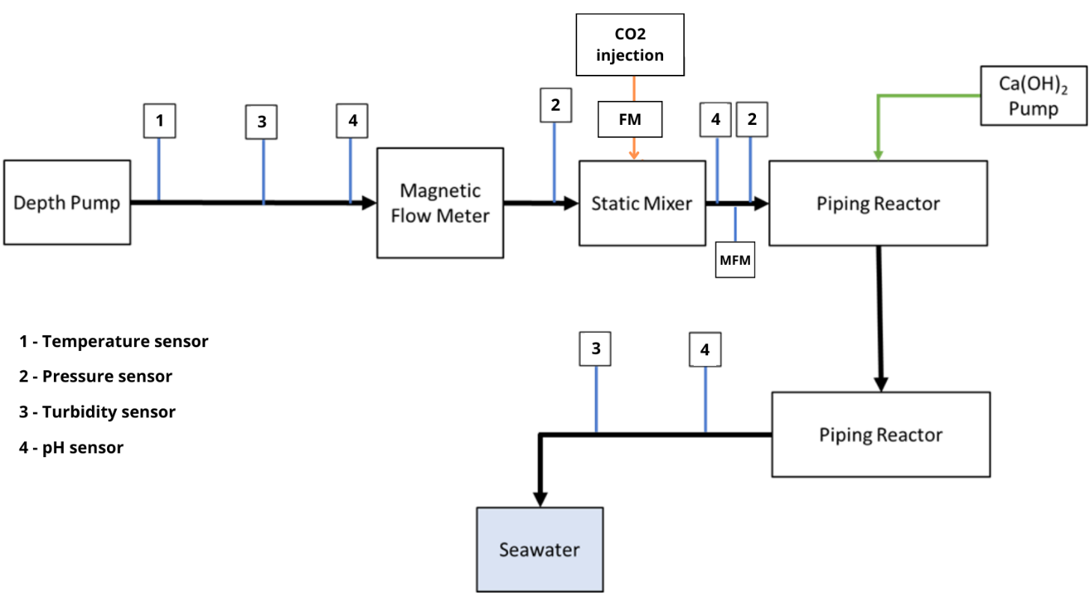
figure 5: Flow of the CO2 storage phase with monitoring instruments

The data analyzed and implemented for this project are derived from various types of sources, which are characterized by different quality and, consequently, different degrees of uncertainty. In particular, the data to be included in the equations in the preceding chapters may be derived from direct and indirect measurements or from calculations with additional formulas or taken from manuals and/or inventories or from estimates, resulting in a different value of uncertainty.
In order to achieve the best possible quality of data needed for quantification of GHG emission avoidance and removal, efforts should be made to increase data quality and reduce uncertainties:
- using measurement instrumentation that is as efficient as possible, ensuring the lowest possible level of error; in the case of this project, instruments that meet the requirements of the MID directive are used;
- obtaining accurate site-specific values.
The operational staff, involved in GHG emissions removals reporting activities, must ensure, each to the extent of its competence and also through the information systems used, the traceability of data and information and must provide for their preservation and archiving in paper and electronic format, so as to allow the reconstruction of the different phases of the calculation process. The data to be preserved must include all parameters and values measured and read continuously by the instrumentation provided in the storage phase.

DATA STORAGE
In order to be able to demonstrate and ensure monitoring compliance and to be able to reconstruct data on GHG emission removals/avoidances achieved through CO₂ storage using LIMENET technology, the final customers, who will transport the CO₂ to the site where the storage will take place, must keep for at least ten years a record of all the information and measured data that have been used to make the calculations.
The operational staff of the final customers, involved in the communication of the removals/avoidances of greenhouse gas emissions, must ensure, as far as expertise and also through the information systems used, the traceability of data and information and ensures its storage in paper and/or electronic format, in order to allow the reconstruction of the different stages of the calculation process. The data to be retained must include those listed in Chapter 10.1.

VALIDATION OF THE GHG PROJECT
The company LIMENET S.r.l., with the aim of validating its project, has contracted with the Certification Body the validation of the methodology for calculating CO₂ storage (removal/avoidance, pursuant to ISO 14064-2) following the application of Limenet technology.
As regards the subsequent verification phase of GHG removals, this will be requested by the entities referred to in paragraph 2.2, as indicated in the next chapter.

PROJECT REPORT ON THE GHG
To proceed with the project verification phase RINA must use the GHG Report format available in Annex 3.
The GHG Report aims to report all relevant information (SSR, Electricity suppliers, reference periods, calculation of consumption and removals of GHG...) site-specific that will be used by end customers to determine the removals of GHG.

Annexes

Annex 1 - SSR identification
Annex 2 - Calculation example
Annex 3 - Validation of the methodology issued by the verification body

