  CO₂ storage following the application of Limenet technology in Augusta site | Document information  001 - A | Date  July 2024
 |   Delivered to | Rev.

PROJECT DESIGN DOCUMENT
CO₂ storage following the application of
Limenet technology
in Augusta site

This document is developed in collaboration with:
 | 

Index
1 SECTION A. General description of project activity 4
1.1 Title of the project activity: 4
1.2 Description of the project activity: 4
1.2.1 Limenet process and company overview 4
1.2.2 PDD project activity 7
1.3 Sustainable development 9
1.4 Project participants: 10
1.5 Technical description of the project activity: 11
1.5.1 Location of the project activity: 11
1.5.2 Category(ies) of project activity: 12
1.5.3 Technology to be employed by the project activity: 12
1.5.4 Estimated amount of emission removal during the project period: 14
1.5.5 Public funding of the project activity: 15
2 SECTION B. Application of a baseline and monitoring methodology 15
2.1 Title and reference of the baseline and monitoring methodology applied to the project activity: 15
2.2 Justification of the choice of the methodology and why it applies to the project activity: 17
2.3 Description of the sources and gases included in the project boundary 17
2.4 Description of how the baseline scenario is identified and description of the identified baseline scenario: 20
2.5 Emission removal: 21
2.5.1 Explanation of methodological choices 21
2.5.2 Data and parameters available at validation 25
2.5.3 Ex-ante calculation of emission removal: 35
2.5.4 Summary of the ex-ante estimation of emissions removal: 36
2.6 Application of the monitoring methodology and description of the monitoring plan: 37
2.6.1 Description of the monitoring plan: 37
2.7 Date of completion of the application of the baseline study and monitoring methodology and the name of the responsible persons(s)/entity(ies) 42
3 SECTION C. Duration of the project activity 42
3.1 Duration of the project activity: 42
3.1.1 Starting date of the project activity: 42
3.1.2 Expected operational lifetime of the project activity: 42
4 SECTION D. Environmental impacts 43
4.1 Documentation on the analysis of the environmental impacts, including transboundary impacts: 43
5 SECTION E. Stakeholders’ comments 43
5.1 Brief description how comments by local stakeholders have been invited and compiled: 43
5.2 Summary of the comments received: 44
5.3 Report on how due account was taken of any comments received: 44
6 Annexes 45

SECTION A. General description of project activity

Title of the project activity:

Title: CO₂ storage following the application of Limenet technology in Augusta site
Version: 001 - A
Date: July 2024

Description of the project activity:

The purpose of the project activity is to install a Limenet storage plant at the gulf of Augusta (Siracusa, Italy) in order to permanently store CO₂ in the form of calcium bicarbonates in seawater to remove CO₂ emissions from the atmosphere and generate negative emissions.
The aim of this document is to describe specifically the plant built in Augusta and calculate the removal of CO₂ emissions due to the storage of CO₂ in the form of calcium bicarbonates, by applying Limenet technology.
The aim of Limenet is to remove CO₂ emissions which come from different sources. CO₂ can come from Direct Air Capture (DAC), biomass or other external sources. Depending on the process from which CO₂ has been obtained, the type of CO₂ storage will be considered removal or avoidance.
The Augusta project aims at storing only biogenic CO₂ after initial tests with technical CO₂

Limenet process and company overview
Limenet is inspired by the geological carbon cycle, a natural process through which carbon is exchanged between the geosphere (soil), the hydrosphere (seas and oceans), the biosphere, and the Earth’s atmosphere. All these portions of the Earth can be considered large carbon tanks, which, under certain conditions, make CO₂ transit from one part to another. Limenet replicates the natural chemistry of the geological carbon cycle and increases the speed of this process. The acceleration of this natural process occurs thanks to the introduction of thermal energy in the system.
The process outlined in this document is based on the natural mechanism of the weathering of limestone rocks through which the ocean securely sequesters carbon. Further goals of LIMENET S.R.L are to enhance ocean health and counteract the degradation of marine ecosystems due to the human-induced release of carbon in the form of CO₂ and the resulting oceans and seas acidification.

Limenet is committed to permanent Carbon Dioxide Removal (CDR). Permanent storage is necessary to ensure that the carbon dioxide removed from the different sources is not released back into the atmosphere. Limenet stores carbon dioxide in the form of dissolved bicarbonate ions (calcium bicarbonates) in which carbon dioxide is immobilized for more than 10.000 years as defined and described by several scientific papers.

- Renforth and Henderson, 2017. https://doi.org/10.1002/2016RG000533
- Middelburg et al., 2020. https://doi.org/10.1029/2019RG000681
- Eisaman et al., 2023. https://doi.org/10.5194/sp-2-oae2023-3-2023
- Riebesell et al. (2023) Mesocosm experiments in ocean alkalinity enhancement research, in: Guide to Best Practices in Ocean Alkalinity Enhancement Research, Copernicus Publications, State Planet, 2-oae2023, 6, https://doi.org/10.5194/sp-2-oae2023-6-2023
- Moras et al. (2022) Ocean alkalinity enhancement – avoiding runaway CaCO₃ precipitation during quick and hydrated lime dissolution, Biogeosciences, 19, 3537–3557, https://doi.org/10.5194/bg-19-3537-2022
- Hartmann et al. (2023) Stability of alkalinity in ocean alkalinity enhancement (OAE) approaches – consequences for durability of CO₂ storage, Biogeosciences, 20, 781–802, https://doi.org/10.5194/bg-20-781-2023.
We have completed a mesocosm experiments in La Spezia (Italy) for verifying the permanence of the stored bicarbonates and the efficiency of the process. The results on the chemical stability of bicarbonates in the sea were positive (Varliero et al., 2024).
We are conducting these experiments in the city of La Spezia (mesocosm installation) and in the city of Milano (laboratories). A technical elaborate is currently being prepared to obtain a third-party verification opinion about bicarbonates stability.

Limenet long term strategy is to internally source the CO₂ through biomass gasification in order to obtain both biogenic CO₂ and a syngas necessary for calcium carbonate calcination. Here are the main process steps:

- The Limenet process starts with the sources of CO₂ and energy. Through the gasification of biomass (formula 1, fig. 1), a syngas is obtained that works both as biogenic CO₂ source and energy source.
- The syngas is later used in a syngas-fired calciner to calcinate the limestone (formula 2, fig. 1). This process output is calcium oxide and CO₂ (with also a flow of water necessary for technical reasons, this is re-used in the process). The calcium oxide is hydrated to obtain calcium hydroxide (formula 3, fig. 1) and then diluted with water to produce slaked lime (formula 3.1, fig. 1). Both the CO₂ coming from syngas combustion and limestone calcination are captured to be stored. The CO₂ needs to be then transported to the storage module. The CO₂ stream is conditioned to be transported using the various methods specified in the transport module (CO₂ transport module, UNDER DEVELOPMENT) to the storage site.
- Finally, the storage process begins, offering two modes of CO₂ storage: offshore and onshore. The CO₂ is stored in seawater in the form of calcium bicarbonates. This last phase comprises 2 stages where CO₂ is initially injected into seawater (formula 4, fig. 1) to generate a slightly acid solution that is later buffered using calcium hydroxide (formula 5, fig. 1) to obtain the calcium bicarbonates solution.
Limenet will carefully select the type of materials and energy that the process would use in order to reduce the carbon footprint and maximize the process efficiency. All this information will be necessary to describe mass and energy balances useful for the creation of an LCA analysis of the entire Limenet process once the plant will be built.
In the following figure 1 is possible to see all the flows, mass balances and chemical reactions of the whole 100.000 negative emissions plant. This is the plant that Limenet will build when, in future, Limenet technology will reach TRL 9.
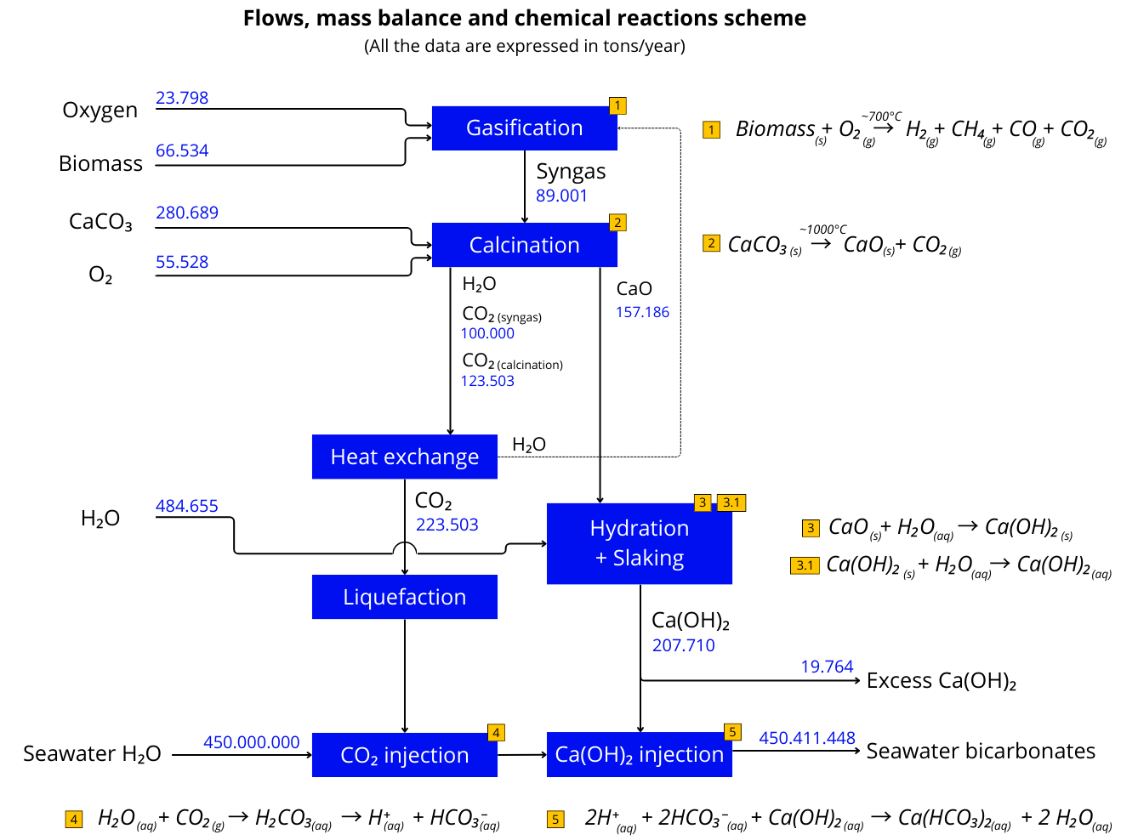
Figure 1: Flows, mass balance and chemical reactions scheme

PDD project activity
A Project Design Document (PDD) is an in-depth and detailed document essential for project validation and verification. It covers the project description, baseline methodology, emissions forecasting, monitoring plans, environmental impact assessments, and stakeholder’s feedback.
The specific project activity described inside this Project Design Document (PDD) regards the only storage phase (also called “dissolution module”, see formulas 4 and 5 of figure 2 and more details in figure 3) of the whole Limenet process described in the previous paragraph (“Limenet process and company overview”). The project will lead to a significant removal of CO₂.
To verify the effectiveness of Limenet storage technology a demonstration plant has been installed in Augusta. Here, only the last steps of the process are performed (formula 4 and 5, figure 2). These include the CO₂ and the Ca(OH)₂ injection to generate the calcium bicarbonate solution.
The simplified process scheme reported in figure 2 is now described.
The plant consists of a seawater pump that allows the introduction of seawater into the plant's piping system. A maximum seawater flow of 500 tons/hour can be pumped into the circuit. A flux of 0,2 tons/hour of CO₂ is then injected into the seawater flow, this creates a slightly acidic solution (formula 4 in figure 2) that is then buffered using a calcium hydroxide slurry flow of 0,168 tons/hour (formula 5 in figure 2) thus creating a solution rich of calcium bicarbonates Ca(HCO₃)₂.
The plant will occupy a limited space (<200 m²), the dimensions are reported in figure 3.
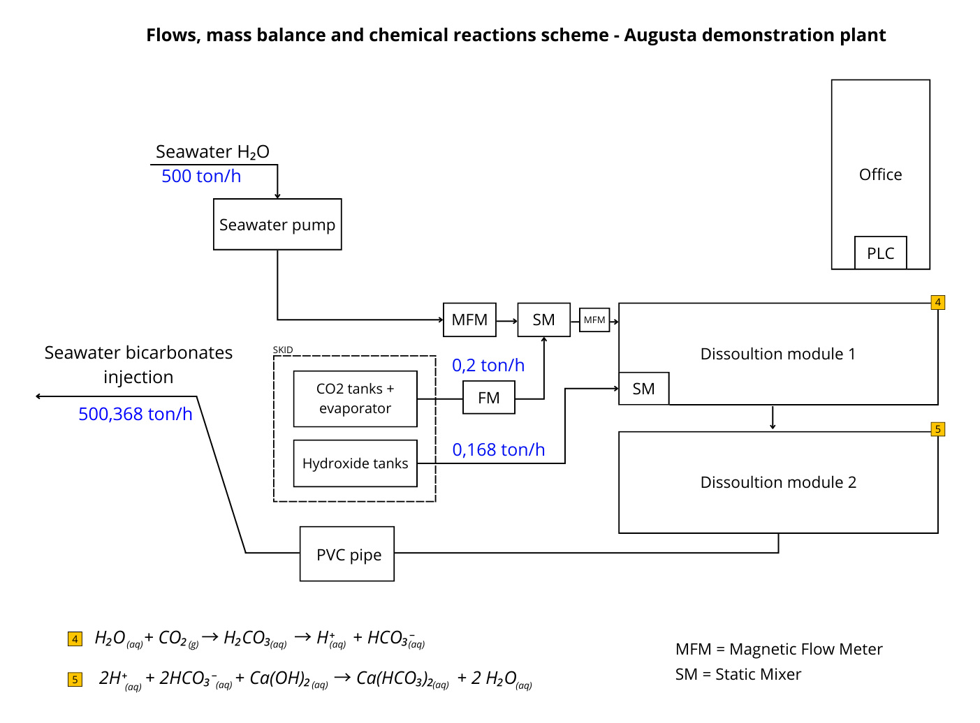
Figure 2: Augusta demonstration plant, mass flows and chemical reactions

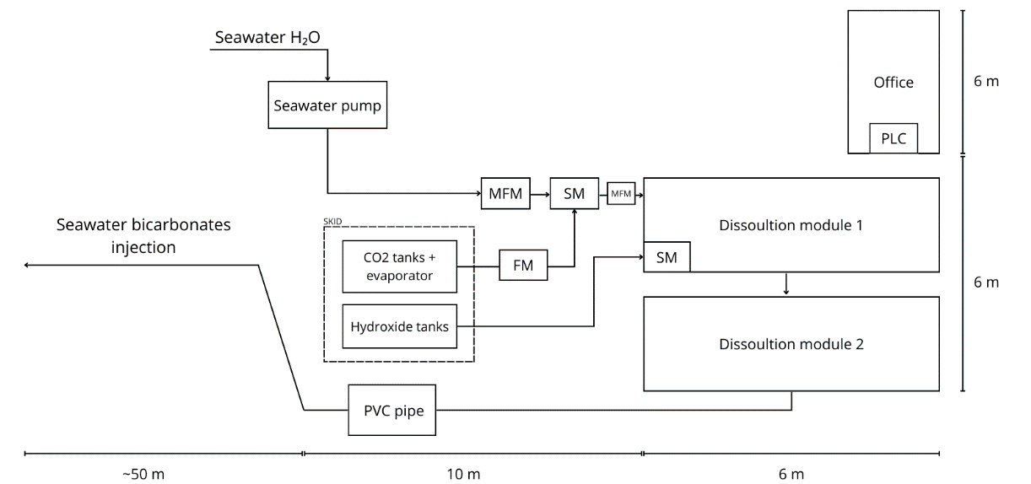
Figure 3: Augusta demonstration plant size
Two picture (Figure 4 and 5) of the 3D rendering of the plant and the under construction plant are here shown:

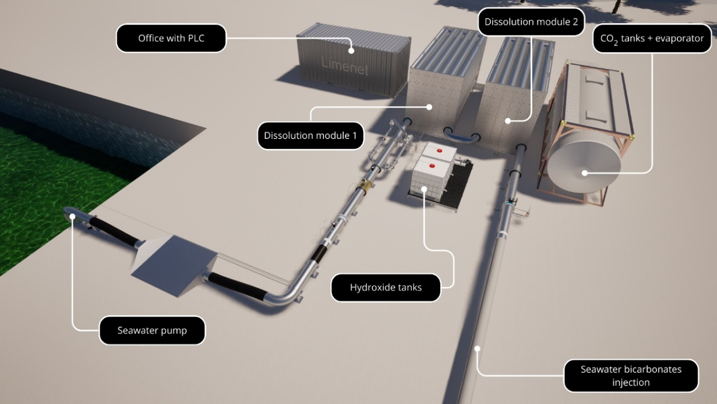
Figure 4: 3D rendering of the plant

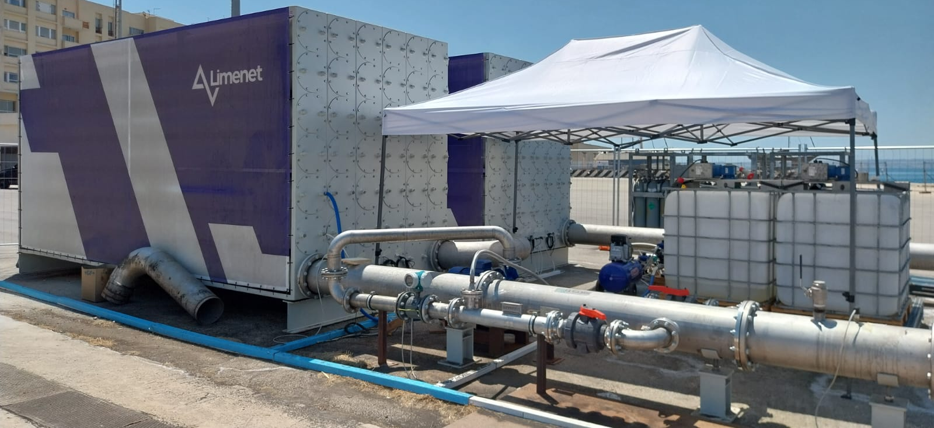
Figure 5: Plant under construction

Sustainable development
The project activity will contribute to sustainable development in different ways.
On one hand, Limenet’s technology removes CO₂ from the atmosphere and stores it as calcium bicarbonates in seawater, contributing to the mitigation of climate change, which is expressed in the thirteenth SDG. In fact, the last IPCC report states that the use of carbon removal technologies to counterbalance the emissions of the hard to abate sector is fundamental to achieve net zero emissions.
On the other hand, our solution mitigates ocean acidification by increasing the sea’s alkalinity with the injection of calcium bicarbonates into seawater. This action will contribute to preserve the marine ecosystem, which is the target of SDG 14.
Moreover, Limenet aligns with the ninth SDG by contributing to enhance scientific research. Limenet is conducting novel studies on the chemical stability of bicarbonates in seawater and the reactions of the marine biota (plankton and benthos communities) to the increase of ocean alkalinity, which could be one of the potential solutions to address ocean acidification.

Project participants:

Table 1: Project Stakeholder participants
Stakeholders Sector | Name of Party involved  ((host) indicates a host Party) | Private and/or public entity(ies) project participants
Industrial Stakeholders | Calcium hydroxide provider (Leone La Ferla) | Private entity
Industrial Stakeholders | Biogenic CO₂ providers (Nippon Gases) | Private entity
Industrial Stakeholders | Technical CO₂ providers (Nippon Gases) | Private entity
Industrial Stakeholders | Electricity producers (ENEL) | Private entity
Industrial Stakeholders | Reactor and piping manufacturer (Hyrogas) | Private entity
Industrial Stakeholders | Pump providers (Milestone Pump Company) | Private entity
Industrial Stakeholders | Mixers (Statiflo) | Private entity
Industrial Stakeholders | Hydroxide mixers (Schwarzer Rührtechnik) | Private entity
Industrial Stakeholders | Wiring and electrical panel (ASCO sistemi) | Private entity
Industrial Stakeholders | Blockchain configuration (ASCO sistemi) | Private entity
Industrial Stakeholders | Office container (ISIP) | Private entity
Industrial Stakeholders | Forklift rental (SEMCAR) | Private entity
Industrial Stakeholders | Assembly (MPC Montaggi e Manutenzione) | Private entity
Industrial Stakeholders | Electrician (Rattizzato) | Private entity
Industrial Stakeholders | Transportation (Ursus Forwarding) | Private entity
Universities stakeholders | Università Politecnico di Milano | Public entity
Universities stakeholders | Università degli studi di Milano-Bicocca | Public entity
CDR market stakeholders | Carbon credits trader and Carbon Accounting Specialists (Aither) | Private entity
Funding stakeholders | Investors | Private entity
Certification stakeholders | Certifying entities (RINA) | Private entity
Certification stakeholders | Consulting entities (Egenia) | Private entity
Marine Stakeholders | Augusta Municipality | Public entity
Marine Stakeholders | Harbour authority of Augusta (Autorità di Sistema Portuale del Mar di Sicilia Orientale) | Public entity
Marine Stakeholders | Harbour Master of Augusta | Public entity
Marine Stakeholders | Province of Siracusa | Public entity
Marine Stakeholders | ASP (Associazione Sanitaria Provinciale) | Public entity
Local stakeholders | Local associations and organizations | Private entity
Local stakeholders | Mebla Studio | Private entity

Technical description of the project activity:

Location of the project activity:

Host Party(ies):
Republic of Italy

Region/State/Province etc.:
Italy, Sicily, Siracusa

City/Town/Community etc:
The project activity takes place in the Municipality of Augusta (province of Siracusa) in Sicily, and more specifically inside the port of Augusta in the “Nuova Darsena Servizi”, managed by the “Autorità di Sistema Portuale del Mare di Sicilia Orientale”.

Detail of physical location, including information allowing the unique identification of this project activity:
The plant is located at the following Google Maps coordinates:
Lat. 37.22315086621576 and Long. 15.217326196945386


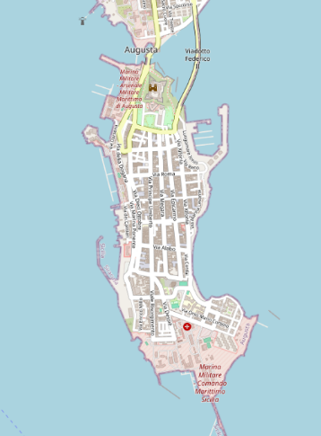


Figure 6: Geographic localization of the plant
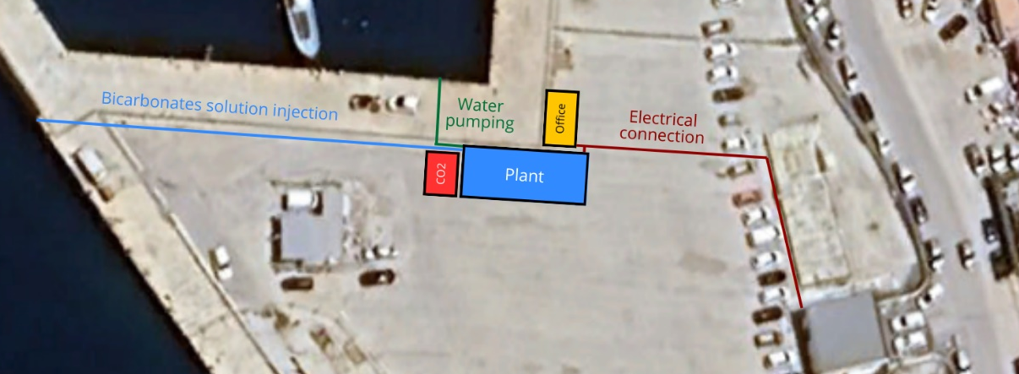
Figure 7: Map and positioning of plant parts
The location where the plant will be installed is inside the local Port Authority (Autorità Di Sistema Portuale del Mare Di Sicilia Orientale). Limenet has entered into an agreement with the port authority and the municipality of Augusta (SR) for the placement of this facility in “Nuova Darsena” spaces. The chosen area is directly located at sea level to allow for the pumping of water, its treatment and subsequent injection of the calcium bicarbonate solution.

Category(ies) of project activity:
The project activity will remove GHG emissions through a CO₂ storage activity.
The project activity comes under the sectoral scope “CO₂ storage into the sea as dissolved calcium bicarbonates and Ocean Alkalinity Enhancement” based on the LIMENET methodology “LM_V1_Methodology_Storage”.

Technology to be employed by the project activity:
LIMENET S.R.L. BENEFIT has industrialized the geological carbon cycle by developing a technology that can permanently store CO₂ in the form of dissolved calcium bicarbonates Ca(HCO₃)₂ in seas and oceans. This technology is designed to accelerate the dissolution of limestone, up to hourly scales, that would otherwise occur in thousands of years.
The LIMENET technology is an evolution of Buffered Accelerated Weathering of Limestone (BAWL) and is called “pH Equilibrated Ocean Alkalinity Enhancement". This technology is verified by studies and researches conducted by Limenet in collaboration with Politecnico di Milano. Preliminary research in the laboratory and then in the field resulted in a scientific paper to be published in the journal Molecules which is now currently submitted to them. The CO₂ storage process is the Limenet pH Equilibrated Ocean Alkalinity Enhancement technology which consists of introducing CO₂ into reactors with seawater, then, in the reactor is introduced a buffering substance: calcium hydroxide Ca(OH)₂. This buffer, reacting with CO₂, converts carbon dioxide into calcium bicarbonates Ca(HCO₃)₂, which remain stable in seawater over time.
The chemical reactions describing the storage process by applying Limenet technology from raw materials which are seawater (H₂O), carbon dioxide (CO₂) and calcium hydroxide Ca(OH)₂ to the formation of calcium bicarbonates Ca(HCO₃)₂ are shown below.

$$H_{2}O_{\left(aq\right)}+ {CO}_{2(g)}→ H_{2}{CO}_{3(aq)}→ H_{(aq)}^{+}+ {HCO}_{3(aq) }^{–} [1]$$

$${2H}_{(aq)}^{+}+ {2HCO}_{3(aq)}^{-}+{Ca(OH)}_{2(aq)}→Ca\left({HCO}_{3}\right)\text{2(aq)}+{2H}_{2}O [2]$$

Where:
H₂O = natural seawater
CO₂ = Carbon dioxide
H₂CO₃ = Carbonic acid
H⁺ = hydron
HCO₃⁻ = Bicarbonate ion
Ca(OH)₂ = Calcium hydroxide
Ca(HCO₃)₂ = Calcium bicarbonate

The global reaction can be described as follows:
$${CO}_{2\left(g\right)}+ {Ca(OH)}_{2\left(aq\right)}↔{Ca(HCO}_{3})_{2(aq)}$$

The reversibility of the reaction depends on the system’s conditions:

- [CO₂]: An increase in the concentration of carbon dioxide shifts the equilibrium of the reaction towards the products forming more calcium bicarbonate.
- [Ca(OH)₂]: An increase in the concentration of calcium hydroxide shifts the equilibrium of the reaction towards the products forming more calcium bicarbonate.
- pH: A high pH (basic solution) favours the dissociation of CO₂ into bicarbonate ions, promoting the reaction towards the formation of calcium bicarbonate. A low pH (acidic solution) favours the formation of carbonic acid and thus the balance shifts towards the decomposition of calcium bicarbonate.
- Temperature: the solubility of gases in water decreases with increasing temperature, so a higher temperature could shift the equilibrium to the left, reducing the amount of calcium bicarbonate formed.

Estimated amount of emission removal during the project period:
During the project period of three years, Limenet plans to remove up to a maximum of 1000 tons of biogenic CO₂.
1000 tons of biogenic CO₂ will be sent to the storage facility by Nippon gasses (see Annex 4 for further details), which is the CO₂ supplier. These CO₂ tons will be sent in batches of 22 tons.
Due to its physical conditions, when the CO₂ tank is not used or the plant is not operating, CO₂ tends to become gaseous and release a certain amount of it from the tank. The value of the effective CO₂ available for the storage can be calculated in two different ways:

- By using the installed instrument on the tank. By reading the value is possible to define the CO₂ inside the tank.
- By using the leakage factor of 0,25% per day defined by the supplier. Considering batches of 22 tons, 4 days for each transported batch and by applying this factor, we obtain that 21,78 tons of biogenic CO₂ for each batch will be effectively made available for storage. This calculated value will be compared with the value of the instrument on the CO₂ tank showing the available CO₂.

(see equations 6.1 and 6.2 for further explanations).
Table 2: Estimated emission removals
ESTIMATION OF EMISSIONS REMOVED
 | Description | Value | U.M.
 | Total biogenic CO₂ to be stored (50 deliveries of 22 tons) | 1000 | tons
 | Stream of injected CO₂ | 100-200 | kg/h
Delivered CO₂ per batch | Batch of CO₂ to be delivered for each transport | 22 | tons
Delivered CO₂ per batch | Tons of CO₂ lost during each transport | 0,220 | tons
Delivered CO₂ per batch | Tons of CO₂ actually delivered for each transport | 21,780 | tons
Net-removed CO₂ per batch | Total emissions due to electricity consumption per batch | 1,656 | tons
Net-removed CO₂ per batch | Total emissions due to transport of raw material per batch | 0,015 | tons
Net-removed CO₂ per batch | Total non_reacted CO₂ during the process (see annex 2 for details) | 0,072 | tons
Net-removed CO₂ per batch | Total estimated removals for each transport net of project emissions | 20 | tons
Net project removals | Total emissions due to electricity consumption of the project | 82,80 | tons
Net project removals | Total emissions due to transport of raw material of the project | 0,75 | tons
Net project removals | Total non_reacted CO₂ during the project | 3,6 | tons
Net project removals | Total net estimated removals of the project | 1000 | tons

The total emissions removals due to the project activity are estimated to be 1000 tons of biogenic CO₂ in batches of 20 tons each for a project period of 3 years.
Emission removals are calculated following the LM_V1_Methodology_Storage.

Public funding of the project activity:
The project activity is not subsidized by official development assistance or any other public funding.

SECTION B. Application of a baseline and monitoring methodology

Title and reference of the baseline and monitoring methodology applied to the project activity:
- The baseline applied for this project activity is described in detail within LM_V1_Methodology_Storage on which this document is based.
- The approved monitoring methodology applied to this project activity is described in detail within LM _V1_Methodology_Storage.

The development of the Methodology and PDD are based on:
- “The GHG Protocol for Project Accounting”, World Business Council for Sustainable Development (WBCSD) and the World Resources Institute (WRI).
- “A Greenhouse Gas Accounting Framework for Carbon Capture and Storage Projects”, Centre for Climate and Energy Solutions.
- “Methodology for the quantification, monitoring, reporting and verification of greenhouse gas emissions reductions and removals from carbon capture and storage projects”, Version 1.1., published by the American Carbon Registry
- “Guidelines for Carbon Capture, Transport and Storage”, WRI.
- “Carbon Capture and Sequestration Protocol under the Low Carbon Fuel Standard”, California Air Resources Board.
The methodology and PDD are also based on the following scientific papers:
- Renforth, P., and G. Henderson (2017), Assessing Ocean alkalinity for carbon sequestration, Rev. Geophys.,55,636–674, doi:10.1002/2016RG000533.
- Riebesell, U., Basso, D., Geilert, S., Dale, A. W., and Kreuzburg, M.: Mesocosm experiments in ocean alkalinity enhancement research, in: Guide to Best Practices in Ocean Alkalinity Enhancement Research, edited by: Oschlies, A., Stevenson, A., Bach, L. T., Fennel, K., Rickaby, R. E. M., Satterfield, T., Webb, R., and Gattuso, J.-P., Copernicus Publications, State Planet, 2-oae2023, 6, https://doi.org/10.5194/sp-2-oae2023-6-2023, 2023.
- Moras, C. A., Bach, L. T., Cyronak, T., Joannes-Boyau, R., and Schulz, K. G.: Ocean alkalinity enhancement – avoiding runaway CaCO3 precipitation during quick and hydrated lime dissolution, Biogeosciences, 19, 3537–3557, https://doi.org/10.5194/bg-19-3537-2022, 2022.
- Hartmann, J., Suitner, N., Lim, C., Schneider, J., Marín-Samper, L., Arístegui, J., Renforth, P., Taucher, J., and Riebesell, U.: Stability of alkalinity in ocean alkalinity enhancement (OAE) approaches – consequences for durability of CO2 storage, Biogeosciences, 20, 781–802, https://doi.org/10.5194/bg-20-781-2023, 2023.
- Oschlies, A., Stevenson, A., Bach, L. T., Fennel, K., Rickaby, R. E. M., Satterfield, T., Webb, R., and Gattuso, J.-P. (Eds.): Guide to Best Practices in Ocean Alkalinity Enhancement Research, Copernicus Publications, State Planet, 2-oae2023, https://doi.org/10.5194/sp-2-oae2023, 2023.
- Middelburg, J. J., Soetaert, K., &Hagens, M. (2020). Ocean alkalinity, buffering and biogeochemical processes. Reviews of Geophysics,58, e2019RG000681. https://doi.org/10.1029/2019RG000681
- W. M. Balch, A. J. Plueddeman, B. C. Bowler and D. T. Drapeau (2009) doi:10.1029/2008JC004902
- Bernard P. Boudreau, Olivier Sulpis, Alfonso Mucci (2019) https://doi.org/10.1016/j.gca.2019.09.037
- Sijia Dong, Adam V. Subhas, Nick E. Rollins, John D. Naviaux, Jess F. Adkins, William M. Berelson (2018) https://doi.org/10.1016/j.gca.2018.07.015

- Sijia Dong, William M. Berelson, Nick E. Rollins, Adam V. Subhas, John D. Naviaux, Aaron J. Celestian, Xuewu Liu, Nitya Turaga, Nathaniel J. Kemnitz, Robert H. Byrne, Jess F. Adkins (2019) https://doi.org/10.1016/j.epsl.2019.03.016
- John D. Naviaux, Adam V. Subhas, Nick E. Rollins, Sijia Dong, William M. Berelson, Jess F. Adkins (2018) https://doi.org/10.1016/j.gca.2018.11.037
- John D. Naviaux, Adam V. Subhas, Sijia Dong, Nick E. Rollins, Xuewu Liu,
- Robert H. Byrne, William M. Berelson, Jess F. Adkins (2019) https://doi.org/10.1016/j.marchem.2019.103684
- Adam V. Subhas, Nick E. Rollins, William M. Berelson, Sijia Dong, Jonathan Erez, Jess F. Adkins (2015) http://dx.doi.org/10.1016/j.gca.2015.08.011
- Dieter A. Wolf-Gladrow, Richard E. Zeebe, Christine Klaas, Arne Körtzinger, Andrew G. Dickson (2007) http://dx.doi.org/10.1016/j.marchem.2007.01.006
- Richard E. Zeebe, D.A. Wolf-Gladrow, H. Jansen (1999) https://doi.org/10.1016/S0304-4203(98)00092-9
- Richard E. Zeebe, Peter Westbroek (2003) doi:10.1029/2003GC000538
- Shamsher Ali and Azhar Ali S (2013) DOI: 10.4172/2161-0398.1000116
- Hari Krishna Bharadwaj, Joo-Youp Lee, Xin Li, Zhouyang Liu, Tim C. Keener (2013) http://dx.doi.org/10.1016/j.jhazmat.2013.02.009
- Yolanda A. Criado, Mó nica Alonso and J. Carlos Abanades (2020) dx.doi.org/10.1021/ie404246p
- John Blamey, Ming Zhao, Vasilije Manovic, Edward J. Anthony, Denis R. Dugwell, Paul S. Fennell (2016) http://dx.doi.org/10.1016/j.cej.2016.01.086
- Philip K. Gbor, Charles Q. Jia (2004) doi: 10.1016/j.ces.2004.01.047
- Harald Justnes, Carlos Escudero-Oñate, Øyvind Aaberg Garmo and Martin Mengede doi:10.3390/ma13214926
- Hongwei Li, Zhigang Tang, Xiao Xing, Dong Guo, Longpeng Cui, Xian-zhong Mao (2018) https://doi.org/10.1016/j.energy.2018.09.066
- OLEG S. POKROVSKY and JACQUES SCHOTT (2002) doi:10.1016/S0016-7037(03)00238-2
- Marcelo V.C. SáClaude E. Boyd (2017) http://dx.doi.org/10.1016/j.aquaculture.2016.11.033

- nicius do Carmo e SáDavi de Holanda CavalcanteFrancisco Roberto dos Santos Lima (2018) DOI: 10.1111/are.14039

Justification of the choice of the methodology and why it applies to the project activity:

The proposed project activity conforms with the “LM_V1_Methodology_Storage”, which describes the Limenet’s storage process and gives a consolidated baseline, since:

- The GHG emissions, specifically the CO₂ emitted, in the absence of the application of the Limenet technology, in different ways would have been emitted into the atmosphere;
- The project activity will store CO₂ in the form of dissolved calcium bicarbonates in the oceans and seas;
- The project activity is based on Limenet patented technology.
The chosen methodology states clearly that it applies to projects that store CO₂ in the form of calcium bicarbonate in seas and oceans.

Description of the sources and gases included in the project boundary
According to the LM_V1_Methodology_Storage the module boundary includes both the pre-/upstream- and the post-/downstream- bicarbonates formation facilities and equipment at the storage site, including the injection and monitoring points and all related equipment. The included processes are shown in figure 8 within the red dotted line.

The processes of the project within the storage phase are:
- Intermediate/final storage of CO₂ received
- Intermediate/final compression and/or conditioning of CO₂ before injection into the pipes
- Injection pipelines, piping, valves, and monitoring instrumentation
- SCADA, communication equipment and PLC monitoring
- CO₂, Ca(OH)₂ and H₂O pumps
- CO₂ compression with interstage cooling (valve/seal losses, and electricity consumption or fuel use)
- the transport of raw materials necessary for the production process (excluding the transport of captured CO₂)

The project activity boundary is illustrated in Figure 8
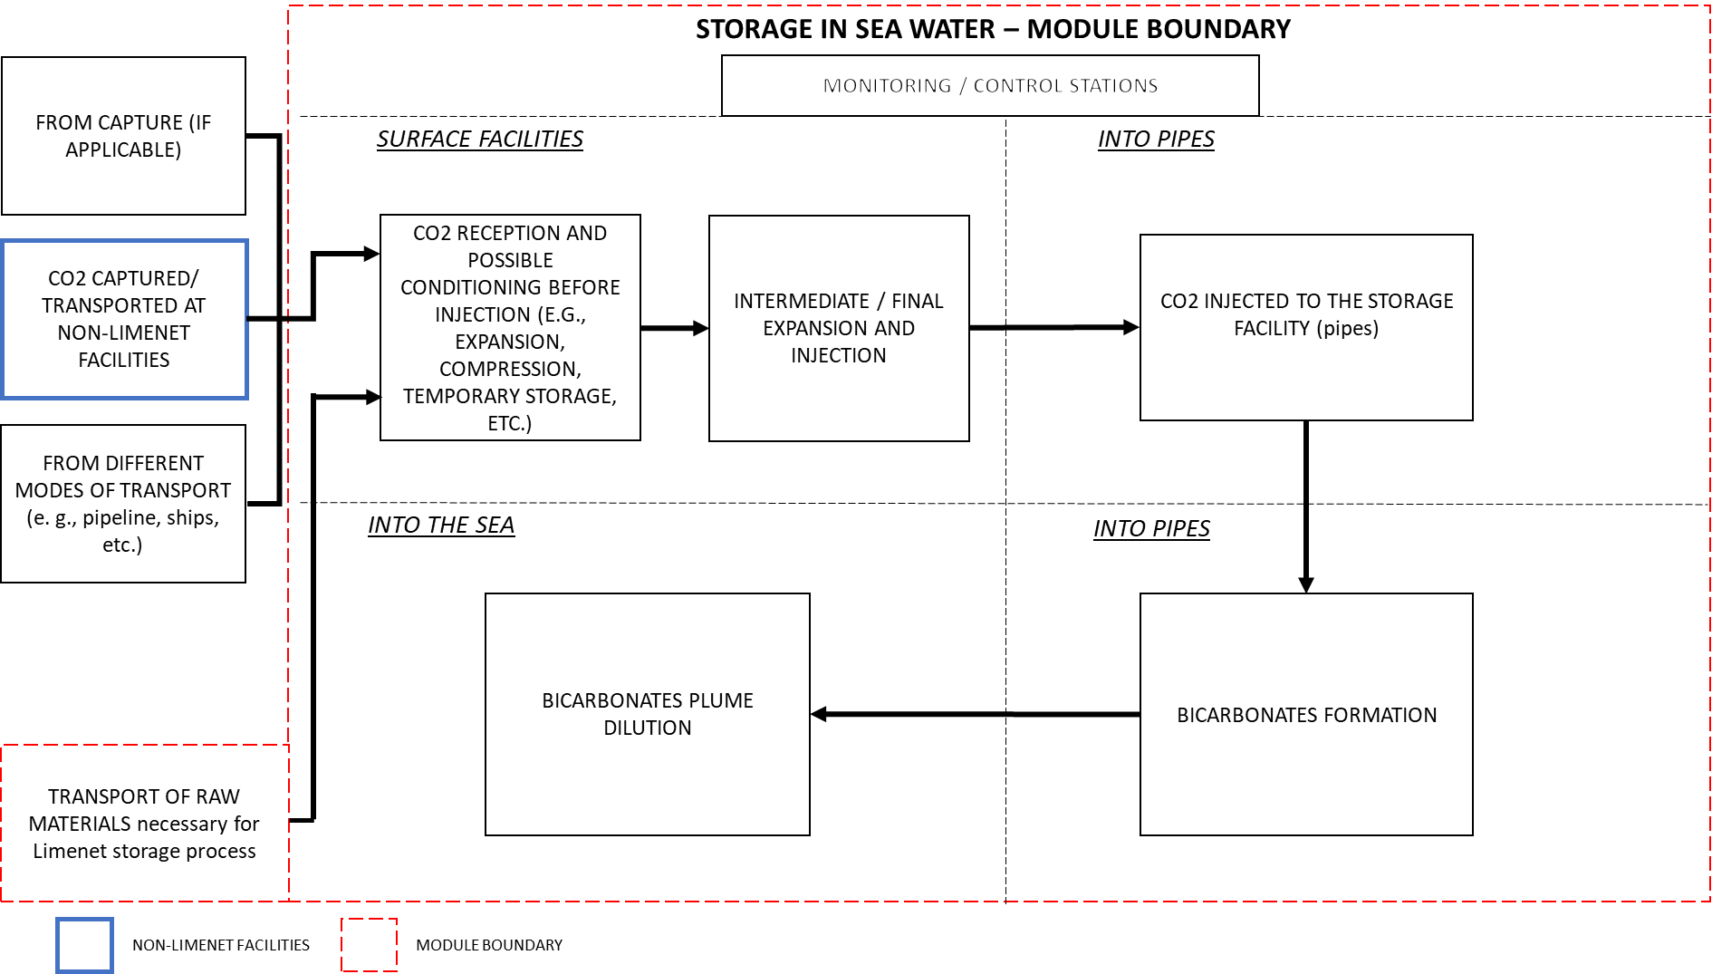
Figure 8:Project activity boundary

The GHG sources included or excluded from the project boundary are shown in Table 3.

Table 3: GHG sources included or excluded in project scenario
 | SOURCE | GAS | INCLUDED? | JUSTIFICATION/EXPLANATION
CO₂ STORAGE | Electricity consumption | CO₂ | Yes | Major emission source.
CO₂ STORAGE | Electricity consumption | CH₄ | No | Excluded for simplicity, emissions are considered negligible.
CO₂ STORAGE | Electricity consumption | N₂O | No | Excluded for simplicity, emissions are considered negligible.
CO₂ STORAGE | Electricity consumption | Other | No | Excluded for simplicity, emissions are considered negligible.
CO₂ STORAGE | Fuel consumed in transport | CO₂ | Yes | Major emission source.
CO₂ STORAGE | Fuel consumed in transport | CH₄ | No | Excluded for simplicity, emissions are considered negligible.
CO₂ STORAGE | Fuel consumed in transport | N₂O | No | Excluded for simplicity, emissions are considered negligible.
CO₂ STORAGE | Fuel consumed in transport | Other | No | Excluded for simplicity, emissions are considered negligible.
CO₂ STORAGE | CO₂ Stream processing | CO₂ | Yes | Any loss of CO₂ due to fugitive or venting emissions during bicarbonates formation will be limited and near to zero thanks to a correct operativity of the plant.
CO₂ STORAGE | CO₂ Stream processing | CH₄ | No | Excluded for simplicity, emissions are considered negligible.
CO₂ STORAGE | CO₂ Stream processing | N₂O | No | Excluded for simplicity, emissions are considered negligible.
CO₂ STORAGE | CO₂ Stream processing | Other | No | Excluded for simplicity, emissions are considered negligible.
CO₂ STORAGE | Leaks of CO₂ from the storage site (intentional and unintentional discharge from surface and subsurface) | CO₂ | Yes | Minimal or null emission source
CO₂ STORAGE |  | CH₄ | No | Excluded for simplicity, emissions are considered negligible.
CO₂ STORAGE |  | N₂O | No | Excluded for simplicity, emissions are considered negligible.
CO₂ STORAGE |  | Other | No | Excluded for simplicity, emissions are considered negligible.

CO₂ stream processing emissions and leaks from the storage site.

Description of how the baseline scenario is identified and description of the identified baseline scenario:

The baseline scenario has been identified within the "LM_V1_Methodology_Storage" methodology:
The baseline is all CO₂ that arrives at the Limenet storage facility, which will then be stored as calcium bicarbonate inside the sea. The emissions related to the transportation of CO₂ and eventual leakages for which the supplier of the CO₂ is responsible are not accounted as project activity emissions.
For the specific Augusta project the baseline corresponds to the 21,78 tons of biogenic CO₂ that arrives to the facility. This value is obtained considering a leakage factor of 1% (0,25% per day, defined by the supplier) during the transportation of the CO₂.

Table 4: GHG sources included or excluded in baseline scenario
Baseline | GHG source | GAS | Included? | Justification/Explanation
Baseline | External companies that supply biogenic CO₂ or capture CO₂ from the atmosphere | CO₂ | Yes | Limenet is involved in the removal of CO₂ emissions
Baseline |  | CH₄ | No | Limenet is not capturing CH₄
Baseline |  | N₂O | No | Limenet is not capturing N₂O
Baseline |  | Other | No | Limenet is not capturing other gases
Baseline | External companies providing fossil CO₂ | CO₂ | Yes | Limenet is involved in the avoidance of CO₂ emissions
Baseline | External companies providing fossil CO₂ | CH₄ | No | Limenet is not capturing CH₄
Baseline | External companies providing fossil CO₂ | N₂O | No | Limenet is not capturing N₂O
Baseline | External companies providing fossil CO₂ | Other | No | Limenet is not capturing other gases
Baseline | Limenet biomass gasification | CO₂ | Yes | Limenet is involved in the removal of CO₂ emissions
Baseline | Limenet biomass gasification | CH₄ | No | Limenet is not capturing CH₄
Baseline | Limenet biomass gasification | N₂O | No | Limenet is not capturing N₂O
Baseline | Limenet biomass gasification | Other | No | Limenet is not capturing other gases
Baseline | Limenet capturing CO₂ from the atmosphere | CO₂ | Yes | Limenet is involved in the removal of CO₂ emissions
Baseline | Limenet capturing CO₂ from the atmosphere | CH₄ | No | Limenet is not capturing CH₄
Baseline | Limenet capturing CO₂ from the atmosphere | N₂O | No | Limenet is not capturing N₂O
Baseline | Limenet capturing CO₂ from the atmosphere | Other | No | Limenet is not capturing other gases

Emission removal:

The project "CO₂ storage following the application of Limenet technology" performs the removal of biogenic CO₂ emissions.
CO₂ removal refers to the capture of CO₂ from the atmosphere, with some types of process (e.g. DAC or biomass), and subsequent permanent storage in natural tanks (seas/oceans).

Data and parameters available at validation

Data from inventories/suppliers
Table 6: CO₂ Molar mass description
Parameter | $${CO}_{2} Molar mass$$
Parameter type | Data from inventories/suppliers
Unit of measurement | g/mol
Description | Molar mass of CO₂
Equations in which it is present | Equations 2,3
Data source | Periodic table
Value applied | 44,0095
Justification for the choice of data or description of measurement methods and procedures applied | A chemical constant
Frequency of acquisition | This data is acquired once
QA/QC procedures to be applied | N.A.

Table 7: Global Warming Potential description
Parameter | GWP
Parameter type | Data from inventories/suppliers
Unit of measurement | t CO_{2eq}/ t GHG
Description | Global Warming Potential
Equations in which it is present | Equation 5
Data source | Sixth assessment report of IPCC - AR6 or subsequent updates
Value applied | values are given in the table below
Description of the measurement/calculation methods and procedures to be applied | N.A.
Frequency of acquisition | This data is acquired once or any time is updated by IPCC
QA/QC procedures to be applied | Parameters must be derived from the most recent published versions available

The GWP values used for the various equations derive from the Sixth Assessment Report of the IPCC - AR6 and are shown in the table 8 below.
Table 8: Global Warming Potential of GHGs
GHG | Chemical formulation | GWP (100 years)
Carbon dioxide | CO₂ | 1
Methane of fossil origin | CH₄ | 29,8
Nitrous oxide | N₂O | 273
Table 9: Electric energy Emission Factor description

Parameter | $${EF}_{ e.e.}$$
Parameter type | Data from inventories/suppliers
Unit of measurement | t_{CO2} /kWh
Description | Emission factor linked to electric energy (e.e.) consumption
Equations in which it is present | Equation 4
Data source | from e.e. Supplier Sustainability Report or from ISPRA reports
Value applied | 0,0002933
Description of the measurement/calculation methods and procedures to be applied | Get the value from the data source
Frequency of acquisition | This data is acquired once or every time an electricity supplier changes or every year
QA/QC procedures to be applied | The parameter must be derived from the most recent published versions available

Table 10: transport emission factor description
Parameter | $${e.f.}_{trasp, GHG}$$
Parameter type | Data from inventories/suppliers
Unit of measurement | g GHG/km or t GHG/TJ
Description | Emission factor relating to means used for the transport of raw materials
Equations in which it is present | Equation 5
Data source | Inventories or similar documents
Value applied | Values are given in the summary table below
Description of the measurement/calculation methods and procedures to be applied | Emission factor inventories for transport emissions in Italy (source ISPRA) (from the most recent published versions available)
Frequency of monitoring | This data is acquired once
QA/QC procedures to be applied | The parameter must be derived from the most recent published versions available

Table 11: trasnport emission factor of GHGs
GHG | Chemical formulation | $${e.f.}_{ trasp}$$ | U.O.M
Carbon dioxide | $$e.f._{trasp, CO2}$$ | 73,952 | tCO₂/TJ
Methane of fossil origin | $$e.f._{trasp, CH4}$$ | 0,000538 | tCH₄/TJ
Nitrous oxide | $$e.f._{trasp, N2O}$$ | 0,00412 | tN₂O/TJ

Table 12: Molar volume standard description
Parameter | $${VM}_{std}$$
Parameter type | Data from inventories/suppliers
Unit of measurement | L/mol
Description | The standard molar volume is the volume occupied by a mole of gas at standard temperature and pressure
Equations in which it is present | Equations 2, 3
Data source | Inventories or similar documents
Value applied | 22,414
Description of the measurement/calculation methods and procedures to be applied | Taken from Encyclopedia Britannica (22,414)
Frequency of monitoring | This data is acquired once
QA/QC procedures to be applied | N.A.

Summary of the data from inventories/suppliers:

Table 13: data from iventories/suppliers summary
Parameter | Value | U.o.M uni
$${CO}_{2} Molar mass$$ | 44,0095 | g/mol
$${EF}_{ e.e.}$$ | 293,3 | gCO₂/kWh
$$e.f._{trasp, CO2}$$ | 73,952 | tCO₂/TJ
$$e.f._{trasp, CH4}$$ | 0,000538 | tCH₄/TJ
$$e.f._{trasp, N2O}$$ | 0,00412 | tN₂O/TJ
$${VM}_{std}$$ | 22,414 | l/mol
GWP Carbon dioxide | 1 | CO_{2eq}
GWP Methane of fossil origin | 29,8 | CO_{2eq}
GWP Nitrous oxide | 273 | CO_{2eq}

Measured data

Table 14: CO₂ injected description
Parameter | $${CO}_{2, in}$$
Parameter type | Measured data
Unit of measurement | Nm³/h
Description | The volume flow is measured by magnetic flow meter
Equations in which it is present | Equations 2, 3
Data source | Readings of the magnetic flow meter
Description of the measurement/calculation methods and procedures to be applied | Mass flow rates must be determined by commercially available devices that measure the mass flow rate of a fluid flowing through a measurement channel.
Frequency of monitoring | Monitored continuously
QA/QC procedures to be applied | The metering equipment must be installed and calibrated in accordance with either the specifications of local/national standards or the manufacturer's specifications. If local/national standards or the manufacturer specification is not available, international standards (e.g., IEC, ISO) must be followed.

Table 15: Electric Energy consumption description
Parameter | $${E.E.}_{consumption}$$
Parameter type | Measured data
Unit of measurement | kWh
Description | Amount of electric energy consumed
Equations in which it is present | Equation 4
Data source | Measuring instrument or electricity bill
Description of the measurement/calculation methods and procedures to be applied | The electricity consumption is determined by the values measured by the electricity meter, or taken directly from the electricity bills, where there are data of monthly or bimonthly consumption
Frequency of monitoring | One measurement at least every two months
QA/QC procedures to be applied | The metering equipment must be installed and calibrated in accordance with either the specifications of local/national standards or the manufacturer's specifications. If local/national standards or the manufacturer specification is not available, international standards (e.g., IEC, ISO) must be followed.

Table 16: Number of journeys for "k" raw material description
Parameter | $$N_{k}$$
Parameter type | Measured data
Unit of measurement | -
Description | Number of journeys required for the transport of each raw material k
Equations in which it is present | Equation 5
Data source | Reading of the discharge register
Description of the measurement/calculation methods and procedures to be applied | The number of journeys of raw material k at the storage site is recorded
Frequency of monitoring | This data is monitored every time a delivery occurs
QA/QC procedures to be applied | The delivery register shall be updated whenever the raw materials are discharged at the site

Table 17: Number of kilometres travelled for "k" raw material description
Parameter | $${km}_{k}$$
Parameter type | Estimated
Unit of measurement | km
Description | Number of kilometres travelled per journey to transport the raw material k at the storage site
Equations in which it is present | Equation 5
Data source | Estimated
Description of the measurement/calculation methods and procedures to be applied | Estimated considering the route traveled through geolocation sites
Frequency of monitoring | This data is monitored every time a discharge occurs
QA/QC procedures to be applied | N.A.

Table 18: seawater input pH description
Data | $${pH}_{in}$$
Data type | Calculated data
Unit of measurement | -
Description | pH level, measure of acidity of a solution
Equations in which it is present | Equation 3
Data source | Readings of the pH-meter
Justification for the choice of data or description of measurement methods and procedures applied | The value is read from the pH-meter that measures the pH of the pumped sewater
Frequency of calculation | Monitored continuously
QA/QC procedures to be applied | N.A.
Table 19: output pH description
Data | $$pHout$$
Data type | Calculated data
Unit of measurement | -
Description | pH level, measure of acidity of a solution
Equations in which it is present | Equation 3
Data source | Readings of the pH-meter
Justification for the choice of data or description of measurement methods and procedures applied | The value is read from the pH-meter that measures the pH of the marine solution after the calcium hydroxide addition and before its injection
Frequency of calculation | Monitored continuously
QA/QC procedures to be applied | N.A.
Table 20: CO2 tank description
Parameter | $${CO}_{2, tank}$$
Parameter type | Measured data
Unit of measurement | tCO₂
Description | CO₂ quantity measured by the instrument installed on the CO₂ biogenic tank
Equations in which it is present | Equation 6.1
Data source | Readings of the instrument
Description of the measurement/calculation methods and procedures to be applied | It is measured when the tank is not connected to the system and therefore affected by leaks
Frequency of monitoring | Measured each time a CO₂ batch is delivered
QA/QC procedures to be applied | The metering equipment must be installed and calibrated in accordance with either the specifications of local/national standards or the manufacturer's specifications. If local/national standards or the manufacturer specification is not available, international standards (e.g., IEC, ISO) must be followed.
Table 21: CO2 declared within the transport document description
Parameter | $${CO}_{2, DDT}$$
Parameter type | Measured data
Unit of measurement | tCO₂
Description | CO₂ declared within the transport document
Equations in which it is present | Equation 6.2
Data source | Readings of the DDT
Description of the measurement/calculation methods and procedures to be applied | The CO₂ is measured by the supplier before the delivery to Limenet facilities
Frequency of monitoring | Measured each time a CO₂ transport is carried out
QA/QC procedures to be applied | The metering equipment must be installed and calibrated in accordance with either the specifications of local/national standards or the manufacturer's specifications. If local/national standards or the manufacturer specification is not available, international standards (e.g., IEC, ISO) must be followed.

Calculated data
Table 22: CO2 emission removals description
Data | $$Em.{CO}_{2, removed}$$
Data type | Calculated data
Unit of measurement | t CO_{2eq}
Description | Net emissions of CO₂ removed
Equations in which it is present | Equation 1
Data source | The value is calculated by applying equation 1
Justification for the choice of data or description of measurement methods and procedures applied | This data allows to know the net removal of CO₂ by considering the whole processes emissions inside the project boundaries
Frequency of calculation | This data is calculated once
QA/QC procedures to be applied | N.A.

Table 23: CO₂ emissions injected description
Data | $$Em.{CO}_{2, injected}$$
Data type | Calculated data
Unit of measurement | t CO_{2eq}
Description | CO₂ emissions stored at sea in the form of calcium bicarbonates
Equations in which it is present | Equations 1, 2, 6.1, 6.2
Data source | The value is calculated by applying equation 2
Justification for the choice of data or description of measurement methods and procedures applied | This data is calculated to know the effective stored CO₂ considering the maximum quantity of non-reacted CO₂ (NR_{CO2})
Frequency of calculation | This data is calculated continuously
QA/QC procedures to be applied | N.A.

Table 24: CO2 emissions due to electricity consumption description
Data | $$Em.{CO}_{2, electricity consumption}$$
Data type | Calculated data
Unit of measurement | t CO_{2eq}
Description | CO₂ emissions related to electricity consumption
Equations in which it is present | Equations 1, 4
Data source | The value is calculated by applying equation 4
Justification for the choice of data or description of measurement methods and procedures applied | This data is calculated since GHGs can be emitted during the electricity production
Frequency of calculation | This data can be calculated depending on frequency of parameter acquisition or continuously
QA/QC procedures to be applied | N.A.

Table 25: CO2 emissions due to raw materials transport description
Data | $Em.{CO}_{2, trasp.}$ r. m.
Data type | Calculated data
Unit of measurement | t CO_{2eq}
Description | CO₂ emissions related to fuel consumption
Equations in which it is present | Equations 1, 5
Data source | The value is calculated by applying equation 5
Justification for the choice of data or description of measurement methods and procedures applied | This data is calculated since GHGs can be emitted during the raw materials transportation
Frequency of calculation | This data can is calculated every time the supplied quantity or supplier change
QA/QC procedures to be applied | N.A.

Table 26: Non reacted CO₂ description
Data | $$Em.{CO}_{2,NR}$$
Data type | Calculated data
Unit of measurement | t CO_{2eq}
Description | Non reacted CO₂
Equations in which it is present | Equations 1, 3
Data source | The value is calculated by applying equation 3
Justification for the choice of data or description of measurement methods and procedures applied | This data is calculated to obtain the value of non reacted CO₂ at the end of the plant operating period
Frequency of calculation | This data can is calculated every once at the end of the storage of a CO₂ batch
QA/QC procedures to be applied | N.A.

Table 27: Fugitive CO2 emissions
Data | $$Em.{CO}_{2, fug}$$
Data type | Calculated data
Unit of measurement | t CO_{2eq}
Description | Fugitive CO₂ emissions
Equations in which it is present | Equations 1, 6.1, 6.2
Data source | The value is calculated by applying equation 6
Justification for the choice of data or description of measurement methods and procedures applied | The fugitive emissions are due to the possible losses of the tank containing the CO₂ that reached the Limenet site will have to be stored (the tank containing the CO₂ during the transport phase and during the phase in which the storage process takes place is the same).
Frequency of calculation | This parameter is calculated each time a CO₂ transport occurs
QA/QC procedures to be applied | N.A.

Ex-ante calculation of emission removal:
The ex-ante calculations of the biogenic stored CO₂ are reported in the annex 2. In this excel sheet is possible to find the ex-ante calculations done before the Augusta plant starts its operations.
Baseline emissions:
As described in chapter 2.4 the baseline is all CO₂ that is made available for storage at the Limenet storage facility. This value has been calculated to be equal to 43,56 by considering a leakage factor set to 0,25% per day by the supplier.
The value of CO₂ actually available for storage will be verified by measuring it during injection using a Magnetic Flow Meter (MFM).

Table28 : Ex ante Baseline CO₂ emissions
Baseline
Identif. | Sent CO₂ | Leakage Factor | Traveled day | Leakage Emissions | Em. CO₂_Baseline emissions
u.m. | tCO₂eq | % | day | tCO₂eq | tCO₂eq
Value | 22 | 0,25 per day | 4 | 0,22 | 21,78

Project emissions:
To calculate the emission removals achieved due to the project activity, the emissions caused by electricity consumption and raw materials transportation during the project activity has been taken into account.
The project activity requires electricity mainly for the pumping of seawater into the circuit. Transportation emissions are related to the delivery of the raw material (only calcium hydroxide, CO₂ transportation emissions are not included in the project boundaries).
The emissions are calculated using the equations 4 and 5 presented in 2.5.1.1
- The electricity consumption has been calculated considering a conservative power absorption from the plant equal to 55kW resulting in around 6050 kWh to store 21,84 tons of CO₂. To obtain the emissions relative to the electricity consumption the Italian emissions factor has been obtained from ISPRA.
- The emissions related to raw materials have been calculated using equation 5. The latter takes in consideration the distance travelled from the supplier to the delivery location, the number of trips (round trip), and the CO₂ equivalent emissions due to fuel consumption.
Table 29: Ex ante project activity calculation
 |  |  | Project activity
Identif. | Em. CO₂_electricity consumption | Em. CO₂_trasp. r.m. |  | Em. CO₂_fug. | Em. CO2_NR | Em. CO_{2_}Project emissions
u.m. | tCO₂eq | tCO₂eq |  | tCO₂eq | tCO₂eq | tCO₂eq
Value | 1,6577 | 0,0148 |  | 0 | 0,0722 | 1,6725

Emission removals:
Finally the ex-ante emission removals are calculated by the equation 1. The project activity is anticipated to remove around 21,78 tons of CO₂ during the project period. The emission removals are presented in tables 30 and 31.

Table 30: Ex ante emission removals calculation
 | Emission removals
Identif. | Em. CO₂_Baseline emissions | Em. CO_{2_}Project emissions | Em. CO₂_removals
u.m. | tCO₂eq | tCO₂eq | tCO₂eq
Value | 21,78 | 1,7447 | ≈20

Explanation of methodological choices
This section establishes overarching quantification approaches for GHG emission removals in baseline and project scenarios. According to the methodology "LM_V1_Methodology_Storage" the emission removals are calculated through the following equations.

Calculation of removed CO₂
The amount of CO_{2eq} removed during the application period of the proposed project must be determined from equation I. This equation calculates the removed CO₂ using the Limenet technology in the Augusta plant. It keeps in consideration the injected CO₂, the amount of non reacted CO₂, the emissions related to the plant electricity consumption, those related to the raw materials transportation (excluding the CO₂ transportation) and those related to fugitive emissions.

Equation I
$$Em.{CO}_{2, removed}=Em.{CO}_{2,injected} -Em.{CO}_{2,NR}- Em.{CO}_{2,electricity consumption }- Em.{CO}_{2, trasp.}-Em.{CO}_{2, fug.}$$
Identification | Definition | Unit of measure | Equation
$$Em.{CO}_{2, removed}$$ | Net CO₂ removed | tCO_{2eq} | 1
$$Em.{CO}_{2, injected}$$ | CO₂ injected inside Augusta plant | tCO_{2eq} | 2
$$Em.{CO}_{2,NR}$$ | Amount of non reacted CO₂ | tCO_{2eq} | 3
$$Em.{CO}_{2, electricity consumption}$$ | CO₂ emissions related to electricity consumption | tCO_{2eq} | 4
$$Em.{CO}_{2, trasp.}$$ | CO₂ emissions due to raw materials transport | tCO_{2eq} | 5
$$Em.{CO}_{2, fug.}$$ | Fugitive emissions due to possible CO₂ losses from the tank within the plant boundaries | tCO_{2eq} | 6.1. 6.2
Equation 1: Calculation of removed CO₂ emissions

The injected CO₂ emissions, first term of equation I, shall be calculated using equation 2. This equation keeps in consideration the flow of CO₂ measured by the Thermal Mass Flow Meter (TMFM) at each timeframe dt and sum the injected CO₂ at each time instant to obtain the total injected CO₂.
The equation 2 is calculated in real time by the PLC.

Equation 2
$${Em.CO}_{2,injected}\left(t\right)= \sum_{t_{initial}}^{t_{final}}{{CO}_{2,in}\left(t\right)*\left(\frac{{CO}_{2} Molar mass}{{VM}_{std}*{10}^{3}}\right)*\frac{1}{3600}*}dt$$
Identification | Definition | Unit of measure | Equation
$$Em.{CO}_{2, injected}$$ | CO₂ injected into reactors | tCO_{2eq} | 2
t__{final} | Instant of opening the CO₂ injection valve opens “XV001” | s
t__{initial} | Instant of closing the CO₂ injection valve opens “XV001” | s
${CO}_{2,in}$(t) | CO₂ flow measured by the TMFM | Nm³/h
$$\frac{{CO}_{2} Molar mass}{{VM}_{std}*{10}^{3}}$$ | Conversion factor of the CO₂ flow from Nm³ to tons | ton/m³
$$\frac{1}{3600}$$ | Conversion factor from seconds to hour | h/s
$$dt$$ | “1second” time interval of the sensor reading “FT002” | s
Equation 2: Calculation of injected CO₂ emissions

The following equation 3 is used to calculate emissions due to non reacted CO₂.
The latter is a term of equation 1 and describes the quantity of non-reacted CO₂ due to time to reach a new equilibrium with the atmosphere or possible lack of Ca(OH)₂ injection, purity of Ca(OH)₂ and variability naturally occurring in the reaction.
If the moles of calcium hydroxide injected are less than the corresponding CO₂ moles that can react with it, considering the stoichiometry of the reaction, some of the CO₂ will not react due to the absence of enough reactant.
The fact that the pH measured before the injection of bicarbonates into the sea (pH_{out}) is lower than the input pH (pH_{in} of seawater) is an indicator: when this happens, it means that part of the CO₂ did not react with the injected hydroxide. This equation is calculated only when the condition pH_{out}<pH_{in} is verified.
The Em. CO_{2,NR} (equation 3) must be calculated continuously because at each moment pH could vary of different values and so the quantity of CO₂ that has not completed the reaction. The equation 3 should be calculated in a continuous way and in real time by PLC.
The linear equation, which estimates the non-reacted CO₂ using pH_{in} and pH_{out} is implemented in equation 3, was calculated using data reported in Table 5. These data are the results of simulations using PHREEQC software. The simulations output is the non-reacted CO₂ considering different pH_{in} and pH_{out} values. The resulting data were used to estimate the parameters of the equation that relates the non-reacted CO₂ to pH_{in} and pH_{out} through the linear regression method.

Table 5: Amount of Non reacted CO₂ in kg/h
pHin | pHout | NR_CO₂ [kg/h]
7,9 | 6,24 | 109,9
7,9 | 6,4 | 93,3
7,9 | 6,59 | 76,9
7,9 | 6,82 | 60,8
7,9 | 7,17 | 44,9
8,1 | 6,3 | 111,5
8,1 | 6,46 | 95,1
8,1 | 6,64 | 79
8,1 | 6,87 | 63
8,1 | 7,23 | 47,2
8,1 | 7,93 | 31,6

Equation 3
$$Em.{CO}_{2,NR} = \sum_{t_initial}^{t_final}{\frac{\left(119 +39 ×{pH}_{in}(t) -53 × {pH}_{out}(t+Δt)\right)}{1000} × \frac{{CO}_{2,in} × \left(\frac{{CO}_{2} Molar mass}{{VM}_{std}*{10}^{3}}\right)}{0,2}*\frac{1}{3600}*}dt$$
Identification | Definition | Unit of measure | Equation
$$Em.{CO}_{2,NR}$$ | Amount of non reacted CO₂ | tCO_{2eq} | 3
t__{final} | Instant of opening the CO₂ injection valve opens “XV001” | s
t__{initial} | Instant of closing the CO₂ injection valve opens “XV001” | s
$$\left(119 +39 ×{pH}_{in} -53 × {pH}_{out}\right)$$ | Equation obtained through linear regression of the output obtained by simulations of PHREEQC software | kg/h
$${CO}_{2,in}$$ | CO₂ flow measured by TMFM | Nm³/h
$$\left(\frac{{CO}_{2} Molar mass}{{VM}_{std}*{10}^{3}}\right)$$ | Conversion factor of the CO₂ flow from Nm³ to tons | ton/m³
0,2 | Maximum flux of CO₂ | ton/h
$${pH}_{in}$$ | Measure of pH_{in} | -
$${pH}_{out}$$ | Measure of pH_{out} | -
$$\frac{1}{1000}$$ | Conversion factor from kg to tons | ton/kg
$$\frac{1}{3600}$$ | Conversion factor from sec to hour | h/s
$$dt$$ | “1s” time interval of sensor reading “FT002” | s
Equation 3: Calculation of non reacted CO₂ emissions

The CO₂ project emissions related to energy consumption during the various steps of the storage phase are calculated by equation 4. The latter keeps in consideration the electric energy consumption multiplied by the emission factor of the specific energy supplier or obtained from a national average value. The electricity consumption is measured by an electricity meter connected to the PLC.

Equation 4
$$Em.{CO}_{2,electricity consumption}=\frac{{E.E.}_{consumption }*{EF}_{e.e.}}{1000000}$$
Identification | Definition | Unit of measure | Equation
$$Em.{CO}_{2, energy consumption}$$ | CO₂ emissions related to energy consumption | t CO_{2eq} | 4
$${E.E.}_{consumption }$$ | Measured electric energy consumption | kWh
$${EF}_{ e.e.}$$ | Emission Factor linked to electric energy consumption | gCO₂/kWh
$$\frac{1}{1000000}$$ | Conversion factor from g to tons | tons/g
Equation 4: Calculation of electricity consumption CO₂ emissions

Transport-related CO₂ emissions can be calculated by applying equation 5, emissions are calculated from the number of kilometres travelled for the various raw materials procurement.

Equation 5
$Em.{CO}_{2, trasp.}= \sum_{k=1}^{n}{(}N_{k}*{km}_{k}*({e.f.}_{trasp,{CO}_{2}}* {GWP}_{CO_{2}}$+ ${e.f.}_{trasp,CH_{4} }* {GWP}_{CH_{4}}$+ ${e.f.}_{trasp,N_{2}O }* {GWP}_{N_{2}O}$))
Identification | Definition | Unit of measure | Equation
$$Em.{CO}_{2, trasp.}$$ | CO₂ emissions related to the transport of raw materials needed for storage and materials necessary for the construction of the plants | t CO_{2eq} | 5
$${km}_{k}$$ | Kilometres travelled for the transport of raw material “k” (roundtrip) | km
$$N_{k}$$ | Number of trips | -
$${e.f.}_{trasp, GHG}$$ | Emission factor linked to road transport | t GHG/ km
$${GWP}_{GHG}$$ | Global Warming Potential | t CO_{2eq} /t GHG
_{n} | Number of raw materials delivered to the storage site | -
_{k} | Factor that varies from 1 to n and each number corresponds to a specific raw material | -
Equation 5: Calculation of transport CO₂ emissions

The fugitive emissions are due to the possible losses of the tank containing the CO₂ that reached the Limenet site (the tank containing the CO₂ during the transport phase and during the phase in which the storage process takes place is the same).
Fugitive emissions are calculated using two equations: Equation 6.1 measures the fugitive emission value calculated by the difference between the CO₂ measured through the instrument in the CO₂ tank, provided by the company distributing CO₂, and the CO₂ actually measured in input to the stacked storage by Limenet.

Equation 6.1
$$Em.{CO}_{2,fug}={CO}_{2, tank}-{Em.CO}_{2,injected}\left(t\right)$$
Identification | Definition | Unit of measure | Equation
$$Em.{CO}_{2,fug}$$ | Fugitive emissions during plant operations | tCO₂ | 6.1
$${CO}_{2,tank}$$ | CO₂ quantity measured by the instrument installed on the CO₂ biogenic tank | tCO₂
$${Em.CO}_{2,injected}\left(t\right)$$ | CO₂ injected into reactors | tCO₂ | 2
Equation 6.1: Calculation of fugitive CO₂ emissions
In addition, through equation 6.2, a further check on fugitive emissions is carried out, so that the value obtained by the instrument and the value obtained through the calculation due to possible losses during transport can be compared: where the values are very different, the value of fugitive emissions calculated with equation 6.2 shall be relied upon.
These losses are calculated as the difference between the CO₂ declared in the transport document considering the transport losses (a percentage of CO₂ equal to 0.25% per day of transport) and the input CO₂ actually measured by Limenet before the storage phase takes place.

Equation 6.2
$$Em.{CO}_{2,fug}={CO}_{2, DDT}*(1-\left(0,25\%*day\right))-{Em.CO}_{2,injected}\left(t\right)$$
Identification | Definition | Unit of measure | Equation
$$Em.{CO}_{2,fug}$$ | Fugitive emissions during plant operations | tCO₂ | 6.1
$${CO}_{2, DDT}$$ | CO₂ declared within the transport document | tCO₂
$$day$$ | Duration of transport | d
$${Em.CO}_{2,injected}\left(t\right)$$ | CO₂ injected into reactors | tCO₂ | 2
Equation 6.2: Checking calculation on fugitive CO₂ emissions

Summary of the ex-ante estimation of emissions removal:
Here is a summary of the ex-ante estimation of the net CO₂ stored into bicarbonates.

Table 31: Summary of ex ante calculation
 | Baseline | Project activity | Emission removals
Identif. | Baseline emissions | Project emissions | CO₂_removed
u.m. | tCO₂eq | tCO₂eq | tCO₂eq
Value | 21,78 | 1,7447 | ≈20

Application of the monitoring methodology and description of the monitoring plan:

Description of the monitoring plan:
A monitoring plan for the project activity is essential to ensure that the carbon storage phase is effective, efficient, safe, and in agreement with its objectives as well as ensuring safe operations and compliance with environmental regulations.
The description of the monitoring plan is reported following the LM_V1_Methodology_Storage.
The previous 2.5.2.2 lists all the parameters that must be monitored in order to correctly calculate the CO₂ removed using the application of Limenet technology during the initial period of application of the proposed methodology.
Equations in subchapter 2.5.1.1 identify how these measured and monitored parameters are used in project calculations of removed emissions.
The project activity has four mandatory monitoring points (control stations) as shown in Figure 9.
At each monitoring point, a series of control operations are planned to verify the proper functioning of the system and the Limenet technology in CO₂ storage:
  - The first is pre-/upstream-bicarbonates formation, which is “surface facilities” (CO₂ reception and conditioning and intermediate/final expansion).
Here, monitoring represents the collection of information regarding the characteristics of the incoming seawater and the supplied CO₂ stream. Incoming seawater is monitored using a flowmeter, temperature, pressure, pH and turbidity sensors to know the main characteristics.
The amount, purity and type of CO₂ are checked using the information described in the data sheet provided by the supplier.
  - The second is pre-/upstream-bicarbonates formation, which is “Into Pipes” (CO₂ injected into the storage reactor); here is where the injection of CO₂ and the pumping of calcium hydroxide into the seawater flowing through the system pipeline takes place. Monitoring is carried out by continuously measuring the injected CO₂ flow and the changes measured by pH sensors placed upstream and downstream of the CO₂ injection point.
  - The third is during bicarbonates formation, which is “Into Reactor”. This is where seawater, CO₂ and calcium hydroxide reacted, leading to the formation of dissolved calcium bicarbonates in seawater. At this level, monitoring concerns in verifying the correct formation of calcium bicarbonates, which is done by analysing the data recorded by pH and turbidity sensors.
As a function of the pH changes, the amount of CO₂ that does not react with the hydroxide and is therefore not stored in the form of calcium bicarbonates will be calculated by applying Equation 3 (presented in 2.5.1.1). The difference between the input CO₂ flux and the amount of CO₂ that does not react is the amount that is stored and will be used as the value on which to calculate the efficiency of the process.
  - The fourth is post-/downstream-bicarbonates formation, which is “Into the sea” (bicarbonates plume dilution). This is where the seawater solution rich in calcium bicarbonates is injected. The monitoring action consists of checking the characteristics of the solution injected into the sea. The pH and turbidity values are recorded with the respective instruments, which must be equal to or close to the values of the seawater entering the plant obtained at the first monitoring station.

Figure 9: Module boundary for CO₂ storage in seawater.

The CO₂ removal from the project activity each year will be assessed during the operation plant and downstream of the project activity through continuous and direct measurements.
Direct measurements: Data collection is carried out using specific instruments, sensors, and equipments that need to be calibrated according to current good practice before recording data and measurements;
Continuous measurements: The use of automatic instruments and sensors allows for continuous monitoring; they need to be calibrated according to current good practice before a constant recording and collection of data and measurements.
The calculation and quantification of the actual permanent storage of CO₂ are carried out through the use of different types of instruments, which are used to obtain the best possible quality of the necessary data.
During the storage phase, there are both instruments that allow direct measurement of data and instruments that allow continuous monitoring of parameters that must be constantly checked to maintain the high quality and efficiency of Limenet technology.
Specifically, the functions and the exact position of each instrument are described within the Augusta flow process which shows the entire process of the Augusta plant shown below. For each instrument, the code, given in brackets, identifies it and specifies its location.

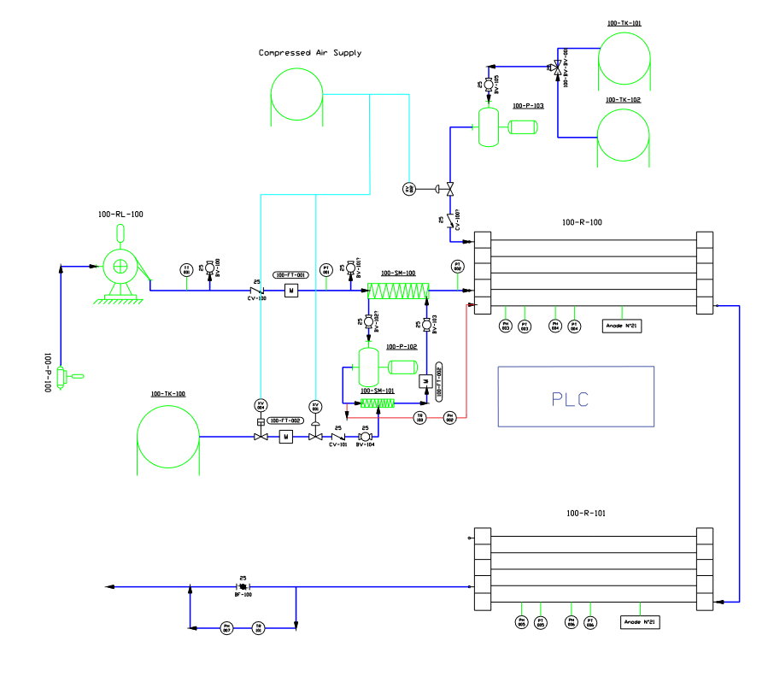
Figure 10: TRL7 Augusta flow process

Augusta flow process and instruments

Seawater is drawn in by a seawater pump (100-P-100), which takes it up to a depth of about 1,5 meters and feeds it into the storage pipeline. The seawater pump is submerged and lifted into the sea by a hoist (100-RL-100) mounted on a forklift. An additional support is installed to provide higher stability.
The flow of seawater entering the pipeline, before entering the “main” static mixer (100-SM-100), passes through a series of instruments, such as:

- Temperature sensor (TT-001)
- Ball valve (BV-100)
- Check valve (CV-100)
- magnetic flowmeter (flow-transmitter) (100-FT-001)
- pressure sensor (PT-001)
- Ball valve (BV-101)

The ball valves have the function of maintenance and venting in the event of air bubbles forming in the flow while the function of check valve is to prevent the water flow from returning and the magnetic flowmeter measures the incoming water flow rate.
The CO₂, which is initially liquid and contained in a cryogenic tank (100-TK-100), is brought back to a gaseous state by an evaporator next to it and flows into a flexible hose connected to a CO₂ management section.
This consists of:

- solenoid valve (XV-004) performing a safety function (shut-down valve)
- magnetic flow sensor (100-FT-002) for CO₂ flow management
- solenoid valve (XV-001)
- check-valve (CV-101) to prevent water from flowing back and damaging the instruments
- ball-valve (BV-104) with a control function and manual adjustment of the system.
From this circuit section, via a second hose, the gaseous CO₂ stream flows into another called the pre-mixing section.
This section consists of a series of secondary hoses connected to the “main” static mixer(100-SM-100) and includes in order:
- ball valve (BV-102) for manual flow regulation
- centrifugal pump (100-P-102), used to draw water from the ‘main’ static mixer into the pre-mixing circuit.
- static mixer (100-SM-101) henceforth referred to as the pre-mixing mixer, used for initial mixing of the CO₂ with the seawater (where we are going to connect with our hose out of the CO₂ management circuit)
- magnetic flow sensor (100-FT-002), used to control the amount of treated water in circulation
- second ball valve (BV-103) also for manual flow regulation.
Part of the water flow entering the pre-mixing section is recirculated to another section of the circuit (indicated by the red line in the Process and Instrumentation diagram (P&ID) where it encounters a turbidity sensor (TR-100) and a pH sensor (pH-002), which are required for seawater characterization.
The water treated with CO₂ is fed back into the main static mixer where it continues its journey along the “main” circuit, encountering a pressure sensor (PT-002) before entering in the first reactor (100-R-100) where the addition of calcium hydroxide takes place.
The reactor consists of a series of interconnected tubes with a length defined by the residence time required for the acid solution (water and CO₂) to react completely with the calcium hydroxide.
The calcium hydroxide is fed into the circuit via a centrifugal pump (100-P-103) connected by two hoses:
A first one directed to the two calcium hydroxide PVC tanks (100-TK-101) (100-TK-102) which are connected to a ball valve (BV-105) and and a 3-way valve (100-BV-BV-001).
A second one directed to the first reactor via solenoid valve (XV-002) and a check valve (CV-100).
The seawater mixed with CO₂ and calcium hydroxide flows through the pipes of the first reactor, encountering in order: another static mixer (mounted inside the first reactor) used to mix the acid solution with the hydroxide, a pH sensor (pH-003), a pressure sensor (PT-003), a pH sensor (pH-004) and a pressure sensor (PT-004).
The treated solution exiting the first reactor is connected using tubing to the second reactor (100-R-101), the structure of which is the same as that of the first reactor except for the static mixer, encountering in order in its path: a pressure sensor (PT-006), a pH sensor (pH-006), a pressure sensor (PT-005) and a pH sensor (pH-005).
The solution exiting the second reactor splits:
most of the flow encounters a butterfly valve (BF-100) which is used to regulate the outflow by causing an increase in upstream pressure and a smaller part enters a ‘secondary’ circuit where it encounters a turbidity sensor (TR-101) and a pH sensor (pH-007) to verify and respect the same conditions as the incoming and outgoing water.
Inside the two reactors there are sacrificial anodes.
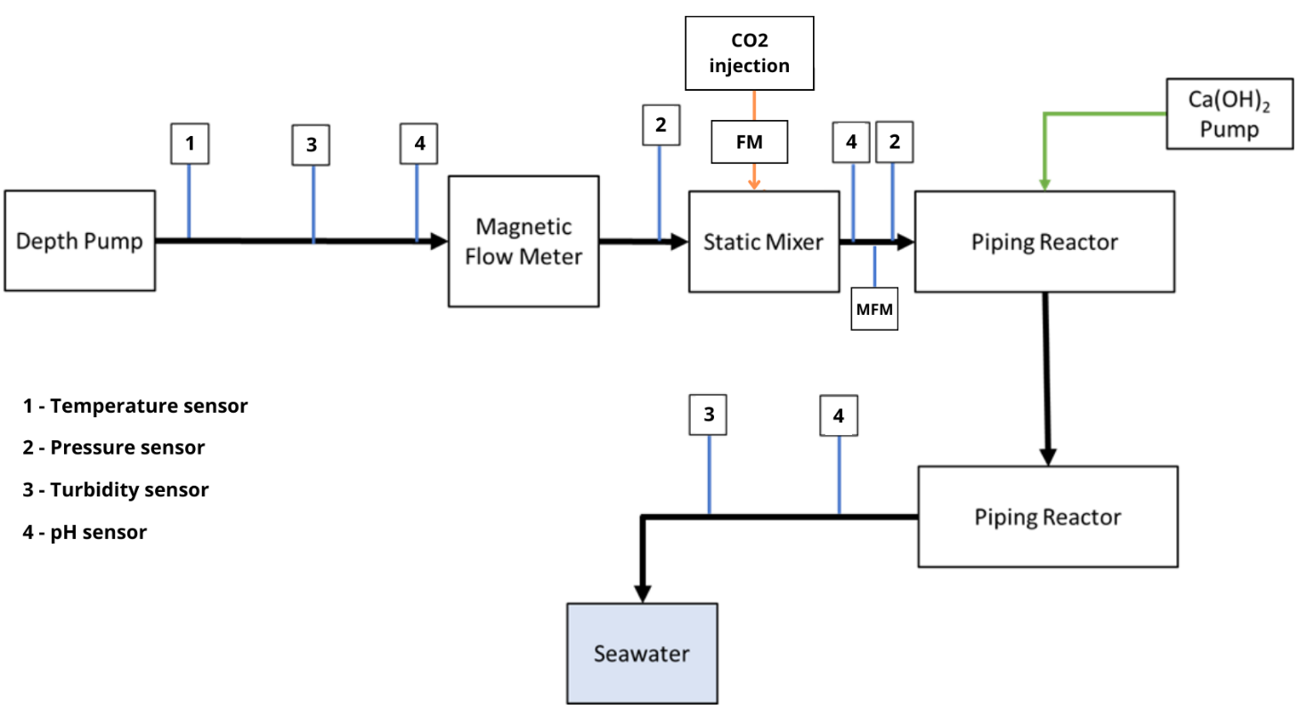
Figure 11: Augusta Plant working processes and sensors used

Data recording and storage:
The data recorded by the sensors along the process are collected in the PLC through LAN cables and locally stored. On the PLC it is possible to see in real time the main parameters of the plant and the formula that need to be calculated in real time.

Date of completion of the application of the baseline study and monitoring methodology and the name of the responsible persons(s)/entity(ies)

- Date of completing the final draft of the baseline: 28/June/2024

Table 32: Baseline and monitoring methodology responsibles
Organization | LIMENET S.R.L. BENEFIT
Address | Via Filanda Maggiore, 5
Postal Zip/City | 23851 Galbiate (LC)
Country | Italy
Represented by: | Stefano Cappello
Salut. /First Name/ Last Name | Mr Federico Comazzi and Mr Saverio Rocchi
Telephone | + 39 3489394480
Email | federico.comazzi@limenet.tech saverio.rocchi@limenet.tech

SECTION C. Duration of the project activity

Duration of the project activity:
The project activity will last at least 3 years

Starting date of the project activity:
to be defined

Expected operational lifetime of the project activity:
3 years

SECTION D. Environmental impacts

Documentation on the analysis of the environmental impacts, including transboundary impacts:

A CDR project must be environmentally friendly and non-harmful to the environment, and this can be achieved through various measures and strategies. The use of calcium bicarbonates as a solution for permanent CO₂ storage in seawater, as in the case of Limenet technology, can contribute to the environmental sustainability of the project. The environmental impacts attributable to project activity were assessed qualitatively. As already stated at the local level the project activity effects the environment very positively and hence it improves the quality of life in the surrounding communities. Particularly water resource quality through CO₂ storage and ocean alkalinization that counteracts the increased acidity of the seas. The pH Equilibrated Ocean Alkalinity Enhancement Storage process not only allows CO₂ removal through permanent storage in seawater but, by dissolving bicarbonate compounds in seawater, increases the alkalinity of water, which is the ability to resist changes in acidity levels, with potential benefits for the ecosystem and marine biota as described in several scientific articles reported in the “sources chapter” of methodology LM_V1_Methodology_Storage.
This approach can provide added value to the eco-compatibility and sustainability of the CDR project, helping to protect the environment and its ecosystems.

SECTION E. Stakeholders’ comments

Brief description how comments by local stakeholders have been invited and compiled:

The local stakeholders of this project are defined to be the Municipality of Augusta, the Harbour Authority of Augusta (Autorità di Sistema Portuale del Mar di Sicilia Orientale), the Harbour Master of Augusta, the province of Siracusa, the local A.R.P.A. (Regional environmental protection agency), and the local associations and organizations. The stakeholders have been informed by the project activity between December 2023 and March 2024.
Different strategies have been used to present the project depending on the stakeholders. At first, one of our local industrial stakeholders has put us in contact with the local municipality and the Harbour Authority of Augusta. Secondly, we contacted them through emails and phone calls to organize a meeting in person to present them the project. During this moment we got their approval for the project and got their feedback on it. The Harbour Master of Augusta was informed on the project through phone calls. Lastly, the Province of Siracusa was contacted via email by the Municipality of Augusta.
Moreover, we organized a public meeting in collaboration with Local Municipality and the Harbour Authority for the community of Augusta to do scientific dissemination on the causes and consequences of climate change, to present Limenet and the project it wanted to carry out in Augusta. To this event were invited the local association and organizations of Augusta via email, and the mailing list was provided to us by the Municipality of Augusta. In addition, to invite the citizens to the event we did a flyer that was send via email, telephone and it was posted in public spaces.

Summary of the comments received:
The project did not receive any objections from the stakeholders. On the contrary, it is well accepted and supported particularly due to the benefits that it generates. We received several questions from the local stakeholders that covered a wide range of topics. Below are reported the comments received during the public event hold in Augusta and other comments collected throughout our activities from different stakeholders.
- Comments regarding our process and the project we are carrying out in Augusta:
  - Amount of energy that is need to the process and the net negative emissions of CO₂ of our process;
  - Information regarding the funding of the project;
  - Information regarding our business model and how we will generate revenues;
  - Information regarding the plant dimensions;
  - If we have already planned to scale at a industrial level;
  - If we have done any estimates, and if so with what results, on the effect of the point release of the solution you release into the water;
  - Why we have chosen Sicily and in particular Augusta to site our plants;
  - Where does the CO₂ that we use come from and if the transport is environmentally sustainable;
  - Where it comes from the energy that we use in the process;
  - How do we plan to manage local permits;
  - Are there any benefits for the local community;
  - How will our project affect local employment.

- Comments regarding the sector our activity belongs to:
  - What is our opinion regarding the effectiveness of CDR technologies in mitigating climate change and if the adoption of these technologies could justify more polluting activities;
  - If the CDR technologies could boost sustainable practices in the hydrogen production;
  - Do exist other plants similar to ours in the world;
  - How many Limenet plants we should build in order to achieve net zero.

Report on how due account was taken of any comments received:

The comments received were taken into consideration in the final project design and communication strategy. They influenced the decision to locate the plants in Augusta and helped improve our communication strategy, making it clearer and more effective by addressing all topics of interest. Additionally, the feedback supported us in better identifying all the local stakeholders affected by the project.

Annexes
Annex 1: LIMENET METHODOLOGY “LM_V1_Methodology_Storage”.
Annex 2: CALCULATION FILES
Annex 3: CALIBRATION CERTIFICATES OF THE MEASURING INSTRUMENTS
Annex 4: Declaration of carbon dioxide as biogenic
Annex 5: LAYOUT
Annex 6: SCIA receipt

Varliero et al., 2024. Assessing the limit of CO₂ storage in seawater as bicarbonate-enriched solutions, submitted to Molecules journal. Preprint is available here: https://www.preprints.org/manuscript/202407.2250/v1
https://www.ipcc.ch/report/ar6/wg3/downloads/report/IPCC_AR6_WGIII_SummaryForPolicymakers.pdf

