Key Project Information & Programme Design Document (PoA-DD)

PUBLICATION DATE 14.04.2023
VERSION 2.2
RELATED SUPPORT

Programme of Activity requirements

TEMPLATE GUIDE Key Project Information & PoA Design Document v.2.2.1

This document contains the following Sections
Key Project Information

SECTION A– General description of PoA
SECTION B - Management System and Inclusion Criteria
SECTION C – Demonstration of additionality
SECTION D – Duration of PoA
SECTION E - Outcome of Stakeholder Consultations

Appendix 1 – Contact information of coordinating/managing entity and responsible person(s)/ entity(ies)
Appendix 2 - Design Changes

KEY PROJECT INFORMATION

GS ID of Programme | GS10789
Title of Programme: | ECOA_BURN multi-country Clean Cooking Programme
Type of PoA | ☒Non – Forestry and/or Non -AGR PoA  ☐Forestry and/or AGR PoA
VPAs scale included in the PoA  Note that same PoA can included VPAs of different scales. Please select all applicable. | ☐Microscale  ☐Small scale  ☒Large scale
Start Date of POA | 01/07/2019
Date of Design Certification | N/A
Start date of crediting cycle of PoA | 01/10/2024
Version number of the PoA-DD | 5
Completion date of the PoA-DD | 26/07/2024
Coordinating/managing entity | BURN Manufacturing Co.
Project Participants and any communities involved | BURN Manufacturing Co.
Host Country (ies) | PD has submitted the current PoA DD for 1st Renewal of crediting period. The PoA will initially renew the country listed under batch 1 (Somalia). Since for this batch at least one real case VPA will be submitted for Design Certification. The countries included under batches 2, 3 and 4 will be formally renewed later on once a real case VPA is renewed.  Batch 1 countries:  Batch 2 countries  Batch 3 countries  Batch 4 countries
  Somalia | Ghana | Mozambique
  Democratic Republic of Congo | Côte d’Ivoire | Tanzania
  Burkina Faso | Guinea | Benin
  Guinea-Bissau | Madagascar | Togo
  Zambia
  Uganda | Kenya
  Liberia | Rwanda | Sierra Leone
  Nigeria | Senegal
  Ethiopia
Activity Requirements applied | ☒ Community Services Activities  ☐ Renewable Energy Activities  ☐ Land Use and Forestry Activities/Risks & Capacities  ☐ N/A
Other Requirements applied | Not applicable
Methodology (ies) applied and version number | Technologies and Practices to Displace Decentralized Thermal Energy Consumption’ (TPDDTEC), version 04.0
Product Requirements applied | ☒ GHG Emissions Reductions & Sequestration  ☐ Renewable Energy Label  ☐ N/A

REAL CASE VPAS (ALL REAL CASE VPAS INCLUDED IN THE POA)
GS ID | Title
GS10790 | GS10789 VPA1: Efficient and Clean Cooking for households in Somalia
GS10791 | GS10789 VPA2: Efficient and Clean Cooking for households in Kenya
GS11673 | GS10789 VPA81: Efficient and Clean Cooking for households in Senegal

General description of PoA
        - Purpose and general description of the PoA
>>
- General operating and implementing framework of PoA
In most of the developing countries, amongst those ones in Sub-Saharan Africa, cooking is done on either 3-stone fires or inefficient traditional cookstoves, consuming a lot of fuel, in particular non-renewable firewood and charcoal. The use of these inefficient cookstove is mostly concentrated in urban informal settlement and rural villages. The high biomass consumption has negative impacts on the environment leading to deforestation and land degradation, Greenhouse Gas Emissions (GHG) emissions, loss of soil fertility and soils’ reduced ability of water retention. Further, indoor air pollution through health- damaging pollutants while combusting firewood and charcoal results in diseases like e.g. pneumonia, stroke, ischemic heart diseases, chronic obstructive pulmonary diseases and lung cancer.

The goal of the Programme of Activities (PoA) ‘ECOA_BURN multi-country Clean Cooking Programme’ is to deploy efficient improved cookstoves (ICS) reducing woody biomass consumption for households, institutions and Small and Medium Enterprises (SMEs) across different countries in Africa (see section A.3. with the list of countries being included under the PoA). It is possible that the PoA will be expanded to other countries beyond the ones listed under section A.3.

The PoA is developed by BURN Manufacturing Co. (BURN), the biggest manufacturer of efficient improved cookstoves in Sub-Saharan Africa producing all its stoves in the first modern cookstove manufacturing facility in Kenya. BURN will collaborate with various local partners to implement the project activities (VPAs) within the countries included in the programme boundary.

- Policy/measure or stated goal of the PoA
The PoA aims to distribute efficient improved cookstoves to households, small and medium enterprises (SMEs) and institutions (e.g. schools, prisons, hospitals, restaurants etc.) cooking in the baseline on inefficient 3-stone fires or traditional cookstoves using non-renewable biomass.
Greenhouse gas (GHG) emission reductions achieved through saving of non-renewable biomass will result in carbon credits following GS certification rules and procedures.
The revenues from the sale of carbon credits are needed to:
- Distribute improved cookstoves to a subsidized price affordable for end-users. This sales approach ensures that project stoves are purchased primarily by low-income families at a subsidised cost;
- scale up and expand the programme, thus reaching a wider range of end-users and generating more jobs;
- further invest in R&D, hence to produce high quality stoves at lower cost;
- provide a reliable after-sales service. A dedicated customer experience team is available to handle end-user inquiries and concerns through call support and other channels, ensuring timely resolution.
- sensitize and raise awareness amongst end-users about the benefits and how to use the improved cookstoves. BURN Manufacturing provides end-user training on the Jikokoa stove use through organized demonstrations and in some cases, home follow-up visits. The purpose is to ensure sensitization of end users towards correct and sustained use of the project stove.

Besides reducing GHG emission in line with the United Nations Sustainable Development Goal (SDG) number 13 ‘Climate Action’, this programme will also seek to increase other long-term sustainability benefits for the local families, SMEs and institutions as well as the local environment. Project activities under the PoA are expected to contribute to different Sustainable Development Goals (SDGs) in the following way:
- Reduction in end-user expenses related to the purchase of fuel for cooking (in line with SDG 1 ‘No Poverty’).
- Time savings both for fuel procurement and cooking, thus more time is available, for other tasks, like income generating activities or for growing food (in line with SDGs 1 ‘No Poverty’, 2 ‘Zero Hunger’ and 5 ‘Gender Equality’).
- Less harmful carbon monoxide and particulate matter during combustion in households/SMEs/institutions will reduce indoor air pollution and thereby decrease of respiratory diseases, headache and itchy eyes, particularly for women and children who spend lot of their time in cooking activities (in line with SDG 3 ‘Good health and well-being’ and 5 ‘Gender Equality’).
- Improved cookstoves cook faster than traditional stoves and use less fuel, enabling children, particularly girls to dedicate more time for education/school instead of for cooking (in line with SDG 4 ‘Quality Education’)
- Increased penetration of clean and reliable cooking technologies (in line with SDG 7 ‘Affordable and Clean Energy’) and raising awareness of the related safety, economic, and environmental benefits (in line with SDG 4 ‘Quality Education’).
- BURN produces its cookstoves in a manufacturing facility located in Kenya, thus generating hundreds of jobs on the African continent. Other jobs will create directly by BURN for sales, marketing, distribution, and monitoring staff. BURN ensures proper stove use through initial training, home visits, and post-purchase follow-ups, where sales agents are trained to reinforce correct and sustained usage practices. Additionally, continuous training of field teams enhances their capacity to conduct usage monitoring, ensuring long-term knowledge retention and effective end-user engagement. BURN may open in future additional factories or assembly lines across the continent depending on the demand (in line with SDGs 1 ‘No Poverty’ and 8 ‘Decent Work and Economic Growth’).
- Reduced deforestation and forest degradation in the areas where non-renewable biomass is used as a source of fuel. This will contribute to the overall stability of forest ecosystems which support biodiversity, watersheds and soil conditions (in line with SDG 15 ‘Life on Land’).
Please note that not all of the aforementioned SDG indicators may be monitored.

- Confirmation that the proposed PoA is a voluntary action by the coordinating/managing entity
The PoA is a purely voluntary activity by BURN, a private entity. BURN is under no obligational requirement to implement such programs. There are no laws/policies mandating the adoption and/or dissemination of the improved cookstoves within the PoA boundary. Therefore, the proposed PoA is a voluntary action by the CME.
        - Physical/ Geographical boundary of the PoA
>>
VPAs under some of the countries listed in Batch 1, 2 and 3, have already been included during crediting period 1. The list of already included countries under different batches are as below:

Batch 1 countries:
Somalia | Ghana | Mozambique
Democratic Republic of Congo | Côte d’Ivoire | Tanzania

Batch 2 countries
Kenya

Batch 3 countries
Nigeria | Senegal

The PoA may include other countries listed under different batches listed in the title page during crediting period 2. One real case VPA from Batch 1 will be submitted for Design Certification along with the PoA DD for renewal of crediting period.

Batch 1 Countries:
Somalia  5°09'47.83" N 46°12'13.32" E | Ghana  7°57'9.97" N -1°01'50.56" W | Mozambique  -18°40'10.76" S 35°31'38.41" E | Democratic Republic of Congo  -4°02'0.66" S 21°45'0.22" E
Côte d’Ivoire  7°32'43.84" N -5°32'51.16" W | Tanzania  -6°22'22.17" S 34°53'32.94" E | Burkina Faso  12°14'22.20" N -1°33'30.27" W | Guinea  9°55'57.95" N -11°21'28.91" W
Benin  9°19'18.20" N 2°18'36.02" E | Guinea-Bissau  11°46'20.45" N -15°10'10.63" W | Madagascar  -18°46'45.36" S 46°50'4.05" E | Togo  8°37'33.34" N 0°49'57.01" E
Zambia  -13°08'25.26" S 27°50'57.50" E | Malawi  -13°15'4.38" S 34°18'5.50" E

Batch 2 Countries:
Uganda  1°22'14.63" N 32°18'11.67" E | Kenya  0°10'36.73" N 37°54'29.98" E

Batch 3 Countries:

Liberia  6°26'1.32" N -9°25'18.31" W | Rwanda  -1°56'37.34" S 29°52'50.08" E | Sierra Leone  8°26'58.20" N -11°47'12.58" W | Nigeria  9°04'39.90" N 8°40'38.84" E
Senegal
14°30'0.62" N -14°26'21.22" W

Batch 4 Countries:

Ethiopia
9°08'57.03" N 40°29'55.92" E

        - Technologies/measures
>>
Project activities under the programme consist of community service activities under the category of end-use energy efficiency projects. Hence the approved GS Community Services Activity Requirements are applicable. ‘End-use energy efficiency’ project activities are one of the pre-defined, eligible project types described in section 3.1.1 (b) of the GS Community Services Activity Requirements (version 1.2). Besides, the approved Impact Quantification Methodology (TPDDTEC Methodology) and appropriate version will be applied for all of the VPAs.
As per section 4.1.3 of GS4GG Principles & Requirements (version 1.2), the project types under this PoA are thus automatically eligible for GS certification. The detailed description on how each of the VPA meets the relevant eligibility criteria will be confirmed and described in detail in each VPA-DD by demonstrating that the eligibility criteria for inclusion of a VPA in the PoA, as described in the Section B.3 of this PoA- DD, are fulfilled.
Each of the VPAs implemented under this PoA meets the eligibility criteria as per section 3.1.1 of GS4GG Principles & Requirements (version 1.2) as per the following:

Type of Project: Projects under the programme will deploy improved cookstoves reducing fuel consumption for households, institutions and SMEs across the territories of the countries indicated in section A.2. The projects will always include physical action/implementation on the ground. Since projects under the programme fall under the approved ‘Community Services Activity Requirements’, they are automatically eligible for GS certification (see Principles & Requirements, 4 (a) 4.1.3.).
Location of Project: Projects under the programme will be located in one of the countries indicated in section A.2. All of the countries have ratified the Kyoto protocol and are listed as non-Annex I countries and do not have a mandatory cap on their GHG emissions. Other countries may be included later in the PoA.
Project Area, Project Boundary and Scale: Projects under the programme will be located in one of the countries indicated in section A.2. Other countries may be included later in the PoA. The projects will be certified as GS projects and will not be included in any other voluntary or compliance standards programme. There will not be any double counting of impacts at design and performance certification. The programme will apply the Gold Standard methodology ‘Technologies and Practices to Displace Decentralized Thermal Energy Consumption’ (TPDDTEC) ver. 4.0, and there will be no aggregated micro-scale or small-scale threshold.
Host Country Requirements: Projects will be in compliance with applicable Host Country’s legal, environmental, ecological and social regulations.
Contact Details: Details of the project developer organization including legal registration details have been provided at the time of opening the GS account.
Legal ownership: It will be demonstrated for each VPA that ownership of any products that are generated under GS certification (e.g. carbon credits) will be transferred from project beneficiaries (users of improved cookstoves) to the project developer/CME.
Other rights: This is expected not to be applicable to the programme and its project activities. If, however, for some reason it becomes applicable, the project developer will demonstrate uncontested legal rights and/or permissions concerning changes in use of other resources required to service the project.
Official Development Assistance (ODA) declaration: The project developer will ensure to submit the ODA declaration for each project activity at the time of Design Certification.

Eligibility Principles and Requirements: Projects under this programme will ensure to contribute to the Vision and Mission of the Gold standard and follow the Eligibility Principles and Requirements as outlined in section 4 of the ‘Principles & Requirements’ and in the ‘Community Services Activity Requirements’

The project activities under this PoA distribute efficient improved cookstoves to households, institutions and Small and Medium Enterprises (SMEs). The use of efficient improved cookstoves allows households/institutions/SMEs to cook the same amount of food using less non-renewable biomass resulting in GHG emission reductions. Carbon credits are claimed for savings of non-renewable biomass through the use of efficient improved cookstoves.

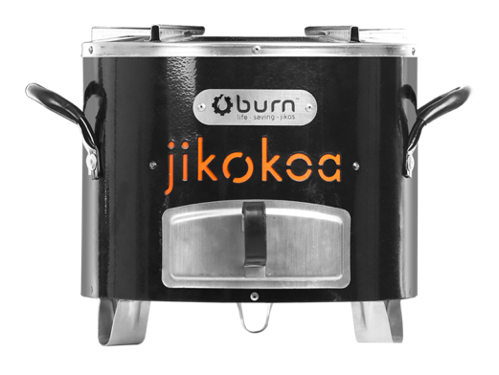 | 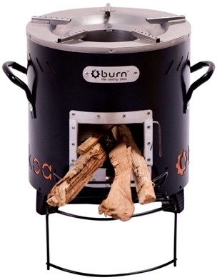
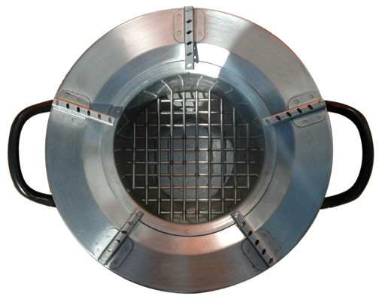 | 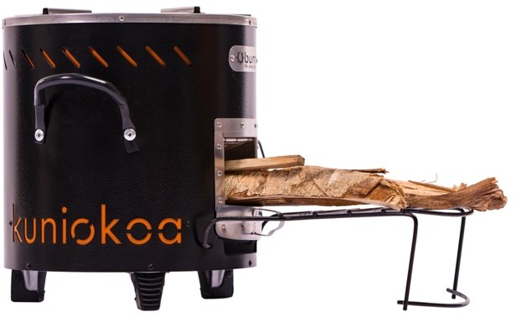
Figure 1: Examples of possible portable improved cookstoves to be distributed under this PoA
BURN Jikokoa stoves using charcoal (2 pictures to the left) and BURN Kuniokoa
stoves using firewood (2 pictures to the right)

Besides reducing GHG emission in line with the United Nations Sustainable Development Goal (SDG) number 13 ‘Climate Action’, this programme will also seek to increase other long-term sustainability benefits for households, SMEs and institutions as well as the local environment. Depending on the specific cookstove model(s) and target group to be implemented by each project activity as well as baseline characteristics in the targeted area, the contribution to the SDGs may vary but will include at least two of the following SDGs:
- Reduction in end-user expenses related to the purchase of fuel for cooking (in line with SDG 1 ‘No Poverty’).
- Time savings both for fuel procurement and cooking, thus more time is available, for other tasks, like income generating activities or for growing food (in line with SDGs 1 ‘No Poverty’, 2 ‘Zero Hunger’ and 5 ‘Gender Equality’).
- Reduction in amount of harmful carbon monoxide and particulate matter during combustion in households/SMEs/institutions will reduce indoor air pollution and thereby decrease of respiratory diseases, headache and itchy eyes, particularly for women and children who spend lot of their time in cooking activities (in line with SDG 3 ‘Good health and well-being’ and 5 ‘Gender Equality’).
- Improved cookstoves cook faster than traditional stoves and use less fuel, enabling children, particularly girls to dedicate more time for education/school instead of for cooking (in line with SDG 4 ‘Quality Education’)
- Increased penetration of clean and reliable cooking technologies (in line with SDG 7 ‘Affordable and Clean Energy’) and raising awareness of the related safety, economic, and environmental benefits (in line with SDG 4 ‘Quality Education’).
- BURN produces its cookstoves in a manufacturing facility located in Kenya, thus generating hundreds of jobs on the African continent. Other jobs are created for sales, marketing, distribution and monitoring staff. Continuous training results in permanent knowledge transfer to local people. BURN may open in future additional factories or assembly lines across the continent depending on the demand (in line with SDGs 1 ‘No Poverty’ and 8 ‘Decent Work and Economic Growth’).
- Reduced deforestation and forest degradation in the areas where non-renewable biomass is used as a source of fuel. This will contribute to the overall stability of forest ecosystems which support biodiversity, watersheds and soil conditions (in line with SDG 15 ‘Life on Land’).
        - Target/Indicator for each of the minimum three SDGs targeted by the PoA
SDGs assessment is conducted at the VPA level. CME shall provide the information in the VPA DD and may also summarize the outcome in the Table below.

>>
SUSTAINABLE DEVELOPMENT GOALS TARGETED | MOST RELEVANT SDG TARGET | SDG IMPACT
SUSTAINABLE DEVELOPMENT GOALS TARGETED | MOST RELEVANT SDG TARGET | INDICATOR (SELECTED IN SDG TOOL)
13 Climate Action (mandatory) | Target 13.3 | GHG emission reductions
1 End poverty in all its forms everywhere | Target 1.4 | Monetary savings related to the purchase of charcoal/firewood and/or time savings for the procurement of fuel
3 Ensure healthy lives and promote well-being for all at all ages | Target 3.9 | Perceived air quality
7 Ensure access to affordable, reliable, sustainable and modern energy for all | Target 7.1 | Number of sold/distributed ICS in use
8 Promote sustained, inclusive and sustainable economic growth, full and productive employment and decent work for all | Target 8.5 | Total number of jobs created
4 Ensure inclusive and equitable quality education and promote lifelong learning opportunities for all | Target 4.3 | Number of people receiving skill development training
5 Achieve gender equality and empower all women and girls | Target 5.4 | Average time saving associated with fuel collection and cooking in the project scenario
15. Protect, restore and promote sustainable use of terrestrial ecosystems, sustainably manage forests, combat desertification, and halt and reverse land degradation and halt biodiversity loss | Target 15.2 | Total non-renewable biomass saved

        - Coordinating/managing entity
>>
The Coordinating and Managing Entity (CME) of the PoA and at the same time project participant is ‘BURN Manufacturing Co.’ (in the following ‘BURN’), a US based company. BURN is the entity which communicates with the Gold Standard Secretariat. The contact details of BURN are provided in Appendix 1.
        - Funding sources of PoA
>>
The PoA is funded by private sources of the CME and its partners. No public funding has been used for the PoA development.

MANAGEMENT SYSTEM AND INCLUSION CRITERIA
        - Management System
>>
The CME uses a management system to ensure all VPA Implementers under the PoA implement, operate, and monitor their respective VPAs in an effective and verifiable manner. The management system will ensure that each VPA meets all requirements and eligibility criteria for inclusion of VPAs in the PoA before its inclusion. The management system covers the following aspects of the VPAs under the PoA:
    - A clear definition of roles and responsibilities of personnel involved in the process of inclusion of VPAs, including a review of their competencies.
    - Records of arrangement for training and capacity development for personnel.
    - Procedures for technical review of inclusion of VPAs.
    - Procedures to avoid double counting (e.g. to avoid the case of including a new VPA that has already been registered either as a GS project activity or as a VPA of another PoA).
    - Records and documentation control processes for each VPA under the PoA include tracking stove serial numbers to ensure accurate monitoring and accountability.
Measures for continuous improvement of the PoA management system are implemented to enhance efficiency and data reliability for continuous improvements of the PoA management system.

The Management System is described below.
- A clear definition of roles and responsibilities of personnel involved in the process of inclusion of VPAs, including a review of their competencies
The CME will ensure that all parties involved in the operation of the VPA (manufacturers, distributors, VPA Implementers, and end users) are aware of and have agreed that their activity is being subscribed to the PoA. Awareness and agreement will be secured through informational material, community trainings, social media, and in contractual agreements. The CME will supply all contractual agreements and issue the Approval Letter for a VPA to be included and ensure that it meets all eligibility criteria of the PoA. The CME is intimately familiar with the eligibility criteria of the PoA and the latest guidelines and standards of the Gold Standard.
The CME’s Lab and Quality Manager reviews the description of the technology to be employed under the VPA. If the description is adequate, the Lab and Quality Manager will recommend the VPA for inclusion to the CME’s Chief Executive Officer.
The CME’s Market Research Manager will review the monitoring plan of the VPA. If adequate the Market Research Manager will recommend the VPA for inclusion to the CME’s Chief Executive Officer. Each VPA implementer will collect and report in addition to the requirements above, the all required data to effectively monitor the emission reductions of each VPA in accordance with the monitoring plan detailed in the VPA- DD. The sales/distribution information is automatically recorded into the electronic database management system operated by the CME and reviewed by the After Sales/distribution Manager.
During monitoring of a VPA, the CME’s After Sales/distribution Manager will report the full-time equivalent appliances operating during the monitoring period to the VPA Implementer as drawn from the sales/distribution records in the electronic database management system.
For parameters to be sampled or surveys, the CME’s After Sales/distribution Manager will provide the VPA Implementer with the USNs of the appliances to be surveyed or sampled along with the survey guidelines if applicable. The VPA Implementer is required to adhere to the directions of the CME to ensure effective and accurate monitoring of each VPA.
Each VPA Implementer verifies that they have read, understood, and agree to comply with the requirements and guidelines of the CME managements system prior to inclusion of each VPA into the PoA.
- Records of arrangement for training and capacity development for personnel
Upon inclusion of a VPA implemented by a VPA Implementer who has not already implemented a VPA under the PoA and whose entity is not supported by BURN in the implementation of the VPA, there will be a formal training conducted by the CME for the VPA Implementer. The training will be documented in the form of a training report and cover the main aspects of the implementation of VPAs under the PoA, including but not limited to the following:
- CME Management System
- Technological Requirements
- Sampling Plan
- Monitoring Methodology

A letter from the VPA Implementer confirming they have been trained and are capable of implementing the VPA will show completion of the training.

- Procedures for technical review of inclusion of VPAs
The CME will check the compliance with each of the eligibility criteria to ensure that the VPA Implementer has met all of those criteria required for inclusion under the PoA.
The CME will review the VPA Design Document and all appendixes to ensure the criteria for inclusion are met before requesting inclusion of the VPA. The CME will show that to the best of its knowledge that all criteria for inclusion have been met by issuing the VPA Implementer with a CME Approval letter.
- Procedures to avoid double counting (e.g. to avoid the case of including a new VPA that has already been registered either as a CDM project activity or as a VPA of another PoA)
The ICS under each VPA of the PoA will avoid double accounting of emissions reductions through the Unique Serial Number (USN). Each device under the PoA is unquestionably assigned to a single PoA (in the instance there are other PoAs under the same methodology) and a single VPA under that PoA. The USN will be clearly visible on the ICS throughout the life of the product as well as stored in the electronic data management system. If there is any doubt regarding the USN of a product, it will be excluded from the PoA.
Each VPA will send the CME a list of products, along with the product’s USN, sold/distributed during or deemed active during the crediting period. The CME will check each USN against the electronic database to ensure that no product with an identical USN is listed under another VPA. If it is found that a product with an identical USN is listed under another VPA, the emission reductions for the product will not be claimed and the product will be removed from the database to ensure emissions are not double counted in future monitoring. After any double counted products have been removed from the database, the random sample for sampling specific parameters will be drawn and sent to the VPA Implementer. The sampling frame consists of those ICS for which end-user data is available.
- Records and documentation control process for each VPA under the PoA
The CME will operate and manage an electronic data management system that will store information on and track all efficient cooking technologies under the PoA. The system will contain the following information for device:
- Unique serial number (USN) of the ICS
- Date of shipment to distributor/retailer
- Name of distributor/retailer
- Quantity of ICS distributed
- Geographic area (state) of distributor/retailer
- Model type of the ICS

Burn initially implemented a 9-digit number format for the initial phase of stove distribution. However, in later stages, a more robust system has been adopted, transitioning to a 6-digit number pattern. The 9-digit format, is elucidated as follows:

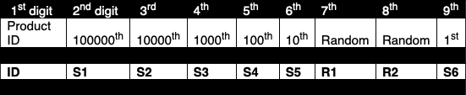

Each section on the USN will identify the product as follows:

      - Product type: the first digit identifies the stove type (e.g. Jikokoa)
      - # Production number: S1 to S6 are digit slots for a sequential numbering ordered by time of production, allowing for 1 million unique serial numbers. For instance, the first stove off the line would have “000000” for its S1-S6 digits.
      - Random digits: R1 and R2 are 2 random digits placed in slots 7 & 8, to make the USN unpredictable to outside parties.

Example for USN: 202728110
      - “2” stands for Jikokoa product ID
      - “027280” for S1-S6, meaning it was the 27,280th Jikokoa produced
      - “11” for R1-R2, the random digits
The 6-digit format, is explained as follows:
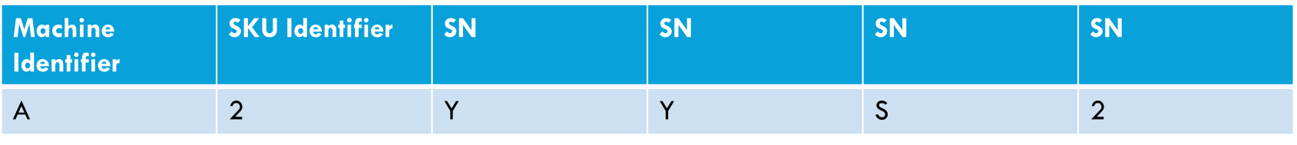
Each section on the USN will identify the product as follows:
- The first character is based on the laser machine.
- The next unique identifier is based on the SKU allowing us to identify a product with just the SN.
- The last four characters is a sequential alphanumeric sequence.
- These characters follow a particular sequence, guaranteeing the absence of repetition.
Examples for 6-digit USN pattern:

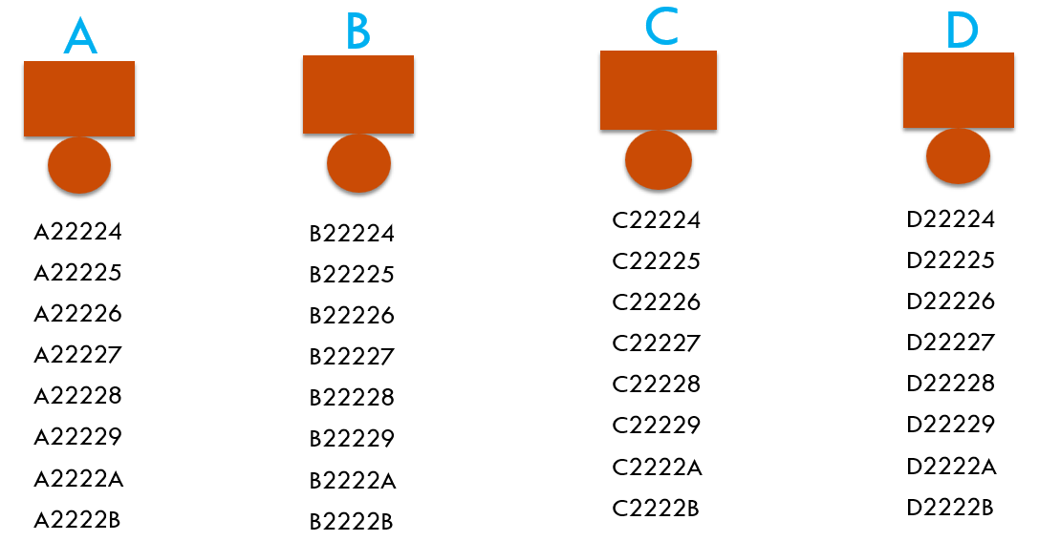
Example for USN: A22224
- “A” stands for identification of laser machine
- The first “2” stands for the identification of SKU.
- “2224”, the random digits.

The data for the system will be updated and modified as required to allow for optimal performance of each VPA implementation and monitoring. All data will be stored for at least two (2) years after the expiry of the crediting period.
- Measures for continuous improvements of the PoA management system
The CME will at least every two years submit a performance review to each VPA Implementer assessing the performance of their VPAs under the PoA, communication with the CME, and requesting feedback on methods for improving the PoA management system based on the experiences of the VPA Implementer. The CME will evaluate the feedback and expand/revise the management system if deemed appropriate.

        - Application of methodologies
>>
The applied methodology is the GS methodology ‘Technologies and Practices to Displace Decentralized Thermal Energy Consumption’ (TPDDTEC), version 04.0.
This is the latest version of the methodology at the time when writing this PoA-DD.
The GS cookstove usage rate guidelines will be followed.
          - Multiple technologies/measures
>>
Not applicable. Since the PoA-DD does not apply any other technologies apart from efficient improved cookstoves.
        - Eligibility criteria for inclusion of a VPA in the PoA
No. | ELIGIBILITY CRITERION | DESCRIPTION/  REQUIRED CONDITION | MEANS OF VERIFICATION/SUPPORTING EVIDENCE  FOR INCLUSION
1 | Geographical Boundary | ICS distributed under any of the VPAs will be located in any of the countries mentioned under section A.3 of the PoA- DD. | The VPA-DD will clearly describe the area where the VPA is being implemented.
2 | Double-counting of project activity | All VPAs will be checked to prevent double counting and are not registered as a separate GS project activity, nor included as part of another registered GS (or other carbon standard) PoA nor that the project activity has been deregistered. | This condition will be checked through carbon standard registries (UNFCCC, GS and VERRA  websites).  Further, it will be confirmed by a letter signed by the VPA implementer.
3 | Technology | Each VPA will implement improved biomass cook stoves. | Technology specification (manufacturer specifications)
4 | Conditions to check the start date of the VPA through documentary evidence | The start date of a project activity is the date on which the first ICS has been distributed/delivered under the VPA.  The start date of retroactive VPAs (with a start date prior to date of first submission of PoA) can be at the earliest 1 year prior to submission | The start date of each VPA will be defined in the VPA DD.  The start date of the VPA will be checked by sales agreement, electronic sales record, proof of shipping or any equivalent for the first ICS distributed under the VPA.
5 | Methodology | Each VPA will comply with the applicability criteria of the applied methodology (TPDDTEC, version 04.0) | The VPA-DD shall describe and justify how the applicability criteria of TPDDTEC are being met at VPA level.
6 | Financial Additionality & Ongoing Financial Needs | Projects (VPAs) to be included under the PoA will be in compliance with item 1.1.3 of Annex B – positive list mentioned in the ‘Community Services Activity Requirements’ or located in LDC, SIDS, LLDC.  A VPA will be solely composed of isolated units (efficient cookstoves) where the users of the technology/measure are household/SMEs/institutions and where each unit results in <= 600 MWh of energy savings per year.  Hence, according to paragraph 4.1.9 of the ‘Community Services Activity Requirements’, a VPA, regardless of the host country in which the project activity is being implemented, is deemed additional and therefore is not required to prove financial additionality at the time of Design Certification; OR a VPA is located in an LDC, SIDS, LLDC. | Demonstration that the energy savings per year at a unit level (i.e. per ICS) are  <=600 MWh; OR that  the VPA is located in an LDC, SIDS, LLDC.
7 | Stakeholder inclusivity | Local stakeholder consultation is done at VPA level, as described in section F of the PoA-DD. Local stakeholder consultation report must be provided along with VPA-DD. A single Stakeholder consultation can be conducted for a group of VPAs as long as convincing justification is provided. | Local stakeholder consultation report for the VPA or a group of VPAs.
8 | Conditions related to environmental Impact Analysis | The VPA has to fulfil host country requirements (if any) concerning environmental impact analysis. | The VPA-DD shall include the summary of the analysis and provide the references to documentation in case the EIA is required by the host country.
9 | CME approval | Each VPA has a project implementer that is either the Coordinating/Managing Entity or another entity that has signed a contractual agreement with the CME.  Those agreements include all rights and responsibilities of both parties, e.g. approval procedures by the CME, monitoring requirements, carbon credit rights transfer. This eligibility criterion is not relevant if the CME is the VPA implementer. | Signed letter by the CME demonstrating the approval of the VPA inclusion.
10 | Transfer of carbon credit ownership | The transfer of carbon credit ownership all along the investment chain is clearly described and communicated to all project participants and end-users so that they are aware of to give up their rights on emission reductions. For technology producers and the retailers of the improved technology, this must be communicated by contract or clear written assertions in the transaction paperwork. The end-users will need to be informed and notified that they cannot claim for emission reductions from the project. | Description of the transfer of carbon credit ownership from end-users to entity to whom the rights are assigned to.  Contractual agreements between technology producers, retailers and the entity to whom the rights are assigned to.
11 | Conditions to provide an affirmation that funding from Annex I Parties, if any, does not result in a diversion of ODA | In case that any of the VPA receives ODA, it is ensured that there is no diversion of ODA, i.e. that no ODA is provided under the condition that all or part of the carbon credits have to be returned to the donor country/entity providing ODA. | VPA implementer signs an ODA declaration confirming that there is no diversion of ODA.
12 | Target Group and distribution mechanism | The VPA serves households, institutions or SMEs either in urban, peri-urban and/or rural areas, and distributes the cook stoves through adequate distribution channels. | The target group of the project activity and the distribution mechanism shall be described in the VPA-DD.
13 | Conditions related to sampling requirements | The VPA complies with the sampling plan as outlined in the VPA-DD, section B.7.2 | The VPA-DD outlines the sampling plan in section B.7.2 which is in line with GS sampling requirements. The VPA makes either part of a single sampling covering a group of VPAs or sampling is conducted separately at VPA level. In case of a grouped sampling approach, the CDM Project Standard for PoAs will be followed.
14 | Double counting of emission reductions | Each VPA will implement a unique identification system for every efficient cooking unit distributed to avoid double counting of emission reductions. | Description of the unique identification system and adherence to the CME Management System. Any multiple use of the same BURN ICS will be taken conservatively into account by each VPA.
15 | Crediting Period | The duration of the crediting period of the VPA does not exceed the end date of the registered PoA or shall be capped by the end date of the PoA. The final date for which ERs can be credited shall be no later than 20 years after the start date of the PoA. | Description of the duration of the VPA crediting period shall be provided in the VPA- DD.

DEMONSTRATION OF ADDITIONALITY
>>
The proposed PoA is a voluntary coordinated action by the CME. There is no mandatory law, policy or requirement in any of the Host Countries included under the PoA to foster the dissemination of improved cook stoves. Hence, this voluntary coordinated action would not be possible in the absence of this PoA and carbon revenues, due to the cost associated with the PoA development, implementation, management and monitoring.
The revenues from the sale of carbon credits are needed to
  - distribute improved cookstoves to a subsidized price affordable for end-users,
  - scale up and expand the programme, thus reaching a wider range of end-users and generating more jobs,
  - further invest in R&D, hence, to produce high quality stoves at lower cost,
  - provide a reliable after-sales service,
  - sensitize and raise awareness amongst end-users about the benefits and how to use the improved cookstoves.
The PoA would not be developed without carbon credit revenues.
A VPA to be included under the PoA will be in compliance with item 1.1.3 of Annex B – positive list mentioned in the ‘Community Services Activity Requirements’ or the VPA is located in an LDC, SIDS, LLDC (as per ‘Community Services Activity Requirements’, 4.1.9, (b)).
A VPA will be solely composed of isolated units (efficient cookstoves) where the users of the technology/measure are households/institutions/SMEs and where each unit results in <= 600 MWh of energy savings per year.
Hence, according to paragraph 4.1.9 of the ‘Community Services Activity Requirements’, a VPA, regardless of the host country in which the project activity is being implemented, is deemed additional and therefore is not required to prove financial additionality at the time of Design Certification; or the VPA is located in an LDC, SIDS, LLDC.

DURATION OF PoA
        - Date of first submission of PoA to Gold Standard
>>
30/06/2020
This is the date when the PoA design consultation report was submitted to Gold Standard for review.
        - Duration of the PoA
>>
20 years

OUTCOME OF PoA LEVEL STAKEHOLDER CONSULTATION
        - Summary of stakeholder consultation at PoA Level
>>
Not applicable. Since the stakeholder consultation will be carried out at VPA-level. A grouped stakeholder consultation may be organized for multiple VPAs if this can be justified.
        - Consideration of stakeholder comments received
>>
Not applicable
        - Final Continuous Input / Grievance Mechanism at PoA Level
>>
Not applicable. Since continuous input / grievance mechanism is implemented at VPA level.

METHOD | INCLUDE ALL DETAILS OF CHOSEN METHOD (S) SO THAT THEY MAY BE UNDERSTOOD AND, WHERE RELEVANT, USED BY READERS.
Continuous Input / Grievance Expression Process Book (mandatory)
GS Contact (mandatory) | help@goldstandard.org
Other

Appendix 1 - Contact information of coordinating/managing entity and responsible person(s)/ entity(ies)
CME and/or responsible person/ entity | CME  Responsible person/ entity for application of the selected methodology(ies) and, where applicable, the selected standardized baseline(s) to the PoA
Organization | BURN Manufacturing Co.
Street/P.O. Box | Suite 220, 18850 103rd Avenue SW
Building
City | Vashon
State/Region | Washington
Postcode | 98070
Country | United States
Telephone | +254 718 125 639
E-mail | peter.scott@burnmfg.com
Website | https://burnstoves.com
Contact person | Peter Scott
Title | CEO BURN
Salutation | Mr.
Last name | Scott
Middle name

Appendix 2 - DESIGN CHANGES
A2.1. Details of proposed or actual design change
>> N/A

A2.2. Describe the Impacts of design change on the following
- Additionality
>>

- Applicability of methodology and other methodological regulatory documents with which the project activity has been certified
>>

- Compliance with the monitoring plan of the applied methodology
>>

- Level of accuracy and completeness in the monitoring of the project activity compared with the requirements contained in the registered monitoring plan
>>

- Scale of the project activity
>>

- Stakeholder consultation
>>

- Sustainable development criteria
>>

- Safeguarding assessment
>>

- Compliance with applicable legislation
>>
Revision History

Version |  | Date |  | Remarks
2.2 |  |  | 14 April 2023 |  | Integrated the design change memo as annex of the document.  Editorial changes
2.1 |  |  | 31 May 2022 |  | Editorial changes and revisions
2.0 |  |  | 04 May 2022 |  | Key Project Information table revised to cater for the following information:  - Scale of PoA  - Title and GS ID of all real case VPAs included in the PoA  A new Management System section included  Safeguarding Principles Assessment section removed  Outcome of PoA Level Stakeholder Consultation section revised in the following manner:  - Justification for Stakeholder Consultation at PoA Level Only section removed  A new Consideration of Stakeholder Comments Received section added
1.1 |  | 14 October 2020 |  | Hyperlinked section summary to enable quick access to key sections  Improved clarity on Key Project Information  Inclusion criteria table added  Clarification on POA level LSC and Safeguard Principles Assessment  Improved Clarity on SDG contribution/SDG Impact term used throughout  Clarity on Stakeholder Consultation information required  Provision of an accompanying Guide to help the user understand detailed rules and requirements
1.0 |  | 10 July 2017 |  | Initial adoption

This is in line with the Deviation Request submitted to the GS on 19/04/2020 and approved by the GS on 15/05/2020.
https://www.iea.org/reports/a-vision-for-clean-cooking-access-for-all/executive-summary https://documents1.worldbank.org/curated/en/164241468178757464/pdf/98664-REVISED-WP-P146621-PUBLIC-Box393185B.pdf
https://cleancooking.org/wp-content/uploads/2023/11/CCA_The-Future-of-Africas-Sustainable-Cities.pdf
https://academicjournals.org/journal/JHF/article-full-text-pdf/5D8823570052#:~:text=The%20total%20consumption%20of%20wood,charcoal%20(GEF%2C%202013%3B%20World
https://www.un.org/sustainabledevelopment/sustainable-development-goals/
In particularly women benefit of more time for other tasks. Since it is most of the times women who are responsible for fuel procurement and cooking activities.
This is in line with the Deviation Request submitted to the GS on 19/04/2020 and approved by the GS on 15/05/2020.
https://www.un.org/sustainabledevelopment/sustainable-development-goals/
In particularly women benefit of more time for other tasks. Since it is most of the times women who are responsible for fuel procurement and cooking activities.
It is possible that the USN format may change in future.
https://globalgoals.goldstandard.org/standards/407_V4.0_EE_ICS_Reduced-Emissions-from-Cooking-and-Heating-TPDDTEC.pdf
https://globalgoals.goldstandard.org/407g-ee-ics-tpddtec-usage-guidelines/
‘Distributed‘ may include the free distribution of ICS, sale to full cost or subsidized cost.
In line with Community Services Activity Requirements (paragraph 4.1.5) the duration of crediting period of a VPA is 5 years which can be renewed maximum twice, i.e. in total a maximum issuance of 15 years

