Monitoring Report

PUBLICATION DATE 14.10.2020
VERSION v. 1.1
RELATED SUPPORT - TEMPLATE GUIDE Monitoring Report v. 1.1

This document contains the following Sections
Key Project Information
SECTION A - Description of project
SECTION B - Implementation of project
SECTION C - Description of monitoring system applied by the project
SECTION D - Data and parameters
SECTION E - Calculation of SDG Impacts
SECTION F - Safeguards Reporting
SECTION G - Stakeholder inputs and legal disputes

KEY PROJECT INFORMATION

Key Project Information
GS ID (s) of Project (s) | GS672
Title of the project (s) covered by monitoring report | Düzova Wind Power Project, Turkey
Version number of the PDD/VPA-DD (s) applicable to this monitoring report | 03
Version number of the monitoring report | 09
Completion date of the monitoring report | 07/10/2024
Date of project design certification | 16/01/2017
Date of Last Annual Report | 15/12/2022
Monitoring period number | 4th
Duration of this monitoring period | 01/08/2021 to 10/08/2023 (both days are included, 2nd Crediting period, 4th Monitoring period)
Project Representative | Ütopya Elektrik Üretim Sanayi ve Ticaret A.Ş.
Host Country | Turkey
Activity Requirements applied | Community Services Activities  Renewable Energy Activities  Land Use and Forestry Activities/Risks & Capacities  N/A
Methodology (ies) applied and version number | ACM0002, “Consolidated baseline methodology for grid connected electricity generation from renewable sources” version 21.0
Product Requirements applied | GHG Emissions Reduction & Sequestration  Renewable Energy Label  N/A

Table 1 - Sustainable Development Contributions Achieved
Sustainable Development Goals Targeted | SDG Impact | Amount Achieved | Units/ Products
SDG 13 Climate Action | Emissions Reductions | Emission Reduction:  163,232 tCO₂  Air Quality:  NO_{x}: 412.4 tons  CO: 46.4 tons  NMVOC: 9.9 tons | VERs
SDG 6 Clean water and sanitation | Wastewater discharge transfer records are to be provided. | Wastewater transfer receipts dated 06/08/2021, 12/10/2021, 07/12/2021, 04/02/2022,  09/04/2022, 04/08/2022, 13/10/2022, 12/01/2023, and 10/03/2023 are provided to VVB. | m³
SDG 8 Decent work and economic growth | The project provides employment. Trainings to be held. | 10 employees work at the WPP. | Number of Employees
SDG 7 Affordable and clean energy | MWh of renewable energy generated | 296,036.87 MWh  renewable energy.  30,302,137 m³ natural gas import is avoided by generation of project activity. | MWh

Table 2– Product Vintages
 |  | Amount Achieved
Start Dates | End Dates | VERs
01/08/2021 | 31/12/2021 | 36,174
01/01/2022 | 31/12/2022 | 84,716
01/01/2023 | 10/08/2023 | 42,342

SECTION A. DESCRIPTION OF PROJECT

A.1. General description of project
Ütopya Elektrik Üretim Sanayi ve Tic. A.Ş. (“Ütopya Elektrik” or project owner) invests into a new wind power plant i.e. Düzova Wind Power Plant (“Düzova WPP”) and granted production license by EMRA on May 2007 for 15 MW, construction work had been started on 01/06/2009, and first commissioning of the turbines occurred on 11/08/2009 and production license amended to 30 MW on April 2010. Second amendment on License Regulation on 11/08/2011, gave right to the project owner to increase mechanical installed capacity of the power plant to 40 MW, provided that electrical power capacity to be fed into the grid shall not exceed the electrical installed capacity stated in the license (30 MWe) and additional turbines shall be built in the project area. By third amendment of license on 13 March 2013, total capacity of the project is increased to 50 MW with 20 turbines each having 2.5 MW capacity.
As stated in the above paragraph, the Düzova WPP consists of 20 wind turbines. 16 of them are GE 2.5xl model turbines with 2.5 MW output each having 100 m diameter rotor, 7,854 m² swept area and 85 m hub height. 4 of them are GE 2.75-100 model with 103 m diameter rotor, 8,332 m² swept area and 100 m hub height. These turbines operate as 2.5 MW (6 of them operate as 2.75 MW). The wind turbines are connected to the wind farm substation through 34.5 kV underground cables. The voltage is raised to 154 kV and is transferred to grid via a 3 km long transmission line which is connected to the bypassing Bergama-Ayvalık transmission line of TEIAS. The net electricity production is 146,018.19 MWh per year for this monitoring period. The total net electricity generation is 296,036.87 MWh for the whole monitoring period.
The purpose of the project is to generate electricity and to feed it into the public grid. Düzova WPP project registration was approved on 22/11/2010 by Gold Standard as a Voluntary Emission Reduction project in order to enable the project implementation by means of financial inflows coming from the credit’s sale. Because of its significant contribution to climate protection and to sustainable development in the region, this project is expected to fulfil the requirements of the Gold Standard. The project activity is not registered with any other compliance or voluntary market-based mechanism. The project owner is aware of that the project activity cannot clan VERs for the same vintage in another standard other than GS. There is no double counting with national climate policies or programs.
Annual energy yield of the first 15 MWe capacity was estimated to be 59,300 MWh and 30 MWe was estimated to be 118,100 MWh. According to the energy yield study of GL Garrad Hassan on 19 July 2013 annual energy generation for 50 MW capacity is estimated to be 152,900 MWh/yr, and the emission reduction is estimated to be 97,481 tCO₂e. The estimated electricity generation for this monitoring period, which is from 01/08/2021 to 10/08/2023, is 319,786 MWh, and the estimated emission reduction is 318,786 tCO₂e. During the monitoring period total actual electricity generation was 296,036.87 MWh and achieved total emission reduction is 163,232 tCO₂.
Finally, by the fourth amendment of license on 19/09/2014, total capacity of project is increased to 51.5 MW without any additional turbines but increasing the capacity of 6 turbines (turbines numbered T13, T14, T17, T18, T19, T20) 0.25 MW from 2.5 MW to 2.75 MW. Also, the electricity generation amount stayed at same, 152,900 MWh. Since the installed capacity of the project is 51.5 MW, this project is a large-scale project.
The main characteristics of the project design changes are given in Table 3.
Table 3. Main Characteristics of the Project Design Changes
Explanation | Date of Issuance or Amendment  of License | Installed Capacity (MWm/MWe) | Number of Turbines | Annual Generation (MWh/yr)
Preliminary Design | 03/05/2007 | 15 MWm / 15 MWe | 6 | 59,300
1. Design Change | 08/04/2010 | 30 MWm / 30 MWe | 12 | 97,200
2. Design Change | 01/03/2012 | 40 MWm / 30 MWe | 16 | 118,100
3. Design Change | 13/03/2013 | 50 MWm / 50 MWe | 20 | 152,900
Non-Design Change | 19/09/2014 | 51.5 MWm / 51.5 MWe | 20 | 152,900

During the monitoring period total electricity generation was 296,036.87 MWh and achieved total emission reduction is 163,232 tCO₂.
The most important milestones are included in Table 5.
Table 4. Milestones of the Düzova Wind Power Project
Date | Milestone
03/05/2007 | Issuance of the license
01/06/2009 | Date for start of construction
11/08/2009 | Starting to the Operation with 6 turbines
25/05/2010 | Electromechanical Contract Signature with GE for additional 6 turbines
03/09/2010 | Starting date for construction of additional 6 turbines
05/10/2010 | Final Validation Report
22/11/2010 | Gold Standard Registration
31/08/2010 | End of the first monitoring period
09/06/2011 | Approval Date of first design Change
30/09/2011 | End of the second monitoring period
15/10/2012 | Approval Date of second design Change
05/04/2012 | Construction start date for second design change
12/02/2013 | Commercial operation date for the four turbines for second design change
18/03/2013 | Electromechanical Contract Signature with GE for additional 4 turbines for third design change
20/05/2013 | Construction start date for third design change
31/05/2013 | End of the third monitoring period
23/08/2013 | Loan Agreement for additional 4 turbines for third design change
21/03/2014 | Commercial operation date for the 50 MW (third design change)
30/09/2014 | End of the 4th monitoring period
31/10/2015 | End of the 5th monitoring period
10/08/2016 | End of the 6th monitoring period of 1st crediting period
11/08/2016 – 10/08/2023 | 2nd crediting period
11/08/2016 - 31/07/2017 | 1st monitoring period of 2nd crediting period
01/08/2017 – 31/07/2019 | 2nd monitoring period of 2nd crediting period
01/08/2019 – 31/07/2021 | 3rd monitoring period of 2nd crediting period
01/08/2021 – 10/08/2023 | 4th monitoring period of 2nd crediting period

According to the methodology, baseline scenario was identified as “the electricity delivered to the grid by the project activity that otherwise would have been generated by the operation of grid-connected power plants and by the addition of new generation sources”.

A.2. Location of project
The project site is located in the Aşağıkırıklar village, Bergama district, İzmir city, Turkey. The project area is completely plain area without any trees. There are not any agricultural activities on proposed project area. Location of the project and the specific positions of the 20 wind turbines are presented below.
Table 5. Geographical Coordinates of the Turbines of Düzova WWP
Turbine Number | Latitude (N) | Longitude (E)
T1 | 39° 2' 51.133" | 27° 1' 5.524"
T2 | 39° 2' 47.659" | 27° 1' 23.619"
T3 | 39° 2' 39.806" | 27° 1' 34.267"
T4 | 39° 2' 30.169" | 27° 1' 42.874"
T5 | 39° 2' 22.835" | 27° 1' 54.976"
T6 | 39° 2' 15.500" | 27° 2' 5.871"
T7 | 39° 2' 36.940" | 27° 2' 15.741"
T8 | 39° 3' 12.641" | 27° 1' 7.859"
T9 | 39° 2' 26.619" | 27° 2' 30.502"
T10 | 39° 2' 15.426" | 27° 2' 34.073"
T11 | 39° 1' 57.532" | 27° 1' 50.306"
T12 | 39° 1' 54.025" | 27° 2' 3.240"
T13 | 39° 2' 27.516" | 27° 1' 11.175"
T14 | 39° 2' 35.759" | 27° 0' 46.425"
T15 | 39° 2' 6.001" | 27° 1' 42.490"
T16 | 39° 3' 3.713" | 27° 1' 40.807"
T17 | 39° 2' 56.996" | 27° 1' 50.623"
T18 | 39° 2' 47.553" | 27° 1' 59.979"
T19 | 39° 2' 13.563" | 27° 1' 27.185"
T20 | 39° 2' 31.638" | 27° 0' 58.738"

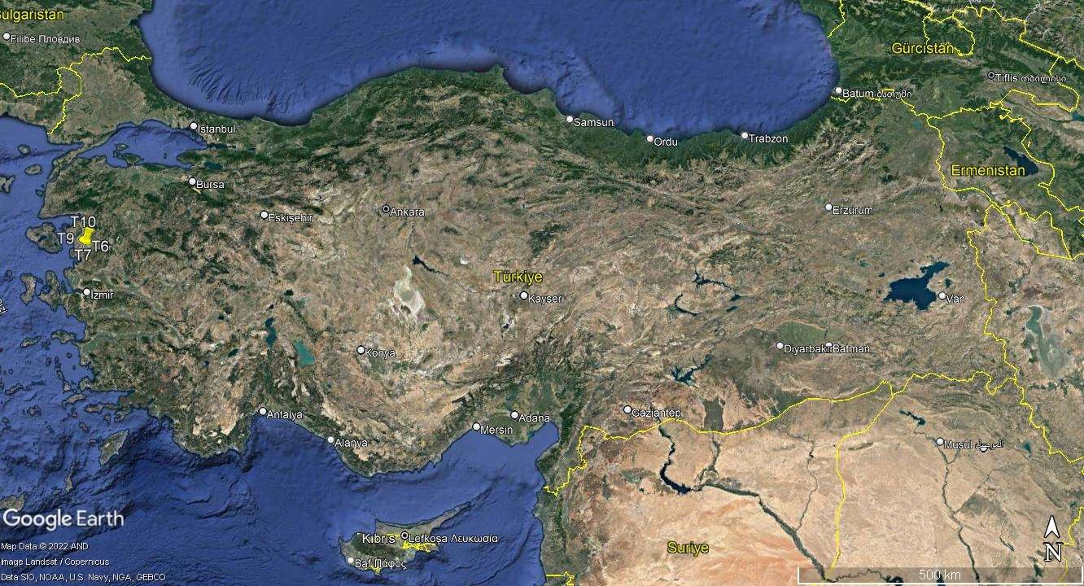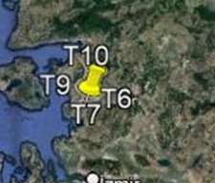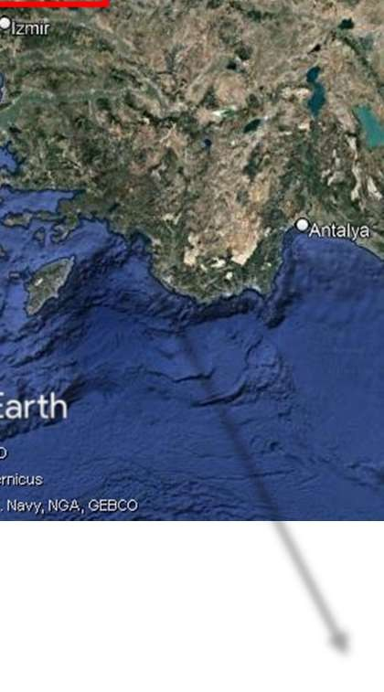
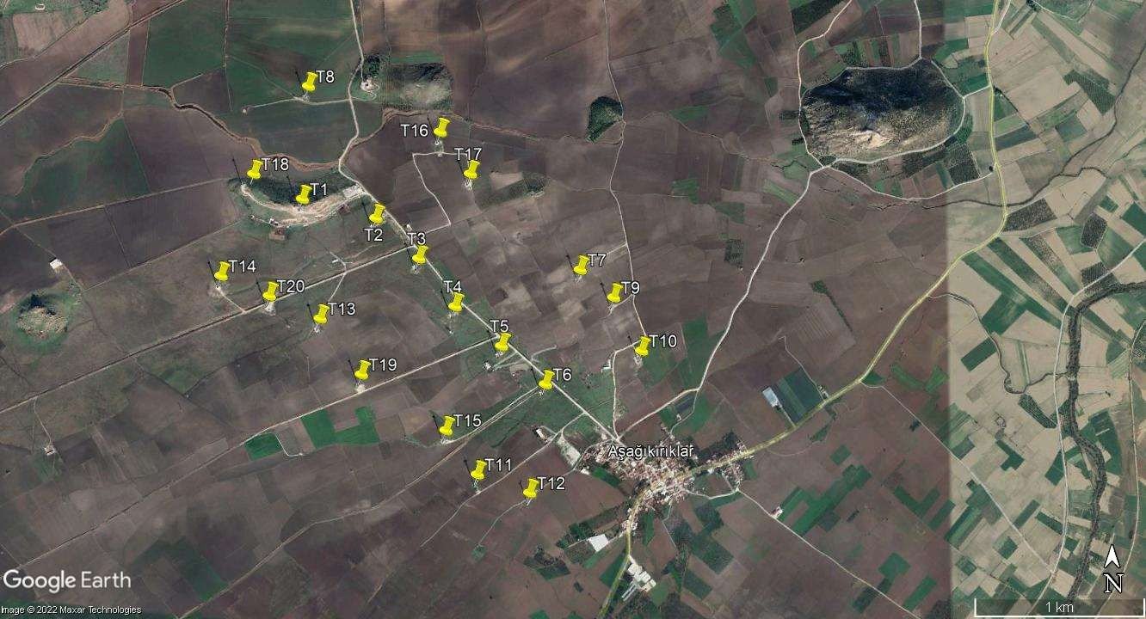
Figure 1. Location of the Project and the positions of the 20 Turbines

A.3. Reference of applied methodology
For the determination of the baseline, the official methodology ACM0002 version 21.0, “Grid-connected electricity generation from renewable sources”, is applied, using conservative options and data as presented in the following section. This methodology refers to six Tools, which are:
- Tool to calculate the emission factor for an electricity system (Version 04.0.0)
- Tool for the demonstration and assessment of additionality (Version 07.0.0)
- Combined tool to identify the baseline scenario and demonstrate additionality (version 05.0.0)
- Tool to calculate project or leakage CO2 emissions from fossil fuel combustion (Version 02.0.0)
- Tool to determine the remaining lifetime of the equipment
- Assessment of the validity of the original/current baseline and update of the baseline at the renewal of the crediting period (version 03.0.1)
For baseline calculation the first tool, for additionality assessment the second tool is used. As third tool is the combination of the first and second tool, it is not used. Since no project emission or leakage calculation is required for wind power project fourth tool is not used, either. To determine the remaining lifetime of the equipment fifth tool is used.
According to the “Procedures for renewal of the crediting period of a registered CDM project activity” (version 06.0, para 1, footnote 1) the continued validity of the original baseline and its update shall be assessed using the methodological tool “Assessment of the validity of the original/current baseline and update of the baseline at the renewal of the crediting period” (Version 03.01).

A.4. Crediting period of project
11/08/2016 - 10/08/2023 (both days are included). Crediting period type is renewable. Crediting period of the project is 7 years which is twice renewable. This is Fourth Monitoring Period of the Second Crediting Period.

SECTION B. IMPLEMENTATION OF PROJECT

B.1. Description of implemented project
Düzova WPP has 20 turbines each with an installed capacity of capacity of 14x2.5 MW and 14x2.500 MW and 6x2.750 MW, corresponding to a total capacity of 51.5 MWm / 51.5 MWe. The project uses GE 2.5/100 and GE 2.75/100 turbines with total electrical output capacity will be limited to 51.5 MWe. 14 of them are GE 2.5xl model turbines with 2.5 MW output each having 100 m diameter rotor, 7,854 m2 swept area and 85 m hub height. 6 of them are GE 2.75-100 model with 103 m diameter rotor, 8,332 m² swept area and 100 m hub height. These turbines operate as 2.5 MW (6 of them operate as 2.75 MW). The wind turbines are connected to the wind farm substation through 34.5 kV underground cables. The voltage is raised to 154 kV and is transferred to grid via a 3 km long transmission line which is connected to the bypassing Bergama-Ayvalık transmission line of TEIAS. The entire net electricity production is 152,900 MWh per year. Detailed technical characteristics of turbine model is given in the table below.
Table 6. Technical Properties
Main Data
Type | GE 2.5-100  GE 2.75-100
Diameter | 100 m
Hub height | 85 m
Cut-in wind speed | 3.0 m/s
Cut-out-wind speed | 25 m/s
Generator
Manufacturer | ABB
Vendor designation | AMG 0500 LN08 AAM
Rated Power | 2640 kW
Rated voltage | 710 V

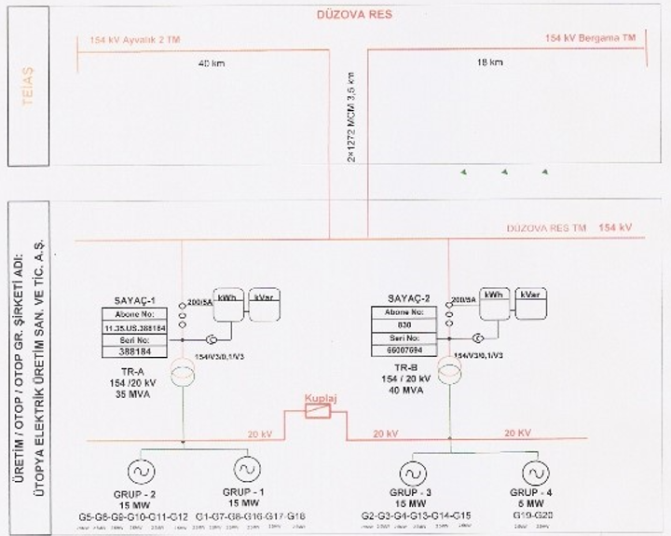
Figure 2. Single line diagram
Specification of old and current meters are as follows.
The details of the old main meters are given in the table below.
Device | Serial Number | Manufacturer | Model | Date of  installation and calibration | Accuracy
Main Meter (Trafo 1) | 65007595 | ITRON | SL7000 | 06/01/2014 | 0.5-2S  (Active-Reactive)
Main Meter (Trafo 2) | 65007594 | ITRON | SL7000 | 06/01/2014 | 0.5-2S  (Active-Reactive)

Table 7. First metering point (current)
Device | Serial Number | Manufacturer | Model | Date of  installation and calibration | Accuracy
Main Meter | 11590286 | EMH | LZQJ-XC | 28/08/2022 | 0.5S
Back Up Meter | 8088829 | EMH | LZQJ-XC | 08/12/2019 | 1S

Table 8. Second metering point (current)
Device | Serial Number | Manufacturer | Model | Date of installation and  calibration | Accuracy
Main Meter | 11590287 | EMH | LZQJ-XC | 28/08/2022 | 0.5S
Back Up Meter | 8088830 | EMH | LZQJ-XC | 08/12/2019 | 1S

There is one test protocol conducted during this Monitoring Period. The test has been conducted on 28/08/2022.

B.1.1 Forward Action Requests
FAR#1: GS VVBs shall resume on-site visit in all future monitoring period verification.
Explanation: GS VVBs will resume on-site visit in all future monitoring period verification.

FAR#2: PP shall maintain regular checks for stakeholder’s logbook since it went missing once. When not available, the book shall be replaced immediately. VVB shall include assessment in all future verifications.
Explanation: Regular checks for stakeholder’s logbook will be conducted. When not available, the book will be replaced immediately. Assessments will be included in all future verifications.

These FARs have been raised in the latest Performance Review (“GS672_ GS4GG Performance Review final 2023-06-27”).

B.2. Post-Design Certification changes
N/A
B.2.1. Temporary deviations from the approved Monitoring & Reporting Plan, methodology or standardized baseline
N/A
B.2.2. Corrections
N/A
B.2.3. Changes to start date of crediting period
N/A
B.2.4. Permanent changes from the Design Certified monitoring plan, applied methodology or applied standardized baseline
N/A
B.2.5. Changes to project design of approved project
N/A

SECTION C. DESCRIPTION OF MONITORING SYSTEM APPLIED BY THE PROJECT
Data handling was slightly revised due to innovation in technology that enables TEİAŞ to read meters remotely. Thus, under this process, the meter is read remotely at the end of every month and published through website of TEİAŞ which can be accessed by project owner to check the correctness of the data. Besides, the data that is read by TEİAŞ, project owner carries monthly protocol to cross-check the data. Once the meter data is correct then the amount is also published in TEİAŞ website which is also accessible by project owner. When all data is correct, an invoice (receipt of sale) is prepared by Ütopya Elektrik and delivered to TEIAŞ. Since that date, EPIAS supplies the data. So that, monthly data from EPIAS are stored electronically on EPIAS website and this data can be accessed by login of Project Developer. Düzova WPP also stores a hardcopy of the monthly meter reading protocols for back up of systematic storage of data.
Potential leakage emissions in the context of power sector projects are emissions arising due to activities such as power plant construction, fuel handling and land inundation. However, according to the methodology, those emission sources are treated as negligible.
two meters are installed in a redundant manner keeps the uncertainty level of the only parameter for baseline calculation low. High data quality of this parameter is not only in the interest of the emission reduction monitoring, but paramount for the business relation between the plant operator and the electricity buyer.
On the last day of each month, the production index is taken from the main as well as the reserve meter by Market Financial Settlement Center (in Turkish PMUM, a state institution responsible for electricity market settlement operations) via Automatic Meter Reading System (OSOS). In following month, PMUM issue electricity generation records for each generation unit which can be accessed by plant operators via logging to secured website. These records are used to monitor net monthly generation of the power plant. For each month, the net electricity amount supplied to the grid is calculated by electricity fed into grid minus electricity withdrawn from the grid available in PMUM records.
TEIAS notices are used to cross-check the EPIAS records. TEIAS sends an electronic spreadsheet which includes daily and monthly electricity generation and withdrawn amounts for each power plant.
In addition to EPIAS recordings, there are always internal reviews of the meter’s data which is controlled by different parties. First of all, data of the meters is collected by technicians daily in written forms. The data collected daily is saved in plant manager computer and backed up and shared by headquarter of Ütopya in Istanbul. The collected data during the monitoring period are kept by the project owner at least two years after the last issuance of GS VERs. Besides the data that can be get from meters, production amount can be checked from SCADA system of GE. SCADA figures differ a bit with meter data due to internal losses.
Operation and management diagram is presented in Figure 2.

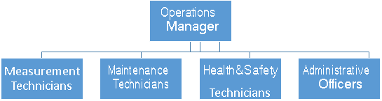
Figure 3. Operation and Management Diagram of the Düzova WPP
The calibration of the monitoring equipment was carried out according to the information provided in the GS-VER PDD. The GS-VER PDD mainly includes the following obligation for the calibration of the appropriate meters:
According to the Article 2 of the 'Communiqué regarding the Meters to be used in the Electricity Market ': ‘The meters to be used in the electricity market shall be compliant with the standards of Turkish Standards Institute or IEC and have obtained “Type and System Approval” certificate from the Ministry of Trade and Industry.’ Therefore, Ministry of Trade and Industry (Ministry) is responsible from control and calibration of the meters. Paragraph b) of the Article 9 of the 'Regulation of Metering and Testing of Metering Systems' (Regulation) of Ministry states that: ‘ b) Periodic tests of meters of electricity, water, coal gas, natural gas and current and voltage transformers are done every 10 years.’ Therefore, periodic calibration of the meters is done every 10 years.
Also according to Article 67 (page 20) of this regulation, the calibration shall be done in calibration stations which have been tested and approved by Ministry of Trade and Industry. Article 10 d) of Communiqué requires the meters shall be three phase four wire and Article 64 of Regulation clearly states how calibration shall be performed for this kind of meters.
According to Article 3 of System Usage Agreement3 done by ÜTOPYA and TEIAS; other than periodic tests, if a party alleges the meters are not working appropriately tests of the meters are done by presence of both parties. If, after controls, it is seen that the meter is not working appropriately, the measurements of reserve meters are taken into account beginning from date both meters are reading the same (page 3, 2-c)
There are two metering points and each of them have two meters, one main and one reserve, in the power plant. The total generation is being calculated by adding up the metering of two meters. Details of the meters are given below. The meters shall be calibrated every 10 years. The old meters before the current ones have been installed on 2014. The current main meters were installed and calibrated on 28/08/2022. Thus, next calibration for the main meters will be in 08/2032. The backup meters were installed and calibrated on 08/12/2019 so that next calibration will be carried out for the backup meters in 12/2029.
Specification of meters are as follows.

Table 7. First metering point (current)
Device | Serial Number | Manufacturer | Model | Date of  installation and calibration | Accuracy
Main Meter | 11590286 | EMH | LZQJ-XC | 28/08/2022 | 0.5S
Back Up Meter | 8088829 | EMH | LZQJ-XC | 08/12/2019 | 1S

Table 8. Second metering point (current)
Device | Serial Number | Manufacturer | Model | Date of installation and  calibration | Accuracy
Main Meter | 11590287 | EMH | LZQJ-XC | 28/08/2022 | 0.5S
Back Up Meter | 8088830 | EMH | LZQJ-XC | 08/12/2019 | 1S

The calibration and maintenance of the meters are carried out in line with the by law on Metering and Metering Devices.
There is one test protocol conducted during this Monitoring Period. The test has been conducted on 28/08/2022.
As the measuring devices are sealed by TEIAŞ, Ütopya Elektrik cannot intervene with the devices. In case of unforeseen problems or failures of the meters or if any differences occur between primary and secondary devices TEIAŞ has to be informed for necessary maintenance and calibration. There is an agreement between Ütopya Elektrik and TEIAŞ that in case of problems or failures (downtime) of the meters TEIAŞ reacts as fast as possible to solve the problem. The calibration and maintenance of the meters will be carried out in line with the by law on Metering and Metering Devices.
The electrical single line diagram is shown in Figure 3.
Figure 4. Single line diagram of the project activity

SECTION D. DATA AND PARAMETERS

D.1. Data and parameters fixed ex ante or at renewal of crediting period

Data/parameter | EF_{grid,CM,y}
Unit | tCO₂/MWh
Description | Combined margin CO₂ emission factor for the project electricity system in year y
Source of data | As per “Tool to calculate the emission factor for an electricity system”
Value(s) applied | 0.5514 tCO₂/MWh
Choice of data or Measurement methods and procedures | Combined Margin Emission Factor (EF_{grid,CM,y}) is calculated ex ante as the weighted average CO₂ of Operating Margin Emission Factor (EF_{grid,OM,y}) and Build Margin Emission Factor (EF_{grid,BM,y})
Purpose of data | Calculation of baseline emissions
Additional comment | -

Data/parameter | EF_{grid,OM,y}
Unit | tCO₂/MWh
Description | Operating margin CO₂ emission factor for the project electricity system in year y
Source of data | As per “Tool to calculate the emission factor for an electricity system”
Value(s) applied | 0.6276 tCO₂/MWh
Choice of data or Measurement methods and procedures | Operating Margin Emission Factor (EF_{grid,OM,y}) is calculated ex ante in accordance with “Tool to calculate the emission factor for an electricity system” by using TEIAS values
Purpose of data | Calculation of baseline emissions
Additional comment | -

Data/parameter | EF_{grid,BM,y}
Unit | tCO₂/MWh
Description | Build margin CO₂ emission factor for the project electricity system in year y
Source of data | As per “Tool to calculate the emission factor for an electricity system”
Value(s) applied | 0.3230 tCO₂/MWh
Choice of data or Measurement methods and procedures | Build Margin Emission Factor (EF_{grid,BM,y}) is calculated ex ante in accordance with “Tool to calculate the emission factor for an electricity system” by using TEIAS values
Purpose of data | Calculation of baseline emissions
Additional comment | -

D.2 Data and parameters monitored
SDG 13
Relevant SDG Indicator | SDG13: Climate Action  Target: 13.3 by emission reduction  Indicator: 13.3.1
Data / Parameter | Air quality
Unit | tons of CO₂e
Description | Amount of CO₂ emission reductions
Source of data | Monthly meter readings for calculation of emission  reduction.
Value(s) applied | The Project generated 296,036.87 MWh during this monitoring period, therefore the Project reduced baseline CO₂ emissions of:  296,036.87 MWh * 0.5514 tCO₂e/MWh = 163,232  tCO₂e
Measurement methods and procedures | Amount of annual net electricity generation, which is calculated by monthly settlement notifications on monthly meter readings, are used to calculate estimated CO₂ emission reduction by project activity.
Monitoring frequency | Annually.
QA/QC procedures | Amount of annual net electricity generation, which is calculated by monthly settlement notifications on monthly meter readings.
Purpose of data | Emission reduction.
Additional comment | -

Relevant SDG Indicator | SDG13: Climate Action  Target: 13.3 by emission reduction
Data / Parameter | Air quality
Unit | tons/GWh
Description | Amount of NO_{x}, CO and NMVOC emission reductions
Source of data | Monthly meter readings
Value(s) applied | According to the current data of electricity amount produced during Monitoring Period (296,036.87 MWh) by Düzova WPP, the amount of avoided emissions is as below for this verification period:  NO_{x}= 412.4 tons/Monitoring Period CO= 46.4 tons/ Monitoring Period  NMVOC=9.9 tons/ Monitoring Period.
Measurement methods and procedures | Amount of annual net electricity generation, which is  calculated by monthly settlement notifications of EPİAŞ based on monthly meter readings, is used to calculate estimated NO_{x}, CO and NMVOC emission reductions by  project activity
Monitoring frequency | Annually
QA/QC procedures | Amount of annual net electricity generation, which is calculated by monthly settlement notifications of EPİAŞ based on monthly meter readings, is used to calculate estimated CO and NMVOC emission reductions by project activity.
Purpose of data | Emission reduction.
Additional comment | -

SDG 8
Relevant SDG Indicator | SDG 8: Decent Work and Economic Growth  Target: 8.8 by employment and decent work  Indicator: 8.8.2
Data / Parameter | Quality of employment
Unit | -
Description | Quality of employment
Source of data | Health & Safety trainings
Value(s) applied | The project proponent aims for improvement of safety for labour providers. All the workers are benefiting from trainings on construction health and safety. During this monitoring period, health & safety trainings have been  held and all employees have attended to those trainings.
Measurement methods and procedures | Health and safety trainings are given continually.  Training attendance list and/or certificates. Safety measures and equipment are provided to VVB.
Monitoring frequency | Annually (Once at the end of each monitoring period).  After first verification period, only new cases are reported.
QA/QC procedures | The training records for all the employees.
Purpose of data | To exhibit employment performance of the plant in order  to monitor the SDG 8 Indicator.
Additional comment | -

Relevant SDG Indicator | SDG 8: Decent Work and Economic Growth  Target: 8.8 by employment and decent work  Indicator: 8.8.2
Data / Parameter | Quantitative employment and income generation
Unit | -
Description | Number of local employments
Source of data | Social security records of employees are provided.
Value(s) applied | Social security insurance receipts and employment forms (including personal ID records) of current employees from the local region have been submitted to VVB. In total there are 10 employees.
Measurement methods and procedures | Social security records are checked.
Monitoring frequency | Continuously.
QA/QC procedures | Social security records of the employees.
Purpose of data | To exhibit employment performance of the plant in order  to monitor the SDG 8 Indicator.
Additional comment | The numerical values given for the number of local  employees are based on current data provided by PO.

SDG 7
Relevant SDG Indicator | SDG 7: Affordable and Clean Energy  Target: 7.2 by using renewable energy systems  Indicator: 7.2.1
Data / Parameter | EG_{facility,y}
Unit | MWh/y
Description | Quantity of net electricity generation supplied by the project plant/unit to the grid in year y
Source of data | The data from the Electricity Meters are the basis for the  monthly invoice. For monitoring, the monthly invoice – exactly the field where net electricity supplied to the grid is stated – is used as source of data.
Value(s) applied | For 2021: 65,604.04 MWh  For 2022: 153,638.43 MWh  For 2023: 76,794.40 MWh  TOTAL: 296,036.87 MWh
Measurement methods and procedures | Four electricity meters are placed (two main and two reserve) at the substation. These meters are sealed by TEIAS and intervention by project proponent is not possible. The fact that two meters are installed in a redundant manner keeps the uncertainty level of the only parameter for baseline calculation low. High data quality of this parameter is not only in the interest of the emission reduction monitoring, but paramount for the business relation between the plant operator and the electricity buyers.  On the last day of each month, the production index is taken from the main as well as the reserve meter by Market Financial Settlement Center (in Turkish EPİAŞ, a state institution responsible for electricity market settlement operations) via Automatic Meter Reading System (OSOS) In following month, EPİAŞ issue electricity generation records for each generation unit which can be accessed by plant operators via logging to secured website. These records are used to monitor net monthly generation of the power plant. For each month, the net electricity amount supplied to the grid is calculated by electricity fed into grid minus electricity withdrawn from the grid available in EPİAŞ records.  Monthly meter reading protocols, which are kept by staff, are used to cross-check the EPİAŞ records. TEIAS notices are used to cross-check the EPİAŞ records. TEIAS sends an electronic spreadsheet that includes daily and monthly electricity generation and withdrawn amounts for each power plant. Thus, cross-check source is the TEIAS meter readings.  Since the meters are reading electricity supplied to the system and withdrawn from the system separately, the net electricity amount supplied to the grid is calculated by electricity supplied minus electricity withdrawn.  The collected data is kept by Project Proponent during the crediting period and until two years after the last issuance of VERs for the Düzova WPP project activity for that crediting period. As of 01/09/2015, EPIAS took over the PMUM procedures from TEIAS. Since that date,  EPIAS supplies the data.
Monitoring frequency | Continuous measurement and at least monthly readings
QA/QC procedures | According to the Article 2 of the Communiqué of Meters  in Electricity Sector: ‘The meters to be used in the electricity market shall be compliant with the standards of Turkish Standards Institute or IEC and have obtained “Type and System Approval” certificate from the Ministry of Trade and Industry.’ Therefore, Ministry of Trade and Industry (Ministry) is responsible from maintenance and calibration of the meters. Also according to Article 11 of this Communiqué, meters shall be in class of 0.5s, which means error interval for measuring is in +-0.5% range which is well acceptable according to rules.  Paragraph b) of the Article 9 of the 'Regulation of Metering and Testing of Metering Systems' (Regulation) of Ministry states that: ‘b) Periodic tests of meters of electricity, water, coal gas, natural gas and current and voltage transformers are done every 10 years.’ Therefore, periodic calibration of the meters will be done every 10 years.  Also according to Article 67 (page 20) of this regulation, the calibration shall be done in calibration stations which have been tested and approved by Ministry of Trade and Industry. Article 10 d) of Communiqué requires the meters shall be three phase four wire and Article 64 of Regulation clearly states how calibration shall be performed for this kind of meters.  As above mentioned, the data acquisition and management and quality assurance procedures that are anyway in place, no additional procedures have to be established for the monitoring plan.
Purpose of data | To exhibit renewable electricity generation performance  the plant to monitor its contribution to SDG 7.
Additional comment | -

Relevant SDG Indicator | SDG 7: Affordable and Clean Energy  Target: 7.2 by using renewable energy systems  Indicator: 7.2.1
Data / Parameter | Balance of payments and investment
Unit | -
Description | Amount of payment for natural gas to be imported for electricity generation.
Source of data | Monthly meter readings
Value(s) applied | With generation of net 296,036.87 MWh electricity, Düzova WPP has led to avoidance of around 30,302.137 m³ natural gas import during monitoring period.
Measurement methods and procedures | According to TEİAŞ; 25,426,014 thousand m³ natural gas is consumed for electricity generation in 2014. In 2014 Electricity generation amount from natural gas is 120,576.0 GWh and share of natural gas in the electricity mix is 47.85%. Since Turkey imports 98% of its consumed natural gas, it is calculated that for 1 GWh electricity generation 98 m³ natural gas is imported in 2014.
Monitoring frequency | Annually.
QA/QC procedures | TEİAŞ statistics for natural gas share in the electricity mix shall help to demonstrate the high import dependency. Amount of annual net electricity generation, which is calculated by monthly settlement notifications of EPİAŞ based on monthly meter readings, will be used to calculate correspondent amount of currency saved by project activity with help of above calculated factor.
Purpose of data | To exhibit balance of payments and investment performance the plant to monitor its contribution to SDG 7.
Additional comment | -

SDG 6
Relevant SDG Indicator | SDG 6: Clean Water  Target: 6.3 by using renewable energy systems  Indicator: 6.3.1
Data / Parameter | Water Quality and Quantity
Unit | m³
Description | Wastewater produced by workers during construction and operation is collected in an impermeable septic tank, which was constructed on the site. Later they will be periodically disposed of.
Source of data | Records of transfer of wastewater by sewage truck and statement of wastewater treatment plant
Value(s) applied | Wastewater is collected in the cesspool and then transferred with sewage trucks. Wastewater transfer receipts dated 06/08/2021, 12/10/2021, 07/12/2021, 04/02/2022, 09/04/2022, 04/08/2022, 13/10/2022, 12/01/2023, and 10/03/2023 are provided to VVB.
Measurement methods and procedures | Records of transfer of wastewater from power plant by sewage truck, if it was performed, is used to demonstrate proper wastewater management.
Monitoring frequency | Annually
QA/QC procedures | -
Purpose of data | -
Additional comment | Monitoring is carried out by an assigned technician by  Plant Manager.

Relevant SDG Indicator / Safeguarding Principle | Other  Safeguarding Principle: 3.9.1 Landscape modification and soil
Data / Parameter | Soil Condition
Unit | -
Description | Amount of waste oil spilled to the environment
Source of data | Monitoring process is handled by the receipt of waste oil transfers
Value(s) applied | Waste oil etc. (gearbox oil waste, oil filters etc.) is collected on site and disposed by licensed companies according to legal requirements. Throughout this  monitoring period, 628 kg of waste oil etc. is disposed.
Measurement methods and procedures | Any waste oil used for cooling of transformer or maintenance work is collected in leak-proof containers and removed to a licensed recycling facility. Receipt for  transfer to recycling facility has shown to VVB on site.
Monitoring frequency | Annually
QA/QC procedures | N/A
Purpose of data | To demonstrate that the project does not impact nearby soil conditions
Additional comment | Monitoring is carried out by Health Safety technician of ÜTOPYA

Relevant SDG Indicator / Safeguarding Principle | Other  Safeguarding Principle:3.9.10 High Conservation Value Areas and Critical Habitats
Data / Parameter | Biodiversity
Unit | -
Description | Number of birds strikes to the turbines.
Source of data | Assigned technician by Plant Manager or assigned carbon consultant.
Value(s) applied | There is no bird collision. Letter for bird observation by Plant Manager is provided to VVB.
Measurement methods and procedures | Monitoring is based on the observation of the villagers and Muhtar. VVB interviewed villagers and Muhtar on bird strikes observation during this verification site visit which will continue until end of the second crediting period.
Monitoring frequency | Once Each Verification
QA/QC procedures | N/A
Purpose of data | To demonstrate that the project does not impact nearby habitat.
Additional comment | -

Relevant SDG Indicator / Safeguarding Principle | Principle 4.1 - Sites of Cultural and Historical Heritage
Data / Parameter | Archaeological Site Control
Unit | -
Description | The impact of the turbines to the archaeological site
Source of data | Project Proponent
Value(s) applied | There is no adverse impact on the archaeological site
Measurement methods and procedures | Conservation plans developed by Ministry of Culture and Tourism and Project Proponent
Monitoring frequency | Once Each Verification
QA/QC procedures | N/A
Purpose of data | To demonstrate that the project does not impact the archaeological site
Additional comment

D.3. Comparison of monitored parameters with last monitoring period
Data/Parameter | Value obtained in this monitoring period | Value obtained last monitoring period
SDG 13 | Emission Reduction:  163,232 tCO₂  Air Quality:  NO_{x}: 412.4 tons  CO: 46,4 tons  NMVOC: 9,9 tons | Emission Reduction: 165,452 tCO₂ Air Quality:  NOx: 406.4 tons  CO: 45.7 tons  NMVOC: 9.8 tons
SDG 8 | Quality of Employment: Training certificates are provided.  Quantitative Employment and Income Generation:  10 employees | Quality of Employment: Training certificates are provided.  Quantitative Employment and Income Generation:  14 employees
SDG 7 | Access to affordable and clean energy services:  296,036.87 MWh | Access to affordable and clean energy services:  300,060.53 MWh
SDG 6 | Wastewater disposal: Wastewater transfer receipts dated 06/08/2021, 12/10/2021, 07/12/2021, 04/02/2022,  09/04/2022, 04/08/2022, 13/10/2022, 12/01/2023, and 10/03/2023 are provided to VVB. | Wastewater disposal: Wastewater transfer receipts are provided.
Others | Soil Condition:  Amount of waste oil spilled to the environment: Waste oil transfer receipts are provided. | Soil Condition:  Amount of waste oil spilled to the environment: Waste oil transfer receipts are provided.
Others | Biodiversity:  The technician by Plant Manager is assigned. There has not been observed any bird collision. | Biodiversity:  The technician by Plant Manager is assigned. There has not been observed any bird collision.

D.4. Implementation of sampling plan
N/A

SECTION E. CALCULATION OF SDG IMPACTS

E.1. Calculation of baseline value or estimation of baseline situation of each SDG Impact
Used Formulas:
For SDG 13
The total emission reductions can be calculated with the results of the below described equations. The emission reduction is equal to the baseline emissions minus project emissions and leakage emissions. Leakage emissions in this project are considered to be negligible. There are no project emissions in this kind of project. The general equation is as follows:
ERy = BEy – PEy - Ly (1)
Where:
ERy = Emission reduction
BEy = Baseline emissions
PEy = Project emissions
Ly = Leakage
y = Refers to a given period
The electricity meters are measuring two parameters: The electricity supplied to the grid (EGexport) and the electricity consumption from the grid (EGimport). To achieve the net amount of supplied electricity, the difference has to be calculated:
EGy = EGexport – EGimport (2)
Where:
EGy = Net electricity supplied to the Grid in MWh
EGexport = Electricity supplied to the Grid in MWh
EGimport = Electricity consumption from the Grid in MWh

According to the applied methodology version the emission reduction is the baseline emissions calculated as the net electricity supplied to the grid multiplied by the grid emission factor.
BEy = EGy x EFgrid,CM,y (3)
Where:
BEy = Baseline emissions in tonnes CO₂e
EFgrid,CM,y = Combined margin CO₂ emission factor for grid connected power generation in year y calculated using the latest version of the “Tool to calculate the emission factor for an electricity system” [tCO2e/MWh].
EGy = Net electricity supplied to the Grid in MWh y = Refers to a given period

CO Emission Avoidance
In order to calculate CO emission from the facility, the first step is to calculate a factor showing CO emission per GWh generated electricity. This factor is derived by dividing “Emission Amount due to Electricity Amount in related year with “Net electricity generation in the related year in GWh”. Then, the CO emission in the baseline scenario is reached by multiplying this factor with the estimated electricity generation of the WPP. This output also refers to Avoided CO Emission Amount.
Calculation of CO Avoidance:
Emission Amount due to Electricity Amount in related year

$$CO Avoidance =\frac{Emission Amount due to Electricity Amount in related year}{Net electricity generation in the related year in GWh}×Electricity Generation of Düzova WPP$$

NMVOC Emission Avoidance
In order to calculate NMVOC emission from the facility, the first step is to calculate a factor showing NMVOC emission per GWh generated electricity. This factor is derived by dividing “Emission Amount due to Electricity Amount in related year with “Net electricity generation in the related year in GWh”. Then, the NMVOC emission in the baseline scenario is reached by multiplying this factor with the estimated electricity generation of the WPP. This output also refers to Avoided CO Emission Amount.
Calculation of NMVOC Avoidance:
Emission Amount due to Electricity Amount in related year

$$NMVOC Avoidance =\frac{Emission Amount due to Electricity Amount in related year}{Net electricity generation in the related year in GWh}×Electricity Generation of Düzova WPP$$

NOx Emission Avoidance
In order to calculate NOx emission from the facility, the first step is to calculate a factor showing NOx emission per GWh generated electricity. This factor is derived by dividing “Emission Amount due to Electricity Amount in related year with “Net electricity generation in the related year in GWh”. Then, the NOx emission in the baseline scenario is reached by multiplying this factor with the estimated electricity generation of the WPP. This output also refers to Avoided NO_{x} Emission Amount.
Calculation of NO_{x} Avoidance:
Emission Amount due to Electricity Amount in related year

$$NOx Avoidance =\frac{Emission Amount due to Electricity Amount in related year}{Net electricity generation in the related year in GWh}×Electricity Generation of Düzova WPP$$

For SDG 6
Wastewater transfer receipts dated 06/08/2021, 12/10/2021, 07/12/2021, 04/02/2022, 09/04/2022, 04/08/2022, 13/10/2022, 12/01/2023, and 10/03/2023 are provided to VVB. for the monitoring period are provided.

For SDG 7
Quantity of net electricity generation supplied by the project plant to the grid in the related year has been calculated by subtracting the value of “Electricity consumption from the grid (MWh)” from “Electricity supplied to the grid (MWh)”

Calculation of Electricity Generation of Düzova WPP:
Electricity Generation of Düzova WPP = Electricity supplied to the grid (MWh) - Electricity consumption from the grid (MWh)
Electricity Generation of Düzova WPP for the forth verification period = 296,036.87 MWh
Access to investment: 30,302.137 m³ natural gas import was avoided by generation of project activity.

For SDG 8
The employment of local people that have necessary technical qualifications for the required post has been the priority and enhanced by all project activities during construction and operation of wind farm. As a result, local poverty and unemployment has been partially eliminated by increased job opportunities and project business activities. Moreover, as contribution of the project to welfare of the region, the quality of the electricity consumed in the region has been increased by local electricity production, which also contributes decreasing of distribution losses.
The number of employees has been reached via the Social Security Institution records. 10 people are employed.

E.2. Calculation of project value or estimation of project situation of each SDG Impact
SDG 6: Water Quality
Wastewater transfer receipts dated 06/08/2021, 12/10/2021, 07/12/2021, 04/02/2022, 09/04/2022, 04/08/2022, 13/10/2022, 12/01/2023, and 10/03/2023 are provided to VVB for the monitoring period.

SDG 7: Affordable and Clean Energy
The project has been generated net 296,036.87 MWh clean electricity for the whole monitoring period while it is calculated as 146,018.24 MWh per annum.

SDG 8: Decent Work and Economic Growth
The project has created 10 employment opportunities.

SDG 13: Climate Action
The project has mitigated 163,232 tCO₂ in the whole monitoring period.

Baseline emission is calculated according to the formula below.
BE_{y} = EG_{PJ,y} × EF_{grid,CM,y}
Where:
EG_{y} = Net electricity delivered to the grid by the project activity in year y excluding transmission losses of the grid
EF_{grid,CM,y} = Emission factor calculated according to selected methodology (EF value used is 0.5514 tCO₂/MWh. Sample calculation is given below)
EF_{grid,CM,y} = (EF_{grid,OM,y} * 0.75) + (EF_{grid,BM,y} * 0.25)

Project emissions are “0” since this is renewable energy plant. Thus;
PE_{y} = 0

As it can be seen in detail in excel spread sheet used for calculations, realized baseline emissions are calculated as follows:
EG_{y} = 296,036.87 MWh
EF_{grid,CM,y}= 0.5514 tCO₂/MWh
BE_{y} = (296,036.87 MWh) x (0.5514 tCO₂/MWh) = 163,232 tCO₂e

Vintage wise breakdown of electricity generation is:
Net Generation in 2021 (MWh) | 65,604.04
Net Generation in 2022 (MWh) | 153,638.43
Net Generation in 2023 (MWh) | 76,794.40
Total Net Generation during Monitoring Period (MWh) | 296,036.87
Vintage wise breakdown of emission reduction is:
Net Emission Reduction in 2021 (tCO₂) | 36,174
Net Emission Reduction in 2022 (tCO₂) | 84,716
Net Emission Reduction in 2023 (tCO₂) | 42,342
Total Emission Reduction during Monitoring Period (tCO₂) | 163,232

E.3. Calculation of leakage
LEy is 0, as it is not considered according to ACM0002 (page 17). PEy is 0 because project is a wind power generation activity (Only for geothermal and hydro project activities, it should be considered according to ACM0002 page 12).

E.4. Calculation of net benefits or direct calculation for each SDG Impact
SDG | SDG Impact | Baseline  estimate | Project  estimate | Net  benefit
13 | CO₂ Emission Reduction  &  Air Quality | Emission Reduction:  163,232 tCO₂  Air Quality:  NO_{x}: 412.4 tons  CO: 46,4 tons  NMVOC: 9,9 tons | Emission Reduction:  0 tCO₂  Air Quality: NOx: 0 tons  CO: 0 tons  NMVOC: 0 tons | Emission Reduction:  163,232 tCO₂  Air Quality:  NO_{x}: 412.4 tons  CO: 46,4 tons  NMVOC: 9,9 tons
8 | Quantitative Employment  And Income Generation  &  Qualitative Employment | Quantitative Employment:  No employment.  Qualitative Employment:  No training | Quality of Employment:  Training certificates are provided.  Health&Safety Trainings have been held and 10 plant employees have attended to those trainings.  Quantitative Employment and Income Generation:  Current employment records are presented. There are 10 employees  working in the plant in total. | Quality of Employment:  Training certificates are provided.  Health & Safety Trainings have been held and 10 plant employees have attended to those trainings.  Quantitative Employment and Income Generation:  Current employment records are presented.  There are 10 employees working in the plant in total.
7 | Electricity Generation | Access to affordable  and clean energy services:  0 MWh | Access to affordable  and clean energy  services:  296,036.87 MWh  Balance of payments and investment:  30,302.137 m³ natural gas import is  avoided by  generation of project  activity. | Access to affordable and clean energy services:  259,283.16 MWh  30,302.137 m³ natural gas import is avoided by generation of project activity.
6 | Water Quality | No wastewater disposal | Wastewater disposal: Wastewater transfer receipts dated 06/08/2021, 12/10/2021, 07/12/2021, 04/02/2022,  09/04/2022, 04/08/2022, 13/10/2022, 12/01/2023, and 10/03/2023 are provided to VVB. | Wastewater disposal: Wastewater transfer receipts dated 06/08/2021, 12/10/2021, 07/12/2021, 04/02/2022,  09/04/2022, 04/08/2022, 13/10/2022, 12/01/2023, and 10/03/2023 are provided to VVB.
Others | Soil Condition | No waste oil generation | Soil Condition:  Amount of waste oil spilled to the environment: Waste oil transfer receipts are provided. | Soil Condition:  Amount of waste oil spilled to the environment: Waste oil transfer receipts are provided.
Others | Biodiversity | No nests and carcass observation | Biodiversity:  The technician by Plant Manager is assigned. There has not been observed any bird collision. | Biodiversity:  The technician by Plant Manager is assigned. There has not been observed any bird collision.

E.5. Comparison of actual SDG Impacts with estimates in approved PDD
SDG | Values estimated in ex ante calculation of approved PDD  for this monitoring period | Actual values achieved during this monitoring period
13 | Emission Reduction: 84,314 tCO₂/yr Air Quality:  NOx: 207.1 tons/yr  CO: 23.3 tons/yr  NMVOC: 5.02 tons/yr | Emission Reduction:  163,232 tCO₂  Air Quality:  NOx: 412.4 tons  CO: 46,4 tons  NMVOC: 9,9 tons
8 | Quality of Employment:  All employees will be trained to have necessary Health&Safety trainings and correspondent certificates.  Quantitative Employment and Income Generation:  As much as staff from local people and target to have at least 3 non-technical employers (safety guards) from close settlements | Quality of Employment: Training certificates are provided.  Quantitative Employment and Income Generation: 10 employees
7 | Access to affordable and clean energy services: 152,900 MWh/yr  Balance of payments and investment: 14.965 million m³ natural gas import was avoided  by project activity. | Access to affordable and clean energy services: 146,055.23 MWh/yr  Balance of payments and investment: 30,302 million m³ natural gas import was avoided  by generation of project activity.
6 | Wastewater disposal:  Wastewater transfer receipts will be provided. | Wastewater disposal: Wastewater transfer receipts dated 06/08/2021, 12/10/2021, 07/12/2021, 04/02/2022,  09/04/2022, 04/08/2022, 13/10/2022, 12/01/2023, and 10/03/2023 are provided to VVB.
Others | Soil Condition:  Amount of waste oil spilled to the environment: Waste oil transfer receipts will be provided. | Soil Condition:  Amount of waste oil spilled to the environment: Waste oil transfer receipts are provided.
Others | Biodiversity:  The technician by Plant Manager will be assigned. There has not been observed any bird collision. | Biodiversity:  The technician by Plant Manager is assigned. There has not been observed any bird collision.

E.5.1. Explanation of calculation of value estimated ex ante calculation of approved PDD for this monitoring period
Estimated annual emission reduction in ex ante calculation of registered PDD is 97,481 tCO₂, which corresponds to 203,241 tCO₂ for 761 days. And actual emission reduction achieved during this monitoring period is 163,232 tCO₂ (for (01/08/2021-10/08/2023), 761 days).

E.6. Remarks on increase in achieved SDG Impacts from estimated value in approved PDD
Estimated annual emission reduction in ex ante calculation of registered PDD is 97,481 tCO₂. And annual actual emission reduction achieved for this monitoring period is 80,513 tCO₂. When they are compared, actual emission reduction achieved during this monitoring period is less than the estimated figure. This situation is arisen from the unexpected wind trend in the project location. Wind potential might have changed. However, when it is compared, actual emission reduction achieved during this monitoring period is acceptable. Because net difference between estimated and actual emission reduction for the project activity is -17.40 %.

SECTION F. SAFEGUARDS REPORTING
Principles | Mitigation Measures Added to the Monitoring Plan
Safeguarding Principle: 3.9.1 Landscape modification and soil | Waste Oil: During the operation phase, waste oil etc. (gearbox oil waste, oil filters etc.) is collected on site and disposed by licensed companies according to legal requirements. Düzova WPP performs verification process every two years and now, Düzova WPP carries out the 4th verification of the 2nd crediting period and this process is carried out successfully every two years. During monitoring, required waste oil invoices are regularly and completely provided.
Safeguarding Principle:3.9.10 High Conservation Value Areas and Critical Habitats | Biodiversity: Monitoring is based on the observation of the villagers and Muhtar. VVB interviewed villagers and Muhtar on bird strikes observation during this verification site visit which will continue until end of the second crediting period. The technician by Plant Manager is assigned. There has not been observed any bird collision.
Principle 4.1 - Sites of Cultural and Historical Heritage | Archaeological Site Control: Conservation plans developed by Ministry of Culture and Tourism and Project Proponent. There is no adverse impact on the archaeological site caused by the turbines.

There is no assessment that have been 'potentially' answered or where requirements require regular re-assessment. (Please see approved GS Transition document)

SECTION G. STAKEHOLDER INPUTS AND LEGAL DISPUTES

G.1. List all Inputs and Grievances which have been received via the Continuous Input and Grievance Mechanism together with their respective responses/mitigations.
For the Düzova Wind Power Project, since mukhtar and made men are the head of the village, they are the contact persons between the project owner and the local stakeholders. Muhtar makes sure that there’s continuous communication between the two parties. A logbook was delivered to the mukhtar of the Aşağıkırıklar village. This logbook is checked during this monitoring period and there are no complaints from the local stakeholders.
Since this project is about the complete its 4th verification of second crediting period and it does not result in different impacts with respect to different vintages, the grievance mechanism does mainly rely on the existed grievance mechanism by use of logbook. There would not requirement to use further grievance tools throughout the project life cycle.

G.2. Report on any stakeholder mitigations that were agreed to be monitored.
There have been no stakeholder mitigations agreed to be monitored.

G.3. Provide details of any legal contest that has arisen with the project during the monitoring period
No legal contest or dispute that has arisen with the project during the monitoring period.

Revision History

Version | Date | Remarks
1.1 | 14 October 2020 | Hyperlinked section summary to enable quick access to key sections  Improved clarity on Key Project Information  Section for POA monitoring  Forward action request section  Improved Clarity on SDG contribution/SDG Impact term used throughout  Clarity on safeguard reporting  Clarity on design changes  Leakage section added for VER/CER projects  Addition of Comparison of monitored parameters with last monitoring period  Provision of an accompanying Guide to help the user understand detailed rules and requirements
1.0 | 10 July 2017 | Initial adoption

https://cdm.unfccc.int/UserManagement/FileStorage/ZPFJL01OU2RYC6N3HASIXV7K84QBG9
Generation license
https://cdm.unfccc.int/UserManagement/FileStorage/ZPFJL01OU2RYC6N3HASIXV7K84QBG9
Test protocol dated 28/08/2022 has been submitted to the VVB.
See, http://www.epdk.org.tr/english/regulations/electric/meters.doc, page 1
See, https://www.sanayi.gov.tr/mevzuat/yonetmelik/mc1607011134, page 2
Law on Metering and Metering Devices
Test protocol dated 28/08/2022 has been submitted to the VVB.
Whenever emission reductions are capped, both the original and capped values used for calculations must be transparently reported. Use brackets to denote original values.

