Key Project Information & Programme Design Document (PoA-DD)

PUBLICATION DATE 14.10.2020
VERSION v. 1.1
RELATED SUPPORT
- TEMPLATE GUIDE Key Project Information & PoA Design Document v.1.1

This document contains the following Sections
Key Project Information

SECTION A – General description of PoA
SECTION B - Management System and Inclusion Criteria
SECTION C – Demonstration of additionality
SECTION D – Duration of PoA
SECTION E – Safeguarding principles assessment
SECTION F - Outcome of Stakeholder Consultations

Appendix 1 – Contact information of coordinating/managing entity and responsible person(s)/ entity(ies)

KEY PROJECT INFORMATION
GS ID of Programme | GS2747
Title of Programme: | African Biogas Carbon Programme (ABC)
Start Date of POA | 06/11/2009,
Date of Design Certification | 13/06/2015
POA Period Start Date | 13/06/2020
Version number of the PoA-DD | 9.2
Completion date of the PoA-DD | 11/12/2023
Coordinating/managing entity | Africa Bioenergy Programs Limited (ABPL)
Project Participants and any communities involved | N/A
Host Country (ies) | Kenya, Uganda and Tanzania
Activity Requirements applied | Community Services Activities  Renewable Energy Activities  Land Use and Forestry Activities/Risks & Capacities  N/A
Other Requirements applied | N/A
Methodology (ies) applied and version number | Methodology for animal manure management and biogas use for thermal energy generation V1.1
Product Requirements applied | GHG Emissions Reduction & Sequestration  Renewable Energy Label  N/A

General description of PoA
        - Purpose and general description of the PoA
>>
The aim of this PoA is to promote biogas systems in Africa, initially focusing on East Africa, as a substitute for traditional thermal energy generation methods. It encompasses various biogas systems catering to domestic and institutional users, deriving biogas from human, animal, or plant waste for cooking and heating, thereby replacing non-renewable biomass like firewood, charcoal, and LPG. The mission is to make biogas systems affordable and accessible to households and institutions across Africa, especially those with low and medium income. To achieve this, a carbon market access service will be provided to Voluntary Project Activity (VPA) implementers to overcome dissemination barriers in host countries.

The implementation of the PoA will be carried out by biodigester construction companies operating under VPA-level contracts with the VPA implementer. The African Biogas Carbon Programme's (ABC) VPA Implementing Partner holds the responsibility of ensuring compliance with GS requirements and ABC PoA terms. Their role includes overseeing the dissemination and installation of biodigesters, establishing comprehensive agreements with end users, providing support for training and maintenance, maintaining an accurate biodigester database, monitoring emission reductions, and coordinating VPA monitoring and verification efforts in collaboration with the CME. Compliance with Gold Standard requirements and active participation in audits and inspections are also expected.

Each host country under the PoA actively promotes the adoption of biogas systems as an alternative energy source, although no mandatory laws or regulations exist regarding their use by households or institutions. The proposed PoA is a voluntary initiative by the CME to drive sustainable biogas development.
        - Physical/ Geographical boundary of the PoA
>>
The geographical region within which all VPAs included in this PoA will be implemented cover Tanzania, Kenya and Uganda. Other host countries may be added in future.

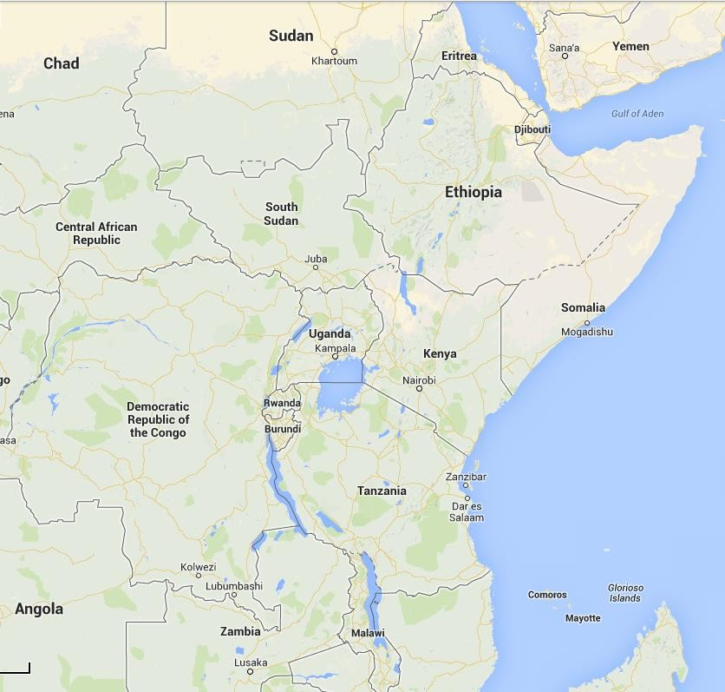
Figure 2: Map of Tanzania, Kenya and Uganda, countries within this PoA

        - Technologies/measures and eligibility under Gold Standard
>>
Each VPA within this PoA will cover a range of biogas systems based on the requirements of the VPA Implementer and specific users. The Implementer possesses the necessary technical expertise and transfers knowledge to local enterprises called Biodigester Construction Enterprises (BCE), equipped with construction, marketing, and business development skills.

In the host countries, biogas systems replace non-renewable biomass and fossil fuels for cooking by producing combustible methane through anaerobic digestion of waste materials. The generated biogas is distributed to various appliances, reducing greenhouse gas emissions. The PoA includes different biogas digester designs, with the fixed dome being the preferred choice in East Africa. Technological specifics are provided at the VPA level while general descriptions are outlined at the PoA level.

1. Fixed Dome Digesters
Fixed dome digesters have demonstrated their robustness, reliability, and low maintenance requirements in multiple countries. These biogas systems typically have a capacity ranging from 2 to 16 m3, but larger sizes are also feasible.

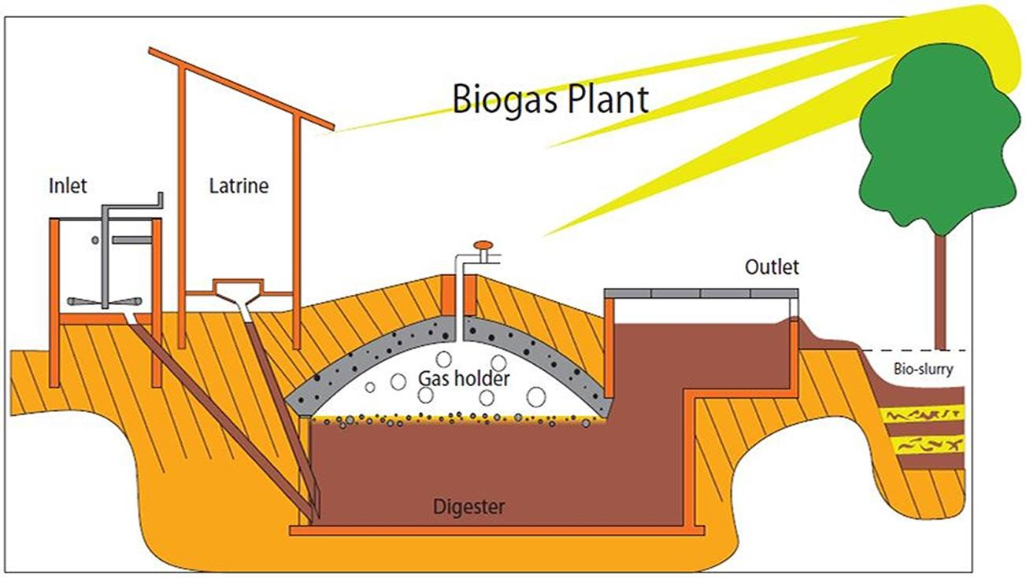
The biogas system comprises various interconnected components, each with its specific role, as outlined below:
Figure 4: Schematic diagram of an archetypical fixed dome digester

- Inlet: The primary function of the inlet is to mix organic material and water, creating a semi-solid state. This mixture is introduced into the digester through an inlet pipe.
- Digester: The digester holds the mixture of manure and water, providing an ideal environment for anaerobic digestion, where microorganisms produce biogas. The digester is cylindrical in shape and is commonly constructed with brick masonry, featuring a concave concrete cover or dome. Typically, the digester is built underground, with only the plumbing, inlet, and outlets visible.
- Dome: The dome's purpose is to collect the gas generated within the digester. It is usually plastered with multiple layers and coated with a specialized paint to minimize gas leakage. As gas accumulates in the dome, it creates pressure, causing the slurry level to decrease and, subsequently, increasing the slurry level in the connected slurry tank. The pressure difference between the slurry tank and the dome facilitates the movement of gas into the outlet pipe. The outlet valve releases the collected gas from the dome to biogas appliances, such as stoves or lamps.
- Outlet (Slurry Tank): The slurry tank stores the slurry displaced by the gas pressure from the dome. As more manure is fed into the digester, the excess slurry overflows into a composting tank. This slurry can then be utilized as fertilizer.

Overall, fixed dome digesters have proven to be dependable and require minimal upkeep. They consist of key components that enable the efficient production and utilization of biogas, providing an environmentally friendly solution for waste management and energy generation.

2. Floating drum technology
The floating drum digester functions similarly to the fixed dome. It consists of a cylindrical or dome-shaped digester with a floating gasholder or drum that moves based on the gas level. The gasholder floats in the digester slurry or a separate water jacket and is stabilized by an internal or external guide frame.

As gas is produced and released, the drum rises, indicating increased gas volume. When the gas is depleted, the drum sinks, visually indicating the gas availability to users.

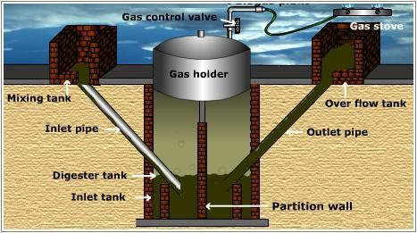
Figure 5: Floating drum biogas system
Costs for building and installing floating drum digesters vary depending on size, materials, and model. Maintenance involves cleaning, painting, and leak fixing.

3. Flexible Balloon Digesters
Flexible balloon digesters, constructed using plastic or rubber bags, offer mobility compared to fixed dome and floating drum digesters. They operate on the same principle, with the biogas stored in the upper part of the balloon. Gas pressure can be adjusted using weights or a gas pump, while safety valves regulate pressure. The lifespan is shorter than fixed dome digesters, but the use of high-quality plastics can extend it closer to fixed dome lifespan.

4. Rural/urban plastic biogas digesters
These digesters function similarly to the above models but are made of portable and easily regulated plastic, allowing for quick installation and quality control.

Biogas Appliances
Appliances used for biogas can vary greatly, including stoves, lamps, and generators. This PoA VVBs not impose specific requirements on appliances. However, it is expected that each VPA Implementer will ensure that all appliances, whether locally manufactured or imported, adhere to appropriate standards. The primary focus of this PoA is the capacity and utilization of biogas for cooking purposes.

The aforementioned classification of biogas systems is merely indicative, as ongoing research and development are expected to enhance system designs and introduce entirely new models to the market. Specific details regarding the technologies employed will be provided at the VPA level.
        - Target/Indicator for each of the minimum three SDGs targeted by the PoA

>>
Sustainable Development Goals Targeted | Most relevant SDG Target | SDG Impact
Sustainable Development Goals Targeted | Most relevant SDG Target | Indicator (Selected in SDG tool)
13 Climate Action (mandatory) | 13.2 Integrate climate change measures into national policies, strategies and planning | Amount of GHGs emissions avoided or sequestered
1 No Poverty | 1.1 By 2030, eradicate extreme poverty for all people everywhere, currently measured as people living on less than $1.25 a day | Average household savings in expenditure on basic services such cooking
2. Zero hunger | 2.4 By 2030, ensure sustainable food production systems and implement resilient agricultural practices that increase productivity and production, that help maintain ecosystems, that strengthen capacity for adaptation to climate change, extreme weather, drought, flooding and other disasters and that progressively improve land and soil quality | Number of farmers adopted practices promoted by the project
2. Zero hunger |  | Area under sustainable agriculture
3 Good Health and Wellbeing | 3.9 By 2030, substantially reduce the number of deaths and illnesses from hazardous chemicals and air, water and soil pollution and contamination | Number of households that observed reduction in PM2.5 & carbon monoxide (CO) concentration reductions
4. Quality education | 4.4 By 2030, substantially increase the number of youth and adults who have relevant skills, including technical and vocational skills, for employment, decent jobs and entrepreneurship | Number of employees provided skill development training
5. Gender equality | 5.4 Recognize and value unpaid care and domestic work through the provision of public services, infrastructure and social protection policies and the promotion of shared responsibility within the household and the family as nationally appropriate | Average time saving associated with cooking time and fuel collection
7. Affordable and clean energy | 7.1 By 2030, ensure universal access to affordable, reliable and modern energy services | Number of beneficiaries: Individuals
7. Affordable and clean energy |  | Number of beneficiaries: households
8. Decent work and economic growth | 8.5 By 2030, achieve full and productive employment and decent work for all women and men, including for young people and persons with disabilities, and equal pay for work of equal value | Total number of jobs
9. Industry, innovation and infrastructure | 9.3 Increase the access of small-scale industrial and other enterprises, in particular in developing countries, to financial services, including affordable credit, and their integration into value chains and markets | Total number of companies supported for their integration into value chains and markets
12. Responsible consumption and production | 12.5 By 2030, substantially reduce waste generation through prevention, reduction, recycling and reuse | Compost produced and used for sustainable and local agriculture
15. Life on land | 15.1 By 2020, ensure the conservation, restoration and sustainable use of terrestrial and inland freshwater ecosystems and their services, in particular forests, wetlands, mountains and drylands, in line with obligations under international agreements | Total non-renewable wood fuel saved

        - Coordinating/managing entity
>>
ABPL is the Coordinating/Managing Entity (CME) for this PoA.

        - Funding sources of PoA
>>
DGIS (Directorate General Internationale Samenwerking) of the Dutch Government through RVO (Netherlands Enterprise Agency) is currently funding the project-Africa Biodigester Component (ABC) I Kenya and Uganda. This project started in 2022 as a build-up of the Africa Biogas Partnership Program (ABPP) (through which public funding was provided until 2019).

Financing provided in connection with the PoA or its VPAs has come from or will come from ODA that has not been or will not be provided under the condition, whether express of implied, that any or all of the carbon credits issued as a result of the project’s operation will be transferred directly or indirectly to the country of origin of the ODA. An ODA declaration is signed and uploaded to the registry.

MANAGEMENT SYSTEM AND INCLUSION CRITERIA
        - Management System
>>
The CME operational management system will ensure that the following requirements are met:

A clear definition of roles and responsibilities of personnel involved in the process of inclusion of VPAs, including a review of their competencies.

The CME has the competencies to review and include VPAs in the PoA. The following CME entities, and their responsibilities, are outlined below:

Table 2: Roles and responsibilities of the CME
CME Role | Responsibility
Carbon Programme Manager | Carbon Programme Manager Strategic management, planning, and communication with ABPL Board of Directors. Ensuring PoA compliance with Gold Standard procedures and guiding VPAs in following PoA guidelines. Managing the inclusion of future VPAs and negotiating contractual agreements with VPA Implementers.
Carbon consultant (external) | Providing monitoring guidance to VPA Implementers. Carbon consultant may assist or lead the drafting Monitoring Reports based on agreements.
Carbon Monitoring Officer | Ensuring project implementation aligns with design requirements. Collaborating with consultants and auditors. Reviewing and analyzing data for carbon monitoring. Assessing emission reduction potential. Tracking and reporting on project outcomes. Conducting marketing research and business development. Supporting Carbon Finance coordination for regular carbon income flow.
Carbon Marketing Manager (external) | Marketing VERs to potential buyers. Facilitating VER transfers and transparently tracking and transferring income to VPA Implementers (if agreed).

Authorized VPA Implementers participating in this PoA must sign a standard contractual agreement with the CME, committing to the following requirements:
- Awareness and Agreement: VPA operators acknowledge and agree that their activity is subscribed to this PoA.
- Non-Assignment: VPA Implementers shall not assign a new VPA that is already registered as a CDM project activity or as a VPA of another PoA.

A contractual agreement is not required in the case a VPA is implemented by ABPL or legally represented by ABPL.

The responsibility of registering the PoA lies with the CME. The CME prepares the required documentation for validation and submits it to the VVB. The inclusion of VPAs and the finalization of VPA-DDs may also be coordinated by the CME, depending on the arrangement with each VPA Implementer.

VPA Implementers are responsible for organizing the monitoring of their VPAs under the PoA through field surveys. The CME provides guidance to ensure compliance with PoA requirements.

As the focal point with the Gold Standard Secretariat, the CME receives the generated VERs. While end-users transfer the VER rights to the VPA Implementer, a separate agreement between the VPA Implementers and the CME transfers the VER rights to the CME. The VERs are then allocated to their corresponding VPAs, and the VPA Implementers decide on their sale. VPA Implementers may handle the sale of VERs themselves or, if capacity is limited or by choice, the CME can offer a sales service to transfer VERs to buyers and provide resulting revenues to the VPA Implementers.

Records of arrangements for training and capacity development for personnel;
VPA Implementers are responsible for ensuring their staff receives necessary training to comply with PoA requirements. The CME may provide additional training if agreed upon, and records of all training conducted, including attendee lists, will be maintained by the VPA Implementer.

Procedure for technical review of inclusion of VPA’s

The CME conducts a technical review of each VPA before inclusion, ensuring compliance with eligibility criteria, approved methodology, baseline, additionality, double counting, and regulatory requirements of the host country(s). For retroactive VPAs, consideration of carbon revenues is verified through early project documentation.

Procedure to avoid double counting
Double counting is prevented through various strategies, including database checks for repeated entries and cross-checking with hard-copy sales agreements (or equivalent document). Unique serial numbers are assigned to each digester, and site visits may be conducted if needed. The VPA Implementers must certify that the proposed VPA is not registered under another CDM or voluntary project activity (such as the Gold Standard, the verified carbon standard, or other), and end-users confirm the assignment or transfer of VER rights to the VPA Implementer in the sales agreement.

Records and documentation control process for each VPA under the PoA;
The registration process for new customers involves completing a Plant Commissioning Report (PCR) and Household Agreements. Functional plants are added to the program database for which the program SalesForce is used, while non-functional plants undergo troubleshooting and are updated to functional status before inclusion. Sales agreements or equivalent documents contain mandatory information, such as customer details, geographical location, and biogas system serial numbers.

Measured for continuous improvement of the PoA management system
The CME is committed to identifying and implementing opportunities for improvement. Feedback from staff and discussions during Program Meetings will help address inefficiencies, explore better methods, control changes, and ensure compatibility with the PoA-DD and VPA-DDs.

Any other elements
N/A
        - Application of methodologies
>>
Methodology for animal manure management and biogas use for thermal energy generation V1.1

The methodology refers to the following tools:
- CDM tool 01: Tool for the demonstration and assessment of additionality. Version 07.0.0
- CDM tool 03: Tool to calculate project or leakage CO2 emissions from fossil fuels and combustion. Version 3.0
- CDM tool 05: Baseline, project and/or leakage emissions from electricity consumption and monitoring of electricity generation. V3.0
- CDM tool 14: Sampling and surveys for CDM project activities and programmes of activities. Version 09.0
- CDM tool 21: Demonstration of additionality of small-scale project activities. Version 13.1
- CDM tool 30: Calculation of the fraction of non-renewable biomass. Version 3.0
- SDG impact tool v1.3
          - Multiple technologies/measures
>>
N/A only 1 methodology is applied.

        - Eligibility criteria for inclusion of a VPA in the PoA
No. | Eligibility Criterion | Description/  Required condition | Means of Verification/Supporting evidence  for inclusion
(i) | The geographical boundary of the VPA including any time-induced boundary consistent with the geographical boundary set in the PoA | All biogas systems included in the VPA will demonstrate they fall within the geographical boundary of the PoA through:  - Recording the address/location of the system in Salesforce or equivalent software  - Warranty or household sales agreement | - Project database (extract from Salesforce  - Contractual agreement between CME and VPA implementer  - Warranty or household sales contract at household
(ii) | Conditions to avoid double counting of GHG emission reductions or net anthropogenic GHG removals, such as unique identifications of product and end-user locations | Double counting is avoided by unique biodigester identification and as per methodology procedure indicator BGTA 1 and 2 | - Project database with unique codes  - To be demonstrated with parameter BGTA 1 and 2 of the applied methodology contained in Section B6.2 of VPA-DD
(iii) | Conditions to confirm that V/CPAs are neither registered as project activities with other offset Schemes, included in other registered PoAs, nor the project activities that have been deregistered; | The required condition is that the biodigester is only registered under this project | - To be demonstrated with parameter BGTA 2 of the applied methodology contained in Section B6.2 of VPA-DD
(iv) | Specification of the technology/measure such as the level and type of service, as well as performance specification based on, inter alia, testing/certification; | Demonstration that the plant is installed according to specifications by conducting a commission check | Project database with plants that are commissioned (Salesforce extract)
(v) | Conditions to check the start dates of VPA through documentary evidence | The start date is defined as the first digester commissioned in a VPA | Warranty certificate or sales contract of the first plant installed
(vi) | Conditions to ensure compliance with the applicability of the applied methodologies, the applied standardised baselines and the other applied methodological regulatory document | The VPA shall provide a discussion on the applicability of the applied methodology | Demonstrated with description as per VPA-DD section B.2
(vii) | Conditions to ensure that VPA meet the requirements for demonstration of  additionality | As per CDM tool 21 Demonstration of additionality of small-scale project activities. Version 13.1 | To demonstrated in VPA-DD section B.5
(viii) | Conditions to ensure no diversion of official development assistance; | VPAs will demonstrate that any Official Development Assistance received for the VPA has not occurred on the condition that the resulting credits are transferred to the donor country | To demonstrated in VPA-DD section A.5
(ix) | Target group (e.g. domestic/commercial/industrial, rural/urban, gridconnected/offgrid) | The VPA will demonstrate which target group(s) is/are to be targeted by the VPA and the distribution mechanism. | Technology manuals describing digester feedstock
(x) | Conditions related to sampling requirements for the PoA | The conditions as stipulated in the applied methodologies | Compliance with sampling requirement is demonstrated in VPA-DD section B7.2.
(xi) | Conditions to ensure that CPAs that will be included meet the small-scale  thresholds and remain within those thresholds throughout the  crediting period | The VPA Implementer will ensure that each VPA remains below the small-scale limits. For activities falling under Type I , each VPA in aggregate will remain below 15 MW (45MWth) per year. For activities falling under Type III , each VPA will achieve below 60,000 tCO2e in emission reductions annually. | Calculation showing the capacity of the biogas system(s) in the ER spreadsheets
(xii) | Conditions to confirm that technologies in V/CPAs are eligible | Only biodigester technologies fed with manure and or other organic material are eligible up to 100 m3 | Technology description in VPA-DD section A.3
(xiii) | Conditions to be met by each VPA regarding SDG outcomes assessment | N/A From 13 March 2022, the SDG Impact Tools are a mandatory part of the project development cycle. This tool has been adopted | SDG impact tool at VPA level

DEMONSTRATION OF ADDITIONALITY
>>
In accordance to the GS4GG principles and requirements v.1.2 section 5.1.47 it is not necessary to reassess additionality at Design certification renewal. On-going financial need, where relevant, will be demonstrated at VPA level.
This version of the PoA-DD is the design change version in which a new methodology version and the SDG impact tool is adopted. Given that all conditions remain the same (implementer, technology, use of the technology (energy for cooking and bio-slurry as potent organic fertilizer) and the target group), no impact on additionality is expected.

Prior consideration was demonstrated in the first crediting period of this PoA with the inclusion of the first VPA, see VPA01-DD of CPI section D.5 item 15.

DURATION OF PoA
        - Date of first submission of PoA to Gold Standard
>>
06/11/2015
        - Duration of the PoA
>>
Duration of PoA: 28 years, from 30/04/2013

SAFEGUARDING PRINCIPLES ASSESSMENT
        - Justification for Safeguarding Principles Assessment at PoA level

N/A The safeguarding principles and SDG outcome assessment are executed at VPA level
        - Assessment of safeguarding principles, if undertaken at PoA level

N/A

Outcome stakeholder consultations
        - Summary of stakeholder consultation at PoA Level
>>
This PoA-DD version is a design change based on the PoA-DD developed for CPII. During the CP renewal, it was not required to develop a PoA Design Consultation report. The only requirement was to request feedback from stakeholders in case of a multi-country PoA. The results, as presented in the validated CPII PoA-DD are included here:
------
The PoA level stakeholder consultation was executed at VPA level. However, during the PoA renewal in 2020, as per 100-GS4GG- Programme of Activity requirements v1.2 6.1.3 it is required to request feedback from stakeholders in case of a multi-country VPA. As per discussions with the GS, email communication suffices. The CME emailed the original LSC participants at VPA level that the PoA is being renewed and asked their feedback on this, see the announcements below.
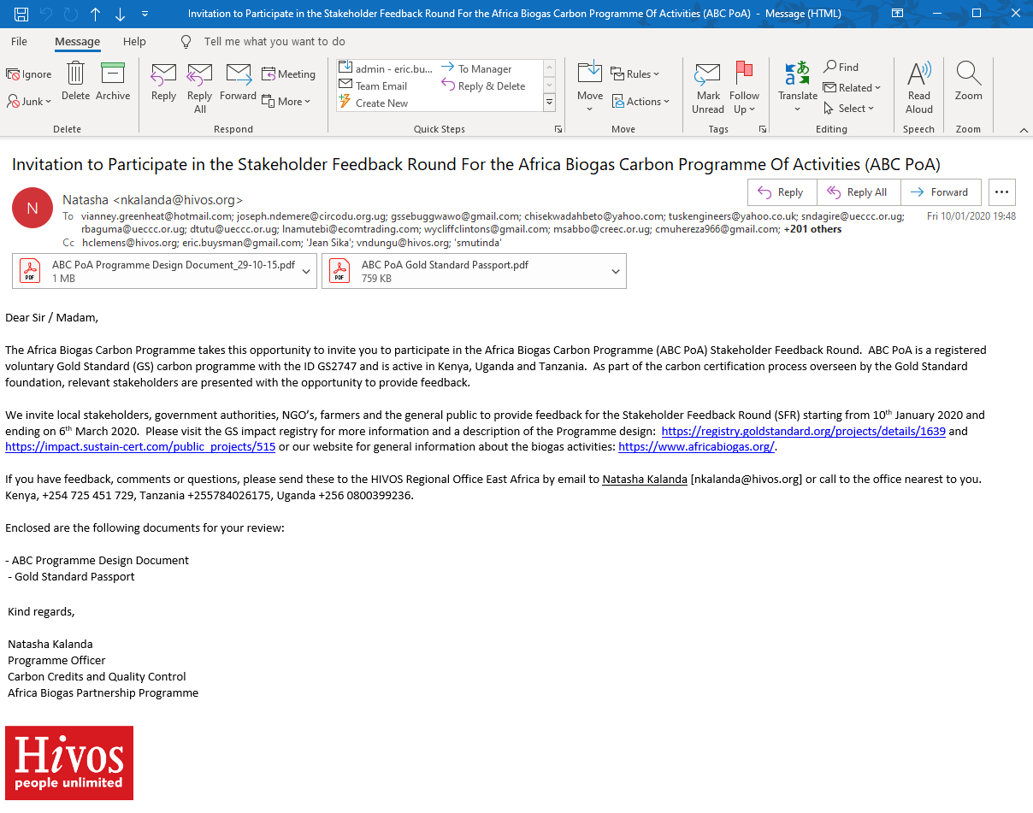 | 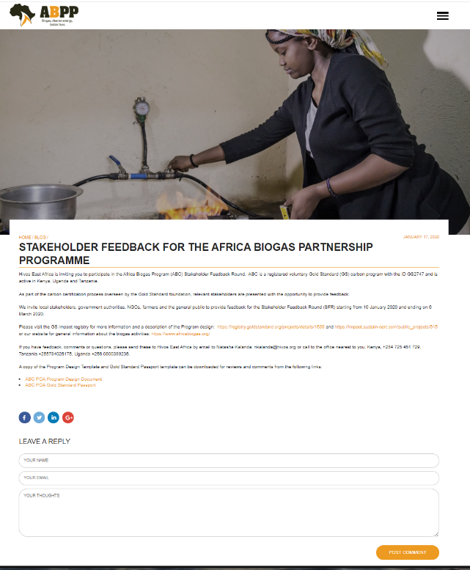

A count of the invitees by category is displayed in the table below:

CATEGORY | Description of GS Stakeholder category | Count
A | Local people impacted by the project or official representatives e.g. farmers, academic institutions etc | 61
B | Local policy makers and representatives of local authorities | 51
C | DNA | 4
D | Local non-governmental organisations working on topics relevant to project | 78
E | Gold Standard Representative | 2
F | NGO Supporters | 6
 | sum | 202
----
        - Consideration of stakeholder comments received
>>
Two weeks and 1 week before closing of the 2 months SFR a reminder was sent by email to the participants. After the closing of the SFR the list of responses was collated. In total 5 responses were received. The outcome is summarized below.

Type | Number | Comment
Information request | 2 | Inquiry on micro-finance and inquiry on what is the feedback round
Inquiry on the type of meeting | 1 | Inquiry on if it was a physical meeting
Confirmation of participation / appreciation of receiving the invitation | 2 | Confirmation, but no feedback received.

Evidence of email communication can be shared at request.

The received stakeholder comments did not relate to the design of the PoA-DD, therefore, no changes were made.

        - Final Continuous Input / Grievance Mechanism at PoA Level
>>
During the CP renewal, it was not required to develop a PoA level grievance mechanism. This mechanism will be developed for the next PoA renewal.

Nevertheless, stakeholders have access to the following grievance methods.

Method | Include all details of Chosen Method (s) so that they may be understood and, where relevant, used by readers.
Continuous Input / Grievance Expression Process Book (mandatory) | Grievances are reported digitally at VPA level.
GS Contact (mandatory) | help@goldstandard.org
Other | N/A

Appendix 1 - Contact information of coordinating/managing entity and responsible person(s)/ entity(ies)
CME and/or responsible person/ entity | CME  Responsible person/ entity for application of the selected methodology(ies) and, where applicable, the selected standardized baseline(s) to the PoA
Organization | ABPL
Street/P.O. Box | P.O. Box 79875-00202 Nairobi
Building | ACS Plaza
City | Nairobi
State/Region | Nairobi
Postcode | 00202
Country | Kenya
Telephone | +254 791496964
E-mail | kkinusu@kbp.co.ke
Website | https://kenyabiogas.com
Contact person | Kevin Kinusu
Title | Programme Coordinator
Salutation | Mr.
Last name | Kevin
Middle name | Kinusu

Revision History

Version | Date | Remarks
1.1 | 14 October 2020 | Hyperlinked section summary to enable quick access to key sections  Improved clarity on Key Project Information  Inclusion criteria table added  Clarification on POA level LSC and Safeguard Principles Assessment  Improved Clarity on SDG contribution/SDG Impact term used throughout  Clarity on Stakeholder Consultation information required  Provision of an accompanying Guide to help the user understand detailed rules and requirements
1.0 | 10 July 2017 | Initial adoption

This is currently the case in Kenya, where ABPL is the legal representative of the Kenya Biogas Programme
A memorandum of understanding will define the conditions and roles of the CME and the VPA implementer. This will be tailored for the specific context in which the VPA operates and the capacity that the VPA implementer has.
Households may lose this agreement overtime. Copies of the contract however are retained in Salesforce
Digesters are fed with animal manure and consequently the target group are livestock farmers
2 December 2019 Skype conversation with the GS

