THE GOLD STANDARD MICRO-SCALE SCHEME PROJECT DESIGN DOCUMENT FORM - Version 2.2

CONTENTS

A. General description of the micro scale project activity

B. Application of an existing or new baseline and monitoring methodology

C. Duration of the project activity and crediting period

D. Stakeholders’ comments

Annexes

Annex 1: Contact information on participants in the proposed micro scale project activity

Annex 2: Information regarding Public Funding

SECTION A. General description of micro-scale project activity

A.1 Title of the micro-scale project activity:
Energy Efficiency measures in DMRC Phase III elevated stations
26/12/2017, Version 02
A.2. Project participants:
>>The project participant is Delhi Metro Rail Corporation Ltd., A Joint Venture of Government of India and Govt. of Delhi
Name of Party involved  ((host) indicates a host Party) | Private and/or public entity(ies)  project participants  (as applicable) | Kindly indicate if  the Party involved  wishes to be  considered as  project participant  (Yes/No)
India(Host) | Delhi Metro Rail Corporation Ltd.  (A public entity) | No

A.3 Description of the micro-scaleproject activity:

Energy Efficiency measures at DMRC Phase IIIelevated stations (hereafter referred to as the “Project”) developed by Delhi Metro Rail Corporation Ltd. (hereafter referred to as the DMRC) is located in state of Delhi, India. The project involves implementation of energy efficiency measures in elevated stations of Phase III of Delhi Metro managed by DMRC as listed in section A.3.1.4 of PDD.
The baseline scenario identified in section B.4 is the same as the scenario existing prior to the start of implementation of the project activity i.e. in a baseline scenario Phase III stations would have been implemented using similar technologies as Phase I with no energy efficiency measures. Similar energy efficiency initiative has been undertaken for Phase II stations (which started operation in 2011) as well and is registered with Gold standard under GS 1246. Hence Phase I stations have been considered as Baseline.
The project also contributes to sustainable development for the wellbeing of the country in terms of environment, socio-economic benefits:
Social well being
- The project activity essentially reduces electricity consumption by the station buildings thus allows the electricity to flow to other important activities in the state. Electricity is one of the basic amenities always in demand due to lack of supply, hence the project contributes towards meeting the electricity needs of the people to the extent the electricity displaced for coming 10 years and thus leading to improvement of quality of life of the people in the state.
- The energy efficient technologies adopted in the Phase III of metro does not alter the quality of service provided by the metro.

Economic well being

- The project activity involves implementation of energy efficient measures in the stations of Delhi metro, thereby reducing the electricity consumption in the Phase III of DMRC. Energy conservation through this initiative contributes to bridging the gap between energy demand and supply in an energy deficit country like India.
- Carbon credit fund expected from the project activity will encourage similar entities for investing in energy efficient projects/ initiative and contribute towards meeting the energy demand of the country.
- A number of metro projects are being developed across country and such projects are expected to replicate the initiative by DMRC. DMRC itself aims to implement further energy efficient technologies in its Phase IV of metro. Such an energy efficiency initiative by a premier organization like DMRC will set an example of successful utilization of technology, thereby promoting more and more similar initiatives. This will go a long way in the economic development of country through conservation of electricity.
- Apart from thisimplementation of metro system as whole improves the economic development of the city by facilitatingmodern and efficient mode of transportation to the city, which reduces the loss of travel time in the current modes of transportation and reducing traffic congestion on the roads, enhance city infrastructure and facilitate business opportunities.

Environmental well being

- The project leads to reduction of GHG emissions
- Leads to overall improvement of environment due to reduced usage of fossil fuels in anthropogenic activities directly or indirectly attributed to the project.

A.3.1. Location of the micro-scale project activity:
>>
A.3.1.1. Host Country:
>>India
A.3.1.2. Region/State/Province etc.:
>>New Delhi and National Capital Region (NCR)

A.3.1.3. City/Town/Community etc.:
>>Delhi and NCR

A.3.1.4. Details of physical location, including information allowing the unique identification of this micro-scale project activity:
The project activity includes 66 over-ground (elevated) metro station buildings forming a part of Phase III of Delhi Metro detailed below. Some of the stations are interchange stations with same station name but different station building area. These are Dwarka, Rajouri Garden, MayurVihar I, AnandVihar, Karkarduma, Welcome and Botanical Garden. The geographical coordinates for all the stations have been given below:
S No. | Station Name | Line | Latitude | Longitude
 | Rohini Sec-18 | Line-2 Ext | 28°44'17.89"N | 77° 8'23.61"E
 | Badli | Line-2 Ext | 28°44'40.54"N | 77° 8'18.08"E
 | BadliMor | Line-2 Ext | 28°43'48.99"N | 77° 8'58.58"E
 | MIE | Line 5 Ext | 28°41'22.34"N | 76°56'52.19"E
 | Bus Stand | Line 5 Ext | 28°41'26.59"N | 76°56'8.74"E
 | City Park | Line 5 Ext | 28°41'56.36"N | 76°54'59.62"E
 | Ghevra | Line 5 Ext | 28°41'6.53"N | 76°59'39.48"E
 | TikriKalan | Line 5 Ext | 28°41'13.71"N | 76°58'16.67"E
 | Tikri Border | Line 5 Ext | 28°41'17.49"N | 76°57'38.17"E
 | Sarai | Line 6 Ext | 28°28'20.67"N | 77°18'21.67"E
 | NHPC | Line 6 Ext | 28°27'41.87"N | 77°18'24.63"E
 | MewalaMaharajpur | Line 6 Ext | 28°27'1.02"N | 77°18'28.08"E
 | Sector 27A | Line 6 Ext | 28°26'0.26"N | 77°18'33.87"E
 | Ajronda | Line 6 Ext | 28°23'42.34"N | 77°18'44.44"E
 | Faridabad New Town | Line 6 Ext | 28°22'51.36"N | 77°18'49.15"E
 | YMCA Chowk | Line 6 Ext | 28°22'6.27"N | 77°18'52.98"E
 | Old Faridabad | Line 6 Ext | 28°24'38.66"N | 77°18'40.34"E
 | Badkhal More | Line 6 Ext | 28°25'34.31"N | 77°18'35.52"E
 | Sadar Bazar | Line 8 | 28°34'37.65"N | 77° 6'36.70"E
 | Shankar Vihar | Line 8 | 28°34'4.52"N | 77° 7'34.75"E
 | Okhla Phase-III | Line 8 | 28°33'19.76"N | 77°16'0.29"E
 | Ishwar Nagar | Line 8 | 28°33'31.38"N | 77°16'21.87"E
 | Jamia Nagar | Line 8 | 28°33'39.66"N | 77°16'58.29"E
 | OkhlaVihar | Line 8 | 28°33'23.39"N | 77°17'33.67"E
 | JasolaVihar | Line 8 | 28°32'47.40"N | 77°17'47.30"E
 | KalindiKunj | Line 8 | 28°32'42.81"N | 77°18'21.68"E
 | Amity Noida | Line 8 | 28°33'20.06"N | 77°19'28.46"E
 | Mukundpur | LINE 7 | 28°43'53.33"N | 77°10'59.17"E
 | Shakurpur | LINE 7 | 28°40'59.72"N | 77° 8'46.68"E
 | Esi hospital | LINE 7 | 28°39'31.55"N | 77° 7'42.85"E
 | Mayapuri | LINE 7 | 28°38'17.43"N | 77° 7'47.76"E
 | Delhi cantt | LINE 7 | 28°36'47.31"N | 77° 8'12.29"E
 | Motibagh | LINE 7 | 28°35'5.50"N | 77°10'21.56"E
 | Mayurvihar pkt-1 | LINE 7 | 28°36'26.84"N | 77°18'14.77"E
 | Trilokpuri | LINE 7 | 28°36'45.58"N | 77°18'22.32"E
 | East vinodnagar | LINE 7 | 28°37'21.75"N | 77°18'13.92"E
 | Vinod nagar | LINE 7 | 28°37'38.90"N | 77°19'2.54"E
 | I p extension | LINE 7 | 28°38'11.18"N | 77°18'51.14"E
 | Krishna nagar | LINE 7 | 28°39'40.00"N | 77°17'15.71"E
 | East azadnagar | LINE 7 | 28°39'58.83"N | 77°17'1.22"E
 | Jaffrabad | LINE 7 | 28°40'33.86"N | 77°16'17.46"E
 | Maujpur | LINE 7 | 28°41'19.31"N | 77°16'40.16"E
 | Gokulpuri | LINE 7 | 28°42'6.12"N | 77°17'1.29"E
 | Shiv vihar | LINE 7 | 28°43'19.19"N | 77°17'21.70"E
 | Johri enclave | LINE 7 | 28°42'38.87"N | 77°17'27.06"E
 | Panjabi Bagh west | LINE 7 | 28°40'18.91"N | 77° 7'40.81"E
 | Karkar duma court | LINE 7 | 28°39'13.27"N | 77°17'46.85"E
 | DhaulaKuan | LINE 7 | 28°35'34.71"N | 77° 9'46.25"E
 | Nagli | Line 3 Ext | 28°35'23.69"N | 77°15'18.95"E
 | Ballabhgarh | Line 6 Ext | 28°33'54.18"N | 77°10'14.92"E
 | NCB | Line 6 Ext | 28°21'8.67"N | 77°19'3.03"E
 | Dwarka | Line 3 Ext | 28°36'54.12"N | 77° 1'21.82"E
 | Rajouri Garden | Line 7 | 28°38'56.49"N | 77° 7'21.79"E
 | MayurVihar I | Line 7 | 28°36'15.96"N | 77°17'21.71"E
 | AnandVihar | Line 7 | 28°38'50.18"N | 77°18'55.76"E
 | Karkarduma | Line 7 | 28°38'57.74"N | 77°18'21.86"E
 | Welcome | Line 7 | 28°40'21.02"N | 77°16'36.76"E
 | Botanical Garden | Line 8 | 28°33'49.24"N | 77°20'2.37"E
 | Shahid Nagar | Line 1 Ext | 28°40’35.8”N | 77°20’01.8”E
 | Raj Bagh | Line 1 Ext | 28°40’37.3”N | 77°24’47.3”E
 | Rajendra Nagar | Line 1 Ext | 28°40’39.4”N | 77°24’31.1”E
 | Shyam Park | Line 1 Ext | 28°40’41.5”N | 77°22’14.5”E
 | Mohan Nagar | Line 1 Ext | 28°40’42.5”N | 77°24’02.9”E
 | Arthala | Line 1 Ext | 28°40’36.4”N | 77°24’32.8”E
 | Hindon River | Line 1 Ext | 28°40'24.14"N | 77°24'23.66"E
 | New Bus Adda | Line 1 Ext | 28°40’12.8”N | 77°24’59.2”E

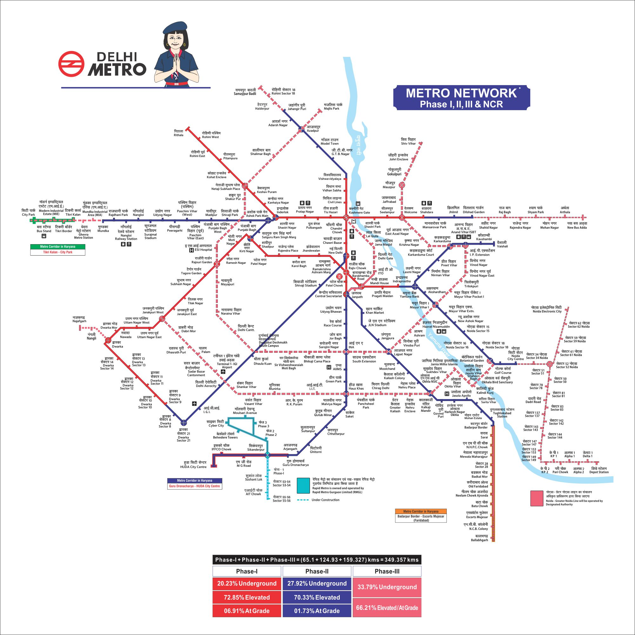
Figure: Project boundary

A.3.2. Description including technology and/or measure of the micro-scale project activity:
>>The Phase III stations are built as Green building stations. This is not the case for baseline Phase I station.
The project activity involves energy efficiency measures undertaken by Delhi Metro Rail Corporation (DMRC) in a number of station buildings forming a part of Delhi Metro Phase III. The energy efficiency measures have been undertaken primarily in the Air Conditioning system, lighting system and other energy efficient measures of station buildings. The measures adopted in the Air Conditioning system result in reduction in electrical energy consumption, in comparison to that for a station building forming a part of Phase I of Delhi Metro. Also a number of architectural design considerationswere incorporated in Phase III station which resulted in lower energy consumption.
The Phase III stations are identical to Phase I station in terms of being located in same geographical and climatic condition and catering to same users (i.e. metro passengers). Also both baseline and project stations are owned, maintained and operated by same agency i.e. DMRC. This project expected to be operational in 2018 and is a Regular Cycle Project.
Energy efficient measures adopted by DMRC in its Phase III stations are as follows:
- T-5 tube lights with along with LED will be used on Elevated stations. Every 4th light is LED type and no incandescent lamps will be used for lighting.

- Variable Voltage Variable Frequency (VVVF) control drive system in Lifts & Escalators, which matches the power requirements with actual load. The Escalators will beinstalled with idling speed of 0.2m/sec against the normal operating speed of 0.5m/sec or 0.65m/sec. This has resulted in estimated energy saving of 1%.

- VRV Chillers:
One of the main energy efficiency measures is the implementation of energy efficient VRV (Variable refrigerant volume) type Chillers under Phase III of DMRC. In Phase I the Split type chillers are used for cooling purposes, whereas in the Phase III more energy efficient VRV type chillers will be used for air-conditioning.VRV (Variable refrigerant volume) is an air-condition system for commercial building application with sophisticated individual zone control. VRV is a system which means "variable refrigerant volume". In principle it is extremely efficient, reliable, energy saving way to heat and cool all types of buildings with minimum installation time or disruption.Conventional systems air condition a building as a whole, whereas the VRV system air conditions each room individually. Hence it is ideal for the constantly changing occupancy of a typical building. Even further, precise level control is possible that reacts to the exact conditions in each room.

The VRV System comprises of:
- Outdoor air cooled condensing units
- Indoor fan-coil units
- Simple refrigerant copper piping
- Power and control cables and
- Remote and centralized controllers for operating the system

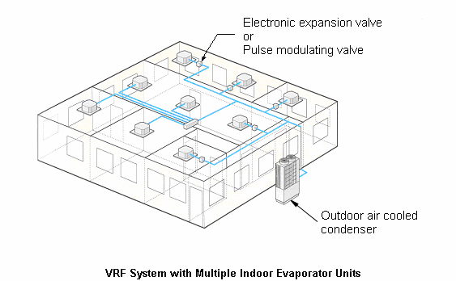

- Maximum utilization of daylight in stations

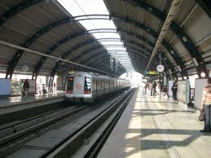
Figure 2: Maximum daylight utilization in stations

- Implementation of SunFilm: Sun films will be used which reduce solar heat gain on ECS system.
Thus all these measures lead to tremendous amount of energy savings. Since the project uses more energy efficient systems as compared to Phase I of Delhi Metro, it will consume less electricity and thus results in reduction of Carbon dioxide emissions (CO₂) emissions.

A.3.3 Estimated amount of emission reductions over the chosen crediting period:
>>
Years | Estimation of annual emission reductions in tonnes of CO₂e
2018 | 6374
2019 | 6374
2020 | 6374
2021 | 6374
2022 | 6374
2023 | 6374
2024 | 6374
2025 | 6374
2026 | 6374
2027 | 6374
Total estimated reductions (tonnes of CO₂e) | 63740
Total number of crediting years | 10
Annual average of the estimated reductions over the crediting period (tonnes of CO₂e) | 6374

A.3.4. Public funding of the micro-scale project activity:
No public funding from parties included in Annex I of the UNFCCC is involved in this project
SECTION B. Application of an existing baseline and monitoring methodology or of a new methodology submitted as part of this project activity

B.1. Title and reference of the existing or new baseline and monitoring methodology applied to the micro-scale project activity:
>>Main Category: Type II – Energy efficiency improvement project
AMS-II.E; “Energy efficiency and fuel switching measures for buildings”
Version 10, CDM EB 35
B.2 Justification of the choice of the methodology and applicability:
>>
Eligibility condition GS VER_Annex AD | Justification
The end‐use energy efficiency improvement category is defined as the reduction in the amount of energy required for delivering or producing non‐energy physical goods or services. Project activities must implement measures to reduce energy requirements as compared to the baseline without affecting the level and quality of the services provided (service equivalence). Furthermore, the following principle applies: efficiency measures implemented are considered 'end‐use' energy efficiency measures when final end‐users of products or services delivered can be clearly identified and therefore are within the project boundaries, and when physical intervention is required at the end‐ user side. Both emission reductions from direct and indirect energy savings are potentially eligible, i.e. the introduction of measures which directly reduce the use of non‐renewable fuels at the point of intervention, or of measures that do not directly reduce the amount of fossil fuels consumed at the point of intervention but lead to a reduction of the amount of an energy intensive product (e.g. fertilizer) used for the delivery of the same non‐energy physical goods or services | Applicable and fulfilled  The project activity is an end-use energy efficiency improvement project that reduces the amount of energy required for delivering or producing non-energy physical goods or services such as air conditioning, lighting and station maintenance. The project activity involves the use of energy efficient lighting and VRV type air conditioners which reduce the amount of electrical energy consumed compared to the baseline scenario. The level and quality of services in the project scenario is the same as the baseline and does not affect the quality of air-conditioning and lighting in the stations of Phase III stations.
Additional GS applicability criteria/ requirements | Justification
Emission reductions associated with end use energy efficiency improvements only shall be eligible for Gold Standard registration. Emission reductions associated with difference in carbon content between a non-renewable fuel and a less carbon intensive non-renewable fuel used for substitution measure shall NOT be eligible. | Applicable and fulfilled  The project activity is an end use energy efficiency project. Emission reductions are associated with the reduction in electrical energy consumption and does not involve any substitution of non-renewable fuel.
Applicability Conditions under AMS-II.E | Justification
This category comprises any energy efficiency and fuel switching measure implemented at a single building, such as a commercial, institutional or residential building, or group of similar buildings, such as a school, district or university. This category covers project activities aimed primarily at energy efficiency; a project activity that involves primarily fuel switching falls into category III.B.  Examples include technical energy efficiency measures (such as efficient appliances, better insulation and optimal arrangement of equipment) and fuel switching measures (such as switching from oil to gas). | Applicable and Fulfilled  The project activity involves energy efficiency measures with installation of energy efficient systems in the metro stations forming a part of Phase III of Delhi Metro.  The project activity leads to reduction in energy consumption by installing efficient equipment (VRV Chillers), lights etc.  Thus this applicability condition is fulfilled.
The technologies may replace existing equipment or be installed in new facilities. | Applicable and Fulfilled  The project involves installation of energy efficient VRV system for air conditioning in new stations forming a part of Phase III of Delhi Metro.  Thus this applicability condition is fulfilled.
This category is applicable to project activities where it is possible to directly measure and record the energy use within the project boundary (e.g. electricity and/or fossil fuel consumption) | Applicable and Fulfilled  The energy consumption in the station building can be directly measured and recorded as electricity consumed in each station.  Thus this applicability condition is fulfilled.
This category is applicable to project activities where the impact of the measures implemented (improvements in energy efficiency) by the project activity can be clearly distinguished from changes in energy use due to other variables not influenced by the project activity (signal to noise ratio). | Applicable and Fulfilled  The impacts of the energy efficiency measures implemented as part of project activity can be clearly distinguished from changes in energy use due to other variables not influenced by the project activity.  Thus this applicability condition is fulfilled.

B.3. Description of the project boundary:
>>The project boundary in accordance with methodology is “the physical, geographical site of the building(s)”. Thus all the elevated and over-ground stations of Phase III of Delhi Metro as listed in Section A.3.1.4 of PDD form the part of project boundary.

B.4. Description of the baseline and its development as per the chosen methodology:
>>According to para 5 of AMS-II.E, the baseline is 5 “the energy baseline consists of the energy use of the existing equipment that is replaced in the case of retrofit measures and of the facility that would otherwise be built in the case of a new facility”.
The baseline scenario identified is the same as the scenario existing prior to the start of implementation of the project activity i.e. Phase III stations implemented as Phase I with no energy efficiency measures.
Energy Baseline
The energy baseline for the project activity under consideration is the per square meter electrical energy consumption of the system of the baseline building (station buildings forming a part of Phase I of Delhi Metro). The per square meter electricity consumption thus obtained have been used to estimate the energy consumption by the project stations in the absence of energy efficient equipments.
For ascertaining the baseline energy consumption, energy consumption of 41 baseline stations of DMRC Phase I was monitored for the year 2012, 2013 and 2014. Month wise electricity consumption of each station was tabulated and added to obtain monthly total energy consumption for each year. The per sq.m energy consumption per month was obtained for the three years and averaged to obtained the per sq.m monthly energy consumption for baseline stations. The monthly electricity consumption data revealed that less electricity is consumed in winter than in summer. This is reasonable since a majority of electricity consumption is attributed to air conditioning system.
Detailed calculation steps and values have been given in Section B.6.1 and B.6.3 of this PDD. The project activity reduces electricity consumption of the stations of Phase III of Delhi Metro in comparison to the baseline scenario. Emission reduction will be based on the reduced electricity drawl from the grid due to the reduced electricity consumption in the stations, in the project scenario compared to the baseline scenario.
Emission factor for electricity drawn from the grid
According to para 6 of AMS-II.E; “each energy form in the emission baseline is multiplied by an emission coefficient. For the electricity displaced, the emission coefficient is calculated in accordance with provisions under category I.D. For fossil fuels, the IPCC default values for emission coefficients may be used.”
Since the project activity leads to reduction in electricity consumptions drawn from North- East- West- North-East (NEWNE) grid, emission coefficient has been calculated for the same. In case of the project activity, a combined margin (CM) emission factor, consisting of the combination of operating margin emission factor and build margin emission factor, calculated by Central Electricity Authority (CEA) according to the procedures prescribed in the ‘Tool to calculate the emission factor for an electricity system’ and made publicly available in the form of CO₂ Baseline Database (Version 9.0, Dated 1st January 2014) has been considered. The combined margin emission factor for NEWNE grid as per this database is 0.98tCO₂/MWh.

B.5. Description of how the anthropogenic emissions of GHG by sources are reduced below those that would have occurred in the absence of the registered micro-scale project activity:
Prior consideration and continuous action
Start date of project activity is Start Date: 02nd January, 2013
Even prior to start date DMRC was aware of emission reduction benefit that can be accrued through Gold standard. This is evident from following evidence
DMRC appointed a consultant to register similar project under its Phase II elevated station. It is registered under GS1246.
The project got registered on 06/01/2014. Post registration, the issuance of VERs occurred on 08/04/2015.
The above discussion clearly elaborated that PP was aware of carbon revenues and took proactive steps in registration of similar project with The Gold Standard even prior to project start.
Post registration and issuance of Phase II, continuous action for Phase III was initiated. This is described below.
- Immediately after project start date DMRC appoints a consultant, M/s Arcadis India Pvt. Ltd. (Erstwhile M/s Senes Consultants India Pvt. Ltd.)
- Local stake holder consultation was organized on 17/12/2014.
- Since prior consideration rules of Gold standard had changed since registration of Phase II, DMRC wrote Mail to Gold standard seeking waiver to prior consideration rules on 1st January 2016.
- Gold standard allows waiver on 14/01/2016
- On approval by DMRC, the PDD was submitted for validation on 22/6/2016.
- The copy of MoU signed between DMRC and GS has been attached as “MoU_21.03.16”.

From the above discussion it is clear that not only PP was aware about carbon revenues, but also that real and continuous actions were taken to secure carbon status for the project activity.
According to “Guidelines for demonstrating Additionality of Microscale Project Activities”, EB 63, Annex 23; Energy efficiency project activities that aim to achieve energy savings at a scale of no more than 20 gigawatt hours per year are considered automatically additional if any one of the conditions below is satisfied:
- The geographic location of the project activity is in an LDC/SIDS or special underdeveloped zone of the host country identified by the government before 28 May 2010;
- The project activity is an energy efficiency activity with both conditions (i) and (ii) below satisfied:
- Each of the independent subsystems/measures in the project activity achieves an estimated annual energy savings equal to or smaller than 600 megawatt hours;
- End users of the subsystems or measures are households/communities/SMEs.

In the project activity, all the subsystems (stations) achieve annual energy savings of less than 600 MWh as shown in the excel sheet submitted along with the PDD and end users are communities and local people of the state. Moreover the annual energy savings is estimated to be 6.479GWh which is less than 20 GWh per annum. The Kalindi Kunj metro station has maximum energy savings of 209MWh, which is less than 600 MWh. Thus the project activity is automatically additional.
Since it is well accepted that objectively demonstrating additionality with facts and figures for a micro scale energy efficiency project is difficult, the above mentioned guidelines have been framed to encourage implementationformicro-scale energy efficiency projects.
B.6 Emission reductions:

B.6.1. Explanation of methodological options or description of new proposed approach:
>>Emission Reductions:
ER_{y} = BE_{y}– (PE_{y}+ L_{y}) ...................(1)

Where:
ER_{y} = Emission Reductions in the year y (in tCO₂e)
BE_{y} = Baseline Emissions in the year y (in tCO₂e)
PE_{y} = Project Emissions in the year y (in tCO₂e)
L_{y} = Leakage Emissions in the year y (in tCO₂e)

Project Emissions
For the project activity under consideration, the emission reductions will be computed on the basis of the net amount of electrical energy consumption reduction w.r.t the baseline scenario. Therefore, there will be no project emissions arising out of additional electricity consumption under the project activity. So, project emissions (PE_{y}) = 0
Baseline Emissions
Baseline emissions have been computed by multiplying the energy savings achieved and the emission coefficient for NEWNE grid.
BE_{y} = ES_{y}* EF_{y} .............(2)
Where:
BE_{y} = Baseline Emissions in year y (in tCO₂e)
ES_{y} = Total Energy savings the given year y (in MWh)
EF_{y} = Emission Coefficient for the NEWNE grid (in tCO₂/MWh)

Step 1: Estimation of Energy Savings in the given year y

$${ES}_{y} = \sum_{m=1}^{m=n}{{ES}_{m}}$$
.............(3)
Where:
ES_{y} = Total Energy savings the given year y (in MWh)
m = Month in the year y
ES_{m} = Total Energy Savings in a given month m (in MWh)

Step 2: Estimation of Energy Savings in the given month m

$${ES}_{m}= \left(\sum_{ST=1}^{ST=n}{{ES}_{ST}}\right)÷1000$$
.............(4)
Where:
ES_{m} = Total Energy Savings in a given month m (in MWh)
ES_{ST} = Energy Savings for a given station in a given month m (in kWh)
ST = Station included in the project activity

Step 3: Estimation of Energy Savings for a station in a given month

$${ES}_{ST}=η_{f,m}×A_{ST,m}$$
.............(5)
Where:
ES_{ST} = Energy Savings for a given station in a given month m (in kWh)
η_{f,m} = Per square meter savings in the given month
A_{ST,m} = Operational area for a given station in a month m (in sq.m)

Step 4: Estimation of Per Unit Energy Efficiency Factor

$$η_{f,m}= η_{BL,m}-η_{PJ,m}$$
.............(6)
Where:
η_{f,m} = Per sqm Energy savings of the project station
η_{BL,m} = Average per sqm Energy Consumption factor for the Baseline Stations in the given month m for the year 2012. 2013 and 2014
η_{PJ,m} = Average per sqm Energy Consumption factor for the Project Activity in the given month m for the year.

Step 5: Estimation of Per Unit Energy Efficiency Factor for Baseline Stations

$$η_{BL,m}= \left(\sum_{ST,BL=1}^{ST,BL=n}{{EC}_{BL,m}}\right)÷\left(\sum_{ST,BL=1}^{ST,BL=n}{A_{BL}}\right)$$

.............(7)
Where:
η_{BL,m} = Average per Unit Energy Consumption factor for the Baseline Stations for a given month m of year 2012, 2013 and 2014
ST = Station included in the baseline
EC_{BL,m} = Energy Consumption for all the stations included in baseline stations of Phase I (in kWh)
A_{BL} = Area of all the stations included in baseline stations of Phase I (in sq.m)

Step 6: Estimation of Per Unit Energy Efficiency Factor for Project Stations

$$η_{PJ,m}= \sum_{ST=1}^{ST=n}{\left({EC}_{PJ,m}÷A_{ST,m}\right)}$$
.............(8)
Where:
η_{PJ,m} = Per Unit Energy Consumption factor for the Project Stations for a given month m
ST = Station included in the project activity
EC_{PJ,m} = Energy Consumption for active stations included in project activity (in kWh)
A_{ST,m} = Area of operational stations included in project activity (in sq.m)

Leakage Emissions
There are no leakage emissions from the project activity
B.6.2. Data and parameters that are available at validation:
>> (Copy this table for each data and parameter)

Data / Parameter: | EFy
Data unit: | t CO2/MWh
Description: | CO2 emission factor for the NEWNE grid
Source of data used: | CEA published grid emission factors
Value applied: | 0.9837tCO₂/MWh
Justification of the choice of data or description of measurement methods and procedures actually applied : | Central Electricity Authority (CEA) database, version 9 dated January 2014 values have been used for authenticity of the data, available publicly by Govt of India with a view to obtain uniformity of approach in the country towards a common objective.
Any comment: | http://www.cea.nic.in/reports/planning/cdm_co2/cdm_co2.htm

Data / Parameter: | EC_{BL,m}
Data unit: | kWh
Description: | Energy consumption in the baseline stations in a given month
Source of data used: | Existing records for Delhi Metro Phase I provided by DMRC
Value applied: | Detailed in Annex 3
Justification of the choice of data or description of measurement methods and procedures actually applied : | The energy consumption data has been taken from the existing records maintained by DMRC on electricity consumption for the year 2012, 2013 and 2014 in the stations covered under Phase I of Delhi Metro.
Any comment:

Data / Parameter: | A_{BL}
Data unit: | Sq.m
Description: | Area of all the stations included in baseline stations of Phase I
Source of data used: | Delhi Metro Phase I records provided by DMRC Limited
Value applied: | Detailed in Annex 3
Justification of the choice of data or description of measurement methods and procedures actually applied : | The area of the stations has been taken from the records maintained by DMRC Limited
Any comment:

Data / Parameter: | η_{BL,m}
Data unit: | kWh/sqm
Description: | Average per sqm Energy Consumption factor for the Baseline Stations in the given month for the year 2012,2013,2014
Source of data used: | Calculated
Value applied:
  Month | Energy Consumption Factor for the baseline  (in kWh/sqm)
  January | 4.85
  February | 4.52
  March | 5.15
  April | 5.45
  May | 5.97
  June | 6.10
  July | 6.00
  August | 5.93
  September | 5.71
  October | 5.66
  November | 4.95
  December | 4.92
Justification of the choice of data or description of measurement methods and procedures actually applied : | This is a calculated parameter.
Any comment:

B.6.3 Ex-ante calculation of emission reductions:
>>According to methodology, emission reductions are given as:

ER_{y} = BE_{y}– (PE_{y}+ L_{y})

Where:
ER_{y} = Emission Reductions in the year y (in tCO₂e)
BE_{y} = Baseline Emissions in the year y (in tCO₂e)
PE_{y} = Project Emissions in the year y (in tCO₂e)
L_{y} = Leakage Emissions in the year y (in tCO₂e)

Baseline Emissions
For estimating baseline energy consumption; the consumption units per square meter of built-up area for each month have been averaged for the years 2012, 2013 and 2014for Phase I stations (baseline energy consumption per sqm). Assuming that the project activity had not been executed, the Phase III stations would have installed the energy consuming equipments as in Phase I. In such a scenario, the energy consumed by Phase III stations have been calculated by multiplying the built-up area of each operational station with baseline energy consumption per sqm in absence of project systems. Thus this gives the energy consumption in baseline stations (Phase III) in absence of project activity.

Estimation of Per Unit Energy Efficiency Factor for Project Stations: Has been detailed in Annex 3 of PDD

$$η_{PJ,m}= \sum_{ST=1}^{ST=n}{\left({EC}_{PJ,m}÷A_{PJ}\right)}$$

Estimation of Per Unit Energy Efficiency Factor for Baseline Stations

$$η_{BL,m}= \left(\sum_{ST,BL=1}^{ST,BL=n}{{EC}_{BL,m}}\right)÷\left(\sum_{ST,BL=1}^{ST,BL=n}{A_{BL}}\right)$$

Month | Energy Consumption Factor for the baseline  (in kWh/sqm)
January | 4.85
February | 4.52
March | 5.15
April | 5.45
May | 5.97
June | 6.10
July | 6.00
August | 5.93
September | 5.71
October | 5.66
November | 4.95
December | 4.92

Estimation of per Unit Energy Efficiency Factor: has been detailed in Annex 3 of PDD

$$η_{f,m}= η_{BL,m}-η_{PJ,m}$$

Estimation of Energy Savings for a station in a given month: has been detailed in Annex 3 of PDD

$${ES}_{ST}=η_{f,m}×A_{ST,m}$$

Estimation of Energy Savings in the given month m: has been detailed in Annex 3 of PDD

$${ES}_{m}= \left(\sum_{ST=1}^{ST=n}{{ES}_{ST}}\right)÷1000$$

Estimation of Energy Savings in the given year y

$${ES}_{y} = \sum_{m=1}^{m=n}{{ES}_{m}}$$

For the Year 2018 onwards= 6374MWh

Baseline emissions have been computed by multiplying the energy savings achieved and the emission coefficient for NEWNE grid.
BE_{y} = ES_{y}* EF_{y}

BE_{y} = 6479.814*0.9837
= 6374
ERy = BEy – (PEy + Ly)
Project Emissions:
Project does not have any project emissions, thus PE_{y} = 0.
Leakage Emissions:
Project does not have any leakage emissions, thus LE_{y} = 0.

B.6.4 Summary of the ex-ante estimation of emission reductions:
>>
Year | Estimation of  project activity  emission (tCO₂) | Estimation of  baseline emissions  (tCO₂) | Estimation of  leakage (tCO₂) | Estimation of overall  emission reductions  (tCO₂)
2018 | 0 | 6374 | 0 | 6374
2019 | 0 | 6374 | 0 | 6374
2020 | 0 | 6374 | 0 | 6374
2021 | 0 | 6374 | 0 | 6374
2022 | 0 | 6374 | 0 | 6374
2023 | 0 | 6374 | 0 | 6374
2024 | 0 | 6374 | 0 | 6374
2025 | 0 | 6374 | 0 | 6374
2026 | 0 | 6374 | 0 | 6374
2027 | 0 | 6374 | 0 | 6374
Total (tonnes of CO₂e) | 0 | 63740 | 0 | 63740

B.7 Application of a monitoring methodology and description of the monitoring plan as per the existing or new methodology applied to the micro-scale project activity:

B.7.1 Data and parameters monitored:
Data / Parameter: | EC_{PJ,m}
Data unit: | kWh
Description: | Energy Consumption for all the stations included in project activity
Source of data to be used: | Site Records maintained by DMRC on electricity consumption for all the stations covered by the project activity and are part of Phase III of Delhi Metro
Value of data | To be monitored. Provided in Annex 3
Description of measurement methods and procedures to be applied, inc. frequency: | The data will be measured continuously and will be recorded every monthfor all the station buildings using electricity meter in log books.
QA/QC procedures to be applied: | The electricity would be maintained in line with the state electricity board’s requirement.
Any comment: | The data archived will be maintained for crediting period +2 years. The data archiving will be done on both paper and electronically.

Data / Parameter: | A_{ST}
Data unit: | Sq.m
Description: | Area of all the stations included in project activity
Source of data used: | Delhi Metro Phase III records provided by DMRC Limited
Value applied: | Detailed in Annex 3
Justification of the choice of data or description of measurement methods and procedures actually applied : | The area of the stations will be taken from the records maintained by DMRC Limited
Any comment:

B.7.2 Description of the monitoring plan:
>>
DMRC proposes the following structure for data monitoring, collection, data archiving and calibration of equipment for this project activity. DMRC will be the responsible entity for all monitoring and would set the procedures verifying the VERs generated by the power project annually.
Monitoring Plan Objective and Organization
The project proponent (DMRC) will monitor the electricity consumed in all the station buildings forming the part of project activity. The data will be archived electronically and be stored for 2 years after the end of the crediting period.
To ensure that the data is reliable and transparent, the project entity will also establish Quality Assurance and Quality Control (QA&QC) measures to effectively control and manage data reading, recording, auditing as well as archiving data and all relevant documents. The data will be monitored on a monthly basis and will be submitted to Quality Assurance team of project proponent.

Quality Assurance and Quality Control
QA&QC procedures for recording, maintaining and archiving data shall be implemented as part of this Gold Standard project activity.
The project proponent will implement QA&QC measures to ensure the accuracy of metering and safety aspects of the project operation. The metering devices will be inspected properly and periodically, according to state electricity board’s specifications and requirements to ensure accuracy in the readings.
Training and maintenance procedures: Carbon credit Quality Advisor would ensure training to on-site staff with respect to adherence to the Monitoring Plan of the project activity. Records of the training would be kept.
Internal audit of all the records of the plant will be carried out twice a year. During these audits all the data and parameters that need to be monitored as per the monitoring plan would be checked and shortcomings if any will be reported and addresses.
Data Storage and Archiving
In order to facilitate auditors’ reference and for any future requirement, relevant literature relating to the project such as the project material and monitoring results will be indexed. All the data items monitored under the monitoring plan will be kept for 2 years after the end of crediting period or till the last issuance of VERs for this project activity, whichever occurs later. The data will be maintained in both electronic and paper formats. The data will be stored in following manner:
A copy of data will be maintained in electronic and paper format on-site for anytime reference and validation. The energy consumption per station data and calibration certificates of all stations will be maintained in the E&M Division of DMRC, Metro Bhawan. The operational area for each station will be stored in the Civil Division of DMRC, Metro Bhawan.
A copy of data will be stored in paper format by project operator in their branch office in safe storage.
B.8 Date of completion of the application of the existing or new baseline and monitoring methodology and name of the responsible person(s)/entity(ies)
>>
Date of completion: 19thDecember 2017
Sumit Barat
M/s Arcadis India Pvt. Ltd.
3rd Floor, Tower B, Logix Techno Park
Sector 127, Noida

*The above entity is not a project participant.
SECTION C. Duration of the project activity / crediting period

C.1 Duration of the project activity:

C.1.1. Starting date of the project activity:
>Start Date: 02nd January,2013
The start date of the construction of the projectactivity is the date of letter of award (LoA) was issued by DMRC to Arvind Techno Engineers Pvt. Ltd. on 02ndJanuary 2013 for the construction of main viaduct, ramp, Mukundpur elevated station and depot, and chainage on Mukundpur-Yamuna Vihar corridor.
C.1.2. Expected operational lifetime of the project activity:
>>30 years
C.2 Choice of the crediting period and related information:

C.2.1. Renewable crediting period

C.2.1.1. Starting date of the first crediting period:
>>Not Applicable
C.2.1.2. Length of the first crediting period:
>>Not Applicable
C.2.2. Fixed crediting period:

C.2.2.1. Starting date:
>> 1st June 2018
C.2.2.2. Length:
>>10 years, 0 months
SECTION D. Stakeholders’ comments
>>
D.1. Brief description how comments by local stakeholders have been invited and compiled:
>>The project being implemented across the National Capital Region of India and since it affects a large proportion of residents of Delhi-NCR, DMRC gives specific importance to Local stakeholder’s participation in the project. For DMRC the stakeholder’s consultation is an ongoing process and a measure to improve its service. Stakeholder Consultation process was carried out in two phases i.e. during the design phase of the project & during the construction phase of the project to ensure the continuous improvement of services & effective grievance redressal. First phase of the stakeholder was conducted on 19th& 20th July, 2011 and 2nd phase of the stakeholder was conducted on 17th December, 2014. The stakeholders were invited through invitation notices displayed at various stations of Delhi metro, notice on DMRC website, direct invitations to NGOs and other relevant organizations

During design phase, Stakeholder’s consultation was conducted for the Phase III of Delhi Metro wherein main stakeholders were general public (users of the metro) and people living near construction sites of the metro were consulted with. Their issues and concerns were identified and appropriate measures were taken to address the same.
Persons living near to construction sites of stations and metro line are one of the stakeholders potentially affected by these activities. They are also the maximum beneficiary from the project activity in terms of cost of transport. Interactive programmes were organized before, during and at post construction stages.

The detailed process of this consultation is available for validation, however the section summaries the process and outcome.
General public are the users of the public transport system and the prime beneficiaries. Communication with the general public was done through street plays and associating children for experimental joyrides etc. Furthermore, people were asked on their satisfaction with metro services in terms such as speed, convenience, cleanliness, safety, ambience and cost of service.

D.2. Summary of the comments received:
>>At construction sites, main concerns were about disruptions of services, congestion and other inconveniences of daily life related to the direct (e.g. noise, dust) or indirect (e.g. congestion) construction impacts. Other comments were related to demand of more bogies to highly populated areas. Grievances of the citizens were recorded and actions were taken for immediate relief.
Surveys realized with general public show that people are very satisfied with metro services and are satisfied with all aspects such as cost, safety, convenience, speed etc.
Comments received during Local Stakeholder Consultation:
Comment 1: While developing project, Pedestrian problem should be taken care of and construction should not affect day to day operation of their shops nearby.
Comment 2: More rail cars to be increased during the peak hours. Special ladies bogies should be increased.
Comment 3: Change from one station to another should be ‘old age people friendly’.
Comment 4: Noise pollution should be controlled during construction.
Comment 5: Observe efficiency in implementing the safety measures as explained during presentation on all accounts.
Comment6:All necessary precaution may be taken during construction to avoid any mis-happening. Efforts should be made that people should face less difficulties as far as possible
Comment 7:The excavation period needs to be fast tracked near residential colonies to minimize air and noise pollution.
Comment 8:What is leakage and how it is equal to zero?
Comment 9: Are there any energy efficiency measures taken for the lighting of the stations?
Comment 10: Passengers shifting from other modes of transport to metro are also conserving energy indirectly (Modal Shift). Then why this aspect is not considered in the project?
D.3. Report on how due account was taken of any comments received and on measures taken to address concerns raised:
DMRC addresses concerns of stakeholders and delivers responses throughout various stages of the project activities.For construction activities, DMRC reduced the magnitude of inconveniences on the one hand by a proactive information policy thus allowing people to take counter-measures and on the other hand by reducing to a minimum construction time and reacting rapidly with repairs e.g. if pipes were broken during construction. Examples include that all traffic diversions will be planned in advance and a scientific study was conducted. Lessons learned while developing the previous phases of the metro will be used to provide a better service & to ensure smoother operation of the metro system.
Also alternative roads, traffic signals and road widening will be ensured before effecting diversions. All public utilities like telephone cables, sewer lines, electricity cables and water pipelines which directly affect the lives of the common man are diverted well in advance to avoid inconvenience. It is being done through media reports, advertising and community interaction programmes.
People are well and timely informed about work plans and potential inconveniences including advance information on disruptions and deviations of public utility services such as electricity or water supply.
Comments received during LSC and response by DMRC:
Comment 1:While developing project, Pedestrian problem should be taken care of and construction should not affect day to day operation of their shops nearby.
Response:During construction, a route plan will be developed in consultation with a traffic/transportation expert. Proper barricading of works will be carried out for pedestrian safety. Access to the shops will not be obstructed and care will be taken so that construction does not affect day to day working of nearby shops.
Comment 2:More rail cars to be increased during the peak hours. Special ladies bogies should be increased.
Response:People were informed that at the design stage itself, the basic unit of 6-car train is proposed for all the new upcoming corridors and provisions for extension of 8 cars has been kept in the design. The number of exclusive bogies for ladies, which is presently one, could be increased depending on the prevailing demand.
Comment 3:Change from one station to another should be ‘old age people friendly’.
Response:The Station design shall take into consideration features which are old and disabled people friendly.
Comment 4: Noise pollution should be controlled during construction.
Response: Proper care will be taken so that noise pollution does not cross the permissible limits during construction.
Comment 5:Observe efficiency in implementing the safety measures as explained during presentation on all accounts.
Response: A passage will be provided at underground metro stations for outside commuters to cross the road without entering in paid area.
Comment6:All necessary precaution may be taken during construction to avoid any mis-happening. Efforts should be made that people should face less difficulties as far as possible
Response:Proper safety measures will be taken during construction to avoid any mis-happening and efforts will be made that people will face least difficulties during construction.
Comment 7:The excavation period needs to be fast tracked near residential colonies to minimize air and noise pollution.
Response:All efforts will be made to minimize the period of excavation during construction and all precautions will be taken to avoid air and noise pollution.
Comment 8:What is leakage and how it is equal to zero?
Response: Leakage corresponds to emissions which are occurring due to project activity but it is not considered in the system boundary. Such emissions are negligible as compared to baseline & project emissions & hence considered as zero.
Comment 9: Are there any energy efficiency measures taken for the lighting of the stations?
Response: Delhi Metro has incorporated a number of energy efficiency measures in the designs including efficient lightening system. T-8 tube lights with 67 lumen/w efficacy along with LED will be used on Elevated stations and no incandescent lamps will be used for lighting.
Comment 10: Passengers shifting from other modes of transport to metro are also conserving energy indirectly (Modal Shift). Then why this aspect is not considered in the project?
Response: Emission Reductions generated from the modal shift of passengers are considered under a separate project.

D.4. Report on the Continuous input / grievance mechanism:
>>
 | Method Chosen (include all known details e.g. location of book, phone, number, identity of mediator) | Justification
Continuous Input / Grievance Expression Process Book | Online portal where commuters and any other stakeholder can report their feedback and complaints. It is discussed in detail in the paragraph below. | Online interface is the easiest, fastest and transparent way to inform DMRC on stakeholder feedback and comments. It delivers the feedback directly to the nodal person within DMRC for taking up requisite action
Telephone access | 24 hour helpline: 155370/011- 22561231
Internet/email access | helpline@dmrc.org
Nominated Independent Mediator (optional)

DMRC strives for the satisfaction of it’s stakeholders. To ensure an easy and continuous mechanism for addressing the feedback from its stakeholders, DMRC has a Feedback/Complaint mechanism in its online portal http://www.delhimetrorail.com/feedback.aspx
The mechanism provides the options for the type of feedback under the headings as: Train frequency, Train timing, Station services, feeder bus services, Career and Other. The feedback/complaint is station specific and stakeholders can submit their responses regarding each station of Delhi Metro. Moreover there is also a 24 hour helpline available. The online platform provided to stakeholders is shown below in the form of webshot taken from DMRC website:
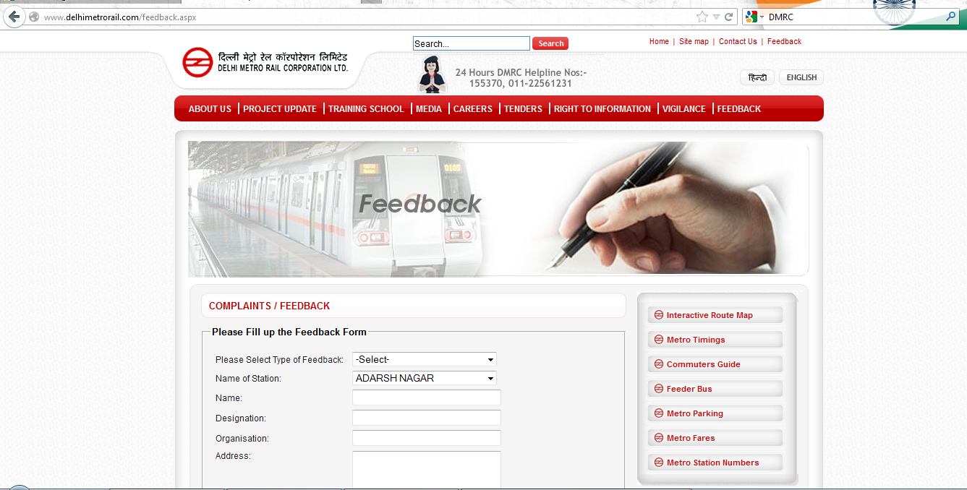
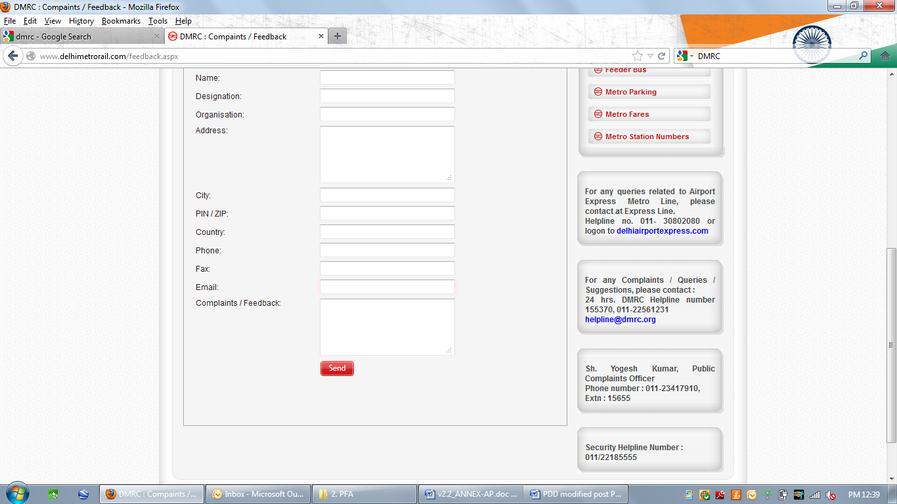

All issues identified during the crediting period through any of the methods shall have a mitigation measure in place that should be added to the monitoring plan.
D.5. Report on stakeholder consultation feedback round:
The SFR was initiatedfrom 26th July 2017 by making the documents publicly available on GS Website for two months. An email intimating the Stakeholders, who attended the LSC, was sent on the same date. However, no comments were received during this period.

Annex 1

CONTACT INFORMATION ON PARTICIPANTS IN THE PROJECT ACTIVITY

Organization: | Delhi Metro Rail Corporation Ltd.
Street/P.O.Box: | Fire Brigade Lane, Barakhamba Road
Building: | Metro Bhawan
City: | New Delhi
State/Region: | New Delhi
Postfix/ZIP: | 110001
Country: | India
Telephone: | +9111-23418304
FAX: | +9111-23418304
E-Mail: | saverma_rs@yahoo.com
URL: | http://www.delhimetrorail.com/
Represented by:
Title: | General Manager
Salutation: | Mr.
Last Name: | Verma
Middle Name: | Adhar
First Name: | Sant
Department: | Environment
Mobile: | +91-9811106868
Direct FAX: | +9111-22484743
Direct tel: | +9111-22484743
Personal E-Mail: | saverma_rs@yahoo.com

Annex 2 - Information regarding Public Funding

The Project activity is partially financed by the Government of Japan through JICA. The funding however is separate from and is not counted towards the financial obligations of the aforesaid party. The ODA declaration form (Annex D) has been signed and submitted for validation.
Annex 3: VER sheet

Phase III Energy Consumption in kWh (Project energy consumption)

Energy Consumption PerSqm (Project)
$$η_{PJ,m}= \sum_{ST=1}^{ST=n}{\left({EC}_{PJ,m}÷A_{PJ}\right)}$$

Energy Efficiency factor
$$η_{f,m}= η_{BL,m}-η_{PJ,m}$$

January | February | March | April | May | June | July | August | September | October | November | December
0.96 | 0.95 | 1.21 | 1.25 | 1.37 | 1.44 | 1.52 | 1.50 | 1.23 | 1.27 | 0.97 | 0.93

Energy Savings
$${ES}_{ST}=η_{f,m}×A_{ST,m}$$

BE_{y} = ES_{y}* EF_{y}
BE_{y} = 6479.8*0.9837
= 6374

Annex 4

BASELINE INFORMATION

Data fixed ex-ante

Data / Parameter: | EFy
Data unit: | t CO2/MWh
Description: | CO2 emission factor for the NEWNE grid
Source of data used: | CEA published grid emission factors
Value applied: | 0.9837tCO₂/MWh
Justification of the choice of data or description of measurement methods and procedures actually applied : | Central Electricity Authority (CEA) database, version 9 dated January 2014 values have been used for authenticity of the data, available publicly by Govt of India with a view to obtain uniformity of approach in the country towards a common objective.
Any comment: | http://www.cea.nic.in/reports/planning/cdm_co2/cdm_co2.htm

http://www.daikintanzania.com/vrv.asp
http://www.cea.nic.in/reports/planning/cdm_co2/cdm_co2.htm

