MONITORING REPORT FORM (CDM-MR) *
Version 01 - in effect as of: 28/09/2010

CONTENTS

- General description of the project activity
  - Brief description of the project activity
  - Project participants
  - Location of the project activity
  - Technical description of the project
  - Title, reference and version of the baseline and monitoring methodology applied to the project activity
  - Registration date of the project activity
  - Crediting period of the project activity and related information
  - Name of responsible person(s)/entity(ies)

- Implementation of the project activity
  - Implementation status of the project activity
  - Revision of the monitoring plan
  - Request for deviation applied to this monitoring period
  - Notification or request of approval of changes

- Description of the monitoring system

- Data and parameters monitored
  - Data and parameters used to calculate baseline emissions
  - Data and parameters used to calculate project emissions
  - Data and parameters used to calculate leakage emissions
  - Other relevant data and parameters

- Emission reductions calculation
  - Baseline emissions calculation
  - Project emissions calculation
  - Leakage calculation
  - Emission reductions calculation
  - Comparison of actual emission reductions with estimates in the registered CDM-PDD
  - Remarks on difference from estimated value

MONITORING REPORT
Version 3.0 19/05/2017

Energy Efficient Cook Stoves for Siaya Communities, Kenya
GS 879
Monitoring period 5 (01/01/2017 - 31/12/2017)

SECTION A. General description of the project activity

A.1. Brief description of the project activity: >>
>>
1. The objective of this project is to construct energy efficient stoves for rural communities in the Siaya County in Nyanza province, Kenya, to replace inefficient 3-stone fires for cooking. Over 7 years the project plans to install approximately 48,900 stoves into households in Siaya County, Kenya.
An innovative village based community savings and loaning mechanism is integrated in the project to enhance affordability and access to efficient cook stoves through soft loans. This scheme involves local capital mobilization methodology that seeks to address the unmet needs of the poor brought about by the existing gap in the major financial services providers like the banks and insurance companies.

2. The employed technology is a fix installed biomass rocket stove designed for burning wood and consisting of two cooking units that can be separately fired. The efficient cook stoves are constructed using locally available materials, such as mud, bricks and sawdust.

3. Relevant dates for the project activity:
Start date of the project: 04 October 2010
Start date of crediting period: 01 January 2011
Date of first stove sale: 04 October 2010
First monitoring period: 01 January 2011 – 02 July 2012
Second monitoring period: 03 July 2012 to 31 Dec 2013
Third monitoring period: 01 Jan 2014 to 31 Dec 2014
Fourth monitoring period: 01 Jan 2015 to 31 Dec 2015
Fifty monitoring period: 01 Jan 2016 to 31 Dec 2016
Sixty monitoring period: 01 Jan 2017to 31 Dec 2017
Date of registration: 03 July 2012
Project is in continuous operation.

4. Total emission reductions achieved in this monitoring period are 110,179tCO2e

A.2. Project Participants
>>
Name of Party involved (*)  ((host) indicates a host Party) | Private and/or public entity(ies) project participants (*)  (as applicable) | Kindly indicate if the Party involved wishes to be considered as project participant (Yes/No)
Kenya (host) | Private entity:  - Tembea Youth Centre for Sustainable Development | No
Switzerland  (Annex 1) | Private entity  - myclimate Foundation | No

A.3. Location of the project activity:
>>
Country: Kenya
Province: Nyanza
County: Siaya
Coordinates: The County is located between the following coordinates: 0°24'08.52''S, 34°17'24.05''E to the south, 0°01'57'59''S, 34°00'31.65''E to the west, 0°19'04.01''N, 34°16'52.80''E to the north and 0°06'38.41''N, 34°33'16.82''E to the far east.
The coordinates of the town Ugunja, where the office of the project owner Tembea Youth Centre for Sustainable Development is located, are 00° 10' 59.88" N and 34° 17' 59.99" E.
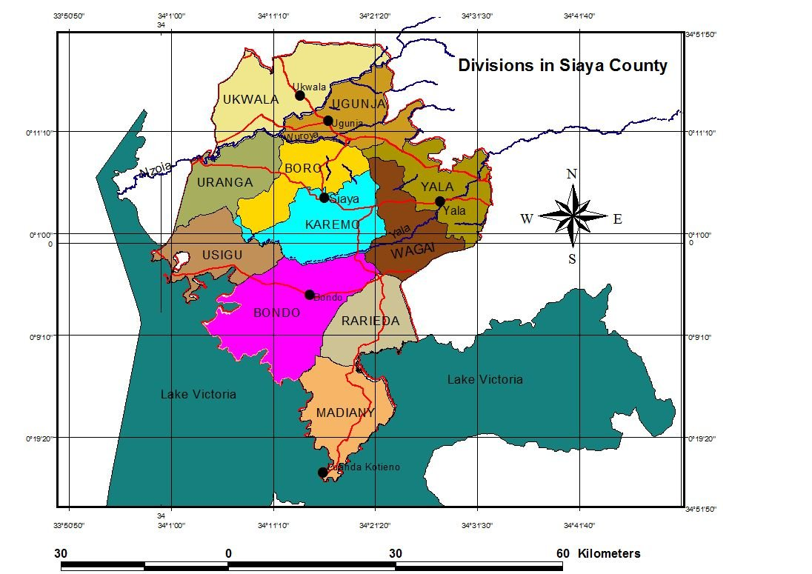
Map 1: Divisions in Siaya County

A.4. Technical description of the project
>>
The project currently produces and installs one type of efficient biomass stoves.

The project disseminates a rocket-type improved cook stove to replace the use of open fires for cooking. The efficient cook stoves are constructed using locally available materials, such as mud, bricks and sawdust. Local artisans are identified in the villages and trained in stove construction and household mobilisation.

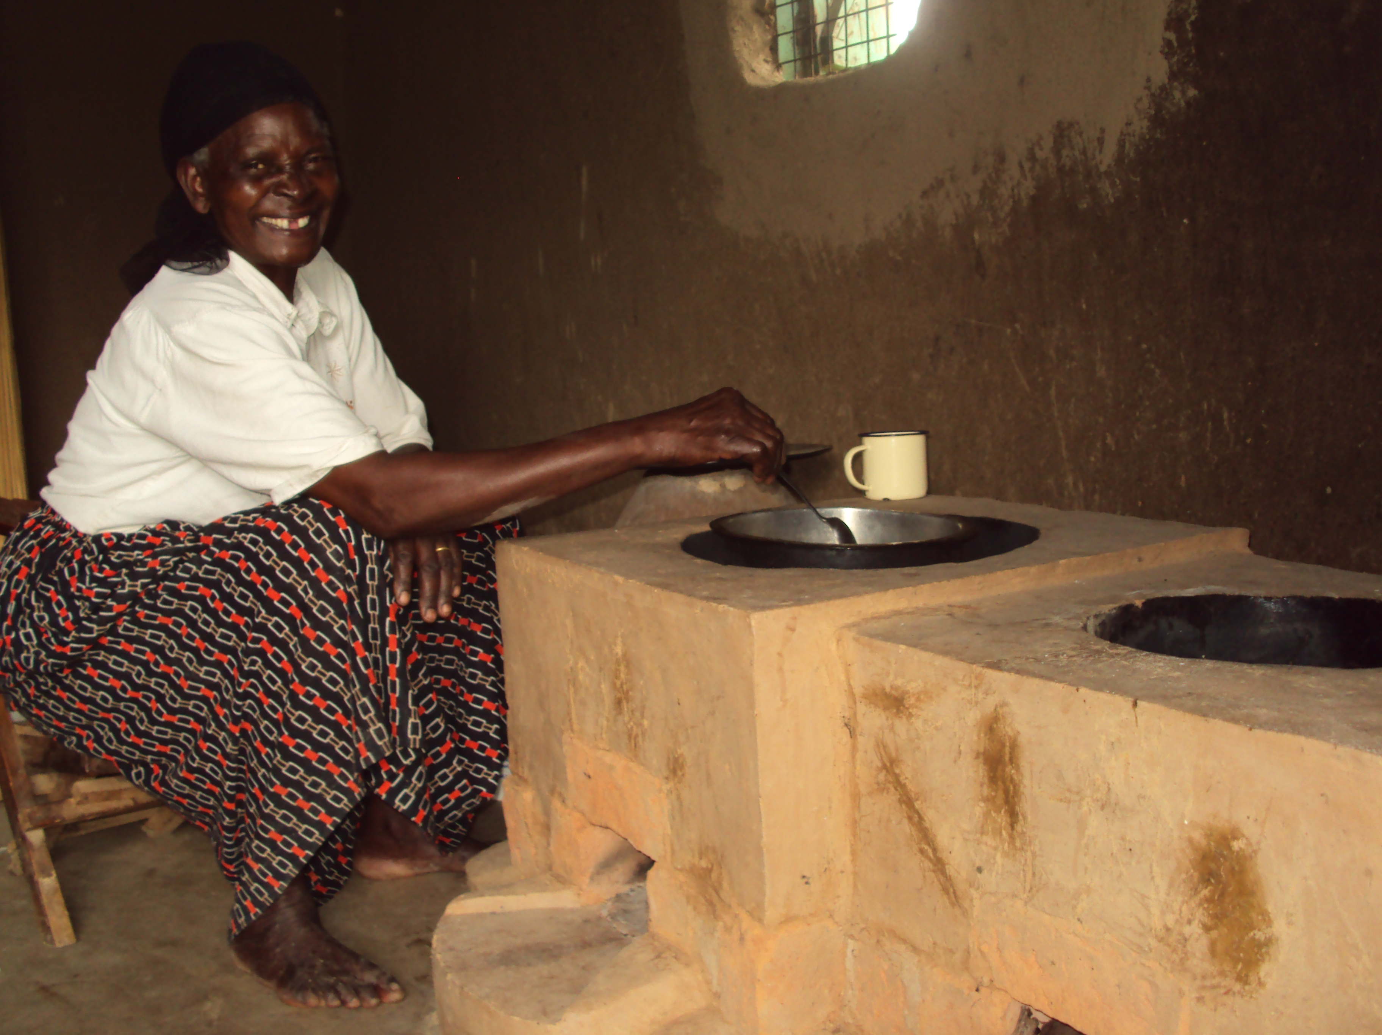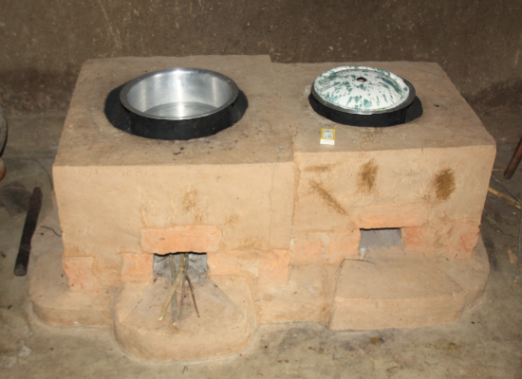
Installed project rocket stove with two cooking units.

A.5. Title, reference and version of the baseline and monitoring methodology applied to the project activity:
>>
The approved monitoring methodology applied to the project activity is Gold Standard methodology “Technologies and Practices to Displace Decentralized Thermal Energy Consumption (11/04/2011).” The reference is http://www.cdmgoldstandard.org/project-certification/gs-methodologies

A.6. Registration date of the project activity:
>> 03 July 2012

A.7. Crediting period of the project activity and related information (start date and choice of crediting period):
>> The start date of the crediting period is 01 January 2011.

A crediting period of 7 years with the option of renewal is chosen for the project activity

A.8. Name of responsible person(s)/entity(ies):
>>
Jared Buoga, Tembea Youth Center for Sustainable Development
buoga.jared@tembeayouth.org

Job Orina, Tembea Youth Center for Sustainable Development
job.orina@tembeayouth.org

Tobias Hoeck, myclimate
tobias.hoeck@myclimate.org

SECTION B. Implementation of the project activity

B.1. Implementation status of the project activity
>>
- Start date of operations: 04 October, 2010
- Actual Operations: The project continuously installed efficient cook stoves since the start of project implementation. Since then a total of 44,156 project stoves have been installed. In this way the project could provide clean and efficient cooking to 205,105 persons. The project also continuously trained community members in the Community Savings and Loaning Methodology (CSL) and established to date a total of 1503 groups with 44,315 participants: of it there are 1257 supervised groups with 39,771 participants. 100% of all cook stoves installed where purchased through the CSL mechanism. This clearly shows how important this saving and loaning mechanism is for the dissemination and affordability of the cook stove.

Table 1: Annual stove installations
Year | number of stoves
2010 | 324
2011 | 4,662
2012 | 5,139
2013 | 5,187
2014 | 6,840
2015 | 14,186
2016 | 7,818
2017 | 6,940
TOTAL | 51,097

Furthermore, the project trained 168 persons in efficient stove construction and conducted awareness and education events on efficient cooking and climate change.
Tembea supports a climate change education program that targets primary and secondary schools. In the monitoring period Tembea was able to implement the program in Siaya County and the entire Nyanza region. The following activities were accomplished;
- Development of Information and education communication materials
- Running a workshop that brought together various actors in Kenya and in climate education
- Community based trainings on climate change
- Support for climate change/environment clubs in schools through provision of vegetable seeds
- Establishment of tree nurseries in schools

The project’s awareness creation activities reached a total number of 3094 people.

- Impact on applicability of methodology: No events occurred during this monitoring period, which impact the applicability of the monitoring methodology.

B.2. Revision of the monitoring plan
>>
The validated monitoring plan has not been revised.

Forward Action Request from Gold Standard 4rd issuance review:

As part of the next monitoring the PP shall provide evidence of unique users of 1320 duplicate data stoves for instance it shall provide names of women in polygamous families, names or pictures of end users using mobile number and address of relatives or friends to ensure uniqueness and verifiability of data. In case PP is unable to provide user data as requested then equivalent VER shall be deducted from the next verification for both this and next monitoring period.

Action taken
- The PP approached GS to enable them address the FAR gradually, the request was approved allowing the PP to close the FAR by the 6th verification.
- By the date of writing this report the PP had traced 1320 stove owners and changed details as expected. The process sought to identify the location of the stoves, the stove owners and stove users. The data has been presented in excel format for consideration.
- The corrections undertaken have been presented for action (170218_FAR list_ver 1)
We have met the outlined tasks by this 6th verification.

B.3. Request for deviation applied to this monitoring period
>>
NA

B.4. Notification or request of approval of changes
>>
NA

SECTION C. Description of the monitoring system
>>
A detailed description of the monitoring system can be found in the latest version of the Monitoring Manual provided as a separate document. This includes roles and responsibilities, organizational structure, etc.

Monitoring coordination

Specific Personnel and Qualifications
Name | Designation | qualification
Job Orina | Internal monitoring manager | Bsc In Disaster Mitigation and Sustainable development, certificate in Low Carbond development (WBI) and monitoring & evaluation (UNPAN), long exepirience in data collection, analysis and report preparation as well long experience in the climate change sector.
Victor John Mondi | Data Manager/deputy manager | Bsc In Disaster Mitigation and sustainable development, long experience in data managment
Nicholas Ngesa | Project officer in charge of construction | Bachelor of Commerce
Joshua Omondi | Project officer in charge of CSL | Certifcate in project design and development and Certificate in Community saving and loaning
Erick Otieno | Field officer csl/stove construction | Certificate in Community Saving and Loaning
Sarah Sophy | Finance officer | Dilploma in Community development and social work, certificate in Accounting
Vincent Odour | Lead artisan | Long experience in stove construction, kenya secondary school certificate

General Summary of Monitoring System:

Data management and storage
Tembea has developed internal mechanisms to ensure availability of data within and beyond the project period. All data used for monitoring is stored in soft and hard copies. Tembea uses cloud storage, back up systems as well as file cabins in the office to ensure safe keeping of the data.

Monitoring data collection tools and methodologies
The following approaches are used in collecting data for monitoring;
a) Office based
- Sales record: this is an excel file that is used to enter details about the stoves. The file enable entry on the data of sale, name of stove owner, location, postal address, telephone number, GPS coordinates, mode of use, stove type, stove number and other monitoring details.
- CSL database: this is a customized excel file that is used to analyze and store data on the community savings and loaning approach that is used to facilitate local communities to acquire cook stoves. The file capture the names of the groups, names and sex of the members, dates of formation, asset based information, loan information amongst others.
- Excel sheet for monitoring data: this is a template that is used to enter and store all the data collected from the field for monitoring surveys. The file captures the questions in the questionnaires and their varying responses. This is used to capture the sustainable development indicators that the project is promoting.
b) Field based
- Artisan Data sheet: this is a tool used by the artisan involved in the construction of the stoves in the field. They capture the following details; date of construction, name of stove user, sub-location, village, address and phone number.
- Lead Artisan construction summary sheet: This is a tool that has been developed to help lead artisans collect information on the stoves constructed. The template collects the date of construction, the constructing artisan information, stove owner name, contacts, stove number, mode of purchase, initial amount, GPS coordinates and lead artisans remarks.
- Transaction books for CSL: these are books that are used by the CSL groups to record their transactions. The book collect the details of the groups including, date of formation, group name, names of members, transaction procedures, loans information and meetings dates.
- Questionnaires: there are many questionnaires that are administered to monitor project progress. The Questionnaires include the one for monitoring and usage survey. They are all attached in the monitoring manual.
C) Data flow consistency and intervals
- Sales Record: the sales records is updated once a month. Every other Monday of the week the data manager receives data from the field and throughout the month QA/QC procedures are administered on the data.
- CSL database: is updated once a month. Throughout the month field officer and the project officer are involved in collecting and verifying data from the groups.
- Excel sheet for monitoring data: this is done once a year as is agreed upon with the project partners.
D) QA/QC measures
Tembea is responsible for ensuring data quality, the following measures are undertaken for the information described above;
- Tracking of data
- Use of SP/SPA
- Counter checking with field officer documents
- Review of group transaction books
- Review of financial records
- Counter checking of data

SECTION D. Data and parameters

D.1. Data and parameters determined at registration and not monitored during the monitoring period, including default values and factors

Data / Parameter: | EF_{b,co2}
Data unit: | tCO2/t_fuel
Description: | CO2 emission factor arising from use of wood-fuel in baseline scenario
Source of data used: | 2006 IPCC Guidelines for National Greenhouse Gas Inventories, Tables 1.2/2.5
Value(s) : | 1.7472 tCO2/t wood
Indicate what the data are used for (Baseline/ Project/ Leakage emission calculations) | Default IPCC values for wood / wood waste are applied
Additional comment:

Data / Parameter: | EF_{b,non-co2}
Data unit: | tCO2/t_fuel
Description: | Non-CO2 emission factor arising from use of wood-fuel in baseline scenario
Source of data used: | 2006 IPCC Guidelines for National Greenhouse Gas Inventories, Table 2.5
Value applied: | 0.1356 tCO2eq/t wood (from 01.01.2013 on)
Justification of the choice of data or description of measurement methods and procedures actually applied : | Default IPCC values for CH4 and N20 emissions for wood / wood waste are applied and summed.  From 01.01.2013 on the following GWP100 are applied: 25 for CH4, 298 for N20.
Any comment:

Data / Parameter: | EF_{p,co2}
Data unit: | tCO2/t_fuel
Description: | CO2 emission factor arising from use of wood-fuel in project scenario
Source of data used: | 2006 IPCC Guidelines for National Greenhouse Gas Inventories, Tables 1.2/2.5
Value applied: | 1.7472 tCO2/t wood (=112.0 tCO2/TJ * 0.0156 TJ/ t )
Justification of the choice of data or description of measurement methods and procedures actually applied : | Default IPCC values for wood / wood waste are applied
Any comment:

Data / Parameter: | EF_{p,non-co2}
Data unit: | tCO2/t_fuel
Description: | Non-CO2 emission factor arising from use of wood-fuel in project scenario
Source of data used: | 2006 IPCC Guidelines for National Greenhouse Gas Inventories, Table 2.5
Value applied: | 0.1356 tCO2eq/t wood (from 01.01.2013 on)
Justification of the choice of data or description of measurement methods and procedures actually applied : | Default IPCC values for CH4 and N20 emissions for wood / wood waste are applied and summed.  From 01.01.2013 on the following GWP100 are applied: 25 for CH4, 298 for N20.
Any comment:

Data / Parameter: | f_{NRB,i,y}
Data unit: | Fractional non-renewability (%)
Description: | Non-renewability status of woody biomass fuel in scenario I during year y
Source of data used: | CDM default value: http://cdm.unfccc.int/DNA/fNRB/index.html
Value applied: | 92%
Justification of the choice of data or description of measurement methods and procedures actually applied : | The CDM default value for fNRB published on the CDM website for Kenya and approved by the Kenyan DNA is applied.
Any comment: | The applied methodology states on page 25: “"The non-renewable biomass fraction is fixed based on the results of the NRB assessment. Over the course of a project activity the project proponent may at any time choose to re-examine renewability by conducting a new NRB assessment. In case of a renewal of the crediting period and as per GS rules, the NRB fraction must be reassessed as any other baseline parameters and updated in line with most recent data available".

Since a fixed baseline is applied, the following baseline parameters are also known. They will not be monitored.

Data / Parameter: | P_{b,y}
Data unit: | t_biomass/unit-year and t_biomass/unit-day
Description: | Quantity of woody biomass consumed in the baseline scenario in year y and per day in year y.
Source of data used: | BFT 2011
Value applied: | 2.6645 t wood/year and 0.0073 t wood/day
Justification of the choice of data or description of measurement methods and procedures actually applied : | Estimated mean (justified because statistical analysis fits within 90/30 rule).
Any comment:

The following project parameter from the PFT was also known at validation, but it is monitored and updated if needed during the crediting period.

Data / Parameter: | P_{p,y}
Data unit: | t_biomass/unit-year and t_biomass/unit-day
Description: | Quantity of woody biomass consumed in the project scenario in year y and per day in year y.
Source of data used: | PFT 2015
Value applied: | 1.3505 t wood/year and 0.0036t wood/day
Justification of the choice of data or description of measurement methods and procedures actually applied : | Estimated mean (justified because statistical analysis fits within 90/30 rule).
Any comment: | Results of the PFT 2011 were confirmed by PFT Update 2017

D.2. Data and parameters monitored
>> Since a fixed baseline is applied only project parameters but no baseline parameters are monitored.

Data / Parameter: | Project technologies credited (units)
Data unit: | Number of stoves installed
Description: | Technologies in the project database/Total Sales Record for project scenario for the year y.
Measured /Calculated /Default: | Measured
Source of data: | Tembea sales records
Value(s) of monitored parameter:
  Year | number of stoves
  2010 | 324
  2011 | 4,662
  2012 | 5,139
  2013 | 5,187
  2014 | 6,840
  2015 | 14,186
  2016 | 7,818
  2017 | 6,940
  TOTAL | 51,097
Indicate what the data are used for (Baseline/ Project/ Leakage emission calculations) | Calculation of technology days
Monitoring equipment (type, accuracy class, serial number, calibration frequency, date of last calibration, validity) | n.a.
Measuring/ Reading/ Recording frequency: | Continuously
Calculation method (if applicable): | The Total Sales Record is continuously populated with all sales of stoves installed since the start date 04 October 2010.  The Total Sales Record for this monitoring period contains sales from 04 October 2010 to 31 December 2017.
QA/QC procedures applied: | Third party financial audit of stove sales activities

Data / Parameter: | P_{p,y}
Data unit: | t_biomass/unit-year and t_biomass/unit-day
Description: | Quantity of woody biomass consumed in the project scenario during year y
Measured /Calculated /Default: | We measured quantity of woody biomass consumed per unit-day and calculated to biomass/unit-year
Source of data: | PFT Update 2017
Value(s) of monitored parameter: | 1.2732 t wood/year and 0.0035t wood/day
Indicate what the data are used for (Baseline/ Project/ Leakage emission calculations) | Project emission reduction calculations
Monitoring equipment (type, accuracy class, serial number, calibration frequency, date of last calibration, validity) | Digital weight scales to measure wood weight
Measuring/ Reading/ Recording frequency: | Once prior to verification and then every other year
Calculation method (if applicable): | Mean of wood biomass use of all selected households was calculated
QA/QC procedures applied: | Transparent data analysis and reporting

Data / Parameter: | Usage (U_{p,2})
Data unit: | Percentage
Description: | Usage rate in project scenario during year y
Measured /Calculated /Default: | Calculated
Source of data: | Usage Survey 2017 (see Usage/Monitoring Survey Report)
Value(s) of monitored parameter: | 95.1%
Indicate what the data are used for (Baseline/ Project/ Leakage emission calculations) | Project emission reduction calculations
Monitoring equipment (type, accuracy class, serial number, calibration frequency, date of last calibration, validity) | N.A.
Measuring/ Reading/ Recording frequency: | Every year
Calculation method (if applicable): | A single usage parameter is weighted to be representative of the quantity of project technologies of each age being credited in a given project scenario. See Project Database for details.
QA/QC procedures applied: | Random sampling of population

Data / Parameter: | Project Technology Days (N_{p,1})
Data unit: | Number of days
Description: | Cumulative number of technology days in the project database for project scenario
Measured /Calculated /Default: | Calculated
Source of data: | Sales record/Project database
Value(s) of monitored parameter: | 17,484,804
Indicate what the data are used for (Baseline/ Project/ Leakage emission calculations) | Project emission reduction calculations
Monitoring equipment (type, accuracy class, serial number, calibration frequency, date of last calibration, validity) | N.A.
Measuring/ Reading/ Recording frequency: | Every year
Calculation method (if applicable): | The number of days between the installation date of each stove and the day before registration (defining the first monitoring period) was calculated then adjusted for the 21 days time period between date of sale and start of stove usage for households.
QA/QC procedures applied: | N.A.

Data / Parameter: | Leakage (LE_{p,y})
Data unit: | t_CO2eq per year
Description: | Leakage in project scenario during year y
Measured /Calculated /Default: | Calculated
Source of data: | PDD and Monitoring/Usage Survey 2017
Value(s) of monitored parameter: | 0  Potential leakage effects were assessed at the stage of validation in 2012 and were considered insignificant.  Further, results from Monitoring/Usage Survey conducted in 2017 showed no leakage effects.
Indicate what the data are used for (Baseline/ Project/ Leakage emission calculations) | Project emission reduction calculations
Monitoring equipment (type, accuracy class, serial number, calibration frequency, date of last calibration, validity) | N.A.
Measuring/ Reading/ Recording frequency: | Every other year
Calculation method (if applicable):
QA/QC procedures applied: | Random selection of surveyed households.

Data / Parameter: | Similar cook stove project activities in the project area
Data unit: | Number of projects and/or extent of overlap
Description: | List of similar cook stove projects and an assessment of how (e.g. target population, cook stove type, etc.) and to what degree overlap occurs
Measured /Calculated /Default: | Reported
Source of data: | Gold Standard registry, UNEP Risoe CDM Pipeline and other local sources.
Value(s) of monitored parameter: | 0 (no similar project activity was identified)
Indicate what the data are used for (Baseline/ Project/ Leakage emission calculations) | Avoid double counting
Monitoring equipment (type, accuracy class, serial number, calibration frequency, date of last calibration, validity) | N.A.
Measuring/ Reading/ Recording frequency: | Annually
Calculation method (if applicable): | N.A.
QA/QC procedures applied: | N.A.

Sustainable Development Indicators:

Data / Parameter: | SD 1) Air Quality
Data unit: | Number of households
Description: | # of positive comments from stove users
Measured /Calculated /Default: | Measured
Source of data: | Monitoring/Usage Survey 2017
Value(s) of monitored parameter: | 100 % of households state improved indoor air quality
Indicate what the data are used for (Baseline/ Project/ Leakage emission calculations) | N.A.
Monitoring equipment (type, accuracy class, serial number, calibration frequency, date of last calibration, validity) | N.A.
Measuring/ Reading/ Recording frequency: | Every year
Calculation method (if applicable): | N.A.
QA/QC procedures applied: | Random sampling of population

Summary: The target for this indicator was that all new stove users give positive comments about indoor air quality. We found that all (100%) stove users agree that the project stove generates less smoke emissions than the baseline stove. As specific indicators for improvements of air quality in the kitchen households mention less eye irritation (98%), it is easier to breathe (95%), less coughing (90%) and less headache (78%). Thus, it can be concluded that the project stove considerably improved indoor air quality and this has an effect on stove users’ health.

Data / Parameter: | SD 2) Quality of employment
Data unit: | Number of persons
Description: | Number of artisans trained in stove construction
Measured /Calculated /Default: | Calculated
Source of data: | Training records
Value(s) of monitored parameter: | Number of artisans trained: 205(52% women, 48% men)
Indicate what the data are used for (Baseline/ Project/ Leakage emission calculations) | N.A.
Monitoring equipment (type, accuracy class, serial number, calibration frequency, date of last calibration, validity) | N.A.
Measuring/ Reading/ Recording frequency: | Every year
Calculation method (if applicable): | N.A.
QA/QC procedures applied: | N.A.

Data / Parameter: | SD 3) Livelihood of the poor
Data unit: | Time (hours/year), money (KSH/year) and number of persons
Description: | - Time and money savings due to reduced fuel consumption: Time and money spent on fuel per household per year compared to the baseline scenario.  - Number of people in savings and loaning groups:  - to acquire efficient cook stoves  - to access medical care, pay for school fees, and other social services.
Measured /Calculated /Default: | Calculated
Source of data: | Household interviews for Monitoring Survey 2017.  Record keeping of savings and loaning groups.
Value(s) of monitored parameter: | - Time and money savings due to reduced fuel consumption:  8,616 KES saved per household per year  280 hours’ time saved per household per year  - Number of people in savings and loaning groups:  - Total: 51,097  - 51,097 acquired efficient cook stoves  - Purposes loans are used for: 35% for trade activities, 21% to access medical care, 25% for food, and 19% for other purposes.
Indicate what the data are used for (Baseline/ Project/ Leakage emission calculations) | N.A.
Monitoring equipment (type, accuracy class, serial number, calibration frequency, date of last calibration, validity) | N.A.
Measuring/ Reading/ Recording frequency: | Every year
Calculation method (if applicable): | N.A.
QA/QC procedures applied: | N.A.

Summary:
The BS estimated an expenditure of KES 10,972 on fuel per year and 431 hours used in fuel gathering per year for the baseline scenario. The monitoring survey 2017 showed average annual expenditures of KES 2,356 on fuel and 151 hours for fuel collection. This results in average annual savings of KES 8,616 and 280 hours per household.
There are a total of 51,097persons participating in 1,579 Saving and Loaning Groups established to date: of it there are 1333 supervised groups with 46,533participants. 100% of participants used the CSL mechanism to purchase an efficient cook stove. Other common purposes loans are used for trade activities (35%), to access medical care (21%), for food (25%) and for other social services (19%).

Data / Parameter: | SD 4) Access to affordable and clean energy services
Data unit: | Number of households
Description: | Number of households using efficient cook stoves.
Measured /Calculated /Default: | Measured
Source of data: | Sales Record/Project Database
Value(s) of monitored parameter: | 48593
Indicate what the data are used for (Baseline/ Project/ Leakage emission calculations) | N.A.
Monitoring equipment (type, accuracy class, serial number, calibration frequency, date of last calibration, validity) | N.A.
Measuring/ Reading/ Recording frequency: | Every year
Calculation method (if applicable): | Number of stoves installed multiplied with latest usage rate (= 51,097 x 95.1)
QA/QC procedures applied: | N.A.

Summary:
The project installed stoves into 44,156 households. Applying the latest usage rate of 92.9% this results in 41021 stoves in use. From the latest monitoring and usage survey we know that households have on average 5.0 members. Thus, the project provided clean and efficient cooking stoves for 205,105 persons.

Data / Parameter: | SD 5) Human/institutional capacity
Data unit: | Number of women, number of persons
Description: | - Number of women trained:  - number of women trained for saving and loaning groups (CSL)  - number of animators (women) trained for awareness creation and education  - Number of people reached through awareness creation on efficient cook stoves and climate change.
Measured /Calculated /Default: | Calculated
Source of data: | Training records
Value(s) of monitored parameter: | - Number of women trained:  - 45,688 women trained for saving and loaning groups (CSL)  - 82animators (59 women and 23 men) trained for awareness creation and education  - 2,033people reached through awareness creation on efficient cook stoves and climate change.
Indicate what the data are used for (Baseline/ Project/ Leakage emission calculations) | N.A.
Monitoring equipment (type, accuracy class, serial number, calibration frequency, date of last calibration, validity) | N.A.
Measuring/ Reading/ Recording frequency: | Every year
Calculation method (if applicable): | N.A.
QA/QC procedures applied: | N.A.

Summary:
The project trained 51,097 persons (of which 45,688 are women) on CLS methodology and at the same time created awareness for clean cook stoves. In addition 2,033 persons were reached through awareness creation events in this monitoring period.

Data / Parameter: | SD 6) Quantitative employment and income generation
Data unit: | Number of persons
Description: | Number of people receiving income from project activity
Measured /Calculated /Default: | Measured
Source of data: | Employment records and financial records
Value(s) of monitored parameter: | - 79 artisans installing cook stoves  - 18 project staff (field officers, coordinator, administration, project officers…)  - 60 community mobilizers  Total: 157 persons receiving income from project activity  100% are local employees
Indicate what the data are used for (Baseline/ Project/ Leakage emission calculations) | N.A.
Monitoring equipment (type, accuracy class, serial number, calibration frequency, date of last calibration, validity) | N.A.
Measuring/ Reading/ Recording frequency: | Every year
Calculation method (if applicable): | N.A.
QA/QC procedures applied: | N.A.

The project aims at maintaining a close and continued contact with the stove users to ensure stove usage. This is important to receive feedback from the stove users and to advise on appropriate project stove application. One main instrument for this is the Community Savings & Loaning groups (CSL) approach. In addition also community mobilizers and environmental clubs in schools are crucial to reach out to households:
- The CSL groups play a very important role for the successful adoption and use of the project stove and discontinuation of the baseline technology. CSL groups meet on a weekly basis and provide a perfect framework for peer-to-peer support and knowhow exchange amongst stove users thus increasing use and adoption of the Tembea stoves. Further, Tembea staff attends CSL meetings of each group on a monthly basis. This is a good opportunity to get regular feedback from households on their experience with the project stove, to advise on appropriate stove usage and to discourage the use of the three stone fire.
- A network of community mobilizers visits stove users on a random basis to provide accompaniment/solidarity in decommissioning the traditional stoves. Regular reporting/feedback from the community mobilizers to lead artisans/project staff helps in gauging the level of discontinuation by stove users.
- The environmental clubs run by Tembea in schools in the project catchment area play a crucial role in sensitizing pupils/students in efficient stove usage and to discourage parents from using traditional stoves.
In addition a new awards scheme was recently introduced on effective and continuous use of Tembea stove during public awareness campaigns. Best stove users are awarded (e.g. with cooking pans or official certificate of recognition) during regular public awareness and education days as well as during visits by mobilizers.
The project monitors the use of baseline technology through monitoring/usage surveys.

SECTION E. Emission reductions calculation

E.1. Baseline emissions calculation
>> According to the applied methodology, there is no need to calculate baseline emissions separately. When the baseline fuel and the project fuel are the same and the baseline emission factor and project emission factor are considered the same, overall GHG reductions achieved by the project activity are calculated as follows (see applied methodology, page 14):

ERy = Σ_{b,y} (N_{p,y}* U_{p,y}* P_{p,b,y}* NCV_{b,fuel}* (f_{NRB,b,y}* EF_{fuel,CO2}+EF_{fuel,} _{nonCO2})) – LE_{p,y}

Where:
Σ_{b,y} = sum over all relevant (baseline b/project p) couples
N_{p,y} = cumulative number of project technology days included in the project database for project scenario p against the baseline scenario b in year y.
U_{p,y} = cumulative usage rate for technologies in project scenario p in year y, based on cumulative adoption rate and drop off rate revealed by usage surveys (fraction)
P_{p,b,y} = Specific fuel savings for an individual technology of project p against an individual technology of baseline b in year y, in tons/day, as derived from the statistical analysis of the data collected from field tests.
NCV_{b,fuel} = Net calorific value of the fuel that is substituted or reduced ((IPCC default for wood fuel, 0.015 TJ/ton)
f_{NRB,b,y} = fraction of biomass used in year y for baseline scenario b that can be established as non-renewable biomass
EF_{fuel,CO2} = CO2 emission factor of the fuel that is substituted or reduced. 112 tCO2/TJ for wood/wood waste.
EF_{fuel,} _{nonCO2} = Non-CO2 emission factor of the fuel that is reduced
LE_{p,y} = leakage for project scenario p in year y (tCO2eq/yr)

The parameters NCV_{b,fuel} and NCV_{p,fuel} are not applicable to this project since EF is in units of tCO2/t_fuel (see methodology page 21). Therefore the formula applied is:

ERy = Σ_{b,y} (N_{p,y}* U_{p,y}* P_{p,b,y}*(f_{NRB,b,y}* EF_{fuel,CO2}+EF_{fuel,} _{nonCO2})) – LE_{p,y}

E.2. Project emissions calculation
>> According to the applied methodology, there is no need to calculate project emissions separately. When the baseline fuel and the project fuel are the same and the baseline emission factor and project emission factor are considered the same, overall GHG reductions achieved by the project activity are calculated as follows (see applied methodology, page 14):

ERy = Σ_{b,y} (N_{p,y}* U_{p,y}* P_{p,b,y}* NCV_{b,fuel}* (f_{NRB,b,y}* EF_{fuel,CO2}+EF_{fuel,} _{nonCO2})) – LE_{p,y}

Where:
Σ_{b,y} = sum over all relevant (baseline b/project p) couples
N_{p,y} = cumulative number of project technology days included in the project database for project scenario p against the baseline scenario b in year y.
U_{p,y} = cumulative usage rate for technologies in project scenario p in year y, based on cumulative adoption rate and drop off rate revealed by usage surveys (fraction)
P_{p,b,y} = Specific fuel savings for an individual technology of project p against an individual technology of baseline b in year y, in tons/day, as derived from the statistical analysis of the data collected from field tests.
NCV_{b,fuel} = Net calorific value of the fuel that is substituted or reduced ((IPCC default for wood fuel, 0.015 TJ/ton)
f_{NRB,b,y} = fraction of biomass used in year y for baseline scenario b that can be established as non-renewable biomass
EF_{fuel,CO2} = CO2 emission factor of the fuel that is substituted or reduced. 112 tCO2/TJ for wood/wood waste.
EF_{fuel,} _{nonCO2} = Non-CO2 emission factor of the fuel that is reduced
LE_{p,y} = leakage for project scenario p in year y (tCO2eq/yr)

The parameters NCV_{b,fuel} and NCV_{p,fuel} are not applicable to this project since EF is in units of tCO2/t_fuel (see methodology page 21). Therefore the formula applied is:

ERy = Σ_{b,y} (N_{p,y}* U_{p,y}* P_{p,b,y}*(f_{NRB,b,y}* EF_{fuel,CO2}+EF_{fuel,} _{nonCO2})) – LE_{p,y}

E.3. Leakage calculation
>>According to PDD, no significant leakages are currently included.

Based on the monitoring conducted no leakages were identified in the possible leakage effects identified in PDD. Leakage therefore is:
∑ LE₁ = 0

E.4. Emission reductions calculation / table
>> According to the applied methodology, we applied the formulae:

ERy = Σ_{b,y} (N_{p,y}* U_{p,y}* P_{p,b,y}* NCV_{b,fuel}* (f_{NRB,b,y}* EF_{fuel,CO2}+EF_{fuel,} _{nonCO2})) – LE_{p,y}

Where:
Σ_{b,y} = sum over all relevant (baseline b/project p) couples
N_{p,y} = cumulative number of project technology days included in the project database for project scenario p against the baseline scenario b in year y.
U_{p,y} = cumulative usage rate for technologies in project scenario p in year y, based on cumulative adoption rate and drop off rate revealed by usage surveys (fraction)
P_{p,b,y} = Specific fuel savings for an individual technology of project p against an individual technology of baseline b in year y, in tons/day, as derived from the statistical analysis of the data collected from field tests.
NCV_{b,fuel} = Net calorific value of the fuel that is substituted or reduced ((IPCC default for wood fuel, 0.015 TJ/ton)
f_{NRB,b,y} = fraction of biomass used in year y for baseline scenario b that can be established as non-renewable biomass
EF_{fuel,CO2} = CO2 emission factor of the fuel that is substituted or reduced. 112 tCO2/TJ for wood/wood waste.
EF_{fuel,} _{nonCO2} = Non-CO2 emission factor of the fuel that is reduced
LE_{p,y} = leakage for project scenario p in year y (tCO2eq/yr)

The parameters NCV_{b,fuel} and NCV_{p,fuel} are not applicable to this project since EF in units of tCO2/t_fuel (see methodology page 21). Therefore the formula applied is:

ERy = Σ_{b,y} (N_{p,y}* U_{p,y}* P_{p,b,y}*(f_{NRB,b,y}* EF_{fuel,CO2}+EF_{fuel,} _{nonCO2})) – LE_{p,y}

The table below summarizes the values used in 2017 for the parameters of the applied formula:

Parameter | Project Scenario
Baseline wood use (tons/day) | 0.0073
Project wood use (tons/day) | 0.0035
P_{p,b,1}: Fuel savings (tons/day) | 0.0038
Fraction NRB | 0.92
U_{p} | 95.1
N_{p} | 17,484,804
EF_{fuel,CO2} | 1.7472
EF_{fuel,} _{nonCO2} | 0.1356
LE_{p} | 0

The formula for emission reduction calculations including the values used for the parameters is:

ER₂₀₁₆ = 17,484,804*0.951 * 0.0038 * (0.92 * 1.7472 + 0.1356) – 0

Total ERs = ER₂₀₁₆ = 110,179

Achieved emission reductions in the monitoring period per calendar year:
Year | ER (tCO2e)
2017 | 109,431
Total | 109,431

E.5. Comparison of actual emission reductions with estimates in the CDM-PDD
>>
This section shall include a comparison of actual values of the emission reductions achieved during the monitoring period with the estimations in the registered CDM-PDD.

Item | Values applied in ex-ante calculation of the registered CDM-PDD | Actual values reached during the monitoring period
Emission reductions (tCO₂e) | 2017: 82,500 | 2017: 110,179

E.6. Remarks on difference from estimated value in the PDD
> Differences between ex ante estimation of ER in PDD and actual monitored emission reductions for first monitoring period are due to the following reasons:
- Increased installation in the previous year due to increased community uptake
- Adjustment values for project technology days in use were not applied during writing the PDD.

Annex 1

References

No. | Description | Available at | File name
1 | Applied methodology:  “Technologies and Practices to Displace Decentralized Thermal Energy Consumption (11/04/2011).” | GS website:  http://www.cdmgoldstandard.org/project-certification/gs-methodologies | -
2 | Monitoring and Usage Survey Report 2017 | GS registry | 171120_Monitoring_Usage_Survey_Report_Tembe_V01.pdf
3 | Monitoring and Usage Survey Data 2017 | GS registry | 171122_Monitoring_Usage_Survey_analysis_V02.xlsx
4 | Monitoring Manual | GS registry | 120829_monitoring_manual_V02.pdf
5 | PDD | GS registry | 120710_PDD_Tembea_V3_2.pdf
6 | GS Passport | GS registry | 120710_GS_Passport_Tembea_V3_2.pdf
7 | Project Database V01 | GS registry | 171120_Tembea_project_database_V01.xlsx
8 | Tembea Monitoring report | GS registry | 171120_Tembea_monitoring_report_V01.pdf

This figure is lower than total number of CSL participants, since the training is conducted at the beginning of a loaning cycle and further participants join the group later on.

