
Project design document form
(Version 10.1)
Complete this form in accordance with the instructions attached at the end of this form.
BASIC INFORMATION
Title of the project activity | Energy Efficient Cook Stoves for Siaya Communities, Kenya
Scale of the project activity | Large-scale  Small-scale
Version number of the PDD | 3.2.5
Completion date of the PDD | 10 July 2012  07.03.2018
Project participants | Tembea Youth Centre for Sustainable Development  Foundation myclimate
Host Party | Kenya
Applied methodologies and standardized baselines | Technologies and Practices to Displace Decentralized Thermal Energy Consumption of 24/04/2015
Sectoral scopes linked to the applied methodologies | 3
Estimated amount of annual average GHG emission reductions | 144,910tCO₂e
  - Description of project activity
    - Purpose and general description of project activity
The objective of this project is to construct energy efficient stoves for rural communities in the Siaya County in Nyanza province, Kenya. Siaya County borders Busia County to the North, Vihiga and Kakamega counties to the North-East, and Kisumu County to the South East. The total area of the county is approximately 2,530 square kilometers. The County is located between the following coordinates: 0°24'08.52''S, 34°17'24.05''E to the south, 0°01'57'59''S, 34°00'31.65''E to the west, 0°19'04.01''N, 34°16'52.80''E to the north and 0°06'38.41''N, 34°33'16.82''E to the far east. Siaya county is divided into 11 administrative divisions namely, Ukwala, Ugunja, Karemo, Wagai, Yala, Rarieda, Madiany, Boro, Bondo, Uranga and Usigu. The coordinates for the town Ugunja, where the office of the project owner Tembea Youth Centre for Sustainable Development is located, are 00° 10' 59.88" N and 34° 17' 59.99" E.

As in many rural regions in developing countries, the supply of modern energy carriers such as electricity and fossil fuels is very expensive and limited. The overall poverty level in the County stands at 58.02% of the County’s population having increased from 41% in 1994. This means that more than half of the population is in some state of poverty. This level of poverty has implications on the County’s efforts in development initiatives since no meaningful development can take place with over half population still unable to meet their basic needs. The County has only 1.4% of the population use electricity for lighting and only 0.1% for cooking purpose. To meet their basic energy needs households rely on locally available biomass fuels such as firewood and also occasionally charcoal: almost 90% of households use firewood for cooking and 9% use charcoal for preparing their meals. Households in Siaya County traditionally cook on open fires consisting of 3 stones, in this way burning large amounts of fuel wood in a very inefficient way. This has severe impacts at the social (e.g. health) and environmental levels (e.g. deforestation, CO2 emissions). This project aims to mitigate these impacts by introducing energy efficient cook stoves to Siaya communities in Kenya.
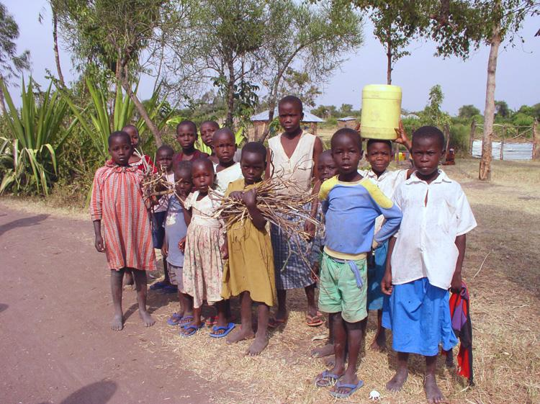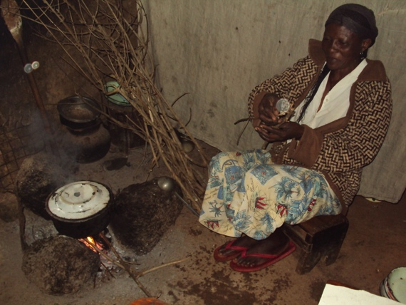
Fig1: Children collecting fuel wood Fig2: Baseline stove - open fire cooking
Biomass source of energy supplies up to of 68% of the total energy demand in Kenya. Based on a comprehensive study undertaken in the year 2000, on supply and demand for energy, the estimated demand for woodfuel and other biomass in Kenya stood at 34.3 million metric tonnes, comprising 15.1 million metric tonnes of fuelwood and 16.5 million metric tonnes of wood for charcoal. Close to 90% of the rural households use firewood for cooking, while 80% of semi-urban households use the same as a source of energy for their cooking.

The efficient cook stove is a biomass rocket stove designed for burning wood and consisting of two cooking units that can be separately fired. The stove is fixed and installed in households. Performance Field Tests (FT or Kitchen tests) carried out in June/July 2017, found daily per capita fuel wood consumption in the baseline of 1.24 kg. Comparing with other figures from several publications, a figure of 1.24 kg per person per day for the FT is representative and plausible figure.

This efficient cook stove brings multiple benefits to the stove users: From the FT results, it reduces firewood consumption by averagely 54% thus reducing the burden of firewood collection on women and children or relieving the household’s budget for fuel purchase; moreover, through the cleaner and more efficient combustion harmful smoke emissions are reduced and indoor air quality is considerably improved; the reduction of firewood consumption helps to conserve forest vegetation and to reduce CO2 emissions, which are responsible for climate change.
The efficient cook stoves are constructed using locally available materials, such as mud, bricks and sawdust. Local artisans are identified in the villages and trained in stove construction and household mobilisation.

The table below shows annual projected stoves dissemination and their respective emission reduction.
Project Year | Dates | New Stoves Disseminated | Stoves in Operation | Emission Reduction
1 | 1-Jan 2018- 31 Dec 2018 | 8400 | 59414 | 129620
2 | 1-Jan 2019- 31 Dec 2019 | 8400 | 63152 | 138395
3 | 1-Jan 2020- 31 Dec 2020 | 8400 | 66413 | 146050
4 | 1-Jan 2021- 31 Dec 2021 | 8400 | 69626 | 153593
5 | 1-Jan 2022- 31 Dec 2022 | 8400 | 71186 | 157255
6 | 1-Jan 2023- 31 Dec 2023 | 8400 | 65400 | 143672
7 | 1-Jan 2024- 31 Dec 2024 | 8400 | 66300 | 145785

An innovative village based community savings and loaning mechanism will be integrated to enhance affordability and access to efficient cook stoves through soft loans. This scheme involves local capital mobilization methodology that seeks to address the unmet needs of the poor brought about by the existing gap in the major financial services providers like the banks and insurance companies. This savings-led microfinance groups will lead to financial and social empowerment of individuals, households and communities, creating a platform for holistic community development on which community-based problem solving flourishes. It is expected the scheme will:
- Provide very poor households with effective, low cost means of improving livelihood security. The financial, social and human capital that locals especially women develop through regular saving-led micro-finance group meetings is transferred to an amazing array of actions that result in behaviour change.
- Provide a platform for community members to embrace e- banking innovations enhancing financial deepening & stabilizing rural financial markets.
- Provide an opportunity for the poor to acquire essential but costly household assets such as the energy efficient cook stoves out of their long term savings under the ASSET BASED FUND component that the community members are trained and closely monitored to operationalize among the self selected group members.

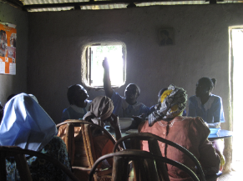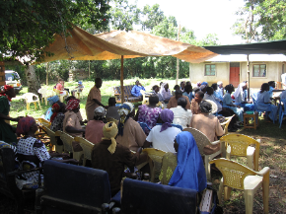
Fig 3 & 4: Community Saving and Loaning Groups during their weekly meetings counting funds and doing their transactions.

The project is developed as a carbon offset project by the Swiss non-profit foundation myclimate (Zurich, Switzerland) and is coordinated and implemented by the Kenyan Tembea Youth Centre for Sustainable Development (Ugunja, Kenya). The project is financed through the mechanism of carbon credits and will be certified under the Gold Standard Foundation. The first crediting period started from 01/01/2011-31/12/2017 and the second crediting period is anticipated to start from 01/01/2018 to 31/12/2024.

Energy Efficient Cookstoves for Siaya Communities – Project Set-Up
TEMBEA
(Project Coordination)
Community Savings and Loaning (CSL) Groups
Artisans
HOUSEHOLDS
Set up, training and monitoring of CSL groups – awareness and product promotion
Training, certification, contract/payment, monitoring and quality assurance
Construction of Tembea efficient cookstoves
Payment (Cash) – Stove Purchase Agreement.
Re-payment /Stove Purchase Agreement
Awareness creation, education and product promotion

    - Location of project activity
Siaya County found within Nyanza province, lies between 0°24'08.52''S, 34°17'24.05''E to the South, 0°01'57'59''S, 34°00'31.65''E to the West, 0°19'04.01''N, 34°16'52.80''E to the North and 0°06'38.41''N, 34°33'16.82''E to the East.
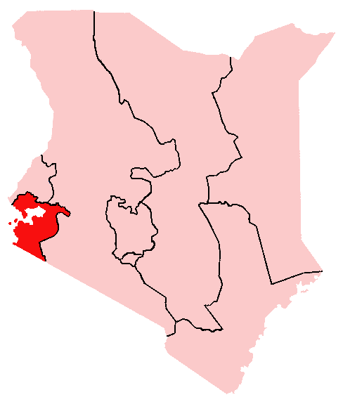
Map 1: Map of Kenya showing Nyanza province
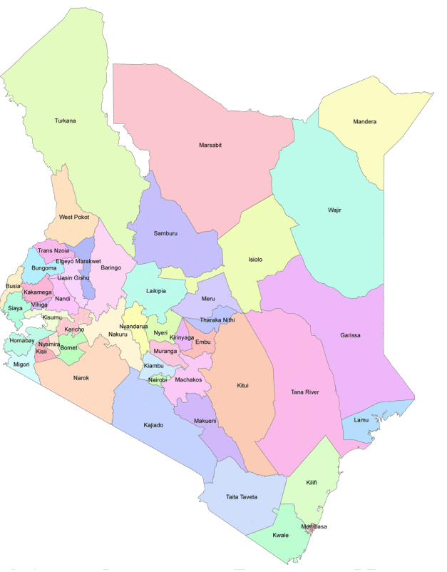
Map 2: Siaya County in Kenya
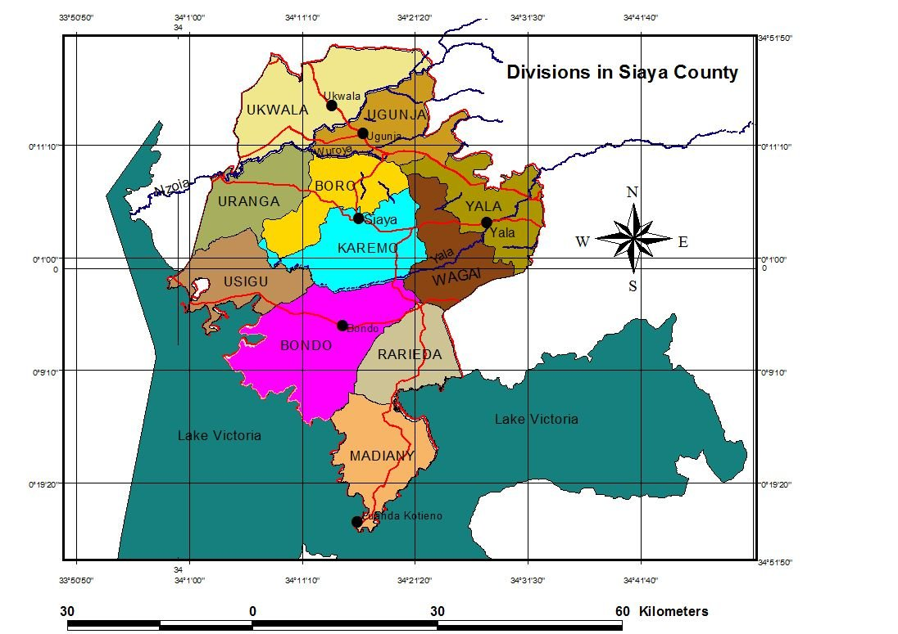
Map 3: Map of Siaya County

    - Technologies/measures
>>

    - Parties and project participants
Parties involved | Project participants | Indicate if the Party involved wishes to be considered as project participant (Yes/No)
Party A (host Party)  Kenya | Private entity A  Tembea Youth Centre for Sustainable Development | No
Party B  Switzerland  (Annex 1) | Private entity B  Foundation myclimate | No
… | …
    - Public funding of project activity
>>
There are no public funds from an ODA that has been channelled to this project. See ODA declaration in the Gold Standard Passport.

    - History of project activity
>>
Prior to implementing this project, the households in the project area used to cook mostly with three stone open fire. This type of fire burnt more non-renewable biomass. Both in the baseline and in the project scenarios the same fuel (non-renewable biomass) is used for cooking, but with project scenario being more efficient compared to the baseline.

The project disseminates a rocket-type improved cook stove to replace the use of open fire for cooking in Siaya County kitchens. This stove technology was originally introduced in 1997 in Kenya and was made in different versions and sizes to meet each client’s need such as households, hotel, institutional stoves and ovens. However, widespread dissemination was hindered due to lack of financing (also see sub-step 4 in Section B.5). The Tembea stove technology disseminated is new among the targeted households in Siaya County. The initial kitchen surveys didn’t show any of the technology type among the households. Stove users need to be trained on how to use it by the artisans once the construction is complete. This is currently being undertaken and so far the technology is well understood by those who already have adopted it. The stove disseminated is environmentally friendly and sound and has been found to be less smoky compared to the open fire, uses less firewood, has less fire accidents compared to open fire (baseline cooking scenario). The project stove (“Tembea stove”) utilised is a biomass rocket stove designed for burning wood and has got two cooking units that can be separately fired. The stoves are fixed installed in households and reduce firewood consumption by averagely 54% thus reducing GHG emissions associated with burning non-renewable biomass during cooking. The Tembea stove is projected to have a lifespan of 7 years.
The stove is made using locally available materials which are:
- Mud
- Bricks
- sawdust

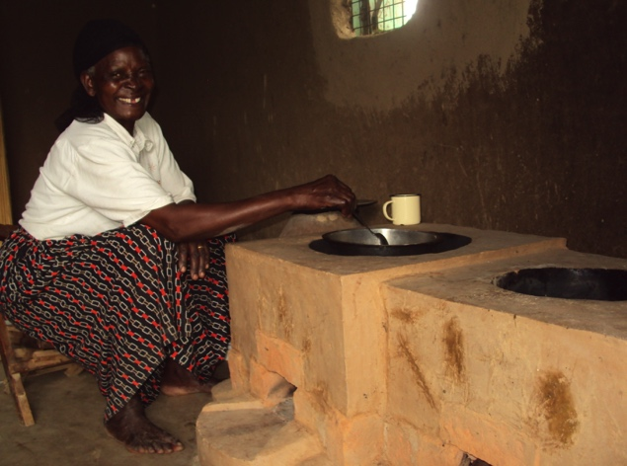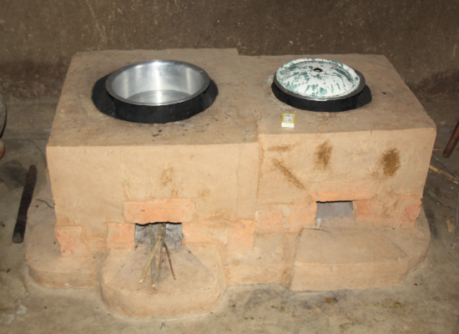
Fig 5 & 6: Installed project rocket stove with two cooking units.

In the absence of the project activity, households in Siaya County would continue to cook with open fire thus resulting in continued emission of greenhouse gases into the environment.

The process of stove Installation is outlined below from material preparation until construction and completion.

Construction process of the project stove:

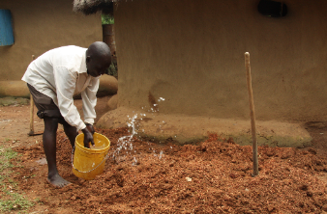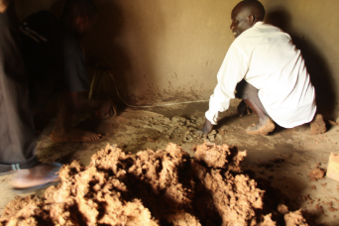
Fig 7: Mixing materials (mud and sawdust) Fig 8: Preparing stove location

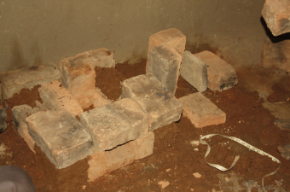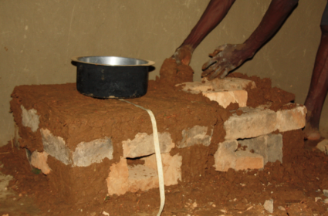
Fig 9: & 10: Arranging brick for the combustion chamber using measuring tapes and pots

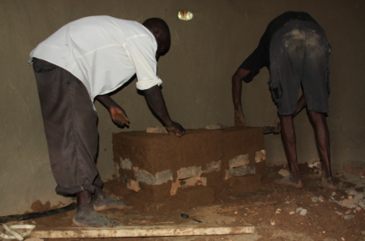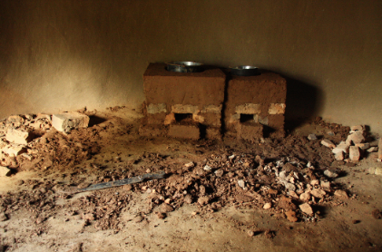
Fig 11 & 12: Adding bricks and mud to give the stove its final shape

It is projected an average of 700 Tembea stoves will be installed every month giving an average of 8400 stoves a year. In total up to 58800 stoves are projected to be built during the seven years crediting period of the project. Annually stoves will be excluded from the sale record taking into consideration aging (after 7 years age limit).
The baseline scenario is the same as the scenario existing prior to the start of the implementation of the project activity.
Project Year | Dates | New Stoves Disseminated | Stoves in Operation | Stoves excluded do to age
1 | 1-Jan 2018- 31 Dec 2018 | 8400 | 59414 | 324
2 | 1-Jan 2019- 31 Dec 2019 | 8400 | 63152 | 4986
3 | 1-Jan 2020- 31 Dec 2020 | 8400 | 66413 | 10125
4 | 1-Jan 2021- 31 Dec 2021 | 8400 | 69626 | 15312
5 | 1-Jan 2022- 31 Dec 2022 | 8400 | 71186 | 22152
6 | 1-Jan 2023- 31 Dec 2023 | 8400 | 65400 | 36338
7 | 1-Jan 2024- 31 Dec 2024 | 8400 | 66300 | 43838

    - Debundling
>>

  - Application of selected methodologies and standardized baselines
    - Reference to methodologies and standardized baselines
>>
Gold Standard Methodology “Technologies and Practices to Displace Decentralized Thermal Energy Consumption – v2.0
https://www.goldstandard.org/sites/default/files/revised-tpddtec-methodology_april-2015_final-clean.pdf

    - Applicability of methodologies and standardized baselines
>>
The project is the production and dissemination of energy efficient, wood-burning cook stoves to displace inefficient traditional, wood-burning 3-stone cooking fires. By reducing the consumption of unsustainably harvested fuel wood in households we are displacing decentralized thermal energy consumption and GHG emissions are reduced. Therefore it qualifies as an End-use, non-industrial Energy Efficiency Improvement project that displaces decentralized thermal energy consumption and satisfy the requirement of the methodology “Technologies and Practices to Displace Decentralized Thermal Energy Consumption - 24/04/2015”.

More specific, the following conditions apply:
- 1. The project boundary can be clearly identified, and the technologies counted in the project are not included in another voluntary market or CDM project activity (i.e. no double counting takes place). The project boundary includes the place of the kitchens where the project stoves are applied and the place of fuel collection, production, and transport in Siaya County. The households in this project are not part of another carbon reduction project. The project shall list other improved stove projects in the project area to establish if any of the stoves are also included in another project, and if so excluded from the project counting (see in section B.7.1. monitoring parameter “Similar cook stove project activities in the project area”).

- 2. The technologies each have continuous useful energy outputs of less than 150kW per unit (defined as total energy delivered usefully from start to end of operation of a unit divided by time of operation). From the FT (Kitchen test) we know that a Tembea stove uses 1.25t of fuel wood per year. With an energy content of fuel wood being 15GJ/t and its being a rocket type stove with thermal efficiency being at most 33%, then potential useful energy in a year is 6.21 GJ (1.25t x 15GJ x 0.33). This energy is delivered in at least 1hour 30min (30 minutes breakfast, 30 minutes lunch time and 30 minutes supper time) a day, which translates to at least 1.971 million seconds in a year. Hence the power rating of the Tembea stove is about 3.2kW (6.53GJ/1.971 M sec). This is far away less than 150KW thermal power output threshold for technologies under this methodology.

- 3. The use of the baseline technology as a backup or auxiliary technology in parallel with the improved technology introduced by the project activity is permitted as long as a mechanism is put into place to encourage the removal of the old technology (e.g discounted price for the improved technology) and the definitive discontinuity of its use. Continuous use of the traditional stove (3-stone fire) shall be monitored through Monitoring Surveys (kitchen surveys) and in case it is significant, the emissions from the use of this stove shall be considered in the project emission. However, as stated in the methodology page 4, footnote 5, “The removal and continued non-use of three stone fires and other easily constructed traditional devices is in many cases unlikely and impractical to monitor.”

- 4. The project proponent must clearly communicate to all project participants the entity that is claiming ownership rights of and selling the emission reductions resulting from the project activity. This must be communicated to the technology producers and the retailers of the improved technology or the renewable fuel in use in the project situation by contract or clear written assertions in the transaction paperwork. As a requirement of this methodology, the project has already communicated this information to the households acquiring a Tembea stove and that end users have a signed a consent note and agreement over the same (called Sales Purchase Agreement). The project has also informed artisans and all other project participants about the ownership of emission reductions from this project.

- 5. Project activities making use of a new biomass feedstock in the project situation (e.g. shift from non-renewable to green charcoal, plant oil or renewable biomass briquettes) must comply with relevant Gold Standard specific requirements for biomass related project activities, as defined in the latest version of the Gold Standard rule. This project is not introducing any new biomass feedstock. The fuel wood type in the baseline is the same as the fuel type in the project scenario.

    - Project boundary, sources and greenhouse gases (GHGs)
>>
The applied methodology has carefully defined the three parameters: Project Boundary, Target Area, and Fuel Collection Area.

- Project Boundary:
The project boundary is the individual households/kitchens which have installed a Tembea Stove

Target Area/Project Area/Fuel collection Area:
Siaya County
Project boundary
HH kitchens

Project boundary
HH Kitchens

Project boundary
HH kitchens

- Target Area:
Defined as all locations in Siaya County being Ukwala, Ugunja, Karemo, Wagai, Yala, Rarieda, Madiany, Boro, Bondo, Uranga and Usigu.

- Fuel Collection Area:
The entire Siaya County specificaly Ukwala, Ugunja, Karemo, Wagai, Yala, Rarieda, Madiany, Boro, Bondo, Uranga and Usigu locations

Source |  | GHG | Included? | Justification/Explanation
Baseline | Source 1 | CO₂ | Yes | Important source of emissions
Baseline | Source 1 | CH₄ | Yes | Important source of emissions
Baseline | Source 1 | N₂O | Yes | Can be significant in some fuels
Baseline | Source 1 | ---
Baseline | Source 2 | CO₂
Baseline | Source 2 | CH₄
Baseline | Source 2 | N₂O
Baseline | Source 2 | ---
Baseline | --- | ---
Baseline | --- | ---
Baseline | --- | ---
Baseline | --- | ---
Project activity | Source 1 | CO₂ | Yes | Important source of emissions
Project activity | Source 1 | CH₄ | Yes | Important source of emissions
Project activity | Source 1 | N₂O | Yes | Can be significant in some fuels
Project activity | Source 1 | ---
Project activity | Source 2 | CO₂
Project activity | Source 2 | CH₄
Project activity | Source 2 | N₂O
Project activity | Source 2 | ---
Project activity | --- | ---
Project activity | --- | ---
Project activity | --- | ---
Project activity | --- | ---
    - Establishment and description of baseline scenario
>>
Assessing the validity of the original/current baseline at the renewal of the crediting period
The CDM tool “Assessment of the validity of the original/current baseline and to update the baseline at the renewal of a crediting period” (Version 03.0.1, EB 66, Annex 47) is applied for assessing the validity of the original baseline. http://cdm.unfccc.int/methodologies/PAmethodologies/tools/am-tool-11-v3.0.1.pdf

Step 1: Assess the validity of the current baseline for the next crediting period

Step 1.1: Assess compliance of the current baseline with relevant mandatory national and/or sectoral policies
The current baseline (using traditional 3 stone fires for cooking for domestic purposes) complies with all relevant mandatory national and/or sectoral policies applicable at the time of requesting renewal of the crediting period.

Step 1.2: Assess the impact of circumstances
In the situation where the baseline scenario identified at the validation of the project activity was the continuation of the current practice without any investment, an assessment of the changes in the market characteristics is required for the renewal of the crediting period.
There are no changes in the market characteristics of the baseline scenario. A study from 2013 published by the Kenya National Bureau of Statistics shows that 90% of households in rural Kenya still cook with primitive fuels (mostly firewood), whereas only 9% use transitional fuel such as charcoal or kerosene and only 1% use advanced fuels like LPG or electricity (KNBS & SID 2013, p 35). Efficient cooking technologies are not yet largely disseminated in rural Kenya. Despite the various cook stove initiatives in
Kenya demand for efficient cooking technologies is high and will continue to be high considering that
Kenya’s population is estimated to grow to over 52 million by 2020 (Kenya Population Data Sheet 2011).

Step 1.3: Assess whether the continuation of use of current baseline equipment(s) or an investment is the most likely scenario for the crediting period for the renewal is requested
Assess whether the remaining technical lifetime of the equipment that would have continued to be used in the absence of the project activity, exceeds the crediting period for which the renewal is requested. Take into consideration market penetration of different technologies. Evaluate the penetration rate of different technologies that are available in the market and evaluate how they could affect the baseline.
90% of the rural population in Kenya still cook with primitive fuels, mostly firewood: The main fuel used for cooking is wood (90%), whereas charcoal or kerosene (9%) and advances fuels such as LPG and electricity (1%) are available only to a minority of households (KNBS & SID 2013, p 35). The common baseline technology is the 3-stone fire, which is easily built and rebuilt using 3 stones. The continuation of the current baseline equipment is the most plausible scenario as outlined in the additionality assessment above.

Step 1.4: Assessment of the validity of the data and parameters
Assess whether data and parameters that were only determined at the start of the crediting period and not monitored during the crediting period are still valid or whether they should be updated.
Some data and parameters determined at the start of the first crediting period need to be updated for the second crediting period. Please see section B.6.2 for newest and updated baseline parameters used for the second crediting period.
The application of steps 1.1, 1.2, 1.3, and 1.4 confirmed that the current baseline is still valid for the
second crediting period. However, the values of some data and parameters need to be updated for the
second crediting period.

Step 2: Update the current baseline and the data and parameters

Step 2.1: Update the current baseline
Update the current baseline emissions for the second crediting period, without reassessing the baseline
scenario, based on the latest approved version of the methodology applicable to the project activity.
The baseline fuel consumption for the defined scenarios has been reassessed with PFT according to the
latest applicable methodology. See section B.6.2 for updated data and parameters.

Step 2.2: Update the data and parameters
The default values (such as for GWP or emission factors), have been updated where needed using latest
available CDM default values. See section B.6.2 for updated data and parameters.
In the baseline scenario, one scenario was established in Siaya County, households that primarily cook with firewood on a 3-stone fire. From the baseline survey we know that 98% of the households in Siaya County indicated to cook with fuel wood as their primary source of fuel. 2% indicated charcoal as their primary source of fuel. However, 100% of the households stated 3 stone fire as their main baseline stove.

As per methodology, Technologies and Practices to Displace Decentralized Thermal Energy Consumption - 24/04/2015, the project proponent is required to carry out the following studies:
For the baseline:
- Baseline non-renewability of biomass assessment
- Baseline survey (BS) of target population
- Baseline performance field tests (BFT) of fuel consumption

For the project:
- Project non-renewability of biomass assessment
- Project survey (PS) of target population
- Project performance field tests (PFT) of fuel consumption

Most plausible baseline scenario:
Since it is assumed that the conditions are unchanging during the project period, a fixed baseline is established as recommended in the methodology “Technologies and Practices to Displace Decentralized Thermal Energy Consumption - 24/04/2015”, page 7, for project activities targeting non-industrial applications.

- Baseline and Project non-renewable biomass (NRB) assessment
The project applies a default value for non-renewable biomass of 92%

In developing the baseline emissions as per the methodology the following steps are crucial:

- Baseline and Project Surveys (BS and PS)
A combined baseline and project survey was conducted where the response on both the use of a 3 stone fire and a Tembea stove, as a project stove, were collected. The steps below were undertaken:

- Survey Representativeness
Household randomly selected represented the various cooking scenarios in Siaya County.
The sole kitchen regime is the domestic cooking using an open fire mode of cooking in the baseline with firewood. The sales record shows only one baseline scenario is available for the project:
One efficient cook-stove per household using fuel wood for cooking with a 3-stone fire as the baseline stove.

- Survey Sample Sizing
As required by the methodology where a baseline survey need to be carried out for each baseline scenario using representative and random sampling, following these guidelines for minimum sample size:
- Group size <300: Minimum sample size 30 or population size, whichever is smaller
- Group size 300 to 1000: Minimum sample size 10% of group size
- Group size > 1000 Minimum sample size 100

Cluster | Cluster size (stoves constructed until May 2017) | Kitchen survey sample size
One cluster established as those households cooking on 3-stone fire using firewood in the baseline | 6197 | Minimum of 100

The size of the baseline and project survey adopted was 100 houses. This is explained in detail in the kitchen survey report (baseline and project survey report).

- Data Collected
The data collected was specific to the characteristics of the baseline scenario, and gathered information about each of the following:
1. User follow up
a. Address or location
2. End user characteristics
a. Number of people served by baseline and project technology
b. Typical baseline technology usage patterns and tasks (commercial, institutional, domestic, etc.)
3. Baseline technology and fuels
a. Types of baseline technologies used and estimated frequency
b. Types of fuels used and estimated quantities
c. Seasonal variations in technology and fuel use
d. Sources of fuels; (purchased or hand-collected, etc) and prices paid or effort made (e.g. walking distances, persons collecting, opportunity cost)
e. Renewability and non-renewability indicators

Main findings of the Survey:
Baseline scenario:
- The mean fuel used was reported to be 24.2 sticks per week for households when cooking on a traditional stove.
- The respondents indicated that more fuel is used both at weekends and in the wet seasons. 6% and 27% indicated that they used more fuel during rainy seasons and weekends, respectively.
- Most households responded not to be using either stove for space heating nor providing light. Though there was small percentage of 24% who indicated they use the traditional stove for space heating. In terms of providing light, 9% indicated they used the traditional stove for providing light. These responses may be due to miss understanding the questions, to mean “a stove which one can feel the heat and can see the light during cooking”. This is also supported by the fact that the minimum mean temperature of Siaya district is 15ºC while the maximum being 30ºC . These temperatures are warm enough to warrant the need for space heating. Hence, there is no danger for leakage and thus no need to monitor the use of the stove for space heating.

Project scenario:
- The average fuel use was found to be 14.7 sticks per week when cooking on a Tembea stove.
- In terms of use of Traditional stove (3-stone fire), 66% of the households indicated they still had the stove even after acquiring a Tembea stove. And on the frequency of using it, 23% indicated they used the stove once a week and this was seen on the nature of foods that needed high power cooking like a mixture of beans and maize. There was up to 34% who indicated they still used the stove 3 to 5 times a week even after acquiring a Tembea Stove. Because the type of food cooked on a Traditional stove is the same both in the baseline and project scenario, the use of a Traditional stove does not contribute to the leakage in the project implementation.
- Leakage effect as a result of using of a charcoal stove in the project is insignificant. This is seen from the response on the frequency of use of the stove. Only 23% of the households use the stove once per week. Most households, 10%, responded they used it once a month. The rest indicated either they used it occasionally or never used it. Use of charcoal stove is negligible and thus needs not to be included in the monitoring plan. Based on the cooking pattern in the project area, a charcoal stove is used mostly during barbequing meat of preparing special bread called chapatti. An increase in the frequency of cooking on a charcoal stove is not foreseen in the project scenario hence the use of charcoal is expected to be the same in the project scenario as in the baseline scenario and therefore not contributing to leakage effect.
- In the case of the amount of food cooked with the new stove, 8% of the respondents indicated to cook more on a Tembea stove than on the Traditional stove. Asking how many more plates per day, half of the 8% indicated less than 2 plates while the other half indicating 2-5 plates. When probed why they cook more some attributed it to children growing up hence more food. Others attributed it to an additional member of the family coming to live with them. Therefore the increase in the amount of food cooked is not attributed in any way to the use of a Tembea stove. There is no foreseeable leakage from the amount of food cooked in the project scenario.
- 23% of the respondents indicated to use a Traditional stove at least once a week. Looking at the response on the types of foods cooked on the Traditional stove, the foods are associated with high power cooking. More so these foods are not the common type of foods cooked by Siaya people. These foods would be cooked about once a week and the frequency of the use of a Traditional stove is not expected to change in the scenario to warrant the possibility for leakage.

Fuel savings:
From the analysis of fuel savings and being conservative, the mean value for Tembea stove would be 14.7 sticks per week while for Traditional stove being 24.2 sticks per week. This represents a fuel savings of 9.5 sticks representing a fuel savings of 39%.

- Baseline and Project Performance Field Test (BFT and PFT)

A paired Performance Field Test was conducted where fuel use was established when a family cooks on a traditional (3 stone fire) and then after a period of seven days the same house was allowed to cook on Tembea stove again for a period of seven days. To be conservative as possible the Baseline FT was conducted end of July-beginning of August, which was a dry period. The Project FT was conducted after the first week of August during the short rains. From the survey findings, households indicated they use more fuel during rainy seasons compared to dry seasons. Thus the Performance Field Test gave lowest fuel use in the Baseline and highest fuel use in the Project scenario, hence conservative figures.

- Sample size and selection
The sample size to be used in the FT was based on the results obtained from BS/PS.
According to the applied GS methodology “Technologies and Practices to Displace Decentralized Thermal Energy Consumption - 24/04/2015”, sample size for the KPT is recommended to be 30 (with a minimum sample size of 20). In order to arrive at good results in the KPT, the methodology further gives guidance on defining the sample size based on the Coefficient Of Variation (COV) from BS/PS or other surveys available for this region. In this case, the COV was calculated based on the fuel saving results from the BS-PS. A COV of 0.63 was obtained. 50 households were sampled for the Baseline and Project performance field tests.

- Make quantitative measurements (Performance Field Tests)
This was conducted by visiting sampled household and carry out quantitative measurement of fuel wood usage by each household for a period of seven days each for the baseline and for the project scenario.
Specifically, the steps below were followed in carrying out the KPT as required by the methodology “Technologies and Practices to Displace Decentralized Thermal Energy Consumption - 24/04/2015” Annex 4 page 46-50:

- Selection of 50 kitchens sampled using a RANDOM selection method. This was done as explained in section 1.1.2 of Kitchen Test Report is also outlined in 170522_Tembea_BPFT_Sampling_v01.xls . Where 6197 stoves, which had been in operation for at least 0-1 years old since installation, were arranged in a list according to the date of installation. Using the link http://stattrek.com/Tables/Random.aspx, 50 random numbers were obtained from the list. These numbers represented households who were visited for kitchen test as explained in details in section 1.1.2 of Kitchen Test Report.
- Choosing of an appropriate test period and an appropriate time of year for the KPT. Late June and early July was chosen for the exercise. The first exercise was chosen to be late June before the start of short rains to achieve conservative figures when using the open fire and the second part involving the Tembea stove conducted during the first week when the short rains had just started. Because the BS and PS indicated higher use of fuel during rainy seasons, it then meant having higher figures during project stoves as possible, hence conservative fuel savings
- Making sure that all households involved in the KPT understand they were expected to cook normally during the test so as to capture the normal cooking behaviour. This was carried out and emphasized before the exercise started.
- Stressing and emphasizing that families cook only on the fuel provide for the purpose of monitoring how much was used. This was made possible by enumerators visiting the household kitchen participating in the KPT on a daily basis just to check on the same and asking whether any other fuel was used apart from the one given
- During the visit, the number of people cooked for was established and recorded in the data sheet as required by the Gold Standard Methodology.
- The fuel used in the KPT was purchased from the common fuel wood vendors in the market place and distributed to the households participating in the KPT. This was the type of fuel used normally by families hence there is no variation in moisture content. In order to avoid over use, an incentive of a T-shirt with Tembea Logo was given to families, which didn’t “over use” the fuel provided.
- Analysis of data was conducted as outlined in the excel file “170718_BPFT_baseline_2017_analysis_V03”Where out of the 50 households visited, 50 households were found to be eligible for analysis.
- After the successful completion of the exercise, no gift was given but a vote of thanks was given to every household that participated in the exercise.
The mean fuel used in the Traditional household was found to be 2.74 tonnes per year, which is 0.0075tonnes per day. The mean fuel for Tembea stove use was found to be 1.25 tonnes per year, or 0.0034 tonnes per day. The mean saving was found to be 1.49 tonnes of fuel per year or 0.0041 tonnes per day. The SD is 2.68 and the COV is 0.09 for the mean fuel saving. The 90% confidence is 0.63, which gives 2% precision (see “170718_BPFT_baseline_2017_analysis_V03’)With this precision and according to the 90/30 rule, the mean fuel savings can be used for emission reduction calculations.

- Specify the Units of emission reduction or fuel consumption
The unit of emission reduction is tCO2 per stove per day. This was then calculated from the results obtained from individual households. Out of 50 households visited during the FT were eligible to be used in data analysis of the results. Using a paired sample analysis, the baseline mean fuel use is found to be 0.0075t/day and in the project scenario to be 0.0034t/day. A paired fuel wood saving analysis shows a saving of 0.0041t/day. The percentage precision is found to be 2% based on the 90% confidence level. Therefore the mean value satisfies the 90/30 rule and thus the mean is the figure to be used for emission reduction calculations.

- Calculation of emission reduction
In this project the baseline fuel and project fuel are the same. Still the baseline emission factors and project emission factors are also the same. Hence the emission reduction in the project is calculated by using the equation on page 15 of the applied methodology:

Σb,p Sum over all relevant (baseline b/project p) couples

Np,y Cumulative number of project technology-days included in the project database for project scenario p against baseline scenario b in year y

Up,y Cumulative usage rate for technologies in project scenario p in year y, based on cumulative adoption rate and drop off rate (fraction)

Pb,p,y, Specific fuel savings for an individual technology of project p against an individual technology of baseline b in year y, in tons/day, and as derived from the statistical analysis of the data collected from the field tests

fNRB,b, y Fraction of biomass used in year y for baseline scenario b that can be established as non-renewable biomass (drop this term from the equation when using a fossil fuel baseline scenario)

NCV_{b,fuel} Net calorific value of the fuel that is substituted or reduced (IPCC default for wood fuel, 0.015 TJ/ton)

EF_{fuel,CO2} CO2 emission factor of the fuel that is substituted or reduced. 112 tCO2/TJ for wood/wood waste.

EF_{fuel,} _{nonCO2} Non-CO2 emission factor of the fuel that is reduced

LEp,y Leakage for project scenario p in year y (tCO2e/yr)

Leakage
The potential leakages as set out in the methodology (page 11) are assessed regarding their risk:

Leakage form | Estimate of risk | Justification
a) The displaced baseline technologies are reused outside the project boundary in place of lower emitting technology or in a manner suggesting more usage than would have occurred in the absence of the project. | Negligible | The displaced traditional stove is the least efficient stove, which is already the most common type of the stove in the rural area of Kenya. Siaya County being neighboured by rural set up, it is highly unlikely that households outside the project boundary who may have obtained a more efficient stove will go back to the use of the displaced 3-stone stove displaced by the project in Siaya County.
b) The non-renewable biomass or fossil fuels saved under the project activity are used by non-project users who previously used lower emitting energy sources. | no | 100% of the households use firewood for cooking and there is no likelihood for the fuel saved being channelled to non-project users because the project users spend a lot of cash and time to gather their fuels and they will not give for free what they have saved.
c) The project significantly impacts the NRB fraction within an area where other CDM or VER project activities account for NRB fraction in their baseline scenario | no | There is no known CDM or VER project in the project area and thus no likelihood the project will affect another CDM or VER project activity for its NRB fraction. However when the project is fully operational, that is at the installation of all the 58,800 Tembea stoves over 7 years, with each stove saving up to 1.49t wood per year, total wood saved is estimated to be 87,612 per year. This reduces total biomass harvested to 718,727 and 427,642 for lowest and highest effects, respectively.
d) The project population compensates for loss of the space heating effect of inefficient technology by adopting some other form of heating or by retaining some use of inefficient technology | no | Space heating or lighting purposes were answered negatively by most households. Though there was small percentag  e of 24% who indicated they use the traditional stove for space heating. These responses may be due to misunderstanding the questions, to mean “a stove which one can feel the heat and can see the light during cooking”. This is also supported by the fact that the minimum mean temperature of Siaya district is 15ºC while the maximum being 30ºC. These temperatures are warm enough to warrant the need for space heating. Hence no need to monitor the use of the stove for space heating in the monitoring survey (for details see Baseline survey report).
e) The project stipulates substitution within households who commonly used a technology with relatively lower emissions. | no | The baseline stove is the 3-stone fire, which has higher emissions than other cooking devices available. 100% of targeted households use a 3-stone fire for cooking (see BS/PS).

Leakage risks are deemed very low thus negligible as the case above presents.
∑LE_{i,y} = 0

    - Demonstration of additionality
>>
The project introduces a Tembea stove, which burns less non-renewable biomass and replaces a less efficient stove in the baseline, the 3-stone fire, thus a reduction in the GHG emissions associated with cooking on the 3-stone fire, is realised. Reductions in GHG emissions will be certified as GS VERs under the Gold Standard. This project will not be used to claim or apply for other GHG credits under other regimes.

The CDM “Tool for demonstrating and assessing additionality, version 05.2.1” was used in assessing and demonstrating the additionality of this project. The following steps were undertaken.

Step 1: Identification of alternatives to the project activity consistent with mandatory laws and regulations

Pre-announcement:
The project has never been publicly announced to be implemented without carbon finance. Discussions between myclimate and Tembea regarding funding this project started as early as January 2009. A MoU between Tembea and myclimate was signed on 23 April 2009. Local Stakeholder meeting according to Gold Standard requirements was conducted on 05 May 2010 and Stakeholder report was uploaded to Gold Standard registry on 18 June 2010. The project started with production and dissemination of first stoves on 04 October 2010. A complementary stakeholder consultation for the second crediting period was held on 28th July 2017.

Timeline of project history:
Date | Decision | Source
23 April 2009 | MoU between Tembea and myclimate signed | MoU
28 April 2010 | Term sheet between Tembea and myclimate signed | Term sheet
05 May 2010 | Stakeholder meeting conducted according to GS requirements | Stakeholder Report
18 June 2010 | Stakeholder report uploaded to Gold Standard registry | GS registry
04 Oct. 2010 | Start with production and dissemination of first stoves | Sales record
21 April 2011 | VERPA between Tembea and myclimate | VERPA
28 July 2017 | Complementary stakeholder consultation
01 Jan 2018 | Start of second crediting period

Sub-step 1a: Define alternatives to the project:
In the absence of implementing the project as a GS-VER project, the households in Siaya County could meet their cooking needs by either of the following alternatives:

- Continued use of open fire ( 3-stone fire) cooking method
- Cooking using charcoal
- Cooking using kerosene
- Cooking using biogas
- Cooking using Liquefied Petroleum Gas (LPG)
- Cooking using Electricity
- Cooking using an improved wood stove that is not part of a project implemented as a GS-VER project

The different alternatives are further discussed under Step 3. Barrier analysis.

Outcome of step 1a: All the above alternative scenarios are credible alternatives to the project activity, that is:
- Continued use of open fire ( 3-stone fire) cooking method
- Cooking using charcoal
- Cooking using kerosene
- Cooking using biogas
- Cooking using Liquefied Petroleum Gas (LPG)
- Cooking using Electricity
- Cooking using an improved wood stove that is not part of a project implemented as a GS-VER project

Sub-step 1b. Consistency with mandatory laws and regulations:
All alternatives comply with all mandatory applicable legislation and regulations.

Outcome of step 1b: None of the seven alternatives contravenes mandatory laws and regulations. All alternative scenarios are consistent with mandatory laws and regulation.

Step 2. Investment analysis
Since a barrier analysis is conducted, step 2 is not required by methodology.

Step 3. Barrier analysis
This step is conducted in order to determine whether the proposed project activity faces barriers that:
a) prevent the implementation of this type of proposed project activity; and
b) do not prevent the implementation of at least one of the alternatives.

The CDM Guidelines for Objective Demonstration of Assessment of Barriers (Version 01) are applied where necessary to substantiate barrier analysis.

Sub-step 3a. Identify barriers that would prevent the implementation of the proposed project Activity:
Investment/financial barrier:
The project generates no rate of return without carbon financing because the cost of producing, distributing, and installing stoves exceeds the revenue generating from the sale of stoves. It is the specific design of the project to sell stoves at a price that is affordable to all rural households. The stoves are thus subsidized and the Community Saving & Loaning (CSL) mechanism is introduced, which allows households to pay for the stoves in several instalments over a period of max. two years. The project sells the improved Tembea stove at KES 1,000 (approx. USD 9.70) as opposed to the actual cost of approx. KES 2,000 (approx. USD 19.40). Detailed costs for stove construction is available in the project budget excel file. Moreover, records from the sale of the first 1674 stoves show that only 268 stoves (16%) could be directly sold, whereas the remaining 1406 stoves (84%) were purchased through the CSL groups. This shows how important the CSL mechanism is to ensure affordability of the stove to rural households.
Carbon credits play an important role in the financing of this project activity. In the first two years the project is financed through pre-payment for future carbon credits (89%) and donations (11%) for project start-up. The pre-payment for carbon credits cannot be paid back by other means than by carbon revenues, since the project does not generate sufficient income from stove sale. Once first carbon credits generate income for the project activity, it will be fully financed through revenues from carbon credits to come up for the financial gap resulting from actual project costs and income from stove sale. This clearly shows that carbon funds are critical for implementing this project activity.
A significant part of the project investment is provided upfront by myclimate as a pre-payment for expected GS VERs. This is an objective demonstration (as per CDM Guidelines for Objective Demonstration of Assessment of Barriers (Version 01), page 4/5, Guideline 6, Example 2) that the GS actually enabled the financing of the project. This is an objective means to demonstrate the barrier.

Technological barrier:
Tembea Youth Center for Sustainable Development is a local NGO registered in 2002 whose operations have been in Ugenya constituency. Tembea has had no previous CDM or carbon reduction projects, leave along a previous similar improved cooking stove project. Tembea had one lead artisan who is expected to train at least 50 artisans for the implementation of the project. From the BS and FT we know that no family was found to have a improve firewood stove prior the project. This can be attributed to lack of qualified personnel to build the stoves, because the Tembea stove (type of rocket stove) requires specialized expertise for its installation. Especially the dimensions of the stoves are crucial for its efficiency and therefore stove construction requires specially trained personnel. Tembea as a local NGO and being relatively new in the market is not expected to have received decent donations for disposable funds for the training of enough personnel for the effective implementation of the project. With the help of carbon finance (pre-payment) the project will be able to train at least 50 artisans who will build high quality improved stoves for the households. Without the project Tembea Youth Group for Sustainable Development would not be able to finance the training of required artisans, hence the adoption of the Tembea stove faces a technological barrier due to the lack of qualified personnel for its construction.

Lack of Capacity barrier:
Lack of business development capacity, financial capital, management skills, and technical training & information in Siaya County pose a significant barrier to widespread adoption of the Tembea stove without the project. According to the report by the Ministry of Planning on Siaya district, poverty level in the project area stands at 58%. This shows that more than half the population in the project area face financial hurdles for the purchase of the Tembea Stove to retail at USD 19.4 without carbon finance subsidies. Main source of income in Siaya County is from agriculture (65.6%), while only 9.2% have income from wage employment. Minimum wages for unskilled labour in Kenya is USD 31 and for skilled labour USD 93. Average annual income in Kenya is USD 730 or USD 61 per month, while most of the people earn less than 1 USD per day, or less than 30 USD per month. In rural areas mean monthly income of an adult person is reported to be KSH 1739 (USD 21). These figures clearly show that ability to pay for the stove is considerably constrained by very low income level. This is one main reason why Tembea Youth Centre for Sustainable Development included a component of Community Savings and Loaning Groups (CSL) into the project. This shall ensure the community members are helped to overcome, among other things, the capital requirement for the purchase of the stoves. The groups are also trained in simple business development & management skills which is a gap that has been identified by the project owner. As explained above there is also a lack of artisans for the construction and repair of the Tembea stove within the project area, which is a barrier for the promotion of the stove.

Barrier due to prevailing practice:
In Scode 2010, a review on Gender and Energy in Kenya, the adoption rate of improved domestic biomass stoves in Kenya is found to be below 5%. Compete 2008 confirms this figures showing that 87.5 % of the population used traditional three-stones for cooking, and that only 4.8% of the households used Maendeleo stoves (improved firewood stove). Even though there are no reports on the penetration of improved cook stove specific for the Siaya County, it is unlikely that the rocket stove’s penetration rate would be more than 20% in Siaya County considering the low adoption figures at national level. More so the BS/PS conducted in May 2011 found that there were no households that had improved firewood stove prior to the project. Therefore adoption rate for improved firewood cook stove (such as the Tembea stove) can confidently be stated to be less than 20% in Siaya County. As outlined in the methodology “Technologies and Practices to Displace Decentralized Thermal Energy Consumption –v2 24/04/2015” page 9, the technology qualifies for “first of its kind” and therefore faces the barrier due to prevailing practice.

Sub-step 3 b. Show that the identified barriers would not prevent the implementation of at least one of the alternatives (except the proposed project activity):
The barriers discussed above do not affect the alternative scenario a), which is the continuation of the current situation, because:
- No investment barrier: households already own a 3-stone stove or can easily build one at no cost by taking 3 stones.
- No technological barrier: the know-how to construct a 3-stone stove is traditionally available.
- No barrier due to prevailing practice: 3-stone fire is found in over 87.5% households and the use of firewood for cooking is found in over 88.5% of the households.

Barriers that the other alternatives face:

Alternative (a): Is the continued use of a 3-stove fire. This option faces no barriers and needs no initial investment.
Alternative (b): According to the research by Theuri 2002, charcoal usage in the rural area was far too low compared to the use of fuel wood in rural Kenya. Again from the BS/PS conducted for this project, only 3% of the households indicated charcoal as their main type of fuel. One of the reasons is, unlike fuel wood, which can be collected, all charcoal must be purchased which retails at averagely Ksh 30 (40 US Cents) per a 2 kg tin of charcoal. The charcoal stove retails at about Ksh 300 ($4). Unlike use of firewood which can be gathered sometimes for free without using any money, and in case for a open fire, a family does not need to invest in the 3-stone as compared to the capital to be invested in purchase of a charcoal stove.
Alternative (c): The same research by Theuri 2002 (page 2) on the Kenyan domestic energy sector indicated that the use of kerosene in rural areas of Kenya is for lighting and not for cooking. Hardly any families cook with kerosene in the rural Kenya. This is because of the cost of kerosene being higher than the cost of wood. One litre of kerosene retailed at about $1 as of 2011 August. To meet their daily cooking needs provided with kerosene, an average family of 5.8 people would require at least extra 0.78 litres of kerosene costing at least $0.78 per day for cooking. This is according to Theuri’s figures that show an extra 49 litres per capita per year is used for cooking in urban areas. This is because families in the urban supplement their cooking with charcoal as Theuri figures showed that 82% of families in the urban area cook with charcoal. If they had to cook purely on kerosene then the figure will be at least double, hence 1.5 litres. This translates to at least $1.5 per day. In addition the household will need to acquire a kerosene stove which retails at $5 on average. This costs more when compared to the use of firewood on a 3 stone fire in the baseline scenario.
Alternative (d): For a household to cook using biogas, they need to have animals they are keeping to supply the biogas feedstock. The family need to be practising already livestock keeping. The family will need to have the capital to invest in a biogas plant. Of all the households surveyed during BS/PS in 2011, not even one was cooking with biogas technology. Various reasons can explain this. According to the feasibility report on promoting biogas plants in Kenya of 2007 conducted by Biogas for a better life Initiative, a family will require at least $1100 to install the plant. This is too high for most of the families in Siaya County whose abject poverty level stands at 58%. The report also outlined several challenges facing the technology dissemination in Kenya, among them lack of capacity building and awareness.
Alternative (e): Cooking with LPG faces several barriers, according to a report on market barriers to clean cooking fuels in Sub-Sahara Africa (the most common one being the financial barrier). On average a 6-kg LPG cylinder retails at $50, subsequent refilling cost of the cylinder being $30. On average a family of 4.4 people will need to refill the cylinder at least once a month. This means spending over $30 per months on cooking fuel. This figures compared to the income levels of the area where only 1% of the household surveyed indicated they have a quantifiable income of at least $4 per day, it implies that only 1% of the household would opt to cook with LPG in the absence of this project. According to Hedon only 1% of the Kenyan rural are accessed to LPG cylinders. This is supported by EAC strategic paper on scaling up on energy use in Kenya that the use of LPG by households is constrained by high cost and low supply rather than the market.
Alternative (f): If the households were to cook with electricity, this option is faced with the barrier that only 1.4% of the households are connected to electricity in Siaya County and only 0.1% use electricity for cooking purpose. Therefore in the absence of the project being implemented as a carbon project, families would not opt to cook with electricity.
Alternative (g): If the families were to acquire a Tembea stove without carbon finance subsidy it will be retailing at $20. With carbon credits the families can acquire one at $10 which they can pay in several instalments through the community savings and loaning mechanism. Very few families will invest their $20 in buying a stove yet they can get three stones at no cost to cook with. There are other improved stoves in the Kenyan market, Upesi stove being the most common one, still its penetration rate stood at 5% by 2006 and it retails at about $10 and it may be high for some family to buy it one-off. Going by this statistics, this will not be the most probable option for the rural families to acquire a Tembea stove or other improved wood stoves without carbon finance subsidies, unless the initiative is carried by development agencies, whose operations is mostly time-bound and once the project is concluded, very little effort is put in place.
It can be therefore concluded that the most probable scenario, which faces no barriers, is the continued use of the three-stone fire (Alternative a). This requires no capital investment by the rural families and does not require any technical knowhow as in other cases (e.g. biogas or electricity). Therefore without the project being implemented as a GS-VER project, the household in the rural areas will continue to use the 3-stone open fire which burns non-renewable biomass inefficiently thus emitting high levels of GHG. With the help of the carbon funds the project will disseminate a more efficient stove that reduces the amount of non-renewable biomass responsible for GHG emission.
Summary of barriers for the different alternatives:
 | Alternative (a): Cooking using 3-stone fire | Alternative (b): Cooking with charcoal | Alternative (c): Cooking with kerosene | Alternative (d): Cooking using biogas | Alternative (e): Cooking using LPG | Alternative (f): Cooking using electricity | Alternative (g): Cooking with Tembea stove not as a GS-VER project
Investment barrier | n/a | X | X | X | X | X | X
Technological barrier | n/a | n/a | n/a | X | X | X | X
Lack of capacity barrier | n/a | n/a | n/a | X | X | X | X
Barrier of prevailing practice | n/a | X | X | X | X | X | X

Step 4: Common practice analysis
Although the additionality tool states that with demonstration of first-of-its kind, project proponents do not need to provide a common practice analysis (page 10), some additional information is provided below.
It is documented by Hedon that 90% of the rural households in Kenya cook on open fire. Further, it is indicated that Upesi cook stove is the most adopted type of improved stove in rural Kenya with an adoption rate of 4.8% (see Compete 2008, page 6). A rocket stove which is similar to Tembea stove has been reported to be more common in Kisii area (Nyanza province), however its adoption is far less than the Upesi stove. From the BS/PS conducted in June/July 2017 it was found that no households had improved firewood stove prior to the project. This clearly shows that the use of firewood for cooking on a three stone open fire is common practice in the project area.

Sub Step 4a: Analyze other activities similar to the proposed project activity
Research by Compete 2008 documents that Maendeleo stove (type of a rocket stove) had a low adoption rate of 4.8% in rural Kenya. The Tembea stove is a type of rocket stove, which was developed by APROVECHO research center and was introduced on pilot basis in Keumbu division in Kisii for one year in 1997 before scaling up to other areas. Rocket stoves were made in different versions and sizes to meet each client’s need such as households, hotel, institutional stoves and ovens. The project, which was piloted in areas of Kisii in Nyanza province focused on capacity building at the local level by creating and adopting:
- Capacity building
- Business to business linkages
- Stakeholder forum
- Stoves association
- Capacity building to local CBOs done in their locality
- Offer opportunity to access to credit through Equity Bank and AFC
- Collaboration with strategic partners such as Community Based Organisations (CBOs), NGOs, agro-industries among others

Even with this, the main challenge that faces the widespread dissemination of the technology is finances, and GTZ recommended the partnering of the project developers with relevant banks and financial institutions to overcome this barrier.

Sub Step 4b: Discuss any similar options that are occurring
As mentioned under sub step 4a, this type of stove was initially introduced by GTZ already in 1997, but the main challenge that faces the widespread adoption of this technology is attributed to financials and lack of capacity to build quality stoves. GTZ recommended the partnering of the project developers with relevant banks and financial institutions to overcome the barrier. This experience to date indicates conditions whereby barriers to market development are severe and have failed to be surmounted through various efforts. Widespread adoption of efficient firewood stove has not taken place until today. This situation demonstrates that carbon financing is a feasible funding option for the project.

Conclusion
The barriers discussed above prevent the implementation of the project activity without carbon funding as well as alternative scenarios discussed. Therefore, the most likely alternative scenario, the baseline scenario, is the continued use of low efficient 3-stone fires using wood for cooking.
The project activity can be considered “first-of-its-kind” since third party reports show that the project technology has been adopted by only approx. 5% of the population, which is below the threshold of 20% required by the applied methodology for “first-of-its-kind”.
In conclusion, the dissemination of improved firewood stoves in Siaya County faces several barriers, which make the project not to be implemented without carbon credits. Gold Standard registration will give the project the needed funding to overcome barriers as follows:
- Investment Barrier: A significant part of the project investment (89%) is provided upfront by myclimate as a pre-payment for expected GS VERs. Financing of the project was only assured due to the benefit of the Gold Standard Registration.
- Financial Barrier: Revenues from carbon credits allow the project to subsidize stoves and sell them at a price far below actual costs making them affordable to rural households. Moreover, carbon funds also allow establishing CSL groups to enhance affordability of the Tembea stove and create awareness among rural households in Siaya County.
- Prevailing Practice Barrier: Although first improved cook stove projects were initiated already in the late 1990ies, almost 90% of the households in the project area are still cooking on 3-stone open fires. Carbon funding will allow the project to sell stoves at affordable price. A subsidized price in combination with the CSL mechanism will help the project to overcome this prevailing practice barrier. First project records show that 90% of households purchased the stove with the help of the CSL mechanism.

Based upon the analysis above, the project activity would not be implemented without carbon funds and is therefore additional.

    - Estimation of emission reductions
      - Explanation of methodological choices
>>
The project is the distribution of efficient cooking stoves to rural households in Siaya thus reduces GHG emissions by reducing the consumption of non-renewable firewood for cooking. The project introduces a Tembea stove, a technology that reduce greenhouse gas (GHG) emissions from the thermal energy consumption for cooking in household, hence satisfy the requirement of the methodology “Technologies and Practices to Displace Decentralized Thermal Energy Consumption – v2 24/04/2015”.

1. Project boundary
a. Project Boundary:
The project boundary is defined by the domestic or institutional kitchens of the project population using the specific models of improved cook-stoves and the specific GHG-reducing measures introduced by the project. In this case the project boundary is defined as including the place of the kitchens where the project stoves are applied. The project boundary is the Siaya County in Nyanza province (see PDD sections A.2 and A.4.1.4).

b. Target Area:
The target area is the area, in which the project has its target population. In this case the target area is defined as Siaya County in Kenya.

c. Fuel Collection Area:
The fuel collection area is the area within which the biomass is produced and supplied, or could reasonably be expected to be produced and supplied, whichever is the greater. In this case the fuel collection area is the area is the entire Siaya County.

2. Selection of baseline scenarios and project scenarios
The applied methodology states that where all units are non-industrial the baseline is by default a fixed baseline with no monitoring of baseline parameters during the crediting period. The baseline scenario is defined by the “typical baseline fuel consumption pattern” in the population targeted, which is a household using firewood on a 3-stone fire.
Project scenario is the Tembea stove, a fixed installed rocket stove, which is more efficient than the baseline stove.

3. Additionality
As required by the Gold Standard Methodology the most recent version of the UNFCCC’s “Tool for the demonstration and assessment of additionality”, in this case Version 05.2, is used to demonstrate additionality. Moreover, CDM Guidelines for Objective Demonstration of Assessment of Barriers (Version 01) are consulted where necessary to substantiate barrier analysis. The Details of the additionality assessment can be found in section B.5 of this PDD.

4. Baseline emissions
Baseline emissions are calculated as outlined in the stated applied methodology. The sections B.4. and B.6.3. of this PDD describe the mode for calculating baseline emissions. Because the type of the fuel used and the respective fuel emission factors both in the baseline and in the project scenario is the same, emission reductions are calculated based on the mean fuel savings per stove (household). Thus there is no separate formula applied for baseline emission calculations.

5. Project emissions
Project emissions are calculated as outlined in the stated applied methodology. The sections B.4. and B.6.3. of this PDD describe the mode for calculating project emissions. Because the type of the fuel used and the respective fuel emission factors both in the baseline and in the project scenario is the same, emission reductions are calculated based on the mean fuel savings per stove (household). Thus there is no separate formula applied for project emission calculations.

6. Leakage
Leakage emissions are assessed as outlined in the stated applied methodology. Leakage effects for this project are assessed and discussed in section B.4. of this PDD. Leakage effects are considered to be insignificant and thus overall leakage of this project is LE = 0.

7. Emissions reduction
Emission reductions are calculated as outlined in the stated applied methodology.
We used equation 1 (page 15) where baseline and project fuels are similar:

ERy = Σ_{b,y} (N_{p,y}* U_{p,y}* P_{p,b,y}* NCV_{b,fuel}* (f_{NRB,b,y}* EF_{fuel,CO2}+EF_{fuel,} _{nonCO2})) – Σ LE_{p,y}
Where:
Σ_{b,y} = sum over all relevant (baseline b/project p) couples
N_{p,y} = cumulative number of project technology days included in the project database for project scenario p against the baseline scenario b in year y.
U_{p,y} = cumulative usage rate for technologies in project scenario p in year y, based on cumulative adoption rate and drop off rate revealed by usage surveys (fraction)
P_{p,b,y} = Specific fuel savings for an individual technology of project p against an individual technology of baseline b in year y, in tons/day, as derived from the statistical analysis of the data collected from field tests.
NCV_{b,fuel} = Net calorific value of the fuel that is substituted or reduced ((IPCC default for wood fuel, 0.015 TJ/ton)
f_{NRB,b,y} = fraction of biomass used in year y for baseline scenario b that can be established as non-renewable biomass
EF_{fuel,CO2} = CO2 emission factor of the fuel that is substituted or reduced. 112 tCO2/TJ for wood/wood waste.
EF_{fuel,} _{nonCO2} = Non-CO2 emission factor of the fuel that is reduced
LE_{p,y} = leakage for project scenario p in year y (tCO2eq/yr)

In the above formula, P_{b,p,y} (which is fuel savings between baseline and project scenarios) was calculated in the following way. First, with the BS/PS we confirmed the preliminary defined baseline and project scenarios. We then conducted a paired sample BFT and PFT with a randomly drawn sample size from the sales record to reach within 30% of the mean at the 90% confidence interval. We calculated both daily and yearly household wood savings (Baseline wood use – Project wood use) and used the estimated mean fuel savings as P_{b,p,y.} For ex-ante estimations of emission reductions we assumed a usage rate (U_{p,y}) of 90% and a cumulative number of project days (N_{p,y}) of 365.

      - Data and parameters fixed ex ante
Data/Parameter | EF_{b,CO2}
Data unit | tCO2/t_fuel
Description | CO2 emission factor arising from use of wood-fuel in baseline scenario
Source of data | 2006 IPCC Guidelines for National Greenhouse Gas Inventories, Tables 1.2/2.5
Value(s) applied | 1.7472 tCO2/t wood
Choice of data or measurement methods and procedures | Default IPCC values for wood / wood waste are applied
Purpose of data
Additional comment

Data/Parameter | EF_{b,non-CO2}
Data unit | tCO2/t_fuel
Description | Non-CO2 emission factor arising from use of wood-fuel in baseline scenario
Source of data | 2006 IPCC Guidelines for National Greenhouse Gas Inventories, Table 2.5
Value(s) applied | 0.1356 tCO2eq/t wood (CH4: 0.1170 tCO2e/t wood; N2O: 0.0186 tCO2eq/t wood)
Choice of data or measurement methods and procedures | Default IPCC values for CH4 and N20 emissions for wood / wood waste are applied and summed.  The following GWP100 are applied: 25 for CH4, 298 for N20
Purpose of data
Additional comment

Data/Parameter | EF_{p,CO2}
Data unit | tCO2/t_fuel
Description | CO2 emission factor arising from use of wood-fuel in project scenario
Source of data | 2006 IPCC Guidelines for National Greenhouse Gas Inventories, Tables 1.2/2.5
Value(s) applied | 1.7472 tCO2/t wood (=112.0 tCO2/TJ * 0.0156 TJ/ t )
Choice of data or measurement methods and procedures | Default IPCC values for wood / wood waste are applied
Purpose of data
Additional comment

Data/Parameter | EF_{p,non-CO2}
Data unit | tCO2/t_fuel
Description | Non-CO2 emission factor arising from use of wood-fuel in project scenario
Source of data | 2006 IPCC Guidelines for National Greenhouse Gas Inventories, Table 2.5
Value(s) applied | 0.1356 tCO2eq/t wood (CH4: 0.1170 tCO2e/t wood; N2O: 0.0186 tCO2eq/t wood)
Choice of data or measurement methods and procedures | Default IPCC values for CH4 and N20 emissions for wood / wood waste are applied and summed.  The following GWP100 are applied: 25 for CH4, 298 for N20
Purpose of data
Additional comment

The parameter NCV_{b} and NCV_{p} are not applicable to this project since EF in units of tCO2/t_fuel. These parameters are therefore not listed here (see methodology page 21).
Since a fixed baseline is applied, the following baseline parameters are also known. They will not be monitored.

Data/Parameter | f_{NRB,i,y}
Data unit | Fractional non-renewability (%)
Description | Non-renewability status of woody biomass fuel in scenario I during year y
Source of data | https://cdm.unfccc.int/DNA/fNRB/index.html
Value(s) applied | 92%
Choice of data or measurement methods and procedures | NRB fraction is calculated as requested in the applied methodology.
Purpose of data
Additional comment

Data/Parameter | P_{b,y}
Data unit | t_biomass/unit-year and t_biomass/unit-day
Description | Quantity of woody biomass consumed in the baseline scenario in year y and per day in year y.
Source of data | BFT 2017
Value(s) applied | 2.7375 t wood/year and 0.0075 t wood/day
Choice of data or measurement methods and procedures | Estimated mean (justified because statistical analysis fits within 90/30 rule).
Purpose of data
Additional comment

The following project parameter from the PFT is also known at validation, but it will be monitored and updated if needed during the crediting period.

Data/Parameter | P_{p,b,y}
Data unit | t_biomass/unit-year and t_biomass/unit-day
Description | Quantity of woody biomass consumed in the project scenario in year y and per day in year y.
Source of data | PFT 2017
Value(s) applied | 1.241 t wood/year and 0.0034t wood/day
Choice of data or measurement methods and procedures | Estimated mean (justified because statistical analysis fits within 90/30 rule).
Purpose of data
Additional comment

      - Ex ante calculation of emission reductions
Because the type of the fuel used and the respective fuel emission factors both in the baseline and in the project scenario is the same, emission reductions are calculated based on the mean fuel savings per stove (household). The following equation from page 15 of the applied methodology is used:

Substituting the following figures into the equation
ERy = Σb,y (Np,y* Up,y* Pp,b,y* NCVb,fuel* (fNRB,b,y* EFfuel,CO2+EFfuel, nonCO2)) –Σ LEp,y

provides the following emission reduction per stove per year:
ERstove-year = 365 * .0.9 * 0.0041 * (0.92 * 1.7472 + 0.1356) – 0 = 2.35 tCO2eq

Comments:
- Fuel saving per day per stove being fuel combusted per day for baseline scenario minus fuel wood combusted per day for the project scenario. This yields 0.0075t - 0.0034t = 0.0041t wood/day/stove
- NCV was excluded because EF was in units of tCO2e/t fuel as per methodology (page 21).

The relevant emission factors are calculated and given as:
Emission factors
CO2 emission factor for wood
item | value
EF wood (tCO2e/TJ) | 112 | IPCC default 2006 (Table 2.5)
NCV wood (TJ/ton fuel) | 0.0156 | IPCC default 2006 (Table 1.2)
EF wood (tCO2e/t fuel) | 1.7472 | calculated
CH4 emission factor
item | value
EF wood (tCH4/TJ) | 0.3 | IPCC default 2006 (Table 2.5)
GWP CH4 | 25 | http://www.ipcc.ch/publications_and_data/ar4/wg1/en/ch2s2-10-2.html
wood tCO2e/TJ | 7.5 | calculated
NCV wood (TJ/ton fuel) | 0.0156 | IPCC default 2006 (Table 1.2)
EF wood tCO2e/t fuel | 0.1170 | calculated
N2O emission factor
item | value
wood tN2O/TJ | 0.004 | IPCC default 2006 (Table 2.5)
GWP N2O | 298 | http://www.ipcc.ch/publications_and_data/ar4/wg1/en/ch2s2-10-2.html
wood tCO2e/TJ | 1.192 | calculated
wood TJ/ton fuel | 0.0156 | IPCC default 2006 (Table 2.5)
EF wood tCO2e/t fuel | 0.0186 | calculated
non-CO2 emission factor for wood
item | value
EF wood tCO2e/t fuel | 0.1356

The ex-ante calculation of emission reductions are given in the copy of the excel spreadsheet as:

Annual ER (tCO2e)
Item | Unit | Value | Source
Project Technology Days (N) | days | 365 | assumption
Cumulative Usage Rate (U) | fraction | 0.9 | assumption
Fuel Savings (P) | t wood/day-stove | 0.0041 | calculated from PFT 2017
Non-renewable biomass fraction | fraction | 92% | calculated in PDD
Net Caloric Value* | TJ/t wood | n.a | IPCC 2006 default
EF wood, CO2 | tCO2e/t wood | 1.7472 | IPCC 2006 default
EF wood, nonCO2 | tCO2e/t wood | 0.1356 | IPCC 2006 default (CH4 + N2O)
Leakage LE | tCO2e/t year | 0 | assumption
*not used if EF is in tCO2/t fuel
Total ER (tCO2e/year-stove) |  | 2.35
Total BE (tO2e/year-stove) |  | 4.29
Total PE (tCO2e/year-stove |  | 1.95
Baseline fuel consumption
Item | Unit | Value | source
Wood combusted | t/year/stove | 2.7375 | Measured BFT 2017
Wood combusted | t/day/stove | 0.0075 | Measured BFT 2017
Project fuel consumption
Item | Unit | Value | source
Wood combusted | t/year/stove | 1.214 | Measured PFT 2017
Wood combusted | t/day/stove | 0.0034 | Measured PFT 2017
Fuel Savings
Item | Unit | Value | source
Wood savings | t/year/stove | 1.4965 | calculated
Wood savings | t/day/stove | 0.0041 | calculated

The emission reduction ER for the project per year is found to be 2.35 tCO2e/year-stove. Baseline emission, BE is computed to be 4.29 tCO2e/year-stove where as project emission, PE, is computed as 1.95 tCO2eq/year-stove. There is no leakage associated with this project hence LE=0

      - Summary of ex ante estimates of emission reductions

Year | Baseline emissions  (t CO₂e) | Project emissions  (t CO₂e) | Leakage  (t CO₂e) | Emission reductions  (t CO₂e)
2018 | 237109 | 107489 | 0 | 129620
2019 | 253161 | 114766 | 0 | 138395
2020 | 267165 | 121115 | 0 | 146050
2021 | 280963 | 127370 | 0 | 153593
2022 | 287662 | 130407 | 0 | 157255
2023 | 262815 | 119143 | 0 | 143672
2024 | 266680 | 120895 | 0 | 145785
Total | 1855556 | 841185 | 0 | 1014371
Total number of crediting years | 7
Annual average over the crediting period | 265079 | 120169 | 0 | 144910
For detailed calculations see excel file “171010_Tembea_ER_forecast_VO3.xls”.

    - Monitoring plan

Applied monitoring methodology:
Section III of the “Technologies and Practices to Displace Decentralized Thermal Energy Consumption – 24/04/2015”
      - Data and parameters to be monitored

Since a fixed baseline scenario is applied, the baseline parameters mentioned under B.6.2. are not monitored.
Data/Parameter | P_{p,y}
Data unit | t_biomass/unit-year and t_biomass/unit-day
Description | Quantity of woody biomass consumed in the project scenario in year y and per day in year y.
Source of data | PFT, FT updates, and any applicable adjustment factors
Value(s) applied
Measurement methods and procedures
Monitoring frequency | Updated every two years
QA/QC procedures | Performance Field Tests conducted and analysed according to the requirements of the methodology “Technologies and Practices to Displace Decentralized Thermal Energy Consumption - 24/04/2015”
Purpose of data
Additional comment | A single project fuel consumption parameter is weighted to be representative of the quantity of project technologies of each age being credited in a given project scenario.

Data/Parameter | U_{p,y}
Data unit | Percentage
Description | Usage rate in project scenario p during year y
Source of data | Annual usage survey
Value(s) applied
Measurement methods and procedures
Monitoring frequency | Annual
QA/QC procedures | Conducting surveys as required by the methodology “Technologies and Practices to Displace Decentralized Thermal Energy Consumption - 24/04/2015”
Purpose of data
Additional comment | A single usage parameter is weighted to be representative of the quantity of project technologies of each age being credited in a given project scenario

Data/Parameter | N_{p,y}
Data unit | Project technologies credited (units)
Description | Technologies in the project database for project scenario p through year y
Source of data | Total sales record
Value(s) applied
Measurement methods and procedures
Monitoring frequency | Continuous
QA/QC procedures | Transparent data analysis and reporting
Purpose of data
Additional comment | The total sales record is divided based on project scenario to create the project database

Data/Parameter | LE_{p,y}
Data unit | t_CO2eq per year
Description | Leakage in project scenario p during year y
Source of data | Baseline and monitoring surveys
Value(s) applied
Measurement methods and procedures
Monitoring frequency | Every two years (i.e. every other year)
QA/QC procedures | Transparent data analysis and reporting (
Purpose of data
Additional comment | Aggregate leakage can be assessed for multiple project scenarios

Data/Parameter | Similar cook stove project activities in the project area
Data unit | Number of projects and/or extent of overlap
Description | List of similar cook stove projects and an assessment of how (e.g. target population, cook stove type, etc.) and to what degree overlap occurs
Source of data | Various sources
Value(s) applied
Measurement methods and procedures
Monitoring frequency | Every year
QA/QC procedures | NA
Purpose of data
Additional comment

The sustainable development parameters will be monitored as explained in the GS passport.

      - Sampling plan
>>
The applied methodology requests the following continuous and periodic monitoring activities:

The monitoring tasks undertaken continuously are:

A. Total Sales Record
The following data shall be recorded for all sold stoves;
1. Date of sale
2. Geographic area of sale
3. Model/type of project technology sold
4. Quantity of project technologies sold
5. Name and telephone number (if available), and address:
a. Required for all bulk purchasers
b. All end users
6. Mode of use: domestic
7. Stove identification number

Each project stove has a unique identification number, which is inscribed on the mud stove.

B. Project Database
Under this monitoring protocol, project database will be derived from the total dissemination record with project technologies differentiated by different project scenarios. Because one project scenario is available for this project, one database based on the result of the applicable monitoring survey for this project scenario shall be maintained in order for ER calculations.

C. Ongoing Monitoring Studies
The following ongoing monitoring studies will be conducted for the project scenario following verification of the associated initial project studies. These monitoring studies will investigate and define parameters that could not be determined at the time of the initial project studies or that change with time.

a) Monitoring Survey – This shall be completed annually, beginning 1 year after project registration
The monitoring survey shall investigate changes over time in a project scenario by surveying end users with project technologies on an annual basis. It will provide critical information on year-to-year trends in end user characteristics such as technology use, fuel consumption and seasonal variations.

Monitoring Survey Representativeness:
End users from a given project scenario will be selected using representative sampling techniques to ensure adequate representation of users with technologies of different ages. Common sampling approaches such as clustered random sampling will be used. End users will be surveyed once a year with care taken to collect information pertaining to seasonal variations in technology and fuel use patterns.
As the project expands to other areas, monitoring surveys will guarantee that noticeable differences are detected and if needed new scenarios or appropriate adjustment factors will be defined.

Monitoring Survey sample sizing and data collection:
The monitoring survey has the same sample sizing and data collection guidelines as the baseline survey, but in this case, the monitoring survey will only be conducted with end users representative of the project scenario and who will be using the project technology at the time of the survey.

b) Usage Survey – completed annually, the usage survey provides a single usage parameter that is weighted based on drop off rates that are representative of the age distribution for project technologies in the total sales record. A usage parameter must be established to account for drop off rates as project technologies age and are replaced. Prior to a verification (also prior to first verification), a usage parameter is required that is weighted to be representative of the quantity of project technologies of each age being credited will be given project scenario. The number of days the stoves are in use will also be determined through usage surveys and considered for emission reduction calculation.

The minimum total sample size will be 100, with at least 30 samples for project technologies of each age being credited. The majority of interviews in a usage survey must be conducted in person and include expert observation by the interviewer within the kitchen in question. The usage survey will establish a useful lifetime for technologies after which they are removed from the project database and no longer credited

c) Project FT Update – completed every other year (every two years)
The PFT update is an extension of the project PFT and provides a fuel consumption assessment representative of project technologies currently in use every two years. Hence the PFT update shall account for changes in the project scenario over time as project technologies age and new customers are added, also as new models and designs are introduced. It is legitimate to apply an Age Test instead of a PFT, to project technologies which remain materially the same year after year.

d) Baseline FT Update
A fixed baseline is adopted in this project and FT Update is thus not required.

e) Leakage Assessment – Completed every other year, starting on time for the first verification.

f) Non-Renewable Biomass Assessment Update
The non-renewable biomass fraction is fixed based on UNFCCC default values. The project applies 92%. The project proponent will update the figure whenever it shall be updated by CDM and checked during every other verification.
In case of a renewal of the crediting period and as per Gold Standard rules, the NRB fraction will be reassessed as any other baseline parameters and updated in line with most recent data available.

Management of monitoring activities
Monitoring will occur through a Monitoring/Research Coordinator at Tembea Youth Center for Sustainable Development. This person and staff will receive oversight and guidance from the Director. This person and staff will coordinate all data collection specifically regarding continuous measures (e.g. total sales records) and periodic measures (e.g. usage surveys, monitoring surveys, PFT).

Monitoring coordination

Quality Assurance and Quality Control of monitoring activities
Tembea Youth Centre for Sustainable Development shall be responsible for accurate and transparent record keeping, monitoring and evaluation. All supporting documentation and records for the project will be easily accessible for spot checking and cross referencing by a third party. Contact information in the total sales record must allow a project auditor to easily contact and visit end users. Tembea Youth Centre for Sustainable Development will ensure quality control for the monitoring activities in order to guarantee for the validity of Sales Records and to confirm the absence of double-counting in any form. Tembea Youth Centre for Sustainable Development will ensure that the Detailed Customer Database and the Project Database are up to date and that the latter is representative of the most recent definitions of clusters. Total Sales Records will be cross-checked with the sales records of retailers, and with production records (materials purchases, staff numbers), and with internal accounting records.
For stoves constructed from 01 July 2012 on, a photograph that captures their unique identification number shall be taken and marched with the sales record number in the database.
Each artisan will be required to be accessible for the households for which he/she installed the Tembea stove. The individual households will be required to have the contacts of the artisan and in the event an issue about the stove arises. The artisan shall review the case and if the case qualifies maintenance and repair services by Tembea, the same will be passed to the lead artisan immediately by the artisan who did the stove. The lead artisan shall communicate the same to the project officer in charge of stove construction whom in conjunction with the Director of Tembea Youth for Sustainable Development will guarantee the availability of funds for repair within a month from the date the attention of the case was received. Once the funds for repair are available, the same shall be handed over to the lead artisan whom together with the individual artisan they will immediately organize for a repair. The lead artisans will be required on a monthly basis to sample representative stoves in a location and pay them a visit, specifically to check on any maintenance issue affecting the stoves.
In case the case reported was due to negligence of the gross mistake of the household user, then Tembea will advice the user to consider self purchasers or contact the field officer coordinating their group for CSL purchasers. The same shall be reported to the project officer in charge of stove construction. Such cases of self purchaser or CSL purchasers, the repair should be taken within one week for villages that are having ongoing construction and at most 2 weeks for the rest.

Data storage and archiving
Tembea Youth for Sustainable Development is responsible for record keeping and storage. In the latest version of the Monitoring Manual the responsible persons for data storage and archiving are listed (see “data storage and archiving” in the latest version of the Monitoring Manual).

      - Other elements of monitoring plan
>>
The Baseline study was developed and conducted by Tembea Youth Center For Sustainable Development with support from myclimate based on the methodology “Technologies and Practices to Displace Decentralized Thermal Energy Consumption -24/04/2015. The BS and PS were conducted early June/July 2017. The BFT and PFT were conducted end of June, beginning of July 20112017.

Date of completion of the baseline section:
10/08/2017

Name of the responsible person/entities:
- Job Orina,Tembea Youth Center for Sustainable Development (Project Participant)
- Tobias Hoeck, myclimate (Project Participant)
- Jared Buoga, Tembea Youth Center for Sustainable Development (Project Participant)

Contact information for person responsible for baseline study:

Job Orina
Tembea youth Center for Sustainable Development
Email: job.orina@myclimate.org

- Tobias Hoeck
Project Manager, Foundation myclimate
Email: tobias.hoeck@myclimate.org

- Jared Buoga
Director, Tembea Youth Center for Sustainable Development
Email: buoga.jared@tembeayouth.org

  - Start date, crediting period type and duration
    - Start date of project activity
>>
The starting date of the project activity is 04 October 2010, (date when the first project stove was constructed)

    - Expected operational lifetime of project activity
>>
21 years 0 month

    - Crediting period of project activity
      - Type of crediting period
>>
Renewable
      - Start date of crediting period
>>
second crediting period
01.01.2018

      - Duration of crediting period
>>
7 years

  - Environmental impacts
    - Analysis of environmental impacts
Not Applicable
    - Environmental impact assessment

Not Applicable
  - Local stakeholder consultation
    - Modalities for local stakeholder consultation

See Gold Standard Passport
    - Summary of comments received

See Gold Standard Passport
    - Consideration of comments received
See Gold Standard Passport
  - Approval and authorization
>>

- Contact information of project participants
Organization name | myclimate – the climate protection partnership
Country | Switzerland
Address | Sternenstrasse 12 Zurich
Telephone | +41 44 500 43 50
Fax | +41 44 500 43 51
E-mail | projects@myclimate.org
Website | www.myclimate.org
Contact person | Mr.Hoeck Tobias

Organization name | Tembea Youth Centre for Sustainable Development
Country | Kenya
Address | P.O. Box 313 40606Ugunja
Telephone
Fax
E-mail | buoga.jared@tembeayouth.org
Website | http://www.tembeayouth.org/
Contact person | Mr Buoga Omondi Jared

- Affirmation regarding public funding

- Applicability of methodologies and standardized baselines

- Further background information on ex ante calculation of emission reductions

- Further background information on monitoring plan

- Summary report of comments received from local stakeholders

- Summary of post-registration changes

- Reference
REFERENCES

- Energy Regulatory Commission website: www.erc.go.ke
- FAO (2005): WISDOM – East Africa: Spatial woodfuel production and consumption analysis of selected African countries
- Kenya Energy Sessional Paper, 2004
- Ministry of State for Planing, national development and vision 2030 [MPNDV] (2008): Siaya District Development Plan 2008-2012
- Senelwa, K.A. & D.O.Hall (1993): A Biomass energy flow chart for Kenya, Biomass and Bioenergy Vol. 4, No. 1, pp. 35-48
- Siaya District development plan 2005-2010: http://www.ncapd-ke.org/UserFiles/File/District%20Strategic%20Plans/Siaya%20FINAL%20Modified.pdf
- http://www.erc.go.ke/ctariff.pdf, page 3
- http://beepdf.com/doc/52695/rural_enenrgy__stoves_and_indoor_air_qiality.html
- http://www.pisces.or.ke/pubs/pdfs/Gender%20and%20Equity%20in%20Bioenergy%20in%20Kenya.pdf
- http://www.compete-bioafrica.net/improved_land/Annex2-2-2-COMPETE-032448-2ndReport-D2-2-D2-3-Final-Final.pdf, page 37
- http://www.hedon.info/docs/BP53-Ingwe-3.pdf, page 8
- http://www.probec.org/fileuploads/fl11122007190326_stovewshop03matrix.xls
- http://v3.weadapt.org/knowledge-base/files/758/4e25a3357a7dc5B-FINAL-kenya-low-carbon-growth-assessment-April.pdf, pp 42
- http://www.hedon.info/KenyaCountrySynthesis
- http://www.eac.int/energy/index.php?option=com_docman&task=doc_download&gid=64&Itemid=70, pp2
- http://www.compete-bioafrica.net/improved_land/Annex2-2-2-COMPETE-032448-2ndReport-D2-2-D2-3-Final-Final.pdf page 39
- http://www.scode.co.ke/Review.doc, pp 18
- http://www.knbs.or.ke/counties.php

http://www.knbs.or.ke/counties.php
The coordinates for Siaya County are from Google Earth.
Siaya district development plan 2005-2010, page 3: http://www.ncapd-ke.org/UserFiles/File/District%20Strategic%20Plans/Siaya%20FINAL%20Modified.pdf
Siaya district development plan 2005-2010, page 3: http://www.ncapd-ke.org/UserFiles/File/District%20Strategic%20Plans/Siaya%20FINAL%20Modified.pdf
Siaya district development plan 2005-2010, page 41: http://www.ncapd-ke.org/UserFiles/File/District%20Strategic%20Plans/Siaya%20FINAL%20Modified.pdf
Kenya Sessional Paper 2004, pp 17
http://www.hedon.info/KenyaCountrySynthesis
Kituyi et al, 2001, documents daily per capita fuel wood consumption to be 0.8- 2.7kg. The Ministry of Energy documents daily per capita consumption of fuel as 2.03 kg and 1.89 kg for rural and urban households, respectively by 2002. An article by Jama et al. 2008, illustrates Nyang’s figure as 1.21Kg of fuel per person per day. Furthermore according to the report by the Kenya Agroforestry report on “Potential of improved fallows to increase household and regional fuel wood supply: evidence from western Kenya” 2008 by Jama, et al. pp. 4, establish the fuel use in Western Kenya to be 1.23 kg per person per day
See Analysis file of FT results (170718_BPFT_baseline_2017_analysis_V03)
Source:http://upload.wikimedia.org/wikipedia/commons/6/60/Kenya-Nyanza.png
http://www.kenyaradarlive.co.ke/?page_id=96
Source: Map put together by Tembea Youth for Sustainable Development in conjunction with the University of Nairobi. The relevant government agencies have not yet a Siaya County Map available to the public.
see KS_Survey_Report page 4 on the baseline stove
see Tembea KPT results and analysis file, spreadsheet Data Analysis & fuel savings calculated
IPCC 2006 default values for NCV of wood
http://www.probec.org/fileuploads/fl11122007190326_stovewshop03matrix.xls
170809_useful_energy_output_Tembea
https://cdm.unfccc.int/DNA/fNRB/index.html
Ministry of State for Planning, national development and vision 2030 [MPNDV] (2008): Siaya District Development Plan 2008-2012, page 21.
See also „Guidelines for Performance Tests of Energy Saving Devices and Kitchen Performance Test (KPTs), Dr. Adam Harvey and Dr. Amber Tomas, http://www.climatecare.org/media/documents/pdf/ClimateCare_Guidelines_for_Performance_Tests_and_K PTsx.pdf
Ministry of State for Planning, national development and vision 2030 [MPNDV] (2008): Siaya District Development Plan 2008-2012, p age 21.
Siaya district development plan 2005-2010, page 8: http://www.ncapd-ke.org/UserFiles/File/District%20Strategic%20Plans/Siaya%20FINAL%20Modified.pdf
Siaya District Development Plan 2008-2012, page 37.
http://en.wikipedia.org/wiki/List_of_minimum_wages_by_country
http://www.bbc.co.uk/news/10505801
http://www.tegemeo.org/documents/work/Tegemeo-WP30-Rural-incomes-inequality-poverty-dynamics-Kenya.pdf, page 12.
http://www.scode.co.ke/Review.doc, pp 18.
http://www.compete-bioafrica.net/improved_land/Annex2-2-2-COMPETE-032448-2ndReport-D2-2-D2-3-Final-Final.pdf, page 6.
http://www.compete-bioafrica.net/improved_land/Annex2-2-2-COMPETE-032448-2ndReport-D2-2-D2-3-Final-Final.pdf, page 6.
Siaya District Development Plan 2008-2012, page 41.
http://beepdf.com/doc/52695/rural_enenrgy__stoves_and_indoor_air_qiality.html
http://beepdf.com/doc/52695/rural_enenrgy__stoves_and_indoor_air_qiality.html
Energy Regulatory Commission website: www.erc.go.ke
http://beepdf.com/doc/52695/rural_enenrgy__stoves_and_indoor_air_qiality.html page 2
http://beepdf.com/doc/52695/rural_enenrgy__stoves_and_indoor_air_qiality.html page 2
http://www.biogasafrica.org/Documents/Kenya-Feasibility-Study.pdf
Ministry of State for Planing, national development and vision 2030 [MPNDV] (2008): Siaya District Development Plan 2008-2012, page 21
http://sociolingo.wordpress.com/2009/01/26/clean-cooking-fuels-in-sub-saharan-africa/),
http://www.hedon.info/KenyaCountrySynthesis
http://www.eac.int/energy/index.php?option=com_docman&task=doc_download&gid=64&Itemid=70, pp2
Ministry of State for Planning, national development and vision 2030 [MPNDV] (2008): Siaya District Development Plan 2008-2012, pp 41.
http://www.pisces.or.ke/pubs/pdfs/Gender%20and%20Equity%20in%20Bioenergy%20in%20Kenya.pdf
http://v3.weadapt.org/knowledge-base/files/758/4e25a3357a7dc5B-FINAL-kenya-low-carbon-growth-assessment-April.pdf, pp 42.
http://www.hedon.info/KenyaCountrySynthesis
http://www.compete-bioafrica.net/improved_land/Annex2-2-2-COMPETE-032448-2ndReport-D2-2-D2-3-Final-Final.pdf, page 6.
http://www.gtzpsda.co.ke/index.php?option=com_content&view=article&id=52&Itemid=77
http://www.gtzpsda.co.ke/index.php?option=com_content&view=article&id=52&Itemid=77
http://www.gtzpsda.co.ke/index.php?option=com_content&view=article&id=52&Itemid=77
171009_Tembea_ER_forecast_2018_2024_v3_xlsx.
https://cdm.unfccc.int/DNA/fNRB/index.html

