
Monitoring report form
(Version 05.1)
Complete this form in accordance with the Attachment “Instructions for filling out the monitoring report form” at the end of this form.
MONITORING REPORT
Title of the project activity | GS 1220 Ecological Stoves for Better Living – Microscale PoA – VPA2 Bolivia
UNFCCC reference number of the project activity | -
Version number of the monitoring report | 2.0
Completion date of the monitoring report | 21/11/2017
Monitoring period number and duration of this monitoring period | 01  17/08/2014 – 31/12/2016
Project participant(s) | Fundación CEDESOL  Foundation myclimate – The Climate Protection Partnership
Host Party | Bolivia
Sectoral scope(s) | Sectoral Scope 1, Energy industries  Sectoral Scope 3, Energy demand  Sectoral Scope 13, Waste handling and disposal
Selected methodology(ies) | Technologies and Practices to Displace Decentralized Thermal Energy Consumption version 1
Selected standardized baseline(s) | Not applicable
Estimated amount of GHG emission reductions or net GHG removals by sinks for this monitoring period in the registered PDD | 1,846 t CO₂e
Total amount of GHG emission reductions or net GHG removals by sinks achieved in this monitoring period | GHG emission reductions or net GHG removals by sinks reported up to 31 December 2012 | GHG emission reductions or net GHG removals by sinks reported from 1 January 2013 onwards
 |  | 1,846 t CO₂e

- Description of project activity
  - Purpose and general description of project activity
>>
This micro-scale VPA 2 (GS 2421) in Bolivia is the second activity of the ‘Ecological Stoves for Better Living – Micro Scale PoA’ (GS 1220) in Bolivia and Paraguay. The main objective of the program is holistic environmental well-being. In keeping with that concept; this VPA concerns the distribution of high efficient solar stoves in Bolivia. This activity is designed to generate GS VERs during a fixed 10-year Gold Standard (GS) crediting life cycle by installing and monitoring 290 domestic solar stoves in two Departments of Bolivia, areas designated as qualified populations in the country of Bolivia by the Coordination Managing Entity (CME) CEDESOL. Without carbon finance obtained in association with Foundation myclimate our beneficiaries would not be able to access the program and receive the education and cooking devices.
Due to the current practices, almost negligible voluntary uptake of improved cooking devices and high number of households, institutions and business using inefficient technology (almost all wood cook stoves currently in use in Bolivia are highly inefficient) the scale of change will be significant.
The project replaces traditional inefficient stoves with efficient designs, in the areas of the population most in need, e.g. communities with wood as a primary fuel. The activity includes the use of the stoves for domestic purposes. This means that all of CEDESOLs’ solar stove sizes described in the PoA-DD and first VPA-DD can be delivered according to the needs identified by the beneficiary, along with their participation in the Environmental Well Being Squads (EWBS).

CEDESOL Solar stove for domestic application

The use of ecological cookers and improved practices will directly reduce the amount of fuel (wood fire or LPG) that is being burned therefore avoiding the release of GHG that are being emitted due to current practices . It is expected that during the first 3 years of the life of the VPA the projected number of stoves will be installed and a significant impact from the educational component as a behavioral change agent will be apparent. During the 10 year crediting period, the educational component shall achieve lasting behavior change in use, especially through incorporation of the retained heat practices and peer monitored stove maintenance which will assist in more stoves staying on line longer, proved by biannual monitoring.
There is a noted lack of national/local policies being instituted to promote a shift to other fuels. Additionally, there is limited economical and technical capacity to change the common practice as evidenced by:

Table 1-A.1
INDICATOR | BOLIVIA
Population size | 10,496,285
Number of people affected by HAP* | 2,624,071
Number of households affected by HAP | 624,779
% of population using solid fuels for cooking | 25%
% of Rural population using solid fuels | 75.4 %
% of Urban population using solid fuels | 6%
*HAP is the new designation for Indoor Air pollution (IAP), meaning Household Air Pollution as defined by the Global alliance for Clean Cookstoves.
Table 1-A.1 documents the existing common practice scenario as well as reveals how extremely important this VPA activity is to our project, where fully more than 600,000 households use solid fuels for cooking. In Bolivia, 25% of the population (2,624,071 people) still use solid fuels for cooking.

Brief description of the installed technology and equipment:
Solar Box and Retain Heat Cooking Practice
In solar box cookers (SBC or solar ovens) the pot is placed inside a closed container, thermally isolated by insulation, the interior of which is heated by solar radiation. Double-glazing traps the solar energy and the interior is covered with reflective material to increase and focus the solar radiation on the pot. Box cookers do not have to be realigned with the position of the sun very often, making them easy to use in everyday life. As there is no fuel consumption, solar cookers emit no harmful GHG or pollute the environment in any way. Therefore these cookers use completely clean energy coinciding with the criteria of sustainable development within our project boundary.

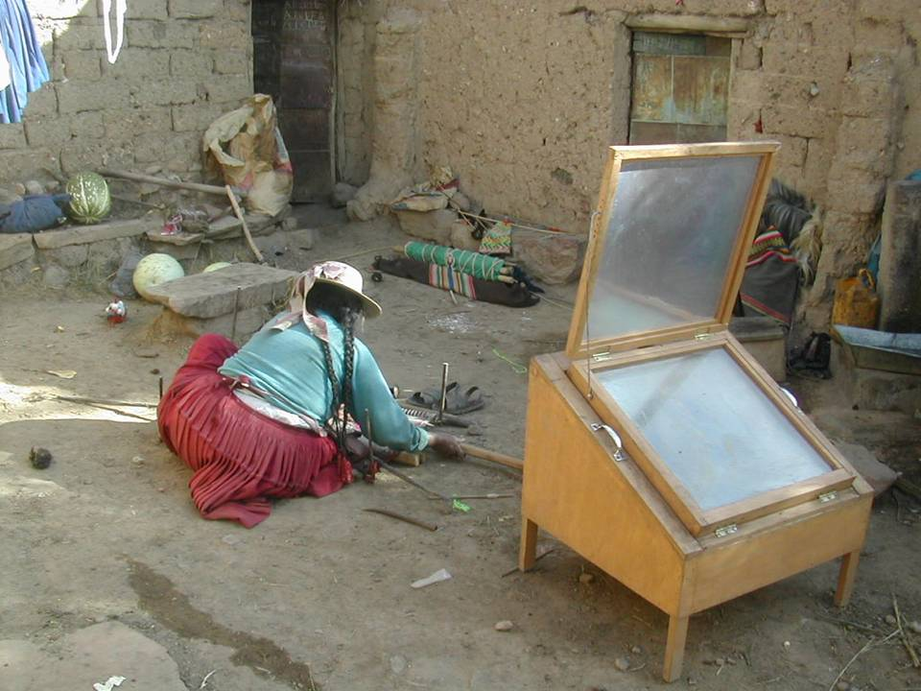
Solar Box model for households
A detailed technical description is available as a separate confidential document.
Retained Heat Cooking - RHC
A common concern among the beneficiaries is that the use of the solar cooker depends on the weather; however we also demonstrate another way of use. When the weather is cloudy or rainy the SBC can be used as a Thermal Cooker (RHC): the beneficiaries can heat their food, bringing it to a boil (aprox. 5 min.) with their traditional fuels (or with their rocket stove), then wrap the container with a blanket and put it in the solar cooker where the food will keep on cooking with the conserved heat. In this way there will still be a reduction in fuel consumption.
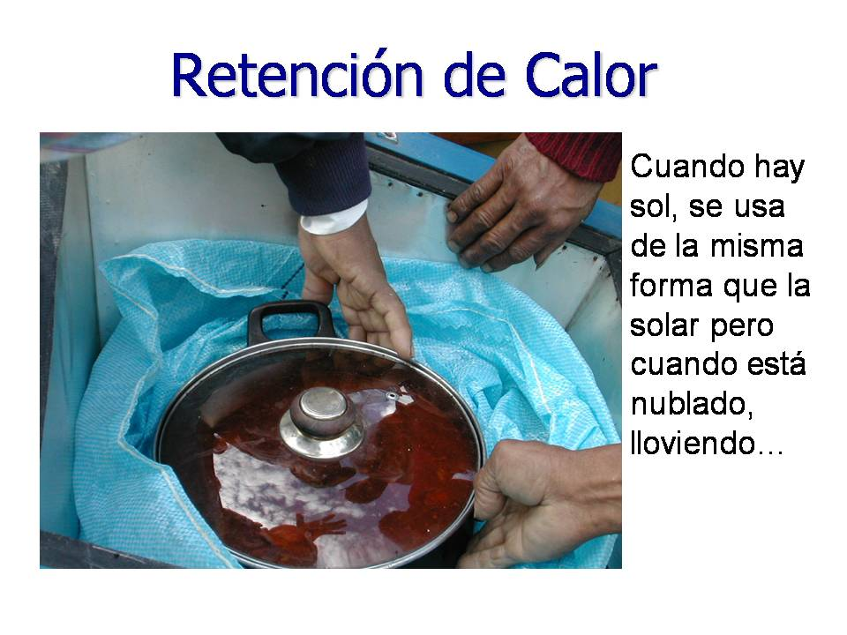 | 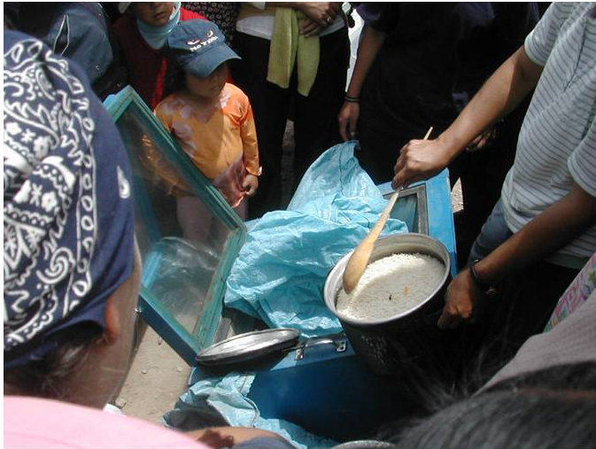
Solar box used as retained heat cooker (RHC)
Thermal cooking can be accomplished without the solar cooker as well using insulated containers to finish the cooking after the food is brought to a boil with another heat device such as the rocket stove. This technology and its use is taught and reinforced through MET modules and its uptake monitored. These insulated container devices (RHCs) will be artisanally made by the beneficiaries using materials common to their households during MET modules.

Relevant dates for the project activity:
The starting date of operation: 19/04/2012 – First solar stove installed
Inclusion date of the project activity: 17/08/2016
GS Crediting Period: 17/08/2014 – 16/08/2024
1st GS Monitoring Period: 17/08/2014 – 31/12/2016

Actual GHG emission reductions in this monitoring period: 1,846 t CO₂e

  - Location of project activity
>>
This VPA 1 is developed inside the country of Bolivia, in the departments of Cochabamba and La Paz.

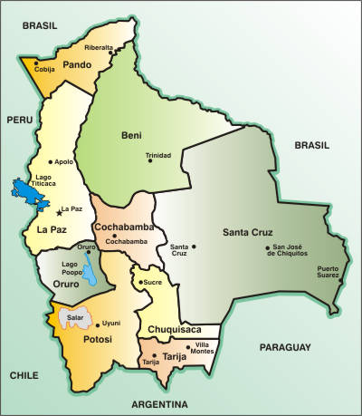
Map of Bolivia with its departments.

  - Parties and project participant(s)
Party involved  ((host) indicates  a host Party) | Private and/or public entity(ies) project participants  (as applicable) | Indicate whether the Party involved wishes to be considered as project participant  (yes/no)
Bolivia | Private entity:  Fundación CEDESOL | No
Switzerland | Private entity:  myclimate – The Climate Protection Partnership | No
  - Reference of applied methodology and standardized baseline
>>

Technologies and Practices to Displace Decentralized Thermal Energy Consumption version 1 (GS TPDDTEC).
http://www.goldstandard.org/sites/default/files/documents/gs_tpddtec_meth_110411.pdf
  - Crediting period of project activity
>>
GS Crediting Period: 17/08/2014 – 16/08/2024

  - Contact information of responsible persons/entities
>>
Paul Leon/ myclimate paul.leon@myclimate.org
Martin Jenk/ myclimate martin.jenk@myclimate.org
David Whitfield/ CEDESOL david@cedesol.org

- Implementation of project activity
  - Description of implemented registered project activity
>>
Project implementation methodology
- Project request or dialogue with the municipal authority. The project is requested through the respected Municipality by letter or verbally with the pertinent authority.
- Local Stakeholder Consultation (LSC) Diagnosis and Demonstration of the technology, and explanation of the project. Once a meeting is held with the interested community, CEDESOL conducts demonstrations on the ecological cookers based on a previous agreement and on a proposed schedule that needs to be followed. After the demonstration is finished, the following steps are performed in order to cover all the needs of the beneficiaries.
- Schedule to follow:
  - List of participants. A list of the participants is made to keep in CEDESOL’s database.
  - Formation of the Environmental Well- being Brigades (EWB).This is one of the principle aspects of the Educational Component, which deals with a co-participatory training process of group learning and teaching along with the housewives within the Environmental Well-being Brigades.
The EWB's will be guided by the "Innovative Leaders (IL’s)", women who are chosen for their Brigade to be trained by experts from CEDESOL with the Modular Environmental Training Program (MET).
This training program includes several modules of instruction. Within each module there are 4 sessions. Each session with the IL's will last approximately 3 hours, reaching a total of twelve hours of intensive training per module.
Once trained, they will in turn train their EWB, if they successfully learned the material in the module, they will be able to replicate this knowledge with their EWB in 2 days. Therefore, each module conducted by a IL with her respective EWB will be carried out once a month for 1 day at a time.
Following this structure, each module will be completed after 2 months. During each term, CEDESOL will also identify the needs of the community. This training aims to equip the beneficiaries with the necessary tools for self-development, a sustainable community and achieving a better quality of life and social equity through the holistic use of the acquired cookers.
  - Delivery of equipment / rrc general training
    - Formation of the brigades. As mentioned above, the brigades are formed once the community decides to participate in the project and the beneficiaries are identified. CEDESOL establishes a meeting with the Community and the steps to follow are stated.
    - Formation of lines of communication. These lines are formed with the objective of keeping in contact and strengthen ties with the communities.
    - Set a specific work schedule. Depending on the needs and limitations of the beneficiary community, a list of activities and responsibilities will be established.
    - Sales record and surveys. This list is made into the baseline, which will be used later in all the documents that are evaluated.
- First Innovative Leader (IL) Training (within 45 days of the general training). This training integrates different learning modules, which will guide and teach the best practices for taking care of one’s health and the environment. This project has two main components which are the provision of clean ecological cookers and a program that will teach, monitor and evaluate the use of the cookers. The duration of the Project Activities (PoA) is 28 years, with a period of evaluation through surveys every 2 years within a fixed 10 year period that is determined in this VPA.
  - Session 1. Thermal Cooker (in accordance with an agreed upon schedule with the community). This training session focuses on, among other things, teaching how the cookers works, their assembly, use and maintenance.
  - Module 2. Rocket Stove (in accordance with an agreed upon schedule with the community). This training focuses on, among other things, teaching how the Rocket Stoves work, their assembly, use and maintenance.
- Follow up. The follow up on the use of the Ecological Cookers is done by the Innovative Leaders after they have received their training and are then able to transmit this knowledge to their Brigades. In this follow up, the leaders monitor and receive information on how they are cooking and problems that could have come up during their use. The follow ups are conducted between training sessions every 30 days, in which the Brigade makes a report of monitoring performed to CEDESOL.
- Monitoring. Monitoring the development of the MET Program will be assessed within 30 days after the ILs have completed their community based modules, at 3 months and annually so as to learn their observations both early and later on in the process.
Through this monitoring, CEDESOL will receive comments and reactions from the EWB's, then providing this valuable information to the trainers and the overall design of the MET.
It should be noted that the beneficiaries will learn to use and maintain themselves the ecological stoves that have been acquired by the Program. The purpose of the educational program is to ensure that the beneficiaries learn how to better handle their resources, both economically and naturally, so that in the future there is an exponential reduction of CO₂ emissions. All this is described in further detail in the POA attached.

  - Post-registration changes
    - Temporary deviations from registered monitoring plan, applied methodology or applied standardized baseline
>>
Not applicable.

    - Corrections
>>
Not applicable.

    - Changes to start date of crediting period
>>
Not applicable.

    - Inclusion of a monitoring plan to the registered PDD that was not included at registration
>>

Not applicable.

    - Permanent changes from registered monitoring plan, applied methodology or applied standardized baseline
>>
Not applicable.

    - Changes to project design of registered project activity
>>
Not applicable.

    - Types of changes specific to afforestation or reforestation project activity
>>
Not applicable.

- Description of monitoring system
>>
The monitoring plan for this VPA follows the guidelines of the Monitoring Methodology in Section III of the applied GS TPDDTEC Meth. as described in the PoA-DD in section D.7.2.1.
Sales record
A sales form is filled out for every delivered ecological stove. Besides required personal data as explained in the TPDDTEC Meth. on page 22 further data in terms of fuel consumption is collected already at this stage to get a first impression of the specific behaviour.
A total sales record and project database are maintained continuously. The project database is derived from the total sales record with project technologies differentiated by different project scenarios (solar domestic, solar institutional/commercial) leading to the two parameters project technology days N_{s-d},y and N_{s-ic},y.
Prior to first Verification – Field Tests - Pr-ic,ic,y
Prior to first Verification a project Field Survey for the domestic scenario was performed.
Afterwards a Baseline Field Test and a Project Field Test were conducted for Solar Domestic stoves to define the average fuel savings for every distributed stove based on real field measurements. Unpaired sampling was applied for the first verification in this VPA.
The Baseline Field Test used for this VPA is the same performed for VPA 1 as the characteristics of the beneficiaries are the same in the whole PoA.

Ongoing Monitoring Studies
The following on-going monitoring studies are conducted for the project scenario of this VPA (solar stoves) following first verification of the associated initial ex-ante project studies. These monitoring studies investigate and define parameters that could not be determined at the time of the initial project studies or that change with time.

1a) Monitoring Survey (including Usage Survey) –
Completed annually, beginning after first verification
The monitoring survey investigates changes over time in every project scenario (and in a baseline scenario in case renewal of crediting period), by surveying end users with improved stoves on an annual basis. It provides critical information on year-to-year trends in end user characteristics such as technology use, fuel consumption and seasonal variations.
Monitoring Survey Representativeness:
End users from a given project scenario are selected using representative sampling techniques to ensure adequate representation of users with technologies of different ages. Common sampling approaches such as clustered random sampling are allowed and geographic distribution should be factored into selection criteria. End users can be surveyed at any time throughout the year with care taken to collect information pertaining to seasonal variations in technology and fuel use patterns.
Monitoring Survey sample sizing:
- Project Scenario Solar Domestic:
Minimum sample size 100 if more than 1000 stoves are distributed in total, else 10% of group size.
- Project Scenario Solar Institutional/Commercial:
Minimum sample size 30 or population size, whichever is smaller.

A monitoring survey has been conducted to families who has a solar domestic stove, 105 surveys were performed in Cochabamba and La Paz.
1b) Usage Survey (part of Monitoring Survey) – Ur-d,y, Ur-ic,y

Completed annually, beginning after first verification.

The usage survey provides a single usage parameter U_{r-d,y} and U_{r-ic,y} for the two project scenarios of this VPA that is weighted based on drop off rates that are representative of the age distribution for project technologies in the total sales record.
A usage parameter must be established to account for drop off rates as project technologies age and are replaced. Prior to a verification, a usage parameter is required that is weighted to be representative of the quantity of project technologies of each age being credited in a given project scenario. For example, if only technologies in the first year of use (age0-1) are being credited, a usage parameter must be established through a usage survey for technologies age0-1. If an equal number of technologies in the first year of use (age0-1) and second year of use (age1-2) are credited, a usage parameter is required that is weighted to be equally representative of drop off rates for technologies age0-1 and age1-2.
The minimum total sample size is 100 (or population size, whichever is smaller), with at least 30 samples for project technologies of each age being credited. The majority of interviews are conducted in person and include expert observation by the interviewer within the kitchen in question in combination with the Monitoring Survey, while some remainder may be conducted via telephone by the same interviewers on condition that in kitchen observational interviews are first concluded and analysed such that typical circumstances are well understood by the telephone interviewers.
A usage survey has been conducted (at the same time with the monitoring survey) to families who has a solar domestic stove, 105 surveys were performed, 67 were done in families with stoves age₃₋₄ and 38 to stove age₂₋₃. These two stoves ages represent the 83% of the domestic solar stove installed, even though stoves from ages ₀₋₁ and ₁₋₂ exists, these were not surveyed because of the reduced number of stoves installed.
2) Project Field Test (PFT) Update –
Completed every other year, or more frequently after first verification.
The PFT update is an extension of the project PFT and provides a fuel consumption assessment representative of project technologies currently in use every two years. Hence the PFT update accounts for changes in the project scenario over time as project technologies age and new customers are added, also as new models and designs are introduced. It is legitimate to apply an Age Test instead of a PFT, to project technologies, which remain materially the same year after year.
Afterwards a Project Field Test Update has been conducted to 35 Solar Domestic stoves to define the fuel consumption of this scenario.

3) Baseline FT Update –
In this VPA a fixed baseline is adopted. Baseline Field Test do not have to be updated because it’s a fixed ten years crediting period.
4) Leakage Re-Assessment –
Leakage is assessed on VPA Level. Leakage will be reassessed every two years.
Leakage Assessment LE
As defined on PoA Level and as described in the TPDDTEC methodology every VPA must discuss the following potential sources of leakage:

L1) The displaced baseline technologies are reused outside the project boundary in place of lower emitting technology or in a manner suggesting more usage than would have occurred in the absence of the project.
- Not possible: the base line kitchen equipment needs to be destroyed before it can be removed (fixed installation of adobe bricks or three stone fire).
L1 = 0
L2) The non-renewable biomass or fossil fuels saved under the project activity are used by non-project users who previously used lower emitting energy sources.
- Not reasonable: Similar baseline for neighboring families, so no fuel switch is possible due to the project.
L2 = 0
L3) The project significantly impacts the NRB fraction within an area, where other CDM or VER project activities account for NRB fraction in their baseline scenario.
- Not realistic: The project boundary is too big to have influence on the NRB fraction on a national scale. However, locally some variations are expected.
L3 = 0
L4) The project population compensates for loss of the space heating effect of inefficient technology by adopting some other form of heating or by retaining some use of inefficient technology.
- Negligible. In the project region, stoves are mainly integrated in the kitchen and not in the living room. Based on CEDESOL experience beneficiaries don’t use stoves as a heating device. Furthermore as an outcome of the first Kitchen Survey for VPA1 it could be demonstrated that only 2.2% of the beneficiaries used their old stove for heating purposes.
L4 = 0
L5) By virtue of promotion and marketing of a new technology with high efficiency, the project stimulates substitution within households who commonly used a technology with relatively lower emissions, in cases where such a trend is not eligible as an evolving baseline
- Not possible: The existing Baseline Scenario is inefficient kitchen equipment. There is currently almost no technology used that is more efficient than the stoves distributed by the project.
L5 = 0
The result of the leakage assessment is that no potential source of leakage could be found at PoA Level that would lead to significant emissions. Therefore:
L = ∑L_{i} = 0

5) Non-Renewable Biomass Assessment Update
Completed annually, if new CDM default values are published.

Sustainable Development Monitoring Plan
The SD monitoring is discussed inside the Validation Appraisal Report of the VPA2. More details of the parameters and its indicators in appendix 2.
- Data and parameters
  - Data and parameters fixed ex ante or at renewal of crediting period
(Copy this table for each piece of data and parameter)
Data/parameter: | fNRB, Bolivia
Unit
Description | Fraction of biomass used in year y for baseline scenario b that can be established as non‐renewable biomass.
Source of data | CDM Small Scale Working group, meeting 37 annex 14, ssc_37_an14.pdf
Value(s) applied) | 84%
Choice of data  or measurement methods and procedures | To justify this value a national governmental proof (by DNA) is needed according Gold Standard rules. CEDESOL tried to get this confirmation. However, for Bolivia the chance for governmental approval is very low, since the country does not accept the CDM and does not have an operating DNA. Thus, Gold Standard proposed to have the value revised by stakeholders: CEDESOL discussed this issue during Stakeholder Consultation Feedback round on PoA Design Level. This includes a renewed contacting of both DNA.
Purpose of data | Project emission calculation  Baseline emission calculation
Additional comments

Data/parameter: | NCV_{b},_{wood}
Unit | TJ/ton
Description | Net calorific value of woody biomass
Source of data | GS TPDDTEC Meth.
Value(s) applied) | 0.015
Choice of data  or measurement methods and procedures | Value from applied Methodology.
Purpose of data | Project emission calculation  Baseline emission calculation
Additional comments

Data/parameter: | EF_{b},_{wood},_{CO2}
Unit | tCO2/TJ
Description | CO2 emission factor for Wood
Source of data | GS TPDDTEC Meth.
Value(s) applied) | 112
Choice of data  or measurement methods and procedures | Value from applied Methodology.
Purpose of data | Project emission calculation  Baseline emission calculation
Additional comments

Data/parameter: | EF_{b},_{wood,nonCO2}
Unit | tCO2/TJ
Description | Non_CO2 emission factor of the fuel that is reduced.
Source of data | 2006 IPCC Guidelines for National Greenhouse Gas Inventories, Vol.2 Energy, Chapter 2, Stationary Combustion, Table 2.5
Value(s) applied) | 8.692
Choice of data  or measurement methods and procedures | Default IPCC values for CH₄ and N₂0 emissions for wood / wood waste, are applied. The following GWP100 are applied: 25 for CH₄, 298 for N₂0  EF_wood_CH₄= 0.3tCH4/TJ  EF_wood_N₂O = 0.004tN2O/TJ
Purpose of data | Project emission calculation  Baseline emission calculation
Additional comments

  - Data and parameters monitored
(Copy this table for each piece of data and parameter)
Data/parameter: | N_{s-d},y
Unit | Days
Description | Cumulative number of project technology-days included in the project database for project scenario s-d (solar domestic) in year y
Measured/calculated/default | Calculate
Source of data | Sales record
Value(s) of monitored parameter | See relevant ER calculation spread sheet For y =  2014: 33,201  2015: 90.155  2016: 90.402
Monitoring equipment | Not applicable
Measuring/reading/recording frequency: | Continuously
Calculation method  (if applicable): | Not applicable
QA/QC procedures: | CEDESOL performs the data collection and puts the data into the sales record. myclimate revises and analyses this data
Purpose of data: | Project emission calculation  Baseline emission calculation
Additional comments: | See excel files “GS2421_MR1_Sales record_CEDESOL_V2_21Nov17.xls” and “GS2421_MR1_ER Calc_CEDESOL_V2_21Nov17.xls”

Data/parameter: | U_{s-d,y}
Unit | Fraction
Description | Cumulative usage rate for technologies in project scenario s-d (solar domestic) in year y, based on first linear assumption.
Measured/calculated/default
Source of data | First assumption based on CMEs experience.
Value(s) of monitored parameter | See relevant ER calculation spread sheet.  For y =  2014: 1.0  2015: 1.0  2016: 1.0
Monitoring equipment | Not applicable
Measuring/reading/recording frequency: | Annually
Calculation method  (if applicable): | Not applicable
QA/QC procedures: | CEDESOL performs the data collection and puts the data into the project database. myclimate revises and analyses this data.
Purpose of data: | Project emission calculation  Baseline emission calculation
Additional comments: | See excel files “GS2421_MR1_Monitoring & Usage Surveys_CEDESOL_V1_22Aug17.xls”

Data/parameter: | Ps-d,d,y
Unit | tons/day
Description | Specific fuel savings for domestic solar stoves in Bolivia of project scenario s-d (solar domestic) against the baseline scenario d (domestic) in year y
Measured/calculated/default | Calculate
Source of data | See relevant FT spread sheet.
Value(s) of monitored parameter | 0.0065
Monitoring equipment | Hand help portable electronic scale. This compact, accurate, and highly functional scale has features such as automatic shut-down, tare weight, display lock and audible feedback.  The scale weighs in units of kilograms, pounds or ounces, and can convert between units. It is accurate to 1% for loads above 1kg (2.2 lb). Accuracy drops to 4% for loads between 0.25kg (0.55 lb) and 1kg (2.2 lb). Holds a maximum of 40kg (88 lb).  It is resettable to 0 after every use or during use via the TARE feature and is accurate to 1% for our purposes.
Measuring/reading/recording frequency: | Every two years
Calculation method  (if applicable): | See Description of measurement methods for the parameter.
QA/QC procedures: | CEDESOL performs the data collection and puts the data into the project database. myclimate revises and analyses this data.
Purpose of data: | Project emission calculation  Baseline emission calculation
Additional comments: | See excel file ”GS2421_MR1_Domestic-Solar Stove_Field test_CEDESOL_V2_21Nov17.xls”

Data/parameter: | LEp,y
Unit | tCO_{2e}/yr
Description | Leakage for project scenario p in year y
Measured/calculated/default | Measured
Source of data | Leakage assessment on VPA-DD under B.5.2.
Value(s) of monitored parameter | 0
Monitoring equipment | Not applicable
Measuring/reading/recording frequency: | Not applicable
Calculation method  (if applicable): | Not applicable
QA/QC procedures: | Not applicable
Purpose of data: | Calculation of leakage
Additional comments:

  - Implementation of sampling plan
>>

Monitoring and Usage surveys

The monitoring and usage survey was carried out for Domestic solar stoves for Project scenario using representative and random sampling, following the guidelines of the methodology the sample sizes:

- Minimum sample size 100 if more than 1000 stoves are distributed in total, else 10% of group size. In the case of monitoring survey.
- The minimum total sample size is 100 (or population size, whichever is smaller), with at least 30 samples for project technologies of each age being credited. In the case of usage survey.

The VPA includes domestic solar stove.
- Domestic solar stove group size : 290

Department | Number of stoves
La Paz | 83
Cochabamba | 207

Domestic Scenario:
105 monitoring and usage surveys were performed in the department of La Paz and Cochabamba; 67 surveys in families with the project technologies for 3-4 years and 38 surveys in families with 2-3 years with the project technology. Only these two ages are considered because there was not a significant quantity of stoves with 1 or 2 years.

The families selected were beneficiaries that received the solar stoves.

A summary of the main findings are included in the annex 3 and the excel file “GS2421_MR1_Monitoring & Usage Surveys_CEDESOL_V1_22Aug17.xls”.

Project Field Test Update
As stated in the PoA-DD section D.6.1 for every scenario CEDESOL performs a performance field tests update for a representative sample of the group as an extension of the previous project PFT and provides a fuel consumption assessment representative of project technologies currently in use.

In this VPA, 35 surveys were conducted for domestic solar stoves in the Department of La Paz and Cochabamba.

The project field test update has been conducted between Abril and May 2017.

According to the field tests the domestic solar stoves have a fuel savings of 5.6 kg wood/unit/day.

The baseline test for domestic stoves was done in this first monitoring report and it will be used for this or different VPAs e.g. same baseline for solar stoves.

Statistical analysis following the guidelines of the methodology of the test results lead to the specific fuel consumption per family. More detail in annex 4.

- Calculation of emission reductions or GHG removals by sinks
  - Calculation of baseline emissions or baseline net GHG removals by sinks
>>
Not applicable.

  - Calculation of project emissions or actual net GHG removals by sinks
>>
Not applicable.

  - Calculation of leakage
>>
This specific micro VPA-DD is analysed and it is concluded that there is no leakage due to the project activity.
  - Summary of calculation of emission reductions or net GHG removals by sinks
Following the methodology, since the baseline fuel and the project fuel are the same for every baseline-project couple under this PoA the following equation is applied to calculate the emission reduction:

For the emission Reduction Calculation we apply the relevant formula from the applied methodology explained in the PoA-DD in section D 6.2.

ER_{y} = N _{s-d,y} * U _{s-d-,y} * P _{s-d,d,y} * NCV _{b,wood} * (f _{NRB, Bolivia} * EF _{wood, CO2} + EF _{wood, nonCO2}) +
N _{s-ic,y} * U _{s-ic,y} * P _{s-ic,ic,y} * NCV _{b,wood} * (f _{NRB, Bolivia} * EF _{wood, CO2} + EF _{wood, nonCO2})

Applied values for the Ex-ante Emission Reduction Calculation are listed above in the parameter sections D.1 and D.2. See also detailed calculation in relevant ER calculation spread sheet.

N _{s-d,y} : Cumulative number of project technology-days included in the project database for project scenario s-d (solar domestic) in year y
U _{s-d-,y} : Cumulative usage rate for technologies in project scenario s-d (solar domestic) in year y, based on first linear assumption.
P _{s-d,d,y} : Specific fuel savings for domestic solar stoves in Bolivia of project scenario s-d (solar domestic) against the baseline scenario d (domestic) in year y.
NCV _{b,wood} : Net calorific value of woody biomass
f _{NRB, Bolivia} : Fraction of biomass used in year y for baseline scenario b that can be established as non‐renewable biomass.
EF _{wood, CO2} : CO2 emission factor for Wood
EF _{wood, nonCO2} : Non_CO2 emission factor of the fuel that is reduced.
N _{s-ic,y} : Cumulative number of project technology-days included in the project database for project scenario s-ic (solar institutional/commercial) in year y.
U _{s-ic,y} : Cumulative usage rate for technologies in project scenario s-ic (solar institutional/commercial) in year y, based on first linear assumption.
P _{s-ic,ic,y} : Specific fuel savings for institutional/commercial solar stoves in Bolivia of project scenario s-ic (solar institutional/commercial) against the baseline ic (institutional/commercial) in year y.

In conclusion, the total of the emission reductions achieved during the monitoring period are:

Baseline emissions from domestic solar stoves: 3,989 tCO₂e
Baseline emissions from domestic institutional/commercial solar: 0 tCO₂e
Total baseline emissions: 3,989 tCO₂e
Project emissions from domestic solar stoves: 1,237 tCO₂e
Project emissions from domestic institutional/commercial solar 0 tCO₂e
Total project emissions: 1,237 tCO₂e
Total leakage: 0 tCO₂e
Total emission reductions: 1,846 tCO₂e

- Item | Baseline emissions or baseline net GHG removals by sinks  (t CO₂e) | Project emissions or actual net GHG removals by sinks  (t CO₂e) | Leakage  (t CO₂e) | GHG emission reductions or net GHG removals by sinks  (t CO₂e) achieved in the monitoring period
 |  |  |  | Up to 31/12/2012 | From 01/01/2013 | Total amount
- Total | 3,989 | 1,237 | 0.0 | - | 1,846 | 1,846

  - Comparison of actual emission reductions or net GHG removals by sinks with estimates in registered PDD
Item | Values estimated in ex ante calculation of registered PDD | Actual values achieved during this monitoring period
Emission reductions or GHG removals by sinks (t CO₂e) | 10,000 | 1,846
  - Remarks on difference from estimated value in registered PDD
>>

The main difference between the emission reduction estimated in the VPA-DD and the calculated in the first monitoring report was the reduction of the number of stoves installed. In the VPA-DD the project considered the implementation of 3158 domestic solar stoves between 2012 and 2016, but because some delays in the project implementation, until December of 2016, 290 domestic solar stoves were installed.
- Contact information of project participants and responsible persons/entities
Project participant and/or responsible person/ entity | Project participant  Person/entity responsible for completing the CDM-MR-FORM
Organization name | Fundación CEDESOL
Street/P.O. Box | Calle Illapa # 2004
Building
City | Cochabamba
State/region | Cochabamba
Postcode | Calle Illapa # 2004
Country | Bolivia
Telephone | (591-4) 4286382
Fax
E-mail | info@cedesol.org
Website | www.cedesol.org
Contact person | David Whitfield
Title | President Director
Salutation | Mr.
Last name | Whitfield
Middle name | Eugene
First name | David
Department
Mobile | 591 77900868
Direct fax
Direct tel.
Personal e-mail | david@cedesol.org

Project participant and/or responsible person/ entity | Project participant  Person/entity responsible for completing the CDM-MR-FORM
Organization name | Foundation myclimate – The Climate Protection Partnership
Street/P.O. Box | Sternenstrasse 12
Building
City | Zürich
State/region | Zürich
Postcode | 8002
Country | Switzerland
Telephone | +41 44 500 43 50
Fax | +41 44 500 43 51
E-mail | projects@myclimate.org
Website | www.myclimate.org
Contact person | Paul Leon
Title | Project Manager
Salutation | Mr
Last name | Leon
Middle name
First name | Paul
Department | Climate Offset Projects
Mobile
Direct fax
Direct tel.
Personal e-mail | paul.leon@myclimate.org
- Sustainability Monitoring conform sustainability monitoring plan in Appraisal Micro-Scale Validation Report

No |  | 1
Indicator |  | Air quality – score positive
Mitigation measure |  | None needed
Chosen parameter |  | Number of beneficiaries who notice the improvement in air quality
Current situation of parameter |  | 100% beneficiaries noticed the improvement in air quality (Solar stove scenario)
Estimation of Baseline situation of parameter |  | Noticeable smoke exposure conditions
Way of monitoring | How | Surveys containing questions about status of indoor air quality according to their perceptions before and during the use of ecological stoves. Beneficiaries noticing an improvement in air quality are counted.
Way of monitoring | When | Annually after first verification
Way of monitoring | By who | CEDESOL forms a team of professionals, interns and/or organizations.

No |  | 7
Indicator |  | Livelihood of the poor – score positive
Mitigation measure |  | None needed
Chosen parameter |  | Number of beneficiaries who notice savings in time, firewood and/or money
Current situation of parameter |  | 100% of beneficiaries noticed savings in time, firewood and/or money
Estimation of Baseline situation of parameter |  | An average household will consume between 5 and 15 kg. firewood per day (depending on region). According to The World Bank the Bolivian rural population spends approximately 7 million working days a year to collect firewood. Families who purchase dung and wood as fuel spend from 2 to 3 times as much money as households using LPG.
Way of monitoring | How | Surveys with questions about the amount fuel, money and time saved.
Way of monitoring | When | Annually
Way of monitoring | By who | CEDESOL forms a team of professionals, interns and/or organizations.
Chosen parameter |  | Amount of Wood saved
Current situation of parameter |  | 46.27% of wood savings
Estimation of Baseline situation of parameter |  | An average household will consume between 5 and 15 kg. firewood per day (depending on region).
Way of monitoring | How | Weighings of firewood are made in the Field Test
Way of monitoring | When | Every 2 years after first verification for a period of 3-4 days.
Way of monitoring | By who | A leader of each community will be trained in the educational program to help with the weighing.

No |  | 8
Indicator |  | Access to affordable and clean energy services
Mitigation measure |  | None needed
Chosen parameter |  | Number of households with access to this technology
Current situation of parameter |  | 290 domestic solar stoves installed
Estimation of Baseline situation of parameter |  | The World Bank estimates that more than 70% of the rural population in Bolivia meet its energy demands with biomass.
Way of monitoring | How | A sales record of all installed stoves.
Way of monitoring | When | Upon delivery of the stoves
Way of monitoring | By who | CEDESOL

No |  | 9
Indicator |  | Human and institutional capacity
Mitigation measure |  | None needed
Chosen parameter |  | Number of people who are trained in our educational program
Current situation of parameter |  | 19 of Innovative Leaders trained overall and  290 of folks completing the Modular Environmental Training (MET)
Estimation of baseline situation of parameter |  | 0
Way of monitoring | How | The project will have a strong educational component through a Modular Environmental Training (MET). The trained people will be count.
Way of monitoring | When | A module every two months for 12 months (6 modules). The modules were 2 days long.
Way of monitoring | By who | CEDESOL

No |  | 11
Indicator |  | Technology transfer and technological self-reliance
Mitigation measure |  | None needed – the Project itself and the above justifications support this indicator as “positive”
Chosen parameter |  | The number of beneficiaries who can use and maintain their stoves.
Current situation of parameter |  | 290 families that are trained about the use and maintenance of their stoves.
Estimation of baseline situation of parameter |  | 0
Way of monitoring | How | Training will be made to all beneficiaries
Way of monitoring | When | Upon delivery of the stoves
Way of monitoring | By who | CEDESOL
Chosen parameter |  | The number of beneficiaries who will receive training for the assembly of solar stoves.
Current situation of parameter |  | 290 families received training for the assembly of solar stoves
Estimation of baseline situation of parameter |  | 0
Way of monitoring | How | The training program ensures the training of a leader who is capable of assembling solar stoves.
Way of monitoring | When | As part of the first module of the training program.
Way of monitoring | By who | CEDESOL

- Monitoring and Usage Survey Results
Summary | Value
Samle size, Number of M&U surveys | 105
Sample size, Number of project technologies with age 2-3 | 38
Sample size, Number of project technologies with age 3-4 | 67

Domestic stoves
Question | Value
B. Data from the Older Stove (BL)
1. Type of stove
Gas stove | 62.9%
Primitive Clay/ Adobe stove | 83.8%
2. Does your stove have a chimney?
Yes | 0.0%
3. Use of the stove
Domestic use | 100%
Commercial use | 0%
Institutional use | 0%
5. People living and eating at home (including schools)
<10 years old | 17%
11-64 years old | 78%
>65 years old | 4.4%
B.1. Fuel Base Line(BL)
9. Type of Fuel and Amount
Wood
Wood (if picked up) | 23.2 | kg/week
Wood (if bought) | -
Time (Hours/Week) | 0.8
Distance (km/month) | -
Frequency (per week) | 0.8
Price (Bs/kg) | -
Gas | -
Quantity | 0.71 | Garrafa/month
Unit
Time (Hours/Week) | -
Distance (km/month) | -
Frequency (per week) | -
Price (Bs/kg) | 24.73
C. Details of the new stove
C.1 Fuel
20. What has been done with the old stove?
I sold / as a gift | 0.0%
The destroyed | 0.0%
It's in the house and used every day | 100.0%
It's in the house and used several times a week | 0.0%
It's in the house and used once a week | 0.0%
It's in the house and used once a month | 0.0%
It is in the house and never used | 0.0%
7. How many times do you cook a day with your ecological stove?
once a day | 100.0%
8. Has there been any change in the use of fuel (with the new stove)?
Yes | 100.0%
9. Fuel type, amount and frequency of pick up [with the (s) stove (s) new (s)].
Wood (kg wood/ unit/ day) | 3.09 | Monitoring Survey
Time (Hours/Week) | 0.8
Frequency (per week) | 0.8
Wood (if bought)
Time (Hours/Week)
Frequency (per week)
Price (Bs/kg)
Gas
Quantity | 0.714
Unit | Garrafa
See attached the observation
C.2. New stove Maintenance (PS)
11. What is the state of the ecological stove?
Excellent | 0.0%
Okay | 1.9%
Regular | 98.1%
Bad | 0.0%
12. What do you like about your ecological stove?
Easy move | 8.4%
Taste of Food | 22.2%
Healthy food | 6.0%
Cost Efficient | 23.4%
Easy use | 34.1%
Good for the health | 6.0%
Good for the environment | 0.0%
13. What problems do you have in the use of ecological stove?
Nothing | 95.24%
The glass is broken | 0.00%
The paint is damaged | 2.99%
Problems with the support | 0.00%
Problems with the leg of the stove | 0.00%
The lid is broken | 0.00%
Another | 0.00%
14.¿Do you have questions about maintaining ecological stove?
No | 95.24%
Yes | 4.76%
15. Have you noticed a difference in the air quality inside your home with the ecological stoves?
Yes | 100.00%
No | 0.00%
Less coughing | 3.45%
Less discomfort in the eyes | 41.38%
Less headache | 18.10%
Less sore throat | 15.52%
Less stinging of nose | 4.31%
Nothing | 17.24%
17. With the effective use of ecological stoves, have noticed
Saving money | 7%
Time saving | 20.3%
Reduction in the requirement for firewood | 72.9%
Nothing | 0.0%
TOTAL | 100.0%
Usage survey and Sustainable Indicators (PS)
18. Use of the ecological stove
Domestic use | 100.00%
Commercial use | 0.00%
Institutional use | 0.00%
17. Use of the ecological stove
Yes, I use | 100.00%
Surveyor’s check | 100.00%
20. How many times did you use the old stove?
Everyday | 100.0%
Surveyor’s check - The old stove has been used | 100.00%
Surveyor’s check - The old stove has not been used | 0.00%
21. Ecological Stoves status (surveyor’s check)
Ok | 100.0%

- Project Field Test Update Results and Analysis

 |  | Domestic Solar Stove
 |  | Savings per day per unit
Wood
(kg / unit / day)
Requested number of measurements |  | >=20
Number of measurements |  | 35
Mean |  | 6.505
Standard Deviation |  | 2.77
Standard Error |  | 0.47
t Value |  | 1.690
Precision |  | 12.2%
90% Conf. Int. High |  | 7.30
90% Conf. Int. Low |  | 5.71
Mean +30% |  | 8.46
Mean - 30% |  | 4.55
Conf. Int. inside +-30% |  | yes
Relevant Value |  | mean
Fuel Savings |  | 46.27%
Consumption of wood - kg / unit / day  Baseline Field Test (Sep 2014) |  | 12.106

- Forward Action Request
FAR#1: The PP shall provide carbon rights waivers on time the first verification.
Emission Reductions (ER) rights are transferred on a voluntary base from the beneficiaries to CEDESOL when signing the sales form. This is explained to the Beneficiaries when filling out the form. A signed Emission Reduction Purchase Agreement between CEDESOL and myclimate guarantees the transfer of the ER rights to myclimate. myclimate itself retires the credits for its clients.

- - - - -

Document information
Version | Date | Description
05.1 | 4 May 2015 | Editorial revision to correct version numbering.
05.0 | 1 April 2015 | Revisions to:  - Include provisions related to delayed submission of a monitoring plan;  - Provisions related to the Host Party;  - Remove reference to programme of activities;  - Overall editorial improvement.
04.0 | 25 June 2014 | Revisions to:  - Include the Attachment: Instructions for filling out the monitoring report form (these instructions supersede the "Guideline: Completing the monitoring report form" (Version 04.0));  - Include provisions related to standardized baselines;  - Add contact information on a responsible person(s)/ entity(ies) for completing the CDM-MR-FORM in A.6 and Appendix 1;  - Change the reference number from F-CDM-MR to CDM-MR-FORM;  - Editorial improvement.
03.2 | 5 November 2013 | Editorial revision to correct table in page 1.
03.1 | 2 January 2013 | Editorial revision to correct table in section E.5.
03.0 | 3 December 2012 | Revision required to introduce a provision on reporting actual emission reductions or net GHG removals by sinks for the period up to 31 December 2012 and the period from 1 January 2013 onwards (EB70, Annex 11).
02.0 | 13 March 2012 | Revision required to ensure consistency with the "Guidelines for completing the monitoring report form" (EB 66, Annex 20).
01 | 28 May 2010 | EB 54, Annex 34. Initial adoption.
Decision Class: Regulatory
Document Type: Form
Business Function: Issuance
Keywords: monitoring report

Our program of holistic well being meets the “first of its kind” guideline, as described in EB 69 REPORT annex 7, GUIDELINES ON ADDITIONALITY OF FIRST-OF-ITS-KIND PROJECT ACTIVITIES (Version 02.0) for project activities and is actually a first of its kind in concept as well since we will work to equally give our beneficiaries educational as well as technological tools that they can use to make continually better decisions about their lives. We incorporate empowerment of women as part of our value chain and support that, by attitude change in conjunction with technological interventions we can achieve a “lasting impact”, especially considering propagation of the better attitudes and knowledge through the “kitchen classroom” most children unconsciously learn in.
Beneficiaries are qualified through a participative group diagnostic where it is established that wood fuel is their primary fuel, that the potential beneficiaries believe the intervention will improve their living standards, that the beneficiaries will become active members of the Environmental Well-being Squads (EWBS), will provide usage information, allow monitoring and will assign their rights to emissions reduction credits to CEDESOL in exchange for participation in the subsidized program and acquiring the improved cooking devices via subsidized prices. They must also accept paying a % of the cost of the devices (usually around 50%) and cannot receive the devices for free.
According to the Global Alliance for Clean Cookstoves’ (GACC) Adoption Indicators, the % of Population using improved biomass cookstoves in Bolivia (0.687) is less than 1%, which demonstrates that without this intervention improved cookstoves are NOT being taken up voluntarily by the population. https://web.archive.org/web/20140511024315/http://www.cleancookstoves.org:80/countries/america/bolivia.html
In rural areas the supply of hydrocarbons is very low. The main energy source in these scattered and remote areas is biomass (especially wood), which on average covers 80% of the total rural energy demand (there are some areas where this resource covers up to 97% of this demand, a situation that has not changed in recent years). Instead, the use of Liquefied Petroleum Gas (LPG), widespread in urban, is only present in major rural centers. In the rest of the country there simply is no availability of the fuel, said the report. http://plataformaenergetica.org/content/3308
Bolivia, with a population of approximately 10.4 million inhabitants, is considered one of the poorest countries in Latin America. While urban areas such as La Paz and Santa Cruz are modern cities with a relatively good supply of modern energy services, the majority of Bolivia’s rural areas are still experiencing a lack of most basic services, including reliable and affordable access to electricity and improved biomass cooking stoves. https://energypedia.info/wiki/Bolivia_Energy_Situation
This table was developed from information obtained from the Global Alliance for Clean Cookstoves, in which they cited as their Source: Food and Agriculture Organization, United Nations Development Programme, World Bank World Economic Forum, and World Health Organization - http://cleancookstoves.org/country-profiles/92-bolivia-plurinational-state-of.html
Solar box cookers are much easier to construct than parabolic cookers and are frequently made from local materials by local artisans after they have been trained (Download: Solarbox.pdf). Box cookers are less powerful than parabolic cookers and do not reach temperatures above 180 °C. Stir-frying is not possible, which makes them unsuitable for countries where this type of cooking is common. However, they are easy to handle, orientation to the sun is not as important as for parabolic cookers, and if the sun is temporarily covered by clouds, the temperature does not drop as fast as in parabolic cookers. During cloudy weather, a box cooker can serve as a retained heat cooker. Box cookers have been successfully disseminated in Bolivia. https://energypedia.info/wiki/Cooking_with_the_Sun / https://energypedia.info/images/f/fe/Lasting_Impacts_of_a_Solar_Cooker_Project_in_Bolivia.pdf
“The fact that the solar box cooker can be used as a retained heat cooker, when there is no sun has been a real boost to our efforts here in Bolivia. We believe that this is one of the reasons we have had such success getting people to develop the habit of using the solar cookers. We have folks that cook at night for their husbands who work the graveyard shift using the solar cooker in rhc mode! They bring the food to boil, put the pots inside the solar cooker and let their husbands take the food out at midnight when they are leaving for work. Those ladies are so happy not to have to cook at 11 at night! In the case of the solar cookers, since discovering their double utility the number of users who use the solar cooker 5 to 7 days a week increased from 77% to 89%. For us this is very significant. The solar cooker/rhc users report a yearly average of 65% fuel savings.” http://stoves.bioenergylists.org/cedintegrhc
Fireless Cook Books! Use for Thermal Cooker Recipes May 10, 2012 — thermalcooker - http://thermalcooker.wordpress.com/2008/07/15/haybox-retained-heat-or-fireless-cookers Thermal cookers are not new and were known as Fireless Cookers a 100 years ago here in the USA. Many old recipe books from that era are available online for free or have been republished and can be bought in book form. http://stoves.bioenergylists.org/node/75, http://stoves.bioenergylists.org/apro1996, http://stoves.bioenergylists.org/content/bibliography-hayboxe,

