Stakeholder Consultation Report

PUBLICATION DATE 05.05.2022
VERSION v. 2.0
RELATED SUPPORT

TEMPLATE GUIDE Stakeholder Consultation Report v.2.0

This is a report template to be used for filling the information pertaining to Local Stakeholder Consultation and Stakeholder Feedback Round conducted in line with the Stakeholder Consultation and Engagement Requirements.

This document contains the following Sections
Key Project Information
Grouped Consultation Information
SECTION A - Information made available to Stakeholders
SECTION B - Invitations made to Stakeholders
SECTION C - Report of the Consultation Process
SECTION D - Continuous input / Grievance mechanism
SECTION E - Stakeholder Feedback Round

KEY PROJECT INFORMATION
GS ID of Project | GS12240
Title of Project | GS 12239 VPA-1 Amazi Meza Rwanda Water Supply Project for Schools
Version number of this Report | 1
Completion date of version | 30/11/2023
Time of First Submission Date | 30/11/2023
Start Date of the Project | 01/07/2023
Date of Meeting (s) | 23/06/2023
Project Cycle: | Regular  Retroactive

grouped consultation INFORMATION
GS ID of Real Case VPA | GS12240
Title of Real Case VPA | GS 12239 VPA-1 Amazi Meza Rwanda Water Supply Project for Schools
Geographical Boundary of Grouped Consultation | Rwanda
Technology covered by the Grouped Consultation | Institutional water treatment technologies (IWT): Water Purification Systems (Supply, Installation and Maintenance)
Validity Period | 2 years
Anticipated number of VPAs | 3

INFORMATION MADE AVAILABLE TO STAKEHOLDERS
        - Preliminary agenda for the meeting
>>
Hotel Lemigo, Kigali-Rwanda
23rd June 2023, 8:30am - 1:00pm

08:00 - 08:30 Registration
08:30 - 08:45 Self-Introduction
08:45 - 09:00 Welcome and Introductions by the Project Developer
09:00 - 09:15 Project Background
09:15 - 09:30 Proposed Solution - Amazi Meza Program
09:30 - 09:45 Questions and Answers
09:45 - 10:15 Coffee Break
10:15 - 11:00 Social, Environmental and Ecological Impacts of the Project
11:00 - 11:45 Questions and Answers
11:45 - 12:00 Closing: Feedback Form & Continuous Grievance Mechanisms
12:00 - 13:30 Lunch and Payment of transportation Facilitation

        - A non–technical summary of the project
>>
Non-technical Summary
According to the World Health Organization, unsafe water, along with poor sanitation and hygiene, are the main contributors to an estimated 4 billion cases of diarrhea disease annually, causing more than 1.5 million deaths (WHO, 2013). The proposed project addresses the lack of safe drinking water in certain schools in Rwanda and the resulting negative impacts on students’ health and learning.

Virridy proposes to install and service water purification systems in approximately five hundred (500) schools countrywide. Schools will be identified based on a set of criteria, with the top criterion being that the water currently being provided to students is determined to be unsafe through microbiological testing. The water purification system that has been identified and procured for installation in schools is the LifeStraw Community Filter (Fig. 1), which is a point-of-use microbiological water purifier designed for routine use in educational settings.

Figure 1. LifeStraw Community Filter
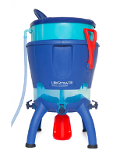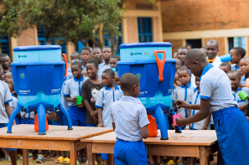

This project will address critical access to safe water, while contributing to pollution reduction through the benefits of carbon financing. The water purification systems will reduce both the use of and demand for firewood and other fuels used to boil drinking water, leading to a reduction in carbon dioxide emissions. The Project will be registered under the Gold Standard was a voluntary emission reduction generating program. The revenue generated by carbon credits from project certification will be used to: (1) cover material costs for repair and replacement of the water purification systems, and (2) monitor and report on water quality testing.

Goal and Objectives of the Projects
The goal of the project is to provide consistent access to safe drinking water in targeted schools by achieving the following objectives: (1) providing water treatment to address microbiological contamination, (2) supporting schools to establish processes (with committed staff time) for water treatment and safe storage, and (3) providing educational and behavior change materials. In achieving these objectives, the project will provide a wide range of social, economic, and environmental benefits for students and staff and the surrounding communities, including:

Health
- Improve water quality for drinking
- Reduce the incidence of smoke and exposure to particulate matter

Economic
- Energy savings
- Cost savings

Social
- Increase clean water availability for students and staff
- Reduce absenteeism due to lack of access to sufficient, safe drinking water

Environmental
- Reduce consumption of firewood, reducing the emission of smoke and pollution
- Support for the conservation of trees and biodiversity

Scale of the project
This program intends to reach at least 500 schools in Rwanda or the equivalent of at least 300,000 students.
Duration
The project start date is July 1, 2023 with a total duration of 15 years, divided in three periods of 5 years each.

Carbon credits ownership
The legal owner of the project is Virridy. The carbon credits generated by the project activity shall be the sole ownership of Virridy. The school leadership will sign an agreement which includes a statement that the rights to the carbon credits have been relinquished to the project developer. By signing the waiver, the rights to the carbon credits generated by the project are transferred to Virridy, remaining uncontested. A portion of the revenue generated by the sale of these credits will be used to: (1) cover material costs for repair and replacement of the water purification systems, and (2) monitor and report on water quality testing.

Implementation plan
The program expects to supply and install water purification systems in 500 schools over an 18-month period. Maintenance of the installed water purification systems is equal to the program total crediting period (15 years).

Sustainable Development Goals (SDGs) contributions
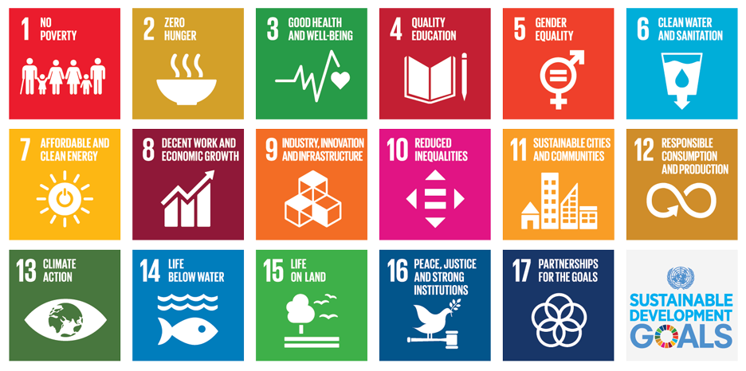

        - Contact details to get further technical detail and project information
>>
Name: Jean NTAZINDA
Position: Climate Finance Director
Address: KK 15 Road Silverback Mall, Third Floor, Unit Number SB1-313
Phone: +250 788 481 439
Email: jean.ntazinda@virridy.com

        - Summary of economic, social and environmental impacts of the Project
>>
Health
- Provide water access for drinking, sanitation and hygiene
- Reduce the incidence of smoke and exposure to particulate matter
Economic
- Employment and job creation
- Energy savings
Social
- Increase safe water availability for schools and host communities in Rwanda
- Reduce time spent boiling and cooking water for drinking
Environmental
- Reduce consumption of firewood, reducing the emission of smoke and pollution
- Reduce deforestation for the conservation of trees and biodiversity
        - Other relevant information to help stakeholders understand the project
>>
Before the local stakeholder consultation meeting, our invitees received a non-technical summary that had details about the project implementation, objective, duration, scale, benefits, and technology applied. At the time of the writing and distribution of the non-technical summary, the identified technology was the LifeStraw Community Filter. However, before the meeting was held, the technology was broadened to ultrafiltration, which is inclusive of the LifeStraw Community Filter but also of other membrane filter units, including those implemented by Water Access Rwanda. The presentation and discussion during the meeting were therefore inclusive of other types of membrane filtration, such as the examples provided in Figure 2 below.

Figure 2. Ultrafiltration examples: Ultrafiltration membrane as part of Splash* treatment system (L); Antunes VZN ultrafiltration system (R)
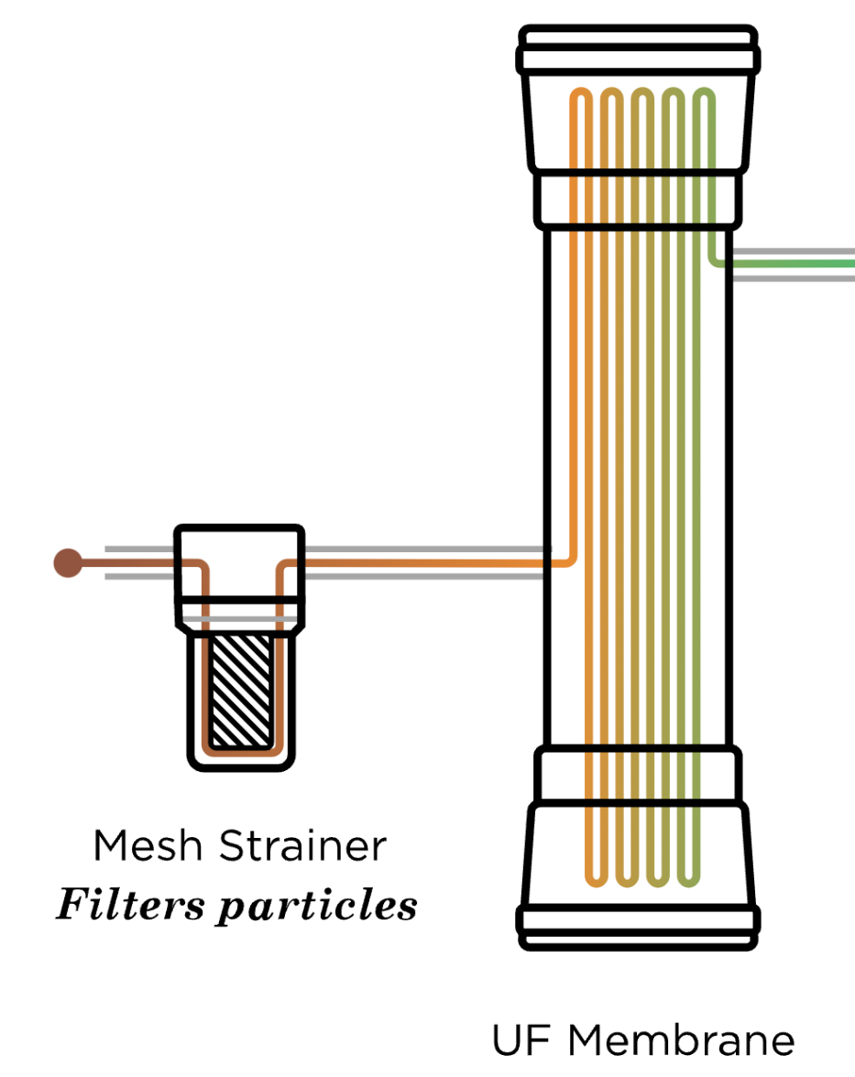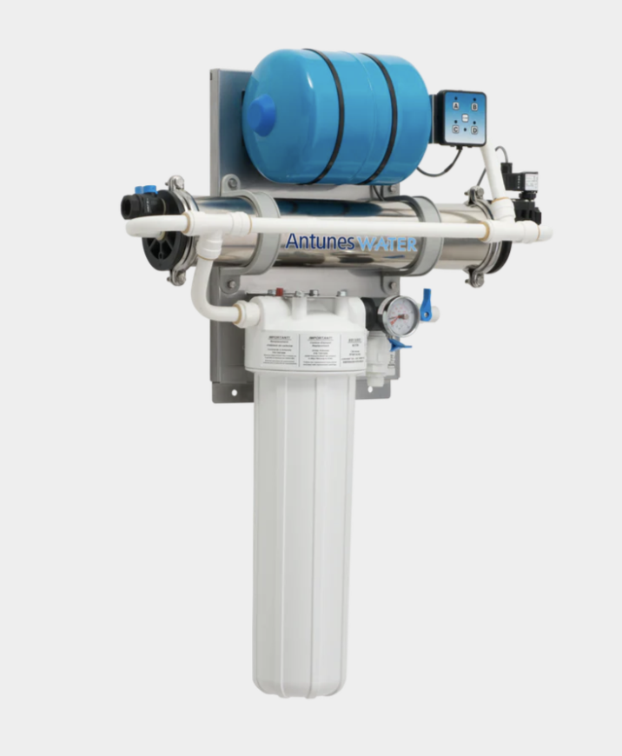

Virridy also shared with stakeholders the continuous grievance mechanisms information throughout the different stages of the consultation to receive inputs. It was important to remind stakeholders that the selection criteria for beneficiary schools are:
- Have no access to utility water supply,
- No water purification means other than boiling water using biomass,
- Presence of e-coli in school drinking water source(s), and
- Enrollment of at least 400 students.
District administrators and school leadership sign collaboration agreements with Virridy for the project implementation.

INVITATIONS MADE TO STAKEHOLDERS
        - Invitation tracking table

Category Code | Stakeholder Type/Organisation (if relevant) | Name of invitee | Male/  Female | Method of invitation | Date of invitation  (>30 days before Meeting)
A | GS Nyabitare (School) | Nyirahabimana Odette | Female | E-mail | 23 May 2023
A | EP Busekera (School) | Umugiramana Petronille | Female | E-mail | 23 May 2023
A | EP Musange (School) | Murekeyiteto Christine | Female | E-mail | 23 May 2023
A | EP Kivumo (School) | Umuhoza Claudine | Female | E-mail | 23 May 2023
A | GS Cyeza (School) | Nshimiyimana Alphonse | Male | E-mail | 23 May 2023
A | GS Cukiro (School) | Twagirimana Viateur | Male | E-mail | 23 May 2023
A | GS Matyazo (School) | Mugabo Hakizimana | Male | E-mail | 23 May 2023
A | GS Sholi (School) | Callixte Ntawukirasongwa | Male | E-mail | 23 May 2023
A | Buringa TSS (School) | Ngaboyamahina Eraste | Male | E-mail | 23 May 2023
A | EP Muyebe (School) | Kamegeri David | Male | E-mail | 23 May 2023
A | EP Nyakabanda (School) | Nkundisano Jean Pierre | Male | E-mail | 23 May 2023
A | EP Gisharu (School) | Eric Tuyisenge | Male | E-mail | 23 May 2023
A | EP Gitumba (School) | Nkundayezu Sylvere | Male | E-mail | 23 May 2023
A | GS Cyicaro (School) | Habintwari Alexandre | Male | E-mail | 23 May 2023
A | GS Nyabinoni (School) | Mwumvaneza Jean de la Croix | Male | E-mail | 23 May 2023
A | Paakkam Limited | Al Hadj NSHUMBUSHO Asman | Male | E-mail | 23 May 2023
C | Water and Sanitation Corporation (WASAC) | UMUHUMUZA Gisele | Female | E-mail | 23 May 2023
C | District of Muhanga | KAYITARE Jacqueline | Female | E-mail | 23 May 2023
C | District of Musanze | RUMULI Janvier | Male | E-mail | 23 May 2023
D | Rwanda Standards Bureau | Raymond MURENZI | Female | E-mail | 23 May 2023
D | Rwanda Environment Management Authority | KABERA Juliett | Female | E-mail | 23 May 2023
D | IRIBA Water Group | Yvette ISHIMWE | Female | E-mail | 23 May 2023
D | Ministry of Education | Valence NGABOYERA | Male | E-mail | 23 May 2023
E | Water Access Rwanda | Christelle Kwizera | Female | E-mail | 23 May 2023
E | University of Global Health Equity | Maria Qambayot | Female | E-mail | 23 May 2023
E | Water for People | Eugene Dusingizumuremyi | Male | E-mail | 23 May 2023
E | RENGOF | Oscar | Male | E-mail | 23 May 2023
F | Gold Standard |  | N/A | E-mail | 23 May 2023
G | Global Offset Research | Siddharth Yadav | Male | E-mail | 23 May 2023
G | CEDESOL | David Whitfield | Male | E-mail | 23 May 2023
G | United Purpose | Lloyd Archer | Male | E-mail | 23 May 2023
G | HIVOS | Harry Clemens | Male | E-mail | 23 May 2023
G | Concern Health Ghana | Isaac Ampomah | Male | E-mail | 23 May 2023
G | NOVA | Montagu Murray | Male | E-mail | 23 May 2023
G | Lean Management Systems Promotion Society | Raave Jain | Male | E-mail | 23 May 2023
Other | USAID | Nadine Munezero | Female | E-mail | 23 May 2023
Other | University of Rwanda | Elias Nyandwi | Male | E-mail | 23 May 2023
Other | USAID | Joshua Vetter | Male | E-mail | 23 May 2023
Other | USAID | Emmanuel Gasana | Male | E-mail | 23 May 2023
Other | University of Rwanda | Ntakirutimana Theoneste | Male | E-mail | 23 May 2023

Due to the nature of the project activity, Category Code “B Stakeholders with land-tenure rights within or adjacent to the project” is not applicable.

          - Appropriateness of methods
>>
The majority of stakeholders invited to the local stakeholder consultation meeting in Kigali were beneficiary schools, District officials, relevant central government officials including Rwanda Standards Bureau (RSB), Rwanda Environment Management Authority (REMA) and the Ministry of Education (MINEDUC). To invite our stakeholders, we used an email and official letter signed and scanned that was sent as an attachment along with the non-technical summary of the project to enable them to have a good understanding of the project ahead of the meeting.

We made follow up phone calls and sent email reminders to ensure that all the participants received the information and planned to attend the meeting. The email content, invitation letter, non-technical summary of the project and feedback form were in both English and Kinyarwanda.

Transportation support (financial and logistics) was provided to participants traveling from outside Kigali, including reimbursement for transportation costs at the end of the meeting.

          - Gender Sensitivity
>>
Invitations were broadly made to stakeholders in the water sector, education sector and carbon credits sector and any likely program beneficiaries within the water supply and purification business. We made an effort to extend the invitations to women to ensure that their views were incorporated during the design of the program. Consequently, about 30% of the invitees and 40% of the attendees (excluding Virridy staff) for the local stakeholder consultation meeting were female. Women were prompted to provide their views on the issues being raised. At the meeting venue, Lemigo Hotel, separate restrooms were available for women on the same floor as the meeting.

          - Evidence proving invites took place as stated
>>
Initial e-mail invitation sent to all stakeholders:
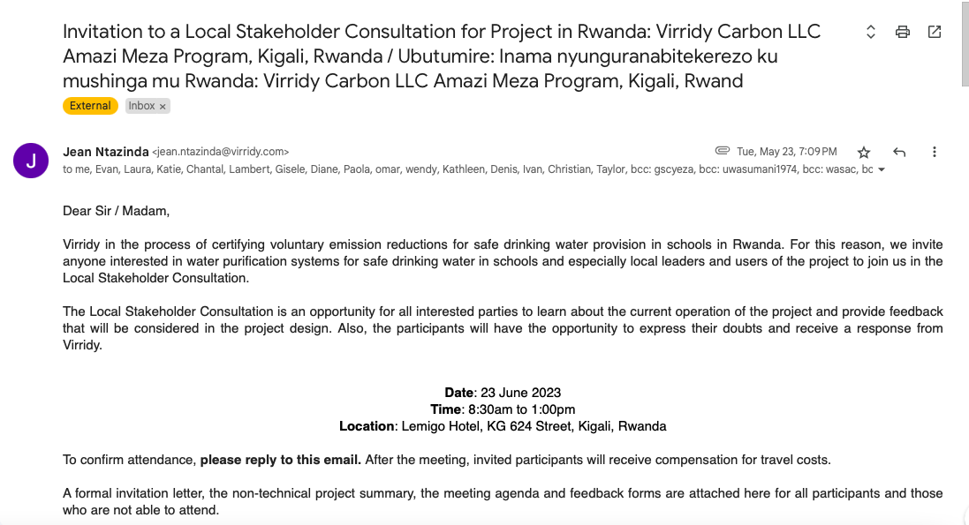

1st reminder e-mail sent to all stakeholders:
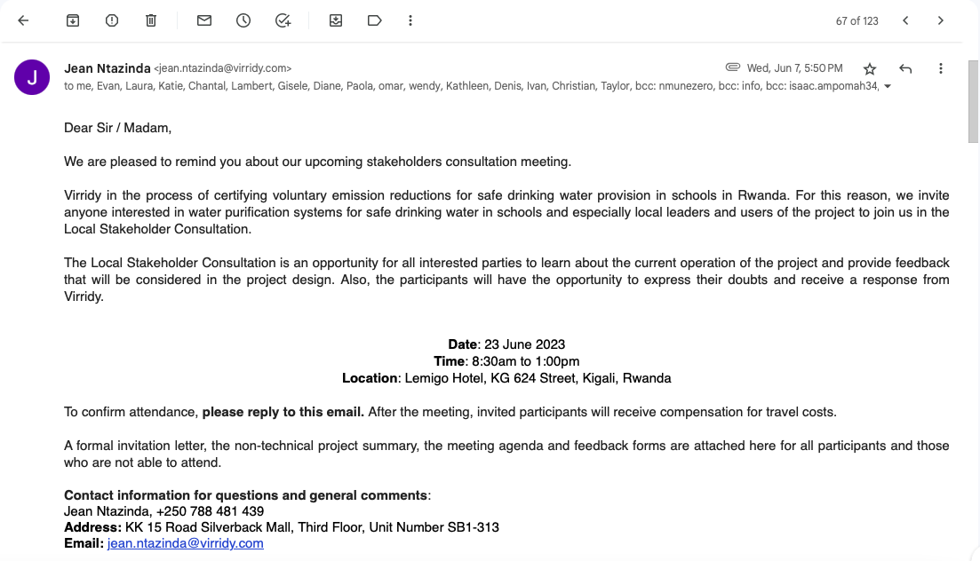

2nd reminder e-mail sent to all stakeholders:
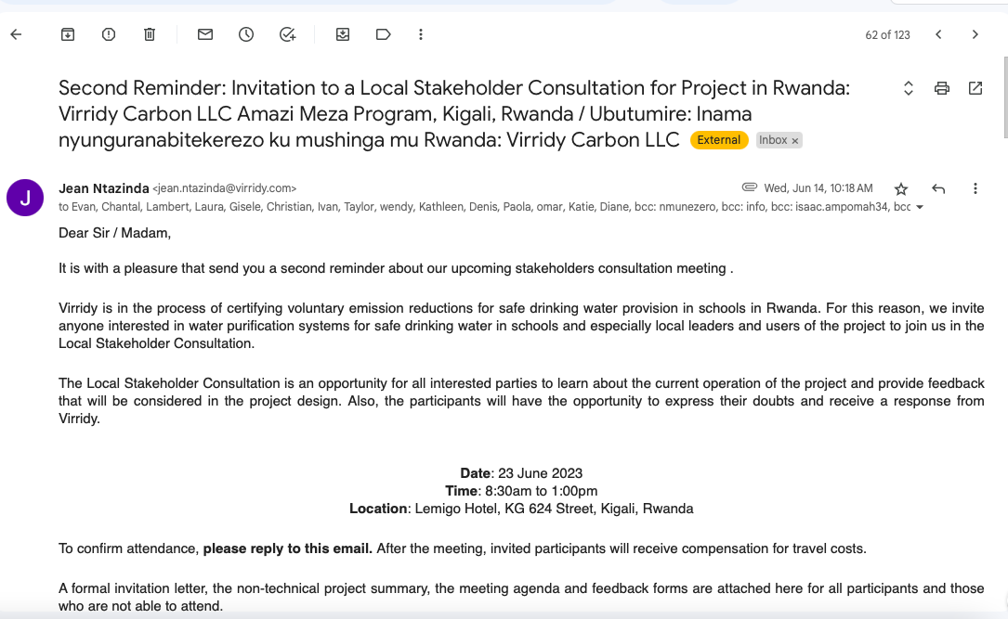

          - Sample content of invites (for each Method above)
>>
Dear Sir / Madam,
Virridy is in the process of certifying voluntary emission reductions for safe drinking water provision in schools in Rwanda. For this reason, we invite anyone interested in water purification systems for safe drinking water in schools and especially local leaders and users of the project to join us in the Local Stakeholder Consultation.
The Local Stakeholder Consultation is an opportunity for all interested parties to learn about the current operation of the project and provide feedback that will be considered in the project design. Also, the participants will have the opportunity to express their doubts and receive a response from Virridy.

Date: 23 June 2023
Time: 8:30am to 1:00pm
Location: Lemigo Hotel, KG 624 Street, Kigali, Rwanda

To confirm attendance, please reply to this email. After the meeting, invited participants will receive compensation for travel costs.

A formal invitation letter, the non-technical project summary, the meeting agenda and feedback forms are attached here for all participants and those who are not able to attend.

Contact information for questions and general comments:
Jean Ntazinda, +250 788 481 439
Address: KK 15 Road Silverback Mall, Third Floor, Unit Number SB1-313
Email: jean.ntazinda@virridy.com
We appreciate you sharing this invitation with your colleagues and contacts who may be interested in the project.

Thank you very much for your attention!

Jean NTAZINDA, Climate Finance Director
www.virridy.com | jean.ntazinda@virridy.com
(+250) 0788 481 439
____________________________________________________________________
About Virridy
Virridy develops and deploys technologies to manage water, energy and agricultural resources in remote, off-grid environments. Our low-cost satellite-connected sensors are compatible with a wide range of fixed infrastructure. Leveraging machine learning, we enable responsive remote management of the environment. Virridy's technologies support carbon credits, energy incentives, water permitting and other environmental market commodities. In Africa, we support the generation of carbon finance-based payments for water services. In the western United States, we improve groundwater management and conservation.

Virridy Local Headquarters: KK 15 Road Silverback Mall, Third Floor, Unit Number SB1-313

Bwana/ Madamu,

Virridy yatangiye umushinga wo kugabanya imyuka ihumanya ikirere utagengwa n’amasezerano mpuzamahanga yo kurwanya ihumana ry’ikirere ibinyujije mu gikorwa cyo gutanga amazi meza mu mashuli mu Rwanda. Kubera iyo mpamvu, tunejejwe no gutumira abantu bose bafite ibikorwa bijyanye no gusukura amazi mu mashuri cyane cyane abayobozi mu nzego zifite aho zihuriye n’ibyo bikorwa ndetse n’abagenerwabikorwa mu kwifatanya natwe mu nama nyunguranabitekerezo n’abafatanyabikorwa.

Inama nyunguranabitekerezo n’abafatanyabikorwa ni uburyo bwiza ku babyifuza bose kugira ngo bahabwe amakuru y’ibikorwa by’umushinga kandi nabo babonereho gutanga ibitekerezo byabo bizashingirwaho hanozwa ishyirwa mu bikorwa ry’umushinga. Ikindi, abitabiriye inama bazahabwa amahirwe yo kugaragaza impungenge zabo kandi bahabwe ibisubizo kuri zo.

Italiki: kuwa 23 Kamena 2023
Amasaha: 8:30AM - to 1:00PM
Ahantu: Lemigo Hotel, KG 624 street, Kigali, Rwanda

Kwemeza ubwitabire, nyabuna subiza kuri imeyili. Nyuma y’inama, ibitabiriye bahasubizwa amafaranga y’urugendo.

Ibaruwa itumira, inshamake y’umushinga, urutonde rw’ibizigirwa mu nama, ndetse n’ifishi yifashishwa mu gutanga ibitekerezo murabibona ku mugereka w’ubu butumwa ku bantu bazitabira ndetse n’abatazabasha kwitabira.

Aho ushobora gutanga ikibazo cyangwa n’igitekerezo muri rusange:
Jean Ntazinda, (+250) 788 481439
Address: KK 15 Road Silverback Mall, Third Floor, Unit Number SB1-313
Email: jean.ntazinda@virridy.com

Tubashimiye kugeza ubu butumire kuri bagenzi bawe n’abandi uzi bashobora kuba bashishikajwe n’ibikorwa by’umushinga.

Murakoze cyane!
___________________________________
Amakuru kuri Virridy
Virridy ikora ikanakwirakwiza ikoranabuhanga ryo gucunga neza umutungo kamere w’amazi, ingufu n’umutungo ukomoka ku buhinzi mu bice bitaragezwamo amashanyarazi. Uburyo bwacu buhendutse bw’ibikoresho-nkusanyamakuru buhujwe n’icyogajuru, bukorana neza n’urwunge rw’ibikorwaremezo bitimukanwa. Twifashisha ikoranabuhanga rigezweho ridushoboza gucunga ibikorwa by’umushinga biri aho dukorera mu buryo bw’iyakure. Ikoranabuhanga rya Virridy rifasha isoko ry’umusaruro w’isoko ry’Igabanywa ry’imyuka ihumanga ikirere, ibihembo ku mishinga y’infu (amashanyarazi) n’ibindi bicuruzwa bijyanye n’ibidukikije. Muri Africa, dufasha mu gukora inyungu ivuye mu gabanya imyuka ihumanya ikirere binyuze mw’ishoramari rya serivisi z’amazi. Mu burengerazuba bw’Amerika, tuzamura urwego rw’imicungire no kubungabunga amazi yo munsi y’ubutaka (Underground water).

Official letter as attachment:
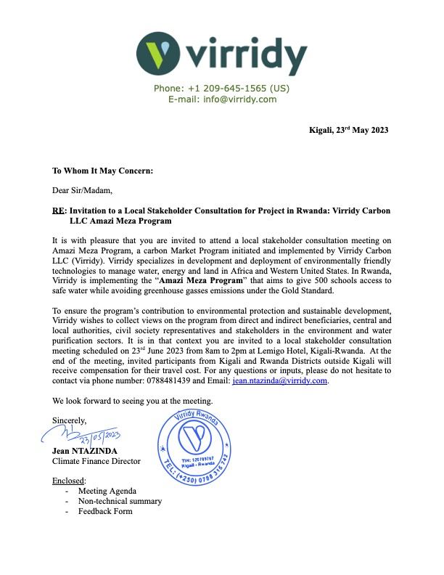

          - Description of other Means and methods to provide feedback for those who are not able to join the consultation meeting
>>
On 23rd May 2023, we sent an invitation with all supporting documents including a non-technical summary of the project, feedback form and grievance mechanisms for providing feedback. The email and attachments were sent to all stakeholders for whom we had contact information and were in both Kinyarwanda and English. The supporting documents were also attached to the 7th and 14th June 2023 reminder emails (documented in B.1.3. above), which were sent to all stakeholders, as well, not only those who had confirmed their attendance. Thus, we ensured that even those who were not able to attend were provided with the necessary context and information to engage in the feedback process.

REPORT OF THE CONSULTATION PROCESS
        - Date of Meeting
>>

23 June 2023

          - Justification of why consultation took place after the project start date (retroactive projects only)
>>
Not applicable.

          - List of participants
Date and Time | 23 June 2023 | Location | Lemigo Hotel, Kigali, Rwanda
Category  Code | Name of the participant, job /  position in the community | Male /  Female |  | Contact details | Organisation  (if relevant) | Signature
A | Nyirahabimana Odette, Headmaster | Female | nyirahabimanamarieodette@gmail.com |  | GS Nyabitare (School) | Refer to Annex 1 (scanned attendance list)
A | Mugabo Hakizimana, Head Teacher | Female | hakizimanamugabo6@gmail.com |  | GS Matyazo (School) | Refer to Annex 1
A | Murekeyiteto Christine, Head Teacher | Female | murekeyitetoh@gmail.com |  | EP MUSANGE (School) | Refer to Annex 1
A | NSABIMANA Bonaventure | Female | 789200791 |  | ITER Rutobwe (School) | Refer to Annex 1
A | Umuhoza Claudine, Head Teacher | Female | umuhozac61@gmail.com |  | EP kivumo (School) | Refer to Annex 1
A | MUKANYANDWI Vestine | Female | 788922042 |  | EP Busekera | Refer to Annex 1
A | Nshimiyimana Alphonse, Head Teacher | Male | gscyeza@gmail.com |  | GS Cyeza (School) | Refer to Annex 1
A | Twagirimana Viateur, Headmaster | Male | tviateur73@gmail.com |  | GS Cukiro (School) | Refer to Annex 1
A | Callixte Ntawukirasongwa, Head Teacher | Male | nizeyecallixte@gmail.com |  | GS Sholi (School) | Refer to Annex 1
A | Kamegeri David, Head Teacher | Male | davidkameg123@gmail.com |  | ES Nyakabanda (School) | Refer to Annex 1
A | Nkundisano Jean Pierre, Head Teacher | Male | nkundisano@gmail.com |  | EP Muyebe (School) | Refer to Annex 1
A | DUSENGIMANA Theogene, Head teacher | Male | 782380581 |  | EP Nyenyeri | Refer to Annex 1
C | Nteziryayo Sylvere, Water and Sanitation Officer | Male | info@muhanga.gov.rw |  | Muhanga District | Refer to Annex 1
E | Maria Albin | Female | malbin@ughe.org |  | UGHE | Refer to Annex 1
E | Christelle Kwizera, Managing Director | Female | kwizera@warwanda.com |  | Water Access Rwanda (Private) | Refer to Annex 1
E | Vanessa HATEGEKIMANA | Female | vanessa@warwanda.com |  | Water Access Rwanda (Private) | Refer to Annex 1
E | Prosper Manikuze, Standards Quality Specialist | Male | wasac@wasac.rw |  | Water and Sanitation Corporation | Refer to Annex 1
F | Gold Standard (Auditor) | N/A | help@goldstandard.org |  | Gold Standard (Auditor) | Refer to Annex 1
 | Laura MacDonald,  International Carbon Programs Director | Female | laura.macdonald@virridy.com |  | Virridy | Refer to Annex 1
 | MANIRABARUTA Gisele, Water Testing Manager | Female | gisele.manirabaruta@amaziyego.com |  | Amazi Yego | Refer to Annex 1
 | KAYITESI Diane, Finance Manager | Female | diane.kayitesi@virridy.com |  | Virridy | Refer to Annex 1
 | Jean NTAZINDA, Climate Finance Director | Male | jean.ntazinda@virridy.com |  | Virridy | Refer to Annex 1
 | Lambert MUGABO,  Research Manager | Male | lambert.mugabo@virridy.com |  | Virridy | Refer to Annex 1

          - Pictures from the physical meeting(s)
>>
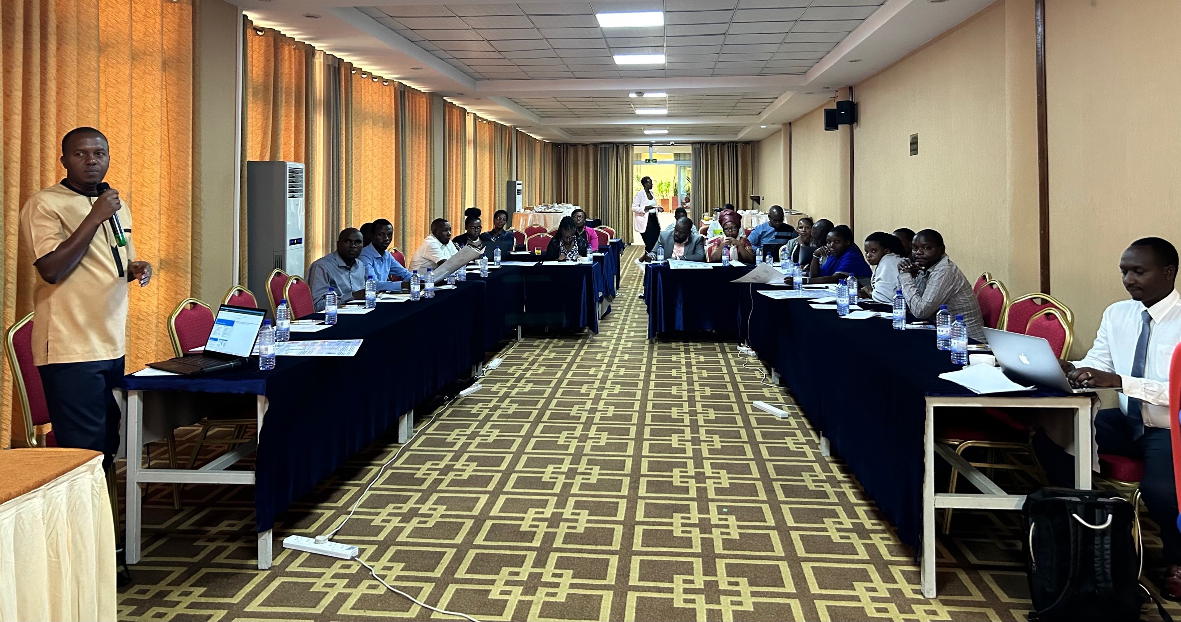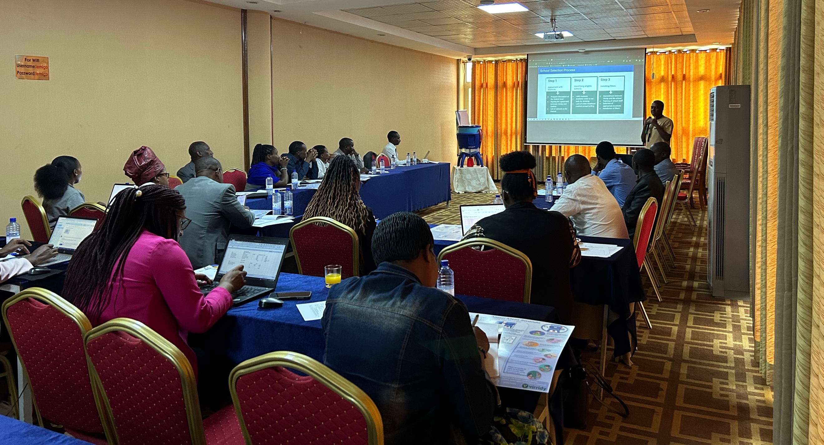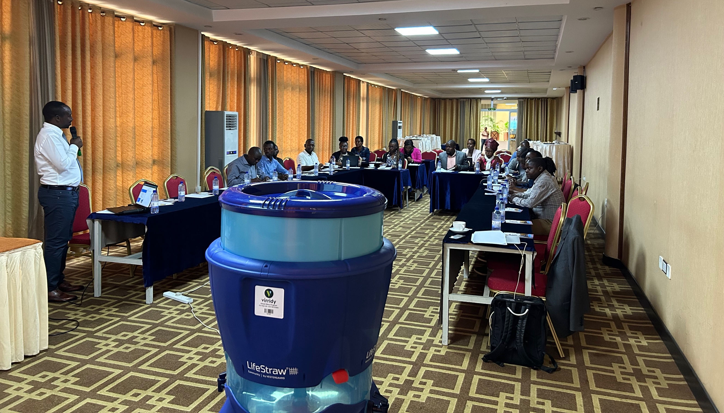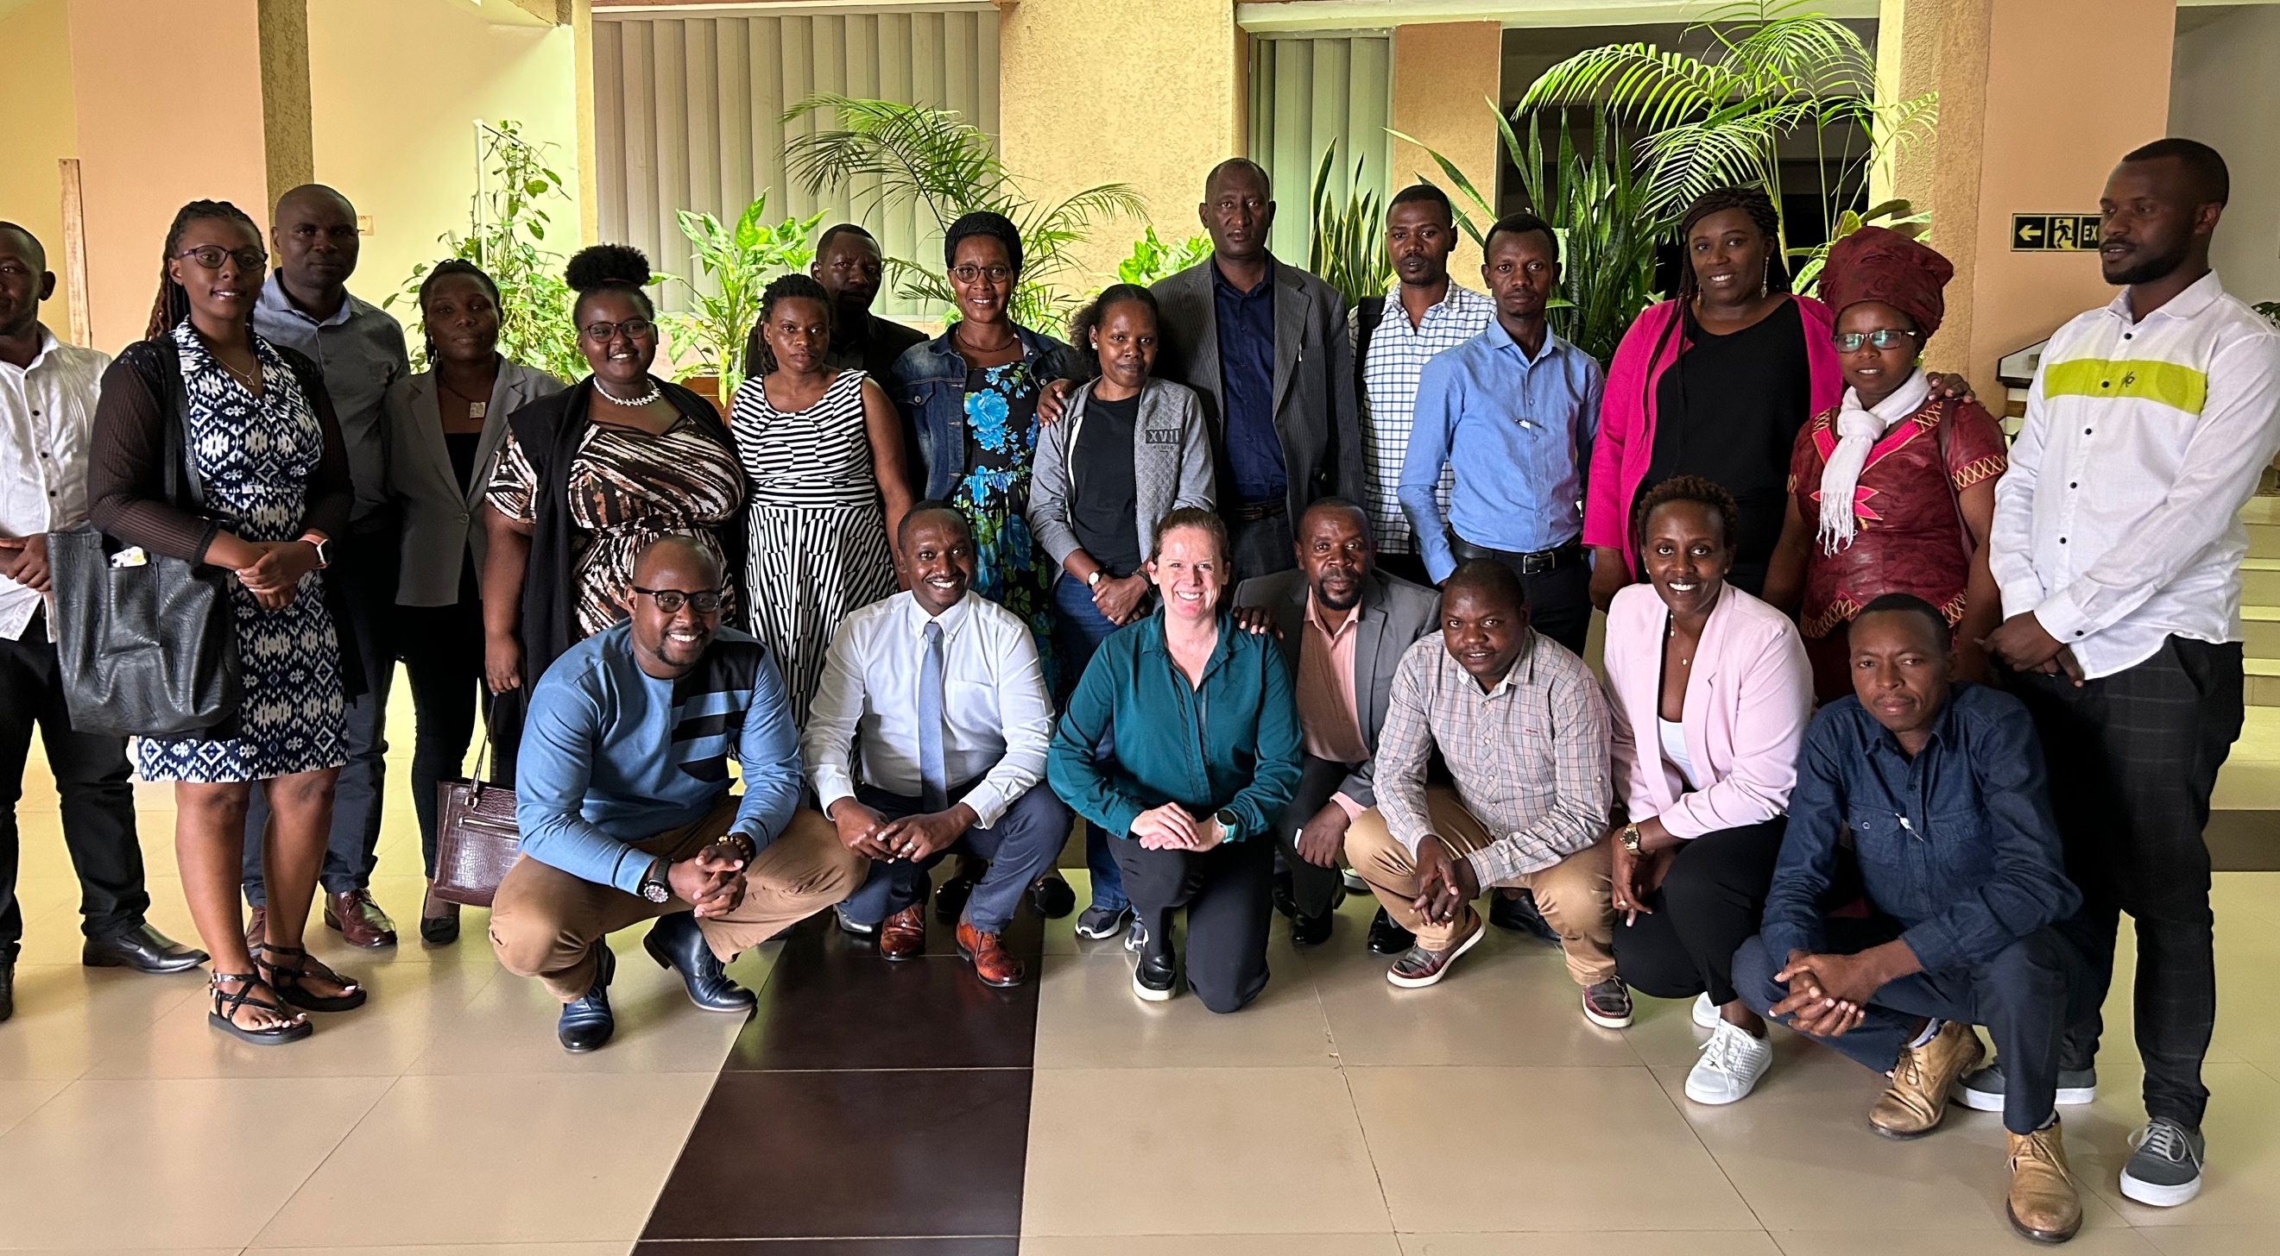
        - Minutes of physical meeting(s)
>>
The local stakeholder consultation meeting was conducted on 23rd June 2023 from Lemigo Hotel, in Kigali-Rwanda. On top of 5 staff from Virridy (the host), 18 participants attended and actively contributed to the meeting proceedings.

The meeting began with introductions by the hosts and all participants. The host introduced Virridy’s background and experience in supporting efficient use of natural resources, especially water in East Africa and the Western United States of America. The host then further introduced the project team that will support implementation of the activities of the Amazi Meza Rwanda Water Supply Project for Schools.

Following introductions, the facilitator started the meeting by giving a general overview of the project background and the current situation of safe water access in schools in Rwanda, highlighting that only a small percentage of schools in Rwanda have access to piped utility water, and lack of safe water remains a critical challenge in many rural schools. A large proportion of these schools use water from protected and unprotected springs, rainwater, or surface water. In some cases, schools rely on high carbon emission practices like using charcoal and wood biomass to boil drinking water for consumption.

The second presenter focused on the proposed solution – water purification technologies, and more specifically, ultrafiltration technologies, explaining how ultrafiltration works and providing examples of potential technologies for implementation. The presenter also stressed the selection and agreement process for identifying the beneficiary schools: agreement with Districts, identification of and agreement with eligible schools, and installation of the water purification technologies. It was an occasion to highlight the role of beneficiary schools in implementation of the project. After training of schools dedicated staff, Virridy a beneficiary school to play a key role in proper use of the water purification technology and timely communication with the project team for maintenance. Time was allowed for questions.

Before a break that allowed participants to exchange with each other and the project team, the facilitator shared with the audience the Gold Standard certification route that must be followed by the project towards generation of verified emission reductions. The presentation also discussed the investment and scale up of the project. After the break, there was a dedicated question and answer session. Most of the questions were for clarification on the capacity and functioning of the proposed water filtration system, project lifespan and responsibilities of the project beneficiaries.

Time was the dedicated to a review of the Safeguarding Principles, with the facilitator introducing each principle and giving participants time to complete the exercise using the worksheet provided and ask any questions. This was followed by a summary of the anticipated health, social, environmental and economic impacts.

Before closing the meeting, the facilitator asked participants to complete the feedback forms provided to each person and highlighted that they could also send feedback after the meeting via the contact information provided. The facilitator also introduced the continuous grievance mechanisms that would be open for the duration of the project.

          - Minutes of other consultations
>>
Not applicable.
        - Assessment of comments from all consultations above
Gender of Stakeholder | Stakeholder  comment | Was comment taken into account (Yes/ No)? | Explanation/  Justification (Why? How?)
Male | To increase the number of schools benefiting from this project. | Yes | 500 schools is an initial target number, with the potential to increase project scale depending on project viability and number of available schools that meet eligibility criteria.
Female | It will be good to share the impacts of this project to the health of children after may be a year of implementation. | Yes | Although Virridy will be monitoring and reporting water quality throughout the project, monitoring and reporting health impact is not within the scope of the project. Virridy is working with other partners to apply for funding for research on the health impact of the project.
Unknown | During the training, ensure that participants are trained on how to dispose of backwashed water. Think about extending the project to communities near schools so that students have access to safe drinking water at both school and home. | Yes | Community-level implementation is outside the scope of this project.
Male | To increase the number of filters per school so that 50 students use one filter. 1) It would great to have different water sources at school, 2) increase the number of water tanks available at school, 3) would be better for filters to have some kind of shelter to avoid moving filters very often. | Yes | Due to the cost of the filters and the current (and foreseeable future) price for carbon credits, providing a filter for each classroom is not viable within the budget. (1) With the exception of WASAC utility connection, all water sources are considered eligible for treatment. (2) Provision of water tanks is outside of the scope of this project. (3) It is the schools' responsibility to provide safe storage and security for the filters, and Virridy staff have a conversation with school staff about this during delivery and installation.
Female | To increase the number of filters so each class room has its own filter. Provide training regularly to increase our knowledge. | Yes | Due to the cost of the filters and the current (and foreseeable future) price for carbon credits, providing a filter for each classroom is not viable within the budget. Training will take place upon filter delivery and installation as well as during follow up visits for monitoring and water quality testing.
Male | The idea is that the project should extend at household level because they use lots of wood to boil water for drinking. | Yes | Household-level water treatment is outside of the scope of this project.
Male | The project should focus on schools which are in remote settings (e.g: Schools located in Rongi sector, Muhanga District) and anywhere else except in urban places. | Yes | Location is considered when determining Districts for potential implementation, particularly because urban settings have a higher rate of connection to WASAC (and therefore higher access to safe drinking water).
Male | To think about the commercial element where filters are available on the market. | Yes | Sale of filters is outside of the scope of this project. Virridy is committed to ensuring the necessary supply chain is in place to repair and replace filters, but not to sell to consumers.
Male | To establish consistent communication between stakeholders. For the next meeting, the project should think about participants who come from far places, thus slightly push back the time of starting the meeting. | Yes | This will be taken into consideration in the future. The meeting started about 1.5 hours after the scheduled start time to allow for participants traveling from distant locations to arrive and participate.
Female | It would be better to have filters with greater storage capacity. | Yes | Virridy has considered many filter options, with filter selection reliant upon a number of criteria, including storage capacity. Virridy will continue to consider other options while it optimizes the project.
Female | Yes, it would be great to think about filters with increased storage capacity. | Yes | Virridy has considered many filter options, with filter selection reliant upon a number of criteria, including storage capacity. Virridy will continue to consider other options while it optimizes the project.
Female | It would be great to speed up the implementation of the project. Include in the project regular monitoring visits, and provide regular feedback to schools on things they can improve. | Yes | Virridy has planned regular filter use and maintenance monitoring by phone calls and in-person visits as well as water quality testing monitoring visits as required by the Gold Standard. During in-person visits, school staff will receive feedback and guidance on filter use and maintenance as well as the results of water quality testing.
Unknown | To speed up the implementation of the project and include monitoring activities to ensure that responsibilities are fulfilled. Consider regualr monitoring visits at schools followed by feedback. | Yes | Virridy has planned regular filter use and maintenance monitoring by phone calls and in-person visits as well as water quality testing monitoring visits as required by the Gold Standard. During in-person visits, school staff will receive feedback and guidance on filter use and maintenance as well as the results of water quality testing.
Unknown | The project should consider undertaking monitoring visits to beneficiaries. To speed up the implementation of the project because it is so much needed. | Yes | Virridy has planned regular monitoring visits to schools, but not to individual households. The project is being rolled out on the fastest feasible timeline dependent on agreements with the Districts to ensure necessary approvals are obtained and on quality of implementation, including training of school staff.
Male | Estabish communication channels between Virridy and stakeholders. | Yes | Virridy staff contact information and mechanisms for feedback have been provided to all stakeholders as well as to school staff and District leaders. Virridy staff maintain regular communication with school staff after installation of filters.
Female | Establish consistent communication between levels including Virridy, District, sector, as well as the school. No additional comment but it would be great to speed up the implementation of the project | Yes | Virridy staff contact information and mechanisms for feedback have been provided to all stakeholders as well as to school staff and District leaders. Virridy staff maintain regular communication with school staff after installation of filters. The project is being rolled out on the fastest feasible timeline dependent on agreements with the Districts to ensure necessary approvals are obtained and on quality of implementation, including training of school staff.
Male | We shall have more ideas as well get experience from using the filters | N/A

Note: All comments written in Kinyarwanda have been translated into English.

          - Evaluation forms (best practice)
Included below are several examples of responses collected during the local stakeholder consultation meeting. Scanned, signed copies of the stakeholder evaluation forms can be found in Annex 2. All responses collected during the meeting can be found in Annex 3, with comments written in Kinyarwanda translated into English.
Name | Nkundisano Jean Pierre
Gender – Male/Female: | Male
What is your impression of the meeting? | The meeting was good.
What do you like about the project? | Took care of the participants to the meeting, provided direction to meeting venue, wellbeing was taken care of.
What do you not like about the project? | Nothing
Signature | Refer to Annex 2.

Name | Murekeyiteto Christine
Gender – Male/Female: | Female
What is your impression of the meeting? | The meeting was well organized and all necessary materials/equipment were available.
What do you like about the project? | The project is designed to solve the existing problem regarding lack of access to safe drinking water.
What do you not like about the project? | There is nothing about the project that I don't like because the project addresses the challenge we had.
Signature | Refer to Annex 2

Name | Hakizimana Mugabo
Gender – Male/Female: | Male
What is your impression of the meeting? | Very good
What do you like about the project? | To solve the problems we had regarding access to safe drinking water at school.
What do you not like about the project? | Nothing
Signature | Refer to Annex 2

Name | Nyirahabimana Marie Gorette
Gender – Male/Female: | Female
What is your impression of the meeting? | Very good
What do you like about the project? | Students will have access to safe drinking water, hence won't drink contaminated water that can cause various illnesses.
What do you not like about the project? | Nothing
Signature | Refer to Annex 2

C.4. Summary of alterations based on comments
>>
Most attendees at the local stakeholder consultation meeting did not raise any issues highlighted in response to “What do you not like about the project?”. For those who did, the main concerns expressed in the comments were focused on the scope of the project, namely:
- The filtration rate of the filter for producing sufficient safe water for the number of students,
- The number of water filters per schools based on the school population, and
- The rate of installation and project scale.

The filter’s capacity and number of needed installations have been carefully defined to ensure that students from selected schools have sufficient safe drinking water. The rate of installation and project scale were based on feasibility and quality implementation. Therefore, no project changes were made as a result of these comments. Further responses to the comments during the meeting are provided in C.3.

Other comments have been received while engaging local administrations at the district level. Involvement of the Districts’ administration is key to project execution. The implementation team shall involve and inform them through each step of the project.

CONTINUOUS INPUT / GRIEVANCE MECHANISM
 | Method Chosen (include all known details e.g. location of the book, phone, number, identity  of mediator) | Justification of Choice  (best practice)
Continuous Input / Grievance Expression Process Book (mandatory) | The project Grievance Book is  located in the Virridy Office  KK 15 Road Silverback Mall, Third Floor, Unit Number SB1-313 | Continuous feedback and grievance expression are most welcome via email, telephone, or writing in the grievance book.
GS Contact (mandatory) | help@goldstandard.org | Mandatory
Telephone access (optional) | +250 788 481 439 | This line is answered by Virridy staff exclusively responsible for this project implementation
Internet/email access (optional) | jean.ntazinda@virridy.com | This email address is accessed by the Virridy staff member who is directly responsible for the carbon credit component of the entire project.
Nominated Independent Mediator (optional)
Other

STAKEHOLDER FEEDBACK ROUND

Please check this box if the project is retroactive and has done only 1 consultation with a physical meeting integrated into the SFR.

        - Length of the Feedback Round

Stakeholder Feedback Round |  | Planned | Actual
Start Date | 23 June 2023
End Date | 22 August 2023

        - Summarise how all stakeholders were/will be invited to provide feedback
>>
Virridy provided all stakeholders with the feedback form and grievance form that has the email of the person to be contacted following the local stakeholder consultation meeting. The feedback form was distributed by email to all invited stakeholders and in hard copy to all participants who attended the LSC meeting. No responses were received from stakeholders after the meeting.

A grievance book has been made available at the Virridy office for any stakeholders interested in submitting written feedback in person. Photographs of the book are provided in Figure 3 below. To date, no such submissions have been made.

Figure 3. Grievance Book
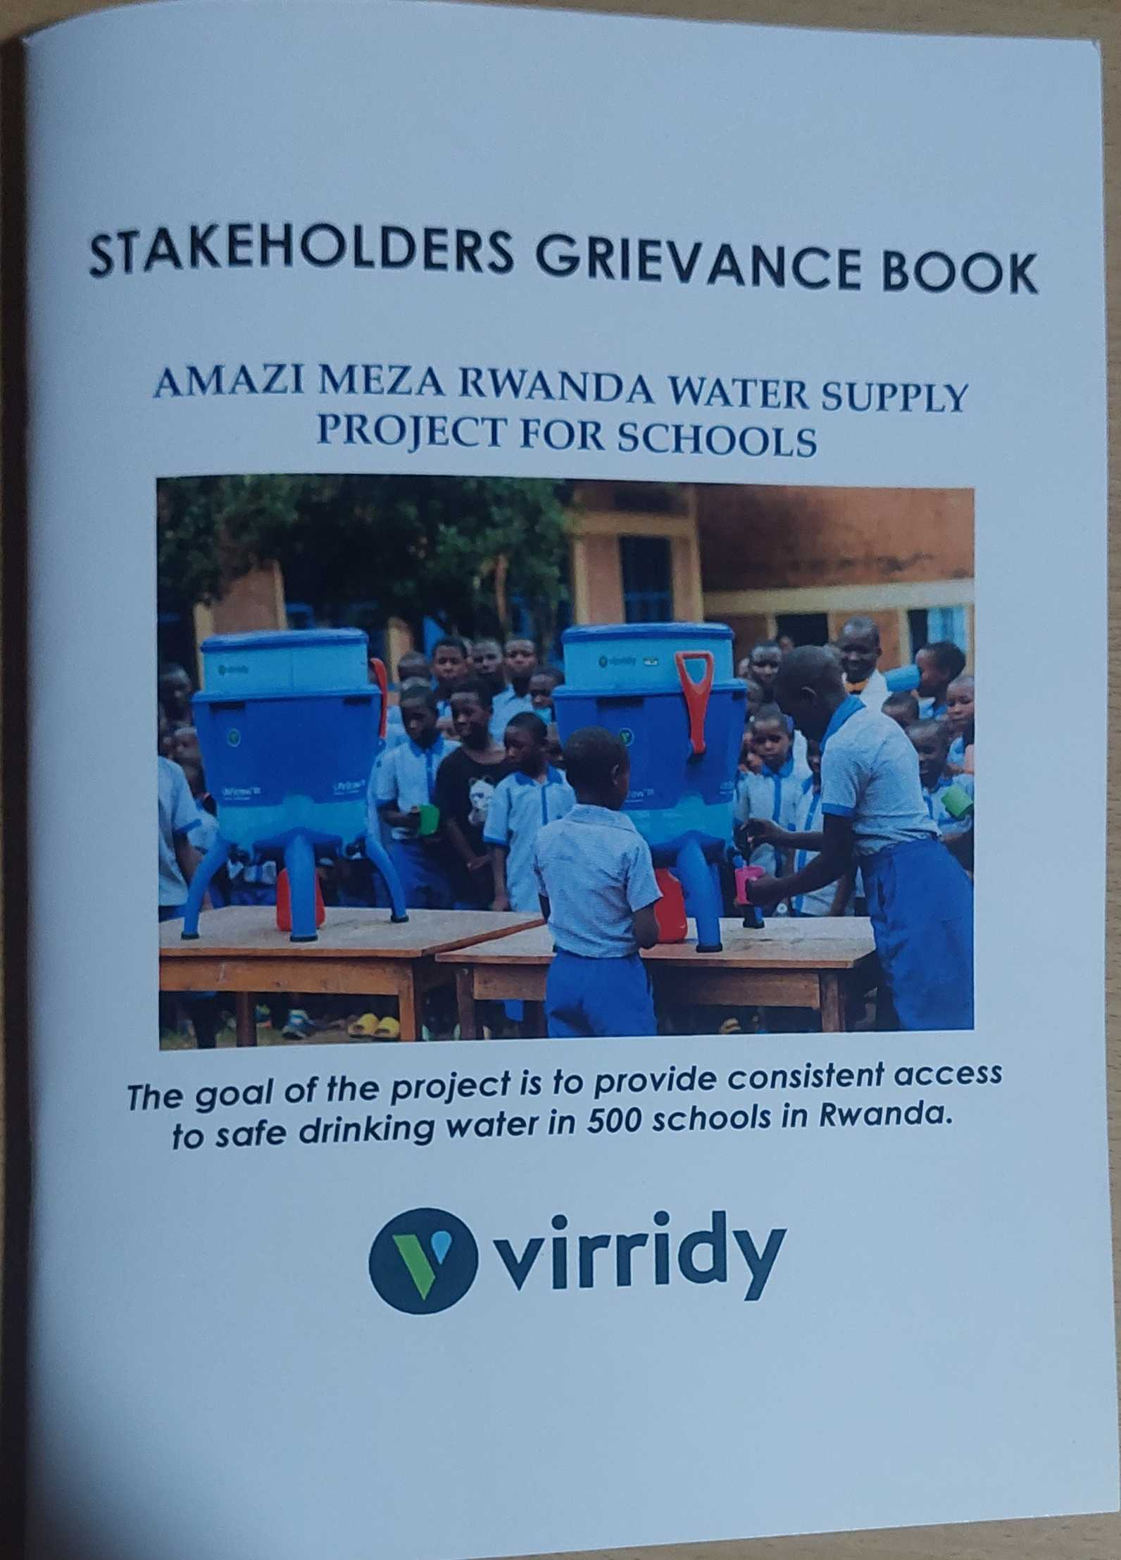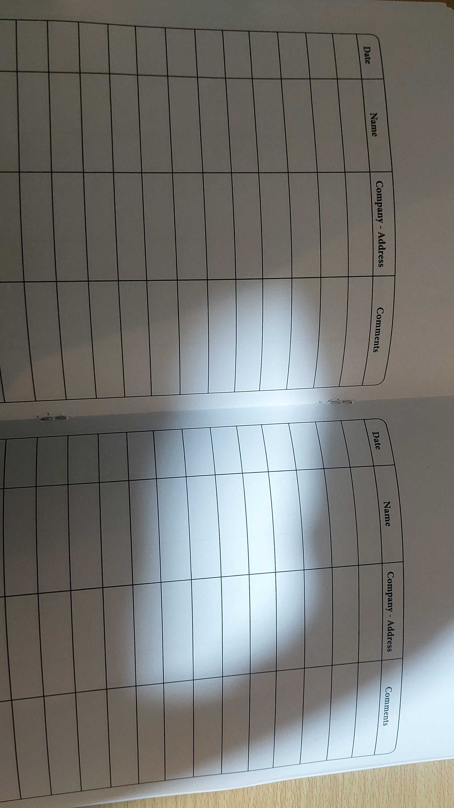
        - Summarise Feedback received, including if any changes in project design were made
>>
No feedback received following the local stakeholder consultation.
Revision History

Version | Date | Remarks
1.2 | 5 May 2022 | Addition of grouped consultation info, preliminary agenda and section to justify retroactive consultation took place.  Minor edits to text.
1.1 | 14 October 2020 | Inclusion of Key Project Information  Restructure, new headings and reorder to better match the steps a developer will follow in consultations.  Removal of some non-mandatory template tables (Blind Sustainable Development Assessment). Clarification of best practice steps that are non mandatory processes, clarification of mandatory discussion points. Clarification regarding publishing names and that original evaluation forms (optional) and attendance lists (mandatory) should be separate documents.  Improved clarity on Stakeholder Feedback round section and procedures for retroactive projects  Provision of an accompanying Guide to help the user understand detailed rules and requirements
1.0 | 14 August 2017 | Initial adoption

The CME also identified SDG 7 and SDG 8 as part of the contributions. These are listed in the VPA-DD.
https://splash.org
https://www.antuneswater.com/collections/vzn/products/vzn-520h-1?variant=31991955718259

