ANNEX AO – THE GOLD STANDARD MICRO-PROGRAMME ACTIVITY DESIGN DOCUMENT TEMPLATE (VPA-DD)

CONTENTS

A. General description of micro-programme activity (VPA)

B. Eligibility of VPA and Estimation of Emission Reductions

C. Stakeholder comments

Annexes

Annex 1: Contact information on entity/individual responsible for the VPA

Annex 2: Information regarding public funding

SECTION A. General description of micro-programme activity (VPA)

A.1. Title of the micro-scale VPA:
>> Title
GS1205 Sustainable Energy for Development PoA, VPA 3: Improved Cook Stove Project in Brazzaville
>>Date and version no
Version 1 (Part A and C) submitted the 11/12/2013
Version 2 (Part A and C) submitted the 11/20/2013
Version 3 submitted the 31/3/2016 for internal validation
Version 4 submitted the 11/11/2016 for the third round of internal validation
Version 5 submitted the 12/5/2016 for the fourth round of internal validation
A.2. Description of the micro-scale VPA:
>>
The use of wood and charcoal for cooking in Brazzaville is very common. The stoves used are not very efficient and need a lot of fuel to operate. Thus, cooking consume a lot of wood and charcoal which cost users more and is a major cause of deforestation in the outer ring of Brazzaville.
The proposed micro-scale VPA aims at creating and organizing a supply and distribution chain for improved cook stoves in Brazzaville. The improved cook stoves promoted can be used with both firewood and charcoal since those two fuels are widely used in Brazzaville.
The project proponent, Initiative Development (ID), helped firstly the creation of a design adapted to local practices. It then organizes the production and distribution by insuring quality and doing some marketing and advertising for the stoves.
Two models have been designed; a big model for restaurants or large families and a smaller model targeting families (although some restaurant owners might also be interested in it).
ID will distribute itself the stoves during the first year and then rely on a network of reseller for the distribution. The prototype creation and the manufacturing of the first stoves will be done by one craftsman that will then train other craftsmen to allow the scaling up of the production.
The expected benefits of this project are essentially a decrease in wood and charcoal consumption in Brazzaville as well as the decrease of toxic fumes when cooking. From an economic point of view, users should also save money on fuel purchase.

A.3. Entity/individual responsible for the micro-scale VPA:
>> Here the information on the entity/individual responsible for the VPA shall be included.
The Entity responsible for the micro-scale VPA is :
Initiative Development,
29 rue Ladmirault, 86000 Poitiers France.
Tel: 05 49 60 89 66
email: carbone@id-ong.org

The contact person is Olivier Lefebvre, Technical Director of Renewable Energy Department
A.4. Technical description of the micro-scale VPA:

A.4.1. Identification of the micro--scale VPA:
The micro-scale VPA is based in the municipality of Brazzaville in the Republic of Congo

A.4.1.1. Host Party:
Republic of Congo

A.4.1.2. Geographic reference or other means of identification allowing the unique identification of the micro--scale VPA (maximum one page):
>>Geographic reference or other means of identification
The micro-scale VPA is taking place in the municipality of Brazzaville in the Republic of Congo.
A unique ID number will be put on each stove manufactured. Then, each stove sold will be recorded in the Project Sale Database with its unique ID number along with the place and date of sale, the name, address and telephone number of the buyer. This will allow to know precisely which stove belong to the proposed micro-scale VPA.
A.4.2. Duration of the micro--scale VPA:

A.4.2.1. Starting date of the micro--scale VPA:
>> 12/11/2013

A.4.2.2. Expected operational lifetime of the micro--scale VPA:
>> 10 years

A.4.3. Choice of the crediting period and related information:
Fixed Crediting period

A.4.3.1. Starting date of the crediting period:
>> 01/01/2015 or two years prior to the registration date, whichever is later.

A.4.3.2. Length of the crediting period, first crediting period if the choice is renewable CP:
10 years

A.4.4. Estimated amount of emission reductions over the chosen crediting period:
The expected VER for the first crediting are derived from the data collected during the first monitoring. With the increasing number of stove included into the project it is anticipated that the 10000 VER/year threshold will be reached for the second year.
Crediting Year | Expected VER
August 2014- August 2015 | 5302
August 2015- August 2016 | 10000
August 2016- August 2017 | 10000
August 2017 - August 2018 | 10000
August 2018 - August 2019 | 10000
August 2019 - August 2020 | 10000
August 2020 - August 2021 | 10000
August 2021 - August 2022 | 10000
August 2022 - August 2023 | 10000
August 2024 – August 2025 | 10000
Average VER/year | 9530
Total over the crediting period | 95302

A.4.5. Public funding of the VPA:
No Public Funding for the proposed micro-scale VPA, see ODA declaration form in Annex 2.

A.4.6. Confirmation that micro--scale VPA is neither registered as an individual GS project activity or with any other standard or is part of another Registered PoA:
This micro-scale VPA is neither registered as an individual GS project activity or with any other standard or is part of another registered PoA.

SECTION B. Eligibility of micro--scale VPA and Estimation of emissions reductions

B.1. Title and reference of the Registered PoA to which micro--scale VPA is added; title of baseline and monitoring methodology applicable to the VPA:
Technologies and Practices to displace Decentralized Thermal Energy Consumption v2.0

B.2. Justification of why the micro--scale VPA is eligible to be included in the Registered PoA:
Criteria | Details | Applicability to the proposed VPA
Geographic Location | The project activity should take place within the administrative boundaries of the following countries:  - People’s Republic of China,  - Republic of Congo | The proposed VPA is taking place in the Republic of Congo
Unique Identification | Each appliance distributed under the VPA should have a unique serial number. A system to collect end users information (date of sale, address, telephone number, type of fuel used in baseline situation) should be set up by the project implementer.  A database with these information should be updated continuously and submitted for each verification. | A unique serial number is engraved into each stove. The complete list of stove sold with their serial number os provided in the project database.
Technology | The technology eligible in the PoA is Improved Cookstove.  An ICS is a single or multi pot portable or in-situ cook stove. Each CPA-Implementer shall clearly describe in detail each type of ICS it is implementing in the VPADD. Below is an indicative and not exhaustive description of the several types of ICS which could be implemented under VPA.  For the purpose of this POA, ICS can be classified using the following characteristics:  1. Construction material - Improved Cooking Stoves are mainly made of single or a combination of the following materials: metal, clay/mud, fired-clay/mud or ceramics and bricks. Classification based on the material helps in selecting an appropriate design on the basis of locally available raw materials, skills for fabrication and necessary production facilities (e.g. centralized/decentralized) in the target area.  2. Portability - On this basis, an Improved Cooking Stove can be classified as location fixed (i.e. attached to a greater structure or non-portable) or portable. Metal and ceramic ICS are normally portable in nature while clay/brick, clay/stone ICS are generally high mass and thus are location-fixed. Stoves in this category can be further sub-divided into different categories depending on the number of pot supports, e.g., single, double and triple.  No minimum performance are required at the time of inclusion. Field Performance Tests (updated every two years) will assess real life performance of the stove and VER will be awarded accordingly.  This criteria is specific to the Improved Cookstove technology. It will be updated by a PoADD Design Change when other technology described in the goal of the Progam of Activity will be added to the program. | The project promote the “Congo Mbote” a stove designed locally in Congo that may be used with firewood or charcoal.  It is made out of metal and is portable.  Two model are included into the project. There are identical beside their size.  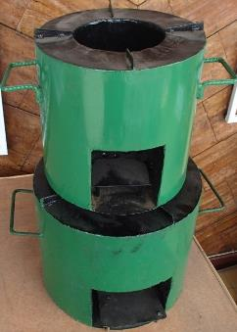  The big size stove has a diameter of 35 cm and a height of 30 cm. The diameter of the combustion chamber is 18 cm.  The small size stove has a diameter of 28.5 cm and a height of 28 cm. The diameter of the combustion chamber is 15cm.  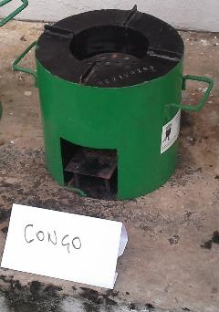  The charcoal is put on the top on a removable grid. When used with firewood, the charcoal grid is removed and the firewood is put at the bottom.
Start Date | If the project implementer manufacture the appliance, then the start date of the project is the date at which the first stove included into the project has started construction. This should be documented by pictures and/or other form of documentation.  If the project implementer does not manufacture the appliance itself but has a role of wholesaler/retailer then the start date of the project is the date at which the first stove included into the project is sold to an end users. This should be documented by a sale receipt or other appropriate evidence. | The appliances are manufactured by independent craftmen that are not salaried by the project.  So the start date is the sale date of the first stove included into the project: November 12th 2013
Regular Cycle VPA | The LSC meeting should take place and the completed VPADD (PartA&C only) should be uploaded to the Gold Standard Foundation registry before the start date of the project activity. | The LSC meeting took place on September 11th 2013. The VPADD (part A &C) was submitted to GS for review on November 12th 2013.
Useful thermal energy output | The useful thermal energy delivered to the cooking pot by the appliance should be less than 150 kW.  Fulfillment of this criteria is deemed automatic for domestic cook-stoves. Those stoves have indeed a useful power of a few kW at most.  For institutional or commercial stoves, useful thermal power output can be estimated in two ways:  - by using the amount of firewood used the cooking time and a conservative thermal efficiency value.  - by doing a Water Boiling Test (WBT) performed as per the latest guidance published on pciaoline.org (or another trustworthy reference). If the first WBT show a useful thermal power (cold start, high power) of less than 120kW then one WBT is enough. Otherwise three WBT should be performed and the average result should be used to check eligibility by this criteria. | Two model are being promoted by the project. A small model and a big model. The small model is used mostly for domestic purposes. It is deemed to be less than 150 kW of useful thermal power.  The bigger model is used by some restaurant. WBT realized internally showed a useful thermal power of 5.1kW, this is well below the 150kW threshold.
Carbon Right | The carbon right should be clear on the whole supply chain from production to the end users.  Contracts mentioning clearly this issue should be provided to the CME. For end users, distributing a leaflet with each stove explaining that by buying the stove the buyer accept to waive its carbon right is enough. | The sale receipt signed by the customers mention explicitly the waiving of the carbon credit ownership to Initiative Developmenent.  Contract with the manufacturer of the stove also include a paragraph on waiving the carbon right to Initiative Developpement.
Reinvestment of Carbon Revenue into the project | There should a contractual legally binding agreement between the CME and the project implementer (or a signed statement from the CME if the CME is also the project implementer of the VPA seeking inclusion) stating that most (ie: at least 51%) of the carbon revenue (defined as the money received by the project implementer after sale tax and other commission from intermediaries have been deducted) will be invested into the project activity that generated the carbon revenue. | For this VPA the CME is the project implementer: Initiative Developpement.  The signed statement from the CME is included into the supporting documentation.
Non diversion of Official Development Assistance | The project activity cannot receive public funding from an Annex 1 country at the condition that VER are awarded to the country of origin of the ODA.  The ODA Declaration Form, signed by the project owner, should be provided as part as the documentation required for inclusion. | Please the ODA non diversion declaration form in Annex 2
Maximum Number of VER | The VER estimated at the time of inclusion of the VPA cannot exceed 10,000 tCO2e/year.  If at any time during the crediting year the amount of VER should exceed 10,000 per year, then the amount of VER issued for this crediting year would be capped at 10,000 VER. | The VER in this VPA are capped at 10,000 VER/year
Monitoing of Sustainable Development Impact (specific to Improved Cookstove Technology) | The monitoring plan presented in the VPADD should include:  - Cost of energy (if fuel is bought) and/or time spent to collect fuel (if fuel is collected)  - End User perception of smoke production  - Amount of firewood saved (if applicable) | These indicators have been monitored and are included in the Monitoring Report.
Removal of old technology. | A clear description of the approach chosen to encourage the removal of the old technology and of the way it is going to be monitored should be provided in the VPADD along with all relevant supporting documentation.  This criteria is not applicable when it can be proven that the baseline technology has a wider range of use than the project technology and that therefore the project technology cannot fully meet the same use (for example: the baseline technology is used for both cooking and space heating whereas the project technology is used only for cooking). | The old technology has been encouraged to be removed by the distribution to each customer of a flyer highlighting all the benefits of the Congo Mbote compared to the traditional stoves (see flyer in the supporting documentation).  The monitoring survey will collect data on the continued usage of the traditional stove among Congo Mbote users.  Potential emission from the continued use of the baseline stove are taken into account by Kitchen Performance Test. This test account for the fuel used by the Congo Mbote but also for the fuel for the baseline stove if it is still being used.

B.3. Assessment and demonstration of additionality of the micro--scale VPA:

B.3.1 Description of how the anthropogenic emissions of GHG by sources are reduced as per the eligibility criteria defined in the registered micro-programme (when Additionality is demonstrated at the micro- programme level):
>>N/A
B.3.2 Description of how the anthropogenic emissions of GHG by sources are reduced below those that would have occurred in the absence of the registered micro-scale project activity (when Additionality is demonstrated at the activity level):
As per the VPA eligibility criteria:
The project is not retroactive: the start date of the project is after the submission of the LSC report to the Gold Standard Foundation.
The individual appliances have less than 150kW of useful thermal energy.
See paragraph B.2 for more details.
This project fulfils the criteria for deemed additionality.
B.4. Description of the sources and gases included in the project boundary and proof that the micro--scale VPA is located within the geographical boundary of the registered PoA.
The following sources and gases are included into the project.
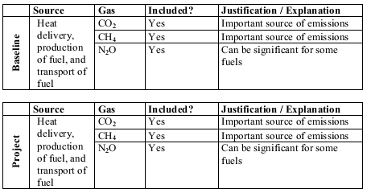

B.5. Emission reductions:

B.5.1. Data and parameters that are available at validation:

Data / Parameter: | EF_{b,CO2}
Data unit: | tCO₂/TJ or tCO₂/t_fuel
Description: | CO₂emission factor arising from use of fuels in baseline scenario
Source of data used: | IPCC 2006 Vol2 Chap1 Table 1.4
Value applied: | EF_{firewood,CO2}= 112 tCO₂/TJ ;  EF_{charcoal} = 487.2 tCO2/TJ  EF_{kerosene,CO2}=71.9 tCO2/TJ  EF_{LPG,CO2}=63.1 tCO2/TJ
Justification of the choice of data or description of measurement methods and procedures actually applied: | For firewood and coal, the IPCC 2006 (Vol 2, Chap 1, Table 1.4) data have been applied.  For charcoal, in accordance with the methodology, the value has been estimated by multiplying the firewood Emission Factor a default charcoal to firewood ratio of 4.35 kg of firewood/kg of charcoal (derived from FAO data). Whenever possible a firewood/charcoal ration from a local credible source should be used instead of this default value.
Any comment: | If EF is in units of tCO₂/t_fuel, remove NCV term from emission calculations.  Term can include a combination of emission factors from fuel production, transport, and use.

Data / Parameter: | EF_{b, nonCO2}
Data unit: | tCO₂/TJ or tCO₂/t_fuel
Description: | Non-CO2 emission factor arising from use of fuels in baseline scenario
Source of data used: | IPCC 2006 Vol2 Chap 2 Table 2.9 and latest GWP of CH4 and N2O (WGI AR5 2013 Table 8A.1 p731)
Value applied: | EF_{fw,nonCO2}= 33.95 tCO₂/TJ ;  EF_{charcoal,nonCO2} = 147.69 tCO₂/TJ
Justification of the choice of data or description of measurement methods and procedures actually applied: | For firewood and coal, the IPCC 2006 (Vol 2, Chap 2, Table 2.9) data have been applied and multiplied by latest GWP data (GWP_{CH4}= 25 and GWP _{N2O}= 298)  For charcoal, in accordance with the methodology, the value has been estimated by multiplying the firewood Emission Factor a default charcoal to firewood ratio of 4.35 kg of firewood/kg of charcoal (derived from FAO data). Whenever possible a firewood/charcoal ration from a local credible source should be used instead of this default value.
Any comment: | Term can include a combination of emission factors from fuel production, transport, and use.

Data / Parameter: | EF_{p,CO2}
Data unit: | tCO₂/TJ or tCO₂/t_fuel
Description: | CO₂ emission factor arising from use of fuels in project scenario
Source of data used: | IPCC 2006 Vol2 Chap1 Table 1.4
Value applied: | EF_{firewood,CO2}= 112 tCO₂/TJ ;  EF_{charcoal} = 487.2 tCO2/TJ  EF_{kerosene,CO2}=71.9 tCO2/TJ  EF_{LPG,CO2}=63.1 tCO2/TJ
Justification of the choice of data or description of measurement methods and procedures actually applied: | For firewood and coal, the IPCC 2006 (Vol 2, Chap 1, Table 1.4) data have been applied.  For charcoal, in accordance with the methodology, the value has been estimated by multiplying the firewood Emission Factor a default charcoal to firewood ratio of 4.35 kg of firewood/kg of charcoal (derived from FAO data). Whenever possible a firewood/charcoal ration from a local credible source should be used instead of this default value.
Any comment: | If EF is in units of tCO₂/t_fuel, remove NCV term from emission calculations.  Term can include a combination of emission factors from fuel production, transport, and use.

Data / Parameter: | EF_{p, nonCO2}
Data unit: | tCO₂/TJ or tCO₂/t_fuel
Description: | Non-CO₂ emission factor arising from use of fuels in project scenario
Source of data used: | IPCC 2006 Vol2 Chap 2 Table 2.9 and latest GWP of CH4 and N2O (WGI AR5 2013 Table 8A.1 p731)
Value applied: | EF_{fw,nonCO2}= 33.95 tCO₂/TJ ;  EF_{charcoal,nonCO2} = 147.69 tCO₂/TJ
Justification of the choice of data or description of measurement methods and procedures actually applied: | For firewood and coal, the IPCC 2006 (Vol 2, Chap 2, Table 2.9) data have been applied and multiplied by latest GWP data (GWP_{CH4}= 25 and GWP _{N2O}= 298)  For charcoal, in accordance with the methodology, the value has been estimated by multiplying the firewood Emission Factor a default charcoal to firewood ratio of 4.35 kg of firewood/kg of charcoal (derived from FAO data). Whenever possible a firewood/charcoal ration from a local credible source should be used instead of this default value.
Any comment: | Term can include a combination of emission factors from fuel production, transport, and use.

Data / Parameter: | NCV_{b}
Data unit: | TJ/ton
Description: | Net calorific value of the fuels used in the baseline
Source of data used: | IPCC 2006 Vol 2, Chap 1, Table 1.2
Value applied: | NCV_{fw} = 0.0156 TJ/ton ;  NCV_{charcoal} = 0.029.5 TJ/ton ;  NCV_{kerosene}=43.8 MJ/kg;  NCV_{LPG}=47.3 MJ/kg;
Justification of the choice of data or description of measurement methods and procedures actually applied: | These values are taken from IPCC Guidelines 2006 Vol 2, Chap 1, Table 1.2
Any comment: | If EF is in units of tCO₂/t_fuel, remove NCV term from emission calculations.

Data / Parameter: | NCV_{p}
Data unit: | TJ/ton
Description: | Net calorific value of the fuels used in the project
Source of data used: | IPCC 2006 Vol 2, Chap 1, Table 1.2
Value applied: | NCV_{fw} = 0.0156 TJ/ton ;  NCV_{charcoal} = 0.0295 TJ/ton  NCV_{kerosene}=43.8 MJ/kg;  NCV_{LPG}=47.3 MJ/kg;
Justification of the choice of data or description of measurement methods and procedures actually applied: | These values are taken from IPCC Guidelines 2006 Vol 2, Chap 1, Table 1.2
Any comment: | If EF is in units of tCO₂/t_fuel, remove NCV term from emission calculations.

Data / Parameter: | P_{b,fuel}
Data unit: | kg/person-meal
Description: | Quantity of fuel that is consumed in baseline scenario b for each fuel
Source of data to be used: | Baseline FT
Value of data applied for the purpose of calculating expected emission reductions | P_{1,firewood}= 0.00  P_{1,charcoal}= 0.28  P_{1,kerosene}= 0.00  P_{1,LPG}= 0.00  P_{2,firewood}= 0.73  P_{2,charcoal}= 0.00  P_{2,kerosene}= 0.00  P_{2,LPG}= 7.14
Description of measurement methods and procedures to be applied: | Fuel consumption will be measured with a Kitchen Performance Test and will be expressed in kg/person-meal
QA/QC procedures to be applied: | Systematic outlier identification procedures  90/30 precision check procedure
Any comment:

Data unit: | Fractional non-renewability
Description: | Non-renewability status of woody biomass fuel in scenario i during year y
Source of data to be used: | Applicable NRB assessment
Value of data applied for the purpose of calculating expected emission reductions | f_{NRB}=90%
Description of measurement methods and procedures to be applied: | Data sourced from the UNFCCC was used.
QA/QC procedures to be applied:
Any comment: | The NRB is used for all biomass (firewood, charcoal) used in both the baseline and the project scenario

B.5.2. Ex-ante calculation of emission reductions:

Both baseline and project Field Performance Test have been already done. The complete monitoring report for the first crediting year is available at the time of the initial submission of the VPADD for validation, so the Ex-ante calculation is based on the Ex-post result of the first monitoring year.
Baseline and Project
Scenario
The TPDDTEC methodology require baseline and project situation to be divided in more homogenous scenario based on important parameter that will impact emissions of greenhouse gas.
Justification of the segmentation by fuel type:
The project target the urban area of Brazzaville. In this area firewood, charcoal and LPG are used sometimes altogether in the same household. Those three fuel have a very different climate warming footprint though.
The table here under show an estimation of emission per unit of useful energy delivered. This show that for the same amount of useful energy delivered to the cooking pot, the climate impact of firewood is about 13 times worse than LPG and that charcoal is about 28 times worse.
fuel | NCV (MJ/kg) | default thermal efficiency* | EF (kg CO2e/GJ) | EF non CO2 (kg CO2e/GJ) | UNFCCC f_{NRB} | EF tot (kg CO2/MJ) | Emission to produce 1 MJ of useful energy (kgCO2/MJ of useful energy) | ratio to LPG
firewood | 15.6 | 10% | 112 | 33.95 | 90% | 134.8 | 1348 | 12.8
charcoal | 29.5 | 20% | 487.2 | 147.69 | 90% | 586.2 | 2931 | 27.9
kerosene | 43.8 | 50% | 71.9 |  | 1 | 71.9 | 144 | 1.4
LPG | 47.3 | 60% | 63.1 |  | 1 | 63.1 | 105 | 1.0

This shows that household using any amount of charcoal (combined or not with other fuel) will have a much higher carbon footprint than the other. If a household does not use charcoal but use firewood (combined or not with other fuel) it will have a higher carbon footprint than household using only LPG or kerosene
Overview of the different scenario identified
Based on the results of the Baseline Survey, we divided the users into 3 category based on the type of fuel used: charcoal, firewood of fossil fuel (kerosene or LPG). We also separated domestic from commercial users.
We have identified five different scenarios for the baseline survey:
Type of Fuel used in BASELINE | Domestic Use | Commercial Use
Charcoal and potentially firewood, LPG and/or kerosene. | Baseline scenario 1 | Baseline scenario 4
Firewood and potentially LPG and/or kerosene (no charcoal) | Baseline scenario 2 | Baseline scenario 5
LPG and or Kerosene only (no firewood or charcoal) | Baseline scenario 3 | No user found

We have identified 4 project scenarios:
Type of Fuel used in PROJECT | Domestic Use | Commercial Use
Charcoal and potentially firewood, LPG and/or kerosene. | Project scenario 1 | Project scenario 3
Firewood and potentially LPG and/or kerosene (no charcoal) | Project scenario 2 | Project scenario 4
LPG and or Kerosene only (no firewood or charcoal) | Not Applicable since the Congo Mbote stove have to be used (so household should use either charcoal or firewood) | Not Applicable since the Congo Mbote stove have to be used (so restaurant should use either charcoal or firewood)

Justification for the segmentation per usage: domestic/commercial
This data derived from the baseline surveys shows that restaurant (S4 and S5) prepare food for a lot more people than households. Their fuel consumption also much greater than households.

Scenario change linked to the purchased of the Congo Mbote
We have seen that multiple fuel are used in Brazzaville in the baseline situation. To make thing more complicated, the Congo Mbote stove may be used with either firewood of charcoal. So it is key to understand the repartition of the current users of the Congo Mbote into the identified project scenario but also to what kind of fuel they were using before they purchased the Congo Mbote stove so that may know from which baseline scenario they were coming from.
That is why we asked in the monitoring survey what fuel they use now but also what fuel they were using before the purchase of the stove.
The pie below summarize this data.

To each of these trajectory correspond a pair of baseline and project emissions. For each of these pair the emission reduction will be different and should be calculated separately.
Summary of the conservative simplifications adopted
Because of the high number of baseline and project scenario identified during the baseline and project survey, some conservative simplifications were made before doing the KPT.
This allowed us to reduce the field work needed for the KPT to something more manageable given the small size of the project while insuring that the VER calculation would remain conservative.
 | Baseline
Baseline Scenario 1 | Full-fledged KPT
Baseline Scenario 2 | Full-fledged KPT
Baseline Scenario 3 | Household in this scenario are considered to have no emissions.*
Baseline Scenario 4 | Emission for restaurant in this scenario is assumed to be the same as Baseline Scenario 1**
Baseline Scenario 5 | Emission for restaurant in this scenario is assumed to be the same as Baseline Scenario 2**
Project Scenario 1 | Full-fledged KPT
Project Scenario 2 | Excluded from project: no emission reduction is claimed for households that fall into this category
Project Scenario 3 | Emission for restaurant in this scenario is assumed to be the same as Project Scenario 1**
Project Scenario 4 | Emission for restaurant in this scenario is assumed to be the same as Project Scenario 2**

* Baseline fossil fuel: because of the small number of people using only fossil fuel and the limited emission from this category it was not deemed worthwhile to do a full fledge KPT for this scenario. We deemed this category has no emission, this is conservative.
** The restaurants have a much more intensive usage of the stove and their fuel consumption is a lot higher than domestic households. The data collected during the baseline survey shows that the restaurants cook for 35 to 52 persons per day in average, by comparison households in the baseline cook for an average of 4 to 5 persons. A baseline KPT was conducted for both the households and restaurants, it shows that the daily average fuel consumption of the restaurant is almost twice as high as for the households. Please refer to the excel spreadsheet (“VER Synthesis” tab) for more details.
Because of these pieces of evidence collected during the baseline survey, considering that one restaurant achieves the same amount of emission reduction as one household is very conservative.
As a result, Baseline Scenario 4 and 5 and project scenario 3 and 4 are merged with the corresponding scenario of domestic users. The user in these scenario were bundled together but the KPT was done on the domestic users only to insure conservativeness.
*** The monitoring survey show that 5% of the Congo Mbote customers use only firewood. 3% remained a firewood user and 2% switch from using charcoal in the baseline to firewood in the project. It was not deemed worthwhile to do a full fledge KPT for the category given the size of the project. As a result no emission reduction are claimed for this category. This is conservative.

Summary of Baseline Survey findings per scenarios
The baseline survey was done for all the scenarios identified. The simplification was done based on the baseline survey before the KPT to limit the number of KPT needed to a reasonable number.
These two pie charts show how the people surveyed fits into the scenarios identified.

Charcoal is the most commonly used fuel in Brazzaville. No fossil fuel user were identified for restaurants since high end restaurant were not eligible (we targeted street food vendors).

This chart shows that most people cook for their breakfast and lunch but mostly have left over for dinner. Street food vendor mostly cook for lunch.
Seasonal variations
Seasonal variation were studied to determine when the baseline KPT should be conducted to yield conservative results. These graph show the percentage of user who have declared some change in their fuel consumption based on the main season of the year. Most users did not declare any change, but a small proportion declared that they use less fuel during the dry seasons (probably because the fuel are drier and have a better calorific value).
The baseline KPT was done during the dry season to insure a conservative estimate since the daily consumption were extrapolated to the rest of the year.

Calculation of the fraction of Non Renewable Biomass.

A f_{NRB} value of 90% was approved for the Democratic Republic of Congo by the CDM EB. This value was used in the calculation.

Calculation of emission reduction
As per the PoADD, the following equation is used to calculate the ER:
ER_{y} = ∑_{b,p} N_{p,y}* U_{p,y}* (f NRB,b, y* ER_{b,p,y, CO2} + ER _{b,p,y, non-CO2}) - LE_{p,y}
Where :
∑_{b,p} Sum over all relevant (baseline b/project p) couples
N_{p,y} Cumulative number of project technology-days included in the project database for project scenario p against baseline scenario b in year y
U_{p,y} Cumulative usage rate for technologies in project scenario p in year y, based on cumulative adoption rate and drop off rate (fraction)
ER_{b,p,y},_{CO2} Specific CO2 emission savings for an individual technology of project p against an individual technology of baseline b in year y, in tCO₂/day, and as derived from the statistical analysis of the data collected from the field tests
ER_{b,p,y} ,_{non-CO2} Specific non-CO2 emission savings for an individual technology of project j against an individual technology of baseline b in year y, converted in tCO₂/day, and as derived from the statistical analysis of the data collected from the field tests
f_{NRB,b,y} Fraction of biomass used in year y for baseline scenario b that can be established as non-renewable biomass (drop this term from the equation when using a fossil fuel baseline scenario
LE_{p,y} Leakage for project scenario p in year y (tCO_{2e}/yr)
ERb,p,y,CO2=PMp,y*fuel(Pb,fuel-Pp,y,fuel)*NCVfuel*EFfuel,CO2
Where:
PMp,y: average number of people meal for scenario p in year y
Pb,fuel: average fuel consumption of fuel in baseline scenario b in kg/people-meal
Pp,y,fuel: average fuel consumption of fuel in project scenario p in kg/people-meal
NCVfuel: Net Calorific Value of fuel in TJ/kg
EFfuel,CO2: Emission Factor of fuel in tCO₂/TJ

ERb,p,y,nonCO2=PMp,y*fuel,b(Pb,fuel-Pp,y,fuel)*NCVfuel*gasEFfuel,gas*GWPgas
Where:
EFfuel,gas:emission factor in tons of gas per TJ. The considered gas in this project are CH4 and N2o.
GWPgas: Global Warming Potential of gas expressed in 100 years CO₂ equivalent.

The KPT protocol encourage us to measure fuel consumption relative to the number of adult equivalent to account for the different size households might have between each other (ie: larger household tend to use more fuel independently from the efficiency of the cooking technology they use).
We have used this approach here to account for the fact that larger household tend to buy the large Congo Mbote, while smaller household tend to adopt the small Congo Mbote. We show that they specific fuel consumption of each stove (expressed in kg of fuel/ (person*meal) is actually very similar.
For more details of these calculation please refer to “KPT Project Large Stove” tab (line 205 and 206) of the excel file.
Table 1: detail of the project KPT showing specific emission for each stove size.
 | firewood kg/person.meal | charcoal kg/person.meal | kerosene kg/person.meal | LPG kg/person.meal | person*meal | emission tCO2e/(person.meal)
Big size | 0.005 | 0.166 | 0.0006 | 0.0191 | 10.4 | 0.000432
Small Size | 0.0209 | 0.154 | 0.0005 | 0.0096 | 8.2 | 0.000427
The specific emission of the two model do not differ by more than +/- 5%, the two model will share the same scenario.
Details on the KPT conducted
Scenario | Implementing entity | Date | Number of Survey done
Baseline Firewood | Initiative Developpement | September 2013 | 31
Baseline Charcoal | Initiative Developpement | September 2013 | 57
Project Charcoal | Initiative Developpement | July 2015 | 70

For each of those survey, the consumption was measured for 3 consecutive days with hand scales: the initial weight of fuel was measured the first day and then again after each period of 24 hours. The cook were told to not change their cooking habit and the survey were conducted outside of any major festival or event that would have influence the fuel consumption.
If new fuel was purchased by the household during the KPT the fuel was weighted before use. If the newly purchased fuel was used by the household before being weighted by the surveyor then the data was discarded. Each time firewood was used the moisture of the wood was measured and its weight converted in dry wood equivalent.
Treatment of outlier
The following method was used to identify outlier:
Daily overall fuel consumption across multiple fuel were expressed in useful MJ/person/meal for each household.
Data was considered an outlier if they were greater than 1.5 times the inter quartile range plus the third quartile as per foot note 63 of the TPDDTEC methodology.
Verification that 90/30 precision requirement are met
The following equation is used to compute the bounds of the 90% one-sided confidence interval:
CI bounds=μBL-μPR±1.26σBL2nBL+σPR2nPR
With the following notation respectfully for the baseline and the project
σ : Standard deviation
µ: average
n: sample size

Baseline Scenario | Project Scenario | average of emission reduction in tCO2e/ (person.meal) | emission reduction, low bound of the 90% one-sided confidence interval in tCO2e/ (person.meal) | emission reduction, high bound of the 90% one-sided confidence interval in tCO2e/ (person.meal)
1 | 1 | 0.0022 | 0.0018 | 0.0026
2 | 1 | -0.0012 | -0.0015 | -0.0010
3 | 1 | -0.0027 | -0.0030 | -0.0025
2 | 2 | 0 | 0 | 0
1 | 2 | 0 | 0 | 0
Others | Others | 0 | 0 | 0

For the top three combination of scenario the one sided 90% confidence interval is within +- 30% of the average, so the difference of the means maybe used to calculate emission reductions.
For the bottom three combination of scenario no VER is claimed as per the simplification explained above.

Summary of the emission reduction at the project scale for the first monitoring year
This table combine the previous results with the scenario trajectory derived from the monitoring survey. Thankfully it appears that the scenario combination yielding a negative emission reduction represent a small minority of Congo Mbote user.

Baseline Scenario | Project scenario | N_{p,b,y} | usage rate | PM_{p,y} | f_{NRB} | ER_{p,b,CO2} (tCO2e/ household/ day) | ER_{p,b,non CO2} (tCO2e/ household/day) | ER_{p,b} (tCO2e/year)
1 | 1 | 325,197.76 | 96% | 9.20 | 90.0% | 0.0166744 | 0.0052 | 6,282.03
3 | 1 | 37,522.82 | 96% | 9.20 | 90.0% | (0.0211) | (0.0062) | (904.47)
2 | 1 | 7,147.20 | 96% | 9.20 | 90.0% | (0.0093) | (0.00268) | (75.74)
2 | 2 | 12,507.61 | 96% | 9.20 | 90.0% | - | 0.00 | 0
1 | 2 | 8,934.00 | 96% | 9.20 | 90.0% | - | 0.00 | 0
others | others | 3,573.60 | 96% | 9.20 | 90.0% | 31,439 | 0.00 | 0

Total | 5,302
For the first monitoring year, a total of 5,302 VER are achieved.

B.5.3. Summary of the ex-ante estimation of emission reductions:
>>
Crediting Year | Expected VER
August 2014- August 2015 | 5,302
August 2015- August 2016 | 10,000
August 2016- August 2017 | 10,000
August 2017 - August 2018 | 10,000
August 2018 - August 2019 | 10,000
August 2019 - August 2020 | 10,000
August 2020 - August 2021 | 10,000
August 2021 - August 2022 | 10,000
August 2022 - August 2023 | 10,000
August 2024 – August 2025 | 10,000
Average VER/year | 9,530
Total over the crediting period | 95,302

B.6. Application of the monitoring methodology and description of the monitoring plan:
A total sales record and project database are maintained continuously. For each project scenario a monitoring survey and usage survey is conducted annually.
For each baseline scenario and project scenario the BFT and PFT is updated every two years, respectively, except in cases of fixed baseline implying no need for a BFT.
A. Total Sales Record
The project proponent must maintain an accurate and complete sales record. The record should be backed up electronically. The required data are:
1. Date of sale
2. Geographic area of sale
3. Model/type of project technology sold
4. Quantity of project technologies sold
5. Name and telephone number (if available), and address:
a. Required for all bulk purchasers, i.e., retailers and industrial users
b. All end users except in cases where this is justified as not feasible. In such cases the number of names/telephone numbers/addresses collected must be as many as commensurate with representative sampling, i.e. the number of end user names and addresses (and phone numbers where possible) within sales record shall be large enough so that surveys and tests can be based on representative purely randomly selected samples. In all cases this should not be less than 10 times the survey and field test sample sizes (including usage surveys for each age of product), in order to ensure an adequate end user pool to which random sampling can be applied.
6. Mode of use: domestic, commercial, other:
a. As many as commensurate with representative sampling
B. Project Database
The project database is derived from the total sales record (or dissemination record in case of non-commercial distribution) with project technologies differentiated by different project scenarios. The differentiation of the project database into sections is based on the results of the applicable monitoring studies for each project scenario, in order that ER calculations can be conducted appropriately section by section Technologies aged beyond their useful lifetime, as established in the usage survey, are removed from the project database and no longer credited.
C. Ongoing Monitoring Studies
The following ongoing monitoring studies are conducted for each project scenario following verification of the associated initial project studies. These monitoring studies investigate and define parameters that could not be determined at the time of the initial project studies or that change with time.
- Monitoring Survey –Completed annually, beginning 1 year after project registration
The monitoring survey investigates changes over time in a project scenario, and in a baseline scenario in case of industrial applications (or renewal of crediting period), by surveying end users with project technologies (and baseline technologies in case on industrial applications) on an annual basis. It provides critical information on year-to-year trends in end user characteristics such as technology use, fuel consumption and seasonal variations.
Monitoring Survey Representativeness:
End users from a given project scenario are selected using representative sampling techniques to ensure adequate representation of users with technologies of different ages. Common sampling approaches such as clustered random sampling are allowed and geographic distribution should be factored into selection criteria. End users can be surveyed at any time(s) throughout the year with care taken to collect information pertaining to seasonal variations in technology and fuel use patterns.
Monitoring Survey sample sizing and data collection:
The monitoring survey has the same sample sizing and data collection guidelines as the baseline survey described in Section II.4 of the methodology, but for non-industrial applications, the monitoring survey is only conducted with end users representative of the project scenario and currently using the project technology (except for the case of a renewal of the crediting period which requires a re-assessment of the baseline). Monitoring surveys can be conducted with usage survey participants that are currently using the project technology.
- Usage Survey –Completed annually, or more frequently, and in all cases on time for any request of issuance.
The usage survey provides a single usage parameter that is weighted based on drop off rates that are representative of the age distribution for project technologies in the total sales record.
A usage parameter must be established to account for drop off rates as project technologies Age and are replaced. Prior to a verification, a usage parameter is required that is weighted to be representative of the quantity of project technologies of each age being credited in a given project scenario. For example, if only technologies in the first year of use (age 0-1) are being credited, a usage parameter must be established through a usage survey for technologies age 0-1. If an equal number of technologies in the first year of use (age 0-1) and second year of use (age 1-2) are credited, a usage parameter is required that is weighted to be equally representative of drop off rates for technologies age 0-1 and age 1-2.
Survey sample sizing and data collection:
The minimum total sample size is 100, with at least 30 samples for project technologies of each age being credited. The majority of interviews in a usage survey must be conducted in person and include expert observation by the interviewer within the kitchen in question, while the remainder may be conducted via telephone by the same interviewers on condition that in-kitchen observational interviews are first concluded and analyzed such that typical circumstances are well understood by the telephone interviewers.
The usage parameter must be applied when calculating the quantity of fuel consumed in Project scenario p during year y (B_{p,y}). Unless proven otherwise, it should be assumed that any drop off in the use of the project technology is replaced by fuel consumption in the applicable baseline scenario. The usage survey will establish a useful lifetime for technologies after which they are removed from the project database and no longer credited.
c) Project FT Update –Completed every other year, or more frequently.
The PFT update is an extension of the project PFT and provides a fuel consumption assessment representative of project technologies currently in use every two years. Hence the PPT update accounts for changes in the project scenario over time as project technologies age and new customers are added, also as new models and designs are introduced. It is legitimate to apply an Age Test instead of a PFT, to project technologies which remain materially the same year after year.
d) Baseline FT Update – This will not be updated, a fixed baseline is chosen.
e) Leakage Assessment –
Leakage:
In this section the risk associated to potential source of leakage is studied.
Potential source of leakage | Risk Level | Justification
- The displaced baseline technologies are reused outside the project boundary in place of lower emitting technology or in a manner suggesting more usage than would have occurred in the absence of the project. | Very Low | The displaced baseline technologies have a rather short lifespan and are already widely available in the greater Brazzaville area.  The number of baseline stoves displaced by the project is negligible compared to the overall number of stoves available in the greater Brazzaville area (0.7% when the project will be at its widest extent). See excel file (“leakage” tab) for more details on the calculations.
- The non-renewable biomass or fossil fuels saved under the project activity are used by non-project users who previously used lower emitting energy sources. | Very Low | The amount of charcoal displaced by the project is negligible compared to the overall charcoal consumption in Brazzaville (0.39%). See the excel file (“leakage” tab) for more details on the calculations.  The project will not affect the availability or overall price of charcoal in the greater Brazzaville area.
- The project significantly impacts the NRB fraction within an area where other CDM or VER project activities account for NRB fraction in their baseline scenario. | Very Low | The amount of biomass displaced by the project is very limited compared to the overall charcoal consumption of Brazzaville (0.39%). Its impact on the NRB fraction is negligible. See excel file (“leakage” tab) for more details on the calculations.
- The project population compensates for loss of the space heating effect of inefficient technology by adopting some other form of heating or by retaining some use of inefficient technology. | Very Low | Congo climate is tropical and space heating is not required even during the coldest months of the year. See chart of temperature in Brazzaville in the excel file (“leakage” tab).
- By virtue of promotion and marketing of a new technology with high efficiency, the project stimulates substitution within households who commonly used a technology with relatively lower emissions, in cases where such a trend is not eligible as an evolving baseline. | Very Low | Some household indeed switched from fossil fuel stove like LPG or kerosene stove (less emissions) to the Congo Mbote.  This is already taken into account in the VER calculation.

Since the risk for each potential source of leakage is very low, they will not be included into the monitoring plan and leakage will ignored in the emission reduction calculations.
f) Non-Renewable Biomass Assessment Update
The non-renewable biomass fraction is fixed based on the results of the NRB assessment. Over the course of a project activity the project proponent may at any time choose to re-examine renewability by conducting a new NRB assessment. In case of a renewal of the crediting period and as per Gold Standard rules, the fraction must be reassessed as any other baseline parameters and updated in line with most recent data available.
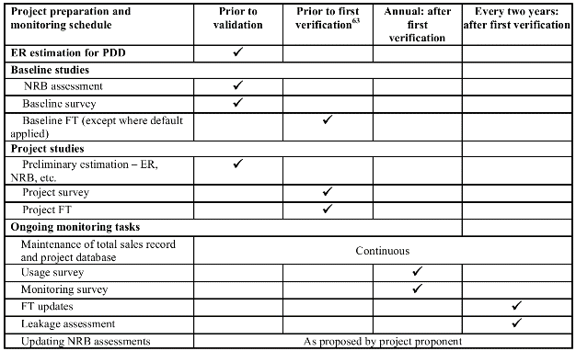
h) continued usage of baseline stove
The monitoring report should highlight the percentage of household that are still using their baseline stove and make sure emission arising from their use are taken into account.

B.6.1. Description of the monitoring plan:
Data and parameters to be monitored by each technology or practice:

Data / Parameter: | P_{p,y}
Data unit: | kg/person-meal
Description: | Quantity of fuel that is consumed in project scenario p during year y
Source of data to be used: | Project FT, project FT updates
Value of data applied for the purpose of calculating expected emission reductions | P_{1,1,kerosene}= 0.004  P_{1,1,firewood}= 0.013  P_{1,1,charcoal}= 0.154  P_{1,1,LPG}= 0.015
Monitoring frequency: | Updated every two years
Description of measurement methods and procedures to be applied: | Fuel consumption will be measured with a Kitchen Performance Test and will be expressed in kg/person-meal
QA/QC procedures to be applied: | Systematic outlier identification procedures  90/30 precision check procedure
Any comment:

Data / Parameter: | U_{p,y}
Data unit: | Percentage
Description: | Usage rate in project scenario p during year y
Source of data to be used: | Annual usage survey
Value of data applied for the purpose of calculating expected emission reductions | 95.7%
Monitoring frequency: | Annual
Description of measurement methods and procedures to be applied: | Usage rate will be weighted to make sure each age group of the stove are adequately represented.
QA/QC procedures to be applied: | Transparent data analysis and reporting
Any comment: | A single usage parameter is weighted to be representative of the quantity of project technologies of each age being credited in a given project scenario.

Data / Parameter: | N_{p,b,y}
Data unit: | Project technologies credited (units*day)
Description: | Cumulative number of project technology-days included in the project database for project scenario p against baseline scenario b in year y
Source of data to be used: | Total sales record
Value of data applied for the purpose of calculating expected emission reductions | Nbaseline charcoal, project charcoal,1= 337,864.6  Nbaseline fossil fuel, project charcoal,1= 37,082.7  Nbaseline firewood, project charcoal,1=8,240.6  Nbaseline firewood, project firewood,1= 12,360.9  Nbaseline charcoal, project firewood,1= 8,240.6  Nbaseline other, project other,1= 8,240.6
Monitoring frequency: | Continuous
Description of measurement methods and procedures to be applied: | This value is based on the sale date of each individual stove. Stove that were sold after the beginning of the crediting period are discounted proportionaly to the time they were used during the crediting year.
QA/QC procedures to be applied: | Transparent data analysis and reporting
Any comment: | The total sales record is divided based on project scenario to create the project database

Data / Parameter: | α_{y}
Data unit: | fraction
Description: | Discount factor for VER if sample size is too small
Source of data to be used: | Baseline and monitoring Kitchen Performance Test
Value of data applied for the purpose of calculating expected emission reductions | 0
Monitoring frequency: | Every two years
Description of measurement methods and procedures to be applied: | This parameter is derived from the statistical analysis of the result. If the sample size is enough to meet the precision requirement of the methodology, then α=0, otherwise this parameter will allow the calculation of the ER based on the lower bound of 90% one-sided interval.
QA/QC procedures to be applied: | Transparent data analysis and reporting
Any comment:

SECTION C. Stakeholders’ comments

C.1. Brief description how comments by local stakeholders have been invited and compiled:
>> Please describe the agenda of physical meeting, Non-technical summary, Invitation tracking table, Text of invitations sent, any other consultation method used
The consultation took place on September 11 2013 at 4pm in Initiative Developpement’s office in Brazzaville
*Agenda of physical meeting
Brazzaville, 07/05/2013
FCE Project
Filière Cuiseurs Economes
Case C3-53, OCH La Glacière,
Bacongo, Brazzaville
BP 1673

Local Stakeholder Consultation Agenda
September, 11th – 4:00 pm
Location : Initiative Développement office – OCH La Glacière, Bacongo, Brazzaville, Republic of Congo
4:00 : Welcome
4:30 : Opening of the meeting
4:45 : Explanation of the Improved Stove Project
5:00 : Questions for clarification about the project explanation
5:15 : Discussion on continuous input and grievance mechanism
5:30 : Discussion on monitoring sustainable development
5:45 : Closure of the meeting
Contacts :
François-Xavier Sorba, Project Manager Improved Stove Project, Initiative Développement

*Non-technical summary
The Non-technical Summary was provided in French (official language of the Republic of Congo, widely understood in Brazzaville), an English translation is displayed below.

The use of wood and charcoal for cooking in Brazzaville is very common. The stoves used by households are mostly traditional ones known to need a lot of combustible. Thus, those households consume a lot of wood and charcoal; costing a lot each day, as well as being a major cause of environmental degradations in the outer ring of Brazzaville.
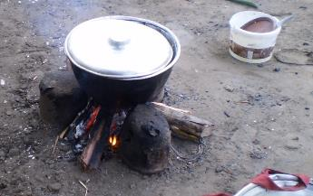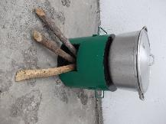

Traditional three rocks stove and Initiative Développement improved stove
Using dual improved stoves – i.e. that can be used with either charcoal or wood – allows Brazzaville households to reduce the quantity of combustible needed for cooking and as a consequence the expenses linked combustible purchases.
The Improved Cook-stove Project carried out by the NGO Initiative Développement aims at creating and organizing a local manufacturing network of quality improved stoves.
During the first year, following a work with a craftsman engineer to define a final model of an improved stove, the small restaurants and the street food vendors of three districts of Brazzaville (Bacongo, Poto-Poto and Moungali) will be touched by the project activities. They will gain access to improved stoves sized to match their needs and their activities. During this first phase, Initiative Développement will be the main reseller for the improved stoves. As an NGO, Initiative Développement will not make a margin on the improved stove sales.
During the second year, the smaller model of improved stove will go under production, the project activities will spread in all of Brazzaville and a network of independent resellers will be organized. This will make the improved stove technology available quicker and more efficiently.
During the following years, the sales of improved stoves will go on. Training as well as other activities (wood, charcoal or forest-themed) could be then carried out.
The expected benefits of this project are essentially the distribution during the first 2 years of at least 500 improved stoves among small restaurants and 2,000 small stoves among households, the decrease in wood and charcoal consumption in Brazzaville as well as the decrease of toxic fumes when cooking. The decrease in wood and charcoal consumption will imply a decrease in greenhouse gases emissions in the atmosphere. From an economic point of view, Brazzaville households will have a decrease of expenses linked to combustible purchases.
Those benefits as well as the potential drawbacks of the project will be raised and discussed during the local stakeholder consultation with future beneficiaries, local authorities and national experts.

*Invitation tracking table

Category | Organization | Name of invitee | Means of invitation | Date of invitation | Confirmation of Reception Y/N
A | Households | - | Newspaper add + on door add + oral | 08/30/2013 | Y
B | AFD | Patrick Dal Bello | Letter of invitation | 08/29/2013 | Y
B | SCAC | COCAC | Letter of invitation | 08/29/2013 | Y
B | UNPD | Alain Mpoué and Jean Felix Issang | Email | 08/30/2013 | Y
B | Ministry of woman promotion | Directeur Général | Letter of invitation | 08/29/2013 | Y
B | Ministry of Forests | Directeur Général | Letter of invitation | 08/29/2013 | Y
B | Ministry of Environment | Directeur Général | Letter of invitation | 08/29/2013 | Y
B | Mairie Bacongo | Administrateur Maire | Letter of invitation | 08/29/2013 | Y
B | Mairie Centrale | Administrateur Maire | Letter of invitation | 08/29/2013 | Y
C | DNA/DFP | No official DNA or DFP exist for the Republic of Congo | - | - | -
D | ASI | Caroline Huron | Email | 08/28/2013 | Y
D | TGH | Demba Sy | Email | 08/28/2013 | Y
D | GRET | Reiye Gandzounou Matombou | Email | 08/28/2013 | Y
D | PCPA | Olga Kabanabandza | Email | 08/28/2013 | Y
D | Yidika | Alain Mbemba | Email | 08/28/2013 | Y
D | Femme Energies | Estelle Malalou | Email and Telephone | 09/06/2013 | Y
D | NIOSI | Samuel Nsikabaka | Letter of invitation | 08/29/2013 | Y
D | Ecole Spéciale | Mathieu De Ladonchamps | Email | 08/28/2013 | Y
E | Gold Standard | Heba Rabie | Email | 08/28/2013 | Y
F | Greenpeace International | - | Email | 08/28/2013 | Y
F | HELIO International | O'Connor-Lajambe Hélène | Email | 08/28/2013 | Y
F | Mercy Corps | Jim Jarvi | Email | 08/28/2013 | Y
F | REEEP | Harvey Katrin | Email | 08/28/2013 | Y
F | World Vision Australia | Thomson Dr. Dean C | Email | 08/28/2013 | Y
F | WWF International | Roscher Bella | Email | 08/28/2013 | Y
F | Climate Action Network South Africa | Lebelo Dorah | Email | 08/28/2013 | Y
F | NOVA Institute | Pauw Christiaan | Email | 08/28/2013 | Y
F | ONKE Training | Mrubata Mmathabo | Email | 08/28/2013 | Y
F | Renewable Energy & Energy Efficiency Institute | Ndhlukula Kudakwashe | Email | 08/28/2013 | Y
F | SouthSouthNorth | Raubenheimer Stefan | Email | 08/28/2013 | Y
F | Zero: Regional Environment Organisation | Chigwada Johannes | Email | 08/28/2013 | Y

The scans of various mean of invitation are provided as a separate document.
*Text of invitations sent
The invitation were made in French, the English translation is given below.
Text of Email and Letter sent
Dear Sir or Madam,
French NGO Initiative Développement is currently carrying out an Improved Cook stove Project in Brazzaville, Republic of Congo.
I have the honour to invite you to join us in our office on the 11th of September at 4:00 pm for a Local Stakeholder Consultation (LSC), according to Gold Standard procedures.
You will find enclosed to this email the non-technical summary of our project as well as the planning of the LSC.
Please confirm your presence.
Best regards,

Newspaper article – Les Dépêches de Brazzaville (see scan of the newspaper in separate evidence document)
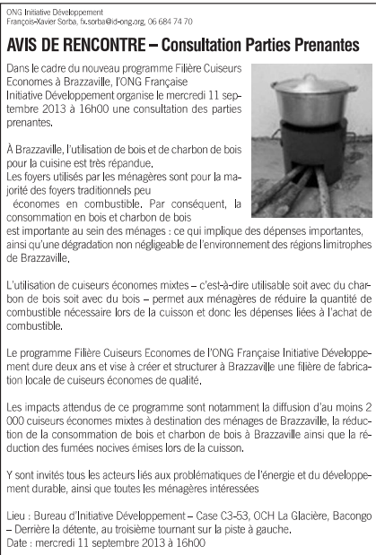

On-door advertisement – ID Office main door
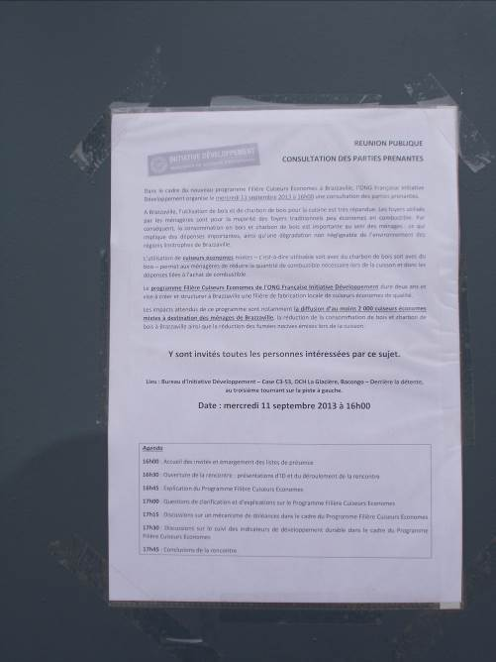

Households have also been invited orally on the restaurant location. They were presented the same information as in the letters of invitation. Location of the consultation was explained.
*Other consultation method used
No other consultation method were used.
C.2. Summary of the comments received:

Participant Lists
Participants list
Date and time: Wednesday 11th September, 4:00 pm
Location: ID office, Case C3-53 OCH La Glacière, Bacongo, Brazzaville, Republic of Congo
Category Code | Name of participant, job/ position in the community | Male/ Female | Organisation (if relevant) | Contact
A | Milloma Agathe | F | Teacher and housewife | 06 657 54 40
A | Koubindana Londa Patience | F | Housewife | 05 509 43 10  05 528 52 20
B | Kedzia Jean-Marc  Chef de service | M | Ministry of tourism and environment | 05 560 44 81  06 979 36 86
B | Mouassi Posso Marie-Colette  Chef de service | F | Ministry of tourism and environment | 06 921 74 43
B | Tabaka Mexan | M | Ministry of Forest (General Direction) | 06 937 82 05  tabakamexan@gmail.com
B | Marquant Baptiste | M | French Agency of Development | 06 937 31 11  marquantb@afd.fr
B | Pfinder Charlotte | F | French Embassy – Cooperation Department | 06 871 01 34  charlotte.pfinder@diplomatie.gouv.fr
B | Tchikaya Oboa Régine | F | Ministry of woman promotion | 05 568 92 36
D | Caroline Huron | F | ASI – Actions de Solidarité Internationale | 05 349 95 90  caroline.huron@asi-france.org
D | Laura Vigoriti | F | CPS – Comunita promozione e sviluppo | 06 841 11 19  lauravigoriti@hotmail.it
D | Assa Passi Graniche | F | Femme-Energie | 06 608 93 67  04 419 28 13  granicheassapassi@yahoo.fr

Evaluation forms
Name | Tabaka
What is your impression of the meeting? | Good
What do you like about the project? | Decrease of purchases of wood energy
What do you not like about the project? | What type of wood should be bought? I think wood from certified forests

Name | Tchikaya Oboa Régine
What is your impression of the meeting? | It’s a very interesting meeting that informed us of an original development project
What do you like about the project? | It’s a technology that can ease women’s life and contributes to the reduction of deforestation and help sustainable development.
What do you not like about the project? | Nothing.

Name | Kedzia Jean Marc
What is your impression of the meeting? | The meeting was carried out with respect to time. It was well driven thanks to the speaker, whom I congratulate.
What do you like about the project? | The use of charcoal and wood is really economic and avoid bad effects of the combustibles
What do you not like about the project? | The presentation of wood-saving stove is too traditional.

Name | Caroline Huron
What is your impression of the meeting? | Interesting and clear presentation. The relevance of the project was highlighted.
What do you like about the project? | *Economic impact to the users  *Improvement of the work environment  *Sustainability and autonomy goal, with the means to reach this goals (10 year monitoring)
What do you not like about the project? | Nothing

Name | Mouassi Posso Colette
What is your impression of the meeting? | Nothing
What do you like about the project? | The decrease of consumption of wood and charcoal (less spending)
What do you not like about the project? | The project is good but you should insist on the stove design

Name | Laura Vigoriti
What is your impression of the meeting? | The welcome, the time were very good. The explanation were clear.  Maybe everyone should have said who they were before speaking up so that we can have an idea of the different stakeholders.
What do you like about the project? | I think this an acceptable, viable and efficient project.
What do you not like about the project? | Nothing to dislike. On the contrary, I realised that ID is very open and maybe we could develop synergies.

Name | Baptiste Marquant
What is your impression of the meeting? | Good.  Maybe it would have been better to take a list of questions and then answer to them in one shot.  People should have said who they were before speaking.  People who already used the stove should have been able to speak up.
What do you like about the project? | The simplicity of the stove; which stays close to the traditional model
What do you not like about the project? | A lack of communication for the project.  Lack of way to convince people fast about the advantages of the stove (such as a free distribution in some areas)

Name | Assa Passi Graniche
What is your impression of the meeting? | For the meeting, the impression can only be good. Ht presentation was really clear and there has been a complement of information for me.
What do you like about the project? | What I like about this project is the fact that it is going to provide a solution to restaurant owners’ problems; often said to be the main responsible of deforestation in the area.
What do you not like about the project? | Nothing

Name | Charlotte Pfinder
What is your impression of the meeting? | Very good presentation.  Relevant questions during the exchange time.  A good initiative..
What do you like about the project? | The project as a whole is convincing.  The prototypes seem well adapted and the concept is relevant.  The fact that the stove can be moved easily (conviniency) is a plus.
What do you not like about the project? | Nothing

Name | Koubindana Londa Patience
What is your impression of the meeting? | The meeting was carried out in an intellectual and discovering atmosphere
What do you like about the project? | The presentation of the project and the wood saving stove in its whole
What do you not like about the project? | The price of the stove

Name | Milloma Agathe
What is your impression of the meeting? | A rich meeting carried out for the presentation of this still unused technology
What do you like about the project? | The presentation of the new technology of the wood saving stove
What do you not like about the project? | I would like to have a wood saving stove to be able to suggest more things

Pictures from the meeting

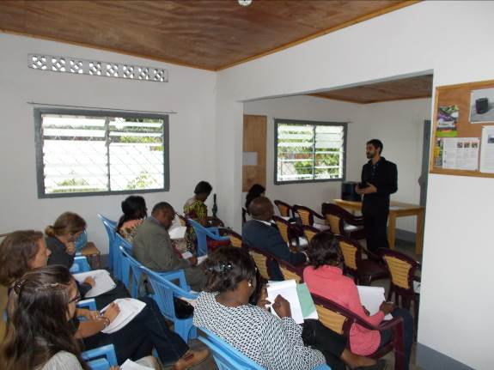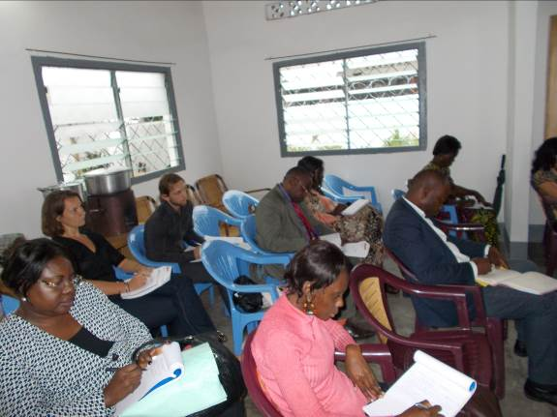

C.3. Report on how due account was taken of any comments received and on measures taken to address concerns raised:

Stakeholder comment | Was comment taken into account (Yes/ No)? | Explanation (Why? How?)
The two sizes of the stove (small and medium) are not enough. You should think of a bigger stove designed for the biggest pots.  Also, you should consider other king of stoves, such as stove dedicated to traditional cake baking. | Yes | For now, the project has developed two different stoves aimed at households and restaurants. It may be possible to develop other kind of stoves later in the project according to ID means and identified needs in Brazzaville.
When using wood, the hole dedicated to wood is small. Are you going to sell a special kind of wood bundle? | No | When using wood, most of the bundles fit the dedicated hole. However, sometimes it is needed to cut in half some bundle to make it fit.
When using wood, people have to use the driest wood possible. Is your stove have impact on that. | No | The use of stove does not impact the dryness of wood. People should dry the wood bundle before using it.
Is it possible to buy the stove right now? | No | The production of the bigger model is due to begin in September and the sales in October.
To sell stoves, you should work with cooperative union or association. | Yes | Indeed, the ID FCE team is currently thinking and working on the different options to spread the improved stove.
Did you think of activities aimed at the professional of the wood energy chain sector? | No | For now, the project is not working with wood energy sector, mainly because we estimated that in the first year of the project, the impact on this sector will be minimal.
To have a good monitoring, you should work with research centres | Yes | For now, it is not planned for the project to work with research centres, but it would be interesting to consider such collaborations.
For the grievance mechanism, you should work with surveyors. | Yes | During the monitoring phase, we will work with surveyors. It may be possible then to ask some questions to beneficiaries.

C.4. Report on the Continuous input mechanism selection:
>>
Discuss the Continuous input / grievance mechanism expression method and details, as discussed with local stakeholders.
 | Method Chosen (include all known details e.g. location of book, phone, number, identity of mediator) | Justification
Continuous Input / Grievance Expression Process Book | A dedicated notebook will be left available to anyone in the office of ID in Brazzaville. | The office is located in at Case C3-83 – La Glaciere-Bacongo / Brazzaville - Congo. Every comment written down in this notebook will be addressed by ID team.
Telephone access | The phone number of Agnes Rossetti – Country Director for ID was made available: +242 06 684 74 70  The Gold Standard may also be contacted directly at: +41 (0) 22 788 7080 | Telephone is an important way of communicating in Brazzaville.  ID team will write down any comment made concerning the project.
Internet/email access | A dedicated email address was created to address any comment : fce@id-ong.org  The Gold Standard may also be contacted directly at: info@goldstandard.org | Even if most people do not have an internet access, with the installation of the optic fiber in Congo, people are surfing more and more.  Once more, ID team will consider any comment sent to this email address.
Nominated Independent Mediator (optional) | None | The three ways proposed above should be enough to guarantee that every stakeholder can voice their concern with the project.

All issues identified during the crediting period through any of the Methods shall have a mitigation measure in place that should be added to the monitoring plan.

C.5. Report on stakeholder consultation feedback round:
>>The Stakeholder Feedback Round took place between November 26 of 2013 and January 26 of 2014 in the following way:
- The present report was be made publicly available on Gold Standard registry
- The link to the report was be sent by email to all the participants that have email addresses (along with a French translation of part C3 and C4 of the report).
- A French translation of the part C.3 and C.4 of the report was printed out and made available in ID office. Some copies was be distributed to the participants of the meeting that do not have email addresses.
- ID has been taking note of all the comments received during the two months period of the Feed Back Round.
The table here under details the people invited to provide comments, all the people present during the first round were invited for comment during the seconds round.
Name | Organization | Means of invitation
Milloma Agathe | Teacher and housewife | Telephone
Koubindana Londa Patience | Housewife | Telephone
Kedzia Jean-Marc  Chef de service | Ministry of tourism and environment | Telephone
Mouassi Posso Marie-Colette  Chef de service | Ministry of tourism and environment | Telephone
Tabaka Mexan | Ministry of Forest (General Direction) | Telephone
Marquant Baptiste | French Agency of Development | Email
Pfinder Charlotte | French Embassy – Cooperation Department | Email
Tchikaya Oboa Régine | Ministry of woman promotion | Telephone
Laura Vigoriti | CPS – Comunita promozione e sviluppo | Telephone
Caroline Huron | ASI | Email
Demba Sy | TGH | Email
Reiye Gandzounou Matombou | GRET | Email
Olga Kabanabandza | PCPA | Email
Alain Mbemba | Yidika | Email
Estelle Malalou | Femme Energies | Email
Samuel Nsikabaka | NIOSI | Email
Mathieu De Ladonchamps | Ecole Spéciale | Email
- | Greenpeace International | Email
O'Connor-Lajambe Hélène | HELIO International | Email
Jim Jarvi | Mercy Corps | Email
Harvey Katrin | REEEP | Email
Thomson Dr. Dean C | World Vision Australia | Email
Roscher Bella | WWF International | Email
Lebelo Dorah | Climate Action Network South Africa | Email
Pauw Christiaan | NOVA Institute | Email
Mrubata Mmathabo | ONKE Training | Email
Ndhlukula Kudakwashe | Renewable Energy & Energy Efficiency Institute | Email
Raubenheimer Stefan | SouthSouthNorth | Email
Chigwada Johannes | Zero: Regional Environment Organisation | Email
Shirley Yuhuan Shen | Gold Standard Foundation | Email
Johann Thaler | Gold Standard Foundation | Email
Subuddhi Banthia | Gold Standard Foundation | Email
Heba Rabie | Gold Standard | Email

No comments were made.

Annex 1

CONTACT INFORMATION ON ENTITY/INDIVIDUAL RESPONSIBLE FOR THE micro--scale VPA

Organization: | Initiative Développement
Street/P.O.Box: | 29 Rue Ladmirault
Building:
City: | Poitiers
State/Region:
Postfix/ZIP: | 86000
Country: | France
Telephone: | +33 (0)5 49 60 89 66
FAX:
E-Mail: | carbone@id-ong.org
URL:
Represented by: | Olivier Lefebvre
Title: | Technical Director of Renewable Energy Department
Salutation: | Mr.
Last Name: | Lefebvre
Middle Name:
First Name: | Olivier
Department: | Renewable Energy Department
Mobile:
Direct FAX:
Direct tel:
Personal E-Mail:

Annex 2

INFORMATION REGARDING PUBLIC FUNDING
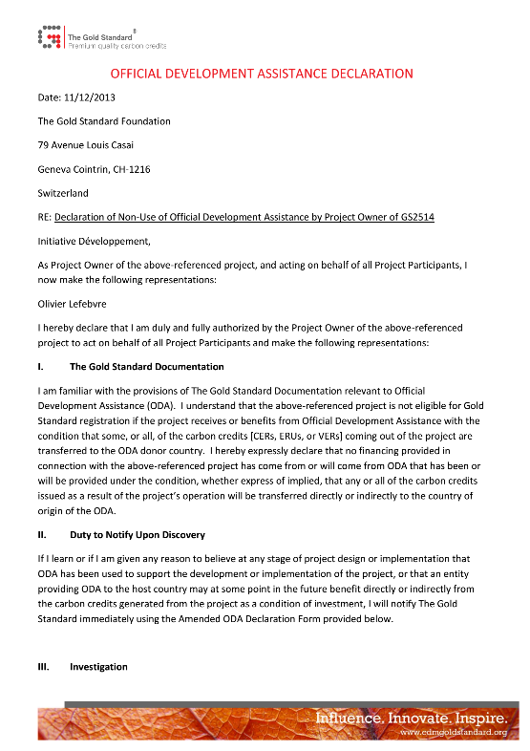
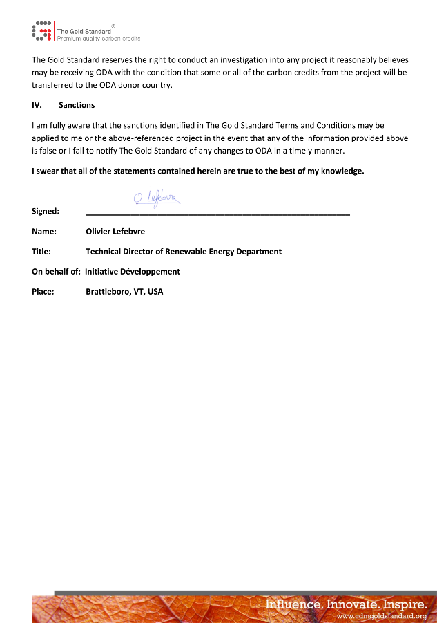

The firepower has been calculated by taking the average of the firepower of the cold start, hot start and simmering phase of the WBT (version 4.2.4). See details in “WBT_largestove_firewood_2015_04_11_Laurent_English.xlsx”, tab result, cell D18; D28 and D35. See also “GS2514_data_BL_MT_2016_3_29.xlsx” Tab “parameter” cell C11:C14 for the details on the calculations.
See the Apendix 1 of : “The role of Wood energy in Africa”, Samir Amous, FAO. Consulted online at: http://www.fao.org/docrep/x2740e/x2740e05.htm#P3854_103806
See table 8.A.1 of: Myhre, G., D. Shindell, F.-M. Bréon, W. Collins, J. Fuglestvedt, J. Huang, D. Koch, J.-F. Lamarque, D. Lee, B. Mendoza, T. Nakajima, A. Robock, G. Stephens, T. Takemura and H. Zhang, 2013: Anthropogenic and Natural Radiative Forcing. In: Climate Change 2013: The Physical Science Basis. Contribution of Working Group I to the Fifth Assessment Report of the Intergovernmental Panel on Climate Change [Stocker, T.F., D. Qin, G.-K. Plattner, M. Tignor, S.K. Allen, J. Boschung, A. Nauels, Y. Xia, V. Bex and P.M. Midgley (eds.)]. Cambridge University Press, Cambridge, United Kingdom and New York, NY, USA.

