Monitoring Report

PUBLICATION DATE 14.10.2020
VERSION v. 1.1
RELATED SUPPORT - TEMPLATE GUIDE Monitoring Report v. 1.1

This document contains the following Sections
Key Project Information
SECTION A - Description of project
SECTION B - Implementation of project
SECTION C - Description of monitoring system applied by the project
SECTION D - Data and parameters
SECTION E - Calculation of SDG Impacts
SECTION F - Safeguards Reporting
SECTION G - Stakeholder inputs and legal disputes

KEY PROJECT INFORMATION

Programme of Activity Information – (delete below table if N/A)
GS ID of Programme | GS1247
Title of Programme | GS1247 Improved Kitchen Regimes Multi-Country PoA
Version of POA-DD applicable to this monitoring report | 3.0
Name and GS ID of fully Validated CPA/VPAs (i.e. non compliance check) | GS1247 VPA 1 Improved Kitchen Regimes: Bugesera, Rwanda. The VPA was submitted with PoA validation

Key Project Information
GS ID (s) of Project (s) | GS7153
Title of the project (s) covered by monitoring report | GS1247 VPA 164 EcoZoom Improved Stove Programme, Uganda
Version number of the PDD/VPA-DD (s) applicable to this monitoring report | 8.0
Version number of the monitoring report | 3.0
Completion date of the monitoring report | 03/12/2023
Date of project design certification | 17/09/2020
Date of Last Annual Report | N/A
Monitoring period number | 3.0
Duration of this monitoring period | 01/05/2022 to 31/07/2023
Project Representative | Erik Wurster, Biolite
Host Country | Uganda
Activity Requirements applied | Community Services Activities  Renewable Energy Activities  Land Use and Forestry Activities/Risks & Capacities  N/A
Methodology (ies) applied and version number | Gold Standard Methodology Technologies and Practices to Displace Decentralized Thermal Energy Consumption Version 1.0
Product Requirements applied | GHG Emissions Reduction & Sequestration  Renewable Energy Label  N/A

Table 1 - Sustainable Development Contributions Achieved
Sustainable Development Goals Targeted | SDG Impact | Amount Achieved | Units/ Products
SDG 13 | Climate Action | 11,923 | VERs
SDG 3 | Good Health and Well Being | 23,535 | Reduced Coughing Bouts per household per day
SDG 7 | Affordable and Clean Energy | 4,393 | Tons/hh per Year

Table 2 – Product Vintages
 |  | Amount Achieved
Start Dates | End Dates | VERs | Reduced Coughing Bouts per household per day | Tons/hh per Year
01/05/2022 | 31/12/2022 | 6,392 | 12,617 | 2,355
01/01/2023 | 31/07/2023 | 5,531 | 10,918 | 2,038

SECTION A. DESCRIPTION OF PROJECT

A.1. General description of project
>>

The Micro-Scale Voluntary Project Activity 164 EcoZoom Improved Stove Programme, Uganda involves the distribution of fuel-efficient cook stoves to households throughout Uganda. The programme is implemented by Biolite in conjunction with CO2Balance UK Ltd., who is the CME of the PoA.
The efficient cook stoves are three different efficient charcoal stoves manufactured by EcoZoom. The EcoZoom stoves will be sold at attractive prices in exchange for the rights to the Voluntary Emission Reductions (VERs). The majority of families would not otherwise have access to the market for advanced fuel-efficient cook stoves for economic reasons.
Between 1990 and 2005 Uganda has lost 26.3% of its forest cover and has a current deforestation rate of over 2% per year. While urban wood demand for construction and furniture plays a large role in this situation, the problem is also exacerbated by demand for charcoal, mostly in urban areas.
Around 95% of households in Uganda cook using traditional cookstoves that are inefficient and very polluting. Improved biomass cookstoves are built that reduce wood and or charcoal consumption and indoor air pollutants from incomplete combustion (CO and PM). This project will reduce greenhouse gas emissions by disseminating biomass stoves that have been proven through testing to be more efficient than traditional models.

A.2. Location of project
>>
Republic of Uganda, nation-wide. The country is located on the East African plateau lying mostly between latitudes 4°N and 2º’S and longitudes 29°and 35°E.
All technologies included in the project activity will be implemented within such a boundary, which is formed by 4 administrative regions (Northern, Eastern, Central and Western).

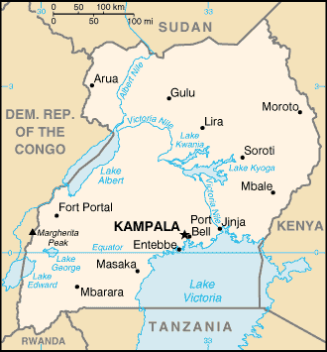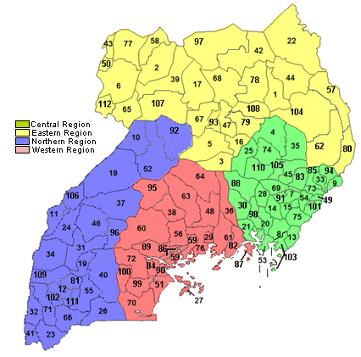

According to the methodology, project proponents must define project boundary, target area, and fuel production and collection area.
The project boundary is defined here as the geographic site where the project technologies are located. The end user contact information and location are recorded in the project database for as many stoves as possible that are distributed as part of the project activity, together with the unique stove serial number.
The target area is defined by the political boundaries of the Republic of Uganda. The target area provides an outer limit to the project boundary in which the project has a target population.
The fuel production and collection is the area within which the woody biomass can reasonably be expected to be produced, collected and supplied. Biomass consumed for cooking and charcoal production in Uganda is sourced throughout the countryside.

A.3. Reference of applied methodology
>>
Gold Standard Methodology Technologies and Practices to Displace Decentralized Thermal Energy Consumption Version 1
Gold Standard for the Global Goals; Requirements and Guidelines: Usage Rate Monitoring Version 2.0; 27.10.2020

A.4. Crediting period of project
>>
Start and end Dates of the Crediting period: 21/11/2017 – 20/11/2024
The length of the crediting period is 7 years up to twice renewable.

SECTION B. IMPLEMENTATION OF PROJECT

B.1. Description of implemented project
>>
Users entered into an agreement with BioLite, transferring rights to the VERs generated by the project activity. The users also agreed to submit to the monitoring programme as described in the registered VPA-DD.

Stoves were sold through a variety of distribution channels through local companies, community groups, financing organizations, etc. End user contact information was collected by salespeople where warranty cards were completed and returned to BioLite, where they were compiled in a database detailing each customer and stove sold. Further details are provided in the monitoring section. Each stove has a unique serial number that is printed on the stove and etched in metal to enable unique stove identification and avoid double counting. Each unique sale was tracked based on the importation and wholesale sale of stoves and unique serial number. The start date of operation of each stove was defined either by i) the reported sale date as reported by the retailer (plus one day in order to be conservative) or ii) the wholesale sale date plus an average inventory period. The average inventory was calculated by taking a sample of portfolio wide sales and calculating the average inventory time across this sample.

A total of 3,186 stoves were distributed as part of this project activity. To avoid double counting, we checked the Gold Standard and CDM registry for any projects that could have included these same types of stoves and there were no such projects in implementation. We then cross referenced all stove serial numbers between all the VPAs we have implemented and found no duplicates.

Technologies and/or measures
There are three models of stove involved in the project: the Jiko Fresh, Jiko Bora and Jiko Bora Mama Yao:

Jiko Fresh
The Jiko Fresh reduces toxic emissions, cooks faster than traditional stoves and saves significant quantities of charcoal compared to the baseline technology. The stove offers the following key characteristics:

- 26cm diameter  - Combustion Chamber Volume: 1,155cm3  - Refractory metal combustion chamber  - Lightweight / high temperature thermal ceramic insulation  - Three-pronged universal cast iron stovetop  - Painted sheet metal with reinforced door  - Steel and silicone handles  - Door of metal with silicone grip on latch  - Non-slip rubber feet  - Thermal efficiency – 36.21%  - Expected useful life is up to 5 years | 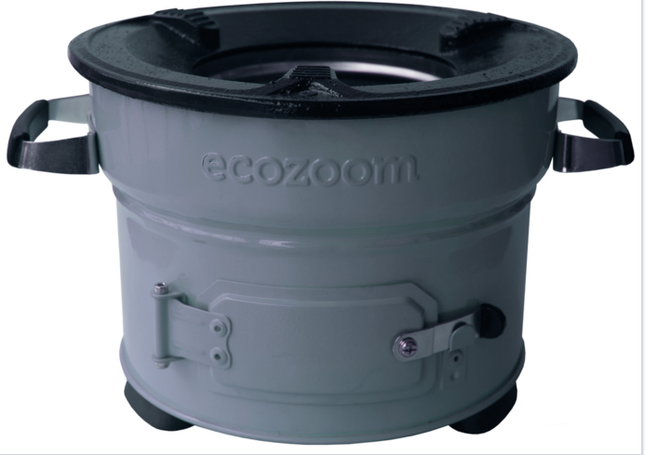

Jiko Bora

The Jiko Bora reduces toxic emissions, cooks faster than traditional stoves and saves even more charcoal than the Jiko Fresh compared to the baseline technology. The stove offers the following key characteristics:

- 28cm diameter  - Combustion Chamber Volume: 1,155cm3  - Refractory metal combustion chamber  - Lightweight / high temperature thermal ceramic insulation  - Three-pronged universal cast iron stovetop  - Painted sheet metal with reinforced door  - Steel and silicone handles  - Door of metal with silicone grip on latch  - Non-slip rubber feet  - Thermal efficiency – 37.74%  Expected useful life is up to 5 years | 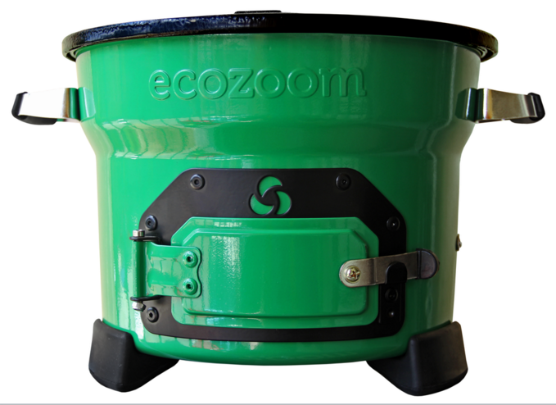

Jiko Bora Mama Yao
The Jiko Bora Mama Yao is the premium stove compared to the other two stoves. The stove offers the following key characteristics:
- 28cm diameter  - Combustion Chamber Volume: 1,866cm3  - Non-slip rubber feet  - Silicon and metal handles  - Three-pronged universal cast iron stovetop  - Refractory metal combustion chamber  - Painted sheet metal with reinforced door  - Thermal efficiency – 40.4%  - Expected useful life is up to 5 years | 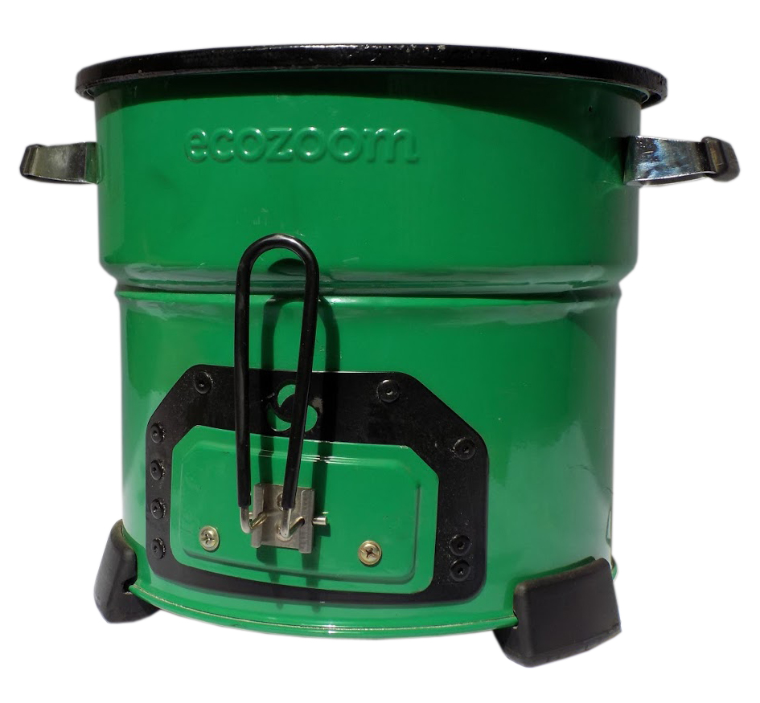

Usage surveys, kitchen surveys and kitchen performance tests were carried out during this monitoring period. Surveys were conducted between February and July 2023. Training of the surveyor was conducted in the runup to the survey period in early February 2023. The training was conducted remotely by Biolite staff, Hesbon Nyangena and attended by the surveyor, Julius Mubiru. The training ensured the survey methods used were in compliance with the monitoring requirements for GS4GG projects. The training focused on:
- Walk through the statement of work detailed tasks
- Explain data collection specifics
- Surveying practices and filling the respective forms for each of the surveys

B.1.1 Forward Action Requests
>>
N/A

B.2. Post-Design Certification changes
>>
B.2.1. Temporary deviations from the approved Monitoring & Reporting Plan, methodology or standardized baseline
>>
N/A
B.2.2. Corrections
>>
N/A
B.2.3. Changes to start date of crediting period
>>
The start date of crediting period was amended to 21/11/2017 as authorized by the Gold Standard Technical Assessment Committee in accordance with the deviation request dated 10th March 2021.

B.2.4. Permanent changes from the Design Certified monitoring plan, applied methodology or applied standardized baseline
>>
N/A
B.2.5. Changes to project design of approved project
>>
N/A

SECTION C. DESCRIPTION OF MONITORING SYSTEM APPLIED BY THE PROJECT
>>
Between February 2023 and July 2023, Biolite conducted a series of surveys of its customers to determine the effect of the project stoves on fuel consumption in households. In multiple locations throughout Uganda, households were surveyed, and stoves were tested to understand the project stoves’ usage patterns and fuel consumption among BioLite’s target population.

Project Database:
The following information was collected and formed part of the project database for this project:
- Name, phone contact and location of the end user
- Date of stove purchase
- Stove model
- Stove Serial Number
The project database will be derived from the Total Sales Record, with project technologies differentiated by different project scenarios. The project proponent expects that any improvements to the current design will not involve significant changes in combustion technology or changes in thermal efficiency of +/- 5%, and hence will not entail a new project scenario. Any such changes to the current design will however be recorded in the project database, and if significant changes do occur, these will be new project scenarios. No such changes were anticipated during the monitoring period. However, the methodology being applied required that should any change occur, new scenarios had to be developed as outlined in page 8 of the methodology under the title on ‘Additional Baseline and project Scenarios’. The useful life of the stove technology is estimated to be more than 5 years. As stoves break and go out of use, they will be replaced with new stoves sold to both new and previous users whose stoves have become unusable due to old age. If users who do not purchase new stoves switch back to traditional practices, then the reductions will not be credited as carbon reduction or SDG impacts due to the monitoring procedures in place. Moreover, the objectives of the project will still be furthered since other households will be coming into the project and will be positively impacted.
All data collected in relation to the project will be held in the local office and/or on the Project Database for the entire life cycle of the project and a period of 2 years afterwards. The data may be archived during the project to maintain clarity and security. A total of 3,186 stoves have been sold since the project started. This number of stoves is larger than the Ex-Ante calculations because the Ex-ante calculations included the Jiko Bora Mama Yao and this VPA included primarily smaller stoves.

Ongoing Monitoring Studies

The following ongoing monitoring studies are conducted for each project scenario following verification of the associated initial project studies. All VPAs with identical scenarios will be monitored as a group, with results of studies applied to each VPA.

a. Kitchen Survey/Monitoring Survey- Completed annually, in time for the first verification
The monitoring survey investigates changes over time in a project scenario by surveying end users with project technologies on an annual basis.

b. Usage Survey- Completed annually, on time for any request of issuance
The usage survey provides a single usage parameter that is weighted based on drop off rates that are representative of the age distribution for project technologies in the installation record.

c. Project KPT (FT) Update- Completed at least every other year
The FT Update will provide a fuel consumption assessment representative of the project technologies currently in use. As the stove remains materially the same each year, an Age Test may be chosen to be applied instead of a PFT.

d. Leakage Assessment- Completed every other year
The potential sources of leakage will be investigated. If the assessment quantifies an increase in fuel consumption by the non-project households attributable to the project activity, then calculations will be adjusted to account for this.

e. Non-renewable Biomass Assessment Update- Reassessed at renewal of crediting period

In accordance with the methodology, the NRB assessment will remain fixed for the entire crediting period, although the project proponent may choose to re-examine the assessment at any time.

f. Abandoning inefficient baseline technology– completed every other year.

The extent to which users are being educated on the health and environmental benefits of abandoning inefficient baseline technology will be investigated every other year to ensure that sufficient effort is being made to abandon dangerous and inefficient cooking methods.

Organizational Structure of Monitoring
Person | Role
CME database administrator | The database administrator is responsible for updating and maintaining all electronic databases and inclusions. Required competencies include experience with data management systems (e.g. Excel, STATA, or SPSS), minimum 2 years working experience in a similar field, and at minimum a bachelor’s degree in a quantitative discipline with a strong grounding in math, science, engineering or other quantitative training.
Monitoring team | The monitoring team is assigned/contracted by the CME to conduct stoves end user interviews and Kitchen Performance tests during the periodic sampling and reports the results to the database administrator. The skills and experience required for the data collection activities include:  - Experience conducting surveys/kitchen tests  - Experience conducting door-to-door surveys of biomass fuel consumption  - Local language skills (especially important for input to questionnaire design and interviewing of end users)  - English language skills  - Cultural awareness  - Numerical proficiency  - Data entry skills

SECTION D. DATA AND PARAMETERS

D.1. Data and parameters fixed ex ante or at renewal of crediting period
>>
SDG 13 (Climate Action)
Indicator13.a: Total project emissions reductions (ER Calcs)
Data/Parameter | fNRB,_{i,y}
Unit | Fraction
Description | Fraction of biomass used during year y for the considered scenario that can be established as non-renewable biomass
Source of Data | UNFCCC
Value(s) applied | 0.88
Choice of data or Measurement methods and procedures | The NRB is assessed in accordance with one of the approaches given in the methodology; here the default country specific fraction available on the CDM website is used.
Purpose of data | Calculation of ERs
Additional comment | Fixed for the entire VPA crediting period, although the project proponent may choose to re-examine the assessment at any time.

SDG 13 (Climate Action)
Indicator13.a: Total project emissions reductions (ER Calcs)
Data/Parameter | NCV_{p}
Unit | TJ/ton
Description | Net calorific value of the project fuel
Source of Data | IPCC default value for charcoal
Value(s) applied | 0.0295
Choice of data or Measurement methods and procedures | IPCC default values are deemed valid by methodology
Purpose of data | Calculation of ERs
Additional comment | Fixed for the entire VPA crediting period

SDG 13 (Climate Action)
Indicator13.a: Total project emissions reductions (ER Calcs)
Data/Parameter | NCV_{b}
Unit | TJ/ton
Description | Net calorific value of the fuel that is substituted or reduced
Source of Data | IPCC default value for wood
Value(s) applied | 0.015
Choice of data or Measurement methods and procedures | IPCC default values are deemed valid by methodology
Purpose of data | Calculate ERs
Additional comment | Fixed for the entire VPA crediting period

SDG 13 (Climate Action)
Indicator13.a: Total project emissions reductions (ER Calcs)
Data/Parameter | NCV_{p}
Unit | TJ/ton
Description | Net calorific value of the project fuel
Source of Data | IPCC default value for wood
Value(s) applied | 0.015
Choice of data or Measurement methods and procedures | IPCC default values are deemed valid by methodology
Purpose of data | Calculate ERs
Additional comment | Fixed for the entire VPA crediting period

SDG 13 (Climate Action)
Indicator13.a: Total project emissions reductions (ER Calcs)
Data/Parameter | NCV_{b}
Unit | TJ/ton
Description | Net calorific value of the fuel that is substituted or reduced
Source of Data | IPCC default value for charcoal
Value(s) applied | 0.0295
Choice of data or Measurement methods and procedures | IPCC default values are deemed valid by methodology
Purpose of data | Calculate ERs
Additional comment | Fixed for the entire VPA crediting period

SDG 13 (Climate Action)
Indicator13.a: Total project emissions reductions (ER Calcs)
Data/Parameter | EF_{b,NON-CO2}
Unit | tCO2/TJ
Description | Non-CO2 emission factor arising from use of wood in baseline scenario that is substituted or reduced
Source of Data | IPCC default value for wood
Value(s) applied | 8.692
Choice of data or Measurement methods and procedures | - Deemed valid by the methodology
Purpose of data | Calculation of ERs
Additional comment | Fixed for the entire VPA crediting period

SDG 13 (Climate Action)
Indicator13.a: Total project emissions reductions (ER Calcs)
Data/Parameter | EF_{p,non-CO2}
Unit | tCO2/TJ
Description | Non-CO2 emission factor of the project fuel
Source of Data | IPCC default value for wood
Value(s) applied | 8.692
Choice of data or Measurement methods and procedures | Deemed valid by the methodology
Purpose of data | Calculation of ERs
Additional comment | Fixed for the entire VPA crediting period

SDG 13 (Climate Action)
Indicator13.a: Total project emissions reductions (ER Calcs)
Data/Parameter | EF_{b,NON-CO2}
Unit | tCO2/TJ
Description | Non-CO2 emission factor arising from use of charcoal in baseline scenario that is substituted or reduced
Source of Data
  IPCC default value for charcoal.
   |  | EF (kg GHG/TJ) | GWP | EF
   |  |  |  | (kgCO2e/TJ)
  Charcoal | CH4 | 330.5= (275+386)/2 | 25 | 8,263
  Charcoal | N2O | 5.45= (1.6+9.3)/2 | 298 | 1,624
  Source | - | 2006 IPCC | IPCC | Calculated from
  Source | - | Guidelines for National Greenhouse Gas Inventories Volume 2, Table 2.9 | Fourth Assessment Report | EF * GWP
Value(s) applied | 9.887= 8.263 + 1.624
Choice of data or Measurement methods and procedures | -
Purpose of data | Calculation of ERs
Additional comment | Fixed for the entire VPA crediting period

SDG 13 (Climate Action)
Indicator13.a: Total project emissions reductions (ER Calcs)
Data/Parameter | EF_{p},_{NON-CO2}
Unit | tCO2/TJ
Description | Non-CO2 emission factor arising from use of Project fuel
Source of Data
  IPCC default value for charcoal.
   |  | EF (kg GHG/TJ) | GWP | EF
   |  |  |  | (kgCO2e/TJ)
  Charcoal | CH₄ | 330.5= (275+386)/2 | 25 | 8,263
  Charcoal | N₂O | 5.45= (1.6+9.3)/2 | 298 | 1,624
  Source | - | 2006 IPCC | IPCC | Calculated from
  Source | - | Guidelines for National Greenhouse Gas Inventories Volume 2, Table 2.9 | Fourth Assessment Report | EF * GWP
Value(s) applied | 9.887= 8.263 + 1.624
Choice of data or Measurement methods and procedures | -
Purpose of data | Calculation of ERs
Additional comment | Fixed for the entire VPA crediting period

SDG 13 (Climate Action)
Indicator13.a: Total project emissions reductions (ER Calcs)
Data/Parameter | EF_{p,co2}
Unit | tCO2/TJ
Description | CO2 emission factor of the project fuel
Source of Data | IPCC default value for charcoal
Value(s) applied | 112
Choice of data or Measurement methods and procedures | Deemed valid by the methodology
Purpose of data | Calculation of ERs
Additional comment | Fixed for the entire VPA crediting period

SDG 13 (Climate Action)
Indicator13.a: Total project emissions reductions (ER Calcs)
Data/Parameter | EF_{b,co2}
Unit | tCO₂/TJ
Description | CO2 emission factor of the fuel that is substituted or reduced
Source of Data | IPCC default value for charcoal
Value(s) applied | 112
Choice of data or Measurement methods and procedures | Deemed valid by the methodology
Purpose of data | Calculation of ERs
Additional comment | Fixed for the entire VPA crediting period

SDG 13 (Climate Action)
Indicator13.a: Total project emissions reductions (ER Calcs)
Data/Parameter | EF_{p,CO2}
Unit | tCO2/TJ
Description | CO2 emission factor of project fuel
Source of Data | IPCC default value for wood
Value(s) applied | 112
Choice of data or Measurement methods and procedures | Deemed valid by the methodology
Purpose of data | Calculation of ERs
Additional comment | Fixed for the entire VPA crediting period

SDG 13 (Climate Action)
Indicator13.a: Total project emissions reductions (ER Calcs)
Data/Parameter | EF_{b,CO2}
Unit | tCO2/TJ
Description | CO2 emission factor of the fuel that is substituted or reduced
Source of Data | IPCC default value for wood
Value(s) applied | 112
Choice of data or Measurement methods and procedures | Deemed valid by the methodology
Purpose of data | Calculation of ERs
Additional comment | Fixed for the entire VPA crediting period

SDG 13 (Climate Action)
Indicator13.a: Total project emissions reductions (ER Calcs)
Data/Parameter | P_{b,y}
Unit | ton/HH-y
Description | Quantity of charcoal fuel that is consumed in baseline scenario-b- during year y
Source of Data | Carbon Baseline and Project Survey Report for Ecozoom Cookstoves in Uganda, BioLite, July 2020
Value(s) applied | 0.00843
Choice of data or Measurement methods and procedures | Kitchen performance test
Purpose of data | Measurement of baseline fuel consumption
Additional comment | A single baseline fuel consumption parameter is weighted to be representative of baseline technologies being compared for project crediting.  Additional SDG Indicator: SDG 7 (Affordable and Clean Energy)  Indicator 7.1: Number of improved cookstoves distributed (sales record), Reduction in Fuel Use (KPT)

SDG 13 (Climate Action)
Indicator13.a: Total project emissions reductions (ER Calcs)
Data/Parameter | P_{b,y}
Unit | ton/HH-y
Description | Quantity of wood fuel that is consumed in baseline scenario b during year y
Source of Data | Carbon Baseline and Project Survey Report for Ecozoom Cookstoves in Uganda, BioLite, July 2020
Value(s) applied | 0.00015
Choice of data or Measurement methods and procedures | Kitchen performance test
Purpose of data | Measurement of baseline fuel consumption
Additional comment | A single baseline fuel consumption parameter is weighted to be representative of baseline technologies being compared for project crediting.  Additional relevant SDG: SDG 7 (Affordable and Clean Energy), Indicator 7.1: Number of improved cookstoves distributed (sales record), Reduction in Fuel Use (KPT)

D.2 Data and parameters monitored
>>
SDG 13 (climate action)
Indicator13.a: Total project emissions reductions (ER Calcs)
Data/Parameter | P_{p,y}
Unit | ton/HH-y
Description | Quantity of wood fuel that is consumed in project scenario p during year y
Source of Data | Carbon Project Survey Report for Ecozoom Cookstoves in Uganda, BioLite, September 2021
Value(s) applied | 0.0
Measurement methods and procedures | Kitchen performance test
Monitoring frequency | Updated every two years, or more frequently
QA/QC procedures | Transparent data analysis and reporting.
Purpose of data | Measurement of project fuel consumption
Additional comment | A single project fuel consumption parameter is weighted to be representative of project technologies of each age being credited in a given project scenario.  Additional SDG Indicator: SDG 7 (Affordable and Clean Energy)  Indicator 7.1: Number of improved cookstoves distributed (sales record), Reduction in Fuel Use (KPT)

SDG 13 (climate action)
Indicator13.a: Total project emissions reductions (ER Calcs)
Data/Parameter | P_{p,y}
Unit | ton/HH-y
Description | Quantity of charcoal fuel that is consumed in project scenario p during year y
Source of Data | Carbon Project Survey Report for Ecozoom Cookstoves in Uganda, BioLite, September 2021
Value(s) applied | 0.005563
Measurement methods and procedures | Kitchen performance test
Monitoring frequency | Updated every two years, or more frequently
QA/QC procedures | Transparent data analysis and reporting.
Purpose of data | Measurement of project fuel consumption
Additional comment | A single project fuel consumption parameter is weighted to be representative of the quantity of project technologies of each age being credited in a given project scenario  Additional relevant SDG Indicator: SDG 7 (Affordable and Clean Energy)  Indicator 7.1: Number of improved cookstoves distributed (sales record), Reduction in Fuel Use (KPT)

SDG 13 (climate action)
Indicator13.a: Total project emissions reductions (ER Calcs)
Data/Parameter | U_{p,y}
Unit | Fraction
Description | Usage rate in project scenario p during year y
Source of Data | Annual usage survey
Value(s) applied | 0.8637
Measurement methods and procedures | Usage survey in line with latest usage guidelines as stated on the Gold Standard for the Global Goals; Requirements and Guidelines: Usage Rate Monitoring Version 2.0; 27.10.2020. Specifically, the project will comply with the Mandatory and Good Practice levels of Usage Monitoring
Monitoring frequency | Annual or more frequently, in all cases on time for any request for issuance
QA/QC procedures | Transparent data analysis and reporting.
Purpose of data | Calculation of ERs
Additional comment | A single usage parameter is weighted to be representative of the quantity of project technologies of each age being credited in a given project scenario.

SDG 13 (climate action)
Indicator13.a: Total project emissions reductions (ER Calcs)
Data/Parameter | N_{p,y}
Unit | Project technologies credited (units)
Description | Technologies in the project database for project scenario p through year y
Source of Data | Total sales record
Value(s) applied | 3,186
Measurement methods and procedures | Continuous tracking, excel database
Monitoring frequency | Continuous
QA/QC procedures | Transparent data analysis and reporting.
Purpose of data | Calculation of ERs
Additional comment | The total sales record is divided based on project scenario to create the project database  Additional relevant SDG Indicator: SDG 7 (Affordable and Clean Energy),  Indicator 7.1: Number of improved cookstoves distributed (sales record), Reduction in Fuel Use (KPT)

SDG 13 (climate action)
Indicator13.a: Total project emissions reductions (ER Calcs)
Data/Parameter | LE_{p,y}
Unit | t_CO2e per year
Description | Leakage in project scenario p during year y
Source of Data | Baseline and monitoring surveys
Value(s) applied | 0
Measurement methods and procedures | Kitchen survey and analysis
Monitoring frequency | Every two years
QA/QC procedures | Transparent data analysis and reporting.
Purpose of data | Calculation of ERs
Additional comment | Aggregate leakage can be assessed for multiple project scenarios, if appropriate

SDG 3 (Good Health and Well Being)
Indicator 3.9: Reduced incidence of smoke related illnesses (Kitchen survey)
Data/Parameter | S_{p,y}
Unit | Bouts per day
Description | Number of coughing bouts per day in scenario p during year y, as self-reported by the user
Source of Data | Kitchen survey
Value(s) applied | 0
Measurement methods and procedures | Kitchen survey and analysis
Monitoring frequency | Every year
QA/QC procedures | Transparent data analysis and reporting
Purpose of data | Reporting on health and well being
Additional comment | Sp,y

SDG 3 (Good Health and Well Being)
Indicator 3.9: Reduced incidence of smoke related illnesses (Kitchen survey)
Data/Parameter | S_{b,y}
Unit | Bouts per day
Description | Number of coughing bouts per day in scenario b during year y, as self-reported by the user
Source of Data | Kitchen survey
Value(s) applied | 5.90
Measurement methods and procedures | Kitchen survey and analysis
Monitoring frequency | Every year
QA/QC procedures | Transparent data analysis and reporting.
Purpose of data | Reporting on health and well being
Additional comment

D.3. Comparison of monitored parameters with last monitoring period
Data/Parameter | Value obtained in this monitoring period | Value obtained last monitoring period
P_{p,y(wood)} | 0.0 ton/HH-y | 0.0 ton/HH-y
P_{p,y(charcoal)} | 0.005563 ton/HH-y | 0.005563 ton/HH-y
U_{p,y} | 0.8635 | 0.8779
N_{p,y} | 3,186 units | 3,186 units
LE_{p,y} | 0 t_CO2e per year | 0 t_CO2e per year
S_{p,y} | 0 Bouts per day | 0 Bouts per day
S_{b,y} | 5.90 Bouts per day | 5.0 Bouts per day

A decrease was observed for parameter Up,y compared with the previous monitoring period This was due to more stoves becoming older and going out of use in the project. Parameter Np,y remained constant for the 2 monitoring periods since this project had reached the microscale cap of 10,000 VERs and thus no new stoves could be added to this project. Parameter Sb,y recorded an increase compared with the last monitoring period.

D.4. Implementation of sampling plan
>>
The parameters above were monitored through random sampling as per the applied methodology. Households were selected using the excel random number function – ‘RAND()’*(x-y) +y. The random number function assigned random numbers to all users in the end user database. The random number column was then sorted in ascending order and users were contacted following the sorted list until the sample size was attained for the monitoring. Since this was a cross sampling exercise, the Usage Survey sampling ensured there were at least 30 stoves from each of the 6 years. In select instances, insufficient samples could be attained from the target time period due to low sales in those specific time periods. In those cases, older samples were selected than these time periods in order to be conservative. For years 2, 3, 4 and 5, insufficient samples were obtained for those specific time periods and therefore to be conservative, older stoves were sampled to ensure there were at least 30 samples for each of those time periods.

Kitchen survey (aka monitoring survey)
BioLite’s field team in Uganda administered a total of 116 kitchen surveys. The surveys took place between February and July 2023 and households covered by this survey were randomly chosen from the company’s records of sales made across all four regions/zones in Uganda. All surveys were conducted in accordance with guidelines on conducting usage surveys as outlined in section b on page 24 and 25 of the applied methodology. It was concluded that leakage effects and seasonal variation were found to be negligible. Many demographic characteristics were concluded from the kitchen survey data collected. The most important information for our purposes, however, was the number of people cooked for in each household. The kitchen survey determined that the average number of people cooked for in each household is 6.73.

Kitchen Performance Test
The kitchen performance test (KPT), referred to in the Gold Standard methodology as the Project Fuel Test (PFT), was not conducted during this monitoring Period. However, results from the KPT conducted in the previous Monitoring period were applied in this monitoring period as allowed in the applied methodology where KPT results are deemed valid for up to 2 years.

The KPT in the previous monitoring period – MP2- was performed in 32 households (HHs) between September and October 2021. The “After KPTs” (project scenario) were conducted over three full days, requiring daily household visits for four days. All household fuels were weighed daily using handheld weighing scales (Model: SF-400). Charcoal moisture was measured daily in each HH using a moisture meter. A KPT survey was also administered daily to record information about stove and fuel usage, the number of meals prepared, and the number of people cooked for.

The results of the 3-day KPT in the project scenarios were analyzed to yield fuel savings, calculated to be 2.865 kgs/hh/day; the observed fuel consumption before the project was 8.428 kgs/hh/day on average, dropping to 5.563 kgs/hh/day after the project stove use
Table 1 below further summarizes the fuel use results of the KPT after purchase of the project stove, in units of kilograms per person-day (kg/person-day) for a sample size of 32 households.
Table 1: Charcoal use for 3-day KPT
Parameter | Results
# of Households | 32
Average household size | 6.612
Charcoal use before project stove (kg/person/day) | 1.319
Charcoal use after project stove (kg/person/day) | 0.841
Fuel Savings (kg/person/day) | 0.478

As required by the Gold Standard cookstove methodology, the 90/30 rule was applied to the fuel savings values (for all 32 KPT HHs), testing whether there is 90% confidence that the observed mean is within 30% precision of the true population value. To determine whether the sample size was large enough to meet the 90/30 rule, the margin of error was calculated using the following formula:

margin of error = [1.645 * s/√n],

where s is the standard deviation and n is the sample size. If the margin of error is less than or equal to 30% of the sample mean, the 90/30 rule is satisfied and the actual fuel use sample means are used in quantifying carbon credits. Table 2 below shows the margin of error and 30% of the sample mean values for all charcoal fuel savings values, using the mean and standard deviation values from Table 4 above.

Table 2: Margin of error and 30% of the mean fuel savings values for households (n=32)
 | Margin of Error | 30% of Mean
Kg/ person/ day | 0.040 | 0.252

Table 2 demonstrates that the 90/30 rule is satisfied for this sample size since the margin of error is less than 30% of the calculated mean. Therefore, the mean fuel savings (Table 1 above) can be used to calculate carbon credits generated from the use of the project stove.
Although in the baseline scenario the use of both charcoal and wood was observed; the latter was only recorded in 3 households, a sample too small to meet the 90/30 rule, and therefore the lower bound 90% CI was applied for the analysis to yield wood fuel use of 0.15 kgs/hh/day. In the project KPT however, no consumption of wood was observed. Therefore, wood savings was found to be 0.15 kgs/hh/day.
Thus, in summary, charcoal savings was found to be 2.865 kgs/hh/day and wood savings was found to be 0.15 kgs/hh/day.

Usage survey
A cross VPA sampling was conducted that covered 234 surveys. The Usage survey was conducted between the months of February and July 2023 and covered stoves that were purchased by customers at least 6 months (0.5 years) prior to the start of the year for which they took part in the project, as required by the methodology. The stove age calculation was based on the date when the household was interviewed. The stoves were randomly sampled from the end user database and were conducted in all regions in which Ecozoom and Biolite stoves were sold, to attain geographic representativeness. All surveys were conducted in accordance with guidelines on conducting usage surveys as outlined in section b on page 24 and 25 of the applied methodology and photos and GPS coordinates were recorded. Following the Gold Standard for the Global Goals; Requirements and Guidelines: Usage Rate Monitoring Version 2.0; 27.10.2020, this monitoring work complied with Good practice usage rate monitoring procedures

The sampling consisted of at least 30 stoves from each of the 6 years. In select instances, insufficient samples could be obtained from the target period due to low sales in those specific periods. In those cases, older samples were selected to be conservative. For years 1,2 and 4, insufficient samples were obtained for those specific time periods and therefore to be conservative, older stoves were sampled to ensure there were at least 30 samples for each of those time periods.

In complying with Mandatory and Good Practice levels of usage rate monitoring procedures, the following activities were conducted:

Level A: Mandatory Usage Rate Monitoring:
Step1: Defining Stove Use and Non-Use
A stove was considered in use if it was being used on a daily basis. In this regard, respondents were asked if they were using the project stove and surveyors were instructed to record the stove as being in use only if it was in use at least on a daily basis. Responses to this question can be seen in column ‘O’ of the Usage survey spreadsheet.

Step2: Household Usage Survey
- Kitchen Observation: Surveyors observed and recorded the status of the project stove during the survey visit. Observations such as if the stove was warm to the touch; if there were ashes in the stove or if the stove appeared to have recently been used were recorded. Responses to these observations can be seen in columns ‘R’, ’S’ and ‘T’ of Usage survey spreadsheet. The usage survey had a nearly identical geographic breakdown as the kitchen survey. The usage survey covered 234 stoves that were purchased by customers at least in the first 6 months (0.5 years) of the year for which they took part in the project, as required by the methodology. Minimum sample requirements were fulfilled by ensuring each vintage had at least 30 samples. In order to be conservative, older samples were selected in cases where we couldn’t get enough samples in each vintage.
- Interview with the Primary cook: All surveys were conducted in accordance with guidelines on conducting usage surveys as outlined in section b on page 24 and 25 of the applied methodology. The surveys were conducted with the primary cook in the household, which was guided by question 1, Section A of the usage survey sheet.
- Photos of the cooking areas: Photos of the kitchen and project stove were taken and recorded.
- GPS coordinates: GPS coordinates of the household location were taken using a smart phone and recorded. A record of the GPS coordinates can be seen in column ‘E’ of the Usage Survey datasheet.
Step3: Verification Checks
A subset of respondents was randomly selected and contacted to verify the usage data collected. All the 21 respondents confirmed the information collected in the Usage survey. Responses to these can be seen on column ‘AA’ of the usage survey spreadsheet

Level B: Good Practice Usage Rate Monitoring:
Field Team Training and Supervision:
The surveyor in this project had previous surveying experience which was one of the requirements for getting hired to conduct the surveys. Furthermore, the surveyor underwent a virtual training with BioLite staff, and their work was regularly reviewed by BioLite staff to ensure best practices were being used during data collection. Training of the surveyor was conducted in the runup to the survey period in early February 2023. The training was conducted remotely by Biolite staff, Hesbon Nyangena and attended by the surveyor, Julius Mubiru. The training ensured the survey methods used were in compliance with the monitoring requirements for GS4GG projects. The training focused on:
- Walk through the statement of work detailed tasks
- Explain data collection specifics
- Surveying practices and filling the respective forms for each of the surveys

End User Training and Follow Up Visits:
It is procedural for BioLite to provide initial training to end users upon sale of a product. Product trainings are routinely carried out as part of sales and marketing activities by BioLite. Activities during these trainings are on product features and benefits, proper product use and after sales service information. In addition, BioLite regularly follows up with end users to ensure customer satisfaction. Additional training is offered by BioLite to end users during warranty reviews.

Awareness Campaign:
This is embedded in BioLite’s marketing programs. BioLite periodically conducts marketing campaigns and distributes marketing materials that communicate product benefits including continuous use of the project stove and how to keep in touch with BioLite.

Overall, a total of 234 stoves purchased between December 2017 and January 2023 were monitored in the Usage Survey. 116 households were from the Kitchen survey while 118 households were dedicated Usage survey households.

The results of the usage survey are as follows:
Stove Age Group | Number of Samples | Number in Use | Number Not in use | Percentage in Use | Adjusted Usage Rate to comply with Level B Usage Survey Guidelines | Percentage Sold of Total | Weighted Average of Use
Age 5 – 6 | 32 | 27 | 5 | 84.4% | 84.4% | 45% | 38%
Age 4 – 5 | 52 | 45 | 7 | 86.5% | 86.5% | 29% | 25%
Age 3 – 4 | 47 | 42 | 5 | 89.4% | 89.4% | 17% | 15%
Age 2 – 3 | 30 | 29 | 1 | 96.7% | 90.0% | 1% | 1%
Age 1 – 2 | 43 | 42 | 1 | 97.7% | 90.0% | 7% | 6%
Age 0 – 1 | 30 | 30 | 0 | 100.0% | 90.0% | 1% | 1%
Total | 234 | 215 | 19 |  |  |  | 86.35%

SECTION E. CALCULATION OF SDG IMPACTS

E.1. Calculation of baseline value or estimation of baseline situation of each SDG Impact
>>
SDG 3 (Good Health and Well Being) - coughing bouts per day
The baseline value for this SDG impact was determined by multiplying the baseline value for the indicator - 'S_{b}’- by the total number of project stoves and the project period in years.
S_{b}=5.90 coughing bouts per household per day

Start Dates | End Dates | Stoves distributed | Duration (Years) | Coughing bouts per day
01/05/2022 | 31/12/2022 | 3186 | 0.67123 | 12,617
01/01/2023 | 31/07/2023 | 3186 | 0.58082 | 10,918
Total |  | 3186 | 1.25205 | 23,535

These calculations are contained in the spreadsheet “VPA 164 - Summary of SDG outcomes-MP3_v1.xlsx” in the tab labelled ’Actuals’

SDG 7 (Affordable and Clean Energy)
According to third party sources 8% of Uganda’s population relies on improved stoves(ADP 2012). This was compared with the total number of stoves sold by this project- 3,186
P_{b_wood}=0.00015 tons/hh-day
P_{b_charcoal}=0.00843 tons/hh-day
The baseline value for this SDG was determined by multiplying the baseline fuel use-P_{b}- by the number of stoves sold and the project duration in days:

Start Dates | End Dates | Stoves distributed | Duration (Days) | Baseline-tons/hh-y
01/05/2022 | 31/12/2022 | 3186 | 245 | 6,697
01/01/2023 | 31/07/2023 | 3186 | 212 | 5,795
Total |  | 3186 | 457 | 12,492

SDG 13 (climate action)

Calculating Emission Reductions:
The methodology provides three choices for calculating emissions reductions:
Equation 1 was considered most appropriate as it requires an analysis of project and a baseline couple. This is the approach that is anticipated in time for the first issuance.
Equation 2 was considered unsuitable as this considered different fuels and/or emissions factors – the baseline and project fuels in this project are the same.
Equation 3 was considered unsuitable as it is relevant for cases of a single sample test. This equation is used, however, in calculating ex-ante emission reductions, but when ex-post emission reductions are calculated, equation 1 is used.
These equations, unless stated otherwise, were supplied in the methodology, the numbering reflects the order listed in the methodology.
The Global Warming Potential (GWP) values, for calculating the carbon dioxide equivalence of anthropogenic emissions by sources and removals by sinks, have been updated as per IPCC AR5. These updates were decided by the Gold Standard Technical Advisory Committees (TACs) and apply to GS4GG project activities and programmes of activities (PoAs) from 01 January 2021. In this regard, emission reductions during this monitoring period were calculated the AR5 GWP values.

The emission reductions are directly calculated using the equation below compared to the baseline scenario. The baseline emissions are not calculated separately.
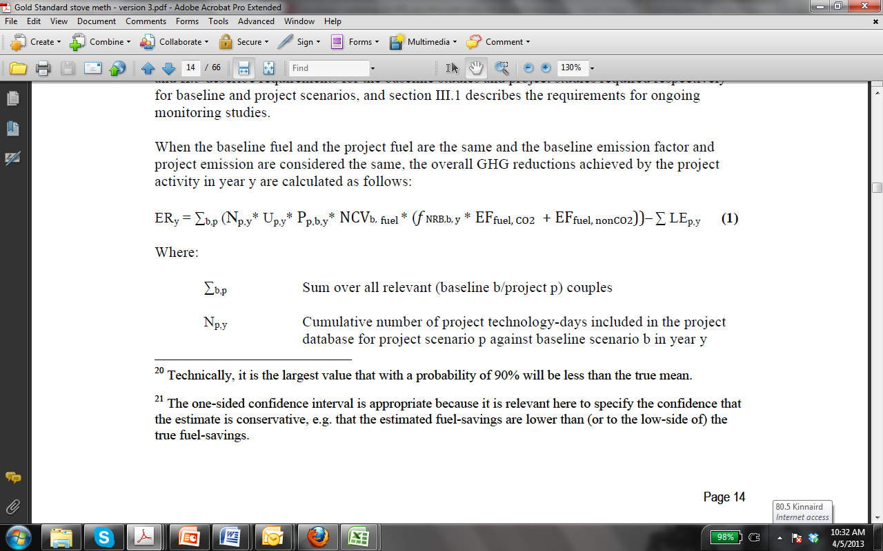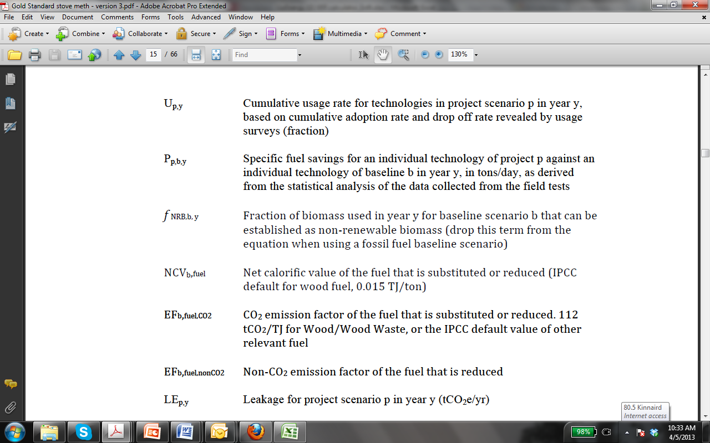

E.2. Calculation of project value or estimation of project situation of each SDG Impact
>>
SDG 3 (Good Health and Well Being)
The project estimate for SDG 3 Impact was determined by multiplying the Project value for the indicator by the total number of stoves sold in the project for the duration of the monitoring period:
S_{py}=0
=0*3,186*1.25205=0

SDG 7 (Affordable and Clean Energy)
P_{p_Wood}=0.0 tons/hh-day
P_{p,Charcoal} =0.00556 tons/hh-day
Start Dates | End Dates | Stoves distributed | Duration (Days) | Project (tons/hh-day)
01/05/2022 | 31/12/2022 | 3,186 | 245 | 4,342
01/01/2023 | 31/07/2023 | 3,186 | 212 | 3,757
Total |  | 3,186 | 457 | 8,100

SDG 13 (Climate Action)
Project Emissions
Emission reductions are calculated using the equation 1 below. Project emissions are not calculated separately:
Emission reductions (ER_{y})
Year | Value (tCO_{2e})
2022 | 6,392
2023 | 5,531
Total | 11,923

Results from this monitoring period shows that the project has achieved 11,923 tCO2e emission reductions.

E.3. Calculation of leakage
>>
A number of questions were asked in the kitchen survey to determine whether leakage was a concern. Specifically, the following areas of leakage were investigated, and determined not to be a factor in total fuel savings:

a) The displaced baseline technologies are reused outside the project boundary in place of lower emitting technology or in a manner suggesting more usage than would have occurred in the absence of the project.

The traditional stoves replaced were found to be unimproved charcoal stoves (47%), with 53% being 3-stone fire; the latter have no market value. There is nothing limiting the use of three stone cooking across the country (technology is lowest, price is zero), which is why this cooking method is so widespread. This leakage source was therefore discounted for these. In terms of the unimproved charcoal stoves, extensive educational and marketing campaigns to discourage the use of inefficient stoves were conducted as they had proven helpful in the past.
b) The non-renewable biomass or fossil fuels saved under the project activity are used by non-project users who previously used lower emitting energy sources.

There is no evidence to suggest significant (if any) use of renewable energy for cooking in the project region as found in the kitchen surveys. As solar ovens are not available, renewable energy use for cooking would likely be use of animal dung or crop residues which will be used due to ease of availability/proximity to the home rather than due to a shortage of wood fuel, therefore being an independent factor. This leakage source was therefore discounted.
c) The project significantly impacts the NRB fraction within an area where other CDM or VER project activities account for NRB fraction in their baseline scenario.

The project boundary covered in this project overlaps with other CDM and VER project activities. A mechanism is in place to distinguish the biomass saved for each individual stove by uniquely identifying each stove with a serial number to ensure none of the project stoves are counted within another CDM or VER project activities as described in the monitoring plan. Kitchen surveys revealed this system to be working as intended.
d) The project population compensates for loss of the space heating effect of inefficient technology by adopting some other form of heating or by retaining some use of inefficient technology.

This is possible in some areas covered by the project; any compensation will however be covered in the results of the monitoring KPT (which encompasses all wood-fuel use) and the monitoring KS (which will pick up on any use of other fuels for space heating) and so this need not be separately assessed.
The climate throughout Uganda is temperate to hot. There is very little if any space heating by stoves throughout the country. No evidence was found that the project will result in increased fuel use for heating from inefficient stoves.
e) By virtue of promotion and marketing of new technology with high efficiency, the project stimulates substitution within households who commonly used a technology with relatively lower emissions, in cases where such a trend is not eligible as an evolving baseline.

The kitchen survey revealed that all households were previously using less efficient technology than the project stove, thus this was not found to be a source of leakage.

E.4. Calculation of net benefits or direct calculation for each SDG Impact
SDG | SDG Impact | Baseline  estimate | Project  estimate | Net  benefit
13 | Climate Action | N/A | N/A | 11,923 tCO_{2e}
7 | Affordable and Clean Energy | 12,492 tons/hh-y | 8,100tons/hh-y | 4,393 tons/hh-y
3 | Good Health and Well-Being | 23,535 Coughing Bouts/day | 0 Coughing Bouts/day | 23,535 Coughing Bouts/day

Please refer to the “VPA 164 - Summary of SDG outcomes-MP3_v1.xlsx” document under the ‘Actuals’ tab for the SDG Impact calculations.

E.5. Comparison of actual SDG Impacts with estimates in approved PDD
SDG | Values estimated in ex ante calculation of approved PDD  for this monitoring period | Actual values achieved during this monitoring period
13 | 12,519 tCO_{2e} | 11,923 tCO_{2e}
7 | 4,272 tons/hh-y | 4,393 tons/hh-y
3 | 7,486 Coughing Bouts/day | 23,535 Coughing Bouts/day

E.5.1. Explanation of calculation of value estimated ex ante calculation of approved PDD for this monitoring period
>>

E.6. Remarks on increase in achieved SDG Impacts from estimated value in approved PDD
>>
Fewer stoves were included in the Ex-ante calculations. In addition, Ex-ante calculations were done on an annual basis while the ex-post calculations were by day therefore, they are much more detailed and accurate compared to the ex-ante calculations.

SECTION F. SAFEGUARDS REPORTING
>>
Safeguarding principles | Assessment questions | Assessment of relevance to the project (Yes/potentially/no) |  |  | Justification | Mitigation measure (if required)
3.1 Human Rights
a. The Project Developer and the Project shall respect internationally proclaimed human rights and shall not be complicit in violence or human rights abuses of any kind as defined in the Universal Declaration of Human Rights.  b. The Project shall not discriminate with regards to participation and inclusion. |  |  | Yes | The project will adhere to all human rights requirements including respecting internationally proclaimed human rights and Universal Declaration of Human Rights and will not discriminate in any way. |  |  | Not required
3.2 – Gender Equality and Women’s Rights
a. Is there a possibility that the Project might reduce or put at risk women’s access to or control of resources, entitlements, and benefits? |  |  | No | The project will increase the access of women to safe and efficient cooking technologies, and will not have an impact on women’s access to or control of resources |  |  | Not required
b. Is there a possibility that the Project can adversely affect men and women in marginalised or vulnerable communities (e.g., potential increased burden on women or social isolation of men)? |  |  | No | There will be less of a burden on women and children especially, as less firewood and charcoal for cooking needs to be collected. |  |  | Not required
c. Is there a possibility that the Project might not take into account gender roles and the abilities of women or men to participate in the decisions/designs of the project’s activities (such as lack of time, child care duties, low literacy or educational levels, or societal discrimination)? |  |  | No | The project takes into account gender roles during the LSC and throughout. Both men and women are encouraged to give feedback about the project during the LSC in various formats of communication. These various formats provide opportunities for even marginalized groups to provide input in a non-threatening environment. |  |  | Not Required
d. Does the Project take into account gender roles and the abilities of women or men to benefit from the Project’s activities (e.g., Does the project criteria ensure that it includes minority groups or landless peoples)? |  |  | No | No groups are excluded from participating in the project. Measures to include women, children and minority groups are excercised in the LSC and will continue to be throughout the project. |  |  | Not Required
e. Does the Project design contribute to an increase in women’s workload that adds to their care responsibilities or that prevents them from engaging in other activities? |  |  | No | The project leads to a decrease in womens workload due to the provision of improved cooking technology, thereby allowing more time to engage in other activities that would otherwise be spent collecting wood, or tending a slower cooking and less efficient fire. |  |  | Not Required
f. Would the Project potentially reproduce or further deepen discrimination against women based on gender, for instance, regarding their full participation in design and implementation or access to opportunities and benefits? |  |  | No | The project aims to benefit the whole community equally and women’s equal participation in the LSC. |  |  | Not required
g. Would the Project potentially limit women’s ability to use, develop and protect natural resources, taking into account different roles and priorities of women and men in accessing and managing environmental goods and services? |  |  | No | The project increases natural protection by reducing the need to collect wood fuel for cooking. |  |  | Not required
h. Is there a likelihood that the proposed Project would expose women and girls to further risks or hazards? |  |  | No | The project is not found to impose further risks for women and girls. In fact, it reduces risk and hazard among women and girls due to improved indoor air quality, and less time spent collecting wood, where women are alone and can become victims of gender-based violence. |  |  | Not required
3.3 Community Health, Safety and Working Conditions
The Project shall avoid community exposure to increased health risks and shall not adversely affect the health of the workers and the community. |  |  | Yes | The fuel efficient cookstoves produce significantly less smoke than traditional stoves and will therefore reduce community exposure to household air pollution. |  |  | Not required
3.4.1 Sites of Cultural and Historical Heritage
Does the Project Area include sites, structures, or objects with historical, cultural, artistic, traditional or religious values or intangible forms of culture (e.g., knowledge, innovations, or practices)? |  |  | No | The project area does not include cultural and historic sites. The focus of the project is sale and distribution of improved cookstoves only. |  |  | Not required
3.4.2 Forced Eviction and Displacement
Does the Project require or cause the physical or economic relocation of peoples (temporary or permanent, full or partial)? |  |  | No | The project sells improved cookstoves and does nothing to displace peoples. |  |  | Not required
3.4.3 Land Tenure and Other Rights
Does the Project require any change to land tenure arrangements and/or other rights? |  |  | No | No changes to land tenure arrangements and/or rights are required. |  |  | Not required
3.4.4 Indigenous Peoples
Are indigenous peoples present in or within the area of influence of the Project and/or is the Project located on land/territory claimed by indigenous peoples? |  |  | No | The improved cookstoves are located in people’s homes and there is no specific selection for indigenous peoples. |  |  | Not required
3.5 Corruption
The Project shall not involve, be complicit in or inadvertently contribute to or reinforce corruption or corrupt Projects. |  |  | Yes | The project shall ensure that all forms of corruption are avoided. Project beneficiaries are able to contact the project developer and implementer through the continuous grievance mechanism to report any form of corruption. |  |  | Not required
3.6. Economic Impacts
a. Labor Rights  b. Negative Economic Consequences |  |  | Yes | The project will adhere to labor laws and requirements.  The project will put in place a maintenance fund to ensure economic sustainability and will not lead to negative economic consequences. |  |  | Not required
4.1.1 Emissions
Will the Project increase greenhouse gas emissions over the Baseline Scenario? |  |  | No | GHG emissions will be reduced in the project through using more efficient cookstove technology. |  |  | Not required
4.1.2 Energy Supply
Will the Project use energy from a local grid or power supply (i.e., not connected to a national or regional grid) or fuel resource (such as wood, biomass) that provides for other local users? |  |  | No | The project will reduce consumption of biomass through use of improved cookstoves. |  |  | Not required
4.2.1 Impact on Natural Water Patterns/Flows
Will the Project affect the natural or pre-existing pattern of watercourses, groundwater and/or the watershed(s) such as high seasonal flow variability, flooding potential, lack of aquatic connectivity or water scarcity? |  |  | No | The project involved use of improved cookstoves and has no impact on watersheds. |  |  | Not required
4.2.2 Erosion and/or Water Body Instability
Could the Project directly or indirectly cause additional erosion and/or water body instability or disrupt the natural pattern of erosion? |  |  | No | The project leads to a reduction in deforestation, which will reduce erosion. |  |  | Not required
4.3.1 Landscape Modification and Soil
Does the Project involve the use of land and soil for production of crops or other products? |  |  | No | No crops or other products are produced in the project. |  |  | Not required
4.3.2 Vulnerability to Natural Disaster
Will the Project be susceptible to or lead to increased vulnerability to wind, earthquakes, subsidence, landslides, erosion, flooding, drought or other extreme climatic conditions? |  |  | No | There will be no impact by the project to natural disasters. |  |  | Not required
4.3.3 Genetic Resources
Could the Project be negatively impacted by the use of genetically modified organisms or GMOs (e.g., contamination, collection and/or harvesting, commercial development)? |  |  | No | No GMOs will be used in the project. |  |  | Not required
4.3.4 Release of pollutants
Could the Project potentially result in the release of pollutants to the environment? |  |  | No | There is no risk or releasing pollutants to the environment. |  |  | Not required
4.3.5 Hazardous and Non-hazardous Waste
Will the Project involve the manufacture, trade, release, and/ or use of hazardous and non-hazardous chemicals and/or materials? |  |  | No | The project does not deal with hazardous or non-hazardous chemicals and/or materials. |  |  | Not required
4.3.6 Pesticides & Fertilizers
Will the Project involve the application of pesticides and/or fertilizers? |  |  | No | No pesticides and/or fertilizers are to be used in the project. |  |  | Not required
4.3.7 Harvesting of Forests
Will the Project involve the harvesting of forests? |  |  | No | The project reduces the consumption of charcoal, therefore having a positive impact on forest conservation. |  |  | Not required
4.3.8 Food
Does the Project modify the quantity or nutritional quality of food available such as through crop regime alteration or export or economic incentives? |  |  | No | The project has no impact on modifying foods or altering crop regimes. |  |  | Not required
4.3.9 Animal husbandry
Will the Project involve animal husbandry? |  |  | No | The project does not involve animal husbandry. |  |  | Not required
4.3.10 High Conservation Value Areas and Critical Habitats
Does the Project physically affect or alter largely intact or High Conservation Value (HCV) ecosystems, critical habitats, landscapes, key biodiversity areas or sites identified? |  |  | No | The project decreases the consumption of charcoal, having a positive impact on conserving forest ecosystems. |  |  | Not required
4.3.11 Endangered Species
a. Are there any endangered species identified as potentially being present within the Project boundary (including those that may route through the area)? |  |  | Yes | The Eritrea clawed frog is present within the project boundary, but the project does not affect its habitat as it is very localized |  |  | Not required
b. Does the Project potentially impact other areas where endangered species may be present through transboundary affects? |  |  | No | The project only impacts existing cooking practices in kitchens and does not impact areas where endangered species are present. |  |  | Not required

SECTION G. STAKEHOLDER INPUTS AND LEGAL DISPUTES

G.1. List all Inputs and Grievances which have been received via the Continuous Input and Grievance Mechanism together with their respective responses/mitigations.
>>
There were no inputs or grievances received from stakeholders during this monitoring period.

G.2. Report on any stakeholder mitigations that were agreed to be monitored.
>>
N/A

G.3. Provide details of any legal contest that has arisen with the project during the monitoring period
>>
No legal contest arose with the project during this monitoring period.

Revision History

Version | Date | Remarks
1.1 | 14 October 2020 | Hyperlinked section summary to enable quick access to key sections  Improved clarity on Key Project Information  Section for POA monitoring  Forward action request section  Improved Clarity on SDG contribution/SDG Impact term used throughout  Clarity on safeguard reporting  Clarity on design changes  Leakage section added for VER/CER projects  Addition of Comparison of monitored parameters with last monitoring period  Provision of an accompanying Guide to help the user understand detailed rules and requirements
1.0 | 10 July 2017 | Initial adoption

REDD and Sustainable Development - Perspective from Uganda
Global Forest Resources Assessment, Country Report - Uganda, FAO 2005
- University of Nairobi, 2015
- University of Nairobi, 2015
- KENYA INDUSTRIAL RESEARCH AND DEVELOPMENT INSTITUTE (KIRDI), NAIROBI, KENYA, DECEMBER 2017
Results from the KPT conducted in the previous Monitoring period were applied in this monitoring period as allowed on Page 26 of the applied methodology where KPT results are deemed valid for up to 2 years.
Results from the KPT conducted in the previous Monitoring period were applied in this monitoring period as allowed on Page 26 of the applied methodology where KPT results are deemed valid for up to 2 years.
From the Kitchen survey
Detailed calculations are shown in the Emission calculation spreadsheet
The emission reductions are directly calculated using equation 1 provided by the Methodology. The baseline emissions and project emissions are not calculated separately.
Whenever emission reductions are capped, both the original and capped values used for calculations must be transparently reported. Use brackets to denote original values.

