Stakeholder Consultation Report

PUBLICATION DATE 05.05.2022
VERSION v. 2.0
RELATED SUPPORT

TEMPLATE GUIDE Stakeholder Consultation Report v.2.0

This is a report template to be used for filling the information pertaining to Local Stakeholder Consultation and Stakeholder Feedback Round conducted in line with the Stakeholder Consultation and Engagement Requirements.

This document contains the following Sections
Key Project Information
Grouped Consultation Information
SECTION A - Information made available to Stakeholders
SECTION B - Invitations made to Stakeholders
SECTION C - Report of the Consultation Process
SECTION D - Continuous input / Grievance mechanism
SECTION E - Stakeholder Feedback Round

KEY PROJECT INFORMATION
GS ID of Project | GS3668
Title of Project | GS2404 International Water Purification Programme – CPA 3 Chlorine Dispensers in Uganda
Version number of this Report | 02
Completion date of version | 14/06/2022
Time of First Submission Date | 01/12/2014
Start Date of the Project | 22/01/2014
Date of Meeting (s) | 07/11/2013 for Stakeholder Consultation meeting in 1st Crediting Period  From 10/02/2022 to 11/04/2022 for stakeholder feedback round of CP renewal
Project Cycle: | Regular  Retroactive

grouped consultation INFORMATION
GS ID of Real Case VPA
Title of Real Case VPA
Geographical Boundary of Grouped Consultation
Technology covered by the Grouped Consultation
Validity Period
Anticipated number of VPAs

INFORMATION MADE AVAILABLE TO STAKEHOLDERS
        - Preliminary agenda for the meeting
>>
Not applicable
Due to the current pandemic situation, no physical meeting has been held. Stakeholder feedback round has been conducted from 10/02/2022 to 11/04/2022.
        - A non–technical summary of the project
>>
Non-Technical Summary

Background

Unsafe drinking water is a leading cause of diarrhea resulting in nearly two billion cases each year. An estimated 525,000 children under the age of five die from diarrhea each year. Chlorine has been shown to be microbiologically effective and has a residual effect that means water can stay safe for drinking for up to seventy-two hours. Chlorinating water therefore means that people do not need to boil their water.

Project General Description

The project seeks to improve access of households and communities to safe and clean drinking water, using a low greenhouse gas emitting water purification technology, chlorine dispensers. The project reduces the use and demand of non-renewable biomass that would have been used to boil the water as a mean of water purification in the absence of the project. This directly leads to reduced greenhouse gas emissions. This project is thus primarily designed for the long-term improvement of the living conditions of the local communities in this part of rural Uganda.

The chlorine dispensers of the project have been installed in in Eastern Uganda (Manafwa and Mbale districts) in 2014. Until now, there have been around 1,000 dispensers normally operating and being used by the local communities.

The project is a small-scale greenhouse gas emission reduction project developed under the Clean Development Mechanism (CDM) of the UNFCCC as well as under the Gold Standard (GS). It is estimated that the project could generate around 45,000 tCO₂ emission reductions annually. The project is part of a Program of Activities called “International Water Purification Programme” (UNFCCC-ID: PoA 5962, GS2404) which is coordinated by Pure Water Ltd. (a subsidiary of South Pole Holding Ltd.) as the coordinating/managing entity and is implemented by Evidence Action as the project implementer.

As a greenhouse gas emission reduction project, as per regulations from CDM and GS, it can claim the emission reductions for 21 years in total (7 years for each crediting period and totally 3 crediting periods). The first crediting period of the project will end in April 2021, and now the project is seeking for crediting period renewal under CDM and GS.

Chlorine Dispenser System

The Chlorine Dispenser System consists of the dispenser hardware, community education, and a regular supply of chlorine. The plastic dispenser is fitted with a valve which consistently delivers a precise 3 ml dose of chlorine (sodium hypochlorite solution). To use the dispenser, community members go to their water source, place their bucket or jerrican under the dispenser, turn the valve to dispense the correct amount of chlorine, and then fill the bucket as they normally would with water from the source. Evidence Action educates the community about the dangers of contaminated water and how to use the dispenser to treat their water. A community member is elected to be the dispenser ‘promoter’, who encourages use of the dispenser, reports any problems, and refills the dispenser with chlorine. Usage and functionality of all dispensers will be closely monitored by Evidence Action.

Economic, social, and environmental impacts

Health Impacts:
- Reduction of the burden of disease from diarrhea in target populations, particularly in children under five.

Environmental Impacts:
- The project will help reduce the use of non-renewable biomass from Uganda’s forests, assisting the maintenance of existing forest stock, protecting natural forest eco-systems and wildlife habitats.
- The protection of standing forests will ensure the maintenance of watersheds that regulate water table levels and prevent flash flooding.
- Reduced burning of non-renewable biomass will lead to reduced greenhouse gas emissions that contribute to climate change.

Social and Economic Impacts:
- Households that use the Chlorine Dispenser System would spend less time and money collecting firewood.
- Purchasing or collecting firewood or fossil fuels to boil drinking water constitutes a significant expense for the very poorest households and communities. The project will provide access to safe drinking water at no cost to communities, which will reduce expenditures for families.
- Improved access to safe drinking water will reduce child and adult morbidity and mortality, can improve attendance at school, and increase productivity.
- Indoor air pollution due to open and uncontrolled combustion for boiling water is a significant health concern in Uganda. Low greenhouse gas emitting water disinfection technologies such as dispensers tackle this problem by reducing the combustion of wood/fossil fuels.
- The project will alleviate the burden on women and children as they spend less time collecting firewood for boiling water. This will provide more opportunities for productive work and to attend school.
- The project will generate short-term employment for local artisans to install dispensers, and for local people to work as survey enumerators and to deliver chlorine refills to communities.

Method to contact and provide feedback

you can use the following methods and contacts details to reach us and get more information of the project or provide feedback on the project.

 | Method Chosen | Justification
Continuous Input / Grievance Expression Process Book | Evidence Action Country office:  Flat 2, Plot 11  Acacia Avenue, Kampala  Evidence Action Mbale office:  Plot 47, Namatala Drive, Mbale | Inputs or grievances can be given at any time directly to Evidence Action staff who are regularly visiting water points for evaluations, hardware check and chlorine delivery. During these visits, the staff can interact with the users and can receive input and relay it to the country office.  Boxes for written comments can be found in the Evidence Action country and field offices.
Telephone access | Evidence Action (project implementer):  Evidence Action Country office:  Contact person: Andrew Ocama  +256 (0) 772532326  Evidence Action Mbale office:  Contact person: Irene Neumbe  +256 (0) 752265181  Pure Water Ltd. (CME):  Contact person: Jane Duan  +86 10 59070872 | Each promoter gets a laminated promoter card with the number as well as some airtime to help them call the number.  Evidence Action engages office-based staff to complete phone calls to promoters on a regular basis because some promoters may be reluctant to call to report problems.
Internet/email access | Via post:  Evidence Action, Uganda  P.O Box 33010  Kampala, Uganda  Evidence Action (project implementer):  Evidence Action Country office:  Contact person: Andrew Ocama  Andrew.ocama@evidenceaction.org  Evidence Action Mbale office:  Contact person: Irene Neumbe  Irene.neumbe@evidenceaction.org  Pure Water Ltd. (CME):  Contact person: Jane Duan  j.duan@southpole.com  Gold Standard:  help@goldstandard.org | Inputs or grievances can be sent at any time to the Evidence Action Uganda country office in Kampala or via email to the contact person.

        - Contact details to get further technical detail and project information
>>
Stakeholders can get further technical detail and project information through the following contact details:
- Evidence Action Kampala Office
Flat 2, Plot 11, Acacia Avenue, Kampala, Uganda
Contact person: Andrew Ocama, +256 (0) 772532326, Andrew.ocama@evidenceaction.org
- Evidence Action Mbale Office
Plot 47, Namatala Drive, Mbale, Uganda
Contact person: Irene Neumbe, +256 (0) 752265181, Irene.neumbe@evidenceaction.org
- Manafwa District, District Water Office
- Mbale District, District Water Office

The contact details were also provided in the invitation letter and the invitation emails.
        - Summary of economic, social and environmental impacts of the Project
>>
Economic, social, and environmental impacts:

Health Impacts:
- Reduction of the burden of disease from diarrhea in target populations, particularly in children under five.

Environmental Impacts:
- The project will help reduce the use of non-renewable biomass from Uganda’s forests, assisting the maintenance of existing forest stock, protecting natural forest eco-systems and wildlife habitats.
- The protection of standing forests will ensure the maintenance of watersheds that regulate water table levels and prevent flash flooding.
- Reduced burning of non-renewable biomass will lead to reduced greenhouse gas emissions that contribute to climate change.

Social and Economic Impacts:
- Households that use the Chlorine Dispenser System would spend less time and money collecting firewood.
- Purchasing or collecting firewood or fossil fuels to boil drinking water constitutes a significant expense for the very poorest households and communities. The project will provide access to safe drinking water at no cost to communities, which will reduce expenditures for families.
- Improved access to safe drinking water will reduce child and adult morbidity and mortality, can improve attendance at school, and increase productivity.
- Indoor air pollution due to open and uncontrolled combustion for boiling water is a significant health concern in Uganda. Low greenhouse gas emitting water disinfection technologies such as dispensers tackle this problem by reducing the combustion of wood/fossil fuels.
- The project will alleviate the burden on women and children as they spend less time collecting firewood for boiling water. This will provide more opportunities for productive work and to attend school.
- The project will generate short-term employment for local artisans to install dispensers, and for local people to work as survey enumerators and to deliver chlorine refills to communities.
        - Other relevant information to help stakeholders understand the project
>>
N/A
Invited stakeholders were provided with the invitation letter (including contact details), the non-technical summary of the project and a feedback form.

INVITATIONS MADE TO STAKEHOLDERS
        - Invitation tracking table
Please complete the table below

Category Code | Stakeholder Type/Organisation (if relevant) | Name of invitee |  |  | Male/  Female |  | Method of invitation | Date of invitation  (>30 days before Meeting)
A | Assistant Promoter |  | Kisaka Kanah | M |  | Invitation letter put in local health center |  | 10/02/2022
A | Promoter |  | Klalimbua Charles Peke | M |  | Invitation letter put in local health center |  | 28/01/2022
A | Promoter |  | Buke Danvel Bwayo | M |  | Invitation letter put in local health center |  | 28/01/2022
A | Promoter |  | Khamalwa Agata | F |  | Invitation letter put in local health center |  | 10/02/2022
A | Promoter |  | Kakayi Madina | F |  | Invitation letter put in local health center |  | 10/02/2022
A | Promoter |  | Nakami Faibe | F |  | Invitation letter put in local health center |  | 10/02/2022
A | Promoter |  | Lunyolo Scovia | F |  | Invitation letter put in local health center |  | 10/02/2022
A | Promoter |  | Mbwoi Muhamad | M |  | Invitation letter put in local health center |  | 28/01/2022
A | Promoter |  | Nambuya Jane | F |  | Invitation letter put in local health center |  | 10/02/2022
A | Promoter |  | Habutono Jesica Wepondi | F |  | Invitation letter put in local health center |  | 10/02/2022
A | Promoter |  | Nakhaima Pred | M |  | Invitation letter put in local health center |  | 28/01/2022
A | Promoter |  | Mbobi Dickson | M |  | Invitation letter put in local health center |  | 28/01/2022
A | Promoter |  | Gessa Yetchel Lazarus | M |  | Invitation letter put in local health center |  | 28/01/2022
A | Promoter |  | Mutonyi Florence | F |  | Invitation letter put in local health center |  | 10/02/2022
A | Promoter |  | Buke Daniel Bwayo | M |  | Invitation letter put in local health center |  | 28/01/2022
A | Promoter |  | Busiku Difasi | M |  | Invitation letter put in local health center |  | 28/01/2022
A | Promoter |  | Mbobi Madina | F |  | Invitation letter put in local health center |  | 28/01/2022
A | Promoter |  | Rev Daniel Matokota | M |  | Invitation letter put in local health center |  | 28/01/2022
B | Land Owner |  | Makasi George | M |  | Invitation letter put in local health center |  | 28/01/2022
C | Manafwa District Local Government |  | Aketch Suzan | F |  | Door-to-door visiting |  | 14/02/2022
C | Manafwa District Local Government |  | Tsekooko Moses | M |  | Door-to-door visiting |  | 14/02/2022
C | Manafwa District Local Government |  | Walekula Emmanuel | M |  | Door-to-door visiting |  | 07/02/2022
C | Manafwa District Local Government |  | ENG. Alunyu Denis | M |  | Door-to-door visiting |  | 07/02/2022
C | Mbale District Local Government |  | Kassawa Moses | M |  | Door-to-door visiting |  | 17/03/2022
C | Mbale District Local Government |  | Mutuwa Reginah Mabonga | F |  | Door-to-door visiting |  | 27/03/2022
C | Mbale District Health Officer |  | Kudhongania Beatrice | F |  | Door-to-door visiting |  | 17/03/2022
C | Bubulo Walanga Health Ceter |  | Mukoya Veronica | F |  | Door-to-door visiting |  | 17/03/2022
C | Bukewa Health Center |  | Lunholo Agali | F |  | Door-to-door visiting |  | 17/03/2022
C | Bukiende Health Center |  | Nagako Poul | M |  | Door-to-door visiting |  | 17/03/2022
C | Bukimajaji Health Center |  | Namwaki Dwinah | F |  | Door-to-door visiting |  | 17/03/2022
C | Bumasikye Subcounty Community officer |  | Kakai Beatrice | F |  | Door-to-door visiting |  | 21/03/2022
C | Busano Health Center |  | Mabonga Julius | M |  | Door-to-door visiting |  | 21/03/2022
C | Busiu Health Center |  | Obokolem Moses | M |  | Door-to-door visiting |  | 21/03/2022
C | Buwangwa Health Center |  | Welikhe Allan H/ass | M |  | Door-to-door visiting |  | 21/03/2022
C | Ikaali Health Center |  | Nambafu Isaac | M |  | Door-to-door visiting |  | 21/03/2022
C | Ikaali Health Center |  | Katisi Esther | F |  | Door-to-door visiting |  | 21/03/2022
C | Jeewa Health Center |  | Kutosi Benard | M |  | Door-to-door visiting |  | 21/03/2022
C | Jeewa Health Center |  | Waienvba Siephey | M |  | Door-to-door visiting |  | 21/03/2022
C | Jeewa Health Centre |  | Namasaba Esther | F |  | Door-to-door visiting |  | 21/03/2022
C | Lwanjusi Health Center |  | Simiyu James | M |  | Door-to-door visiting |  | 21/03/2022
D | Ministry of Water and Environment |  | Bob Natifu | M |  | Email |  | 10/02/2022
D | Ministry of Water and Environment |  | Alfred Okot Okidi | M |  | Email |  | 10/02/2022
D | DNA Secretariat, Uganda |  | Henry Bbossa | M |  | Email |  | 10/02/2022
E | Uganda Muslim Rural Development Association |  | umurda5@yahoo.com | N/A |  | Email |  | 10/02/2022
E | ChildFund International |  | Ugandaoffice@childfund.org | N/A |  | Email |  | 10/02/2022
E | Kibuku Rural Development Initiative |  | awujoesther@gmail.com | N/A |  | Email |  | 10/02/2022
E | Plan International |  | uganda.co@planinternational.org | N/A |  | Email |  | 10/02/2022
E | A Little Bit of Hope Uganda |  | alboh.hope02@gmail.com | N/A |  | Email |  | 10/02/2022
E | Africa Water Solutions |  | info@africawatersolutions.org | N/A |  | Email |  | 10/02/2022
E | African Rural Development Initiatives |  | ardiuganda@yahoo.com | N/A |  | Email |  | 10/02/2022
E | World Vision Uganda |  | Uganda@wvi.org | N/A |  | Email |  | 10/02/2022
E | Youth Environment Service |  | yes.busia@yahoo.com | N/A |  | Email |  | 10/02/2022
F | Gold Standard representative |  | help@goldstandard.org | N/A |  | Email |  | 10/02/2022
G | United Purpose |  | Lloyd Archer | M |  | Email |  | 10/02/2022
G | Global Offset Research |  | Siddharth Yadav | M |  | Email |  | 10/02/2022
G | CEDESOL |  | David Whitfield | M |  | Email |  | 10/02/2022
G | Lean Management Systems Promotion Society |  | Raave Jain | M |  | Email |  | 10/02/2022
G | HIVOS |  | Harry Clemens | M |  | Email |  | 10/02/2022
G | Concern Health Ghana |  | Isaac Ampomah | M |  | Email |  | 10/02/2022
G | Care International |  | Rolf Herno | M |  | Email |  | 10/02/2022
G | Climate Action Network South Africa |  | Dorah Lebelo | M |  | Email |  | 10/02/2022
G | HELIO International |  | Helene O’Connor-Lajambe | M |  | Email |  | 10/02/2022
G | NOVA Institute |  | Christiaan Pauw | M |  | Email |  | 10/02/2022
G | ONKE Training |  | Mmathabo Mrubata | M |  | Email |  | 10/02/2022
G | REEEP |  | Katrin Harvey | M |  | Email |  | 10/02/2022
G | Renewable Energy & Energy Efficiency Institute |  | Kudakwashe Ndhlukula | M |  | Email |  | 10/02/2022
G | SouthSouthNorth |  | Stefan Raubenheimer | M |  | Email |  | 10/02/2022
G | WWF International |  | Bella Roscher | F |  | Email |  | 10/02/2022
G | Zero: Regional Environment organisation |  | Johannes Chigwada | M |  | Email |  | 10/02/2022

          - Appropriateness of methods
>>
All invitation letters and materials (non-technical summary and feedback form) were shared in English.

Invitation Letters: Evidence Action (VPA implementer) ensured that the invitation letters reached community representatives (Category A), stakeholders with land-tenure rights (Category B), and the representatives of local authorities (Category C) by putting the invitation letters on the notice board at the local health centers and by phone calls or oral communications. Follow-up phone and in-person discussions took place to ensure that most invited representatives were available to provide comments / feedback on the project.

Invitation Emails: Evidence Action (VPA implementer) and Pure Water Ltd. (CME) invited relevant national government officials (Category D), local non-government organizations (NGOs) and Women Groups (Category E), the Gold Standard representative (Category F) and relevant international Gold Standard NGO supporters (Category G) by sending out the email invitations.
          - Gender Sensitivity
>>
Special attention was given to include female representatives. In total 17 invited local representatives were women for category group A, B and C.
          - Evidence proving invites took place as stated
>>
Screenshots of email invitations:

Email invitation for stakeholders of categories D, F and G:
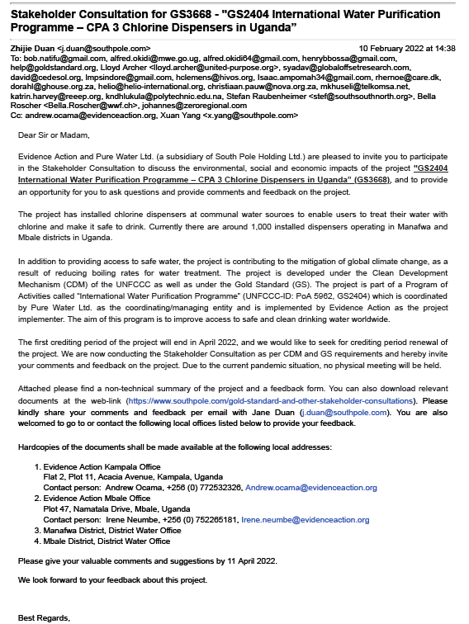 | 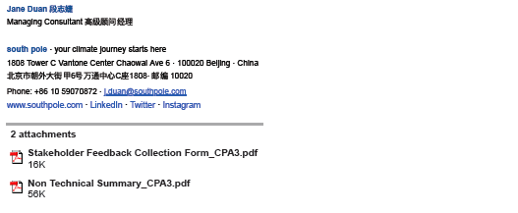

Email invitation for stakeholders of category E:
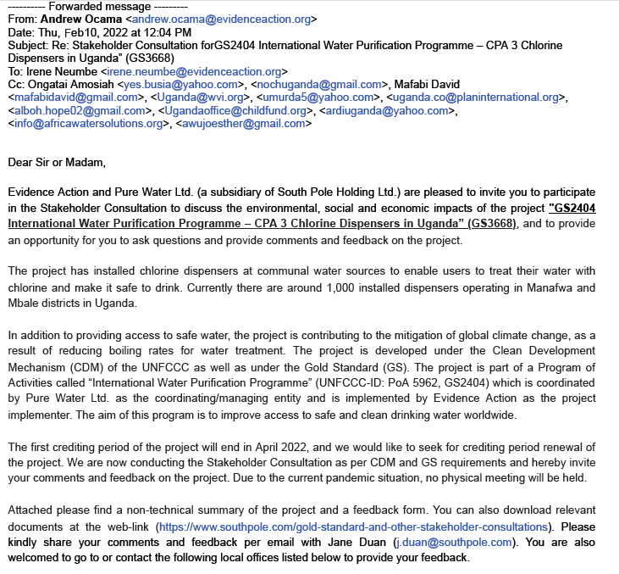 | 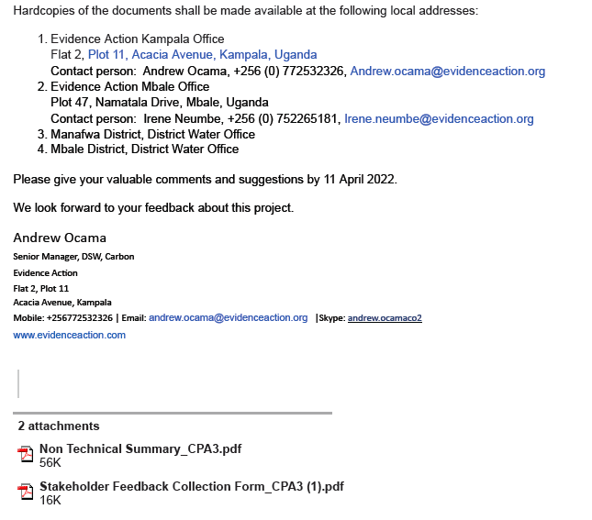

Screenshot of responses from Gold Standard representative (category F):
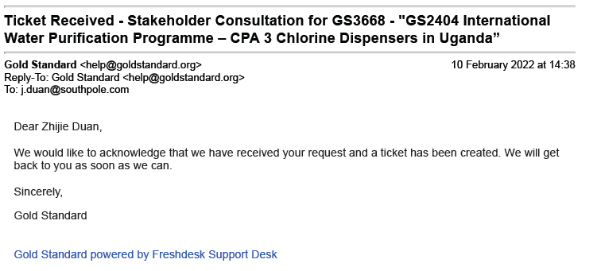

Photos of Invitation letter put in local health centers for stakeholders of categories A, B and C:
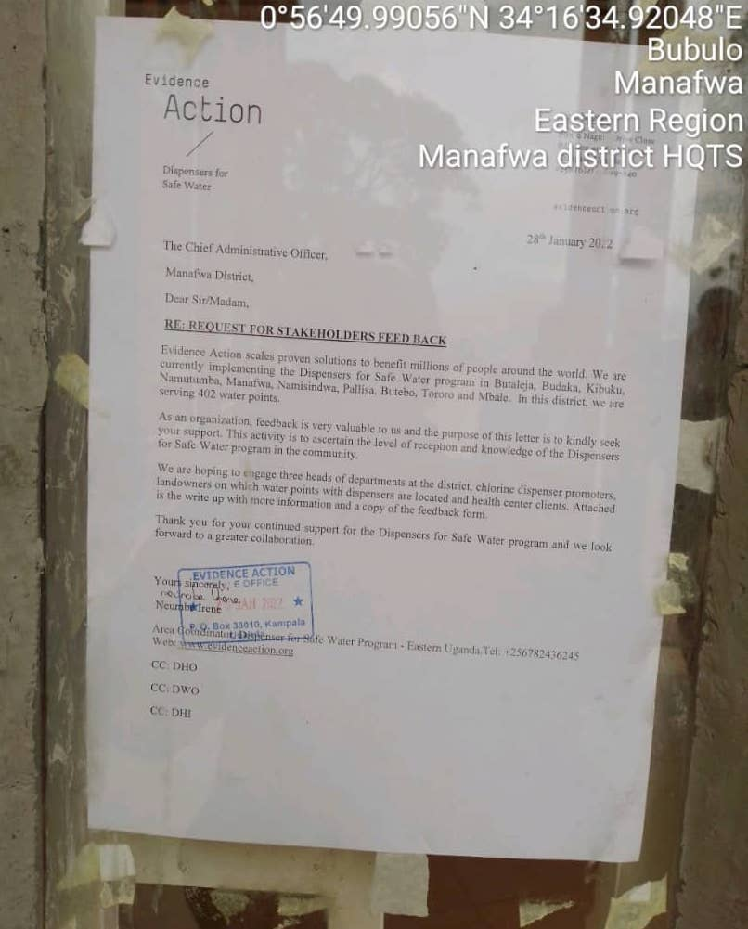 | 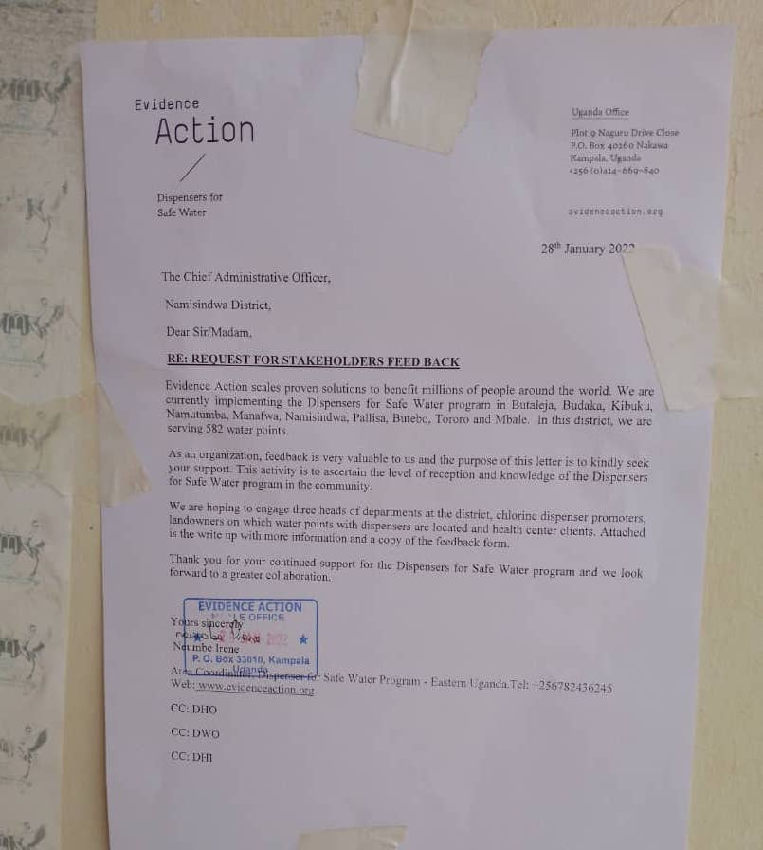
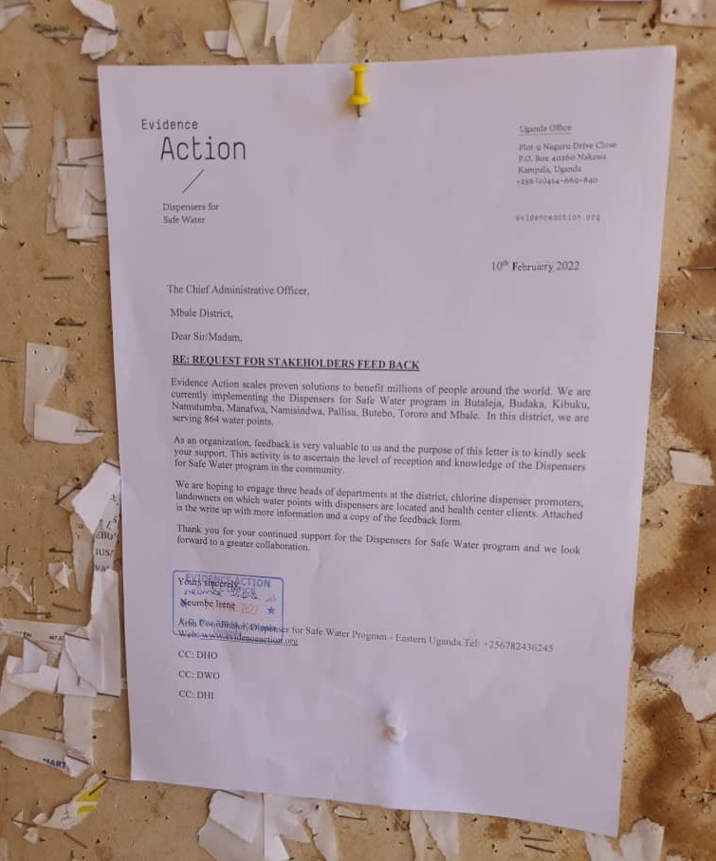

          - Sample content of invites (for each Method above)
>>
Invitation email sample:

Stakeholder Consultation for GS3668 - "GS2404 International Water Purification Programme – CPA 3 Chlorine Dispensers in Uganda”

Dear Sir or Madam,

Evidence Action and Pure Water Ltd. (a subsidiary of South Pole Holding Ltd.) are pleased to invite you to participate in the Stakeholder Consultation to discuss the environment, social and economic impacts of the project "GS2404 International Water Purification Programme – CPA 3 Chlorine Dispensers in Uganda” (GS3668), and to provide an opportunity for you to ask questions and provide comments and feedback on the project.

The project has installed chlorine dispensers at communal water sources to enable users to treat their water with chlorine and make it safe to drink. Currently there are around 1,000 installed dispensers operating in Manafwa and Mbale districts in Uganda.

In addition to providing access to safe water, the project is contributing to the mitigation of global climate change, as a result of reducing boiling rates for water treatment. The project is developed under the Clean Development Mechanism (CDM) of the UNFCCC as well as under the Gold Standard (GS). The project is part of a Program of Activities called “International Water Purification Programme” (UNFCCC-ID: PoA 5962, GS2404) which is coordinated by Pure Water Ltd. as the coordinating/managing entity. The aim of this program is to improve access to safe and clean drinking water worldwide.

The first crediting period of the project will end in April 2022, and we would like to seek for crediting period renewal of the project. We are now conducting the Stakeholder Consultation as per CDM and GS requirements and hereby invite your comments and feedback on the project. Due to the current pandemic situation, no physical meeting will be held.

Attached please find a non-technical summary of the project and a feedback form. You can download relevant documents at the web-link (https://www.southpole.com/gold-standard-and-other-stakeholder-consultations). Please kindly share your comments and feedback per email with Jane Duan (j.duan@southpole.com). You are also welcomed to go to or contact the following local offices listed below to provide your feedback.

Hardcopies of the documents shall be made available at the following five local addresses:

- Evidence Action Kampala Office
Flat 2, Plot 11, Acacia Avenue, Kampala, Uganda
Contact person: Andrew Ocama, +256 (0) 772532326, Andrew.ocama@evidenceaction.org
- Evidence Action Mbale Office
Plot 47, Namatala Drive, Mbale, Uganda
Contact person: Irene Neumbe, +256 (0) 752265181, Irene.neumbe@evidenceaction.org
- Manafwa District, District Water Office
- Mbale District, District Water Office
Please give your valuable comments and suggestions by 11 April 2022.
We look forward to your feedback about this project.

Regards,

Invitation letter sample:

The Chief Administrative Officer,
*** District,
Dear Sir/Madam,

RE: REQUEST FOR STAKEHOLDERS FEED BACK

Evidence Action scales proven solutions to benefit millions of people around the world. We are currently implementing the Dispensers for Safe Water program in Butaleja, Budaka, Kibuku, Namutumba, Manafwa, Namisindwa, Pallisa, Butebo, Tororo and Mbale. In this district, we are serving *** water points.

As an organization, feedback is very valuable to us and the purpose of this letter is to kindly seek your support. This activity is to ascertain the level of reception and knowledge of the Dispensers for Safe Water program in the community.

We are hoping to engage three heads of departments at the district, chlorine dispenser promoters, landowners on which water points with dispensers are located and health center clients. Attached is the write up with more information and a copy of the feedback form.

Thank you for your continued support for the Dispensers for Safe Water program and we look forward to a greater collaboration.

Your sincerely,

Neumbe Irene

Area Coordinator, Dispenser for Safe Water Program – Eastern Uganda, Tel: +256782436245
Web: www.evidenceaction.org
CC: DHO
CC: DWO
CC: DHI

          - Description of other Means and methods to provide feedback for those who are not able to join the consultation meeting
>>
Due to the current pandemic situation, no physical meeting would be held. Stakeholder feedback round has been conducted. The invited stakeholders can provide comments and feedback on the project through the following contact details:
- Evidence Action Kampala Office
Flat 2, Plot 11, Acacia Avenue, Kampala, Uganda
Contact person: Andrew Ocama, +256 (0) 772532326, Andrew.ocama@evidenceaction.org
- Evidence Action Mbale Office
Plot 47, Namatala Drive, Mbale, Uganda
Contact person: Irene Neumbe, +256 (0) 752265181, Irene.neumbe@evidenceaction.org
- Manafwa District, District Water Office
- Mbale District, District Water Office

REPORT OF THE CONSULTATION PROCESS
        - Date of Meeting
>>
Not applicable
Due to the current pandemic situation, no physical meeting has been held. Stakeholder feedback round has been conducted from 10/02/2022 to 11/04/2022.

          - Justification of why consultation took place after the project start date (retroactive projects only)
>>
Not applicable. The VPA is regular VPA and now seeking for crediting period renewal.

          - List of participants
Please complete the table below

Date and Time |  | Location
Category  Code | Name of the participant, job /  position in the community | Male /  Female |  | Contact details | Organisation  (if relevant) | Signature
Not applicable
Due to the current pandemic situation, no physical meeting has been held. Stakeholder feedback round has been conducted.

          - Pictures from the physical meeting(s) (best practice)
>>
Not applicable
Due to the current pandemic situation, no physical meeting has been held. Stakeholder feedback round has been conducted.
        - Minutes of physical meeting(s)
>>
Not applicable
Due to the current pandemic situation, no physical meeting has been held. Stakeholder feedback round has been conducted.
          - Minutes of other consultations
>>
N/A

        - Assessment of comments from all consultations above
Please complete the table below
Gender of Stakeholder | Stakeholder  comment | Was comment taken into account (Yes/ No)? | Explanation/  Justification (Why? How?)
F | The project helps us in treating water with chlorine to drink safe water in our homes. | No changes made to the project design. | This is in line with the original project design and the purpose of the project.
M | Chlorine treatment of water means people do not have to boil water, in return reducing deforestation. | No changes made to the project design. | This is in line with the original project design and the purpose of the project.
F | The project will bring more employment opportunities to the local people. | No changes made to the project design. | The project activity can provide employment opportunities through the installation and maintenance and management of the chlorine dispensers, and the chlorine delivery; and also during annual monitoring surveys of the project.
M | We appreciate for the service but we request for more dispensers. | Yes | From January 2014 to October 2014, in total 1,013 chlorine dispensers were installed at corresponding communal water points, which is in line with the deployment plan and the scale of the project.  The project implementer will include new dispensers in this VPA or other VPAs of the PoA if the financial issues are solved.

          - Evaluation forms (best practice)
You may use the table format below to collect feedback on your consultation

Name | Tsekooko Moses
Gender – Male/Female: | M
What is your impression of the meeting? | N/A
What do you like about the project? | The project has improved the hygiene and sanitation around water sources
What do you not like about the project? | -
Signature

Name | Lunyolo Scovia
Gender – Male/Female: | F
What is your impression of the meeting? | N/A
What do you like about the project? | The project has provided us with chlorine which helps to prevent diseases and kills germs and virus in water.
What do you not like about the project? | -
Signature

Name | Mutonyi Florence
Gender – Male/Female: | F
What is your impression of the meeting? | N/A
What do you like about the project? | The project helps us in treating water with chlorine to drink safe water in our homes.
What do you not like about the project? | -
Signature

Name | Makasi George
Gender – Male/Female: | M
What is your impression of the meeting? | N/A
What do you like about the project? | It has boosted our health.
What do you not like about the project? | -
Signature

Name | Mabonga Julius
Gender – Male/Female: | M
What is your impression of the meeting? | N/A
What do you like about the project? | Water treatment of community water sources using chlorine reduced diarrheal cases among both adults and children.
What do you not like about the project? | -
Signature

        - Summary of alterations based on comments
>>
Overall, the stakeholders are very positive about the project activity. The stakeholders greatly appreciate the project, as the project brings access to safe drinking water with treatment from the chlorine dispensers, which reduces waterborne diseases and improves health and living conditions of local people, the community members no longer boil drinking water. They hope that project could keep on going to provide services to local communities and even expand the chlorine dispensers to other areas. So, there are no alterations needed in project design or adjustment in implementation strategy.

Please use the table below to report on the methods agreed with stakeholders

CONTINUOUS INPUT / GRIEVANCE MECHANISM
 | Method Chosen (include all known details e.g. location of the book, phone, number, identity  of mediator) | Justification of Choice  (best practice)
Continuous Input / Grievance Expression Process Book (mandatory) | Evidence Action Country office:  Flat 2, Plot 11  Acacia Avenue, Kampala  Evidence Action Mbale office:  Plot 47, Namatala Drive, Mbale | Inputs or grievances can be given at any time directly to Evidence Action staff who are regularly visiting water points for evaluations, hardware check and chlorine delivery. During these visits, the staff can interact with the users and can receive input and relay it to the country office.  Boxes for written comments can be found in the Evidence Action country and field offices.
GS Contact (mandatory) | help@goldstandard.org
Telephone access (optional) | Evidence Action (project implementer):  Evidence Action Country office:  Contact person: Andrew Ocama  +256 (0) 772532326  Evidence Action Mbale office:  Contact person: Irene Neumbe  +256 (0) 752265181  Pure Water Ltd. (CME):  Contact person: Jane Duan  +86 10 59070872 | Each promoter gets a laminated promoter card with the number as well as some airtime to help them call the number.  Evidence Action engages office-based staff to complete phone calls to promoters on a regular basis because some promoters may be reluctant to call to report problems.
Internet/email access (optional) | Via post:  Evidence Action, Uganda  P.O Box 33010  Kampala, Uganda  Evidence Action (project implementer):  Evidence Action Country office:  Contact person: Andrew Ocama  Andrew.ocama@evidenceaction.org  Evidence Action Mbale office:  Contact person: Irene Neumbe  Irene.neumbe@evidenceaction.org  Pure Water Ltd. (CME):  Contact person: Jane Duan  j.duan@southpole.com | Inputs or grievances can be sent at any time to the Evidence Action Uganda country office in Kampala or via email to the contact person.
Nominated Independent Mediator (optional)
Other

STAKEHOLDER FEEDBACK ROUND

Please check this box if the project is retroactive and has done only 1 consultation with a physical meeting integrated into the SFR.

        - Length of the Feedback Round

Stakeholder Feedback Round |  | Planned | Actual
Start Date | 10/02/2022
End Date | 11/04/2022

        - Summarise how all stakeholders were/will be invited to provide feedback
>>
All invitation and materials (non-technical summary and feedback form) were shared in English.

Invitation Letters: Evidence Action (VPA implementer) ensured that the invitation letters reached community representatives (Category A), stakeholders with land-tenure rights (Category B), and the representatives of local authorities (Category C) by putting the invitation letters on the notice board at the local health centers and by phone or oral communications. Follow-up phone and in-person discussions took place to ensure that most invited representatives were available to provide comments / feedback on the project.

Invitation Emails: Evidence Action (VPA implementer) and Pure Water Ltd. (CME) invited relevant national government officials (Category D), local non-government organizations (NGOs) and Women Groups (Category E), the Gold Standard representative (Category F) and relevant international Gold Standard NGO supporters (Category G) by sending out the email invitations.
        - Summarise Feedback received, including if any changes in project design were made
>>
The stakeholders provided very positive feedback. Nevertheless, none of the comments required immediate changes in project design or adjustment of the implementation strategy. See explanations by CME and Evidence Action in section C.3.
Revision History

Version | Date | Remarks
1.2 | 5 May 2022 | Addition of grouped consultation info, preliminary agenda and section to justify retroactive consultation took place.  Minor edits to text.
1.1 | 14 October 2020 | Inclusion of Key Project Information  Restructure, new headings and reorder to better match the steps a developer will follow in consultations.  Removal of some non-mandatory template tables (Blind Sustainable Development Assessment). Clarification of best practice steps that are non mandatory processes, clarification of mandatory discussion points. Clarification regarding publishing names and that original evaluation forms (optional) and attendance lists (mandatory) should be separate documents.  Improved clarity on Stakeholder Feedback round section and procedures for retroactive projects  Provision of an accompanying Guide to help the user understand detailed rules and requirements
1.0 | 14 August 2017 | Initial adoption

https://www.who.int/news-room/fact-sheets/detail/diarrhoeal-disease

