

Design Change Memo

The purpose of this Design Change Memo is to assess the impacts of the design change on PoA GS5047 African Improved Cookstoves and Clean Water Programme. The design consultation process was carried out between June 2020 and August 2020 and included both efficient cook stoves and safe water technologies. The purpose of the design change was to expand the applicability of PoA GS5047 from Rwanda, Uganda and Zambia, to also include Tanzania and the Democratic Republic of Congo (DRC).

Based on the guidance given, the following aspects will be assessed in this Design Change Memo:
- Additionality
- Scale of project
- Applicability of methodology
- Stakeholder feedback on design change
- Sustainable Development Assessment
- Sustainable Development Monitoring Plan
- Legislation

- Additionality

Under the Community Service Activity Requirements (https://globalgoals.goldstandard.org/wp-content/uploads/2019/10/200-GS4GG-Community-Services-Activity-Requirements-v1.1TC.pdf (latest version is TRACKED)) section 4.1.9 defines that all projects that meet any of the following criteria are considered as deemed additional and therefore are not required to prove Financial Additionality at the time of Design Certification:

- Positive list (Annex B the Requirements)
- Projects located in LDC, SIDS, LLDC
- Microscale projects

As Tanzania and DRC, as well as Rwanda, Uganda and Zambia, are Least Developed Countries (LDCs), and the PoA remains a micro-scale Programme of Activities, all activities in the PoA are deemed additional.

- Scale of project

The PoA is a micro-scale Programme of Activities, where each of the VPAs is limited by annual emission reductions of 10,000 tCO2e. There will be no modification to the scale of the project by the expansion to DRC. The maximum number of technologies per VPA is limited by the 10,000 tCO2e limit and is dependent on the project baseline which will vary from VPA to VPA.

- Applicability of methodology

The revised VPA-DD applies the same methodology as in the registered version (Technologies and Practices to Displace Decentralized Thermal Energy Consumption, version 3.1).

- Stakeholder feedback on design change

The stakeholder feedback process for the design change started on 19 June 2020 and lasted for 60 days. Emails were sent out to relevant stakeholders for Tanzania and DRC, see below.

Email sent to Stakeholders relevant for Tanzania:

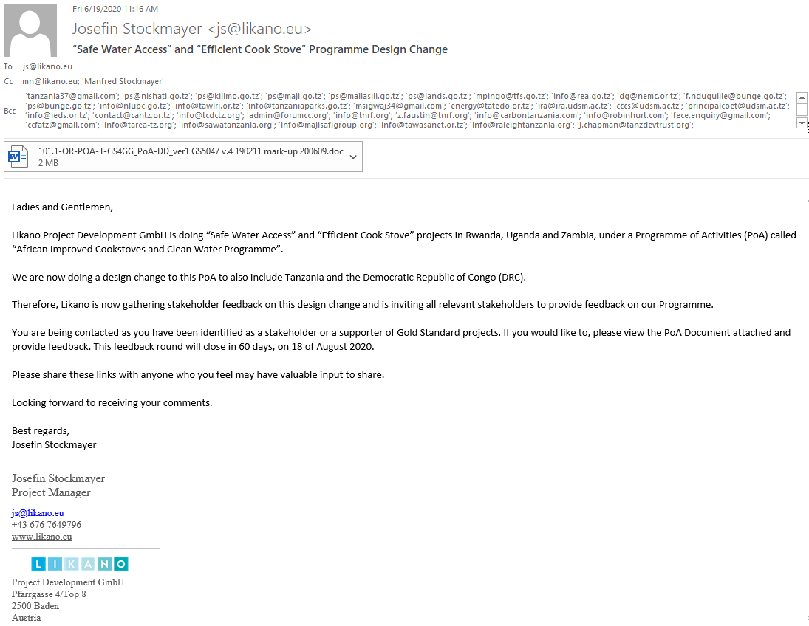

Email sent to Stakeholders relevant for DRC:

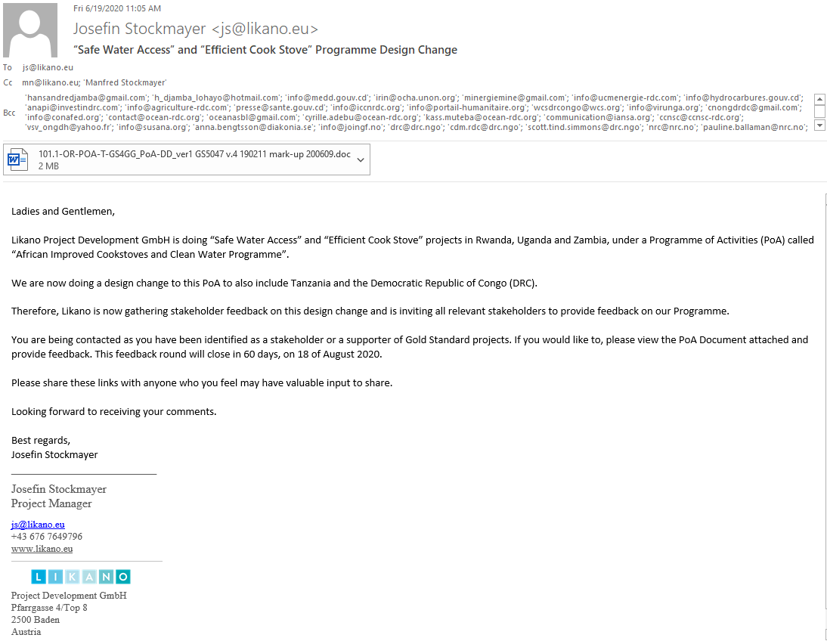

The following lists include all the stakeholders reached out to:

Stakeholders in Tanzania:

Organisation | Name | Email
Designated National Authority (DNA) | Mr. Richard S. MUYUNGI | tanzania37@gmail.com
Ministry of Energy | Permanent Secretary, Eng. Zena Ahmed Said | ps@nishati.go.tz
Ministry of Agriculture | Permanent Secretary | ps@kilimo.go.tz
Ministry of Water and Irrigation | Permanent Sectretary | ps@maji.go.tz
Ministry of Natural Resources and Tourism | Permanent Sectretary | ps@maliasili.go.tz
Ministry of Lands, Housing and Human Settlements Development | Permanent Secretary | ps@lands.go.tz
Tanzania Forest Service Agency (TFS) | Dar Es Salaam Office | mpingo@tfs.go.tz
Rural Energy Agency (REA) | Dodoma Office | info@rea.go.tz
National Environment Management Council | Dr. Eng. Samuel Gwamaka Mafwenga | dg@nemc.or.tz
ministry of Health | Hon. Dr. Faustine Engelbert Ndugulile | f.ndugulile@bunge.go.tz, ps@bunge.go.tz
National Land use planning commission | Dar Es Salaam Office | info@nlupc.go.tz
Tanzania Wildlife Research Institute (TAWIRI) | Arusha Office | info@tawiri.or.tz
Tanzania National Parks | Arusha Head Office | info@tanzaniaparks.go.tz
Renewable Energy Technology Center Tanzania | Dr. Consalva Msigwa | msigwaj34@gmail.com
Tatedo - Centre for Sustainable Energy Services | Dar Es Salaam Office | energy@tatedo.or.tz
Institute of Resource Assessment | University of Dar Es Salaam | ira@ira.udsm.ac.tz
Centre for Climate Change Studies | University of Dar Es Salaam | cccs@udsm.ac.tz
The Department of Water Resources Engineering (WRED) | University of Dar Es Salaam | principalcoet@udsm.ac.tz
Institute for Environment and Development Sustainability (IEDS) | Dar Es Salaam Office | info@ieds.or.tz
NGOs
Climate Action Network Tanzania | Dar Es Salaam Office (NGO) | contact@cantz.or.tz
Tanzania Communication and Development Center | Dar Es Salaam Office (NGO) | info@tcdctz.org
Tanzania Civil Society Forum on Climate Change (ForumCC) | Dar Es Salaam Office (int-NGO) | admin@forumcc.org
Tanzania Natural Resource Forum | Arusha office (NGO) | info@tnrf.org, z.faustin@tnrf.org
Carbon Tanzania | Arusha office (NGO) | info@carbontanzania.com
Robin Hurt Wildlife Foundation | Arusha office (NGO) | info@robinhurt.com
Foundation for Energy Climate and Environment | Dar Es Salaam Office (NGO) | fece.enquiry@gmail.com
Clean Cookstoves and Fuels Alliance of Tanzania (CCFAT) |  | ccfatz@gmail.com
Tanzania Renewable Energy Association (TAREA) | NGO | info@tarea-tz.org
Sanitation and Water Action SAWA Tanzania |  | info@sawatanzania.org
Maji Safi Group (Water, Sanitation and Hygien) |  | info@majisafigroup.org
Tanzania Water and Sanitation Network | Dar Es Salaam Office | info@tawasanet.or.tz
Sustainable Sanitation Alliance (SUSANA) |  | info@susana.org
Raleigh Tanzania (access to safe water) | Morogoro | info@raleightanzania.org
Tanzania Development Trust |  | j.chapman@tanzdevtrust.org
Simavi |  | thea.bongertman@simavi.nl, info@simavi.nl
INTERNATIONAL w Country offices
Green Climate Fund | William Mwegoha | WILLIAM.MWEGOHA@VPO.GO.TZ
UNICEF | Dar Es Salaam Office | daressalaam@unicef.org
UNDP | Country director, Christine Musisi | christine.musisi@undp.org
Caritas | Tanzania office | caritast@tec.co.tz
Africare | Country Office , Alfred Kalaghe | akalaghe@africare.org
Development Partners Group (DPG) Tanzania | Tanzania Office Faustine Ninga | dpge.tanzania@gmail.com
Climate Neutral Group |  | info@climateneutralgroup.com
Global Alliance for Clean Cookstoves |  | info@cleancookstoves.org
Climate Care |  | business@climatecare.org
End Water Poverty | London office | info@endwaterpoverty.org
Atmosfair | Dietrich Brockhagen | brockhagen@atmosfair.de
Cleancookingalliance | Tanzania Office | knowledge@cleancookingalliance.org
Wildlife Conservation Society (WCS) | Tanzania country office | wcstanzania@wcs.org
SNV Tanzania Country Office | Duncan Rhind | drhind@snv.org
GIZ | Tanzania Country office | giz-tanzania@giz.de
Water Aid |  | info@wateraid.se
Water Aid |  | info@wateraid.org
Empower Women |  | empower.women@unwomen.org
Dare Women's Foundation |  | darewomens@gmail.com
Kivulini Women’s Rights Organisation |  | admin@kivulinitz.org

Stakeholders in DRC:

Organisation | Name | Email
Designated National Authority (DNA) | Mr. Hans Andre Lohayo Djamba | hansandredjamba@gmail.com, h_djamba_lohayo@hotmail.com
Ministry of Environment and Sustainable Development (MEDD) |  | info@medd.gouv.cd
UN Department of Humanitarian Affairs Integrated Regional Information Network for Central and Eastern Africa | DRC | irin@ocha.unon.org
ministere-energie-mines |  | minergiemine@gmail.com
UCM, l'Unité de Coordination et de Management des Projets du Ministère de l’Energi |  | info@ucmenergie-rdc.com
Ministre des Hydrocarbures |  | info@hydrocarbures.gouv.cd
Agence Nationale pour la Promotion des Investissements |  | anapi@investindrc.com
Ministry of Agriculture |  | info@agriculture-rdc.com
Ministry of Health |  | presse@sante.gouv.cd
l’Institut Congolais pour la Conservation de la Nature (ICCN) | Kinshasa | info@iccnrdc.org
Portail Humanitaire |  | info@portail-humanitaire.org
Wildlife Conservation Society (WCS) DR Congo | Kinshasa | wcsdrcongo@wcs.org
Virunga National Park |  | info@virunga.org
NGOs local
Conseil Régional des Organisations non gouvernementales de Développement du Bas-Congo | Kinshasa | cnongdrdc@gmail.com
Comité National Femme et Développement | Gombe | info@conafed.org
Organisation Congolaise des Ecologistes et Amis de la Nature |  | contact@ocean-rdc.org, oceanasbl@gmail.com
Organisation Congolaise des Ecologistes et Amis de la Nature | Coordonnateur National : Cyrille ADEBU | cyrille.adebu@ocean-rdc.org
Organisation Congolaise des Ecologistes et Amis de la Nature | Chef d'antenne: Alidor MUTEBA KASONGO | kass.muteba@ocean-rdc.org
Femmes des Medias pour la Justice au Congo |  | communication@iansa.org
Cadre de concertation nationale de la société civile RDC | Jean-Baptiste MBILIZI | ccnsc@ccnsc-rdc.org
La Voix des Sans Voix |  | vsv_ongdh@yahoo.fr
Sustainable Sanitation Alliance (SUSANA) |  | info@susana.org
NGOs international
Diakonia | Country Director, Anna Bengtsson | anna.bengtsson@diakonia.se
Hope in Action, Join Good Forces |  | info@joingf.no
Danish Refugee Council (DRC) | HQ | drc@drc.ngo
Danish Refugee Council (DRC) | Country Director, Martine Villeneuve | martine.villeneuve@drc.ngo
Danish Refugee Council (DRC) | HQ, Scott Tind Simmons | scott.tind.simmons@drc.ngo
Norwegian Refugee Council (NRC) | HQ | nrc@nrc.no
Norwegian Refugee Council (NRC) | Pauline Ballaman | pauline.ballaman@nrc.no
Norwegian Refugee Council (NRC) | Maureen Philippon | maureen.philippon@nrc.no
Actionaid | Head Office | mail.jhb@actionaid.org
WHO | Country office, Dr Amédée Prosper Djiguimde | afwcocd@who.int
WWF | Country office | wwfdrc@wwfdrc.org
Water Aid |  | info@wateraid.se
Water Aid |  | info@wateraid.org
Women for Women International | HQ | general@womenforwomen.org
Women for Women International | German Office | kontakt@womenforwomen.org
Enabel DR CONGO | Philippe Serge Degernier | representation.rdc@enabel.be
INTERNATIONAL w Country offices
Green Climate Fund | Mr. Hans Djamba | HANSANDREDJAMBA@GMAIL.COM, H_DJAMBA_LOHAYO@HOTMAIL.COM
UNICEF | Kinshasa Office | kinshasa@unicef.org
UNDP | Goma office | registry.cd@undp.org
Caritas | DRC office | directeur@caritasdev.cd, communication@caritasdev.cd
Africare | Head Office USA | info@africare.org
Development Partners Group (DPG) |  | dpge.drc@gmail.com
Climate Neutral Group |  | info@climateneutralgroup.com
Global Alliance for Clean Cookstoves |  | info@cleancookstoves.org
Climate Care |  | business@climatecare.org
End Water Poverty | London office | info@endwaterpoverty.org
Atmosfair | Dietrich Brockhagen | brockhagen@atmosfair.de
Cleancookingalliance |  | knowledge@cleancookingalliance.org
Wildlife Conservation Society (WCS) |  | wcsdrca@wcs.org
SNV | DR Congo Country Office | drcongo@snv.org
GIZ | Country Director DRC, Andreas Kalk | giz-kongo-rdc@giz.de
Mercy Crops (Water and Health) |  | info@mercycorps.org

Two comments were received from stakeholders in Tanzania, no comments were received from DRC. The following table lists the comments received on the design change:

Tanzania
Stakeholder comment |  | Was comment taken into account (Yes/ No)? |  | Explanation (Why? How?)
Dear Josefin,  Thank you for your email, and thank you for inviting me to participate as a stakeholder in this big project. I understand that the first version for PoA - as per the attached document was released on July 2017, Version 1, the objectives being i) increase the up-take of improved cook-stoves and ii) water treatment. By that time the host countries were Rwanda, Uganda, and Zambia. Now that the project has added Tanzania and DRC into the picture, I was wondering whether I can add - "supporting the modern clean energy penetration in remotely and rural areas" in the region as another activity; this will give the room for using renewable energy sources to generate energy for cooking, water treatment and etc, and reduce GHGas well as assisting in improving the social and economic activities in the said region. More as we want our people to effectively use biomass as the source of energy, we would like them to use all available renewable energy sources for cooking, water treatment, and other socio-economic activities for improving their wellbeing.  Looking forward to hearing from you,  Sincerely,  Consalva Msigwa  Department of Electrical Engineering  Dar es Salaam Institute of Technology,  Dar es Salaam, Tanzania. |  | Yes |  | Dear Consalva,  Thank you for your interest in our program.  We are always interested in looking at new opportunities. However we can only work with energy efficiency on a household level.  I understand that you perhaps talk about projects that would in the end benefit on a household level. But the basis of our program do not allow us to take in projects that aims at generating new energy for example. It has to do with the methodology we are using to calculate the emission reductions, which is based on calculations on energy efficiency on a household level.  If you have project that could fit under this program please do let us know.
Dear Josefin,  Many thanks for sharing this document and for us looks very good and relevant for Tanzanian communities. I just wanted to know if the programme focuses to rural communities or it also includes urban/peri-urban or both provided meet project criteria?. Sorry I didn’t see this.  We confirm our availability to take forward the initiative.  CAN TZ team |  | Yes |  | Dear CAN TZ team,  Thank you for contacting us and for your interest.  The project is not limited to either rural or urban areas.  We are always interested in investigating new opportunities so if you or your colleagues come across interesting opportunities for efficient cookstove and safe water projects, please let us know. We would be very interested in taking a look at that.
DRC
Stakeholder comment | Was comment taken into account (Yes/ No)? |  | Explanation (Why? How?)
No comments received | - |  | -

- Sustainable Development Assessment

Sustainable Development Assessment will be carried out on VPA level.

- Sustainable Development Monitoring Plan

The Sustainable Development Monitoring Plan will be elaborated on VPA level.

- Legislation

There is no need for new approvals/licenses to implement clean cooking and safe water technologies in Tanzania and DRC.

