Key Project Information & VPA Design Document (PDD)

PUBLICATION DATE 7.10.2020
VERSION v. 1.1
RELATED SUPPORT
– TEMPLATE GUIDE Key Project Information & VPA Design Document v.1.1

This document contains the following Sections
Key Project Information

SECTION A – Description of project
SECTION B - Application of approved Gold Standard Methodology (ies) and/or demonstration of SDG Contributions
SECTION C – Duration and crediting period
SECTION D – Summary of Safeguarding Principles and Gender Sensitive Assessment
SECTION E – Summary of Local stakeholder consultation
Appendix 1 – Safeguarding Principles Assessment (mandatory)
Appendix 2 - Contact information of VPA Implementer (mandatory)
Appendix 3 - Summary of Approved Design Changes (project specific)

KEY PROJECT INFORMATION
GS ID of Project | GS11025
Title of Project | GS5047 VPA90 African Improved Cookstoves and Clean Water Programme: Gishwati – Mukura Forest Conservation Project XVII
Time of First Submission Date | 07/05/2020
Date of Design Certification | Estimated 19/10/2021
Version number of the VPA-DD | Version 7
Completion date of version | 12/10/2021
Coordinating/managing entity | Likano Project Development GmbH
VPA Implementer (s) | Likano Project Development GmbH
Project Participants and any communities involved | Likano Project Development GmbH  Various villages within the districts of Rutsiro and Ngororero
Host Country (ies) | Republic of Rwanda
GS ID and Title of applicable Design Certified VPA | GS ID: GS10826  Title: GS5047 VPA50 African Improved Cookstoves and Clean Water Programme: Ibanda – Makera Forest Cook Stove Project I
GS ID and Title of applicable Performance Certified VPA | GS ID: GS7448  Title: GS5047 VPA33 African Improved Cookstoves and Clean Water Programme: Nyungwe Rainforest Cookstove Project I
Activity Requirements applied | Community Services Activities  Renewable Energy Activities  Land Use and Forestry Activities/Risks & Capacities  N/A
Scale of the project activity | Micro scale  Small Scale  Large Scale
Other Requirements applied | N/A
Methodology (ies) applied and version number | Technologies and Practices to Displace Decentralized Thermal Energy Consumption Version 3.1
Product Requirements applied | GHG Emissions Reduction & Sequestration  Renewable Energy Label  N/A
Project Cycle: | Regular  Retroactive

Table 1 – Estimated Sustainable Development Contributions
Sustainable Development Goals Targeted | SDG Impact  (defined in B.6) | Estimated Annual Average | Units or Products
SDG 13 Climate Action (mandatory) | Emission  Reductions | 5,014 VERs
SDG 3 Ensure healthy lives  and promote well-being for  all at all ages | Number of  Households with improved in-air quality | 1,125 Households
SDG 7 Ensure access to  affordable, reliable,  sustainable and modern  energy for all | Active Stoves | 2,250 Stoves

- DESCRIPTION OF PROJECT
  - Purpose and general description of project
Purpose of Project Activity
This Micro-Scale Voluntary Project Activity for the PoA African Improved Cookstoves and Clean Water Programme involves the distribution of domestic fuel-efficient cookstoves to households within the districts of Rutsiro and Ngororero, Republic of Rwanda, which previously have had no access to improved cookstoves. The Gishwati – Mukura Forest Conservation Project currently includes a total of 20 VPAs. The plan is to distribute 2,500 stoves in each and every VPA, which gives a total of 50,000 stoves. The project owner Likano Project Development GmbH will work closely with the in-country partner Rwandese Association of Ecologists (ARECO) in the preparation and implementation of the project.

Most families in the area use the traditional three-stone cooking stove which consumes large amounts of firewood. This means that a lot of time is spent collecting firewood that could be otherwise used for other developmental activities. The large quantities of firewood required for three-stone fires put a lot of pressure on the protected forests in the Gishwati Mukura National Park. Traditional stoves also produce a lot of smoke which causes respiratory disease, particularly in women/girls who use it for cooking, but also in young children and other people (e.g. the elderly) who spend a lot of time indoors. The use of this inefficient cooking method also has unintentional negative impacts on the environment surrounding the local people. Biomass, principally firewood, holds huge importance in Rwanda, accounting for at least 86% of energy consumption. Wood fuel is in particularly high demand, especially in rural areas where 98% of households rely on wood as their main cooking fuel. The replacement of traditional stoves by fuel-efficient stove will lead to a significant reduction in the annual usage of biomass for users.

In addition to reducing the usage of biomass, and thus reducing greenhouse gas emissions, the distribution of fuel-efficient cookstoves will also lessen the amount of harmful smoke and indoor air pollution currently associated with traditional three-stone fires. This will result in a decrease in the incidences of negative health impacts, such as respiratory diseases, amongst rural households. The environmental, social and economic benefits of the distribution of efficient cookstoves will be further explored later.

Users will enter into an agreement with Likano Project Development GmbH (the CME), transferring the rights to the VERs generated by the VPA in return for a very low-cost contribution to the stove mounting (material for fixing the stove in the house) and education on its use. The users also guarantee access to a representative of Likano to maintain and monitor the condition of the stove.

The implementation of the project will be led by Likano as the CME and will be supported by local partners. ARECO will be responsible for arranging the dissemination of stoves in the project area as well as baseline and monitoring studies. Rwanda of Peace and Progress (RPP) will be responsible for carrying out Kitchen Performance Tests both for the baseline and project scenarios. RPP has been a long-term partner of Likano and renamed in July 2020 from FAPDR to RPP. ARECO and RPP are not project participants.

Indicative time plan for project implementation
The Kitchen Performance Test and the Baseline study was carried out mid-March 2021. The dissemination period for the stoves is planned to start in Q3/2022.

    - Eligibility of the project under approved PoA
No. | Eligibility Criterion | Description/  Required condition | Means of Verification/Supporting evidence  for inclusion
1 | VPA Location and Project Boundary | The geographical  boundary within which  the technologies are installed will be within  the Project Boundary outlined in Section A.2 | The location of the VPA is specified in Section A.2, in which the CME states that the location is within Republic of Rwanda.  The VPA has been uniquely defined by the current administrative maps to define the project boundary.
2 | Avoiding Double Counting of Emissions Reductions | Each VPA will ensure double counting of emission reductions is avoided, through a unique identification number of each technology. | The identification system employed is outlined in the PoA-DD.  Each technology is linked with a unique identification number. Personal householder information is also gathered. These details are uploaded to a central database which is available to view by the Objective Observer.
3 | Technology and Target Group | Each VPA will involve the distribution and installation of efficient cook stoves to households and/or communities currently cooking with firewood on a traditional three-stone stove, for domestic purposes, with each having a continuous energy output of less than 150kW per unit. | Surveys or desk based research will be used to determine those households matching the target group.
4 | Baseline | The characteristics and current biomass consumption of households in the baseline scenario will be identified for each VPA. | Surveys to determine characteristics and current biomass consumption of households will be carried out for the VPA, and will be detailed in a ‘Baseline Report’.
5 | Technology Output | The technologies will each have continuous energy outputs of less than 150kW per unit. | Calculations for the cookstoves to show they are within the 150kW limit are submitted with this VPA-DD.
6 | Methodology | Each VPA will be in compliance with Technologies and  Practices to Displace Decentralized Thermal Energy Consumption Version 3.1. | The applicability of the methodology is justified in Section B.2 of this VPA-DD.
7 | Additionality | Each VPA will demonstrate additionality according to the criteria outlined in Section D.5 of the  PoA-DD. | In accordance with the Micro-Programme rules, any activity meeting one of the criteria outlined in Section D.5 of the PoA-DD shall be deemed additional. The VPA is within Republic of Rwanda, an LDC and is therefore additional.
8 | Carbon Transfer | The ownership rights of and selling the emission reductions resulting from the project activity will be signed over to the project developer using CTFs (Carbon Transfer Forms). | The stove recipients are clearly explained by the local partner about the transfer of the ownership rights and selling the emission reductions resulting from the project activity once they accept the stove free of charge and in return of the education on its correct use. They are explained that by signing the form at the point of distribution and providing their contact information for monitoring purposes, they enter into agreement that the VERs are transferred to the project developer.
9 | Non-Diversion of ODA | There will be no public funding or diversion of ODA for any of the proposed VPA’s. | A declaration confirming that there is no public funding for the VPA is attached with the VPA-DD.
10 | Avoiding Double Counting of Programme Activities | Each VPA will show that it is exclusive to the PoA  and not registered as another project activity  or VPA under another  PoA. | It is stated that the VPA is neither registered as a project activity with GS or any other standard or as a VPA of another PoA.  The appropriate registries (Gold Standard and CDM) have been accessed on 14/04/2021 to confirm this.
11 | Check of the start date of project activity | The start date of each  VPA will be checked through documentary evidence. | The estimated start date of the project activity is 01/07/2022 and is evidenced by the date of dissemination of first stove, which is evidenced by the Total Distribution Record. The start date will be updated and proof of the date will be provided in the verification process.
12 | Sampling requirements | Parameter values shall be estimated by sampling in accordance with the requirements in the applied methodology separately and independently for each of VPA included in the POA. | The VPA will apply requirements in the Standard for Sampling and Surveys for CDM Project Activities and Programme of Activities Version 4.0, as well as the methodology Technologies and Practices to Displace Decentralized Thermal Energy Consumption Version 3.1 (TPDDTEC), where sampling requirements in TPDDTEC supersede requirements from the CDM standard.
13 | Micro-scale threshold | As per requirements, the number of technologies or devices per VPA shall not exceed the 10,000 tCO2e limit defined for micro-scale threshold for activities. | The total number of emission reductions in this VPA will be limited to 10,000t CO2. The exact number of technologies is dependent on the baseline results and may vary from VPA to VPA.
14 | Local stakeholder consultations and environmental impact analysis | As per requirements, local stakeholder consultations will be organized for each component project activity. Environmental Impact analysis is carried out in line with Gold Standard Micro-scale Scheme Rules. | Supporting documents for local stakeholder consultations can be found at section E. Assessment of Gold Standard safeguarding principles are detailed in Appendix 1.

    - Legal ownership of products generated by the project and legal rights to alter use of resources required to service the project
The project is implemented by Likano Project Development GmbH, which is the Coordinating/Managing Entity (CME) of the PoA and the VPA and is also the project owner. At the point of technology installation, a Carbon Transfer Form (CTF) will be signed stating that the rights to the carbon credits are transferred to Likano.

The stoves are purchased by Likano from producers and Likano disseminates the stoves. The dissemination is done by the in-country partner ARECO in the name of the Likano.

  - Location of project
The location of the project activity is in various villages within the districts of Rutsiro and Ngororero, in the Western Province of the Republic of Rwanda. Below are the geographic references to allow unique identification of the cookstove project in the districts of Rutsiro and Ngororero in Rwanda. The project boundary is taken from the administrative boundaries of the districts of Rutsiro and Ngororero. The target area and the fuel collection area are defined as being contained within project boundary.

Continent | Country | Region | District | Sector | Geographical reference  (center)
Africa | Republic of Rwanda | Western Province | Rutsiro | N/A | -1.963561 | 29.387787
Africa | Republic of Rwanda | Western Province | Ngororero | N/A | -1.863459 | 29.599831

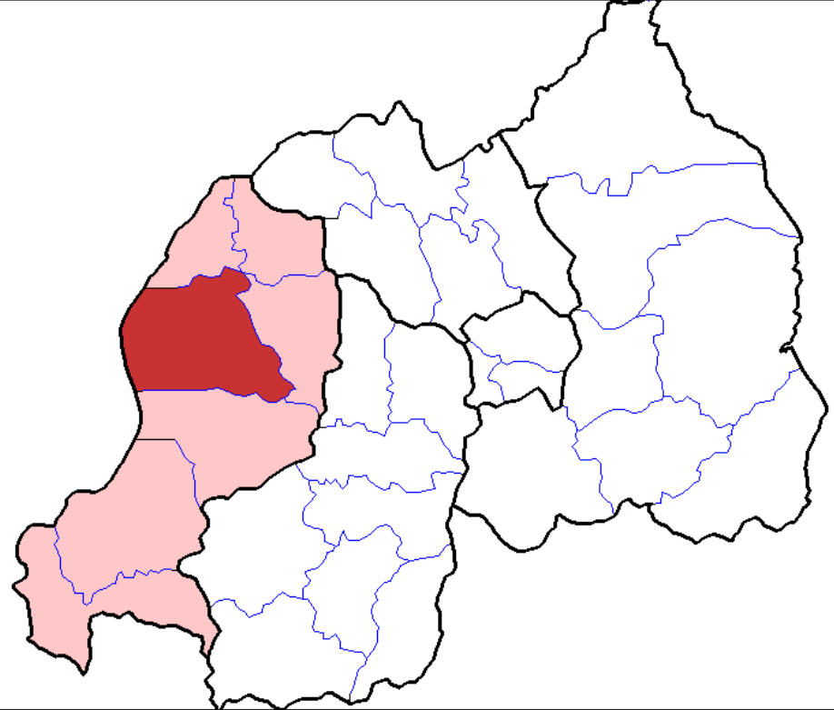
Figure 1: Rutsiro District, Western Province, Republic of Rwanda (highlighted with deep red)

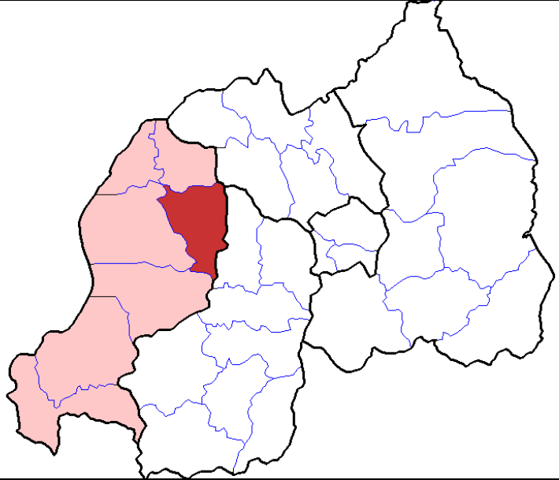
Figure 2: Ngororero District, Western Province, Republic of Rwanda (highlighted with deep red)

  - Technologies and/or measures
The stove to be distributed is the CANARUMWE Stove, which uses less firewood and emits less smoke, and which will reduce daily firewood costs and alleviate illness caused by smoke inhalation. The CANARUMWE stove is a locally manufactured household stove.

The stove is hand-made out of clay, using pottery clay and sand water, formed inside a bucket giving its pot-shape. It is a ceramic-lined build-in-place stove with flat bottom, installed in a mud surround in the Kitchen. The Dimensions are (l/w/h) 190/300/210 mm, and its Weight is 4.0 kg. The Maximum pot capacity is 20 L. The stove has an efficiency of 26.3%. The stove will be manufactured in the region by local cooperatives.

The estimated lifespan of the stove is five years, based on information from the Clean Cooking Alliance. A maintenance budget will be provided by the CME to carry out repairs of the stoves in the kitchens with the aim of increasing the lifetime of the stoves. This will focus on repairing cracks in the stove with a negative impact on the usability of the stove.

To avoid double counting of emission reductions a unique identification number will be given to each cookstove during the production process. The stove number will be engraved inside on the upper part of the stove.

Below is a picture of the CANARUMWE stove:

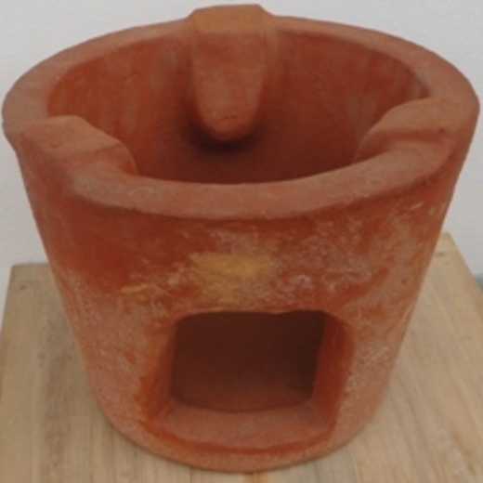

Below are pictures from dissemination of stoves and of stoves installed in a kitchen with mud surround, showing the engraved unique identification numbers:
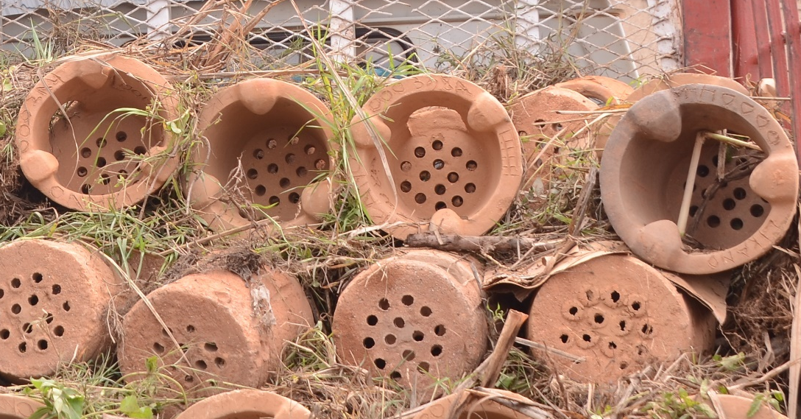

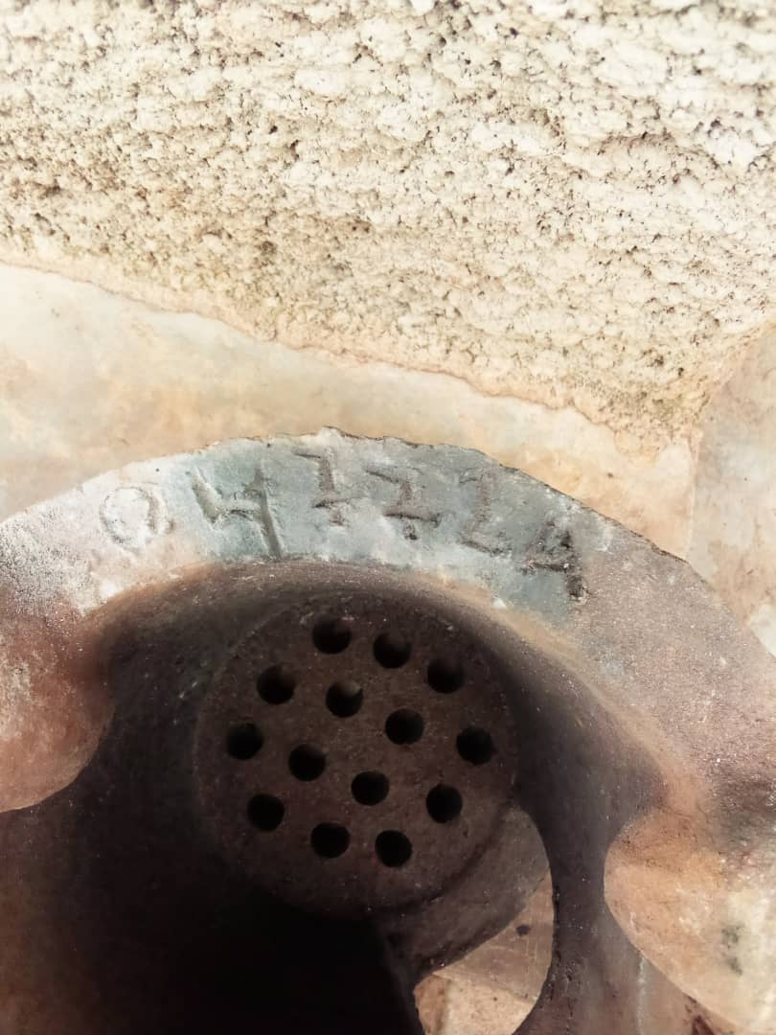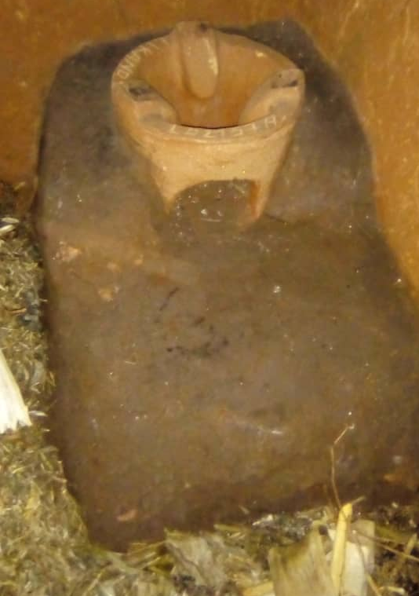

In Rwanda wealth ranking is divided into quintiles, dividing the population in to five categories of wealth. Category 1 includes the 20 % of the population with the lowest income, while category 5 includes 20% of the population with the highest income. Thus categories 1 and 2 represent 40% of the population with lowest income.

The stove will be provided to category 1 and 2 households for free, making sure local people are able to apply this efficient technology. Households will have to provide material (clay) for fixing the stove in the house at own costs. Households in category 1 and 2 are invited by the local authorities to sign up for getting a stove which will then be provided at time of dissemination.

In addition to reducing Greenhouse Gas emissions, so contributing to the mitigation of climate change, this project will provide local benefits to communities:
- Reduced deforestation and degradation of surrounding forests, as less wood will be needed to cook;
- Reduced soil erosion and nutrient loss as trees protect the land;
- Reduced risk of flooding in hilly areas as trees and plants on slopes soak up rain;
- Reduced poverty, as the efficient wood stove reduces annual expenditure on cooking fuels;
- Reduced adverse health effects associated with smoke inhalation;
- Reduced cooking and wood collection time, which will allow more time to be spent on other important household tasks and/or supervising children;
- Reduced pressure on protected forests in the Gishwati Mukura National Park;
- Reduction in burns and injuries as the CANARUMWE Stove is safer to cook on.

The project will positively contribute to the following 3 SDGs:
SDG 3 – Good Health and Well-being
SDG 7 – Affordable and Clean Energy
SDG 13 – Climate Action

In the project area, households use inefficient stoves (mainly 3-stone fire) for cooking. These inefficient stoves are characterized by high consumption of fuel wood and are responsible for massive indoor air pollution. Through the implementation of improved cookstoves, less wood will be consumed, which leads to a reduction of GHG emissions (contributing to SDG 13). The more efficient burning process in the efficient stove also reduces indoor air pollution (thereby contributing to SDG 3).
The dissemination of efficient stoves improves the access to affordable and more modern energy source for cooking (thereby contributing to SDG 7).

  - Scale of the project
The VPA implemented is a micro-scale VPA under PoA GS5047. Emission reductions are limited at 10,000 per year as per the requirements under GS as well as the eligibility criteria listed in section A.1.1.

  - Funding sources of project
The CME generates income for this project by marketing the anticipated carbon credits from the wood savings to ethical investors, so households must agree to transfer the emissions reductions over to the CME in return for them receiving an improved cookstove. The stoves are distributed to category 1 and 2 households for free, only material (clay) for fixing the stove in the house the households will have to provide at own costs. The investment into the cookstoves as well as all other preparation and operation cost of the VPA (GS fees, national and international consultants, etc.) is financed by the CME.

The project receives no public funding. A signed Official Development Assistance (ODA) declaration is being provided.

- APPLICATION OF APPROVED GOLD STANDARD METHODOLOGY (IES) AND/OR DEMONSTRATION OF SDG CONTRIBUTIONS

  - Reference of approved methodology (ies)
The VPA applies the Gold Standard Methodology Technologies and Practices to Displace Decentralized Thermal Energy Consumption Version 3.1.

  - Applicability of methodology (ies)
Methodology requirement | Project
The project boundary needs to be clearly identified, and the technologies counted in the project are not included in any other voluntary market or CDM project activity (i.e. no double counting takes place). In some cases there maybe another similar activity within the same target area. Project proponents must therefore have a survey mechanism in place together with appropriate mitigation measures so as to prevent any possibility of double counting. | The location of the VPA is specified in Section A.2, in which the CME states that the location is within the districts of Rutsiro and Ngororero in the Republic of Rwanda. The VPA has been uniquely defined by the current administrative maps to define the project boundary.  It is confirmed that this VPA is neither registered as a project activity with GS or any other standard or as a VPA of another PoA. The appropriate registries (Gold Standard and CDM) have been accessed on 14/04/2021 to confirm the above statement. The check also confirmed that no other CDM or GS project is active within the project boundaries.
The technologies each have continuous useful energy output of less than 150kW per unit (defined as total energy delivered usefully from start to end of operation of a unit divided by time of operation). For technologies or practices that do not deliver thermal energy in the project scenario but only displace thermal energy supplied in the baseline scenario, the 150kW threshold applies to the displaced baseline technology. | The project technology displaces thermal energy in the baseline scenario, therefore the 150kW threshold applies to the baseline technology (3-stone fire). Based on the fuel consumption identified in the cookstove project under GS5047 using the same baseline technology, the continuous useful energy output delivered in the most energy intensive scenario has been estimated well within the limit imposed by the methodology of 150kW as per the uploaded Emission Reduction calculations.
Using the baseline technology as a backup or auxiliary technology in parallel with the improved technology introduced by the project activity is permitted as long as a mechanism is put into place to encourage the removal of the old technology (e.g. discounted price for the improved technology) and the definitive discontinuity of its use. The project documentation must provide a clear description of the approach chosen and the monitoring plan must allow for a good understanding of the extent to which the baseline technology is still in use after the introduction of the improved technology.  For example, whether the existing baseline technology is not surrendered at the time of the introduction of the improved technology, or whether a new baseline technology is acquired and put to use by targeted end users during the project crediting period – see section 3.0. The success of the mechanism put into place must therefore be monitored, and the approach must be adjusted if proven unsuccessful. If an old technology remains in use in parallel with the improved technology, the  corresponding emissions must be accounted for as part of the project emissions – see section 2.5. | As part of the monitoring process, the usage rate will be determined which accounts for uptake and drop off rate of the project technology. Surveys will be conducted annually in line with the methodology and will be carried out by trained staff to meet the specific requirements of the methodology.
The project proponent must clearly communicate to all project participants the entity that is claiming ownership rights of and selling the emission reductions resulting from the project activity. For technology producers and the retailers of the improved technology or the renewable fuel in use, this must be communicated by contract or clear written assertions in the transaction paperwork. If the claimants are not the project technology end users, the end users will need to be informed and notified that they cannot claim for emission reductions from the project. | At the point of technology dissemination, a Carbon Transfer Form (CTF) will be signed by each household receiving an improved cookstove. CTFs will confirm that the rights to the carbon credits will lie with Likano.
Project activities making use of a new biomass feedstock in the project situation (e.g. shift from non-renewable to green charcoal, plant oil or renewable biomass briquettes) must comply with relevant Gold Standard specific requirements for  biomass related project activities, as defined in the latest version of the Gold Standard rules. | The emission reductions from this project will result from a change in quantity of fuel consumed, rather than change of fuel type, therefore this condition is not applicable.
Adequate evidence is supplied to demonstrate that indoor air pollution (IAP) levels are not worsened compared to the baseline, and greenhouse gases emitted by the project fuel/stove combination are  estimated with adequate precision. The project fuel/stove combination may include instances in which the project stove is a baseline stove. | The fuel used in both the project and baseline scenario is the same, as such there are no additional harmful gases released in the project scenario. By disseminating improved cookstoves, the project will ensure that households consume less firewood for cooking, which will lead to a reduction of indoor air pollution levels.
Records of renewable fuel sales may not be used as sole parameters for emission reduction calculation, but may be used as data informing the  equations in section 2.0 of this methodology. These records need to be correlated to data on distribution and results of field tests and surveys  confirming (a) actual use of the renewable fuel and usage patterns (such as average fraction of non-renewable fuels used in mixed combustion or  seasonal variation of fuel types), (b) GHG emissions, (c) evidence of CO levels not deteriorating (d) any further factors effecting emission reductions significantly. | The emission reduction calculation will be based on fuel wood usage measurements for cookstoves in the form Kitchen Performance Tests (KPTs). Fuel sales will not be monitored or used in any equation in this project.

  - Project boundary
The sources listed below are included in the project boundary. The VPA is limited to the districts of Rutsiro and Ngororero which is within the Republic of Rwanda, as illustrated in Section A.2, therefore within the geographical boundary of the registered PoA.

Source |  | GHGs | Included? | Justification/Explanation
Baseline scenario | Combustion  of  woody biomass | CO₂ | Yes | Important source of emissions
Baseline scenario | Combustion  of  woody biomass | CH₄ | Yes | Important source of emissions
Baseline scenario | Combustion  of  woody biomass | N₂O | Yes | Gas included in the calculations. Emission  factors for fuel in Stationary combustion  by the IPCC
Project scenario | Combustion  of  woody biomass | CO₂ | Yes | Important source of emissions
Project scenario | Combustion  of  woody biomass | CH₄ | Yes | Important source of emissions
Project scenario | Combustion  of  woody biomass | N₂O | Yes | Gas included in the calculations. Emission  factors for fuel in Stationary combustion  by the IPCC
Project scenario | Combustion  of  woody biomass | …

  - Establishment and description of baseline scenario
In accordance with the methodology, the baseline scenario is defined by the typical baseline fuel consumption patterns in a population that is targeted for adopting the new project technology. To calculate wood consumption in the baseline, Kitchen Performance Tests (KPTs) have been carried out in randomly selected households in Rutsiro and Ngogorero District. The baseline scenario is households cooking food on traditional three-stone-fires. To calculate wood consumption in the baseline, 120 Kitchen Surveys and 60 Kitchen Performance Tests (KPTs) were carried out in the districts between 17 and 23 March 2021. Out of the 90 cells in the two districts, 8 cells (Mageragere, Biruyi, Kagusa, Ruhanga, Myiha, Buhindura, Gitwa, Nsibo) were randomly selected. In these 8 cells, the households for the 120 Kitchen Surveys and 60 Kitchen Performance Tests (KPTs) were randomly selected from household lists provided by authorities (covering a total of around 6,100 households in those 8 cells). 17 surveyors were trained on 15 and 16 March 2021 on KPTs and Kitchen Surveys in sector offices in the project area.

The Kitchen Surveys showed that 100% of households use firewood on 3-stone-fire both in the dry and the rainy season. The KPTs resulted in an average fuel consumption of 8.77 kg per household and day. The weighted average number of people per household was 2.96 persons, the baseline fuel consumption per adult person per day was 2.96 kg. Details can be found in the Baseline Report. As for the fraction of non-renewable biomass (fNRB), the project applies a fraction of 77% as per the Standardized Baseline ASB0041-2018. PP has the right to present an updated calculation of fNRB based on the latest version of TOOL30 at the first verification. If a revised calculation is submitted, the resulting fraction will be applied for the first crediting period.
  - Demonstration of additionality
The project follows the “Community Service Activity Requirements (CSA)” for additionality demonstration and the following table shows how the project meets each applicable requirement of the applied CSA requirements:

Criteria | Requirement | Project
2. Eligible project types | 2.1.2 All CSA Projects shall lead to climate change mitigation and/or adaptation by providing or improving access to services/resources at the household or community or institution level. Eligible services include electricity and energy, water and sanitation, waste management, housing, etc. | The project reduces the fuel wood consumption during cooking, saving energy and contributing to energy efficiency.
3. General eligibility criteria  3.1.1 Types of project | (b) End-use energy efficiency: Project activities that reduce energy requirements as compared to baseline scenario without affecting the level and quality of services or products, where the end-user of the products and services are clearly identified and when the physical intervention is required at the user end. For example, efficient cooking, heating, lighting, etc. | The purpose of the project is efficient cooking. By distributing energy efficient cookstoves, the amount of fuel wood needed for cooking is reduced.
3.1.2 Project area, boundary and scale | Micro-scale: (a) CSA Project issuing emission reductions less than or equal to 10,000 tCO2eq per annum | The total number of technologies to be installed (2,500 stoves) has been calculated to ensure the emission reductions remain within this limit of a maximum of 10,000 tCO2eq per annum. Calculations are provided with this VPA-DD.
3.4.1 Legal ownership | (a) Projects involving the distribution of a large number of devices for services such as heating, cooking, lighting, electricity generation, water treatment technology such as water filter, etc. shall provide a clear description of the ownership of the Products that are generated under Gold Standard Certification all along the investment chain. In line with the FPIC requirement, the proofs that end-users are aware of and willing to give up their rights on Products shall be provided.  (b) The transfer of Product ownership shall be discussed during local stakeholder consultations for regular cycle projects. | At the point of technology installation, a Carbon Transfer Form (CTF) will be signed by the user and uploaded to the database stating that the rights to the carbon credits generated by the VPA will lie with Likano.  The stakeholders have during the local stakeholder consultation been duly informed about the carbon credit transfer and ownership and the procedures for Likano to obtain them.
4. Eligibility principles and requirements | 4.1.9 Projects that meet any of the following criteria are considered as deemed additional and therefore are not required to prove Financial Additionality at the time of Design Certification:  - Positive list (Annex B the Requirements)  - Projects located in LDC, SIDS, LLDC  - Microscale projects | The project is both in the Republic of Rwanda, which is an LDC, and micro-scale.

    - Prior Consideration
N/A
    - Ongoing Financial Need
N/A

  - Sustainable Development Goals (SDG) outcomes
Relevant Target/Indicator for each of the three SDGs
Sustainable Development  Goals Targeted | Most relevant  SDG Target | SDG Impact
Sustainable Development  Goals Targeted | Most relevant  SDG Target | Indicator (Proposed or SDG Indicator)
SDG 13 Climate Action (mandatory) | N/A | Emission  Reductions
SDG 3 Ensure healthy lives and promote well-being for  all at all ages | 3.9: By 2030, substantially reduce the number of deaths  and illnesses from hazardous chemicals and air, water and  soil pollution and contamination | Number of  Households with improved in-air quality
SDG 7 Ensure access to affordable, reliable,  sustainable and modern  energy for all | 7.1: By 2030, ensure universal  access to affordable, reliable  and modern energy | Active Stoves

    - Explanation of methodological choices/approaches for estimating the SDG Impact
Outcomes for SDG 3 (Good Health and Well-being) are calculated as follows:

The efficient cookstove leads to a reduction in fuel consumption and through the improved burning process to an improvement in indoor air quality. This has positive impacts on decreasing in health related issues like respiratory problems, eye and throat irritations. The relevant indicator is: Mortality rate attributed to household and ambient air pollution.

The contribution to SDG 3 is calculated as the number of households confirming improvement in-air quality. To collect information on the improvement of air quality, the Monitoring Kitchen Survey includes 2 questions related to that topic.
- Do you think there is any difference in how much smoke is produced by the improved stove compared to the 3-stone fire?
- Do you think the improved stove produces more or less smoke than the 3-stone?
The share of households confirming less smoke by the improved stove in the Monitoring Kitchen Survey will be multiplied with the number of stoves disseminated under the specific VPA and will result in the number of households confirming improvement in-air quality.

Baseline
Baseline is the continued use of 3-stone fire. There are no improvements in-air quality.

Project Outcome
$$S_{less smoke}=S_{install} x {HH}_{less smoke,y} x U_{p,y}$$

Where:
S_{less smoke} No of households with improved in-air quality
S_{install} Number of stoves installed
HH_{less smoke,y} Share of households confirming less smoke through improved stove
U_{p,y} Usage rate in year y

Net impact
$$Net impact{=S}_{less smoke}-0 (no improvements of inair quality)$$

Outcomes for SDG 7 (Affordable and Clean Energy) are calculated as follows:

The dissemination of efficient stoves upgrades the technology and supplies sustainable energy services in a land-locked developing country. The contribution to SDG 7 is measured by the number of efficient stoves disseminated and operating in each VPA (S_{active}). The relevant indicator is: Proportion of population with primary reliance on clean fuels and technology.

The number of cookstoves disseminated is taken from the installation record and multiplied by the usage rate. This gives the number of active cookstoves and thus the contribution to SDG 7. The number of active cookstoves is calculated as follows:

Baseline
Baseline is the continued use of 3-stone fire. There is no upgrade in technology.

Project Outcome
$$S_{active}= S_{install} x U_{p,y}$$

Where:
S_{active} Number of active stoves
S_{install} Number of stoves installed
U_{p,y} Usage rate in year y

Net impact
$$Net impact=S_{active}- 0 (no upgrade in technology)$$

Outcome for SDG 13 (Climate Action)

Outcome for SDG 13 is calculated by deducting project emissions from baseline emissions. Calculations are as follows:

Baseline Emissions
Baseline emissions are calculated using equation (3):
$${BE}_{b,y}= B_{b,y}*\left(\left(f{NRB}_{y}*{EF}_{b,fuel,co2}\right)+{EF}_{b,fuel,nonco2}\right)*{NCV}_{b,fuel}$$
Where:
$B_{b,y}=N_{b,y}*P_{b,y}$ (4)
BE_{b,y} Emissions for baseline scenario b during the year y
B_{b,y} Quantity of fuel consumed in baseline scenario b during year y
fNRB_{y} Fraction of non-renewable biomass
EF_{b,fuel,co2} CO2 emission factor of wood reduced
EF_{b,fuel,nonco2} Non-CO2 emission factor of wood reduced
NCV_{b,fuel} Net calorific value of fuel (wood) reduced

Project Emissions
Project emissions are calculated using equation (5):
$${PE}_{p,y}= B_{p,y}*\left(\left(f{NRB}_{y}*{EF}_{p,fuel,co2}\right)+{EF}_{p,fuel,nonco2}\right)*{NCV}_{p,fuel}$$
Where:
B_{p,y} = N_{p,y} * ((P_{p,y} * U_{p,y}) + (P_{b,y} * (1- U_{p,y}))) (6)
Pe_{p,y} Emissions for project scenario p during the year y (estimated)
B_{p,y} Quantity of fuel consumed in project scenario p during year y (estimated)
N_{p,y} Project technology-days
P_{p,y} Specific fuel consumption for an individual technology in project scenario p during year y (estimated)
U_{p,y} Usage rate (estimated)

Overall Emission Reductions
${ER}_{y}=Σ{BE}_{b,y}-Σ{PE}_{p,y}-Σ{LE}_{p,y}$ (7)
ER_{y} Emission Reductions (estimated)
LE_{p,y} Leakage

    - Data and parameters fixed ex ante
SDG13
Data/parameter | EF_{b,co2}
Unit | tco₂/TJ
Description | CO₂ emission factor arising from use of fuels in baseline scenario
Source of data | IPCC default value
Value(s) applied | 112
Choice of data or Measurement methods and procedures | Deemed valid by GS VER Methodology  2006 IPCC Guidelines for National Greenhouse Gas Inventories  Justification:  IPCC default values IPCC 2006 Guidelines for National Greenhouse gas Inventories Chapter 2: Stationary Combustion Page 2.23/ Table 2.5
Purpose of data | Calculation of baseline scenario
Additional comment | -
SDG13
Data/parameter | EF_{b,non-co2}
Unit | tco₂/TJ
Description | Non-CO₂ emission factor arising from use of fuels in baseline scenario
Source of data | As provided by IPCC in section 2.10.2 of IPCC Fourth Assessment Report: Climate Change 2007 (http://www.ipcc.ch/publications_and_data/ar4/wg1/en/ch2s2-10- 2.html) and Emission Factor value provided in Table 2.5 of Chapter 2: Stationary Emissions (2006 IPCC Guidelines for National Greenhouse Gas Inventories).
Value(s) applied | 9.46
Choice of data or Measurement methods and procedures | 9.46 ((CH4=0.3*GWP 28) + (N2O=0.004*GWP 265))  Justification: Deemed valid by GS VER Methodology  Determined as per IPCC default figures
Purpose of data | Calculation of baseline scenario
Additional comment | -

SDG13
Data/parameter | EF_{p,co2}
Unit | tco₂/TJ
Description | CO₂ emission factor arising from use of fuels in project scenario
Source of data | IPCC default value
Value(s) applied | 112
Choice of data or Measurement methods and procedures | Deemed valid by GS VER Methodology  2006 IPCC Guidelines for National Greenhouse Gas Inventories  Justification:  IPCC default values IPCC 2006 Guidelines for National Greenhouse gas Inventories Chapter 2: Stationary Combustion Page 2.23/ Table 2.5
Purpose of data | Calculation of project scenario
Additional comment | -

SDG13
Data/parameter | EF_{p,non-co2}
Unit | tco₂/TJ
Description | Non-co2 emission factor arising from use of fuels in project scenario
Source of data | As provided by IPCC in section 2.10.2 of IPCC Fourth Assessment Report: Climate Change 2007 (http://www.ipcc.ch/publications_and_data/ar4/wg1/en/ch2s2-10- 2.html) and Emission Factor value provided in Table 2.5 of Chapter 2: Stationary Emissions (2006 IPCC Guidelines for National Greenhouse Gas Inventories).
Value(s) applied | 9.46
Choice of data or Measurement methods and procedures | 9.46 ((CH4=0.3*GWP 28) + (N2O=0.004*GWP 265))  Justification: Deemed valid by GS VER Methodology  Determined as per IPCC default figures
Purpose of data | Calculation of project scenario
Additional comment | -

SDG13
Data/parameter | NCV_{b}
Unit | TJ/ton
Description | Net calorific value of the fuels used in the baseline
Source of data | IPCC (2006) "IPCC Guidelines for National Greenhouse Gas Inventories", Volume 2, Energy, Chapter 1, Introduction, Table 1.2, p 1.19
Value(s) applied | 0.0156
Choice of data or Measurement methods and procedures | Deemed valid by Methodology  Determined as per IPCC default figures
Purpose of data | Calculation of baseline scenario
Additional comment | -

SDG13
Data/parameter | NCV_{p}
Unit | TJ/ton
Description | Net calorific value of the fuels used in the project
Source of data | IPCC (2006) "IPCC Guidelines for National Greenhouse Gas Inventories", Volume 2, Energy, Chapter 1, Introduction, Table 1.2, p 1.19
Value(s) applied | 0.0156
Choice of data or Measurement methods and procedures | Deemed valid by Methodology  Determined as per IPCC default figures
Purpose of data | Calculation of project scenario
Additional comment | -

SDG13
Data/parameter | f_{NRB,i,y}
Unit | Fractional non-renewability
Description | Non-renewability status of woody biomass fuel in scenario i during year y
Source of data | Applicable NRB assessment
Value(s) applied | 0.77
Choice of data or Measurement methods and procedures | A fraction of 77% is applied based on the Standardized Baseline ASB0041-2018. PP has the right to present an updated calculation of fNRB based on the latest version of TOOL30 at the first verification. If a revised calculation is submitted, the resulting fraction will be applied for the first crediting period.
Purpose of data | Calculation of baseline scenario and project scenario
Additional comment | -

SDG13
Data/parameter | P_{b,y}
Unit | tons/household/day
Description | Quantity of fuel that is consumed in baseline scenario b during year y
Source of data | Baseline FT
Value(s) applied | 0.00877 (estimate)
Choice of data or Measurement methods and procedures | The Baseline Report determined the average biomass usage per annum in the project area based on a sample of stove end users. This data has be gathered according to: Technologies and Practices to Displace Decentralized Thermal Energy Consumption Version 3.1; Standard For Sampling And Surveys For CDM Project Activities and Programme of Activities (Version 4.0); Annex 4 of EB 86  P_{b,y} is calculated as the wood fuel use per adult person served and day (0.00296 tons) - as determined in the Baseline Report - and multiplied by the average household size based on adult person served. The average household size has been calculated in the baseline as 2.96 p/HH and will be monitored in project KPTs.
Purpose of data | Calculation of baseline scenario
Additional comment | The parameter is fixed during the crediting period and not monitored during the crediting period.

    - Ex ante estimation of SDG Impact

Parameter | Value | Unit | Description
BE_{by} | 11,949 | tco₂e | Emissions for baseline scenario b during the year y
B_{by} | 8,003.9 | tons/yr | Quantity of fuel consumed in baseline scenario b during year y
fNRBy | 0.77 | Fraction | Fraction of non-renewable biomass
NCV_{bfuel} | 0.0156 | TJ/ton | Net calorific value of fuel (wood) reduced
EF_{bfuelCO2} | 112 | tco₂/TJ | CO₂ emission factor of wood reduced
EF_{bfuelnonCO2} | 9.46 | tco₂/TJ | Non-CO₂ emission factor of wood reduced
S_{install} | 2,500 | Number | Number of stoves installed as per installation record
HH_{less smoke,y} | 50% | Fraction | Share of households confirming less smoke through improved stove
N_{py} | 912,500 | Number | Project technology-days
P_{by} | 0.00877 | tons/day | Specific fuel consumption for an individual technology in baseline scenario b during year y
PE_{py} | 6,099 | tco₂e | Emissions for project scenario p during the year y (estimated)
B_{py} | 4,085.4 | tons/yr | Quantity of fuel consumed in project scenario p during year y (estimated)
P_{py} | 0.004 | tons/day | Specific fuel consumption for an individual technology in project scenario p during year y (estimated)
U_{py} | 0.90 | Fraction | Usage rate (estimated)
LE_{py} | 0 | tco₂e | Leakage
ER_{y} | 5,850 | tco₂e | Emission Reductions (estimated) – SDG13
S_{less smoke} | 1,125 | No | No of households with improved in-air quality – SDG3
S_{active} | 2,250 | No | Number of active stoves – SDG7

    - Summary of ex ante estimates of each SDG outcome
SDG 3 (Unit: households with improved in-air quality)
Year | Baseline estimate | Project estimate | Net benefit
01/07/2022-30/06/2023 | 0 | 1,125 | 1,125
01/07/2023-30/06/2024 | 0 | 1,125 | 1,125
01/07/2024-30/06/2025 | 0 | 1,125 | 1,125
01/07/2025-30/06/2026 | 0 | 1,125 | 1,125
01/07/2026-30/06/2027 | 0 | 1,125 | 1,125
01/07/2027-30/06/2028 | 0 | 1,125 | 1,125
01/07/2028-30/06/2029 | 0 | 1,125 | 1,125
Total |  | 1,125 | 1,125
Total number of crediting years: 7
Annual average over the crediting period | 0 | 1,125 | 1,125

SDG 7 (Unit: active stoves)
Year | Baseline estimate | Project estimate | Net benefit
01/07/2022-30/06/2023 | 0 | 2,250 | 2,250
01/07/2023-30/06/2024 | 0 | 2,250 | 2,250
01/07/2024-30/06/2025 | 0 | 2,250 | 2,250
01/07/2025-30/06/2026 | 0 | 2,250 | 2,250
01/07/2026-30/06/2027 | 0 | 2,250 | 2,250
01/07/2027-30/06/2028 | 0 | 2,250 | 2,250
01/07/2028-30/06/2029 | 0 | 2,250 | 2,250
Total |  | 2,250 | 2,250
Total number of crediting years: 7
Annual average over the crediting period | 0 | 2,250 | 2,250

SDG 13 (Unit: VERs generated)
Year | Baseline estimate | Project estimate | Net benefit
01/07/2022-30/06/2023 | 5,974.5 | 3,049.5 | 2,925
01/07/2023-30/06/2024 | 11,949 | 6,099 | 5,850
01/07/2024-30/06/2025 | 11,949 | 6,099 | 5,850
01/07/2025-30/06/2026 | 11,949 | 6,099 | 5,850
01/07/2026-30/06/2027 | 11,949 | 6,099 | 5,850
01/07/2027-30/06/2028 | 11,949 | 6,099 | 5,850
01/07/2028-30/06/2029 | 5,974.5 | 3,049.5 | 2,925
Total | 71,694 | 36,594 | 35,100
Total number of crediting years: 7
Annual average over the crediting period | 10,242 | 5,228 | 5,014

  - Monitoring plan
    - Data and parameters to be monitored
SDG 13
Data / Parameter | Pp,y
Unit | tons/household-day
Description | Quantity of fuel that is consumed in project scenario p during year y
Source of data | Project Kitchen Performance Test (KPT)
Value(s) applied | 0.004 (estimate)
Measurement methods and procedures | KPT will be carried out based on guidance of methodology. Current estimate of the fuel consumption (Pp,y) in the project scenario is based on best estimate of the monitoring results of other verified projects which used the CANARUMWE stove, this parameter is estimated at 0.004 tons/household and day.  Pp,y is calculated as the wood fuel use per adult person served and day multiplied by the weighted average household size as per the Project KPT.
Monitoring frequency | Every second year
QA/QC procedures | The Project KPT will be carried out by local in-country staff trained by the CME to meet the specific requirements of the methodology. All data presented in excel is subject to checking and cross referencing of a sample of the raw data by the CME.
Purpose of data | Determination of biomass consumption per household and year in project scenario.
Additional comment | -

SDG 13
Data / Parameter | Np,y
Unit | Number
Description | Project technology-days
Source of data | Total stove distribution record
Value(s) applied | 912,500 (estimate)
Measurement methods and procedures | Project technologies days will be monitored continuously using an electronic database derived from the total stove distribution records.
Monitoring frequency | Annually
QA/QC procedures | Quality of data uploaded will be assured by computer using unique IDs to ensure no duplication of records resulting from human error.
Purpose of data | Determination of project technology days
Additional comment | -

SDG 7, SDG 13
Data / Parameter | Up,y
Unit | Fraction
Description | Usage rate for project scenario P in year y that accounts for uptake and drop off rate of the project technology
Source of data | Usage surveys
Value(s) applied | 0.90 (estimate)
Measurement methods and procedures | Surveys will be conducted annually in line with the methodology and will be carried out by staff trained by the CME to meet the specific requirements of the methodology.
Monitoring frequency | Annually
QA/QC procedures | Surveys will be conducted annually in line with the methodology and will be carried out by staff trained by the CME to meet the specific requirements of the methodology.
Purpose of data | Determination of usage rate in project scenario.
Additional comment | -

SDG 13
Data / Parameter | LEp,y
Unit | t_CO2e per year
Description | Leakage in project scenario p during year y
Source of data | Baseline and monitoring surveys
Value(s) applied | 0 (estimate)
Measurement methods and procedures | Kitchen Surveys which will be carried out by trained staff.
Monitoring frequency | Annually
QA/QC procedures | Kitchen Surveys which will be carried out by trained staff.
Purpose of data | Determination of leakage in project scenario
Additional comment | -

SDG 3, SDG 7
Data / Parameter | Sinstall
Unit | Number
Description | Number of stoves installed
Source of data | Total stove distribution record
Value(s) applied | 2,500 (estimate)
Measurement methods and procedures | Number of stoves installed will be derived from the total stove distribution records.
Monitoring frequency | Annually
QA/QC procedures | Quality of data uploaded will be assured by computer using unique IDs to ensure no duplication of records resulting from human error.
Purpose of data | Determination number of stoves installed
Additional comment | -

SDG 3
Data / Parameter | HHless smoke,y
Unit | Fraction
Description | Share of households confirming less smoke through improved stove
Source of data | Project survey
Value(s) applied | 50% (estimate)
Measurement methods and procedures | 2 questions will be included in the Monitoring Kitchen Survey:  - Do you think there is any difference in how much smoke is produced by the improved stove compared to the 3-stone fire?  - Do you think the improved stove produces more or less smoke than the 3-stone?  The percentage of households confirming less smoke by the improved stove will be calculated.
Monitoring frequency | Annually
QA/QC procedures | Surveys will be conducted annually in line with the methodology and will be carried out by staff trained by the CME to meet the specific requirements of the methodology.
Purpose of data | Determination of share of households confirming less smoke through improved stove
Additional comment | -

    - Sampling plan

Installation Record
A comprehensive Installation Record will be stored electronically and the paper records will be filled out by the local partner of the CME. The following data will be collected:

- The date of installation
- The sector and cell location of the stove beneficiaries
- Unique Stove ID: this will be engraved on top of the stove to allow identification of the stove.
- The total number of stoves installed
- Address and telephone number of all stove end users
- Whether the stove will be used for commercial or domestic purposes

Project Database
The Project Database is derived from the Installation Record. It is divided by different project scenarios if these were to occur as a result of the monitoring surveys. Technologies aged beyond their useful lifetime are removed from the Project Database and no longer credited.

Ongoing Monitoring Studies
All monitoring studies will be recorded on a hard copy which the monitoring team will transfer into digital format for analysis documentation and reporting. The hard copies are also scanned and then filed to enable transparent auditing.

Monitoring Survey
- Completed annually.
- Begins 1 year after project registration.
- Surveys end users currently using project technologies to explore changes in project scenario over time including the cessation of three stone fire use.
- Carried out by or under the supervision of local project partner.
- Guidance on the sampling strategy will be provided by the CME.

Usage Survey
- Completed annually.
- Provides a usage rate which is weighted based on drop off rates in line with the assumption (outlined in the methodology) that end users fall back to the baseline technology.
- As all stoves are expected to last the lifetime of the project and a minimum sample of 30 for different aged technologies will be considered during the monitoring studies. The annual usage survey will be conducted using a minimum sample size of 100.

Project FT Update
- Completed biennially and in time for first verification.
- Extension of the KPT to provide fuel consumption representation of project technologies currently in use.
- As per the methodology, Age Test will not be applied to the initial project KPT, which will maintain a more realistic assessment of the project scenario (and also contribute to a conservative result).
- Carried out by or under the supervision of local project partner.
- Guidance on the sampling strategy will be provided by the CME.
- The project FT will be used to determine the average amount of fuelwood used by the stove beneficiaries and how this compares to the old technology.

Baseline FT Update
A fixed baseline will be adopted.

Leakage Assessment
The following sources of leakage will be monitored:

i) The displaced baseline technologies are reused outside the project boundary in place of lower emitting technology or in a manner suggesting more usage than would have occurred in the absence of the project.
In all cases the traditional stoves replaced are three rocks; these have no market value and are not a product as such. There is nothing limiting the use of three stone cooking across the country (technology is lowest, price is zero), which is why this cooking method is so widespread. This leakage source can therefore be discounted.

ii) The non-renewable biomass or fossil fuels saved under the project activity are used by non-project users who previously used lower emitting energy sources.
There is no evidence to suggest significant (if any) use of renewable energy for cooking in the project region as found in the Kitchen Surveys. As solar ovens are not available, renewable energy use for cooking would likely be use of animal dung or crop residues which will be used due to ease of availability/proximity to the home rather than due to a shortage of wood fuel, therefore being an independent factor. This leakage source can therefore be discounted.

iii) The project significantly impacts the NRB fraction within an area where other CDM or VER project activities account for NRB fraction in their baseline scenario.

The NRB fraction has been determined on a national level for the Republic of Rwanda. With 2.41 million private households in Rwanda (as per the 4th Population and Housing Census), it is expected that nationwide projects that use National Level NRB estimates will not be significantly impacted by the impact of stoves implemented in 50,000 households in Rutsiro and Ngororero districts.

iv) The project population compensates for loss of the space heating effect of inefficient technology by adopting some other form of heating or by retaining some use of inefficient technology.
This is possible in some areas covered by the project, any compensation will however be covered in the results of the monitoring KPT (which encompasses all wood-fuel use) and the monitoring KS (which will pick up on any use of other fuels for space heating) and so this need not be separately assessed. A report on this impact on the project leakage will be submitted biennially.

v) By virtue of promotion and marketing of new technology with high efficiency, the project stimulates substitution within households who commonly used a technology with relatively lower emissions, in cases where such a trend is not eligible as an evolving baseline.
All stove recipients cook on three-stone fires, in which case the only scenario producing this leakage would be a recipient reducing use of renewable fuels such as crop residues. This will be captured through monitoring KS and KPTs. A report on this impact on the project leakage will be submitted biennially.

Non-Renewable Biomass Assessment Update
The non-renewable biomass fraction will remain fixed based on the results of the NRB assessment for the duration of the crediting period. In case of a renewal of the crediting period, the NRB assessment will be reassessed and updated using the most recent data.

The following table summarizes the project preparation and monitoring schedule.

Verification Sampling
As stated in the PoA, VPAs which utilise the same technology, have similar start dates and monitoring periods, and are located in a homogenous region the project developer can apply either cross sampling of technologies across during the monitoring period or VPA sampling method if deemed more suitable.

During each verification period, a sampled group of stove users in the VPA will be identified to be monitored. If multiples VPAs are being verified, then the project developer will sample from an aggregate database including all HHs/ technology users within those VPAs. This sample group will alter during every verification period, according to a random selection process.

In accordance with the Gold Standard methodology Technologies and Practices to Displace Decentralized Thermal Energy Consumption, the following data will be monitored over the crediting period of the project activity:
- Quantity of fuel consumed in project scenario (Pp,y)
- Usage rate in project scenario (Up,y)
- Technologies in the project database for project scenario (Np,y)
- Leakage in project scenario (LEp,y)
The parameters above will be monitored through a Random Sample Group (RSG). This size of the sample group will be selected to ensure the parameters measured satisfy the requirements of the methodology. The individual participants will be selected at random from the stove information database. A random number generator will rank the unique serial numbers of the stoves in the project, generating a RSG. The size of the RSG will vary depending on the variance of the parameter being monitored.

As cross sampling of technologies might be applied for project activities under PoA GS5047, the technologies will be randomly selected from an aggregate database of the selected VPAs. The RSG will be reselected for every monitoring period to ensure the selection remains random.
Cross sampling will be applied to the following surveys;
- Monitoring Kitchen Surveys
- Usage Surveys
- Kitchen Performance Tests
The surveys will be conducted so as to ensure that they are within the end date of the respective monitoring periods for each VPA.

The Usage Survey will be following the Level B Good Practice Monitoring Requirements set out in the "Rule Update: Requirements and Guidelines for carrying out usage surveys for projects implementing improved cooking devices" of August 2017. Level B allows for a usage rate of between 75 and 90%. This Level requires the Mandatory Monitoring requirements to be adhered to as well as the increased rigor of the Good Practice requirements.
    - Other elements of monitoring plan
N/A

- DURATION AND CREDITING PERIOD
  - Duration of project
    - Start date of project
01/07/2022
The start date of the project will be evidenced by the invoice for the stoves as well as confirmation of the first part-payment of the invoice.
The project is regular as the start date (01/07/2022) is after the date of the LSC (04/03/2020).
    - Expected operational lifetime of project
10-15 years lifetime of the project

  - Crediting period of project
    - Start date of crediting period
01/07/2022
The above date is an estimate. The start date of crediting period is the day after the first stove has been disseminated. Dissemination dates are evidenced by the Total Distribution Record. The date will be updated and proof will be provided in the verification process.
    - Total length of crediting period
7 years. Twice renewable to a total of 21 years.

This project is a GS4GG transition project, and uses the PoA crediting period model of "7 years, twice renewal".

- SUMMARY OF SAFEGUARDING PRINCIPLES AND GENDER SENSITIVE ASSESSMENT
  - Safeguarding Principles that will be monitored
A completed Safeguarding Principles Assessment is in Appendix 1, ongoing monitoring is summarised below.
Principles | Mitigation Measures added to the Monitoring Plan
Principle x.y | N/A

  - Assessment that project complies with GS4GG Gender Sensitive requirements
Question 1 - Explain how the project reflects the key issues and requirements of Gender Sensitive design and implementation as outlined in the Gender Policy? | The Gishwati – Mukura Forest Conservation Project meets the mandatory gender-sensitive requirements by complying with the Gender Safeguarding Principles and Requirements and by carrying out gender sensitive stakeholder consultations.  Women are the key focus of the project. In the project area close to the Gishwati Mukura National Park, women are the main cook in the families, spending hours each day in the kitchen to prepare an average of 2 meals for their families. This means daily exposure to indoor air pollution, which also includes babies, as they are carried around by women until the baby is able to walk. In the majority of households, wood is collected by women and kids (in the majority of cases girls), only a small portion of households is purchasing wood. In the case of women, the time spent for collecting wood is missing in carrying out agricultural work, work in the household and working with their children on education. Girls who are collecting wood are missing school lessons, which has a negative impact on the education level.  The design of the project makes sure that through the provision of improved cookstoves for households in the poorest income classes (1st and 2nd income class) indoor air pollution is drastically reduced, less time is spent for cooking and collecting wood, more time is available for income generating work and education. Work with the local communities on a cell level will be mainly through the weekly cell meetings, where both women and men are present.  The design of the stakeholder consultation took care that there is an equal representation of women and men. Around half of the Executive Secretaries and Socio-Economic Development Officers invited and present at the local stakeholder consultation were women.  All participants received a travel budget, allowing them to cover the costs for the participation in the stakeholder consultation.
Question 2 - Explain how the project aligns with existing country policies, strategies and best practices | The project is fully aligned with Rwanda’s National Gender Policy of 2010. The policy states: “Access to energy is a serious issue for both men and women; however, the latter are more concerned as they are the majority involved in seeking firewood for cooking and other related domestic activities. This affects the time that women could use for other activities for the development of their own families and communities.” Based on this, the policy includes an objective which aims “To ensure that rural households are trained in the use of energy saving stoves and are facilitated in accessing them”. The Project provides access to improved cookstoves as well as training on the use of these improved cookstoves.
Question 3 - Is an Expert required for the Gender Safeguarding Principles & Requirements? | Based on the answers on questions 1 and 2 above, no expert is required.
Question 4 – Does the project apply the Gold Standard Stakeholder Consultation & Engagement Procedure, Requirements & Guidelines? | Does the project apply the Gold Standard Stakeholder Consultation & Engagement Procedure, Requirements & Guidelines?  The Project meets all Gold Standard Stakeholder Consultation & Engagement Procedure, Requirements & Guidelines, the most important points are as follows:  - The key local counterparts for project implementation are Executive Secretaries and Socio-Economic Development Officers on cell level, as these interact with the population on a cell level on a weekly basis. These positions are held by women and men, the share of women and men in the invitations and participation was equal.  - Representatives of the National Women Council in the sectors were invited to the stakeholder consultation.  - All participants received a travel budget, allowing them to cover the costs for the participation in the stakeholder consultation, thereby making sure that a lack of financial resources does not prevent stakeholders from participating.  - A non-technical summary was sent together with the invitation and was also disseminated at the beginning of the stakeholder consultation. The summary specifically mentions the benefits of the stove for women and children.  The meeting was held in Kinyarwanda, the local language. A translator was engaged to make sure contributions from the international stakeholders are being translated.

- SUMMARY OF LOCAL STAKEHOLDER CONSULTATION
The below is a summary of the 2 step GS4GG Consultation for monitoring purposes. Please refer to the separate Stakeholder Consultation Report for a complete report on the initial consultation and stakeholder feedback round.
  - Summary of stakeholder mitigation measures
The following comments were received during the Local Stakeholder Consultation:
- What is the relation of the project to the carbon market?
  - The project is generating carbon emission reductions under the Gold Standard. Households will sign a Carbon Transfer Form (CTF), transferring the right for carbon credits to Likano. Likano will use the proceeds from selling the VERs to finance the project.

- How does installation of the stove work if households don’t have money to pay for the material? Are the materials necessary for fixing the stove available in all sectors and cells?
  - ARECO will coordinate with communities to see which materials are available in the project area for stove fixing and will advise on which to use. This should not be a problem as the same materials used to build houses are found locally and can be used to fix the stoves. The contribution by the households is important as households should take ownership of the stoves and use them on a daily basis.

- What is the lifetime of the stoves?
  - The average lifetime is around 5 years.

- The project is targeting 1st and 2nd income class, which have less consumption than households in 3rd class. Can the project be extended?
  - The project will focus on 1st and 2nd category as these are high in number and have the highest need to reducing their fuel consumption, this is the poorest part of the society. If the project is taken up well, we can look at opportunities of expanding to category 3.

- How will beneficiaries be selected?
  - ARECO and Likano will work with local authorities on village, cell and sector level to identify eligible households.

- Who will give training to the households?
  - Persons to provide training will be selected as part of the sensitization process. Training of households is a key component in the project.

- Which cooperative will you be using?
  - We haven’t selected the cooperatives yet. There is a need to investigate their capacity and quality before taking a decision.

- IUCN is currently preparing an improved cook stove project in Western Rwanda. Is there an overlap with the project?
  - One point of these consultations is to coordinate with other activities in the region. We will reach out to IUCN to make sure there is no duplication. It is the task of cell and village leaders to make sure that households don’t take a second stove when confirming the list of beneficiaries.

- Storage of stoves might be far away and it will be difficult for people to transport the stove to their house.
  - It is a standard practice that during awareness meetings which are organized by ARECO, beneficiaries and local authorities agree on places where stoves can be stored which are close to households.

- Households will not be happy with only one stove, as they are not happy to cook only one meal. It might be necessary to give more stoves to households.
  - Households in 1st and 2nd category cook less, so there is no need for a second stove. Households participating in the project can only get one stove and this stove needs to be the main cooking device.

- What happens after the project has ended? Can people be taught how a stove is being produced?
  - We will be using local cooperatives for the production of stoves. Over the years we expect that willingness to pay is increasing after stoves have been used for some time. This in combination with more local production should lead to a situation where households are able to pay for a replacement.

  - Final continuous input / grievance mechanism
Method | Include all details of Chosen Method (s) so that they may be understood and, where relevant, used by readers.
Continuous Input / Grievance Expression Process Book (mandatory) | A small notebook will be placed at in which users can write comments that will be communicated to ARECO. The book will be checked by ARECO, which will also help to find a solution to any issues raised.  ARECO, the in-country partner of the project developer will be managing the concerns/inputs as part of the Continuous Input Mechanism.  Households are in regular contact with ARECO, so people will be able take advantage of the contact to give feedback and access the book.
GS Contact (mandatory) | help@goldstandard.org
Other | MUKAKAMARI Dancilla of ARECO:  Local phone number: 0788521732  E-mail: mukakamari@yahoo.fr  Gold Standard’s telephone number is +41 (0) 22 788 7080.

Appendix 1 - Safeguarding Principles Assessment
Complete the Assessment below and copy all Mitigation Measures for each Principle into SECTION D above. Please refer to the instructions in the Guide to Completing this Form below.
Assessment Questions/  Requirements | Justification of Relevance (Yes/potentially/no) | How Project will achieve Requirements through design, management or risk mitigation. | Mitigation Measures added to the Monitoring Plan (if required)
Principle 1. Human Rights
- The Project Developer and the Project shall respect internationally proclaimed human rights and shall not be complicit in violence or human rights abuses of any kind as defined in the Universal Declaration of Human Rights  - The Project shall not discriminate with regards to participation and inclusion |  | - The Project Developer and the Project respects the internationally proclaimed human rights and rejects any violence or human rights abuses of any kind as defined in the Universal Declaration of Human Rights.  - The project is open for any household which previously have had no access to improved cookstoves. The stoves are presented to the public and any household can list up at the local authorities to get a stove. Both women and men will benefit from the project activities, no group is excluded from participating in the project activities.
Principle 2. Gender Equality
- The Project shall not directly or indirectly lead to/contribute to adverse impacts on gender equality and/or the situation of women  - Projects shall apply the principles of non-discrimination, equal treatment, and equal pay for equal work  - The Project shall refer to the country’s national gender strategy or equivalent national commitment to aid in assessing gender risks  - (where required) Summary of opinions and recommendations of an Expert Stakeholder(s) |  | - The project reduces the need for women to leave their homes in order to seek firewood. This leads to reduced risk of gender-based violence. The project will increase the control of resources by reducing wood consumption through the improved cookstove. Due to less need for collection of firewood, more time will be available which can be used e.g. for income generating activities, child care or education.  - Both women and men will benefit from the project activities, no group is excluded from participating in the project activities. By ensuring women’s and men’s representation at the LSC, the project takes into account and has the potential to enhance the ability of women and men to participate in the project. Due to less need for collection of firewood, more time will be available which can be used e.g. for income generating activities, child care or education.  - The project is, by inviting women’s organisation and youth groups to the LSC, contributing to Rwanda’s Gender Strategy (“Gender Accountability for Sustainable Development – Strategic Plan 2017-2022”), referring to “fostering inclusive partnership”.
Principle 3. Community Health, Safety and Working Conditions
- The Project shall avoid community exposure to increased health risks and shall not adversely affect the health of the workers and the community |  | The Project reduces health risks through improvement of indoor air pollution. Further, the project, involving dissemination of stoves on a household level in villages and non-isolated areas, does not involve any risk of community exposure to increased health risks and the Project Developer ensures that the health and safety of the workers during the manufacturing of the stoves is not endangered, as defined in the Universal Declaration of Human Rights. This has been confirmed by Likano’s in-country partner ARECO.
Principle 4.1 Sites of Cultural and Historical Heritage
Does the Project Area include sites, structures, or objects with historical, cultural, artistic, traditional or religious values or intangible forms of culture? | No | There are no sites, structures, or objects with historical, cultural, artistic, traditional or religious values or intangible forms of culture in the Project Area.
>> | No
Principle 4.2 Forced Eviction and Displacement
Does the Project require or cause the physical or economic relocation of peoples (temporary or permanent, full or partial)? | No | No physical or economic relocation is taking place because of the Project.
>> | No
Principle 4.3 Land Tenure and Other Rights
Does the Project require any change, or have any uncertainties related to land tenure arrangements and/or access rights, usage rights or land ownership? | No | No changes to land tenure arrangements and/or rights are required.
>> | No
Principle 4.4 Indigenous Peoples
Are indigenous peoples present in or within the area of influence of the Project and/or is the Project located on land/territory claimed by indigenous peoples? | No | No indigenous peoples are in the Project Area and the Project is not on land claimed by indigenous people.
>> | No
Principle 5. Corruption
- The Project shall not involve, be complicit in or inadvertently contribute to or reinforce corruption or corrupt Projects |  | The Project, involving dissemination of stoves free of charge on a household level and with no linkage to other Projects, does not involve, will not be complicit in or inadvertently contribute to or reinforce corruption or corrupt Project.
Principle 6.1 Labour Rights
- The Project Developer shall ensure that all employment is in compliance with national labour occupational health and safety laws and with the principles and standards embodied in the ILO fundamental conventions  - Workers shall be able to establish and join labour organisations  - Working agreements with all individual workers shall be documented and implemented and include:  - Working hours (must not exceed 48 hours per week on a regular basis), AND  - Duties and tasks, AND  - Remuneration (must include provision for payment of overtime), AND  - Modalities on health insurance, AND  - Modalities on termination of the contract with provision for voluntary resignation by employee, AND  - Provision for annual leave of not less than 10 days per year, not including sick and casual leave.  - No child labour is allowed (Exceptions for children working on their families’ property requires an Expert Stakeholder opinion)  - The Project Developer shall ensure the use of appropriate equipment, training of workers, documentation and reporting of accidents and incidents, and emergency preparedness and response measures |  | Labour rights in Rwanda are regulated in the Labour Code under the Labour Law: N° 66/2018 of 30/08/2018 Law regulating labour in Rwanda, set out in ‘Official Gazette no. Special of 06/09/2018’. The Project Developer ensures that obligations under international law are fulfilled and that consistency with the principles and standards embodied in the ILO fundamental conventions applies.
Principle 6.2 Negative Economic Consequences
- Does the project cause negative economic consequences during and after project implementation? | No | There are positive economic impacts, during and after the project, as the stove will be produced locally, using local resources (clay). For the implementation of the project as well as maintenance, local people will be hired, which provides additional work opportunities. This leads to knowledge transfer in the project area.
>> | No
Principle 7.1 Emissions
Will the Project increase greenhouse gas emissions over the Baseline Scenario? | No | GHG emissions will be reduced as the improved cookstove will consume less wood.
>> | No
Principle 7.2 Energy Supply
Will the Project use energy from a local grid or power supply (i.e., not connected to a national or regional grid) or fuel resource (such as wood, biomass) that provides for other local users? | No | The project will reduce consumption of the fuel resource (biomass) through the dissemination of improved cookstoves.
>> | No
Principle 8.1 Impact on Natural Water Patterns/Flows
Will the Project affect the natural or pre-existing pattern of watercourses, ground-water and/or the watershed(s) such as high seasonal flow variability, flooding potential, lack of aquatic connectivity or water scarcity? | No | There is no impact on natural water patterns and flow.
>> | No | There is no impact on natural water patterns and flow.
Principle 8.2 Erosion and/or Water Body Instability
Could the Project directly or indirectly cause additional erosion and/or water body instability or disrupt the natural pattern of erosion? | No | The project will lead to less consumption of firewood, which is collected in the project area. This also reduces the pressure on the protected forests in the Gishwati Mukura National Park and contributes to reducing deforestation, which can have a positive impact on erosion.
>> | No
Principle 9.1 Landscape Modification and Soil
Does the Project involve the use of land and soil for production of crops or other products? | No | No crops or other products will be produced in the project.
>> | No | No crops or other products will be produced in the project.
Principle 9.2 Vulnerability to Natural Disaster
Will the Project be susceptible to or lead to increased vulnerability to wind, earthquakes, subsidence, landslides, erosion, flooding, drought or other extreme climatic conditions? | No | There will be no impact by the project to natural disasters.
>> | No | There will be no impact by the project to natural disasters.
Principle 9.3 Genetic Resources
Could the Project be negatively impacted by or involve genetically modified organisms or GMOs (e.g., contamination, collection and/or harvesting, commercial development, or take place in facilities or farms that include GMOs in their processes and production)? | No | No GMOs will be used in the project.
>> | No | No GMOs will be used in the project.
Principle 9.4 Release of pollutants
Could the Project potentially result in the release of pollutants to the environment? | No | As less firewood is being consumed by the improved stoves, there is no risk or releasing pollutants to the environment.
>> | No
Principle 9.5 Hazardous and Non-hazardous Waste
Will the Project involve the manufacture, trade, release, and/ or use of hazardous and non-hazardous chemicals and/or materials? | No | The project does not deal with hazardous or non-hazardous chemicals and/or materials.
>> | No
Principle 9.6 Pesticides & Fertilisers
Will the Project involve the application of pesticides and/or fertilisers? | No | No pesticides and/or fertilisers will be used in the project.
>> | No
Principle 9.7 Harvesting of Forests
Will the Project involve the harvesting of forests? | No | As the project reduces the consumption of firewood, there is a positive impact on forests.
>> | No
Principle 9.8 Food
Does the Project modify the quantity or nutritional quality of food available such as through crop regime alteration or export or economic incentives? | No | The project has no impact on the quantity or nutritional quality of food.
>> | No
Principle 9.9 Animal husbandry
Will the Project involve animal husbandry? | No | The project will not involve animal husbandry.
>> | No | The project will not involve animal husbandry.
Principle 9.10 High Conservation Value Areas and Critical Habitats
Does the Project physically affect or alter largely intact or High Conservation Value (HCV) ecosystems, critical habitats, landscapes, key biodiversity areas or sites identified? | No | The project has no impact on ecosystems, critical habitats, landscapes, key biodiversity areas or sites.
>> | No
Principle 9.11 Endangered Species
Are there any endangered species identified as potentially being present within the Project boundary (including those that may route through the area)?  AND/OR  Does the Project potentially impact other areas where endangered species may be present through transboundary affects? | No  No | There are no endangered species in the project area. However, the project is carried out around the protected forests in the Gishwati Mukura National Park and thereby reduces the pressure on the forests and thereby supports fauna and flora.  There are no impacts on other areas.
>> | No  No

Appendix 2- Contact information of VPA Implementer

Organization name | Likano Project Development GmbH
Registration number with relevant authority | FN 421445y
Street/P.O. Box | Pfarrgasse 4/Top 8
Building
City | Baden
State/Region
Postcode | 2500
Country | Austria
Telephone | +43 699 11 76 22 73
E-mail | ms@likano.eu
Website | www.likano.eu
Contact person | Manfred Stockmayer
Title | Carbon Asset Manager
Salutation | Mr.
Last name | Stockmayer
Middle name
First name | Manfred
Department
Mobile | +43-676-3523356
Direct tel.
Personal e-mail | ms@likano.eu

Appendix 3-Summary of Approved Design Changes
Please refer to Annex A of Principles and Requirements for more information on procedures governing Design Changes

Revision History

Version | Date | Remarks
1.1 | 7 October 2020 | Hyperlinked section summary to enable quick access to key sections  Improved clarity on Key Project Information  Inclusion criteria table added  Gender sensitive requirements added  Prior consideration (1 yr rule) and Ongoing Financial Need added  Safeguard Principles Assessment as annex and a new section to include applicable safeguards for clarity  Improved Clarity on SDG contribution/SDG Impact term used throughout  Clarity on Stakeholder Consultation information required  Provision of an accompanying Guide to help the user understand detailed rules and requirements
1.0 | 10 July 2017 | Initial adoption

Rwanda Ministry of Infrastructure (MININFRA), 2011: http://mininfra.gov.rw/index.php?option=com_content&task=view&id=115&Itemid=143
World Health Organisation (WHO), 2005 Environmental Health Statistics: http://apps.who.int/ghodata/?vid=34000
http://catalog.cleancookstoves.org/stoves/227
http://catalog.cleancookstoves.org/stoves/227
http://gmo.gov.rw/fileadmin/user_upload/strategic/GMO%20Strategic%20Plan%202017-2022.pdf

