Gold standard for the global goals
Monitoring report



June 2017, version 1

Title of the project | Improved cook stoves in pastoral and agro-pastoral communities in Southern Ethiopia
Gold Standard project id | GS3422
Version number of the monitoring report | Version 03
Completion date of the monitoring report | 16/10/2019
Date of project design certification | 05/12/2015 (Project registration date)
Start date of crediting period | 12/10/2014
Duration of this monitoring period | 01/04/2018 to 31/03/2019
Duration of previous monitoring period | 01/04/2017 to 31/03/2018
Project representative(s) | Carbonsink Group S.r.l. (Carbonsink)
Host Country | Ethiopia
Certification pathway (activity certification/impact certification) | Impact certification
SDG Contributions targeted (as per approved PDD) | 1 – SDG 13: Climate action  2 – SDG 1: No Poverty  3 – SDG 3: Good Health and Well-being  4 – SDG 7: Affordable and Clean Energy
Gold Standard statement/product certification sought (GSVER/ADALYs/RECs etc.) | GSVER
Selected methodology(ies) | The Gold Standard Simplified Methodology for Efficient Cookstoves (February 2013)
Estimated amount of annual average certified SDG impact (as per approved PDD)
  Vintage | Estimated amount (tCO₂e)
  2018 (01/04 – 31/12/2018) | 7,261
  2019 (01/01 – 31/03/2019) | 2,360
  Total | 9,621
Total amount of certified SDG impact (as per approved methodology) achieved in this monitoring period
  Vintage | Estimated amount (tCO₂e)
  2018 (01/04 – 31/12/2018) | 6,724
  2019 (01/01 – 31/03/2019) | 3,060
  Total | 9,784

- Description of project
  - Purpose and general description of project
The Project Activity has involved the distribution of 4,955 fuel efficient cookstoves to families within Liben, Gorodola and Arero Woredas of Oromia Regional State and Filtu and Hudet Woredas of Somali, Regional State in Southern Ethiopia. The goal of the project is to improve energy efficiency as well as the conditions of the local population. At the same, the project will reduce CO₂ emission by the reduced fuel use for cooking activities.

In the baseline situation most families (75%) living in the above mentioned woredas, cook with the traditional three stone fires or other inefficient wood stoves that consume large amounts of firewood. In the rural areas, which are the focus area of this project, firewood is practically the only fuel used due to the fact that alternative fuel sources are either unavailable or unaffordable. This means that lots of firewood is used and a lot of time spent for the fuel collection. The traditional cooking method also produces a lot of smoke which causes respiratory diseases, particularly in women/girls who use it for cooking, but also in young children and other people (e.g. the elderly) who spend a lot of time indoors. The use of inefficient cooking method has also unintentional negative impacts on the environment.

The project activity has organized Fuel Saving Stove (FSS) producing cooperatives in the main centres of the project area, Negele Borena town in Guji Zone (Oromia Regional State) and Filtu in Liben Zone (Somali Regional State). Part of the stoves will be bought also directly from the already existing producers from the capital city, Addis Ababa, and brought to the project invention area for selling. The distribution of the stoves to end-users will be made by retailers with the support of project proponent (COOPI). The cookstove model distributed in the project is Tikikil Rocket Stove. This stove model is tailored and optimized for local cooking requirements and it can accommodate the Ethiopia’s most commonly used pot types. The fuel used by the stove is firewood.

The stove distribution started on 11th of October 2014 and was completed within one year (by 11th of November 2015). All together 4,955 stoves have been distributed to the local families.

This Monitoring Report covers the fourth monitoring period from 01/04/2018 to 31/03/2019 (totally 12 months) for which the monitoring activities were implemented in the field during March and April 2019. The GHG emissions achieved during this monitoring period are 9,784 tCO₂e.

  - Location of project

Host Party: Federal Democratic Republic of Ethiopia
Regional State: Oromia and Somali Regional States
Woredas: Arero, Liben and Gorodola Woredas of Oromia Regional State and
Filtu and Hudet Woredas of Somali Regional State

The core area of the project will be the surroundings of the towns of Negele Borena and Filtu as these two towns will host the project stove producing cooperatives. Therefore, the coordinates of these towns are used to represent the physical location of the project activity (table 1).

Table 1: coordinates of the towns of Negele Borena and Filtu
Coordinates | Latitude (North) | Longitude (East)
Negele Borena | 5°19’58.24 | 39°34’27.70
Filtu | 5°06’45.97 | 40°39’15.69

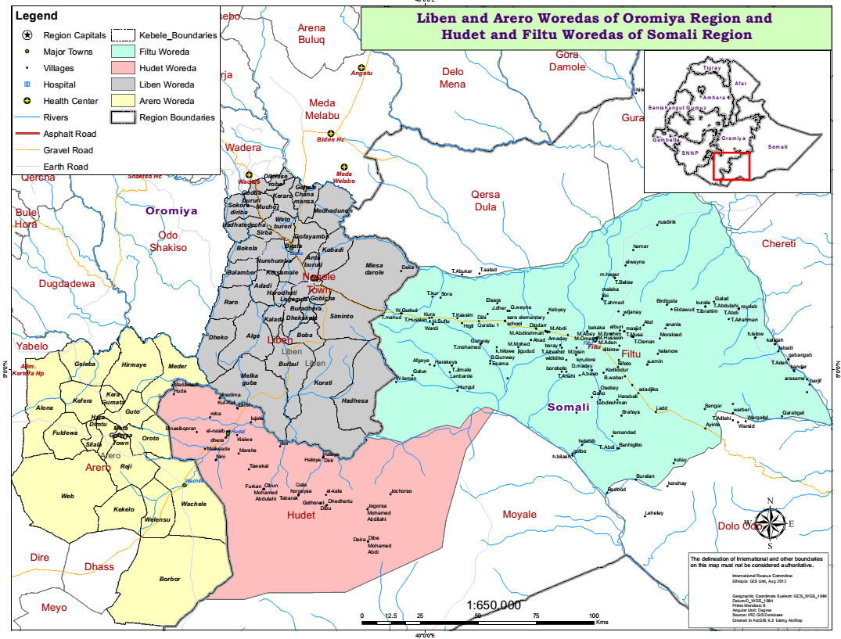
Figure 1: Project invention area including Arero, Liben, Gorodola, Filtu and Hudet woredas. Note that Gorodola woreda is presented as a part of Liben woreda since this woreda is only recently separated from Liben woreda.

  - Reference of applied methodology
The applied methodology is the Gold Standard Simplified Methodology for Efficient Cookstoves (February 2013).

  - Crediting period of project
The type and length of crediting period applied to this project is renewable 7 years crediting period. The start date of the crediting period is 12/10/2014 and the crediting period end date is 11/10/2021.

This Monitoring Report covers the period of 01/04/2018 to 31/03/2019.

- Implementation of project
  - Description of implemented project

Purpose of Project Activity and the description of the installed technology
The Micro-Scale Voluntary Project Activity GS3422 “Improved cook stoves in pastoral and agro-pastoral communities in Southern Ethiopia” involves the distribution domestic fuel-efficient cookstoves to households within the project area located in Oromia and Somali Regional States in Southern Ethiopia. The goal of the project is to improve energy efficiency as well as the conditions of the local population. At the same, the project will reduce CO₂ emission by the reduced fuel use for cooking activities.

The cookstove model distributed in the project is Tikikil Rocket Stove (figure 2). This stove model is tailored and optimized for local cooking requirements and it can accommodate the Ethiopia’s most commonly used pot types. The fuel used by the stove is firewood. The design of the stove ensures efficient combustion leading to fuel wood usage reduction up to 50% of compared to the traditional three stone fires and average thermal efficiency of 27%. The Tikikil stoves also emit less smoke compared to the traditional cooking methods. The technical specifications of the model are shown in the table below (table 2).

Table 2: Technical specifications of Tikikil double skirt stove
Technical specification | Tikikil duble skirt stove
Stove Type | Portable rocket stove
Production materials | Inner clay liner for the combustion chamber clad with galvanized sheet metal on the outside
Dimensions | Skirt diameter 29 cm and 33 cm  Height 36 cm
Thermal efficiency | 27%⁴
Average lifespan | Up to 5 years

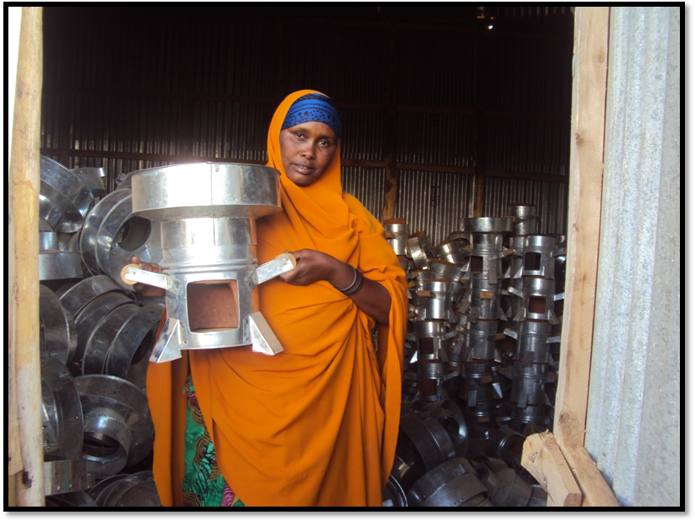
Figure 2: Tikikil Rocket Stove production in Filtu (Photo: COOPI)

Implementation status

The project started in October 2014 when the first project stoves were distributed to the local families and totally 4,955 stoves are included in this project.

The fourth monitoring period covers a period from 01/04/2018 to 31/03/2019 (12 months). The activities in the field for this monitoring period were implemented during March and April 2019. Below table presents a summary of the project phases to date.

Timing | Date | Task/Event
October 2014 | 11/10/2014 | Project start date (Stove distribution start date)
October 2014 | 12/10/2014 | Project crediting period start date
November 2014 | 03/11/2014 | Project listed with GS
October 2015 | 10/10/2015 | Stove distribution completed
December 2015 | 05/12/2015 | Project registered with GS
February – March 2016 | 17/02 – 19/03/2016 | 1st Usage survey
March 2017 | 24/03/2017 | 1st issuance with GS  (covering 12/10/2014 to 31/03/2016)
May – June 2017 | 15/05 – 14/06/2017 | 2nd Usage survey
March 2018 | 23/03/2018 | 2nd issuance with GS  (covering 01/04/2016 to 31/03/2017)
April – May 2018 | 03/04 – 16/05/2018 | 3rd Usage survey
July 2018 | 09/07/2018 | Submission to GS for transition to GS4GG and for the 3rd verification
November 2018 | 07/11/2018 | Transition to GS4GG accepted by GS
March – April 2019 | 04/03 – 20/04/2019 | 4th Usage Survey
July 2019 | 30/07/2019 | 3rd issuance with GS (covering 01/04/2017 to 31/03/2018)

In accordance with the implementation plan, the stoves have been sold to the families at a subsided cost, in exchange for the rights to the Voluntary Emission Reductions (VERs). With the signature of the “Carbon Transfer Contract” at the moment they have bought the stove, the users have entered into an agreement with the project implementer, transferring rights to the VERs generated by the VPA in return for the subsided payment of the stove.

The local workers implementing the stove distribution were trained by COOPI to fill the “Carbon Transfer Forms (CTF)” in a correct and carefully manner. The data from the “Carbon Transfer Forms” have been entered into the electronic stove selling database to enable the monitoring of the stoves over the crediting period. Data collected during Monitoring Survey have also been recorded in electronic format.

  - Post-registration changes
    - Temporary deviations from Certified Key Project Information, Project Design Document, Monitoring & Reporting Plan, applied methodology or applied standardized baseline

There has been only one temporary deviation from the registered monitoring plan during this monitoring period as some areas were inaccessible due to infrastructure problems and for this reason, the starting of the monitoring activities was postponed until these problems were solved. In fact, the survey was not made during February-March 2019 as foreseen in the original Monitoring Plan but during March-April 2019. This slight delay is not expected to have any impact on the results (and in fact, the previous monitoring survey was made during April-May 2018 and thus the gap between the two monitoring periods is not longer than 12 months). Moreover, as during the previous year, a part of the interviews was made via telephone for the families who are living in the areas which are difficult to reach. Totally of 31 interviews out of 100 interviews were made via telephone.

    - Corrections
There have been no corrections.

    - Changes to start date of crediting period
There have been no changes to the start date of the crediting period during this monitoring period.

    - Permanent changes from registered monitoring plan, applied methodology or applied standardized baseline
There have been no permanent changes from the registered monitoring plan, the applied methodology during this monitoring period or standardized baseline.

    - Changes to project design of approved project
There have been no changes to project design of the registered project activity during this monitoring period.

- Description of monitoring system applied by the project
Below is presented the description of the monitoring system and its implementation during the fourth monitoring period. The monitoring of the project is made in accordance with “The Gold Standard Simplified Methodology for Efficient Cookstoves (February 2013)” and the updated “Project Monitoring Plan” validated during the project transition under Gold Standard for Global Goals.

- Sale record
The Sale Record will include the following data as required by the methodology:
- Date of sale and of installation
- Geographic area of sale
- Model/type of project cookstove(s) sold
- Name and telephone number (if available), address
- Required for all bulk purchasers, i.e. retailers
- All end users; the names and telephone numbers or names and addresses collected must be commensurate with representative sampling, i.e. the names and addresses or phone numbers (where possible) within sales records shall be large enough so that surveys can be based on representative, random selected sample.

The above information has been collected in paper format during the stove selling. The electronic Sale Record is maintained and updated continuously by the project participant, COOPI. The original hard copies and the electronic database will be stored for entire life cycle of the project.
In line with the sale record the number of stoves distributed is totally 4,955. No new stoves were sold or substituted after the last project verification.

- Project database

The project database is derived from the total sales record with project cookstoves differentiated by different project scenarios. The differentiation of the project database into sections is based on the results of the applicable monitoring studies for each project scenario, in order that emissions reduction calculations can be conducted appropriately section by section. Project database is maintained and updated by the project participant, COOPI. The data will be backed up electronically, with original documentation being stored for entire life cycle of the project.
During this monitoring period only one project scenario, installation of Tikikil stoves, has been identified.

- Ongoing Monitoring Studies
In line with the registered PDD, the ongoing monitoring studies are conducted for each project scenario annually, at least beginning one year after the project registration and on time for any request of issuance. Survey format B in Annex A of the applied methodology will be applied for carrying out the studies.
- Monitoring consist of checking of a representative sample, once every year (annually) to ensure that project cookstoves are still operating by carrying out the usage survey as per the guidelines below.
Usage survey must be conducted to estimate the drop off rates as project cookstoves may not be adopted or may be disposed off and potentially replaced again by a baseline stove. Moreover, through the usage survey it will be ensured that the possible households using in the baseline improved stoves or other fuels than firewood will be excluded from the ER calculations.
Prior to the verification, a usage survey for each cookstove age-groups is required. For example, if only cookstoves in the first year of use (age0-1) are being credited, a usage parameter must be established for age-group 0-1, through a usage survey for cookstove age 0-1. If cookstoves of age 0-1 and age 1-2 are being credited (as part of first request for issuance), usage parameters must be established for age-group 0-1 and 1-2, respectively through a usage survey. If cookstoves of age-group 0-1 and age-group 1-2 are being credited (as part of second request for issuance), usage parameter must be established for age group 1-2 only through a usage survey as the usage rate for cookstoves of age-group 0-1 can be applied from the previous issuance.
To successfully conduct a usage survey, a minimum project cookstove sample size of each age-group should be in line with the following guidelines:
    - Target population < 300: Minimum sample size 30
    - Target population 300 to 1,000: Minimum sample size 10% of group size
    - Target population > 1,000: Minimum sample size 100
- Where replacements are made, monitoring shall ensure that the efficiency of the new cookstove is similar to the appliance being replaced.
- The project must monitor the use of baseline stove in the project activity during annual surveys.
- The project must monitor the physical conditions of the cookstoves during annual surveys.

For this monitoring period 100 randomly selected project families were interviewed between 4th March 2019 and 20th April 2019. The random selection of the families was made by using the function “Random” of Microsoft Excel for extracting the stove IDs the from the Selling Database. The project partner, COOPI, carried out the questionnaire interviews mainly through face-to-face interviews by visiting the project households (61% of the interviews). 31% of interviews were made via telephone because of the infrastructural problems occurring in part of the project area. The collected data have been inserted in an electronic database file by COOPI and analysed by Carbonsink. The used questionnaire (two questions have been added to those of the previous monitoring surveys to fulfil the FAR#01 raised during the previous verification review), scanned survey forms and the collected raw data are presented in separate files, .

Below are presented the main evidences emerged by the 2019 annual survey.

- End-user profile: within the monitoring sample, each family had averagely 6.4 family members composed averagely from 34% of children, 33% of women and 34% of men (figure 3).

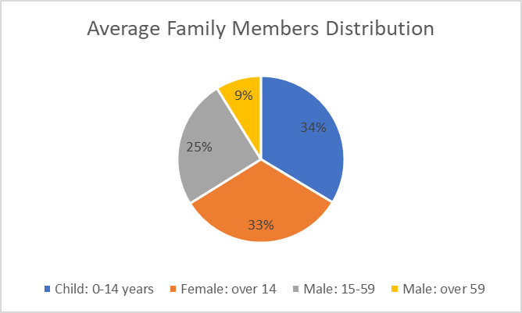
Figure 3: average family members per household

- Cooking technologies used in the baseline situation: Most families, 99% stated that they used only three stone fire in the baseline situation. The remaining 1 percent declared to have used both three stone fires and charcoal stove. No other cooking technologies were stated to have been used in baseline situation.

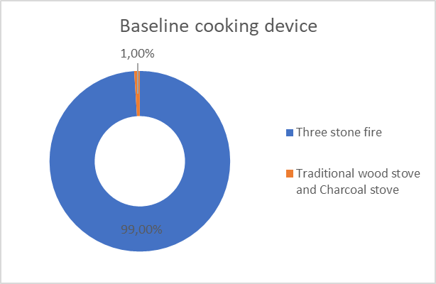
Figure 4: Principal cooking technologies used in the baseline situation

- Cooking fuels used in the baseline situation: All the households, 100 respondents out of 100, stated to have used firewood as their baseline fuel. In addition to firewood 1 household (1%), had used also charcoal (figure 5) and this is in line with the previous questions. No other fuels were mentioned as principal baseline cooking fuel.

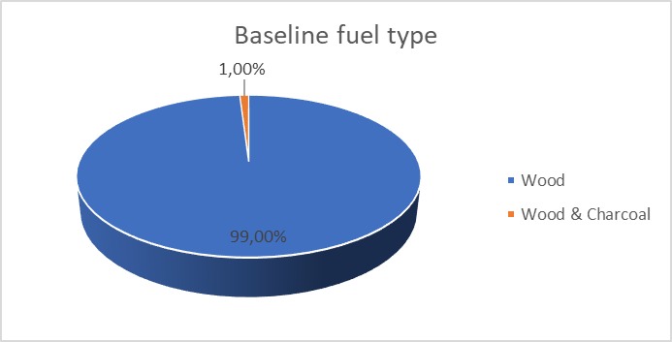
Figure 5: types of fuel used in the baseline situation

- Project stoves usage: All the households (100%) declared to use the project stoves on daily basis. However, one respondent (1%) stated that in the last week she didn’t cook with the project stove, so to be conservative in the ERs calculation, 99% was used as the usage rate. An average of 2.8 daily meals were cooked with the project stoves (figure 6).

Even though the major part of project stoves was evaluated by the user to be in good conditions (97%), some users (17% of all respondents) stated that their stoves have some small partial damages (like damages in pot stabilizer). This kind of small damages are totally in line with the current operation lifetime of the project stoves and do not hinder the proper use of the stoves and, in fact, also all of these stoves were found to be working properly and to be used by the households daily.

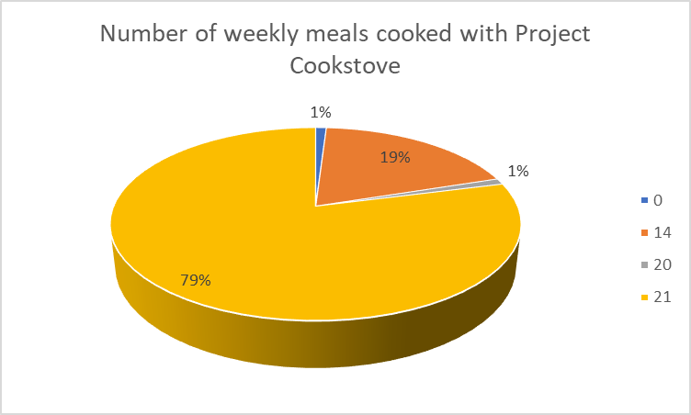
Figure 6: number of weekly meals cooked with Project stove

- Simultaneous use of additional technologies: 17% of the respondents (17 respondents out of 100) stated to use other technologies in addition to the project stoves. From these 17 respondents, just one (1% of total sample) stated used charcoal stove, while the others used firewood based methods: three stone fires (13%) or traditional wood stoves (1%) (figure 7).

In all the cases, the project stoves were used anyhow always as the primary cooking method. The total number cooked meals were estimated by the respondents to be averagely 3 meals/day/family from which averagely 93.2% were cooked with the project stoves and 6.8% with the other stoves (figure 8).

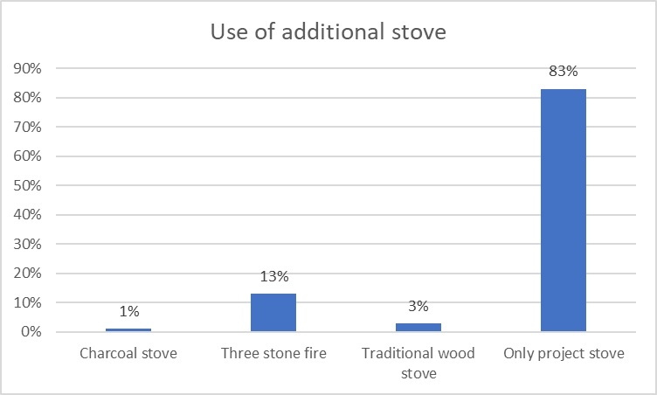
Figure 7: percentages of respondents using the additional stoves

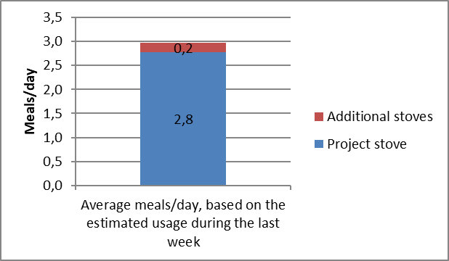

Figure 8: daily meals cooked averagely with project and additional stoves estimated based on the usage of one week

- Fuel consumption in project situation: All 100 respondents stated to use wood for cooking activities. 1 % of the respondents stated to use charcoal in addition to firewood. No any other fuels, like kerosene or LPG, were identified to be used.

All 100 respondents (100%) also estimated to consume currently less wood than before. In line with this, 100% respondents stated to spend currently less money and time for fuel collection compared to the baseline situation. At this point the interviewees were asked to describe how they use the money and the time saved thanks to the project activities.

As shown in the graphics below saved money was stated to be used by 60% of respondents for buying daily necessities like food items, fuel wood or clothes for kids and by 40% saved for later occasions. Saved time was stated instead to be used by 50% of respondents for income generating activities (like agriculture related activities or opening a new restaurant business) and by 50% for looking after kids.

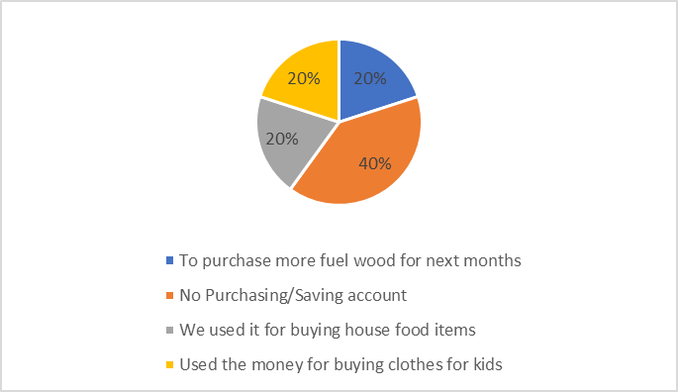
Figure 9: How do you use the saved money?

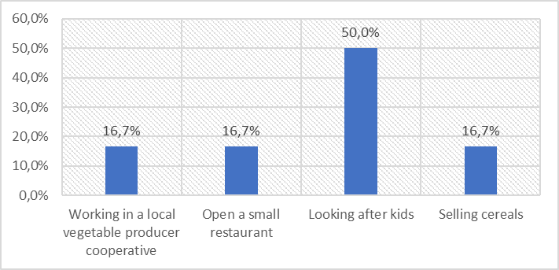
Figure 10: How do you use the saved time?

- Air quality in project situation: All 100 respondents (100%) estimated to have had less respiratory problems and itchy eyes and moreover they have noted a reduction in smoke emission after starting the usage of the project stove. No one of the respondents stated to have currently more (or even the same amount) of respiratory problems or itchy eyes as in the baseline situation.

- Discussion regarding FAR 2 (from Internal Validation process): During the Monitoring Survey totally 100 families who had bought the project stove were visited. In the same way as during the previous monitoring years during the implementation of monitoring survey observations and discussion with the families were made also to find out the cooking pot sizes used currently. Based on the monitoring it is concluded that the only efficient stove model currently in use the Tikikil model distributed by the project activity and no indications of the use of pots smaller than 24 cm were observed.

- Data and parameters
  - Data and parameters fixed ex ante or at renewal of crediting period

Relevant SDG Indicator | SDG 13
Data/parameter: | f_{NRB,i,y}
Unit | Fractional non-renewability
Description | Non-renewable status of wood fuel during year y
Source of data | Default f_{NRB} value provided by CDM Executive Board and endorsed by the host country DNA.
Value(s) applied) | 0.88
Choice of data  or measurement methods and procedures | The default NRB value provided by the CDM executive board and endorsed by the host country DNA is deemed valid by the applied methodology
Purpose of data | Calculation of project emissions or actual net GHG removals by sinks
Additional comments | The project activity may choose to update the f_{NRB} during the crediting period. The possible updates on the default country specific fraction of non- renewable woody biomass (f_{NRB}) value available on the CDM website will be controlled annually.

Relevant SDG Indicator | SDG 13
Data/parameter: | EF_{b,fuel,CO2}
Unit | tCO₂/tonne of firewood
Description | CO₂ emission factor arising from use of firewood in baseline scenario
Source of data | IPCC default value, table 1.4 of chapter 1 of Vol.2, 2006 IPCC Guidelines for National Greenhouse Gas Inventories
Value(s) applied) | 1.747
Choice of data  or measurement methods and procedures | Default value deemed valid by the applied methodology (see page 6 of the methodology)
Purpose of data | Calculation of baseline emissions or baseline net GHG removals by sinks
Additional comments | Fixed for entire crediting period

Relevant SDG Indicator | SDG 13
Data/parameter: | EF_{b,fuel,non-CO2}
Unit | tCO₂/tonne of firewood
Description | Non-CO₂ emission factor of firewood that is substituted or reduced
Source of data | IPCC default value, table 2.9 of chapter 2 of Vol.2, 2006 IPCC Guidelines for National Greenhouse Gas Inventories
Value(s) applied) | 0.455
Choice of data  or measurement methods and procedures | Default value deemed valid by the applied methodology (see page 6 of the methodology)
Purpose of data | Calculation of baseline emissions or baseline net GHG removals by sinks
Additional comments | Fixed for entire crediting period

Relevant SDG Indicator | SDG 13
Data/parameter: | ηb
Unit | Fraction
Description | Efficiency of the baseline cookstove being replaced (fraction)
Source of data | Default value of the applied methodology
Value(s) applied) | 0.10
Choice of data  or measurement methods and procedures | Default value of 10% is deemed valid by the applied methodology as the baseline stoves are three stone fires: “A default value of 10% shall be used if the replaced cookstoves is a three stone fire, or a conventional device without a grate or a chimney i.e. with no improved combustion air supply or flue gas ventilation.” (section 4.1. of the methodology)
Purpose of data | Calculation of baseline emissions or baseline net GHG removals by sinks
Additional comments | Fixed for entire crediting period

Relevant SDG Indicator | SDG 13
Data/parameter: | η_{p}
Unit | Fraction
Description | Efficiency of project cookstove (fraction) determined at the start of the project activity
Source of data | Water Boiling test (WBT)
Value(s) applied) | 0.27
Choice of data  or measurement methods and procedures | Efficiency test made in accordance with section 4.3 of the applied methodology (test conducted by independent expert, following the Water Boiling Test protocol)
Purpose of data | Calculation of project emissions or actual net GHG removals by sinks
Additional comments | Fixed for entire crediting period

Relevant SDG Indicator | SDG 13
Data/parameter: | B_{b,y}
Unit | Tonnes firewood per household per year (tons/hh/year)
Description | Quantity of firewood consumed in baseline scenario during year y
Source of data | Minimum service level in line with the 4.2 option (c) of the Section 4.2 of the applied methodology
Value(s) applied) | 2.5
Choice of data  or measurement methods and procedures | Default value baseline biomass consumption of 0.5 tons/person/year for is deemed valid by the applied methodology (see the page 6 of the methodology).  Moreover, in accordance with the methodology (page 6) the household size shall be determined by using credible references/literature or target population specific survey. The justification of the household size (5 persons/household) determination is described in registered PDD.  According the above the average annual consumption of firewood per household can be estimated to be 2.5 tons/year (0.5 tons/person/year * 5 persons/household = 2.5 tons/household/year).
Purpose of data | Calculation of project emissions or actual net GHG removals by sinks
Additional comments | Fixed for entire crediting period

  - Data and parameters monitored

Relevant SDG Indicator | SDG 13, SDG 7
Data/parameter: | U_{p,y}
Unit | Percentage
Description | Usage rate in project scenario p during year y
Measured/calculated/default | Calculated
Source of data | Annual usage survey/monitoring survey
Value(s) of monitored parameter | 0.99
Monitoring equipment | Usage survey
Measuring/reading/recording frequency: | Annually
Calculation method  (if applicable): | N/A
QA/QC procedures: | Transparent data analysis and reporting
Purpose of data: | Monitoring of SDG 13 (i.e. Calculation of project emissions or actual net GHG removals by sinks) and monitoring of SDG 7
Additional comments: | A usage parameter is derived for each age group of project cookstove being credited

Relevant SDG Indicator | SDG 13, SDG 7
Data/parameter: | N_{p,y}
Unit | Number of project cookstove credited (units)
Description | Cookstove in the project database for project scenario p through year y
Measured/calculated/default | Measured
Source of data | Sales record
Value(s) of monitored parameter | 4,707
Monitoring equipment | Stove selling database
Measuring/reading/recording frequency: | Continuous monitoring. The number of project cookstove is recorded in the total sales record.
Calculation method  (if applicable): | N/A
QA/QC procedures: | Transparent data analysis and reporting
Purpose of data: | Monitoring of SDG 13 (i.e. Calculation of project emissions or actual net GHG removals by sinks) and monitoring of SDG 7
Additional comments: | To be conservative it is estimated that only 95% of the households in the area are using firewood as their baseline fuel and thus from 4,955 distributed stoves only 95% are accounted in the Emission Reduction calculations as described more in detail in Section D.3 Thus N_{p,y} = 4,955*0.95 = 4,707

Relevant SDG Indicator | SDG 13
Data/parameter: | DF_{n}
Unit | Fraction
Description | Discount factor to account for efficiency loss of project cookstoves
Measured/calculated/default | Default
Source of data | Annual monitoring / applied methodology
Value(s) of monitored parameter | 0.99
Monitoring equipment | Monitoring survey
Measuring/reading/recording frequency: | Annual monitoring
Calculation method  (if applicable): | N/A
QA/QC procedures: | Transparent data analysis and reporting
Purpose of data: | Monitoring of SDG 13 (i.e. calculation of project emissions or actual net GHG removals by sinks)
Additional comments: | This default value can be used if stoves are found in good condition during annual surveys. For each year, the stoves of the age-group x-y should be physically verified. In the case of progressive installations, stove of age-group 0-1 shall also be physically verified each year through a random sampling approach. The survey format B (Annex A of the applied methodology) will be followed to capture the required information. Minimum number of sample size shall be selected following the guidelines provided in section 4.2, option (b) of the applied methodology.  During annual survey if it is found that the project cookstoves are not in working conditions, the proportionate population of project cookstoves should be excluded from the project database, until these cookstoves are replaced with new cookstoves.

Relevant SDG Indicator | SDG 13
Data/parameter: | DF_{b,stove,y}
Unit | Fraction
Description | Discount factor to account for the baseline stove use in project scenario p during the year y
Measured/calculated/default | Measured
Source of data | Annual monitoring
Value(s) of monitored parameter | 0.068
Monitoring equipment | Annual monitoring
Measuring/reading/recording frequency: | Annual monitoring
Calculation method  (if applicable): | N/A
QA/QC procedures: | Transparent data analysis and reporting
Purpose of data: | Monitoring of SDG 13 (i.e. calculation of project emissions or actual net GHG removals by sinks)
Additional comments: | The discount factor for baseline-stove use may be determined based on number of meals cooked using the baseline stoves. The required information shall be captured through sample-surveys carried out following a random sampling approach for each age-group of the project stove. The minimum number of samples sizes shall be selected following the guidelines provided in section 4.2, option (b) of the applied methodology. The survey format B (Annex A of the applied methodology) will be followed to capture the required information. The impact of seasonal variations on use of baseline stove should be considered as part of the monitoring survey.

Relevant SDG Indicator | SDG 1
Data/parameter: | Money spent for purchasing wood and time spent for collecting wood
Unit | -
Description | Money spent for purchasing wood and time spent for collecting wood in the project scenario in comparison with the baseline scenario estimated via qualitatively self-estimation by the families
Measured/calculated/default | Measured
Source of data | Monitoring Survey
Value(s) of monitored parameter | Less money/time spent for purchasing/collecting fuel stated by 100% of sampled households
Monitoring equipment | Monitoring Survey will study qualitatively money and time spent for firewood collection activities in the project scenario in comparison with the baseline scenario (The sample of project households are asked to evaluate if they are using less, more or the same amount of money for acquiring firewood or if they are spending less, more or same time for collecting firewood).
Measuring/reading/recording frequency: | Annually
Calculation method  (if applicable): | -
QA/QC procedures: | Trained survey team
Purpose of data: | Monitoring of SDG 1
Additional comments: | Based on the baseline survey the majority of the household in the area uses three stone fires and are thus consuming lots of firewood for their daily cooking activities. This means also that lots of time is spent and efforts made for firewood collection which reduces the available time for education and income generating activities.  In the Monitoring Survey made in 2019 all 100 respondents (100%) estimated to consume currently less wood than before. In line with this, 100% respondents stated to spend currently less money and time for fuel collection compared to the baseline situation.

Relevant SDG Indicator | SDG 1
Data/parameter: | Type of activities being done with the time and money saved through the use of the project cookstoves
Unit | -
Description | The type of the activities done with the time and money saved through the use of the project cookstoves is estimated via qualitatively self-estimation by the families
Measured/calculated/default | Measured
Source of data | Monitoring Survey
Value(s) of monitored parameter | Saved time used by 50% of respondents for income generating activities and by 50% for looking after kids.  Saved money used by 60% of respondents for buying daily necessities like food items, fuel wood or clothes for kids and by 40% saved for later occasions.
Monitoring equipment | Monitoring Survey will study qualitatively the types of the activities done with the time and money saved through the use of the project cookstoves (The sample of project households are asked firstly to evaluate if they are using less, more or the same amount of money for acquiring firewood or if they are spending less, more or same time for collecting firewood. For the families stating to use less time/money in project scenario is asked a further specification regarding the types of the activities which are done with the saved time/money).
Measuring/reading/recording frequency: | Annual
Calculation method  (if applicable): | -
QA/QC procedures: | Trained survey team
Purpose of data: | Monitoring of SDG 1
Additional comments: | Based on the baseline survey the majority of the household in the area uses three stone fires and are thus consuming lots of firewood for their daily cooking activities. This means also that lots of time is spent and efforts made for firewood collection which reduces the available time for education and income generating activities.

Relevant SDG Indicator | SDG 3
Data/parameter: | Frequency of smoke related inconveniences (like smoke levels, itchy eyes and respiratory problems)
Unit | -
Description | Frequency of smoke related inconveniences with the project families estimated via qualitatively self-estimation by the families
Measured/calculated/default | Measured
Source of data | Monitoring Survey
Value(s) of monitored parameter | Less smoke related inconveniences (like smoke levels, itchy eyes and respiratory problems) stated by 100% of sampled households
Monitoring equipment | Monitoring Survey will study qualitatively the smoke levels, itchy eyes and respiratory problems in the project scenario in comparison with the baseline scenario (The sample of project households are asked to evaluate if they experience less, more or the same amount of smoke, itchy eyes and respiratory problems as before the project).
Measuring/reading/recording frequency: | Annual
Calculation method  (if applicable): | -
QA/QC procedures: | N/A
Purpose of data: | Monitoring of SDG 3
Additional comments: | In the baseline situation large levels of smoke and TSPM are emitted by inefficient firewood combustion during the cooking with three stone fires which is causing discomfort and health problems like itchy eyes. It is not justifiable to measure this quantitatively, but it will be measured qualitatively through the experienced smoke levels, itchy eyes and respiratory problems.  In the Monitoring Survey made in 2019 all 100 respondents (100%) estimated to have had less respiratory problems and itchy eyes and moreover they have noted a reduction in smoke emission after starting the usage of the project stove. No one of the respondents stated to have currently more (or even the same amount) of respiratory problems or itchy eyes as in the baseline situation.

Relevant SDG Indicator | SDG 7
Data/parameter: | Number of project households using fuel efficient cookstove
Unit | -
Description | Number of households using the project cookstove
Measured/calculated/default | Monitored
Source of data | Project Database and Monitoring Survey
Value(s) of monitored parameter | 4,660
Monitoring equipment | -
Measuring/reading/recording frequency: | Annually
Calculation method  (if applicable): | Project Database regarding the number of project cookstoves credited and Monitoring Survey regarding the Usage Rate. Calculated as number of project cookstoves * Usage rate = Np,y * Up,y = 4,707 * 99% = 4,660
QA/QC procedures: | N/A
Purpose of data: | Monitoring of SDG 7
Additional comments: | N/A

  - Implementation of sampling plan
- Description of implemented sampling design

The sampling for this monitoring period was based on simple random sample method and it was selected within the stoves recorded in the Stove Selling Database. Totally 100 project families were interviewed in line with the applied methodology requiring a minimum sample size of 100 for the target population larger than 1,000.
It can be noted that during this monitoring period there is present only one age-vintage of the project technologies as all the project stoves have been installed within 1 year of the start of the crediting period.

- Data and parameters analysis

The values of data and parameters monitored are discussed below and summarized in the Table 3 (in the column “4th Monitoring Period”):

- Households using firewood as their baseline fuel: Based on the Usage Survey all the project families stated to have used firewood as their cooking fuel in the baseline situation, however a small part, 1% of the households, stated they use also charcoal as fuel in the baseline situation.

As the used Gold Standard methodology is applicable only for the baseline of firewood usage, 99% of the households should be eligible based on the above described results of the Usage Survey. However, in order to be more conservative, the same value of the second and third monitoring periods is applied, and thus only 95% of the sold cookstoves are accounted in the Emission Reduction calculations.

- Usage rate (U_{p,y}): 100% of the respondents use the project stoves as their main cooking technology in daily basis. However, one respondent stated that she had not cooked with the project stove in the last week, so to obtain a more conservative value, 99% was used as a Usage Rate.

- Discount factor to account for efficiency loss of project cookstoves (DF_{n}): The default value of the methodology (0.99) can be used as the monitored stoves were found all in good condition.

- Discount factor to account for the baseline stove use in project scenario (DF_{b,stove,y}): Averagely 93.2% of all the meals cooked are prepared with the project stoves, therefore, discount factor (DF_{P,stove,y}) for this monitoring period is set as 6.8%.

Table 3: Summary of the values used for the emission reduction calculations. The column “4th Monitoring Period” is including the values used calculating the ER referred in this Monitoring Report. The values regarding the previous Monitoring Periods are showed here only for comparison.
 | 1st Monitoring Period | 2nd Monitoring Period | 3rd Monitoring Period | 4th Monitoring Period
Households using firewood as their baseline fuel | 96% | 95% | 95% | 95%
Usage rate (U_{p,y}) | 96%* | 100% | 100% | 99%
Discount factor to account for efficiency loss of project cookstoves (DF_{n}) | 0.99 | 0.99 | 0.99 | 0.99
Discount factor to account for the baseline stove use in project scenario (DF_{b,stove,y}) | 3% | 7.5% | 1.9% | 6.8%
*In the 1st monitoring period 100% of the families were found to use daily the project stove but conservatively (based on the unclarities in the stove ID numbers indicated the monitoring database) the usage rate was set as 96%.

- Demonstration on whether the required confidence/precision has been met

As the monitoring is made through Survey of local usage (Option b of the section 4.2. of the applied methodology) there is no need to determine confidence/precision level.

- Calculation of SDG outcomes
  - Calculation of baseline value or estimation of baseline situation of each SDG outcome

Calculations related to the SDG 13
See the Section E.3. and E.4. below. The complete ER calculations of the regarding the SDG 13 are provided in a separate Excel Spreadsheet uploaded to Sustaincert.

Calculations related to the SDG 1
No specific calculation method used for the baseline value, the estimation of baseline situation is made based on the Baseline Survey.

- Based on the baseline survey most of the household in the area use three stone fires and are thus consuming lots of firewood for their daily cooking activities. This means also that lots of time is spent and efforts made for firewood collection which reduces the available time for education and income generating activities.

Calculations related to the SDG 3
No specific calculation method used for the baseline value, the estimation of baseline situation is made based on the Baseline Survey.

- In the baseline situation large levels of smoke and TSPM are emitted by inefficient firewood combustion during the cooking with three stone fires which are associated with discomfort and health problems like itchy eyes.

Calculations related to the SDG 7
No specific calculation method used for the baseline value, but estimation of baseline situation is made based on the Baseline Survey.

- Based on the baseline survey most of the household in the area use three stone fires and no fuel efficient cookstoves are in use in the area.

  - Calculation of project value or estimation of project situation of each SDG outcome

Calculations related to the SDG 13
See the Section E.3. and E.4. below. The complete ER calculations of the regarding the SDG 13 outcomes are provided in a separate Excel Spreadsheet uploaded to Sustaincert.

Calculations related to the SDG 1
The monitoring of SDG 1 is made through a qualitative auto-evaluation of the sample families during the annual monitoring survey and thus no specific calculation method used for calculating the SDG 1 outcomes:

- Monitoring Survey studies qualitatively money and time spent for firewood collection activities in the project scenario in comparison with the baseline scenario. The sample of project households were asked to evaluate if they are using less, more or the same amount of money for acquiring firewood or if they are spending less, more or same time for collecting firewood.

Calculations related to the SDG 3
The monitoring of SDG 3 is made through a qualitative auto-evaluation of the sample families during the annual monitoring survey and thus no specific calculation method used for calculating the SDG 3 outcomes:

- Monitoring Survey studies qualitatively the smoke levels, itchy eyes and respiratory problems in the project scenario in comparison with the baseline scenario. The sample of project households were asked to evaluate if they experience less, more or the same amount of smoke, itchy eyes and respiratory problems as before the project.

Calculations related to the SDG 7
The number of households using the project cookstove is estimated based on the Project Database on the distributed stoves and Monitoring Survey regarding the Usage Rate. Calculated as number of project cookstove credited (units)* Usage rate rate in project scenario p during year y = N_{p,y} * U_{p,y}.

  - Calculation of net benefits as difference of baseline and project values or direct calculation for each SDG outcome

Calculations related to the SDG 13

The outcomes of the SDG 13 are measured as reduced CO₂e emissions applying “The Gold Standard Simplified Methodology for Efficient Cookstoves (February 2013)”. Below are described the equations on which the methodology is based. The complete ER calculations of the regarding the SDG 13 are provided in a separate Excel Spreadsheet uploaded to Sustaincert. The values used for each parameter are indicated in the above sections D.1 and D.2.

The emission reductions are calculated with the following equation:

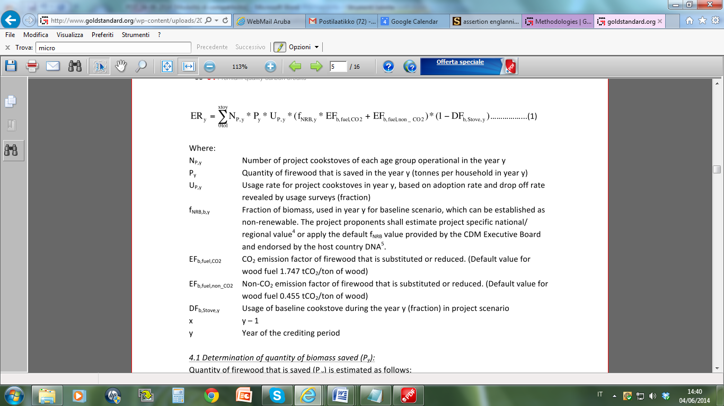

Where:
N_{P,y} Number of project cookstoves of each age group operational in the year y
P_{y} Quantity of firewood that is saved in the year y (tonnes per household in year y)
U_{P,y} Usage rate for project cookstoves in year y, based on adoption rate and drop off rate
revealed by usage survey (fraction)
f_{NRB,b,y} Fraction of biomass, used in year y for baseline scenario, which can be established as non renewable. The project proponents shall estimate project specific national/regional value or apply the default f_{NRB} value provided by CDM Executive Board and endorsed by the host country DNA.
EF_{b,fuel,CO2} CO₂ emission factor of firewood that is substituted or reduced. (Default value for wood fuel 1.747 tCO₂/ton of wood)
EF_{b,fuel,non_CO2} Non-CO₂ emission factor of firewood that is substituted or reduced. (Default value for wood fuel 0.455 tCO₂/ton of wood)
DF_{b,Stove,y} Discount factor to account for the baseline stove use in project scenario p during the year y
y Year of the crediting period

Determination of quantity of biomass saved (P_{y})
Quantity of firewood that is saved (P_{y}) is estimated as follows:

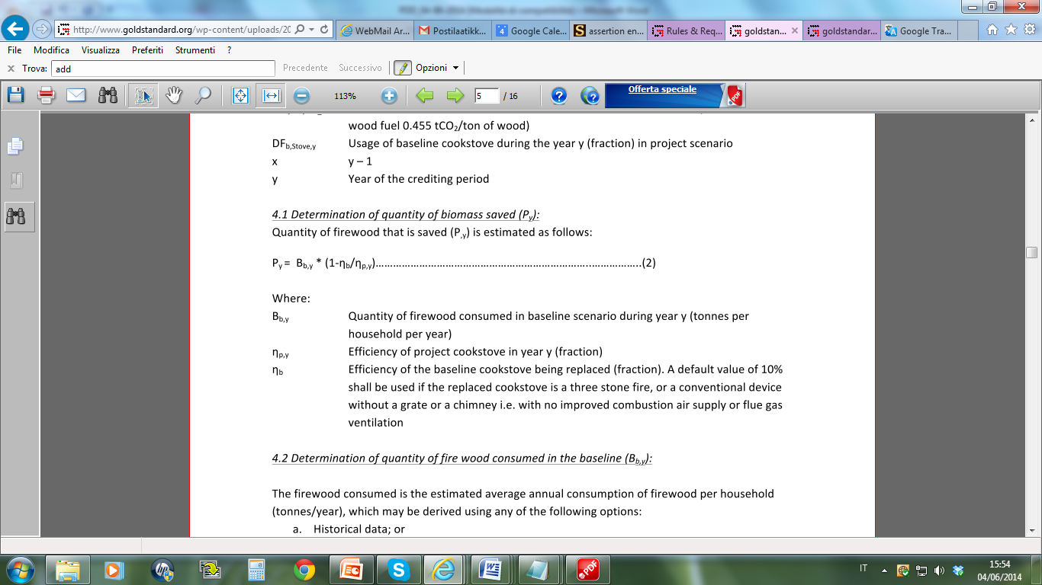

B_{b,y} Quantity of firewood consumed in baseline scenario during year y
ɳ_{b} Efficiency of the baseline cookstove being replaced (fraction). A default value of 10% shall be used if the replaced cookstoves is a three stone fire, or a conventional device without a grate or a chimney i.e. with no improved combustion air supply or flue gas ventilation
ɳ_{p,y} Efficiency of project cookstove in year y (fraction)

Determination of quantity of firewood consumed in the baseline (B_{b,y})
The quantity of firewood consumed in the baseline is determined based on the estimated average annual consumption of firewood per household (tones/year). For this purpose, the option (c) “Minimum service level” (0.5 tons per capita per year) of the applied methodology is chosen as described in the registered PDD. In accordance with the methodology, the household size shall be determined in this case by using credible references/literature or target population specific survey.

As described in the registered PDD and according to the data of Ethiopia’s Central Statistical Agency (CSA), the mean households size in Ethiopia, in 2012, was 5.0 persons/household in rural and 3.0 persons/household in urban areas. For estimating the baseline wood consumption in the project area, it is chosen conservatively to use the national mean household size of rural areas (5.0 persons/household). This can be considered conservative choice in respect to the results of the Baseline Survey (included 587 households), according to which the majority of the families (64%) living in the project area are having 6 or more family members and according to the national average fertility rate of 4.6 live births per woman in 2010-2015 as per UN Data.
According to the above, the average annual consumption of firewood per household can be estimated to be 2.5 tons/year (0.5 tons/person/year * 5 persons/household = 2.5 tons/household/year).

Determination of project cookstove efficiency (ɳ_{p,y} and ɳ_{p})
Efficiency of project cookstoves in year y (ɳ_{p,y}) is estimated as follows:

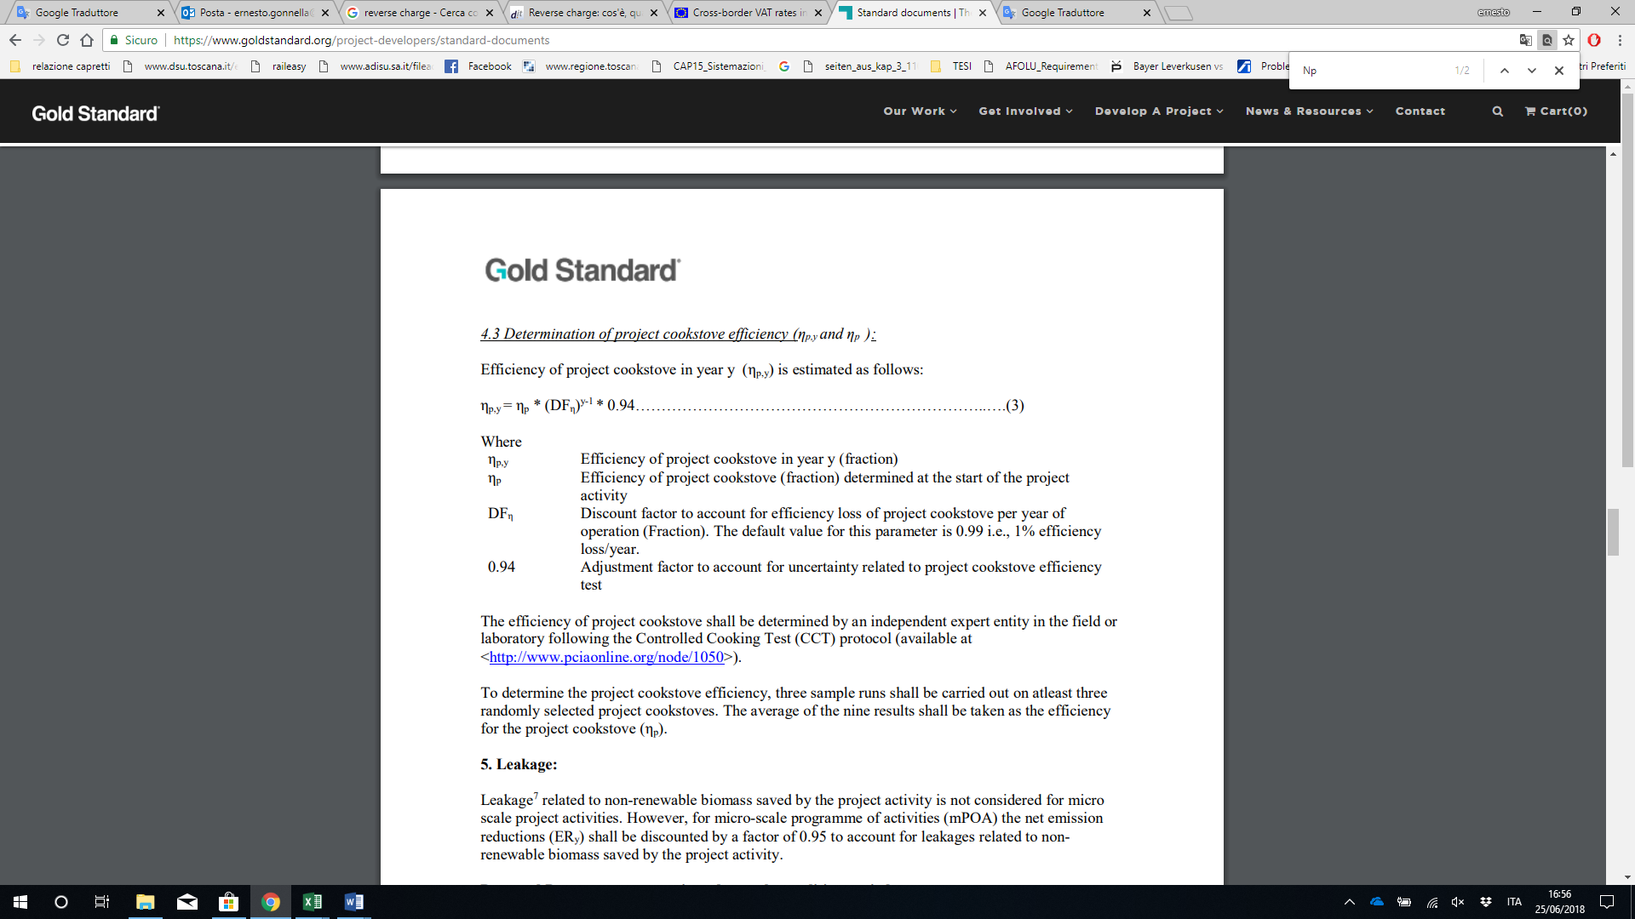

ɳ_{p,y} Efficiency of project cookstove in year y (fraction)
ɳ_{p} Efficiency of project cookstove (fraction) determined at the start of the project activity
DF_{ɳ} Discount factor to account for efficiency loss of project cookstove per year of operation (Fraction). The default value for this parameter is 0.99 i.e. 1% efficiency loss/year
0.94 Adjustment factor to account for uncertainty related to project cookstove efficiency test

In accordance with the applied methodology, the efficiency of the project cookstove is determined by an independent expert or entity, in the field or laboratory, following the Water Boiling Test (WBT) protocol (available at http://www.pciaonline.org/node/1048). As described in registered PDD, the project cookstove efficiency was carried out by independent entity, GIZ, who performed the efficiency test in laboratory in accordance with the above described requirements.

In line with the applied methodology and the registered PDD, the option to make the efficiency test at the time of installation and to use the default factor for determining the efficiency for the latter is chosen to be used.

Calculation of leakage
In accordance with the applied methodology leakage related to non-renewable biomass saved by the project activity is not considered as the proposed project is a stand-alone micro-scale project activity.

Calculations related to the SDG 1

As discussed in the above section E.2, the monitoring of SDG 1 is made through a qualitative auto-evaluation of the sample families during the annual monitoring survey and thus no specific calculations are not made for the determining the SDG 1 outcomes.

Calculations related to the SDG 3

As discussed in the above section E.2, the monitoring of SDG 3 is made through a qualitative auto-evaluation of the sample families during the annual monitoring survey and thus no specific calculations are not made for the determining the SDG 3 outcomes.

Calculations related to the SDG 7

Number of project households using fuel efficient cookstove
N_{p,y} * U_{p,y} = 4,707 * 99% = 4,660

  - Summary of ex-post values of each SDG outcome for the current monitoring period

SDG 13 Outcomes

- Item | Baseline estimate | Project estimate | Net benefit
- SDG 13  - 2018  - (01/04/2018-31/12/2018) | 17,181 tCO₂e | 7,766 tCO₂e | 6,724 tCO₂e
- SDG 13  - 2019  - (01/01/2019-31/03/2019) | 5,623 tCO₂e | 2,563 tCO₂e | 3,060 tCO₂e
- Total | 22,804 tCO₂e | 10,328 tCO₂e | 9,784 tCO₂e

SDG 1 Outcomes

Type of activities being done with the time and money saved through the use of the project cookstoves

- Saved time used by 50% of respondents for income generating activities and by 50% for looking after kids.
- Saved money used by 60% of respondents for buying daily necessities like food items, fuel, wood or clothes for kids and by 40% saved for later occasions.

Money spent for purchasing wood and time spent for collecting wood
- Less money/time spent for purchasing/collecting fuel stated by 100% of sampled households

SDG 3 Outcomes

Frequency of smoke related inconveniences (like smoke levels, itchy eyes and respiratory problems)
- Less smoke related inconveniences (like smoke levels, itchy eyes and respiratory problems) stated by 100% of sampled households

SDG 7 Outcomes

Number of project households using fuel efficient cookstove
- 4,660

  - Comparison of actual value of outcomes with estimates in approved PDD
Item | Values estimated in ex ante calculation of approved PDD | Actual values achieved during this monitoring period
- SDG 13  - 2017  - (01/04/2018-31/12/2018) | 7,261 tCO₂e | 6,724²³ tCO₂e
- SDG 13  - 2018  - (01/01/2019-31/03/2019) | 2,360 tCO₂e | 3,060 tCO₂e
- Total | 9,621 tCO₂e | 9,784 tCO₂e

  - Remarks on difference from estimated value in approved PDD
The estimated value calculated ex ante and presented in the registered PDD is different from the actual value calculated for this Monitoring Period mainly due to following aspects:

First of all, in the ex ante estimations the number of the distributed stoves were estimated to be in totally 5,090. The real number of the distributed stoves was instead 4,955 from which only 95% (corresponding 4,707 stoves) has been considered within the Emission reduction calculations to be conservative as described in Section D.3 above.

Moreover, the values of used for Usage Rate (U_{p,y}) and Discount factor to account for the baseline stove use in project scenario (DF_{b,Stove,y}) have been updated for the ex post calculations based on the monitoring results; in ex ante estimations the Usage rate for the first four project years was estimated to be conservatively only 80%, instead, based on the current monitoring the Usage rate was 99%. The discount factor to account for the baseline stove use was instead estimated ex-ante to be 20% while the current monitoring survey confirmed it to be currently 6.8 %.

- Stakeholder inputs and legal disputes

  - List all inputs/grievances which have been received for the project during the monitoring period together with their respective answers/actions

During this Monitoring Period no inputs/grievances were received.
  - List all inputs/grievances from previous monitoring period where follow up action is to be verified in this monitoring period

During the previous monitoring period no inputs/grievances were received.
  - Provide details of any legal contest or dispute that has arisen with the project during the monitoring period

No dispute or legal problems occurred in the project during this monitoring period.

BAGER SAFE ENVIRONMENT FOR HEALTH SERVICES PLC, 2012 (uploaded to GS registry during 1st verification)
To be conservative it is estimated that only 95% of the households in the area are using firewood as their baseline fuel and thus from 4,955 distributed stoves only 95% (corresponding 4,707 stoves) are accounted in the Emission Reduction calculations as described more in detail in Section D.3
Note. From 9,784 tCO2e is composed of totally 6,724 of vintage 2018 ERs and 3,060 of vintage 2019 ERs. Annual ERs are capped as 10,000 VERs for each project year as showed in the ER calculation spreadsheet (see the cell N6).
The Water Boiling Test results (“WBT sample 1-3”) provided to Gold Standard during the validation process.
Deutsch Gesellschaft für Internationale Zusammenarbeit (GIZ) GmbH, 2011. Available at https://energypedia.info/images/2/2c/GIZ_HERA_2012_Tikikil_Stove_ET.pdf (site visited 22/05/2014)
The durability test forecasts the Tikikil stove lifetime to be from 2 to 5 years. Eco-Energy Options Pty Ltd, 2011: Durability Testing of the Tikikil Stove as provided to Gold Standard during the validation process.
To be conservative it is estimated that only 95% of the households in the area are using firewood as their baseline fuel and thus from 4,955 distributed stoves only 95% (corresponding 4,707 stoves) are accounted in the Emission Reduction calculations as described more in detail in Section D.3..
Example of Carbon Transfer Contract 11-10-2014 (uploaded to GS registry during 1st verification)
No modifications to the Stove Selling Database since the last verification. Please refer the Excel file “GS3422_Stove Selling Database ver02 and Sample 2019” uploaded to Sustaincert
GS3422_4th Monitoring Raw Data and Analysis (2019) has been uploaded to Sustaincert
Note: The monitoring activities for the second monitoring period were implemented in the field during May and June 2017
As not all the project families do have their one telephones, the telephone interviews were organized during the weekly market/praying days (in Weiyb kebelle, Kulay, Diriri and Hudet town) using the mobile phones of the local contact persons working as kebelle managers, IGA owners or other local experts. All the interviewed families were pre-selected randomly by the project developer and reached beforehand by the local contact person who agreed the data and time for the fore coming telephone interview.
Please refer to Stove Selling Database ver02 has been already uploaded to GS Registry (note: no changes from the previous verifications). To be conservative it is estimated that only 95% of the households in the area are using firewood as their baseline fuel and thus from 4,955 distributed stoves only 95% (corresponding 4,707 stoves) are accounted in the Emission Reduction calculations as described more in detail in Section D.3
Please refer the file “GS3422_Stove Selling Database_ver02 and Sample 2019” uploaded to Sustaincert
“GS3422_Monitoring Questionnaire 2019” has been uploaded to Sustaincert
“GS3422_4th Monitoring Raw Data and Analysis (2019)” and “GS3422_Examples of Filled Monitoring Forms (2019)”
To be conservative it is estimated that only 95% of the households in the area are using firewood as their baseline fuel and thus from 4,955 distributed stoves only 95% (corresponding 4,707 stoves) are accounted in the Emission Reduction calculations as described more in detail in Section D.3
This is in line with the FAR#01 (The parameter “Type of activities being done with the time and money saved through the use of the project cookstoves” shall be monitored and reported before the next verification.”) raised during the previous verification.
Available at http://cdm.unfccc.int/DNA/fNRB/index.html (Site visited 03/07/2018)
The Water Boiling Test results (“WBT sample 1-3”) provided to Gold Standard during the validation
This parameter has been monitored starting from the current monitoring year (01/04/2018-31/03/2019). This parameter was, in fact, not included in the original monitoring plan accepted at the time of VPA inclusion but added only at the time of transition of the VPA to GS4GGs (transition was accepted in November 2018, in other words, only after the monitoring activities made after that are including this parameter.)
Stove Selling Database ver02 has been uploaded to GS Registry (note: no changes from the 1st and 2nd verification)
To be conservative it is estimated that only 95% of the households in the area are using firewood as their baseline fuel and thus from 4,955 distributed stoves only 95% (corresponding 4,707 stoves) are accounted in the Emission Reduction calculations as described more in detail in Section D.3.
In line with the Transition Annex of this VPA accepted in November 2018, in future the Monitoring Survey will moreover study qualitatively the types of the activities done with the time and money saved through the use of the project cookstoves (The sample of project households are asked firstly to evaluate if they are using less, more or the same amount of money for acquiring firewood or if they are spending less, more or same time for collecting firewood. For the families stating to use less time/money in project scenario is asked a further specification regarding the types of the activities which are done with the saved time/money).
As reported in “Population Stabilisation Report, Ethiopia” published in March 2014 provided to Gold Standard during the validation process
BAGER SAFE ENVIRONMENT FOR HEALTH SERVICES PLC, 2012. A Baseline Report on the assessment of the social and technical acceptability of Fuel Saving Stove (FSS) in Filtu and Liben Woreda.
http://data.un.org/CountryProfile.aspx?crName=Ethiopia (site visited 24/03/2015)
The value has been capped to remain within the micro-scale limit of 10,000 tCO₂e during the year 2018
The approved PDD estimated the annual ERs for the period of 365 days starting from 12th of October each year. To convert these estimations to the period of 365 days starting from 1st of April each year the following simplified procedure has been used: The amount of ERs estimated ex-ante for the monitoring period of 365 days have been divided firstly with 365 days for achieving the corresponding daily ER estimation. This value has been then multiplied with 275 days for achieving the estimation for the period 01/04/2018 – 31/12/2018 (9,637 tC02e/yr : 365 days * 275 days = 7,261 tC02e) and with 90 days for achieving the estimation for the period 01/01/2019 – 31/03/2019 (9,570 tC02e/yr : 365 days * 90 days = 2,360 tC02e).
To be conservative it is estimated that only 95% of the households in the area are using firewood as their baseline fuel and thus from 4,955 distributed stoves only 95% (corresponding 4,707 stoves) are accounted in the Emission Reduction calculations as described more in detail in Section D.3

