Monitoring Report

PUBLICATION DATE 14.10.2020
VERSION v. 1.1
RELATED SUPPORT – TEMPLATE GUIDE Monitoring Report v. 1.1

This document contains the following Sections
Key Project Information
SECTION A - Description of project
SECTION B - Implementation of project
SECTION C - Description of monitoring system applied by the project
SECTION D - Data and parameters
SECTION E - Calculation of SDG Impacts
SECTION F - Safeguards Reporting
SECTION G - Stakeholder inputs and legal disputes

KEY PROJECT INFORMATION

Programme of Activity Information – (delete below table if N/A)
GS ID of Programme | GS1247
Title of Programme | GS1247 Improved Kitchen Regimes Multi-Country PoA
Version of POA-DD applicable to this monitoring report | 15.3
Name and GS ID of fully Validated CPA/VPAs (i.e. non compliance check) | GS1247 VPA 159 Improved Kitchen Regimes Manica Province Safe Water (Mozambique) (GS7132)  GS1247 VPA 160 Improved Kitchen Regimes Manica Province Safe Water (Mozambique) (GS7133)  GS1247 VPA 161 Improved Kitchen Regimes Manica Province Safe Water (Mozambique) (GS7134)  GS1247 VPA 162 Improved Kitchen Regimes Manica Province Safe Water (Mozambique) (GS7135)  GS1247 VPA 163 Improved Kitchen Regimes Manica Province Safe Water (Mozambique) (GS7136)  GS1247 VPA 198 Improved Kitchen Regimes Manica Province Safe Water (Mozambique) (GS7470)  GS1247 VPA 199 Improved Kitchen Regimes Manica Province Safe Water (Mozambique) (GS7471)  GS1247 VPA 200 Improved Kitchen Regimes Manica Province Safe Water (Mozambique) (GS7472)  GS1247 VPA 201 Improved Kitchen Regimes Manica Province Safe Water (Mozambique) (GS7473)  GS1247 VPA 202 Improved Kitchen Regimes Manica Province Safe Water (Mozambique) (GS7474)

Key Project Information
GS ID (s) of Project (s) | GS 7132  GS 7133  GS 7134  GS 7135  GS 7136  GS 7470  GS 7471  GS 7472  GS 7473  GS 7474
Title of the project (s) covered by monitoring report | GS1247 VPA 159 Improved Kitchen Regimes Manica Province Safe Water (Mozambique) (GS7132)  GS1247 VPA 160 Improved Kitchen Regimes Manica Province Safe Water (Mozambique) (GS7133)  GS1247 VPA 161 Improved Kitchen Regimes Manica Province Safe Water (Mozambique) (GS7134)  GS1247 VPA 162 Improved Kitchen Regimes Manica Province Safe Water (Mozambique) (GS7135)  GS1247 VPA 163 Improved Kitchen Regimes Manica Province Safe Water (Mozambique) (GS7136)  GS1247 VPA 198 Improved Kitchen Regimes Manica Province Safe Water (Mozambique) (GS7470)  GS1247 VPA 199 Improved Kitchen Regimes Manica Province Safe Water (Mozambique) (GS7471)  GS1247 VPA 200 Improved Kitchen Regimes Manica Province Safe Water (Mozambique) (GS7472)  GS1247 VPA 201 Improved Kitchen Regimes Manica Province Safe Water (Mozambique) (GS7473)  GS1247 VPA 202 Improved Kitchen Regimes Manica Province Safe Water (Mozambique) (GS7474)
Version number of the PDD/VPA-DD (s) applicable to this monitoring report | GS 7132: Version 5  GS 7133: Version 5  GS 7134: Version 5  GS 7135: Version 5  GS 7136: Version 5  GS 7470: Version 3  GS 7471: Version 3  GS 7472: Version 3  GS 7473: Version 3  GS 7474: Version 3
Version number of the monitoring report | Version 4
Completion date of the monitoring report | 15/06/2023
Date of project design certification | 04/12/2019
Date of Last Annual Report | 20/03/2021
Monitoring period number | MP3
Duration of this monitoring period | All VPAs: 01/07/2021 – 30/06/2022
Project Representative | Serena Coccioli, CO2balance UK Ltd  Matthew Pike, CO2balance UK Ltd
Host Country | Republic of Mozambique
Activity Requirements applied | Community Services Activities  Renewable Energy Activities  Land Use and Forestry Activities/Risks & Capacities  N/A
Methodology (ies) applied and version number | TPDDTEC v.1
Product Requirements applied | GHG Emissions Reduction & Sequestration  Renewable Energy Label  N/A

Table 1 - Sustainable Development Contributions Achieved
Sustainable Development Goals Targeted | SDG Impact | Amount Achieved |  | Units/ Products
SDG 3 Good Health and Well-being | Additional people consuming safe water | GS 7132  GS 7133  GS 7134  GS 7135  GS 7136  GS 7470  GS 7471  GS 7472  GS 7473  GS 7474 | 6063  6353  5817  6136  6574  6034  6649  6408  7121  6808 | Number of people
SDG 5 Gender Equality | Variation of time spent on firewood and water collection | GS 7132  GS 7133  GS 7134  GS 7135  GS 7136  GS 7470  GS 7471  GS 7472  GS 7473  GS 7474 | 1.44  1.44  1.44  1.44  1.44  1.44  1.44  1.44  1.44  1.44 | Hours
SDG 6 Clean Water and Sanitation | People gain access to safe water | GS 7132  GS 7133  GS 7134  GS 7135  GS 7136  GS 7470  GS 7471  GS 7472  GS 7473  GS 7474 | 8861  9285  8502  8968  9609  8819  9718  9366  10407  9951 | Number of People
SDG 13 Climate Action | Emissions Reduction | GS 7132  GS 7133  GS 7134  GS 7135  GS 7136  GS 7470  GS 7471  GS 7472  GS 7473  GS 7474 | 7377  7312  8308  5423  5060  4934  4786  4795  4542  4801 | tCO2e

Table 2 – Product Vintages
GS7132
 |  | Amount Achieved
Start Dates | End Dates | VERs
01/07/2021 | 31/12/2021 | 2522
01/01/2022 | 30/06/2022 | 4855

GS7133
 |  | Amount Achieved
Start Dates | End Dates | VERs
01/07/2021 | 31/12/2021 | 2363
01/01/2022 | 30/06/2022 | 4949

GS7134
 |  | Amount Achieved
Start Dates | End Dates | VERs
01/07/2021 | 31/12/2021 | 3774
01/01/2022 | 30/06/2022 | 4534

GS7135
 |  | Amount Achieved
Start Dates | End Dates | VERs
01/07/2021 | 31/12/2021 | 1665
01/01/2022 | 30/06/2022 | 3758

GS7136
 |  | Amount Achieved
Start Dates | End Dates | VERs
01/07/2021 | 31/12/2021 | 1489
01/01/2022 | 30/06/2022 | 3571

GS7470
 |  | Amount Achieved
Start Dates | End Dates | VERs
01/07/2021 | 31/12/2021 | 1539
01/01/2022 | 30/06/2022 | 3395

GS7471
 |  | Amount Achieved
Start Dates | End Dates | VERs
01/07/2021 | 31/12/2021 | 1574
01/01/2022 | 30/06/2022 | 3212

GS7472
 |  | Amount Achieved
Start Dates | End Dates | VERs
01/07/2021 | 31/12/2021 | 1520
01/01/2022 | 30/06/2022 | 3275

GS7473
 |  | Amount Achieved
Start Dates | End Dates | VERs
01/07/2021 | 31/12/2021 | 1398
01/01/2022 | 30/06/2022 | 3144

GS7474
 |  | Amount Achieved
Start Dates | End Dates | VERs
01/07/2021 | 31/12/2021 | 1645
01/01/2022 | 30/06/2022 | 3156

- DESCRIPTION OF PROJECT
  - General description of project
>> The Micro-Scale VPA Manica Province Safe Water project is eligible under the Gold Standard methodology Technologies and Practices to Displace Decentralized Thermal Energy Consumption Version 1.0. The project will support the provision of safe water using borehole technology to hundreds of households within Manica Province, Mozambique. By providing safe water, the project will ensure that households consume less firewood during the process of water purification and as a result there shall be a reduction of carbon dioxide emissions from the combustion process.

Manica Province is a largely rural province where local people typically use wood fuel on inefficient three stone fires to purify their drinking, cleaning and washing water. This process results in the release of greenhouse gas emissions from the combustion of wood - this can be avoided if a technology that does not require fuel (wood or fossil) supplies clean water desired by households.

Many existing boreholes were established by community groups or community based organizations (CBOs) and have fallen into disrepair because maintenance programmes have been poorly managed, or proven too expensive. CO2balance will be working in partnership with British NGO, Village Water, that operate in Manica Province. CO2balance and Village Water will work with a local NGO and communities in Manica Province to identify communities in need of a safe water source, where boreholes will be installed; and identify broken down boreholes which will be rehabilitated, so that communities have reliable access to clean, safe water. The capacity of communities to maintain their boreholes will also be supported through the project to ensure that the water keeps flowing. The boreholes included under the project will be powered entirely by emission-free technologies such as hand or solar-powered pumps. The depth of the boreholes will be limited to 100m or less.

CO2balance and Village Water rehabilitated the boreholes and deliver the maintenance programme for all the boreholes included in the project activity to ensure that the quality of the water delivered by the boreholes is fit for human consumption for the entire length of the project, which will be a minimum of five years.

This project will be developed under the Gold Standard carbon credit body, which in addition to checking that the carbon credits from this project are real, also measures local social, environmental and economic impact.

The date of rehabilitation was confirmed by a Repair Confirmation Form which was signed by the mechanic carrying out the repair along with a village administrator from the local community. The date of rehabilitation was used as the start date of operation and crediting for each borehole; we have conservatively assumed that the first day of crediting is not counted.

The number of days each borehole credited for in this monitoring period was multiplied by the number of people using the borehole to give the total number of project technology days for that borehole. The individual project technology days for each borehole were totaled to give the total number of project technology days for this monitoring period.

  - Location of project
Below are details of the physical location to allow unique identification of the project. The Manica Province is marked in red in Figure 1 below. The target area and the fuel collection area are defined as being contained within the project boundary, with the outer limits of the project boundary being clearly defined below. As the majority of beneficiaries collect their wood fuel locally in close proximity to their homesteads, the wood fuel collection area and target area are considered the same.

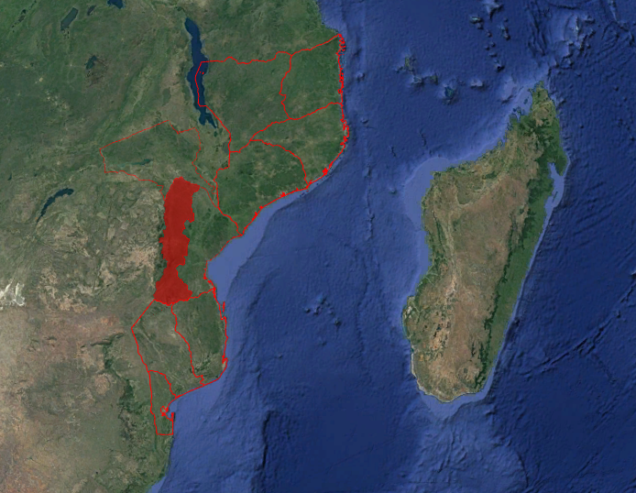
Figure 1 Project area - Manica Province, Mozambique (Google Earth image).
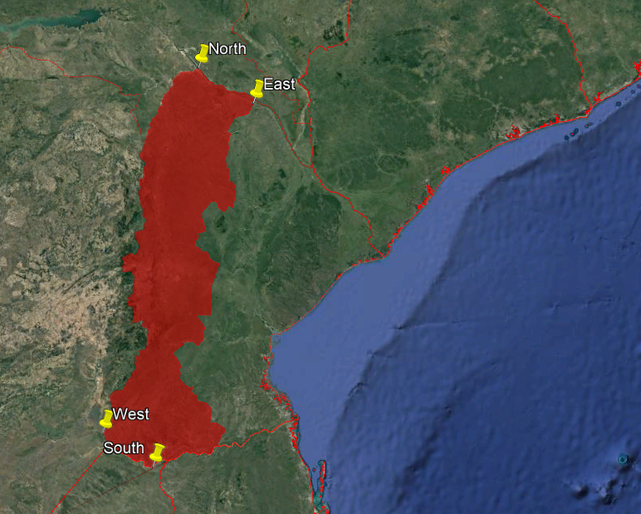
Figure 2 The northern, eastern, southern and western boundaries of the project area pinned in yellow.

All villages are within the project boundary shown in Figures 1 and 2 above. The table below shows the extent with latitude and longitude coordinates.

Project Area Coordinates
 | Latitude | Longitude
North | 16°23'7.12"S | 33°47'4.90"E
South | 21°35'9.51"S | 33° 4'3.46"E
East | 16°51'59.19"S | 34°32'5.72"E
West | 21° 8'12.18"S | 32°22'0.32"E

In total 240 boreholes were rehabilitated as part of this project between 09/04/2019 and 13/04/2022. The type of pump used for all boreholes rehabilitated is Afridev. The date, location and number of people served by each borehole are included in the project database that is shared during verification.

  - Reference of applied methodology
>> This project utilises the Gold Standard Methodology ‘Technologies and Practices to Displace Decentralized Thermal Energy Consumption v1’.
  - Crediting period of project
>> The date of rehabilitation was used as the start date of operation. It was conservatively assumed that the first day of crediting is not counted and the crediting period begins the following day after the borehole is rehabilitated. The length of the crediting period is 5 years as per the approved PDD.
The start dates for the projects, and crediting periods, are as follows:

Project ID | Crediting Period Start Date | Crediting Period End Date
7132 | 19/06/2019 | 19/06/2024
7133 | 01/10/2019 | 01/10/2024
7134 | 15/05/2019 | 15/05/2024
7135 | 10/04/2019 | 10/04/2024
7136 | 29/08/2019 | 29/08/2024
7470 | 31/05/2019 | 31/05/2024
7471 | 31/05/2019 | 31/05/2024
7472 | 14/06/2019 | 14/06/2024
7473 | 10/09/2019 | 10/09/2024
7474 | 18/09/2019 | 18/09/2024

- IMPLEMENTATION OF PROJECT
  - Description of implemented project
CO2balance and Village Water have rehabilitated 240 boreholes as part of these VPAs. The boreholes are in working order but a few of them went through some technical problems and didn't produce safe water while they were not functional; the non-functional days have been discounted from the ERs.

Hand pump specifications:

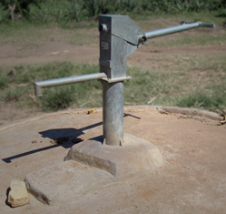
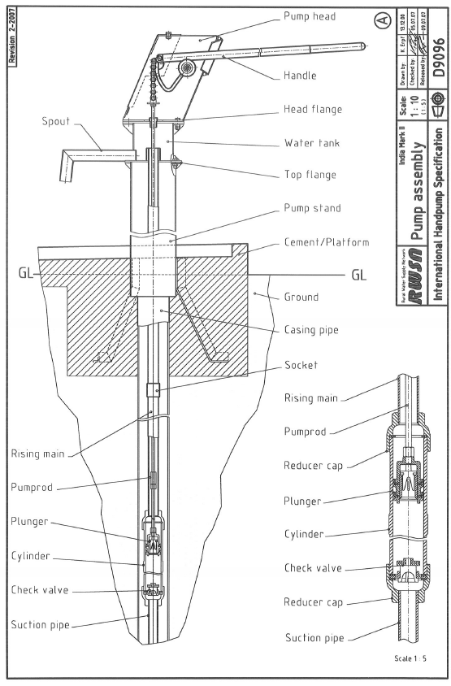
Examples of the Afridev Handpump and India Mark II

Technical Specifications:
 | Afridev | India Mark II
Cylinder Diameter (mm) | 50 | 63.5
Maximum Stroke (mm) | 225 | 125
Approx. discharge at about 75 watt input (m3/h) | At 10m head 1.4 | at 10 m head 1.8
 | At 15 m head 1.1 | at 15 m head 1.3
 | At 20m head 0.9 | at 20 m head 1.0
 | At 30m head 0.7 | at 30 m head 0.8
Pumping Lift (m) | 10-45 | 10-50
Water Consumption (litres per capita) | 15-20 | 15-20

Borehole Functionality

Village Water (CO2balance in-country project partner) are the main contact for all water point committees which exist for every borehole. If there are any problems with borehole functionality, the water resource committee will contact Village Water to inform them:

For major repairs, Community Water committee reports the problem to the local partner, who contacts the technicians; the technicians visit the site and conduct a technical assessment and repairs if possible, if they need extra materials they arrange for a time to revisit and carry out the maintenance. When the cause of the pump malfunction is a major problem and a technician is needed, the maintenance forms are signed by the technician, by a member of the Water Committee and by a representative of the project.

If the breakdown is minor, the community looks after the repair themselves: a local pump minder will assess the problem and get the parts. The costs are covered with the fees paid by the members of the community. The community informs the local partner stating the problem, the non-functional days and the details of the repairs done, and should report the work and cost In the log-books. When the cause of breakdown is minor and the community enacts the repair, the form is signed by a representative of the project as the community usually informs our local partner of the problem and parts repaired via phone.

Village Water inform CO2balance when the borehole is not functional. The non-functional days are then discounted in the PTDs and the ERs are not accredited for those days.

A full breakdown of all boreholes that underwent any maintenance during this MP has been supplied in the accompanying Emissions Reductions spreadsheet under the specified maintenance section. This details all works required, carried out, date from reported first break down to repair as well as whether the repair was carried out by the community or project partner/technician. An additional down day has been added to all total non-functional days per repair for added conservativeness.

Water Quality Testing
All boreholes undergo annual water quality testing to ensure the water is safe for human consumption as per Mozambique national water standards.

Feedback Mechanisms
Grievance log-books are placed at boreholes and any feedback received during this monitoring period from the borehole users on damage or breaking of boreholes through telephone and verbal reports will be reported. The feedback/grievance mechanisms were discussed during the LSC so that all relevant stakeholders are aware of the processes in place for reporting any issues.

    - Forward Action Requests
MP3:
No FARs were raised during the last Monitoring Period reviews.
  - Post-Design Certification changes
>> N/A
    - Temporary deviations from the approved Monitoring & Reporting Plan, methodology or standardized baseline
>>
A deviation request was submitted regarding the annual monitoring conducted earlier in the monitoring period for MP3 only.

The PD is requested to:
a. apply conservative assumptions or discount factors to address the gap (if any) in monitoring to the extent and wherever required, to ensure that GHG emission reductions/SDG impacts will not be overestimated
b. document the deviation request, its implications, and GS’ decision in the appropriate section of the GS Monitoring Report (for the relevant MP)

The approved deviation is temporary in nature and only applies for the monitoring period starting from 01/07/2021 and ending on 30/06/2022.

The deviation is described and substantiated below:

MP2 covered the dates between 01/07/2020 and 30/06/2021. During this time, the annual monitoring was carried out by the partner in March, the first day being 04/03/2021. The annual monitoring was, therefore, within the 6 months from end of the monitoring period. However, during MP3, 01/07/2021 to 30/06/2022, the annual monitoring was carried out in September and October. The project and usage surveys were conducted between 16/09/2021 and 05/10/2021 and the WCFT was conducted between 15/09/2021 and 24/09/2021. The project and usage surveys, as well as the WCFT were not within the 6 months to the end of the monitoring period and instead closer to the start of MP3.

We are confident that the earlier annual monitoring in MP3 would not negatively impact the project and may be considered an acceptable deviation considering the steps we are taking, described below. Furthermore, it will allow for capturing of monitoring data during a different season from what had been the norm, allowing us to consider seasonal variation in the project.

- The partner has continued to carry out regular maintenance and WQTs as per the methodology requirements throughout 2022.
- The partner is continually carrying out remote follow-ups across the villages.
- There is a continuous grievance mechanism – the partner ensures that the project is still providing safe water regardless of when the project and usage surveys, and WCFTs were conducted.
    - All breakdowns are recorded, maintenance and re-repairs are carried out on a regular basis as and when needed, ensuring that communities are able to access safe water throughout the project even during the rainy season when access to communities for monitoring has been impacted.Corrections
>> N/A
    - Changes to start date of crediting period
>> N/A
    - Permanent changes from the Design Certified monitoring plan, applied methodology or applied standardized baseline
>> These VPAs transitioned to GS4GG. The Monitoring Plan was therefore updated from including Sustainable Development Indicators to monitoring impacts and contributions towards the Sustainable Development Goals as per the approved Transition Annex.
The Wp,y and Wb,y value has changed for this monitoring period and will remain as a
permanent change. Previous monitoring periods used a measured baseline value
obtained from the Baseline Water Boiling Test. However, the recent update to the
parameters means a cap has now been introduced which has been applied to this
project for this monitoring period- considering the firewood required to boil 1 litre of
water for 10 minutes using a three stone fire (0.4 kg/L).
Updates have been made to parameter EF (Non-CO2 CH4 and N2O emission factor arising from use of wood fuel in baseline scenario), as the new rule update came into force on 01/01/2021, both 2021 and 20222 vintages have been calculated with the updated AR5 value in the corresponding parameter box.
    - Changes to project design of approved project
>> N/A

- DESCRIPTION OF MONITORING SYSTEM APPLIED BY THE PROJECT
All surveys are administered by trained CO2balance staff and in country partner NGO, Village Water, that employs local staff and conversant in the local dialects to ensure that the responses are consistent and not biased by any regional language barriers. Each participant is provided with a briefing on the purpose of the survey and is assured that no individual names are used in the analysis.

The Project and Usage Survey are deployed via mobile devices, where all the answers are securely stored online. The results of the surveys are then downloaded and collated in Excel spreadsheets and stored on a central server in an electronic format.

The Water Consumption Field Test (WCFT) survey is carried out on paper and all the original copies are retained in the office and are scanned upon request of the UK team. The results of the surveys are collated in Excel spreadsheets and stored on a central server in an electronic format. These are then sent to the UK head office for data analysis. The documentation procedure that CO2balance has devised ensures a minimum chance of original data being lost and data entry error.

Below is a summary of the key information that has been collected and monitored as part of this project;

Borehole database

The borehole installation/rehabilitation record includes the following information:
- Date of installation/rehabilitation
- Model of the borehole
- Quantity of boreholes installed
- The total number of people obtaining their water from each borehole
- Mode of use: commercial/domestic

The installation record will be backed up electronically, with original documentation being stored in the appropriate office for the respective VPAs.

The project database will be derived from the Installation Record, with project technologies differentiated by different project scenarios (if required).

All data collected in relation to the project will be held in the local office and/or on the Project Database for the entire life cycle of the project and a period of 2 years afterwards. The data may be archived during the project in order to maintain clarity and security

Ongoing Monitoring Studies
The following ongoing monitoring studies were conducted; the results are given in the parameter boxes tables

- Water Consumption Field Test (WCFT): The Water Consumption Field Test was carried out on a randomly selected sample of 40 households from the project database in Manica province. This complies with the recommended minimum sample size of 30 in the Gold Standard requirements.

The test was carried out over a period of four days (1 day preparation and 3 days measurement) following a similar method as the Kitchen Performance Test, and all tests were conducted between 15/09/2021 – 29/09/2021. The total litres of water consumed each day was measured and divided by the number of people consuming water in that day – this measurement was repeated over 3 consecutive days and an overall average per household was calculated. The results showed that on average 8.15 litres of non boiled clean water used only for drinking, hand washing and food preparation (capped at 7.5l) and 0 litres of boiled clean water is consumed per person per day.

The total amount of water credited for in this monitoring period is equal to the average amount of clean non-boiled water consumed per person per day (7.5l), minus the average amount of boiled clean water consumed per person per day (0).
The WCFT is carried out by staff trained by CO2balance to meet the specific requirements of the methodology. All data presented in Excel is subject to checking and cross referencing of a sample of the raw data by CO2balance.

- Water Quality Test (WQT): The quality of the treated water will be assessed to ensure that it is fit for human consumption. It is assessed in accordance with Mozambique national standards. The parameters used to assess the water quality will be in line with Mozambique standards for potable water and all parameters will be shown to be within levels considered acceptable for domestic human consumption.

- Usage Survey: Usage Survey is used to determine the Up,y (usage rate in the project scenario p through year y) parameter. The annual usage survey is conducted, exceeding the minimum sample size of 100 as 110 surveys were carried out. During this monitoring period the Usage Survey was conducted between 16/09/2021 – 05/10/2021 and found a usage rate of 100%, which has been capped at 95%.
The updated and approved Usage Survey also captures average litres collected from the borehole per household across seasons- used to gain an average litres per user figure.

- Project Survey – Conducted annually to survey end users currently using project technologies in order to explore changes in project scenario over time. The annual project survey is conducted, exceeding the minimum sample size of 100 as 110 surveys were carried out. Individual participants were selected from the borehole user data base using the random sampling process outlined in the monitoring plan. Sample sizes are in line with the Gold Standard requirements. During this monitoring period the Project Survey was conducted between 16/09/2021 – 05/10/2021. Data collected during the project surveys explores the following characteristics:

  - General information – Name, address, telephone number etc
  - Household socio-demographic information
  - Water use and purification characteristics
  - Sources and availability of fuel
  - Time use and time saved information
  - Hygiene and Sanitation practices In the Household

- Project Technology Days (Np,y)- Number of persons consuming water supplied by project scenario p through year y. Sum of the total number of people using each borehole in the project multiplied by the number of crediting days each borehole earns in this monitoring period. The total number of households using each borehole will be determined through information supplied by our partner. Using this method, the total number of people using each borehole will be known, and hence a figure for person days can be calculated. All monitoring tasks will be selected at random. The following caps are applied:
  - 95% functionality in the monitoring period.
  - Treatment Capacity. Calculations to cap people served, capped at 300 users on this occasion, by each borehole can be found in corresponding emissions reductions calculation spreadsheets.

Individual participants were selected from the borehole user data base using the random sampling process outlined in the monitoring plan. Sample sizes are in line with the Gold Standard requirements.

Double Counting
To avoid double counting during the monitoring period the project has not been included in any other voluntary or compliance standards programmes, and dual certification has not been sought. As the project area contains multiple VPAs double counting has further been avoided through the unique identification of each water point along with GPS coordinates.

fNRB
Below is described the method used to develop the fraction of non-renewable biomass (fNRB) for Mozambique in line with the Annex 1 section A.1.3 of the TPDDTEC v.1. The source of data is the Global Forest Resources Assessment Reports for the years 2015 and 2020 from FAO.

As the Carbon Living biomass related to forest shows a decrease from 2015 to 2020, the following condition is observed: (a) Survey results, national or local statistics, studies, maps or other sources of information such as remote sensing data show that carbon stocks are depleting in the project area thus the approach described in the Annex 1 section A.1.3 of the TPDDTEC v.1 is applicable.

a. fNRB = NRB / (NRB + DRB)
86% = 100,152,498/ (100,152,498+ 16,262,285)

where:
fNRB = Fraction of non-renewable biomass in the country (%)
NRB = Quantity of non-renewable biomass in the country (t/yr)
DRB = Demonstrably Quantity of renewable biomass in the country (t/yr). The approach satisfies the following condition regarding DRB:

Condition 1 - The woody biomass is originating from land areas that are forests
where:
(a) The land area remains a forest; and
(b) Sustainable management practices are undertaken on these land areas to ensure, in particular, that the level of carbon stocks on these land areas does not systematically decrease over time (carbon stocks may temporarily decrease due to harvesting); and
(c) Any national or regional forestry and nature conservation regulations are complied with.

b. NRB = R - DRB
100,152,498= 116,414,783 - 16,262,285

And

c. R = MAI + ΔF
116,414,783= 85,759,936 + 30,654,847

And

d. MAI = F * GR
85,759,936 = 36,743,760 * 2.33

Where:
R = Total annual biomass removals in the country (t/yr)
MAI = Mean Annual Increment of biomass growth (t/yr)
ΔF = Annual change in living forest biomass (t/yr)
F = Extent of forest (ha)
GR = Annual Growth rate of biomass (t/ha-yr)

e. DRB = PA * GR
16,262,285 = 6,967,560 * 2.33

Where:
PA = Protected Area Extent of Forest (ha)

- DATA AND PARAMETERS
  - Data and parameters fixed ex ante or at renewal of crediting period
>>
Relevant SDG Indicator | SDG 13.B.1 (Climate Action)
Data/parameter: | EF_{b,co2}
Unit | tco₂/TJ
Description | co₂ emission factor arising from use of fuels in baseline scenario
Source of data | IPCC default value, EFDB Emission Factor Database. Accessible: https://www.ipcc-nggip.iges.or.jp/EFDB/main.php
Value(s) applied) | 112
Choice of data  or measurement methods and procedures | Deemed valid by Methodology.
Purpose of data | Calculation of baseline emissions.
Additional comments | -

Relevant SDG Indicator | SDG 13.B.1 (Climate Action)
Data/parameter: | EF_{b,non co2}
Unit | tCO₂e/TJ
Description | Non-CO2 (CH4 and N2O) emission factor arising from use of wood fuel in baseline scenario
Source of data | IPCC Default emissions factor, EFDB Emission Factor Database. Accessible: https://www.ipcc-nggip.iges.or.jp/EFDB/main.php
Value(s) applied) | 9.460
Choice of data  or measurement methods and procedures | Deemed valid by Methodology
  Gas | Default Emissions factor (kg_gas/TJ_{NCV}) | GWP of gas | Default Emissions factor (kg_CO₂e/TJ_{NCV}) | Default Emissions factor (t_CO₂e/TJ_{NCV})
  CH₄ | 300 | 28 | 8,400 | 8.4000
  N₂O | 4 | 265 | 1,060 | 1.060
   |  |  | Total | 9.460
Purpose of data | Calculation of emission reductions.
Additional comments | AR5 values applied to 2021 and 2022 vintage for this MP.

Relevant SDG Indicator | SDG 13.B.1 (Climate Action)
Data/parameter: | EF_{p,co2}
Unit | tCO₂/TJ
Description | CO₂ emission factor arising from use of wood fuel in project scenario
Source of data | Volume 2: 2006 IPCC Guidelines for National Greenhouse Gas Inventories, Chapter 2, Table 2.5
Value(s) applied) | 112
Choice of data  or measurement methods and procedures | Deemed valid by Methodology.
Purpose of data | Calculation of emission reductions.
Additional comments | -

Relevant SDG Indicator | SDG 13.B.1 (Climate Action)
Data/parameter: | EF_{p,non co2}
Unit | tCO₂e/TJ
Description | Non-CO2 (CH4 and N2O) emission factor arising from use of wood fuel in project scenario
Source of data | IPCC Default emissions factor, EFDB Emission Factor Database. Accessible: https://www.ipcc-nggip.iges.or.jp/EFDB/main.php
Value(s) applied) | 9.460
Choice of data  or measurement methods and procedures | Deemed valid by Methodology
  Gas | Default Emissions factor (kg_gas/TJ_{NCV}) | GWP of gas | Default Emissions factor (kg_CO₂e/TJ_{NCV}) | Default Emissions factor (t_CO₂e/TJ_{NCV})
  CH₄ | 300 | 28 | 8,400 | 8.4000
  N₂O | 4 | 265 | 1,060 | 1.060
   |  |  | Total | 9.460
Purpose of data | Calculation of emission reductions.
Additional comments | -

Relevant SDG Indicator | SDG 13.B.1 (Climate Action)
Data/parameter: | NCV_{b}
Unit | TJ/ton
Description | Net calorific value of the wood fuel used in the baseline
Source of data | https://www.ipcc-nggip.iges.or.jp/public/2006gl/pdf/2_Volume2/V2_1_Ch1_Introduction.pdf (Table 1.2)
Value(s) applied) | 0.0156
Choice of data  or measurement methods and procedures | Deemed valid by Methodology.
Purpose of data | Calculation of emission reductions.
Additional comments | -

Relevant SDG Indicator | SDG 13.B.1 (Climate Action)
Data/parameter: | NCV_{p}
Unit | TJ/ton
Description | Net calorific value of the wood fuel used in the project
Source of data | https://www.ipcc-nggip.iges.or.jp/public/2006gl/pdf/2_Volume2/V2_1_Ch1_Introduction.pdf  (Table 1.2)
Value(s) applied) | 0.0156
Choice of data  or measurement methods and procedures | Deemed valid by Methodology.
Purpose of data | Calculation of emission reductions.
Additional comments | -

Relevant SDG Indicator | SDG 13.B.1 (Climate Action), SDG 3.9.2 (Good Health and Well-Being)
Data/parameter: | W_{b,y}
Unit | T/litre
Description | Quantity of wood fuel that is used to treat 1 litre of water in the baseline scenario b during year y
Source of data | Default Value  GS Rule Update: Application of TPDDTEC Methodology to Safe Water Supply Projects (section 2.1.2)
Value(s) applied) | 0.0004
Choice of data  or measurement methods and procedures | The baseline water boiling test is used to determine the amount of wood used to purify 1 litre of water by boiling. This data is gathered according to: Technologies and Practices to Displace Decentralized Thermal Energy Consumption Version 1, Draft General Guidelines On Sampling And Surveys; EB37 Annex 27; and Standard For Sampling And Surveys For CDM Project Activities and Programme of Activities (Version 02); EB65 Annex 2
Purpose of data | Calculation of emission reductions and impact on SDG 3.
Additional comments

Relevant SDG Indicator | SDG 13.B.1 (Climate Action), SDG 3.9.2 (Good Health and Well-Being)
Data/parameter: | W_{p,y}
Unit | T/litre
Description | Quantity of wood fuel that is used to treat 1 litre of water in the project scenario p during year y
Source of data | Default Value GS Rule Update: Application of TPDDTEC Methodology to Safe Water Supply Projects (section 2.1.2)
Value(s) applied) | 0.0004
Choice of data  or measurement methods and procedures | The baseline water boiling test is used to determine the amount of wood used to purify 1 litre of water by boiling. This data is gathered according to: Technologies and Practices to Displace Decentralized Thermal Energy Consumption Version 1, Draft General Guidelines On Sampling And Surveys; EB37 Annex 27; and Standard For Sampling And Surveys For CDM Project Activities and Programme of Activities (Version 02); EB65 Annex 2
Purpose of data | Calculation of emission reductions.
Additional comments

Relevant SDG Indicator | SDG 13.B.1 (Climate Action), SDG 6.1.1 (Clean Water and Sanitation)
Data/parameter: | Cj
Unit | Percentage
Description | Portion of users of project safe water supply who were already in baseline using a non-boiling safe water supply.
Source of data | Baseline study.
Value(s) applied) | 0.79%
Choice of data  or measurement methods and procedures | The portion of safe water users is determined though the baseline project survey and refers to the number of users that already use safe water from water sources such as boreholes. Deemed valid by Methodology.
Purpose of data | Calculation of emission reductions and SDG 6 impact.
Additional comments | -

Relevant SDG Indicator | SDG 13.B.1 (Climate Action)
Data/parameter: | Xboil Non-Suppressed Demand
Unit | Percentage
Description | Percentage of premises that in the absence of the project activity would have used non-GHG emitting technologies like chlorine treatment techniques (if available) in the project boundary.
Source of data | Baseline study. Credible literature, studies, survey, reports, relevant to the project target area
Value(s) applied) | 14.29%
Choice of data  or measurement methods and procedures | Suppressed demand will be determined through a set of questions in the project survey that establish the method households use to purify their water, if any, and how they would choose to purify if they were not subject to monetary and access barriers. This is in line with the Gold Standard principles of suppressed demand outline in annex 2. A fixed suppressed demand baseline has been opted for, however, in the event the project surveys show a substantial change in fuel use characteristics, a new baseline shall be conducted.
Purpose of data | Calculation of emission reductions.
Additional comments | -

Relevant SDG Indicator | SDG 5.4.1 (Gender Equality)
Data/parameter: | T_{b,y}
Unit | Hours
Description | Time spent collecting firewood per household per day prior to project
Source of data | Baseline survey
Value(s) applied) | 3.67
Choice of data  or measurement methods and procedures | Measured by question in the baseline survey.
Purpose of data | Calculating time saved collecting water by project.
Additional comments | -

  - Data and parameters monitored
>>
Relevant SDG Indicator | SDG 13.B.1 (Climate Action)
Data/parameter: | fNRB,i,y
Unit | Fractional non-renewability
Description | Non-renewability status of woody biomass fuel in scenario i during year y
Measured/calculated/default | N/A
Source of data | The data used for the assessment are obtained from the "Global Forest Resources Assessment Reports" for the years 2015 and 2020 from FAO. http://www.fao.org/forest-resources-assessment/past-assessments/fra-2015/country-reports/en/  http://www.fao.org/forest-resources-assessment/fra-2020/country-reports/en/
Value(s) of monitored parameter | 0.86
Monitoring equipment | Desk study
Measuring/reading/recording frequency: | Ongoing
Calculation method  (if applicable): | fNRB = NRB / (NRB + DRB)  86% = 100,152,498/ (100,152,498 + 16,262,285)  where:  fNRB = Fraction of non-renewable biomass in the country (%)  NRB = Quantity of non-renewable biomass in the country (t/yr)  DRB = Demonstrably Quantity of renewable biomass in the country (t/yr). The approach satisfies the following condition regarding DRB:
QA/QC procedures: | The fNRB assessment has been done in line with Annex 1 section A.1.3 of the TPDDTEC v.1. both condition 1 (p.31) and a (p.31) are satisfied.
Purpose of data: | Calculation of emission reductions.
Additional comments: | -

Relevant SDG Indicator | SDG 13.B.1 (Climate Action)
Data/parameter: | N_{p,y}
Unit | Project Technology Days
Description | Number of persons consuming water supplied by project scenario p through year y
Measured/calculated/default | N/A
Source of data | Borehole Project Database
Value(s) of monitored parameter | GS7132 – 1,845,180  Down Days: 33  GS7133 – 1,829,130  Down Days: 90  GS7134 –2,077,935  Down Days: 12  GS7135 – 1,356,344  Down Days: 61  GS7136 – 1,265,604  Down Days: 32  GS7470 – 1,234,487  Down Days: 44  GS7471 – 1,197,328  Down Days: 5  GS7472 – 1,199,636  Down Days: 8  GS7473 – 1,135,820  Down Days: 9  GS7474 – 1,201,061  Down Days: 40
Monitoring equipment | Project Database
Measuring/reading/recording frequency: | Annual
Calculation method  (if applicable): | Sum of the total number of people using each borehole in the project multiplied by the number of days crediting each borehole earns in a given monitoring period.  A 95% functionality cap is implemented on all BHs claiming functionality above this figure to be conservative.  Where below 95% functionality is present, the true value is used to calculate the Project Technology Days.  PTDs are also further capped as a result of a 300 user cap during this MP.
QA/QC procedures: | N/A
Purpose of data: | Calculation of emission reductions.
Additional comments: | -

Relevant SDG Indicator | SDG 13.B.1 (Climate Action), SDG 6.1.1 (Clean Water and Sanitation)
Data/parameter: | U_{p,y}
Unit | Percentage
Description | Usage rate in project scenario p through year y
Measured/calculated/default | N/A
Source of data | Usage Survey
Value(s) of monitored parameter | 100% (capped at 95%)
Monitoring equipment | Usage Survey
Measuring/reading/recording frequency: | Annual
Calculation method  (if applicable): | The usage survey has been carried out by trained local staff to meet the specific requirements of the methodology. All data presented in excel is subject to checking and cross referencing of a sample of the raw data by CO2balance UK Ltd.
QA/QC procedures: | N/A
Purpose of data: | Calculation of usage.
Additional comments: | -

Relevant SDG Indicator | SDG 13.B.1 (Climate Action), SDG 3.9.2 (Good Health and Well-Being)
Data/parameter: | Q_{p,y}
Unit | Litres per person per day
Description | Quantity of safe water supplied in the project scenario p during the year y using the zero or low emissions clean water supply technology
Measured/calculated/default | 7.5
Source of data | Water Consumption Field Test (WCFT)
Value(s) of monitored parameter | 8.15 (capped at 7.5)
Monitoring equipment | WCFT Survey
Measuring/reading/recording frequency: | Biennial
Calculation method  (if applicable): | Method used similar to Kitchen Performance Test in which the volume of water consumed in each household is averaged over 3 days. Volume is capped at 7.5 litres per person per day as per the methodology. The WCFT will be carried out by trained local staff to meet the specific requirements of the methodology. All data presented in excel is subject to checking and cross referencing of a sample of the raw data by CO2balance UK Ltd.
QA/QC procedures: | N/A
Purpose of data: | Calculation of emission reductions.
Additional comments:

Relevant SDG Indicator | SDG 13.B.1 (Climate Action), SDG 3.9.2 (Good Health and Well-Being)
Data/parameter: | Q_{p,cleanboil,y}
Unit | Litres per person per day
Description | Quantity of safe water boiled in the project scenario p during the year y using the zero or low emissions clean water supply technology
Measured/calculated/default | N/A
Source of data | Water Consumption Field Test (WCFT)
Value(s) of monitored parameter | 0
Monitoring equipment | WCFT Survey
Measuring/reading/recording frequency: | Biennial
Calculation method  (if applicable): | Method used similar to Kitchen Performance Test in which the volume of water consumed in each household is averaged over 3 days. The WCFT has been carried out by trained local staff to meet the specific requirements of the methodology. All data presented in excel is subject to checking and cross referencing of a sample of the raw data by CO2balance UK Ltd.
QA/QC procedures: | N/A
Purpose of data: | Calculation of emission reductions.
Additional comments:

Relevant SDG Indicator | SDG 13.B.1 (Climate Action)
Data/parameter: | Q_{p,rawboil, y}
Unit | Litres per person per day
Description | The raw of unsafe water that is still boiled after installation of the water treatment technology
Measured/calculated/default | N/A
Source of data | Water Consumption Field Test (WCFT)
Value(s) of monitored parameter | 0
Monitoring equipment | WCFT Survey
Measuring/reading/recording frequency: | Biennial
Calculation method  (if applicable): | Method used similar to Kitchen Performance Test in which the volume of water consumed in each household is averaged over 3 days. The WCFT has been carried out by trained local staff to meet the specific requirements of the methodology. All data presented in excel is subject to checking and cross referencing of a sample of the raw data by CO2balance UK Ltd.
QA/QC procedures: | N/A
Purpose of data: | Calculation of emission reductions.
Additional comments:

Relevant SDG Indicator | SDG 6.1.1 (Clean Water and Sanitation)
Data/parameter: | Quality of Treated Water
Unit | Parameters as per national standards:
Description | Performance of the treatment technology
Measured/calculated/default | Measured
Source of data | Laboratory Tests
Value(s) of monitored parameter | Pass
Monitoring equipment | Laboratory equipment
Measuring/reading/recording frequency: | Annual
Calculation method  (if applicable): | The District Service for Planning and Infrastructure/ Serviço Distrital de Planeamento e Infraestrutura (SDPI) has certified each water supply is in line with national standards.
QA/QC procedures: | Laboratory checks by multiple staff
Purpose of data: | To test water quality for safety of human consumption.
Additional comments: | -

Relevant SDG Indicator | SDG 13.B.1 (Climate Action)
Data/parameter: | LE_{p,y}
Unit | tCO2e per year
Description | Leakage in project scenario p during year y
Measured/calculated/default | 0
Source of data | Baseline and Monitoring surveys
Value(s) of monitored parameter | 0
Monitoring equipment | Desk based research
Measuring/reading/recording frequency: | Completed every two years
Calculation method  (if applicable): | Assessed every two years using baseline and monitoring surveys.
QA/QC procedures: | N/A
Purpose of data: | Calculation of leakage.
Additional comments: | -

Relevant SDG Indicator | SDG 5.4.1 (Gender Equality)
Data/parameter: | T_{p,y}
Unit | hours
Description | Project time spent collecting firewood and water per household per day (hours)
Measured/calculated/default | 0
Source of data | Project Survey
Value(s) of monitored parameter | 2.23 hours
Monitoring equipment | Project Survey
Measuring/reading/recording frequency: | Annual
Calculation method  (if applicable): | Assessed every year using Project Survey
QA/QC procedures: | N/A
Purpose of data: | Calculation of SDG 5.
Additional comments: | -

Relevant SDG Indicator | SDG 6.1.1 (Clean Water and Sanitation), SDG 3.9.2 (Good Health and Well-Being)
Data/parameter: | P,y
Unit | Number of people
Description | Number of persons having access to safe water in the project activity
Measured/calculated/default | 0
Source of data | Usage Survey and Household List
Value(s) of monitored parameter | GS7132:  GS7133:  GS7134:  GS7135:  GS7136:  GS7470:  GS7471:  GS7472:  GS7473:  GS7474: | 9402  9851  9021  9515  10195  9357  10311  9937  11042  10558
Monitoring equipment | Project Database/Household List
Measuring/reading/recording frequency: | Annual
Calculation method  (if applicable): | Assessed every year using Project Survey, Usage Survey and Household list
QA/QC procedures: | N/A
Purpose of data: | Calculation of SDG 6 and SDG 3
Additional comments: | -

Relevant SDG Indicator | SDG 3.9.2 (Good Health and Well-Being)
Data/parameter: | P_{safe}
Unit | Number
Description | Number of additional persons having access to safe water in the project activity compared to the baseline scenario
Measured/calculated/default | Calculated
Source of data | Project Database/Household list; Usage Survey
Value(s) of monitored parameter | GS 7132:  GS 7133:  GS 7134:  GS 7135:  GS 7136:  GS 7470:  GS 7471:  GS 7472:  GS 7473:  GS 7474: | 6063  6353  5817  6136  6574  6034  6649  6408  7121  6808
Monitoring equipment | Project Database/Household list; Usage Survey
Measuring/reading/recording frequency: | Annual
Calculation method  (if applicable): | Assessed every year using the Project Database and Usage Survey
QA/QC procedures: | N/A
Purpose of data: | Calculation of SDG 3
Additional comments: | -

Relevant SDG Indicator | SDG 5.4.1 (Gender Equality)
Data/parameter: | Usage of time saved on firewood collection
Unit | %
Description | Uses of time saved which was previously spent on firewood collection
Measured/calculated/default | Measured
Source of data | Project Survey
Value(s) of monitored parameter | Unpaid domestic work – 97%  Income generating activities – 97%  Religious activities – 90%  Social and leisure activities – 70%  Voluntary activities – 75%  Education and training – 88%  Other (Specify) – 0%
Monitoring equipment | Project Survey
Measuring/reading/recording frequency: | Annual
Calculation method  (if applicable): | Percentage of Project Survey respondents
QA/QC procedures: | N/A
Purpose of data: | To quantify how time which was previously spent on firewood collection is now being used
Additional comments: | -

Relevant SDG Indicator | SDG 6.1.1 (Clean Water and Sanitation)
Data/parameter: | P_{access}
Unit | Number of people
Description | Number of additional persons having access to safe water in the project activity compared to the baseline scenario
Measured/calculated/default | Calculated
Source of data | Project Survey and baseline survey
Value(s) of monitored parameter | GS7132:  GS7133:  GS7134:  GS7135:  GS7136:  GS7470:  GS7471:  GS7472:  GS7473:  GS7474: | 8861  9285  8502  8968  9609  8819  9718  9366  10407  9951
Monitoring equipment | Project Survey, Usage Survey and Household list
Measuring/reading/recording frequency: | Annual
Calculation method  (if applicable): | Assessed every year using the Project Database and Usage Survey
QA/QC procedures: | N/A
Purpose of data: | Calculation of SDG 6
Additional comments: | -

Relevant SDG Indicator | SDG 5.4.1 (Gender Equality)
Data/parameter: | TR_{,y}
Unit | hours
Description | Total reduction in time spent collecting firewood and water per day for project activity in year y
Measured/calculated/default | Calculated
Source of data | Project Survey and baseline survey.
Value(s) of monitored parameter | 1.44 hours (39% reduction in project compared to baseline)
Monitoring equipment | Project Survey
Measuring/reading/recording frequency: | Annual
Calculation method  (if applicable): | Assessed every year using Project Survey. Calculate the average amount of time spent collecting firewood and water in the project scenario and compare to the pre-project scenario
QA/QC procedures: | N/A
Purpose of data: | To quantify whether the project has contributed to a reduction in the amount of time spent collecting firewood compared to the pre-project scenario towards SDG 5 target.
Additional comments: | -

  - Comparison of monitored parameters with last monitoring period
Data/Parameter | Value obtained in this monitoring period |  |  | Value obtained last monitoring period
fNRB_{,i,y} | 0.86 |  |  | 0.86
N_{p,y} | GS7132:  GS7133:  GS7134:  GS7135:  GS7136:  GS7470:  GS7471:  GS7472:  GS7473:  GS7474: | 1,845,180  1,829,130  2,077,935  1,356,344  1,265,604  1,234,487  1,197,328  1,199,636  1,135,820  1,201,061 |  | GS7132: 826546  GS7133: 832200  GS7134: 832200  GS7135: 817145  GS7136: 710582  GS7470: 760461  GS7471: 832200  GS7472: 755568  GS7473: 671308  GS7474: 832200
U_{p,y} | 100% (capped at 95%) |  |  | 100% (capped at 95%)
Q_{p,y} | 8.15 (capped at 7.5) |  |  | 8.53 (capped at 7.5)
Q_{p,cleanboil,y} | 0 |  |  | 0
Q_{p,rawboil, y} | 0 |  |  | 0
Quality of Treated Water | Pass |  |  | Pass
LE_{p,y} | 0 |  |  | 0
T_{p,y} | 2.23 |  |  | 2.26
P,y | GS7132:  GS7133:  GS7134:  GS7135:  GS7136:  GS7470:  GS7471:  GS7472:  GS7473:  GS7474: |  | 9402  9851  9021  9515  10195  9357  10311  9937  11042  10558 | GS7132: 2397  GS7133: 2400  GS7134: 2400  GS7135: 2382  GS7136: 2131  GS7470: 2220  GS7471: 2400  GS7472: 2179  GS7473: 1936  GS7474: 2400
P_{safe} | GS 7132:  GS 7133:  GS 7134:  GS 7135:  GS 7136:  GS 7470:  GS 7471:  GS 7472:  GS 7473:  GS 7474: |  | 6063  6353  5817  6136  6574  6034  6649  6408  7121  6808 | GS7132: 1546  GS7133: 1548  GS7134: 1548  GS7135: 1536  GS7136: 1374  GS7470: 1432  GS7471: 1548  GS7472: 1405  GS7473: 1248  GS7474: 1548
Usage of time saved on firewood collection | Unpaid domestic work – 97%  Income generating activities – 97%  Religious activities – 90%  Social and leisure activities – 70%  Voluntary activities – 75%  Education and training – 88%  Other (Specify) – 0% |  |  | Unpaid domestic work – 99%  Income generating activities – 96%  Religious activities – 92%  Social and leisure activities – 96%  Voluntary activities – 78%  Education and training – 60%  Other (Specify) – 0%
P_{access} | GS7132:  GS7133:  GS7134:  GS7135:  GS7136:  GS7470:  GS7471:  GS7472:  GS7473:  GS7474: | 8861  9285  8502  8968  9609  8819  9718  9366  10407  9951 |  | GS7132: 2259  GS7133: 2262  GS7134: 2262  GS7135: 2245  GS7136: 2008  GS7470: 2092  GS7471: 2262  GS7472: 2054  GS7473: 1825  GS7474: 2262
TR_{y} | 1.44 |  |  | 0.65

  - Implementation of sampling plan
>> Surveys were conducted through use of a Random Sample Group (RSG) in accordance with 90/30 precision. The individual participants surveyed from the RSG were selected at random from the project database, in accordance with the methodology’s minimum sample size requirement for each survey, as detailed in Section D.4.1, D.4.2, and D.4.3 below. All surveys complied with the required precision and are therefore representative of the project area. The project area includes neighbouring Woredas which were found to have homogenous characteristics in household characteristics, water sources and purification methods in the initial baseline studies conducted.

Field staff are provided training prior to monitoring surveys taking place.
In this Monitoring Period, the minimum recommended sample size of the RSG to meet 90/30 precision was 7 boreholes (see below). The individual participants surveyed from the RSG are selected at random from the project database using the same random number generator process, in accordance with the minimum sample size requirement for each survey. A snapshot of the random numbers generated for the boreholes is shared below. The same process was carried out to allocate random numbers to the 385 households in the borehole sample. The sampling process has been submitted during the project verification.
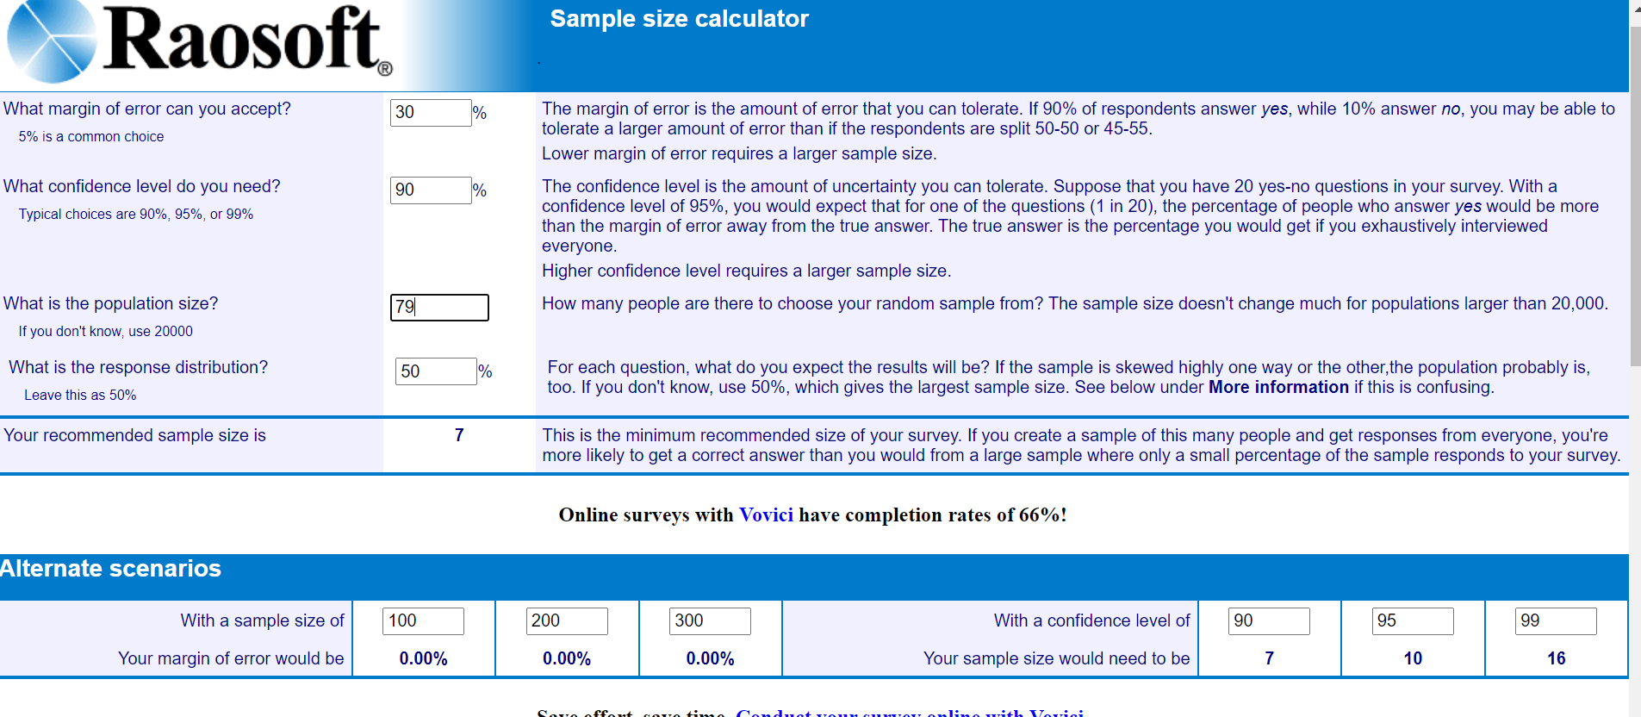
Figure 3 The Raosoft Random Sampling Size Calculator shows that with a 90% confidence and 30% precision, 7 boreholes are required in the sample.

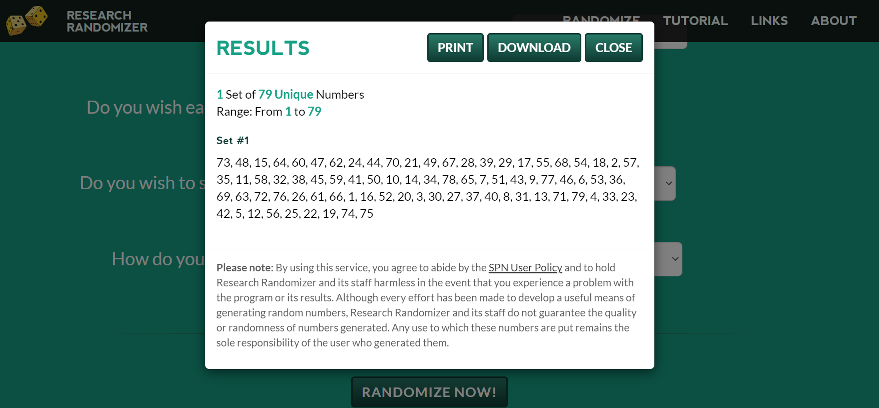
Figure 4 The Random Number Generator provides a list of random numbers that are allocated to the boreholes in the project. These are then ordered and the first 7 are selected for sampling.

Using CDM sampling tool “Guideline: Sampling and surveys for CDM project activities and programmes of activities Version 03.1”, the obtained usage rate of 100% capped at 95% was input to calculate the relative precision of the sampling, achieving 3.6%. This demonstrates 90/30 sampling criteria was met as per the methodological requirements. See below.

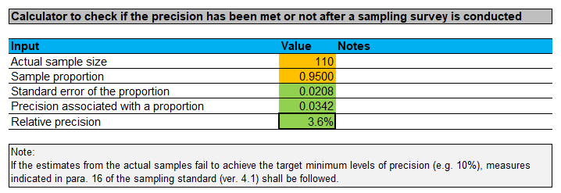

Using CDM sampling tool “Guideline: Sampling and surveys for CDM project activities and programmes of activities Version 03.1”, the results from the WCFT demonstrate the sample size met the precision requirements of 90/30, with the survey returning a relative precision of 3.9%, shown below.

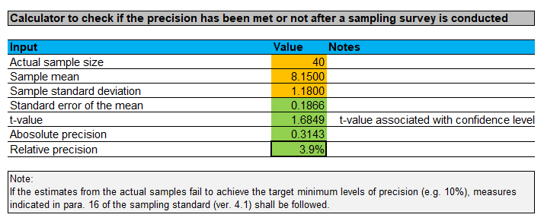

Regarding the project surveys, the 110 survey responses exceeds the minimum sample size of 100 that is required in TPDDTEC v1.
D.4.1 Water Consumption Field Test
The Water Consumption Field Test was carried out on a randomly selected sample of 40 households from the project database in Manica province. This complies with the recommended minimum sample size of 30 in the Gold Standard requirements.
The test was carried out over a period of four days (1 day preparation and 3 days measurement) following a similar method as the Kitchen Performance Test, and all tests were conducted between 15/09/2021 – 29/09/2021. The total litres of water consumed each day was measured and divided by the number of people consuming water in that day – this measurement was repeated over 3 consecutive days and an overall average per household was calculated. The results showed that on average 8.15 litres of non boiled clean water used only for drinking, hand washing and food preparation (capped at 7.5l) and 0 litres of boiled clean water is consumed per person per day.
The total amount of water credited for in this monitoring period is equal to the average amount of clean non-boiled water consumed per person per day (7.5l), minus the average amount of boiled clean water consumed per person per day (0).
D.4.2 Usage Survey
The usage survey establishes the proportion of beneficiaries that use the boreholes, a key parameter in the emission reduction calculations. The annual usage survey has been conducted, exceeding the minimum sample size of 100, as there were 110.
The usage surveys in this monitoring period were carried out by field staff between the 16/09/2021 – 05/10/2021 in Manica province. The households that participated in the survey were randomly selected from the borehole user lists. The results confirmed that 100% of the respondents and their family members use the boreholes that were rehabilitated by the project.
D.4.3 Project Survey
Project surveys were conducted between 16/09/2021 – 05/10/2021 on 110 randomly selected households from across the VPAs in Manica Province, to explore changes in the project scenario demographics, water use and purification practices etc) over time.
Data collected during the project surveys includes the following:
- General information - Name, address, telephone number etc.
- Household socio-demographic information.
- Water use and purification characteristics.
- Sources and availability of fuel.
- Time use and time saved information
- Hygiene and Sanitation practices in the households

- CALCULATION OF SDG IMPACTS
  - Calculation of baseline value or estimation of baseline situation of each SDG Impact
>> Details of equations and indicators used to estimate baseline values for SDG outcomes are explained below. Calculation is provided in the corresponding Emission Reductions calculations in the 'SDG Calculations' Sheet.

SDG 3 (Good Health and Wellbeing):
The outcome for SDG 3 is quantified as the additional number of persons consuming safe water in the project activity compared to the baseline scenario (P_{safe}). The percentage of users who were already consuming safe water in the baseline without boiling it (C_{j}) is determined through the baseline survey and deducted. Additionally, the percentage of users who consumed safe water by boiling it in the baseline (P_{b, boil}) is deducted. The baseline indicators are detailed in Section D.1 and are as follows:

C_{j} Expressed as a percentage, the portion of users of the project technology j who in the baseline were already consuming safe water without boiling it.
P_{b, boil} Percentage of persons boiling water for purification in the baseline scenario.

SDG 5 (Gender Equality):
The average decrease in hours per household in time spent gathering firewood (T_{b,y}) will be taken as a contribution towards the SDG target. The baseline parameter for time spent collecting firewood per household per day is monitored in the baseline project survey. The baseline indicators are detailed in Section D.1 and are as follows:

T_{b,y} Time spent collecting firewood per household per day prior to project (hours)

T_{b,y} = 3.67 hours

SDG 6 (Clean Water and Sanitation):
The outcome for SDG 6 is quantified as the additional number of persons having access to safe water in the project activity compared to the baseline scenario. The percentage of users who were already consuming safe water in the baseline without boiling it (9) was determined through the baseline survey. The baseline indicators are detailed in Section D.1 and are as follows:

C_{j} Expressed as a percentage, the portion of users of the project technology j who in the baseline were already consuming safe water without boiling it.

C_{j} = 0.79%

SDG 13 (Climate Action)

CO2 emission reductions are the indicator to demonstrate that the project has raised capacity for effective climate change-related planning and management. This outcome is measured using the emission reduction calculations. The baseline indicators are detailed in Section D.1 and are as follows:

Baseline Emissions:
$${BE}_{b,y}= B_{b,y}*\left(\left(f{NRB}_{y}*{EF}_{b,fuel,co2}\right)+{EF}_{b,fuel,nonco2}\right)*{NCV}_{b,fuel}$$
Example VPA, GS7132: 9,061 = 5,491 * ((0.86 * 112) + 9.46) * 0.0156
See accompanying Emissions Reductions calculations for all VPAs.

Where:
$$B_{b,y}= {(1-C}_{j})* N_{j,y}* W_{b,y}*{(Q}_{p,y}+Q_{p,rawboil,y})$$
Example VPA, GS7132: 5,491 = (1 - 0.0079) * 1,845,180 * 0.0004 * (7.5 + 0)
See accompanying Emissions Reductions calculations for all VPAs.

Where:
N_{j,y} Number of person days consuming water supplied by project scenario p through year y.

C_{j} Expressed as a percentage, the portion of users of the project technology j who in the baseline were already consuming safe water without boiling it.

B_{b,y} Quantity of fuel consumed in baseline scenario b during the year y in tons.

Q_{p,y} Quantity of safe water in litres consumed in the project scenario p and supplied by project technology per person per day.

Q_{p,rawboil,y} Quantity of raw water boiled in the project scenario p per person per day.

W_{b,y} Quantity of fuel in tons required to treat 1 litre of water using technologies representative of baseline scenario b during the project year y, as per Baseline Water Boiling Test
  - Calculation of project value or estimation of project situation of each SDG Impact
>> Details of equations used to calculate project value for SDG outcomes appear below. Calculation is provided in the corresponding Emission Reductions calculations in the ‘SDG Calculations’ Sheet.

Outcomes for SDG 3 (Good Health and Wellbeing):
The VPAs are premised on generating Emission Reductions by ensuring that water point users have safe water, thereby removing the need for them to burn non-renewable biomass in order to boil water to purify it. Emission reductions are also claimed through the principle of suppressed demand, meaning that some users lacked the resources, time or information necessary to purify their water prior to the project. Therefore, the users for whom ERs are claimed through suppressed demand were forced to use unsafe water for drinking, food preparation and basic personal hygiene prior to the project.

The outcome for SDG 3 is quantified as the additional number of persons consuming safe water in the project activity compared to the baseline scenario (P_{safe}). The calculation is as follows:

$$P_{safe}= P_{y}*(1-C_{j}) *\left(1- P_{b, boil}\right)$$
Example VPA, GS7132: 6,063 = 9,402 * (1 – 0.0079) * (1 – 0.35)
See accompanying Emissions Reductions calculations for all VPAs.

Where:
P_{safe} Number of additional persons consuming safe water in the project activity compared to the baseline scenario.

P_{y} Number of persons having access to safe water in the project activity.

C_{j} Expressed as a percentage, the portion of users of the project technology j who in the baseline were already consuming safe water without boiling it.
P_{b, boil} Percentage of persons boiling water for purification in the baseline scenario.

Outcomes for SDG 5 (Gender Equality):
The overall reduction in time spent collecting firewood by the project activity is calculated as follows:

TR_{y} = T_{b,y} - T_{p,y}
All VPAs: 0.39 = 3.67 – (1.79+0.44)
Where:
TR_{y} Total reduction time spent collecting firewood per day for project activity in year y (hours)
T_{b,y} Baseline time spent collecting firewood and water per household per day (hours)
T_{p,y} Project time spent collecting firewood and water per household per day (hours)

Outcomes for SDG 6 (Clean Water and Sanitation):
The outcome for SDG 6 is quantified as the additional number of persons having access to safe water in the project activity compared to the baseline scenario. Calculations are as follows:

$$P_{access}= P_{y}*(1-C_{j})*U_{p,y}$$
Example VPA, GS7132: 8,861 = 9,402 * (1 - 0.0079) * 0.95
See accompanying Emissions Reductions calculations for all VPAs.

Where:
P_{access} Number of additional persons having access to safe water in the project activity compared to the baseline scenario.

P_{y} Number of persons having access to safe water in the project activity.

C_{j} Expressed as a percentage, the portion of users of the project technology j who in the baseline were already consuming safe water without boiling it.

U_{p,y} Usage rate in project scenario p during year y

Outcomes for SDG 13 (Climate Action):
CO2e emission reductions are the indicator to demonstrate that the project has raised capacity for effective climate change-related planning and management contributing to SDG 13. The emissions reductions for the current monitoring period can be found in the corresponding Emission reductions excel document and section E.4. below.
  - Calculation of leakage
Leakage
The potential sources of leakage listed in the methodology have been investigated, and addressed below:

a) The displaced baseline technologies are reused outside the project boundary in place of lower emitting technology or in a manner suggesting more usage than would have occurred in the absence of the project.
In all cases the baseline technologies displaced are three stones; these have no market value and are not a product as such. There is nothing limiting the use of three stone cooking across the country (the technology is lowest rung on the energy ladder and the price is zero), which is why this cooking method is so widespread. In any case the primary purpose of these three rocks is for cooking so they will not be replaced/displaced in their entirety as a result of this project - which means they will not be reused outside the project boundary. This leakage source can therefore be discounted.

b) The non-renewable biomass or fossil fuels saved under the project activity are used by non-project users who previously used lower emitting energy sources.

There is no evidence to suggest significant (if any) use of renewable energy for purifying water in the project region as found in the Baseline Water Surveys. As solar purification devices are not used, renewable energy used for purifying water would likely be animal dung or crop residues which will be used due to ease of availability/proximity to the home rather than due to a shortage of wood fuel, therefore it is an independent factor. This leakage source can therefore be discounted.

c) The project significantly impacts the NRB fraction within an area where other CDM or VER project activities account for NRB fraction in their baseline scenario.
As the majority of participants collect wood from within the project boundary, it is not expected that the NRB in other areas will be affected. There are currently no other CDM or VER projects in the project area (defined as Manica Province).

d) The project population compensates for loss of the space heating effect of inefficient technology by adopting some other form of heating or by retaining some use of inefficient technology.
The space heating effect of boiling water for purification purposes will be minimal, as the predominant use of baseline technology is for cooking. Therefore it is highly unlikely that another technology will be used for heating when users no longer boil water.

e) By virtue of promotion and marketing of new technology with high efficiency, the project stimulates substitution within households who commonly used a technology with relatively lower emissions, in cases where such a trend is not eligible as an evolving baseline.
This project is not marketing efficient technology; it is eliminating the need for a fuel based technology to deliver pure water. Lower emission technology substitution within households is therefore not possible and this leakage source can therefore be discounted.
Therefore, a value of 0 is applied for leakage.

  - Calculation of net benefits or direct calculation for each SDG Impact

SDG | SDG Impact | Baseline  estimate | Project  estimate |  | Net  benefit
3 | Additional people consuming safe water | GS7132: 2944  GS7133: 2752  GS7134: 2728  GS7135: 2691  GS7136: 2911  GS7470: 2856  GS7471: 2952  GS7472: 2904  GS7473: 2850  GS7474: 2882 | GS7132: 9402  GS7133: 9851  GS7134: 9021  GS7135: 9515  GS7136: 10195  GS7470: 9357  GS7471: 10311  GS7472: 9937  GS7473: 11042  GS7474: 10558 | GS 7132: 6063  GS 7133: 6353  GS 7134: 5817  GS 7135: 6136  GS 7136: 6574  GS 7470: 6034  GS 7471: 6649  GS 7472: 6408  GS 7473: 7121  GS 7474: 6808
5 | Variation of time spent on firewood collection | 3.67 hours spent collecting firewood and water per household per day | 2.23 hours spent collecting firewood and water per household per day | 1.44 hours saved collecting firewood and water per household per day
6 | People gain access to safe water | GS7132: 477  GS7133: 446  GS7134: 442  GS7135: 436  GS7136: 471  GS7470: 463  GS7471: 478  GS7472: 470  GS7473: 462  GS7474: 467 | GS7132: 9402  GS7133: 9851  GS7134: 9021  GS7135: 9515  GS7136: 10195  GS7470: 9357  GS7471: 10311  GS7472: 9937  GS7473: 11042  GS7474: 10558 | GS 7132:  GS 7133:  GS 7134:  GS 7135:  GS 7136:  GS 7470:  GS 7471:  GS 7472:  GS 7473:  GS 7474: |  | 8861  9285  8502  8968  9609  8819  9718  9366  10407  9951
13 | Emissions Reduction  tCO2e | Baseline Emission Estimate for each VPA (BE_{b,y}):  GS7132: 8026  GS7133: 7516  GS7134: 7709  GS7135: 6797  GS7136: 5612  GS7470: 5810  GS7471: 5729  GS7472: 5443  GS7473: 4927  GS7474: 5673 | Project Emission Estimate for each VPA (PE_{p,y}):  GS7132: 0  GS7133: 0  GS7134: 0  GS7135: 0  GS7136: 0  GS7470: 0  GS7471: 0  GS7472: 0  GS7473: 0  GS7474: 0 | Emissions Reductions for each VPA (ER_{y}) – also includes leakage and usage rate:  GS7132: 7377  GS7133: 7312  GS7134: 8308  GS7135: 5423  GS7136: 5060  GS7470: 4934  GS7471: 4786  GS7472: 4795  GS7473: 4542  GS7474: 4801

  - Comparison of actual SDG Impacts with estimates in approved PDD
SDG | Values estimated in ex ante calculation of approved PDD  for this monitoring period | Actual values achieved during this monitoring period
3 | GS 7132: 2260  GS 7133: 2260  GS 7134: 2260  GS 7135: 2260  GS 7136: 2260  GS 7470: 2260  GS 7471: 2260  GS 7472: 2260  GS 7473: 2260  GS 7474: 2260 | GS 7132:  GS 7133:  GS 7134:  GS 7135:  GS 7136:  GS 7470:  GS 7471:  GS 7472:  GS 7473:  GS 7474: | 6063  6353  5817  6136  6574  6034  6649  6408  7121  6808
 | Total: 22,600 | Total: 63,964 people
5 | At least 0.5 hours per trip per household time saved | 1.44 hours per trip per household saved
6 | GS 7132: 3125  GS 7133: 3125  GS 7134: 3125  GS 7135: 3125  GS 7136: 3125  GS 7470: 3125  GS 7471: 3125  GS 7472: 3125  GS 7473: 3125  GS 7474: 3125 | GS 7132:  GS 7133:  GS 7134:  GS 7135:  GS 7136:  GS 7470:  GS 7471:  GS 7472:  GS 7473:  GS 7474: | 8861  9285  8502  8968  9609  8819  9718  9366  10407  9951
 | Total: 31,250 | Total: 93,485 people
13 | All VPAs: 10,000 tCO2e/y  Total: 100,000 tCO2e/y | GS 7132:  GS 7133:  GS 7134:  GS 7135:  GS 7136:  GS 7470:  GS 7471:  GS 7472:  GS 7473:  GS 7474: | 7377 tCO2e  7312 tCO2e  8308 tCO2e  5423 tCO2e  5060 tCO2e  4934 tCO2e  4786 tCO2e  4795 tCO2e  4542 tCO2e  4801 tCO2e
13 | All VPAs: 10,000 tCO2e/y  Total: 100,000 tCO2e/y | Total: 57,338 tCO2e

    - Explanation of calculation of value estimated ex ante calculation of approved PDD for this monitoring period
Ex-ante estimations are derived from ex ante calculations supplied at Internal Validation and Design Review of the Projects. These calculations use a mix of baseline project survey data and assumptions ahead of annual monitoring data collection to estimate SDG impacts for each VPA.

SDG 3: Good Health and Well-Being
In ex ante calculations, 500 users per borehole are assumed. The remaining parameters, Cj and Pb,boil, in the calculation use baseline project survey data and are fixed ex ante, as found in Section D.1. of the MR.

SDG 5: Gender Equality
The parameter Tb,y is estimated using the baseline project survey and is fixed ex ante (Section D.1. of the MR). In order to estimate the reduction in time spent collection firewood (TRy), the ex ante calculations assumed a 0.5 hour reduction for Tp,y. This parameter is monitored annually in the project survey.

SDG 6: Clean Water and Sanitation
In ex ante calculations, 500 users per borehole are assumed as well as a 90% usage rate. The remaining parameter, Cj, is fixed ex ante, as found in Section D.1. of the MR.

SDG 13: Climate Action
The ex ante calculations for SDG 13 use a mix of baseline monitored parameters, methodology caps and figures assumed ahead of data collection. The major difference between ex ante estimates and figures reported in the MR is the reported baseline water boiling test value (used for parameters Wb,y and Wp,y in section D.1. of the MR). In ex ante calculations this was set at 0.00097 tonnes per litre, however this value has subsequently been capped at 0.0004 tonnes per litre in this monitoring period.

  - Remarks on increase in achieved SDG Impacts from estimated value in approved PDD
>> SDG 3: Actual values are above estimates. There has been bundling of boreholes during this monitoring period into all VPAs. This means an increase in the number of people having access to safe water for MP3 even though there is still a max 300 user cap. All project participants now consume safe water without the need to boil. Even those above the cap. Participants are now experiencing fewer illnesses associated with consuming unsafe water.

SDG 5: Actual value exceeds estimate. Time spent collecting firewood and water reduced by 1.44 hours in the project. This presents a reduction in time spent collecting firewood and water compared to the baseline and exceeds the ex-ante estimate of 0.5 (30 minutes) hours saved.

SDG 6: Actual values are above estimates. There has been bundling of boreholes during this monitoring period into all VPAs. This means an increase in the number of people having access to safe water.

SDG 13: No increase in actual values compared to PDD estimates.
- SAFEGUARDS REPORTING
>> The Stakeholder Consultation process identified four individual safeguarding principles as relevant to the project, to be included in the monitoring report.
- Gender Equality and Women’s Rights
Two parameters to be monitored annually were identified. Firstly, the time saved through the collection of firewood, Tp,y, is monitored and presented in Section D.2. of the MR. Secondly, how time saved is used is also monitored annually and this parameter is presented in Section D.2. of the MR. No issues were raised in the monitoring of these two parameters.
- Corruption
Communities involved in the projects are able to communicate any cases of corruption through the continuous input mechanism established for the projects. No instances of corruption have been reported in the monitoring period.
- Negative Economic Consequences
Community-orientated trainings on conducting minor maintenance were established at the beginning of the project. All breakdowns are recorded in the monitoring report and average functionality is well above 75%, shows that this initiative has been highly successful. All down days are recorded in Section D.2. of the monitoring report.
- Community Health, Safety, and Working Conditions
Incidences of water borne illnesses are monitored annually in the monitoring project survey and compared with baseline results. A rate of 0%, as compared to 93% in the baseline shows successful establishment of a clean water supply in the communities.

- STAKEHOLDER INPUTS AND LEGAL DISPUTES
  - List all Inputs and Grievances which have been received via the Continuous Input and Grievance Mechanism together with their respective responses/mitigations.
>> There are multiple methods for stakeholders to give feedback. Continuous input/Grievance Expression Process log books are held at a water point level on which users can comment on.

In addition, a telephone number for the WATSAN in-country office was provided as well as email addresses for the relevant Village Water UK and CO2balance staff and the Gold Standard were provided. All methods of communication were shared with stakeholders during the LSC.

No Stakeholder feedback or comments have been received during this monitoring period.
  - Report on any stakeholder mitigations that were agreed to be monitored.
N/A
  - Provide details of any legal contest that has arisen with the project during the monitoring period
N/A

Revision History

Version | Date | Remarks
1.1 | 14 October 2020 | Hyperlinked section summary to enable quick access to key sections  Improved clarity on Key Project Information  Section for POA monitoring  Forward action request section  Improved Clarity on SDG contribution/SDG Impact term used throughout  Clarity on safeguard reporting  Clarity on design changes  Leakage section added for VER/CER projects  Addition of Comparison of monitored parameters with last monitoring period  Provision of an accompanying Guide to help the user understand detailed rules and requirements
1.0 | 10 July 2017 | Initial adoption

Whenever emission reductions are capped, both the original and capped values used for calculations must be transparently reported. Use brackets to denote original values.

