


INSTALLATION OF HIGH EFFICIENCY WOOD BURNING COOKSTOVES IN MOZAMBIQUE
Document Prepared by C-Quest Capital LLC
1015 18th Street, NW Suite #730
Washington, DC 20036

Project Title | Installation of high efficiency wood burning cookstoves in Mozambique
Version | 01
Date of Issue | 20-05-2022
Project Location | Republic of Mozambique
Project Proponent(s) | C Quest Capital Stoves Asia Limited  Ken Newcombe, CQC-Operations@cquestcapital.com; 1 (240) 491 - 2650  Tridip Kumar Goswami, CQC-Operations@cquestcapital.com; + 91-11-47481741
Assessor Contact | Carbon Check (India) Private Limited  2071/38, 2nd Floor, Naiwala, Karol Bagh, New Delhi-110005  URL: www.carboncheck.co.in  E-mail: info@carboncheck.co.in/ projects@carboncheck.co.in  Contact #: +91 (120) 4373114
Project Lifetime | 27-January-2021 to 26-January-2031, ten years Lifetime
History of SD VISta Status | No previous attempts at SD VISta certification made to date
Other Certification Programs | VERRA Verified Carbon Standard (2351)
Expected Future Assessment Schedule | Initial validation/verification anticipated in 2022

Contents
1 Summary of SDG Contributions 4
2 Project Design 9
2.1 Project Objectives, Context and Long-term Viability 9
2.2 Stakeholder Engagement 22
2.3 Project Management 32
3 Benefits for People and Prosperity 37
3.1 Condition of Stakeholders at Project Start 37
3.2 Expected Impacts on Stakeholders 38
3.3 Stakeholder Monitoring Plan 41
3.4 Net Positive Stakeholder Well-being Impacts 51
4 Benefits for the Planet 53
4.1 Condition of Natural Capital and Ecosystem Services at Project Start 53
4.2 Expected Impacts on Natural Capital and Ecosystem Services 54
4.3 Natural Capital and Ecosystem Services Monitoring Plan 54
4.4 Net Positive Natural Capital and Ecosystem Services Impacts 57
Appendix 1 58
Appendix 1: CAUSAL CHAIn 61

Summary of SDG Contributions

Table 1: Summary of Project SDG Contributions
Row number | Estimated Project Contribution by the End of Project Lifetime | SDG Target | SDG Indicator | Net Impact on SDG Indicator | Section Reference | Claim, Asset  or Label
1 | Contribute to providing access to basic services (clean cooking technology considered as basic service under access to modern energy) to the poor and vulnerable communities of Mozambique. The project will lead to providing access to 0.5 million clean cookstoves by the end of its lifetime.  Thus, the project will achieve SDG Goal 1: End poverty in all its forms everywhere | 1.4 | 1.4.1 Proportion of population living in households with access to basic services – Clean Technology | Implement activities to increase | 3.2 | SD VISta labeled VCUs
2 | Contribute to reducing prevalence of stunting (height for age <-2 standard deviation from the median of the World Health Organization (WHO) Child Growth Standards) among children under 5 years of age, by introducing efficient stoves that use less fuelwood and hence address the issue of food insecurity related to fuelwood scarcity.  The project will target to reduce stunting to a level below 43% of child population which is the current percentage of stunting observed in children under five years of age in Mozambique.  Hence the project will achieve SDG Goal 2: End hunger, achieve food security and improved nutrition and promote sustainable agriculture. | 2.2¹ | 2.2.1 Prevalence of stunting (height for age <-2 standard deviation from the median of the World Health Organization (WHO) Child Growth Standards) among children under 5 years of age | Implemented activities to decrease | 3.2 | SD VISta labeled VCUs
3 | The project activity by replacing 500,000 traditional cookstoves with energy efficient project cookstoves will contribute to improved health and well-being brought about by reduced levels of fine particulate matter (PM_{2.5}) emissions within households.  Thus, the project will achieve SDG Goal 3: Ensure Healthy lives and promote well-being for all at all ages. | 3.9 | Project specific indicator: Reduction in PM_{2.5} emissions which indicates improved health of end-users | Implemented activities to decrease | 3.2 | SD VISta labeled VCUs
4 | Contribute to increasing vocational and relevant skills of local individuals by providing non-formal education and training on issues related to climate change, with specific skill building in operations and surveying activities related to stove distribution and its monitoring under VCS.  The project through its targeted youth and women program will lead to training 50 number of individuals in its region of implementation.  Thus, the project will achieve SDG Goal 4: Ensure inclusive and equitable quality Education and promote lifelong learning opportunities for all. | 4.3 | Project-specific indicator: Number of individuals who received any informal training to enable their employment in project activity or elsewhere. | Implemented activities to Increase | 3.2 | SD VISta labeled VCUs
5 | Contribute to reducing drudgery and reducing gender inequality, especially for women and children by saving time spent in collecting fuel wood and cooking, considered for an individual African firewood-gathering household, the average time spent on fuel collection daily ranges from just under 1 hour to more than 5 hours, with a regional average of 2 hours spent on the task daily -an immense loss of human productivity using an open fire or similar traditional cook stove.  The project will lead to time savings and reduced drudgery in 500,000 households translating to equal number of women as they are primary cooks and fuelwood collectors in most of the households. The women can use the time saved for doing more productive activities or personal care.  Thus, the project will achieve SDG Goal 5: Achieve Gender Equality and empower all women and girls | 5.4 | 5.4.1 Time spent on unpaid domestic and care work, by sex, age, and location. | Implemented activities to Decrease | 3.2 | SD VISta labeled VCUs
6 | Contribute to increasing access to clean cooking technology with TLC Rocket Stove installations in 500,000 Mozambique households that have been using traditional three stone fire, over the project lifetime.  Thus, the project will achieve SDG Goal 7: Ensure access to affordable, reliable, sustainable, and modern energy for all. | 7.1 | 7.1.2 Proportion of population with primary reliance on clean fuels and technology | Increase | 3.2 | SD VISta labeled VCUs
7 | Contribute to generation of employment in informal sector (total economy, agriculture and non-agriculture) by contracting locals with a target employment of 50 employees for varying lengths of time over the project lifetime with a focus on hiring females.  Employment comprises all persons of working age who, during a short reference period (minimum one week), or full time (more than 6 months) will be engaged in any activity to produce goods or provide services for pay or profit.  Since, the project leads to generation of employment opportunities, it achieves SDG Goal 8: Promote Sustained, inclusive, and sustainable economic growth, full and productive employment, and Decent Work for all. | 8.3 | 8.3.1 Proportion of informal employment in non-agriculture employment, by sex. | Increase | 3.2 | SD VISta labeled VCUs
8 | Contribute to GHG emission reduction through an estimated reduction of ~63.62 tCO₂e per stove due to replacement of baseline stoves with TLCRS over 10 years of crediting period.  Thus, the project will achieve SDG Goal 13: Take urgent action to combat Climate Change and its impacts | 13.0 | Project Specific Indicator: Reduction in GHG emissions as compared to the baseline scenario (open fire) | Implemented activities to decrease | VCS validation report | SD VISta labeled VCUs
9 | Contribute an estimated reduction in removal of woody biomass to the tune of ~38.34 tons per stove over the 10 years of crediting period, from forests surrounding the communities thereby leading to an increase in above ground biomass in these forests.  Thus, the project will achieve SDG Goal 15: Protect, restore, and promote sustainable use of terrestrial ecosystems, sustainably manage forests, combat desertification, and halt and reverse land degradation and halt biodiversity loss. | 15.2 | 15.2.1 Progress towards sustainable forest management by increasing above ground biomass in forests | Implemented activities to increase | 4.2 | SD VISta labeled VCUs

Project Design

Project Objectives, Context and Long-term Viability

Summary of Project Sustainable Development Objective(s)
C-Quest Capital LLC’s (CQC) Improved Cookstove (ICS) project – “Installation of high-efficiency wood-burning cookstoves in Mozambique” will enable household level access clean and modern energy in the community of Mozambique by distributing, installing, and maintaining fuel-efficient improved cookstoves, and contribute to overall sustainable development and improving the well-being of the community. The project aligns with and will contribute to sustainable development objectives outlined in Table 1: Summary of SDG Contributions. Through the distribution and implementation of TLCRS, this grouped project aims to (1) reduce demand for wood fuel, (2) slow local deforestation, (3) reduce the drudgery of collecting wood fuel– performed mainly by women and children, (4) reduce time spent on cooking over open fires resulting in extended exposure to toxic smoke, (5) increase time spent on improving quality of life i.e., through economic endeavors and knowledge dissemination, (6) Improve the health status through reduced exposure to household air pollutants (HAPs) and (7) improve nutrition
The project can be defined in several thematic buckets that reflect the key pillars of sustainable development namely- (a) Economic well-being, (b) Social Well-being, and (c) Environmental well-being.
 | SDG Goal Addressed | Target beneficiary | Impact envisaged through the project's lifetime
Economic Well Being | SDG 1 | End users receiving project stoves | 0.5 million households
Economic Well Being | SDG 8 | Employees hired during various stages of project implementation & operation | 50
Social well Being | SDG 2 | Children below 5 years of age | Children below 5 years of age in 0.5 million households
Social well Being | SDG 4 | Staff receiving non- formal education & training | 50
Social well Being | SDG 5 | Women and girls | 0.5 million women who are primary cooks in the 0.5 million households
Social well Being | SDG 7 | End-user households | 0.5 million project beneficiary households will have access to clean technology which they would not have been able to afford.
Environmental well being | SDG 3 | End-user households with a focus on women who are primary cooks | 0.5 million households are expected to experience reduced indoor air pollution.
Environmental well being | SDG 13 | Natural Capital | Avoided emissions to the tune of ~63.62 tCO₂e per stove over the 10-year crediting period
Environmental well being | SDG 15 | Natural Capital | Avoided removal of approximately 38.34 tons of woody biomass per stove per over the 10-year crediting period, from forests surrounding the communities.
Each of the SDG Goals achieved through the present project activity is discussed in detail in the following paragraphs-
- Economic Wellbeing
The project will provide access to a basic service, i.e., modern energy in the form of clean cooking alternative to the rural and peri-urban communities of Mozambique. The project will lead to a distribution of 0.5 million energy-efficient ICS throughout its lifetime. Thus, the project will achieve:
- SDG GOAL 1: Improved cookstove is a basic service necessary to lead a healthy and productive life, including saving time and money at the household level (1.4)
Further, the project will result in generating employment opportunities, both long-term as well as short-term, for the local individuals of Mozambique. Long-term employment under the project refers to engaging individuals for at least six months while short-term refers to an engagement of a minimum of 1 week. Staff will be paid a monthly salary with provision of performance-based incentive per stove built and registered.
- SDG GOAL 8: Contracting of individuals on full-time and part-time basis with a focus on hiring local people and women (8.3) . In the short term, teams of local men and women will be employed and trained to make bricks and build stoves.
- Social Wellbeing
The project is envisaged to improve the overall social well-being within the project implementation area by yielding human health benefits, increasing awareness levels, reducing gender inequality, and providing access to clean cooking technology to economically weaker sections of the society that does not have affordability and access to this technology. Each of the benefit aligned with respective SDG has been explained in the following points:
The projects will address SDG 2, SDG 3, SDG 4, SDG 5, and SDG 7 in the following ways:
- SDG GOAL 2: Contribute to reducing prevalence of stunting (height for age <-2 standard deviation from the median of the World Health Organization (WHO) Child Growth Standards) among children under 5 years of age, by introducing efficient stoves that use less fuelwood and hence address the issue of food insecurity related to fuelwood scarcity.
Studies show that coping strategies to tackle fuelwood scarcity negatively affect the food security of the population concerned. These can be differentiated into supply side and demand side strategies (Köhlin et al., 2011; Damte et al., 2012; Schuenemann et al., 2018).
Demand side strategies , such as omitting or substituting dishes with extended cooking times, even though these typically carry high nutritional value (e.g., dry beans) (Brouwer et al., 1996; Kees and Feldmann, 2011; Makungwa et al., 2013; Sola et al., 2016) negatively affect food security of the population.
Supply side strategies such as increasing labour to collect fuelwood, collecting fuelwood from non-forest areas, using crop residues etc. on the other hand impact women more as women are traditionally responsible for collecting fuelwood, cooking, and developing strategies to mitigate the increasing fuelwood scarcity (Heltberg,2004).
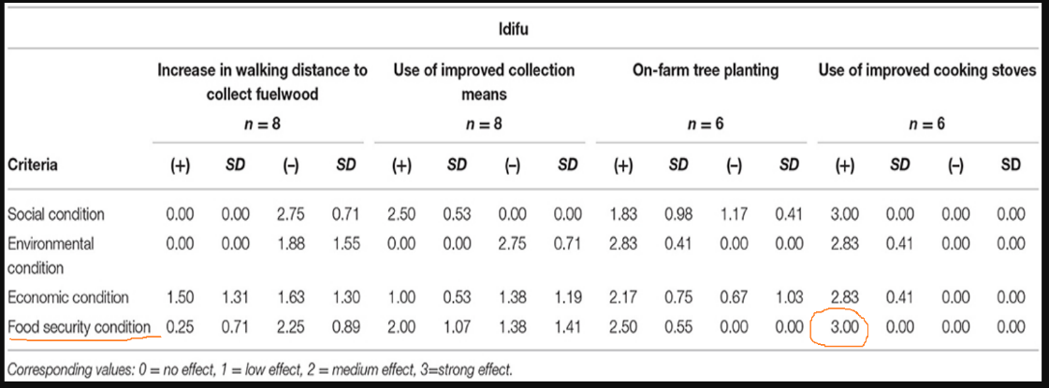
Research conducted to study the effect of ICS on food security found strong relation between the two, suggesting that an improved cookstove by reducing fuelwood requirement as well as time spent in collecting wood and cooking allowed the households to better manage their nutritional requirements.
- SDG Goal 3: Reduced emission of fine particulate matter (PM_{2.5}) resulting in lowering of household air pollution due to use of the TLCRS, improving well-being for women and children (3.9)
Apart from improving the health of women, the stoves also reduce accidental burns in infants and children due to its design comprising of a closed combustion chamber and stable base.
- SDG GOAL 4: Contribute to increasing vocational and relevant skills of local individuals by introducing them to issues related to climate change, and bring awareness about importance of sustainable development, health, nutrition, and well-being, through formal and informal training which will enhance their avenues for getting decent jobs and employment opportunities (4.4).
The employed individuals will be provided with regular trainings to enhance their vocational skills related to various aspects of project implementation and monitoring which would increase their employability and chances of getting long-term employment even after the completion of the project. Field staff, also known as “health promotors” (HPs) will be specifically trained in stove construction. Some of the HPs will be trained to work as ‘enumerators’ and carry out stove registrations, captured through a mobile phone application that sends captured information to an online cloud database.
- SDG Goal 5: Reduce women and children’s drudgery through times savings by reducing time spent cutting, collecting, and carrying firewood from trees far removed from households and reduce time spent cooking over toxic smoky open fires. These tasks are a major cause of gender inequality in rural communities of Mozambique which will be addresses by the project activities by providing the women folk and children opportunities to involve in more productive activities (5.4).
By switching to fuel in small, twig-sized pieces of woody biomass, women, and girls save time collecting, cutting, and carrying heavy wood over long distances. Also, as the CQC TLCRS burns at a higher temperature, with less fuel used, due to combustion chamber and stove design, cooking the day's meal takes approximately an hour less than it would take to cook the same meal over the TSF. Research by Berkeley Air Monitoring Group, showed two hours a day savings in switching to two stoves per household from the TSF and a meta-analysis of all research into time savings from ICS showed the on average time savings across sub-Saharan Africa to be about one hour per day.
Children, particularly girls, are frequently kept at home to support household chores, like cooking and collecting firewood, estimated on average to be 10 hours per week, with a TLCRS more time can be dedicated to education – attending school and studying,
- SDG Goal 7: The primary activity under the project is distribution of clean cooking project stoves to sections of the Mozambique population that are predominantly reliant on wood fuel for meeting their cooking need and are unable to afford improved cookstoves. As clean cooking technology provides an essential tool to addressing energy poverty and ensuring sustainable energy security in approximately 0.50 million households in Mozambique during the project lifecycle, the project will generate an overall positive impact on the community.
- Environmental Wellbeing
The distribution of efficient cookstoves is expected to reduce the fuelwood consumption for cooking purpose which will not only reduce the amount of emissions being released in the atmosphere but also reduce the burden on forest ecosystems in and around the project area. Thus, the project will contribute to SDG 13 and SDG 15 in the following ways:
- Goal 13: Reduce carbon emissions by approximately 63.62 tCO₂e per stove in the project lifetime from the reduction in burning solid fuels for cooking in the household, this does not include black and brown carbon (13.0)
- Goal 15: Reduce deforestation and degradation by up to 38.34 tons, per stove, in the project lifetime (15.3)
Forest, observed as a public place is often used for the collection of fuelwoods, which significantly contributes to deforestation and degradation. The distribution of the TLCRS will reduce fuelwood consumption and hence reduce the pressure on the forests. Due to TLCRSs efficiency and widespread community use, there will be a reduction in firewood cutting from live trees resulting in better management of protected areas.

Description of the Project Activity
Installation of High-Efficiency Wood Burning Cookstoves in Mozambique, a low-emission climate-resilient initiative by a CQC, was developed in response to the need to reduce greenhouse gas emissions (GHG) to address the rising climate catastrophe that largely impacts the most vulnerable populations that reside in Sub-Saharan Africa. The project focuses on the underprivileged in rural and peri-urban areas who cook over open flames ('three-stone fires cookstoves' (TSFs)). The project activity is designed to facilitate household level improvements in cooking amenities and improved health and well-being for women, girls, and children with benefits to all the members of the household,.
The primary activity under this grouped project, is installation of ICSs
- Improved Cookstove (TLCRS): The primary project activity is the distribution and installation of the TLC Rocket Stove (TLCRS), a high-efficiency, long-life metal and (made from local material) brick stove that transitions households away from traditional open fire cooking to cleaner, more efficient cooking solutions with renewable biomass fuels. The TLCRS is oﬀered in exchange for in-kind contributions of materials and labor only, as the rural population’s disposable cash is limited, and employment, where possible, is often informal and operates external to the cash economy.
In contrast to the traditional TSF, ICS strengthens the combustion efficiency and thermal transfer to the vessel by incorporating a number of cutting-edge elements, including one or more of a 'rocket elbow'; a highly insulated combustion chamber that provides a conducive environment for clean and efficient combustion of wood. This significantly increases the efficiency of the stove and hence reduces the fuelwood consumption in comparison to the baseline stoves.
TLCRS includes a total of 15 bricks, which will be handcrafted by families using locally available clay, the block is 22.5cm x 11cm x 6.5cm on average. A mixture of 5 liters of clay, sand, manure/cow dung, and water will be used to bind the bricks together. To improve combustion and heat transport, metal components have been incorporated into the design. This results in less heat loss and better insulation. Figure below represents a TLCRS stove that is being provided in Mozambique households.
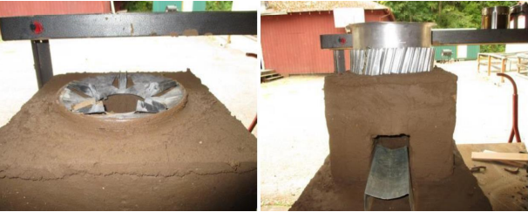

Figure 1: TLC Rocket stove (TLCRS)
The stove includes a metal top that allows the pot to sit higher, boosting airflow into the combustion chamber and out the top. An adjustable aluminum pot skirt ensures more efficient heat transfer from the fire to the pot while also helping to deflect wind. It also uses a metal stick support that lies in front of and slightly within the stove opening and serves as a firewood feeding station. This maintains sufficient airflow while feeding the fuel into the combustion chamber, resulting in complete wood burning. The overall design of the stove ensures an average thermal efficiency of 34.5% as estimated through the water boiling test (WBT) conducted by the Aprovecho Research Centre. The following table represents the technical specifications of the TLCRS being installed under the project activity.
Parameter | Technical Specifications
Stove Size | Depth: 35 cm  Width: 35 cm  Height: 28 cm
Combustion Chamber Size | Depth: 12 cm  Width: 12 cm  Height: 28 cm
Efficiency | 34.5%
Average Life | 10 years
Furthermore, CQC uses an innovative digital platform to track and manage the ICS project. Education and training of field staff is an important component of project implementation. Using smartphones, CQC and its implementing partners administer various surveys and questionnaires to track project objectives, and beneficiary information, and to monitor and evaluate implementation performance.
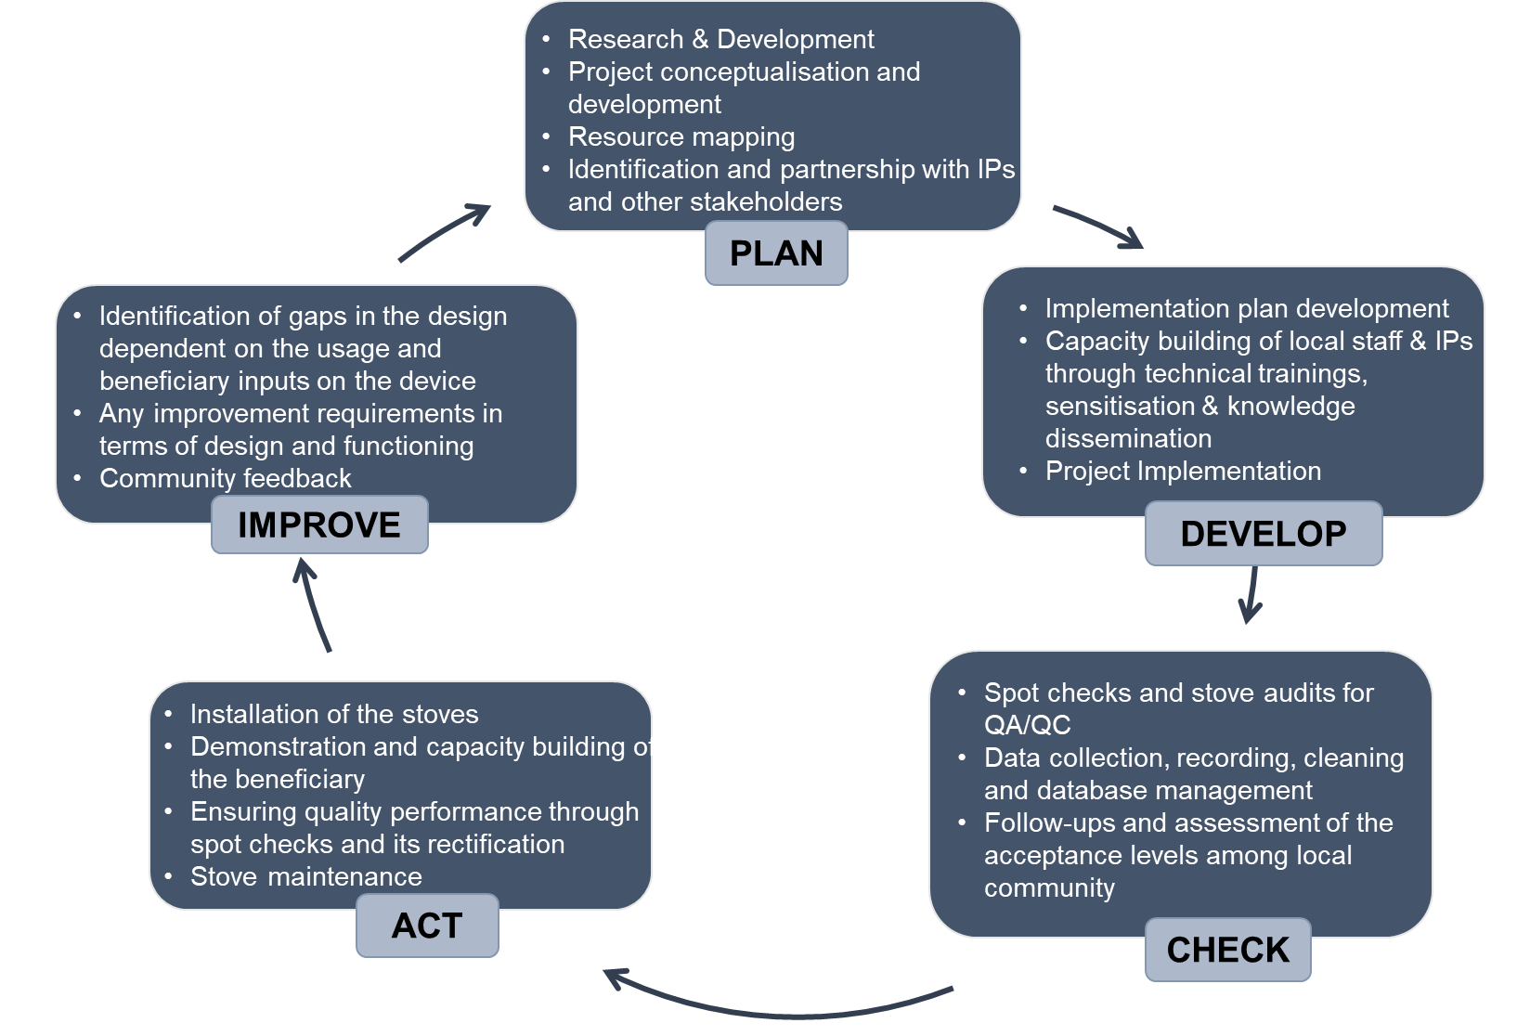
The following figure represents the project cycle that will be adopted for TLCRS distribution.

Figure 2: TLCRS Project Cycle
The associated benefits of this primary activity on local community and ecosystem have been detailed in the section above. Apart from the primary activity, the secondary activities under the Grouped project and their impacts are as follows:
Stove Champions Program: The Stove Champion (SC) program is a unique program under which the most successful health promoters are selected and trained to service 500-1000 households and be in direct communication with their female clients. SC’s undertake a minimum of one annual visit post-wet season to each household receiving a stove and ensure repairs are made following storm damage and users follow best practices in stove management upkeep and repair. The key objectives of the SC program are to address any communication deficiencies and reiterate stove benefits and good practice in stove use and maintenance and maximize the benefits of improved stove use and ventilation to women, children, and the environment. SCs are paid on a monthly basis and performance incentives are also considered based on stove built and registered.
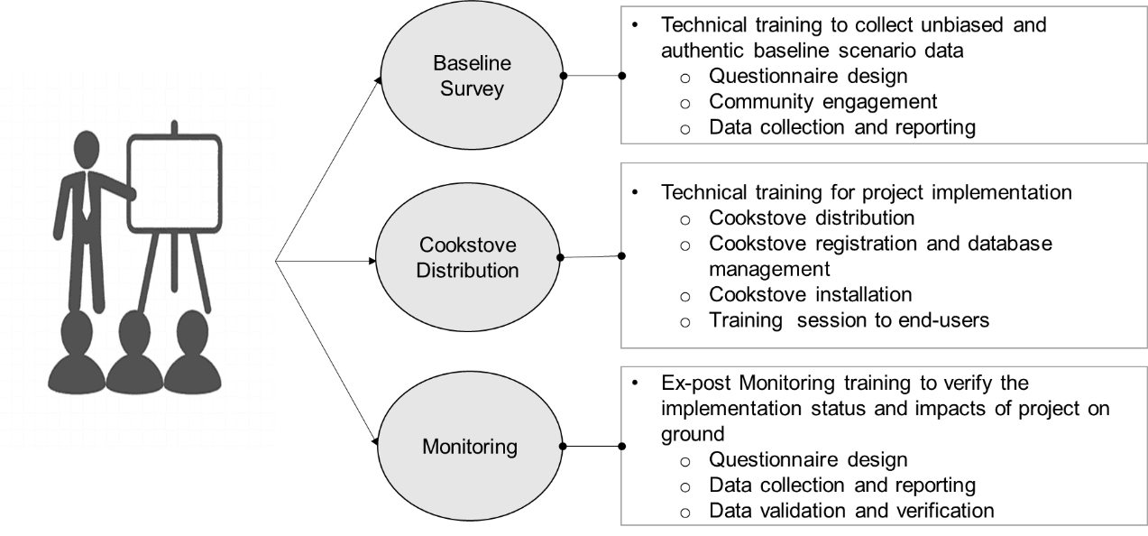
Trainings: Training is an integral part of any project implemented by CQC. While training its staff, CQC undertakes an introductory course on climate change including impacts of household pollution on health and well-being, which builds a background on the importance of efficient cookstove intervention. Apart from course, throughout the process of implementation of the project, be it during stove registrations, monitoring surveys, maintenance schedules etc., the staff is provided with numerous opportunities to upgrade their skills, which help them not only to undertake activities in the said project but also improve their future employability prospects. These training help generate positive impacts on community groups by enabling community members to build alternative skills and build capacity. These interventions are expected to advance socio-economic status, generate greater community capacity for sustainable livelihoods, and increase climate resilience.
Figure 3: Trainings conducted during various stages of the project cycle

Implementation Schedule
Date | Milestone(s) in the Project’s Development and Implementation
27 January 2021 | Project Start date: Project Activities commence with TLCRS installations
9 November 2020 | Listing of VCS PD on VERRA
13 May 2022 | Registration of project under VCS
25 May 2022 | CQC submits the project documents to VERRA for listing under SD VISta Program
January 2021 – January 2031 | Concurrent monitoring and evaluation
26 January 2031 | The 10-year project validation period concludes with a projected 0.5 million additional stoves installed.

Project Proponent
Organization Name | C-Quest Capital Stoves Asia Limited
Role in the Project | Project Proponent
Contact Person | Ken Newcombe
Title | Director
Address | 38 Beach Road, #29-11, South Beach Tower, Singapore (189767).
Telephone | +1-240 491-2650  +6 087 42828  +1-202 247-7976
Email | CQC-Operations@cquestcapital.com

Other Entities Involved in the Project
No other entity is involved with the CQC-TLCRS Project.

Project Type
This is a non-AFOLU (agriculture, forestry, and other land use) grouped project with general sector contributions identified in the chart below, primarily energy efficiency.
SD VISta Sectoral Scopes | U.N. Sustainable Development Goals
Sectoral Scope 2 - Climate Change Adaptation | Climate Action 13.0  Life on Land 15.3
Sectoral Scope 3 - Education | Vocational Training for Implementation Partners 4.0
Sectoral Scope 4 - Energy | Affordable energy 7.1
Sectoral Scope 5 - Food | Zero Hunger and elimination of malnutrition 2.1
Sectoral Scope 7 - Health | Good Health and Wellbeing 3.0
Sectoral Scope 10 - Livelihoods | End Poverty in all its forms everywhere 1.4  Decent Work and Economic Growth 8.3
Sectoral Scope 14 – Women's Empowerment | Gender Equality 5.4

Project Location
The project location will be the geographical boundary of Republic of Mozambique with coordinates 18°39'56.5'' S latitude and 35°31.774' E longitude.
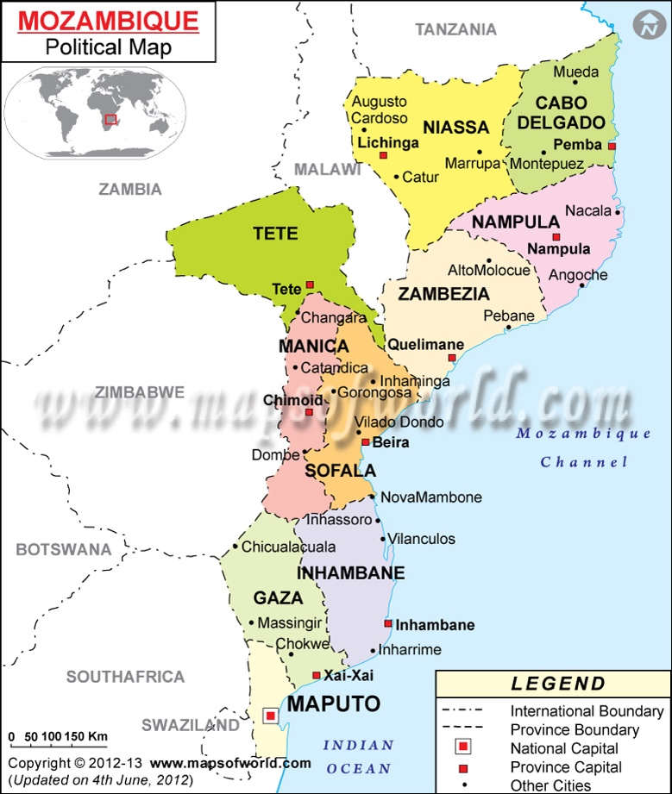
Figure 4: Mozambique map
Mozambique is divided into 10 provinces and 1 capital city with provincial status. To facilitate the management, implementation, monitoring and sampling stages of the project, the project proponent divides the project boundary into 3 project areas according to the provinces.
S.No. | Project Area | Provinces
1 | North | Cabo Delgado, Nampula, Niassa, Zambezia
2 | Central | Manica, Sofala, Tete
3 | South | Gaza, Inhambane, Maputo City, Maputo

Baseline Scenario
Mozambique is in Eastern Africa bordering the Indian Ocean, between South Africa and Tanzania. With over 2,500 km of coastline, and a total land boundary of 4,783 km, it shares borders with six other countries - South Africa, Eswathini, Zimbabwe, Mozambique, Malawi, Tanzania. Mozambique has a population density of 39.75 people per square km of land area. However, Mozambique has vast population distribution disparities, with large population clusters in Matola, Maputo and Nampula. Mozambique has an urban population of 38.2% of the total population and an annual rate of change at 4.24% with 62.93% of the population categorized as rural.
Majority of the households in the rural areas of Mozambique use TSF common to much of sub-Saharan Africa. The TSF used by the target population requires large diameter logs, commonly procured from nearby non-renewable live biomass sources (firewood) found on forest patches or growing on/near farmland, necessary for managing an open ‘three-stone fire’ cookstove. As population growth and density have increased, demand for large diameter wood for three-stone open fires has led to intensified deforestation and land degradation and an increasing amount of time spent by women and girls, collecting firewood further and further away from their village communities. Apart from this, other negative externalities associated with the use of traditional biomass include household air pollution (HAP), human health damage, climate change, etc. which is also a prominent challenge being faced by the rural communities.

Causal Chain(s)
See appendix A for the Causal Chain image.

Threats to the Project
The potential threats to the proposed project can be classified under two categories, i.e., human induced threats and nature induced threats. This section describes the potential threats and the corresponding approach that will be adopted by the PP to mitigate these threats for ensuring smooth implementation of the project activity.
Human-Induced Threats
Threat: Stove users’ lack of upkeep of stove resulting in either malfunctioning of the stove as designed or lack of stove use.
Solution: CQC conducts routine spot audits early in the process of construction of stoves in each main geographic focus for mass stove installation to detect defects in stove construction, maintenance, and sub-optimal stove use. CQC requires its Implementing Partners (IPs) to hire, train, and supervise stove builders and users, to visit each household to inspect their stoves, up to 2 times per year. This dramatically reduces the threat listed above. Additionally, CQC contracts independent third-party auditors or local CQC staff to perform spot checks or sample size reviews to identify lapses in stove upkeep. Upon receiving these reports CQC contracts sub-proponents to perform follow-up visits to households to provide additional education and encourage stove upkeep and use.
Where metal parts of ICS’s commonly found on the market are made of low-grade steel, CQC has upgraded the metal parts for the TLCRS to higher-grade heat resistant steels having a lifespan of a minimum of 10 years, determined by extensive stress testing by Colorado State University, USA. Metal parts include a fuel shelf that doubles as a brick mould, pot skirt, and stovetop.
Threat: Failure of Behaviour Change resulting in high levels of non-adoption
Solution: CQC continuously researches the impacts of behaviour change for successful adoption. Study outcomes, whether formal or informal, are included in future training and community sensitizations to continue to positively, shape knowledge, enhance positive peer-to-peer influence, and increase women’s sense of empowerment feeding into social cognitive theory on identity and self-belief. Non-adopters and non-implementors are specifically engaged to understand the barriers to success, these outcomes and conclusions are included in future training, and disinformation is countered through community sensitization.
Threat: Carbon-financed stove distribution is not shown to have an increased impact on household uptake.
Solution: The co-benefits like time savings and increased health benefits (decreases in acute respiratory illness for mothers and children, decreased morbidity/mortality from HAP, and increased nutrition status through retention of nutrients due to decreased cook times) aligned with the adoption of ICS work as prominent incentives for increased uptake of these stoves. The training conducted by CQC highlights that even though CQCs ICS is provided at subsidized rates, yet factors like time savings, health benefits, previous users reasons for adoption (cleanliness of pots, increased social standing, appearance, safety, less smoke), etc. are more important in large scale adoption. Furthermore, awareness of these impacts of cooking using ICS is used to counter this threat.
Threat: Envisaged lobbying by fuel vendors to restrict communities from switching to project cookstoves as they might experience a loss in their income levels
Solution: This threat is not of practical significance, ~84% of rural population in Mozambique relied on wood fuel as primary source of cooking fuel. With majority of people depending on wood for cooking it is unlikely that the reduction in demand for wood within project boundary would greatly impact the stakeholders involved in selling wood. So, any reduction in demand for wood fuel within project boundary will shift the stakeholders selling wood to outside project boundary, without causing significant reduction in their business as there would still exist a considerable demand for the product.
Nature-Induced Threats
Threat: Climate Crisis induced displacement/migration (shock-related drought or flood) causing households to change location
Solution: Although the ICS installed under the project are fixed type of stoves, however, the main body which consists of bricks made of commonly found local elements (5L each of clay, sand, dung, and water) can be easily reconstructed whereas the steel parts can be easily removed and used again in newly constructed stoves. This technology can travel easily with the household in their migration and can be rebuilt at a new location using the steel brick mould which is provided to each end user at the time of stove installation. The end user is also provided with the knowledge and requisite training on construction of the bricks as well as stove assembly should the need arise for them to reconstruct the stoves.
Threat: Continued deforestation and degradation making firewood an untenable source of biomass.
Solution: Although increased scarcity would support the use of the TLCRS, there is the potential that as the population continues to expand, particularly on the African Continent, there may be a point when firewood becomes an untenable source. Although access to modern fuels may not be physically or financially accessible to ICS households in the future, creating more dependence on biomass cooking. CQC trains on the use of small branches and twigs and use of crop residues such as maize cobs to ensure a close-to-home source of regenerative biomass. Where possible, CQC will advocate for policy changes and the inclusion of regenerative forestry in governments' low-carbon action plans to support forest protection and regenerative woodlots for sustainable consumption.

Benefit Permanence
To ensure the ICS project’s long-term viability and the permanence of ICS and other program benefits, CQC has committed to the following long-term aims:
- Associating the project under the GHG mechanism, i.e., VCS and SD VISta to ensure that it is operational and yields carbon credits at least throughout the project lifetime.
- Continuous check on end users to ensure the continued use of ICS: To guarantee this, Implementation and Spot Audit teams will be hired to conduct year-round audits. These teams will be provided with transportation that helps meet their physical mobility and remote connection requirements of them locally. Transportation provided includes bicycles, motorbikes, or motor vehicles, depending on the position. The allocated bicycles remain with staff members contributing to year-round physical mobility that reduces time spent traveling by foot, increases access to local markets to sell income-generating products, and provides reliable access to local health facilities; overall, acting as a catalyst for upward economic well-being. This is a long-term commitment.
- CQC has developed a continuous grievance redressal mechanism which continuously addresses the challenges associated with distributed cookstoves or any other concern associated with the project activity to impart trust and belongingness among the beneficiaries.
- CQC also provides technical trainings to the IPs and local staff to ensure effective implementation of the project and minimising non-adoption. This also includes knowledge dissemination regarding the benefits and co-benefits aligned with the adoption of ICS.

Stakeholder Engagement

Stakeholder Identification
A Three-step approach is adopted by CQC for identifying the relevant stakeholders associated with the project throughout its lifetime. The following figure describes the approach adopted for stakeholder identification:
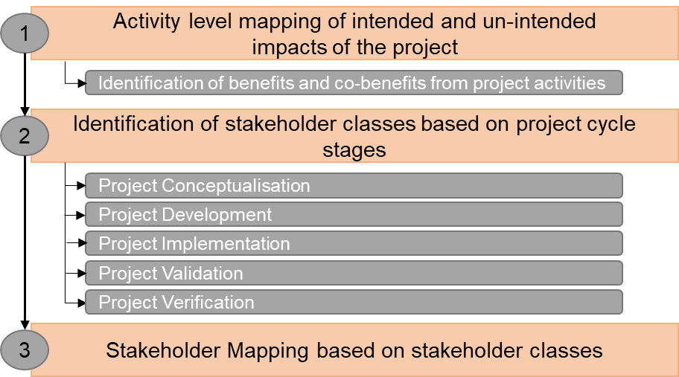

Figure 5: Stakeholder Identification Process
The first step involves developing a logic framework model for the designed project to identify activities based on intended and un-intended impacts associated with the project activities. This step will include the identification of benefits and co-benefits aligned with the project activity to identify the potential stakeholders associated at different stages of the project cycle.
After developing a holistic outlook about the overall benefits and co-benefits of the project; stage level stakeholder group identification is undertaken. The different stages considered for stakeholder identification are:
- Project conceptualization- stakeholders would include self-help groups, academia, community representatives who can help the project promoter make ingress within the community etc.
- Project Development- government representatives, community development groups, investors, employable youth, NGOs working in similar sectors etc. would be the stakeholders at this stage.
- Project implementation- end-users, implementing partners, stove part manufacturers etc. would comprise the stakeholders during implementation.
- Project monitoring- surveyors, database developers etc could be some of the main stakeholders during project monitoring.
At the end of the second step, different groups of stakeholders affected during different stages of project development will be identified.
For the convenience of engaging different stakeholder groups and obtaining their response, CQC generally identifies stakeholders under two broad classes: directly affected parties and indirectly affected parties. A detailed description of these classes is defined in section 2.2.2.
The final step includes stakeholder mapping and identification of representative individuals from each stakeholder class identified in step 2. Focus is kept on identifying stakeholders within each of the following categories: end-users, government organizations, international government agencies, non-governmental organizations, religious aid agencies, academic, current, and potential future implementing partners, stove manufacturers, carbon sector organizations, partner donors, the media, and individuals, and their families. Specific focus is made to include individuals and groups who may be directly or indirectly adversely affected by project activities.

Stakeholder Description
The stakeholders identified through the process described in section 2.2.1 are generally grouped under two broad categories as represented in the figure below:
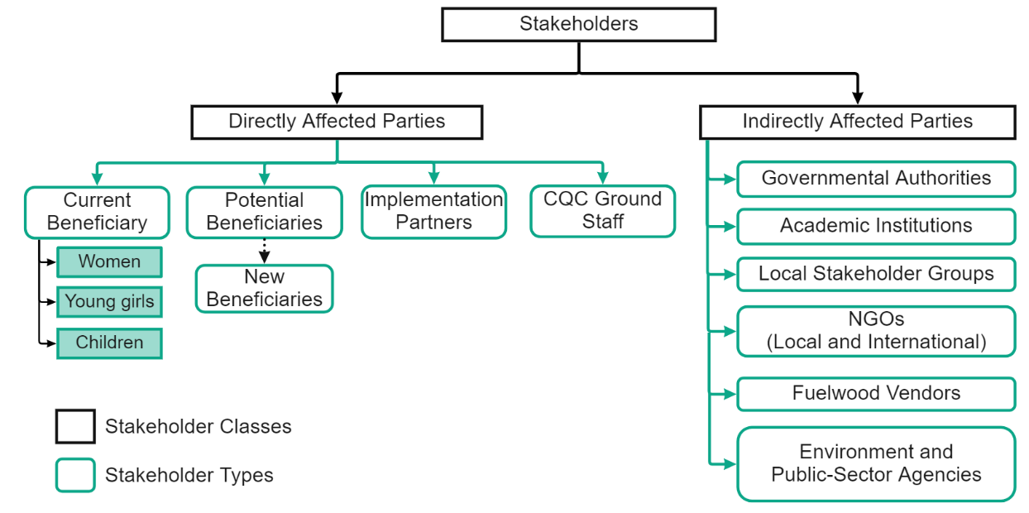

Figure 6: Type of Stakeholders associated with project activity

The stakeholders can be defined as
Directly affected parties: Directly affected parties can be further sub-divided into 4 categories:

- Current Beneficiary- TLCRS registered users: Women, young children, and elders are identified as individuals who are directly influenced by project activity, primarily women as the cook in the household, who are willing to adopt clean cooking technology. No hierarchy of priority is established to determine who receives an ICS sooner rather than later. Each household demonstrates interest and provides in-kind contributions to build the stove exterior. CQC will provide an ICS to each household in Mozambique that expresses the desire to adopt the technology. However, there could be occasional delays between the household’s desire to have a stove and its implementation owing to the availability of metal parts or implementing partner workloads, but CQC will ensure that all the households will receive the cookstoves in a stipulated time frame.

- Potential beneficiaries- New Users and potential adopters: Through advertisements, sensitization events, active communication and interaction with community leaders, groups such as Self-Help Groups and community meetings, local partnerships with academia, and government institutions and stakeholder consultation, CQC actively seeks out new beneficiaries.

The current and potential beneficiaries typically share similar characteristics within Mozambique as our current target demographics are individuals and households in rural settings, although there are plans to expand into the peri-urban and urban settings to offer the TLCRS to any individual prepared to adopt its technologies. This plan is designed to drastically reduce the need to use the three-stone cookfire. CQC provides all households with a double stove, which consists of two sets of metal parts and two individual brick constructions attached with two bricks at floor level to eliminate the use of the TSF cookstove for cooking.

Implementation Partner- Organizations in partnership with CQC: IP are the organizations with a local presence, community networks and knowledge of on-ground scenarios which gives them an extra edge in implementing the project. The IP are directly benefited/ impacted by the project through knowledge, skilled employability, and monetary benefits incurred due to project implementation.

- CQC on-ground staff: C-Quest Capital employs local manpower during various stages of project development and implementation to carry out its developmental activities in host countries. These individuals benefit not only from immediate employment in the organization but also through various training programs throughout the project life thereby improving their overall chances of employment.
Indirectly affected parties:
- Governmental Authorities: CQC and implementing partners engage with local traditional authorities through ‘Courtesy Calls’ to provide information and gain input on the anticipated projects and the target population. CQC teams gain permission from the local Traditional Authorities, to operate in these areas through these ‘Courtesy Calls;’
- Environment, Health, and Nutrition public-sector agencies: In-country agencies that work in tandem with CQC’s projects through implementation, operate in the same geographical areas, or operate their projects that may touch upon similar sectors as the projects CQC implements.
- Academic Institutions: CQC is invested in partnerships, providing funds, and welcoming interested academic institutions to study our projects at any level but our particular interest is through direct household-level studies of beneficiaries so that CQC can best understand the impacts, positive and negative, how to magnify the positive and eliminate or reduce the negative impacts. CQC currently has relationships with academic partners at Duke University, Lilongwe University, and Oregon State University, and various contracts through other high-ranking academic institutions.
- Local and International NGOs: In-country partners that work in tandem with CQC’s projects through implementation, operate in the same geographical areas, or operate their projects that may touch upon similar sectors as the projects CQC implements.
- Media: Any national media or international media that is interested in our projects.
- Others, as applicable and interested: CQC welcomes feedback and interest in our projects from interested sources that may not have been identified in this description. However, CQC reserved the right to act upon feedback and correspond with the party providing feedback to ensure it originates from a constructive source.

Stakeholder Consultation
CQC is committed to continuing consultations with stakeholders to ensure project activities include the identified benefits as they correspond to the Sustainable Development Goals. The LCS for the SD VISta process will be executed like that of the VCS process, with additional requirements of the SD VISta continuous engagement of stakeholders. CQC Implementing Partners engage with beneficiaries and their families several times over the year through household visits. During these visits, education and maintenance are consistently reinforced to the household, with hands-on technical assistance, if necessary. During the initial community sensitization and training by Implementing Partners, the benefits of the project are detailed to community members. Educational materials (brochures) are distributed to potential beneficiaries. For SD VISta, CQC will approach again all the identified stakeholders as well as expand impacted stakeholders to match the defining parameter. Identified stakeholders will be contacted through virtual means, informed about the SD VISta registry and the identified sustainable development initiatives. The stakeholders will also be provided with a detailed project description, and feedback will be collected and evaluated to determine if project designs should be altered to magnify positive impacts. Stakeholders will also be encouraged to provide public comments during the VERRA public comment period. The following chart provides information on how CQC will conduct stakeholder consultations for the SD VISta application with respect to different stakeholder groups.
Stakeholder Group | Identified Stakeholder  (Continuously expanding) | Information regarding Assessor’s site visit provided via | Consultation Activities
Directly Affected Parties | Current Beneficiaries (individual, household, and community level) | - Stove Champion  - Word of mouth | -Community Level Sensitization Activities  -Open Communication with implementing partner and CQC Direct
Directly Affected Parties | Potential Beneficiaries and Community Groups (individual, household, and community level) | - Stove Champion  - Word of mouth | -Community Level Sensitization Activities  -Open Communication with implementing partner and CQC  Direct
Directly Affected Parties | Implementing Partners | -Project Proponent  -Stove Champions | -Open Communication with CQC  -Training on Impacts of TLCRS and secondary project activities
Directly Affected Parties | CQC Local Staff |  | Open Communication with CQC and implementing partners  -Process of continuous stakeholder feedback through CQC website, and use of other medium as appropriate.
Indirectly Affected Parties | Governmental Authorities, Environment, Health and Nutrition public-sector agencies, Academic Institutions, Local and International NGOs, Media, and Others as applicable | -Email  -Telephonic conversation by Project Proponent | -Published announcement of continuous stakeholder feedback – local newspapers, CQC website, and other media as appropriate.  -Online, Email and Phone Distanced Feedback options  -CQC’s Social Media Communication and Updates  -Research Collaboration (academic, others (as applicable)
For the VCS project, CQC underwent a local stakeholder consultation (LSC) process between 13-April-2021 to 30-April-2021 through which feedback was sought virtually, due to the ongoing Covid-19 pandemic, through feedback forms on CQC’s website, direct email, and phone calls, with in-person distanced meetings occurring with individuals and groups of current beneficiaries. Stakeholders were invited to provide feedback via multiple methods including, an announcement posted on C-Quest Capital’s website on April 13th, 2021, with an electronic feedback form, Project Description Presentation, and Non-Technical Summary. Furthermore, an English newspaper advert ran in The Nation, a major national newspaper, on March 26th, 2021; and e-mail invitations were sent from C-Quest Capital on 24th February, 2021, to 43 people from organizations around the country including government, NGOs, stove manufacturers, project developers, academia and private and public-sector entities involved with cookstoves and/or sustainable energy.
Feedback was received from nine national stakeholders (Development Fund of Norway, United Purpose, Energy Africa, Total Land Care, Balaka Hospital/Tingathe Project, Balaka Civil Society Coalition, Ministry of Environmental Affairs/Department of Energy, Traditional Authority of Chiseka, USAID/Feed the Future) and female beneficiaries [see Annex VII and IX]. In summary, there was a considerable amount of positive feedback regarding the stove project. The female beneficiaries of the project greatly appreciated the lack of smoke on the CQC stove compared to open fires and that the stove has increased their time for other social/economic activities by allowing them to cook with fewer sticks. They also indicated that the pot skirt helps keep their pot cleaner and retain heat, thus allowing fast cooking. The stove releases less carbon, providing evidence that the CQC promoted stove can reduce respiratory infections if it is consistently used by households and supplemented by opening windows to allow for proper ventilation. Stakeholders agreed with these claims and further highlighted that the stove is responding to the issue of the growing scarcity of firewood. Energy Africa, indicated to be impressed with stove part production increases and subsequent increases in the installation of stoves among households.
Beneficiaries and their families are visited by CQC Implementing Partners several times throughout the year. During these visits, the household is continually reminded of the importance of education and upkeep, as well as receiving hands-on technical assistance. Educational materials (brochures) are provided to potential beneficiaries during the initial community sensitization and training by Implementing Partners.
Overall responses to feedback concluded that CQC/Mozambique should continue the stove projects and work towards being visible at the national level. Attending national level cookstove steering committee meetings and supporting the organization of such meetings, could help with visibility among key stakeholders. Additionally, steps should continue to be pursued to achieve two cooking stations per household and that CQC promoted cookstove interventions should be coupled with kitchen reconstruction to improve the health of beneficiaries. In considering this, maximum advocacy should be taken on the shared importance of the role an unventilated kitchen presents, in conducting improved cookstove implementation projects for rural communities. In conclusion, participants widely recognized the benefits of the stove programs already active in Mozambique and look forward to seeing how the reach and impact will be expanded on and how the lives of the people living there will be changed in the years ahead.
PP will ensure that regular monitoring will be conducted by the field staff and/or project managers to take feedback from the local stakeholders. Stakeholders’ will raise their concerns (positive or negative) during implementation of the project activity. The project proponent will take due account of the input received and will take the necessary action in terms of either updating the project design or justifying the stakeholder to resolve their queries.

Continued Consultation and Adaptive Management
To effectively meet the need of the beneficiaries and enhance the impacts of the project activities, CQC is driven to adapt and evolve, wherever possible throughout the lifecycle of the project. We are also committed to exploring new avenues and projects that promote sustainable development and, boost women's empowerment, child and household nutrition, health, and economic well-being.
CQC gathers feedback from beneficiaries throughout the year, ranging from informal consultations to more formal and rigorous surveys with specific questions about ICS use and uptake. Stakeholder input, specifically from the academy, beneficiaries, and potential beneficiaries, is encouraged to ensure continuous improvement.

Anti-Discrimination
CQC fosters an environment of mutual respect where employees and business partners can work together without fear of harassment, discrimination, or infringement on human rights. Any program which is implemented by CQC ensures that all applicable laws, regulations, and international standards, including the Universal Declaration of Human Rights and core ILO Conventions are adhered to. CQC has strict policies against discrimination and all implementing partner are provided a copy of it. This policy lays down clear directives on the process to follow if any sort of discrimination is observed.

Worker Training
Independent Contractors are contracted through CQC and the contract reflects the workers have trained in the U.S.A. anticorruption laws before the start of their employment and contracting. CQC provides training to country managers and other team managers, as appropriate, once these individuals are trained, they are responsible for providing standardized and regularly revised training and guidance to the teams they oversee and are trained by CQC in a train-the-trainer model. The contractors are also responsible for providing training to the household’s primary cooks in construction, maintenance, and best practices in using the TLCRS before the registration of the stove.
The training that is provided to the independent contracts by CQC is a two-day extensive training with ‘in-the-classroom’ education and the second day of on-the-ground training. The agenda topics for day one includes Review of the Program, information about CQC, The process, the purpose of the training, expectations, roles and responsibilities, basics of climate change, the impact of traditional fires, heat science, Details of the Stove, Registration & Verification. The agenda topics for day two include: time to travel to-from the village for stove implementation, group building of stoves, discussion of maintenance of stoves, construction of stoves in smaller groups, and wrap-up.
Training materials are in flux as CQC makes edits to the stove design or other identified areas where the training needs to be redesigned. Topics in the training that relates to the SDGs include education on climate change, health, and nutrition benefits of stove adoption, while having the double benefit of educating implementors on these topics, so they can engage in educated decisions in their day-to-day lives. The first day of training involves the description and visualization (PowerPoint) of how to construct the stove and the second day of training is when the project’s workers are trained directly in villages on how to construct the stove. The coverage and hands-on training build locally useful skills and knowledge to increase local participation in project implementation. These trained trainers go on to provide sensitization campaigns and training of each beneficiary, so the benefits are amplified.

Equal Work Opportunities
CQC makes every effort to abide by the laws and regulations of the countries it operates in, as well as, US law, and international statutes, as applicable. When conducting recruitment, CQC prioritizes hiring local community members and offers new opportunities to project beneficiaries as CQC expands operations and job openings arise.
This priority demonstrates CQC’s reverence for the deep understanding of cultural nuances that only local community members could hold and this quality in addition to the ability to take initiative and work independently are primary qualifications CQC seeks in candidates. CQC also seeks to mirror the percentage of women/men in the country in its in-country workforce, making all efforts to hire women candidates for all levels of positions.
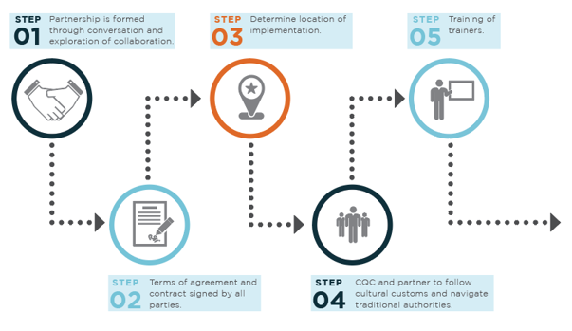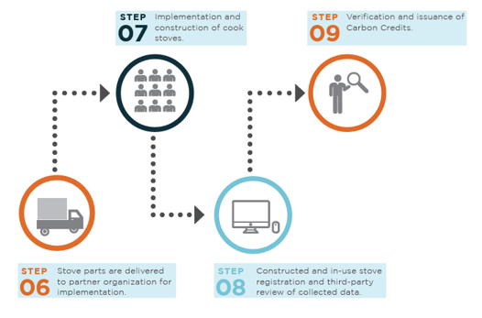
Figure 7: Steps of Project Cycle that include identification of equal work opportunities, partnerships, and training

Workers’ Rights
The contractor, synonymous with implementing partner, enters into an independent contractor agreement with CQC. The agreement contains details of CQC’s and the contractor’s compliance with laws including, national, sub-national, state, and local, as well as policies, laws, rules, and regulations, including the United States Foreign Corrupt Practices Act. Specific information is provided on anti-terrorism and anti-corruption efforts, including a code of conduct. Per the Core Labour Conventions of the International Labour Organization (ILO), CQC, respects, and works in tandem with the elimination of all forms of forced or compulsory labour, the effective abolition of child labour, minimum age convention, the right to organize, and the elimination of discrimination in respect of paid positions and occupation.

Occupational Safety Assessment
The employment opportunities generated through this project, or the use of the project stoves do not increase the safety risks that are already present in the landscape of the country. Moreover, accurate care is taken to mitigate the unintended potential occupational safety hazards by contracting workers who have lived in the community for several years. This assists in mitigating the occupational hazards through community familiarity, language fluency, and being native the culture. This understanding of traditional value, and mutual respect in the communities for CQC staff serves to support the reduction of safety hazards. Besides, to take care of any untoward incidences, CQC provides Group Personal Accident insurance to its office staff.
Paid positions or use of the stove do not increase the safety risks that are already present in the landscape of the country.

Feedback and Grievance Redress Procedure
CQC’s Feedback and Grievance Redress Policy and Procedure ensures that project-affected communities and individual grievances are properly prioritized and addressed. These measures are taken to enhance CQC’s accountability and transparency and to support the project initiatives that can help the communities to identify adverse effects to them, or their environment which had not previously been identified and mitigated by CQC. The full grievance redress policy and the procedure is available upon request and represented in the figure below:
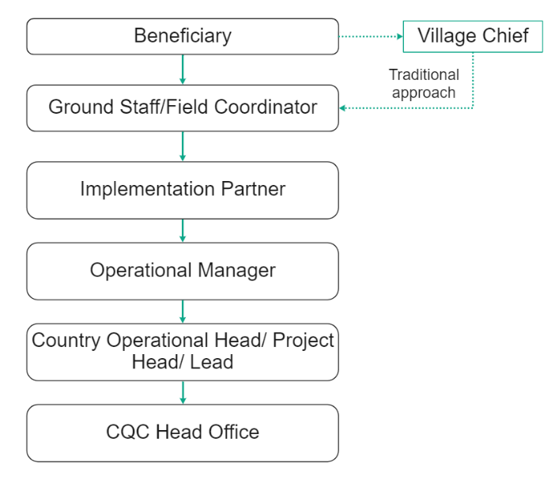

Figure 8: Grievance Redressal Mechanism
The first step of a complaint is typically applied to the informal procedure, where the affected person discusses the identified issue or provides feedback to the Field Coordinator or another member of the management team. In case the end-users are not very comfortable in approaching CQC team directly, a provision is made for them to approach it through their village chief. The village chief then reports the concerns to the concerned person, i.e., field staff from CQC who takes it further and resolves the issue. This is undertaken to protect the traditional sentiments and value system of the villages and help them express their issues without any hesitation. The Field Coordinator attempts to resolve the grievance immediately on an informal basis, seeking advice from other parties (Area Development Committee, etc.) where necessary. The Field Coordinator and affected person work together as immediately as possible, to solve the identified issue. This informal procedure does not prevent an individual or community from a formal complaint process at any time.
The formal process requires the grievance to be filled in a written form, with the form available at the TA’s office and collected by the CQC Field Coordinator. If literacy is a barrier, or other barriers exist such as distance to the TA’s office, a telephone call to the CQC Direct office in Mozambique is recommended where the grievance is recorded in written form by a staff member at the office. The CQC Direct office number is available to all project beneficiaries on brochures and posters provided at registration and during community sensitization.
All grievances are to be assessed and an update is provided to the grievant within 10 days. Three options for procedure guide CQC Direct’s response (a) resolution is offered immediately according to the request made by the grievant; (b) resolution is more complex and requires additional consideration or extraordinary resources will lead to the grievant invited to a meeting to discuss options; and (c) where the complaint cannot be resolved through a meeting an investigation is arranged within 1 week (7 days) to gather additional information, led by the Field Coordinator, followed by a grievance hearing within 10 working days of the completed investigation. Formal grievances are recorded in summary and shared with CQC to identify if the complaint is a project-wide issue that necessitates a system change in implementation.

Feedback and Grievance Redress Procedure Accessibility
The CQC Grievance Policy and Procedure is accessible as a phone number of the CQC office in Mozambique is available on the brochure provided to each household, which is the most accessible manner to provide feedback. CQC policy and procedure outline the process to evaluate and respond to complaints; the procedure details when a serious level complaint should be communicated to CQC country teams and when it would be best addressed by the implementing partner.

Stakeholder Access to Project Documentation
A hard copy of all the project related documents is maintained with CQC IPs and central office in the host country which is accessible to all the stakeholders associated with the project, especially end-users. Considering that the project documents are very technical and will be difficult for the end-users to comprehend, a non-technical summary detailing the project activities and its outcomes is also available with IPs as well as central office in the host country. During the distribution of the project stoves, enhanced focus is laid on verbally communicating the information about accessibility of project documents among CQC implementing partners, staff, and local community members. In addition to verbal communications, a dedicated helpline number is provided to the end-users through which they can contact the IPs or CQC ground staff to access the project documents. Further, CQC also posts these reference documents on its website offering open access to all the stakeholders. An effort is also made to ensure that end-users understand the process of accessing these documents on website by providing them verbal communication as well as a flyer with pictorial representation of the steps to access this documentation. Efforts are made to publish links to these materials across CQC's social media footprint.

Information to Stakeholders on Assessment Process
CQC informs the beneficiaries and their families that they are participating in a project that distributes the TCLRS improved cookstove at an in-kind donation (labour and bricks constructed from locally available resources) to improve their respiratory health, food security, family economy through reduced cost of firewood and times saving, and the environment. We also inform them of our need to track their successes and monitor key data, such as money spent on wood fuel and/or time spent collecting wood fuel, among other indicators. As CQC is committed to preserve the cultural integrity of the community and the stakeholders involved in the project, prior information about the assessment process and assessors site visit is provided to all the relevant stakeholders. The medium adopted to inform the stakeholders about assessors’ site visit is also provided in section 2.2.3.
The end-users are informed before hand about the probable dates of the assessor site visit and the type of information that might be enquired from the end-users. This information is provided based on the experience gained by the project proponent from previously concluded audits. This information is communicated to the end-users through the stove champions and word of mouth as they personally visit the families to provide the information. Anyhow post implementation stove champions visit the families for spot audits and regular checks to ensure that the stoves are working efficiently and if the end-users are facing any kind of challenges. In addition to end-users, other stakeholders like Implementing partners and surveyors are informed regarding the assessors visit by CQC through telephonic conversations and emails. Apart from implementing partners and end-users, assessors also interact with local stakeholders like academicians, local people, government officials etc. These stakeholders are also informed about the assessors visit by the project proponent through emails or telephonic conversation.
Conclusively, as the SD VISta program progresses, the main forms of communication to stakeholders will be through stove champions, social media, and the CQC website. We will announce our participation through training, community sensitization programs, social media, public releases, and our website.

Project Management

Avoidance of Corruption
CQC and/or its affiliates and subsidiaries, as the primary project proponent, and those entities contracted as implementing partners, are committed to combating any form of corruption, bribery, embezzlement, fraud, favouritism, cronyism, nepotism, extortion, and collusion. CQC’s employees sign a code of business ethics and conduct form provided to them in the employees’ handbook that mandates performance of all duties with honesty, integrity, and impartiality, without improper preferential treatment of any person, and undergo mandatory anti-corruption and antibribery training as a condition of employment. CQC’s implementation partners are required to review CQC’s anti-corruption and anti-bribery policies and must take anticorruption and antibribery training before performing any project implementation services as a condition of their contract.

Statutory and Customary Rights
CQC operates from private homes, enhancing remote employment capabilities, and a central office location in Washington, D.C. U.S.A. Community sensitizations and training take place either on public land, i.e., a central town meeting point, or on private property with the explicit verbal invitation of the homeowner. The CQC implementing partners enter the kitchen space of the household to install the TLCRSs only with the explicit permission of the household. CQC and its implementing partners take active consideration of individual and collective rights to ensure all rights are respected.

Recognition of Property Rights
CQC's implementing partners only install a stove at the informed invitation of the household and CQC’s ICS does not infringe or interact with property rights.

Free, Prior and Informed Consent
The project activities will take place with the approval of Village Development Committees and Area Development Committees in a series of consultation meetings as documented. In addition, ICS is a completely voluntary activity and households in participating villages are free to choose whether they take part or not. Free, prior, and informed consent takes place before installation.

Restitution and/or Compensation for Affected Resources
CQC's installation of an ICS does not affect any party’s access to resources or their lands; no negative effects have been identified.

Property Rights Removal/Relocation of Property Rights Holders
CQC’s ICS installation does not impede, involuntarily remove, or relate the land or property rights of the beneficiaries or their families. ICS installation incentivizes the beneficiaries to end the use of three-stone fires and use project stoves for cooking activities. While this may change the cooking activity practices to some extent, post-implementation surveys of beneficiaries suggest that the ICS allows them to decrease cooking times while making identical food items as with three-stone fires. This is seen as clean technology adoption and not an infringement of important cultural activities.
The project activities do not involve the removal or relocation of property rights holders from lands or territories, nor do they force rights holders to relocate activities.

Identification of Illegal Activities
Theft and corruption are commonly identified as illegal activities in Mozambique. As there is no transfer of funds at the beneficiary level CQC expects to eliminate the cause of corruption. Theft of metal stove parts has occurred in the past and CQC has since implemented secure storage and direct hand-off of stove parts to reduce this occurrence

Ongoing Conflicts or Disputes
There are no identified ongoing conflicts or disputes as the project scope does not involve rights to lands, territories, and resources. As the project implementation takes place within the private household, project activities would not interfere with the outcome of an unresolved dispute.

National and Local Laws and Regulations
CQC adheres to the local and national laws of the country. Project Implementors are registered with appropriate national authorities allowing them to conduct their operations, with CQC projects as an add-on. Relevant and applicable international and U.S. statutes and regulations are abided by.

Project Ownership
Beneficiaries agree to allow CQC to do the following:
- Claim the GHG emission reduction and/or removals generated by the technology used by the CC ICS project.
- Conduct follow-up and spot audits for increased adoption and monitoring purposes.
The stoves themselves are owned by the beneficiaries with in-kind contributions, including making and constructing the bricks for the construction of the TLC Rocket Stove.

Grouped Projects
With CQC’s group projects, secondary projects are identified through stakeholder assessment and development initiatives at the community level that we can meet. New project activities are assessed and evaluated to determine if they provide significant individual impacts (funding of education), household (cookstove), or community level (training on climate change). Following, new project activities are evaluated against current projects in their thematic buckets to determine if CQC and IPs have the bandwidth to take on additional projects. If acceptable, pilot projects on a small scale may begin to evaluate the implementation and identify necessary changes. CQC remains committed to being flexible with the addition of new projects so long as current projects continue their projected timelines and anticipated impact and benefit to the beneficiaries.
For the inclusion of new project activity instances i.e., ICS, the project proponent shall ensure that it meets the eligibility criteria below – per Appendix 1 – Grouped Projects (GP) of the SD VISta Standard.

S.No. | Criterion | How the new project activity instances to comply
1 | Adopt and implement the project activities in the same manner as specified in the project description. | New project activity instances will be implemented in the same manner as described in the project description and will be implemented directly with beneficiaries of the TLCRS (TLC Rocket Stove), extending benefits and reinforcing project stove adoption
2 | Where appropriate, meet the applicability conditions of the SD VISta asset methodology applied to a project. | The project activity as well as the new project instances do not apply for SD VISta assets and hence this criterion is not applicable
3 | Are subject to the same scenarios at project start with respect to stakeholders’ well-being as determined for initial project instance(s), where (per Section 2.1.5.2 above) the project must meet the criteria of Section 3.1 above | New project activity instances will have the same baseline scenario, which was available during the start of project, i.e., usage of TSF cookstoves in the households. Also, the instances will be designed to maximize intended impact and preserve well-being, with monitoring and ongoing stakeholder consultations to ensure impact,
4 | Are subject to the same scenarios at project start with respect to natural capital and ecosystem services as determined for initial project instance(s) where (per Section 2.1.5.2 above) projects must meet the criteria of Section 3.2 above. | New project instances will have the same scenario w.r.t natural capital and ecosystem services as determined in the baseline scenario. All the new instances will also have households relying on wood fuels for meeting their daily cooking energy demands.
5 | Are subject to the same processes for stakeholder engagement described in the project description | The new project activity instances will be detailed during continuous stakeholder consultations, refresher trainings for Implementing Partners and feedback consider in secondary project activity design to maximize intended impact and preserve well-being.
6 | Are subject to the same processes for respect for rights to lands, territories and resources – including free, prior and informed consent – described in Section 2.4 above. | The outlined Project Management (Section 2.3) will apply for each additional project activity
7 | Secondary projects will have similar monitoring elements to those set out in the project description | Additional projects will have equivalent monitoring plans and procedures as described in Section 3.3

Benefits for People and Prosperity

Condition of Stakeholders at Project Start
Current and Potential beneficiaries- Mozambique’s vulnerability to climate change is a function of its location and geography: large areas of the country are exposed to tropical cyclones, droughts (every three to four years) and river/coastal storm surge flooding. This vulnerability is heightened by the country’s 2,470 km of coastline and socioeconomic fragility. More than 60% of the population lives in low-lying coastal areas, where intense storms from the Indian Ocean and sea level rise put infrastructure, coastal agriculture, key ecosystems, and fisheries at risk. Although migration to urban areas is rising, two-thirds of the population still resides in rural areas with limited access to electricity, improved drinking water and sanitation. 45% of the population lives below the poverty line and 70% depends on climate-sensitive agricultural production for their food and livelihoods. Increased frequency and severity of intense storms, droughts and floods are likely to exacerbate these development challenges.
The country also suffers from high rates of poverty and ~45% of the population lives below the poverty line and 70% depends on climate-sensitive agricultural production for their food and livelihood. Malnutrition in childhood and pregnancy has many adverse consequences for child survival and long-term well-being. It also has far-reaching consequences for human capital, economic productivity, and national development overall. In Mozambique 6% of children under-five are acutely malnourished or wasted (have low weight-for-height) and 43% of children under-five are stunted (have low height-for-age), according to the most recent Demographic and Health Survey (DHS) (MISAU, INE, and ICFI 2011).
This firewood is typically large diameter logs that the women and children, primarily girls, are responsible for collecting. As the population has increased and rapid deforestation results, where the industry is also a contributor, women, and children have had to travel farther distances to gather firewood for their three-stone cookfires. Cooking on three-stone cookfires occurs in a closed walled building, made from locally available resources. With these low-efficient cookfires, women and children are exposed to HAP for extended durations, resulting in high levels of Chronic Obstructive Pulmonary Disease (COPD), asthma, and other negative respiratory effects. Due to the long cooking times on the inefficient TSF, much of the nutrients in the food are lost resulting in the consumption of lower nutrient-rich food.
Implementing Partners- The condition of implementing partners at the start of the project varies between partner and their organizational network and structure. Traditionally, partners are considered based on their current or prior scope of work, existing networks, history of development projects of similar scope or significance, history of work within communities of project implementation and general standing. The TLCRS project is often coupled with existing projects under the IPs work portfolio.
CQC employees in the host country- Mozambique faces major employment challenges. The unemployment rate currently stands at 27%, and of those employed, only 6% are employed in the formal sector and only 3% are active in the private sector. Therefore, the informal economy is estimated to absorb 68% to 95% of the total labour force (ibid). Moreover, many of the existing jobs are in low-productivity or low-income-earning activities. According to the Let’s Work Partnership (forthcoming), as much as 80% of the working population earns less than $2 a day. Also, considering the current influx of youth entering the labour market standing at around 3% annually presents the immense need of generating employment opportunities. In view of this, the proposed project generates employment opportunities and hence impact the local individuals of the country.

Expected Impacts on Stakeholders

Impact #1 | Ability to cook using TLCRS
Type of Impact | Positive, actual, direct
Affected Stakeholder Group(s) | Beneficiaries, beneficiaries’ families
Resulting Change in Well-being | - Decreased reliance on fuelwood.  - Switching to small branches and twigs from perennial shrubs, agroforestry, and crop residues.  - Freeing up time and money for other income-generating pursuits.  - Health benefits due to reducing exposure to smoke in the home.  - Increased food security due to nutrient retention with decreased cooking time.

Impact #2 | Improved Health Status
Type of Impact | Positive, Predicted, Direct
Affected Stakeholder Group(s) | Beneficiaries, Beneficiaries’ families, specifically women, children under 5 years of age.
Resulting Change in Well-being | - Lowered risk of developing COPD or worsening COPD.  - Less instance of acute lower respiratory illness and anticipated reduction of burns due to contained flames.  - Improved overall respiratory health  - Increased ability to consume safe drinking water by reducing boiling water time.

Impact #3 | Reduction of time spent on unpaid domestic work
Type of Impact | Positive, Predicted, Direct
Affected Stakeholder Group(s) | Beneficiaries (most notably, female, elderly, and children, primarily girls)
Resulting Change in Well-being | - Females will have a predicted time saving which can be redirected to income-generating activities or relaxation time.  - Contributing to enhanced conditions for gender equity.

Impact #4 | Improved Economic Outcomes
Type of Impact | Positive, Predicted, Indirect
Affected Stakeholder Group(s) | Beneficiaries, Beneficiaries’ Families, primarily female children
Resulting Change in Well-being | - Families predict money and time savings with fuel efficiency.  - Reducing costs of firewood purchases and/or time savings on the collection of wood.

Impact #5 | Improved Nutrition through access to cookstove to cook meals with reduced biomass need
Type of Impact | Positive, Predicted, Indirect
Affected Stakeholder Group(s) | Beneficiaries’ Families, particularly children
Resulting Change in Well-being | - More consistent access to cooked food because the household cook will no longer be reliant on large-diameter wood to cook a meal; instead, small twigs or crop biproducts can be easily collected in and around the household, ensuring reliable fuelwood access to cook food.  - When fuelwood limitations are included in, the effect is amplified, affecting both the quality and amount of cooked food.

Impact #6 | Trainings imparted on climate change, project implementation and monitoring procedures
Type of Impact | Positive, Predicted, Indirect
Affected Stakeholder Group(s) | Implementing Partner Staff, CQC Country Staff
Resulting Change in Well-being | Training and skill development related to community engagement, survey conduction, technical trainings like conducting Water Boiling Tests (WBT) will be provided to many stakeholder groups which is envisaged to empower their lives by not only providing long-term employability but also through increased awareness levels regarding issues related to climate change, social equity.

Impact #7 | Reduced income of fuelwood vendors
Type of Impact | Negative, Predicted, Indirect
Affected Stakeholder Group(s) | Local fuel wood vendors
Resulting Change in Well-being | There is a possibility that reduction in the demand of wood-fuel associated with usage of energy efficient ICS might affect the vendors selling fuel wood in Mozambique. However, considering the significant demand-supply gap and the over reliance of Mozambican population on fuelwood for cooking needs, decrease in the fuel-wood demand in project location is not likely to have a significant negative impact on wood vendors.

Stakeholder Monitoring Plan
This section explains the monitoring approach that will be undertaken by the PP to monitor the impacts of the designed project activities observed on the key stakeholders associated with the project activity. The impact mapping for every stakeholder has been conducted with respect to the potential SDG claimable for that stakeholder category.
The following tables describes the mapping of project activity with impacts on stakeholder classes and the monitoring parameter that will be used to assess the intended and un-intended impacts of the project activities:

S.No. | Stakeholder Group Impacted | Impact | SDG Indicator | Monitoring parameters | Monitoring Approach | Sampling | Monitoring frequency
1 | End User Household | Access to clean cooking technology | 1.4 | Monitor the number of ICS distributed under the project as an indicator of providing access to basic services to households | $$Net Benefit= {ICS}_{project}-{ICS}_{baseline}$$  Where:  Source: ICS distribution records | 100 per cent of data | At the start of project
  $${ICS}_{project}$$ | Number of ICS installed representing access to basic service in project scenario
  $${ICS}_{baseline}$$ | Number of ICS present in baseline. A value of 0 is considered as the project activity is implemented in only those HHs that use three stone fire or traditional stoves in baseline.
 |  |  |  | Monitor proportion of users reporting money saving due to reduction in purchase of fuelwood post project implementation | $$Net Benefit=\frac{{HH}_{less FW purchase}}{{HH}_{FW purchase}} ×100$$  Where:  Source: ex-post monitoring survey records | Simple Random sampling with 90 per cent confidence interval and a 10 per cent margin of error achieved for monitored parameter | Annually/  Biennially
  $${HH}_{less FW purchase}$$ | HHs reporting reduction in expenses due to less fuelwood purchase post project implementation
  $${HH}_{FW purchase}$$ | HHs reporting purchase of fuelwood in baseline scenario. Determined once prior to or concurrent with first verification.
2 | End User Household | Reduced exposure to PM_{2.5} emissions and household air pollution | 3.9 | Reduced PM_{2.5} emissions | $$Net Benefit= {PM}_{2.5 baseline}-{PM}_{2.5 project}$$  where  Source: Lab test report of Project stoves providing emission level of PM_{2.5}. | Not applicable | At the start of the project
  $${PM}_{2.5 baseline}$$ | PM_{2.5} emissions in baseline stoves (TSF) a value of of 52.699 mg/min (or 3.9 g/Kg fuel) is considered based on lab test report of TSF.  Clean Cooking Catalog (cleancookstoves.org)
  $${PM}_{2.5 project}$$ | PM_{2.5} emissions in project stoves.
2 | Primary cook (mainly women and young girls) |  | 3.9 | Users reporting reduction in smoke/improvement in health parameters associated with cooking | $$Net Benefit= {IC}_{baseline}-{IC}_{ project}$$  where  Source: monitoring surveys conducted to determine percentage of users reporting inconvenience due to smoke in the kitchen post project implementation. | Simple Random sampling with 90 per cent confidence interval and a 10 per cent margin of error achieved for monitored parameter | Annually/  Biennially
  $${IC}_{baseline}$$ | Users experiencing inconvenience due to smoke in baseline. Determined once prior to or concurrent with first verification.
  $${IC}_{ project}$$ | Users experiencing inconvenience due to smoke post project implementation
3 | End User Households | Affordable and clean energy | 7.1 | Monitor proportion of ICS distributed and operating under project as an indicator of clean technology | $$Net Benefit={ICS}_{ project}×N_{y}$$  where  Source: ICS distribution records and ex-post monitoring surveys conducted to determine proportion of operational stoves | ${ICS}_{project}$-100% of data  $N_{y}$- Simple Random sampling with 90 per cent confidence interval and a 10 per cent margin of error achieved for monitored parameter. | Annually/  Biennially
  $${ICS}_{project}$$ | Number of ICS installed representing access to clean technology in project scenario
  $$N_{y}$$ | Proportion of operational stoves
4 | Women and young girls | Reduced drudgery | 5.4 | Proportion of users reporting time saving due to reduction in fuel collection amount and faster cooking on project stoves | $$Net Benefit=T_{ baseline}-T_{project}$$  where  Source: monitoring surveys conducted to determine average time saved in project scenario. | Simple Random sampling with 90 per cent confidence interval and a 10 per cent margin of error achieved for monitored parameter | Annually/  Biennially
  $$T_{ baseline}$$ | Average time spent in fuel collection and cooking in baseline scenario. Determined once prior to or concurrent with first verification. Alternatively a value of 10.5 hrs/week can be assumed (Review of Wood fuel Biomass Production and Utilization in Africa: A Desk Study (unep.org))
  $$T_{project}$$ | Average time spent in fuelwood collection and cooking in project scenario
5 | Children | Improvement in overall health status | 2.0 | Reduced Stunting observed in children under 5 years of age indicating improved nutrition | $$Net Benefit={ST}_{ baseline}-{ST}_{project}$$  where  Source: monitoring surveys conducted to determine proportion of children below 5 years exhibiting signs of stunting. | Simple Random sampling with 90 per cent confidence interval and a 10 per cent margin of error achieved for monitored parameter | Annually/  Biennially
  $${ST}_{ baseline}$$ | Proportion of children reporting height for age <-2 standard deviation from the median of the World Health Organization (WHO) Child Growth Standards in baseline. Fixed ex-ante through survey. Alternatively default value of 35% can be used
  $${ST}_{project}$$ | Proportion of children reporting height for age <-2 standard deviation from the median of the World Health Organization (WHO) Child Growth Standards post project implementation.
6 | Implementation Partners and Survey Agencies | Employment generation | 8.3 | i. Number of local people employed for ICS distribution activities  ii. Number of local people employed for conducting impact survey. | $$Net Benefit={ES}_{ project}-{ES}_{baseline}$$  where  Source: employment records | 100% of data | To be monitored for the duration of monitoring period at the time of each verification
  $${ES}_{ project}$$ | Gainfully employed staff in project scenario.
  $${ES}_{baseline}$$ | Gainfully employed staff in baseline. A value of 0 shall be considered as in absence of project activity there would not have been any increase in employment opportunity
7 | CQC staff | Skill set development and awareness generation | 4.4 | Number of individuals trained | $$Net Benefit={Training}_{ project}-{Training}_{baseline}$$  where  Source: Training Records; Feedback forms |  | To be monitored for the duration of monitoring period at the time of each verification
  $${Training}_{ project}$$ | Trainings provided in project scenario
  $${Training}_{baseline}$$ | Trainings provided in baseline. A value of 0 shall be considered as in absence of project activity, no training would be required to be conducted

Sampling Plan
The end-user impact survey indicated in the table above refers to the primary survey that will be conducted to assess the impacts associated with the implementation of project activities. The following section describes the sampling approach that will be adopted to conduct these surveys.
Target Population: The quantification of benefits achieved through the project will be conducted by consulting the end-user beneficiaries, i.e., the households that have received the ICS.
Sampling Method: Simple random technique will be adopted to conduct a sampling survey among ICS batches. This approach will be adopted owing to the following aspects:
  - Homogenous nature of the project activity, i.e., common technology (ICS) with similar operating characteristics is distributed across different states/provinces of the country.
  - Existing of homogeneous sub-population
To ensure a random selection of ICS, random number generators shall be applied. Each ICS in the target population is uniquely identifiable by its unique ID number. Each ICS can thus be allocated a Sample Selection Number in each monitoring period, starting at 1 and increasing up to the total number of ICS in the database for that pre-defined sampling frame. Applying the random number generators, the ICS can then be randomly chosen from the defined population up to the required sample size as calculated by the project proponent.

Sampling Unit: Households that have received project stoves
Sampling Parameters: The following two parameters are used to estimate the sample size:
N_{y,i,j}: | Visual inspection of the premises to see if ICS is operational and in use. Interview with end-user if required to verify that ICS is still in use (Yes/No)
B_{y=1,new,i, survey} | Interview with end-user for determining the average quantity of firewood used in the project stove per day. Measurement campaigns for estimation of consumption of wood in project households. (Woodfuel quantity)
Sample Size:
For the estimation of the proportion or mean value of the parameters investigated, the minimum sample size for each sample frame must achieve 90/10 confidence/precision. The procedure to determine the sample of households will ensure that they adequately represent the broader project population, minimizing sampling error. Using a 90 per cent confidence level, and a 10 per cent margin of error, random samples will be selected from each Primary Sampling Unit. To calculate the required sample size estimates, proportions and the mean values are required. Furthermore, the standard deviation needs to be assumed in the case of sampling for a mean value. As per Guidelines for Sampling and surveys for CDM project activities and programmes of activities, there are different ways available to obtain the estimates of the parameter of interest:
- Refer to the result of previous studies and use these results.
- In a situation where information from previous studies is not available, a preliminary sample as a pilot could be conducted and use that sample is used to provide the estimates.
- Use best guesses based on the researcher’s own experiences.
For the registration purpose of project, option (c) as stated above shall be applied. For the following monitoring periods, the estimates can be adjusted taken the results of the previous monitoring period(s) into account or the result from recent pilot study which is conducted after the previous monitoring periods.
The following assumptions are made to exemplify the sample size calculation for the parameters.
- An overview of the estimated sample sizes for a hypothetical population of 100,000 ICS units applying a level of 90/10 is provided below. It is likely that all the sample frames for each parameter will include fewer than 100,000 ICS in the first monitoring period, so this is a conservative approach. Hence, population size, N, is taken as 100,000 households/ICS (Assuming one ICS for one household).
- It is expected at least 80% of ICS still in operation, hence the expected proportion p is taken as 0.8.

Sample size calculation:
Parameter N_{y,i,j}:
The calculation of the required sample size for each parameter in the first monitoring period is illustrated below. In all cases a conservative approach is taken, however, if for any parameter the required confidence/precision is not met then the Coordinating and Managing Entity (CME) will randomly select an additional sample and collect further data from this sample to ensure the pooled data meet or exceed the required thresholds.
Based on the above assumptions, the resulting sampling size is calculated as:
$$n≥\frac{1.{645}^{2}×100,000×0.8\left(1-0.8\right)}{\left(100,000-1\right)×0.1^{2}×0.8^{2}+1.{645}^{2}×0.8\left(1-0.8\right)}=67.61$$
Therefore, in this case, a sample size of 68 is to be sampled from each primary sampling unit.
Parameter B_{y=1,new,i, survey}:
To determine sample size in the first monitoring period, the performance of ICS is characterized by the range of likely mean wood consumption and the likely values of SD relative to the mean, according to the type of ICS. The ICS models that are manufactured in modern factories tend to be very highly efficient (30-50% thermal efficiency) and have been designed to meet stringent efficiency specifications, so the standard deviation is expected to be relatively low.
To estimate the sample size for parameter B_{y=1,new,i, survey} the following equation is used:
Where:
n = Sample size
N = Population size (Total number of households/ICS)
mean = Expected mean of ICS thermal efficiency
SD = Expected standard deviation
1.645= Represents the 90% confidence required
0.1 = Represents the 10% relative precision
Based on the above assumptions, the sample size calculation would be
$$n≥\frac{1.{645}^{2}×100,000×{\left(\frac{0.076}{0.38}\right)}^{2}}{\left(100,000-1\right)×0.1^{2}+1.{645}^{2}×{\left(\frac{0.076}{0.38}\right)}^{2}}=10.82$$
The resulting sample size based on the above equation is smaller than 30, since B_{y=1,new,i, survey} is a numeric mean value (i.e. not a proportion or percentage) the Student’s t-distribution shall be used as per paragraph 14 of “Standard for Sampling and Surveys for CDM Project Activities and Programme of Activities, version 09.0.
The sample size for parameter B_{y=1,new,i, survey} under t-distribution is referred to the equation below:
Where t_{n-1} is the value of the t-distribution for 90% confidence when the sample size is n. Since the sample size is not known yet, the first step is to use the value for 90% confidence when the sample is large, i.e., 1.645 and then redefine the calculation.
$$n={\left(\frac{1.645×0.076}{0.1×0.38}\right)}^{2}=10.82$$
Thus, n is rounded up to 11.
The calculation now needs to repeat using t-value for 90% confidence and n = 11
$$n={\left(\frac{2.228×0.076}{0.1×0.38}\right)}^{2}=19.86$$
And n is rounded to 20.
The calculation now needs to repeat using t_{n-1} value for n = 20. The process should be iterated until there is no change to the value of n.
t₁₉₋₁ | 2.093
n= | 17.52
Round up | 18

t₁₈₋₁ | 2.110
n= | 17.81
Round up | 18

The repeated calculation shows that n = 18. Thus, the sample size to be sampled from each sampling unit is 18.
Since parameters N_{y,j,j} , and B_{y=1,new,i, survey} share the same sampling units, CME may choose to have one common survey for these two parameters with the largest number of sample size between these two parameters being chosen. Sampling more than one parameter within the same sample (household) helps reduce travel needs for monitoring and the associated costs. At the same time, this approach ensures the random selection of samples for every parameter.
Oversampling is strongly encouraged, not only to compensate for any attrition, outliers or non-response associated with the sample, but also to prevent a situation at the analysis stage where the required reliability is not achieved, and additional sampling efforts would be required. The sample size shown above will be adjusted upwards to account for non-responses, CME shall determine the appropriate non-responses rate based on previous experience.
Data type and data collection tool: Qualitative data regarding the benefits and co-benefits aligned with project implementation will be collected from end-users to obtain unbiased and reliable information on the SDGs claimed under the SD VISta programme. This will be captured through a structured questionnaire which will be prepared based on effective brainstorming, review of literature and baseline scenario assessment of the project locations. Questionnaire comprising of both open and closed-ended questions will be adopted to gather feedback from the end-users and relevant stakeholders within the countries.
Quality Assurance/ Quality Control:
PP will apply measures to ensure the required confidence/precision for each sampled parameter is met, allowing for non-response and the possible removal of outliers from the sample, as part of a Quality Control/Quality Assurance system. The choice of measure applied to each parameter will depend on the cost of each data collection approach and the logistics required. The PP will determine the most effective measure for each parameter from the following list (illustrated using a required sample size of 20 and an effect of non-response of 2 to 4 ICS):
- Oversampling: Randomly draw a sample of a minimum of 24 ICS and collect data from each
- Buffer Group: Randomly draw a sample of a minimum of 24 ICS and collect data from only 22 ICS. If this would not result in the required sample size data would be collected from the additional 2 ICS that were selected in the sample.
- Draw an additional sample: Randomly draw a sample of 22 ICS and collect data from these. If the required sample size is not achieved, an additional sample of 2 elements will be drawn and included in the sample.
- Use lower confidence bound (of N_{y,i,j.}, B_{y=1,new,i, survey}) or, with a conservative approach according to the parameter definitions,

The CME may choose to stop monitoring a particular parameter once the required level of confidence/precision has been reached if the calculated minimum number of samples has been achieved. As an example, the following steps could logically be followed for the case of applying a 30% buffer:
- Visit the first 10% of premises required for the 30% buffer. If the number of responses is sufficient to achieve the required reliability level, then stop sampling.
- If step 1 is not sufficient to achieve the required reliability level, then visit the next 10% of premises (increases the additional sampling to 20% of the 30% buffer). If this additional sampling is sufficient, then stop sampling.
- If step 2 is not sufficient to achieve the required reliability level, then complete the final 10% of the additional sampling buffer (bringing the total to 30%).
The sampling plan has the following procedures in place to ensure good quality data. The CME will ensure that field personnel have reviewed, understand, and signed the monitoring plan, including provisions for maximizing response rates, and documenting out-of-population cases, refusals, and other sources of non-response. Quality control and assurance strategy will be documented. Quality control and assurance strategies include addressing non-sampling errors, such as non-response or bias from the interviewer. The monitoring plan will explain how to properly survey households to prevent bias from the interviewer. In the case a household refuses to participate, another household will be chosen at random. To reduce interviewer bias, a good questionnaire design and well-tested questionnaires will be used.
The calculation of the sample size will be carried out using estimates for parameter proportions, mean values and standard deviations, as the actual characteristics of the population/sampling frame are unknown. To ensure the quality of the sampling results, the CME can draw on the provisions for reliability calculations as provided by the Guidelines for Sampling and Surveys in CDM Project Activities and Programme of Activities (version 04). If the sampling results do not fulfil the required level of confidence and precision, the CME can undertake additional samples. If the reliability is still not sufficient after additional samples or other measures, the sampling may be repeated with increased sample size. Alternatively, the CME may choose to apply the lower bound or higher bound according to the more conservative approach.
Data archiving
Hard copies of the surveys will be kept, and the registration database will have a backup. Original stove purchase contracts or other means of acceptance by the users will be stored in the main office for the coordinating entity. A backup of the registration database will also be stored on an electronic medium by the PP. All data monitored and required for verification and issuance will be kept for two years after the end of the crediting period or the last issuance of VCUs for the project activity, whichever is later.
Analysis
The PP will manage a project database that includes the following data that can be directly attributable to the project activity, thereby allowing unambiguous determination of the emission reductions attributable to the project:
- A list of households participating in project activity, including name, community/location, distribution date and unique serial number
- Where replacements are made, assurance that the efficiency of the new ICS is like the specified
Data obtained from the samples will be used to estimate proportions and mean values for the parameters described above. The values will then be factored into the emissions reduction calculations and result in the request for issuance of VCUs. The stoves that are not in use will be excluded from emissions reduction calculations and will not be counted towards the total number of ICS in operation during the monitoring period.
Implementation
Sampling for the purpose of emission reduction calculation and elaboration of the monitoring report will occur at the end of each monitoring period. This sampling will be conducted by trained personnel either part of the CPA Implementer or CME team or an experienced third-party entity. The maximum length of one monitoring period will be two years (duration, not calendar years). The CPA Implementer will be responsible for managing household data collection and entry into the project database. Field personnel will receive training on how to properly deal with surveying techniques and reduce errors and sign a document certifying that there is no conflict of interest of those involved in data collection and analysis. If there is a conflict of interest, the personnel will not be allowed to participate in data collection and analysis. The project database will record the start and end dates of each monitoring period and record the emission reductions attributable to each monitoring period. Appropriate record-keeping procedures will be implemented to ensure that each monitoring period data set can be transparently attributed to its corresponding CPA, preventing any occurrences of double counting. An internal review of the project database will be able to determine the status of the project the duration of previous monitoring periods, the households delivering monitoring data, and current verification activities.
Assessment for Leakage
According to methodology VMR 0006, version 1.1, section 8.3; Leakage shall be considered as default 0.95 in accordance with Section 5.4 of AMS-II.G., therefore, a default value of leakage as 0.95 will be applied.
Monitoring Reporting
The PP will assess all monitoring data and produce one or two monitoring reports for the project for the VVB to verify corresponding to the preceding monitoring period of the project. This report will present the data relating to the emission reductions generated by the project at the time of the monitoring period.

Net Positive Stakeholder Well-being Impacts
All the impacts identified in section 3.2 except for six, which is “Fewer wood vendors” generate a positive impact on the stakeholders. However, considering that ~84% of the rural population of Mozambique rely on wood-fuel and there exists a significant demand-supply gap for fuel wood in the country, any reduction in demand for wood fuel within project boundary will shift the stakeholders selling wood to outside project boundary, without causing significant reduction in their business as there would still exist a considerable demand for the product. Even though impact on fuel sellers is an unintended negative impact because of the project activity, but based on the existing scenario in Mozambique, it does not make considerable impact and outweighed by the positive impacts of the following combined, long-term sustainable development benefits observed for the project’s stakeholders:
- A higher proportion of population will live in a household with access to basic services and will rely on clean cooking technology for meeting their daily cooking needs
- Beneficiaries will have a greater capacity to save money used for buying wood fuel due to the reduced demand of fuel wood for cooking purposes
- Women and young girls will have to spend less time on hard menial, unpaid and dull work of collecting wood fuel and household chores like cooking
- Women and young girls can use the time saved from cooking and fuel wood collection in more productive activities which can generate income as well
- Women and children will be exposed to lower levels of HAP, as ICS would reduce the amount of PM_{2.5} emissions being released from cookstoves
- Improved health status is expected to be achieved for all the household members due to reduced levels of HAP
- Fewer children will be on a risk of experiencing burn injuries associated with open cooking fires
- Local individuals will be trained and have better vocational skills enhancing their long-term employability and influencing their overall social and economic well-being

Benefits for the Planet

Condition of Natural Capital and Ecosystem Services at Project Start
The harvesting of non-renewable biomass is very common in Mozambique. Since 2000, Mozambique has lost 3.25Mha of tree cover, equivalent to a 12% decrease and 1.25Gt of CO₂e emissions released into the atmosphere. From 2001 to 2020, Mozambique lost 11.2kha of humid primary forest making up 0.32% of total tree cover loss in the same time-period. The total area of humid primary forest decreased by 9.3% during the same period. In 2010, Mozambique had 27.0 Mha of natural forests, extending over 34% of its land area. In 2020, it lost 233kha of natural forests, equivalent to 88.5 Mt of CO₂ emissions.
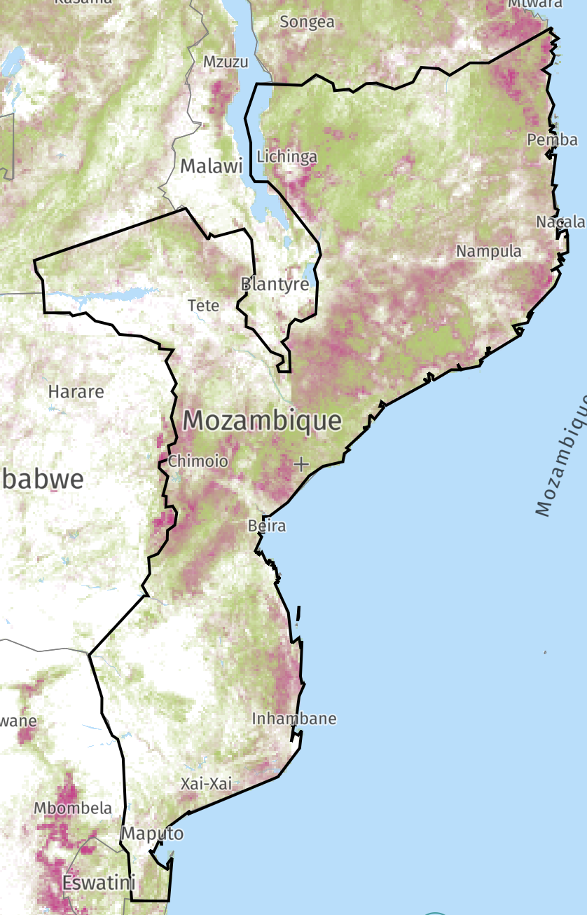
The following image represents tree cover loss that occurred in Mozambique between 2001 and 2020 further indicating the potential benefits aligned with the adoption of improved cookstoves in Mozambique for the community, environment, and overall well-being of the community.
Figure 9: Map of Mozambique indicating tree cover loss between 2001 and 2020

Expected Impacts on Natural Capital and Ecosystem Services

Impact #1 | Reduced demand for large diameter non-renewable firewood from live trees due to only needing finger-sized woody biomass, i.e., twigs and crop residues, for cooking on the TLCRS
Type of Impact | Positive, actual, direct
Affected Natural Capital and/or Ecosystem Service(s) | Live plant biomass, Biodiversity and species Richness, Soil and Water Conservation
Resulting Change in Condition | By slowing the consumption of woody biomass for cooking purposes and by eliminating the need for large diameter woody biomass due to the technology in the TLCRS, the resulting drop in demand slows deforestation, thus increasing the above-ground biomass in the adjoining forests near the project area. Reduction in unsustainable harvesting of plant biomass would in turn reduce soil erosion and result in improvement in biodiversity and species richness of the implementation area.

Impact #2 | Avoided emission of GHGs made possible by using TLCRS
Type of Impact | Positive, predicted, indirect
Affected Natural Capital and/or Ecosystem Service(s) | Air quality in the households as well as surroundings
Resulting Change in Condition | The project stoves require less fuelwood for producing the same amount of thermal energy, therefore, resulting in lesser carbon dioxide emission in the atmosphere. As carbon dioxide is a greenhouse gas, its reduced emission translates to a positive impact on climate change.

Natural Capital and Ecosystem Services Monitoring Plan
In addition to monitoring the ICS implemented each year, CQC will monitor the following to evaluate the net ecological impact of the project:
- Survey the amount of woody biomass used to fuelwood to meet the thermal energy needs for meal preparation on the TLCRS and calculate the reduction in woody biomass used in comparison to a TSF cookstove.
Natural capital use will also be monitored through fuel use studies contracted by CQC to academic partners. Through these studies, CQC will ascertain the natural capital savings, specific to impacts 1 and 2 in the above charts.
The following data and parameters will be monitored under the project to assess the impacts on the natural capital and ecosystem. The sampling approach adopted for collecting the corresponding data has been presented in section 3.3 of the PD.

S.No. | Natural Capital Impacted | Impact | SDG Indicator | Monitoring parameters | Monitoring Approach | Sampling | Monitoring frequency
1 | Atmosphere | Reduced levels of emissions and household air pollution | 13.0 | Reduced GHG emissions | $${ER}_{y,i,j}=B_{y,sav,i,j}×N_{o,i,j}×n_{y,i,j}×μ_{y}×f_{NRB,y}×{NCV}_{biomass}×\left({EF}_{wf, CO2}+{EF}_{wf, non CO2}\right)$$  Source-Monitoring Report for the corresponding SD VISta period of VCS Project ID 2340 | NA | NA
2 | Forest Ecosystem adjoining project implementation area | Increase in Above Ground Biomass | 15.3 | Fuelwood saved by the project stoves | $$B_{y,sav,i,j}=B_{y=1,new,i,j,survey}×(\frac{η_{new,i,j}}{η_{old,i,j}}-1)$$  Source-Monitoring Report for the corresponding SD VISta period of VCS Project ID 2340 | NA | NA

Net Positive Natural Capital and Ecosystem Services Impacts
Replacing three-stone cooking open fires and other traditionally used fuel-inefficient cook fires with ICS technology the primary project activity, will generate an estimated ~63.62 tCO₂e GHG emission reduction per stove over the ten-year project crediting period.

Appendix 1
References
Appendix A: Causal Chain
Appendix B: Beneficiary Brochure (English)
Note: Brochure includes Grievance and country-specific Feedback Number.
Appendix C: List of Abbreviations
Appendix D: Fuel-wood savings estimates

References
Anon., 2021. USAID. https://www.usaid.gov/sites/default/files/documents/tagged_Mozambique-Nutrition-Profile.pdf
Energy, A.R., 2014. Clean and improved cooking in Sub-Saharan Africa. The World Bank Group: Washington, DC, USA.
Frontiers | Adapting to Fuelwood Scarcity: The Farmers' Perspective | Sustainable Food Systems (frontiersin.org)
Amegah A. K. (2020). Improving Child Survival in Sub-Saharan Africa: Key Environmental and Nutritional Interventions. Annals of global health, 86(1), 73. https://doi.org/10.5334/aogh.2908
Das, K., Pradhan. G., & Nonhebel, S. (2019) Human energy and time spent by women using cooking energy systems: A case study of Nepal. https://doi.org/10.1016/j.energy.2019.06.074
Clean Cooking Alliance (n.d). Delivering on the Sustainable Development Goals through Clean Cooking. https://www.cleancookingalliance.org/feature/delivering-on-the-sustainable-development-goals-through-clean-cooking.html
Makonese, T., Ifegbesan, A.P. and Rampedi, I.T. (2018). Household cooking fuel use patterns and determinants across southern Africa: Evidence from the demographic and health survey data. Energy & Environment, 29(1), 29-48. https://doi.org/10.1177/0958305X17739475
Mortimer, K., Ndamala, C. B., Naunje, A. W., Malava, J., Katundu, C., Weston, W., Havens, D., Pope, D., Bruce, N. G., Nyirenda, M., Wang, D., Crampin, A., Grigg, J., Balmes, J., & Gordon, S. B. (2017). A cleaner burning biomass-fuelled cookstove intervention to prevent pneumonia in children under 5 years old in rural Malawi (the Cooking and Pneumonia Study): a cluster randomized controlled trial. Lancet (London, England), 389(10065), 167–175. https://doi.org/10.1016/S0140-6736(16)32507-7
CIA World Factbook, (As on 23rd March 2022. Page last updated on 9th March 2022). Mozambique https://www.cia.gov/the-world-factbook/countries/mozambique
World Bank Database, (2020). Population Density – Mozambique https://data.worldbank.org/indicator/EN.POP.DNST?locations=MZ
CIA World Factbook, (As on 23rd March 2022. Page last updated on 9th March 2022). Mozambique https://www.cia.gov/the-world-factbook/countries/mozambique
World Bank Database, (2020). Rural Population % - Mozambique https://data.worldbank.org/indicator/SP.RUR.TOTL.ZS?locations=MZ
https://energypedia.info/wiki/Energy_Access_in_Mozambique#cite_note-5
Anon., 2018. USAID. https://www.climatelinks.org/resources/climate-risk-profile-mozambique#:~:text=Mozambique's%20vulnerability%20to%20climate%20change,river%2Fcoastal%20storm%20surge%20flooding.
Rosenthal, J., Quinn, A., Grieshop, A.P., Pillarisetti, A. and Glass, R.I., 2018. Clean cooking and the SDGs: Integrated analytical approaches to guide energy interventions for health and environment goals. Energy for Sustainable Development, 42, pp.152-159.
Balchin, N., Coughlin, P., Papadavid, P., te Velde, D.W. and Vrolijk, K., 2017. Economic transformation and job creation in Mozambique. Synthesis Paper. London: Supporting Economic Transformation. (https://set.odi.org/wp-content/uploads/2017/10/Economic-transformation-and-job-creation-in-Mozambique-Full-Synthesis-Paper_Oct-2017.pdf)
Global Forest Watch. (2020) Mozambique. https://www.globalforestwatch.org/map/country/MOZ/?mainMap=eyJzaG93QW5hbHlzaXMiOnRydWV9&map=eyJjZW50ZXIiOnsibGF0IjotMTguODY5MzgyMzY3MTQ0MjQ3LCJsbmciOjM1LjUyNzM4NzYyMDA4NTgwNH0sInpvb20iOjQuNzI3MzgwODEwNDQ0NTg0LCJjYW5Cb3VuZCI6ZmFsc2V9&mapPrompts=eyJvcGVuIjp0cnVlLCJzdGVwc0tleSI6InN1YnNjcmliZVRvQXJlYSJ9

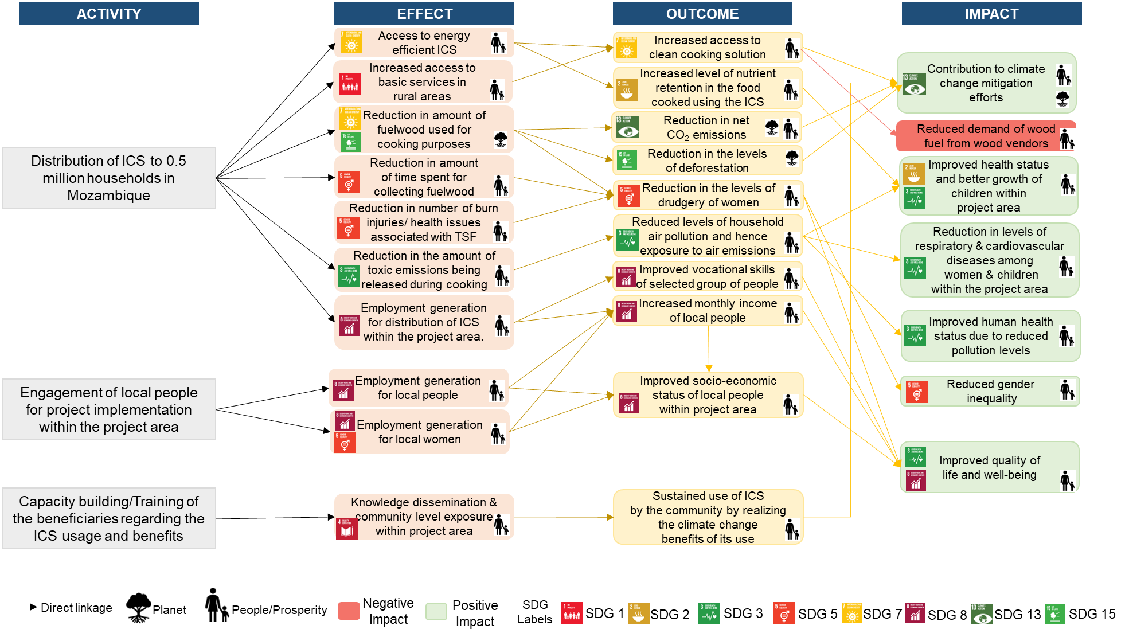
Appendix 1: CAUSAL CHAIn

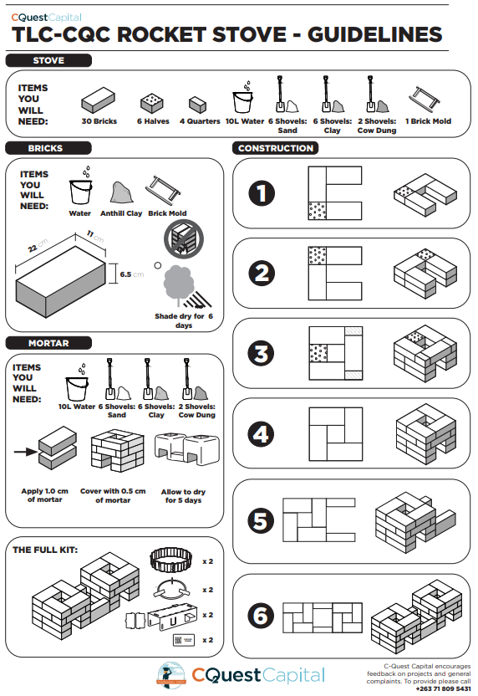
Appendix B: Brochure (English)
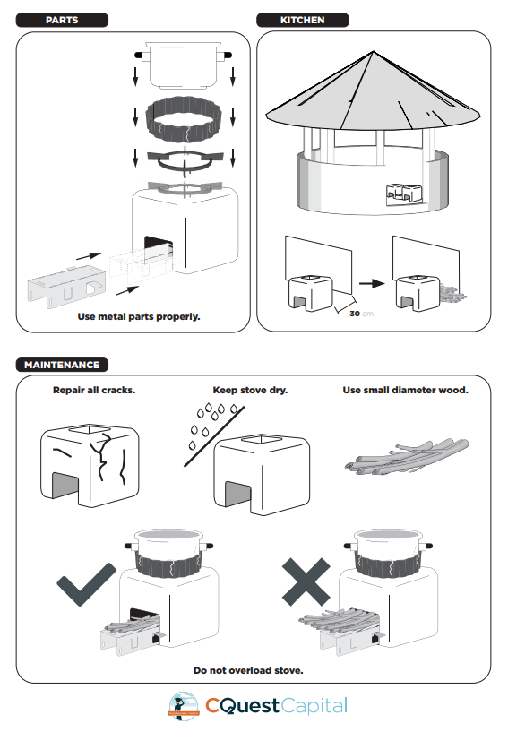

Appendix C: List of Abbreviations
ADC: Area Development Committee
COPD: Chronic Obstructive Pulmonary Disease
CQC: C-Quest Capital LLC
GP: Grouped Project
GVH: Group Village Headperson
HAP: Household Air Pollution
ICS: Improved Cookstoves
ILO: International Labour Organisation
LSC: Local Stakeholder Consultation
PM_{2.5}: Particulate Matter
SC: Stove Champions
SDG: Sustainable Development Goals
TA: Traditional Authority
TLCRS: TLC Rocket Stoves
TSF: Three-stone fire stove
VCS: Voluntary Carbon Standard

Appendix D: Fuel-wood savings estimates
Equation used for wood saving estimation

$$B_{y,sav,i,j}=B_{y=1,new,i,j,survey}×(\frac{η_{new,i}}{η_{old}}-1)$$
Where:
$η_{old,i,j}$ = Efficiency of baseline devices that are replaced by project devices of type i (fraction)
$η_{new,i,j}$ = Efficiency of project device of type i (fraction)
$B_{y=1,new,i,j,survey}$= Quantity of woody biomass used per project device of type i from batch j (tonnes)

https://unstats.un.org/sdgs/metadata/
Anon., 2021. USAID. [Online] https://www.usaid.gov/sites/default/files/documents/tagged_Mozambique-Nutrition-Profile.pdf
https://unstats.un.org/sdgs/metadata/
https://unstats.un.org/sdgs/metadata/
Energy, A.R., 2014. Clean and improved cooking in Sub-Saharan Africa. The World Bank Group: Washington, DC, USA.
Applies to employment of individuals who were absent from the formal sector and previously lived near, at, or below the international poverty level.
Applies to employment of staff at full and productive levels with decent work for all, specifically in non-agriculture employment with equal pay for work of equal value across sexes – the ethos of SDG 8.
Frontiers | Adapting to Fuelwood Scarcity: The Farmers' Perspective | Sustainable Food Systems (frontiersin.org)
Amegah A. K., 2020.
K.Das et al., 2019.
Berkeley Air Monitoring Group, 2020.
Clean Cooking Alliance, n.d.
Makonese et al., 2017.
Mortimer, K., et al., 2017.
Sharma & Jain, 2019.
https://www.geodatos.net/en/coordinates/mozambique
https://www.mapsofworld.com/mozambique/mozambique-political-map.html
https://en.wikipedia.org/wiki/Provinces_of_Mozambique
8. CIA World Factbook, (As on 23rd March 2022. Page last updated on 9th March 2022). Mozambique https://www.cia.gov/the-world-factbook/countries/mozambique
9. World Bank Database, (2020). Population Density – Mozambique https://data.worldbank.org/indicator/EN.POP.DNST?locations=MZ
8. CIA World Factbook, (As on 23rd March 2022. Page last updated on 9th March 2022). Mozambique https://www.cia.gov/the-world-factbook/countries/mozambique
10. World Bank Database, (2020). Rural Population % - Mozambique https://data.worldbank.org/indicator/SP.RUR.TOTL.ZS?locations=MZ
Wylie et al., 2017
https://energypedia.info/wiki/Energy_Access_in_Mozambique#cite_note-5
Anon., 2018. USAID. https://www.climatelinks.org/resources/climate-risk-profile-mozambique#:~:text=Mozambique's%20vulnerability%20to%20climate%20change,river%2Fcoastal%20storm%20surge%20flooding.
Rosenthal, J., Quinn, A., Grieshop, A.P., Pillarisetti, A. and Glass, R.I., 2018. Clean cooking and the SDGs: Integrated analytical approaches to guide energy interventions for health and environment goals. Energy for Sustainable Development, 42, pp.152-159.
Balchin, N., Coughlin, P., Papadavid, P., te Velde, D.W. and Vrolijk, K., 2017. Economic transformation and job creation in Mozambique. Synthesis Paper. London: Supporting Economic Transformation. (https://set.odi.org/wp-content/uploads/2017/10/Economic-transformation-and-job-creation-in-Mozambique-Full-Synthesis-Paper_Oct-2017.pdf)
Such as reduced cough from smoke inhalation and less irritation of eyes resulting from soot and smoke.
This value only accounts for the time spent in collecting fuelwood, hence if used, time spent in fuelwood collection post project implementation must only be considered.
For CPAs not qualifying the conditions under paragraph 12 of Tool 19, the requirements of the applied methodology shall apply.
16. Global Forest Watch. (2020) Mozambique. https://www.globalforestwatch.org/map/country/MOZ/?mainMap=eyJzaG93QW5hbHlzaXMiOnRydWV9&map=eyJjZW50ZXIiOnsibGF0IjotMTguODY5MzgyMzY3MTQ0MjQ3LCJsbmciOjM1LjUyNzM4NzYyMDA4NTgwNH0sInpvb20iOjQuNzI3MzgwODEwNDQ0NTg0LCJjYW5Cb3VuZCI6ZmFsc2V9&mapPrompts=eyJvcGVuIjp0cnVlLCJzdGVwc0tleSI6InN1YnNjcmliZVRvQXJlYSJ9
Global Forest Watch, 2020.
VMR0006 Methodology
VMR0006 Methodology

