Monitoring Report

PUBLICATION DATE 14.10.2020
VERSION v. 1.1
RELATED SUPPORT – TEMPLATE GUIDE Monitoring Report v. 1.1

This document contains the following Sections
Key Project Information

SECTION A - Description of project
SECTION B - Implementation of project
SECTION C - Description of monitoring system applied by the project
SECTION D - Data and parameters
SECTION E - Calculation of SDG Impacts
SECTION F - Safeguards Reporting
SECTION G - Stakeholder inputs and legal disputes

KEY PROJECT INFORMATION

Key Project Information

GS ID (s) of Project (s) | GS4364
Title of the project (s) covered by monitoring report | Institutional improved cook stoves for schools and institutions in Uganda
Version number of the PDD/VPA-DD (s) applicable to this monitoring report | PDD version 03.0
Version number of the monitoring report | 4
Completion date of the monitoring report | 11/02/22
Date of project design certification | 29/07/2017
Date of Last Annual Report | Not applicable
Monitoring period number | 3
Duration of this monitoring period | 20/03/2020 to 30/09/2021 (both days included)
Project Representative | Virginia Echavarria
Host Country | Uganda
Activity Requirements applied | Community Services Activities  Renewable Energy Activities  Land Use and Forestry Activities/Risks & Capacities  N/A
Methodology (ies) applied and version number | AMS.II.G version 08.0
Product Requirements applied | GHG Emissions Reduction & Sequestration  Renewable Energy Label  N/A

Table 1 - Sustainable Development Contributions Achieved
Sustainable Development Goals Targeted | SDG Impact | Amount Achieved | Units/ Products
SDG 1 No poverty | Equal rights to economic resources | 96,120,000 | Ugandan shillings
SDG 3 Good health and well-being | Reduce the number of illnesses from air pollution | 156 kitchen staff confirmed  better perception | Air quality
SDG 4 Quality education | Provide a safe learning environment | 413 training sessions conducted, 209 kitchen staff trained, 407 kitchen training assessments made | Training sessions  Kitchen staff  Training assessments
SDG 5 Gender equality | Promote women empowerment | 78 | Women trained
SDG 7 Access to affordable and clean energy services | Double the global rate in energy efficiency | 77 schools  263 IICS | Schools  IICS
SDG 8 Decent work and economic growth | Achieve full and productive employment and equal pay for all | 10 | Jobs
SDG 13 Climate action | Integrate climate change measures into national policies, strategies and planning | 1,647 | tCO2 emission reductions
SDG 15 Life on land | Halt deforestation | 3,356 | Tons of firewood
SDG 17 Partnerships for the goals | Enhance the global partnership for sustainable development | 14 | KCCA school

Table 2 – Product Vintages
 |  | Amount Achieved
Start Dates | End Dates | GS VERs | … | …
20/03/2020 | 31/12/2020 | 542
01/01/2021 | 30/09/2021 | 1,105

- DESCRIPTION OF PROJECT
  - General description of project
The purpose of this project activity is the dissemination of institutional improved cook stoves (IICS) in Uganda. The project aims at changing the traditional cooking habits used in up to around 450 schools and institutions, benefiting approximately 340,000 individuals, reducing 31,286 tonnes of annual CO2, and 219,003 tonnes of CO2 during the 7 year crediting period.

Although the Project Activity has been originally registered with both the Clean Development Mechanism and the Gold Standard, with past verified and issued GS VERs during its previous two monitoring periods, the Project Participant will be claiming for Gold Standard Verified Emission Reductions during this period monitoring, due to current uncertainties with the Clean Development Mechanism post 2020 regulations.

The IICS may be of different models and/or different sizes and will consume firewood. The different models of IICS may be manufactured by local and/or international stove manufacturers. As schools and institutions move up in the energy ladder, and fuel briquettes made of agricultural residues become available in Uganda, these IICS could also be used with such fuel briquettes in the future. In the case that a school/institution/IICS will use briquettes made of renewable biomass (agricultural residues and/or firewood from renewable plantations), the PP will ensure that no emission reduction credits will be claimed from the fuel switch from non-renewable to renewable biomass but only from the fuel savings resulting from the introduction of the IICS.

The IICS are both portable as well as fixed built-in types, serving school and other institutional users like prisons, plantation estates and hospitals. These IICS are more efficient in transferring heat to the cooking pots, thus IICS require less fuel to prepare the same meal. This efficiency is translated into fuel savings compared to traditional stoves used in Uganda. By reducing fuel consumption, the project activity reduces greenhouse gas emissions from the use of fuel. This reduction in fuel consumption is estimated and corresponding CO2 emission reductions are calculated from these savings.

The project activity shall initially distribute the Ugastove portable rocket firewood IICS of different sizes to schools (one example see illustrated in figure 1 below), but may distribute other models of IICS that meet the minimum thermal efficiency requirement of 20% to schools and/or other institutions later on. The different IICS sizes are conditioned by the saucepan capacity and range from 30 litres and up to 450 litres.

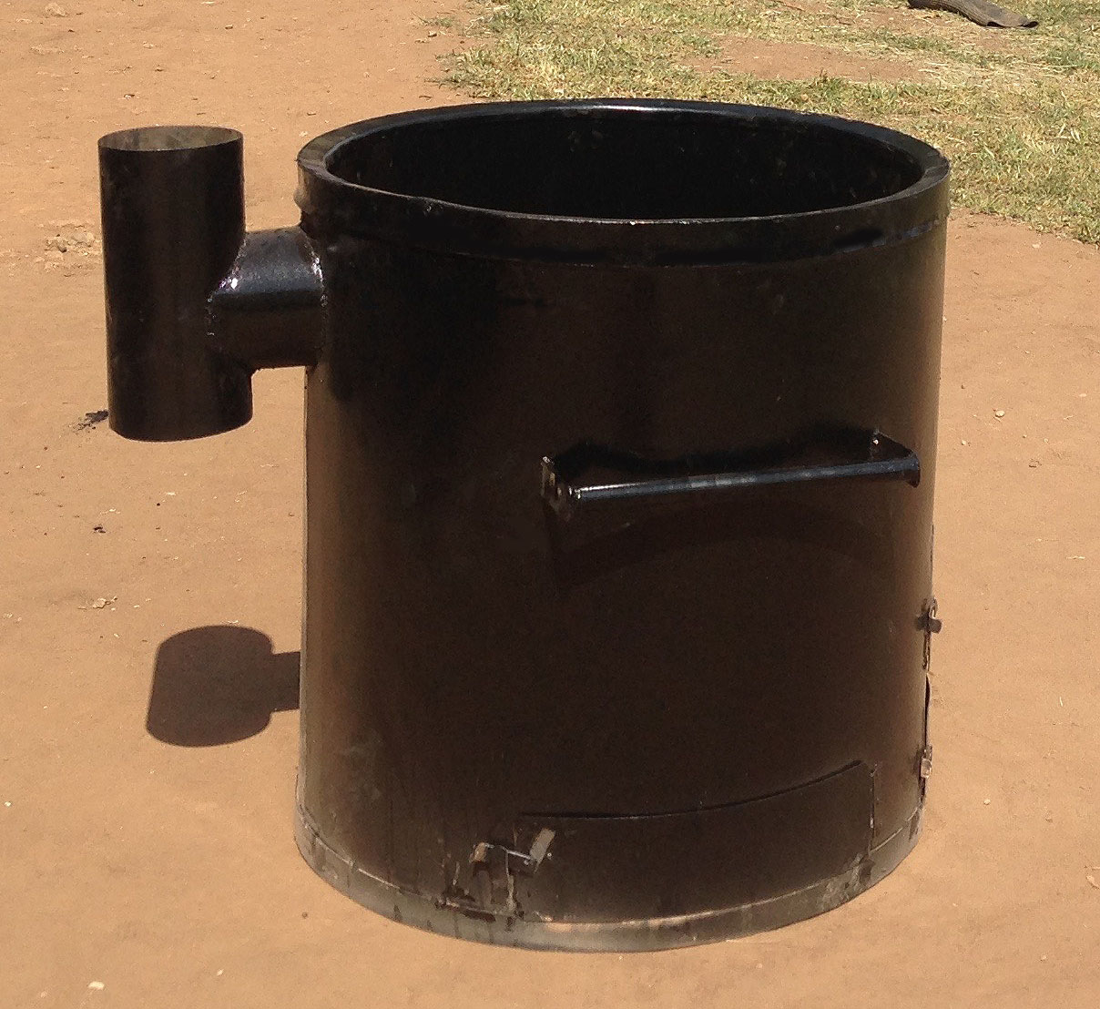
Figure 1 – Ugastove portable rocket firewood IICS

The Uganda National Alliance for Clean Cooking (UNACC) estimated in 2012, that only 7% of the population were using clean and efficient cook stoves. Similarly, the institutions in Uganda such as schools, health centres, prisons, commercial buildings and restaurants, primarily rely on traditional cooking technologies such as three stone stoves, open fires etc. (Government of Uganda, 2001). As per the Uganda Bureau of Statistics (UBOS) 2012 survey, 14.88% of the population have access to power grid services (54.8% in urban, and 7% in rural areas). If solar home systems and diesel generators, used mainly by rural households, are included, the national electrification access rate represents 26.1%. The most prevalent form of cooking fuel in the schools of Uganda is wood with 96% of the schools using it as their main cooking fuel, followed by charcoal with 4% of the schools (Ministry of Education and Sports, 2013). The baseline scenario is the same as the scenario existing prior to the implementation of the project activity.

Simoshi Limited (Simoshi) is the project participant of this project activity. As such, it will coordinate the efforts to manufacture, select the IICS suppliers, promote, sell and distribute the IICS in Uganda and comply with the requirements of this project activity.

During implementation, Simoshi will:

- Test IICS models according to the project activity requirements
- Manufacture, procure IICS from manufacturers, market, sell and distribute IICS to schools and institutions
- Annually maintain all IICS population
- Keep records of sales and schools/institutions as per the monitoring plan
- Keep current with regards to the UNFCCC requirements
- Organise and collect all necessary information from schools and institutions for monitoring purposes
- Provide technical and administrative support to schools and institutions to guarantee compliance of IICS and record keeping with the project activity requirements
- Manage the execution of VER agreements and distribution of the benefits
- Be responsible for the monitoring activities and data management required during the lifetime of the project activity
- Maintain a database of sales records used to compute VERs and ensure that no double-counting of IICS sales occurs
- Be the focal point for VER registration and verification

IICS are sold through payment schemes that include three equal installments, at no interest rate, allowing schools and institutions to comfortably pay back their debt throughout the year. Schools and institutions do not need to search for money outside their budget or secure financial loans, as they use the money saved from firewood not consumed to pay back to Simoshi. By providing flexible consumer finance options and free annual maintenance, Simoshi expects to increase the rate of IICS adoption in schools and institutions.

National and international donors also support schools/institutions by covering partially or totally the cost of the IICS.

When purchasing the IICS, the school/institution fills a sales agreement with Simoshi that contains, among others, information about the IICS model, price and payment, the name, location/address and phone number of the school/institution. This information will allow the identification and the monitoring of the IICS and its usage. By filling the sales agreement, the school/institution will agree to discontinue the use of the traditional stove, and to use the IICS instead. By signing the sales agreement, the school/institution is aware of and willing to give up its rights on emission reductions and transfer all carbon rights to Simoshi. Additional measures such annual maintenance schemes of the IICS population will confirm that the IICS is in operation and will help to track the IICS.

  - Location of project
Republic of Uganda (Uganda). The project boundary of this project includes whole Uganda including its 111 districts and the city of Kampala.

Uganda is a landlocked country in East Africa. It is bordered to the east by Kenya, to the north by South Sudan, to the west by the Democratic Republic of the Congo, to the southwest by Rwanda, and to the south by Tanzania. The southern part of the country includes a substantial portion of Lake Victoria, shared with Kenya and Tanzania.

The latitude and longitude denominations of Uganda are 1° 00 North and 32° 00 East.

Republic of Uganda (Uganda). The project boundary of this project includes whole Uganda including its 111 districts and the city of Kampala.

Uganda is a landlocked country in East Africa. It is bordered to the east by Kenya, to the north by South Sudan, to the west by the Democratic Republic of the Congo, to the southwest by Rwanda, and to the south by Tanzania. The southern part of the country includes a substantial portion of Lake Victoria, shared with Kenya and Tanzania.

The latitude and longitude denominations of Uganda are 1° 00 North and 32° 00 East.

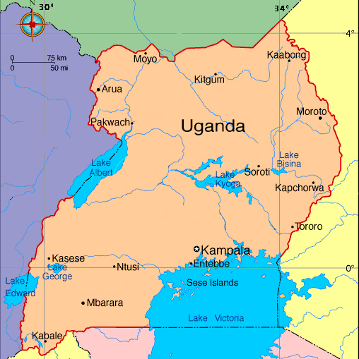
Figure 2 – Map of Uganda

  - Reference of applied methodology
- AMS.II.G “Energy efficiency measures in thermal applications of non-renewable biomass” Version 8.0
- Methodological tool “Project and leakage emissions from biomass” Version 02.0
- Methodological tool “Demonstration of additionality of small-scale project activities” Version 10.0
- ASB0016 Standarised baseline ‘Institutional Cook Stoves in Uganda’, Version 01.0
- General guidance on leakage in biomass project activities (version 03)

  - Crediting period of project
01/03/2017 - 29/02/2024. The first crediting period is 7 years. The number of renewal periods is 2.

- IMPLEMENTATION OF PROJECT
  - Description of implemented project
This Monitoring Report has been developed for the purpose of the Gold Standard (GS) verification exercise for the greenhouse gas emission reductions achieved by the project activity “Institutional Improved Cook Stoves for Schools and Institutions in Uganda”.

The purpose of this project activity is the dissemination of institutional improved cook stoves (IICS) in schools and institutions in Uganda. The IICS disseminated are manufactured by Uganda Stove Manufacturers Limited (Ugastove). The model is the portable rocket firewood IICS of different sizes that meet the minimum thermal efficiency requirement of 20%. The different IICS sizes are conditioned by the saucepan capacity and range from 30 litres and up to 450 litres.

These IICS are more efficient in transferring heat to the cooking pots, thus requiring less fuel to prepare the same meal. This efficiency is translated into fuel savings compared to traditional stoves used in Uganda. By reducing fuel consumption, the project activity reduces greenhouse gas emissions from the use of fuel. This reduction in fuel consumption is estimated and corresponding CO2 emission reductions are calculated from these savings.

IICS are sold through payment schemes that include installment modalities, allowing schools to comfortably pay back their debt throughout the school year, using the money saved from firewood not consumed to pay back for the acquired IICS. The on-going support Simoshi provides to all schools includes continuous monitoring and training of kitchen staff, annual free maintenance for all IICS, advice on kitchen infrastructure improvements and hygiene. Simoshi takes a holistic approach in the school kitchen environment, that includes interventions in the whole chain of actors and activities involved, from the supply of firewood, through the use of energy efficient stoves, the kitchen infrastructure and hygiene/sanitation practices. Simoshi has developed a relationship of trust with all participating schools, as they witness the overall benefits accrued from the use of an IICS.

Simoshi Limited is the project participant of this project activity. As such, it coordinates the efforts to select the IICS manufacturer, promote, sell and distribute the IICS in Uganda and comply with the requirements of this project activity.
The start date of the project is 26/03/2016, when the first IICS was disseminated in a school. The project activity was registered with the CDM on 07/02/2017 (https://cdm.unfccc.int/Projects/DB/CarbonCheck_Cert1486462226.32/view).
The registration of the project was approved by GS as per the submitted Registration Review Feedback Form with project ID GS4364.

The third monitoring period was conducted from 20/03/2020 to 30/09/2021 (both days included) and the total amount of greenhouse gas emission reductions achieved by the project activity is 1,647. Due to the Covid-19 pandemic restrictions, schools in Uganda were only allowed to operate from 15/10/2020 to 06/06/2021 (both days included), with a reduced number of in-person attendance of children and classes.

Year | 2020 | 2021
Amount tCO2 emission reduction | 542 | 1,105

Year | 2016 | 2017 | 2018 | 2019 | 2020 | 2021
Number of IICS installed | 68 | 57 | 28 | 36 | 34 | 40

    - Forward Action Requests
This was the FAR raised at the time of previous validation review: “The PP shall report the parameter “aggregate energy savings from total number of institutions” during next verification to make sure that the project activity shall not exceed the equivalent of 60 GWh per year or 180 GWh thermal per year in fuel input”. PP has already calculated the threshold and it is included in the ER Calculation Spreadsheet tab. The actual number of 77 included school is much smaller than the schools required to achieve the limit 180 GWh per year.

  - Post-Design Certification changes
None.

    - Temporary deviations from the approved Monitoring & Reporting Plan, methodology or standardized baseline
None.

    - Corrections
None.

    - Changes to start date of crediting period
None.

    - Permanent changes from the Design Certified monitoring plan, applied methodology or applied standardized baseline
None.

    - Changes to project design of approved project
None.

- DESCRIPTION OF MONITORING SYSTEM APPLIED BY THE PROJECT
Simoshi has been responsible for surveying the schools/institutions prior the installation of the IICS, the sale of the IICS, the collection of all Sales Agreement data, for internally verifying the information in the Sales Agreements, and the creation of this Monitoring Report. Simoshi has been responsible for data entry into the Sales Records and for ensuring that the information in the Sales Agreements is complete and correct. The total amount of Sales Agreements reveals the quantity of IICS sold and schools and institutions included at the end of this Monitoring Period. The electronic database through the dedicated Kenga IT infrastructure records the start and end dates of each selling year y for each IICS (t fraction), and used to calculate the emission reductions attributable to each Monitoring Period. Appropriate record keeping procedures have been implemented to ensure that each Monitoring Period dataset can be transparently attributed to the project activity, preventing any occurrences of double-counting. Hence, the project database and Kenga IT infrastructure keeps records on the duration of previous Monitoring Periods, the school/institution surveys, and verification activities.

In order to account for drop-off in use (U) and continued use of pre-project devices, the IICS deployed have been monitored through systematic verification. Monitoring included a combination of the following activities or events:
(a) an annual IICS maintenance/repair event when required
(b) customer inspections resulting from loan or hire purchase agreements when schools paying for their IICS
(c) double verified records of Simoshi’s Project Officers and data entry on Kenga IT infrastructure
(d) collection of population served – students and school/institution staff - and amount of firewood spent in Ugandan Shillings in each school/institution three times per year
(e) continuous training of kitchen staff on the appropriate use of the IICS following the “Kitchen Management Technique”
(f) information collection on a quarterly basis of cooking appliances used by the school/institution in the “Kitchen Information Update” form
All of the above indicators have been collected by Simoshi’s staff, at different stages during the monitoring period from 20/03/2020 and until 30/09/2021. The dates when the collection of each indicator took place is recorded in each specific form and reported in the different pages of the Excel calculation spreadsheet submitted for verification purposes. These are also used to confirm the monitoring frequency was achieved. Such forms are also scanned for auditing purposes.

Simoshi’s Project Officers were responsible for collecting all the indicators (b), (c), (d), (f) and conducting the training (e) at the schools. Simoshi’s Maintenance Officer was responsible for repairing and maintaining all the IICS during the monitoring period (a). Simoshi’s bookkeeper was responsible for all customer inspections resulting from IICS sold under loans/hire purchase (b).

During the year 2020 at the end of each school term, Simoshi’s Project Officer interviewed the school administrators and accountants/bursars to confirm the number of children and staff enrolled, and the amount of firewood spent in Ugandan shillings for cooking all school meals. Because of the Covid-19 pandemic restrictions and number of children allowed to attend in–person learning, Simoshi decided to increase the number of visits made to each school during the year 2021, to ensure a more accurate calculation of children enrolled. This information was completed on the School Term Update form, which was further stamped and signed by the school official, and has been performed five times during this 8-month monitoring period for every participating school. During that same visit, the Project Officer also visited the kitchen to inspect the condition of every IICS, ensure no traditional or baseline stoves were in use, confirmed whether any maintenance or repairs were needed, trained the kitchen staff to ensure they were diligently following the Kitchen Management Techniques and Firewood Best Practice Manual, while conducting the interview to collect indicators with regards the air quality situation when compared to their previous experience with the former stoves.

During this monitoring period, a fourth visit to the school kitchen was conducted to inspect once again the condition of every IICS, ensure no traditional or baseline stoves were in use, confirm whether any maintenance or repairs were needed, trained the kitchen staff to ensure one more time they were diligently following the Kitchen Management Techniques and Firewood Best Practice Manual, and collected indicators with regards the air quality perception by the kitchen staff. All trained and interviewed kitchen staff signed the Kitchen Training Log Sheets, together with Simoshi’s Project Officers and Simoshi’s Supervisor.
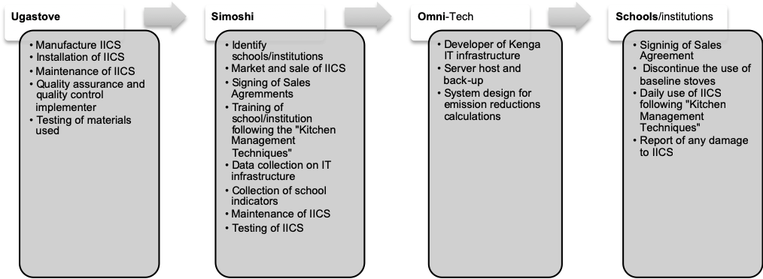
Figure 3 – Operational sturcture and key responsabilities

Requirements for replacement of traditional stoves
Monitoring practices ensures that either the replaced low efficiency appliances are disposed of and are not used or found in the kitchen environment within the boundary or within the region. Whenever a low efficiency appliance was found in place and in use, Simoshi ensured the school/institution discontinued its use and replaced it with a Ugastove IICS.

Monitoring procedures
Simoshi checked that replaced low efficiency appliances have been dismantled and are no longer in use by the schools/institutions within the project boundary.

During usage surveys, if evidence of use of traditional cooking appliances was found in schools/institutions that have purchased an IICS only during peak cooking needs (e.g. for celebrations) then it was assumed that there is no adjustment needed because the baseline study is performed in schools/institutions during normal cooking conditions and data from peak cooking has not been taken into account in the B_{old} calculations.

Monitoring procedures for efficiency or fuel consumption of IICS
In general, a cohort is defined as the year that an IICS model is sold in or gone through maintenance in the same year.

Cohorts of IICS that are older than the expected normal lifetime of the IICS may or may not be included in the monitoring, and accordingly regarded in the calculation of emission reductions. For example, the Ugastove portable firewood IICS has got a 10-year lifetime. After its 10 years of use from the time of the IICS’s commissioning date, Simoshi will assess whether the IICS will go through a complete overhaul to continue being used under the same serial number, or will be completely replaced with a new IICS. For this Monitoring Period, the first IICS were installed during March 2016 hence all IICS have been included.

The project activity has conducted systematic verification for the usage rate and continued use of pre-project devices, hence no sampling has been carried out and no categorization in batches is necessary in regards to these two parameters.

The WBT option has been chosen for calculating the IICS thermal efficiency used in By,savings. The simplified approach has been selected (for details see section 6.1, table 11 of the methodology). The tests have been conducted by the PP.

PP has carried out WBTs on all 30 litres IICS capacity and applied conservatively the lowest resulted thermal efficiency across all IICS sizes. The SSC WG considered that applying the lowest efficiency found in IICS with saucepan capacities of 30 litres for IICS with saucepan capacities larger than 30 litres would be a conservative approach when the IICS designs and maintenance practices are comparable.

The sampling frame consists of all schools/institutions and its corresponding IICS from the first batch. The first batch is defined as the first year (i.e. from 26/03/2016 to 25/03/2017) in which schools/institutions were included in the project and IICS disseminated to those institutions. The IICS disseminated in the period from 26/03/2016 to 25/03/2017 represent the first and oldest age group amongst the overall population. An institution which has been identified as non-user does not make part of the sampling frame.

The project activity has decided to take a census approach and tested all the twelve IICS of 30 litres capacity from the first batch from 26/03/2016 to 25/03/2017. Results from this first batch will be applied to all subsequent batches. The efficiency of the project devices of the school/institution of this first batch will be monitored annually through a census approach and the results will be applied correspondingly to all subsequent batches.

Simoshi has systematically conducted quality checks on its IICS orders to the IICS manufacturer Ugastove, following the Quality Assurance and Quality Control Manual, assuring a good quality management system is in place. Simoshi has ensured that IICS models from the selected IICS Ugastove manufacturer follows Simoshi’s Quality Assurance and Quality Control Manual (which includes consistency in manufacturing practices and materials used) and Simoshi’s Maintenance Manual that demonstrates comparable maintenance and repair practices on all IICS included under the project activity.

Data collection
Simoshi collects the data necessary for the monitoring and for the emission reductions calculation. Data is managed through an electronic database and an especially dedicated Kenga IT infrastructure – developed by Omni-Tech Limited - that can directly attribute the data to each school/institution, thereby allowing unambiguous determination of the emission reductions attributable to the project activity.

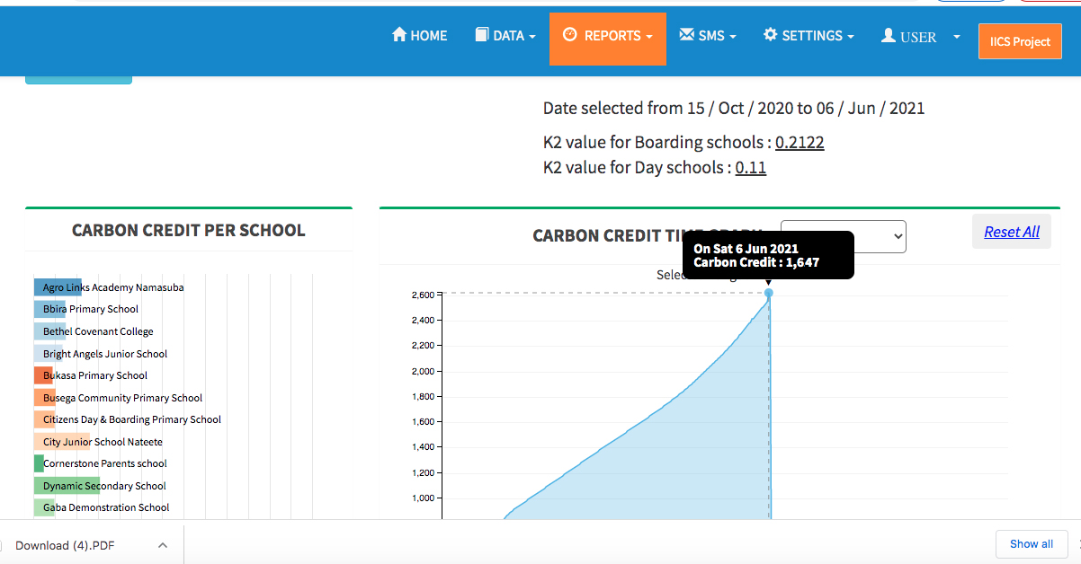
Figure 4 – Screenshot of Kenga IT infrastructure for ER calculations

Data archiving
Sales Agreements are stored by Simoshi, with an original copy kept by each participating school/institution. A back-up of the project database is also stored on an electronic medium by Simoshi and remotely by the Kenga IT infrastructure provider, Omni-Tech Limited. All data monitored and required for verification and issuance is kept for at least two years after the end of the crediting period or the last issuance of CERs for the project activity, whichever is later.

Training
Simoshi provided the necessary training to its staff and the parties involved in the monitoring to ensure that the data recorded is complete and accurate.

Quality Assurance/Quality Control Procedures
Different quality control and quality assurance measures have been put in place by Simoshi to ensure that all emission reductions are real. Surveys and testing have been carried out and Simoshi has checked the consistency of the results. Simoshi has ensured the studies are accurate and that a conservative approach has been taken.

Simoshi’s project officer and Simoshi’s data clerk have checked Sales Agreements two levels – when collecting and completing the information on site, and when entering the information on the Kenga IT infrastructure. Missing or wrong data has been corrected if errors made. All IICS under the project activity have been traced and monitored following the monitoring plan.

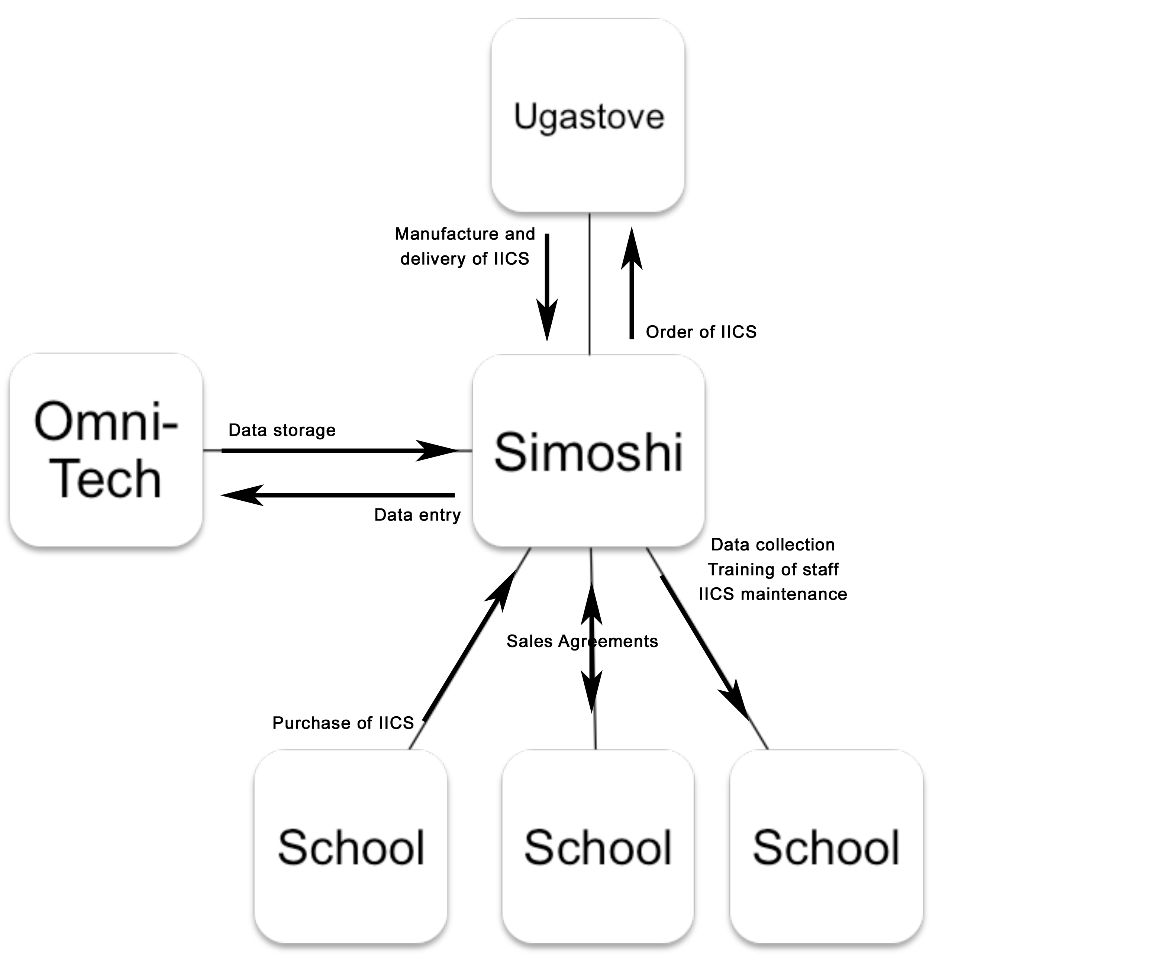
Figure 5 – Sales monitoring flowchart

- DATA AND PARAMETERS
  - Data and parameters fixed ex ante or at renewal of crediting period
Relevant SDG Indicator | Goal 13: Take urgent action to combat climate change and its impacts
Data / Parameter | Bold,p
Unit | Tonnes/person/year
Description | Annual quantity of woody biomass that would have been used per person in the school/institution in the absence of the project activity to generate useful thermal energy equivalent to that provided by the project devices
Source of data | Standardized baseline ASB0016 ‘Institutional cook stoves in Uganda’, version 01.0
Value(s) applied | Boarding schools: 0.38  Day schools: 0.19  Prisons, plantation estates and hospitals: 0.59
Choice of data or Measurement methods and procedures | Default values as per ASB0016
Purpose of data | Calculation of baseline emissions
Additional comment

Relevant SDG Indicator | Goal 13: Take urgent action to combat climate change and its impacts
Data / Parameter | f_{NRB,y}
Unit | Fraction
Description | Fraction of woody biomass saved by the project activity in the year y that can be established as non-renewable biomass
Source of data | https://cdm.unfccc.int/DNA/fNRB/index.html and Standardised Baseline for Institutional Cook Stove in Uganda (version 01.0)
Value(s) applied | 0.82
Choice of data or Measurement methods and procedures | Default values as per https://cdm.unfccc.int/DNA/fNRB/index.html
Purpose of data | Calculation of baseline emissions
Additional comment

Relevant SDG Indicator | Goal13: Take urgent action to combat climate change and its impacts
Data / Parameter | NCV biomass
Unit | TJ/tonne
Description | Net calorific value of the non-renewable woody biomass that is substituted
Source of data | IPCC default 2006 (volume 2, chapter 1, Table 1.2)
Value(s) applied | 0.0156
Choice of data or Measurement methods and procedures | IPCC Default value
Purpose of data | Calculation of baseline emissions
Additional comment

Relevant SDG Indicator | Goal13: Take urgent action to combat climate change and its impacts
Data / Parameter | EFprojected fossil-fuel
Unit | tCO2/TJ
Description | Emission factor for the substitution of non-renewable woody biomass by similar consumers
Source of data | IPCC
Value(s) applied | 81.6
Choice of data or Measurement methods and procedures | Default value in accordance with paragraph 15 of AMS-II.G (version 08)
Purpose of data | Calculation of baseline emissions
Additional comment | As per AMS-II.G

Relevant SDG Indicator | Goal13: Take urgent action to combat climate change and its impacts
Data / Parameter | 𝐿𝐿𝐸𝑦
Unit | Factor
Description | Net to gross adjustment factor to account for leakage
Source of data | AMS-II.G (version 08), paragraph 32
Value(s) applied | 0.95
Choice of data or Measurement methods and procedures | Default value in accordance with proposed value for multiplying 𝐵𝑦 ,𝑠𝑎𝑣𝑖𝑛𝑔𝑠 ,𝑖𝑖 by a net gross adjustment value
Purpose of data | To reduce the need for surveys
Additional comment

Relevant SDG Indicator | Goal13: Take urgent action to combat climate change and its impacts
Data / Parameter | η𝑜𝑙𝑑
Unit | Fraction
Description | Efficiency of the baseline appliance being replaced
Source of data | Standardised Baseline for Institutional Cook Stoves in Uganda (version 01.0)
Value(s) applied | 0.12
Choice of data or Measurement methods and procedures | Default value according to the Standardised Baseline, ASB0016: Institutional Cook Stoves in Uganda (version 01.0)
Purpose of data | Calculation of baseline emissions
Additional comment

  - Data and parameters monitored

Relevant SDG Indicator/Safeguarding Principle | Goal 1 – End poverty in all its forms everywhere
Data / Parameter | Training of school staff and kitchen monitoring, following the “Kitchen Management Techniques” and “Firewood Best Practice Manual”, to improve the overall conditions and safety of the kitchen environment.
Unit | Ugandan Shillings (UGX)
Description | Amount in UGX saved by school/institution per school term
Source of data | “School Term Update” survey
Value(s) applied | 96,120,000
Measurement methods and procedures | School bursars are usually responsible for all firewood purchases during the school term. PP monitors these firewood expenditures right at the beginning during the baseline survey it conducts in each school, and after the IICS have been deployed.  baseline UGX expenditure – school term UGX expenditure: UGX firewood saved per school term.
Monitoring frequency | PP collects the amount of firewood spent in Ugandan Shillings (UGX) at the end of each school term (three times per year) and monitors that savings are still achieved compared to the baseline expenditure through the “School Term Update” form. It is expected that a 50% reduction in firewood expenditure is achieved as the school/institutions use the IICS for all of the cooking activities. Because of the Covid-19 pandemic restrictions, PP decided to calculate the amount firewood spent on a monthly basis during the year 2021.
QA/QC procedures | N/A
Purpose of data | To monitor SDG1 to ensure financial savings are achieved through the firewood savings
Additional comment | The amount of firewood spent in UGX is completed on the “School Term Update” form, stamped by the school and signed by the school administrator responsible for providing such information. Because the number of children attending school was reduced due to the Covid-19 pandemic restrictions, PP conservatively used the amount of firewood spent throughout the 8-month monitoring period to calculate the firewood savings against the 3-month school firewood baseline term. All participating schools under the Project Activity had successfully reduced at least 50% their firewood expenditures throughout the monitoring period. Calculations found on Excel spreadsheet “Ny Term Information Update” tab, column P.

Relevant SDG Indicator/Safeguarding Principle | Goal 3 – Ensure healthy lives and promote well-being for all at all ages
Data / Parameter | Air quality
Unit | -
Description | Amount of CO and RPM emission reductions achieved, indirectly measured through perception of improvement of air quality.  Research indicates reduced CO and RPM as follows: A quantitative estimation for the reduction of CO, RPM etc. arising from the emission reductions of the programme due to the reduced consumption of firewood or charcoal. It can be derived as follows (Reference: Modelling indoor air pollution from cookstove emissions in developing countries using a Monte Carlo single-box model, Johnson et.al; made available to the DOE):  Wood-fuel stoves reduce CO emissions by three-fourths and PM emissions by nearly half. More precisely for the model compared in the study (table 2, page 4) it indicates a mean reduction of PM in the range of 35% and 83% (1975 µg per cubic metre to 1266 measured in the field and 328 measured in the lab respectively). Similarly, the measured CO emissions are reduced by 50% or more (25, compared to 12 or 7 mg per cubic metre respectively).  For charcoal rocket stoves, CO emissions are reduced by at least half.  However, measurements of CO and RPM emissions complex and costly, hence the indicator ‘Air quality’ is monitored indirectly through perception of improvement of air quality.
Source of data | Interview of kitchen staff from “Kitchen Information Update” survey.
Value(s) applied | 156 kitchen staff interviewed perceived air quality as better after the installation of IICS.
Measurement methods and procedures | The perception of members of the school/institution (staff responsible for cooking) concerning air quality after the introduction of IICS were evaluated on the basis of the results of the “Kitchen Information Update” survey. The question is “How do you perceive air quality when using an IICS?”. The enumerators are instructed to elaborate this question further by asking detailed questions (perceived smoke level, incidents of coughing, respiratory illness, eye infections, etc.).  Changes in fuel consumption and the monitored air quality perception of schools/institutions was taken into consideration to confirm the improvement of air quality in institutions achieved through the introduction of IICS.
Monitoring frequency | Quarterly
QA/QC procedures | -
Purpose of data | Reduction of smoke levels, incidents of coughing, respiratory illness, eye infections.  There are very high levels of CO2 emissions associated with the low numbers of IICS in use, and therefore high fuel consumption per stove. This results in correspondingly high levels of CO and RPM levels in cooking environments as cited above.  Three stone fires used in the baseline scenario cause high smoke levels, incidents of coughing, respiratory illness, eye infections.
Additional comment | PP has systematically conducted the “Kitchen Information Update” survey during the school visits. Every three months, kitchen staff were interviewed and asked how the air quality was perceived in the kitchen – with options to choose between worse, same or better, while asked to further expand if discomfort was felt as a result of smoke from firewood burning (such as coughing, eye infections, respiratory illnesses, etc). The question posed the kitchen staff is “How do you perceive air quality with regards to smoke level, coughing, respiratory illness and eye infections?” The respondent is given the option to choose between worse, same or better.  On the other hand, PP also reinforces the training of the “Firewood best Practice Manual” that teaches staff how to best keep firewood dry to minimise the smoke in the kitchen.  100% of those staff interviewed responded that air quality was perceived as better since the installation of IICS.

Relevant SDG Indicator/Safeguarding Principle | Goal 4 – Quality education
Data / Parameter | Training of school staff and kitchen monitoring, following the “Kitchen Management Techniques” and “Firewood Best Practice Manual”, to improve the overall conditions and safety of the kitchen environment.
Unit | -
Description | Number of schools and institutions with IICS in year y
Source of data | Training records and kitchen data obtained by Simoshi’s Project Officers from the “Kitchen Management IICS Training Log Sheet” and “Kitchen Training Assessment”
Value(s) applied | 413 training sessions conducted, 209 kitchen staff trained, 407 kitchen training assessments made
Measurement methods and procedures | a) kitchen staff is trained, and such training exercise is captured when each participant includes their name, signature and date when the training took place and b) the kitchen is assessed as per the training provided to ensure goals are achieved
Monitoring frequency | 6 times per year
QA/QC procedures | On-site inspection of the IICS to ensure it is performing in optimal manner
Purpose of data | To monitor SDG4 through the training records and kitchen assessments provided to the schools/institutions
Additional comment | 77 schools were visited and the kitchen staff trained at least 6 times in each school, with PP conducting the training sessions following the “Kitchen Management Manual” and the Firewood Best Practice Manual”. All participants signed attendance during such sessions.

Relevant SDG Indicator/Safeguarding Principle | Goal 5 – Achieve gender equality and empower all women and girls
Data / Parameter | Number of women
Unit | -
Description | Number of women benefitting from the use of IICS
Source of data | Training records obtained by Simoshi’s Project Officers from the “Kitchen Management IICS Training Log Sheet”
Value(s) applied | 78 female kitchen staff
Measurement methods and procedures | When the school/institution kitchen staff is trained, PP captures participant’s name, gender, signature and date when the training took place
Monitoring frequency | 6 times per year
QA/QC procedures | On-site inspection of the IICS to ensure it is performing in optimal manner while kitchen staff are following the correct guidelines from the ‘Kitchen Management Manual” and the “Firewood Best Practice Manual”
Purpose of data | To monitor SDG5 through the training records ensuring women benefit from the IICS
Additional comment | -

Relevant SDG Indicator/Safeguarding Principle | Goal 7 – Ensure access to affordable, reliable, sustainable and modern energy
Data / Parameter | Sale of IICS and increase number of schools/institutions using the cooking technology
Unit | -
Description | Number of schools and institutions with IICS in year y
Source of data | Sales database and usage survey
Value(s) applied | 77 schools using 263 IICS of different saucepan capacities
Measurement methods and procedures | Sales database and usage survey to confirm the amount of IICS in use and number of participating schools/institutions
Monitoring frequency | Continuously through sales database and quarterly through the on-site inspection of the IICS to ensure it is performing in optimal manner.
QA/QC procedures | On-site inspection of the IICS to ensure it is performing in optimal manner
Purpose of data | To monitor SDG7 through the number of schools/institutions that access clean energy services
Additional comment | -

Relevant SDG Indicator/Safeguarding Principle | Goal 8 – Promote inclusive and sustainable economic growth, employment and decent work for all
Data / Parameter | Employment generation
Unit | -
Description | Uganda last set a minimum wage of Ugandan shillings 6,000 per month in 1984, which has remained in force to this day. The Minimum Wage Advisory Council in 1995 recommended a Ugandan shillings 75,000 minimum monthly wage for unskilled workers, which has never been implemented. Uganda has 34.6% of its population living on USD 1.99 per person per day (World Bank). Simoshi will continue to provide improved salaries when compared to the proposed UGX 250,000 monthly by Trade Unions (USD 70).
Source of data | Employment records
Value(s) applied | 10
Measurement methods and procedures | Employment records with evidence for improved income generation for both men and women in an equal manner, than average wages in Uganda for workers involved in the project activity. These include project officers, field workers, data clerks, maintenance workers, where applicable. Documents include employment contracts, payment slips and employment lists
Monitoring frequency | Annually
QA/QC procedures | -
Purpose of data | To monitor SDG8 through quantitative employment and income generation for both men and women and equal pay for equal work.
Additional comment | The project has directly employed 2 drivers, 4 project officers, 2 administrator/book keeper, 1 communications officer and 1 stove maintenance officer during the monitoring period.

Relevant SDG Indicator/Safeguarding Principle | Goal 8 – Promote inclusive and sustainable economic growth, employment and decent work for all
Data / Parameter | Labour standards-Compliance with health and safety guidelines
Unit | -
Description | Provision of all necessary personal protective equipment for stove manufacturers’ employees when handling metal sheets for IICS construction.
Source of data | -
Value(s) applied | -
Measurement methods and procedures | Regular monitoring process and unannounced visits to Ugastove’s manufacturing sites (both documented)
Monitoring frequency | Annually
QA/QC procedures | -
Purpose of data | To monitor SDG 8 to promote employment and decent work for all
Additional comment | Ugastove complied with all Ugandan health and safety guidelines and the provision of all necessary personal protective equipment for stove manufacturers’ employees when handling metal sheets for IICS construction, therefore no corrective actions were needed

Relevant SDG Indicator/Safeguarding Principle | Goal 8 – Promote inclusive and sustainable economic growth, employment and decent work for all
Data / Parameter | Labour standards-sexual harassment
Unit | -
Description | All incidents of sexual harassment involving Simoshi or stove manufacturers’ employees
Source of data | -
Value(s) applied | -
Measurement methods and procedures | All reports of sexual harassment immediately reported to PP for appropriate action in compliance with Ugandan legislation and best practice.
Monitoring frequency | As incidents arise, and as summarized at the end of each year
QA/QC procedures | -
Purpose of data | To monitor SDG 8 to ensure employees do not suffer from sexual harassment
Additional comment | No sexual harassment incidents were reported during the monitoring period

Relevant SDG Indicator/Safeguarding Principle | Goal 13: Take urgent action to combat climate change and its impacts
Data / Parameter | η𝑛𝑒𝑤,i, j
Unit | Fraction
Description | Efficiency of the IICS of each type i and batch j being deployed as part of the project activity
Source of data | WBT reports
Value(s) applied  Monitoring equipment | The most conservative value among the results of efficiency tests conducted on cook stoves of sizes equal to or smaller than 30 litres capacity have been used for stoves that are larger than 30 litres capacity in lieu of actual testing of the efficiency of stoves that are above 30 litres capacity (for details, please see ER calculation excel spreadsheet)
  Test | Result
  Test 1 SL0000036 | 23.00
  Test 2 SL0000044 | 25.67
  Test 3 SL0000054 | 30.67
  Test 4 SL0000060 | 26.67
  Test 5 SL0000066 | 26.33
  Test 6 SL0000104 | 27.67
  Test 7 SL0000088 | 28.67
  Test 8 SL0000102 | 27.67
  Test 9 SL0000103 | 30.00
  Test 10 SL0000120 | 28.00
  Test 11 SL0000089 | 24.00
  Test 12 SL0000069 | 27.67
  Average | 27.17%
   | Weighing scale
  Type | TCS
  Accuracy class | 150 kg capacity by 0.01 kg
  Calibration date | 23/06/2021
  Calibration entity | UNBS
  Certificate number | 01210885
  Serial number | 66286
  Calibration frequency | Before annual monitoring
   | Digital thermometer
  Type | SL-TH01 Model TME 2000
  Accuracy class | -200° C to 1372° C by 0.1° C
  Calibration date | 18/06/2021
  Calibration entity | UNBS
  Certificate number | 02210679
  Serial number | SL-TH01
  Calibration frequency | Before annual monitoring
   | Moisture meter
  Type | -
  Accuracy class | 5 – 50%
  Calibration date | 22/06/2021
  Calibration entity | UNBS
  Certificate number | 06210338
  Serial number | CP/1/215
  Calibration frequency | Before annual monitoring
Measurement methods and procedures | PP has opted to carry out WBTs on 30 litres IICS capacity and apply conservatively the resulted thermal efficiency across all IICS sizes. The SSC WG considered that applying the lowest efficiency found in IICS with saucepan capacities of 30 litres for IICS with saucepan capacities larger than 30 litres would be a conservative approach when the IICS designs and maintenance practices are comparable.  A census approach was taken and all 12 disseminated IICS of 30 litres capacity from the first batch were tested following the WBT version 4.2.3, with three tests conducted on every IICS. All testing equipment was calibrated at the Uganda National Bureau of Standards.
Monitoring frequency | Annually
QA/QC procedures | On-site inspection of the IICS to ensure it is performing in optimal manner
Purpose of data | Calculation of emission reductions
Additional comment | Applicable for calculating By,savings  Option 2 of the PDD for parameter B_{new,KPT,} is not used for monitoring purposes. PP is using option 3 (WBT), “where the loss of efficiency in the IICS i in each batch j due to aging shall be accounted during the monitoring period y using the following option proposed in paragraph 25 of the methodology”.

Relevant SDG Indicator/Safeguarding Principle | Goal 13: Take urgent action to combat climate change and its impacts
Data / Parameter | tfraction i
Unit | Fraction of 365 for Institutions  Fraction of 236 for Schools
Description | Fraction of the days in use in year y of the IICS installed
Source of data | Derived from sales records
Value(s) applied | ER calculation spreadsheet (column T of tab ER calculations)
Measurement methods and procedures | Simoshi keeps a paper and electronic record of the sales date, and the IICS is considered to be in use from the commissioning date, which is the date on which the IICS is put into use for the first time. tfraction,i is calculated by the number of days the IICS is in use in the respective year divided by 236 (in case of schools) and 365 (for any other institution).The number of operational IICS each year has been summarised in a table and justified by comparing the efficiency savings of each school and the project activity’s scale limit of savings of 180 GWhth per year. This factor is calculated through the electronic database and the Kenga IT infrastructure.
Monitoring frequency | Continuously (reported annually)
QA/QC procedures | Sales records are stored by Simoshi as physical evidence and in an electronic database and the Kenga IT infrastructure, where the information of each IICS and school/institution is recorded.  Every three months, Simoshi monitors all sold IICS through physical inspection/verification monitoring events. These monitoring events include a combination of the following activities or events:  (a) School/institution inspections resulting from the collection of payments from credit agreements  (b) Inspection of IICS to ensure the IICS are performing in optimal manner  (c) Training of kitchen staff to ensure the IICS are operated in optimal manner following Simoshi’s “Kitchen Management Techniques”  (d) Collection of number of children/staff annually enrolled in schools/institutions together with the firewood expenditure in Ugandan shillings
Purpose of data | Calculation of emission reductions
Additional comment | -

Relevant SDG Indicator/Safeguarding Principle | Goal 13: Take urgent action to combat climate change and its impacts
Data / Parameter | Date of commissioning of project device i
Unit | Date
Description | Actual date of commissioning of the project device
Source of data | Sales records/electronic database and Kenga IT infrastructure
Value(s) applied | Date  Column D under tab “ER calculations” of ER calculation spreadsheet  Column E under tab “IICS serial numbers” of ER calculation spreadsheet
Measurement methods and procedures | Simoshi keeps a paper and electronic record of the sales date, and the IICS is considered to be in use from the commissioning date, which is the date on which the IICS is put into use for the first time. Simoshi conducts a training session when IICS are deployed, support sessions thereafter within the same week, and completes the date in the Sales Agreement and its database to confirm when the IICS has been put in use.
Monitoring frequency | Continuously (reported annually)
QA/QC procedures | Simoshi completes the commissioning date in the Sales Agreement and its database and Kenga IT infrastructure that confirms when the IICS has been put in use. The commissioning date is provided by the kitchen staff and the school/institution officials as of when they agree to put the IICS in use. Simoshi confirms this date is true through an on-site visit.
Purpose of data | The date of commissioning of project device i is used to determine the fraction of the days in use in year y of the IICS installed
Additional comment | No categorization of institutions/IICS in batches and ER will be calculated for each institution separately. ER credits are claimed from the commissioning date onwards, however earliest with the registration date of the project at UNFCCC.

Relevant SDG Indicator/Safeguarding Principle | Goal 13: Take urgent action to combat climate change and its impacts
Data / Parameter | 𝑁𝑦,𝑖nst
Unit | Number of people in the school/institution in year y
Description | Number of people in the school/institution that consume food cooked by IICS
Source of data | Derived from records collected from the school/institution
Value(s) applied | 266 (for details please see column M row 353, from tab Ny Term Information Update of ER calculation spreadsheet)
Measurement methods and procedures | Simoshi annually collects three times a year the population enrolled in the school/institution and the number of staff (teachers and non-teachers) applicable to the consumption of food cooked in the school/institution kitchen. To determine the number of people in the school/institution in year y, the average of the quarterly figures throughout the year will be taken.
Monitoring frequency | Three times a year
QA/QC procedures | The form “Term Information Update” is completed for each school/institution three times per year and contains the detailed information of number of people attending, type (day or boarding) and it is signed and officially stamped by the school/institution. The average of the information in the three ‘Term Information Update’ sheets of the respective year has been taken for the number of people in the school/institution in year y and automatically updated and calculated using the Kenga IT infrastructure and the Excel spreadsheet for emission reduction calculations.
Purpose of data | Calculation of emission reductions
Additional comment | The number of children attending school has reduced when compared to previous monitoring periods, due to the Covid-19 pandemic restrictions.

Relevant SDG Indicator/Safeguarding Principle | Goal 13: Take urgent action to combat climate change and its impacts
Data / Parameter | μy
Unit | Fraction
Description | Adjustment to account for any continued use of pre-project devices during the year y
Source of data | Monitoring/usage surveys
Value(s) applied | 1.0
Measurement methods and procedures | Surveys have been conducted since the use of data loggers to record the continued operation of baseline devices is demonstrated to be not practical, taking into consideration that the baseline devices are usually three stone fires. The surveys have been designed in a way to capture the cooking habits and stove usage of institutions, including quantification of use of baseline devices, by formulating questions and/or collecting evidences to determine the frequency of usage of both the project devices and baseline devices. The information on any continued use of pre-project devices during the year y is captured through quarterly data collection through the ‘Kitchen Information Update’. An average of these quarterly results is taken to determine the fraction of any continued use of pre-project devices during the year y.
Monitoring frequency | Quarterly
QA/QC procedures | Simoshi collects information in the form “Kitchen Information Update” from each school/institution on a quarterly basis to ensure that (i) all IICS are in use, (ii) the condition of the IICS and whether they need maintenance/repair, and (iii) no traditional stoves are seen in use.
Purpose of data | Calculation of emission reductions
Additional comment | Throughout the monitoring period, the project devices have always been found in use in all of the quarterly ‘Kitchen Information Updates’, while no pre-project devices were found in use in any of the participating school/institution’s kitchens.

Relevant SDG Indicator/Safeguarding Principle | Goal 13: Take urgent action to combat climate change and its impacts
Data / Parameter | U_{y,inst}
Unit | Fraction
Description | Usage rate of stoves in institution in year y
Source of data | Usage surveys
Value(s) applied | 1.0
Measurement methods and procedures | - Measured directly through systematic usage surveys. PP checked for all institutions if the project devices are in use or not. If the project devices are not found in use in any of the quarterly ‘Kitchen Information Updates’, the institution will be excluded from the emission reduction calculation accordingly for the respective year in which at least one of the four “Kitchen Information Updates” reported that the project devices were not being in use. This is conservative bearing in mind that even though the project devices might not have been found in use in one of the quarterly “Kitchen Information Updates”, they might have been found in use (e.g. after repair) again in the subsequent Kitchen Information Update of the same year.  - In case that an institution does not use all of its project devices at the same time, but at least some of them (as minimum one IICS), the institution is counted as user.
Monitoring frequency | Quarterly
QA/QC procedures | Simoshi collects information in the form “Kitchen Information Update” from each school/institution on a quarterly basis to ensure that (i) all IICS are in use, (ii) the condition of the IICS and whether they need maintenance/repair, and (iii) no traditional stoves are seen in use. If a school/institution does not use all of its IICS, Simoshi has asked for the reasons and take immediate corrective actions (if needed) to repair or replace those IICS not in use.
Purpose of data | Calculation of emission reductions
Additional comment | Throughout the monitoring period, the project devices have always been found in use in all of the quarterly ‘Kitchen Information Updates’

Relevant SDG Indicator/Safeguarding Principle | Goal 15 – Sustainably manage forests, combat desertification, halt and reverse land degradation, halt biodiversity loss
Data / Parameter | IICS Quality and Efficiency
Unit | Tons
Description | Lab tests on the clay and mica used for the insulation of fire chamber of all IICS  Thickness/gauge of the metal sheets used for the body of all IICS  Feedback about the results to the manufacturer.  Progressive disciplinary actions on suppliers that sell deficient IICS  At least 10% alumina content in clay  At least 20% alumina content in mica  1,5 mm. thickness metal sheets
Source of data | Uganda Industrial Research Institute or any other certified laboratory for clay and mica testing  PP for metal sheet
Value(s) applied | 22.13% of alumina content in clay  32.48% of alumina content in mica  1,5 mm. thickness of all metal sheets used
Measurement methods and procedures | Laboratory tests on random samples taken from the raw material purchased by the IICS manufacturer to determine the amount of clay and mica content found in the material.  Measurement of metal sheets randomly taken at the IICS manufacturer factory site.
Monitoring frequency | Annually
QA/QC procedures | -
Purpose of data | To monitor SDG 15 to ensure an optimum IICS quality hence achieving maximum firewood savings from unsustainable forests
Additional comment | -

Relevant SDG Indicator/Safeguarding Principle | Goal 17 – Revitalize the global partnership for sustainable development
Data / Parameter | Number of Kampala Capital City Authority schools included
Unit | -
Description | Number of KCCA schools included under the Project Activity using IICS for all their cooking activities
Source of data | School survey
Value(s) applied | 14
Measurement methods and procedures | -
Monitoring frequency | Continuous
QA/QC procedures | -
Purpose of data | To monitor SDG 17 to ensure the number of KCCA schools increase under the Project Activity
Additional comment | Fourteen schools – Kasubi C.O.U. P/S, Katwe P/S, Kibuye P/S, Kyambogo P/S, Luzira C.O.U. P/S, Mackay Memorial P/S, Makerere C.O.U P/S, Mengo P/S, Mirembe P/S, Munyonyo C.O.U P/S, Muslim Girls P/S, Nakasero P/S, St. James Biina P/S, St. Jude P/S - were added during this monitoring period, bringing the total number of KCCA schools under the Project Activity to 34

  - Comparison of monitored parameters with last monitoring period
Data/Parameter | Value obtained in this monitoring period | Value obtained last monitoring period
SDG1 | 96,120,000 UGX | 44,439,500 UGX
SDG3 | 156 kitchen staff perceived Better Air Quaily | 218 kitchen staff perceived Better Air Quaily
SDG4 | 413 training,  209 staff trained,  407 training  assessments | 235 training sessions conducted, 371 kitchen staff trained, 243 kitchen training assessments made
SDG5 | 78 women | 86 women
SDG7 | 77 schools  263 IICS | 62 schools  214 IICS
SDG8 | 10 jobs | 9 jobs
SDG15 | 3,356 | 3,984
SDG13 | 1,647 | 3,950
SDG17 | 14 schools | 1 school

As a result of the Covid-19 pandemic and specific safety measures imposed during the partial reopening of schools, it had a direct effect on the number of children that were allowed to attend class. For this reason, the Project Developer decided to visit the schools on a monthly basis to collect the number of children enrolled during the monitoring period, and have a more accurate number of the total enrollment which is then used for the ER calculations. Because school visits increased, the Project Developer took advantage of those visits to also increase the number of visits to the kitchens, the IICS assessments, and the training of the kitchen staff. This is why the indicators measured for SDG4 have seen an increase when compared to the previous monitoring period.

  - Implementation of sampling plan
None. The PP has taken a census approach. All 12 IICS of 30 litres capacity were tested for thermal efficiency belonging to the first batch from 26/03/2016 to 25/03/2017 following the Water Boiling Test. The entire IICS population is quarterly monitored for various usage surveys.

- CALCULATION OF SDG IMPACTS
  - Calculation of baseline value or estimation of baseline situation of each SDG Impact
SDG 13 Climate action
The IICS disseminated in the project activity are appliances with different saucepan capacities, for efficiency improvements in the thermal application of non-renewable biomass. It is assumed that in the absence of the project activity, in accordance with AMS-II.G, the baseline scenario would be the use of fossil fuels for meeting similar thermal energy needs.

According to the applied methodology, emission reductions have been calculated as per the following equation.

The calculation of emission reductions is based on the number of individuals served (in the case of a school based on the average number of children attending on a day and boarding basis, and including the number of staff also working in the school) instead of number of project devices. This is also due to the fact that B_{old} values in the standardized baseline ASB0016 are provided in tonnes/person/year

𝐸𝑅𝑦 ,𝑖 = 𝐵𝑦 ,𝑠𝑎𝑣𝑖𝑛𝑔𝑠 ,𝑖 x 𝑁𝑦,𝑖 x μ_{y} x 𝑓𝑁𝑅𝐵 ,𝑦 x 𝑁𝐶𝑉𝑏𝑖𝑜𝑚𝑎𝑠𝑠 x 𝐸𝐹𝑝𝑟𝑜𝑗𝑒𝑐𝑡𝑒𝑑 _𝑓𝑜𝑠𝑠𝑖𝑙𝑓𝑢𝑒𝑙 * t_{fraction,i} - 𝐿𝐸𝑦

Where:
𝐵𝑦,𝑠𝑎𝑣𝑖𝑛𝑔𝑠 ,𝑖 = Quantity of woody biomass that is saved per person in year y (calculated value)

𝑁𝑦,𝑖 = Number of individuals served in year y

μ_{y} = Adjustment to account for any continued use of pre-project devices during the year y when applying equations 6 and 8 of the methodology (fraction). Use 1.0 in other cases

𝑓𝑁𝑅𝐵 ,𝑦 = Fraction of woody biomass saved by the project activity in year y that can be established as non-renewable biomass using survey methods or government data or default country specific fraction of non-renewable woody biomass (fNRB) values available on the CDM website The parameter value may be fixed ex ante at the beginning of each crediting period (default value 82%)

𝑁𝐶𝑉𝑏𝑖𝑜𝑚𝑎𝑠𝑠 = Net calorific value of the non-renewable woody biomass that is substituted (IPCC default for wood fuel, 0.0156 TJ/tonne)

𝐸𝐹𝑝𝑟𝑜𝑗𝑒𝑐𝑡𝑒𝑑 _𝑓𝑜𝑠𝑠𝑖𝑙𝑓𝑢𝑒𝑙 = Emission factor for the fossil fuels projected to be used for substitution of non-renewable woody biomass by similar consumers. Use a value of 81.6 t CO2/TJ

t_{fraction,I} = Fraction of the days in use in year y of the IICS installed

𝐿𝐸𝑦 = Leakage emissions in the year y
Option 3: Water Boiling Test (WBT) as per paragraph 20 of the methodology was used to calculate 𝐵𝑦,𝑠𝑎𝑣𝑖𝑛𝑔𝑠,𝑖 in woody biomass

𝐵_{𝑦 ,𝑠𝑎𝑣𝑖𝑛𝑔𝑠 ,𝑖} = 𝐵_{𝑜𝑙𝑑 ,𝑖} x (1 − η𝑜𝑙𝑑/ η𝑛𝑒𝑤,𝑖 )

Where:
𝐵_{𝑜𝑙𝑑 ,𝑖} = Annual quantity of woody biomass that would have been used per person in the school/institution in the absence of the project activity to generate useful thermal energy equivalent to that provided by the project devices

η𝑜𝑙𝑑 = Efficiency of the baseline system/s being replaced by project devices of type i.

η𝑛𝑒𝑤,𝑖 = Efficiency of the system being deployed as part do the project activity (fraction), as determined using the Water Boiling Test (WBT) protocol. Use weighted average values if more than one type of system is being introduced by the project activity.

Emission reductions for this monitoring period have been estimated based on registered PDD.

SDG 1 No poverty
Financial savings from avoided firewood purchases. School bursars are usually responsible for all firewood purchases during the school term. PP monitors these firewood expenditures right at the beginning during the baseline survey it conducts in each school, and after the IICS have been deployed. PP collects the amount of firewood spent in Ugandan Shillings (UGX) at the end of each school term and monitors that savings are still achieved compared to the baseline expenditure through the “School Term Update” form. It is expected that a 50% reduction in firewood expenditure is achieved as the school/institutions use the IICS for all of the cooking activities.

Measurement calculation: baseline UGX expenditure – school term UGX expenditure: UGX firewood saved per school term.

SDG 3 Good health and well-being
The parameter captures the perception of members of the school/institution (staff responsible for cooking) concerning air quality after the introduction of IICS evaluated quarterly on the basis of the results of the “Kitchen Information Update” survey. The question is “How do you perceive air quality when using an IICS?”. The enumerators are instructed to elaborate this question further by asking detailed questions (perceived smoke level, incidents of coughing, respiratory illness, eye infections, etc.). The monitoring of this indicator confirms the parameter during on site interviews to cross-check that information captured four times a year on the “Kitchen Information Update” sheet proves that air quality perception is better.

Measurement calculation: this parameter is based on a qualitative assessment obtained from the IICS users. It is expected that with the introduction of the IICS, the air quality is perceived as better when compared to the bad baseline situation prior the installation of the IICS.

SDG 4 Quality education
PP’s service-oriented approach provides better perceptions and outcomes from users, promoting a positive behavioural change in the kitchen. On-going training and free IICS annual maintenance are the added on values necessary for the behavioural transition to happen. PP empowers the kitchen staff (usually neglected by school managers, badly remunerated and working in unhealthy and poor environments) through the continuous training and monitoring model, following the “Kitchen Management Techniques” and “Firewood Best Practice Manual”, and the “Kitchen Training Assessment” to improve the overall conditions and safety of the kitchen environment.

Measurement calculation: at least 6 times per year the school/institution kitchen staff is trained, and such training exercise is captured when each participant includes their name, signature and date when the training took place in the “Kitchen Management IICS Training Log Sheet”.

SDG 5 Gender equality
Cooks are usually women who play an instrumental role in raising awareness between their peers and community members about the dangers of utilizing traditional cooking methods. Addressing gender issues in clean energy recognizes that women are key players in health, environmental, economic and climate change issues. Clean cooking results in tangible impacts for women and girls. They play a crucial leadership role in the adoption and use of clean cooking solutions.

Measurement calculation: at least 6 times per year the school/institution kitchen staff is trained, and such training exercise is captured when each participant includes their name, signature and date when the training took place in the “Kitchen Management IICS Training Log Sheet” and “Kitchen Information Update” surveys. Such records indicate the gender of the participants, allowing PP to quantify the number of women benefitting from such exercise.

SDG 7 Access to affordable and clean energy services
Number of schools and institutions with IICS in year y are monitored. Sales database and usage survey to confirm the amount of IICS in use and number of participating schools/institutions.

Measurement calculation: addition of number of schools included under the Project Activity, and number of IICS disseminated and in use are reported.

SDG 8 Decent work and economic growth
Employment records including evidence for income generation is collected by PP for workers involved in the IICS chain. These include stove manufacturers, vendors, data clerks and project officers, extension workers, where applicable. Documents include employment contracts, payment slips, employment lists and others. Labour standards on sexual harassment and compliance with health and safety guidelines are also monitored.

Measurement calculation: amount in UGX of income earned by workers involved in the IICS chain is higher than the Ugandan average gross salary survey reported by the Ministry of Public Survey or Trade Unions in Uganda.

SDG 15 Life on land
To ensure an optimum IICS quality hence achieving maximum firewood savings from unsustainable forests, PP annually monitors the IICS quality and efficiency.

Measurement method used includes laboratory tests on the clay and mica used for the insulation of fire chamber of all IICS are conducted every year at the Uganda Industrial Research Institute, to ensure At least 10% alumina content in clay and at least 20% alumina content in mica is achieved. Thickness/gauge of the metal sheets used for the body of all IICS are also monitored to confirm 1,5 mm. thickness metal sheets is used.

PP ensures that IICS models from the selected IICS manufacturers are of similar design, following Simoshi’s Quality Assurance and Quality Control Manual (which includes consistency in manufacturing practices and materials used) and Simoshi’s Maintenance Manual that demonstrates comparable maintenance and repair practices on all IICS included under the project activity to ensure the maximum firewood savings are achieved.

SDG 17 Partnership for the goals
The number of Kampala Capital City Authority schools included under the Project Activity is monitored, as part of the mutual efforts to move government schools away from traditional cooking practices.

PP gathers information of all schools included under its Project Activity, with information related to whether the participating school is private or government, and whether it belongs to the Kampala Capital City Authority division. This ensures PP discloses any addition of government supported schools that can be properly accounted for in its effort to revitalize the global partnership for sustainable development.

  - Calculation of project value or estimation of project situation of each SDG Impact
SDG 13 Climate action
Since the biomass consumption (B_{old,i}) is presented on a per capita basis, therefore the computation for emission reductions is based on the population served instead of number of IICS. In other words, the parameter 𝑁𝑦 ,𝑖 is interpreted as population served (e.g. number of children and staff served in a school/institution). 𝐵𝑜𝑙𝑑 ,𝑖 is determined on a per capita basis and further denominated as B_{old,p}.

The values of Bold,p for various schools and institutions are shown in the table below and are taken from the approved standardized baseline ASB0016: Institutional Cook Stoves in Uganda.

Institution Type | Value of 𝐵𝑜𝑙𝑑 ,p (tonnes/person/year
Boarding Schools | 0.38
Day Schools | 0.19
Prisons, Plantation Estates and Hospitals | 0.59

The table below shows a day school scenario on how emission reductions were calculated for Munyonyo Church of Uganda Primary School, with IICS deployed during the year 2021, commissioning date 19/02/21, and end of school closure due to the Covid-19 pandemic measures on 06/06/2021 of the monitoring period ending 30/09/2021. All IICS were found in use (μ_{y}, inst), with no pre-project devices found in use on site either (μ_{y}).

Type | Num. of people | Baseline efficiency | IICS thermal efficiency | 𝐵𝑜𝑙𝑑 ,p | 𝐵𝑦 ,𝑠𝑎𝑣𝑖𝑛𝑔𝑠 ,𝑖 | N𝑦,𝑖 | fNRB | NCV biomass | EF | Tfraction, i | Leakage
Day | 169.25 | 12% | 27.17% | 0.19 | 0.11 | 169.25 | 0.82 | 0.0156 | 81.6 | 0.30 | 0.95
Boarding | 0 | 12% | 27.17% | 0.38 | 0.21 | 0 | 0.82 | 0.0156 | 81.6 | 0.30 | 0.95

19/02/21 – 06/06/21= 108 days of IICS operation for year 2021

T fraction, i= 108/365
= 0.30 days

𝑁𝑦,𝑖= 169.25 individuals
Where 𝐵𝑦 ,𝑠𝑎𝑣𝑖𝑛𝑔𝑠 ,𝑖 = 0.19 X (1- 12/27.17)
= 0.11
𝑁𝑦,𝑖= 0 individuals
Where 𝐵𝑦 ,𝑠𝑎𝑣𝑖𝑛𝑔𝑠 ,𝑖 = 0.38 X (1- 12/27.17)
= 0.21

𝐸𝑅𝑦 ,𝑖 = 𝐵𝑦 ,𝑠𝑎𝑣𝑖𝑛𝑔𝑠 ,𝑖 x 𝑁𝑦,𝑖 x μ_{y} x 𝑓𝑁𝑅𝐵 ,𝑦 x 𝑁𝐶𝑉𝑏𝑖𝑜𝑚𝑎𝑠𝑠 x 𝐸𝐹𝑝𝑟𝑜𝑗𝑒𝑐𝑡𝑒𝑑 _𝑓𝑜𝑠𝑠𝑖𝑙𝑓𝑢𝑒𝑙 * t_{fraction,i} - 𝐿𝐸𝑦

Emission reductions for 2020 (day) = 0.11 x 169.25 x 1 x 0.82 x 0.0156 x 81.60 x 0.30 x 0.95
= 5.27

Emission reductions for 2020 (boarding) = 0.21 x 0 x 1 x 0.82 x 0.0156 x 81.60 x 0.30 x 0.95
= 0

SDG 1 No poverty
School bursars are usually responsible for all firewood purchases during the school term. PP monitors these firewood expenditures right at the beginning during the baseline survey it conducts in each school, and after the IICS have been deployed. The monitored parameters are reported on the Emission Reductions Calculation Spreadsheet and totalled ugx 96,120,000 saved by schools on firewood purchases.

The table below shows a day school scenario on how firewood expenditure was calculated for Agrolinks Academy Namasuba Secondary School. As a result of the Covid-19 pandemic and subsequent Standard Operational Procedures for school’s safety, the PP decided to collect the number of children enrolled at a higher frequency, to ensure better accuracy as children enrolment was affected.

Date of visit | Frame | Firewood expenditure | Total Firewood Expenditure | Firewood Baseline Per Term | Total Firewood Saved | 2020/2021 Firewood Expenditure
03/12/2020 | 2020 | USh150,000 | USh890,000 | USh1,620,000 | USh880,000 | USh150,000
04/02/2021 | Jan_Feb | USh150,000 | USh890,000 | USh1,620,000 | USh880,000 | USh740,000
01/04/2021 | March | USh300,000
14/05/2021 | April | USh170,000
02/06/2021 | May | USh120,000

baseline UGX expenditure – school term UGX expenditure: UGX firewood saved per school term.

SDG 3 Good health and well-being
The purpose of monitoring the kitchen air quality is to ensure a reduction of smoke levels, incidents of coughing, respiratory illness, eye infections. There are very high levels of CO2 emissions associated with the low numbers of IICS in use, and therefore high fuel consumption per stove. This results in correspondingly high levels of CO and RPM levels in cooking environments with three stone fires used in the baseline scenario.

The perception of members of the school/institution (staff responsible for cooking) concerning air quality after the introduction of IICS is evaluated on the basis of the results of the “Kitchen Information Update” survey performed by the PP. The question is “How do you perceive air quality when using an IICS?”. The enumerators are instructed to elaborate this question further by asking detailed questions (perceived smoke level, incidents of coughing, respiratory illness, eye infections, etc.). Changes in fuel consumption and the monitored air quality perception of schools/institutions are taken into consideration to confirm the improvement of air quality by 156 kitchen staff achieved through the introduction of IICS.

SDG 4 Quality education
Training of school staff and kitchen monitoring, following the “Kitchen Management Techniques” and “Firewood Best Practice Manual”, to improve the overall conditions and safety of the kitchen environment. PP conducts on-site inspection of the IICS to ensure it is performing in optimal manner.

Monitoring of such parameters is conducted by PP 6 times per year at each participating school/institution where a) kitchen staff is trained, and such training exercise is captured when each participant includes their name, signature and date when the training took place and b) the kitchen is assessed as per the training provided to ensure goals are achieved. This resulted in 413 training sessions conducted, 209 school staff trained and 407 training assessments made.

SDG 5 Gender equality
The purpose of this exercise is to monitor the number of women that have been trained during the school/institution visit when inspecting the use of the IICS to ensure it is performing in optimal manner. Six times per year the school/institution kitchen staff is trained, and such training exercise is captured when each participant includes their name, signature and date when the training took place, obtained by Simoshi’s Project Officers from the “Kitchen Management IICS Training Log Sheet”. This facilitates PP’s monitoring and accountability for disclosure of 78 women that had benefitted from the training exercises.

SDG 7 Access to affordable and clean energy services
The sale of IICS and increase number of schools/institutions using the cooking technology ensures access to affordable, reliable, sustainable and modern energy is achieved. Through a continuous data input to the PP’s sales database and quarterly through the on-site inspection of the IICS to confirm it is performing in optimal manner, the PP monitored the number of 77 new schools/institutions that accessed clean energy services and their 263 IICS in use of different saucepan capacities during the monitoring period.

SDG 8 Decent work and economic growth
Employment records are recorded annually by the PP. Evidence for improved income generation for both men and women in an equal manner, than average wages in Uganda for workers involved in the project activity is disclosed to promote inclusive and sustainable economic growth, employment and decent work for all.

Disclosed records include a list of project officers, field workers, data clerks, maintenance workers, and drivers to account for 10 jobs generated by PP, while scanned and submitted documents includes payment slips and employment lists.

SDG 15 Life on land
Laboratory tests on random samples taken from the raw material purchased by the IICS manufacturer to determine the amount of clay and mica content found in the material. Measurement of metal sheets randomly taken at the IICS manufacturer factory site, while checks are also made on purchasing orders and receipts made by the IICS manufacturer.

Measurement calculation: Water Boiling Tests performed by PP annually on 30 litres IICS models from first cohort prove they are at least 20% thermal efficient when compared to the baseline stoves. Annual tests performed by the Uganda Industrial Research Institute showed clay with a 22.13% of alumina content, while maica contained a 32.48% of alumina content. Purchase receipts from IICS manufacturer for metal sheets used in the IICS fabrication was also confirmed of containing 1,5mm thickness.

As a result of the above IICS quality achieved, this translates into 3,356 tons of firewood not burned and trees not cut from unsustainable forests.

PP uses the collected figures from each school/institutions of number of children enrolled on a term basis (for both day and boarding modalities) together with the teaching and non- teaching staff, and multiplies the resulted figure by the amount of tons of firewood saved, as shown on the table below:

𝐵𝑦 ,𝑠𝑎𝑣𝑖𝑛𝑔𝑠 ,𝑖 = 𝐵𝑜𝑙𝑑 ,𝑖 x (1 − η 𝑜𝑙𝑑/η𝑛𝑒𝑤 ,𝑖) | Boarding schools |  | 0.21 | tonnes wood/person/y
𝐵𝑦 ,𝑠𝑎𝑣𝑖𝑛𝑔𝑠 ,𝑖 = 𝐵𝑜𝑙𝑑 ,𝑖 x (1 − η 𝑜𝑙𝑑/η𝑛𝑒𝑤 ,𝑖) | Day schools |  | 0.11 | tonnes wood/person/y

Number of boarding students: 30,107
Number of day students: 64,805
Number of teachers: 5,810
Number of non-teaching staff: 3,188

SDG 17 Partnership for the goals
The number of Kampala Capital City Authority schools included under the Project Activity is monitored, as part of the mutual efforts to move government schools away from traditional cooking practices.

PP gathers information of all schools included under its Project Activity, with information related to whether the participating school is private or government, and whether it belongs to the Kampala Capital City Authority division. This ensures PP discloses the addition of 14 KCCA government supported schools that can be properly accounted for in its effort to revitalize the global partnership for sustainable development.

  - Calculation of leakage
In order to account for leakage, B_{y,savings,i} was multiplied by a net to gross adjustment factor of 0.95 in line with paragraph 32 of the methodology. Hence no surveys in regards to leakage are required.

Leakage as per paragraph 33 is not applicable to the project activity. No devices currently being utilised outside the project boundary are transferred to the project activity. Biomass is predominantly used for cooking on three stone fire or traditional metal stoves. Since three stone fire is abundantly and available for free and traditional inefficient metal stoves can be easily and cheaply purchased, there is no reason why those devices should come from outside of the project boundary where they are currently used.

Paragraph 22 of the methodology is not applicable since the same is only relevant for projects having more than one device in households. Since the given project activity however targets schools and other institutions, and ER calculation is based on the number of people served in a school/ institution and not on the number of stoves, the paragraph is not applicable.

  - Calculation of net benefits or direct calculation for each SDG Impact

SDG | SDG Impact | Baseline  estimate | Project  estimate | Net  benefit
13 | CO2 emission reduction | 1,647 | 0 | 1,647
1 | Equal rights to economic resources | 150,955,000 | 96,120,000 | 96,120,000
3 | Reduce the number of illnesses  from air pollution | Worse | 156 kitchen staff confirmed  better perception | 156 kitchen staff confirmed  better perception
4 | Provide a safe learning  environment | n/a | 413 training,  209 staff trained,  407 training  assessments | 413 training,  209 staff trained,  407 training assessments
5 | Promote women empowerment | n/a | 78 | 78
7 | Double the global rate in energy efficiency | n/a | 77 schools  263 IICS | 77 schools  263 IICS
8 | Achieve full and productive employment  and equal pay for all | n/a | 10 jobs | 10 jobs
15 | Halt deforestation | n/a | 3,356 tons of firewood  Clay: above 10% alumina content  Maica: above 20% alumina content  Metal sheets: 1,5mm. thickness | 3,356 Tons of firewood  Clay: 22.13%  alumina content  Maica: 32.48%  alumina content  Metal sheets: 1,5mm. thickness
17 | Enhance the global partnership for  sustainable development | n/a | 14 | 14

  - Comparison of actual SDG Impacts with estimates in approved PDD
SDG | Values estimated in ex ante calculation of approved PDD  for this monitoring period | Actual values achieved during this monitoring period
13 | 53,857 tCO2e CDM/VER for annual average. | 1,647
1 | 50% firewood savings achieved equivalent to USD 800 per year for an average school of 700 day scholars. | 96,120,000
3 | The cleaner and more efficient combustion of IICS and the reduction of at least 50% in fuel consumption are directly related to indoor air pollution from other harmful emissions. | 156 kitchen staff confirmed  better perception
4 | 450 schools/institutions will improve their kitchen facilities with cleaner and safer environments for both staff and children. | 413 training, 209 staff trained,  407 training assessments
5 | With improved health, less time spent collecting fuel and faster cooking time, women can pursue income-generating, educational opportunities, or just have more free time, contributing to poverty alleviation. | 78
7 | 1,400 IICS sold. | 77 schools, 263 IICS
8 | Employment generation and compliance with labour standards. | 10 jobs
15 | 163 tons of firewood saved per boarding school per year, and 82 tons of firewood saved per day school per year. | 3,356 tons of firewood saved
17 | Partnership with Kampala Capital City Authority to support the Kampala Climate Change Action Strategy | 14

    - Explanation of calculation of value estimated ex ante calculation of approved PDD for this monitoring period
The IICS disseminated in the project activity are appliances with different saucepan capacities, for efficiency improvements in the thermal application of non-renewable biomass. It is assumed that in the absence of the project activity, in accordance with AMS-II.G, the baseline scenario would be the use of fossil fuels for meeting similar thermal energy needs.

According to the applied methodology, emission reductions have been calculated as per the following equation.

The calculation of emission reductions is based on the number of individuals served (in the case of a school based on the average number of children attending on a day and boarding basis, and including the number of staff also working in the school) instead of number of project devices. This is also due to the fact that B_{old} values in the standardized baseline ASB0016 are provided in tonnes/person/year.

𝐸𝑅𝑦 ,𝑖 = 𝐵𝑦 ,𝑠𝑎𝑣𝑖𝑛𝑔𝑠 ,𝑖 x 𝑁𝑦,𝑖 x μ_{y} x 𝑓𝑁𝑅𝐵 ,𝑦 x 𝑁𝐶𝑉𝑏𝑖𝑜𝑚𝑎𝑠𝑠 x 𝐸𝐹𝑝𝑟𝑜𝑗𝑒𝑐𝑡𝑒𝑑 _𝑓𝑜𝑠𝑠𝑖𝑙𝑓𝑢𝑒𝑙 * t_{fraction,i} - 𝐿𝐸𝑦

Where:
𝐵𝑦,𝑠𝑎𝑣𝑖𝑛𝑔𝑠 ,𝑖 = Quantity of woody biomass that is saved per person in year y (calculated value)

𝑁𝑦,𝑖 = Number of individuals served in year y

μ_{y} = Adjustment to account for any continued use of pre-project devices during the year y when applying equations 6 and 8 of the methodology (fraction). Use 1.0 in other cases

𝑓𝑁𝑅𝐵 ,𝑦 = Fraction of woody biomass saved by the project activity in year y that can be established as non-renewable biomass using survey methods or government data or default country specific fraction of non-renewable woody biomass (fNRB) values available on the CDM website The parameter value may be fixed ex ante at the beginning of each crediting period (default value 82%)

𝑁𝐶𝑉𝑏𝑖𝑜𝑚𝑎𝑠𝑠 = Net calorific value of the non-renewable woody biomass that is substituted (IPCC default for wood fuel, 0.0156 TJ/tonne)

𝐸𝐹𝑝𝑟𝑜𝑗𝑒𝑐𝑡𝑒𝑑 _𝑓𝑜𝑠𝑠𝑖𝑙𝑓𝑢𝑒𝑙 = Emission factor for the fossil fuels projected to be used for substitution of non-renewable woody biomass by similar consumers. Use a value of 81.6 t CO2/TJ

t_{fraction,I} = Fraction of the days in use in year y of the IICS installed

𝐿𝐸𝑦 = Leakage emissions in the year y

Option 3: Water Boiling Test (WBT) as per paragraph 20 of the methodology was used to calculate 𝐵𝑦,𝑠𝑎𝑣𝑖𝑛𝑔𝑠 ,𝑖 in woody biomass

𝐵_{𝑦 ,𝑠𝑎𝑣𝑖𝑛𝑔𝑠 ,𝑖} = 𝐵_{𝑜𝑙𝑑 ,𝑖} x (1 − η𝑜𝑙𝑑/ η𝑛𝑒𝑤,𝑖 )

Where:
𝐵_{𝑜𝑙𝑑 ,𝑖} = Annual quantity of woody biomass that would have been used per person in the school/institution in the absence of the project activity to generate useful thermal energy equivalent to that provided by the project devices

η𝑜𝑙𝑑 = Efficiency of the baseline system/s being replaced by project devices of type i.
η𝑛𝑒𝑤,𝑖 = Efficiency of the system being deployed as part do the project activity (fraction), as determined using the Water Boiling Test (WBT) protocol. Use weighted average values if more than one type of system is being introduced by the project activity.

Emission reductions for this monitoring period have been estimated based on registered PDD

  - Remarks on increase in achieved SDG Impacts from estimated value in approved PDD
The actual emission reductions are lower compared to the ex-ante calculations because the number of schools/institutions included under the Project Activity is lower than anticipated.

- SAFEGUARDS REPORTING
Quantitative employment and income generation - The project proponent has directly employed 10 Ugandan nationals to support the marketing, sale, training and maintenance of the IICS is schools and institutions. Simoshi’s Project Officers have been trained on aspects from clean cooking and carbon finance to good hygiene practices in the kitchen environment. Especially dedicated IICS Maintenance Officers have been responsible for providing free annual maintenance to all IICS in operation to further support the schools in achieving the maximum amount of firewood savings. On-going training to all kitchen staff and the free IICS annual maintenance have been the key pillars in the project activity to achieve a long-term sustainable kitchen environment. PP has not only generated better employment conditions within its own employees, but indirectly has also had a positive impact in the quality of employment of those involved in the school kitchens. PP's service-oriented approach provides better perceptions and outcomes from users, promoting a positive behavioural change in the long term. On-going training and free IICS annual maintenance are the added on values necessary for the behavioural transition to happen. The inclusion and empowerment of kitchen staff (usually neglected by school managers, badly remunerated and working in unhealthy and poor environments) in the continuous training and monitoring model, gives them not only a decent working environment but also a voice in future decisions to be made as the model continuously adapts to changes and innovates to improve.
Project Specific Risk – IICS Quality - PP has conducted its annual tests at Uganda Industrial Research Institute (UIRI) on the clay and maica used by the manufacturer Ugastove. All submitted testing certificates prove that the alumina content found in clay is above 10% and in mica is above 20%.

Simoshi’s quality assurance and quality control procedures are followed for the manufacturing of every IICS and recorded accordingly on the ‘QA & QC IICS production assessment sheet” and show that the metal sheets used are of the appropriate thickness as per the manufacturing manual.PP found no sub standards in the material used by Ugastove for the manufacturing of IICS and the laboratory tests results provided by UIRI on the clay and maica used for insulation.

Labour standards-Compliance with health and safety guidelines -PP has conducted regular visits to the IICS manufacturer Ugastove responsible for the production of all IICS distributed under the project activity, at both production sites in Nkere zone and the industrial park in Nakawa. Documentation includes a signed training log sheet by all those attending the Quality Assurance and Quality Control training sessions, and log sheet to confirm that workers involved in IICS production were provided with (1) all necessary protective equipment when handling metal sheets, (2) protective gloves, (3) goggles for vision protection during welding, (4) a headset for noise protection, and (5) closed shoes. PP found no health and safety inconsistencies during its unannounced visits with Ugastove complying with all required guidelines.

Details of the individual monitoring visits are provided on table 1 in Annex I.

Labour standards-sexual harassment - PP’s Managing Director conducted on site interviews to the Ugastove’s and Simoshi’s employees on a quarterly basis to find out if any incident involving sexual harassment had been experienced within. No sexual harassment complaints have been filed by neither Ugastove’s or Simoshi’s employees since the commencement of the project activity. A project book was made available at Simoshi’s office enabling stakeholders to provide feedback of whatever nature they wish during the monitoring period. PP regularly informed the school administrators of the PP’s monitoring process and book existence, and confirmed no comments or suggestions were received throughout that period.

- STAKEHOLDER INPUTS AND LEGAL DISPUTES
  - List all Inputs and Grievances which have been received via the Continuous Input and Grievance Mechanism together with their respective responses/mitigations.
A project book was made available at Simoshi’s office enabling stakeholders to provide feedback of whatever nature they wish during the monitoring period. PP regularly informed the school administrators of the PP’s monitoring process and book existence, and confirmed no comments or suggestions were received throughout that period.

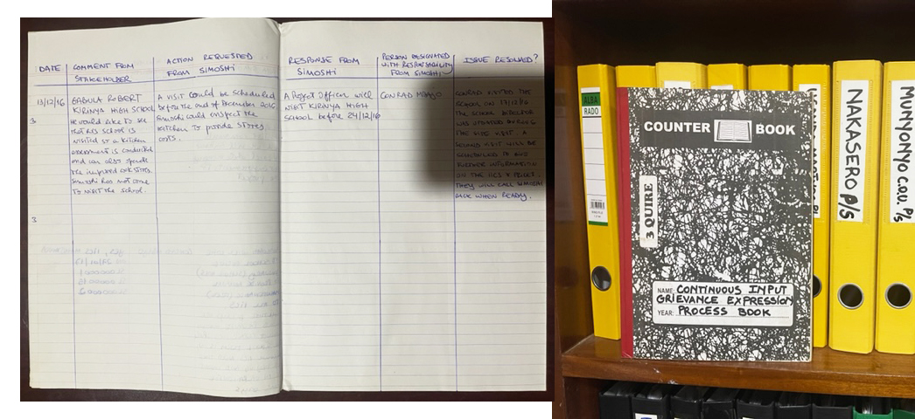
  - Report on any stakeholder mitigations that were agreed to be monitored.
N/A.

  - Provide details of any legal contest that has arisen with the project during the monitoring period
None.

ANNEX I
Date | Ugastove Representative | Parameter | Status | Simoshi Representative
16/10/20 | Rehema Nakyazze | Provision of protective equipment | yes | Virginia Echavarria
 |  | Provision of protective gloves | yes
 |  | Provision of goggles | yes
 |  | Provision of headset | yes
 |  | Provision of closed shoes | yes
08/12/20 | Rehema Nakyazze | Provision of protective equipment | yes | Virginia Echavarria
 |  | Provision of protective gloves | yes
 |  | Provision of goggles | yes
 |  | Provision of headset | yes
 |  | Provision of closed shoes | yes
17/02/21 | Rehema Nakyazze | Provision of protective equipment | yes | Virginia Echavarria
 |  | Provision of protective gloves | yes
 |  | Provision of goggles | yes
 |  | Provision of headset | yes
 |  | Provision of closed shoes | yes
22/04/21 | Rehema Nakyazze | Provision of protective equipment | yes | Virginia Echavarria
 |  | Provision of protective gloves | yes
 |  | Provision of goggles | yes
 |  | Provision of headset | yes
 |  | Provision of closed shoes | yes
28/09/21 | Rehema Nakyazze | Provision of protective equipment | yes | Virginia Echavarria
 |  | Provision of protective gloves | yes
 |  | Provision of goggles | yes
 |  | Provision of headset | yes
 |  | Provision of closed shoes | yes

Table 1 – Details on the individual monitoring visits conducted at Ugastove

Revision History

Version | Date | Remarks
1.1 | 14 October 2020 | Hyperlinked section summary to enable quick access to key sections  Improved clarity on Key Project Information  Section for POA monitoring  Forward action request section  Improved Clarity on SDG contribution/SDG Impact term used throughout  Clarity on safeguard reporting  Clarity on design changes  Leakage section added for VER/CER projects  Addition of Comparison of monitored parameters with last monitoring period  Provision of an accompanying Guide to help the user understand detailed rules and requirements
1.0 | 10 July 2017 | Initial adoption

The project had initially the intention to be included under the PoA 7014 : Improved Cook Stoves for East Africa (ICSEA), however due to different reasons (to be kept confidential), the PP preferred to proceed with a standalone activity.
Though the SSC threshold calculation has resulted in a maximum of 400 institutions (for details, please see tab ‘SSC threshold’/VER calculation excel spreadsheet), this might change over time since it depends on several factors, like B_{y,savings,i}, the proportion of boarding schools to day schools, thermal efficiency and loss in efficiency of the IICS, and number of students/staff per institution. If those factors change, the SSC threshold might be higher or lower than 400 institutions. PP will ensure through continuous checks that the number of schools/institutions included into the project do not pass the SSC theshold at any time during the crediting period. If the SSC threshold allows more than 450 institutions, the project may disseminate IICS to more than 450 schools/institutions until the SSC threshold is reached.
This is calculated by multiplying 450 schools/institutions with the average size of 756 heads of the first 24 included institutions.
Downrounded value
Commercial establishments such as restaurants and hotels are excluded as per ASB0016 and hence cannot be included in this project activity.
Ministry of Energy and Mineral Development (June 2015). “Uganda’s Sustainable Energy for all Initiative – Action Agenda”. Page 9.
Ministry of Energy and Mineral Development (June 2001). “National Biomass Energy Demand Strategy 2001-2010 [http://www.energyandminerals.go.ug/downloads/BEDS-Contents.pdf]
http://www.ubos.org/onlinefiles/uploads/ubos/statistical_abstracts/Statistical%20Abstract%202014.pdf
http://www.education.go.ug/files/downloads/Abstract_2013.pdf
http://cdm.unfccc.int/methodologies/DB/UFM2QB70KFMWLVO7LJN8XD1O2RKHEK
Refer to Excel emission reduction calculation spreadsheet
See AMS-II.G., 6.1, table 8
AMS II.G., 6.1., table 9
The same has been confirmed by the manufacturer of the IICS. The confirmation letter has been presented to the DOE during validation.
This is in line with the response given from the SSG WG to Request for Clarification SSC_726.
This is in line with the response given from the SSG WG to Request for Clarification SSC_725.
26/03/2016 is defined as the project start date, i.e. the date when the first stoves were disseminated to an institution.
The 2nd batch will include institutions and IICS disseminated in the time period from 26/03/2017 to 25/03/2018, the 3rd batch will consist of the time period from 26/03/2018 to 25/03/2019 and so on.
This is in line with the response given from the SSG WG to Request for Clarification SSC_725.
Default values endorsed by designated national authorities and approved by the Board are available at <http://cdm.unfccc.int/DNA/fNRB/index.html>.
This value represents the emission factor of the substitution fuels likely to be used by similar users, on a weighted average basis. It is assumed that the mix of present and future fuels used would consist of a solid fossil fuel (lowest in the ladder of fuel choices), a liquid fossil fuel (represents a progression over solid fuel in the ladder of fuel use choices) and a gaseous fuel (represents a progression over liquid fuel in the ladder of fuel use choices). Thus a 50 per cent weight is assigned to coal as the alternative solid fossil fuel (96 t CO2/TJ) and a 25 per cent weight is assigned to both liquid and gaseous fuels (71.5 t CO2/TJ for kerosene and 63.0 t CO2/TJ for liquefied petroleum gas (LPG).
Whenever emission reductions are capped, both the original and capped values used for calculations must be transparently reported. Use brackets to denote original values.
Default values endorsed by designated national authorities and approved by the Board are available at <http://cdm.unfccc.int/DNA/fNRB/index.html>.
This value represents the emission factor of the substitution fuels likely to be used by similar users, on a weighted average basis. It is assumed that the mix of present and future fuels used would consist of a solid fossil fuel (lowest in the ladder of fuel choices), a liquid fossil fuel (represents a progression over solid fuel in the ladder of fuel use choices) and a gaseous fuel (represents a progression over liquid fuel in the ladder of fuel use choices). Thus a 50 per cent weight is assigned to coal as the alternative solid fossil fuel (96 t CO2/TJ) and a 25 per cent weight is assigned to both liquid and gaseous fuels (71.5 t CO2/TJ for kerosene and 63.0 t CO2/TJ for liquefied petroleum gas (LPG).

