Monitoring Report

PUBLICATION DATE 14.10.2020
VERSION v.1.1
RELATED SUPPORT – TEMPLATE GUIDE Monitoring Report v. 1.1

This document contains the following Sections
Key Project Information
SECTION A - Description of project
SECTION B - Implementation of project
SECTION C - Description of monitoring system applied by the project
SECTION D - Data and parameters
SECTION E - Calculation of SDG Impacts
SECTION F - Safeguards Reporting
SECTION G - Stakeholder inputs and legal disputes

KEY PROJECT INFORMATION

Key Project Information
GS ID (s) of Project (s) | GS950
Title of the project (s) covered by monitoring report | Kayaduzu Wind Power Plant, Turkey
Version number of the PDD/VPA-DD (s) applicable to this monitoring report | 16
Version number of the monitoring report | 6
Completion date of the monitoring report | 26/08/2024
Date of project design certification | 11/12/2012
Date of Last Annual Report | 29/12/2022
Monitoring period number | 3rd Monitoring period  2nd Crediting period
Duration of this monitoring period | 29/10/2021 – 25/04/2023
Project Representative | 1. Eksim Enerji A.Ş.  2. SILA DURAN  sila@sekansanismanlik.com  Sekans Danışmanlık
Host Country | Turkey
Activity Requirements applied | Community Services Activities  Renewable Energy Activities  Land Use and Forestry Activities/Risks & Capacities  N/A
Methodology (ies) applied and version number | ACM0002 “Grid-connected electricity generation from renewable sources”,  Version 20.0
Product Requirements applied | GHG Emissions Reduction & Sequestration  Renewable Energy Label  N/A

Table 1 - Sustainable Development Contributions Achieved
Sustainable Development Goals Targeted | SDG Impact | Amount Achieved | Units/ Products
SDG 7 Ensure access to affordable, reliable, sustainable and modern energy for all | Affordable and Clean Energy  (MWh of renewable energy generated) | 166,401.27 | MWh
SDG 8 Promote sustained, inclusive and sustainable economic growth, full and productive employment and decent work for all Decent Work and Economic Growth | Decent Work and Economic Growth  (Number of employment) | 17 | Employees
SDG 13 Take urgent action to combat climate change and its impacts | Climate actions  (Emission reductions) | 103,134 | VERs

Table 2 – Product Vintages

 |  | Amount Achieved
Start Dates | End Dates | VERs
29/10/2021 | 31/12/2021 | 13,493
01/01/2022 | 31/12/2022 | 72,923
01/01/2023 | 25/04/2023 | 16,718

- DESCRIPTION OF PROJECT
  - General description of project
Baktepe Enerji A.Ş (hereafter referred as the “Project Owner”) installed Kayaduzu Wind Power Plant, Turkey (hereafter referred to as the “Kayaduzu WPP” or “Proposed Project”) with total capacity of 40.0 MW in Kayadüzü Village of Merzifon District in Amasya Province of Turkey, in Black Sea Region.

The purpose of the project is to produce renewable electricity and to contribute to Turkey’s growing electricity demand through a sustainable and low carbon technology. The project displaces the same amount of electricity generated by fossil fired power plants; thereby helping reduce the weight of electricity generation by fossil-fired power plants in the national grid. The annual emission reduction estimated by the project is 69,213 tonnes of CO2eq.

The project activity pursues both to contribute to providing energy needs of Turkey and to create local industry as well as providing employment. The project activity is Merzifon District of Amasya Town in Black Sea Region, Turkey. The project start date is 06/10/2010 as the date of electromechanical agreement with Nordex.

Total capacity of the project activity is 40.0 MW. The estimated annual electricity generation of the project is 111,670 MWh. The electricity generated is transmitted to the national grid via a 154 kV high voltage transmission line over the Kayaduzu Transformer Station.

Table 3 – The start dates of turbines included in capacity
Phase | Date | Capacity | Turbines
1st | 16/03/2012 | 7.5 MW | T1, T2, T3
2nd | 15/06/2012 | 17.5 MW | T4, T5, T6, T7, T8, T9, T10
3rd | 09/09/2017 | 10.0 MW | T20, T21, T22, T23
4th | 21/09/2017 | 2.5 MW | T24
5th | 27/09/2018 | 2.5 MW | T19

As the generation license has been revised for capacity extension, fourteen turbines were added to the project on 15/06/2012, 09/09/2017, 21/09/2017 and 27/09/2018. The installed capacity of the project has been raised to 82 MWm/75 MWe with the revision. As the registered capacity of the project is considered, the electricity generation and the emission reduction of the added units are ignored for this monitoring period. The Project Owner will not issue CER and GS VERs for the same vintages of the added units in this MP.

For the aim of reaching the actual values derived from the registered capacity, the generation of the added turbines taken from SCADA system of the project activity will be subtracted from the total generated amount which could be monitored through EPIAS records. Thus, baseline emissions will be based on the "adjusted net electricity supplied to the grid". This value will be calculated as below:

Adjusted net electricity supplied to the grid [MWh] | = | EG_{PJ,grid, y} [MWh] | - | Generation of added capacity taken from the SCADA System [MWh]

Equation (1)

The new turbine numbers are T11, T12, T13, T14, T15, T16, T17, T18, T25, T26, T27, T28, T29 and T30. The newly added turbine types are Nordex N117-3.0 MW. The commissioning dates of the newly added turbines are as below:

Table 4 – The start dates of newly added turbines
Date | Capacity | Turbines
15/06/2012 | 9.0 MW | T11, T12, T13
09/09/2017 | 18.0 MW | T14, T17, T18, T27, T28, T29
21/09/2017 | 6.0 MW | T15, T16
27/09/2018 | 9.0 MW | T25, T26, T30

Please see below the technical specifications of the turbines of the project activity
The commissioning dates of the project activity may be seen through Table 5:

Table 5 – Recent timeline of the project
Date | Comissioning of Turbines
01/07/2012 | 1st Crediting period start date
01/07/2012 – 30/04/2014 | 1st Monitoring period
27/08/2016 – 30/06/2019 | 2nd Monitoring period
30/06/2019 | 1st Crediting period end date
01/07/2019 | 2nd Crediting period start date
29/10/2021 – 25/04/2023 | 3rd Monitoring period
30/06/2026 | 2nd Crediting period end date

During its operation during this monitoring period, the actualized net electricity generation is 166,401.27 MWh. The actual emission reduction has been calculated as 103,134 tonnes CO2 for this monitoring period.

The project has produced positive environmental benefits as displacing the electricity generated by fossil fuel fired power plants by utilising the renewable resources to avoid environmental pollution and GHG emissions.

  - Location of project

The project activity is located in Kayadüzü Village, Merzifon District of Amasya Province in Black Sea Region, Turkey.

Table 6 – Coordinates of the wind turbines of registered capacity

Turbine # | E | N
1 | 35°30’14.5764” | 40°56’28.3164’’
2 | 35°30’27.198” | 40°56’29.598’’
3 | 35°30’36.6804” | 40°56’29.3892’’
4 | 35°30’45.162” | 40°56’28.6548’’
5 | 35°30’56.7324” | 40°56’24.738’’
6 | 35°31’1.218’’ | 40°56’14.5248’’
7 | 35°31’18.3468’’ | 40°56’15.1548’’
8 | 35°31’20.7516’’ | 40°56’1.968’’
9 | 35°31’29.0136” | 40°55’59.9412’’
10 | 35°31’36.7104” | 40°55’56.5932’’
19 | 35°33’53.9064” | 40°55’27.6888’’
20 | 35°34’2.4384” | 40°55’26.1372’’
21 | 35°34’11.442” | 40°55’25.7412’’
22 | 35°34’20.0856” | 40°55’24.834’’
23 | 35°34’27.192” | 40°55’20.6544’’
24 | 35°34’35.166” | 40°55’18.012’’

Table 7 – Coordinates newly added the wind turbines

Turbine # | E | N
T11 | 35°31’53.7456” | 40°56’2.706’’
T12 | 35°32’6.6984” | 40°56’4.8516’’
T13 | 35°32’15.4968” | 40°56’4.6572’’
T14 | 35°32’37.6008” | 40°55’53.5044’’
T15 | 35°33’2.4444” | 40°55’46.8264’’
T16 | 35°33’33.8904” | 40°55’41.88’’
T17 | 35°33’41.1804” | 40°55’38.0532’’
T18 | 35°33’47.304” | 40°55’32.7288”
T25 | 35°30’51.1128” | 40°56’1.7088”
T26 | 35°31’12.7272” | 40°56’4.5456”
T27 | 35°32’49.9092” | 40°55’57.8028”
T28 | 35°32’55.2048” | 40°55’50.9088”
T29 | 35°33’6.966” | 40°55’39.9144”
T30 | 35°33’15.7356” | 40°55’37.8732”

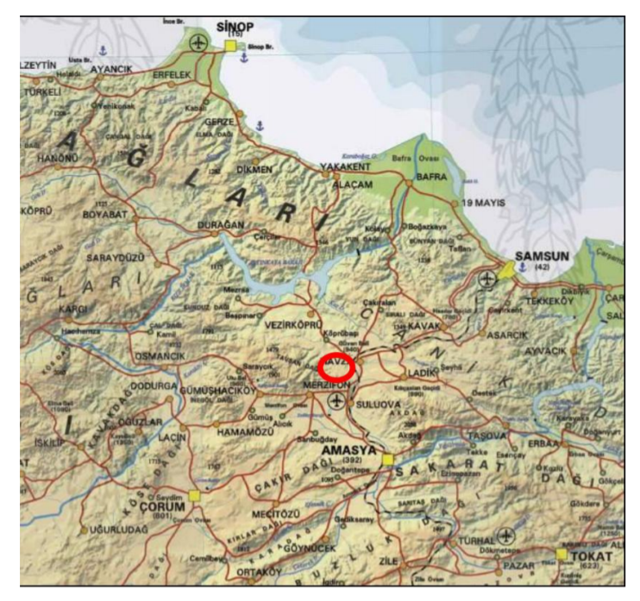
Figure 1. Project Location on Turkey Map Site Layout

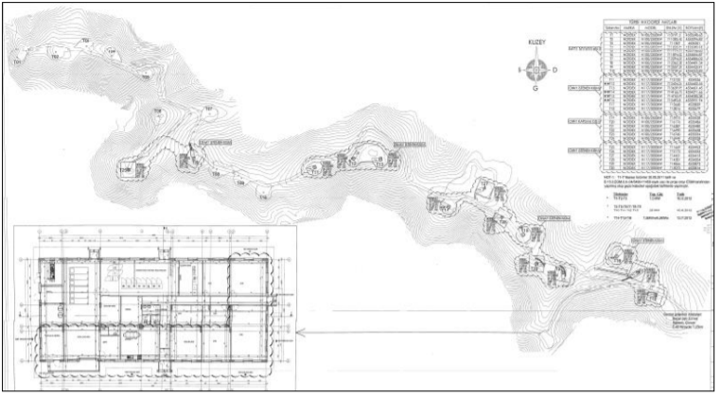
Figure 2. Site Layout
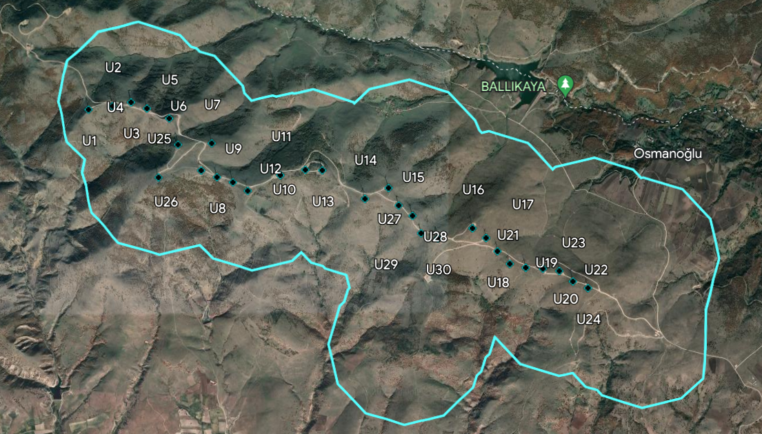
Figure 3. The locations of the turbines in the project area

  - Reference of applied methodology

Applied approved baseline and monitoring methodologies:

Methodology: ACM0002 “Consolidated baseline methodology grid-connected electricity generation from renewable sources”, Version 20.0

The methodology refers to:
- “Tool to calculate the emission factor for an electricity system”, Version 07.0
- “Tool for the demonstration and assessment of additionality”, Version 07.0.0
- “Combined tool to identify the baseline scenario and demonstrate additionality”, Version 07.0
- “Tool to calculate project or leakage CO2 emissions from fossil fuel combustion”, Version 03.0
- Tool “Assessment of the validity of the original/current baseline and update of the baseline at the renewal of the crediting period”, Version 03.0.1

  - Crediting period of project
The first crediting period is 7 years and renewable twice.

Start date of the first crediting period: 01/07/2012
End date of the first crediting period: 30/06/2019

Start date of the second crediting period: 01/07/2019
End date of the second crediting period: 30/06/2026

- IMPLEMENTATION OF PROJECT
  - Description of implemented project

The proposed project activity involves the installation of 16 units of wind turbines with a total installed capacity of 40.0 MW. The estimated annual electricity generation of the project is 111,670 MWh/year.
The start date of the project activity is 06/10/2010 as the date of electromechanical agreement with Nordex. Regarding the actual operation of the project activity, the first temporary acceptance protocol signed by the Ministry of Energy and Natural Resources is dated 16/03/2012 for the commissioning of the 3 turbines. The second temporary acceptance protocol with the Ministry was signed on 15/06/2012 for the next ten turbines. The third temporary acceptance protocol with the Ministry was signed on 13/07/2012 for the remaining three turbines.

The newly added turbine numbers are T11, T12 T13, T14, T15, T16, T17, T18, T25, T26, T27, T28, T29 and T30. The newly added turbines type is Nordex N117/3000. Ten of the turbines have a capacity of 3.0 MWm/3.0 MWe, three have a capacity of 3.0 MWm/2.0 MWe and one has a capacity of 3.0 MWm/1.0 MWe. The commissioning dates of the newly added turbines are 15/06/2012 (T11, T12, T13), 09/09/2017 (T14, T17, T18, T27, T28, T29), 21/09/2017 (T15, T16) and 27/09/2018 (T25, T26, T30).

The baseline emissions are based on the adjusted net electricity supplied to the grid. The adjusted net electricity is 166,401.27 MWh and the baseline emissions are 103,134 tCO2 for this monitoring period. These values represent the generation and emission reduction of the power plant excluding the generation of turbines newly added in respect of capacity extension. For the aim of reaching the actual values derived from the registered capacity, the generation of the added turbines taken from SCADA system of the project activity were subtracted from the total generated amount which could be monitored through EPIAS records.

The ‘adjusted net electricity supplied to the grid’ is calculated as below:

Adjusted net electricity supplied to the grid [MWh] | = | EG_{PJ,grid, y} [MWh] | - | Generation of added capacity taken from the SCADA System [MWh]

The grid connection point is Transformer Station. The connection voltage is 154 kV. The wind turbines of the plant are to be supplied from Nordex. The technology used in the plant includes first hand wind turbines and its auxiliary equipment with extensive automatization. The project does not need extensive initial training and maintenance efforts to work as presumed during the project period. Necessary trainings to the plant staff will be delivered by the supplier in line with the agreement between the project owner and the supplier. In addition, according to EMRA, the average lifetime of wind turbines is between 20 and 25 years and it is accepted as 20 years for financial analysis of proposed project to be conservative side.

The Nordex N100/2500 turbine model was selected for the 16 turbines of the project. It’s a three-bladed variable-speed wind turbine generator with a rotor diameter of 100 m. The hub height of the turbines is 91 m. The nominal power of each turbine is 2500 kW. The turbines are connected to the Kayadüzü Transformer Station and the electricity generated is transmitted to the national grid via a 154 kV high voltage transmission line. The metering has been done at substation before electricity is fed into the grid.

Table 8 – Technical details of turbines of the the project

Parameter | Nordex N100/2500 | Nordex N117/3000
Manufacturer | Nordex | Nordex
Number of units | 16 | 14
Rotor Diameter | 100 m | 117 m
Rated Power | 16 x 2.5 MWm/2.5 MWe | 10 x 3.0 MWm/3.0 MWe  1 x 3.0 MWm/2.0 MWe  3 x 3.0 MWm/1.0 MWe
Rated Wind Speed | 14.0 – 20.0 m/s | 12.6 m/s
Hub Height | 80 m | 91 m
Operating wind | 4.0 - 20.0 m/s | 3.0 - 25.0 m/s

There are four meters installed at the site where the two of them are called the main meters and the other ones are secondary meters. All meters are ITRON branded. The serial number of the main meter is “3574753” and the serial number of the spare meter is “3574754” for TR-1. The serial number of the main meter is “3574755” and the serial number of spare the meter is “3574756” for TR-2. All meters have an accuracy class of 0.2S. The latest test date of the meters is 13/10/2022.

    - Forward Action Requests

FAR #1:
In-line with GS4GG Principles and Requirements, VVB and PP shall consider the following rule after Design Renewal Certification is achieved: 5.1.29: 1st verification shall be completed within two years after the certification is achieved.
Answer: In line with the rule, the currentmonitoring period is between 29/10/2021 – 25/04/2023. So, it is in accordance with the rules.

FAR #2:
As remote audit conducted, VVB shall resume site visit when COVID-19 situation eases In-line with relevant Interim Measures.
Answer: Physical site visit was conducted on 26/04/2023.

FAR #3:
Delay in the completion of re-validation beyond the last date of current certification cycle shall result in a reduction of any issuance of Certified Products and/or Impact Statements available during following certification cycle (for example, a delay of 1 year beyond the first cycle shall mean that no Certified Impact Statements shall be issued for the period of delay). Thus, PD can claim credits from 29 Oct 2021 in CP2.
Answer: In line with the rules, the currentmonitoring period started from 29/10/2021.

FAR #4:
As per provided 2022 ornithological studies, it is understood that a solar component in addition to the project activity is planned. PP shall note that such inclusion to the registered project activity will be subject to GS4GG design change requirements.
Answer: As of yet, there are no additional installations to the existing project activity.

  - Post-Design Certification changes
    - Temporary deviations from the approved Monitoring & Reporting Plan, methodology or standardized baseline
There are no project or methodology deviations applied during this monitoring period.
    - Corrections
There are no corrections applied during this monitoring period.
    - Changes to start date of crediting period
There are no changes applied to the start date of the crediting period during this monitoring period.
    - Permanent changes from the Design Certified monitoring plan, applied methodology or applied standardized baseline
There are no changes applied to the start date of the crediting period during this monitoring period.
    - Changes to project design of approved project
There are no changes to project design during this monitoring period.

- DESCRIPTION OF MONITORING SYSTEM APPLIED BY THE PROJECT
The objective of the monitoring plan is to ensure the complete, consistent, clear, and accurate monitoring and calculation of the emission reductions during the whole crediting period. The Project Owner is responsible for the implementation of the monitoring plan.

The Project Owner is responsible for the overall management of the monitoring procedures including recording, data collection, calculating emission reductions and project emissions.
All monitoring procedures and requirements of the proposed project activity is in accordance with the methodology ACM0002 “Grid-connected electricity generation from renewable sources” Version 20.0.

Metering: The main source for electricity generation metering will be the TEIAS meters installed and sealed by TEIAS. Since the TEIAS meters are sealed by TEIAS and are also the basis of invoicing, a high accuracy and reliability is ensured. Also, the TEIAS meters have the ability to measure both the amount of electricity exported to the grid as well as the amount of electricity imported by the project activity, which provides an accurate and reliable measurement of the net electricity.

Additionally, the Project Owner enters the expected electricity generation on daily basis to the website of EPIAS which is the financial settlement center of TEIAS. The website of EPIAS is accessible to project owner with their unique user ID and password. The difference between the expected and generated electricity (imbalance) is costed the project owner at the end of each month. The electricity generation data is reported monthly. EPIAS records are used as the source of net generated electricity value and meter reading forms or OSF forms issued by TEIAS will be used for the crosscheck.

Meter readings: Once a month, the project participant will perform data readings. The monthly results will be recorded by the project participant both manually and electronically.

All four meters are ITRON branded (SL7000) and the accuracy class of them is 0.2S. For TR-1, the serial number of the main meter is “3574753” and the serial number of the spare meter is “3574754”. For TR-2, the serial number of the main meter is “3574755” and the serial number of the spare meter is “3574756”. The latest test dates of the meters are 29/09/2020 and 13/10/2022. The meters are calibrated every ten years. Additionally, the meters are tested every two years.
Data storage: Data will be stored electronically, during the crediting period and at least two years after the last issuance of credits for the wind farm project activity in the concerning crediting period. The Project Participant will be responsible for storage of data received from the measuring devices.

Responsibilities for monitoring: The Project Owner is responsible for the operation and maintenance of the project activity and the installed equipment. The project owner is also responsible for the administration of the data, setting up a VER team who is responsible for monitoring all data required to estimate emission reductions. Emission reductions are calculated by the VER consultant, Sekans. In the diagram below the organization of monitoring management and data application may be seen:

Figure 4. The management structure for the plant operation

The operation manager is responsible for performing all administrative, financial, organizational and strategic management of the power plant. The Administrative Personnel is responsible for the correct management and control of cleaning, consumables, food and other service processes. The Operations Technician is responsible for the daily switchgear and turbine operations.

Quality assurance and quality control: The main source of measurement is the TEIAS meters, which are sealed by TEIAS and since it is subject to monthly invoicing high reliability and accuracy is secured. In accordance with the requirements of TEIAS, there are four meters installed at the site where two of them are called the main meters and the other ones are as secondary meters. TEIAŞ is the main responsible for calibration and maintenance of the devices. TEIAŞ performs the necessary maintenance and calibration. Since the electricity generation data is used for the billing and accounting between TEIAŞ and the project participant the data is of high quality.

The primary source is the EPIAS records. Net electricity exported is crosschecked with Meter Reading Forms. EPIAS is the financial settlement center of TEIAS. The Meter Reading Forms are filled in by the project owner and approved by the governmental officers. Additionally, remote reading by the governmental body is also available. The website of EPIAS is accessible to Project Owner with their unique user ID and password. Once accessed, the Project Owner is able to call electricity generation for invoicing TEIAS. The electricity generation data is reported monthly.

Corrective actions and emergency preparedness: The Project Owner regularly checks the monitoring system for errors. In the case of errors, corrective actions will be undertaken by the Project Participant, or if required, by the supplier of the monitoring equipment.

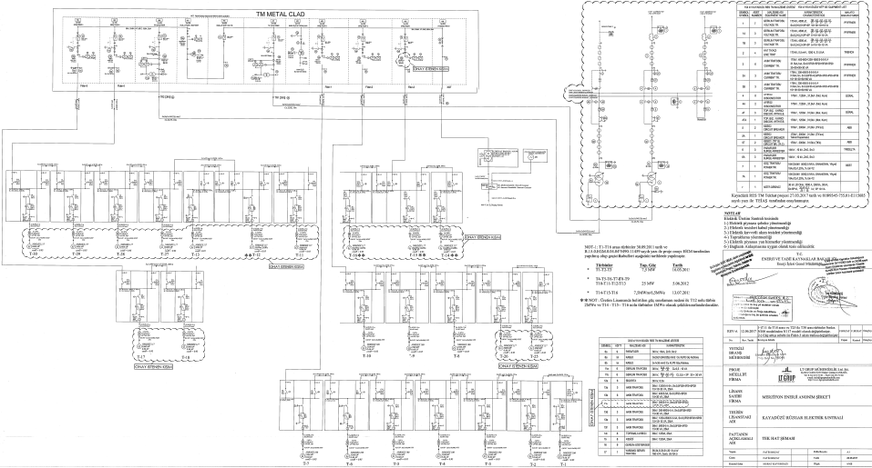
Figure 5. The single line diagram of the Project Activity

Data will be stored electronically, during the crediting period and at least two years after the last issuance of credits for the wind farm project activity in the concerning crediting period. The Project Owner is responsible for storage of data received from the measuring devices. The site manager is responsible for data aggregation.

During the monitoring period, no breakdown or serious maintenance work has been experienced. Ordinary maintenance activities have been executed.

- DATA AND PARAMETERS
  - Data and parameters fixed ex ante or at renewal of crediting period
Relevant SDG Indicator/Safeguarding Principle | 13.3.2 Number of countries that have communicated the strengthening of institutional, systemic and individual capacity-building to implement adaptation, mitigation and technology transfer, and development actions
Data / Parameter | EF_{grid, CM, y}
Unit | tCO₂/MWh
Description | Emission factor of the Turkish grid determined ex-ante. It has been published by the Ministry of Energy for 2018.
Source of data | Ministry of Energy. Please see:  https://enerjiapi.etkb.gov.tr/Media/Dizin/ETKB/Duyurular//0c6b62eabf2f-4fea-b9b3-28bc6f48ddf2_Bilgi_Formu_-_Web_Sitesi.pdf
Value(s) applied | 0.6198
Choice of data  or measurement methods and procedures | Official data
Purpose of data/parameter | Calculation of baseline emissions and to demonstrate contribution to the SDG13-13.2.2
Additional comments | The emission factor of the Turkish grid is calculated ex-ante and has been fixed for the second crediting period.

  - Data and parameters monitored
Relevant SDG Indicator/Safeguarding Principle | SDG 7.2.1 Renewable energy share in the total final energy consumption
Data / Parameter | EG_{PJ, grid, y}
Unit | MWh/yr
Description | Quantity of net electricity generation supplied by the project plant/unit to the grid in year y
Source of data | EPIAS records
Value(s) applied
  Period | Generation (MWh)
  29.10.2021-31.12.2021 | 21,770.96
  01.01.2022-31.12.2022 | 117,656.69
  01.01.2023-25.04.2023 | 26,973.61
  Total | 166,401.27
Measurement methods and procedures | TEİAŞ is performing remote reading of the meters and monthly power meter readings are the basis for monitoring net electricity fed into the grid. EPİAŞ records will be used as the source of net generated electricity value and meter reading forms or OSF forms issued by TEİAŞ will be used for the crosscheck.  Power meters belong to the Project Activity:
  TR-1 | Main Meter | Back-up Meter
  Manufacturer | ITRON | ITRON
  Serial Number | 3574753 | 3574754
  Date of Installation | 02/08/2017 | 02/08/2017
  Latest Test Date of the Meters | 13/10/2022 | 13/10/2022
  Accuracy of meters | 0.2S class | 0.2S class
  TR-2 | Main Meter | Back-up Meter
  Manufacturer | ITRON | ITRON
  Serial Number | 3574755 | 3574756
  Date of Installation | 28/07/2017 | 28/07/2017
  Latest Test Date of the Meters | 13/08/2018 | 13/08/2018
  Accuracy of meters | 0.2S class | 0.2S class
Monitoring frequency | Continuous monitoring, hourly measurement and at least monthly recording
QA/QC procedures | - Back-up meters are used for crosschecking the accuracy and all meters are periodically tested.  - The metering devices are in line with the technical requirements which are set out by the Communiqué for Metering Devices to be used in the Electricity Market, which describes the minimum accuracy requirement the metering devices have to fulfill, which are categorized according to the installed capacity. The periodical test or maintenance is the responsibility of TEİAŞ. Since TEİAŞ meters are sealed by TEİAŞ, the project proponent cannot intervene with the devices. The meters are calibrated every ten years. Additionally, the meters are tested every two years.  - The net electricity export/supplied to a grid is the difference between the measured quantities of the grid electricity export and the import. EPİAŞ records are crosschecked with the meter reading protocols (OSOS-OSF forms).  - In addition to metering devices, every single wind turbine generation is monitored, and the data will be stored through a SCADA system.
Purpose of data, | To measure the electricity produced and supplied to the grid and thus calculation of emission reductions.
Additional comment | -

Relevant SDG Indicator/Safeguarding Principle | 13.3.2 Number of countries that have communicated the strengthening of institutional, systemic and individual capacity-building to implement adaptation, mitigation and technology transfer, and development actions
Data / Parameter | ER_{y}
Unit | tCO2/y
Description | Emission reductions by the project activity in year y (tCO2/yr) In accordance with ACM0002, baseline emissions include CO2 from electricity generation in powerplants that are displaced due to the project activity. And baseline emissions correspond to emission reductions and are calculated as the net electricity generated by the project activity, multiplied with combined margin CO2 emission factor for grid connected power generation in year y.
Source of data | Both measured and calculated.  Emission reductions were calculated as considering the EPIAS records for the net electricity generated and the emission factor for the grid, 0.6198 tCO2/MWh, published by the Ministry of Energy.
Value(s) applied | The achieved emission reductions for this monitoring period (29/10/2021 – 25/04/2023) is 103,134 tCO2.
  Vintages | Achieved emission reductions
  29/10/2021 – 31/12/2021 | 13,493 tCO2
  01/01/2022 – 31/12/2022 | 72,923 tCO2
  01/01/2023 – 25/04/2023 | 16,718 tCO2
Measurement methods and procedures | Methodology ACM0002, Version 20.0
Monitoring frequency | Once for each year of operation
QA/QC procedures | - According to the methodology applied, the electricity supplied to the national grid by the project and the electricity consumed by the project activity shall be monitored. The net electricity is the difference of the electricity supplied and consumed by the project and shall be taken into account for emission reduction calculations.  - Four power meters are installed at the grid interface of the project. Two of them are main meters and the other ones are back-up meters of the main meters for cross-checking. All meters are jointly inspected and sealed to be protected from interference by any of the parties.
Purpose of data | Calculation of combined margin CO2 emission factor and thus the baseline emissions.  To demonstrate contribution to SDG Target 13.3.: Improve education, awareness-raising and human and institutional capacity on climate change mitigation, adaptation, impact reduction and early warning.
Additional comments | -

Relevant SDG Indicator/Safeguarding Principle | 8.5.2. Unemployment rate, by sex, age and persons with disabilities
Data / Parameter | Number of employment
Unit | Number
Description | Number of people permanently working for the operation of the project
Source of data | Social Security System (SGK)
Value(s) applied | 17 personnel are working for the project activity:  - 1 Operation Manager  - 4 O&M Technicians  - 5 Control Operators  - 1 Administrative Personnel  - 5 Security Staff (Subcontractor-Akdeniz Security)  - 1 O&M Technician (Nordex)  8 personnel are from local region.
Measurement methods and procedures | Social Security System (SGK) records
Monitoring frequency | Once for each monitoring period
QA/QC procedures | SGK records of employees are provided during each monitoring period.
Purpose of data | SDG 8.5.By 2030, achieve full and productive employment and decent work for all women and men, including for young people and persons with disabilities, and equal pay for work of equal value
Additional comment | -

Relevant SDG Indicator/Safeguarding Principle | 8.8.1. Frequency rates of fatal and non-fatal occupational injuries, by sex and migrant status
Data / Parameter | - Number of trainings  - Fair wage, working hours and occupational injuries
Unit | - Number  - N/A
Description | - Number of training sessions held  - The social security conditions provided to the employees
Source of data | - Attendance records or training certificates  - Social Security Records
Value(s) applied | Training certificates and training attendance lists are available to the VVB.
  No | Date | Training
  1 | 19/01/2021 | Singleton Advaned Rescue Training – Nacelle
  2 | 20/01/2021 | Singleton Advaned Rescue Training – Hub
  3 | 15/02/2022 | Working at Heights Refresher
  4 | 09/09/2022 | Working at Heights Refresher
  5 | 10/11/2022 | Working at Heights Refresher
  6 | 10/11/2022 | Manuel Handling
  7 | 10/11/2022 | Fire Awareness
  8 | 11/11/2022 | First Aid
  9 | 17/11/2022 | Working at Heights Refresher
Measurement methods and procedures | Social Security Records, training certificates or training attendance lists
Monitoring frequency | Once for each monitoring period
QA/QC procedures | Social Security Records, training certificates or training attendance lists are provided during each monitoring period.
Purpose of data | Monitoring the trainings to justify contribution to SDG 8.8. Protect labour rights and promote safe and secure working environments for all workers, including migrant workers, in particular women migrants, and those in precarious employment
Additional comment | -

  - Comparison of monitored parameters with last monitoring period
Since the project is not community service project, this section is non-applicable.

  - Implementation of sampling plan
N/A
- CALCULATION OF SDG IMPACTS
  - Calculation of baseline value or estimation of baseline situation of each SDG Impact
SDG 13

According to the methodology baseline emissions include only CO₂ emissions from electricity generation in fossil fuel fired power plants that are displaced due to the project activity. The methodology assumes that all project electricity generation above baseline levels would have been generated by existing grid-connected power plants and the addition of new grid-connected power plants. The baseline emissions are calculated as follows:

$${BE}_{y}={EG}_{PJ, y}* {EF}_{grid, CM}$$

where:

BE_{y} | Baseline emissions in year y (tCO2/year)
EG _{PJ,y} | Quantity of net electricity generation that is produced and fed into the grid as a result of the implementation of the CDM project activity in year y (MWh/yr)
EF_{grid,CM} | Combined margin CO2 emission factor for grid connected power generation calculated using the latest version of the “Tool to calculate the emission factor for an electricity system”. The combined margin is calculated ex-post and has been fixed for the second crediting period.  BEy= 166,401.27 x 0.6198 = 103,134 tCO2

Table 9 - Baseline Emissions

Month | (A)  Electricity  supplied to  the grid  [MWh] | (B)  Electricity  consumed from  the grid  [MWh] | (C) = (A) - (B)  EG (ID 8)  Net electricity  supplied to the grid  [MWh] | EF  [tCO₂/MWh] | Baseline  emission:  ER = EG * EF  [t CO₂-eq] | (E) = (D) - (B) Adjusted  net electricity  supplied to the grid  [MWh] | Adjusted baseline  emission:  ER = EG * EF  [t CO₂-eq]
Oct-21 (29-31/10/2021 | 1,361.50 | 36.91 | 1,324.59 | 0.6198 | 821 | 614.80 | 381
Nov-21 | 19,760.81 | 28.26 | 19,732.55 | 0.6198 | 12,230 | 9,582.49 | 5,939
Dec-21 | 23,880.64 | 28.89 | 23,851.75 | 0.6198 | 14,783 | 11,573.67 | 7,173
Jan-22 | 24,538.17 | 23.54 | 24,514.63 | 0.6198 | 15,194 | 11,886.73 | 7,367
Feb-22 | 21,369.88 | 35.12 | 21,334.76 | 0.6198 | 13,223 | 10,254.86 | 6,356
Mar-22 | 18,769.93 | 31.08 | 18,738.85 | 0.6198 | 11,614 | 8,816.31 | 5,464
Apr-22 | 20,667.75 | 23.26 | 20,644.49 | 0.6198 | 12,795 | 9,246.31 | 5,731
May-22 | 17,151.29 | 27.07 | 17,124.22 | 0.6198 | 10,614 | 7,831.47 | 4,854
Jun-22 | 22,507.55 | 28.65 | 22,478.90 | 0.6198 | 13,932 | 10,424.66 | 6,461
Jul-22 | 33,572.53 | 7.74 | 33,564.79 | 0.6198 | 20,803 | 15,737.12 | 9,754
Aug-22 | 25,609.25 | 18.06 | 25,591.19 | 0.6198 | 15,861 | 11,935.71 | 7,398
Sep-22 | 17,937.87 | 22.87 | 17,915.00 | 0.6198 | 11,104 | 8,020.87 | 4,971
Oct-22 | 19,885.07 | 36.94 | 19,848.13 | 0.6198 | 12,302 | 8,635.62 | 5,352
Nov-22 | 14,490.09 | 44.54 | 14,445.55 | 0.6198 | 8,953 | 6,486.35 | 4,020
Dec-22 | 18,387.40 | 27.49 | 18,359.91 | 0.6198 | 11,379 | 8,380.70 | 5,194
Jan-23 | 16,315.39 | 47.83 | 16,267.56 | 0.6198 | 10,083 | 7,043.06 | 4,365
Feb-23 | 16,987.62 | 29.98 | 16,957.64 | 0.6198 | 10,510 | 7,622.79 | 4,725
Mar-23 | 16,943.21 | 44.87 | 16,898.34 | 0.6198 | 10,474 | 7,523.71 | 4,663
Apr-23 (01-25/04/2023) | 10,702.06 | 24.38 | 10,677.68 | 0.6198 | 6,618 | 4,784.06 | 2,965
2021 Vintage  (29.10.2021-31.12.2021) | 45,002.95 | 94.06 | 44,908.89 | 0.6198 | 27,834 | 21,770.96 | 13,493
2022 Vintage  (01.01.2022-31.12.2022) | 254,886.78 | 326.36 | 254,560.42 | 0.6198 | 157,776 | 117,656.69 | 72,923
2023 Vintage  (01.01.2023-25.04.2023) | 60,948.28 | 147.06 | 60,801.22 | 0.6198 | 37,684 | 26,973.61 | 16,718
Total | 360,838.00 | 567.48 | 360,270.52 | 0.6198 | 223,294 | 166,401.27 | 103,134

During this period, the project contributed to decreased fossil fuel consumption as well as a more sustainable development by generating 360,270.52 MWh and thus the reduction of 223,294 tCO2. These values represent the generation and emission reduction of the power plant also including the capacity increase. For the aim of reaching the actual values derived from the registered capacity (40 MW), the generation of the added turbines taken from SCADA system of the project activity will be subtracted from the total generated amount which could be monitored through EPIAS records. Thus, baseline emissions will be based on the adjusted net electricity supplied to the grid. The adjusted net electricity is 166,401.27 MWh and the baseline emissions are 103,134 tCO2 for this monitoring period.

The emission factor (EF_{grid,CM}) is taken as 0.6198 tCO2eq/MWh for the second crediting period as per the registered PDD.

SDG 7
The baseline value for renewable energy generation is 0. In the absence of the project activity, there wouldn’t be renewable energy generation.

SDG 8
The baseline value for number of employment and training is 0. In the absence of the project activity, there wouldn’t be employment of new staff.

The positions at the wind farm require skilled workers, which is achieved by adequate training. The project provides workers with a safe and healthy work environment and is not complicit in exposing workers to unsafe or unhealthy work environments.

  - Calculation of project value or estimation of project situation of each SDG Impact
SDG 13
In accordance with the methodology ACM0002 Version 20.0 “Grid-connected electricity generation from renewable sources”, no project emissions need to be considered. Project emissions apply only for geothermal power plants, solar thermal power plants and for some hydro power plants. Therefore,

PEy = 0.

SDG 7
The project value for renewable energy generation 166,401.27 MWh.

SDG 8
The project value for employment is 17. In total, 17 employees are working for PP at the site.

6 trainings as “Singleton Advanced Rescue Training - Nacelle”, “Singleton Advaned Rescue Training – Hub”, “Manuel Handling”, “Fire Awareness”, “First Aid” and “Working at Heights Refresher” are given to the employees.

  - Calculation of leakage
In line with the requirements of ACM0002 Version 20.0 “Grid-connected electricity generation from renewable sources”, no leakage emissions are considered. The main emissions potentially giving rise to leakage in context of electric sector projects are emissions arising due to activities such as power plant construction and upstream emissions from fossil fuel use (e.g., extraction, processing and transport). These emission sources are neglected.

LE_{y} = 0

  - Calculation of net benefits or direct calculation for each SDG Impact
SDG | SDG Impact | Baseline  estimate | Project  estimate |  | Net  benefit
13 | Climate Action | 103,134 VERs |  | 0 | 103,134 VERs
7 | Affordable and Clean Energy | 0 |  | 166,401.27 MWh | 166,401.27 MWh
8 | Decent Work and Economic Growth  (Number of employment) | 0 |  | 17 | 17

In accordance with ACM0002, the baseline emissions are calculated as the net electricity generated by the project activity multiplied with the baseline emission factor of the project grid.

𝑩𝑬_{𝒚} = 𝑬𝑮𝑷𝑱,𝒚 × 𝑬𝑭_{𝒈𝒓𝒊𝒅, CM} Equation (1)

where:

- BE_{y} = Baseline Emissions in year y (tCO2e)
- EG_{PJ,y} = Quantity of net electricity generation that is produced and fed into the grid as a result of the implementation of the CDM project activity in year y (MWh)
- EF_{grid,CM} = Combined margin CO2 emission factor for grid connected powergeneration in year y calculated using the latest version of the “Tool to calculate the emission factor for an electricity system”(t CO2/MWh)

BE_{y}= 166,401.27 x 0.6198 = 103,134 tCO2

Emission Reductions
ERy = BEy - PEy - LEy Equation (2)
ERy = 103,134– 0 – 0
ERy = 103,134 tCO2
  - Comparison of actual SDG Impacts with estimates in approved PDD
SDG | Values estimated in ex ante calculation of approved PDD  for this monitoring period | Actual values achieved during this monitoring period
13 | 103,156 tCO2 | 103,134 tCO2
7 | 166,434.19 MWh | 166,401.27 MWh
8 | 17 employees | 17 employees

    - Explanation of calculation of value estimated ex ante calculation of approved PDD for this monitoring period

SDG13
Annual estimated emission reduction in ex ante calculation of registered PDD is 69,213 tCO2, which corresponds to 103,156 tCO2 for 544 days. And actual emission reduction achieved during this monitoring period is 103,134 tCO2 (for 29/10/2021 -25/04/2023, 544 days).

SDG 7
Estimated electricity generation in ex ante calculation of registered PDD is 111,670 MWh, which corresponds to 166,434.19 MWh for 544 days. And net electricity generation achieved during this monitoring period is 166,401.27 MWh (for 29/10/2021 - 25/04/2023, 544 days).

SDG8
The baseline value for the number of employments is 0. In the absence of the project activity, there wouldn’t be employment of new staff. For the project activity, 17 employees have been hired.
  - Remarks on increase in achieved SDG Impacts from estimated value in approved PDD
SDG 7
The difference between achieved electricity generation and amount estimated ex ante is -0.02 % during the monitoring period. This marginal spread from the estimation is probably due to weather conditions.

Table 10 - Comparison of electricity generation
Vintage | Period | Total Days | Amount achieved during this monitoring period (MWh) | Amount estimated ex ante (MWh) | Difference (MWh) | Difference (%)
2021 | 2021 Vintage  (29.10.2021-31.12.2021) | 64 | 21,770.96 | 19,580.49 | 2,190.47 | 11.2%
2022 | 2022 Vintage  (01.01.2022-31.12.2022) | 365 | 117,656.69 | 111,670.00 | 5,986.69 | 5.4%
2023 | 2023 Vintage  (01.01.2023-25.04.2023) | 115 | 26,973.61 | 35,183.70 | -8,210.09 | -23.3%
Total |  | 544 | 166,401.27 | 166,434.19 | -32.92 | -0.02%

SDG13
The difference between achieved electricity generation and amount estimated ex ante is -0.02 % during the monitoring period. This marginal spread from the estimation is probably due to weather conditions.

Table 11 - Comparison of emission reductions
Vintage | Period | Total Days | Amount achieved during this monitoring period (tCO2e) | Amount estimated ex ante (tCO2e) | Difference (tCO2e) | Difference (%)
2021 | 2021 Vintage  (29.10.2021-31.12.2021) | 64 | 13,493 | 12,136 | 1,357 | 11.2%
2022 | 2022 Vintage  (01.01.2022-31.12.2022) | 365 | 72,923 | 69,213 | 3,710 | 5.4%
2023 | 2023 Vintage  (01.01.2023-25.04.2023) | 115 | 16,718 | 21,807 | -5,089 | -23.3%
Total |  | 544 | 103,134 | 103,156 | -22 | -0.02%

SDG 8
If the project hadn't been realized, there wouldn’t be employment opportunity for employees. Therefore, the achieved impact for this SDG is 17.

- SAFEGUARDS REPORTING

Data / Parameter | Biodiversity (Principle 4.3.10)
Unit | N/A
Description | Impact on bird/bat carcasses and nests
Source of data | Monitoring of Project Participant’s appointed personnel
Value(s) applied | There are no bird/bat carcasses and nests. Site personnel appointed by the Project Owner monitors bird/bat carcasses and nests in site. In case of any case, he reports to the management in his monthly reports.
Measurement methods and procedures | Bird/bat carcasses and nests are monitored.
Monitoring frequency | Monthly reporting  Once for each monitoring period
QA/QA procedures | N/A
Purpose of data/parameter | To monitor compliance to Safeguarding Principle 4.3.10: High Conservation Value Areas and Critical Habitats
Additional comments | -

Data / Parameter | Hazardous and Non-hazardous Waste (Waste Oil)
Unit | N/A
Description | The waste oil generated during the operation of the power plant will be disposed/managed in accordance with the applicable law and regulations. The dates of disposal records are 23/03/2021, 10/03/2022 and 08/03/2023, respectively.
Source of data | Through visual inspection or through evidence of disposal
Value(s) applied | N/A
Measurement methods and procedures | N/A
Monitoring frequency | Once for each monitoring period
QA/QA procedures | N/A
Purpose of data/parameter | To monitor compliance to Safeguarding Principle 4.3.5: Hazardous and Non-hazardous Waste
Additional comments | -

Data / Parameter | Noise Pollution
Unit | N/A
Description | The target is to hold the noise level within the limits in accordance with the applicable law and regulations.
Source of data | Interviews with local residents about noise pollution.
Value(s) applied | N/A
Measurement methods and procedures | N/A
Monitoring frequency | Once for each monitoring period
QA/QA procedures | N/A
Purpose of data/parameter | To monitor compliance to Safeguarding Principle 4.3.4 (Release of pollutants)
Additional comments | -

No | Indicator | Explanation
1 | Air Quality | Since the project is a wind project and its contribution to air quality is already monitored under SDG 7 and SDG13, the calculation of estimated CO and NMVOC emission reductions by project activity is not preferred to be continued. During the latest MP of the 1st CP, the following reductions have been occurred: NMVOC =11.7 tons; CO=46.1 tons
2 | Water quality and quantity | Domestic wastewater during operation is collected in the leakage-proof septic tank and periodically transferred by municipality. During the 1st CP, wastewater disposal invoices were provided to the VVBs.
3 | Balance of Payments | To monitor the amount of payment for natural gas to be imported for electricity generation is not convenient.

- STAKEHOLDER INPUTS AND LEGAL DISPUTES
  - List all Inputs and Grievances which have been received via the Continuous Input and Grievance Mechanism together with their respective responses/mitigations.
The grievance mechanism is in place, and this was also confirmed by the interviewed local villagers and Kayadüzü Village Mukhtar (Village Head) during the site visit of the last verification. As the contact information of the plant responsible exists at the Mukhtar, any complaint or a request can be directed to the Project Owner. No negative inputs have been received during this monitoring period.

  - Report on any stakeholder mitigations that were agreed to be monitored.
All requests/complaints received from stakeholders, have been solved. Since there is no request or complaint from the stakeholders, no mitigation is monitored specially.
  - Provide details of any legal contest that has arisen with the project during the monitoring period.
No legal contest or dispute has arisen with the project during the monitoring period.

Revision History

Version | Date | Remarks
1.1 | 14 October 2020 | Hyperlinked section summary to enable quick access to key sections  Improved clarity on Key Project Information  Section for POA monitoring  Forward action request section  Improved Clarity on SDG contribution/SDG Impact term used throughout  Clarity on safeguard reporting  Clarity on design changes  Leakage section added for VER/CER projects  Addition of Comparison of monitored parameters with last monitoring period  Provision of an accompanying Guide to help the user understand detailed rules and requirements
1.0 | 10 July 2017 | Initial adoption

The date of Design Renewal Review is 03/02/2022.
The company has been grouped under Eksim Enerji A.Ş. by the same project owner. (In the remaining part of the monitoring report, the project owner is expressed as “Eksim Enerji A.Ş.”.)
T11, T12 and T13 turbine types (N100/2500) were replaced with N117/3000 turbine types on 09/09/2017. The capacity of each turbine was also changed from 2.5 MW to 3.0 MW.
T14 turbine type (N100/2500) were replaced with N117/3000 turbine type on 09/09/2017. The capacity of T14 was also changed from 2.5 MW to 3.0 MW.
Each of the turbines numbered T15 and T16 will operate with an installed power of 3 MWm/1 MWe.
https://cdm.unfccc.int/UserManagement/FileStorage/AG07ZJQ3EXD42LT5YV9HR16M8KINPO
https://cdm.unfccc.int/methodologies/PAmethodologies/tools/am-tool-07-v7.0.pdf
https://cdm.unfccc.int/methodologies/PAmethodologies/tools/am-tool-01-v7.0.0.pdf
https://cdm.unfccc.int/methodologies/PAmethodologies/tools/am-tool-02-v7.0.pdf
https://cdm.unfccc.int/methodologies/PAmethodologies/tools/am-tool-03-v3.pdf
https://cdm.unfccc.int/methodologies/PAmethodologies/tools/am-tool-11-v3.0.1.pdf
Reference: www.nordex-online.com
Registered PDD
Meter test protocols have been provided to the VVB.
On 02/08/2017, the old power meters of TR-1 (Main meter with serial number “422418” and the spare meter with the serial number “422419”) have been changed with the current TR-1 ones.
Please see Clause 9: Measuring instruments directive
Please see Clause 9: Measuring instruments directive
Whenever emission reductions are capped, both the original and capped values used for calculations must be transparently reported. Use brackets to denote original values.

