Monitoring Report

PUBLICATION DATE 14.10.2020
VERSION v. 1.1
RELATED SUPPORT – TEMPLATE GUIDE Monitoring Report v. 1.1

This document contains the following Sections
Key Project Information
SECTION A - Description of project
SECTION B - Implementation of project
SECTION C - Description of monitoring system applied by the project
SECTION D - Data and parameters
SECTION E - Calculation of SDG Impacts
SECTION F - Safeguards Reporting
SECTION G - Stakeholder inputs and legal disputes

KEY PROJECT INFORMATION

Key Project Information
GS ID (s) of Project (s) | GS3906
Title of the project (s) covered by monitoring report | Biogas project, Uttarakhand, India
Version number of the PDD/VPA-DD (s) applicable to this monitoring report | 6.5
Version number of the monitoring report | 1.2
Completion date of the monitoring report | 24/05/2022
Date of project design certification | 02/01/2019
Date of Last Annual Report | 14/09/2021
Monitoring period number | 3rd
Duration of this monitoring period | 01/01/2020-31/12/2020
Project Representative | HELVETAS Swiss Intercooperation  Partners in Prosperity (PnP)  WWF Switzerland  myclimate - The Climate Protection Partnership
Host Country | India
Activity Requirements applied | Community Services Activities  Renewable Energy Activities  Land Use and Forestry Activities/Risks & Capacities  N/A
Methodology (ies) applied and version number | Gold Standard Methodology: Technologies and Practices to Displace Decentralized Thermal Energy Consumption version 2.0
Product Requirements applied | GHG Emissions Reduction & Sequestration  Renewable Energy Label  N/A

Table 1 - Sustainable Development Contributions Achieved
Sustainable Development Goals Targeted | SDG Impact | Amount Achieved | Units/ Products
SDG 1: No poverty | Cumulative number units of biogas units installed | 3,900 | Units
SDG 2: Zero Hunger | Share of farmers who used slurry as fertilizer | 72.97 | %
 | Number of people trained (men and women) on different aspects of the project | 1,091 persons and 19 User Groups | Number of people
SDG 3: Good health and well-being | User’s perception on smoke. | 100.00 | %
 | Concerning soil pollution, share of farmers who used slurry as fertilizer | 72.97 | %
SDG 4: Education | Number of people trained (men and women) on different aspects of the project | 1,091 persons and 19 User Groups | Number of people
SDG 5: Gender equality | Number of women trained by ICSD (since 2019 PnP) on income generating activities | 353 | Number of people
 | Proportion of farmers who saves time for collecting fuel wood | 98.88 | %
SDG 7: Affordable and clean energy | Number of persons that benefit from efficient and clean technologies | 18,162 | Number of people
SDG 8: Decent work and economic growth | Number of local people employed (men and women) due to the project activity | 4 | Number of people
 | Average wages of people employed (men and women) due to the project activity | 338,181 | INR
SDG 12: Sustainable consumption and production | Fuel savings in % achieved by project technologies compared to baseline | 91.80 | %
SDG 13: Climate action | ER expected in the crediting period₂₀₁₈ | 16,609 | VERs
SDG15: Life on Land | Amount of wood equivalents saved by the project | 3.49 | Tons/y/HH
SDG17: Partnership for the goals | Number of people trained (men and women) on different aspects of the project | 1,091 persons and 19 User Groups | Number of people
SDG17: Partnership for the goals | Cumulative number units of biogas units installed | 3,900 | Units

Table 2 – Product Vintages
 |  | Amount Achieved
Start Dates | End Dates | VERs
01/01/2020 | 31/12/2020 | 16,609

- DESCRIPTION OF PROJECT
  - General description of project
>>
The Biogas project, Uttarakhand in India will install 4,900 biogas plants constructed in the villages surrounding the Jim Corbett National Park and Nandhor Wild Life Sanctuary in the districts of Nainital, Udham Singh Nagar, and Haridwar in Uttarakhand and in the districts of Sravasti and Bahraich in Uttar Pradesh. Until December 31, 2020 - 3,900 biogas plants have been installed.

This project was developed in response to the findings from WWF India preliminary study, and because of the co-benefits from Intercooperation Social Development India (ICSD) sustainable rice project (now the name of the entity is Partners in Prosperity - PnP). The project aims to reduce the amount of fuelwood used for cooking and to replace inefficient traditional cooking stoves with cleaner biogas stoves. Between 2008 and 2010, WWF India installed 300 biogas plants immediately around the Jim Corbett National Park. Considering the advantages and availability of sufficient substrate (dung) and water, the HHs rapidly adopted this technology. As a result of three years of operations, it was seen that the fuelwood utilization had reduced substantially amongst the HHs from 24 kg/day to less than 6 kg/day. Therefore, it is believed that rapid broadcasting of the HH biogas system is possible in the area and this will have the co-benefit of generating slurry, which can be used as manure in the organic rice farming system that PnP and HELVETAS are helping to establish in the region.

Stakeholders and activities of the project
PnP is the implementing entity of the Biogas Project in Uttarakhand, India, with the help of HELVETAS as the technical backstopping. WWF Switzerland will cover one third of the total cost as an upfront payment for the generated carbon credits. Another 1/3 of the cost will be put as subsidies from the Indian government or corporate sources and 1/3 must be contributed by the HHs adopting biogas plants. PnP manages the database, checks the quality of the installed plants, ensures after sales services through pre-qualified companies and manages the contribution from Indian government and from the HHs. Carbon finance will be used towards subsidization of the units, trainings, operations and maintenance, reaching people in remote areas and other activities pertaining to the project.

Monitoring period: 01/01/2020 – 31/12/2020 (including both day)
Emission Reductions: 16,609

  - Location of project
>>

Host Party
Republic of India

Region/State/Province etc.
The biogas plants under the proposed project will be installed in 5 out of the 676 districts in India, which are Nainital, Udham Singh Nagar, Haridwar, Sravasti and Bahraich.

City/Town/Community etc.
The 4,900 biogas plants under the proposed project will be installed in different blocks of the districts of Nainital, Udham Singh Nagar, Haridwar, Sravasti and Bahraich in India.

Physical/Geographical location
The biogas plants under the proposed project will be built across various locations of the districts of Nainital, Udham Singh Nagar, Haridwar, Sravasti and Bahraich in India. Details of the geographic location are presented in the maps below:
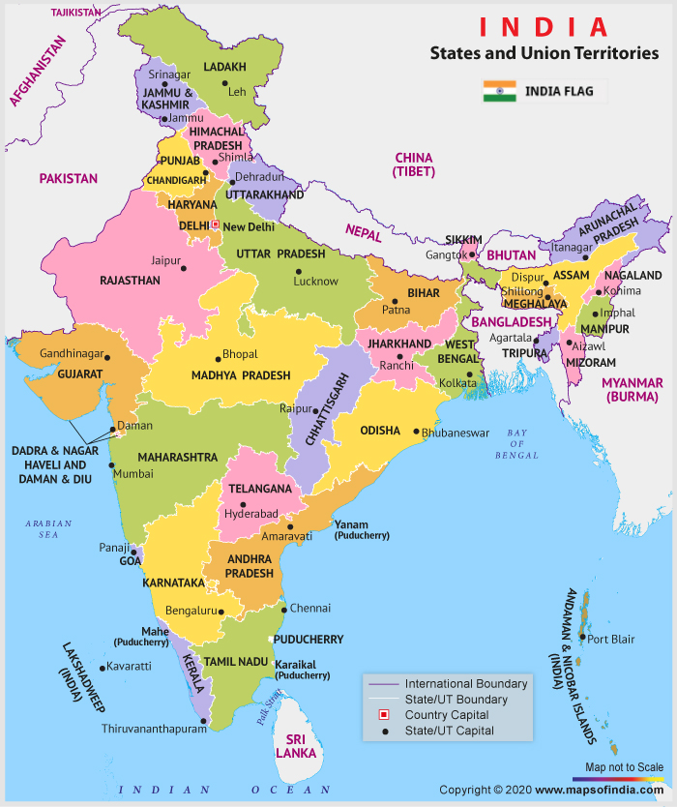
/Table: A.2.1 Map of India: Uttarakhand and Uttar Pradesh.
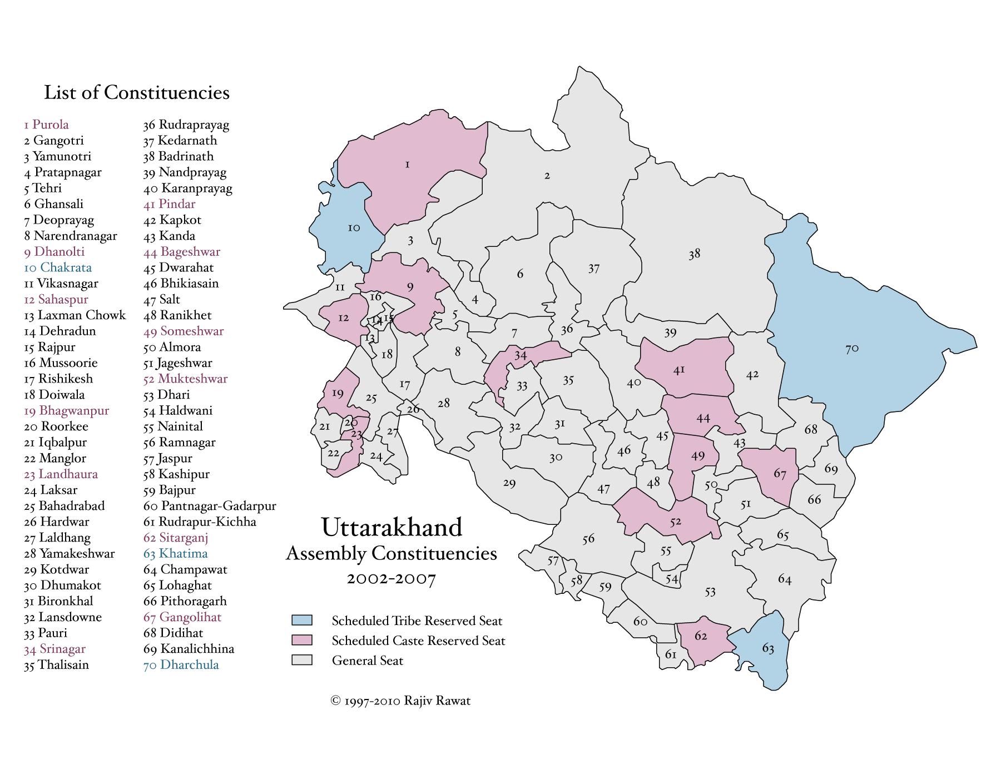Table A.2.2 Overview of Districts of Uttarakhand.

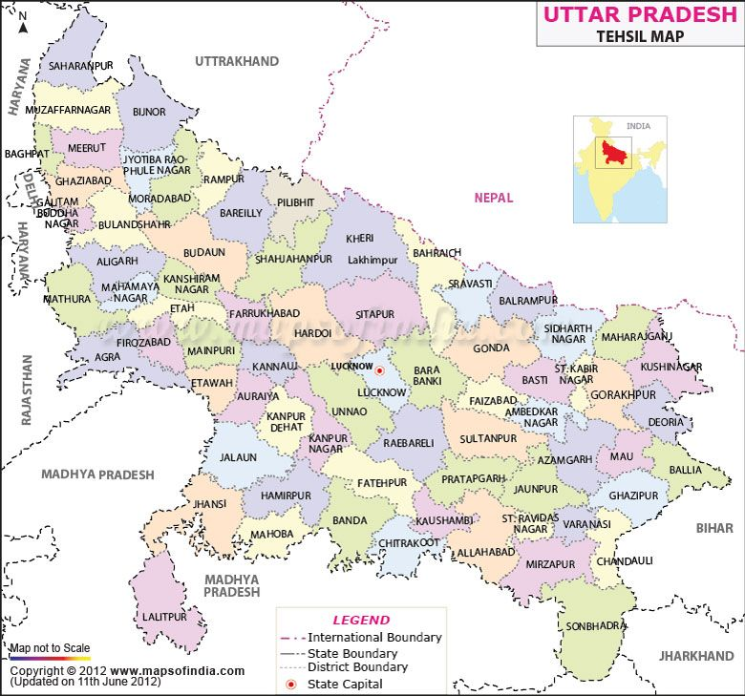
Table A.2.3 Overview of Districts of Uttar Pradesh

Districts | Block
Nainital | Kotabag, Ramnagar, Betalghat, Haldwani, Bhimtal, Okhalkanda, Ramgarh)
Udham Singh Nagar | Jaspur, Kashipur, Bajpur, Pantnagar-Gadarpur, Rudrapur-Kiccha, Sitarganj, Khatima
Haridwar | Bhagwanpur, Bahadrabad, Laksar, Narsan, Khanpur, Roorkee
Sravasti | Sirsiya
Bahraich | Balha, Chitaura, Nanpara, Nawabganj, Risia, Shivpur, Mahasi, Mihinpurwa

GPS-coordinates of project location:
GPS-coordinates | Nainital | Udham Singh Nagar | Haridwar | Bahraich | Sravasti
Latitude | 29° 22’ 48’’ N | 28° 54’ 42’’ N | 29° 56’ 53’’ N | 27° 34' 27.44" N | 27° 31' 1.46" N
Longitude | 79° 27’ 00’’ E | 79° 31’ 12’’ E | 78° 09’ 37’’ E | 81° 35' 41.06" E | 82° 03' 2.23" E

  - Reference of applied methodology
>>
Gold Standard Methodology: Technologies and Practices to Displace Decentralized Thermal Energy Consumption v02.

  - Crediting period of project
>>
The project has a renewable crediting period.
1st GS Crediting Period: 02/01/2017 – 01/01/2024
The starting date of operation: 15/01/2015 – First biogas unit installed
Registration date of the project activity: 02/01/2019
- IMPLEMENTATION OF PROJECT
  - Description of implemented project
>>
Until December 31st of 2020 the project has installed the biogas units in 3900 HHs in 2 State in 5 Districts in India, for each one a family size biogas is installed. The biogas unit is either 2 or 3m³ capacity depending on the number and type of cattle owned by the HH and the number of people in the HH. Average cattle holding is 2-4 cows, bullocks or buffaloes, which provide sufficient manure for these sizes of biogas plants.

This project is meant for creating sustainable energy supply to the HHs for their energy needs and result in greenhouse gas (GHG) emission savings. Indeed, the biogas displaces GHG emissions from fuelwood that are currently used for cooking. The biogas produced from cattle manure is a renewable source of energy as the CO₂ that is absorbed during the growth of the organic matter in the dung equals the CO₂ emitted when the biogas is burnt. In accordance with approved methodology used, emission reductions are calculated for the non-renewable part of the fuelwood that is used for cooking without the proposed project activity.

The project will have multiple sustainable development benefits in addition to the reduction of GHG emissions, as follow:
- Efficient cooking stoves fired with biogas reduce indoor air pollution and respiratory problems currently caused by smoke from inefficient cook stoves burning fuelwood;
- The installation of a biogas unit reduces the consumption of fuelwood by participating HHs and therefore reduce the pressure on scarce forest resources in the project area;
- Substantial decrease in degradation of forests in and around the forest area
- Women and children can use time that was otherwise required for collecting fuelwood for education and generating income;
- Improve livelihood of rice farmers by the combination of the biogas project and the organic rice project of Coop (implemented by Helvetas and PnP).
- Biogas provides a more convenient, dependable energy source that is renewable and that reduces cooking time and cleaning time of the kitchen (less soot and particulate matter produced);
- The slurry produced from the biogas units is a valuable organic fertiliser that can be applied directly to the fields or composted with other organic material to improve crop yields and reduce the use of chemical fertilisers.
- Better health of women and children (less smoke in kitchen)
- Improved productivity of farming due to slurry application (less temporary nitrogen blockage in the soil, more easily available nutrients for top dressing)
- Skilled manpower who are able to provide their services towards construction, maintenance, marketing and financing of biogas plants
- Reduced human-wildlife conflict in the project area.

PnP has developed extensive knowledge about biogas units that are suitable for rural HHs in India. They know what functions well and what may induce problems, as well as knowledge about waste management, slurry application, composting and proper use of slurry or compost. They conduct meetings with eligible HHs and provide training to transfer this knowledge.

Project Activity has been implemented and operated as per the registered GS Passport /PDD after the Design Change (see section B.2.5 below) and there have been no major changes during the current monitoring period as no new biodigester were installed in period 01/01/2020-31/12/2020.

The project is not part of another VPA or CPA that has been excluded from a registered Programme as a result of erroneous inclusion of project activities.
    - Forward Action Requests
>>
Based on COVID_DEV 166 document a FAR is released for current verification:
PD shall check the monitored value of the parameter during the next verification cycle
(i.e., for MP post 31/12/2019) and retroactively adjust the number of ERs for the
current verification accordingly, if the actual trend (in the parameter value) shows
that the ERs for the current verification have been overestimated.
- The value of firewood consumption in biogas plant users is (PFT 2021) 0.00085 t/day/stove, but in PFT 2017 upper bound value was 0.00224 t/day/stove, it is concluded that there is not an overestimation is previous verification as the surveys conducted this year showed a reduction of previous value used. Therefore, there is no need for retroactively adjust the number of ERs in previous verification.

  - Post-Design Certification changes
>>
    - Temporary deviations from the approved Monitoring & Reporting Plan, methodology or standardized baseline
>>
Not applicable.
    - Corrections
>>
Not applicable.
    - Changes to start date of crediting period
>>
Not applicable.
    - Permanent changes from the Design Certified monitoring plan, applied methodology or applied standardized baseline
>>
Not applicable.
    - Changes to project design of approved project
>>
A Post Registration Change was approved on June 4, 2020. The project has included a new state Uttar Pradesh as part of project scope.

- DESCRIPTION OF MONITORING SYSTEM APPLIED BY THE PROJECT
>>
The applied methodology in the project requests continuous and periodic monitoring activities. The monitoring tasks undertaken continuously are:

A. Total Sales Record
The following data is recorded for all installed biogas units;
            - Date of sale
            - Geographic area of sale
            - Model/type of project technology sold
            - Quantity of project technologies sold
            - Name and telephone number (if available), and address:
              - Required for all bulk purchasers (retailers)
              - All end users
            - Mode of use: domestic
            - Stove identification number

Each bio-digester has a unique identification number. This project has a unique geographical reference/file number.

B. Project Database
The project database is derived from the total installation record with project technologies. One scenario was established: HHs cooking on traditional open fire using firewood in the baseline. A total sales record and project database are maintained continuously. The project database is derived from the total sales record leading to the one parameter project technology days N_{p},y.

C. Prior to first Verification

Baseline and Project non-renewable biomass (NRB) assessment
The NRB estimation was made to the state of Uttarakhand and Uttar Pradesh and the five districts included in the project, see PDD version 6.5 appendix N° 9 - NRB Assessment.

As per applied methodology the non-renewable biomass fraction is fixed, and the project proponent may at any time over the course of a project activity choose to re-examine renewability by conducting a new NRB assessment as it was the case as the project conducted a Post Registration Change approved June 4, 2020. In case of a renewal of the crediting period and as per GS rules, the NRB fraction must be reassessed as any other baseline parameters and updated in line with most recent data available.

Baseline and Project surveys
This survey was explained as part of the 1st Monitoring Report.

Baseline and Project Field Tests – P_{b,y} and P_{p,y}

The baseline field test and the first project field test were explained as part of the 1st Monitoring Report.

D. Ongoing Monitoring Studies
The following ongoing monitoring studies were conducted for the project scenario following verification of the associated initial project studies. These monitoring studies investigate and define parameters that could not be determined at the time of the initial project studies or that change with time.

- Monitoring Survey – This shall be completed annually, beginning 1 year after project registration

The monitoring survey investigates changes over time in a project scenario by surveying end users with project technologies on an annual basis. It will provide critical information on year-to-year trends in end user characteristics such as technology use, fuel consumption and seasonal variations.

Monitoring Survey Sample size:
As per applied methodology monitoring surveys should be applied to end users of the project scenario – biogas users – with the same sampling a survey needs to be carried out for each baseline and project scenario using representative and random sampling, following the guidelines for minimum sample size:
- Group size <300: Minimum sample size 30 or population size, whichever is smaller
- Group size 300 to 1000: Minimum sample size 10% of group size
- Group size > 1000 Minimum sample size 100

Monitoring Survey Sampling approach:
End users from a given project scenario are selected using stratified random sampling of user’s geographic distribution and different ages of the technology (because the Usage Survey was conducted at the same time) was factored into the selection criteria. A Stratified Sampling approach is used and the sub-populations are divided in districts (called the strata). The project will have as much stratums as districts with biogas unit implemented have, in this case three districts.

The number of HHs sampled for each district is proportional to the size of the district within the population. The HH to be interviewed were selected randomly (using the next link https://stattrek.com/statistics/random-number-generator.aspx) for sampling. The list of HHs selected are included in the excel document where it is described the procedures to select the HHs to be surveyed.

Scenario | Population size (stoves constructed until December 2020) | Sample size
HHs using the bio-digester | 3,900 | 178
- District 1: Haridwar | 461 | 12
- District 2: Nainital | 2,023 | 85
- District 3: Udham Singh Nagar | 1,016 | 26
- District 4: Bahraich | 394 | 55
- District 5: Shrawasti | 6 | 0

Monitoring Survey Representativeness:
The monitoring survey is only conducted with end user’s representative of the project scenario and who are using the project technology at the time of the survey. End users are selected using stratified random sampling of users in three districts (Nainital, Udham Singh Nagar, and Haridwar) with the technology installed with different ages (age₀₋₁ and age₁₋₂). End users are surveyed with care taken to collect information pertaining to seasonal variations in technology and fuel use patterns (including the type of fuels used as primary and secondary source). In case other fuels are used as primary fuels, the frequency and quantity of consumption is calculated and the weighted percentage (based on the quantity of hour used per day) of biogas users will be included in the drop-off rate.

Project scenario (the database of the survey is included in excel file ‘Monitoring-Usage Survey 2021’ spreadsheet ‘Mon&Usa’):
- The survey was conducted between July-October of 2021.
- 78% of the HHs use biogas as primary fuel (cell BW185 of survey database), 14% use LPG (cell BW187 of survey database) and 7% use firewood as primary fuel (cell BW189/BW191 of survey database). As secondary fuel, 56% use LPG (cell BX187 of survey database) and firewood is used by 12% of the families (cell BJ149 of survey database).
- Average fuelwood consumption for cooking per HH per day is 0.68kg (cell CA184 of survey database).
- Average time spent for firewood collection is 2.12 hours a month (cell DQ184 of survey database).
- Manure management: 77% of families put the manure in the bio-digester (cell GK185 of survey database).

- Usage Survey – completed annually
The usage survey provides a single usage parameter that is weighted based on drop off rates that are representative of the age distribution for project technologies in the total sales record. A usage parameter must be established to account for drop off rates as project technologies age and are replaced. A usage parameter is required prior to any request for issuance.

Usage Survey Sample size:
As per applied methodology the interviews in a usage survey are conducted in person and include expert observation by the interviewer within the kitchen in question. The usage survey establishes a useful lifetime for technologies after which they are removed from the project database and no longer credited. The minimum total sample size will be 100, with at least 30 samples for project technologies of each age being credited.

Usage Survey Sampling approach:
End users from a given project scenario are selected using stratified random sampling of user’s geographic distribution and different ages of the technology (because the Usage Survey was conducted at the same time) was factored into the selection criteria. A Stratified Sampling approach is used and the sub-populations are divided in districts (called the strata). The project will have as much stratums as districts with biogas unit implemented have, in this case three districts.
The number of HHs sampled for each district is proportional to the size of the different ages of the technology and the district within the population. The number of samples of project technologies of age₁₋₂, age₂₋₃, age₃₋₄ and age₄₋₅ is above 30, complying the minimum number requested by the methodology. The HH interviewed are selected randomly (using the link https://stattrek.com/statistics/random-number-generator.aspx) for sampling. The list of HHs selected are included in the excel document where it is described the procedures to select the HHs surveyed.

To ensure conservativeness, participants in a usage survey with technologies in the first year of use (age0- 1) must have technologies that have been in use on average longer than 0.5 years. For technologies in the second year of use (age1-2), the usage survey must be conducted with technologies that have been in use on average at least 1.5 years, and so on (meth. p. 24)

In search of the value for parameter usage rate of a biogas unit, a question about its use is included in the monitoring and usage surveys performed in 2021.

The Usage survey (with the Monitoring Survey) conducted in 2021.

Scenario | Population size (stoves constructed until December 2020) | Sample size
HHs using the bio-digester | 3900 | 178
- Age₁₋₂ | 177 | 34
- Haridwar  - Nainital  - Udham Singh Nagar  - Bahraich  - Shrawasti | 0  0  0  171  6 | 0  0  0  34  0
- Age₂₋₃ | 392 | 37
- Haridwar  - Nainital  - Udham Singh Nagar  - Bahraich  - Shrawasti | 0  169  0  223  0 | 0  16  0  21  0
- Age₃₋₄ | 672 | 33
- Haridwar  - Nainital  - Udham Singh Nagar  - Bahraich  - Shrawasti | 20  652  0  0  0 | 0  33  0  0  0
- Age₄₋₅ | 1615 | 37
- Haridwar  - Nainital  - Udham Singh Nagar  - Bahraich  - Shrawasti | 299  514  802  0  0 | 7  12  18  0  0
- Age₅₋₆ | 1044 | 37
- Haridwar  - Nainital  - Udham Singh Nagar  - Bahraich  - Shrawasti | 142  688  214  0  0 | 5  24  8  0  0

Summary of Usage Survey Result:

 | Age₁₋₂ | Age₂₋₃ | Age₃₋₄ | Age₄₋₅ | Age₅₋₆ | Total
Usage Survey 2021 | 76% | 70% | 76% | 81% | 81% | 77%*
* The average usage rate values found in Usage Survey 2021 was 76.97%. The usage rate weighted of each age being credited is 78.62%. For conservativeness is used the lowest value for the monitoring period.

- Project FT Update – completed every other year (every two years)

The PFT update is an extension of the project PFT and provides a fuel consumption assessment representative of project technologies currently in use every two years. Hence the PFT update shall account for changes in the project scenario over time as project technologies age and new customers are added, also as new models and designs are introduced. It is legitimate to apply an Age Test instead of a PFT, to project technologies which remain materially the same year after year.

The sample size used in the FT was based on the results obtained from first and second project FT. There were conducted in October 2015 and 50 test were performed and an error of 7.92% and also in June and July 2017 were conducted 50 test with an error of 9.82%, both have complied the 90/30 rule. The sample size for the FT was defined as 50HHs. The project FT update was conducted between the months of July and October 2021.

52 tests were performed and an error of 7.01% comply the 90/30 rule.

For the FT sampled HHs were visited and fuelwood consumption at HH level was measured for a period of three days in project scenario.
Specifically, the steps below were followed in carrying out the FT as required in the Annex 4 of the methodology:

- Independent FT. Selection of 50 HHs using a stratified random sampling. The sub-populations is divided in districts (called the strata). The project will have as much stratums as districts with biogas unit implemented have, in this case three districts.
The HH interviewed are selected randomly (using the next link using the link https://stattrek.com/statistics/random-number-generator.aspx) for sampling. The list of HHs selected are included in the excel document where it is described the procedures to select the HHs surveyed.
In general, there are two phases, the BEFORE phase (before the bio-digester is adopted, the baseline scenario) and the AFTER phase (after it is adopted, the project scenario). The test is made in separate phases in separate sets of kitchens having appropriately similar socio-economic and cultural conditions (INDEPENDENT sampling).
- Choosing of an appropriate test period and an appropriate time of year for the FT. A test period of 3 days is selected (the minimum required). It was important to avoid times like festivals or holidays when more cooking is done than usual.
- The HHs involved in the FT understand they were expected to cook normally during the test to capture the normal cooking behavior. This was carried out and emphasized before the exercise started.
- During the FT, the interviewers stressed and emphasized that families use fuel only from a designated and pre-weighed stock.
- The number of people cooked for and number of meals was recorded in the data sheet for the test period as required by the methodology.
- The fuel used in the FT was collected from the usual place or purchased from the common fuelwood vendors in the market place and distributed to the HHs participating in the FT. This was the type of fuel used normally by families hence there is no variation in moisture content. The families had to pay for the fuelwood (for purchase option) to avoid excessive use of fuelwood.
- Analysis of data was conducted in the excel file using standard statistical tools. Before beginning the analysis, it was checked the “outliers”, i.e., values which are very different to most of the sample. Outliers were examined to check for mistakes with data recording or investigated to ascertain if there were unusual circumstances which led to that result. No outliers were found in the field test conducted. In cases of independent sampling, there are two valid options for the statistical analysis:
- 90/30 rule. This option allows us to calculate emission reductions on the basis of the estimated MEAN (or average) fuel saved by introduction of the bio-digester, or on the estimated MEAN (or average) fuel use in one family if using a single sample. We can only use the mean if the test results satisfy the 90/30 rule, i.e., the endpoints of the 90% confidence interval lie within +/- 30% of the estimated mean. If this is not the case, then we can use the test data gathered so far to estimate how much larger the sample size needs to be. The mean value will always result in a larger estimate of fuel-savings than the value obtained using the second option below, but in some cases, we might choose to analyze using the second option, because it is not practical or too expensive to increase the sample size sufficiently.
- 90% confidence rule (Lower bound of the one-sided 90% confidence interval). This option allows us to obtain a result even if 90/30 precision is not achieved, although in a similar manner to the 90/30 rule, a minimum sample size of 30 is recommended. We can use this approach when the 90/30 rule forces a sample size which is difficult to implement in practice. The disadvantage is that the fuel saving result is not the mean (or average) test result, but a lower value. This estimate is very conservative, and it will probably be worthwhile to augment the sample size instead in cases when augmentation is practically possible.
- After the successful completion of the exercise, a gift of heat resistant tea/coffee cup was given and a vote of thanks was given to every HH that participated in the exercise.

Scenario | Population size (stoves constructed until December 2020) | Sample size
HHs using the bio-digester | 3,900 | 52
- District 1: Haridwar | 461 | 6
- District 2: Nainital | 2,023 | 26
- District 3: Udham Singh Nagar | 1,016 | 14
- District 4: Bahraich | 394 | 6
- District 5: Shrawasti | 6 | 0

Summary of FT results:

 | t/day/stove | t/year/stove | Standard deviation | Coefficient of variation
Project fuel consumption* | 0.00085 | 0.31 | 0.00145 | 2.81
Fuel Savings (P) | 0.00957 | 3.49 | - | -
*The upper bound value of the confidence interval is used as conservative approach.

The fuel saving used for this monitoring period is based in the upper bound of the fuel consumption in project scenario and the average value found in baseline scenario.

- Baseline FT Update
A fixed baseline is adopted in this project and FT Update is thus not required.

- Leakage Assessment – Completed every other year, starting on time for the first verification.

The potential sources of leakage as set out in the methodology are re-assessed regarding their risk based on Monitoring surveys conducted between July-October of 2021.

- Non-Renewable Biomass Assessment Update
The non-renewable biomass fraction was re-evaluated as part of the Post Registration Change as a new state is included in the project. The value was approved as part of GS’ review.
In case of a renewal of the crediting period and as per Gold Standard rules, the NRB fraction will be reassessed as any other baseline parameters and updated in line with most recent data available.

- DATA AND PARAMETERS
  - Data and parameters fixed ex ante or at renewal of crediting period
>>
Relevant SDG Indicator: SDG 13 Climate Action

Data/Parameter | EF_{b,CO2}
Unit | tCO2/tfuel
Description | CO2 emission factor arising from use of wood-fuel in baseline scenario
Source of data | 2006 IPCC Guidelines for National Greenhouse Gas Inventories, Tables 1.2/2.5
Value(s) applied | 1.7472 tCO2/t wood
Choice of data  or measurement methods and procedures | Default IPCC values for wood / wood waste are applied
Purpose of data/parameter | Calculation of Baseline and Project Emissions
Additional comments

Data/Parameter | EF_{b,non-CO2}
Unit | tCO2/tfuel
Description | Non-CO2 emission factor arising from use of wood-fuel in baseline scenario
Source of data | 2006 IPCC Guidelines for National Greenhouse Gas Inventories, Table 2.5
Value(s) applied | 0.1356 tCO2eq/t wood (CH4: 0.1170 tCO2e/t wood; N2O: 0.0186 tCO2eq/t wood)
Choice of data  or measurement methods and procedures | Default IPCC values for CH4 and N20 emissions for wood / wood waste are applied and summed.  The following GWP100 are applied: 25 for CH4, 298 for N20
Purpose of data/parameter | Calculation of Baseline and Project Emissions
Additional comments

Data/Parameter | EF_{p,CO2}
Unit | tCO2/t_fuel
Description | CO2 emission factor arising from use of wood-fuel in project scenario
Source of data | 2006 IPCC Guidelines for National Greenhouse Gas Inventories, Tables 1.2/2.5
Value(s) applied | 1.7472 tCO2/t wood (=112.0 tCO2/TJ * 0.0156 TJ/ t )
Choice of data  or measurement methods and procedures | Default IPCC values for wood / wood waste are applied
Purpose of data/parameter | Calculation of Baseline and Project Emissions
Additional comments

Data/Parameter | EF_{p,non-CO2}
Unit | tCO2/t_fuel
Description | Non-CO2 emission factor arising from use of wood-fuel in project scenario
Source of data | 2006 IPCC Guidelines for National Greenhouse Gas Inventories, Table 2.5
Value(s) applied | 0.1356 tCO2eq/t wood (CH4: 0.1170 tCO2e/t wood; N2O: 0.0186 tCO2eq/t wood)
Choice of data  or measurement methods and procedures | Default IPCC values for CH4 and N20 emissions for wood / wood waste are applied and summed.  The following GWP100 are applied: 22 for CH4, 298 for N20
Purpose of data/parameter | Calculation of Baseline and Project Emissions
Additional comments

Data/Parameter | f_{NRB,i,y}
Unit | Fractional non-renewability (%)
Description | Non-renewability status of woody biomass fuel in scenario I during year y
Source of data | See appendix N° 9 of the PDD- NRB Assessment.
Value(s) applied | 86.48%
Choice of data  or measurement methods and procedures | Calculated value as per excel sheet NRB assessment. The excel sheet applies the guidelines defined in section IV of the methodology.
Purpose of data/parameter | Calculation of Baseline and Project Emissions
Additional comments | The applied methodology states: “"The non-renewable biomass fraction is fixed based on the results of the NRB assessment. Over the course of a project activity the project proponent may at any time choose to re-examine renewability by conducting a new NRB assessment. In case of a renewal of the crediting period and as per GS rules, the NRB fraction must be reassessed as any other baseline parameters and updated in line with most recent data available".  The value for the two states are: 86.48% for Uttarakhand  87.28% for Uttar Pradesh, but for conservativeness is used the lowest value for the whole monitoring period.

Data/Parameter | P_{b,y}
Unit | t_biomass/unit-year and t_biomass/unit-day
Description | Quantity of woody biomass consumed in the baseline scenario in year y and per day in year y.
Source of data | Baseline Field Test (BFT)
Value(s) applied | 0.01042 (t_biomass/day)
Choice of data  or measurement methods and procedures | Estimated mean (justified because statistical analysis fits within 90/30 rule).
Purpose of data/parameter | Calculation of Baseline Emissions
Additional comments | Baseline Field Test conducted in May 2015

Data/Parameter | GWP_{CH4}
Unit | tCO2e per tCH4
Description | Global Warming Potential (GWP) of methane
Source of data | IPCC: https://archive.ipcc.ch/publications_and_data/ar4/wg1/en/ch2s2-10-2.html
Value(s) applied | 25
Choice of data  or measurement methods and procedures | IPCC Default value
Purpose of data/parameter | Calculation of Baseline and Project Emissions
Additional comments

  - Data and parameters monitored
>>
Relevant SDG Indicator: SDG 1
Target 1.4.1 Proportion of population living in households with access to basic services
Relevant SDG Indicator: SDG17
Target 17.7.1 Total amount of approved funding for developing countries to promote the development, transfer, dissemination and diffusion of environmentally sound technologies

Data/Parameter | N_{biogas}
Unit | Number of biogas units
Description | Cumulative number units of biogas units installed
Source of data | Total Sales record
Value(s) applied | 3,900
Measurement methods and procedures | Registration of biogas units installed
Monitoring frequency | Annual
QA/QC procedures | Transparent data analysis and reporting.
Purpose of data | Calculation of project and baseline emissions
Additional comments | Biogas installed until December 31st, 2020.  See ER calculation file spreadsheet ‘Database’.

Relevant SDG Indicator: SDG 2
Target 2.3.1 Volume of production per labour unit by classes of farming/pastoral/forestry enterprise size
Relevant SDG Indicator: SDG 3
Target 3.9.3 Mortality rate attributed to unintentional poisoning

Data / Parameter | Share of farmers who used slurry as fertilizer
Unit | %
Description | Percentage of farmers who applicate the sludge from the biogas unit
Source of data | Monitoring survey
Value(s) applied | 76.97% - Monitoring and Usage Survey 2021
Measurement methods and procedures | Share of farmers who use the sludge from the biogas unit by household after project intervention.
Monitoring frequency | Annually
QA/QC procedures | Monitoring team from the project level randomly checked the data collected and found to be reasonable
Purpose of data | SDG 2 and SDG 3 Contributions
Additional comment | The monitored results can be found in the spread sheet under the monitoring survey excel page.  See Monitoring & Usage survey file cell GJ185.

Relevant SDG Indicator: SDG 2
Target 2.3.1 Volume of production per labour unit by classes of farming/pastoral/forestry enterprise size
Relevant SDG Indicator: SDG 4
Target 4.4.1 Proportion of youth and adults with information and communications technology (ICT) skills, by type of skill
Relevant SDG Indicator: SDG 17
Target 17.7.1 Total amount of approved funding for developing countries to promote the development, transfer, dissemination and diffusion of environmentally sound technologies

Data / Parameter | Total number of people trained on different aspects of the project
Unit | Number of persons
Description | Number of people trained on different aspects of the project
Source of data | PnP records
Value(s) applied | In 2020:  1091 Persons and 19 User Group.  - 79 Awareness campaign.  - 204 O&M training.  - 187 O&M Farmer’s training.  - 398 Farmer’s training.  - 224 Refresher training.
Measurement methods and procedures | Counting number of participants trained/awareness creation activities
Monitoring frequency | Annual
QA/QC procedures | Transparent data analysis and reporting
Purpose of data | SDG 2, SGD 4 and SGD 17 Contributions
Additional comment | The information of trainings were taken from PnP records. See files with root name ‘SDG 2-4-17’.

Relevant SDG Indicator: SDG 3
Target 3.9.1 Mortality rate attributed to household and ambient air pollution

Data / Parameter | Percentage of project households confirming that with the project there is no smoke inside the home.
Unit | Proportion (%) of answers that stated there is no smoke inside the home.
Description | Proportion of families surveyed who stated there is no smoke inside the home divided by total of users interviewed.
Source of data | Monitoring Survey
Value(s) applied | 100.00% (Monitoring survey 2021).
Measurement methods and procedures | % of project household confirming that with the project there is no smoke inside the home.
Monitoring frequency | Annual
QA/QC procedures | Transparent data analysis and reporting
Purpose of data | SDG 3 Contributions
Additional comment | The monitored results can be found in the spread sheet under the monitoring survey excel page.  See Monitoring & Usage survey file cell GI185.

Relevant SDG Indicator: SDG 5
Target 5.A.1 (a) Proportion of total agricultural population with ownership or secure rights over agricultural land, by sex; and (b) share of women among owners or rights-bearers of agricultural land, by type of tenure

Data / Parameter | Number of women benefited trained on income generating activities by PnP
Unit | Number of women trained
Description | Number of women trained by PnP on income generating activities
Source of data | PnP training records
Value(s) applied | 353
Measurement methods and procedures | Counting number of women users trained
Monitoring frequency | Annual
QA/QC procedures | Transparent data analysis and reporting
Purpose of data | SDG 5 Contributions
Additional comment | The information of trainings were taken from PnP records.  See document ‘SDG5_Income generating program’.

Data / Parameter | Proportion of farmers who saves time for collecting fuel wood
Unit | %
Description | Proportion of farmers who saves time for collecting fuel wood
Source of data | Monitoring Survey 2021
Value(s) applied | 98.88%
Measurement methods and procedures | % of project household confirming that the farmers saves time for collecting fuel wood
Monitoring frequency | Annual
QA/QC procedures | Transparent data analysis and reporting
Purpose of data | SDG 5 Contributions
Additional comment | The monitored results can be found in the spread sheet under the monitoring survey excel page.  See Monitoring & Usage survey file cell GK185.

Relevant SDG Indicator: SDG 7
Target 7.1.2 Proportion of population with primary reliance on clean fuels and technology

Relevant SDG Indicator: SDG 13 Climate Action

Data / Parameter | U_{p,y}
Unit | Percentage
Description | Usage rate in project scenario p during year y
Source of data | Annual usage survey
Value(s) applied | 76.97% - Monitoring and Usage Survey 2021
Measurement methods and procedures | Conducting usage surveys as required by the methodology “Technologies and Practices to Displace Decentralized Thermal Energy Consumption V02”
Monitoring frequency | Annual
QA/QC procedures | Transparent data analysis and reporting. More details in section B.7.3. QA/QC of PDD for monitoring activities.
Purpose of data | SDG 13 Contributions
Additional comment | The single usage parameter weighted to be representative of the quantity of project technologies of each age being credited is 78.62% for this monitoring period (results can be found in the spread sheet under the monitoring survey excel page), and the average value found is 76.97%, hence for conservativeness is used the average usage parameter found in the usage survey which is the lowest value.  See Monitoring & Usage survey file cell GM185 and GM204.

Data / Parameter | Number of persons that benefit from efficient and clean technologies
Unit | Number of persons
Description | Number of persons that benefit from efficient and clean technologies
Source of data | Project database, Monitoring survey
Value(s) applied | 18,162 persons benefit by the project
Measurement methods and procedures | Total number of biogas units installed multiplied with usage rates multiplied with average household size
Monitoring frequency | Annual
QA/QC procedures | Transparent data analysis and reporting
Purpose of data | SDG 7 Contributions
Additional comment | According to the latest monitoring surveys conducted in 2021, 6.05 is the average size of a family, 3900 biogas units have been installed and all 76.97% of the families surveyed use the biogas (the monitored results can be found in spread sheet of monitoring survey).  See Monitoring & Usage survey file cell Q187 for the average size of a family.

Relevant SDG Indicator: SDG 8
Target 8.5.1 Average hourly earnings of female and male employees, by occupation, age and persons with disabilities

Data / Parameter | Number of jobs offered
Unit | Number of employees
Description | Number of jobs offered (men and women) by PnP to local employees.
Source of data | PnP employment and training records
Value(s) applied | 4 people employed under the project.
Measurement methods and procedures | Total number of permanent Vs temporary /contract employees
Monitoring frequency | Annual
QA/QC procedures | Transparent data analysis and reporting
Purpose of data | SDG 8 Contributions
Additional comment | The information of employment were taken from PnP records. See document ‘SDG8_Employee Insurance’.

Data / Parameter | Annual average wage of employees
Unit | Rupees per year
Description | Annual average wage of people employed (men and women) due to the project activity.
Source of data | PnP employment records
Value(s) applied | 338,181 Rupees per year
Measurement methods and procedures | Average wage of people employed due the project activity shall be at par/above par with the minimum wage rate mandated by the local regulations.  Equal pay for men and women (for same scope of work) shall be demonstrated.
Monitoring frequency | Annual
QA/QC procedures | Transparent data analysis and reporting
Purpose of data | SDG 8 Contributions
Additional comment | The average wage per month is above 28,000 Rupees which is above in any of the minimum wage in industries and class of employment in in the states of Uttarakhand and Uttar Pradesh. The minimum wage is between 9,1000 - 11,300 Rupees per month.  https://paycheck.in/salary/minimumwages/22125-uttarakhand  https://paycheck.in/salary/minimumwages/21888-uttar-pradesh/21965-all-registered-factories-which-are-not-mention  See document ‘SDG8_Job&wage Employment letter’.

Relevant SDG Indicator: SDG 12
Target 12.2.2 Domestic material consumption, domestic material consumption per capita, and domestic material consumption per GDP
Data / Parameter | Fuel savings achieved
Unit | %
Description | Fuel savings in % achieved by project technologies compared to baseline.
Source of data | Baseline Field Test and Project Field Test
Value(s) applied | 91.80%
Measurement methods and procedures | Fuel savings divided by baseline fuel consumption expressed in %
Monitoring frequency | Every year
QA/QC procedures | Transparent data analysis and reporting
Purpose of data | SDG 12 Contributions
Additional comment | The values applied are based on latest PFT (2021) – upper bound – parameter P_{p,y} and BFT (2015) parameter P_{b,y}.  See excel file ER calculation spreadsheet ‘SDG’ cell I16.

Relevant SDG Indicator: SDG 13 Climate Action

Data/Parameter | P_{p,y}
Unit | t_biomass/unit-year and t_biomass/unit-day
Description | Quantity of woody biomass consumed in the project scenario in year y and per day in year y.
Source of data | PFT, FT updates, and any applicable adjustment factors
Value(s) applied | 0.00085 (t_biomass/day) FT 2021
Measurement methods and procedures | See Description of measurement methods for the parameter.  Scale (balance) calibrated at least 10 kg capacity (mechanical - hanging spring scale - or electronic model). The scale is calibrated every time is used. The balance used for the weighting has a precision of no less than 50g.
Monitoring frequency | Updated every two years after the first verification
QA/QC procedures | Transparent data analysis and reporting.
Purpose of data | Calculation of Project emissions
Additional comments | The electronic scales used were provided by the provision shops in villages (which are used continuously). These shops lent the weighing scales available with them. Photographs where the monitoring team weights the firewood have been sent to DOE during verification.  See excel file ‘Field Test Update Report’ cell AZ69.

Data/Parameter | N_{p,y}
Unit | Number of days
Description | Cumulative number of technology days in the project database for project scenario
Source of data | Total Sales record/Project database
Value(s) applied | 1,427,400
Measurement methods and procedures | The number of days between the installation date of each stove and the end of the monitoring period is calculated.
Monitoring frequency | Annual
QA/QC procedures | Transparent data analysis and reporting.
Purpose of data | Calculation of project and baseline emissions
Additional comments | See ER calculation file spreadsheet ‘Database’ cells V3910.

Data/Parameter | LE_{p,y}
Unit | t_CO2eq per year
Description | Leakage in project scenario p during year y
Source of data | Baseline and monitoring surveys
Value(s) applied | 699
Measurement methods and procedures | Interviewing HHs with baseline and monitoring surveys
Monitoring frequency | Every two years
QA/QC procedures | Transparent data analysis and reporting. More details in section B.7.3. QA/QC for monitoring activities of the PDD.
Purpose of data | Calculation of leakage
Additional comments | Aggregate leakage can be assessed for multiple project scenarios. Every two years a leakage investigation must be conducted (if conditions explained in section B.4 Leakage change) using relevant survey methods that can be combined with monitoring surveys as is applicable. Leakage risks deemed very low can be ignored as long as the case for their insignificance is substantiated. Please also check section E.3 for a detailed explanation.

Relevant SDG Indicator: SDG 15
Target 15.1.1 Forest area as a proportion of total land area
Data / Parameter | Amount of wood equivalents saved by the project
Unit | Tons of wood equivalents
Description | Amount of wood savings achieved by the project per year expressed in wood equivalents
Source of data | Baseline Field Test and Project Field Test
Value(s) applied | 3.4925 tons/year/HH
Measurement methods and procedures | Project technology days multiplied with wood savings in t/day/stove
Monitoring frequency | Annual
QA/QC procedures | Transparent data analysis and reporting
Purpose of data | SDG 15 Contributions
Additional comment | The values applied are based on latest PFT (2021) parameter P_{p,y} and BFT (2015) parameter P_{b,y}.  See excel file ER calculation spreadsheet ‘SDG’ cell I17.

Safeguarding Principle 3.3 Community Health, Safety and Working Conditions
Data / Parameter | Proportion of farmers who put the animal waste in the biodigester.
Unit | %
Description | Proportion of farmers who put the animal waste in the biodigester.
Source of data | Monitoring survey
Value(s) applied | 76.97% (Monitoring survey 2021).
Measurement methods and procedures | % of project household confirming that the farmers put the animal waste in the biodigester
Monitoring frequency | Annually
QA/QC procedures | Transparent data analysis and reporting
Purpose of data | -
Additional comment | The values applied are based on latest Monitoring Survey (2021). See Monitoring & Usage survey file cell GL185.

From GS Passport
Data / Parameter | Subsidy received from government  Contribution by farmers
Unit | CHF (Swiss francs)
Description | Investment directly provided for biogas and subsidy received and contribution from farmers will be accounted for in the project as it progresses.
Source of data | Contract agreement between the First Party (ICSD – now PnP) and the Second Party (Beneficiary) with the breakup of contributions from Project fund, Beneficiary and Government subsidy.
Value(s) applied | 0 CHF Subsidy received from government.  0 CHF Contribution by farmers.
Measurement methods and procedures | Collect contract agreements signed for beneficiaries and the entities involved and use an average amount invested per unit.
Monitoring frequency | Annually
QA/QC procedures | Transparent data analysis and reporting
Purpose of data | -
Additional comment | Investment was already done for 3900 installed so far. No new units were built during 2020.

  - Comparison of monitored parameters with last monitoring period
Data/Parameter | Value obtained in this monitoring period | Value obtained last monitoring period
Cumulative number units of biogas units installed | 3,900 | 3,900
Share of farmers who used slurry as fertilizer | 72.97% | 69.91%
Total number of people trained on different aspects of the project | 1091 persons trained (O&M farmer’s training, awareness campaign, farmer’s training, refresher training and O&M training)  19 User Groups created. | 59 (2018) and 41 (2019) masons  62 (2018) and 62 (2019) O&M personnel  985 (2018) and 819 (2019) women trained on income generating activities.  70 (2018) and 41 (2019) persons below age 35 coming from low-income backgrounds and remote areas trained annually.  16 (2018) and none (2019) User Groups created.
Share of farmers confirming that with the project there is no smoke inside the home | 100.00% | 99.28%
Number of women trained by PnP (since 2019 PnP) on income generating activities | 353 | 985 (2018) and 819 (2019)
Proportion of farmers who saves time for collecting fuel wood | 98.88% | 70.29%
Usage rate | 77% | 71%
Number of persons that benefit from efficient and clean technologies | 18,162 | 15,695
Number of local people employed (men and women) due to the project activity | 4 | 7 (2018) and 10 (2019)
Annual average wage of people employed (INR) | 338,181 | 461,805 (2018)  458,320 (2019)
Fuel savings achieved | 91.80% | 78.52%
P_{p,y} | 0.00085 (t_biomass/day) FT 2021 | 0.00224 (t_biomass/day) FT 2017
Number of days | 1,427,400 | For 2018 = 1,311,854  For 2019 = 1,408,394
Amount of wood equivalents saved by the project | 3.4925 | 2.9872
LE_{p,y} | 0 | 0
Proportion of farmers who put the animal waste in the biodigester | 77% (Monitoring survey 2021). | 73% (Monitoring survey 2019).
Subsidy received from government  Contribution by farmers | 0 CHF Subsidy received from government  0 CHF Contribution by farmers | 61,600 CHF Subsidy received from government  61,600 CHF Contribution by farmers

  - Implementation of sampling plan
>>
The applied methodology defines minimum sample sizes for the different monitoring activities and requires random and representative sampling methods. Below the sample sizes and sampling methods listed for each monitoring activity (the three tables below refer to the applied GS methodology).

1. Monitoring surveys
Sample size: | 178 samples – Monitoring Survey 2021  The sample size of the monitoring surveys has more than 100 samples
Sampling approach: | Stratified random sampling (per district)
Representativeness: | Haridwar: 12 samples  Nainital: 85 samples  US Nagar: 26 samples  Bahraich: 55 samples
Frequency | Annual after the first verification
Comments: | Monitoring survey is conducted with usage survey participants that are currently using the biogas units.  The parameter LE_{p,y} will use the output of the monitoring surveys to perform the assessment.  The monitoring of parameters for SDG Monitoring Plan will be an output of the monitoring surveys.

2. Usage surveys
Sample size: | 178 samples – Usage Survey 2021  The sample size of each usage survey has at least 100 samples
Sampling approach: | Random sampling approaches
Representativeness: | Usage Survey 2021  34 samples for biogas units age 1-2  37 samples for biogas units age 2-3  33 samples for biogas units age 3-4  37 samples for biogas units age 4-5  37 samples for biogas units age 5-6  The sample size of each usage surveys has more than 30 samples for project biogas unit of each age being credited.
Frequency | Annual after the first verification
Comments: | Usage survey is conducted with monitoring survey (for 2021) with participants that are currently using the project technology.  The results obtained from the Usage Surveys will be the input for parameter U_{p,y} that impacts directly in the emission reduction calculation.

3. Project FT Update
Sample size: | Minimum sample size is greater than 20 (meth. p. 14)  Sample size attrition should be considered to achieve minimum number of valid results (meth. p. 47)  52 samples – PFT 2021
Sampling approach: | Stratified random sampling (per district)
Representativeness: | 90/30 rule is satisfied.  Error 7.01% (less than 30%) PFT 2021
Frequency | Every two years after the first verification
Comments: | The results obtained from the FT Update will be the input for parameter P_{p,y}, the upper bound value of the confidence interval of the quantity of woody biomass consumed in the project scenario, that impacts directly in the project emissions and in the emission reduction calculation.

The parameter Number of days (N_{p,y}) does not use a sampling method, the overall information (per each biogas unit installed) is provided by the total Sales record/Project database.

- CALCULATION OF SDG IMPACTS
  - Calculation of baseline value or estimation of baseline situation of each SDG Impact
>>
SDG1: No Poverty
Without the project, there are no biogas unit installed.
Baseline value = 0 units.

SDG2: Zero hunger
Without the project, there is no slurry – as a subproduct of biodigester - disposed in the crop fields as there are no biogas unit installed. But in baseline survey conducted in 2015 was found that 4% of the families put the animal manure in the pit (it is inferred that the digested dung from the pits would result in similar manure application to the fields).
Baseline value = 4%.

Without the project, there is no trained (men and women) on different aspects of the project.
Baseline value = 0.

SDG3: Good health and well-being
Without the project, there is no perception of improved health because better air quality.
Baseline value = 0%.

Without the project, there is no slurry disposed in the crop fields as there are no biogas unit installed. But in baseline survey conducted in 2015 was found that 4% of the families put the animal manure in the pit (it is inferred that the digested dung from the pits would result in similar manure application to the fields).

Baseline value = 4%.

SDG4: Quality Education
Without the project, there is no trained (men and women) on different aspects of the project.
Baseline value = 0.

SDG5: Gender equality
Without the project, there is not women trained by PnP on income generating activities.
Baseline value = 0.

Without the project, there is no time savings
Baseline value = 0.

SDG7: Affordable and clean energy
Without the project, there is anybody with a biogas unit.
Baseline value = 0.

SDG8: Decent work and economic growth
Without the project, there is no local people employed by the project activity.
Baseline value = 0.

SDG12: Responsible consumption and production
Without the project, there would be families which consumes firewood for cooking.
P_{b,y} = 3.80 tonnes wood/y/unit.

SDG13: Climate Action
It is not applicable as the methodology used only has a formula for Emission Reduction (see section E.4). But it is estimated based on the same formula for ER but instead of the parameter fuel savings is used the fuel consumption for baseline scenario (0.01042 t/day/stove).
Baseline emissions = 18,855 tCO₂

SDG15: Life on Land
Without the project, there would be families which consumes firewood for cooking.
P_{b,y} = 3.80 tonnes wood/y/unit.

SDG17: Partnership for the goals
Without the project, there is no trained (men and women) on different aspects of the project.
Baseline value = 0.

Without the project, there are not any biogas unit installed
Baseline value biogas units = 0.

  - Calculation of project value or estimation of project situation of each SDG Impact
>>
SDG1: No Poverty
Cumulative number units of biogas units installed.
N_{biogas} = 3900 units

SDG2: Zero hunger
Share of farmers who used slurry as fertilizer
Project value = 76.97%

Number of people trained on the project:
Project value = 1091 persons: 79 Awareness campaign.
204 O&M training.
187 O&M Farmer’s training.
398 Farmer’s training.
224 Refresher training.
19 User Groups created.

SDG3: Good health and well-being
Proportion of families confirming the perception of improved health because better air quality.
Project value = 100.00%

Share of farmers who used slurry as fertilizer
Project value = 76.97%

SDG4: Quality Education
Number of people trained on the project:
Project value = 1091 persons: 79 Awareness campaign.
204 O&M training.
187 O&M Farmer’s training.
398 Farmer’s training.
224 Refresher training.
19 User Groups created.

SDG5: Gender equality
Number of women benefited trained by PnP
Project value = 353 women

Proportion of farmers who saves time for collecting fuel wood
Project value = 98.88%

SDG7: Affordable and clean energy
Number of persons that benefit from efficient and clean technologies

Project value = N_{biogas} * average household size * U_{p,y}= 18,162 persons benefit by the project.

SDG8: Decent work and economic growth
Number of jobs offered (man and women) by the project activity to local employees.
Project value = 4 people employed

The average wage ₂₀₁₈ per year is INR 338,181.

SDG12: Responsible consumption and production
With the project, there would be families which consumes firewood for cooking.
P_{p,y} = 0.31 tonnes wood/y/unit.

SDG13: Climate Action
It is not applicable as the methodology used only has a formula for Emission Reduction (see section E.4). But it is estimated based on the same formula for ER but instead of the parameter fuel savings is used the fuel consumption in project scenario (0.00085 t/day/stove).
Project emissions = 1,547 tCO₂

SDG15: Life on Land
With the project, still there are families which consumes firewood for cooking
P_{p,y} = 0.31 tonnes wood/y/unit.

SDG17: Partnership for the goals
Number of people trained on the project:

Project value = 1091 persons: 79 Awareness campaign.
204 O&M training.
187 O&M Farmer’s training.
398 Farmer’s training.
224 Refresher training.
19 User Groups created.

Cumulative number units of biogas units installed.
N_{biogas} = 3,900 units.

  - Calculation of leakage
>>

Leakage risks are deemed negligible as discussed in the previous monitoring report.
∑LE_{p,y}= 0

In PDD is stated that the leakage will be evaluate every two years if conditions in section B.4 of the PDD changed, but according the project survey 2021, the conditions allow to infer the leakage risks are deemed negligible not only for this monitoring period, but for the entire first crediting period.
It was found in Monitoring and Usage 2021 that LPG consumption by the families have been spread out (a potential reason is the pandemic), an average of 59.94 kg LPG/year per household was found (see Monitoring & Usage survey file cell FE184). For conservativeness this LPG consumption is accounted as leakage and estimated as below.

-> | LPG consumption for the entire 3'900 users | 233.78 | tn of LPG/year
 | Estimation of leakage emissions because LPG increasing
 | Parameter | Value | Unit | Source
 | EF_LPG_CO₂ | 63.1000 | tCO₂/TJ | IPCC
 | EF_LPG_CH₄ | 0.0010 | tCH₄/TJ | IPCC
 | EF_LPG_N₂O | 0.0001 | tN₂O/TJ | IPCC
 | GWP_CH₄ | 25 |  | IPCC
 | GWP_N₂O | 298 |  | IPCC
 | NCV_LPG | 0.0473 | TJ/tn | IPCC
 | LE for additional LPG use | 698.36 | tCO₂/y
 | LE | 699.0 | tCO₂/y

  - Calculation of net benefits or direct calculation for each SDG Impact

SDG | SDG Impact | Baseline  estimate | Project  estimate* | Net  benefit
13 | ER expected in the monitoring period | BE: 18,855 | BE: 2,246 | ER: 16,609
1 | Cumulative number units of biogas units installed | 0 | 3,900 | 3,900
2 | Share of farmers who used slurry as fertilizer | 4% | 76.97% | 72.97%
2 | Number of people trained (men and women) on different aspects of the project | 0 | 1091persons and 19 user groups | 1091persons and 19 user groups
3 | User’s perception on smoke. | 0% | 100.00% | 100.00%
3 | Concerning soil pollution, share of farmers who used slurry as fertilizer | 4% | 76.97% | 72.97%
4 | Number of people trained (men and women) on different aspects of the project | 0 | 1091persons and 19 user groups | 1091persons and 19 user groups
5 | Number of women trained by ICSD (since 2019 PnP) on income generating activities | 0 | 353 | 353
5 | Proportion of farmers who saves time for collecting fuel wood | 0% | 98.88% | 98.88%
7 | Number of persons that benefit from efficient and clean technologies | 0 | 18,162 | 18,162
8 | Number of local people employed (men and women) due to the project activity | 0 | 4 | 4
8 | Average wages of people employed (men and women) due to the project activity | 0 | 338,181 INR | 338,181 INR
12 | Fuel savings in % achieved by project technologies compared to baseline | 3.80 | 0.31 | 91.80%
15 | Amount of wood equivalents saved by the project | 3.80 | 0.31 | 3.49
17 | Number of people trained (men and women) on different aspects of the project | 0 | 1091persons and 19 user groups | 1091persons and 19 user groups
17 | Cumulative number units of biogas units installed | 0 | 3,900 | 3,900
*Project estimate plus leakage

Calculation of emission reductions
In this project activity the baseline fuel is fuelwood and the main project fuel is renewable biogas. But in the project activity fuelwood will still be used but in much smaller quantities. Thus, for the calculation of emission reductions baseline fuel and project fuel are the same, so are the emission factors in the baseline and project scenario. Thus, emission reductions from reduction of fuelwood are calculated using the equation on page 15 of the applied methodology:

Σb,p Sum over all relevant (baseline b/project p) couples

Np,y Cumulative number of project technology-days included in the project database for project scenario p against baseline scenario b in year y

Up,y Cumulative usage rate for technologies in project scenario p in year y, based on cumulative adoption rate and drop off rate (fraction)

Pb,p,y, Specific fuel savings for an individual technology of project p against an individual technology of baseline b in year y, in tons/day, and as derived from the statistical analysis of the data collected from the field tests

fNRB,b, y Fraction of biomass used in year y for baseline scenario b that can be established as non-renewable biomass (drop this term from the equation when using a fossil fuel baseline scenario)

NCV_{b,fuel} Net calorific value of the fuel that is substituted or reduced (IPCC default for wood fuel, 0.015 TJ/ton)

EF_{fuel,CO2} CO2 emission factor of the fuel that is substituted or reduced.112 tCO2/TJ for wood/wood waste.

EF_{fuel,nonCO2} Non-CO2 emission factor of the fuel that is reduced

LEp,y Leakage for project scenario p in year y (tCO2e/yr)

Year | Emission reductions
Year | (t CO₂e)
2020 | 16,609
Total | 16,609

Applied values for the Emission Reduction Calculation are listed above in the parameter sections D.1 and D.2. See also detailed calculation in relevant ER calculation spread sheet.

  - Comparison of actual SDG Impacts with estimates in approved PDD
SDG | Values estimated in ex ante calculation of approved PDD  for this monitoring period | Actual values achieved during this monitoring period
13 | ER₂₀₁₈: 28,124  ER₂₀₁₉: 28,124 | ER₂₀₂₀: 16,609
1 | 4,900 | 3,900
2 | 99% | 72.97%
2 | 40 masons (2017)  52 O&M personnel (2017)  23 women trained on income generating activities (2017)  55 persons below age 35 coming from low-income backgrounds and remote areas trained annually (2017)  11 User Groups created (2017) | 1091persons and 19 user groups
3 | 96% | 100.00%
3 | 99% | 72.97%
4 | 40 masons (2017)  52 O&M personnel (2017)  23 women trained on income generating activities (2017)  55 persons below age 35 coming from low-income backgrounds and remote areas trained annually (2017)  11 User Groups created (2017) | 1091persons and 19 user groups
5 | 23 | 353
5 | 91% | 98.88%
7 | 18,622 | 18,162
8 | 5 | 4
8 | 222,000 INR | 338,181 INR
12 | 86.73% | 91.80%
15 | 3.30 | 3.49
17 | 40 masons (2017)  52 O&M personnel (2017)  23 women trained on income generating activities (2017)  55 persons below age 35 coming from low-income backgrounds and remote areas trained annually (2017)  11 User Groups created (2017) | 1091persons and 19 user groups
17 | 4,900 | 3,900

    - Explanation of calculation of value estimated ex ante calculation of approved PDD for this monitoring period
>>
For SDG 13 the ex-ante value used is based on ER calculation from the VPA-DD version 6.5 which assumed the installation of 4,900 units by the monitoring period requested 2018-2019.
For SDG 1 and SDG 17 the cumulative number units of biogas units installed would be 4,900 by the monitoring period requested 2018-2019.
For SDG 2 and SDG 3 the share of farmers who used slurry as fertilizer is based on Transition Annex (monitoring survey conducted in 2017).
For SDG 2, SDG 4 and SDG 17 the number of people trained is based in Transition Annex (1st Monitoring Report).
For SDG 3 the proportion of families confirming the reduction on smoke in households is based on Transition Annex (monitoring survey conducted in 2017).
For SDG 5 the number of people women trained is based on Transition Annex (1st Monitoring Report).
For SDG 5 the proportion of families who save time for collecting fuel is based on Transition Annex (monitoring survey conducted in 2017).
For SDG 8 the number of local people employed is based on Transition Annex (1st Monitoring Report).
For SDG 12 the fuel savings in % achieved by project technologies compared to baseline was estimated in 87% based on Transition Annex (PFT 2017 and BFT 2015).
For SDG 15 the ex-ante value for amount of wood equivalents saved by the project is based on Transition Annex (PFT 2017 and BFT 2015).

  - Remarks on increase in achieved SDG Impacts from estimated value in approved PDD
>>
The SDG Impacts achieved of each parameter are not greater than the amount based on the ex-ante estimation in the Design Certified PDD. Mostly all of them are below than expected as the project has not completed the installation of the total number of units planned, the only parameter which has an increase is the user’s perception on smoke (SDG 3) with a slight increase which emphasize the positive impact of the project - no smoke inside the home – after the biogas was installed and also in user’s perception on save time on fuelwood collection (SDG 5) after the biogas was installed.

- SAFEGUARDS REPORTING
>>
- An update on the implementation including information on relative success and failures, or improvements to proposed mitigation measures
The parameters included in Safeguarding Principles Assessment table (GS transition annex approved) were already included in other SDG impacts, the only parameter included for Safeguarding Principle 3.3 Community Health, Safety and Working Conditions is the proportion of farmers who put the animal waste in the biodigester which was monitored in monitoring survey 2021. The value got was 76.97% which is slightly above below than previous monitoring survey (73.19%), this value is linked with the usage rate (76.97%) obtained in the same monitoring survey.
Data / Parameter | Proportion of farmers who put the animal waste in the biodigester.
Unit | %
Description | Proportion of farmers who put the animal waste in the biodigester.
Source of data | Monitoring survey
Value(s) applied | 76.97% (Monitoring survey 2021).
Measurement methods and procedures | % of project household confirming that the farmers put the animal waste in the biodigester
Monitoring frequency | Annually
QA/QC procedures | Transparent data analysis and reporting
Purpose of data | -
Additional comment | The values applied are based on latest Monitoring Survey (2021), cell GL185 spreadsheet ‘Mon&Usa’.

- Monitoring and reporting on any key indicators identified, including against pre-set tolerances
The parameter identified in Safeguarding Principles Assessment table (GS transition annex approved) and included in mitigation measure column are already included in section D.2. Data and parameters monitored.

- Information on any assessment questions answered ‘Potentially’ or where Requirements call for regular re-assessment
Any safeguarding principle was answer as ‘Potentially’ in GS transition annex approved and the one answered as Yes are already included in section D.2.

- STAKEHOLDER INPUTS AND LEGAL DISPUTES
  - List all Inputs and Grievances which have been received via the Continuous Input and Grievance Mechanism together with their respective responses/mitigations.
>>
The complaints were received through phone call and they were noted down and attended to. A excel register of all complaints are delivered to the DOE during verification including information of the status of each grievance received. Furthermore, is maintained a complains passbook (hard copies) and the reparation done by the vendors (hard copies).

Complains passbook samples:

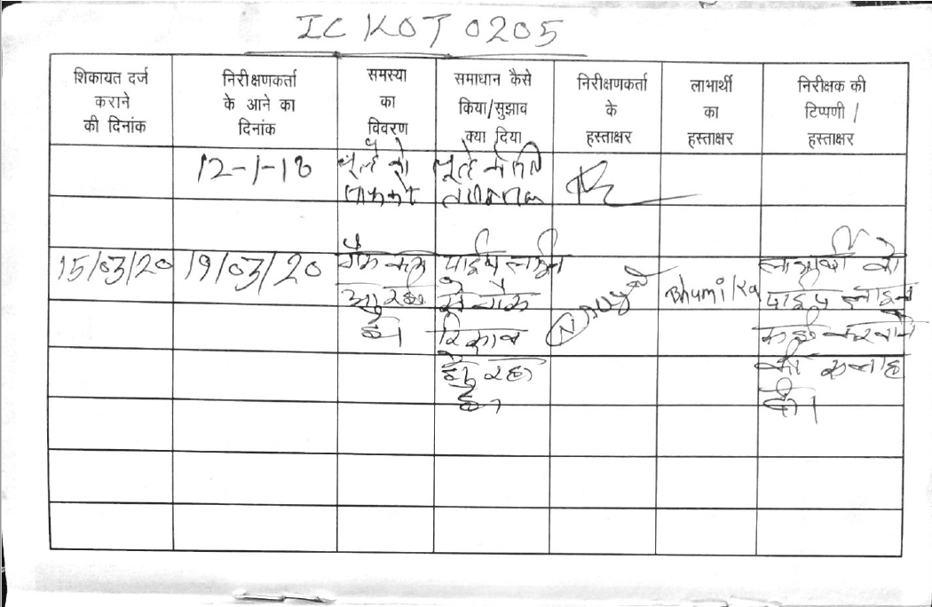

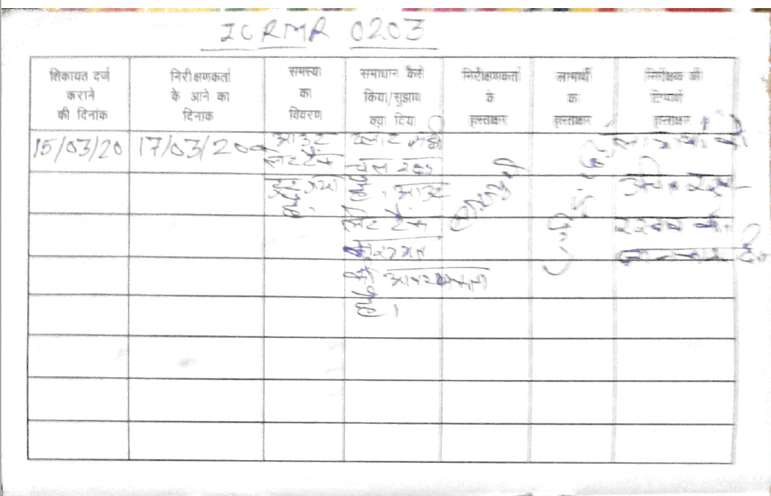

Reparation by vendors:
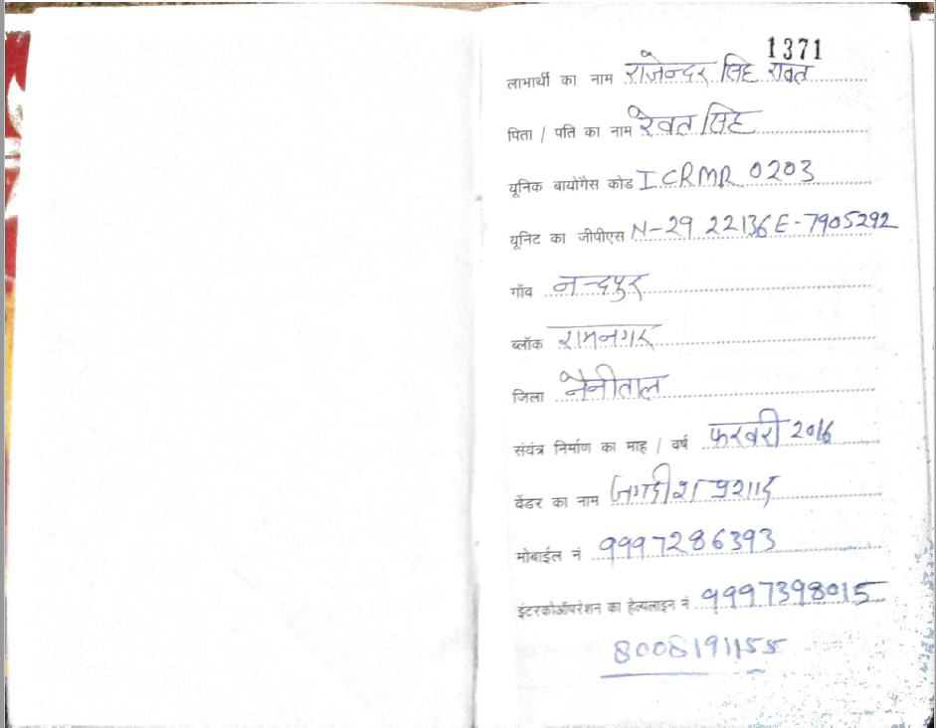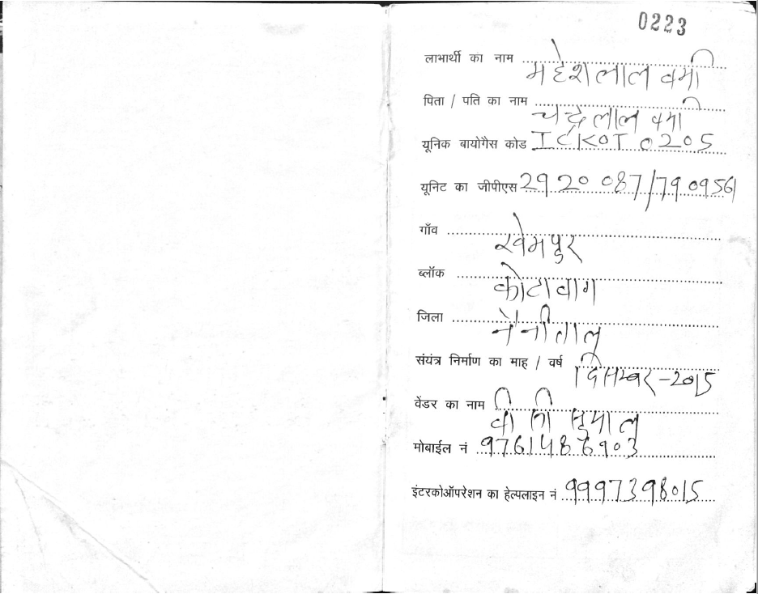

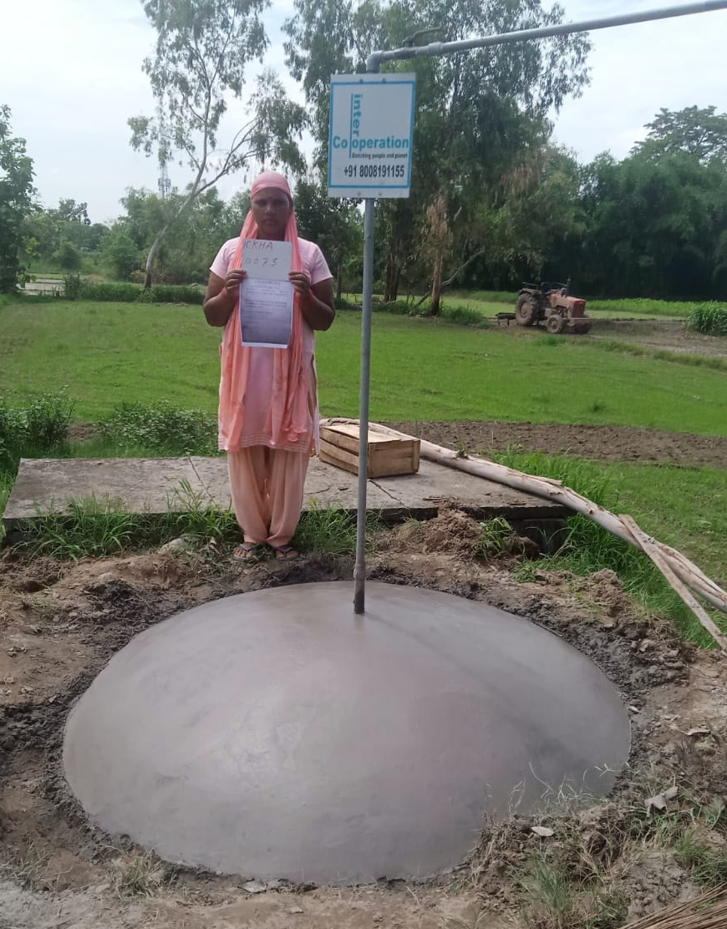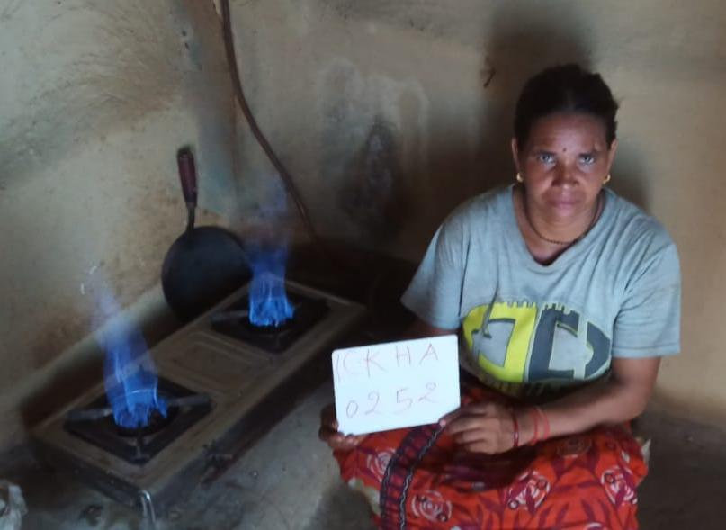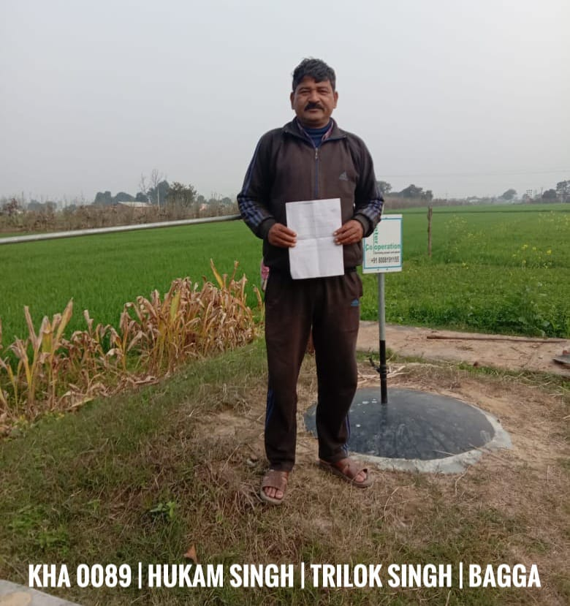

  - Report on any stakeholder mitigations that were agreed to be monitored.
>>
There were not any stakeholder mitigations agreed to be monitored.
  - Provide details of any legal contest that has arisen with the project during the monitoring period
>>
No legal contest was arisen during the monitoring period.

Revision History

Version | Date | Remarks
1.1 | 14 October 2020 | Hyperlinked section summary to enable quick access to key sections  Improved clarity on Key Project Information  Section for POA monitoring  Forward action request section  Improved Clarity on SDG contribution/SDG Impact term used throughout  Clarity on safeguard reporting  Clarity on design changes  Leakage section added for VER/CER projects  Addition of Comparison of monitored parameters with last monitoring period  Provision of an accompanying Guide to help the user understand detailed rules and requirements
1.0 | 10 July 2017 | Initial adoption

Legal documents have been provided to DOE during verification.
http://latitude.to/map/in/india/cities/almora/articles/2439/nainital
http://latitude.to/map/in/india/cities/kichha
http://latitude.to/map/in/india/cities/haridwar
https://latitude.to/map/in/india/cities/bahraigh
https://latitude.to/articles-by-country/in/india/21545/sravasti
Technologies and Practices to Displace Decentralized Thermal Energy Consumption Version 2.0” https://globalgoals.goldstandard.org/standards/407_V2.0_EE_ICS_Technologies-and-Practices-to-Displace-Decentrilized-Thermal-Energy-TPDDTECConsumption.pdf p.26 Error! Hyperlink reference not valid.
See the excel file ‘List of beneficiaries to be surveyed 2021’
See the excel file ‘List of beneficiaries to be surveyed 2021’
Technologies and Practices to Displace Decentralized Thermal Energy Consumption Version 2.0” https://globalgoals.goldstandard.org/standards/407_V2.0_EE_ICS_Technologies-and-Practices-to-Displace-Decentrilized-Thermal-Energy-TPDDTECConsumption.pdf p.46-50
See the excel file ‘List of beneficiaries to be surveyed 2021’
See Excel file FTP Report Updated - cell BC59.
See the excel file ‘FTP Report Updated 2021’
Technologies and Practices to Displace Decentralized Thermal Energy Consumption Version 2.0” https://globalgoals.goldstandard.org/standards/407_V2.0_EE_ICS_Technologies-and-Practices-to-Displace-Decentrilized-Thermal-Energy-TPDDTECConsumption.pdf p.12
Ibid p.26
Technologies and Practices to Displace Decentralized Thermal Energy Consumption Version 2.0” https://globalgoals.goldstandard.org/standards/407_V2.0_EE_ICS_Technologies-and-Practices-to-Displace-Decentrilized-Thermal-Energy-TPDDTECConsumption.pdf p.10, 14, 46.
See the excel ‘Other Document 13 (Baseline-Project survey 2015 v02.xlsx’ – cell IE109 - submitted during the first performance review (Other Document 13 in SC App - Performance Review no. 1)
Idem
See excel file ER calculation spreadsheet ‘ER_calculation_per_Stove’ cell C32.
See excel file FTP Report Updated cell AZ69.
Whenever emission reductions are capped, both the original and capped values used for calculations must be transparently reported. Use brackets to denote original values.

