Transition Request Form - Project

PUBLICATION DATE 01/04/2021
VERSION 1.0
RELATED SUPPORT

- TEMPLATE GUIDE Key Project Information & Project Design Document v.1.2

CONTACT DETAILS:

The Gold Standard Foundation
Chemin de Balexert 7-9
1219 Châtelaine
International Environment House 2
Geneva, Switzerland
Tel: +41 22 788 70 80
Email: help@goldstandard.org

Summary:
The projects transitioning from CDM or other Standards to Gold Standard for Global Goals (GS4GG) shall submit the transition request form and PDD (this document). The Transition Request Form is also to be completed for projects that are already registered with GS4GG for CER labelling and seek to move to GSVER stream to issue Gold Standard VERs..

This document contains the following Sections
Section - Transition Request Form
TRF.1 ELIGIBILITY CHECK FOR TRANSITION
TRF.2 TRANSITION PROJECT INFORMATION
TRF.3 TRANSITION CHECKLIST

Key Project Information
Section - Project design document
SECTION A – Description of project
SECTION B - Application of approved Gold Standard Methodology (ies) and/or demonstration of SDG Contributions
SECTION C – Duration and crediting period
SECTION D – Summary of Safeguarding Principles and Gender Sensitive Assessment
SECTION E – Outcome of Stakeholder Consultations
Appendix 1 – Safeguarding Principles Assessment (mandatory)
Appendix 2 - Contact information of Project participants (mandatory)
Appendix 3 - LUF Additional Information (project specific)
Appendix 3 - Summary of Approved Design Changes (project specific)

The following table summarises how different sections of this document shall be filled to facilitate request for transition from other standard to GS4GG.

Section | Required for | How to complete the section
Transition Request Form
TRF.1 Eligibility check for transition | All projects | Answer the assessment questions and provide supporting information as needed
TRF.2 Transition project information | All projects | Provide project information pertaining to the standard the project is transitioning from (e.g., CDM)
TFR.3 Transition checklist | All projects | Answer the assessment questions and provide supporting in the section in the PDD section as needed
Project Design Document
Key project information | All projects | Include project details pertaining to GS4GG
Section A to E | All projects | Provide information as needed. Any section/subsections  - that requires information/justification or additional information as per transition checklist, AND  - that involves update/revision to the information provided for registration with other standards. In such cases, the project shall copy and paste the information from registered PDD (other standard) and mark the additional information in track changes.

Section – Transition Request form

TRF.1 Eligibility check for transition
To be completed for all projects seeking transition to GS4GG from other standards.
Requirement | To be completed by project developer  GHG Emissions Reductions and Sequestration Product Requirements
The project must have a crediting period start date with CDM/other standard on or after 01 January 2016 | Is the project crediting period start date after 01 January 2016?  ☐ Yes  ☒ No (go to questions below)
The project that has a crediting period start date with CDM/other standard before 01 January 2016 shall demonstrate the risk of discontinuation without carbon revenue. | Explain the risks/barriers that may cause discontinuation of project without carbon revenue.  The absence of the carbon revenues would impact directly in the continuous use of the biodigester by the families as the annual monitoring and training activities and reparation of the units are conducted with the carbon revenues paid each time that an issuance is accomplished.  As mentioned in the PDD, the project activity would not have occurred without the CDM because beneficiary households cannot afford the bio-digester units without the 73% cost subsidy provided by the carbon revenues. This is demonstrated by the fact that the bio-digesters cost between 82% and 103% of the average annual household income in the project activity area.  Myclimate has made investment for each of the biodigester unit installed in this project since the beginning, in addition is paid a price per credit issued each time an issuance process is accomplished. Therefore the positive outcomes: continuous and proper use of the biodigester, their reparations and training activities about their use and maintenance would not continue to happen without the carbon revenues.  It is worth to mention that we monitor the annual SDG impacts accomplished by the project thanks to the carbon revenues including the reduction in incidence of hospitalization due the project, the time and money saved annually, the amount of chemical fertilisers reduced, the jobs generated by the projects, the training activities conducted and reparation activities. Our partner SKG Sangha would not be able to accomplish these activities in the scenario the project stop issuing credits under GS since vintage 2021 until the end of its crediting period (March 2022).
The project that has a crediting period start date with CDM/other standard before 01 January 2016 shall demonstrate how the project has been operational in the absence of carbon revenue, if carbon credits have not been issued to the project in recent years. | Explain how the project has managed the operation in the absence of carbon revenue in recent years.  The project has issued credits since its start date of the crediting period (01/04/2012), hence the project, hence no need to demonstrate the absence of carbon revenues as happened the opposite.
List of supporting documents | Please list all supporting documentation.  - PDD.  - GS transition annex  - Excerpts from the contract signed between myclimate and SKG Sangha (the content of this document is confidential).  If any of the supporting documents are confidential, please indicate here to ensure they are omitted from being published

TRF.2 Transition project information
Project developer shall provide project information (in grey rows), pertaining to the standard, the project is transitioning from (e.g., CDM) in the table below.
Name of the original standard | ☒ CDM  ☐ Other (Add the standard name here)
Project status with original standard | The current status of project with CDM/other standard at the time of submission of this form.
Project status with original standard | ☒ Active (registration status is valid)  ☐ Withdrawn (deregistered)  ☐ Provisional (awaiting guidance from the CMP at CMP 16, CDM PoA only)
CDM/ other standard reference ID | Reference number/ID allocated to the project by CDM/other standard.
CDM/ other standard reference ID | 4058
Project reference weblink | The weblink of the project page of CDM/other standard.
Project reference weblink | https://cdm.unfccc.int/Projects/DB/SGS-UKL1287587238.03/view
Title of Project | The title of the project used for registration with CDM/other standard.
Title of Project | Kolar Biogas Project
New title of Project (if applicable) | The title of the project if it has been changed for registering with Gold Standard.
New title of Project (if applicable) | N.A.
Activity Scale | Project scale registered with CDM/other standard.
Activity Scale | Small scale
Methodology used | Methodology title and the version number applied for registration with CDM /other standard.
Methodology used | AMS-I.C. ver. 18 - Thermal energy production with or without electricity  AMS-III.R. - Methane recovery in agricultural activities at household/small farm level  AMS-I.E. ver. 3 - Switch from Non-Renewable Biomass for Thermal Applications by the User
Amount of reductions | Average annual emission reductions (tCO₂eq/year).
Amount of reductions | 55,147
Registration date | The project registration date with CDM/other standard.
Registration date | 24/11/2011
Type of crediting period | ☐ renewable crediting period  ☒ fixed crediting period
Crediting period | The project registered crediting period start date and end date with CDM/other standard.
Crediting period | Start date: 01/04/2012  End date: 31/03/2022
Total Monitoring Periods issued | The total period that has already been issued by CDM/other standard.
Total Monitoring Periods issued | Start date: 01/04/2012  End date: 31/12/2020
Latest monitoring period | The latest monitoring period that has already been issued or submitted for issuance to CDM/other standard.
Latest monitoring period | Start date: 01/01/2020  End date: 31/12/2020
Latest monitoring period | Issuance Status | ☒ Issued  ☐ Awaiting issuance
Latest monitoring period | Date of Issuance, if issued. | 23/06/2022
Declaration | Click on the tick box to confirm.
Declaration | The Project Developer/Representative hereby acknowledges that project developer;  ☐ Option 1 - has included information in this document that has not been validated/verified as part of CDM PDD OR  X Option 2 - has copied all validated information as it appears in the original and then used tracked changes to highlight any information that not been validated/or has changed - Note if option 2 is selected the project developer shall fill all sections in the PDD template of this document.  The Project Developer/Representative hereby acknowledges that project developer;  X is aware that for a given vintage, a registered Gold Standard project can request the issuance of the emission reductions under only one standard/certification scheme. (applicable to all projects).  X is aware that all projects that transition to GS4GG shall demonstrate Ongoing Financial Need at the time of renewal of their crediting period following applicable GS4GG requirements. (applicable to all projects).  X confirms that the project developer/representative will make a declaration, in writing, in the monitoring report submitted to Gold Standard that (applicable to CDM PoA/CPAs)  - project will/has not issue both a CER/other compliance units under Paris Agreement and a GSVER for the same vintage.  - project developer agrees to comply with all future UNFCCC COP/CMP decisions including adjustment of GWP values
Project Developer/ authorised signatory | Name and designation of the project developer/authorised signatory
Project Developer/ authorised signatory | Foundation myclimate - The Climate Protection Partnership  Paul Leon

TRF.3 Transition Checklist
Project developer shall answer all assessment questions listed below and provide additional information/justification in the PDD section, where required. Please note that the checklist is based on the GHG Emissions Reductions and Sequestration Product Requirements.

The checklist also provides relevant requirements applicable to project transitioning to GS4GG for easy referencing. The PD shall refer to relevant GS4GG documents, as applicable, for further details. It is recommended that PD refers to Guidelines in the table below for more information on the requirements and flexibilities provided. This document (in word) shall be submitted to SustainCERT along with other required documents for preliminary review as listed below –
- Cover Letter
- Terms and Conditions
- Official Development Assistance declaration
- Stakeholder Consultation Report
- Project Design Document (PDD) final version (CDM/other standard)
- Validation report submitted to CDM/other standard
- Last Monitoring and Verification report submitted to CDM/other standard
- Transition pathway
- Option 1: Is project seeking registration with GS4GG to issue GSCERs while maintaining the CDM registration? (Ref: GHG Product Requirements) |  | ☐ Yes  ☒ No
- Option 2: Is project seeking registration with GS4GG to issue GSVERs only and/or conversion of issued CERs to GSVERs? (Ref: Annex B, GHG Product Requirements)  Note – for conversion of issued CERs to GSVERs, the project must be registered with GS4GG. |  | ☒ Yes  ☐ No
- Option 3: Is project seeking registration with GS4GG to issue GSVERs only and/or conversion of emission reduction to GSVERs issued by standard other than CDM? (Ref: Annex B, GHG Product Requirements) |  | ☐ Yes  ☒ No
Requirement:

All projects submitting request for transition on or after 1/1/2021 must demonstrate compliance with requirements stated in Annex B, GHG Product Requirements.

The project following option 1 above;
- may seek registration under GS4GG based on provisional CDM EB decision
- may seek issuance of GSVERs in exchange of provisional CERs based on CDM EB decision but must transfer issued CERs to the Gold Standard Swiss CDM Registry Account. If there are any implications for issued volume or project eligibility due to CMP decision regarding GWP, additionality or any other decision, the PD must address these issues, as applicable in consultation with SustainCERT/GS.
- A/R projects are not eligible for option 1.

The project transitioning to GS4GG following option 2 above,
- may convert issued CERs to GSVERs
- are not required to deregister from CDM but shall not claim emission reductions under both GS4GG and CDM for the same vintage
- Eligible LUF project is required to deregister from CDM to issue GSVERs.

The project transitioning to GS4GG following option 3 above,
- may convert issued emission reductions unit to GSVERs
- may issue GSVERs
- shall deregister project from other standard before registration with GS4GG

Guidelines:
Project already undergoing design certification for CER labelling can continue with their existing process. SustainCERT shall be notified of the intention to switch to GSVER stream, at the earliest possible opportunity.

Project already certified for CER labelling can switch to GSVER stream by completing this form and notifying SustainCERT. Such project may leave the PDD section blank as this information has been captured in GS4GG PDD version submitted earlier.
- Transition approval procedure
- Option 1 - Is the project undergoing a preliminary review by sustainCERT, validation by VVB and design review by SustainCERT? |  | ☐ Yes  ☐ No
- Option 2 - Is the project undergoing a combined preliminary review, validation, and design review by SustainCERT? (restrictions apply, see 5.3 below) |  | ☐ Yes  ☐ No
- Option 3- Is the project undergoing preliminary review by SustainCERT, combined validation & verification by VVB, followed by combined design and performance review by SustainCERT? |  | ☐ Yes  ☐ No
Requirement:
The project certification under GS4GG involves following key steps. Refer to Section 5. Project cycle Principles and Requirements for details.

Preliminary review - Preliminary Review is conducted once at the time of first submission to Gold Standard. It involves desk review of the Key Project Information and Draft Project Design Document by SustainCERT.

Design certification (validation + design review) - Design certification involves validation by VVB and design review by SustainCERT. With successful design certification the Project will obtain ‘Certified design’ status that is equivalent to registration under CDM and other standard.

Performance certification (verification + performance review) - Performance certification involves verification by VVB and performance review by SustainCERT. The positive conclusion of the Performance Review period shall result in Gold Standard ‘Certified Project status’ and Project can issue GSVERs. The project may opt for combined Design Certification, conducting both the first Verification and Performance Review under GS4GG at the same time.

To minimise disruption and keep the transition review time and costs minimum, the projects are provided with flexibilities as summarised in the table below;

Certification outcome | Certification stage | Option 1 | Option 2* | Option 3
Certification outcome | Certification stage | Normal certification pathway | Combined Preliminary review  + Validation + Design review | Combined validation + verification followed by combined design + performance review
Listing | Preliminary review | SustainCERT | SustainCERT | SustainCERT
Certified Design  = Registration | Validation | VVB | SustainCERT | VVB
Certified Design  = Registration | Design review | SustainCERT | SustainCERT | SustainCERT
Certified project = Issuance | Verification | VVB | VVB | VVB
Certified project = Issuance | Performance review | SustainCERT | SustainCERT | SustainCERT
Comments |  | Project shall go through preliminary review by SustainCERT  (4 weeks)  Design review  (minimum 4 weeks) is conducted after Validation by VVB and is concluded when all CARs/CLs are successfully closed.  Performance review (minimum 3 weeks) is conducted after Verification by VVB and is concluded when all CARs/CLs are successfully closed. | Project may combine preliminary review with validation and design review. All these steps can be combined and completed by SustainCERT.  VVB shall complete the verification.  Performance review (minimum 3 weeks) is conducted after verification by VVB and is concluded when all CARs/CLs are successfully closed | Project shall go through preliminary review by SustainCERT  (4 weeks)  Project Developers may combine Design Certification with first Verification and Performance Review.  VVB may combine site visits and VVB submits positive Validation and Verification Reports at the same time.  Concurrent Design Review and Performance Review (minimum 6 weeks) is conducted after submission of validation and verification reports by VVB and is concluded when all CARs/CLs are successfully closed.
For option 1, a validation site visit by VVB is not required as long as the VVB conducted a site visit as part of validation/verification in last three years (from time of first submission for preliminary review) and new/updated information can be audited based on desk review and/or using remote audit approaches.

For Option 2, SustainCERT conducts project design elements desk based audit and approve project transition, without VVB’s opinion. Note that this option will involve additional review fee levied by SustainCERT. The project developer shall confirm the applicable fee and timelines with SustainCERT (help@sustain-cert.com) before submitting the request for transition.

If transition project is applying a new/latest version of the methodology which requires full audit but VVB, option 2 cannot be applied.

- Project Eligibility
- Is the project eligible project type under Gold Standard for the Global Goals? | ☐ Yes  ☐ No
Requirement: The transitioning project shall be one of the eligible project types for issuance of Gold Standard VERs (Ref: GHG Product Requirements).

Guidelines: Typical eligible project types are Renewable Energy Supply, End-Use Energy Efficiency Improvement, Waste Handling & Disposal, Land Use and Forests.
- Afforestation/Reforestation project registered with CDM/other standard may transition to GS4GG for issuance of GSVERs only but are not eligible for labelling of issued emission reduction units.
- RE projects shall refer to Renewable Energy Activity Requirements for eligibility check.
- RE projects for example - · Hydropower · biomass resources · landfill gas and biogas from agro-processing, wastewater and other residues · Waste Heat/Gas recovery · Fossil co-generation · Waste incineration and gasification · Waste handling and disposal are required to demonstrate compliance with the specific eligibility requirements. Refer to Annex – A of Renewable Energy Activity Requirements for further details.
- Community Services Activities projects for example - Hydropower · biomass resources · landfill gas and biogas from agro-processing, wastewater and other residues · Waste Heat/Gas recovery · Fossil co-generation · Waste incineration and gasification · Waste handling and disposal · Relighting · End-use fossil switching are required to demonstrate compliance with the specific eligibility requirements. Refer to Annex – A of Community Services Activity Requirements for further details.
- Compliance with relevant Activity Requirements
- Does the project conform to the relevant Activity Requirements (CSA/RE /LUF)? | ☐ Yes  ☐ No
- Does any specific eligibility criteria/requirement stipulated in Annex A of CSA/RE requirements apply to the project? (see section 2.0 for LUF) | ☐ Yes  ☐ No
- Does specific eligibility criteria/requirement stipulated in Annex A of CSA/RE requirements that apply to the project, lead to any change in the registered PDD? If Yes, please provide a full explanation in section A.1.1. below. | ☐ Yes  ☐ No
Requirement:
(Ref: Section 4.1.1 of GHG Product Requirements)
Projects shall conform to the relevant Activity Requirements and Gold Standard Approved Methodologies, including eligible CDM Methodologies.

RE rule update / RE PoA rule update:
Grid connected Renewable Energy projects seeking to transition from another carbon crediting scheme to GS4GG or labelling of emission reductions under GS4GG are exempted from eligibility requirements listed in para 2.1.3 of the RE Activity Requirements. This exemption is only allowed to projects that started the first crediting period with the original carbon crediting scheme from 01/01/2016 or later but before 24/01/2020. (Ref: Section 2.1.1 and 2.1.2 of RU 2020 AR –RE V1.2)

Specific Renewable Energy Activity requirements (refer to Annex A): Hydropower, biomass resources, landfill gas and biogas from agro-processing, wastewater and other residues, Waste Heat/Gas recovery, Fossil co-generation, Waste incineration and gasification, Waste handling and disposal.

Specific Community Service Activity requirements (refer to Annex A): Hydropower, biomass resources, landfill gas and biogas from agro-processing, wastewater and other residues, Waste Heat/Gas recovery, Fossil co-generation, Waste incineration and gasification, Waste handling and disposal, Relighting, End-use fossil switching.
- Applicability of the methodology/tool version
- Does the project apply an eligible GS methodology? Refer to list of the eligible methodologies here. |  | ☐ Yes  ☐ No
- Does the project apply the version of the methodology and applicable tools applied for CDM/other standard registration or renewal? |  | ☐ Yes  ☐ No
- Does the project apply the latest version of the methodology and applicable tools available at the time of first submission of this form? If Yes, please provide a full explanation in section B below. And note that the project cannot opt for option 2 mentioned transition approval procedure. |  | ☐ Yes  ☐ No
Requirement: (Ref: Annex B of GHG Product Requirements)
Transition project shall
- conform to the relevant Activity Requirements and Gold Standard Approved Methodologies, including eligible CDM Methodologies.
- also meet the additional GS4GG methodology eligibility requirements, where applicable. Refer to CDM Methodologies for Gold Standard Eligibility Requirements.
Transition project shall apply the version of GS approved CDM methodology or methodology tool for transition to GS4GG as follows;
- version applied at the time of registration/renewal of crediting period with other standard, OR
- version available at the time of first submission (preliminary review) this form.
- Demonstration of additionality
- Are you aware that the transitioning project will be required to demonstrate Ongoing Financial Need as per the relevant GS rules and requirements available at the time of renewal of crediting period? (Refer to para 4.1.51 – 4.1.53 of Principles & Requirements.) |  | ☐ Yes  ☐ No

Requirement:
- The CDM and JI project are not required to carry out additional assessment for demonstration of additionality over and above what has been done for registration/determination with the CDM unless the project falls into a category that is deemed non-additional in an applicable Gold Standard Activity Requirement. In such cases the relevant Activity Requirement shall take precedence. Ref: Annex B GHG Product Requirements.
- Transition projects registered with standards other than CDM are required to undergo additionality revalidation to re-establish the validity of the underlying assumptions applied in the demonstration of additionality at the time of registration with the other standard.
- The projects seeking combined transition and renewal of crediting period with GS4GG are not required to demonstrate OFN at the time of transition but must demonstrate OFN at the time of Crediting Period renewal after transitioning to GS4GG.
- Sustainable Development Assessment
- Does the project positively contribute towards minimum three Sustainable Development Goals (SDGs) - SDG13 (mandatory) + two other SDGs? |  |  |  | ☐ Yes  ☐ No
- Have you identified the monitoring parameters linked with selected SDGs and corresponding SDG targets?  For example – the monitoring parameter Amount of GHGs emissions avoided or sequestered is linked with SDG 13. Climate action, SDG target 13.2 Integrate climate change measures into national policies, strategies and planning. |  |  |  | ☐ Yes  ☐ No
Fill section B.6. Sustainable Development Goals (SDG) outcomes and B.7 Monitoring plan, below for SDGs monitoring parameters not covered in registered PDD with other standards.

Fill Table 1 – Estimated Sustainable Development Contributions below.

Requirement:
The transitioning project shall demonstrate a clear, direct contribution to sustainable development, defined as making demonstrable, positive impacts on at least three Sustainable Development Goals (SDGs), one of which must be SDG 13 (Ref: Section 4.(c) of Principles and Requirements)

Refer to Annex B, GHG Product Requirements for further guidelines for transition projects.

Guidelines:
Selected SDG impacts must not result from a one-off from design/construction/distribution/ start-up or decommissioning of the project.

You may refer to /use the SDG impact Tool (under consultation currently) to identify the relevant monitoring indicator, SDGs and corresponding SDG targets and design monitoring plan for identified indicators.
- Start date and duration of the crediting period
- Has the crediting period of the transitioning project registered with other carbon standard/certification scheme changed and/or extended? | ☐ Yes  ☐ No
- Is the total duration of the crediting period (i.e. including period that had been issued under the host standard) less than/equal to the maximum crediting period allowed under relevant GS4GG activity requirements? | ☐ Yes  ☐ No

Complete the section C.2.2 Total length of crediting period below.

Requirement:
- The crediting period of the transitioning project/PoA/CPA registered with other standards or certification schemes cannot be changed/extended.
- Maximum crediting period allowed under GS4GG are as
CSA – 15 Yrs, RE – 15 Yrs, LUF 30 – 50 Yrs, AGR – 10 Yrs, if not defined in activity requirement or applicable methodology – 10 Yrs.
- The start date of the GS crediting period shall be same as the start date of the CDM crediting period. (Annex B, GHG Product Requirements)
- For a transitioning project, PoA/CPA, the total duration of the crediting period, including the period that has been claimed under the host standard, shall not exceed the maximum crediting period allowed under relevant GS4GG activity requirements.
If a given project transitioning to GS4GG, was registered under Standard X with -
  - fixed crediting period (10 years): The total crediting period (Standard X + GS4GG) must remain 10 years. The project can only claim remaining years of its 10-year crediting period after transitioning to GS4GG.
  - renewable crediting period (7*3 year): The total crediting period (Standard X + GS4GG) must be equal to that allowed under relevant GS4GG activity requirements. The project can only claim remaining years of the maximum allowed crediting period after transitioning to GS4GG. For example; the maximum crediting period allowed for renewable energy project is 15 years. A renewable energy project that has already claimed 5 years under Standard X can only claim remaining 10 years of the total 15 years of its allowed crediting period after transitioning to GS4GG
- For a transitioning project, the start date of the Gold Standard Crediting Period starts with crediting period start date with other standard or maximum two years before the date of first submission (submission for preliminary review), whichever occurs later. (Ref: Annex B, GHG Product Requirements)
- Safeguarding Principles Assessment
- Does the project conform to the Gold Standard Safeguarding Principles and Requirements? |  |  | ☐ Yes  ☐ No
- Is there any risk and/or likely adverse outcomes of the project? |  |  | ☐ Yes  ☐ No
- If answer is yes for Q 9.2 |above, can the project achieve requirements with regards to the relevant principle through design, management or risk mitigation? |  |  | ☐ Yes  ☐ No
- If answer is yes for Q 9.3 |above, have the Mitigation Measures added to the Monitoring Plan (if required)? |  |  | ☐ Yes  ☐ No

Complete the Annex 1 and section D. Summary of Safeguarding Principles below.

Requirement: The transitioning project shall conform to the Gold Standard Safeguarding Principles and Requirements. (Ref: Section 4.1.19 of GS4GG Principles and Requirements)

Guidelines: The detailed Safeguarding Principles and Requirements checklist is available in Annex 1 of this document.
- Stakeholder Consultation Requirements
- Has the project conducted a Stakeholder Consultation in accordance with the requirements of Gold Standard Stakeholder Consultation & Engagement Requirements?  The answer to Q 10.1 is “No”, if any of the questions below is answered as “No”. The project should take the question(s) into account and address the gap when conducting supplementary stakeholder consultation to comply with GS4GG requirements.  Please answer the below question with regards to the stakeholder consultation conducted to comply with CDM/other standard requirements? |  |  | ☐ Yes  ☐ No
- Did you conduct the stakeholder consultation before the project start date? |  |  | ☐ Yes  ☐ No
- Did you discuss identified direct positive and negative impacts of the projects with stakeholders? |  |  | ☐ Yes  ☐ No
- Does the invited stakeholder covers all stakeholder groups (a to g) listed in paragraph 3.1.1. of STAKEHOLDER CONSULTATION AND ENGAGEMENT REQUIREMENTS? |  |  | ☐ Yes  ☐ No
- Did the invitation methods solicit input from women and marginalised groups? |  |  | ☐ Yes  ☐ No
- Were the stakeholders invited at least 30 days before the stakeholder meeting? |  |  | ☐ Yes  ☐ No
- Did a local language version of the non-technical summary with information required as per paragraph 5.1.1. of STAKEHOLDER CONSULTATION AND ENGAGEMENT REQUIREMENTS, shared with stakeholders? |  |  | ☐ Yes  ☐ No
- Was a physical meeting conducted? |  |  | ☐ Yes  ☐ No
- Was a gender lens applied to assessing comments? (for example, if only men provided comments on household device project, was this taken into consideration when assessing the relevance of the comment?) |  |  | ☐ Yes  ☐ No
- Were any serious, reasonable and proportional concerns raised and taken into account and satisfactorily addressed? |  |  | ☐ Yes  ☐ No
- Were any points that warrant ‘Mitigation measures’ marked as such and monitoring plan has been designed and included in the PDD? |  |  | ☐ Yes  ☐ No
- Is the mandatory Continuous Input / Grievance Expression Process Book’s location clearly stated (and therefore usable)? |  |  | ☐ Yes  ☐ No
- Does PDD include a summary report of the comments received from local stakeholders? |  |  | ☐ Yes  ☐ No

Complete the section E. Summary of Local Stakeholder Consultation below.

Requirement: Ref: Section 4.1.25 of GS Principles and Requirements.

Guidelines: Project that conducted a stakeholder consultation meeting to comply with CDM/other standard requirements, should conduct, at minimum,
- one round of consultation for identified gaps i.e., gaps due to differences in stakeholder consultation requirements of GS4GG and CDM/other standard. For instance, if original consultations only involve one physical meeting, CME/PD should conduct a stakeholder feedback round covering all the identified gaps. The additional stakeholder consultations may involve a physical meeting or stakeholder feedback round, as necessary.

If COVID interim measures are applicable (currently till 30/06/2021), the physical meeting and stakeholder feedback round may be postponed, and a draft SCR shall be mandatorily submitted to cover the consultation activities carried out till date.

KEY PROJECT INFORMATION
GS ID of Project | GS670
Title of Project | Kolar Biogas Project
Time of First Submission Date | 20/08/2009
Date of Design Certification | 18/10/2013
Version number of the PDD | 15.0
Completion date of version | 11/11/2022
Project Developer | Foundation myclimate – The Climate Protection Partnership
Project Representative | Foundation myclimate – The Climate Protection Partnership
Project Participants and any communities involved | SKG Sangha
Host Country (ies) | India
Activity Requirements applied | ☐ Community Services Activities  ☐ Renewable Energy Activities  ☐ Land Use and Forestry Activities/Risks & Capacities  ☐ N/A
Scale of the project activity | ☐ Micro scale  ☐ Small Scale  ☐ Large Scale
Other Requirements applied | Tool to calculate project or leakage CO2 emissions from fossil fuel combustion” ver.2  Tool to calculate baseline, project and/or leakage emissions from electricity consumption” ver.1  Tool for the demonstration and assessment of additionality” ver. 05.2
Methodology (ies) applied and version number | AMS.I.C – “Thermal energy for the user with or without electricity” ver. 18  AMS.I.E – “Switch from Non-Renewable Biomass for  Thermal Applications by the User” ver.3  AMS.III.R – “Methane recovery in agricultural activities at household/small farm level” ver.1
Product Requirements applied | ☐ GHG Emissions Reduction & Sequestration  ☐ Renewable Energy Label  ☐ N/A
Project Cycle: | ☐ Regular  ☐ Retroactive

Table 1 – Estimated Sustainable Development Contributions
Sustainable Development Goals Targeted | SDG Impact  (defined in B.6.) | Estimated Annual Average | Units or Products
SDG1: No Poverty | Time and monetary savings | Time saving: 388.2  Money saving: 829 | hours per year/HH  Rupees per year/HH
SDG2: Zero Hunger | Application of sludge | Value: 9.8 | tons/year
 | Total number of people trained on different aspects of the project | Value: 419 | Pp
SDG3: Good health and well-being | Proportion confirming the reduction in health problems after using the biogas plants | Value: 100 | %
 | Average amount of chemical fertilisers reduced in the agricultural soils (kg/y) of households after project intervention. | Value: 88.8 | kg/year
SDG4: Quality Education | Total number of people trained on different aspects of the project | Value: 419 | Pp
SDG5: Gender equality | Number of women benefited trained by SKG Sangha | Value: 419 | Pp
SDG7: Affordable and clean energy | Number of persons that benefit from efficient and clean technologies | Value: 40,282 | Pp
SDG8: Decent work and economic growth | Number of jobs offered | Value: 11 | Pp
 | Annual average wage of people employed | Value: 222,000 | INR
SDG12: Responsible consumption and production | Fuel savings achieved | Value: 99.35 | %
SDG13: Climate Action | ER expected in the crediting period | Value: 45,650 | GS VER
SDG15: Life on Land | Amount of wood equivalents saved by the project | Value: 4.71 | tons/year
 | Application of sludge | Value: 9.8 | tons/year  tons/year
SDG17: Partnership for the goals | Total number of people trained on different aspects of the project | Value: 419 | pp
 | Number of systems (biogas units) operating | N: 8,000 | Units

SECTION A. DESCRIPTION OF PROJECT

A.1 Purpose and general description of project
>>
The proposed project will provide biogas units to households in rural areas of Kolar District in Karnataka State in India. The project will reduce the amount of fuel wood and kerosene used for cooking and heating water and will replace inefficient traditional cooking stoves with cleaner biogas stoves. The project will also reduce methane emissions from cattle manure and will contribute strongly to the sustainable development of the rural households involved in the project.

The biogas technology is tried and tested in rural India. SKG Sangha, an Indian non-governmental organisation (NGO), will implement the project. SKG Sangha has already successfully implemented over 50,000 biogas units in India over the last 15 years. Many of these biogas units were implemented with the help of government subsidies but the availability of these subsidies has reduced dramatically in recent years from around 250,000 units per year to around 5-10,000 units per year for the entire country. As there are over 600 districts in India, this equates to at best only tens of biogas units per District and an even smaller number at a Taluk level. Similarly, charity or donor financing has contributed to biogas units in the past but such financing is not able to cover the vast need for improving the energy supply to rural households in India. SKG Sangha therefore turned to the Clean Development Mechanism to provide biogas systems to rural households.

The project encompasses 9,380 households in all five Taluks in Kolar District – Srinivaspur, Kolar, Mulbagal, Malur, and Bangarapet.

The Taluk is an Indian administrative unit. The Karnataka state is divided into several districts and each district is divided into taluks. Each taluk is subdivided into panchayaths for administrative purposes.

A taluk consists of several Panchayaths. Each taluk may have between 10 and 50 panchayaths. A Panchayath will have several hamlets or villages as part of it. A village is the bottom structure of human settlement. Each village may have few to few hundred households.
Generally, a Taluk consists of a city or town that serves as its headquarters, possibly additional towns, and a number of villages. As an entity of local government, it exercises certain fiscal and administrative power over the villages and municipalities within its jurisdiction. It is the ultimate executive agency for land records and related administrative matters.

In each of the 9,380 households covered by the proposed project a family size biogas unit will be installed. The biogas unit will be of either 2m³ or 3m³ capacity depending on the number and type of cattle owned by the household and the number of people in the household. At least two cattle will be required for a household to be eligible for a 2m³ biogas unit and at least 3 cattle will be required for a household to be eligible for a 3m³ biogas unit. Overall it is planned to install 2,814 units of 3 m³ capacity and 6,566 units of 2 m³ capacity.

The project will result in greenhouse gas (GHG) emission savings in the following ways:
- The biogas will displace GHG emissions from kerosene and fuel wood that are currently used for cooking. The biogas produced from cattle manure is a renewable source of energy as the CO₂ that is absorbed during the growth of the organic matter in the dung equals the CO₂ emitted when the biogas is burnt (see the introduction in chapter 10.1, Volume 4 of the Revised IPCC Guidelines 2006). In accordance with methodology AMS-I.E, emission reductions are calculated for the non-renewable part of the fuel wood and for the share of kerosene that would be used for cooking without the proposed project activity.
- The biogas will displace GHG emissions from cattle manure that is currently dumped in pits near the household. The cattle manure is dumped along with other waste such as straw from the cow shed, some kitchen waste, crop residues and other organic matter and liquids in the pit. This organic waste is never dry and does not get mixed therefore animal waste is decaying anaerobically and emitting methane. When cattle manure is fed to the biogas reactor, the emissions from the amount of manure that is added to the bioreactor will be avoided.
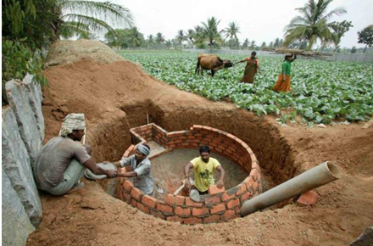
Biogas digester under construction

The project will have multiple sustainable development benefits in addition to the reduction in GHG emissions:
- Efficient cooking stoves fired with biogas will reduce indoor air pollution and respiratory problems currently caused by smoke from inefficient cookstoves burning fuel wood and kerosene;
- Currently the majority of the collected fuel wood used for cooking and heating water represents non-renewable biomass. The installation of a biogas unit will reduce the consumption of fuel wood by participating households and will therefore reduce the pressure on scarce forest resources in the project area;
- Women and children can use time that was otherwise required for collecting fuel wood for education and generating income;
- Biogas provides a more convenient, dependable energy source that is renewable and that reduces cooking time as there is no longer a need to set a fire and get it going;
- Cleaning of the kitchen and pots used for cooking is easier as biogas is a clean burning fuel and does not produce the levels of soot and other particulate matter that is produced by burning fuel wood and kerosene; and
- The slurry produced from the biogas units is a valuable organic fertiliser that can be applied directly to the fields or composted with other organic material to improve crop yields and reduce the use of chemical fertilisers.
SKG Sangha has developed extensive knowledge about biogas units that are suitable for rural households in Karnataka State, what functions well and what may induce problems, as well as knowledge about waste management, sludge application, composting and proper use of sludge or compost. SKG Sangha will conduct a number of meetings with eligible households and provide training to transfer this knowledge.

Total estimate reductions (tonnes of CO₂e) | 456,504
Total number of crediting years | 10
Annual average over the crediting period of estimated reductions (tonnes of CO₂e) | 45,650

The total estimated emissions reductions are 456,504 t/CO₂e and the annual average estimated emission reductions are 45,650 t/CO₂e.

The project provides biogas units to 9,380 households in rural areas of Kolar District in Karnataka State in India. The project reduces the amount of fuel wood and kerosene used for cooking and heating water and replaces inefficient traditional cooking stoves with cleaner biogas stoves. The project also reduces methane emissions from cattle manure and contributes strongly to the sustainable development of the rural households involved in the project. Measures taken for GHG emission reductions are:

(1) to replace fuel wood and kerosene for cooking with biogas. The non-renewable biomass used for cooking and water heating replaced by the renewable biogas will reduce GHGs
(2) to avoid methane emissions from cattle manure Project saves methane emissions caused by the animal dung fermenting in anaerobic condition in traditional compost pits. This will be avoided feeding the dung into biogas plant and by burning the generated methane in biogas burners to be used for cooking and heating water.

Relevant dates for the project activity:

Date of first biodigester construction | January 2012
Date of first biodigester commissioning | 10/01/2012
Numbers of biodigesters operating at the end of 2020 | 7,944

The project has already completed the transition to GS4GG as a GS CER project. The version used was GS4GG transition requirement version 1.1 (approve 01/03/2018) available at the time of submission.

    - Eligibility of the project under Gold Standard

The following General Eligibility Criteria applies to all projects seeking Gold Standard Certification. The information below was adapted from the PDD and Passport versions approved the project was registered under GS in 2013.
Gold Standard General Eligibility Criteria | Project attributes
Types of Project: Eligible Projects shall include physical action / implementation on the ground. Pre-identified eligible Project types are identified in the Eligibility Principles and Requirements section. | The project falls under the eligibility criteria described in section 4.1.3 - “A Project type is automatically eligible for Gold Standard Certification if there are Gold Standard published Activity Requirements and/or Gold Standard Approved Methodologies associated with it or as referenced in Gold Standard Product Requirements.” (GS4GG Principles and Requirements v1.2).  The project activity is to install bio digesters which will be fed with cow dung to generate biogas (AMS-III.R under CDM). The generated biogas will be used as cooking fuel replacing the traditional wood fuel cook stove and some kerosene usage (AMS-I.C under CDM). The wood fuel used in the project area is coming from non-renewable (AMS-I.E under CDM) sources and the cow dung is a renewable source.  The generated biogas will be used for cooking and if at all any biogas remains will be used for water heating purpose. The intended biogas plant is not replacing the entire fire wood used by the beneficiary households. It will replace 100% fire wood used for cooking and some portion to fulfil the water heating needs. Hence the 100% generated biogas in the project is utilized. This biogas generation and utilization will be monitored.  The project type is Community Services Activity which is eligible as falls under Gold Standard Approved Methodologies referenced in the Gold Standard Product Requirement “GHG Emissions Reductions & Sequestration Product Requirements” v.2.1, section 5.11. Eligible Project Types, category (a) “Renewable Energy Supply”. The project started its implementation by 2012.
Location of Project: Projects may be located in any part of the world | The project is located in India.
Project Area, Project Boundary and Scale:  The Project Area and Project Boundary shall be defined. Projects may be developed at any scale though certain rules, requirements and limitations may apply under specific Activity Requirements, Impact Quantification Methodologies and Products Requirements.  In order to avoid double counting the Project shall not be included in any other voluntary or compliance standards programme unless approved by Gold Standard.  Also, if the Project Area overlaps with that of another Gold Standard or other voluntary or compliance standard programme of a similar nature, the project shall demonstrate that there is no double counting of impacts at design and performance certification (for example use of similar technology or practices through which the potential arises for double counting or misestimation of impacts amongst projects). | The project area is defined in section A.2 of the PDD. The project area is located in India.  The Project is not included in any other voluntary or compliance standards programme unless approved by Gold Standard. The project has been issuing credits under CDM and GS mechanism for vintages 2012-2020.
Host Country Requirements: Projects shall be in compliance with host country’s legal, environmental, ecological and social regulations. | No negative environmental impacts were identified. The project will have the following positive environmental impacts in addition to the reduction in CO₂ and CH₄ emissions:  - The project will reduce consumption of fuel wood reducing pressure on scarce forest resources. Currently the major part of collected fuel wood represents non-renewable biomass;  - Efficient cooking stoves will reduce indoor air pollution;  - Soil quality and its water retention capacity are expected to improve after replacing indiscriminate use of chemical fertilisers with application of high-quality compost; and  - The risk of water pollution will be reduced due to proper management of wastewater and reduced use of chemical fertilisers and pesticides.  An Environmental impact analysis for the project activity is not required by Indian laws.
Contact details: The contact details of the project developer. | Contact details of the project developer are provided in Appendix 2 of the PDD.
Legal Ownership: Full and uncontested legal ownership of any products that are generated under Gold Standard Certification, should be demonstrated. Where such ownership is transferred from project beneficiaries this must be demonstrated transparently and with full, prior and informed consent. | The project applies for issuance of GS VERs. In any case, and to ensure transparency, the project developer have an ‘end user’ agreement clarifying the rights to the claims made through the Gold Standard certification.  SKGS shall ensure that each household for whom it installs a bio-digester in accordance with a Projects transfers ownership of any Offsets generated from the use of its bio-digester to SKGS {or signs a waiver in favour of SKGS stating that, in consideration for the bio-digester being installed, the household disclaims any ownership rights over any Offsets}.
Other Rights: As well as legal title and ownership, the Project Developer shall also demonstrate where required uncontested legal rights and/or permissions concerning changes in use of other resources required to service the Project (for example, access rights, water rights etc.). Any known disputes or contested rights must be declared immediately to Gold Standard by the Project Developer and resolved prior to further Project implementation and certification in affected areas. | There are no legal permissions required for the implementation of the project. Neither any disputes regarding implementation.

    - Legal ownership of products generated by the project and legal rights to alter use of resources required to service the project
>>
All the carbon credits ownership rights were with women with whom the contracts were made.
SKGS shall ensure that each household for whom it installs a bio-digester in accordance with a Projects transfers ownership of any Offsets generated from the use of its bio-digester to SKGS {or signs a waiver in favour of SKGS stating that, in consideration for the bio-digester being installed, the household disclaims any ownership rights over any Offsets}.

A.2 Location of project
>>
The proposed project activity will be implemented in rural areas of Kolar District, which has five Taluks – Srinivaspur, Kolar, Mulbagal, Malur, and Bangarapet.

Host Party: India
State: Karnataka
Rural areas of Kolar District (Srinivaspur, Kolar, Mulbagal, Malur, and Bangarapet Taluks)

The map to the left shows the approximate
location of the project on a large scale map of
India. The actual project boundaries will be the
outer boundaries of Kolar District. Kolar District
encompasses the following five Taluks:
Srinivaspur, Kolar, Mulbagal, Malur and
Bangarapet.
The red line on the Kolar District map below
shows the outer District boundaries for Kolar
District.

As the proposed project activity is going to be
implemented in 9,380 households distributed
over an area, it is impractical to give geographic
coordinates of 9,380 points. Instead, the
geographical coordinates of the taluk centres are
given below:

Centre | Latitude N | Longitude, E
Kolar Taluk | 13º08´12.04´´ | 78º08´20.44´´
Bangarapet Taluk | 12º59´04.97´´ | 78º10´42.40´´
Malur Taluk | 12º59´20.71´´ | 77º55´42.12´´
Mulbagal Taluk | 13º09´39.22´´ | 78º23´19.11´´
Srinivaspur Taluk | 13º20´19.13´´ | 78º12´38.15´´

A.3 Technologies and/or measures
>>
The project falls into the following categories of small-scale project activities:
I.C – “Thermal energy for the user with or without electricity”
I.E – “Switch from Non-Renewable Biomass for Thermal Applications by the User”
III.R – “Methane recovery in agricultural activities at household/small farm level”
The project will involve using cattle dung for the production of biogas (category III.R), which will displace the use of kerosene (category I.C) and non-renewable biomass (category I.E) for household cooking purposes.
The project conforms to these small-scale categories because:
- Introduced renewable energy technologies – biogas systems – have an aggregate capacity less than 45 MW: the average capacity of the units that will be installed under the proposed project activity is 2.97 kW so the aggregate capacity of the systems is in the order of 27.9MW (see justification below); and
- Recovery and destruction of methane from manure and agricultural wastes in all systems (all households) results in emission savings of less than 60kt CO₂e annually.

Justification of installed capacity
- The biogas produced from cattle manure and kitchen waste in household-size biodigesters has an average content of 60% of methane with the rest being CO₂ and traces of other gases.
- The calorific value of this biogas is 21.6 MJ/m³ (Nijaguna, 2002), or 0.0060048 kWh/l at a normal pressure, as gas pressure at a burner is a normal pressure.
- The Average thermal stove efficiency is 55% (Nijaguna, 2002)
- A Stove with a double burner burns 900l/h Therefore the capacity of an average biogas unit is 2.97 kW, and thus the total capacity of 9,380 units is 27.9 MW, which is below 45 MW threshold.

Technology
In each household, a family-size biodigester together with a biogas-based cooking stove unit will be installed. The biogas units will be constructed of bricks, sand, cement, pipes, pipe fittings, metal clips, wire and gas burners. Each bioreactor will be a mesophylic fixed dome. The capacity of the biodigesters will be either 2m³ or 3m³ of biogas per day. The biogas unit size for a particular household will be chosen based on the number and type of cattle owned by the household and the number of people in the household. SKG Sangha will build the systems with the help of people from the households. Cattle dung and wastewater will be fed into the biodigester daily. Cattle dung and kitchen wastewater will be added to a mixing tank above ground which has an inlet pipe to a digester chamber which is below ground. The dung and wastewater slurry remains in the chamber for approximately 40 days and breaks down anaerobically producing biogas. This biogas builds up above the slurry and remains in the chamber until it is released through the gas outlet pipe at the top of the dome when the gas burner in the household is turned on (the pipe at the top of the biodigester leads to the cooking stove in the household). The biodigester also produces a slurry which is pushed into the outlet tank and displacement chamber as the biogas builds up in the digester and finally exits through the slurry discharge hole. The technology has been tested and widely used in India.

A.4 Scale of the project
>>
According Standard CDM project standard for project activities Version 3.0 the small-scale project type applicable to project activity Type I: For thermal applications of biomass, biofuels or biogas (e.g. cookstoves), the limit of 45 MW(th) is the installed/rated capacity of the thermal application equipment or device(s) (e.g. biogas stoves).

Each cubic meter (m³) of biogas contains the equivalent of 6 kWh of calorific energy. The units installed under the project activity is 2m³ and 3m³, thus 12kwh and 18kwh respectively. The number of hours that biogas is used is 3.69h (based on Monitoring Survey conducted end 2020), thus the energy output is 3.25kW for 2m³ unit and 4.87kW for 3m³ unit. Based on the expected number of units installed per size (6566 2m³ and 2814 3m³), the total output capacity is 35.04MW which is below the limit for Type I - 45 MW(th).

Type III: Other project activities not included in Type I or Type II that result in GHG emission reductions not exceeding 60 kt CO₂e per year in any year of the crediting period which is accomplished by the project as demonstrated in section B.6.3 SDG 13.

A.5 Funding sources of project
>>
The project does not include public funding. The participating households will make a small in kind contribution of materials and labour but otherwise no other funding or assistance will be available to implement the project. The project will be funded solely from the sale of the offsets created from the project’s GHG emission reductions.

SECTION B. APPLICATION OF APPROVED GOLD STANDARD METHODOLOGY (IES) AND/OR DEMONSTRATION OF SDG CONTRIBUTIONS

B.1. Reference of approved methodology (ies)
>>
The following approved small scale baseline and monitoring methodologies are applied to the Kolar Biogas Project:
(i) Version 18 of AMS-I.C “Thermal energy for user with or without electricity”
(ii) Version 3 of AMS-I.E “Switch from non-renewable biomass for thermal applications by the user”
(iii) Version 1 of AMS-III.R “Methane recovery in agricultural activities at the household/small farm level”

Component 1, Thermal energy generation:

AMS.I.C – “Thermal energy production with or without electricity” ver. 18 https://cdm.unfccc.int/methodologies/DB/6EL4AG49US2S1DNH55Y4S7GDQFA2JF

”Tool to calculate project or leakage CO2 emissions from fossil fuel combustion” ver.2 http://cdm.unfccc.int/methodologies/PAmethodologies/tools/am-tool-03-v2.pdf

“Tool to calculate baseline, project and/or leakage emissions from electricity consumption” ver.1 http://cdm.unfccc.int/methodologies/PAmethodologies/tools/am-tool-05-v1.pdf

“Tool for the demonstration and assessment of additionality” ver. 05.2 http://cdm.unfccc.int/methodologies/PAmethodologies/tools/am-tool-01-v5.2.pdf

AMS.I.E – “Switch from Non-Renewable Biomass for Thermal Applications by the User” ver.3 http://cdm.unfccc.int/methodologies/DB/WHTQUFLWCVNB9CIUZC198A712WGQR4

Component 2, Methane-emissions-avoidance:

AMS.III.R – “Methane recovery in agricultural activities at household/small farm level” ver. 1
https://cdm.unfccc.int/methodologies/DB/JQHRMGL23TWZ081T6G7G1RZ63GM1BZ

B.2. Applicability of methodology (ies)
>>
- AMS-I.C “Thermal energy for user with or without electricity”, version 18
Criteria for the applicability of the methodology | Justification why the methodology is suitable for the proposed project activity
This category comprises renewable energy technologies that supply users with thermal energy that displaces fossil fuel use. | In the proposed project, this methodology is applied for estimating and monitoring emission reductions from displacing kerosene use (fossil fuel) in household cooking stoves (thermal energy) with the use of biogas generated from cattle dung and organic kitchen waste (renewable sources).
Biomass – based co – generating systems that produce heat and electricity are included in this category. For the purpose of this methodology “Cogeneration” shall mean the simultaneous generation of thermal energy and electrical and/or mechanical energy in one process. | In the proposed project activity the biogas unit will not generate electricity. The biogas stove will burn biogas for cooking purpose.
The total installed / rated thermal energy generation capacity of the projects equipment is equal to or less than 45 MW thermal | The average capacity of the biogas units is 2.97 kW so the aggregate capacity of 9,380 systems is in the order of 2.97 MW (see justification in section A.3 above)
For co-fired systems, the total installed thermal energy generation capacity of the project equipment, when using both fossil and renewable fuel shall not exceed 45 MWth. | Co – fired system uses both fossil and renewable fuels. In the proposed project activity, after introducing a biogas unit, fossil fuel will not be used; the biogas stove will burn only biogas for cooking purpose.
In case electricity and / or steam / heat produced by the project activity is delivered to another facility or facilities within the project boundary, a contract between the supplier and consumer (s) of the energy will have to be entered into specifying that only the facility generating the energy can claim emission reductions from the energy displaced. | In the proposed project activity the heat produced by the biogas units will not be delivered to another facility.
Project activities that seek to retrofit or modify an existing facility for renewable energy generation are included in this category | The proposed project activity will replace inefficient traditional cooking stoves with cleaner biogas stoves. The project will reduce the amount of fuel wood and kerosene used for cooking stoves with cleaner biogas stoves, there are no existing renewable energy facilities. Hence the proposed project activity does not seek to retrofit or modify an existing facility for renewable energy generation.
The capacity limits specified in the above paragraphs apply to both new facilities and retrofit projects. In the case of project activities that involve the addition of renewable energy units at an existing renewable energy facility, the total capacity of the units added by the project should comply with capacity limits in paragraphs in paragraphs 3 to 5 of the methodology AMS. I –C version 18 and should be physically distinct from the existing units. | The proposed project activity will replace inefficient traditional cooking stoves with cleaner biogas stoves. The project will reduce the amount of fuel wood and kerosene used for cooking stoves with cleaner biogas stoves, there are no existing renewable energy facilities.
Charcoal based biomass energy generation project activities are eligible to apply the methodology only if the charcoal is produced from renewable biomass sources. | The proposed project activity will replace inefficient traditional cooking stoves with cleaner biogas stoves. The project will reduce the amount of fuel wood and kerosene used for cooking stoves with cleaner biogas stoves, there are not charcoal energy generation.

- AMS-I.E “Switch from non-renewable biomass for thermal applications by the user”, version 3

Criteria for the applicability of the methodology | Justification why the methodology is suitable for the proposed project activity
This category comprises small thermal appliances that displace the use of non-renewable biomass by introducing new renewable energy end-user technologies. Examples of these end user technologies include biogas stoves and solar cookers. | The proposed project will introduce small, family-size biogas systems (bioreactors and cookers) that supply thermal energy for household cooking needs. In the area of the proposed Kolar Biogas Project, 78% of fuel wood used for cooking is considered non-renewable biomass (see section B.4 below for information on how the fraction was estimated). For households participating in this project, their fuel wood use will be replaced with the use of biogas generated in small biogas reactors (renewable energy derived from cattle dung).
If any similar registered small-scale CDM project activities exist in the same region as the proposed project activity then it must be ensured that the proposed project activity is not saving the non-renewable biomass accounted for by the other registered project activities. | A similar activity, ‘Hassan Biogas Project’ has been proposed for registration under the CDM, which is located in the same state but separated from the proposed Kolar Biogas Project by Tumkur and Bangalore Districts. The two project areas are more than 100 km apart (see A.6). This is far above the distance travelled by project participants to collect fuel wood. The baseline survey described in section B.4 below showed that the average distance for collecting fire wood is 2 km, and the maximum distance mentioned was 15 km.
Project participants are able to show that non-renewable biomass has been used since 31 December 1989, using survey methods | A number of studies on bioresource use in Karnataka show that non-renewable biomass has been used since 31 December 1989. In particular, Ramachandra et al in “Bioresource Status in Karnataka” (2004 – see reference 2 in Appendix 5) noted that the share of fuel wood in cooking in rural areas increased from 56% in 1989/90 to nearly 62% in 1994/95. This increased demand could not have been met by renewable supplies of fuel wood in Kolar District due to the serious bioresource shortages in Kolar District. A number of studies have shown that Kolar District is a bioresource deficient zone meaning that not only is there insufficient fuel wood to meet cooking and water heating demands, there is also a shortage of other possible bioresource substitutes like animal, crop and horticultural residues. With more than 70% of the population in rural areas, Ramachandra et al (2004 – see reference 2 in Appendix 7) note that there is tremendous demand on resources such as fuel wood and agricultural residues to meet people’s daily fuel needs. More recent studies on non-renewable biomass use in Kolar District including Ramachandra and Rao in “Inventorying, Mapping and Monitoring of Bio-resources Using GIS and Remote Sensing” (2005 – see reference 3 in Appendix 7) have noted the high level of non-renewable biomass use in Kolar District so the pattern that was established from 1989/90 has continued in more recent years due to the sustained demand on bioresources to meet rural energy needs. This is supported by the baseline survey of a sample of households in the region (see B4 below and Appendix 5 for further details) which confirmed that the time for collecting fuel wood and the price for purchasing fuel wood has been increasing, which shows persistent and growing non-renewable biomass use.

- AMS-III.R “Methane recovery in agricultural activities at the household/small farm level”, version 1
Criteria for the applicability of the methodology | Justification why the methodology is suitable for the proposed project activity
This project category comprises recovery and destruction of methane from manure and wastes from agricultural activities that would be decaying anaerobically emitting methane to the atmosphere in the absence of the project activity. Methane emissions are prevented by:  (a) Installing methane recovery and combustion system to an existing source of methane emissions, or  (b) Changing the management practice of a biogenic waste or raw material in order to achieve the controlled anaerobic digestion equipped with methane recovery and combustion system. | In the proposed project activity, animal manure is currently dumped in pits. Each household has a pit in the ground which is at least 1 m deep, where waste from the cattle shed – cow dung, straw, green fodder and urine – is dumped. Waste from the cattle shed is dumped in the pit along with some crop waste, any food waste, and sometimes toilet waste. The waste is not turned or mixed during the year. Cow urine, wastewater from the kitchen and other liquids are added to keep the mass in the pits wet or liquid. During the rainy season the pits also get filled with rainwater. The pits are cleaned out once a year. Additionally the average annual temperature in the region is 29.7º C. The animal waste is decaying anaerobically in the pit and emits methane.  After introducing a biogas unit, the amount of animal manure fed into biodigesters will not be left to decay anaerobically in the pit. Instead the manure that is fed into the biodigester will break down anaerobically in the biodigester. The biogas that is produced will be held in the biodigester until it is combusted in the biogas burners and used for cooking and heating water. The project scenario conforms to the (b) situation described in the methodology.
The category is limited to measures at individual households or small farms (e.g. installation of a domestic biogas digester). Methane recovery systems that achieve an annual emission reduction of less than or equal to 5 tonnes of CO₂e per system are included in this category. | Biogas digesters will be installed in individual households in rural areas.  A 2 m³ single biogas system avoids annually 2.36 t CO₂e and a 3 m³ unit 3.54 t CO₂e due to this methane recovery (see below for calculations) i.e. less than the 5 t CO₂e maximum annual amount from methane recovery permitted under this methodology.
This project category is only applicable in combination with AMS I.C | The methodology AMS-I-C is applied for the use of methane for thermal energy (cooking and heating water).
The project activity shall satisfy the following conditions:  (a) The sludge must be handled aerobically. In case of soil application of the final sludge the proper conditions and procedures that ensure that there are no methane emissions must be ensured. | The sludge from the bio-digesters will be used as a fertiliser by spreading thinly and directly on the ground. Training for biogas system users will include training on the proper handling of sludge.
b) Measures shall be used (e.g. combusted or burnt in a biogas burner for cooking needs) to ensure that all the methane collected by the recovery system is destroyed. | The methane that builds up in the bio-digester is destroyed on a daily basis by burning it in cookers for meeting household cooking needs and in some cases water heating needs. The bio-digesters will not create any surplus gas over and above household requirements. This is because the bio-digesters will provide maximum energy to the household of 2.77. GJ per year which is lower than the actual household energy requirement of 5.7 GJ.
Aggregated annual emission reductions of all systems included shall be less than or equal to 60 kt CO₂ equivalent. | Aggregate annual emission reductions from avoided methane of all 9,380 households included will be 25,453,574 t CO2e. Maximum annual emission reductions from the project activity as a whole are 56,227 t CO2e. In both cases emission reductions are less than the 60,000t CO₂e limit that applies to this methodology. The calculations are based on a projection that 30% of the units will be 3m³ capacity units and that the remaining 70% of the units will be 2m³ capacity units.

B.3. Project boundary
>> Leave this section blank if there is no change in registered PDD.
Source |  | GHGs | Included? | Justification/Explanation
Baseline scenario | Source 1 | CO₂ | N.A. | N.A.
Baseline scenario | Source 1 | CH₄ | N.A. | N.A.
Baseline scenario | Source 1 | N₂O | N.A. | N.A.
Baseline scenario | Source 1 | … | N.A. | N.A.
Baseline scenario | Source 2 | CO₂ | N.A. | N.A.
Baseline scenario | Source 2 | CH₄ | N.A. | N.A.
Baseline scenario | Source 2 | N₂O | N.A. | N.A.
Baseline scenario | Source 2 | …
Baseline scenario | … | …
Baseline scenario | … | …
Baseline scenario | … | …
Project scenario | Source 1 | CO₂ | N.A. | N.A.
Project scenario | Source 1 | CH₄ | N.A. | N.A.
Project scenario | Source 1 | N₂O | N.A. | N.A.
Project scenario | Source 1 | … | N.A. | N.A.
Project scenario | Source 2 | CO₂ | N.A. | N.A.
Project scenario | Source 2 | CH₄ | N.A. | N.A.
Project scenario | Source 2 | N₂O | N.A. | N.A.
Project scenario | Source 2 | …
Project scenario | … | …
Project scenario | … | …
Project scenario | … | …

B.4. Establishment and description of baseline scenario
>>
The baseline parameters were identified using a survey of a sample of target households in the Kolar region. The survey was carried out in 361 households including:
- 75 households in Bangarpet Taluk
- 69 households in Kolar Taluk
- 69 households in Malur Taluk
- 68 households in Mulbagal Taluk
- 80 households in Srinivasapur Taluk
The survey results show that a typical household has on average 6.3 persons, an annual income of 25,468 rupees (ca. €390), and 5 heads of cattle (ca. 2.7 dairy cows, 1.4 buffalo and 0.7 non-dairy cow). The table with the main baseline survey results is given in Appendix 5.

(i) Kerosene component
According to AMS-I.C “Thermal energy for user with or without electricity”, version 18,
“For renewable energy technologies that displace technologies using fossil fuels, the simplified baseline is the fuel consumption of the technologies that would have been used in the absence of the project activity times an emission for the fossil fuel displaced. IPCC default values for emission coefficients may be used.”

Without the proposed programme activity, households in rural areas of the Kolar District will continue with their current practices of cooking using fuel wood and kerosene (for further discussion on this see section B.5 below).

The baseline survey results show that the average total kerosene consumption of a household in the project area that would potentially be eligible for a biogas unit is 42.5 litres per year. The average amount of kerosene that is used for starting fires and cooking from this total amount is 24.12 litres per year. The balance of the kerosene is used for lighting. The biogas systems will displace the average amount of kerosene used for cooking and starting fires as the kerosene will no longer be required as an accelerant to start cooking fires and for providing a quick convenient fuel used to boiling water for tea for visitors.

Therefore the baseline for the kerosene component of the proposed project activity is considered to be the use of 24.12 litres of kerosene per household per year. The IPCC default value for stationary combustion of kerosene in a residential category is used as the emission factor.

(ii) Non-renewable biomass component
According to AMS-I.E: “Switch from non-renewable biomass for thermal applications by the user”, it is assumed that in the absence of the project activity, the baseline scenario would be the use of fossil fuels for meeting similar thermal energy needs.”
In the proposed project activity, the average participating household uses 4.7 tonnes of fuel wood per year for cooking according to the baseline survey results. Studies at the Karnataka State level have shown that Kolar District is a bioresource deficit zone where the demand for fuel wood and other bioresources far exceeds supply. For example, in the study “Bioresource Status in Karnataka” (Ramachandra et al, 2004 – see reference 2 in Appendix 7) Kolar District was included in the Eastern Dry Agro Climatic Zone which was identified as having a bioresource availability to demand ratio of 0.39 i.e. only 39% of the bioresources that were used could be considered to be renewable. Similar comments were made in the study “Bioresource Potential of Karnataka: Technical Report No. 109” (Ramachandra and Kamakshi, 2005 – see reference 4 in Appendix 7). These state level studies support the results of specific studies on bioresource use in Kolar District. The study “Inventorying, Mapping and Monitoring of Bioresources Using GIS and Remote Sensing (Kolar District)” (Ramachandra and Rao, 2005 – see reference 3 in Appendix 7) assessed bioresource use in Karnataka through remote sensing data analyses, field surveys involving village level inventorying of the tree diversity and mapping of resources using geographic information systems and global positioning systems. This study generated a bioresource availability to demand ratio for each taluk in Kolar District with an average ratio for Kolar District of 0.22. This ratio means that on average only 22% of the bioresources that are used in Kolar District are renewable and that 78% of the bioresources used in Kolar District are non-renewable. As this study is specific to Kolar District rather than a more general state level study and given that the study incorporates detailed analysis of villages in the project area these results represent the most accurate and appropriate figure for non-renewable biomass use in the Kolar District.

The households will switch to biogas systems which are able to meet all their cooking and some of their water heating needs. All fuel wood that is used for cooking will therefore be replaced once a household has a biogas unit. For the households in the project area, fossil fuels generally are too expensive and/or need expensive equipment for their use for cooking purposes (for more details see the section B.5 on additionality). There is no clear projected fossil fuel to which such families would switch, as the gap between current income and the income needed to afford fossil fuel use for cooking purposes is large. Nevertheless, kerosene could theoretically be considered as a projected fossil fuel, as it does not need expensive cooking equipment, is available in the market, and some kerosene is already used by households as an accelerant in cooking fires.

Therefore the baseline for the non-renewable biomass part of the programme is the use of kerosene for supplying the same amount of thermal energy that 3.70 t (i.e., 78% of 4.7 t) of non-renewable woody biomass generates.

(iii) Cattle manure component
According to AMS-III.R “Methane recovery in agricultural activities at the household/small farm level”, version 1:
“The baseline scenario is the situation where, in the absence of the project activity, biomass and other organic matter are left to decay anaerobically within the project boundary and methane is emitted to the atmosphere. Baseline emissions (BEy) are calculated ex ante using the amount of the waste or raw material that would decay anaerobically in the absence of the project activity, with the most recent IPCC tier 2 approach (chapter ‘Emissions from Livestock and Manure Management’ under the volume ‘Agriculture, Forestry and other Land use’ of the 2006 IPCC Guidelines for National Greenhouse Gas Inventories). Country/regional-specific values shall be used if available.”
“The amount of waste or raw materials that would decay anaerobically in the absence of the project activity is determined by survey of a sample group of households/small farms with a confidence level of 95%. The survey should determine the baseline animal manure management practices applied. This small-scale methodology is only applicable to the portion of the manure, which would decay anaerobically in the absence of the project activity established by the survey.”

The general pattern of manure and waste management was defined during preliminary visits to potentially participating households, and then clarified during the baseline survey. In a typical household that will participate in the proposed project activity, animal manure is currently dumped in pits. Households collect animal manure produced when cattle is kept in a shed. Each household has a pit in the ground, which is on average approximately 1.4 m deep, where waste from the cattle shed – cow dung, straw, green fodder and urine – is dumped. Waste from the cattle shed is dumped in the pit along with some crop waste and any food waste. The waste is not turned or mixed during the year. During the rainy season the pits get filled with water. In other times of the year, in order to keep the material in the pit wet or liquid, kitchen waste water is also poured into the pits. The animal waste is therefore decaying anaerobically in the pit and emits methane. The pits are cleaned out once a year and the material is applied in the fields as a fertiliser. Such manure and pit management is also described in the study carried out by the Regional Biogas Development and Training Centre, University of Agriculture Sciences, Bangalore (ref. 1 in Appendix 7).

Questions were included in the baseline survey on how long the material in the pits corresponds to (i) an uncovered slurry, (ii) drier cover on top but slurry below the crust, (iii) solid wet material, and (iv) solid dry material. The survey categories correspond to the following manure management systems given in Table 10.18, Chapter 10.4, Volume 4 of the IPCC 2006 Guidelines: (i) liquid/slurry manure management system, (ii) liquid/slurry with crust cover manure management system and (iii) solid storage manure management system. The survey results are backed up by the University of Agriculture Sciences study referred to above.

The survey results have shown that manure is handled in a liquid/slurry manure management system for 5.5 months, in a liquid/slurry with crust cover manure management system for 3.3 months and in a solid storage manure management system for 2.8 months. In the remaining 0.5 months the material is solid and dry.

Animal manure is collected primarily when the animals are kept in the sheds that are attached to or close by the house. All the manure from the shed is put into the pit. When animals are grazing outside, dung is only rarely collected and put into the pit. A check of the amount of manure going into the pit was incorporated in the survey by measuring the approximate total manure production per day and the amount of manure that is collected and dumped in the pit. This gives a share of 76%. Animals are kept in the sheds on average for 17.7 hours per day, 74% of the total time. Accordingly, 74% of the total manure produced by the cattle is collected from the sheds and put into the pit as described above. Although some manure that is dropped in the fields is also collected and put into the pit, this manure has not been included in the baseline calculations for the sake of conservativeness. Estimation of the total amount of manure excreted by cattle is considered to be less accurate than estimation of the time per day when animals are kept in the shed, therefore the share identified according to the time the cattle are kept in the shed (i.e. 74%) is used for calculating the baseline.

The following table summarises how the shares of manure handled in different manure management systems have been defined:

Survey question (For how many months does the material in the pit look…) | Corresponding manure management system according to IPCC definitions | Survey result (months) | Share of collected manure from total manure produced | Share of manure handled in different manure management systems (MS)
 |  | A | B | =A / 12 * B
… like an uncovered slurry | Liquid/slurry | 5.30 | 0.72 | 0.32
… like a slurry with a crust cover | Liquid/slurry with crust cover | 3.2 | 0.72 | 0.20
… solid but wet | Solid storage | 2.70 | 0.72 | 0.16
… solid but dry | Solid storage | 0.4

After the installation of a biogas system, all the manure collected by an average surveyed household will be fed into the 3m³ biogas units. For the 2m³ units, the household will have fewer cattle than the 3m³ biogas units but in the same proportion of different cattle types.
Although the survey results are indicative of an average number of cattle aggregated for both types of households – i.e. those eligible for a 3 m³ unit and those eligible for a 2 m³ unit – in ex-ante calculations for the sake of conservativeness it is assumed that only 2/3 of the collected manure of an average surveyed household will be fed into the 2m³ units (as the 2m³ units only have 2/3 the capacity of the 3m³ units). The methane will be captured and used for cooking.

B.5. Demonstration of additionality
>>
Pre-project situation
Families in rural areas of Kolar District use traditional cooking stoves fired with fuel wood and additionally with kerosene. These can be cooking stoves made of three stones or simple design stoves made of clay. The three-stone cooking stove costs almost nothing and the traditional constructed stove costs only slightly more at 100 Indian Rupees (£1). The fuel wood is collected from woody shrubs and forested areas. The demand for fuel wood is much higher than the regeneration of the woody biomass so there is a severe shortage of fuel wood and forest resources are depleting. 78% of the collected fuel wood is non-renewable (see analysis in section B.4). Additionally, families use some kerosene for enhancing the burning of fuel wood. Each household uses 24.12 litres of kerosene per year for cooking purposes. (source: baseline survey, the template of which is provided in Appendix 5).

The traditional cooking stoves have poor efficiency: a large amount of fuel wood is needed to generate enough thermal energy for the household’s cooking needs. Burning of fuel wood in such cooking stoves also results in comparatively large amounts of incomplete combustion products – CH₄, N₂O, CO, and non-methane hydrocarbons (NMHC), which are all greenhouse gases more potent than CO₂.

Demonstration of additionality
Approach
The approach used to demonstrate project additionality has been based on the application of the “Tool for the demonstration and assessment of additionality” Version 05.2 (EB39 Annex 10). In step 3 we have also referred to specific guidance for establishing the additionality of small scale CDM (SSC) projects, namely Annex 34 of EB 35 (“Non-binding best practice examples to demonstrate additionality for SSC project activities”). As a consequence our approach follows the four methodological steps contained within EB39 Annex 10.
The approach used to demonstrate additionality uses four analytical steps:

Step 1. In this step we have identified alternatives to the project activity (in line with step 1 of EB39 Annex10).;
Step 2. In this step we have conducted the Investment Analysis (again in line with step 2 of EB 39 Annex 10). As there are no sources of income for the project activity other than the CDM we have applied the simple cost analysis described in sub-step 2b Option 1 of EB 39 Annex 10.
Step 3. On the completion of step 1b of EB 39 Annex 10 project developers are required to “Proceed to Step 2 (Investment analysis) or Step 3 (Barrier analysis). (Project participants may also select to complete both Steps 2 and 3.)”We have chosen to complete both the investment and the barrier analysis. This step details the barrier analysis. The barrier of relevance falls into the category of “Investment barriers” as described in step 3a of EB 39 Annex 10. It is also akin to the “Access to Finance Barrier” described in Annex 34 of EB35 (which provides non-binding best practice examples to demonstrate additionality for SSC project activities);
Step 4. The rules specified in EB 39 Annex 10 (at the end of step 2b Option 1) state “If it is concluded that the proposed CDM project activity is more costly than at least one alternative then proceed to Step 4 (Common practice analysis)”. As we have found the project activity to be more costly than one alternative scenario we have carried out Step 4, Common Practice Analysis.
Analysis
Step 1. Identification of alternatives to the project activity consistent with current laws and regulations

In this stage we identify alternatives to the project activity in accordance with Step 1 of EB 39 Annex 10. Step 1 of EB39 Annex 10 requires the identification of project alternatives that are consistent with current laws and regulations.

Sub-step 1a: Define alternatives to the project activity:

Sub step 1 a of EB 39 Annex 10 requires the project developer to “Identify realistic and credible alternative(s) available to the project participants or similar project developers that provide outputs or services comparable with the proposed CDM project activity”.

Alternatives to the proposed project activity could be:

Scenario 1 - Use of kerosene for all cooking purposes (subsidised fuel);
Scenario 2 - Use of Liquid Petroleum Gas (LPG) Systems (subsidised fuel);
Scenario 3 - Use of sustainable agricultural residues (traditional stove);
Scenario 4 – Project activity – use of project biogas systems; or
Scenario 5 – Pre-project situation: three stones stove plus subsidised kerosene.

Sub-step 1b: Consistency with mandatory laws and regulations:

Sub step 1 b of EB 39 Annex 10 requires the project developer to ensure that the alternative scenarios identified in sub-step 1 a are “...in compliance with all mandatory applicable legal and regulatory requirements, even if these laws and regulations have objectives other than GHG reductions, e.g. to mitigate local air pollution”.
There are no legal regulations for households to use renewable energy sources for their cooking needs or to capture methane from manure and organic waste. Therefore all the above alternatives are consistent with existing laws and regulations. Similarly there are no legal regulations that prohibit any of the alternative scenarios.

Step 2. Investment analysis
The investment analysis described in Step 2 of EB 39 Annex 10 requires project developers to “Determine whether the proposed project activity is not:
(a) The most economically or financially attractive; or
(b) Economically or financially feasible, without the revenue from the sale of certified emission reductions (VERs).”
The investment analysis requires project developers to conduct a number of analytical steps. These are described in turn below.

Sub-step 2a: Determine appropriate analysis method
During sub-step 2a of EB 39 Annex 10 project developers are required to “Determine whether to apply simple cost analysis, investment comparison analysis or benchmark analysis”. The tool states that “If the CDM project activity and the alternatives identified in Step 1 generate no financial or economic benefits other than CDM related income, then apply the simple cost analysis (Option I”). As the project generates no sources of income other than the CDM we have chosen to apply simple cost analysis. The simple cost analysis that we have carried out in step 2b is an analysis of average annual costs. Average annual costs of the project activity and each alternative scenario = (capital costs ÷ technology lifetime) + annual fuel costs + annual maintenance costs).

Sub-step 2b: Option I. Apply simple cost analysis
During sub-step 2b Option I of EB 39 Annex 10 project developers are required to “Document the costs associated with the CDM project activity and the alternatives identified in Step 1 and demonstrate that there is at least one alternative which is less costly than the project activity”
The costs associated with the CDM project activity and the alternatives identified in Step 1 are summarised in the table below.

Table: Average Annual Costs of the Project Activity and Alternative Scenarios
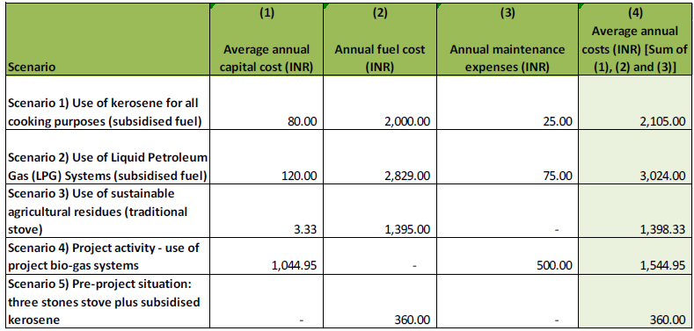
Data to calculate the costs in each case was attained from a report produced by the International Energy Initiative in 2004 entitled “Report on the use of LPG as a domestic cooking fuel option in India” (reference 6 in Appendix 7), from baseline survey (subsidised kerosene cost) (the template of the survey can be seen in Appendix 5), official subsidised LPG cost and bio-digester cost information that was attained from SKG Sangha. Full calculations and source information are provided in Appendix 9.

The results were also corroborated against an article written by Preeti Malhotra entitled ‘Environmental implications of the energy ladder in rural India’ which depicts a graphical representation of fuel use in India as a “ladder”, on which the first step shown on the far left of the image denotes the most common and cheapest fuel sources used. Each subsequent step on the ladder from left to right of the diagram denotes the next fuel used, which is generally used less frequently than the fuel source denoted in the previous step because of cost or availability. The energy ladder obtained from this article is shown in the figure below.

Energy Ladder in Rural India

Source: ‘Environmental implications of the energy ladder in rural India’ (see source 7, Appendix 7)

The simple cost analysis, summarised in the table, Average Annual Costs of the Project Activity and Alternative Scenarios, shown above, clearly demonstrates that the project activity (Scenario 4) is more expensive than the current pre-project situation (Scenario 5). It can clearly be seen that the project activity meets the requirements of sub-step 2b option 1, as, in accordance with the tool “..there is at least one alternative which is less costly than the project activity”

Step 3. Barrier Analysis

At the end of step 1b, EB 39 Annex 10 stipulates “Proceed to Step 2 (Investment analysis) or Step 3 (Barrier analysis). (Project participants may also select to complete both Steps 2 and 3.)” We have, in accordance with the rules chosen to complete both Steps 2 and 3. The sub-steps for this stage of the analysis are described in turn below.

Sub-step 3 a. Identify barriers that would prevent the implementation of the proposed CDM project activity:
In this step the project developer is required to “Establish that there are realistic and credible barriers that would prevent the implementation of the proposed project activity from being carried out if the project activity was not registered as a CDM activity.”
The barrier of relevance to the project is the “investment barrier” described in Sub Step 3a, paragraph 1 (a) of EB39 Annex 10. (Note this is also akin to the “Access to Finance Barrier” described in EB35 Annex 34.)
The existence of this barrier can be demonstrated for this project on two grounds.

Firstly, the project activity would not have occurred without the CDM because beneficiary households cannot afford the bio-digester units without the 73% cost subsidy provided by the CDM. This is demonstrated by the fact that the bio-digesters cost between 82% and 103%of the average annual household income in the project activity area. This calculation is based on survey findings (see Appendix 5). Surveys identified that average annual income of households in the project area is around INR 25,468 whereas the 2 cubic metre and 3 cubic metre bio-digesters cost INR 20,899 and INR 26,219, respectively. The prohibitive cost of the bio-digesters is substantiated by the fact that nearly all of the biogas systems that have been installed to date have been paid for by the government subsidy programme and almost all biogas plants owners are basically farmers with an average annual income of INR 49,640 this is shown in the “Evaluation Study On National Project on Biogas Development” (see Source 11, Appendix 7). That is consistent with the EB39 Annex10, according to which investment barrier can be demonstrated by showing that similar activities have only been implemented with grants or other non-commercial finance terms.

Secondly, EB35 Annex 34 provides an example of the Access to finance barrier as being able to demonstrate that the project activity could not access appropriate capital without consideration of CDM revenues. This is true for the project. The PP was not able to approach any financial institute since they have insufficient assets to secure any finance and there is no income stream generated by the Project Activity. It would not be credible for any approach to have been made for capital finance without any CDM revenue. The PP identified CH4NGE as a source of capital but this was contingent upon validation of the project as it was only able to attain a finance agreement from CH4NGE because of its ability to generate GS VER income. This is evident from a letter that has been supplied by CH4NGE to the validator which demonstrated that the provision of funding was contingent upon validation of the project.

The following extracts from the Agreement between CH4NGE and S K G Sangha further demonstrate that CH4NGE is providing finance in return for the Offsets (GS VERs).
7. CH4NGE's Obligations
7.1 CH4NGE shall be responsible for providing funding to SKGS sufficient to allow SKGS to meet Project Costs in accordance with the relevant Budget.
7.2 CH4NGE shall be responsible for carrying out or coordinating all activities relating to the production and sale of Offsets, including (without limitation):
(a) Production of the Project Design Document;
(b) Appointment of the Validator and the Verifier and overseeing the activities of the Validator and the Verifier;
(c) Arranging for Certification of Offsets; and
(d) Arranging for the sale of Offsets to Customers (including all legal and contractual aspects of the Offset sales process).
9. Sale of Offsets
9.1 SKGS shall ensure that each household for whom it installs a bio-digester in accordance with a Projects transfers ownership of any Offsets generated from the use of its bio-digester to SKGS {or signs a waiver in favour of SKGS stating that, in consideration for the bio-digester being installed, the household disclaims any ownership rights over any Offsets}.
9.2 Title to the Offsets will rest with SKGS until completion of Certification. Title shall pass to CH4NGE immediately after Certification and SKGS hereby acknowledges that it has no right, title, benefit or interest to or in the Offsets thereafter nor shall SKGS hold itself out as having any such right, title, benefit or interest.

This is also in line with Guideline 6 of EB50 Annex13 which states: In case the PPs make the claim for investment barriers, they should demonstrate in the PDD that the financing of the project was assured only due to the benefit of the CDM. Therefore, it should be demonstrated that the loan approval (or other significant financing decision(s)) by the lender takes explicitly the CDM registration into account.
The provision of funding by CH4NGE is entirely dependent on the benefit of the CDM and CH4NGE explicitly took account of CDM registration in reaching their decision.

We have also used the general guidelines of EB50 Annex 13, guidelines 01 and 02

Guideline 1 states: While demonstrating barriers related to the lack of access to capital, technologies and skilled labour, the project proponents shall provide information on the nature of the companies and entities involved in the financing and implementation of the project.

SKG Sangha will implement the project. SKG Sangha is registered in India under the Karnataka Societies Registration Act under number 768/92-93 Its registered offices are at Devarayasamudra Village, Mulabagal Taluk, Karnataka State, India and central office at N0.532, 2nd Main Road, Gandhinagar, Kolar – 563101, Karnataka State, India.

SKG Sangha relies on charitable donations for its project funding. In 2008/9 its turnover was Rs1, 62, 02,710. [approx. $US 344,775] They made a profit of Rs, 1, 50,009 [approx. $US 3,190] and their assets totalled Rs2, 17,428 [approx. $US 4, 625].

CH4NGE Limited will provide finance for project implementation in return for which it will receive title to all VERs on certification. CH4NGE is registered in England and Wales under company number 06695049. Its registered office is at c/o Martineau (Ref. DRJ), 35 New Bridge Street, London, EC4V 6BW. CH4NGE will raise the funds for the finance from shareholders/investors but this will only be possible once it can be demonstrated that the project has been validated.

Guideline 2 states: The barrier test in Step 3 of the Tool for the demonstration and assessment of additionality states that .If the CDM does not alleviate the identified barriers that prevent the proposed project activity from occurring, then the project activity is not additional.
The PP is required to “Demonstrate in an objective way how the CDM alleviates each of the identified barriers to a level that the project is not prevented any more from occurring by any of the barriers. Provide transparent and documented evidence, and offer conservative interpretations of this documented evidence.”
“For example, the prospects of a project, that it will generate GS VERs, may attract financiers who would normally not finance this kind of project without CDM.” Since the project generates no revenue for the PP other than through the sale of GS VERs, the financiers will only provide the funding for implementation of the project in return for the GS VERs generated under the CDM. A copy of the agreement between SKG Sangha and CH4NGE has been provided to the DoE in confidence.

Sub-step 3 b: Show that the identified barriers would not prevent the implementation of at least one of the alternatives (except the proposed project activity)

In sub-step 3b of EB 39 Annex 10 project developers are required to “Show that the identified barriers would not prevent the implementation of at least one of the alternatives (except the proposed project activity”.

This investment barrier does not; prevent the continuation of the pre-project situation (scenario 5). Without the project activity, the households would continue using fuel wood and kerosene, which do not require any upfront finance. This assertion is supported by the common practice analysis described in Step 4.

In the proposed project activity, the households will make an in-kind contribution in a form of labour, obtaining sand, purchasing bricks, etc. The contribution will correspond to 23% of the total costs of installing a 2 m³ biogas unit (bio-digester and cooker), and 30% of the costs of a 3 m³ unit.

The remaining 77% and 70% of the costs of 2 and 3 m³ units, respectively, will be covered by revenues from carbon offsets. Without the carbon revenue, the project cannot be implemented.

Step 4. Common practice analysis
According to the methodological tool EB39 Annex10, the common practice analysis is used to complement the investment and/or barrier analysis. The common practice analysis looks at the extent to which the proposed project type has already diffused in the relevant sector and region.

Sub-step 4a: Analyze other activities similar to the proposed project activity:
The majority of rural households use traditional cooking stoves and burn fuel wood with some kerosene. There is a small number of existing biogas schemes in the Kolar District but none in the villages that will be targeted in this project (see sub-step 4b for more information).

Sub-step 4b: Discuss any similar Options that are occurring:
Some biogas systems have been installed in poor rural households of Kolar District, but they have been either supported by schemes using charity or development assistance funding or government subsidies. The Indian government used to provide annual subsidies for around 250,000 biogas units per year but now only provides subsidies for around 10,000 biogas units per year for the whole country. This amounts to only a handful of biogas units per year at a Taluk level. Letters were obtained from local authorities showing that the level of subsidies available in the project area are insufficient. [These letters were shown to the DoE.] As a result SKG Sangha have stated that they no longer use government subsidies for installing biogas units. The project could therefore not proceed on the basis of government subsidies.
The biogas units from this project will be installed in villages where there are no initiatives supported by other NGOs or public agencies for the installation of biogas digesters and the proposed biogas project activity will be solely dependent on carbon finance (apart from a small in kind contribution of labour and materials from the beneficiary households). Therefore the project is additional to what would otherwise occur.
SKG Sangha is the only organisation implementing a biogas programme in the Kolar district. This assertion is supported by a letter from the local Government which has been reviewed by the validator.

B.5.1 Prior Consideration
>>
The proposed project activity has not been announced to local households yet, only the project idea was presented during stakeholder consultation meetings. The project activity is dependent upon receiving carbon credits and this intention was expressed during stakeholder consultation.

The project activity formerly started on 18 December 2008. This is the date of the signed agreement between SKG Sangha and CH4NGE Ltd. Note that the crediting period will start in June 2011 (see C.2.2.1.). The first version of the PDD (PDD V01) was published for global stakeholder consultation at the commencement of the validation of the PDD on 16 September 2008, i.e. before the start of the project activity, and hence is in full compliance with EB 49 Annex 22 entitled “Guidance on the demonstration and assessment of prior consideration of the CDM”.
B.5.2 Ongoing Financial Need
>>
This section was not included in the original PDD, it is added as part of the explanation about the risks/barriers that may cause discontinuation of project without carbon revenue requested in TRF.1 ELIGIBILITY CHECK FOR TRANSITION.

The absence of the carbon revenues would impact directly in the continuous use of the biodigester by the families as the annual monitoring and training activities and reparation of the units are conducted with the carbon revenues paid each time that an issuance is accomplished.

As mentioned in the PDD, the project activity would not have occurred without the CDM because beneficiary households cannot afford the bio-digester units without the 73% cost subsidy provided by the carbon revenues (c.f Validation Report page 138) where is stated that the carbon revenues finance 77% of a 2 cubic meter unit (cost of a unit: INR 20,899 and carbon revenues covers INR 16,000) and 70% a 3 cubic meter biodigester unit (cost of a unit: INR 26,219 and carbon revenues covers INR 18,400) This is demonstrated by the fact that the bio-digesters cost between 82% and 103% of the average annual household income in the project activity area. This calculation is based on baseline survey findings (baseline survey database for first monitoring report is submitted). Surveys identified that average annual income of households in the project area is around INR 25,468 whereas the 2 cubic meter and 3 cubic meter bio-digesters cost INR 20,899 and INR 26,219, respectively.

The cost estimation for 2 cubic meter and 3 cubic meter bio-digester, input values and assumption used was submitted during validation of the project (c.f Validation Report page 39). The cost of 2 cubic meter and 3 cubic meter biodigester cost INR 20,899 and INR 26,219 respectively and this lies between 82% (2 cubic meter) and 103% (3 cubic meter) of the average annual household income in the project activity area.

The prohibitive cost of the bio-digesters is substantiated by the fact that nearly all of the biogas systems that have been installed to date have been paid for by the government subsidy programme and almost all biogas plants owners are basically farmers with an average annual income of INR 49,640 this is shown in the “Evaluation Study On National Project on Biogas Development”.

Myclimate has made investment for each of the biodigester unit installed in this project since the beginning, in addition is paid a price per credit issued each time an issuance process is accomplished. Therefore the positive outcomes: continuous and proper use of the biodigester, their reparations and training activities about their use and maintenance would not continue to happen without the carbon revenues.

It is worth to mention that we monitor the annual SDG impacts accomplished by the project thanks to the carbon revenues including the reduction in incidence of hospitalization due the project, the time and money saved annually, the amount of chemical fertilisers reduced, the jobs generated by the projects, the training activities conducted and reparation activities. Our partner SKG Sangha would not be able to accomplish these activities in the scenario the project stop issuing credits under GS since vintage 2021 until the end of its crediting period (March 2022).

B.6. Sustainable Development Goals (SDG) outcomes
>>
Relevant Target/Indicator for each of the three SDGs
Sustainable Development  Goals Targeted | Most relevant  SDG Target | SDG Impact
Sustainable Development  Goals Targeted | Most relevant  SDG Target | Indicator (Proposed or SDG Indicator)
13 Climate Action  (mandatory) | N.A. | ER expected in the crediting period
1 No Poverty | 1.2 By 2030, reduce at least by half the proportion of men, women and children of all ages living in poverty in all its dimensions according to national definitions | Time and monetary savings
2 Zero Hunger | 2.3 By 2030, double the agricultural productivity and incomes of small-scale food producers, in particular women, indigenous peoples, family farmers, pastoralists and fishers, including through secure and equal access to land, other productive resources and inputs, knowledge, financial services, markets and opportunities for value addition and non-farm employment. | Application of sludge
2 Zero Hunger |  | Total number of people trained on different aspects of the project
3 Good health and well-being | 3.9 By 2030, substantially reduce the number of deaths and illnesses from hazardous chemicals and air, water and soil pollution and contamination | Proportion confirming the reduction in health problems after using the biogas plants
3 Good health and well-being |  | Average amount of chemical fertilisers reduced in the agricultural soils (kg/y) of households after project intervention.
4 Quality Education | 4.4 By 2030, substantially increase the number of youth and adults who have relevant skills, including technical and vocational skills, for employment, decent jobs and entrepreneurship | Total number of people trained on different aspects of the project
5 Gender equality | 5.A Undertake reforms to give women equal rights to economic resources, as well as access to ownership and control over land and other forms of property, financial services, inheritance and natural resources, in accordance with national laws | Number of women benefited trained by SKG Sangha
7 Affordable and clean energy | 7.1 By 2030, ensure universal access to affordable, reliable and modern energy services | Number of persons that benefit from efficient and clean technologies
8 Decent work and economic growth | 8.5 By 2030, achieve full and productive employment and decent work for all women and men, including for young people and persons with disabilities, and equal pay for work of equal value | Number of jobs offered
8 Decent work and economic growth |  | Annual average wage of people employed
12 Responsible consumption and production | 12.2 By 2030, achieve the sustainable management and efficient use of natural resources | Fuel savings achieved
15 Life on Land | 15.1 By 2020, ensure the conservation, restoration and sustainable use of terrestrial and inland freshwater ecosystems and their services, in particular forests, wetlands, mountains and drylands, in line with obligations under international agreements | Amount of wood equivalents saved by the project
15 Life on Land |  | Application of sludge
17 Partnership for the goals | 17.7 Promote the development, transfer, dissemination and diffusion of environmentally sound technologies to developing countries on favourable terms, including on concessional and preferential terms, as mutually agreed | Total number of people trained on different aspects of the project
17 Partnership for the goals |  | Number of systems (biogas units) operating

B.6.1 Explanation of methodological choices/approaches for estimating the SDG Impact
>>

The source of this information is the GS4GG transition annex.

SDG 1: No poverty
Applied methodology/approach | Equation/calculation
Annual household surveys to capture  confirmation on time saved (in case of  firewood collection) and money saved (in  case of fuel purchase and other activities) after project intervention | 1. Average diary saving time saving (hours) from collecting firewood of households after project intervention multiply by 365.  2. Average annual monetary (Indian Rupee) savings of money spent on fire wood and kerosene for cooking, and any additional income generation by the women through the saved time of households after project intervention.

SDG 2: Zero hunger
Applied methodology/approach | Equation/calculation
Annual household surveys to capture data on the quantity of slurry disposed  Annual records from SKG Sangha on training activities | 1. Application of sludge = Average amount of spent slurry disposed in the crop fields per year of households after project intervention.  2. Total number of people (men and women) trained by SKG Sangha on different aspects of the project.

SDG 3: Good health and well-being
Applied methodology/approach | Equation/calculation
Annual household surveys to capture confirmation on improvement of air, water and soil quality after project intervention | Air pollution  1. H_{stove} = Average Number of hours a single burner is used per day of households after project intervention.  2. Percentage project households confirming reduction in incidence of hospitalization  Water pollution  3. B_{manure,fed} =Average amount of dung (kg) fed into the biogas plant daily of households after project intervention.  Soil pollution  4. Average amount of of chemical fertilisers reduced in the agricultural soils (kg/y) of households after project intervention.

SDG 4: Quality education
Applied methodology/approach | Equation/calculation
Annual records from SKG Sangha on training activities | Total number of people (men and women) trained by SKG Sangha on different aspects of the project

SDG 5: Gender equality
Applied methodology/approach | Equation/calculation
Database of the biogas units and training records | Total number of women benefited trained by SKG Sangha

SDG 7: Affordable and clean energy
Applied methodology/approach | Equation/calculation
Database of the biogas units  Annual household surveys to capture confirmation on usage of the biogas unit after project intervention.  Annual household surveys to capture the. average household size after project intervention. | Total number of biogas units installed (N_{operating}) multiplied with the proportion of positive answers from project biogas users on use of the units after project intervention and multiply with average household size.

SDG 8: Decent work and economic growth
Applied methodology/approach | Equation/calculation
SKG Sangha employment records | 1. Total number of employees (man and women) getting employment because of the project.  .  2. Annual average wage of people employed (men and women) due to the project activity.

SDG 12: Sustainable consumption and production
Applied methodology/approach | Equation/calculation
Household baseline surveys in non-project users and household annual monitoring surveys in project users | 1. Fuel savings divided by baseline fuel consumption expressed in % (B_{biomass, project} – B_{Biomass, Baseline})/ B_{Biomass, Baseline} * 100%2. F_{kerosene, project}= Average annual amount of kerosene consumed by households after installation of biogas unit  3. B_{biomass, non-project} = Average consumption of fuel wood for cooking in non-project households per year

SDG 13: Climate action
Applied methodology/approach | Equation/calculation
AMS.I.C – “Thermal energy for the user with or without electricity” ver. 18  AMS.I.E – “Switch from Non-Renewable Biomass forThermal Applications by the User” ver.3  AMS.III.R – “Methane recovery in agricultural activities at household/small farm level” ver.1 | As outlined in section B.6.3.

SDG 15: Life on land
Applied methodology/approach | Equation/calculation
Household baseline surveys in non-project users and household annual monitoring surveys in project users.  Annual household surveys to capture information about slurry disposed in crop fields. | 1. B_{biomass, project} – B_{Biomass, Baseline} in t/y/HH  2. Application of sludge = Average amount of spent slurry disposed in the crop fields per year

SDG 17: Partnerships for the goals
Applied methodology/approach | Equation/calculation
Database of the biogas units | 1. N_{operating} = Total number of biogas units installed since project start  2. Number of People trained (men and women) on different aspects of the project

B.6.2 Data and parameters fixed ex ante
Copy the table for each piece of data and parameter; use headings to group parameter tables by SDG

Relevant SDG Indicator: SDG 12 Responsible consumption and production
Target 12.2.2 Domestic material consumption, domestic material consumption per capita, and domestic material consumption per GDP
Data/parameter | BBiomass, Baseline
Unit | Tonnes/year
Description | Quantity of biomass that is substituted or replaced in an average household
Source of data | Baseline survey
Value(s) applied | 4.74
Choice of data or Measurement methods and procedures | Baseline Survey
Purpose of data | Calculation of baseline scenario
Additional comment

Relevant SDG Indicator: SDG 13 Climate Action
Data/parameter | ρkerosene
Unit | kg/l (kilogrammes per litre)
Description | Density of kerosene
Source of data | http://www.simetric.co.uk/si_liquids.htm
Value(s) applied | 0.817
Choice of data or Measurement methods and procedures | Default value
Purpose of data | Calculation of baseline scenario
Additional comment | N.A.

Data/parameter | NCVkerosene
Unit | TJ/Gg (terajoules per gigagram)
Description | Net calorific value of kerosene
Source of data | Table 1.2 in 2006 IPCC Guidelines for National Greenhouse Gas Inventories, Volume 2, Chapter 1.
Value(s) applied | 43.8
Choice of data or Measurement methods and procedures | Default value
Purpose of data | Calculation of baseline scenario
Additional comment | -

Data/parameter | EFkerosene
Unit | Kg CO₂/TJ (kilogrammes of CO₂ per terajoule)
Description | Emission factor from burning kerosene in households
Source of data | Table 2.5 in 2006 IPCC Guidelines for National Greenhouse Gas Inventories, Volume 2, Chapter 2.
Value(s) applied | 71,900
Choice of data or Measurement methods and procedures | Default value
Purpose of data | Calculation of baseline scenario
Additional comment | Default emissions factor for stationary combustion in the residential category suggested by IPCC. This value is used for calculating BE_{kerosene}. For BE_{NRB}, the default value specified in AMS I.E, 71,500 kg CO₂/TJ, is used.  For Project Emissions based on AMS.I.C, as per defined tool the upper value of 73,700 kg CO₂/TJ for kerosene is used.

Data/parameter | Fkerosene, baseline
Unit | L (litres)/year
Description | Annual amount of kerosene used for cooking and starting fires in an average household
Source of data | Baseline Survey
Value(s) applied | 24.12
Choice of data or Measurement methods and procedures | Survey
Purpose of data | Calculation of baseline scenario
Additional comment

Data/parameter | fNRB
Unit | Dimensionless
Description | Fraction of biomass used in the absence of project activity that can be established as non-renewable biomass using survey methods
Source of data | ”Inventorying, Mapping and Monitoring of Bioresources Using GIS and Remote Sensing” study (Ramachandra and Rao 2005)
Value(s) applied | 0.78
Choice of data or Measurement methods and procedures | The study by Ramachandra and Rao is both recent and specific to Kolar District. It uses remote sensing data analyses, field surveys involving village level inventorying of the tree diversity and mapping of resources using geographic information systems and global positioning systems in villages in the project area. The 0.78 value is obtained from the average bioresource availability to demand ratio for the Taluks in Kolar District
Purpose of data | Calculation of baseline scenario
Additional comment | N.A.

Data/parameter | GWP CH₄
Unit | t CO₂ / t CH₄ (tonnes of CO₂ per tonne of CH₄)
Description | Global warming potential for methane
Source of data | IPCC Guidelines for National Greenhouse Gas Inventories,
Value(s) applied | 25
Choice of data or Measurement methods and procedures | Default value
Purpose of data | Calculation of baseline scenario
Additional comment | Default value suggested by IPCC

Data/parameter | VS(T)
Unit | kg (kilogrammes) dry matter / (head * day)
Description | Daily volatile solid excreted for livestock category T
Source of data | Tables 10A-4 to 10A-6 in 2006 IPCC Guidelines for National Greenhouse Gas Inventories (Volume 4, Chapter 10), Biogas Technology by B.T. Nijaguna (see reference 5 in Annex 5), Table 2.12 p29.
Value(s) applied | 3.8 for dairy cow, 3.1 for buffalo, 1.4 for other cattle
Choice of data or Measurement methods and procedures | India specific value taken for dairy cows from Biogas Technology by B.T. Nijaguna. As nationally published values are not available for other cattle, IPCC default Indian subcontinent values are used for buffalo and other cattle.
Purpose of data | Calculation of baseline scenario
Additional comment | Default value suggested by IPCC

Data/parameter | Bo(T)
Unit | m³ CH₄/kg VS (cubic meters of CH₄ per kilogramme Volatile Solid)
Description | Maximum methane producing capacity for manure produced by livestock  category T
Source of data | India specific value taken for dairy cows from Biogas Technology by B.T. Nijaguna (Nijaguna, B.T, Biogas Technology (New Age International (P) Ltd, 4835/24 Ansari Road, Daryaganj, New Delhi 110 002, 2002). As nationally published values are not available for other cattle, IPCC default values are used for buffalo and other cattle. Tables 10A-4 to 10A-6 in 2006 IPCC Guidelines for National Greenhouse Gas Inventories
Value(s) applied | 0.15 for dairy cattle, 0.1 for buffalo and other cattle
Choice of data or Measurement methods and procedures | India specific value taken for dairy cows from Biogas Technology by B.T. Nijaguna (see reference 5 in annex 5). As nationally published values are not available for other cattle, IPCC default values are used for buffalo and other cattle. Tables 10A-4 to 10A-6 in 2006 IPCC Guidelines for National Greenhouse Gas Inventories, Volume 4, Chapter 10.
Purpose of data | Calculation of baseline scenario
Additional comment | India specific value taken for dairy cows from Biogas Technology by B.T. Nijaguna. As nationally published values are not available for buffalo and other cattle, IPCC default values are used for buffalo and other cattle. Tables 10A-4 to 10A-6 in 2006 IPCC Guidelines for National Greenhouse Gas Inventories, Volume 4, Chapter 10.

Data/parameter | MCFmanure (MCFliquid, MCFliquid with crust and MCFsolid)
Unit | % (percentage)
Description | Methane correction factor for cattle manure for each manure management system S by climate region k
Source of data | Table 10.17 in 2006 IPCC Guidelines for National Greenhouse Gas Inventories, Volume 4, Chapter 10.
Value(s) applied | 80 for liquid/slurry manure management system (MCF_{liquid}), 50 for liquid/slurry manure management system with natural crust cover (MCF_{liquid} with crust), 5 for solid storage manure management system (MCF_{solid}).
Choice of data or Measurement methods and procedures | Default value
Purpose of data | Calculation of baseline scenario
Additional comment | Values corresponding to average annual temperature of 29.6 C are taken for MCFliquid and MCFliquid with crust. Temperature data was taken from the Indian Meteorological Department, Government of India.

Data/parameter | MSmanure (MSliquid, MSliquid with crust, MSsolid)
Unit | Dimensionless
Description | Fraction of livestock category T’s manure STOVEandled using manure management system S in climate region k (fraction of livestock manure handled using liquid/slurry manure management system, fraction of livestock manure handled using liquid/slurry with natural crust cover and fraction of livestock manure handled using solid storage manure management system)
Source of data | Based on baseline survey
Value(s) applied | 0.32 for liquid/slurry manure management system (MSliquid), 0.20 for  liquid/slurry with crust cover manure management system (MSliquid with crust),  0.16 for solid storage manure management system (MSsolid)
Choice of data or Measurement methods and procedures | 0.32 for liquid/slurry manure management system (MSliquid), 0.20 for liquid/slurry with crust cover manure management system (MSliquid with crust), 0.16 for solid storage manure management system (MSsolid)
Purpose of data | Calculation of baseline scenario
Additional comment | The parameters ensure a precision at 95% confidence level.

B.6.3 Ex ante estimation of SDG Impact
>>

The source of this information is the GS4GG transition annex.

SDG1: No Poverty
Without the project, there is no time and monetary savings.
Baseline value = 0 hours per year/hh.
Baseline value = 0 Rupees per year/hh

SDG1: No Poverty
Time (in case of collection of firewood) saved per household per year due to fuel savings achieved by project biogas units.
Project value = 388.2 hours per year/hh.

Money (in case of purchase of firewood and kerosene for cooking, and any additional income generation through the saved time) saved per household per year due to fuel savings achieved by project biogas units.
Project value = 829 Rupees per year/hh

SDG2: Zero hunger
Without the project, there is no slurry – as a subproduct of biodigester - disposed in the crop fields as there are no biogas unit installed.
Baseline value = 0.

Without the project, there is no trained (men and women) on different aspects of the project.
Baseline value = 0.

SDG2: Zero hunger
Average amount of spent slurry disposed in the crop fields per year of households after project intervention
Application of sludge = 9.8 tonnes/year

Number of people trained on the project:
Project value = 419 beneficiaries (women) were trained individually

SDG3: Good health and well-being
Without the project, there is no perception of improved health because better air quality.
Baseline value = 0%.

Without the project, there is no slurry disposed in the crop fields.
Baseline value = 0.

Without the project, there is not a reduction in quantity of chemical fertilizers used in the agricultural soils.
Baseline value = 0.

SDG3: Good health and well-being

Proportion of families confirming the perception of improved health because better air quality.
Project value = 100%

Average amount of reduction of chemical fertilizers used in the agricultural soils.
Project value = 88.8 kg/year

SDG4: Quality Education
Without the project, there is no trained (men and women) on different aspects of the project.
Baseline value = 0.

SDG4: Quality Education
Number of people trained on the project:
Project value = 419 beneficiaries (women) were trained individually

SDG5: Gender equality
Without the project, there is not women trained by SKG Sangha.
Baseline value = 0.

SDG5: Gender equality
Number of women benefited trained by SKG Sangha
Project value = 419 women

The number of women benefited trained by SKG Sangha during the current monitoring period is defined as the biodigester units were installed until 2017. SKG trained beneficiaries, if needed during the monitoring and maintenance visits. Information of repair and maintenance can be found in the repair and maintenance data sheet in the ER spread sheet. This aspect of training to beneficiaries individually was not documented separately, that’s reason which was defined as the same value as SDG4.

SDG7: Affordable and clean energy
Without the project, there is anybody with a biogas unit.
Baseline value = 0.

SDG7: Affordable and clean energy
Number of persons that benefit from efficient and clean technologies

Project value = N_{operating} * average household size = 40,282 persons benefit by the project.

SDG8: Decent work and economic growth
Without the project, there is no local people employed by the project activity.
Baseline value = 0.

SDG8: Decent work and economic growth
Number of jobs offered (man and women) by SKG Sangha to local employees.
Project value = 11 people employed
The average wage per year is INR 222,000

SDG12: Responsible consumption and production
Without the project, there would be families which consumes firewood for cooking.
Total B_{Biomass} = 4.74 tonnes wood/y/unit.

SDG12: Responsible consumption and production
With the project, there would be families which consumes firewood for cooking.
B_{biomass, project} = 0.031 tonnes/year

SDG13: Climate Action
Baseline emissions are calculated as follows:
- Avoided Kerosene
Annual baseline emissions for 1 operating unit:
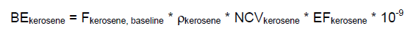
The following parameters are used:

Parameter | Value | Unit | Source
F_{kerosene, baseline} | 24.12 | L/year | Baseline Survey
ρ_{kerosene} | 0.817 | Kg/l | IPCC
NCV_{kerosene} | 43.8 | TJ/Gg | IPCC 2006 T.1.2
EF_{kerosene} | 71,900 | kg CO₂/TJ | IPCC 2006 T.2.5

Therefore:

= 24.12 l * 0.817kg/l * 43.8TJ/t * 71,900kg CO₂/TJ * 10⁻⁹ = 0.062 t /CO₂e

- Avoided non-renewable biomass
Annual baseline emissions for 1 operating unit:

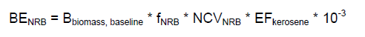

The following values are used:

Parameter | Value | Unit | Source
B_{biomass, baseline} | 4.74 | T/year | Baseline Survey
f_{NRB} | 0.78 | % | Study by Ramachandra and Rao 2005, see Annex 5
NCV_{biomass} | 0.015 | TJ/t | IPCC 2006 T.1.2
EF_{kerosene} | 71,500 | kg CO₂/TJ | AMS I.E.

Therefore:
BE = 4.74 t * 0.78 * 0.015 TJ/t * 71,500kg CO₂/TJ * 10⁻³ = 3.966 t CO₂e

- Avoided methane from cattle manure
Annual baseline emissions for 1 operating unit:
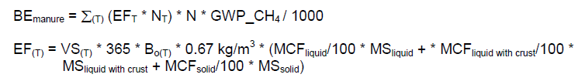
The following values are used:

Parameter | Value | Unit | Source
$$GWP_{CH}_{4}$$ | 21 | Kg CO₂ /kg CH₄ | IPCC
$${MCF}_{liquid}$$ | 80 | % | IPCC 2006 T. 10A-4 to 10A-6
$${MCF}_{liquid with crust}$$ | 50 | % | IPCC 2006 T. 10A-4 to 10A-6
$${MCF}_{solid}$$ | 5 | % | IPCC 2006 T. 10A-4 to 10A-6
$${MS}_{liquid}$$ | 0.32 | - | Baseline Survey
$${MS}_{liquid with crust}$$ | 0.20 | - | Baseline Survey
$${MS}_{solid}$$ | 0.16 | - | Baseline Survey
Dairy Cow
$$N_{T}$$ | 2.56 | - | Baseline survey
$${VS}_{(T)}$$ | 3.8 | Kg dry matter/(head*day) | Biogas Technology by B.T. Nijaguna
$$B_{o\left(T\right)}$$ | 0.15 | m³ CH₄ /kg VS | Biogas Technology by B.T. Nijaguna
Buffalo
$$N_{T}$$ | 1.17 |  | Baseline survey
$${VS}_{(T)}$$ | 3.1 | Kg dry matter/(head*day) | IPCC 2006 T. 10A-4 to 10A-6
$$B_{o\left(T\right)}$$ | 0.1 | m³ CH₄ /kg VS | IPCC 2006 T. 10A-4 to 10A-6
Other Cattle
$$N_{T}$$ | 0.55 |  | Baseline survey
$${VS}_{(T)}$$ | 1.4 | Kg dry matter/(head*day) | IPCC 2006 T. 10A-4 to 10A-6
$$B_{o\left(T\right)}$$ | 0.1 | m³ CH₄ /kg VS | IPCC 2006 T. 10A-4 to 10A-6

Therefore:
EF_{dairy cow} = 3.8 kg VS/(head*day) * 365 * 0.15 m³ CH₄/kgVS * 0.67 kg/m³ * (80/100 * 0.24 + 50/100 * 0.20 + 5/100 * 0.16) = 50.59 kgCH₄/year

EF_{buffalo} = 3.1 kg VS/(head*day) * 365 * 0.1 m³ CH₄/kgVS * 0.67 kg/m³ * (80/100 * 0.24 + 50/100 * 0.20 + 5/100 * 0.16) = 27.52 kgCH₄/year

EF_{other cattle} = 1.4 kg VS/(head*day) * 365 * 0.1 m³ CH₄/kgVS * 0.67 kg/m³ * (80/100 * 0.24 + 50/100 * 0.20 + 5/100 * 0.16) = 12.43 kgCH₄/year

${BE}_{manure}$annual for a 3m³ unit = (50.59 kgCH₄/year * 2.56+ 27.52 kgCH₄/year * 1.17 + 12.43 kgCH₄/year * 0.55) * 21 kgCO₂/kgCH₄ / 1000 = 3.54 tCO₂e
${BE}_{manure}$ annual for a 2m³ unit = 3.54 tCO₂e * (2/3) = 2.36 tCO₂e

As it is planned that 30% of the units are 3m³ units and 70% are 2m³ units, then BE_{manure} for 1 average unit is:

${BE}_{manure}$ = 3.54 tCO₂e * 0.3 + 2.36 tCO₂e * 0.7 = 2.714 tCO₂e

- Total baseline emissions for one operating unit:

BE = ${BE}_{kerosene}$+ ${BE}_{NRB}$ + ${BE}_{manure}$ = 0.062 tCO₂e + 3.966 tCO₂e + 2.714 tCO₂e = 6.74 tCO₂e

Project emissions
Annual project emissions for one operating units:

PE = LF_{AD} * Σ_{(T)} (GWP_CH₄ * 0.67 kg/m³ * Bo_{(T)} * N_{(T)} * VS_{(T)} * 365) / 1000
= LF_{AD} * GWP_CH₄ * 0.67 kg/m³ * 365 * Σ_{(T)} (Bo_{(T)} * N_{(T)} * VS_{(T)})* 365

The same parameters as the ones used for calculating baseline emissions from cattle manure are used.
Therefore PE for one 3 m³ unit:
Therefore:
PE_3m³ = 0.1 * 21 kgCO₂/kgCH₄* 0.67 kg/m³ * 365 * (2.56 heads *0.15 m³ CH₄/kg VS * 3.8 kg VS/(head*day) + 1.17 heads *0.1 m³ CH₄/kg VS * 3.1 kg VS/(head*day) + 0.55 heads *0.1 m³ CH₄/kg VS * 1.4 kg VS/(head*day)) /1000 = 0.975 tCO₂e

PE for one 2m³ unit:
PE_2m³ = 2/3* PE_3m³ = 0.650 tCO₂e

Assuming 30% of the units are 3m³ units and 70% of the units are 2m³ units, than PE for 1 average unit is:

PE = 0.975 tCO₂e * 0.3 + 0.650 tCO₂e * 0.7 = 0.748 tCO₂e

Project emissions due to kerosene and fuelwood consumption during project activity are based on the monitoring survey results. There are no project emissions due to fuelwood and kerosene consumption expected and thus for the ex-ante calculation of emission reductions PE_{y}, NRB and PE_{kerosene} are assumed to be = 0.

Emission reductions
Emission reductions for one operating unit:
ER = BE – PE - L = 6.74 t CO₂e – 0.748 t CO₂e - 0 = 5.99 t CO₂e

Year | Units built | Cumulative units installed by the end of each year | Units in Operation
2012 | 2,484 | 2,848 | 1,242
2013 | 1,595 | 4,079 | 3,282
2014 | 2,500 | 6,579 | 5,329
2015 | 2,500 | 9,079 | 7,829
2016 | 301 | 9,380 | 9,230
2017 |  | 9,380 | 9,380
2018 |  | 9,380 | 9,380
2019 |  | 9,380 | 9,380
2020 |  | 9,380 | 9,380
2021 |  | 9,380 | 9,380
2022 |  | 9,380 | 9,380

Annual emission reductions for the whole project are calculated by multiplying emission reductions for one operating unit by number of biogas units operating in that year. Schedule for construction and operation of biogas units is provided in the table below:

The table above shows:
- the number of bio-digester units installed during each year (the build schedule);
- the cumulative number of units that will have been installed by the end of each year; and
- the average number of units that will have been operating, that is producing biogas and creating emission reductions in each year.
The average number of units that will be operating in each year is one of the main determinants of project activity emission reductions. In the three years in which units are being installed (2009 -2011) the average number of units that will be operating in each year will always be lower than the cumulative number of units that have been installed by the end of each year. This is because units will be added gradually throughout each year and therefore not all units will be operating throughout the entire year. For example if a unit is installed on the first day of the year it can clearly be seen that that unit can be regarded as having operated all year. If, however, a unit is installed on the first day of the last month in the year it will only be operating for 1/12th of the year. Approximately one month lag should be allowed from the start of construction to the start of proper operation, as construction and technical checks last on average one month.

SDG15: Life on Land
Without the project, there would be families which consumes firewood for cooking
Baseline value = 4.74 tonnes wood/y/unit

Without the project, there is no slurry disposed in the crop fields.
Baseline value = 0.

SDG15: Life on Land
With the project, there would be families which consumes firewood for cooking.
B_{biomass, project} = 0.031 tonnes/year

Average amount of spent slurry disposed in the crop fields per year of households after project intervention
Application of sludge = 9.8 tonnes/year

SDG17: Partnership for the goals
Without the project, there are not any biogas unit installed
Baseline value biogas unit = 0.

Without the project, there is no local people employed by the project activity.
Baseline value = 0.

SDG17: Partnership for the goals
Number of biogas units installed.
N_{operating} = 8,000

Number of people trained on the project:
Project value = 419 beneficiaries (women) were trained individually

B.6.4 Summary of ex ante estimates of each SDG Impact
>>
SDG 1 No Poverty
Time and monetary savings

Year | Baseline estimate | Project estimate | Net benefit
Year 1 | 0 | 1. 388.2 hours per year/HH  2. 829 Rupees per year/HH | 1. 388.2 hours per year/HH  2. 829 Rupees per year/HH
Year 2 | 0 | 1. 388.2 hours per year/HH | 1. 388.2 hours per year/HH
Year 3 | 0 | 2. 829 Rupees per year/HH | 2. 829 Rupees per year/HH
Year 4 | 0 | 1. 388.2 hours per year/HH | 1. 388.2 hours per year/HH
Year 5 | 0 | 2. 829 Rupees per year/HH | 2. 829 Rupees per year/HH
Year 6 | 0 | 1. 388.2 hours per year/HH | 1. 388.2 hours per year/HH
Year 7 | 0 | 2. 829 Rupees per year/HH | 2. 829 Rupees per year/HH
Year 8 | 0 | 1. 388.2 hours per year/HH | 1. 388.2 hours per year/HH
Year 9 | 0 | 2. 829 Rupees per year/HH | 2. 829 Rupees per year/HH
Year 10 | 0 | 1. 388.2 hours per year/HH  2. 829 Rupees per year/HH | 1. 388.2 hours per year/HH  2. 829 Rupees per year/HH
Total | 0 | 1. 3882 hours/HH  2. 8290 Rupees per /HH | 1. 3882 hours/HH  2. 8290 Rupees per /HH
Total number of crediting years | 10
Annual average over the crediting period | 0 | 1. 388.2 hours per year/HH | 1. 388.2 hours per year/HH

SDG 2 Zero Hunger / SDG 15 Life on land
Application of sludge
Year | Baseline estimate | Project estimate | Net benefit
Year 1 | 0 | 9.8 | 9.8
Year 2 | 0 | 9.8 | 9.8
Year 3 | 0 | 9.8 | 9.8
Year 4 | 0 | 9.8 | 9.8
Year 5 | 0 | 9.8 | 9.8
Year 6 | 0 | 9.8 | 9.8
Year 7 | 0 | 9.8 | 9.8
Year 8 | 0 | 9.8 | 9.8
Year 9 | 0 | 9.8 | 9.8
Year 10 | 0 | 9.8 | 9.8
Total | 0 | 98 | 98
Total number of crediting years | 10
Annual average over the crediting period | 0 | 9.8 | 9.8

SDG 2 Zero Hunger/ SDG 4 Quality Education / SDG 17 Partnership for the goals
Total number of people trained on different aspects of the project
Year | Baseline estimate | Project estimate | Net benefit
Year 1 | 0 | 419 | 419
Year 2 | 0 | 419 | 419
Year 3 | 0 | 419 | 419
Year 4 | 0 | 419 | 419
Year 5 | 0 | 419 | 419
Year 6 | 0 | 419 | 419
Year 7 | 0 | 419 | 419
Year 8 | 0 | 419 | 419
Year 9 | 0 | 419 | 419
Year 10 | 0 | 419 | 419
Total | 0 | 4190 | 4190
Total number of crediting years | 10
Annual average over the crediting period | 0 | 419 | 419

SDG3 Good health and well-being
Proportion confirming the reduction in health problems after using the biogas plants
Year | Baseline estimate | Project estimate | Net benefit
Year 1 | 0 | 100% | 100%
Year 2 | 0 | 100% | 100%
Year 3 | 0 | 100% | 100%
Year 4 | 0 | 100% | 100%
Year 5 | 0 | 100% | 100%
Year 6 | 0 | 100% | 100%
Year 7 | 0 | 100% | 100%
Year 8 | 0 | 100% | 100%
Year 9 | 0 | 100% | 100%
Year 10 | 0 | 100% | 100%
Total | 0 | 100% | 100%
Total number of crediting years | 10
Annual average over the crediting period | 0 | 100% | 100%

SDG 3 Good health and well-being
Average amount of chemical fertilisers reduced in the agricultural soils (kg/y) of households after project intervention.

Year | Baseline estimate | Project estimate | Net benefit
Year 1 | 0 | 17.88 | 0
Year 2 | 0 | 17.88 | 0
Year 3 | 0 | 17.88 | 0
Year 4 | 0 | 17.88 | 0
Year 5 | 0 | 17.88 | 0
Year 6 | 0 | 17.88 | 0
Year 7 | 0 | 17.88 | 0
Year 8 | 0 | 17.88 | 0
Year 9 | 0 | 17.88 | 0
Year 10 | 0 | 17.88 | 0
Total | 0 | 178.8 | 0
Total number of crediting years | 10
Annual average over the crediting period | 0 | 17.88 | 0

SDG 5 Gender quality
Number of women benefited trained by SKG Sangha

Year | Baseline estimate | Project estimate | Net benefit
Year 1 | 0 | 419 | 419
Year 2 | 0 | 419 | 419
Year 3 | 0 | 419 | 419
Year 4 | 0 | 419 | 419
Year 5 | 0 | 419 | 419
Year 6 | 0 | 419 | 419
Year 7 | 0 | 419 | 419
Year 8 | 0 | 419 | 419
Year 9 | 0 | 419 | 419
Year 10 | 0 | 419 | 419
Total | 0 | 4190 | 4190
Total number of crediting years | 10
Annual average over the crediting period | 0 | 419 | 419

SDG 7 Affordable and clean energy
Number of persons that benefit from efficient and clean technologies

Year | Baseline estimate | Project estimate | Net benefit
Year 1 | 0 | 40,282 | 40,282
Year 2 | 0 | 40,282 | 40,282
Year 3 | 0 | 40,282 | 40,282
Year 4 | 0 | 40,282 | 40,282
Year 5 | 0 | 40,282 | 40,282
Year 6 | 0 | 40,282 | 40,282
Year 7 | 0 | 40,282 | 40,282
Year 8 | 0 | 40,282 | 40,282
Year 9 | 0 | 40,282 | 40,282
Year 10 | 0 | 40,282 | 40,282
Total | 0 | 402,820 | 402,820
Total number of crediting years | 10
Annual average over the crediting period | 0 | 40,282 | 40,282

SDG 8 Decent work and economic growth
Number of jobs offered & Annual average wage of people employed

Year | Baseline estimate | Project estimate | Net benefit
Year 1 | 0 | 11 jobs  220,000 INR | 11 jobs  220,000 INR
Year 2 | 0 | 11 jobs  220,000 INR | 11 jobs  220,000 INR
Year 3 | 0 | 11 jobs  220,000 INR | 11 jobs  220,000 INR
Year 4 | 0 | 11 jobs  220,000 INR | 11 jobs  220,000 INR
Year 5 | 0 | 11 jobs  220,000 INR | 11 jobs  220,000 INR
Year 6 | 0 | 11 jobs  220,000 INR | 11 jobs  220,000 INR
Year 7 | 0 | 11 jobs  220,000 INR | 11 jobs  220,000 INR
Year 8 | 0 | 11 jobs  220,000 INR | 11 jobs  220,000 INR
Year 9 | 0 | 11 jobs  220,000 INR | 11 jobs  220,000 INR
Year 10 | 0 | 11 jobs  220,000 INR | 11 jobs  220,000 INR
Total | 0 | 110 jobs  2,200,000 INR | 110 jobs  2,200,000 INR
Total number of crediting years | 10
Annual average over the crediting period | 0 | 11 jobs  220,000 INR | 11 jobs  220,000 INR

SDG 12 Responsible consumption and production
Fuel savings achieved

Year | Baseline estimate | Project estimate | Net benefit
Year 1 | 0 | 99.35% | 99.35%
Year 2 | 0 | 99.35% | 99.35%
Year 3 | 0 | 99.35% | 99.35%
Year 4 | 0 | 99.35% | 99.35%
Year 5 | 0 | 99.35% | 99.35%
Year 6 | 0 | 99.35% | 99.35%
Year 7 | 0 | 99.35% | 99.35%
Year 9 | 0 | 99.35% | 99.35%
Year 8 | 0 | 99.35% | 99.35%
Year 10 | 0 | 99.35% | 99.35%
Total | 0 | 99.35% | 99.35%
Total number of crediting years | 10
Annual average over the crediting period | 0 | 99.35% | 99.35%

SDG 13
ER expected in the crediting period

Year | Baseline estimate | Project estimate | Net benefit
Year 1 | 15,748 | 1,746 | 14,002
Year 2 | 26,725 | 2,964 | 23,762
Year 3 | 41,546 | 4,607 | 36,939
Year 4 | 55,930 | 6,202 | 49,728
Year 5 | 62,563 | 6,938 | 55,625
Year 6 | 63,240 | 7,013 | 56,227
Year 7 | 63,240 | 7,013 | 56,227
Year 8 | 63,240 | 7,013 | 56,227
Year 9 | 63,240 | 7,013 | 56,227
Year 10 | 57,970 | 6,428 | 51,541
Total | 513,441 | 56,936 | 456,504
Total number of crediting years | 10
Annual average over the crediting period | 51,344 | 5,694 | 45,650

SDG 15 Life on land
Amount of wood equivalents saved by the project

Year | Baseline estimate | Project estimate | Net benefit
Year 1 | 0 | 4.71 | 4.71
Year 2 | 0 | 4.71 | 4.71
Year 3 | 0 | 4.71 | 4.71
Year 4 | 0 | 4.71 | 4.71
Year 5 | 0 | 4.71 | 4.71
Year 6 | 0 | 4.71 | 4.71
Year 7 | 0 | 4.71 | 4.71
Year 8 | 0 | 4.71 | 4.71
Year 9 | 0 | 4.71 | 4.71
Year 10 | 0 | 4.71 | 4.71
Total | 0 | 47.1 | 47.1
Total number of crediting years | 10
Annual average over the crediting period | 0 | 4.71 | 4.71

SDG 17 Partnership for the goals
Number of systems (biogas units) operating

Year | Baseline estimate | Project estimate | Net benefit
Year 1 | 0 | 2,484 | 2,484
Year 2 | 0 | 4,079 | 4,079
Year 3 | 0 | 6,579 | 6,579
Year 4 | 0 | 9,079 | 9,079
Year 5 | 0 | 9,380 | 9,380
Year 6 | 0 | 9,380 | 9,380
Year 7 | 0 | 9,380 | 9,380
Year 8 | 0 | 9,380 | 9,380
Year 9 | 0 | 9,380 | 9,380
Year 10 | 0 | 9,380 | 9,380
Total | 0 | 78,501 | 78,501
Total number of crediting years | 10
Annual average over the crediting period | 0 | 7,850 | 7,850

B.7. Monitoring plan
>>
B.7.1 Data and parameters to be monitored
(Copy the table for each piece of data and parameter; use headings to group parameter tables by SDG)

>>
SDG 1: 1.2.2 Proportion of men, women and children of all ages living in poverty in all its dimensions according to national definitions
Data / Parameter | Time and monetary savings
Unit | Hours / Indian Rupee per household per year
Description | Average time (hours) and money (Indian Rupee) saved per household per year due to fuel savings achieved by project biogas units
Source of data | Monitoring survey
Value(s) applied | 1. 388.2 hours per year/HH  2. 829 Rupees per year/HH
Measurement methods and procedures | Monitoring questionnaire  1. Annual time expenditures (hours) saved per household per year due to fuel savings achieved by project biogas units.  2. Annual monetary (Indian Rupee) saved per household per year due to fuel savings achieved by project biogas units.
Monitoring frequency | Annual
QA/QC procedures | Transparent data analysis and reporting
Purpose of data | Calculation of project scenario
Additional comment | This value came from GS4GG Transition Annex and is based on Monitoring Survey (December 2017).

SDG 2: 2.3.1 Volume of production per labour unit by classes of farming/pastoral/forestry enterprise size

SDG 15: 15.1.1 Forest area as a proportion of total land area
Data / Parameter | Application of sludge
Unit | tons/year
Description | Proper application of the sludge from the biogas unit
Source of data | Monitoring survey
Value(s) applied | 9.80 tons/year
Measurement methods and procedures | Monitoring questionnaire  Quantity of tons of sludge from the biogas unit by household after project intervention.
Monitoring frequency | Annually
QA/QC procedures | Monitoring team from the project level randomly checked the data collected and found to be reasonable
Purpose of data | Calculation of project scenario
Additional comment | SKG Sangha has conducted number of training programmes with the beneficiaries and trained them on application of sludge. The monitored results can be found in the ER spread sheet under the monitoring survey excel page BD.  This value came from GS4GG Transition Annex and is based on Monitoring Survey (December 2017).

SDG 2: 2.3.1 Volume of production per labour unit by classes of farming/pastoral/forestry enterprise size
SDG 4: 4.4.1 Proportion of youth and adults with information and communications technology (ICT) skills, by type of skill
SDG 17: 17.7.1 Total amount of approved funding for developing countries to promote the development, transfer, dissemination and diffusion of environmentally sound technologies
Data / Parameter | Total number of people trained on different aspects of the project
Unit | Number of persons
Description | Number of people trained on different aspects of the project
Source of data | SKG Sangha records
Value(s) applied | 419 beneficiaries (419 women) were trained individually and 5 persons (5 men) in monitoring and maintenance of biogas plant (Based on latest Monitoring Period - SKG Sangha records).
Measurement methods and procedures | Counting number of participants trained/awareness creation activities
Monitoring frequency | Annual
QA/QC procedures | Transparent data analysis and reporting
Purpose of data | Calculation of project scenario
Additional comment | The information of trainings were taken from Monitoring Period (January-December 2017).  SKG Sangha has not trained any new masons in 2017 as units installation has been coming to an end and also has trained existing supervisors on the modern techniques of unit repairs 5 supervisors participated in it.  This value came from GS4GG Transition Annex.

SDG 3: 3.9.1 Mortality rate attributed to household and ambient air pollution
SDG 13: Climate Action
Data / Parameter | H_{stove}
Unit | H (hours)/year
Description | Annual hours of operation of an average system (hours of burner functioning)
Source of data | Monitoring survey
Value(s) applied | 1,179.98 h/y
Measurement methods and procedures | Beneficiaries made records for a week writing down each day hours when a burner is functioning. They wrote down the time of starting cooking and finishing cooking, and noted whether one or two burners were used.  Average use was 3.23 h/d, thus 3.23 *365 = 1179.98 h/y.
Monitoring frequency | Annually
QA/QC procedures | The data collected will be statistically checked for acceptance as per  applicable reliability / precision levels.
Purpose of data | Calculation of project scenario
Additional comment | The survey result shows that the digester produces enough biogas to substitute the previous energy needs. This value came from GS4GG Transition Annex and is based on Monitoring Survey (December 2017).

SDG 3: 3.9.1 Mortality rate attributed to household and ambient air pollution
Data / Parameter | Percentage project households confirming reduction in incidence of hospitalization
Unit | Proportion (%) of answers that stated the reduction in incidence of hospitalization
Description | Proportion of families surveyed who stated that a reduction in incidence of hospitalization happened divided by total of users interviewed.
Source of data | Monitoring Survey
Value(s) applied | 100%
Measurement methods and procedures | Monitoring questionnaire  % of project household confirming the reduction in health problems after using the biogas plants
Monitoring frequency | Annual
QA/QC procedures | Transparent data analysis and reporting
Purpose of data | Calculation of project scenario
Additional comment | This value came from GS4GG Transition Annex and is based on Monitoring Survey (December 2017).

SDG 3: 3.9.2 Mortality rate attributed to unsafe water, unsafe sanitation and lack of hygiene (exposure to unsafe Water, Sanitation and Hygiene for All (WASH) services)
SDG 13: Climate Action
Data / Parameter | B_{manure,fed}
Unit | T (Tonnes)/year
Description | Average amount of animal manure fed into biogas digester per year.
Source of data | Monitoring survey
Value(s) applied | 17.88
Measurement methods and procedures | Monitoring questionnaire  The amount of dung fed into the biogas plant is measured using spring balance on the day of the monitoring survey in sampled HHs. The basket used to handle the dung is measured with dung in it in sampled HHs and in the remaining HH the baskets were counted by discussion with the HH members.
Monitoring frequency | Annually
QA/QC procedures | One day accumulation of dung in the confined shed area in selective households was measured. In other households the basket in which HH collects the dung is measured.
Purpose of data | Calculation of project scenario
Additional comment | Total out of 49.50 kg generated in the shed 48.98 kg will be fed to the biogas plant and the remaining 0.52 kg per day will be dumped in the compost pits.  48.98 * 365/1000 = 17.88 tons/y will be fed to biogas plant.  This value came from GS4GG Transition Annex and is based on Monitoring Survey (December 2017).

SDG 3: 3.9.3 Mortality rate attributed to unintentional poisoning
Data / Parameter | Average amount of chemical fertilisers reduced in the agricultural soils (kg/y) of households after project intervention.
Unit | Kg of reduced chemical fertilisersused in the agricultural soils (kg/y)
Description | Reduction in quantity of chemical fertilisers used in the agricultural soils
Source of data | Monitoring Survey
Value(s) applied | 88.8 kg/year
Measurement methods and procedures | Total number of bags reduced times bag size (50kg).
Monitoring frequency | Annual
QA/QC procedures | Transparent data analysis and reporting
Purpose of data | SDG 3 Contributions
Additional comment | This value came from GS4GG Transition Annex and is based on Monitoring Survey (December 2017).

SDG 5: 5.A.1 (a) Proportion of total agricultural population with ownership or secure rights over agricultural land, by sex; and (b) share of women among owners or rights-bearers of agricultural land, by type of tenure
Data / Parameter | Number of women benefited trained by SKG Sangha
Unit | Number of women trained
Description | Number of women trained by SKG Sangha to assure an efficient use of the biogas units
Source of data | SKG Sangha training records
Value(s) applied | 419 women beneficiaries were trained individually
Measurement methods and procedures | Counting number of women users trained
Monitoring frequency | Annual
QA/QC procedures | Transparent data analysis and reporting
Purpose of data | SDG 5 Contributions
Additional comment | This value came from GS4GG Transition Annex and is based on the information of trainings were taken from Monitoring Period (January-December 2017)

SDG 7: Afford 7.1.2 Proportion of population with primary reliance on clean fuels and technology
Data / Parameter | Number of persons that benefit from efficient and clean technologies
Unit | Number of persons
Description | Number of persons that benefit from efficient and clean technologies
Source of data | Project database, Monitoring survey
Value(s) applied | 40,282 persons benefit by the project
Measurement methods and procedures | Total number of biogas units installed multiplied with usage rates multiplied with average household size
Monitoring frequency | Annual
QA/QC procedures | Transparent data analysis and reporting
Purpose of data | SDG 7 Contributions
Additional comment | According the monitoring surveys conducted in December 2017, 5.03 is the average size of a family, 8000 biogas units have been installed and all the families surveyed use the biogas (the monitored results can be found in the ER spread sheet under the monitoring survey excel page under the column O).  This value came from GS4GG Transition Annex.

SDG 8: 8.5.1 Average hourly earnings of female and male employees, by occupation, age and persons with disabilities
Data / Parameter | Number of jobs offered
Unit | Number of employees
Description | Number of jobs offered (man an women) by SKG Sangha to local employees
Source of data | SKG Sangha employment and training records
Value(s) applied | 11 people employed under the project during the last monitoring period (Based on latest SKG Sangha records)
Measurement methods and procedures | Total number of permanent Vs temporary /contract employees
Monitoring frequency | Annual
QA/QC procedures | Transparent data analysis and reporting
Purpose of data | SDG 8 Contributions
Additional comment | This value came from GS4GG Transition Annex.  The information of employees were taken from Monitoring Period (January-December 2017).

SDG 8: 8.5.1 Average hourly earnings of female and male employees, by occupation, age and persons with disabilities
Data / Parameter | Annual average wage of employees
Unit | Rupees per year
Description | Annual average wage of people employed (men and women) due to the project activity.
Source of data | SKG Sangha employment records
Value(s) applied | 222,000 Ruppes per year
Measurement methods and procedures | Average wage of people employed due the project activity shall be at par/above par with the minimum wage rate mandated by the local regulations.  Equal pay for men and women (for same scope of work) shall be demonstrated.
Monitoring frequency | Annual
QA/QC procedures | Transparent data analysis and reporting
Purpose of data | SDG 8 Contributions
Additional comment | This value came from GS4GG Transition Annex.  The information of wages were taken from Monitoring Period (January-December 2017).  The average wage per month is 18,500 Ruppes which is above in any of the miminum wage in industries and class of employementin in the state of Karnataka. http://labour.kar.nic.in/labour/2016-17%20Minimum%20wages%20rates.pdf

SDG 12: 12.2.2 Domestic material consumption, domestic material consumption per capita, and domestic material consumption per GDP
Data / Parameter | Fuel savings achieved
Unit | %
Description | Fuel savings in % achieved by project technologies compared to baseline.
Source of data | Baseline Survey and Monitoring Survey
Value(s) applied | 1. 99.35% (Based on latest Monitoring Survey and Baseline Survey)
Measurement methods and procedures | Fuel savings divided by baseline fuel consumption expressed in %
Monitoring frequency | Every year
QA/QC procedures | Transparent data analysis and reporting
Purpose of data | SDG 12 Contributions
Additional comment | This value came from GS4GG Transition Annex and is based on Monitoring Survey (December 2017).

SDG 12: 12.2.2 Domestic material consumption, domestic material consumption per capita, and domestic material consumption per GDP
SDG 13: Climate Action
Data / Parameter | F_{kerosene, project}
Unit | l (litres)/year
Description | Annual amount of kerosene consumed by household after installation of biogas unit
Source of data | Monitoring survey
Value(s) applied | 4.86
Measurement methods and procedures | Monitoring questionnaire
Monitoring frequency | Annually
QA/QC procedures | Monitoring team did random checks to check whether the data recorded by the Taluk level team is reasonable.
Purpose of data | SDG 13 Contributions
Additional comment | The monitoring surveys have shown that no kerosene is consumed for cooking by households after installation of biogas units. Thus, no project emissions related to use of kerosene for cooking have to be considered in the emission reduction calculations. But kerosene is used to start the fire in water heating stove this amount is considered as project emission and has been accounted.  This value came from GS4GG Transition Annex and is based on Monitoring Survey (December 2017).

SDG 13: Climate Action
Data / Parameter | B_{biomass, non-project}
Unit | T (tonnes)/year
Description | Consumption of fuel wood for cooking in households not participating in the  project activities.
Source of data | Monitoring survey
Value(s) applied | 7.58
Measurement methods and procedures | The amount of fuel wood used for different uses was measured using spring  balance on the day the monitoring survey in sampled HH and in the remaining HH it has been decided with discussion with the HH members.
Monitoring frequency | Annually
QA/QC procedures | Monitoring team from the project level does random checks to check whether the data recorded by the taluk level team is reasonable and correct.
Purpose of data | SDG 13 Contributions
Additional comment | The non-project households are survey to make sure that there is no increase in fuel wood consumption in non-project households due to higher fuel wood availability based on project activity.  Following fuel wood consumption was measured in the baseline and in the non-project households.  It is clear that that the consumption of firewood from cooking and for water heating in the non-project households is lower than in the baseline, and thus there is no leakage due to project activity.  This value came from GS4GG Transition Annex and is based on Monitoring Survey (December 2017).
  Item | Baseline HH fuel wood consumption | Non-Project HH fuel wood consumption
  Fire wood use for cooking in Kg/day | 12.9 | 7.58
  Fire wood use for water heating | 8.6 | 3.53
  Total fire wood use | 21.5 | 11.11

SDG 13: Climate Action
SDG 17: 17.7.1 Total amount of approved funding for developing countries to promote the development, transfer, dissemination and diffusion of environmentally sound technologies
Data / Parameter | N_{operating}
Unit | Dimensionless
Description | Number of systems (biogas units) operating
Source of data | SKG Sangha
Value(s) applied | 8000
Measurement methods and procedures | N.A
Monitoring frequency | Continuously
QA/QC procedures | The level of uncertainty of recording this parameter is low. The methodology requires recording the number of systems operating annually. In this case, the recording was done monthly, and any periods of nun-functioning where recorded. Beneficiaries are not likely not to report faults, as any non-functioning means non availability of clean and simple cooking. Normally beneficiaries want to resolve any problems as soon as they appear. Nevertheless, monitoring team from the project level did random checks to check whether the data recorded by the motivator is correct.
Purpose of data | SDG 13 Contributions
Additional comment | This value came from GS4GG Transition Annex and is based on Monitoring Survey (December 2017).

SDG 13: Climate Action
Data / Parameter | B_{biomass, project}
Unit | T (Tonnes) /year
Description | Consumption of fuel wood in households participating in the project activities
Source of data | Monitoring survey
Value(s) applied | 0.031
Measurement methods and procedures | Spring balance was used to measure the weight of the fuel wood used on the  day of the monitoring survey for different uses and the same was recorded
Monitoring frequency | Annually
QA/QC procedures | Monitoring team did random checks to check whether the data recorded by the Taluk level team is reasonable
Purpose of data | SDG 13 Contributions
Additional comment | Statistical precision has not been met - there are only 8 data sets out of 285.  The monitoring surveys have shown that very little amount of biomass is consumed for cooking by households after installation of biogas units. Thus, project emissions related to use of biomass have to be considered in the emission reduction calculations (see section E.2 component 2: Non-renewable biomass component). For conservatism, the average value is taken.  This value came from GS4GG Transition Annex and is based on Monitoring Survey (December 2017).

SDG 13: Climate Action
Data / Parameter | N_{(T)}
Unit | Dimensionless (number)
Description | Annual average animal population in a household (number of heads of dairy cow, buffalo and other cattle).
Source of data | Monitoring survey
Value(s) applied | 2.34 for dairy cows  0.13 for buffalos  0.14 for other cattle
Measurement methods and procedures | Monitoring Questionnaire
Monitoring frequency | Annually
QA/QC procedures | The data collected will be statistically checked for acceptance as per  applicable reliability / precision levels.
Purpose of data | SDG 13 Contributions
Additional comment | This value came from GS4GG Transition Annex and is based on Monitoring Survey (December 2017).

SDG 13: Climate Action

Data / Parameter | B_{manure,generated}
Unit | T (Tonnes)
Description | Average amount of animal manure generated per household per year.
Source of data | Monitoring survey
Value(s) applied | 18.07
Measurement methods and procedures | Amount of total dung generated is not measured but the dung generated in the confinement area is measured using spring balance. The basket used to handle the dung is measured with dung in it in sampled HHs and in the remaining HH the baskets were counted by discussion with the HH members. Dung excreted when the animals were grazing was decided based on the information provided by the HH members.
Monitoring frequency | Annually
QA/QC procedures | One day accumulation of dung in the confined shed area in selective households was measured. In other households the basket in which HH collects the dung is measured.
Purpose of data | SDG 13 Contributions
Additional comment | Total Dung form shed produced (kgs/day) times days per year:  49.50 * 365/1000 = 18.07  This value came from GS4GG Transition Annex and is based on Monitoring Survey (December 2017).

SDG 15: 15.1.1 Forest area as a proportion of total land area
Data / Parameter | Amount of wood equivalents saved by the project
Unit | Tons of wood equivalents
Description | Amount of wood savings achieved by the project per year expressed in wood equivalents
Source of data | Project database
Value(s) applied | 4.71 tons/year/HH (Based on Baseline survey and latest Monitoring Survey)
Measurement methods and procedures | Project technology days multiplied with wood savings in t/day/stove
Monitoring frequency | Annual
QA/QC procedures | Transparent data analysis and reporting
Purpose of data | SDG 15 Contributions
Additional comment | Amount of wood equivalents saved by the project.  This value came from GS4GG Transition Annex and is based on Monitoring Survey (December 2017).

B.7.2 Sampling plan
>>
Sampling is applied for the listed parameters as following:

A. Monitoring of annual hours of operation
A sample (at least 30% of beneficiaries in the first year of the crediting period, at least 5% thereafter - only those who can write will be selected) will be given a sheet where they will make records for a week writing down each day the hours when a burner was functioning. i.e. each day a beneficiary will write down the time of starting cooking and finishing cooking, and note whether one or two burners were used. The motivator will distribute the sheets and collect the filled sheets, which will be sent to the project level monitoring team. The team will enter the data into the database and calculate average annual hours of operation for 2 m³ and 3 m³ sizes. Some households that do this monitoring of annual hours of operation will be included in the sample of random visits to check whether the data recorded by beneficiaries is reasonable.

B. Surveys of a sample of units
Taluk level monitoring teams will carry out annual surveys of a sample of beneficiaries to determine the following parameters and information:
- Annual hours of operation of a unit (operation of a burner)
- Annual amount of kerosene used
- Annual amount of fuel wood used
- Animal population per household (for each type of cattle)
- Amount of manure generated on the farm
- Amount of animal manure fed into the system
- Proper soil application of the final sludge
The sampling plan is detailed in Appendix 6 and the survey sheet is given in Appendix 8.
The schedule of surveys is projected to be as follows:
- 250 households in the 1st year
- 208 households in the 2nd year
- 392 households in the 3rd year
- 469 households in each subsequent year
Surveys will be carried out each year, but over an extended period, as only a few beneficiaries can be surveyed by one person or team in one day.
Survey sheets will be delivered to the project level monitoring team, which will enter the data into the database and calculate average values of each parameter, separately for 2 m³ and 3 m³ sizes. The resulting data will be used for calculating and checking emission reductions.

C. Surveys of non-project households
Taluk level monitoring teams will carry out annual surveys of at least 100 households in the project area to determine the amount of biomass uses for cooking purposes, the sources of biomass and trends in sourcing the biomass. Survey sheet is provided in Annex 6.

B.7.3 Other elements of monitoring plan
>>
Through its work with biogas plants over the last 15 years, SKG Sangha has developed a system of installing and maintaining the biogas units. The operational and monitoring plan builds on this experience. Monitoring is done in a hierarchical manner with a large number at the village level reporting to and supervised by a small team at each taluk in turn reporting to the project coordinator and his team at the main office.
The scheme in the page below shows the distribution of monitoring tasks and responsibilities between different levels of project implementation: the project level (the main SKG Sangha office: project coordinator with a team), the taluk level (supervisor with a team) and the village level ( motivator).
In each village cluster where SKG Sangha starts installing biodigesters, a local person is selected to be the motivator. The motivators are trained in how to:
- supervise project implementation in the village;
- maintain and repair the biogas units;
- monitor the functionality of biogas units;
- keep records; and
- report to Taluk level
A number of separate training sessions are also run for the households who have biodigesters installed to ensure that beneficiaries use their units correctly. All users will receive training from SKG Sangha for the use of the digester as soon as it is installed. The motivator participates in the training sessions to ensure all beneficiaries are familiar with the main contact in the village. The beneficiaries are instructed to report any faults or problems with the units to the motivator.
During installation the household will sign three pieces of paper to confirm that the masonry work, the pipe fitting work and the overall biodigester has been installed satisfactorily. A technician from SKG Sangha will check the unit once it has been installed to ensure the biogas unit has been installed correctly and this information will then be recorded and logged in SKG Sangha’s records as well as in paper monitoring journals of the relevant motivator. The records will also include information on the size of each unit – whether it is a 3 m³ unit or a 2 m³ unit. During project implementation, SKG Sangha will make records of every biogas unit installed, and calculation of real emission reductions may be adjusted according to the actual ratio of 2 m³ and 3 m³ biogas units if the ratio turns out to be slightly different than is currently planned. Each biodigester is given a unique identification marking to indicate:
- who sponsored the biodigester;
- who built the biodigester;
- which year the biodigester was built in; and
- which number biodigester it is for that village for that year.

SECTION C. DURATION AND CREDITING PERIOD

C.1. Duration of project
>>
C.1.1 Start date of project
>>
28/02/2012
The project activity is registered as the CDM project activity on 2011/11/24 by which no real action has been taken regarding the implementation of the project activity. The date of first submission of the project activity to the Gold standard is on 20/08/2009. The project has started the implementation of the project activity on 2012/02/28. This is the date on which the first upfront payment installment has been received from the funder. Hence PP has considered this as the real start date of the project (c.f. GS Validation Report).

C.1.2 Expected operational lifetime of project
>>
20 years.

C.2. Crediting period of project
C.2.1 Start date of crediting period
>>
01/04/2012
C.2.2 Total length of crediting period
>>
Crediting Period: 01/04/2012 - 31/03/2022 (10 years).
As stated in GHG Emissions Reduction & Sequestration Product Requirements v.2.1Annex B section 6.3 ‘If a given project was registered under Standard X with; - fixed crediting period i.e., 10 years: The total crediting period i.e., Standard X + GS4GG crediting period, must remain 10 years’, therefore the same length of the crediting period is maintained – 10 years.

SECTION D. SUMMARY OF SAFEGUARDING PRINCIPLES AND GENDER SENSITIVE ASSESSMENT

D.1 Safeguarding Principles that will be monitored
A completed Safeguarding Principles Assessment is in Appendix 1, ongoing monitoring is summarised below.
Principles | Mitigation Measures added to the Monitoring Plan
Principle 9.1  Principle 9.6 | Application of sludge

D.2. Assessment that project complies with GS4GG Gender Sensitive requirements
Question 1 - Explain how the project reflects the key issues and requirements of Gender Sensitive design and implementation as outlined in the Gender Policy. | The project does not consider the GS4GG Gender Sensitive requirements since its inception as the project was registered with GS in 2013. But the gender topic was consider in the next way ‘No, the project does not impact or put at risk women’ access to or control of resources, entitlements and benefits. The project will also free up time that women now use for collecting fuel wood and the women will instead be able to use time for income generating activities’ and ‘No, the project does not adversely affect men or women in marginalised or vulnerable communities.  All the households and all people are eligible to have units provided they have sufficient space for the unit installation and sufficient animal excreta to feed the plant daily. In contrast, the project specifically fosters women participation in the project and women are also main beneficiaries of the project (in the baseline scenario there is no training to the women). In the project scenario all the plant owners will be exposed to the new technology, educated on this technology, trained on operation and maintenance of plants.  SKG Sangha provides training to all the beneficiaries especially women to assure an efficient use of the biogas units. This will leads to the empowerment of women. This enables women to obtain opportunities for social and economic activities leading to fulfilling  their needs and enhancing their self-confidence and empowerment’.
Question 2 - Explain how the project aligns with existing country policies, strategies and best practices. | Addressing the issue of gender in India is one of the key drivers in SKGS’ development model. All installations are contracted to the senior women in the family, giving them the property rights to what is likely to be a large source of income and value to the family. This move is intended to address the standing of women in rural household in India, giving them executive powers and restoring an element of independence and dignity. All the GS VER ownership rights were with women with whom the contracts were made. All the beneficiaries, women were trained number of times on the technology, operation and maintenance of the project unit. This leads to the tempering of their technical knowledge. Priory and importance will be given to ensure women’s attendance to the stake holder meetings. Even before giving the unit, existing women self-help groups will be contacted for listing likely beneficiaries in their area.  There is a Draft National Policy for Women released in 2016 by the Ministry of Women and Child Development, however it has not been updated since then. SKG Sangha follow this guidelines.
Question 3 - Is an Expert required for the Gender Safeguarding Principles & Requirements? | No expert was required for Gender Safeguarding Principles & Requirements as this evaluation was not conducted as the project was registered at 2013. But we consider that safeguarding principle assessment cover the risk of gender issues.
Question 4 - Is an Expert required to assist with Gender issues at the Stakeholder Consultation? | As explained in question 3, no expert was required to assist with Gender issues at the Stakeholder Consultation as this meeting were performed between December 2008 with previous GS rules. The topic of gender discrimination was discussed and no concern were raised.

SECTION E. SUMMARY OF LOCAL STAKEHOLDER CONSULTATION
The below is a summary of the 2 step GS4GG Consultation for monitoring purposes. Please refer to the separate Stakeholder Consultation Report for a complete report on the initial consultation and stakeholder feedback round.

E.1 Summary of stakeholder mitigation measures
>>
The project conducted a stakeholder consultation at 19 December 2008 (c.f Stakeholder Consultation Report pages 2-3). And a feedback round has been conducted again from 2-6-2013 to 2-8-2013. It has been conducted in 2 ways. First an Email has been sent to all the GS supporting NGOs and local entities and NGOs along with a copy to the DNA, VVB and GS requesting their feedback on the documents provided in through a link to GS registry. Again a reminder also has been sent to all these individuals and organizations requesting their feedback. The second way of stakeholder feedback round has been conducted by made available the PDD, LSC report and Passport at the relevant gram panchayaths and requesting the public in general through a notice on those office broads to send their feedback. Prescribed feedback forms were also made available in those establishments for public consumption. (c.f Stakeholder Consultation Report pages 29 and 52-60).

The next paragraph is part of the Report on consideration of comments received:
The comments did not influence the project design, as no negative comments and assessments that could influence the project design were received from stakeholders. Stakeholders liked and welcomed the project idea. Negative comments were only related to reasons behind project area restriction – why it cannot be expanded to other taluks and to households with less cattle. Households with fewer cattle may not profit from the biogas reactors as the reactors would not generate enough biogas. Project expansion to other taluks may be possible if a biomass availability study can be conducted and if it shows a high share of non-renewable biomass.

There were not concern raised by stakeholders during the consultations meeting, the parameter identified in Safeguarding Principles Assessment table (Appendix 1) and already included in section D.2 were positive aspects of the project activity which monitor the impact of the project in SDG 2 and 15 (Application of sludge) identified in GS4GG transition annex.

E.2 Final continuous input / grievance mechanism
Method | Include all details of Chosen Method (s) so that they may be understood and, where relevant, used by readers.
Continuous Input / Grievance Expression Process Book (mandatory) | The grievance mechanism of the project is as follows:  a. Beneficiary can directly contact respective area supervisor through the phone number provided to each and every beneficiary:  - A.V. Rajanna – Kolar & Malur – Phone : No. +91 9901304799  - N.V. Jagadish – Srinivasapur & Mulabagal – Phone No. +91 8694044291  - T. Amaranarayana Reddy – Bangarapet – Phone No. +91 8095319879  - +91 Venkatakrishna Reddy – Kolar- Phone No. 9108633484  b. Beneficiary can directly call project office through the telephone number provided: +91 8152-241146  c. Beneficiary can send email to the email address provided: skgsangha@gmail.com  d. Beneficiary can directly come to the project office through the address provided: “MANDARA”, 3rd Main Road Muneshwara Nagar. Kolar – 563101  Grievances through Email, Phone and direct approach are recorded in the complaint book maintained at the project office. Grievances will be addressed within 10 days based on the intensity of the problem.
GS Contact (mandatory) | help@goldstandard.org
Other | Area supervisor will report the grievances addressed through the repair/maintenance card and also report any digester repairs in the monthly reports to the project office. This data will be maintained in the project office in hard and soft copies.  • Copy of Complaint book will be attached in monitoring report.  • Information of repairs taken up during the monitoring period will be attached in each monitoring report.

Appendix 1 - Safeguarding Principles Assessment
>> Fill this section
Complete the Assessment below and copy all Mitigation Measures for each Principle into SECTION D above. Please refer to the instructions in the Guide to Completing this Form.
Assessment Questions/  Requirements | Justification of Relevance (Yes/potentially/no) | How Project will achieve Requirements through design, management or risk mitigation. | Mitigation Measures added to the Monitoring Plan (if required)
Principle 1. Human Rights
- The Project Developer and the Project shall respect internationally proclaimed human rights and shall not be complicit in violence or human rights abuses of any kind as defined in the Universal Declaration of Human Rights  - The Project shall not discriminate with regards to participation and inclusion | No | 1. The project respects human rights. The project units will be installed in any house hold without any discrimination those who are willing to have it and also have sufficient dung to feed the plant on daily basis. The project implementation promotes the human right to access to clean renewable energy source. SKG Sangha respects internationally proclaimed human rights and adheres to the principles of the UN Global Compact (https://www.unglobalcompact.org/what-is-gc/mission/principles).  2. The project is not in any way discriminate gender, race, religion etc. All the households and all people are eligible to have units provided they have sufficient space for the unit installation and sufficient animal excreta to feed the plant daily.  Non-discrimination is an important principle of SKG Sangha’ work. | Not needed.
Principle 2. Gender Equality
- The Project shall not directly or indirectly lead to/contribute to adverse impacts on gender equality and/or the situation of women  - Projects shall apply the principles of non-discrimination, equal treatment, and equal pay for equal work  - The Project shall refer to the country’s national gender strategy or equivalent national commitment to aid in assessing gender risks  - (where required) Summary of opinions and recommendations of an Expert Stakeholder(s) | No | 1. No, the project does not adversely affect men or women in marginalised or vulnerable communities.  All the households and all people are eligible to have units provided they have sufficient space for the unit installation and sufficient animal excreta to feed the plant daily. In contrast, the project specifically fosters women participation in the project and women are also main beneficiaries of the project (in the baseline scenario there is no training to the women). In the project scenario all the plant owners will be exposed to the new technology, educated on this technology, trained on operation and maintenance of plants.  SKG Sangha provides training to all the beneficiaries especially women to assure an efficient use of the biogas units. This will leads to the empowerment of women. This enables women to obtain opportunities for social and economic activities leading to fulfilling  their needs and enhancing their self-confidence and empowerment.  2. The project follows the principles of non-discrimination and fosters women participation giving them executive powers and restoring an element of independence and dignity. SKG pay according the capacities of the employees.  3. There is a Draft National Policy for Women released in 2016 by the Ministry of Women and Child Development , however it has not been updated since then. SKG Sangha follow this guidelines.  4. No expert was required for Gender Safeguarding Principles & Requirements as this evaluation was not conducted as the project was registered at 2013. But we consider that safeguarding principle assessment cover the risk of gender issues. | Not needed.
Principle 3. Community Health, Safety and Working Conditions
- The Project shall avoid community exposure to increased health risks and shall not adversely affect the health of the workers and the community | No | 1. The project is to treat the wastes and utilize them properly to create sanitation and to remove unhealthy conditions. Avoids indoor air pollution, avoids bad odors, reduces mosquitoes breeding by treating the organic wastes in anaerobic condition. | Not needed.
Principle 4.1 Sites of Cultural and Historical Heritage
Does the Project Area include sites, structures, or objects with historical, cultural, artistic, traditional or religious values or intangible forms of culture? | No | The biogas units and project technology is part of the rural areas in India. The project area does not include such sites, structures or objects. | Not needed.
>> | No |  | Not needed.
Principle 4.2 Forced Eviction and Displacement
Does the Project require or cause the physical or economic relocation of peoples (temporary or permanent, full or partial)? | No | The project does not require or cause relocation of people. | Not needed.
>> | No | The project does not require or cause relocation of people. | Not needed.
Principle 4.3 Land Tenure and Other Rights
- Does the Project require any change, or have any uncertainties related to land tenure arrangements and/or access rights, usage rights or land ownership?  - For Projects involving land use tenure, are there any uncertainties with regards to land tenure, access rights, usage rights or land ownership? | No | a. The project does not involve or influence land tenure arrangements and/or rights.  b. The project does not involve in land use. Biogas units will be installed in their own land of the beneficiary. | Not needed.
>> | No |  | Not needed.
Principle 4.4 - Indigenous people
Are indigenous peoples present in or within the area of influence of the Project and/or is the Project located on land/territory claimed by indigenous peoples? | No | The project is not located on land/territory claimed by indigenous peoples. The project units will be installed on the land owned by the beneficiary. | Not needed.
>> | No |  | Not needed.
Principle 5. Corruption
- The Project shall not involve, be complicit in or inadvertently contribute to or reinforce corruption or corrupt Projects | No | The project does not involve or encourage corruption. The project is a rural development project funded by donations. | Not needed.
Principle 6.1 Labour Rights
- The Project Developer shall ensure that all employment is in compliance with national labour occupational health and safety laws and with the principles and standards embodied in the ILO fundamental conventions  - Workers shall be able to establish and join labour organisations  - Working agreements with all individual workers shall be documented and implemented and include:  - Working hours (must not exceed 48 hours per week on a regular basis), AND  - Duties and tasks, AND  - Remuneration (must include provision for payment of overtime), AND  - Modalities on health insurance, AND  - Modalities on termination of the contract with provision for voluntary resignation by employee, AND  - Provision for annual leave of not less than 10 days per year, not including sick and casual leave.  - No child labour is allowed (Exceptions for children working on their families’ property requires an Expert Stakeholder opinion)  - The Project Developer shall ensure the use of appropriate equipment, training of workers, documentation and reporting of accidents and incidents, and emergency preparedness and response measures | No | 1. The project does not involve in any form of forced labour. Any trained mason can install the units. The project is encouraging the local artisans to learn the technology and is providing trainings.  2. The project does not restrict employees’ rights and Freedom. In India national regulation prescribe for larger employers to define staff representatives to join labour organisations. SKG Sangha follows local laws.  3. SKG Sangha follows local laws on employment. A copy of the employee agreement is attached.  4. The project does not encourage any form child labour and children are not employed by the project developer. More over the project frees children from the drudgery of fire wood collection and  processing as there will not be any need to collect fire wood after installation of the project unit.  5. All the workers and supervisory staff are trained on installation of biogas plants and maintenance of units. Al the beneficiaries will be trained on all aspects of operation and maintenance of the  unit. | Not needed.
Principle 6.2 Negative Economic Consequences
- Does the project cause negative economic consequences during and after project implementation? | No | The project does not affect the local economy negatively. In contrast, the project generates local added value through creation of jobs and income.  The project will create job opportunities in the project area as it requires about 50 man days of direct labour for each plant installation. As well as creating more time for income generation through the displacement of fuel wood for cooking, the project unit also displaces the other major cooking fuels, kerosene or LPG. LPG and kerosene are expensive sources of energy. The fact that biogas  can replace this expenditure means it can not only improve household savings, but also reduce their dependence on a volatile market. | Not needed.
>> | No |  | Not needed.
Principle 7.1 Emissions
Will the Project increase greenhouse gas emissions over the Baseline Scenario? | No | The project reduces GHG emissions over the baseline. | Not needed.
>> | No | The project reduces GHG emissions over the baseline. | Not needed.
Principle 7.2 Energy Supply
Will the Project use energy from a local grid or power supply (i.e., not connected to a national or regional grid) or fuel resource (such as wood, biomass) that provides for other local users? | No | Project biogas units reduce the consumption of firewood, kerosene and LPG in households. | Not needed.
>> | No |  | Not needed.
Principle 8.1 Impact on Natural Water Patterns/Flows
Will the Project affect the natural or pre-existing pattern of watercourses, ground-water and/or the watershed(s) such as high seasonal flow variability, flooding potential, lack of aquatic connectivity or water scarcity? | No | The project does not influence water sources. | Not needed.
>> | No | The project does not influence water sources. | Not needed.
Principle 8.2 Erosion and/or Water Body Instability
- Could the Project directly or indirectly cause additional erosion and/or water body instability or disrupt the natural pattern of erosion?  - Is the Project’s area of influence susceptible to excessive erosion and/or water body instability? | No | The project does not cause directly or indirectly erosion. The project activity will help to improve soil condition due to the application of the slurry from the biodigester. The slurry is a valuable organic fertiliser which can improve soil condition by displacing chemical fertilisers. | Not needed.
>> | No |  | Not needed.
Principle 9.1 Landscape Modification and Soil
Does the Project involve the use of land and soil for production of crops or other products? | Yes | The project involve the use of land and soil but to improve crop yields and reduce erosion, the slurry from the biogas unit is a valuable organic fertiliser which can improve soil condition by displacing chemical fertilisers. | A monitoring parameter of the application of the sludge from the biodigester is proposed and also the chemical fertiliser use per year by the households will be monitored
>> | Yes
Principle 9.2 Vulnerability to Natural Disaster
Will the Project be susceptible to or lead to increased vulnerability to wind, earthquakes, subsidence, landslides, erosion, flooding, drought or other extreme climatic conditions? | No | The project activity does not lead to increase vulnerability in any aspects. Organic fertilisers applied to the fields improved crop yields and reduce erosion. | Not needed.
>> | No |  | Not needed.
Principle 9.3 Genetic Resources
Could the Project be negatively impacted by or involve genetically modified organisms or GMOs (e.g., contamination, collection and/or harvesting, commercial development, or take place in facilities or farms that include GMOs in their processes and production)? | No | The project does not involve use of GMO and is not prone to be affected by GMO contamination. | Not needed.
>> | No |  | Not needed.
Principle 9.4 Release of pollutants
Could the Project potentially result in the release of pollutants to the environment? | No | The project activity does not result in release of pollutants. | Not needed.
>> | No |  | Not needed.
Principle 9.5 Hazardous and Non-hazardous Waste
Will the Project involve the manufacture, trade, release, and/ or use of hazardous and non-hazardous chemicals and/or materials? | No | The project does not deal with any type of hazardous material or chemical. The project is to install biogas units to treat animal excrement in anaerobic condition and the generated biogas is used for cooking replacing fuel wood. | Not needed.
>> | No |  | Not needed.
Principle 9.6 Pesticides & Fertilisers
Will the Project involve the application of pesticides and/or fertilisers? | Yes | The families who has a biogas units, in the baseline scenario cow dung is fermenting in traditional compost pit and chemical fertilisers are used in agricultural soils, but with the project activity the slurry from the biogas unit is a valuable organic fertiliser which can improve soil condition by displacing chemical fertilisers. A monitoring parameter of the application of the sludge from the biodigester is proposed and also the chemical fertiliser use per year by the households will be monitored. | A monitoring parameter of the application of the sludge from the biodigester is proposed and also the chemical fertiliser use per year by the households will be monitored.
>> | Yes
Principle 9.7 Harvesting of Forests
Will the Project involve the harvesting of forests? | No | The project does not involve harvesting of forests. But the reduction in the consumption of fuel wood will reduce pressure on scarce forest resources and will help to stop the depletion of renewable forest stocks. | Not needed.
>> | No |  | Not needed.
Principle 9.8 Food
Does the Project modify the quantity or nutritional quality of food available such as through crop regime alteration or export or economic incentives? | No | The project does not affect availability or quality of food. | Not needed.
>> | No | The project does not affect availability or quality of food. | Not needed.
Principle 9.9 Animal husbandry
Will the Project involve animal husbandry? | No | The project does involve in animal husbandry. The project deals with the existing animal dung in the households for betterment of the family and soils. | Not needed.
>> | No |  | Not needed.
Principle 9.10 High Conservation Value Areas and Critical Habitats
Does the Project physically affect or alter largely intact or High Conservation Value (HCV) ecosystems, critical habitats, landscapes, key biodiversity areas or sites identified? | No | The project does not affect ot alter degradation of natural habitats. Moreover it improves conditions in the natural habitats. The project unit, a biogas plant will be installed in the back yard of the household. The project does not affect or alter HCV ecosystems etc. | Not needed.
>> | No |  | Not needed.
Principle 9.11 Endangered Species
a. Are there any endangered species identified as potentially being present within the Project boundary (including those that may route through the area)?  - Does the Project potentially impact other areas where endangered species may be present through transboundary affects? | No | a. The biogas unit will be installed in the household back yards, owned by the beneficiary. The project does not affect endangered species.  b. The biogas unit will be installed in the household back yards, owned by the beneficiary. The project does not affect endangered species. | Not needed.
>> | No |  | Not needed.

Appendix 2- Contact information of project participants
>> Fill this section
Organization name | Foundation myclimate – The Climate Protection Partnership
Registration number with relevant authority | CHE-110.336.005
Street/P.O. Box | Pfingstweidstr. 10
Building
City | Zurich
State/Region
Postcode | 8005
Country | Switzerland
Telephone | +41 44 500 43 50
E-mail | info@myclimate.org
Website | www.myclimate.org
Contact person
Title
Salutation | Mr.
Last name | Finsterwald
Middle name
First name | Thomas
Department
Mobile
Direct tel.
Personal e-mail | thomas.finsterwald@myclimate.org

Organization name | SKG Sangha
Registration number with relevant authority | 768/92-93, Regitrar of Societies, Kolar, Karnataka State
Street/P.O. Box | 3nd Main Road, Muneswar Nagar
Building | ‘Mandara’
City | Kolar
State/Region | Karnataka
Postcode | 563101
Country | India
Telephone | +91 8152241370
E-mail | skgsangha@gmail.com
Website | http://www.skgsangha.org/
Contact person | Vidya Sagar Devabhaktuni
Title | President
Salutation | Mr.
Last name | Devabhaktuni
Middle name
First name | Vidya Sagar
Department | Governing Body
Mobile | + 91-9844160038
Direct tel.
Personal e-mail | info@skgsangha.org

Appendix 3- LUF Additional Information
>> Fill this section, if applicable
Risk of change to the Project Area during Project Certification Period: | N.A.
Risk of change to the Project activities during Project Certification Period: | N.A.
Land-use history and current status of Project Area: | N.A.
Socio-Economic history: | N.A.
Forest management applied (past and future) | N.A.
Forest characteristics (including main tree species planted) | N.A.
Main social impacts (risks and benefits) | N.A.
Main environmental impacts (risks and benefits) | N.A.
Financial structure | N.A.
Infrastructure (roads/houses etc): | N.A.
Water bodies: | N.A.
Sites with special significance for indigenous people and local communities ‐ resulting from the Stakeholder Consultation: | N.A.
Where indigenous people and local communities are situated: | N.A.
Where indigenous people and local communities have legal rights, customary rights or sites with special cultural, ecological, economic, religious or spiritual significance: | N.A.

Appendix 4-Summary of Approved Design Changes
Please refer to Design Change Requirements for more information on procedures governing Design Changes.

Approved Design Change 19 January 2016

Following permanent changes from registered monitoring plan, applied methodology or applied standardized baseline have been applied:
  - The Start of crediting period has been changed from 24/11/11 – 23/11/21 to 01/04/12 – 31/03/22. This change has already been approved by the UNFCCC. As a consequence the year and dates of the monitoring periods as written in the PDD were not correct anymore. All the dates have now been adapted accordingly to the prevailing crediting period. Also the length of the first and the last monitoring period have been changed: the first monitoring period lasts now 1 year and 9 month and the last monitoring period lasts now 1 year and 3 month. In total there are now only 9 monitoring periods.
  - The biogas implementation plan has been adapted to the current status. Number of units installed per year has been corrected down. Number of Total units installed under the project activity has been corrected down from 10,000 units to 9,380 units.
  - The parameter GWP_CH₄ has been changed from 21 to 25 for the second commitment period. The value remains 21 for the first commitment period.
  - The parameter EF_{_kerosene} used under AMS-I.C has been changed from 71,500 kg CO₂/TJ to 73,700 kg CO₂/TJ for the project emissions and is now in line with the methodological tool used (am-tool-03-v2). The Emission Reduction Calculations are now more conservative, because the value used for calculation of project emissions is higher.
  - The ER calculation have been adapted according to all the parameters changed.
  - The parameter B_{Biomass} has been subdivided in B_{Biomass,baseline} and B_{Biomass,project} to make the parameter clearer. The same is for parameter F_{_Kerosene.},which has been subdivided in F_{_Kerosene,baseline} and F_{_Kerosene,project}.
  - The project participants have been changed; CarbonAided Ltd and CH4NGE Ltd have withdrawn and foundation myclimate – The Climate Protection Partnership were added.
  - Several editorial changes have been made to improve to PDD quality.

Appendix 5- Baseline Information
- English translation of baseline survey sheet:
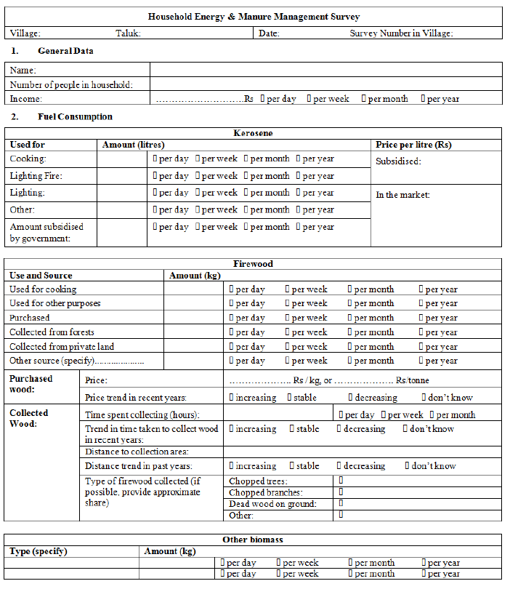

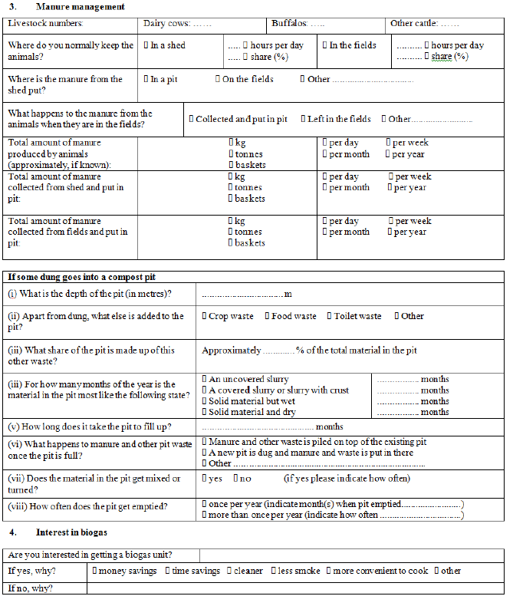

- Survey results.

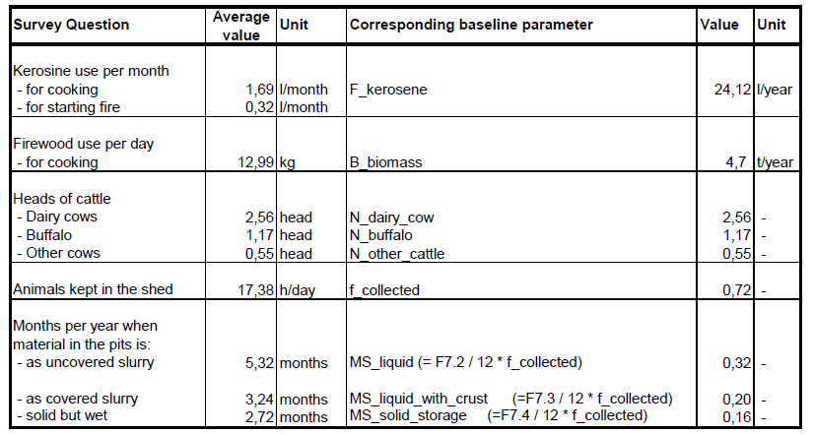

- Calculations
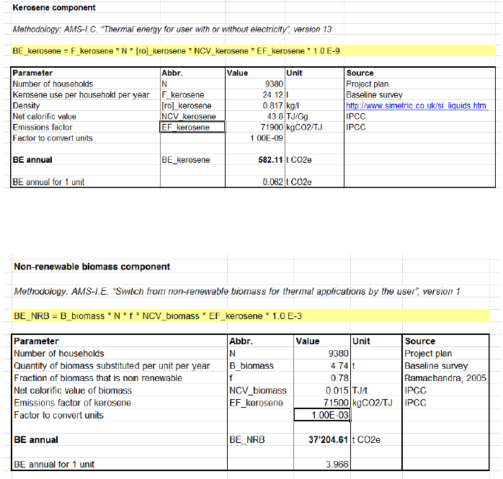

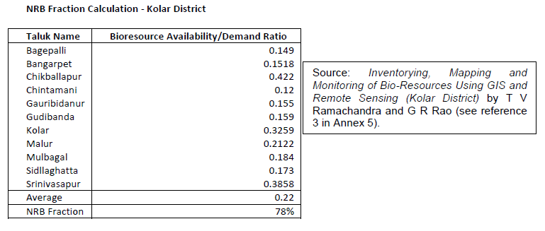

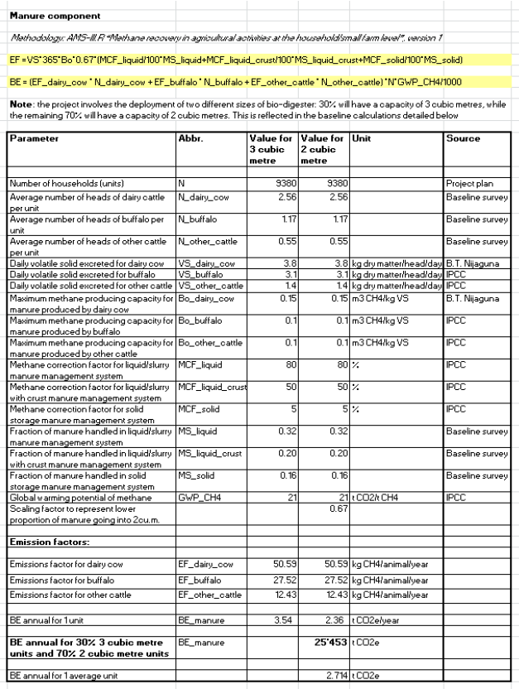

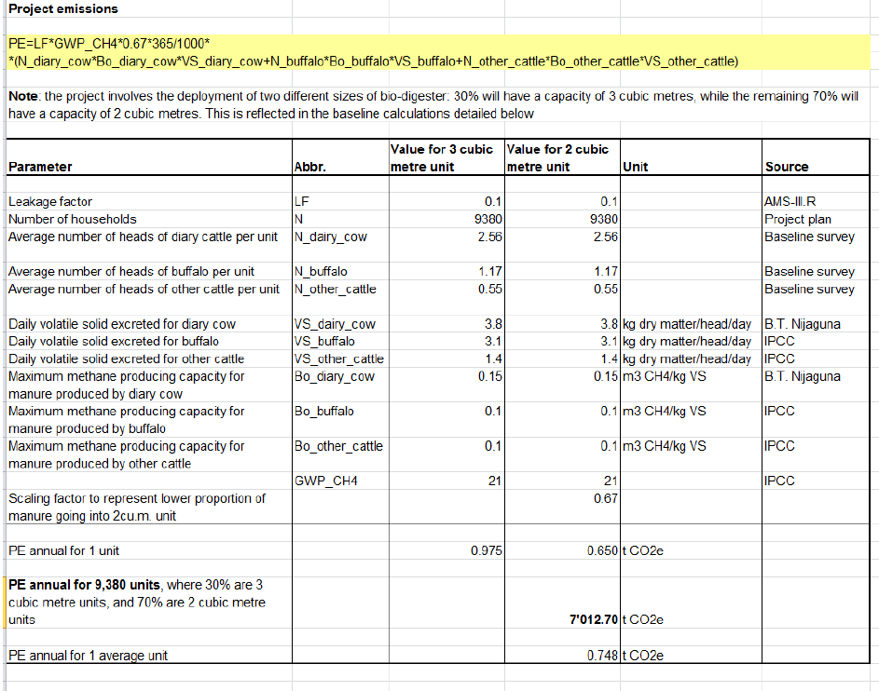

Appendix 6- Monitoring Information
Through its work with biogas plants over the last 15 years, SKG Sangha has developed a system of installing and maintaining the biogas units. The operational and monitoring plan builds on this experience. Monitoring is done in a hierarchical manner with a large number at the village level reporting to and supervised by a small team at each taluk in turn reporting to the project coordinator and his team at the main office.
The scheme in the page below shows distribution of monitoring tasks and responsibilities between different levels of project implementation: the project level (the main SKG Sangha office: project coordinator with a team), the taluk level (supervisor with a team) and the village level (so-called motivator).
In each village where SKG Sangha starts installing biodigesters, a local person is selected to be the so-called motivator. The motivators are trained in how to:
- supervise project implementation in the village;
- maintain and repair the biogas units;
- monitor the functionality of biogas units;
- keep records;
- report to taluk level.
A number of separate training sessions are also run for the households who have biodigesters installed to ensure that beneficiaries use their units correctly. All users will receive training from SKG Sangha for the use of the digester as soon as it is installed. The motivator participates in the training sessions to ensure all beneficiaries are familiar with the main contact in the village. The beneficiaries are instructed to report any faults or problems with the units to the motivator.
During installation the household will sign three pieces of paper to confirm that the masonry work, the pipe fitting work and the overall biodigester has been installed satisfactorily. A technician from SKG Sangha will check the unit once it has been installed to ensure the biogas unit has been installed correctly and this information will then be recorded and logged in SKG Sangha’s central records as well as in paper monitoring journals of the relevant motivator. The records will also include information on the size of each unit – whether it is a 3 m³ unit or a 2 m³ unit. Each biodigester is given a unique identification marking to indicate:
- who sponsored the biodigester;
- who built the biodigester;
- which year the biodigester was built in; and
- which number biodigester it is for that village for that year.

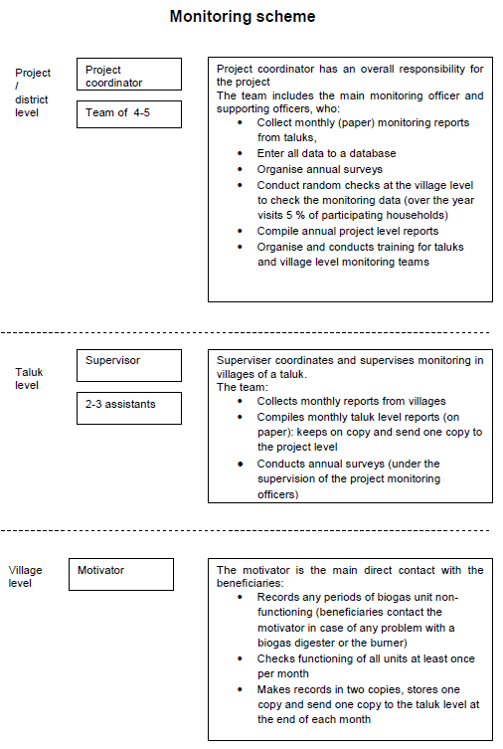

A. Monitoring of biogas unit functionality
Once the unit is installed and checked by the technician, the motivator marks the start of unit operation. Beneficiaries are instructed to report any faults or problems with a biodigester or a burner to the motivator. Normally any problems with the biogas units will be resolved the same day as the original complaint. The motivator will record any periods (in days) when the unit was not operating. Households also have a separate pre-paid post form that they can send directly to SKG Sangha to inform SKG Sangha of any problems in the event that they experience any problems with their village representative. The fact that households make an in-kind contribution to the construction of biogas units also makes them more interested in making proper use of these units. Besides recording problems, the motivator will check all project units in the village at least once per month to record whether they are functioning properly. The records will be made by hand writing, on two copies of a monitoring journal. At the end of each month one copy will be delivered to the taluk level monitoring team, and one copy remains with the motivator.
The taluk level monitoring team collects monitoring journals from the villages in their taluk, and compiles monthly taluk-level reports, which include:
- Number of units that started operations before the monitoring period (i.e. before the beginning of the relevant monitoring month), separately for 2 m³ and 3 m³ sizes;
- Detailed records of units installed during the monitoring month, including the location, the beneficiary, the size of the biodigester, and the date of start of operations;
- Sum of non-operational days of a 2 m³ unit and a 3 m³ unit (i.e. if there were 10 units of 2 m³ size that were not operational for 1 day, the record is that a 2 m³ unit was not operational for 10 days.
The monthly reports are made in two copies, one of which is delivered to the project level (main SKG Sangha office), and another one remains at the taluk level.
The project level monitoring team collects the monthly reports. Throughout the year it makes random visits to villages to check in whether the data recorded by the motivator is correct.
The project level monitoring team enters all data into the central project database, which includes:
- Records of every unit installed, including the location, the beneficiary, the size of the biodigester, the date of start of operations, and the end of operations in case the unit broke down
- Records of non-operational days, separately for 2 m³ and 3 m³ sizes, for every village (corrected after the random visits if needed)

B. Monitoring of annual hours of operation
A sample (at least 30% of beneficiaries in the first year of the crediting period, at least 5% thereafter - only those who can write will be selected) will be given a sheet where they will make records for a week writing down each day the hours when a burner was functioning. i.e. each day a beneficiary will write down the time of starting cooking and finishing cooking, and note whether one or two burners were used. The motivator will distribute the sheets and collect the filled sheets, which will be sent to the project level monitoring team. The team will enter the data into the database and calculate average annual hours of operation for 2 m³ and 3 m³ sizes. For the random checks the team will be doing for monitoring of unit functionality, some households that do monitoring of annual hours of operation will be included in the sample of random visits to check whether the data recorded by beneficiaries is reasonable.

C. Surveys of a sample of units
Taluk level monitoring teams will carry out annual surveys of a sample of beneficiaries to determine the following parameters and information:
- Annual hours of operation of a unit (operation of a burner)
- Annual amount of kerosene used
- Annual amount of fuel wood used
- Animal population per household (for each type of cattle)
- Amount of manure generated on the farm
- Amount of animal manure fed into the system
- Proper soil application of the final sludge
The sampling plan is detailed in F. Below. The Survey sheet is given in Appendix 8.
The schedule of surveys is projected to be as follows:
- 250 households in the 1st year
- 208 households in the 2nd year
- 392 households in the 3rd year
- 469 households in each subsequent year
Surveys will be carried out each year, but over an extended period, as only a few beneficiaries can be surveyed by one person or team in one day.
Survey sheets will be delivered to the project level monitoring team, which will enter the data into the database and calculate average values of each parameter, separately for 2 m³ and 3 m³ sizes. The resulting data will be sued for calculating and checking emission reductions.

D. Surveys of non-project households
Taluk level monitoring teams will carry out annual surveys of at least 100 households in the project area to determine the amount of biomass uses for cooking purposes, the sources of biomass and trends in sourcing the biomass. Survey sheet is provided in Appendix A.

E. Calculation of emission reductions
Emission reductions will be calculated using formulae (1), (3), (7), and (9). Kerosene consumption in the baseline will be adjusted by monitored value of F_{kerosene} and B_{biomass.} Difference of the value of B_{biomass} non-project determined before project implementation and monitored after project implementation will be used for establishing the leakage (after adjusting it for the NRB fraction).
Monitored values B_{manure_generated} and B_{manure_fed} will be used for adjusting f_{collected} in the formula (7).
Monitored value H_{stove} will be used for checking whether the biogas generated in the biodigester covers at least the same energy needs that were covered by burning fuel wood and kerosene in traditional stoves. This will allow checking whether the biogas fully displaces the NRB and kerosene use in the baseline.
The overall project emission reductions will also be adjusted for the real proportion of operational 2 m³ and 3 m³ size units.

F. Sampling Plan
1. Sampling Objective.
Eight different parameters will be monitored using sampling. N_{operating}, the number of units operating, is not included in the sampling plan as all units that are operating will be monitored. Whilst, the parameter, Application of sludge, is included in the sampling plan, it should be noted that this variable does not impact emissions arising from or saved by the project activity. This parameter is monitored for sustainability reasons. That is to ensure that project participants derive the most value from being able to use the sludge as a fertilizer.
The objective is to determine the mean average annual value of each of the parameters listed below during the crediting period and with a 90/10 confidence/ precision:
H_{stove} (hours) - Annual hours of operation of an average system (hours of burner functioning)
F_{kerosene,project} (Litres) – Amount of kerosene consumed by household after installation of biogas unit
B_{biomass,project} (Tonnes)– Consumption of fuel wood in households participating in project activity
B_{biomass, non-project} (Tonnes) – Consumption of fuel wood in households not participating in project activity
N_{t} (dimensionless) – annual average animal population in a household (number of heads of dairy, cow, buffalo and other cattle)
B_{manure_generated} (Tonnes) – Average amount of animal manure generated per household per year
B_{manure,fed} (Tonnes) – Average amount of animal manure fed into a biogas digester per year
Application of sludge (qualitative information) – Proper application of the sludge from the biogas unit

2. Field Measurement Objectives and Data to be collected.
Information on the variables and data to be collected, the scope and method of the survey and their frequency are provided for each parameter in the following paragraphs:
H_{stove} (hours) – There are three key variables for this parameter that will determine average annual hours of operation of an average system (hours of burner functioning): cooking start time, cooking end time and whether one or two burners were used. Data on these variables will be collected for at least 30% of project beneficiaries in year 1 (June 2011 to May 2012) and at least 5% of project beneficiaries thereafter. The survey will be carried out once a year by village level Project Motivators. Each Project Motivator will distribute sheets of paper to project beneficiaries (that are able to write) in their village, on which beneficiaries will make records for every day during one week in the year for the three variables described above.
F_{kerosene,project} (litres) – There is one key variable, for this parameter, kerosene used for cooking. Data for this variable will be collected for at least 30% of project beneficiaries in year 1 and 5% of project beneficiaries thereafter. The survey will be carried out once a year by village level Project Motivators. Each Project Motivator will meet with project beneficiaries in their village and determine kerosene used for cooking (distinguishing this from kerosene used for other purposes such as lighting) through discussions with the beneficiaries and by measuring kerosene usage on the day of their visit. The motivators will enter findings from their discussions into survey questionnaire sheets which will be completed for each household.

B_{biomass,project} (Tonnes) – There is one key variable, consumption of fuel wood in households participating in the project activity. Data for this variable will be collected for at least 30% of project beneficiaries in year 1 and 5% thereafter. The survey will be carried out once a year by village level Project Motivators. Each Project Motivator will meet with project beneficiaries in their village and determine fuel wood usage through discussions with each relevant beneficiary and by weighing wood consumed on the day of the visit. The Project Motivators will enter findings from their discussions into survey questionnaire sheets which will be completed for each beneficiary.
B_{biomass, non-project} (Tonnes) – There is one key variable, consumption of fuel wood in households not participating in the project activity. Data for this variable will be collected by surveying 100 non-project households that use fuel wood. The survey will be carried out once a year by the Taluk level monitoring team. The team will meet with households and determine fuel wood usage through discussions with each relevant household and by weighing wood consumed on the day of the visit. Team members will enter findings from their discussions into survey questionnaire sheets which will be completed for each household.
N_{t} (Dimensionless) – There is one key variable, annual average animal population in a household. Data for this variable will be collected by surveying at least 30% of project beneficiaries in year 1 and 5% of project beneficiaries thereafter. The survey will be carried out once a year by the Taluk level monitoring team. The team will meet with beneficiaries, count the number of heads of cattle on the day of their visit and will clarify through discussions with each relevant beneficiary whether there were changes in number of heads throughout the year. Team members will enter findings from their discussion into survey questionnaire sheets which will be completed for each beneficiary.
B_{manure,generated} (Tonnes) – There is one key variable, average amount of animal manure generated per project beneficiary per year. Data for this variable will be collected for at least 30% of project beneficiaries in year 1 and 5% thereafter. The survey will be carried out once a year by the Taluk level monitoring team. The team will meet with the beneficiaries, and will determine the amount of manure generated through discussions with each relevant beneficiary and by weighing manure on the day of their visit. Team members will enter findings into survey questionnaire sheets which will be completed for each beneficiary.
B_{manure,fed} (Tonnes) – There is one key variable, average amount of manure fed into a bio-digester per project beneficiary per year. Data for this variable will be collected for at least 30% of project beneficiaries in year 1 and 5% thereafter. The survey will be carried out once a year by the Taluk level monitoring team. The team will meet with the beneficiaries, and will determine the amount of manure fed into the bio-digester through discussions with each relevant household and by weighing manure on the day of their visit. Team members will enter findings into survey questionnaire sheets which will be completed for each beneficiary.
Application of sludge (qualitative information) – There is one key variable, use of sludge from the biogas unit. Information for this variable will be collected for at least 30% of project beneficiaries in year 1 and 5% thereafter. The survey will be carried out once a year by the Taluk level monitoring team. The team will meet with the beneficiaries, and will determine sludge application through discussions with each relevant beneficiary. Team members will enter findings into survey questionnaire sheets which will be completed for each beneficiary.

3. Target Population and Sampling Frame.
For all parameters with the exception of B_{biomass, non-project} the target population is the beneficiaries that will receive the bio-digesters in the project. The sampling frame for these parameters will be at least 30% of beneficiaries with bio-digesters in year 1 and 5% thereafter (see section 5). A clustered sampling approach considering 5 geographic clusters each corresponding to one of the 5 regions “Taluks” involved in the project will be adopted. As two types of bio-digester will be deployed in the project (a 2m³biogas unit and a 3m³ biogas unit) there will also be an element of stratification in the sampling frame, distinguishing beneficiaries by type of biogas unit.
For B_{biomass, non-project} the target population is households that are not involved in the project activities but are located in the same regions in which the project activities take place. The sampling frame for this parameter is 100 households in the project activity regions that are not involved in the project activity. As for all other parameters, a clustered sampling approach considering 5 geographic clusters each corresponding to one of the 5 regions “Taluks” involved in the project will be adopted.

4. Sample Method.

The sampling method will be carried out as follows:

Sampling objectives
The sampling objectives have been clearly defined (as summarized in section 1 of the sampling plan above) and these objectives will be clearly communicated by the Project Communicator and his team to Taluk supervisors, the project motivators and Taluk monitoring team members that will carry out and review the surveys. To ensure that the data needs are clearly understood and collated in a consistent manner, standard survey sheets have been prepared for completion by all individuals that will carry out the sampling. A copy of this is provided in Appendix 8.

Target population
For all parameters with the exception of B_{biomass, non-project} the target population is the beneficiaries that will receive the bio-digesters in the project For B_{biomass, non-project} the target population is households that are not involved in the project activities but are located in the same regions in which the project activities take place.

Sampling frame
For all parameters with the exception of B_{biomass, non-project}, the overall sampling frame will be the full list of households receiving bio-digesters in the project and have sufficient levels of literacy to track some of the data that will be required. To ensure that the target population accounts for literacy, information on the literacy of project beneficiaries will be recorded by Project Motivators at the time of installing the bio-digesters and this information will be kept in the central project database that will be managed by the Project Coordinator. To enable clustering by geographic area, for each bio-digester installed, the Project Coordinator and his team will, in the central project database, record details of the village and Taluk in which the bio-digester was installed and whether it was a small (2m³biogas unit) or large (3m³) biogas unit.
For B_{biomass, non-project} the sampling frame are households that are not involved in the project activities but are located in the same villages in which the project activities take place.
Randomizing cases and drawing sample
To promote the drawing of a representative and random sample, the Project Coordinator and his team will develop the sample list of households as follows:

a. Developing a representative sample
When drawing the sample the Project Coordinator and his team will firstly analyze the deployment distribution of operating biogas units to determine the number of households to be sampled in each Taluk in order to generate a sample population that reflects the distribution of biogas units by region and size.
e.g.
Number of biogas units installed by region and size
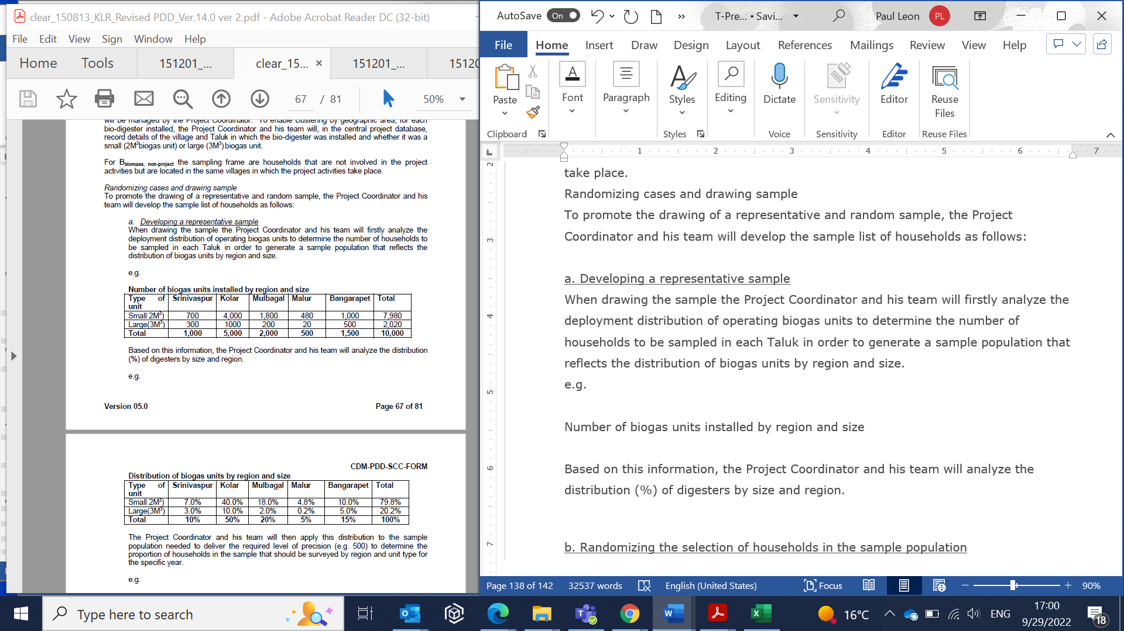
Based on this information, the Project Coordinator and his team will analyze the distribution (%) of digesters by size and region.
The Project Coordinator and his team will then apply this distribution to the sample population needed to deliver the required level of precision (e.g. 500) to determine the proportion of households in the sample that should be surveyed by region and unit type for the specific year.

b. Randomizing the selection of households in the sample population
For each category of the population (size of unit by region) the Project Coordinator and his team will use a random number generator function in Excel to select the households to be sampled (from the full list of households falling into each category, by region and type of biogas unit).

The Project Coordinator and his team will then develop a schedule for biogas visits for each year (reviewed on a monthly basis) with an aim of ensuring that 1/12 of the sample population is surveyed in each month (to try to prevent problems associated with seasonal cycles).

Selecting the most effective information gathering method
As described in section 2, information will be gathered by the Project Motivators and Taluk level monitoring team using a mixture of visual inspections, measurement of parameters during visual inspections, self reporting and discussions with project beneficiaries.

In all cases data will be entered into standardized survey forms prepared by the Project Coordinator and his team to be completed by members of the monitoring team/Project Motivators or beneficiaries.

The forms will then be transferred, on a monthly basis, upwards through the monitoring team hierarchy (shown above in the “Monitoring Scheme” figure) until finally data is entered into the database kept by the Project Coordinator and his team.

Conducting surveys and measurements
Procedures will be put in place to ensure that field data collection is performed properly and that any potential intentional errors or unintentional errors are minimized and documented. These will include:
- Preparation of standard survey forms to be completed by the monitoring team and households (see Appendix 8)
- Training of project monitoring team
- Establishing a clear project monitoring hierarchy, which will enable sample data to be checked at various stages
- Monthly analysis of survey findings by the Project Coordinator and his team to identify outliers and possible errors, which will be documented in the database
- Subsequent discussion of possible errors with Taluk level supervisors, who will, in turn, discuss these errors with the individuals responsible for conducting the surveys. On the basis of these discussions, surveys will be carried out again or eliminated from the sample, with the resulting corrective action communicated to the Project Coordinator, who will then log this in the central project database.

Minimizing non-response
A core feature of the project is the central role that project motivators play in the monitoring process. With project motivators being members of the communities in which the biogas units are installed they will have existing relationships with the beneficiaries. These relationships should minimize the chance of non-response. Further, project motivators will be involved in the installation of biogas units and will serve as a point of contact and issue resolution in the case that biogas unit do not work as planned and therefore will be continuously exposed to the households that will be surveyed.

Not-withstanding this feature of the project, a number of corrective measures will be employed, including over-sampling (see section 5). Further, as sampling will be carried out throughout the year, the Project Coordinator will be in a position to review response rates as the year progresses and take action to increase sampling efforts if non-response is an issue.

5. Desired Precision/Expected Variance and Sample Size.

Indicative simplified baseline and monitoring methodologies for selected small-scale CDM project categories (I.E/ Version 3) states that a sample size shall be chosen for a 90/10 level of precision (a 90% confidence interval and 10% margin of error).
The proposed sampling approach has been found to meet this requirement. This is demonstrated as follows:
The formula for determining the minimum sample size of a population that should be used to demonstrate a 90% confidence interval is as follows:
n = (Zα/2 * σ/E)²
Where:
n = the sample size
Z_{α/2}= 1.65 for a confidence interval of 90%
σ = the standard deviation
E = the maximum error of estimate – in this case 10% of the average value of the specific parameter

As neither σ nor E is known for the parameters to be sampled, these values were calculated from an analysis of the results obtained from the baseline survey, the results of which have been inspected by the validator.
By applying the formulae to the values calculated from the survey findings, the minimum sample size (n) for each parameter was calculated and is summarized in the table below.

Calculation of minimum sample size required to deliver a 90% confidence interval and a 10% margin of error for each parameter to be sampled.

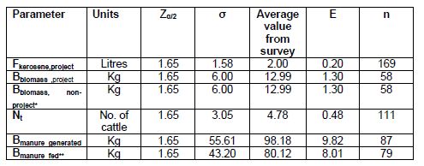

The table shows that the sample size required to achieve a confidence interval of 90% of the different factors ranges from 58 to 169.
A minimum sample of 169 households is needed to achieve a confidence interval of 90%.
For B_{biomass, non-project} we propose to sample a minimum of 100 households. With a minimum sample size of 58 required for this parameter, this should allow for the possibility of non-response.
For all other parameters, we propose to sample a minimum of 30% of households with bio-digesters in Yr 1 and 5% thereafter. In each year the Project Coordinator will be responsible for ensuring that an adequate number of households are sampled to deliver the required level of precision and will sample more households (than the 30%, 5% approach detailed) if necessary to ensure a confidence interval of 90%. The table below shows the anticipated number of households that would be sampled in each year using various sampling approach when applied to the anticipated bio-digester deployment plan and shows that in each case more than 169 beneficiaries (the maximum value of n for all parameters) will be sampled, allowing for the possibility of non-response. Specifically, 250, 208 and 392 beneficiaries will be surveyed in years 1, 2 and 3, respectively. Thereafter, 469 beneficiaries will be sampled.

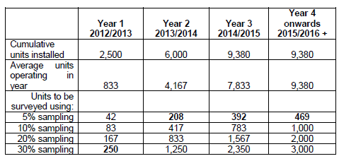
The baseline survey did not capture information on two of the parameters that will be sampled, H_{stove} and Application of sludge. Neither of these parameters will be used to calculate project activity emissions. They will instead be monitored to check whether the bio-digesters produce enough bio-gas to substitute previous use of non-renewable biomass and kerosene and to check the appropriate use of sludge as a fertilizer. Information for both parameters will be gathered by sampling 30% of households in year 1 and 5% thereafter
For H_{stove} sample data gathered during the project activity will be analyzed on a quarterly basis (using the formula shown above) to calculate the minimum sample size required to achieve a confidence interval of 90% and the number of households to be sampled will be amended in subsequent quarters if necessary to achieve this. Information on the application of sludge is qualitative and therefore a minimum sample size is difficult to calculate. However, as the sampling approach has been derived in order to ensure that a 90% confidence interval can be achieved for all other parameters, it is expected that this will ensure that sufficient information is captured for reliably monitoring this parameter.

- Procedures for Administering Data Collection and Minimizing Non-Sampling Errors.

Procedures for data collection
As described in section 2, sampling will be carried out by the village level Project Motivators or the Taluk level monitoring teams, with review of findings carried out at the Taluk level and overall project level. Sampling will be carried out on a monthly basis, with the aim of collating information for 1/12 of the sample population in each month. This will overcome any issues associated with seasonality.
To promote effective data collection, project motivators and monitoring team members will use standardized forms developed by SKG Sangha and will also receive training from SKG Sangha.
In all cases, the survey sheets for all beneficiaries and households surveyed in each village will be collected by the Project Motivator or the Taluk level monitoring teams. In each case copies of survey findings will be kept on file by the individuals conducting the survey. Copies will also be sent to the relevant Taluk level supervisor. The Taluk level supervisors will collate all survey sheets for their Taluk, keeping copies on file and sending copies to the Project Coordinator and his team.
The Project Coordinator (and his team) has responsibility to enter all survey data into a database and to use the survey information to analyze sample findings.

Quality assurance
The results from sample findings will be reviewed once a month by the Project Coordinator and his team to identify response rates, check that sampling is on track to achieve the 90/10 precision and to identify any values that appear to deviate significantly from what was expected. This will enable the Project Coordinator to adjust sample sizes in subsequent months and to discuss unexpected results with the relevant Taluk level supervisors, Project Motivators or monitoring team members to check whether results can be justified or are the result of errors in data capture/ entry. If results appear to be the result of errors, this will be documented in the database and the household will be re-surveyed or excluded from the sample.
Response rates will be maximized by the involvement of project motivators in sampling. Project motivators will be individuals selected from the local communities in which the bio-digesters are implemented. As such project motivators are likely to have good relationships with project beneficiaries that should maximize response rates. In addition, response rates will be maximized by use of a sufficiently large sample that allows room for non-response. Further, the Project Coordinator and has team will review response rates on a monthly basis and adjust target sample numbers for subsequent periods, if response rates are lower than anticipated.

7. Implementation.
The schedule for implementing the sampling effort should be defined as well as indication of who will conduct the actual data collection and the analyses; include qualifications, experience and any potential conflicts of interest of those involved in the data collection and analyses.

The Project Coordinator will have responsibility for determining and implementing the sampling schedule for the year. This will be carried out as follows:

At the start of each year, The Project Coordinator will be aware of the target number of beneficiaries and households to be surveyed in the period (30% in year 1, 5% thereafter and 100 non-project households). The Project Coordinator will, however, need to develop monthly sampling schedules that not only take account of these overall aims, but also reflect actual deployment rates by area and type of digester. The Project Coordinator will receive information on the number of units installed and operating in each month from the Taluk level monitoring team (who, in turn, will receive this information from project motivators).

The Project Coordinator, will then develop a schedule for the operating units to be sampled in the subsequent month. This will be done, using the sample method described in (4) and with a view to sampling the total number of beneficiaries required to achieve a 90% confidence interval (described in 5).

The Project Coordinator will then issue the list of beneficiaries to be surveyed in each month to the Taluk level monitoring team, who in turn, will distribute lists to the project motivators. At the end of each month, sample findings will be relayed to the Project Coordinator and his team for analysis and the Project Coordinator will use these findings to finalise the list of households to be surveyed in the subsequent month. This will be done with reference to possible errors, non-response rates and verification that sampling is on track to deliver the 90/10 level of precision.

The “Monitoring Scheme” diagram above summarises the individuals that will be responsible for the actual data collection and analyses.

The qualifications and experience of the Project Coordinator and other team member who have responsibility for managing the sampling and analysis are provided below.

Data collation will be carried out by a number of Project Motivators and the project monitoring team. Although these will be employees of SKG Sangha who is the Project Owner and will indirectly benefit from the sale of the VERs, there are no anticipated potential conflicts of interest in those involved in data collection and analyses. The funding is provided to SGS in advance and the funder takes the risk of short delivery hence the monitors are sufficiently removed from the reward that there is no potential conflict of interest.

CURRICULUM VITATE

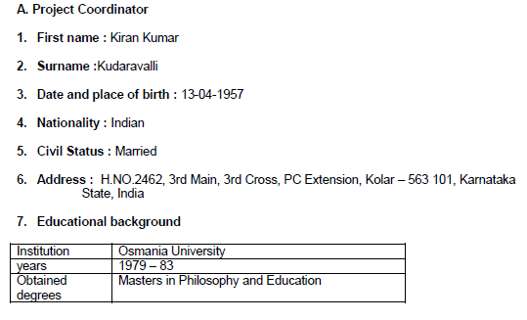

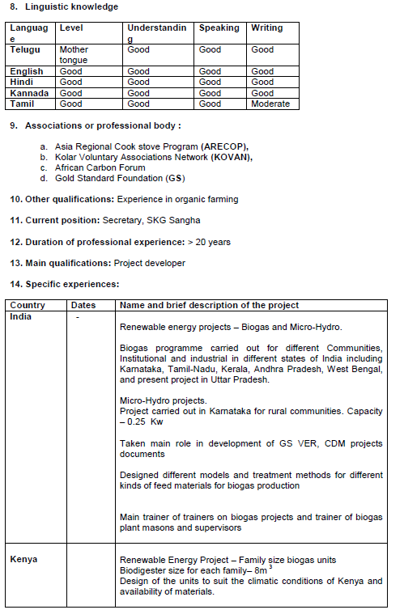
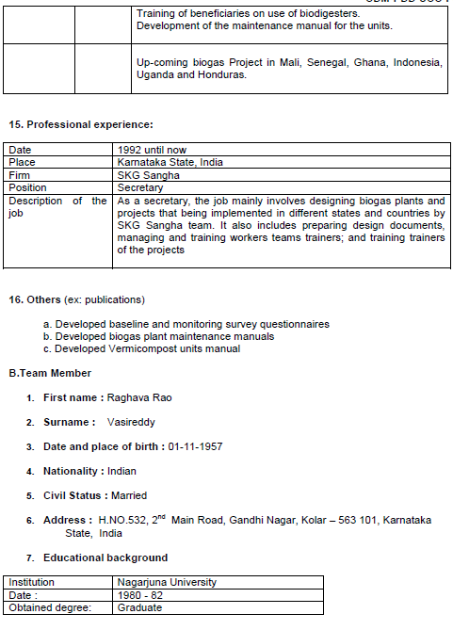

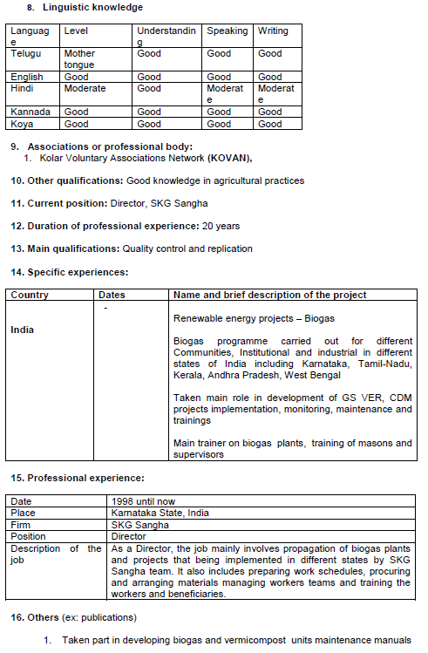

Appendix 7- REFERENCES

1. Kumargoud, V, Report on Manure Management Systems by Regional Biogas Development and Training Centre, University of Agricultural Sciences, Bangalore.
2. Ramachandra, T.V. et al, Bioresource Status in Karnataka, Renewable and Sustainable Energy Reviews, Volume 8, Issue 1, February 2004, pages 1-47.
3. Ramachandra T.V. and Rao, G.R, Inventorying, Mapping and Monitoring of Bioresources Using GIS and Remote Sensing (Kolar District) (2005).
http://wgbis.ces.iisc.ac.in/energy/paper/Biores_using_RS_GIS/index.htm
4. Ramachandra, T.V. and Kamakshi, G, Bioresource Potential of Karnataka: Technical Report No: 109, Energy and Wetlands Research Group, Indian Institute of Science, Bangalore, 560012 (November 2005).
1. Nijaguna, B.T, Biogas Technology (New Age International (P) Ltd, 4835/24 Ansari Road, Daryaganj, New Delhi 110 002, 2002).
2. D’Sa, A and Narasimha Murthy, K.V, Report on the use of LPG as a domestic cooking fuel option in India, International Energy Initiative (2004) (see https://web.archive.org/web/20140308034632/http://www.iei-asia.org/IEIBLR-LPG-IndianhomesReport.pdf)
3. Malhotra, P, Environmental implications of the energy ladder in rural India, Boiling Point Issue 42 (1999) (see https://web.archive.org/web/20090512173212/http://www.hedon.info/EnvironmentalImplicationsOfTheEnergyLadderInRuralIndia)
4. Gangopadhyay, S, Ramaswami, B and Wadhwa, W, Reducing subsidies on household fuels in India: how will it affect the poor?, Energy Policy 33 (2005). (see https://web.archive.org/web/20120722223401/https://www.idfresearch.org/pdf/fuel%20subsidy.pdf)
5. Thiagu, I et al, Kerosene and Gas Stoves in Nagercoil, South India, Boiling Point, Issue 20 (1989) (see https://web.archive.org/web/20100305004147/http://hedon.info/BP20:KeroseneAndGasStovesInNagercoil)
6. Study on biomass management for sustainable soil fertility in Hassan district, University of Agricultural Sciences Bangalore
7. Evaluation Study On National Project on Biogas Development, Programme Evaluation Organization, Planning Commision, Government of India, New Delhi (2002) (https://web.archive.org/web/20190819162238/http://planningcommission.gov.in/reports/peoreport/peoevalu/peo_npbd.pdf)

Appendix 8- mONITORING SURVEY SHEET

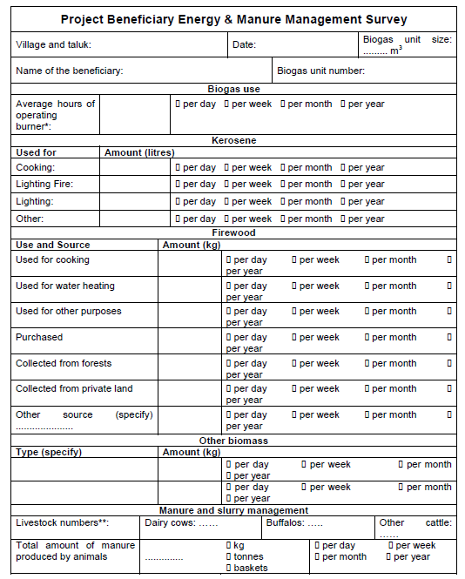

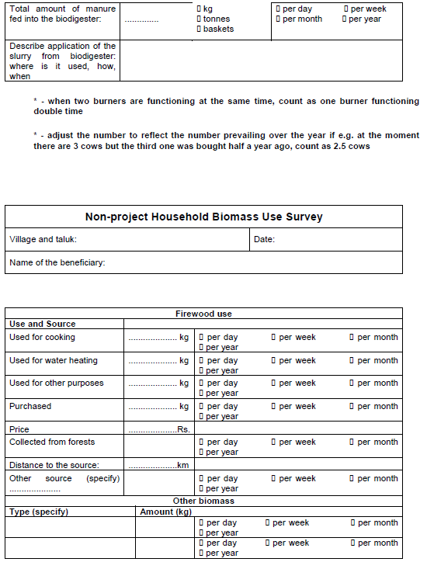

Appendix 9- Simple cost analysis of the project activity and alternative scenarios

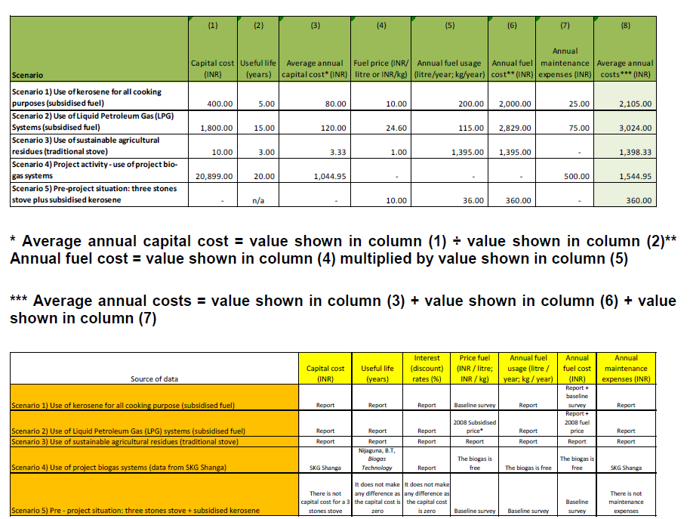
Report = Report on the use of LPG as a domestic cooking fuel option in India”, International Energy Initiative, 2004 (see Annex 3)
* A domestic LPG cylinder has 14.2 kg and it sells at 350 Rs.
http://timesofindia.indiatimes.com/Cities/Kolkata_/LPG_switch_catalyst_for_gas_racket_/articleshow/3730124.cms

Revision History

Version | Date | Remarks
1.0 | 10 July 2017 | Initial adoption

CDM clarification available on this topic as on date can be referred to here.
Chikballapur District was created out of Kolar District on 23 August 2007 (https://web.archive.org/web/20130802025747/http://chikballapur.nic.in/district_profile.html). As a result, Kolar is now comprised of five taluks - Srivinvaspur, Kolar, Mulbagal, Malur and Bangarapet (http://www.karnataka.com/districts/#).
http://www.electrigaz.com/faq_en.htm https://web.archive.org/web/20160918112053/http://www.biogas2.com/faq/ https://energypedia.info/wiki/Electricity_Generation_from_Biogas#Conversion_to_Electricity
In ER spread sheet is added a new sheet ‘Max. limit’ where is explained the calculations for Type I limit.
These parameters have been adjusted in order to ensure a precision at 95% confidence level resulting: 2.6 dairy cows, 1.2 buffalo and 0.5 non-dairy cows.
These parameters have been adjusted in order to ensure a precision at 95% confidence level, given a result of: in a liquid/slurry manure management system for 5.3 months, in a liquid/slurry with crust cover manure management system for 3.2 months and in a solid storage manure management system for 2.7 months. In the remaining 0.4 months the material is solid and dry.
This parameter has been adjusted in order to ensure a precision at 95% confidence level, given a result of: animals kept in the sheds on average 17.4 hours per day, 72% of the total time.
Table 10.18 in the IPCC 2006 Guidelines defines this system as the situation when “manure is stored as excreted or with some minimal addition of water in either tanks or earthen ponds outside the animal housing, usually for periods less than one year”.
No separate definition is given for this system in the IPCC 2006 Guidelines compared to the liquid/slurry definition, but the Methane Correction Factor is different when the material has a crust cover.
Table 10.18 in the IPCC 2006 Guidelines defines this system as “The storage of manure, typically for a period of several months, in unconfined piles or stacks. Manure is able to be stacked due to the presence of a sufficient amount of bedding material or loss of moisture by evaporation”.
https://web.archive.org/web/20090512173212/http://www.hedon.info/EnvironmentalImplicationsOfTheEnergyLadderInRuralIndia
https://web.archive.org/web/20110106224220/https://planningcommission.gov.in/reports/peoreport/peoevalu/peo_npbd.pdf
https://wcd.nic.in/sites/default/files/draft%20national%20policy%20for%20women%202016_0.pdf
https://www.ceew.in/sites/default/files/Improving-Womens-Incomes-and-Productivity-through-Clean-Energy-in-India.pdf
https://wcd.nic.in/sites/default/files/draft%20national%20policy%20for%20women%202016_0.pdf
http://resources.metapress.com/pdfpreview.axd?code=br68457w2216t668&size=largest

