Monitoring Report

PUBLICATION DATE 14.10.2020
VERSION v. 1.1
RELATED SUPPORT - TEMPLATE GUIDE Monitoring Report v. 1.1

This document contains the following Sections
Key Project Information
SECTION A - Description of project
SECTION B - Implementation of project
SECTION C - Description of monitoring system applied by the project
SECTION D - Data and parameters
SECTION E - Calculation of SDG Impacts
SECTION F - Safeguards Reporting
SECTION G - Stakeholder inputs and legal disputes

KEY PROJECT INFORMATION

Key Project Information
GS ID (s) of Project (s) | 11544
Title of the project (s) covered by monitoring report | Maji Safi, Maisha Bora Project
Version number of the PDD/VPA-DD (s) applicable to this monitoring report | 3.5
Version number of the monitoring report | 2.5
Completion date of the monitoring report | 18/03/2026
Date of project design certification | 22/03/2023
Date of Last Annual Report | 16/01/2025
Monitoring period number | 1
Duration of this monitoring period | 20/09/2023- 31/05/2025
Project Representative | Ceres-Enve
Host Country | Kenya
Activity Requirements applied | Community Services Activities  Renewable Energy Activities  Land Use and Forestry Activities/Risks & Capacities  N/A
Methodology (ies) applied and version number | GS Methodology for Emissions Reduction from Safe Drinking Water Supply (v 1.0)
Product Requirements applied | GHG Emissions Reduction & Sequestration  Renewable Energy Label  N/A

Table 1 - Sustainable Development Contributions Achieved
Sustainable Development Goals Targeted | SDG Impact | Amount Achieved | Units/ Products
13 Climate Action (mandatory) | Emission reductions | 8,296 | tCO2e
15 Life on Land | Amount of firewood saved | 4,100.7 | tonnes
3 Good Health and Well-being | Proportion of target population using safely managed drinking water services without water-borne diseases | 97% | Percentage
5 Gender Equality | Proportion of households who perceive saved time from collecting wood and water boiling | 99% | Percentage
6 Clean Water and Sanitation | - Amount of safe water served at the required quality by national standards.  - Increased awareness due to annual Water hygiene campaigns | 35,905  1 Wash Campaign | -m³  -Number
7 Affordable Clean Energy | Total electricity produced -Renewable | 87,110 | kWh
8 Decent work and economic growth | Number of temporary and permanent jobs created | 23 | Number

Table 2– Product Vintages
Start Dates | End Dates | VERs
20/09/2023 | 31/12/2023 | 416
01/01/2024 | 31/12/2024 | 4,568
01/01/2025 | 31/05/2025 | 3,312
Total |  | 8,296

SECTION A. DESCRIPTION OF PROJECT

A.1. General description of project
>>
OffgridSun, in collaboration with Genius Watter and local partners Makohaa (CBO) Jerri-Hydro Experts and PENWA (water supply system operator); is implementing “Maji Safi, Maisha Bora Project” in Siaya County, located in Western Kenya on the Lake Victoria in the former Nyanza Province. The project is a Community level Water Treatment Technologies (CWT) project where users retrieve safe treated water from public distribution points equipped with smart meter kiosks. The project also supplies safe water access to individual end users through domestic connections.

A.2. Location of project
>>
Republic of Kenya, Siaya County, Bondo District, East and West Yimbo Wards
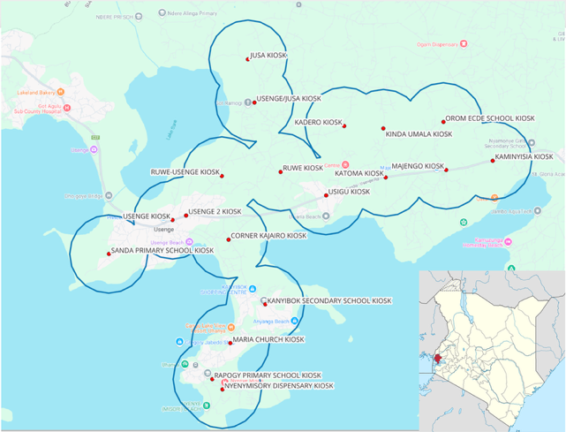Figure 1 Map of Project area

Table 3 Coordinates of the uppermost points of combined service area.
 | Longitude | Latitude
Northernmost point | 34.0761 | -0.0304
Southernmost point | 34.0703 | -0.1065
Westernmost point | 34.1391 | -0.0565
Easternmost point | 34.0420 | -0.0756

A.3. Reference of applied methodology
>>
Gold Standard Methodology: Emission reductions from safe drinking water supply Version 1.0.
Applicable GS4GG requirements are as follows:
- GHG Emissions Reduction & Sequestration Product Requirements v 2.1
- Community Services Activity Requirements v 1.2

A.4. Crediting period of project
>>
First crediting period: 20/09/2023- 19/09/2028

SECTION B. IMPLEMENTATION OF PROJECT

B.1. Description of implemented project
>>
The project is implemented as described in the registered project documents. The figure below shows the refurbished kiosks (existing kiosks) and newly built lines and kiosks. The intake system is located in Nyamonye area, where the pumps are fed by grid electricity (Intake pumping). The suction line is 73 m from lake to Pump house (Intake piping). Then, the water is directed through a main delivery pipeline of 4,815 m long into three big tanks build in concrete: one raw water tank where the water is first stocked, two sand filter tanks (Current Tank). There is also one chlorine tank where the water is treated through a chlorination machine. The tanks are located Kinda Umala, which is the highest place in the area. The project refurbished all 4 tanks and utilize the chlorination tank for clean water storage. An additional 200 m³ tank has been placed to support the system in Kinda Umala. Capacities of all tanks are provided in the Table 4.

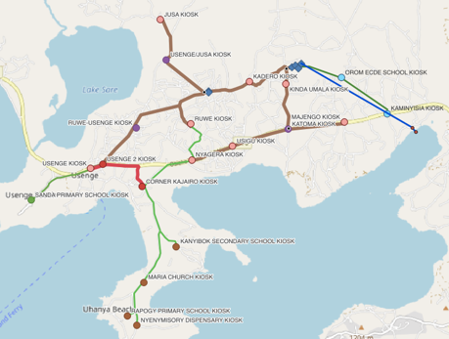 | 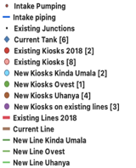
Figure 2. Project structure

Table 4. The capacities of the tanks.
Existing Tanks | Number | Capacity(m3) | Place
Raw water Tank | 1 | 101.69 | Kinda Umala
Sand Filter Tanks | 2 | 139.89 | Kinda Umala
Chlorine Tank | 1 | 104.7 | Kinda Umala
Elevated Steel Storage Tank installed in 2018 | 1 | 50 | Uwambasa Primary School
Concrete Storage Tank | 1 | 111.61 | Uwambasa Primary School
Plastic water tanks Tanks placed in 2018 | 2 | 5 | Usenge 2 Kiosk  Corner Kajairo Kiosk
New Tanks | Number | Capacity(m3) | Place
Storage Tank | 1 | 200 | Kinda Umala
Storage Tank | 1 | 200 | Wambasa Primary School

Then the water is further transferred from Wambasa to the surrounding areas by gravitation through two secondary pipelines, one of which goes to West to Usenge and the other supplies water to North to Jusa. Total length of existing distribution line 20kms.

There are 10 kiosks that are rehabilitated and used as vending points at the first stage of implementation. The system has been extended by 10 new water kiosks; 2 located in Kinda Umala, 1 in Usenge/Ovest, 4 in Uhanya and 3 more on the existing pipeline Total number of vending points are 20 and total extension pipeline is 14 kms.
Table 5 The coordinates of Kiosks
Existing Kiosks
NO | X | Y | Name | Start date of operation
1 | 34.0608843 | -0.064354 | USENGE 2 KIOSK | 20/09/2023
2 | 34.0706347 | -0.069876 | CORNER KAJAIRO KIOSK | 20/09/2023
3 | 34.057788 | -0.065365 | USENGE KIOSK | 20/09/2023
4 | 34.082614 | -0.054337 | RUWE KIOSK | 20/09/2023
5 | 34.075138 | -0.02844 | JUSA KIOSK | 20/09/2023
6 | 34.097251 | -0.043835 | KADERO KIOSK | 20/09/2023
7 | 34.082947 | -0.063229 | NYAGERA KIOSK (Closed) | 20/09/2023- Closed on 28/02/2024 due to low demand
8 | 34.093073 | -0.059783 | USIGU KIOSK | 20/09/2023
9 | 34.120738 | -0.053894 | MAJENGO KIOSK | 20/09/2023
10 | 34.106281 | -0.044369 | KINDA UMALA KIOSK | 20/09/2023
New Kiosks
NO | X | Y | Name | Start date of operation
1 | 34.131404 | -0.051734 | KAMINYISIA KIOSK | 04/01/2024
2 | 34.1200615 | -0.042839 | OROM ECDE SCHOOL KIOSK | 04/01/2024
3 | 34.071087 | -0.093661 | MARIA CHURCH KIOSK | 19/03/2024
4 | 34.0668983 | -0.101999 | RAPOGY PRIMARY SCHOOL KIOSK | 19/03/2024
5 | 34.069238 | -0.104309 | NYENYMISORY DISPENSARY KIOSK | 19/03/2024
6 | 34.079095 | -0.084777 | KANYIBOK SECONDARY SCHOOL KIOSK | 14/02/2024
7 | 34.043114 | -0.073213 | SANDA PRIMARY SCHOOL KIOSK | 04/01/2024
8 | 34.1067988 | -0.055565 | KATOMA KIOSK | 19/03/2024
9 | 34.0766299 | -0.038372 | USENGE/JUSA KIOSK | 01/04/2024
10 | 34.06913148 | -0.055261906 | RUWE-USENGE KIOSK | 05/07/2024

Nyagera Kiosks is closed due to the low demand in the region. The kiosk is located outskirts of Usingu city center where a few houses exist. The kiosk and its service area is excluded from the project boundary (Figure.3).

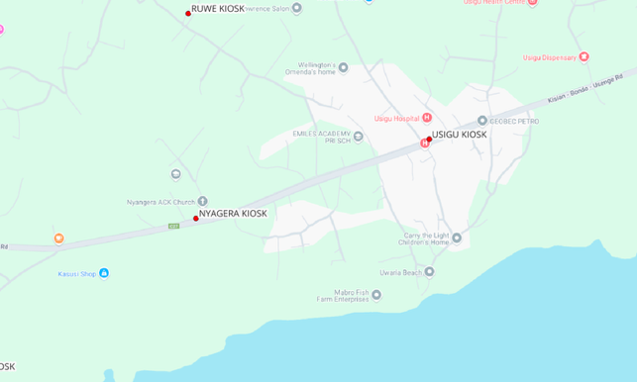Figure 3. Nyagera Kioks closed due to low demand.

Both the new and the old kiosks are equipped with smart water kiosks with the applied technology: LORENTZ smartTAP, an off-grid water dispensing and management system which enables revenue collection, water entitlement and sustainable water provision. Each smart water dispenser are powered by solar panels of 10 W. LORENTZ smartTAP combines hardware, software and predefined business models to allow for water infrastructure to be delivered in an economically sustainable way. Users of the system access water from a tap using a tag. The tag is pre-charged with water credits through mobile money at local shop or directly with the connected optional GSM modem (Figure 4).

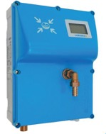 | 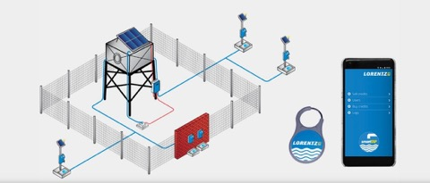
Figure 4. Metering equipment
The project Maji Safi Maisha Bora rehabilitated and improved the system by:
- Improving/renovating the current pipeline and water tanks. Two more storage tanks have been added to support the existing tanks; one in Kinda Umala and another in Uwambasa
- Improving the intake system by substituting the current suction line and pump system
- The storage and treatment station in Kinda Umala has been restored and improved (raw tank, twin sand filter tanks, chlorine tank).
- Disconnecting the system by the electrical grid by connecting it to an off-grid solar system powers the whole system
- Extending the existing pipeline up to underved areas such Uhanya (South), Usenge/Ovest (West), Kinda Umala (East).
- Restoring the water kiosks by installing smart water kiosks dislocated in the area powered by solar energy where people can buy safe water at an affordable price through pay&go system
- Building additional 10 water kiosks in total on the existing and extended lines
- Improve the organizational and financial management of the system through capacity building to PENWA
Models and average lifetime of the equipment are given in Table 6. Models and average lifetime of the equipment. The system is expected to be operational for 30 years. The concrete tanks can last quite a long time up to 40 years if well managed, which may lengthen the lifetime of the system up to 37 years by retrofitting the equipment.

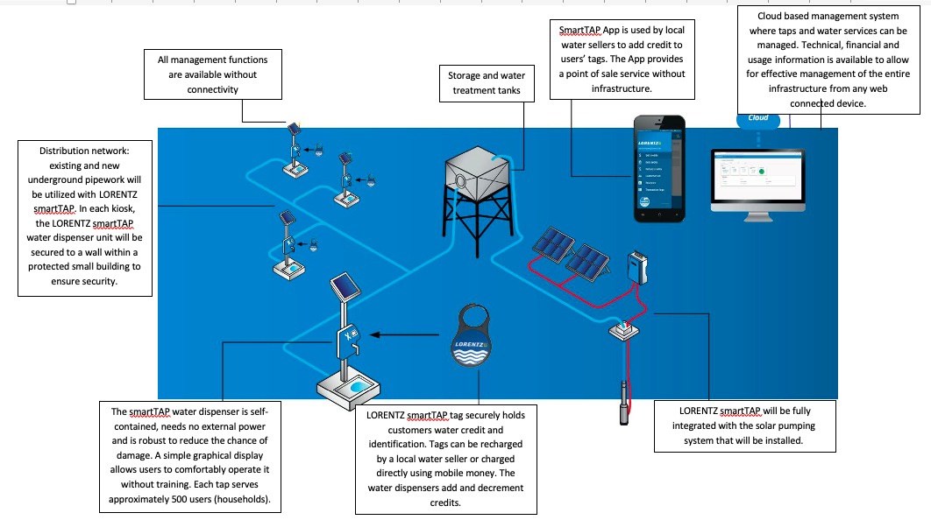
Figure 5. Drawing showing the of off-grid solar treatment and supply system main components

Table 6. Models and average lifetime of the equipment
Equipment type | Brand | Average lifetime
30 kW submersible pump | Grundfos SP46-20 | 24 months warranty  20 years expected lifetime
Speed controller inverter to power pumping system | Nastec Vasco Solar | 24 months warranty  30 years expected lifetime
Solar panels | Futura Sun 375M modules | 25 years warranty  40 years expected lifetime
Off-grid Smart Water Kiosks | Lorentz | 24 months warranty  30 years expected lifetime
Automatic Chlorine Dispenser | Dosatron D30WL | 24 months warranty  30 years expected lifetime
HDPE Pipes | Agro-irrigation | 50 years warranty  Over 100 years expected lifetime
Concrete Masonry Water tanks |  | Concrete water tanks can last quite a long time. Generally speaking, they do take 20 to 30 years and with proper maintenance, a high-quality concrete tank can last up to 40 years and above according IS 3370:2009 Part I – IV. (The IS 3370:2009 Part I – IV states that where the concrete underground or surface water is constructed with concrete strength of M 20 and above, the structure can last up to and above 40 years.) Whereas we’re using concrete strength M 25 and M 30 which is way above.

Water Filtration is very vital part of water supply system and two robust types of filtration system within the Usigu Water Supply System is designed as described below:

USIGU TWIN SLOW SAND FILTERS
Usigu Filtration System comprises of two concrete tanks with a height of 2.5m high and diameter of 9m wide with filter media arranged as shown on the diagram below. The filtration process percolates untreated water slowly through a bed of porous sand to geo-textile membrane layer to gravel park, with the influent water introduced over the surface of the filter from the raw water tank and then drained from the bottom of the tank through the slotted Screen pipes with a flow regulator to control the filtration process. Slow sand filter provides an excellent treated water quality with no chemical added to aid the filtration process and it removes suspended particles with effluent turbidity below 1.0 achieving 90% to 99% reductions in bacteria and viruses.
Figure 6. Water Filtration System
AUTOMATIC CHLORINE CHEMICAL DISPENSER
The second Filtration System in Usigu Water Supply is an automatic Chlorine Chemical Dispenser installed immediately after the twin slow sand filter as shown below. The Dispenser is easy to use and maintain and does not require electricity to operate. In this stage, the Dispenser receives already filtered water from the slow sand filter and dosed it to the clean water tank at Kinda –Umala.

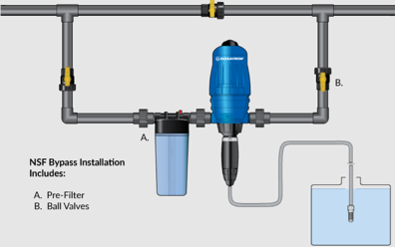
Figure 7. Chlorination

A normal level for drinking water disinfection can range from 1.0 to 4.0 mg/L. Chloramine levels up to 4 milligrams per liter (mg/L) or 4 parts per million (ppm) are considered safe in drinking water hence harmful health effects are unlikely to occur. Therefore, with the use of the Dosatron technology chlorine dosing equipment which comes with two very important features, namely, dosing scale setting and the adjustable dosing rate, we will be able to achieve chlorine doses from any ranges to final treated waters ranging from 0.2–2.0 mg/l of free chlorine to give a residual of about 0.02–0.3 mg/l at the consumer’s tap. The system motor flow capacity ranges from 8-30 m3/h with a chemical injection flow ranging between 0.24- 9 l/hr

The Project uses solar power for the intake system and establishment of smart water kiosks to overcome the problem of collecting payments. The system is upgraded with the required renovation works on technical infrastructure. The project partners Offgridsun and Genius Water has done the technical work while local partner PENWA runs the system. Makohaa is responsible for capacity building component of the project and carried out water hygiene campaigns.

The project is estimated to provide safe drinking water to 64,715 m³ annually during the design phase. Total amount of water pumped to the system during the monitoring period is measured 116,817.22 m³. However, we have identified a significant discrepancy between the volume of water pumped from the clean water storage tanks and the volume metered through the water kiosks. Specifically, our observations show that around 70% of the treated and pumped water does not reach the water kiosks. As a result, only a small fraction of the safe drinking water supplied by the project reaches to paying users.

Despite thorough checks, no system leakages of this magnitude have been identified, leaving the cause of this discrepancy currently undefined. Therefore, the loss is suspected to come from thefts which is identified one of reason for high non-revenue water rates in Kenya. The estimated Kenya’s average of NRW ratio was 41% (2017-2018) as Non-revenue Water Management Annual Report-2017-2018. Furthermore, Siaya -Bondo Water and Sanitation Company (SIBOWASCO) reported 52% non-revenue water rate for 2023/2024 period. That is higher than the country average of 41%. A few illegal connections have been identified supporting the assumption at the time of this report and the users were registered to the system. The investigation is still going on.

B.1.1 Forward Action Requests
>> Following FARs were raised during the preliminary review:
FAR#1: As required by the methodology, the Maintenance and repair plan prepared by Jerri Hydro Expert shall be submitted prior to 1st verification.

Maintenance and repair plan, describing daily, weekly and monthly activities have been submitted to the VVB. The plan also identifies possible animalities and how to deal with them as well as actions to be taken in case of low or no power and how to power the pump from grid.

FAR#2: Project technology performance level (CWT and CWS): For each individual CWT or CWS, it shall be demonstrated at the start of each crediting period with water quality testing reports that the water directly supplied by the project water technology/source achieves microbial quality and compliance with national or international water quality standards. This shall be done when the project start operation and evidence to be submitted to the VVB during the 1st issuance.

Water quality test for the system was undertaken on 16/10/2023 and the results has been provided to the VVB. The samples are taken from the pumping station where treated water is fed to the system. Physical-chemical analysis and microbial laboratory results confirmed that the water served by the system meets Kenyan drinking water standard: KS EAS 12: 2018 by the Water Resources Authority (WRA) of Kenya.

WRA is the state agency responsible for regulating, managing, and protecting water resources in the country and was established under the Water Act, 2016, replacing the former Water Resources Management Authority (WRMA). They issue water use permits for abstraction (surface and groundwater) (Please see the link: https://wra.go.ke/water-use-allocation/).

B.2. Post-Design Certification changes
>>
B.2.1. Temporary deviations from the approved Monitoring & Reporting Plan, methodology or standardized baseline
>> N/A
B.2.2. Corrections
>>N/A
B.2.3. Changes to start date of crediting period
>> Crediting period start date was indicated as 01/08/2023 in the registered PDD. The first set of kiosks become operational on 20/09/2023 and therefore the crediting period start date is revised accordingly. In case of changes in crediting period start date up to one year, no justification and/or approval is required as per GS Design Change Request Requirements and Procedures (V2.0).
B.2.4. Permanent changes from the Design Certified monitoring plan, applied methodology or applied standardized baseline
>>N/A
B.2.5. Changes to project design of approved project
>> Nyagera Kiosks is closed due to the low demand in the region. The kiosk is located outskirts of Usingu city center where a few houses exist. The kiosk and its service area is excluded from the project boundary. Please see Section B.1 above.

The kiosk was planned to serve a population of 1,175 in East Yimbo. That population is divided by household size of 5.29 and 222 buildings have been dropped out from total 5743 to 5521 in east Yimbo for calculation of quantity of safe drinking water that could be consumed by project end users.

SECTION C. DESCRIPTION OF MONITORING SYSTEM APPLIED BY THE PROJECT
>>

Monitoring activities officially commenced on 20 September 2023, coinciding with the date when the first 10 kiosks became operational. From this point onwards, the project has been systematically tracking the volume of water supplied through both kiosks and private household connections. The monitoring process is conducted using a dual approach:
- Remote monitoring – where available, digital systems record and transmit water usage data in real time.
- Manual monitoring – project staff carry out monthly site visits to record meter readings at the end of each month.

This combined method ensures accuracy, provides cross-verification of data, and minimizes the risk of discrepancies in reported water volumes.

During the monitoring period, the kiosks were out of operation in April and May 2024 due to flooding of the pump (Figure 8). The flood affected only the pump house operation which caused operational disruptions rather than direct contamination of the water itself. The primary issue was the inability to pump the treated water from the treatment facility to distribution kiosks. The total amount of water supplied through 19 kiosks are metered during the monitoring period 20/09/2023- 31/05/2025 as 35, 905,000 liters.

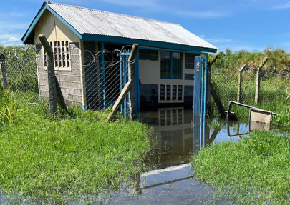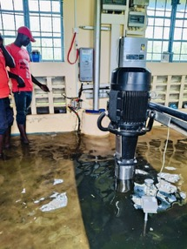
Figure 8. Flooding of the pumphouse in April-May 2024.

180 private connections were established, and 1921 user tags were distributed to fetch water from the kiosks. Total numbers of houses counted during the baseline survey are 4,705 and 5,743 for East and West Yimbo respectively. It is predicted that the user tags are shared by other families on the project site and total households benefitted from the water supply system is higher than the registered users.
Table 7 Metered water consumption during the monitoring period
Reading date | Water kiosks (m³) | Private Connections (m³) | Total (m³)
31/10/2023 | 280 | 171 | 451
30/11/2023 | 147 | 232 | 379
31/12/2023 | 466 | 475 | 941
31/01/2024 | 271 | 0 | 271
29/02/2024 | 423 | 0 | 423
31/03/2024 | 677 | 2698 | 3375
30/04/2024 | 0 | 0 | 0
31/05/2024 | 0 | 0 | 0
30/06/2024 | 609 | 1263 | 1872
31/07/2024 | 713 | 1004 | 1717
31/08/2024 | 584 | 1195 | 1779
30/09/2024 | 920 | 1785 | 2705
31/10/2024 | 699 | 1467 | 2166
30/11/2024 | 671 | 1431 | 2102
31/12/2024 | 864 | 2476 | 3340
31/01/2025 | 742 | 2759 | 3501
28/02/2025 | 1166 | 2362 | 3528
31/03/2025 | 837 | 1560 | 2397
30/04/2025 | 533 | 1965 | 2498
31/05/2025 | 634 | 1826 | 2460
TOTAL |  |  | 35,905

WASH campaigns

Summary of trainings:
During the months of May and June of 2024, OffgridSun staff has carried out a WASH Campaign in the project area in accordance with Gold Standard methodology. Sub-county health departments were consulted in designing the campaign and they are engaged to all activities. The departments supported the campaign by mobilizing public health officers and community health assistants for training and supervision.

From May 18 to May 22, 2024, the NGO Makohaa conducted a WASH (Water, Sanitation, and Hygiene) training for project officials, led by public health officer Jessica Oyoo. The training covered water sources, unsafe water characteristics, purification methods, sanitation, types of toilets, waterborne diseases, prevention, and conducting WASH campaigns. The trained staff would then train community health volunteers for household sensitization. The list of subjects covered are as folllows:
Day-1: Sources of water, characteristics of unsafe water and water purificaiton methods.
Day-2: Definition of sanitation, types of toilets, common water borne diseases and prevention of water related diseases.
Day-3: Training on use of chlorine test kits, trainign on how to conduct a WASH campaign and site visits to project infrastructure, a few households that use project water including checking toilet conditions in the houses.

On June 3rd 2024, Community Health Volunteers, Community Health Assistants and Public Health Officers from the villages within the project area assembled at the Usigu community Social Hall for the WASH training. The main points discussed in the training are as follows:
- Sources of water around the area: lakes, rivers, rainwater, streams, wells, water pans
- Chemical, physical and biological Characteristics of safe water and unsafe water
- Water purification methods
- Effects of drinking unsafe water
- Common waterborne diseases
- Source and transmission of water related diseases
- Prevention of water related diseases
- The project maji safi maisha bora, its main aim and area of span of the project
- Process of conducting household sensitization
- Training on how to fill the household questionnaire (kobotoolbox)

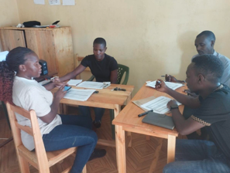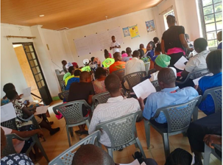
Figure 9 Pictures from trainings

Household Sensitization
After the training, the household sensitization begun 4th of June 2024. A total of 3100
households were visited across 40 villages, amounting to 15.500 beneficiaries reached. Household data including number of household members, source of drinking water and frequency of cleaning water storage facility; was collected during the visits.

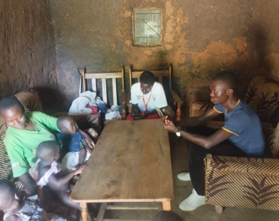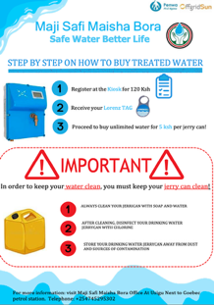
Figure 10 Household Sensitization and a copy of poster introducing the project.

Cleaning and disinfection of jerrycans
During the wash campaign, the project offered jerry can cleaning and disinfection services for free at the project’s kiosks. Residents would bring their jerrycans at the kiosks and project staff would clean their jerrycans and disinfect for free. This was a great way to promote of jerry can cleaning and safe water practices.

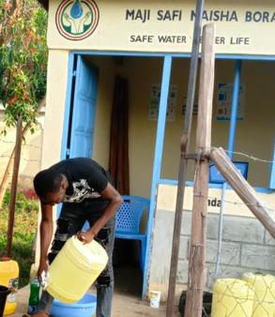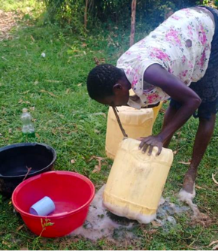
Figure 11. Jerrycan cleaning at the kiosks

Household registration
On 6th of June 2024, the kiosk attendants started to visit households and registered them into the system at a discounted fee of Ksh 50, as opposed to the usual Ksh 120. Total users registered become 1921.

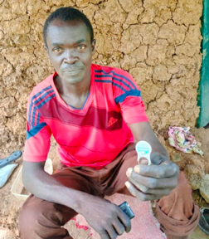
Figure 12 A household registered with the tag
Distribution of reflectors
A brief sensitization session on the use and importance of drinking treated water was
conducted for motorbike operators at the main boarding points. The operators were tasked with educating community members on the importance of using safe water and promoting the water tags offer. After the session, the operators were provided with reflectors.

Sensitization of schools
A fun day was organized at Kanyibok Secondary School, where the project management team met with all the students to educate them on WASH (Water, Sanitation, and Hygiene) practices. Quizzes on WASH practices were held, and students who performed well received mathematical sets, mathematical tables, and T-shirts as rewards. Although the school did not have an active health club, the project team collaborated with the school principal to establish one. Booklets focusing on safe water use were distributed to the health club, which then shared them with the students.

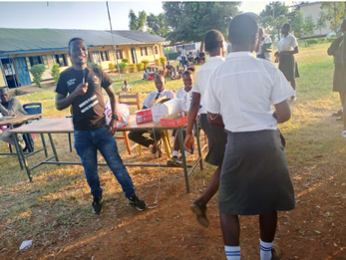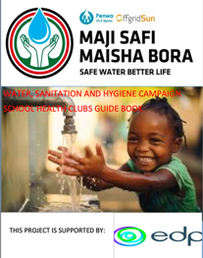
Figure 13 Picture from sensitization of schools and cover page of the guide book

SECTION D. DATA AND PARAMETERS

D.1. Data and parameters fixed ex ante or at renewal of crediting period
>>
SDG13
        - Related to water quality
Parameter ID | SDWS 1
Data/parameter | Number of household/institution per CWT/CWS
Unit | Number of end-user premises, quantity
Description | End users premises (e.g. households, institutions) within 1 km distance of project water source
Source of data | House counting
Value(s) applied | 4,705 counted in West Yimbo  5,743 counted in East Yimbo
Choice of data or Measurement methods and procedures | House counting survey: The households has been selected within the 1km circle of the planned locations of water kiosks where the people can retrieve the safe drinking water.
Purpose of data | Determination of number of eligible households.
Additional comment | N/A

Parameter ID | SDWS 2
Data/parameter | Project technology description
Unit | N/A
Description | The project applies zero emission solar powered technologies.
Source of data | Manufacturer Specifications, Workplans, Technical Assessment Report.
Value(s) applied | N/A
Choice of data or Measurement methods and procedures | Manufacturer Specifications and Technical Assessment Report as per the applicable standards.
Purpose of data | Confirmation on technology specifications and performance level
Additional comment | N/A

Parameter ID | SDWS 3
Data/parameter | Project technology performance level (CWT or CWS)
Unit | N/A
Description | The water directly supplied by the project must comply with:  - Microbial quality in line with (i) national standards or guideline for microbial quality of drinking water, or in their absence, (ii) the guideline values for verification of microbial quality from the Guidelines for drinking-water quality, 4th edition (Table 7.10, WHO, 2017); and  - Chemical quality (i) national standards or guidelines on priority chemical contamination and physical and aesthetic aspects, or in the absence of such requirements, (ii) international standards or guidelines on priority chemical contamination18 and physical and aesthetic aspects  Once at the start of the crediting period, and microbial quality at the CWS and CWT location must be retested following an event that could lead to contamination of the source water (e.g. flooding).
Source of data | Water quality test reports dated 16/10/2023 and prepared by Water Resources Authority in Kenya have been provided to the VVB. The samples taken from the pumping station where treated water is fed to the system. The coordinates of samples taken are provided in the report. Physical-chemical analysis and microbial laboratory results confirmed the water served by the system meets Kenyan drinking water standard: KS EAS 12: 2018.  The Water Resources Authority (WRA) of Kenya is the state agency responsible for regulating, managing, and protecting water resources in the country. It was established under the Water Act, 2016, replacing the former Water Resources Management Authority (WRMA). They issue water use permits for abstraction (surface and groundwater).
Value(s) applied | N/A
Choice of data or Measurement methods and procedures | Laboratories with quality accreditation will be used for water quality testing. The accreditation confirms adequate quality management plan in place which addresses both quality assurance and quality control test procedures.  The project will comply with the quality standards defined in “Guidelines on Drinking Water Quality and Effluent Monitoring” published by Water Services Regulatory Body (WASREB) that is authority to determine standards for the provision of water services to consumers and to monitor compliance with established standards for the operation and maintenance of the facilities for water services.
Purpose of data | Calculation of project scenario
Additional comment | N/A

Parameter ID | SDWS 4
Data/parameter | Regulatory framework for safe water supply
Unit | N/A
Description | List and provide a summary of any national, sub-national and local regulations or guidance for safe drinking water supply, operation and maintenance, including any tariff requirements.  Describe how the project complies with the regulatory framework.  Update at the start of each crediting period.
Source of data | National, sub-national and local authorities
Value(s) applied | N/A
Choice of data or Measurement methods and procedures | in The project is in compliance with Water Act 2016, Kenya. The Act defines ownership of and rights in water resources of Kenya.  The Water Act 2016 under Section 72 requires Water Services Regulatory Board (WASREB) to determine and prescribe national standards for the provision of water services. Guidelines on Drinking Water Quality and Effluent Monitoring contain information on establishing the minimum number of samples to be taken, water quality parameters to be measured, recording and reporting/ publication of results. Compliance with this guideline is a condition of the licence granted to the water services board.
Purpose of data | Confirmation that the project does not undermine or conflict with any national, sub-national and local regulations or guidelines for safe drinking water supply, operation and maintenance, including any tariff requirements.
Additional comment | The parameter is used for the contribution to SDG 6 to demonstrate that the water served meets the national standards.

Parameter ID | SDWS 5
Data/parameter | Water sources in the project boundary
Unit | N/A
Description | Identify the water sources in the project boundary, and identify whether they are used for drinking water, and for all that are used for drinking water, classified as improved and unimproved water source.
Source of data | Baseline Survey (Final_Baseline Survey Data_889 Maji Safi Solar.xlsx)
Value(s) applied | 98% of the target population uses unimproved water sources.
Choice of data or Measurement methods and procedures | Baseline Survey was performed
Purpose of data | Calculation of baseline scenario.
Additional comment | The parameter is used for the contribution to SDG 6 to demonstrate that the project provides access to clean drinking water.

b.Related to emission reductions
Parameter ID | SDWS 6
Data/parameter | Stove technologies used in the project boundary
Unit | N/A
Description | The proportion of different stove types used in premises in the geographical area of the project.
Source of data | Baseline Survey (Final_Baseline Survey Data_889 Maji Safi Solar.xlsx)
Value(s) applied | The following categories of stove types are identified in the project boundary:  - Three-stone fire  - Charcoal stoves  - Metallic Charcoal Stove (a conventional system for woody biomass lacking improved combustion air supply mechanism and flue gas ventilation system)  - Kenya Ceramic Jiko (improved charcoal cookstove)  - improved cookstoves (≥ 20% thermal efficiency)
  Type | Current Season | Other Season
  Only 3 stone fire | 52% | 32%
  Only charcoal cookstove | 30% | 49%
  Both 3 stone and charcoal | 17% | 17%
  Improved fuelwood | 1% | 1%
Choice of data or Measurement methods and procedures | Baseline assessment prior to validation for classification and clustering (if applicable) of baseline stove types is being conducted.
Purpose of data | Calculation of baseline scenario
Additional comment | N/A

Parameter ID | SDWS 7
Data/parameter | Expected technical life or project technology
Unit | Time period
Description | The operation lifetime of the project technology is at least 30 years as per the manufacturer specifications
Source of data | Manufacturer specifications
Value(s) applied | at least 30 years
Choice of data or Measurement methods and procedures | Manufacturer specifications
Purpose of data | Assessment of technical life against crediting period and if necessary (total crediting period ≥ expected technical life) inclusion of appropriate replacement mechanism as part of the project design.
Additional comment | N/A

Parameter ID | SDWS 8
Data/parameter | 𝑋_{f}
Unit | Percentage of fuel f use in target population
Description | Percentage of fuel f use in target population
Source of data | Baseline survey (Final_Baseline Survey Data_889 Maji Safi Solar.xlsx)
Value(s) applied
  Fuel type | Dry season | Wet season
  Fuelwood | 62% | 42 %
  Charcoal | 38% | 58%
Choice of data or Measurement methods and procedures | Questions about fuel used for water boiling were asked to the participants to the baseline survey for both seasons. Please refer to the Baseline Survey results.
Purpose of data | Calculation of baseline scenario
Additional comment | -

Parameter ID | SDWS 9
Data/parameter | EFb,f,CO2
Unit | tCO2e/TJ
Description | CO2 emission factor arising from use of wood fuel in baseline scenario
Source of data | Calculated from IPCC defaults; Volume 2:2006 IPCC Guidelines for National Greenhouse Gas Inventories, Chapter 2, Table 2.5
Value(s) applied | Fuelwood- 112  Charcoal- 165.22
Choice of data or Measurement methods and procedures | Deemed valid by Methodology
Purpose of data | Calculation of baseline scenario
Additional comment | -

Parameter ID | SDWS 10
Data/parameter | EFb,f,non CO2
Unit | tCO2e/TJ
Description | Non-CO2 (CH₄ and N₂O) emission factor arising from use of wood fuel in baseline scenario
Source of data | EFb,non CO2; calculated from IPCC defaults; Volume 2:2006 IPCC Guidelines for National Greenhouse Gas Inventories, Chapter 2, Table 2.5  Global Warming Potential (GWP); from IPCC Fifth Assessment Report (AR5) Climate Change 2013: The Physical Science Basis
Value(s) applied | Fuelwood- 9.46  Charcoal-44.83
Choice of data or Measurement methods and procedures | Deemed valid by Methodology
Purpose of data | Calculation of baseline scenario
Additional comment | -

Parameter ID | SDWS 11
Data/parameter | 𝜂_{𝑤𝑏}
Unit | Percentage
Description | Weighted average efficiency of the baseline water boiling devices. Calculate the weighted average of the water boiling efficiency in the project boundary using the proportion of different stove types used and the stove efficiencies.
Source of data | Baseline survey (Final_Baseline Survey Data_889 Maji Safi Solar.xlsx)
Value(s) applied
  Wet season | Dry season
  12.4% | 13.6%
Choice of data or Measurement methods and procedures | The following default values for cookstoves are applied to calculate the weighted average of the water boiling efficiency.
  Cookstove Type | Efficiency
  Three-stone fire | 10%
  Kenya Ceramic Jiko | 24.5%
  Metallic Charcoal Stove | 12%
  Charcoal Stoves Average | 16%
  Improved fuelwood | 30%
Purpose of data | Calculation of baseline scenario
Additional comment | Metallic charcoal stoves are classified as unimproved in the report Kenya Household Cooking Sector Study 2019 by Ministry of Energy. Table 24 summarizes the default values for voluntary performance targets and tiers. Further in page 159, A.1.7 Categorization of cookstoves and fuels chart; three-stone fire is classified as Tier 0 (<10%) and metallic charcoal stoves (without insulation) is classified as Tier 0-1 (up to 10%).  Water Boiling Test will be done to determine the thermal efficiency of metallic charcoal stoves before the first monitoring period.  Siaya County Integrated Development Plan 2018- 2022 indicates the usage rate of Ordinary Jiko or Kenya Ceramic Jiko as 10.8%. The same percentage is applied to the sample group (11% of 114 stoves) and the rest of charcoal stoves (25% of all stoves) are assumed to be Metallic Jiko.

Parameter ID | SDWS 12
Data/parameter | C_{b}
Unit | Percentage
Description | Proportion of project end-users who in the baseline were already using safe water, either from an improved water source, or from a water treatment method other than boiling.  At the start of each crediting period
Source of data | Baseline survey (Final_Baseline Survey Data_889 Maji Safi Solar.xlsx)
Value(s) applied | 36%
Choice of data or Measurement methods and procedures | The percentages for population with access to safe water (3%) and using chlorine (33%) have been summed to calculate the percentage who do not boil water.
Purpose of data | Calculation of baseline scenario
Additional comment | The primary purification method preferred by households are crosschecked by the following study:  Public Knowledge and Perception of Drinking Water Quality And Its Health Implications: An Example From The Makueni County, South-Eastern Kenya (11 February 2022). 43% of the respondents boil water, 14% use chlorine-based disinfectant and the rest uses both two methods as well as water filters.  The parameter is used for the contributions to SDG3 to demonstrate the proportion of end-users who gained access to safely managed drinking water services without water-borne diseases.

Parameter ID | SDWS 21
Data/parameter | fNRB,f,y
Unit | Percentage
Description | Non-renewability status of woody biomass fuel during year y in case the baseline fuel is biomass or charcoal
Source of data | Determined by:  CDM TOOL30, calculation of the fraction of non-renewable biomass  https://cdm.unfccc.int/DNA/fNRB/index.html
Value(s) applied | 0.76
Choice of data or Measurement methods and procedures | Calculated as per referred tool version 3.0 by 9 Eylul University, Izmir, Turkey.
Purpose of data | Calculation of baseline scenario
Additional comment | -

Parameter ID | SDWS 24
Data/parameter | 𝑄𝑃𝑊𝑝
Unit | Liters/person/day
Description | Volume of drinking water per person per day for premises type p
Source of data | Default value in the methodology
Value(s) applied | 4
Choice of data or Measurement methods and procedures | Option 1: Apply the default value per person.  In the case of institutions, such as schools, the value should reflect the expected drinking water use per person while on the premises of the institution, in line with the following defaults:  - Full-day premises: 4 L/person/day  - Boarding school: 4 L/person/day  - Half-time premises: 3 L/person/day  The default value for full-day premises is used.
Purpose of data | Calculation of baseline scenario
Additional comment | -

Parameter ID | SDWS 16
Data/parameter | EF_{ec}
Unit | tCO2/kWh
Description | Emission factor associated with electricity use
Source of data | Default value in the methodology
Value(s) applied | 0.0008
Choice of data or Measurement methods and procedures | The grid electricity use is expected to be none or minimal (less than 250kWh/yr) during the implementation of the project.
Purpose of data | Calculating project scenario
Additional comment

Parameter ID | SDWS 17
Data/parameter | TDL_{ec}
Unit | %
Description | Transmission and distribution losses associated with the electricity use
Source of data | Default value in the methodology
Value(s) applied | 20
Choice of data or Measurement methods and procedures | -
Purpose of data | Calculating project scenario
Additional comment

D.2 Data and parameters monitored
>>
SDG 13
a.Related to Water quality
Parameter ID | SDWS 18
Data / Parameter | M_{q,y}
Unit | Fraction
Description | Ongoing water quality indicated as the fraction of the samples that pass microbial quality standard requirements specified in relevant microbial quality standard for drinking water of the host country.  In case a national standard is not available, the water quality shall comply with WHO Guideline values for verification of microbial quality i.e., all water directly intended for drinking must not have detectable E.Coli in any 100 ml sample i.e., less than 1 Colony Forming Unit (CFU) of E.Coli /100 ml.
Source of data | Water quality test for samples taken from the transport containers when it reaches the end-user premises (e.g. household, institution) on 8th February 2025.
Value(s) applied | 1
Measurement methods and procedures | The water quality test applies the bacterial quality standard <1 cfu E.coli/100ml, and the sampling determines the proportion of pass and fail results.  A minimum sample size 30 will be selected.
Monitoring frequency | Annual sampling, and the first round of testing will be conducted at least after six months from the start date.
QA/QC procedures | Laboratories used for water quality testing are approved by local health authorities and/or have quality accreditation; and have an adequate quality management plan in place which addresses both quality assurance and quality control test procedures. Tests were carried out by a laboratory accredited to ISO17025: 2017 (Spectralab)  The project complies with the quality standards defined in “Guidelines on Drinking Water Quality and Effluent Monitoring” published by Water Services Regulatory Body (WASREB) that is authority to determine standards for the provision of water services to consumers and to monitor compliance with established standards for the operation and maintenance of the facilities for water services.
Purpose of data | Calculation of project scenario
Additional comment

Parameter ID | SDWS 20
Data / Parameter | Water hygiene education campaigns
Unit | N/A
Description | Hygiene campaigns carried out among project safe water end-users.
Source of data | Report of annual hygiene campaign results
Value(s) applied | 1
Measurement methods and procedures | The impacts of the hygiene campaign shall be assessed using the WHO/UNICEF Joint Monitoring Programme Core questions for drinking water and hygiene to determine the fraction of the households and institutions where Safe water and Hygiene practices are found to fulfill “safely managed” or “basic” requirements.  In-person or telephone or by messaging (e.g. text, app) based survey shall be conduct covering all the JMP core questions for drinking water and core questions for hygiene.
Monitoring frequency | Annually
QA/QC procedures | The fraction of the households where Safe water and Hygiene practices are found to fulfill “safely managed” or “basic” requirements is expected to increase over time as a result of the hygiene campaigns.
Purpose of data | Calculation of project scenario
Additional comment | The parameter is also used for the contribution to SDG 6.

b. Related to emission reductions
SDG 13
Parameter ID | SDWS 22
Data / Parameter | X_{cleanboil,y}
Unit | Percentage
Description | Proportion of project end-users that boil safe (treated, or from safe supply) water after installation of project technology in year y
Source of data | Project Survey
Value(s) applied | 0.002
Measurement methods and procedures | This survey may be performed in person, by telephone, by messaging (e.g. text, app), appropriate to the context.
Monitoring frequency | Annually
QA/QC procedures | Random sampling is done among the users within the project boundary. This is cross-checked by GPS coordinates or addresses of the participants to the survey.
Purpose of data | Calculation of project scenario
Additional comment | -

Parameter ID | SDWS 23
Data / Parameter | Q_{m,y}
Unit | Litres/year
Description | Monitored quantity of safe water provided by the CWT project in year y
Source of data | At the central location of the CWT:  Option 1: Flow meter measures water volume directly  Option 2: Operation sensor measures directly operation time or pump stroke count, and volume is calculated as capacity (defined in Project technology description) multiplied by operation time or pump strokes, depending on the sensor type.  The smart kiosks are monitored from remote and he quantity of supplied water is cross-checked by manual readings by the end of each month at each kioks. Option 1 is selected.  Meter readings are carried out regularly for the domestic/private connections.
Value(s) applied | 35,905,000  2023:1,771,000  2024:19,750,000  2025: 14,384,000
Measurement methods and procedures | Direct measurement
Monitoring frequency | Continuously
QA/QC procedures | The PD follows manufacturer, sector, national or international standards or guidelines for calibration and maintenance of the measurement device.  Total volume served is cross-checked by the readings at the pump house meter where treated water is fed to the system.
Purpose of data | Calculation of project scenario
Additional comment | The parameter is also used for the contribution to SDG 6.

Parameter ID | SDWS 25
Data / Parameter | HN_{p,y}
Unit | Number
Description | Number of individuals per premises type p in the project boundary in year y
Source of data | Project Survey
Value(s) applied | 5.44 for West Yimbo  5.29 for East Yimbo
Measurement methods and procedures | Direct measurement
Monitoring frequency | Annual
QA/QC procedures | The value applied shall be cross-checked against at least one other source on the list. For cross-check purposes, sources applied may be up to 5 years old. Further, cross-check with older sources may be used provided they provide conservative results.
Purpose of data | Calculation of project scenario
Additional comment | Household sizes are revised as per the monitoring survey done on 27-28 November 2024.

Parameter ID | SDWS 26
Data / Parameter | HH_{p,y}
Unit | Number
Description | Number of premises type p served by the project in year y
Source of data | Project Survey
Value(s) applied | 2023:  1,438 in West Yimbo  3,038 in East Yimbo  2024:  4,315 in West Yimbo  5,064 in East Yimbo
Measurement methods and procedures | How often the premises within 1km distance of the water kiosks used the project source during a year will be checked.  Premises that report at least every-two days use will be counted. A minimum 100 samples will be selected.
Monitoring frequency | Annually
QA/QC procedures | Numbers are cross-check with population data under mWater portal. This population density data is sourced from the Humanitarian Data Exchange and shared under a Creative Commons license (CC BY 4.0). The data is derived from satellite imagery using machine learning cross-referenced with census data and it is due to be updated every 3 months.
Purpose of data | Calculation of project scenario
Additional comment | The parameter will be used for SDG claims to predict number of households with limited services: Households using an improved source with water collection times of no more than 30 minutes per round trip are classified as having basic services, and those using improved sources with water collection times exceeding 30 minutes.  East Yimbo buildings are revised to exclude Nyegare kiosk that is closed due to low demand.  The estimated population for the kiosk was 1,175 and that is divided by household size of 5.29. 222 buildings have been dropped out from total 5743 to 5521, then multiplied by usage rate.

Parameter ID | SDWS 27
Data / Parameter | DO_{p,y}
Unit | Days
Description | Days the project technology is operational for end-users in premises p in year y
Source of data | Project Survey
Value(s) applied | Dry season:  2024:186  2025:93  340 Wet season:  2023: 93  2024:186  2025:62
Measurement methods and procedures | In order of preference:  1. Measure directly using operation sensor, or  2. Demonstrate from log of operation and maintenance system.
Monitoring frequency | Annually
QA/QC procedures | Values higher than 347 days may only be applied when option 1 is used.
Purpose of data | Calculation of project scenario
Additional comment | The maintenance work is assumed to be done for 211 days in dry season as the weather conditions were convenient to carry out the field work and 1 daty in wet season during the monitoring period of 619 days

Parameter ID | SDWS 34
Data / Parameter | EC_{p,y}
Unit | kWh
Description | Quantity of electricity that is used by the project during year y
Source of data | Metered consumption
Value(s) applied | Total: 64,414.  2023: 10,019  2024:38,613  2025: 15,782
Measurement methods and procedures | In case the pumps use grid electricity, hours of use are recorded and multiplied by the pumps’ specific electricity use per hour.  Grid connection is established on 3 August 2024 to ensure greater operational safety, to be able to provide sufficient pressure in rainy days in the most disadvantaged points of the system. During the monitoring period 18,769 kWh electricity is consumed from grid.
Monitoring frequency | Annual
QA/QC procedures | Manufacturer’s guidelines is followed to calculate the electricity consumption.
Purpose of data | Calculation of project scenario
Additional comment

Parameter ID | SDWS 35
Data / Parameter | LE_{y}
Unit | tCO2e per year
Description | Leakage emissions during year y
Source of data | Project Survey
Value(s) applied | 0
Measurement methods and procedures | Questions related to purification method implemented ex ante and ex post the project are asked to the respondents who stated they still purify water.
Monitoring frequency | Every two years
QA/QC procedures | Compliance with the general requirements for sampling and general requirements for data and information sources.
Purpose of data | Calculation of project scenario
Additional comment

SDG 3
Data / Parameter | Reduced incidents of water borne diseases
Unit | Percentage
Description | Proportion of the households who experienced reduced incidents of water borne diseases
Source of data | Project Survey
Value(s) applied | 97
Measurement methods and procedures | Questions about the incidents of water borne diseases in the family are asked during monitoring survey on 27-28 November 2024.
Monitoring frequency | Annually
QA/QC procedures | GPS locations of the respondents are recorded during the survey and are checked if they are within the project boundaries.
Purpose of data | Calculation of project scenario
Additional comment | -

SDG 5
Data / Parameter | Perception of time savings
Unit | Percentage
Description | Proportion of the households who perceived reduced time for collecting wood and water boiling.
Source of data | Project Survey
Value(s) applied | 99
Measurement methods and procedures | Questions are asked to understand if less time is spent on fetching firewood and water boiling during monitoring survey on 27-28 November 2024.
Monitoring frequency | Annually
QA/QC procedures | GPS locations of the respondents are recorded during the survey and are checked if they are within the project boundaries.
Purpose of data | Calculation of project scenario
Additional comment

SDG 7
Parameter ID | Total electricity produced: Renewable
Data / Parameter | RE
Unit | kWh
Description | Quantity of electricity that is produced by the solar panels during year y
Source of data | Remote metering
Value(s) applied | Total: 87,110  2023: 13,066.5  2024: 52,266  2025: 21,777.5
Measurement methods and procedures | The net electricity produced is remotely measured.
Monitoring frequency | Continuously
QA/QC procedures | The total electricity are cross- checked by pumping hours.  Total electricity consumed by the pumps are recorded as 64,414 kWh; which corresponds 4843 hours. The solar power has the capacity to fully cover the pump consumption. Once all kiosks were operational by July 2024 and the grid unidirectional connection is established on 3 August 2024 to ensure greater operational safety, to be able to provide sufficient pressure in rainy days in the most disadvantaged points of the system. The project plans to connect the photovoltaic system to the public grid under the net-metering regulation dated 26/07/2024, which has recently started to be implemented in Kenya.
Purpose of data | Calculation of project scenario
Additional comment

SDG 8
Data / Parameter | Jobs created
Unit | Number
Description | Temporary and permanent jobs created during the implementation of the project.
Source of data | Project database
Value(s) applied | 23
Measurement methods and procedures | All employees are registered and trained for implementing health and safety measures.
Monitoring frequency | Annually
QA/QC procedures | The official list of employees with their salaries is provided to the bank for monthly payments. A sample bank letter is provided to the VVB.
Purpose of data | Calculation of project scenario
Additional comment

SDG 15
Parameter ID | Amount of firewood saved by the project per year
Data / Parameter | Amount of fuelwood saved
Unit | ton
Description | Amount of fuelwood saved due to avoided water boiling for purification.
Source of data | Project database
Value(s) applied | 4,100.7  2023: 192.8  2024: 2,250.1  2025: 1,657.8
Measurement methods and procedures | Amount of fuelwood used will be calculated by the following formula:  Amount of fuelwood saved= (𝑆𝐸𝑤,𝑏,𝑦 * ((1 − 𝐶𝑏 − 𝑋𝑐𝑙𝑒𝑎𝑛𝑏𝑜𝑖𝑙,𝑦)*𝑄𝑦)/ NCV_{fuelwood}
Monitoring frequency | Annually
QA/QC procedures | The total fuelwood saved are cross- checked by questions regarding the use of fuelwood during the project survey.
Purpose of data | Calculation of project scenario
Additional comment

Safeguarding Principle 9.5 Hazardous and non-hazardous waste
Data / Parameter | Transfer of chlorine
Unit | N/A
Description | The chemicals are transferred and stored in impermeable containers.
Source of data | Declaration of the project staff that no incidence of leakage happened in the monitoring period.
Value(s) applied | -
Measurement methods and procedures | Granular form of chlorine was applied during the monitoring period. The product name Dayliff Chlorine 65 provided by David&Shirtliff company in Kenya. The company has Integrated Management Policy and follows the requirements of ISO9001, ISO14001 and ISO45001 standards.  The project staff responsible from the maintenance are trained about handling chlorine safely and measures to be taken in case of leakage.
Monitoring frequency | Annually
QA/QC procedures | The amount of chlorine purchased is recorded and checked by the operating staff. Necessary measures are taken to avoid leakages. Dosatron technology is applied which is safe to avoid leakages.
Purpose of data | Maintaining safe operation of the water treatment facility.
Additional comment

D.3. Comparison of monitored parameters with last monitoring period

Not applicable as this is the first monitoring period.
Data/Parameter | Value obtained in this monitoring period | Value obtained last monitoring period

D.4. Implementation of sampling plan
>>
Project Surveys and Water Quality Tests
The project survey for the monitoring period has been carried out on 27-28 November 2024 for the monitoring period roughly covering 20 months (20/09/2023-31/05/2025). Operational conditions were stable throughout the period. Sampling covers all 19 kiosks within 1 km perimeter from each serving point.

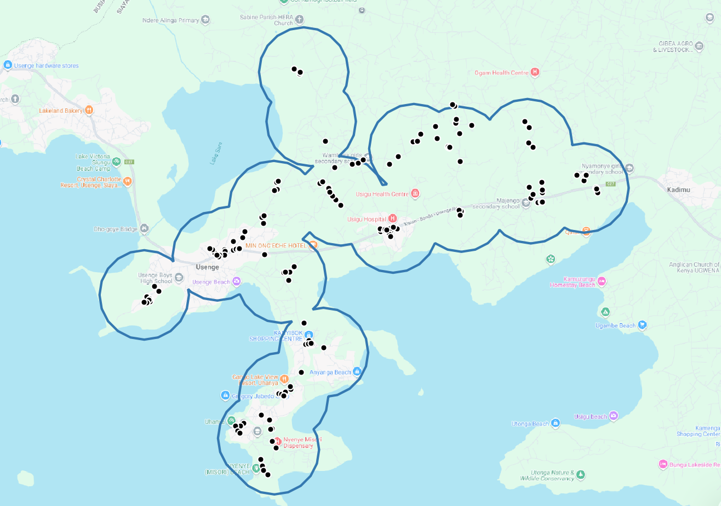
Figure 14. Selected samples for the monitoring survey

Project survey aims to collect data of project beneficiaries regarding the following parameters:
- Proportion of project end-users that boil safe water
- Number of individuals per premises
- Number of premises served. Premises that report at least every-two days use will be counted
- WASH related questions about hygienic handling of clean water
- Instances of water-borne diseases
- Time savings due to omitted water boiling

At least 100 households need to be sampled when the target groups size is > 1000
The sample of 157 households were selected based on the population served in line with the above stated requirements. The survey results comply with 90/10 precision/confidence level.

Ongoing water quality indicated as the fraction of the samples that pass microbial quality standard requirements specified in relevant microbial quality standard for drinking water of the host country. Among the same households, 40 samples have been selected for the purpose.

Table 8. Monitoring Frequency Compliance Summary
Monitoring Activity | SDWS Parameter | PDD Frequency | Date Conducted | Sample Size / Coverage | Compliance Status
Technology Performance Water Quality Test (fixed ex-ante) | SDWS 3 | Once at start of crediting period; retest if source-water contamination event occurs | 16 October 2023 | Samples at pumping station (treated water output); tested by WRA Kisumu laboratory | Compliant — KS EAS 12:2018 met. Apr–May 2024 flooding affected pump house only (no source contamination); retest not triggered.
Ongoing Water Quality Sampling (Mq,y) | SDWS 18 | Annual (first test ≥ 6 months after project start) | 8 February 2025 | 40 samples from end-user transport containers (jerry cans) at household/kiosk level; tested at ISO 17025-accredited Spectralab laboratory | Compliant — 100% pass rate (Mq,y = 1). Conducted ~17 months after project start, satisfying the ≥ 6-month minimum condition.
Annual Monitoring Survey (household survey) | SDWS 22, 25, 26 & SDG co-benefits | Annual | 27–28 November 2024 | 157 households; exceeds minimum sample of 100 for population > 1,000; 90/10 confidence/precision achieved | Compliant — conducted ~14 months after project start. Timing justified by progressive kiosk rollout (see rationale below).

Rationale for single annual monitoring survey applied to the full monitoring period (~20 months, 20/09/2023–31/05/2025): The project kiosks were commissioned progressively between 20 September 2023 and 5 July 2024, with the final serving point (Ruwe-Usenge Kiosk) becoming operational on 05/07/2024. The annual monitoring survey was intentionally timed for 27–28 November 2024 to ensure all 19 serving points were fully commissioned and the user base had stabilized under representative operational conditions. In accordance with the General Guidelines for SSC CDM Methodologies (version 23.1, Section 4.8, paragraphs 26–27), survey results may be applied for monitoring periods of up to 12 months after the survey date provided: (i) average equipment lifetime ≥ 4 years — confirmed (minimum 20 years per Table 6 of this Monitoring Report); and (ii) ≥ 50% of distributed units were functional in the previous survey — not applicable to the first monitoring period (paragraph 27). The first survey must be conducted within 24 months of implementing the first unit (paragraph 26); this is met (survey conducted 14 months after first kiosk start). The survey achieved the required 90/10 confidence/precision standard across 157 sampled households, statistically confirming its applicability to the full ~20-month monitoring period.

Following results have been obtained:
- 92% of households fetch water every 2 days or more frequently.
- 6 out of 157 repondents said that they are boiling 5% of drinking water; which equals to 0.002%.
- 99% of households confirmed that they spend less time to fetch water while 95% indicated time required id less than 30 minutes. Basic level service conditions are met; which is “Drinking water from an improved source, provided collection time is not more than 30 minutes for a roundtrip including queuing”
- 86% respondents confirmed that the indoor pollution has decreased, and 89% confirmed that respiratory diseases are less observed.
- 97% of respondents confirmed that the occurrence of water-borne diseases has dropped. This is in line with the rate of users who fetch drinking water form project points.
- 40 samples were taken to test absence/presence of E.Coli and all of them found to be clean (100%). All samples are taken from the containers of water kiosk users in 8th February 2025. Although the households are recorded as private connections; all have a stand tap in the compound where they fetch water with containers. The additional connections inside the house are done at owners will and cost; therefore, not preferred by the users.

Hygiene questions
- Almost all of the users (97%) have hand washing facility with water available.
- Soap and detergent were available in 96% of the households who have hand washing facility.

SECTION E. CALCULATION OF SDG IMPACTS

E.1. Calculation of baseline value or estimation of baseline situation of each SDG Impact
>>
SDG 13: Take urgent action to combat climate change and its impacts
Parameter: Emission reductions achieved by fuelwood savings at household level

Baseline emission is calculated by the following formula for dry and wet seasons separately:
𝐵𝐸𝑦 = 𝐸𝐹𝑏 × (1 − 𝐶𝑏 − 𝑋𝑐𝑙𝑒𝑎𝑛𝑏𝑜𝑖𝑙,𝑦) × 𝑄𝑦 × 𝑀𝑞,𝑦

Parameter | Unit | Description | Data Source | Value
EF_{b} | tCO2e/L | Emission factor for the use of fuel to obtain safe water in the baseline (tCO2e/L) | Calculated | Dry season: 0.000358  Wet Season: 0.000369
𝐶𝑏 | Percentage | Proportion of project end-users who in the baseline were already using a safe water supply that did not require boiling | Baseline Survey | 36%
𝑋𝑐𝑙𝑒𝑎𝑛𝑏𝑜𝑖𝑙,𝑦 | Percentage | Proportion of project end-users that boil safe water in the project year y | Monitoring Survey | 0.002%
𝑄𝑦 | L | Quantity of safe drinking water provided by the project in year y | Metered (Q_{m,y}) | Dry Season:19,696,000  Wet Season:16,209,000
HNp,y | Number | Number of individuals per premises type p (e.g. household, school) in year y | Monitoring survey | 5.29 for East Yimbo, 5.44 for West Yimbo
HHp,y | Number | Number of premises type p served by the project in year y | House count, corrected by usage rate | 5,064 for East Yimbo;4,315 for West Yimbo
QPWp | L/pp | Volume of drinking water per person per day for premises type p | Default value | 4
𝑀𝑞,𝑦 | Fraction | Modifier for the water quality in year y | Microbial quality tests | 1
DOp,y | Days | Days the project technology is operational for end-users in premises p in year y | Maintanance records | 212
Total population and amount of water served are calculated as follows:
Pop East Yimbo= 5,064 houses x 5.29 person per house = 26,783
Pop West Yimbo= 4,315 houses x 5.44 persons per house =23,474
Total Pop=50,257
This value has been cross-check by mWater data which indicates 43,288 people living in the service area. In order to follow a conservative approach, the project takes into account the mWater population.

Q_{pop,y}= (43,288 x 4 lt x 279 days)=48,231,490 Lt for Dry season.
211 maintenance days have been recorded for Dry Season. Amount of water that should be dropped from total water served is calculated as follows:

Water loss due to maintenance=Average Water consumption per day per kiosks x Number of maintenance days

Average water consumption per kiosks= ((43,288 (Pop)x 4 liter/pp)/19 kiosks)=9,113 liters x 211 days=1,922,899 liters
Q_{pop,y}=46,308,591

Q_{pop,y} =43,288 x4 lt x 340 days =58,949,598 Lt for Wet Season
Dropping 1 day consumption due to maintenance service (9,113 liters); total amount served is 58,940,485 liters

Total Q_{pop,y} =105,249,076 lt for the monitoring period.

Measured water consumption through kiosks and private connections during the monitoring period is 35, 905,000 liters (Q_{m,y}). Although the actual amount of water pumped from treatment plant to the system is 80,549,000 liters, a big portion of this amount is lost due to theft and cannot reach to the paying users.
Once the water loss detected, the infrastructure has been checked for evidence of leakages, and none was detected. Therefore, the loss is suspected to come from thefts which is identified one of reason for high non-revenue water rates in Kenya. The estimated Kenya’s average of NRW ratio was 41% (2017-2018) as Non-revenue Water Management Annual Report-2017-2018
Siaya -Bondo Water and Sanitation Company (SIBOWASCO) reported 52% non-revenue water rate for 2023/2024 period. That is higher than the country average.
Breakdown of seasons are as follows:

Dry season: Q_{m,y}= 19,696,000 liters
Wet season: Q_{m,y}= 16,209,000 liters

Quantity of safe drinking water provided by the project is calculated as follows:

Qy = Min(Q_{m,y}; Q_{pop,y})
Dry season : Min (46,308,591; 19,696,000)= 19,696,000 liters
Wet season: Min (58,940,485; 16,209,000)= 16,209,000 liters

Baseline emissions are calculated as per season and year as follows:
Years | 2023 | 2024 |  | 2025
Season | Wet | Dry | Wet | Dry | Wet
Q_{y} | 1,771,000 | 10,270,000 | 9,480,000 | 9,426,000 | 4,958,000
BE | 416 | 2,348 | 2,230 | 2,155 | 1,166
Annual Sum | 416 | 4,578 |  | 3,321
GRAND TOTAL | 8,315

SDG 15. Protect, restore and promote sustainable use of terrestrial ecosystems, sustainably manage forests, combat desertification, and halt and reverse land degradation and halt biodiversity loss
Parameter: Amount of firewood saved by the project per year
Amount of firewood saved is zero in baseline scenario.
SDG 6. Ensure availability and sustainable management of water and sanitation for all

Parameters:
- Amount of safe water served at the required quality by national standards.
- Increased awareness due to annual Water hygiene campaigns
Amount of safe water served is zero in the baseline scenario as a high proportion of the target population (92.3%) was drinking water either from the lake or from the river as per the baseline survey.

SDG 7. Ensure access to affordable, reliable, sustainable and modern energy for all
Parameter: Total electricity produced -Renewable
Total renewable energy generated is zero in the baseline scenario.
SDG 3. Ensure healthy lives and promote well-being for all at all ages

Parameter: Proportion of target population using safely managed drinking water services without water-borne diseases
The proportion of people using safe water in the baseline scenario is zero scenario as a high proportion of the target population (92.3%) was drinking water from the lake or river as per the baseline survey.
SDG 5. Achieve gender equality and empower all women and girls
Parameter: Proportion of households who perceive saved time from collecting wood and water boiling
No time savings is accountable without the implementation of the project.
SDG 8. Promote sustained, inclusive and sustainable economic growth, full and productive employment and decent work for all
Parameter: Number of temporary and permanent jobs created
No jobs were available without the implementation of the project.

E.2. Calculation of project value or estimation of project situation of each SDG Impact
>>
SDG 13: Take urgent action to combat climate change and its impacts
Parameter: Emission reductions achieved by fuelwood savings at household level

The pumping system was connected to the grid on 3 August 2024 to ensure greater operational safety, to be able to provide sufficient pressure in rainy days in the most disadvantaged points of the system. The water supply system consumed 10,224 kWh and 8,545.22kWh grid electricity to run the system in 2024 and 2025 respectively. The default grid emission factor by the methodology is 0.0008 tCO2e/kWh and a default 20% transmission lost is accounted. Project emissions due to grid electricity consumption is calculated by the following formula:

$$PE= {EC}_{p,y }x{EF}_{ec}x ( 1+{TDL}_{ec})$$
Where;
${EC}_{p,y }$ =Quantity of electricity that is used by the project during year y (kWh)
${EF}_{ec}$= Emission factor associated with the electricity use (tCO2/kWh)
${TDL}_{ec}$ = Transmission and distribution losses associated with the electricity use (%)

Project emissions (2024)= 10224 kWh x 0.0008 tCO2e/kWh x (1+20%)= 9.8 tCO2e, rounded up 10 tCO2e

Project emissions (2025)= 8545.22 kWh x 0.0008 tCO2e/kWh x (1+20%)= 8.2 tCO2e, rounded up to 9 tCO2e

SDG 15. Protect, restore and promote sustainable use of terrestrial ecosystems, sustainably manage forests, combat desertification, and halt and reverse land degradation and halt biodiversity loss
Parameter: Amount of firewood saved by the project per year
Amount of firewood saved is calculated by the formula:
Amount of fuelwood saved= (𝑆𝐸𝑤,𝑏,𝑦 * ((1 − 𝐶𝑏 − 𝑋𝑐𝑙𝑒𝑎𝑛𝑏𝑜𝑖𝑙,𝑦)*𝑄𝑦)/ NCVfuelwood
=(2,900.09 kJ/L*(1-0.36-0)*19,696,000 L )+(2,661.03 kJ/L*(1-0.36-0)* 16,209,000 L)/0.0156 TJ/t =4100.7 tonnes of firewood

SDG 6. Ensure availability and sustainable management of water and sanitation for all

Parameters:
- Amount of safe water served at the required quality by national standards.
- Increased awareness due to annual Water hygiene campaigns
- Amount of safe water served is metered as 35,905,000 liters. Although the actual amount of water pumped from treatment plant to the system is 80,549,000 liters, a big portion of this amount is lost due to theft and cannot reach to the paying users.
- Trainings, distribution of educational material, sensitization of households and children at schools were provided during the WASH campaign that enabled the project reaching at different levels of the community.
SDG 7. Ensure access to affordable, reliable, sustainable and modern energy for all
Parameter: Total electricity produced -Renewable
Total renewable energy generated is 87,110 kWh. This is remotely metered value for the system during the monitoring period.
Total renewable electricity generated by the solar panels surpasses the consumption by the pumps and the remaining cannot be fed to the grid at the time of reporting. The project plans to connect the photovoltaic system to the public grid under the net-metering regulation dated 26/07/2024, which has recently started to be implemented in Kenya. The net-metering regulation allows to compensate the energy taken from the grid with the energy injected to the grid and pay just the difference between consumption and injection. According to this regulation, the project will do an agreement with Kenya Power to use the pump during the night with the grid electricity and compensate that amount with the daily surplus of energy from the project’s photovoltaic system.

SDG 3. Ensure healthy lives and promote well-being for all at all ages

Parameter: Proportion of target population using safely managed drinking water services without water-borne diseases
The proportion of people using safe water is monitored as 92% within the 1 km perimeter of the water supply points.
SDG 5. Achieve gender equality and empower all women and girls
Parameter: Proportion of households who perceive saved time from collecting wood and water boiling
99% of the respondents confirmed time savings due to the project implementation.
SDG 8. Promote sustained, inclusive and sustainable economic growth, full and productive employment and decent work for all
Parameter: Number of temporary and permanent jobs created
23 permanent jobs are created. The list of employees is provided to the VVB.

E.3. Calculation of leakage
>>
Leakage emission are deemed to be negligible due to the nature and size of the project.

E.4. Calculation of net benefits or direct calculation for each SDG Impact
SDG | SDG Impact | Baseline  estimate | Project  estimate | Net  benefit
13 | Emission reductions achieved by fuelwood savings at household level | 8315 | 19 | 8296
15 | Amount of firewood saved by the project per year | 0 | 4100.7 | 4100.7
6 | Amount of safe water served at the required quality by national standards.  Increased awareness due to annual Water hygiene campaigns | 0 | 35,905 | 35,905
7 | Total electricity produced -Renewable | 0 | 87,110 | 87,110
3 | Proportion of target population using safely managed drinking water services without water-borne diseases | 0 | 97% | 97%
5 | Proportion of households who perceive saved time from collecting wood and water boiling | 0 | 99% | 99%
8 | Number of temporary and permanent jobs created | 0 | 23 | 23

E.5. Comparison of actual SDG Impacts with estimates in approved PDD
SDG | Values estimated in ex ante calculation of approved PDD  for this monitoring period | Actual values achieved during this monitoring period
13 | 24,276 | 8,306
15 | 12,512.6 | 4,100.7
6 | 109,749.5 | 35,905
7 | 131,757.5 | 87,110
3 | 95% | 97%
5 | 95% | 99%
8 | 25 | 23

E.5.1. Explanation of calculation of value estimated ex ante calculation of approved PDD for this monitoring period
>>
SDG 13. Emission reductions achieved by fuelwood savings at household level
Annual emission reductions are estimated as 14,315 tCO2eq annually. Total duration of this monitoring period is 619 days; therefore ex ante estimate for this monitoring period is:
ER= 14,315 tCO2eq/y x (619 days/365 days)= 24,276 tCO2eq for the monitoring period
SDG.15 Amount of firewood saved by the project per year
Amount of firewood is calculated based on the estimate that 7,378.2 tonnes will be saved annually by families as follows:
Firewood saved for MP=7,378.2 ton/y x (619 days/365 days)= 12,512.6 tonnes
SDG.6 Amount of safe water served at the required quality by national standards.
Total population is estimated to be 47,881 within water service area covered by all kiosks. Total consumption per year was estimated as 64,715 m³ based on 4 liters consumption per day. Total water served for the monitoring period is estimated as:
Water served for MP= 64,715m³/y x (619 days/365 days)=109,749.5 m³
SDG 7. Total electricity produced -Renewable
Annual generation of solar powered electricity was calculated as 77,692.25 kWh annually which corresponds to 131,757.5 for the monitoring period.
Electricity generated= 77,692.25 kWh/y x(619 days/365 days) =131,757.5 kWh
SDG 3. Proportion of target population using safely managed drinking water services without water-borne diseases
95% of the population is estimated to report reduced water-borne diseases
SDG 5. Proportion of households who perceive saved time from collecting wood and water boiling
95% of women is estimated to save time from fuelwood collection and water boiling
SDG 8. Number of temporary and permanent jobs created
25 jobs are estimated to be created.

E.6. Remarks on increase in achieved SDG Impacts from estimated value in approved PDD
>>
Only increase is observed in impacts on SDG 3 and SDG 5 where a higher percentage of respondents confirmed reduced water-borne diseases and time savings due to project implementation compared to the ex ante estimate.

SECTION F. SAFEGUARDS REPORTING
>>
Principles | Mitigation Measures added to the Monitoring Plan
Principle 9.5 Hazardous and non-hazardous waste | The project involves the use of Chlorine in water treatment. The chemicals will be transferred and stored in impermeable containers. Necessary health and safety measures will be taken in order to minimize the exposure to the environment.

Please see Section D.2 for the monitoring results.

SECTION G. STAKEHOLDER INPUTS AND LEGAL DISPUTES

G.1. List all Inputs and Grievances which have been received via the Continuous Input and Grievance Mechanism together with their respective responses/mitigations.
>>
There are 23 feed-backs received through suggestion boxes. Most of the comments were related with cuts in water services due to illegal connections and issues regarding repair. All of them have addressed and solved.

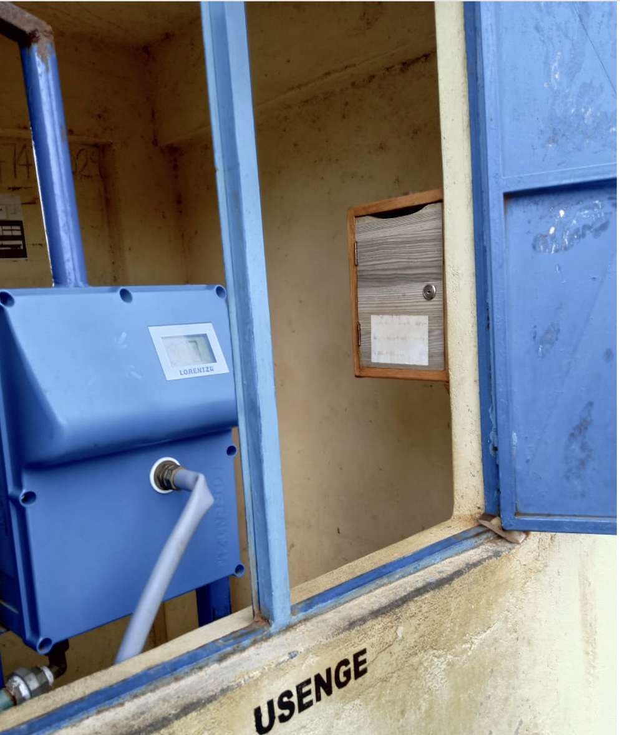
Figure 15. Suggestion box in Usenge

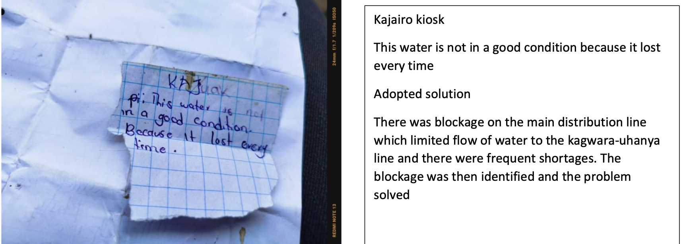
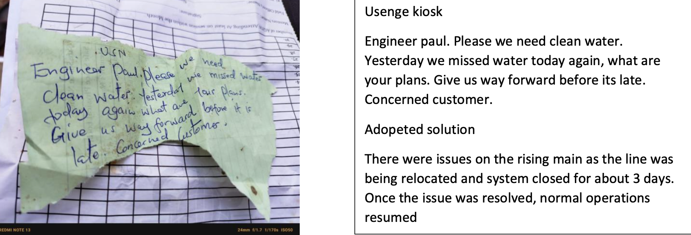
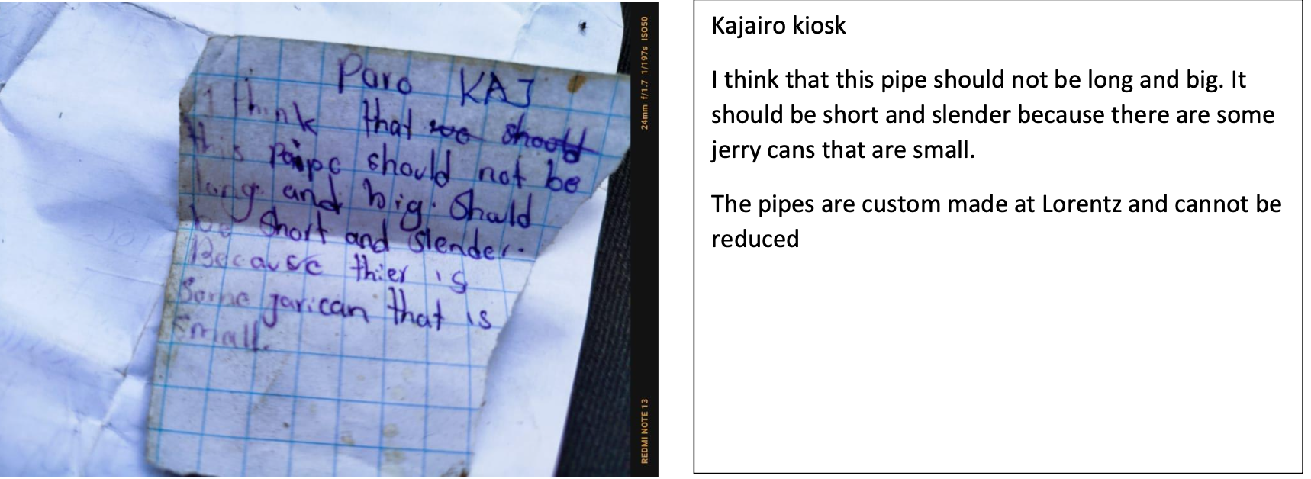

G.2. Report on any stakeholder mitigations that were agreed to be monitored.
>>
N/A

G.3. Provide details of any legal contest that has arisen with the project during the monitoring period
>>
N/A

Revision History

Version | Date | Remarks
1.1 | 14 October 2020 | Hyperlinked section summary to enable quick access to key sections  Improved clarity on Key Project Information  Section for POA monitoring  Forward action request section  Improved Clarity on SDG contribution/SDG Impact term used throughout  Clarity on safeguard reporting  Clarity on design changes  Leakage section added for VER/CER projects  Addition of Comparison of monitored parameters with last monitoring period  Provision of an accompanying Guide to help the user understand detailed rules and requirements
1.0 | 10 July 2017 | Initial adoption
2.5 | 18 March 2026 | Section D.4 updated: monitoring frequency compliance summary table (Table 8) and survey applicability rationale added in response to Gold Standard review comments (PERR Rd.3, items 4.3, 4.16, 4.19). Version number and completion date updated accordingly.

https://globalgoals.goldstandard.org/429-ee-sws-emission-reductions-from-safe-drinking-water-supply/
https://www.goldstandard.org/project-developers/standard-documents
https://globalgoals.goldstandard.org/201-ar-community-services-activity-requirements/
The system has an unidirectional connection to the grid and awating for the approval for switching to bidirectional state. Net-metering regulation dated 26/07/2024,has recently started to be implemented in Kenya. Once it is granted, the electricity consumption will be offset by the renewable energy fed back into the grid.
Confirmation from the contractor
https://www.water.go.ke/sites/default/files/publications/Annual%20Report%20Non%20Revenue%20Water%20finall.pdf
https://sibowasco.co.ke/wp-content/uploads/2024/12/SIBOWASCO-LATEST-TARIFF.pdf
https://www.who.int/publications/i/item/9789241549950
https://wra.go.ke/water-use-allocation/
https://wasreb.go.ke/downloads/Water_Quality_&_Effluent_Monitoring_Guidelines.pdf
https://wasreb.go.ke/downloads/Water%20Act%202016.pdf
https://wasreb.go.ke/downloads/Water_Quality_&_Effluent_Monitoring_Guidelines.pdf
https://www.ipcc-nggip.iges.or.jp/public/2006gl/
https://www.ipcc.ch/report/ar5/wg1/
https://eedadvisory.com/wp-content/uploads/2020/09/MoE-2019-Kenya-Cooking-Sector-Study-compressed.pdf
13.3 Energy Access, page 20, (https://repository.kippra.or.ke/bitstream/handle/123456789/1218/2018-2022%20%20Siaya%20County%20CIDP.pdf?sequence=1&isAllowed=y)
V) Watre treatement, page 13 (https://www.mdpi.com/1660-4601/19/8/4530/htm)
Applicable until 31/12/2025 as per GS Rule Update: fNRB Application for GS4GG Certification
https://spectralab.co.ke
https://wasreb.go.ke/downloads/Water_Quality_&_Effluent_Monitoring_Guidelines.pdf
https://portal.mwater.co/?source=post_page---------------------------#/resource_center/population_density
https://new.kenyalaw.org/akn/ke/act/ln/2024/104/eng@2024-07-26
https://www.davisandshirtliff.com/products-and-solutions/product/dayliff-chemicals
https://www.davisandshirtliff.com/integrated-management-system-policy-01
https://washdata.org/monitoring/drinking-water
https://www.water.go.ke/sites/default/files/publications/Annual%20Report%20Non%20Revenue%20Water%20finall.pdf
https://sibowasco.co.ke/wp-content/uploads/2024/12/SIBOWASCO-LATEST-TARIFF.pdf
https://new.kenyalaw.org/akn/ke/act/ln/2024/104/eng@2024-07-26
Whenever emission reductions are capped, both the original and capped values used for calculations must be transparently reported. Use brackets to denote original values.

