Design Change MemO

PUBLICATION DATE 04.03.2021
VERSION v. 1.1

KEY PROJECT INFORMATION

GS ID (s) | 1729
Title of Project | Myanmar Stoves Campaign
Start date of any New measures/Technologies: | 05/01/2022
Date of Memo Submission (must be within 1 year of start date above): | 22/08/2022

Details of Proposed Design Change
>>
Soneva Foundation, the CME and project developer of the Myanmar Stoves Campaign (PoA GS 1729), is applying for a design change review. Since the project inception, the Myanmar Stoves Campaign has been using the Envirofit M-5000 (later renamed as SuperSaver GL) as our project stove. This stove is used right from the project inception till the present. The manufacturer of these stoves, Envirofit (US) has however, in late 2019 had prompted about the uncertainty in production and selling of these stoves going further, due to which Soneva Foundation had to look out for and select a suitable alternative to our existing stove and safeguard the project from being adversely impacted due to shortage of stove supplies. The new stove is going to be SuperSaver AI, which is identical to the M-5000, in terms of efficiency and usability, also Envirofit (INDIA) has assured the supply of cookstoves and the model (SuperSaver AI or PCS-1) supplied by them.

Following is the efficiency of the new stove:

Stove type | Efficiency
SuperSaver AI (PCS-1) | 36.5%

The technical details of the new SuperSaver AI, and all other relevant information of this stove change has been summarized and presented in the design change review memo. Soneva Foundation also engaged with the local population in Myanmar who are the target group for this project to get their feedback on the Stove.

SuperSaver AI or PCS - 1 | Specifications
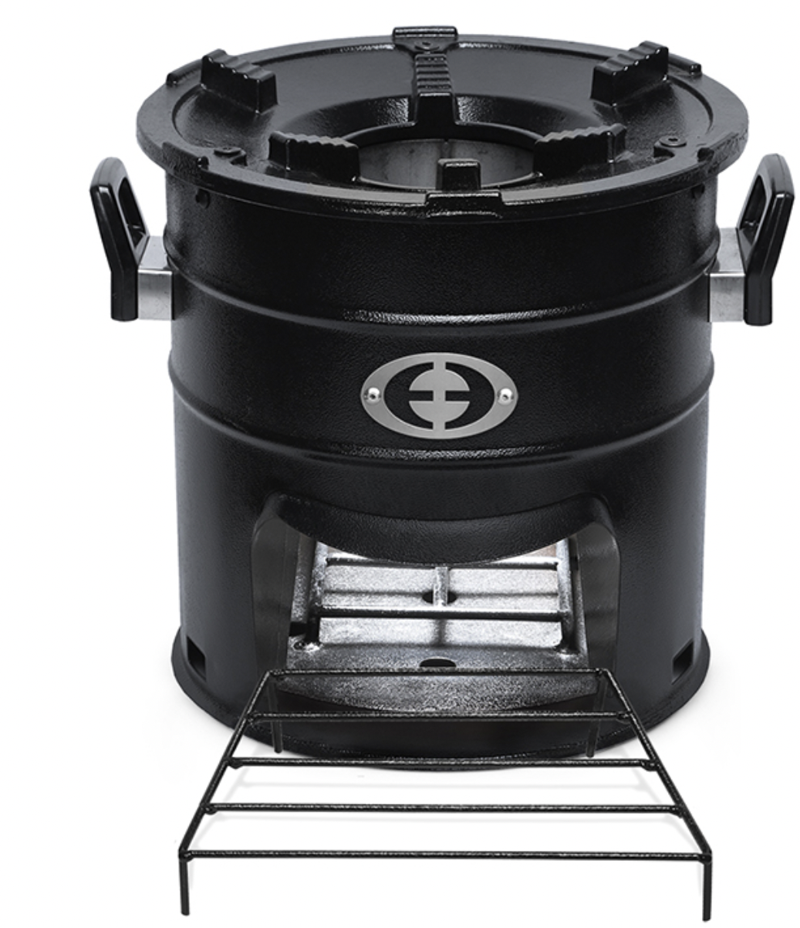 | - Unit Size (cm)  26 x 31 x 27  - Unit Weight  5.1 KG  - Fuel Use Reduction  60%  - CO2 Reduction  60%  - Warranty  2 years  - Est. Lifespan  5 years

For further comparison between the stoves, please refer the test reports of these stoves provided with the design change request documentation Below is the impact of this change on the following aspects of this project:
Implementation Plan: Currently, the Soneva Foundation, has around more than 6,000 of the M-5000 stoves with it, planned to be distributed in the coming months. The distribution of the new SuperSaver AI is to be conducted in either of the scenarios below:

A) SuperSaver AI to be used after all the current Envirofit M-5000 inventory is over.

Rest of the implementation process remains the same with our current implementation partner, Mercy Corps as outlined in our PoA-DD. However, if in future, more implementation partners are on-boarded, then we will inform GS about it and submit that specific request under a review.

Describe the Impacts of Design Change on the following
- Additionality
>>
There is no impact to the additionality due to this change in the project cookstove. The new cookstoves would still be distributed with the same subsidy model, like it’s being done now. Without the carbon finance subsidy, this new stove distribution/project would not be able to go ahead. The project does not benefit from any official development assistance, and depends entirely on the revenue from future sales of carbon credits arising from this project to cover the stove subsidy, distribution and sales, operations and management costs.

- Applicability of methodology and other methodological regulatory documents with which the project activity has been certified
>>
The project will continue to adhere to micro-scale rules, and the total emission reductions applied per VPA would be maximum of 10,000 VERs. It is also worth noticing that the stove efficiencies for both are only different by 0.1%, hence, this change would not have any noticeable impact on our VER calculations of scale of project. The project would continue to follow ‘The Gold Standard Simplified Methodology for Efficient Cookstoves, Version 01, February 2013, and Version 1.1 April 2020’ the same original methodology going forward. The target users remain the same, i.e.., households/domestic users, currently using three-stone fires and firewood to cook under baseline conditions.

- Compliance with the monitoring plan and the applied methodology
>>
The project would continue to follow ‘The Gold Standard Simplified Methodology for Efficient Cookstoves, Version 01, February 2013, and Version 1.1 April 2020’ the same original methodology going forward. The transition to Greenway Stove/SuperSaver AI from the current Envirofit stove does not have any impact on the monitoring plans. The monitoring plant applied for our previous VPAs will be the same for the future ones with the new stoves as well.

- Level of accuracy and completeness in the monitoring of the project activity compared with the requirements contained in the registered monitoring plan
>>
The project would continue to follow ‘The Gold Standard Simplified Methodology for Efficient Cookstoves, Version 01, February 2013, and Version 1.1 April 2020’ the same original methodology going forward. The issue of double counting would be completely avoided as SuperSaver AI stove comes with a unique serial number etched to the body of the stove. This serial number is unique to each stove user and is recorded at the point of sale and during annual monitoring and can be traced in the user database for any verification/Objective observer checks. Soneva Foundation also confirms that the Myanmar Stoves Campaign is only registered with the Gold Standard and no other carbon standard.

- Project Scale (note suppressed demand rules for large scale)
>>
The project will continue to adhere to micro-scale rules, and the total emission reductions applied per VPA would be maximum of 10,000 VERs.

- Stakeholder feedback on design change
>>
Soneva Foundation along with the implementation partner, Mercy Corps Myanmar ran field tests of the new SuperSaver AI stoves in Myanmar, and gained a positive response from the target group.

- Sustainable Development Assessment
>>
The transition to SuperSaver AI from the current Envirofit stove does not have any impact on the SDA or the monitoring plans. The sustainable development assessment applied for our previous VPAs will be the same for the future ones with the new stoves as well. Hence, no change in the sustainable development monitoring plan would be required.

- Safeguarding Assessment
>>
The transition to SuperSaver AI from the current Envirofit stove does not have any impact on the SA or the monitoring plans. The safeguarding assessment applied for our previous VPAs will be the same for the future ones with the new stoves as well. Hence, no change in the safeguarding assessment would be required.

- Legislation
>>
The introduction of SuperSaver AI stoves into the project does not require any special permissions or licenses from the concerned authorities.

Emission Reductions Before Change (as per PDD) | 8607
Emission Reductions After Change (as per PDD) | 9502 (for SuperSaver AI)

Documentation submitted
>>
31/08/2022

https://envirofit.org/product/cookstoves/supersaver-ai-wood/

