Stakeholder Consultation Report

PUBLICATION DATE 05.05.2022
VERSION v. 2.0
RELATED SUPPORT

TEMPLATE GUIDE Stakeholder Consultation Report v.2.0

This is a report template to be used for filling the information pertaining to Local Stakeholder Consultation and Stakeholder Feedback Round conducted in line with the Stakeholder Consultation and Engagement Requirements.

This document contains the following Sections
Key Project Information
Grouped Consultation Information
SECTION A - Information made available to Stakeholders
SECTION B - Invitations made to Stakeholders
SECTION C - Report of the Consultation Process
SECTION D - Continuous input / Grievance mechanism
SECTION E - Stakeholder Feedback Round

This template has been revised to aid a consistent interpretation and to better support project developers submitting documentation for certification. Please read the accompanying guide to understand how to complete this template accurately.- TEMPLATE GUIDE Stakeholder Consultation Report v. 1.2
Please delete blue text boxes upon completion

KEY PROJECT INFORMATION
GS ID of Project | 1729 – PoA ID
Title of Project | Myanmar Stove Campaign
Version number of this Report | 1.0
Completion date of version | 25/01/2023
Time of First Submission Date | 25/01/2023
Start Date of the Project | 08/03/2015
Date of Meeting (s) | 15/09/2022
Project Cycle: | Regular  Retroactive

grouped consultation INFORMATION
GS ID of Real Case VPA | NA
Title of Real Case VPA | NA
Geographical Boundary of Grouped Consultation | NA
Technology covered by the Grouped Consultation | NA
Validity Period | NA
Anticipated number of VPAs | NA

INFORMATION MADE AVAILABLE TO STAKEHOLDERS
        - Preliminary agenda for the meeting
>>
The Stakeholder feedback round has been planned to consider and receive feedback from all the possible stakeholders to the project, i.e., local villagers, farmers, community members, O&M suppliers, local government bodies, O&M operators and employees. Apart from these the stakeholders as identified by Gold standard Board: -
Agenda-
- Registration
- Opening of the meeting and Introduction of MSC team, SD and SAs
- from Pyin Oo Lwin
- Explanation of the project + Questions & Answers
- Focus group discussion on fuel usage
- Feedback questions
- Demonstration on FES Stove usage
- Closure of the meeting & Lunch
        - A non–technical summary of the project
>>
The purpose of this PoA is the use of carbon finance to support the dissemination and maintenance of domestic and non-domestic Fuel-Efficient Stoves ("FES") through local Implementation Partners ("IP") in Myanmar.

Household energy surveys conducted in rural communities in the Dry Zone and Delta Region in Myanmar confirm that the current cooking practice is the use of "three stone fires" with wood as the predominant fuel. By using the FES, families will replace the traditional three-stone fires with a superior technology that brings considerable additional benefits.
        - Contact details to get further technical detail and project information
>>
Mr. Arnfinn Oines, Secretary
Email id - arnfinn@soneva.com
        - Summary of economic, social and environmental impacts of the Project
>>
The PoA will contribute to the sustainable development in Myanmar by offering specific environmental, social and economic benefits.
- Improving household air quality: According to the WHO nearly 50% of pneumonia deaths amongst children under five are due to smoke and particulate matter inhaled from indoor air pollution. People exposed to heavy indoor smoke are 2-3 times more likely to develop chronic obstructive respiratory diseases. By using the clean burning FES, households will no longer be exposed to dangerous air pollutants from open fires used for cooking. The Global Burden of Disease study suggests that household air pollution is directly responsible for 3.5 million premature deaths annually.
- Protecting biodiversity: The use of biomass by households for cooking is a major cause of deforestation in developing countries and in Myanmar in particular. The use of the FES distributed under the VPA will significantly reduce the amount of wood consumed by households, and reducing pressure on forest resources locally and further a field.
- Creating employment: Employment opportunities will be created through the manufacturing, assembly and retailing of FES technologies. Local entrepreneurs will be trained to act as distribution partners responsible for awareness raising, selling and maintenance of FES in the communities. Project activities will provide small- and micro-business opportunities in the areas where they are implemented through the non-domestic use of the FES for income generation.
- Livelihood of the poor: The use of a clean burning FES may reduce morbidity due to respiratory diseases resulting in an improvement in the productivity of women and reducing the illness related financial burden on households especially amongst families that lack an adequate level of service. The reduction in fuel use will also have a positive effect on disposable incomes, allowing households to spend more money on nutrition, education and health.
- Human and institutional capacity: Over the time, the PoA will support the transfer of technology and skills to local manufacturers and local small businesses.

The PoA will contribute directly to achieving Sustainable Development Goals in Myanmar.

- SDG-13 targets reductions in child mortality rates. The distribution of FES will reduce household air pollution, resulting in a reduction in diseases related to smoke inhalation.

- SDG-7 targets ensuring environmental sustainability. This includes: 7(b) which targets the reduction in biodiversity loss through reducing deforestation, reducing CO2 emissions, and reducing the proportion of species threatened with extinction; 7(c) which targets a halving the proportion of the population without access to safe drinking water and; 7(d) which targets improving the lives of slum dwellers. The distribution of FES technology will reduce demand for wood which may raise disposable incomes of local populations or free up time for income producing activities which would contribute to improving livelihoods of the rural and urban poor, including those living in slums.

General operating and implementing framework of PoA

- Soneva Foundation (“SF”) is the coordinating/managing entity ("CME") for this micro-scale PoA. The CME will oversee the efforts of local Implementation Partners ("IP"), who act as operators of project activities, to distribute the FES in Myanmar through a network of local vendors. As per Annex 38 to EB55 Report, paragraph 8, "operators of individual VPAs are not required to be project participants”. Therefore, IPs are not required to be project participants. Only the CME will request inclusion of new VPAs to the PoA.
- As the overall program manager, SF is the main focal point for all parties involved. The program manager is responsible for coordinating all the legal, technical and financial issues associated with the program. These issues comprise the development, operation and maintenance of the program, including sourcing finance, validation, registration, VPA inclusion, performance and maintenance of VPAs, monitoring and database management, carbon credit issuance, carbon credit marketing and revenue distribution.
- A critical element of SFs work is building the trust needed amongst all stakeholders, providing support for bringing together the human, institutional, and financial resources for the successful implementation of project activities, and effectively promoting the programme to attract future participants.
- Confirmation that the proposed PoA is a voluntary action by the coordinating/managing entity.The proposed PoA undertaken by Soneva Foundation is a voluntary action since no laws or regulations in Myanmar obligate the dissemination and use of Fuel Efficient Stoves.
        - Other relevant information to help stakeholders understand the project
>>
The PoA will be implemented using the approved "Simplified Methodology for Efficient Cookstoves". Activities that "introduce new wood fired cookstoves that reduce the use of non-renewable firewood or switch from non-renewable to renewable firewood to meet thermal energy requirement for household cooking."
Project activities included in the PoA can use locally produced FES or imported models as long as the technology complies with the requirements of the methodology and those set out by the CME. According to the methodology, the project stove can be a "single pot or multi pot portable or in-situ cookstove with specified efficiency of at least 20%".
The FES can be used for different purposes:
  - Domestic application: FES in the household
  - Non-domestic application: FES for use in market stalls or other income generating activities (e.g. producing food for sale o animal food)
  - Institutional application: FES for use in different types of institutions such as schools, hospitals, tea houses or monasteries.

Design Change Review Request for Inclusion of New Stove
Myanmar Stoves Campaign selected the Envirofit M-5000, later to be re-named by the manufacturer as SuperSaver GL, for this project. This stove is used right from the project inception till the present. The manufacturer of these stoves, Envirofit (US) has however, in late 2019 had prompted about the uncertainty in production and selling of these stoves going further, due to which Soneva Foundation had to look out for and select a suitable alternative to our existing stove and safeguard the project from being adversely impacted due to shortage of stove supplies. The new stove is going to be Greenway Prime Stove, which is identical to the M-5000, in terms of efficiency and usability, also Envirofit (INDIA) has assured the supply of cookstoves and the model (SuperSaver AI or PCS-1) supplied by them is similar to the SuperSaver GL, with slight higher efficiency.
Following are the efficiency of these stoves:
Stove type | Efficiency
SuperSaver AI (PCS-1) | 36.5%

The technical details of the new Greenway Prime Stoves and SuperSaver AI, and all other relevant information of this stove change has been summarized and presented in the design change review memo.
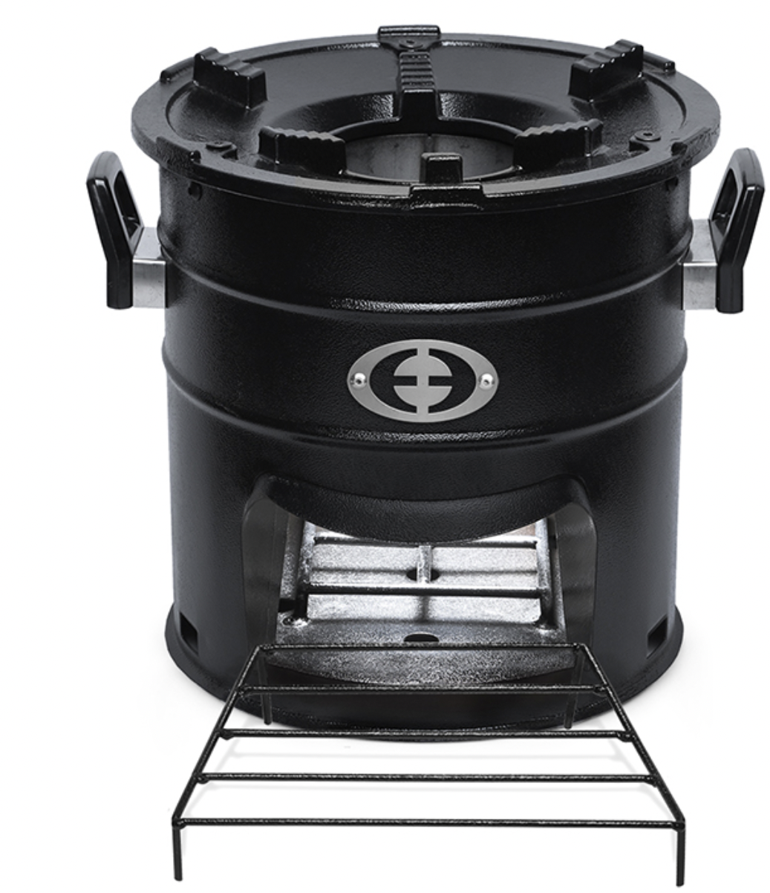
SuperSaver AI or PCS - 1

INVITATIONS MADE TO STAKEHOLDERS
        - Invitation tracking table
Please see appendix -1

          - Appropriateness of methods
>>
The physical local stakeholder consultation meeting was conducted on 15/09/2022. Followed by that, the Stakeholder Feedback Round (SFR) was initiated on 15/09/2022 and the follow-up email on SFR.The consultation involved inviting comments/feedback from the following, but limited to, category of stakeholders:
• Local people impacted by the project and official representatives.
• Local policy makers and representatives of local authorities
• Local non-governmental organizations working on topics relevant to the PoA
• Host country DNA
• Research organizations/institutes working on the technology involved in the PoA
• Renewable energy/energy development nodal agencies
• GS NGO Supporters (present in that host country) + International GS NGO Supporter NGOs
• Other relevant local NGOs of the host country
The consultation process included invitations to wide range of invitees, in order to include effective and equal participation of both men and women. However,due to COVID-19 pandemic situation in the country, the attendees to the consultation meeting were less than expected. Prior to the consultation, Soneva Foundation had provided the invitees with the following documents (in the language that allows local stakeholders to understand and engage with the project):
- Non-Technical summary with relevant information
- Summary of the economic, social and environmental impacts of the project
- Contact details of the Soneva Foundation to get for getting technical and project related information of the project.
          - Gender Sensitivity
>>
The project reflects key gender issues and requirements of gender sensitive design and implementation. On the design, production and distribution side, the project engages women in various activities of the value chain. Additionally, the project is aimed at reducing energy poverty which disproportionately affects women and young girls due to the roles that they play in most households (collecting of firewood and cooking over open fires and inefficient cookstoves in poorly ventilated kitchens).

The primary beneficiaries of the project will be women and children since the project aims at reducing exposure of toxic gases due to cooking using the polluting fuels. As aforementioned, the project supports empowerment of women by providing equal employment opportunities and reducing inequalities. The project also aims to invite post consultation feedback from relevant NGOs working with women.

The project does not involve, and is not complicit in any form of discrimination based on gender difference. All beneficiaries were invited for the consultation through invitation displayed at public places (local administration Offices, social media, market etc.) which are easily accessible to women.

          - Evidence proving invites took place as stated
>>
Invitation has been sent personally since there is no proper internet factifies in the villages
Here is the sample:
Invitation

To,
ADDRESS

Dear ____________
Sub: Invitation to Local Stakeholder Consultation for Project Activity
The Myanmar Stoves Campaign (Gold Standard Micro Programme)
MSC team and the Soneva Foundation would like to invite you to take part in the stakeholder consultation meeting of the project activity.
The project activity aims to replace inefficient traditional stoves (three stone fires) with highly efficient cook stoves, thereby reducing families’ wood consumption and Greenhouse Gas emissions. The meeting is going to take place in Anglican Church , Zewaka street, 5th Ward, Pyin Oo Lwin Township Mandalay Division.
The project activity seeks inclusion in the Gold Standard Micro Programme to enable it to receive "carbon credits", a financial remuneration for the emission reductions it achieves. This mechanism allows beneficiaries of this project to purchase fuel efficient cook stoves at a price that is affordable to them. This project not only achieves the goal of reducing GHG emissions and curbing de-forestation in Myanmar but also brings health benefits and time savings to families while supporting the sustainable development of the country. In addition to this, the project also adheres and contributes positively to all the relevant and applicable economic, social and environmental impacts of the project as per Safeguarding Principles & Requirements set out by the Gold Standard For Global Goals. These impacts shall be explained in detail during the meeting.
We look forward to your valuable participation during the meeting and ask that you confirm your attendance. Should you be unable to attend in person we invite you to send us your comments and questions via email to the following addresses arnfinn@soneva.com/ttoe@mercycorps.org or get in touch with MYANMAR COOKSTOVES CAMPAIGN Team. A non-technical summary of the project activity and the meeting agenda are attached to this invitation.
Sincerely,

          - Sample content of invites (for each Method above)
>>
Invitation

To,
ADDRESS

Dear ____________
Sub: Invitation to Local Stakeholder Consultation for Project Activity
The Myanmar Stoves Campaign (Gold Standard Micro Programme)
MSC team and the Soneva Foundation would like to invite you to take part in the stakeholder consultation meeting of the project activity.
The project activity aims to replace inefficient traditional stoves (three stone fires) with highly efficient cook stoves, thereby reducing families’ wood consumption and Greenhouse Gas emissions. The meeting is going to take place in Anglican Church , Zewaka street, 5th Ward, Pyin Oo Lwin Township Mandalay Division.
The project activity seeks inclusion in the Gold Standard Micro Programme to enable it to receive "carbon credits", a financial remuneration for the emission reductions it achieves. This mechanism allows beneficiaries of this project to purchase fuel efficient cook stoves at a price that is affordable to them. This project not only achieves the goal of reducing GHG emissions and curbing de-forestation in Myanmar but also brings health benefits and time savings to families while supporting the sustainable development of the country. In addition to this, the project also adheres and contributes positively to all the relevant and applicable economic, social and environmental impacts of the project as per Safeguarding Principles & Requirements set out by the Gold Standard For Global Goals. These impacts shall be explained in detail during the meeting.
We look forward to your valuable participation during the meeting and ask that you confirm your attendance. Should you be unable to attend in person we invite you to send us your comments and questions via email to the following addresses arnfinn@soneva.com/ttoe@mercycorps.org or get in touch with MYANMAR COOKSTOVES CAMPAIGN Team. A non-technical summary of the project activity and the meeting agenda are attached to this invitation.
Sincerely,

          - Description of other Means and methods to provide feedback for those who are not able to join the consultation meeting
>>
The feedback forms were shared with stakeholders along with the invitation letter. Feedback has been taken in the local language from the stakeholders

REPORT OF THE CONSULTATION PROCESS
        - Date of Meeting
>>

15/09/2022

          - Justification of why consultation took place after the project start date (retroactive projects only)
>>
          - List of participants

Date and Time |  | Location
Category  Code | Name of the participant, job /  position in the community | Male /  Female |  | Contact details | Organisation  (if relevant) | Signature

          - Pictures from the physical meeting(s) (best practice)
>>
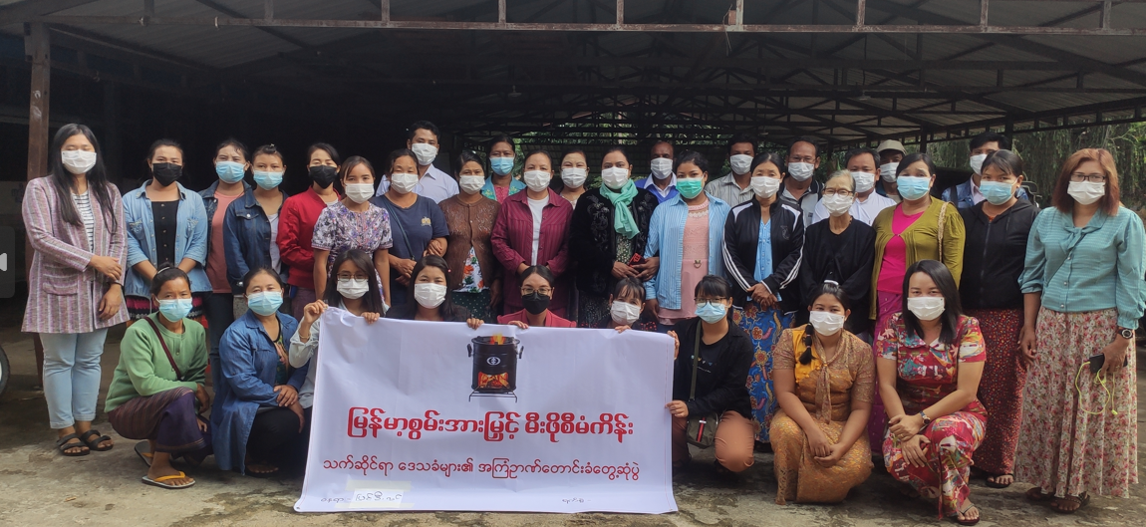

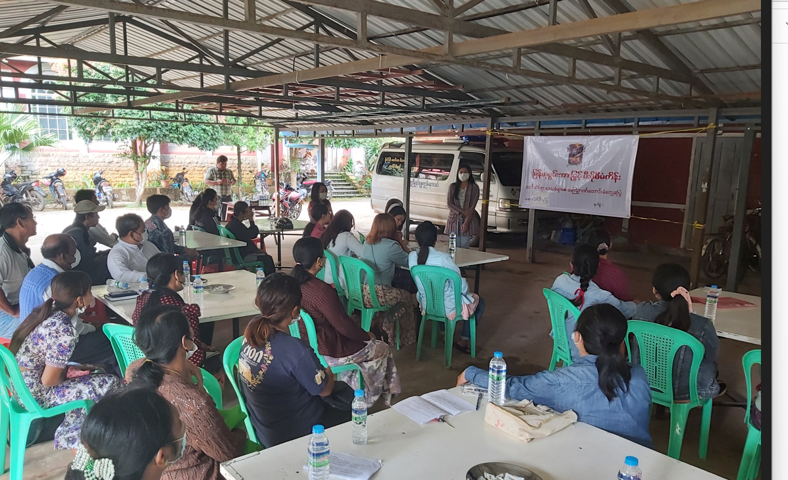
        - Minutes of physical meeting(s)
>>
The project activity aims to replace inefficient traditional stoves (three stone fires) with highly efficient cook stoves, thereby reducing families’ wood consumption and Greenhouse Gas emissions. The meeting is going to take place in Anglican Church , Zewaka street, 5th Ward, Pyin Oo Lwin Township Mandalay Division.
The project activity seeks inclusion in the Gold Standard Micro Programme to enable it to receive "carbon credits", a financial remuneration for the emission reductions it achieves. This mechanism allows beneficiaries of this project to purchase fuel efficient cook stoves at a price that is affordable to them. This project not only achieves the goal of reducing GHG emissions and curbing de-forestation in Myanmar but also brings health benefits and time savings to families while supporting the sustainable development of the country. In addition to this, the project also adheres and contributes positively to all the relevant and applicable economic, social and environmental impacts of the project as per Safeguarding Principles & Requirements set out by the Gold Standard For Global Goals. These impacts shall be explained in detail during the meeting.

Detailed Agenda: -
Registration
- Invitees are welcomed and requested to register themselves in the participants list
Opening of the Meeting
- Welcome and thank you note
- Introduction of presenters and the people in the audience
Explanation of the Project
A) Presentation on:
i) Introduction to the Soneva Foundation, Myanmar Cookstoves Campaign, and Other Key Stakeholders
ii) Introduce the Project, provide general background of the project, climate change overview and carbon mechanism
iii) Project implementation, co-benefits and economic, social and environmental Impact, and project fit with
MOECAF targets
iv) A brief about the new cook stove Super Saver AI and Greenway prime.
B) Questions and Answers
Focus Group Discussion
Gathering comments/concerns and feedback from the audience to improve and balance the project’s impacts and about the fuel usage.
Feedback question
Collection of feedback form
          - Minutes of other consultations
>>
NA
        - Assessment of comments from all consultations above

Gender of Stakeholder | Stakeholder  comment | Was comment taken into account (Yes/ No)? | Explanation (Why? How?)
Male | Program should be rolled out to cover the entire country especially the area prone to environmental degradation | Yes | The geographical area covered is fully Mayanmar.
Female | Carbon credits should be availed to all major green companies | Yes | The company is yet to decide on this.
Female | Customers should be given caps, shirts, and money when visited for surveys | Yes | We are providing shirt/caps etc for survey team
Male | Should add more effort in the products/ publish in radio and televisions of the product | Yes | May consider in future after discussion with management
Male | Slow response | Yes | Have the grievances mechanism and consider the point raised and try to reach out people alternatively
Male | The moderator was knowledgeable | Yes | Narrated the technologies and operations etc to stakeholders in better way by live demonstrations.
Female | UPE needs to understand properly the culture of our people and the challenges | Yes | Already implemented this strategy and Trying to improve as required.

          - Evaluation forms (best practice)

Name | Ma Hnin Wint Lwin
Gender – Male/Female: | Female
What is your impression of the meeting? | Good
What do you like about the project? | I like that Job Opportunity, Reduce Deforestation and Healthy Environment by reducing emission of carbon.
What do you not like about the project? | Calculation of Wood Consumption in Baseline Carbon Survey is not clear
Signature | Ma Hnin Wint Lwin

Name | Daw Ni Ni Khaing
Gender – Male/Female: | Female
What is your impression of the meeting? | Good
What do you like about the project? | I like that FES stoves reduce amount of wood consumption
What do you not like about the project? | No
Signature | Daw Ni Ni Khaing

Name | Tin Mar Aye
Gender – Male/Female: | Female
What is your impression of the meeting? | Good
What do you like about the project? | I like that FES stoves reduce amount of wood consumption and reducing deforestation
What do you not like about the project? | No
Signature | Tin Mar Aye

Name | Daw Htay
Gender – Male/Female: | Female
What is your impression of the meeting? | Good
What do you like about the project? | The project have benefit to the village
What do you not like about the project? | No
Signature | Daw Htay

Name | Ma Aye Aye Soe
Gender – Male/Female: | Female
What is your impression of the meeting? | FES stoves save money, time and reduce deforestation
What do you like about the project? | I like that FES stoves ensure Fire Safety, save money, reduce toxic emissions for health and reduce deforestation
What do you not like about the project? | No
Signature | Ma Aye Aye Soe

        - Summary of alterations based on comments
>>
NA

CONTINUOUS INPUT / GRIEVANCE MECHANISM
 | Method Chosen (include all known details e.g. location of the book, phone, number, identity  of mediator) | Justification of Choice  (best practice)
Continuous Input / Grievance Expression Process Book (mandatory) | Continuous input / Grievance Expression process book is available  at the following office: Soneva Foundation , Myanmar | Grievance Expression book will be placed at Soneva office in Myanmar. Stakeholders are free to voice their concerns via the Grievance Expression Book. By maintaining feedback book at the local office, it is ensured that stakeholders that don’t have access to electronic media for expressing concerns / grievances are also able to share their concerns / feedback. Additionally, the end users always have an option to revert to the salesperson (representative of distribution/retail partners etc.) in case of any feedback / complaints with the product post distribution.
GS Contact (mandatory) | help@goldstandard.org
Telephone access (optional) | -
Internet/email access (optional) | arnfinn@soneva.com
Nominated Independent Mediator (optional) | -
Other

STAKEHOLDER FEEDBACK ROUND

Please check this box if the project is retroactive and has done only 1 consultation with a physical meeting integrated into the SFR.

        - Length of the Feedback Round

Stakeholder Feedback Round |  | Planned | Actual
Start Date
End Date

        - Summarise how all stakeholders were/will be invited to provide feedback
>>
        - Summarise Feedback received, including if any changes in project design were made
>>

Appendix – 1

Revision History

Version | Date | Remarks
1.2 | 5 May 2022 | Addition of grouped consultation info, preliminary agenda and section to justify retroactive consultation took place.  Minor edits to text.
1.1 | 14 October 2020 | Inclusion of Key Project Information  Restructure, new headings and reorder to better match the steps a developer will follow in consultations.  Removal of some non-mandatory template tables (Blind Sustainable Development Assessment). Clarification of best practice steps that are non mandatory processes, clarification of mandatory discussion points. Clarification regarding publishing names and that original evaluation forms (optional) and attendance lists (mandatory) should be separate documents.  Improved clarity on Stakeholder Feedback round section and procedures for retroactive projects  Provision of an accompanying Guide to help the user understand detailed rules and requirements
1.0 | 14 August 2017 | Initial adoption

