Gold Standard for the Global Goals
Annual Report

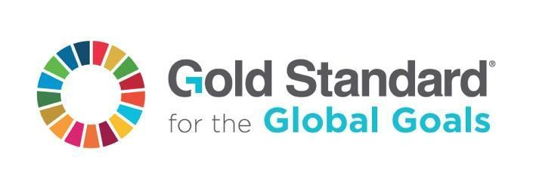

March 2018 - Version 1.1

Project Title | Nairobi River Basin Biogas Project
Gold Standard ID | 939
Date of Annual Report | 31-Jan-2023
Date of Design Certification | 11-Jun-2012
Date of Transition Approval (Transition Projects only) | 04-Sep-2019
Date of Last Verification | 09-Sep-2022

A/R Projects Only - If the project is certified according to the Forest Stewardship Council (FSC), the Certification Status replaces the completion of this template. Please provide the FSC Audit Report and provide a reference to this supporting document in this template. In addition, please provide evidence on how the project demonstrates conformity to Gold Standard Safeguarding Principle 4.2.1 on Water (FSC Certification is not deemed as evidence that this Principle is met). For further guidance refer to the section “FSC Dual Certification” in the Land Use and Forests Activity Requirements.

Please outline how your project meets each of the following requirements, referring to any supporting documentation where necessary.
1 – Annual Reporting

Please include the following information

(a) a summary of the recent activities, events and actions related to the Project:

The small-scale project activity aims to construct up to 10,000 domestic biogas units of mainly 2m³ and 3m³ gas storage capacities each for individual households with at least 2 zero-grazing cows in Nairobi River Basin. The project activity is saving greenhouse gas emissions by replacing non-renewable biomass (mainly fuel wood and charcoal) with renewable biogas.
In the annual reporting period from January 1st 2021 to December 31st 2021 79 biogas units were added to the project, thus raising the total number of biogas units to 875 units registered under the project at the end of the year 2021.

The thermal capacity was increased in this annual reporting period to 2.903 MWth (December 30st, 2021).

Trainings conducted and skilled and non-skilled employees involved in the project:

- Masons training

In 2021 and 2022 in total 4 handyman became masons. Working masons are responsible for the training of handymen and masons.

- Working staff
In 2021 47 people were regularly working for SES.

(b) a clear statement on how stakeholders may provide inputs/grievances:

The stakeholders are aware of the atmosfair website including contact details so that they can submit their comments if any. The main stakeholders for the project activity are the end users using the biogas units. Those do furthermore have the contact details of SES and simply give the project manager a call whenever there is a problem or they have questions. SES also collects feedback when visiting the new end users after commissioning of the biogas units and when reaching out to potential new biogas users.

(c) a list of all inputs/grievances that have been received since last Annual Report together with their respective answers/actions

no input/grievances received

(d) any incidents or events that may impact the Outcomes/Impacts delivered to date (in terms of loss) or the ongoing Performance of the Project.

None.

(e) any legal contest or dispute that has arisen

None.

(f) any updates to the Key Project Information, Project Design Document, Monitoring & Reporting Plan and any other supporting documentation

None.

(g) a brief descriptive summary of all monitoring information collected during the year

SDG 7: Affordable and Clean Energy

The thermal capacity of the 875 biogas plants under the project up until end of 2021 adds up to 2.903 MWth.

SDG 8: Decent Work
Working staff: In 2021 47 people were regularly working for SES.

SDG 13: Climate Action
- 79 biogas units were added to the project in 2021

SDG 17: Partnerships for the Goals
- 79 biogas units were added to the project in 2021
- In 2021 47 people were regularly working for SES.

(h) list of stakeholders (with contact details) who will receive the ‘Annual Report‘

S.  No. | Name of Stakeholder | Designation & Contact Details
1. | Mr. David Karanja | CEO  Sustainable Energy Strategies Ltd. (SES)  Nairobi, Kenya  email: ses@jambo.co.ke

(i) any update of the ‘Project Participants & Secured Titles’ (in case of changes)

None.

3 - Declaration of correct project information

Project Owner Organization | atmosfair gGmbH
Registration number with relevant authority | HRB 13789
Full Address (including Country) | Harzer Straße 39  12059 Berlin  Germany
Website | https://www.atmosfair.de/
Email address | pschera@atmosfair.de

I hereby certify and declare that, to the best of my knowledge, the project complies with the project information submitted to The Gold Standard.
First name | Patrizia
Last name | Pschera
Position | Project Manager
Place, Date and Signature | 31-Jan-2023, Berlin  