

Off grid Solar PV project at IAMGOLD Essakane SA Gold Mine
Document Prepared by AERA Group
On Behalf of IAMGOLD

Project Title | Off grid Solar PV project at IAMGOLD Essakane SA Gold Mine
Version | 3.0
Date of Issue | 05-October-2021
Prepared By | AERA Group
Contact | 28 Cours Albert 1er, 75008 Paris, France  Ph +33 1 42 18 02 02 I Fax +33 1 43 25 80 06  www.aera-group.fr

Contents
1.1 Summary Description of the Project 3
1.2 Sectoral Scope and Project Type 3
1.3 Project Eligibility 4
1.4 Project Design 4
1.5 Project Proponent 4
1.6 Other Entities Involved in the Project 4
1.7 Ownership 5
1.8 Project Start Date 5
1.9 Project Crediting Period 5
1.10 Project Scale and Estimated GHG Emission Reductions or Removals 5
1.11 Description of the Project Activity 6
1.12 Project Location 10
1.13 Conditions Prior to Project Initiation 11
1.14 Compliance with Laws, Statutes and Other Regulatory Frameworks 12
1.15 Participation under Other GHG Programs 13
1.16 Other Forms of Credit 13
1.17 Additional Information Relevant to the Project 14
2.1 No Net Harm 16
2.2 Local Stakeholder Consultation 20
2.3 Environmental Impact 20
2.4 Public Comments 20
2.5 AFOLU-Specific Safeguards 20
3.1 Title and Reference of Methodology 20
3.2 Applicability of Methodology 21
3.3 Project Boundary 21
3.4 Baseline Scenario 21
3.5 Additionality 21
3.6 Methodology Deviations 21
4.1 Baseline Emissions 21
4.2 Project Emissions 21
4.3 Leakage 21
4.4 Estimated Net GHG Emission Reductions and Removals 21
5.1 Data and Parameters Available at Validation 23
5.2 Data and Parameters Monitored 23
5.3 Monitoring Plan 23
6.1 Data and Parameters Monitored 23
6.2 Baseline Emissions 24
6.3 Project Emissions 26
6.4 Leakage 26
6.5 Net GHG Emission Reductions and Removals 26

Project Details

Summary Description of the Project
“Off-grid Solar PV project at IAMGOLD Essakane SA Gold Mine” (hereafter referred to as the “Project” or “Project Activity”) is a small-scale project activity, which involves the development, construction and operation by Essakane Solar S.A.S. of a greenfield solar PV plant with a total installed capacity of 14.928 MWp at the Essakane gold mine, which is in the Sahel region of Burkina Faso about 330 km North-East from Ouagadougou.
Jointly owned by IAMGOLD Corporation (90%) and the Government of Burkina Faso (10%), IAMGOLD Essakane SA, which owns and operates the Essakane gold mine, and produced 377,000 ounces of gold in 2016.
Being owned by Essakane Solar S.A.S. (hereinafter referred to as the “Project Implementer”), a specific purpose vehicle owned by Total Eren as a majority shareholder (>90%), the main objective of the project is to deliver clean, renewable energy based electricity to IAMGOLD Essakane SA. It will do so by adding capacity to the 11 existing fuel-powered engines. The Project will replace fuel consumption of the technology in use.
The latitude of the Essakane gold mine offers very favourable radiation conditions throughout the year, with an average of 2,150 - 2,250 kWh / m² per year3. This allows an estimated electricity generation of approximately 28,868 MWh for the first full year and 24,881 MWh on a yearly average over the 7-year crediting period. The Project will result in 19,904 tCO2e of emission reductions per year or 139,329 tCO2e over a 7-year crediting period.
Implementation timeline
Date | Event
17-March-2017 | Signature of the EPC contractor’s contract
26-May-2017 | Start of construction of power plant
from 01-May to 13-May-2018 | Performance tests under EPC contract & power purchase agreement
01-June-2018 | Effective start date of electricity production

Sectoral Scope and Project Type
Sectoral Scope : 1 - Energy industries (renewable - / non-renewable sources)
The project is a renewable energy type and is not a grouped project.

Project Eligibility
The project is eligible under the scope of the VCS Program because:
- It results in CO₂ emission reductions, one of the six Kyoto Protocol greenhouse gases
- It consists in electricity generation using (small scale) solar power plant in a Least Developed Country.

Project Design
The project has been designed to include a single installation of an activity.

Eligibility Criteria
N/A as the project is not a grouped project

Project Proponent

Organization name | Essakane Solar S.A.S.
Contact person | Mrs Emma KANTIONO
Title | Managing director
Address | 06 BP 9302 Zogona 06  Secteur 13, Zone du bois  Avenue Babanguida, Rue Kindfu
Telephone | +33 1 58 97 26 21
Email | emma.kantiono@essakane-solar.com

Other Entities Involved in the Project
.
Organization name | AERA GROUP SAS
Role in the project | Carbon consultant
Contact person | Alexandre Dunod
Title | Head, Certification & Deliveries
Address | 28 cours Albert Ier 75008 Paris
Telephone | +33 1 42 18 02 02
Email | a.dunod@aera-group.fr

Ownership
Essakane Solar owns a concession to produce and distribute electricity as per Ministry of energy’s concession agreement to Essakane Solar SAS dated 28-April-2017.

Project Start Date
01 June 2018
The project started producing electricity at this date. It’s the start date of the CDM crediting period.

Project Crediting Period
The project adopts a seven (7) years crediting period, renewable twice. The crediting period therefore is 1st June 2018 - 31st May 2025.

Project Scale and Estimated GHG Emission Reductions or Removals

Project Scale
Project | X
Large project

Inter
Year | Estimated GHG emission reductions or removals (tCO₂e)
01/06/2018 – 31/12/2018 | 13,471
2019 | 22,420
2020 | 21,299
2021 | 20,234
2022 | 19,223
2023 | 18,261
2024 | 17,348
01/01/2025 – 31-05-2025 | 7,073
Total estimated ERs | 139,329
Total number of crediting years | 7
Average annual ERs | 19,904

Description of the Project Activity
The Project consists in the installation of a greenfield renewable power plant. The Project will rely on solar power source through photovoltaic conversion technology to produce electricity, which will be delivered to IAMGOLD Essakane SA.
The PV array will consist of 128,880 thin film (CdTe) photovoltaic modules, including 42,840 of 117.5 W (FS-4117-3 of First Solar Series 4™) and 86,040 of 115 W (FS-4115-3) for a total installed capacity of 14.928 MW provided by First Solar manufacturer through Wärtsilä EPC services.
The photovoltaic panels are arranged in line and fixed on galvanized steel support structures that will be nailed into the ground minimizing the occurrence of shadows or a variation in their orientation and inclination (15°).
The Project also includes 6 inverters and 3 transformers located in power powerhouses wired to the modules through buried cables. Two medium voltage overhead MV lines (6.6 kV) will then connect the project to the offtaker’s busbar, which is connected to two existing fuel oil based electrical generator sets in the baseline scenario of a total capacity of 58.24 MW. They consist of a total of 11 electrical generator units (5 x 5,256 kW and 6 x 5,327.2 kW) of which 2 spare units (1 for maintenance, 1 for emergency spare).
A hybrid automation system (Wärtsilä Supervisory Control and Data Acquisition (SCADA) system, real-time controllers and photovoltaic combining switchgear) synchronizes the project plant with the existing fossil fuel-based power plant and allows the whole PV facilities to be manually or automatically controlled and monitored.

The meter equipment of the Project plan involves two bi-directional meters of Schneider Electric PowerLogic PM8240 meter of class 0.2S (active energy) and class 0.5S (reactive energy) at the two delivery points.
ID of the meters :
BAO904
Compteur 1 : SN/1706B040-02
Compteur 2: SN/1706B060-02
BAO911
Compteur 1 : SN/1706B032-02
Compteur 2: SN/1706B257-02

The figure below illustrates the project design and indicates the situation of the meters at the delivery points.
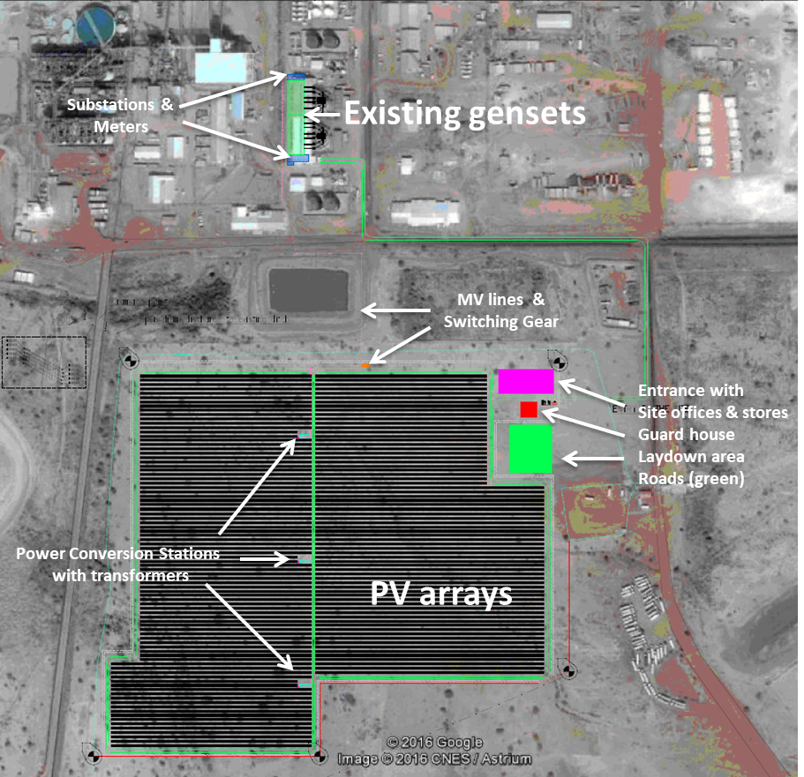
Figure 1: Site layout
The technical characteristics of the modules, inverters and transformers installed are identical or similar to those in the tables below:
Table 1: Electrical and mechanical characteristics of the modules (Standard Test Conditions)
Peak Power (W) | 115 W | 117.5 W
Type of cells | Thin-film CdTe semiconductor
Rated voltage (V_{mpp}) (V) | 69.3 | 70.1
Rated current (I_{mpp}) (A) | 1.66 | 1.68
Efficiency (%) | 16.0 | 16.3
Length (mm) | 1,200
Width (mm) | 600
Thickness (mm) | 6.8
Table 2: Technical data of the inverters
Parameter | Unit | Description
Manufacturer |  | ABB
Model |  | PVS980, -1909kVA-J
Maximum DC input power (P_{PV,max}) | kWp | 3,055
Nominal AC output power (SN(AC)) | kVA | 1,909
Maximum AC output power (Smax (AC)) | kVA | 2,100
Output frequency range | Hz | 50/60
Nominal output voltage | V | 630
Maximum efficiency | % | 98.8
Own consumption in operation | W | 2,500
Own consumption in standby | W | 225
Table 3: Technical data of transformers
Parameter | Unit | Description
Manufacturer | - | ABB
Rated power | kVA | 3818
High voltage | V | 6600
Low voltage (no load) | V | 630 (630)
Rated frequency | Hz | 50

Based on a mean annual global horizontal solar radiation potential estimated 2,242.5 kWh/m² for the project site and the specifications of the solar PV system, net annual output is conservatively expected at 28,868 MWh for the first year. According to the warranty of the considered module manufacturer, the average annual power output degradation of the module is expected not to exceed 0.5 % per year over 25 years, which is also the typical lifetime of solar modules. All installed equipment is new.
The different types of losses are illustrated in the figure below.
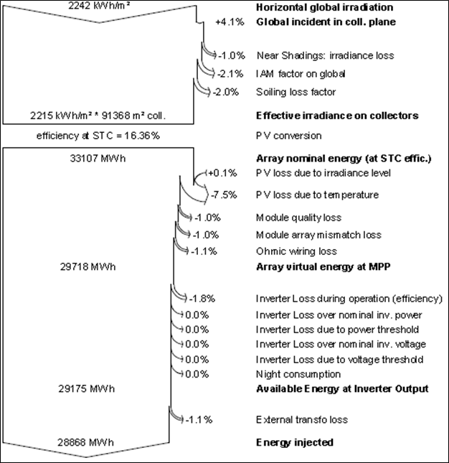
Figure 2: Loss diagram
Expected load factor is 1,936 hours/year (22.1%) as per engineering company Wärtsilä’s PVsyst performance study provided to banks and equity financiers while applying the project activity for project financing; its corresponds to an estimated net annual power production of 28,868 MWh

Project Location
The Project is located in north-eastern Burkina Faso (host party), West Africa. It straddles the boundary of the Oudalan and Seno provinces in the Sahel region of Burkina Faso and is approximately 330 km North-East of the capital, Ouagadougou. It is situated 42 km East of the nearest large town and the provincial capital of Oudalan, Gorom-Gorom.
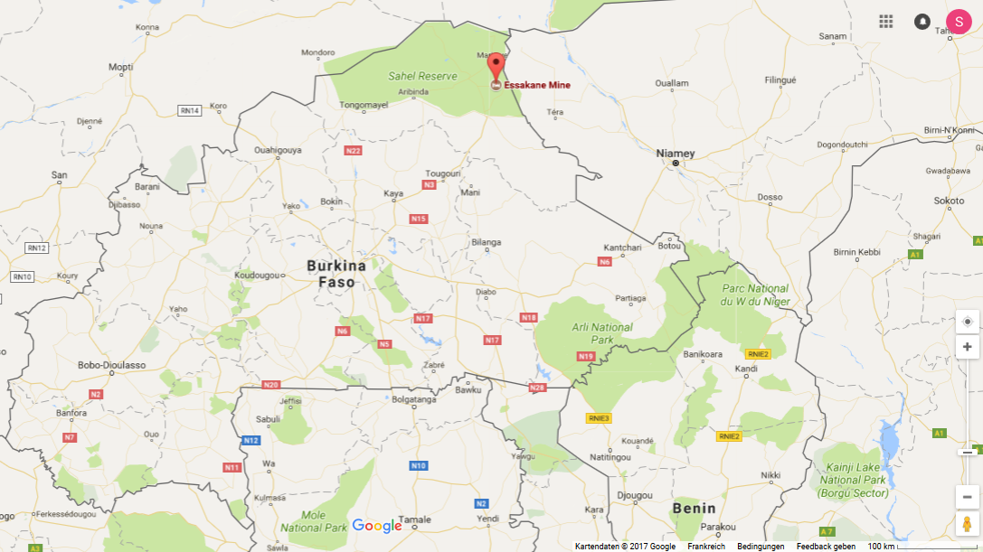
Project location
Figure 3: Project location in Burkina Faso
The six villages involved around the project site are:
- Essakane – site
- Essakane – village
- Falagountou
- Goulgountou
- Petabara – Seno
- Petabara - Oudalan

The diagram and map below reveal the exact geo-coordinates and situation of the Project site vis-a-vis the gold mine and the existing fossil fuel based power plants:

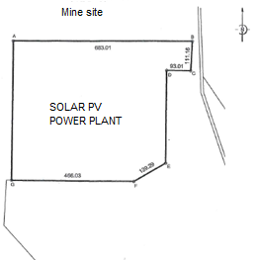 | 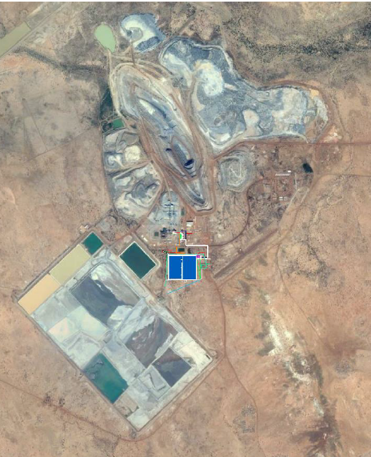  SOLAR PV  POWER PLANT
   | Latitude | Longitude
  A | 14°21’29.3’’ N | 0°4’30.1’’ E
  B | 14°21’59.5’’ N | 0°4’52.9’’ E
  C | 14°21’55.9’’ N | 0°4’52.8’’ E
  D | 14°21’55.9’’ N | 0°4’49.7’’ E
  E | 14°21’44.5’’ N | 0°4’49.7’’ E
  F | 14°21’42.2’’ N | 0°4’45.7’’ E
  G | 14°21’42.2’’ N | 0°4’30.1’’ E
Figure 4: Project borders and project location on goldmine site

Conditions Prior to Project Initiation
The baseline is described by Paragraph 8 of AMS-I.A., Version 16 as “…the fuel consumption of the technology in use or that would have been used in the absence of the project activity to generate the equivalent quantity of energy…”, estimated using one of three possible options.
For the project activity, Option 2 is applied, such that the energy baseline is calculated based on annual electricity generation from project renewable energy technologies as per the below:

E_{BL,y} = Σ_{i} EG_{i,y} / (1 – l)

Where:
E_{BL,y} | Annual energy baseline; kWh
Σ_{i} | The sum over the group of i renewable energy technologies (e.g. renewable energy technologies for solar home systems, solar pumps) implemented as part of the project activity.
EG_{i,y} | The estimated annual output of the renewable energy technologies of the group of i renewable energy technologies installed; kWh
l | Average technical and distribution losses that would have been observed in diesel powered minigrids installed by public programmes or distribution companies in isolated areas, expressed as a fraction.

The emission baseline is the energy baseline calculated in accordance with Paragraph 8(b) of AMS-I.A. times a default emission factor:

BE_{CO2,y} = E_{BL,y} * EF_{CO2}

Where:
BE_{CO2,y} | Emissions in the baseline in year, y; tCO₂
E_{BL,y} | Annual energy baseline in year, y; kWh
EF_{CO2} | CO₂ emission factor; tCO₂/kWh

For EF_{CO2}, default value of 0.8 kg CO₂-e/kWh, which is derived from diesel generation units, may be used.

The facilities, systems and equipment in the baseline scenario and how the project provides the same types and levels of services provided are further described in section 1.11

Compliance with Laws, Statutes and Other Regulatory Frameworks
To date, there are no regulations and policies preventing the implementation of the project
activity. Burkina Faso has prioritised the development of its use of the renewable energy sector, as
the country has huge potential for solar and wind energy. The establishment of a National Agency for renewable energies and energetic efficiency in December 2016 was the first step in the government’s promotion of renewable energy. One of its main objectives is to reduce the country dependence to fossil fuel energy.

Participation under Other GHG Programs

Projects Registered (or seeking registration) under Other GHG Program(s)
The project is registered under the Clean Development Mechanism (Project #10398) on 05 May 2018, although its GHG emission reduction will either be claimed under the VCS programme or the CDM programme, never both.
CDM Monitoring period : 01-June-2018 – 31-May-2019, CER issued : 19,119 : https://cdm.unfccc.int/Projects/DB/KBS_Cert1502356514.63/iProcess/Applus1565174567.59/view

Projects Rejected by Other GHG Programs
The project has not been rejected by any other GHG program.

Other Forms of Credit

Emissions Trading Programs and Other Binding Limits
The project does not reduce GHG emissions from activities that are included in an emissions trading program or any other mechanism that includes GHG allowance trading.

Other Forms of Environmental Credit
The project has neither sought nor received another form of GHG-related environmental credits.

Additional Information Relevant to the Project

Leakage Management
In accordance with AMS-I.A., Version 16, if the energy generating equipment is transferred from another activity or if the existing equipment is transferred to another activity, leakage is to be considered. This is not the case in this project and as such leakage emissions are not considered. Thus there is no leakage management.

Commercially Sensitive Information
There is no information deemed as commercially sensitive for this project activity.

Sustainable Development
Sustainable development
While the the UN General Assembly adopted new global Sustainable Development Goals (SDGs) on 25 September 2015, Burkina Faso’s “National Sustainable Development Policy” (NSDP) of 2013 and the “Burkina 2025” outlook remain in place outlining Burkina Faso’s sustainable development policy. The NSDP stresses the objective of promoting a green economy and lays down guiding principles for action. The Burkina 2025 provides analyses, vision and strategies. A new and more specific “Strategy for Accelerated Growth and Sustainable Development (SAGSD) 2016-2020” is currently being drafted.
The Project contributes to Burkina Faso’s sustainable development policy as follows:
- Access to electricity as a production factor and resource management:
The Project reduces the country’s dependency on imported fossil fuel and its price fluctuations. By making use of a local energy source, which is well suited to the local climate conditions, the project reduces fuel logistics for the largest private company in Burkina Faso located in a remote area, attracts foreign direct investment and increases national energy security/self-sufficiency.
- Access to technologies and development of human capital (through employment and training):
The Project constitutes a significant step forward in the promotion of solar technology in Burkina Faso. It provides an opportunity of knowledge transfer through training and employment of local staff during the operation and construction phases of the Project. The Project will set an example for technology diffusion and CDM reference for stakeholders who plant to implement similar technologies in the region. Up to 100 jobs are created during construction phase, while project operations will employ about 40 people on the long term, most of them originating from the 6 nearby locations.

Further Information
- Healthy life and environment:
The Project does not only address climate change by reducing the amount of GHG emissions generated from the electricity production, it also reduces the amount of noxious SO₂, NO_{x}, PMs, CO and VOC emitted into the air from burning fossil fuel. Health effects include premature death, acute respiratory illness, aggravated asthma, chronic bronchitis and decreased lung function. Solar PV technology is furthermore noise-free and this Project will be installed at an existing industrial site, i.e. with little negative impact on the environment and activities of nearby communities. The Project Implementer commits to allocating approximately 1% of the Project turnover to local communities (about 50,000 USD/year) and to implement an environmental and social monitoring plan.

The project participants obtained all necessary clearances; hence no legislative, economic,
sectoral, social, environmental, geographic, site-specific risks are anticipated which may have
impact on the eligibility of the project activity and the net GHG emission reductions.

Safeguards

No Net Harm
 | Receiver |  | Impacts |  | Environmental action |  | Objective of the action |  | Action stains |  | Actors of the action |  | Costs in FCFA |  | Follow-up Actor |  | Implementation schedule  work |  | Monitoring indicators
 | Air |  | Air quality degradation due to gaseous emissions (VOC, CO, CO2, NOx) |  | Providing site personnel with personal protective equipment Maintenance of site vehicles Watering of the  site |  | Reduce the emission of CO, CO2,  NOx, and dust in the atmosphere |  | Search for a qualified provider |  | ESSAKANE SOLAR |  | Included in the construction contract with the contractor in charge of the construction of the plant |  | ESSAKANE SOLAR BUNEE |  | During construction |  | Compliance of emissions with national standards,  Number of complaints
 | Sound environment |  | Noise nuisance due to localized increase in noise levels |  | Use of less noisy equipment during work, Regular maintenance of equipment |  | Reduce noise pollution caused by product transport vehicles |  | Search for a qualified provider |  | ESSAKANE SOLAR |  | Included in the construction contract with the contractor in charge of the construction of the  plant |  | ESSAKANE SOLAR BUNEE |  | During construction |  | Condition of construction equipment  Number of complaints
 | Soil |  | Soil pollution |  | Proper management of solid and liquid waste and hydrocarbon stocks |  | Avoid soil pollution by waste disposal (used batteries if used and leakage of motor oil)  Avoiding contamination |  | Ensure the collection of waste and its deposit in approved sites  Conduct regular inspections of facilities to ensure the absence of  leaks |  | ESSAKANE SOLAR |  | 1 000 000 |  | ESSAKANE SOLAR BUNEE |  | During construction and operation |  | Existence of an inspection schedule for the facilities,  Number of inspections performed per year  Site compliance with soil pollutant discharge standards
 | Water resources |  | Risk of  pollution  of  ecosystems  aquatic |  | Management of  spills  accidental  of hydrocarbons |  | Minimize the  risks of  pollution by  hydrocarbons |  | Formation of the  staff on the  management of  liquid waste Training on  techniques for  decontamination of  contaminated sites |  | ESSAKANE SOLAR |  | 500 000 |  | ESSAKANE SOLAR  BUNEE |  | During operation |  | Number of  training sessions number  of people  trained
 | Security |  | Risks  accident  s  involving  employees and those  of  company  s  surrounding  es |  | Formation of the  staff on the  fire hazards  and the means to  prevent or treat them.  Equipping employees  of PPE.  Respect for  instructions for  security of the  mine. |  | Avoiding  injuries  and the  loss of life  human |  | Organize  sessions of  training on  sources  potential for fires to occur in  the unit and on the  means of control  against these  fires |  | ESSAKANE SOLAR |  | Included in the construction contract with the contractor in charge of the construction of the plant |  | ESSAKANE SOLAR BUNEE |  | During construction and  the operation |  | Number of  sessions of  training  made  Level  application of the measures of  security  Number  of accidents
Vegetation |  | Destruction of vegetation cover |  | Recovery of the upper soil horizons (arable soils) to be used for rehabilitation purposes;  Carrying out the compensation plantings; Monitoring and maintaining the plants for at least three years after they are planted,  Compensation  loss of utility trees |  | Restore destroyed vegetation cover |  | -location identification  storage of topsoil, stripping, transport and disposal  Research of the reforestation site,  Acquisition of plants,  -cooking  Planting of the seedlings |  | ESSAKANE SOLAR |  | 4 455 000 |  | ESSAKANE SOLAR BUNEE, DREEVCC/S  ahel |  | Operation phase |  | Area reforested, Number of plants planted,  Success rate of the plants planted  -
Landscape |  | Landscape modification |  | Realization of planting of alignment and hedges on the perimeter of  the institution |  | Improve the living and working environment |  | Search for a landscaping specialist |  | ESSAKANE SOLAR |  | 2 000 000 |  | ESSAKANE SOLAR BUNEE |  | Operating phase |  | Existence of landscaping
Employment |  | Creation of temporary and permanent jobs |  | Recruiting female staff where possible |  | Increase the social acceptability of the project |  | Organize the recruitment of local employees |  | ESSAKANE SOLAR |  | PM |  | ESSAKANE SOLAR |  | Before starting up the plant |  | Number of local jobs created,  Proportion of female staff  working in the plant
Agriculture and livestock |  | Loss of  agricultural land |  | Compensation  of the loss of the agricultural  Compensation  s financial  loss of land  agricultural  Compensation  for the  loss of grazing land productivity |  | Restore the  means of subsistence of  people  impacted |  | Accompany  PAPs in the search for agricultural land  Develop the  land acquired  - Evaluate the cost  of the loss of  productivity |  | ESSAKANE SOLAR |  | 19 814 400 |  | ESSAKANE  SOLAR BUNEE |  | During the  construction phase |  | Compensated land area  -area of developed land  for PAPs  Level of  productivity of  land acquired  for the  populations  Number of  complaints
 | Home |  | Loss of a  building |  | Compensation  financial |  | Allow the  owner  to rebuild  his house |  | Assessing the value  of the impacted building |  | ESSAKANE SOLAR |  | 1 890 000 |  | ESSAKANE  SOLAR BUNEE |  | Before the  start of work |  | Payment status

Overall, ESIS states that “the negative impacts generated by the project are manageable because the magnitude of the anticipated changes on most of the different environmental components that will be affected remains average to negligible.”
As a consequence, the Environmental Ministry granted the project implementer an approval (“Arrêté de Faisabilité Environnementale”) on 12/01/2017.
Based on the findings and recommended mitigation measures included in the ESIS, the ministerial approval, IFC standards and the project implementer’s own environmental and social policy, the project implementer introduces an Environmental and Social Management System (ESMS), which includes a general environmental and social policy, a compensatory agreement signed with the impacted communities, a stakeholder engagement plan and lays ground for a decommissioning plan. The Bureau National des Evaluations Environnementales (BUNEE), an agency of the Ministry of Environment for Burkina Faso, will act as an external auditor and monitor the ESMS implementation during 3 years with two inspections per year.

Local Stakeholder Consultation
No grievance was registered during this monitoring period. However, the grievance mechanism is as follows:
1. Reception: Applications are received either at the headquarters in the Zogona district of Ouagadougou or in theOuagadougou, or at the information centers of the Health, Safety and Sustainable Development Development Department. Depending on the geographical location of the request, mail is forwarded either to the Corporate Affairs Department (requests at the national level) , or to the SSDD Department (requests at the regional level)
2. Processing: once received, the requests are recorded in a follow-up table (model in annex 2) and are analyzed every week by the department concerned, especially during team meetings. Validation is done by the head of the department or his representative.
3. Result: once the request has been processed, the results of the analysis are communicated to the applicant

Environmental Impact
N/A (see registered CDM PDD).

Public Comments
The project was open for public comment from 03/09/2021 to 03/10/2021 on VERRA webpage. There were no GSP comments received during this period.

AFOLU-Specific Safeguards
N/A (not an AFOLU project)

Application of Methodology

Title and Reference of Methodology
N/A (see registered CDM PDD).

Applicability of Methodology
N/A (see registered CDM PDD).

Project Boundary
N/A (see registered CDM PDD).

Baseline Scenario
N/A (see registered CDM PDD).

Additionality
N/A (see registered CDM PDD).

Methodology Deviations
No methodology deviation were applied.

ESTIMATed GHG Emission Reductions and Removals

Baseline Emissions
N/A (see registered CDM PDD).

Project Emissions
N/A (see registered CDM PDD).

Leakage
N/A (see registered CDM PDD).

Estimated Net GHG Emission Reductions and Removals
According to AMS-I-A, emission reductions are calculated as:
ER_{y} = BE_{CO 2,y} – PE_{y} – L
Where:
ER_{y} | Emission reductions in the year y; tCO₂e
BE_{CO2,y} | Emissions in the baseline in the year, y; tCO₂e
PE_{y} | Project emissions in the year, y; tCO₂e
L | Leakage in the year, y; tCO₂e
 |  | Value/Result | Unit | Source/reference
Total installed capacity |  | 42,840x117.5W+86,040x115W | MW_{p} | CDM PDD Section A.3 / Project document
 |  | 14,928 | MW_{p} | CDM PDD Section A.3 / Project document
Net electricity delivered to the grid, average year (EG_{PJ,y}) |  | 24,881.14 | MWh | A.3; B.7  [E_{BL,y} = Σ_{i} EG_{i,y} / (1 – l)]
Baseline emission factor (EF_{CO2}) |  | 0.8 | tCO₂/MWh | CDM PDD Section B.6.1 and Section B.6.2
Baseline emissions (BE_{y}) |  | 24,881 MWh/yr x  0.8 tCO₂/MWh =  19,904 | tCO₂/y | BE_{y} = EG_{PJ,y} x EF_{grid,CM,y}
Project emissions (PE_{y}) |  | 0 | tCO₂/y | CDM PDD section B.6.1
Emission reduction (ER_{y}) |  | 19,904 | tCO₂/y | ER_{y} = BE_{y} – PE_{y}

Year | Estimated baseline emissions or removals  (tCO₂e) | Estimated project emissions or removals  (tCO₂e) | Estimated leakage emissions (tCO₂e) | Estimated net GHG emission reductions or removals  (tCO₂e)
01/06/2018 – 31/12/2018 | 13,471 | - | - | 13,471
2019 | 22,420 | - | - | 22,420
2020 | 21,299 | - | - | 21,299
2021 | 20,234 | - | - | 20,234
2022 | 19,223 | - | - | 19,223
2023 | 18,261 | - | - | 18,261
2024 | 17,348 | - | - | 17,348
01/01/2025 – 31/05/2025 | 7,073 | - | - | 7,073
Total | 139,329 | - | - | 139,329

Monitoring

Data and Parameters Available at Validation
Not applicable (see registered CDM PDD)

Data and Parameters Monitored
Not applicable (see registered CDM PDD)

Monitoring Plan
Not applicable (see registered CDM PDD)

ACHieVED GHG Emission Reductions and Removals

Data and Parameters Monitored

Data / Parameter | EGy
Data unit | kWh/y
Description | Annual net output of the solar photovoltaic power plant
Value applied:
  2019 | 2020
  13,774 | 23,443
Comments | As per PowerLogic PM8000 Series manual, “all meters are tested and verified at the factory in accordance with International Electrotechnical Commission (IEC) and American National Standards Institute (ANSI) standards. [These] digital power meters typically do not require re-calibration”.  Besides the installation of a main & back-up meter at each feed-in point, reconciliation of measurement results between Essakane Solar and IAMGOLD occur monthly before electricity invoicing takes place. Furthermore, Essakane Solar installed own meters at the transformer’s point for transmission losses assessment.  The meter equipment of the Project plan involves two bi-directional meters of Schneider Electric PowerLogic PM8240 meter of class 0.2S (active energy) and class 0.5S (reactive energy) at the two delivery points.  ID of the meters :  BAO904  Compteur 1 : SN/1706B040-02  Compteur 2: SN/1706B060-02  BAO911  Compteur 1 : SN/1706B032-02  Compteur 2: SN/1706B257-02

Baseline Emissions
The baseline is described by Paragraph 8 of AMS-I.A., Version 16 as “…the fuel consumption of the technology in use or that would have been used in the absence of the project activity to generate the equivalent quantity of energy…”, estimated using one of three possible options.
For the project activity, Option 2 is applied, such that the energy baseline is calculated based on annual electricity generation from project renewable energy technologies as per the below:
E_{BL,y} = Σ_{i} EG_{i,y} / (1 – l)
Where:
E_{BL,y} | Annual energy baseline; kWh
Σ_{i} | The sum over the group of i renewable energy technologies (e.g. renewable energy technologies for solar home systems, solar pumps) implemented as part of the project activity.
EG_{i,y} | The estimated annual output of the renewable energy technologies of the group of i renewable energy technologies installed; kWh
l | Average technical and distribution losses that would have been observed in diesel powered minigrids installed by public programmes or distribution companies in isolated areas, expressed as a fraction.
The emission baseline is the energy baseline calculated in accordance with Paragraph 8(b) of AMS-I.A. times a default emission factor:
BE_{CO2,y} = E_{BL,y} * EF_{CO2}
Where:
BE_{CO2,y} | Emissions in the baseline in year, y; tCO₂
E_{BL,y} | Annual energy baseline in year, y; kWh
EF_{CO2} | CO₂ emission factor; tCO₂/kWh

For EF_{CO2}, default value of 0.8 kg CO₂-e/kWh, which is derived from diesel generation units, is used.
Month | BE_{y} | E_{BL,y} | EF_{CO2}
Month | t CO₂ | MWh | tCO₂/MWh
June 19 | 1,470 | 1,838 | 0.8000
July 19 | 1,385 | 1,731 | 0.8000
August 19 | 1,453 | 1,817 | 0.8000
September 19 | 1,593 | 1,991 | 0.8000
October 19 | 1,632 | 2,041 | 0.8000
November 19 | 1,732 | 2,166 | 0.8000
December 19 | 1,751 | 2,189 | 0.8000
January 20 | 1,603 | 2,005 | 0.8000
February 20 | 1,690 | 2,113 | 0.8000
March 20 | 1,709 | 2,137 | 0.8000
April 20 | 1,456 | 1,821 | 0.8000
May 20 | 1,460 | 1,826 | 0.8000
June 20 | 1,346 | 1,683 | 0.8000
July 20 | 1,471 | 1,839 | 0.8000
August 20 | 1,436 | 1,796 | 0.8000
September 20 | 1,450 | 1,814 | 0.8000
October 20 | 1,763 | 2,204 | 0.8000
November 20 | 1,665 | 2,081 | 0.8000
December 20 | 1,699 | 2,125 | 0.8000
TOTAL | 29,764 | 37,217 | 0.8000

Thus, BE_{CO2,y} = 37,217 kWh * 0.0008 tCO₂/kWh = 29,764 tCO2.

Project Emissions
The project activity is a solar PV project and auxiliary consumption is taken account in the net electricity off-taken by the mine. Therefore, as per the applied methodology AMS-I.A., the GHG emission from the project activity is considered as zero.

Leakage
No leakage emissions are considered. The emissions potentially arising due to activities such as power plant construction and upstream emissions from fossil fuel use (e.g. extraction, processing, transport etc.) are neglected.

Net GHG Emission Reductions and Removals

Year | Baseline emissions or removals (tCO₂e) | Project emissions or removals (tCO₂e) | Leakage emissions (tCO₂e) | Net GHG emission reductions or removals (tCO₂e)
2019 | 11,016 | - | - | 11,016
2020 | 18,748 | - | - | 18,748
Total | 29,764 | 0 | 0 | 29,764

The estimated amount of emission reduction for this period is calculated as follows: Total days= 580, Annual average VERs=19,904 tCO_{2eq}, Thus, estimated ER for this monitoring period = 31,628 tCO_{2eq} Difference= -5.9%

despites a slight upscaling of capacity by +0,1% since PVsyst simulation was performed
In conformity with §3(a)(b) of the Guidelines for the reporting and validation of Plant Load Factors
Since 2015 installed capacity of about 325 MW which consisted exclusively of thermal and hydro power plants (cf. http://sonabel.bf/index.php/nous-connaitre/metiers/production), the largest solar power plant in West Africa has been partially commissioned as CDM-CPA 10320-0003 in September 2017 (33.7 MW Zagtouli)

