

RENEWABLE POWER PROJECT BY AXIS WIND FARMS (MPR DAM) PRIVATE LIMITED
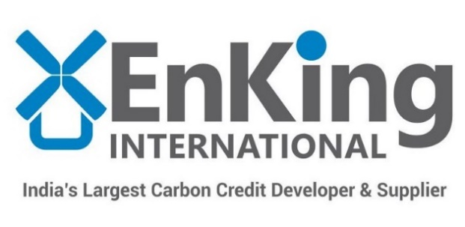
Document Prepared by EKI Energy Services Limited
Project Title | Renewable Power Project by Axis Wind Farms (MPR Dam) Private Limited
Version | 03
Report ID | VVER18202
Date of Issue | 26-June-2020
Project ID | 1790
Monitoring Period | 02-August-2018 to 01-October-2019 (Inclusive of both days)
Prepared By | EKI Energy Services Limited
Contact | Email ID : prakash@enkingint.org  Address: Office no. 201, Plot 48, Scheme 78 part 2  Vijay Nagar, Near Brilliant Convention Centre  Indore - 452010 (M.P, India) Website www.enkingint.org

Contents
1 Project Details 3
1.1 Summary Description of the Implementation Status of the Project 3
1.2 Sectoral Scope and Project Type 3
1.3 Project Proponent 4
1.4 Other Entities Involved in the Project 4
1.5 Project Start Date 4
1.6 Project Crediting Period 4
1.7 Project Location 4
1.8 Title and Reference of Methodology 6
1.9 Participation under other GHG Programs 7
1.10 Other Forms of Credit 7
1.11 Sustainable Development 7
2 Safeguards 8
2.3 AFOLU-Specific Safeguards 9
3 Implementation Status 9
3.1 Implementation Status of the Project Activity 9
3.2 Deviations 10
3.3 Grouped Projects 10
4 Data and Parameters 10
4.1 Data and Parameters Available at Validation 10
4.2 Data and Parameters Monitored 11
4.3 Monitoring Plan 13
5 Quantification of GHG Emission Reductions and Removals 14
5.1 Baseline Emissions 14
5.2 Project Emissions 15
5.3 Leakage 15
5.4 Net GHG Emission Reductions and Removals 15
APPENDIX 1: Calibration Records 17

Project Details

Summary Description of the Implementation Status of the Project
The main purpose of this project activity is to generate clean form of electricity through renewable wind energy sources. The project activity involves installation of a 100 MW wind power project in Andhra Pradesh state of India.
Over the 10 years of first crediting period, the project will replace anthropogenic emissions of greenhouse gases (GHG’s) estimated to be approximately 195,052 tCO₂e per year, thereon displacing 205,860 MWh/year amount of electricity from the generation-mix of power plants connected to the Indian grid, which is mainly dominated by thermal/fossil fuel based power plant.
The details of the project and their location of installation are mentioned in the table below:-
Name of Investor | Capacity in MW | COD | Connection with Grid | State | Usage
Axis Wind Farms (MPR Dam) Private Limited | 100 MW | 30-March-2017 | Indian Grid | Andhra Pradesh | Sale to State Discom
Total emission reductions achieved in this monitoring period:
During the Current Monitoring Period from 02-August-2018 to 01-October-2019 (First and last date included), the project activity has supplied 271,852.50 MWh of electricity, and thus contributing to the GHG reductions 257,579 tCO₂e.

Sectoral Scope and Project Type
The project activity falls under the following Sectoral scope and Project Type:
Sectoral Scope : 01 - Energy industries (renewable / non-renewable sources)
Project Type : I - Renewable Energy Projects
Project Category : Grid-connected electricity generation from renewable sources ACM0002- Version 18.1

The project is not a grouped project activity.

Project Proponent
Organization name | Axis Wind Farms (MPR Dam) Private Limited
Contact person | Murali Krishnam Raju M
Title | Sr Manager - CDM & GIMS
Address | Dwaraka Vilas, Plot No. D-46, Basavataraka Nagar, Near Jai Jawan School, Kalyanadurgam Road, Anantapur- 515001, Andhra Pradesh, India
Telephone | +91 40 40300100
Email | info@greenkogroup.com

Other Entities Involved in the Project
Organization name | EKI Energy Services Limited
Role in the Project | Project Consultant
Contact person | Mr. Prakash Sahu
Title | Project Manager
Address | Office No 201, Plot No 48, Scheme 78, Vijay Nagar Part- II, Indore 452010, India
Telephone | +91-9589899649
Email | prakash@enkingint.org

Project Start Date
Start date of the project activity is the earliest date of interconnection with the grid i.e. 30-March-2017. This is the date of commissioning of 100 MW Wind Project activity by Axis Wind Farms (MPR Dam) Private Limited.
The details of the commissioning dates of the individual project activity are mentioned in the section 1.1 of this report.

Project Crediting Period
Crediting Period Start date : 30-March-2017
Crediting Period End date : 29-March-2027
The project activity adopts renewable crediting period of 10 years period which can be renewed for maximum 2 times.

Project Location
The details of the project locations are mentioned in the table below
Name of Investor | Capacity (MW) | Village(s) | Tehsil / Mandal | District | State
Axis Wind Farms (MPR Dam) Private Limited | 100 MW | Ipperu | Kuderu | Anantapuram | Andhra Pradesh
The Geo-Coordinates of all the WTGs involved in the project activity is provided in the table below:
WTG no | Latitude (N) | Longitude (E)
MPR 01 | 14° 50’ 10.7556” | 77° 23’ 12.1804
MPR 02 | 14° 50’ 02.0256” | 77° 23’ 29.2367”
MPR 03 | 14° 49’ 54.7248” | 77° 23’ 40.2233”
MPR 04 | 14° 44’ 46.7376” | 77° 21’ 28.7729”
MPR 05 | 14° 44’ 41.3556” | 77° 20’ 58.3010”
MPR 06 | 14° 46’ 45.4332” | 77° 20’ 42.9873”
MPR 07 | 14° 49’ 12.3204” | 77° 24’ 38.6315”
MPR 08 | 14° 50’ 41.5572” | 77° 24’ 29.9906”
MPR 09 | 14° 50’ 28.7772” | 77° 24’ 36.2687”
MPR 10 | 14° 50’ 04.9128” | 77° 25’ 03.2868”
MPR 11 | 14° 49’ 49.7208” | 77° 25’ 06.6286”
MPR 12 | 14° 46’ 32.5956” | 77° 20’ 19.4172”
MPR 13 | 14° 46’ 16.2048” | 77° 20’ 22.3838”
MPR 15 | 14° 45’ 14.2776” | 77° 19’ 27.8421”
MPR 14 | 14° 46’ 08.4612” | 77° 20’ 38.6797”
MPR 16 | 14° 45’ 45.4680” | 77° 19’ 27.9395”
MPR 17 | 14° 44’ 51.4212” | 77° 20’ 34.3447”
MPR 18 | 14° 44’ 38.4648” | 77° 21’ 48.8706”
MPR 19 | 14° 45’ 54.9468” | 77° 19’ 23.3941”
MPR 21 | 14° 45’ 01.7460” | 77° 21’ 36.9895”
MPR 23 | 14° 45’ 14.2884” | 77° 21’ 50.7949”
MPR 24 | 14° 51’ 06.8940” | 77° 22’ 02.9782”
MPR 25 | 14° 50’ 57.6816” | 77° 22’ 19.6636”
MPR 26 | 14° 50’ 47.1156” | 77° 22’ 28.4760”
MPR 27 | 14° 50’ 34.8792” | 77° 22’ 29.2786”
MPR 30 | 14° 48’ 44.0208” | 77° 21’ 52.7650”
MPR 31 | 14° 48’ 36.4716” | 77° 22’ 02.6457”
MPR 32 | 14° 48’ 31.5504” | 77° 22’ 35.3550”
MPR 33 | 14° 48’ 22.0212” | 77° 22’ 35.0172”
MPR 34 | 14° 48’ 12.6108” | 77° 22’ 36.1515”
MPR_20 | 14° 46’ 59.0556” | 77° 21’ 12.2493”
MPR_22 | 14° 46’ 47.4708” | 77° 21’ 09.6843”
MPR_28 | 14° 46’ 53.7924” | 77° 21’ 40.3386”
MPR_29 | 14° 46’ 31.4040” | 77° 21’ 22.3136”
MPR 35 | 14° 44’ 23.2440” | 77° 21’ 58.4986”
MPR 36 | 14° 44’ 09.8052” | 77° 21’ 43.0135”
MPR_37 | 14° 45’ 01.5120” | 77° 20’ 04.7061”
MPR_38 | 14° 45’ 11.8044” | 77° 20’ 03.1448”
MPR_39 | 14° 45’ 20.9268” | 77° 19’ 55.3874”
MPR_40 | 14° 45’ 30.2148” | 77° 19’ 59.9987”
MPR_41 | 14° 46’ 21.7416” | 77° 21’ 19.4351”
MPR_42 | 14° 45’ 03.8016” | 77° 20’ 54.6314”
MPR_43 | 14° 45’ 28.9944” | 77° 21’ 21.8416”
MPR_44 | 14° 45’ 16.8480” | 77° 21’ 16.8978”
MPR_45 | 14° 45’ 37.8216” | 77° 21’ 07.6310”
MPR_46 | 14° 46’ 30.3060” | 77° 20’ 52.9532”
MPR_47 | 14° 49’ 01.3512” | 77° 21’ 40.6498”
MPR_48 | 14° 49’ 12.5040” | 77° 21’ 41.1050”
MPR_49 | 14  ° 48’ 50.7708” | 77° 24’ 46.6506”
MPR_50 | 14° 48’ 50.7708” | 77° 24’ 46.6506”
The project locations have been shown in the map below:
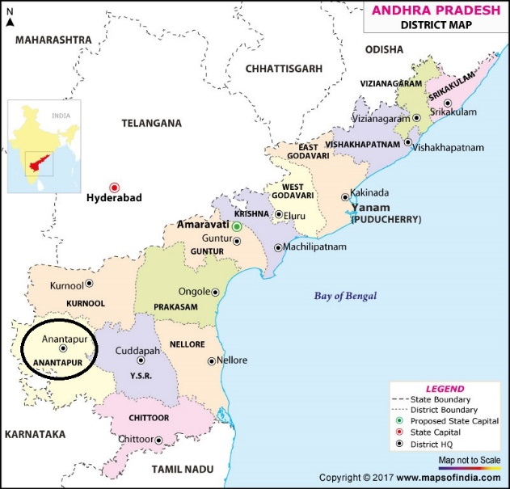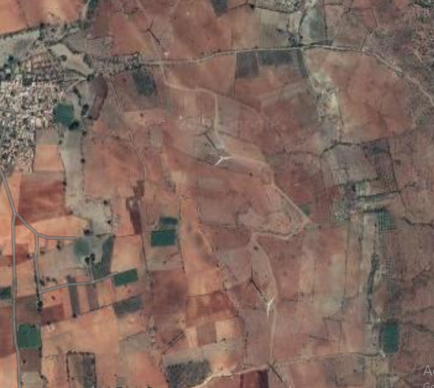

Title and Reference of Methodology
Title : Grid-connected electricity generation from renewable sources
Reference : The project activity meets the eligibility criteria of large scale project as it is more than 15 MW
Methodology : ACM0002: Grid-connected electricity generation from renewable sources - Version 18.¹
Type I : Energy industries (renewable / non-renewable sources)
Category : Approved Consolidated Methodology (ACM0002)
Tools referred with above methodology and applicable for project activity are:
- Tool to calculate the emission factor for an electricity system - Version 06.0 (EB 97, Annex 07)
- Methodological Tool- Tool for the demonstration and assessment of additionality - Version 07.0.0 (EB 70, Annex 08)

Participation under other GHG Programs
Not Applicable, as the project activity is not registered with any other program.
The undertaking from PP has been submitted for no any double accounting for current monitoring period and project activity is not participated any other GHG program other than VCS.

Other Forms of Credit
The project activity is not availing any REC benefits and the same can be confirmed from publically available link of REC generators.
Web-link: https://www.recregistryindia.nic.in/index.php/general/publics/registered_regens PP has also submitted undertaking for not availing other forms of environmental credit for the same crediting period under consideration.

Sustainable Development
Contribution to sustainable development:
Ministry of Environment, Forests and Climate Change, GoI has stipulated economic, social, environment and technological well-being as the four indicators of sustainable development. The project contributes to sustainable development using the following ways.
- Social well-being: The project would help in generating employment opportunities during the construction and operation phases. The project activity will lead to development in infrastructure in the region like development of roads and also may promote business with improved power generation.
- Economic well-being: The project is a clean technology investment in the region, which would not have been taken place in the absence of the VCS benefits the project activity will also help to reduce the demand supply gap in the state.
The project activity will generate power using zero emissions wind energy based power generation which helps to reduce GHG emissions and specific pollutants like SOx, NOx, and SPM associated with the conventional thermal power generation facilities.
- Technological well-being: The successful operation of project activity would lead to promotion of wind power generation and would encourage other entrepreneurs to participate in similar projects
- Environmental well-being: Wind being a renewable source of energy, it reduces the dependence on fossil fuels and conserves natural resources which are on the verge of depletion. Due to its zero emission the Project activity also helps in avoiding significant amount of GHG emissions.

Safeguards

No Net Harm
The project activity does not involve any major construction activity. It primarily requires the installation of the WTGs, interfacing the generators with the State Electricity Board by setting up HT transmission lines and installation of other accessories.
The report on “Developmental Impacts and Sustainable Governance Aspects of Renewable Energy Projects” prepared by MNRE dated September 2013. This report clearly mentioned that wind power project activity operations do not result in direct air pollution, noise pollution. Please refer below web link for the same.
Thus there are no any significant impacts due to implementation of project activity on air, water, soil quality and ambience are envisaged due to the project activity.

Local Stakeholder Consultation
As a part of continual improvement process, feedback from the associated stakeholders is vital, therefore a dedicated Visitor register cum grievance register has been placed at the project site which is accessible to stakeholders to provide their feedback on the project. It is appropriate publicly accessible location at which local stakeholders can provide their feedback on the project. This location is also conducive to continuous and regular checks for stakeholder comments. For the global stakeholders, the suggestion and the grievance can be mailed to info@greenkogroup.com.
At the time of project validation, a broad range of audiences (State Nodal Officers, Village Panchayat Members, District collector office and Local stakeholders) were invited by several means (Invitation, Calls, Notice pasted on common area). Various channels were used to reach maximum number of participants. At the validation stage stakeholder meeting, it was announced that the grievances register would be placed at the site for localities for their feedback and complaints.
Stakeholder meetings are organized on regular intervals in order to identify the major challenges around the area, stakeholders are invited well in advance through printed invitation, calls, meeting and a notice is placed around the local common areas. Various CSR activities around site are carried out with proper stakeholder requirements meeting. The stakeholder are also request to share their experiences and grievances on continuous basis. Registers is used to records the grievances and feedback. During the current monitoring period, positive feedback are received regarding site operation. No any grievances received during the current monitoring period, therefore, no any mitigation measures are required. Incase of grievances, the nature of probable resolution is discussed with the plant head office and implemented by the site incharge. The details of stakeholder meeting
during verification
Sl. No. | Invitation Date | Invitation Mode | Meeting Date | Meeting venue | Number of participants
01 | 11/11/2019 | Public notice, calls and personal invitations | 22/11/2019 | Site Office- Ipperu,Axis wind farms (MPRDAM) | 13

AFOLU-Specific Safeguards
Not applicable to this as this is not an AFOLU project activity.

Implementation Status

Implementation Status of the Project Activity
The project activity involves the installation of Wind project. The total installed capacity of the project is 100 MW Wind project located at Andhra Pradesh state in India. The project is promoted by Axis Wind Farms (MPR Dam) Private Limited.
The Project activity is a new facility (Greenfield) and the electricity generated by the project will be exported to the Indian electricity grid. The project will therefore displace an equivalent amount of electricity which would have otherwise been generated by fossil fuel dominant electricity grid. The Project Proponent plans to avail the VCS benefits for the project.
In the Pre- project scenario the entire electricity, delivered to the grid by the project activity, would have otherwise been generated by the operation of grid-connected power plants and by the addition of new generation sources.
The project shall result in replacing anthropogenic emissions of greenhouse gases (GHG’s) estimated to be approximately 195,052 tCO₂e per year, thereon displacing 205,860 MWh/year amount of electricity from the gird over the 10 years crediting period.
The technical specification for 100 MW Wind project having 50 unit of the Gamesa WTG is provided below.
WTG Make and Model No. | Gamesa, G114
Generator Type & Rating | Doubly-Fed Induction generator
Generator Rating | 2000 kW
WTG configuration | 50 X 2000 kW
Rotor Diameter | 114 m
Swept Area | 10,207.0 m²
Hub Height | 93
Tower Type & Shape | Conical Tubular Steel
Cut-in-wind speed | 2.5 m/s
Rated wind speed | 10.0 m/s
Cut-out wind speed | 25.0 m/s
Survival wind speed | 60.0 m/s

Deviations

Methodology Deviations
No methodology deviation is applied during the monitoring period.

Project Description Deviations
No deviation has taken place in project description during the monitoring period.

Grouped Projects
The project is not a grouped project thus this is not applicable.

Data and Parameters

Data and Parameters Available at Validation
Data / Parameter | EF_{grid, OM, y}
Data unit | tCO₂/MWh
Description | Operating margin CO₂ emission factor for the project electricity system in year y
Source of data | Calculated from CEA database, Version 13, June 2018
Value applied | 0.9726
Justification of choice of data or description of measurement methods and procedures applied | Calculated as per “Tool to calculate the emission factor for an electricity system, version 06” as 3-year generation weighted average using data for the years 2014-15, 2015-16 & 2016-17. The data are obtained from “CO₂ Baseline Database for Indian Power Sector” version 13, published by the Central Electricity Authority, Ministry of Power, Government of India.
Purpose of Data | For the calculation of the Baseline Emission
Comments | This parameter is fixed ex-ante for the entire crediting period.

Data / Parameter | EF_{grid, BM, y}
Data unit | tCO2/MWh
Description | Build margin CO₂ emission factor for the project electricity system in year y
Source of data | Calculated from CEA database, Version 13, June 2018
Value applied | 0.8723
Justification of choice of data or description of measurement methods and procedures applied | Calculated as per “Tool to calculate the emission factor for an electricity system, version 06” as per the latest data available for the most recent year 2016-17. The data is obtained from “CO2 Baseline Database for Indian Power Sector” version 13, published by the Central Electricity Authority, Ministry of Power, Government of India.
Purpose of Data | For the calculation of the Baseline Emission
Comments | This parameter is fixed ex-ante for the entire crediting period.

Data / Parameter | EF_{grid, CM, y}
Data unit | tCO₂/MWh
Description | Build margin CO₂ emission factor for the project electricity system in year y
Source of data | Calculated from CEA database, Version 13, June 2018
Value applied | 0.9475
Justification of choice of data or description of measurement methods and procedures applied | The combined margin emissions factor is calculated as follows:  EF_{grid,CM,y}= EF_{grid,OM,y}* W_{OM} + EF_{grid, BM,y}* W_{BM}  Where:  EF_{grid,BM,y}= Build margin CO2 emission factor in year y (tCO₂/MWh)  EF_{grid,OM,y}= Operating margin CO2 emission factor in year y (tCO2/MWh)  W_{OM} = Weighting of operating margin emissions factor (%) = 75%  W_{BM} = Weighting of build margin emissions factor (%) = 25%
Purpose of Data | For the calculation of the Baseline Emission
Comments | This parameter is fixed ex-ante for the entire crediting period.

Data and Parameters Monitored
Data / Parameter | EG_{PJ, y}
Data unit | MWh/y
Description | Quantity of net electricity generation supplied by the project plant/unit to the grid in year y (MWh)
Source of data | Monthly joint meter reading reports
Description of measurement methods and procedures to be applied | The difference of final value of export and import is used for monthly values of net electricity supplied to the grid by the project activity and same value will be considered for ER calculations.
Frequency of monitoring/recording | Continuous measurement & monthly recording
Value monitored | 271852.5
Monitoring equipment | The electricity exported / supplied by the plant to pooling substation and further to substation. This meter also measures electricity imported by the plant from the grid.  There are numerous meters used in this project activity and the details including Meter serial number, Make, accuracy class and the calibration dates are mentioned APPENDIX 1: Calibration Records
QA/QC procedures to be applied | The meters is approved, tested & sealed by the State Utility. The meters are in the custody of State Utility. The frequency of calibration is once in 5 years. The monthly electricity supplied/exported by the project activity in the JMR report is cross checked with the monthly invoices of sale. In the absence or delay in the meter calibration appropriate Guidelines will be applied appropriately to confirm the conservativeness of metering.  The metering arrangement, accuracy class of meters, calibration frequency is under control of state electricity board and PP does not have any control on it. PP is getting value of net electricity supplied to grid and the same is considered the monitoring parameter.  The billing is raised based on substation meters.
Purpose of the data | Calculation of baseline emissions
Calculation method | Thus, Net electricity supplied to the grid by the project plant in a given month = Export, kWh– Import, kWh
Comments | Data will be archived in paper & electronic form for two years after the end of crediting period or of the last issuance of VERs for this project activity, whichever occurs later.

Monitoring Plan
The monitoring plan is developed in accordance with the modalities and procedures for CDM project activities and is proposed for grid-connected wind power project being implemented. The monitoring plan, which will be implemented by the project participant describes about the monitoring organisation, parameters to be monitored, monitoring practices, quality assurance, quality control procedures, data storage and archiving.
The authority and responsibility for registration, monitoring, measurement, reporting and reviewing of the data rests with the project participant. PP proposed the following structure for data monitoring, collection, data archiving and calibration of equipments for this project activity. The team comprises of the following members:
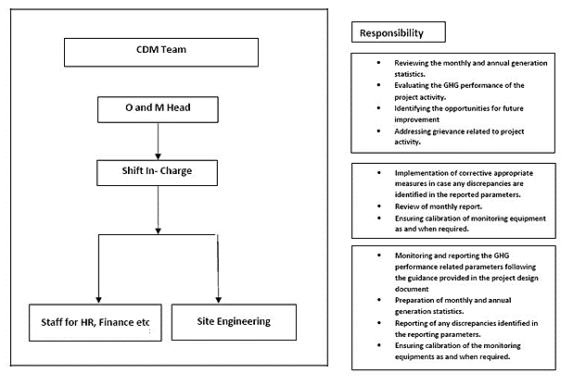
Data Measurement
The export and import energy will be measured continuously using above mentioned Main and Check meters located at the substations. Readings of meters shall be taken on monthly basis by authorized officer of SEB in the presence of PP or representative of PP. Based on the Meter Reading Statement to PP, invoices will be raised. These invoices can be used for cross checking the meter readings taken for the respective project activity.
Data collection and archiving
Readings from meters will be collected in the presence of the plant in-charge. Export and Import data would be recorded and stored in logs as well as in electronic form on a daily basis. The records are checked periodically by the Plant Manager and discussed thoroughly with the plant supervisor. The period of storage of the monitored data will be 2 years after the end of crediting period or till the last issuance of VERs for the project activity whichever occurs later.
Emergency preparedness
The project activity will not result in any unidentified activity that can result in substantial emissions from the project activity. No need for emergency preparedness in data monitoring is visualized.
Personnel training
In order to ensure a proper functioning of the project activity and a properly monitoring of emission reductions, the staff will be trained. The plant helpers will be trained in equipment operation, data recording, reports writing, operation and maintenance and emergency procedures in compliance with the monitoring plan.
Metering Arrangement
Line diagram with metering arrangement for the wind project activity is shown below.
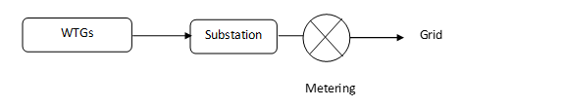
The wind plants have their own dedicated metering arrangement at the substation end. The metering arrangement is under control of state electricity board and may change in future.

Quantification of GHG Emission Reductions and Removals

Baseline Emissions
As per the approved consolidated Methodology ACM0002 (Version 18.1) para 42:
Baseline emissions include only CO2 emissions from electricity generation in fossil fuel fired power plants that are displaced due to the project activity. The methodology assumes that all project electricity generation above baseline levels would have been generated by existing grid-connected power plants and the addition of new grid- connected power plants. The baseline emissions are to be calculated as follows:
BEy = EG_{PJ, y} x EF_{grid, CM, y}
Where:
BE_{y} = Baseline emissions in year y (tCO2/yr)
EG_{PJ,y} = Quantity of net electricity generation that is produced and fed into the grid as a result of the implementation of the CDM project activity in year y (MWh/yr)
EF_{grid, CM,y} = Combined margin CO2 emission factor for grid connected power generation in year y calculated using the latest version of the “Tool to calculate the emission factor for an electricity system” (t CO2/MWh)
Therefore,
BE_{y} = EG_{PJ, y} x EF_{grid, CM, y}
= 271852.5 x 0.9475
= 257,579 tCO₂e (rundown values)

Project Emissions
Not Applicable, since emissions from the project activity is zero as per ACM0002 methodology.

Leakage
Not Applicable, since emissions from the project activity is zero as per ACM0002 methodology.

Net GHG Emission Reductions and Removals
The Formula used to calculate the net emission reduction for the project activity is
ER_{Y} = BE_{y} – PE_{y} – LE_{y}
Where,
ER_{y} = Emission Reduction in tCO₂/year
BE_{y} = Baseline emission in tCO₂/year
PE_{y} = Project emissions in tCO₂/year
LE_{y} = Leakage Emissions in tCO₂/year
For the project activity during the current monitoring period, as per section 5.1
BE_{y} = 257,579 tCO₂e
PE_{y} = 0 tCO₂e
LE_{y} = 0 tCO₂e

Year | Baseline emissions or removals  (tCO₂e) | Project emissions or removals (tCO₂e) | Leakage emissions (tCO₂e) | Net GHG emission reductions or removals  (tCO₂e)
02-August-2018 to 31-December-2018 | 67,465 | 0 | 0 | 67,465
01-January-2019 to 01-October-2019 | 190,114 | 0 | 0 | 190,114
Total | 257,579 | 0 | 0 | 257,579

The achieved GHG emission is 13.15 % is higher than the estimated value. This is due to higher wind flow pattern at the site which is not in the control of the project proponent. Also, the increased plf (Observed PLF is 25.19 %) is crossed checked with the IRR breaching values (Breaching values 14.77% and the observed value is 11.49%), the result found within the breaching limit.

APPENDIX 1: Calibration Records
Meter and Calibration details of 100 MW Wind power project by Axis Wind Farms (MPR Dam) Private Limited:
Meter Details | Main Meter | Check Meter | Standby Meter
Meter Serial No | 16400232 | 16400234 | 16400235
Meter Make | L & T | L & T | L & T
Accuracy Class | 0.2s | 0.2s | 0.2s
Date of Calibration | 08-March-2017 | 08-March-2017 | 08-March-2017
Date of Subsequent Calibration | 21-February-2019 | 21-February-2019 | 21-February-2019
Due Date of Calibration | 20-February-2024 | 20-February-2024 | 20-February-2024

http://cdm.unfccc.int/methodologies/DB/5725LCHYPYM4I1V8OD9SFYVAMFFWNP
http://cdm.unfccc.int/methodologies/DB/5725LCHYPYM4I1V8OD9SFYVAMFFWNP
http://cdm.unfccc.int/methodologies/PAmethodologies/tools/am-tool-07-v6.pdf
http://cdm.unfccc.int/methodologies/PAmethodologies/tools/am-tool-01-v7.0.0.pdf
http://mnre.gov.in/file-manager/UserFiles/report-on-developmental-impacts-of-RE.pdf
https://en.wind-turbine-models.com/turbines/428-gamesa-g114-2.0mw
http://www.cea.nic.in/reports/others/thermal/tpece/cdm_co2/user_guide_ver13.pdf
http://www.aegcl.co.in/Metering_Regulations_Of_CEA_17_03_2006.pdf

