Stakeholder Consultation Report

PUBLICATION DATE 14.10.2020
VERSION v. 1.1
RELATED SUPPORT –
TEMPLATE GUIDE Stakeholder Consultation Report v. 1.1

This document contains the following Sections

Key Project Information

SECTION A – Information made available to Stakeholders

SECTION B – Invitations made to Stakeholders

SECTION C – Report of the Consultation Process

SECTION D – Continuous input / Grievance mechanism

SECTION E – Stakeholder Feedback Round

KEY PROJECT INFORMATION
GS ID of Project | GS11150  GS11151  GS 11152  GS11153
Title of Project | GS10959 VPA07 Safe Water Project in Bangladesh I  GS10959 VPA08 Safe Water Project in Bangladesh II  GS10959 VPA09 Safe Water Project in Bangladesh III  GS10959 VPA10 Safe Water Project in Bangladesh IV
Version number of the SCR | 04
Completion date of version | 07/11/2021
Time of First Submission Date | 04/04/2021
Start Date of the Project | To be decided
Date of Meeting (s) | 10/06/2021
Project Cycle: | Regular  Retroactive

- INFORMATION MADE AVAILABLE TO STAKEHOLDERS
  - A non–technical summary of the project
>>
English version:
Guangzhou Iceberg Environmental Consulting Services Co., Ltd. (hereinafter referred to as Iceberg), a Chinese company committed to provide clean water and energy for developing countries through carbon finance, will cooperate with local NGO Social Aid to implement four borehole maintenance projects in Cox’s Bazar District, Chittagong Division of Bangladesh. The projects will provide clean water for local communities through maintaining no fewer than 100 boreholes. The broken boreholes will be identified and the broken parts of boreholes, such as hand pumps, will be rehabilitated. Chemical disinfection may be applied in case that water quality cannot meet the related requirements of Bangladesh after borehole maintenance. The four projects will be registered as carbon emission reduction projects under an international standard called “Gold Standard for Global Goals”. The income from selling these carbon credits to international carbon market will confirm the sustainability and extendibility of the projects. The projects are small scale projects since their annual emission reductions achieved will be less than 60,000 tCO₂e each, which is the threshold of small scale project. The duration of the projects is 15 years.

The implementation plan of the projects is shown as follows:

Content | Time
Site visit and holding of local stakeholder consultation meeting | 05/2021-06/2021
Projects Implementation | Estimated to be 08/2021-02/2022, maybe adjusted due to lockdown

Donation and carbon transfer agreements will be signed between the project developer and water management committees where the projects are located. So the project developer has full rights over the Products generated from Gold Standard Certification.

Bengali version:
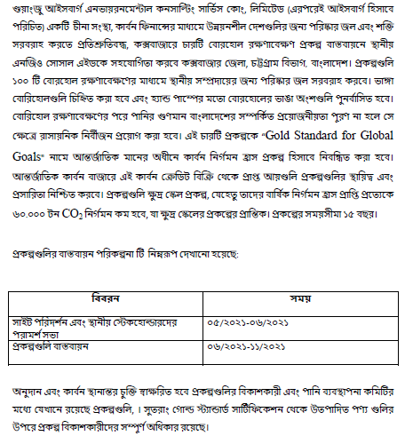

  - Contact details to get further technical detail and project information
>>
Iceberg: Mr. Ji BAO baoji@icebergchina.com
Social Aid: Engr. Md. Babul Aktar admin@socialaid.org.bd
  - Summary of economic, social and environmental impacts of the Project
>>
Analysis about potential negative economic, social and environmental impact of the project is shown as follows:

Assessment Questions/  Requirements | Justification of Relevance (Yes/potentially/no) | How Project will achieve Requirements through design, management or risk mitigation. | Mitigation Measures added to the Monitoring Plan (if required)
Principle 1. Human Rights
- The Project Developer and the Project shall respect internationally proclaimed human rights and shall not be complicit in violence or human rights abuses of any kind as defined in the Universal Declaration of Human Rights  - The Project shall not discriminate with regards to participation and inclusion | 1.No  2.No | 1. Bangladesh has ratified many UN Human Rights Conventions. The CME and the VPA will respect related laws of People's Republic of Bangladesh and will not lead to violations of human rights or discrimination of any kind.  2. The VPA is set up to include people of all genders, races, religions, educational backgrounds or any other aspects. The VPA will not discriminate with regards to participation and inclusion as the safe water supply is free to be used for everybody. | 1.N/A  2.N/A
Principle 2. Gender Equality
- The Project shall not directly or indirectly lead to/contribute to adverse impacts on gender equality and/or the situation of women  - Sexual harassment and/or any forms of violence against women – address the multiple risks of gender-based violence, including sexual exploitation or human trafficking.  - Slavery, imprisonment, physical and mental drudgery, punishment or coercion of women and girls.  - Restriction of women’s rights or access to resources (natural or economic).  - Recognise women’s ownership rights regardless of marital status – adopt project measures where possible to support to women’s access to inherit and own land, homes, and other assets or natural resources.  - Projects shall apply the principles of nondiscrimination, equal treatment, and equal pay for equal work  - Where appropriate for the implementation of a Project, paid, volunteer work or community contributions will be organised to provide the conditions for equitable participation of men and women in the identified tasks/activities.  - Introduce conditions that ensure the participation of women or men in Project activities and benefits based on pregnancy, maternity/paternity leave, or marital status.  - Ensure that these conditions do not limit the access of women or men, as the case may be, to Project participation and benefits.  - The Project shall refer to the country’s national gender strategy or equivalent national commitment to aid in assessing gender risks  - (where required) Summary of opinions and recommendations of an Expert Stakeholder(s) | 1.No  2.No  3.No  4.No | 1.(a) The VPA will not directly or indirectly lead or contribute to adverse impacts on gender equality or the situation of women. In fact, the access to clean and safe water are foreseen to improve the general conditions of women and not to lead to any risk of contributing issues like sexual harassment, sexual exploitation, violence, human trafficking  1.(b) The VPA will not directly or indirectly lead to/contribute to slavery, imprisonment, physical and mental drudgery, punishment or coercion of women and girls. In contrast, the VPA will contribute to health and well-being of women and girls.  1.(c) Boreholes are usually located in the public place of villages for everyone to use. No one can restrict women to access or control the natural resources. The VPA will benefit to local community regardless of gender. All inhabitants of  Bangladesh may turn to Committee on Economic, Social and Cultural Rights of the United Nations for women’s rights violations.  1.(d) The VPA will not have any impact on women’s ownership rights to inherit and own land, homes and other assets. Bangladesh's progressive land ownership policy will be applied to everybody irrespective of gender.  2.(a) For maintenance work and any other eventual paid or volunteer work in the VPA, the principle of the equal pay for equal work will be applied and organized in way to provide the conditions for equitable participation of men and women.  2.(b) The VPA applies the principles of nondiscrimination and equal treatment. Pregnancy or marital status does not affect the ability of a person to engage in the VPA.  2.(c) Equal participation of women and men in the VPA activities, like using the clean and safe water and participating in the annual hygiene campaigns, is guaranteed.  3. Bangladesh has ratified an  Equal Rights into their respective constitution (National Women's Development Policy), which guarantees equal gender rights. The VPA will abide by the national gender strategy. So the VPA does not involve and is not complicit in any form of discrimination based on gender difference.  4. Not applicable as no opinion or recommendation is received from expert stakeholder. | 1.N/A  2.N/A  3.N/A  4. N/A
Principle 3. Community Health, Safety and Working Conditions
- The Project shall avoid community exposure to increased health risks and shall not adversely affect the health of the workers and the community | No | The project activities do not pose risks to the health of the community. In fact, the VPA will reduce the risk of water borne illness for local communities and indoor air pollution caused by boiling water for purification. Local communities will benefit from clean and safe water. | N/A
Principle 4.1 Sites of Cultural and Historical Heritage
Does the Project Area include sites, structures, or objects with historical, cultural, artistic, traditional or religious values or intangible forms of culture? | No | There are no sites, structures, or objects with historical, cultural, artistic, traditional or religious values or intangible forms of culture in the Project Area. | N/A
>> | No |  | N/A
Principle 4.2 Forced Eviction and Displacement
Does the Project require or cause the physical or economic relocation of peoples (temporary or permanent, full or partial)? | No | The project activity consists of introducing clean and safe water and therefore no physical or economic relocation of people is involved. | N/A
>> | No |  | N/A
Principle 4.3 Land Tenure and Other Rights
Does the Project require any change, or have any uncertainties related to land tenure arrangements and/or access rights, usage rights or land ownership? | No | The VPA rehabilitates existing boreholes that have been in place for many years. No changes to land tenure arrangements and/or rights are required. | N/A
>> | No |  | N/A
Principle 4.4 Indigenous Peoples
Are indigenous peoples present in or within the area of influence of the Project and/or is the Project located on land/territory claimed by indigenous peoples? | No | There are no indigenous people present within the area of influence of the VPA. The VPA is not located on territory claimed by indigenous people. | N/A
>> | No |  | N/A
Principle 5. Corruption
- The Project shall not involve, be complicit in or inadvertently contribute to or reinforce corruption or corrupt Projects | No | The VPA does not involve or inadvertently contribute to or reinforce or is not complicit in any corruption. Bangladesh has ratified the UN Convention against Corruption which the VPA will obey. | N/A
Principle 6.1 Labour Rights
- The Project Developer shall ensure that all employment is in compliance with national labour occupational health and safety laws and with the principles and standards embodied in the ILO fundamental conventions  - Workers shall be able to establish and join labour organisations  - Working agreements with all individual workers shall be documented and implemented and include:  - Working hours (must not exceed 48 hours per week on a regular basis), AND  - Duties and tasks, AND  - Remuneration (must include provision for payment of overtime), AND  - Modalities on health insurance, AND  - Modalities on termination of the contract with provision for voluntary resignation by employee, AND  - Provision for annual leave of not less than 10 days per year, not including sick and casual leave.  - No child labour is allowed (Exceptions for children working on their families’ property requires an Expert Stakeholder opinion)  - The Project Developer shall ensure the use of appropriate equipment, training of workers, documentation and reporting of accidents and incidents, and emergency preparedness and response measures | 1.No  2.No  3.No  4.No  5. No | 1. The CME follows the labour laws and policies of Bangladesh. Bangladesh has ratified many ILO Conventions, including convention 87 (Freedom of Association and Protection of the Right to Organise Convention), convention 98 (Right to Organise and Collective Bargaining Convention), convention 29 (Forced Labour Convention) and 105 (Abolition of Forced Labour Convention).  2. The CME does not restrict workers to be able to establish or join Labour organisations.  3. The CME does not hire local employees. The CME will supervise local partners to follow the labour laws of Bangladesh about the employees’ working hours, remuneration, annual leave and so on. All employees of the CME’s local partners will work voluntarily and attend trainings on health & safety. The employment model related to the VPA will be also locally and culturally appropriate.  4. The age of all the staffs hired by local partners of the CME will be checked through ID cards to make sure that no one is below 18. Bangladesh has ratified ILO Conventions 182 (Worst Forms of Child Labour Convention) which the CME and all its local partners will obey.  5. All the work will be done by appropriate equipment with properly trained workers. Emergency preparedness and response measures have been set up and all the accidents and incidents will be recorded and reported. | 1.N/A  2.N/A  3.N/A  4.N/A  5. N/A
Principle 6.2 Negative Economic Consequences
- Does the project cause negative economic consequences during and after project implementation? | No | 1.a) At the beginning, the CME will provide fund to cover the operation cost of the VPA including expenditures beyond the project certification cycle, e.g. maintenance of boreholes, hygiene campaigns and monitoring. After the successful sale of carbon credits generated from the VPA, the carbon market will provide financial sustainability of the VPA.  1.b) The VPA provides clean and safe water free for everybody and therefore the VPA benefits local communities.The VPA has positive economic benefit due to less expenditure on firewood for water boiling and more job opportunities for borehole maintenance. | N/A
>> | No |  | N/A
Principle 7.1 Emissions
Will the Project increase greenhouse gas emissions over the Baseline Scenario? | No | GHG emissions will be reduced through replacing water purification using firewood with access to safe water. | N/A
>> | No |  | N/A
Principle 7.2 Energy Supply
Will the Project use energy from a local grid or power supply (i.e., not connected to a national or regional grid) or fuel resource (such as wood, biomass) that provides for other local users? | No | The VPA will reduce consumption of biomass through the reduced need to boil water. Safe water will be supplied by boreholes with hand pumps thus the VPA will not use energy from a local grid or power supply. | N/A
>> | No |  | N/A
Principle 8.1 Impact on Natural Water Patterns/Flows
Will the Project affect the natural or pre-existing pattern of watercourses, ground-water and/or the watershed(s) such as high seasonal flow variability, flooding potential, lack of aquatic connectivity or water scarcity? | No | The VPA does not impact natural water patterns and flows. It uses existing aquifers and does not affect the volume of water consumed by villagers. | N/A
>> | No |  | N/A
Principle 8.2 Erosion and/or Water Body Instability
Could the Project directly or indirectly cause additional erosion and/or water body instability or disrupt the natural pattern of erosion? | No | The water is taken from existing boreholes that are rehabilitated mainly for domestic use. The VPA will not cause additional erosion and/or water body instability or disrupt the natural pattern of erosion. | N/A
>> | No |  | N/A
Principle 9.1 Landscape Modification and Soil
Does the Project involve the use of land and soil for production of crops or other products? | No | The VPA provides safe and clean water and does not involve use of land and soil for production or crops or other products. | N/A
>> | No |  | N/A
Principle 9.2 Vulnerability to Natural Disaster
Will the Project be susceptible to or lead to increased vulnerability to wind, earthquakes, subsidence, landslides, erosion, flooding, drought or other extreme climatic conditions? | No | This VPA does not have any impacts that may affect vulnerability to these natural disasters. | N/A
>> | No |  | N/A
Principle 9.3 Genetic Resources
Could the Project be negatively impacted by or involve genetically modified organisms or GMOs (e.g., contamination, collection and/or harvesting, commercial development, or take place in facilities or farms that include GMOs in their processes and production)? | No | The VPA is not relevant to the use of genetically modified organisms or GMOs since it is a borehole maintenance project. | N/A
>> | No |  | N/A
Principle 9.4 Release of pollutants
Could the Project potentially result in the release of pollutants to the environment? | No | The purpose of the VPA is to provide clean water for community residents through boreholes. The VPA is not potentially resulting in release of pollutants to the environment. | N/A
>> | No |  | N/A
Principle 9.5 Hazardous and Non-hazardous Waste
Will the Project involve the manufacture, trade, release, and/ or use of hazardous and non-hazardous chemicals and/or materials? | Potential | If water quality cannot meet the requirements after borehole maintenance, chemical disinfection will be applied. So water disinfectants containing chlorine may be used in the VPA. | Water disinfectants used in the VPA should obtain international or domestic certificate, such as CE certificate, US FDA certificate or Bangladesh national authority’s certificate.
>> | Potential
Principle 9.6 Pesticides & Fertilisers
Will the Project involve the application of pesticides and/or fertilisers? | No | No pesticides and/or fertilisers will be used in the VPA. | N/A
>> | No | No pesticides and/or fertilisers will be used in the VPA. | N/A
Principle 9.7 Harvesting of Forests
Will the Project involve the harvesting of forests? | No | The VPA reduces the consumption of firewood, therefore having a positive impact on forest conservation. | N/A
>> | No |  | N/A
Principle 9.8 Food
Does the Project modify the quantity or nutritional quality of food available such as through crop regime alteration or export or economic incentives? | No | The VPA does not have any expected effects on modification of the quantity or nutritional quality of food available such as through crop regime alteration or export or economic incentives. | N/A
>> | No |  | N/A
Principle 9.9 Animal husbandry
Will the Project involve animal husbandry? | No | The VPA does not involve animal husbandry. | N/A
>> | No | The VPA does not involve animal husbandry. | N/A
Principle 9.10 High Conservation Value Areas and Critical Habitats
Does the Project physically affect or alter largely intact or High Conservation Value (HCV) ecosystems, critical habitats, landscapes, key biodiversity areas or sites identified? | No | The VPA will not cause any risk to HCV ecosystems, critical habitats, landscapes, key biodiversity areas or sites identified. In fact, the VPA benefits biodiversity of forest by reducing the use of firewood for water boiling. | N/A
>> | No |  | N/A
Principle 9.11 Endangered Species
Are there any endangered species identified as potentially being present within the Project boundary (including those that may route through the area)?  AND/OR  Does the Project potentially impact other areas where endangered species may be present through transboundary affects? | No | There are no endangered species identified as potentially being present within the project boundary. The VPA is not expected to potentially impact other areas where endangered species may be present through transboundary affects. | N/A
>> | No |  | N/A

Since the water disinfectant that may be applied in the project has already obtained CE Certificate, the project will have no negative economic, social and environmental impact.

The project will have the following positive impacts:
Economic impacts
- The project will reduce expenditures of households on firewood for water boiling.
- The project will contribute to the scale-up of local business and organizations with the potential to create jobs in borehole, such as productions, assembly, marketing and distribution of related devices.

Social impacts
- The project will provide safe water to households to reduce water-borne disease. Water-borne disease is a leading cause of death for children under the age of five.(SDG 3&6)
- The project will reduce the time and work load to fetch water, which is mostly taken by women and girls in Bangladesh. (SDG 5)

Environmental impacts
- The project will help significantly reduce greenhouse gas emissions from firewood combustion for water boiling. (SDG 13)
- The traditional way (three stones) of boiling water produces a lot of smoke and harmful gases. The project will reduce indoor air pollution and therefore respiratory illness and mortality rates, especially among women and children. (SDG 3)
- The project reduces the demand for non-renewable biomass and fossil fuels required for water boiling, which can protect natural forest eco-systems and benefit biodiversity.

  - Other relevant information to help stakeholders understand the project
>>
The paper version of project design document has been provided at the meeting site and used to aid stakeholder understanding. For those who cannot attend the physical meeting, a linkage (http://www.icebergchina.com/contents/86/237.html) was created for them to provide feedback, including the Bengali version of non-technical summary which allows local stakeholders to understand and engage more with the project.

- INVITATIONS MADE TO STAKEHOLDERS
  - Invitation tracking table
Please complete the table below
Category Code | Stakeholder Type/Organisation (if relevant) | Name of invitee | Male/  Female | Method of invitation | Date of invitation  (>30 days before Meeting)
A | Fotekharkul Union Parishad/Council, Ramu | Faridul Alam | M | Email | 18/04/2021
A | Rajarkul Union Parishad/Council, Ramu | Mufijur Rahman | M | In person | 17/04/2021
A | Khuniya Palong Union, Ramu | Abdul mabud | M | Email | 18/04/2021
A | Chowfaldandi Union Parishad/Council, Cox's Bazar Sadar | Waskarim Babul | M | Letter | 17/04/2021
A | Jalalabad Union Parishad/Council, Cox's Bazar Sadar | Imrul Hasan Rashed | M | Email | 18/04/2021
A | Dokkhinmithachhari Union Parishad/Council, Ramu | Md Yunus Bhuttu | M | Letter | 17/04/2021
A | Chakmarkul Union Parishad/Council, Ramu | Mr Nurul Islam Sikdar | M | Email | 18/04/2021
A | WMC(Water Management Committee) | Sher Ali | M | In person | 17/04/2021
A | WMC(Water Management Committee) | Nipu Sharma | F | In person | 17/04/2022
A | WMC(Water Management Committee) | Rupban | F | In person | 17/04/2023
A | WMC(Water Management Committee) | Riaz Uddin | M | In person | 17/04/2024
A | WMC(Water Management Committee) | Mizanur Rahman | M | In person | 17/04/2025
A | PMKhali Union Parishad/Council, Cox's Bazar Sadar | Md. Abdur Rahim | M | Email | 18/04/2021
A | Jhilongjha Union Parishad/Council, Cox's Bazar Sadar | Tipo Sultan | M | Email | 18/04/2021
A | Varuakhali Union Parishad/Council, Cox's Bazar Sadar | Shafiqur Rahman | M | Email | 18/04/2021
A | Khurushkhul Union Parishad/Council, Cox's Bazar Sadar | Md Jasim Uddin Jasim | M | Email | 18/04/2021
A | Fashiyakhali Union Parishad/Council, Chakaria | Giyas Uddin Choudhuri | M | In person | 17/04/2021
A | Khuntakhali Union Parishad/Council, Chakaria | Md. Abdur Rahman | M | In person | 17/04/2022
A | Local people/communities | Easmin Akter | F | In person | 17/04/2021
A | Local people/communities | Sadeka Jahan | F | In person | 17/04/2022
A | Local people/communities | Rasheda Akter | F | In person | 17/04/2023
A | Local people/communities | Sadia Asma | F | In person | 17/04/2024
A | Local people/communities | Noor Mohammad | M | In person | 17/04/2022
A | Local people/communities | Sadiya Tasmin | F | In person | 17/04/2023
A | Local people/communities | Aca Uddin | M | In person | 17/04/2024
A | Local people/communities | Arun Kanti | M | In person | 17/04/2025
A | Local people/communities | Ruma Akter | F | In person | 17/04/2023
A | Local people/communities | Saima Burhana | F | In Person | 17/04/2022
A | Local people/communities | Sana Ullah | M | In person | 17/04/2024
A | Local people/communities | Rubaida Islam Tuha | F | In person | 17/04/2022
A | Local people/communities | Masharu Islam Nammi | F | In person | 17/04/2023
A | Local people/communities | Yasmin Akter | F | In person | 17/04/2024
A | Local people/communities | Farvin Binte Faria | F | In person | 17/04/2025
A | Local people/communities | Rehena Akter | F | In person | 17/04/2026
A | Local people/communities | Parbin Biboge Pariya | F | In person | 17/04/2026
A | Local people/communities | Easmin Akter | F | In person | 17/04/2026
B | Land-tenure right | Juhra Akter | F | In person | 17/04/2027
B | Land-tenure right | Arfa Siddiqa | F | In person | 17/04/2028
C | Department of Public Health Engineering (DPHE), Cox's Bazar | Engineer Hrittik Choudhury | M | Email | 18/04/2021
C | Department of Public Health Engineering (DPHE), Cox's Bazar | Md Al Amin | M | Email | 18/04/2021
C | Department of Public Health Engineering (DPHE), Ramu | Kchai Mong Chak | M | Email | 18/04/2021
C | Upazilla Parishad/Council, Ramu | Mr Pronoy Chakma | M | Email | 18/04/2021
C | Upazilla Parishad/Council, Cox's Bazar Sadar | Suraya Akter Sweety | F | Email | 18/04/2021
C | Upazilla Parishad/Council, Ramu | Afsana Jesmin Popi | F | Letter | 17/04/2021
C | Upazilla Parishad/Council, Cox's Bazar Sadar | Hamida Taher | F | Letter | 17/04/2022
C | Upazilla Parishad/Council, Ukhiya | Kamrunnesa Bebi | F | Letter | 17/04/2023
C | Upazilla Parishad/Council, Ramu | Md Salah Uddin | M | In person | 17/04/2024
C | Upazilla Parishad/Council, Ukhiya | Md Jahangir Alom | M | Letter | 17/04/2024
D | Department of Forest | Md Kamal Uddin | M | In person | 17/04/2025
D | Department of Environment, Bangladesh | Mirza Sahwkat Ali | M | Email | 18/04/2021
D | Department of Environment, Bangladesh | Md.Mostafa Raihan | M | Email | 18/04/2021
D | Upazila Social Service | Md. Siraj Uddin | M | In person | 18/04/2021
E | Diganta Women Organization | Muslima Akter | F | In person | 17/04/2021
E | Diganta Women Organization | Sajeda Akter | F | In person | 17/04/2021
E | Good Neighbor Bangladesh | Mehnaz Khan | F | Letter | 17/04/2022
E | Jagoroni Women Samiti(JMS) | Jatis Chakma | F | Email | 18/04/2021
E | Community Development Center-Codec | Lutfur Rahman | M | Email | 18/04/2021
E | Community Development Center-Codec | Tanjima Akter Tuhfa | F | Letter | 17/04/2021
E | Community Development Center-Codec | Humaira Akter | F | In person | 17/04/2022
E | Brac( Bangladesh Rural Advancement Committee) | Reduara Sultana Runa | F | In person | 17/04/2023
E | Brac( Bangladesh Rural Advancement Committee) | Ayesha Siddiqa | F | In person | 17/04/2024
E | Jagorani Chakra Foundation | Mizan Muktadir | M | In Person | 17/04/2026
E | Friendship | Kamal Hossen | M | In Person | 17/04/2027
E | Jagorani Chakra Foundation | Sabekunnahar | F | In Person | 17/04/2028
E | SHED | Umme Hafsa Kajal | F | In Person | 17/04/2022
E | SHED | Redoara Nasrin Chy | F | In Person | 17/04/2023
E | Pulse Bangladesh | Rahena Akter | F | In person | 17/04/2025
E | Pulse Bangladesh | Morsheda Begum | F | In person | 17/04/2026
E | Brac( Bangladesh Rural Advancement Committee) | Samira Akter | F | In person | 17/04/2027
E | Bandhu Social Welfare Society | Md Nazmul Haque | M | Email | 18/04/2021
E | Social Aid | Engineer Md. Babul Aktar | M | Email | 18/04/2021
E | Eau et Vie | M.A.H. Sumon | F | Email | 18/04/2021
E | Plan International Bangladesh | ORLA MURPHY | F | Email | 18/04/2021
E | Concerned Women for Family Development | Dr. Hamida Akhter Begum | F | Email | 18/04/2021
E | Community Development Center-Codec | Rina Akhter | F | Letter | 17/04/2021
E | Environment and Social Development | Dr. Shahriar Hossain | M | Email | 18/04/2021
E | PHALS (Programme for Helpless and Lagged Society) | Rahela Parvin Rina | F | Letter | 17/04/2021
E | Community Development Center-Codec | Yasmin Akter Jesi | F | Letter | 17/04/2022
E | Community Development Center-Codec | Khaleda Akter | F | Letter | 17/04/2023
F | Gold Standard representative | help@goldstandard.org | N/A | Email | 18/04/2021
G | HIVOS | Carol Gribnau | F | Email | 18/04/2021
G | Redemption Research for Health and Educational Development Society | Shri. Pulipati Kennedy | M | Email | 18/04/2021
G | Mercy Corps | Tjada D’Oyen McKenna | F | Email | 18/04/2021
G | China Foundation for Poverty Alleviation | Gu Fengfeng | F | Email | 18/04/2021
G | Care Bangladesh | Hillol Sabhan | M | Email | 18/04/2021
G | Education International Bangladesh | Onumita Borua Lupa | F | Letter | 17/04/2022

    - Appropriateness of methods
>>
Various inviting methods were applied for the stakeholder consultation meeting. For the convenience of villagers, an invitation letter in both English and Bengali was sent to them through broadcast in villages. For some local people, invitation letters were sent to them as formal invitation. Other invitees were invited by email.

    - Gender Sensitivity
>>
The invitation considered Gold Standard’s gender equality requirements and Bangladesh’s national gender policy. 55.29% of the invitees (47 of 85) are female. The radio broadcast invitation and meeting used Bengali to make sure everyone can understand.

The VPAs meet the mandatory gender-sensitive requirements by complying with the Gender Safeguarding Principles and Requirements Version 1.2 and by carrying out gender sensitive stakeholder consultations. Women and children are the key focus of the VPAs. The households in the project area currently only have access to unsafe water from rivers and rain. In most families it is the responsibility of the women to collect firewood and boil water before using it, which takes time for them. In many cases, women are supported in the collection of firewood by children (predominantly girls). In the case of women, the time spent for collecting wood is missing in carrying out agricultural work, working in the household and working with their children on education. Girls who are collecting wood are missing school lessons, which has a negative impact on the education level. In regular cases of water-borne diseases from the consumption of unsafe water, women carry the burden of taking care of sick family members. Through the provision of access to safe water, women will not have to cook water for their daily purposes, which leaves more time for agriculture, working in the households or supporting children in education. The reduction in the need for collecting firewood will have a positive impact on women and children (predominantly girls). So women attended the stakeholder consultation meeting actively. During the meeting they spoke enthusiastically, asked questions and paid close attention to the VPAs. They said the project benefit them, and the opinions of the women were also listed in Section C.3.

    - Evidence proving invites took place as stated
>>
Email invitation:
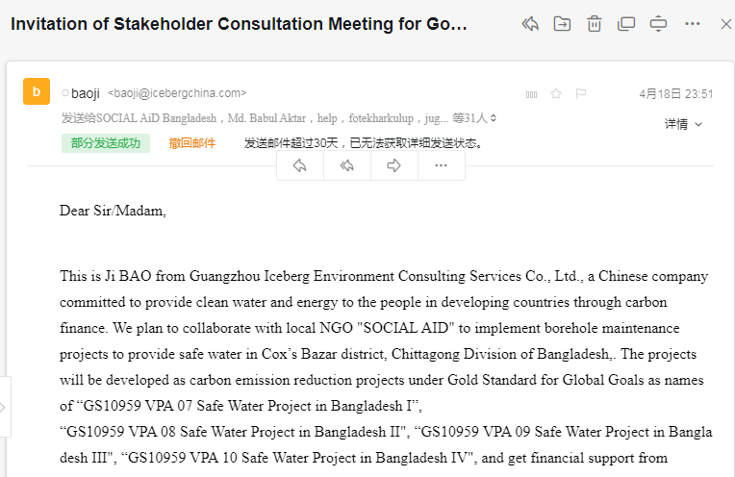
Figure 1 Email Invitation

Broadcast invitation:

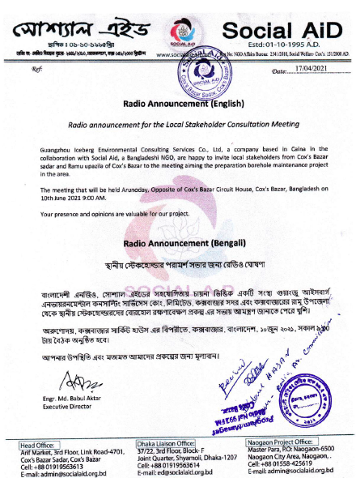
Figure 2 Broadcast Invitation

Letter invitation:
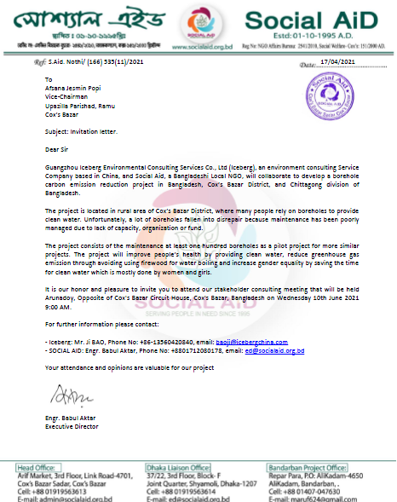
Figure 3 Letter Invitation

    - Sample content of invites (for each Method above)
>>
Email invitation:
Figure 4 Email Invitation

Broadcast invitation:

Figure 5 Broadcast Invitation

Letter invitation:
Figure 6 Letter Invitation

    - Description of other Means and methods to provide feedback for those who are not able to join the consultation meeting
>>
>>
The following email addresses are provided for those who are not able to join the consultation meeting to provide feedback:
Iceberg: Mr. Ji BAO baoji@icebergchina.com
Social Aid: Engr. Md. Babul Aktar: ed@socialaid.org.bd

If stakeholders have no access to internet and emails, there are several ways that have been adopted to keep contact between the users of boreholes and the Iceberg and Social Aid.

- The first way is to use the phone and they could report problems concerning the project by phone. The following phone numbers were provided to participants:
Engr. Md. Babul Aktar: +88-01712080178
Md Maruf: 01887670849
Md Rashel: 01889528429
Md Rashed: 01827-041033
Nuri Akter: 01839566480
Md Kamal Uddin: 01818138805

- The second way is to put books in the following places near the project sites where the representatives of Social Aid will monthly check the books to see the problems reported and find solutions with users:
Middle Meronglua beside Bypass Bus Station Ramu
Futkhali,Muhuri Para, behind the Cox's Bazar Govt College.Cox's Bazar Sadar
150ft sculpture, Sa Bagan,Ramu
Deil Para,beside Gonosastho Kendro, khurushkul, Cox's Bazar Sadar
Ghunar Para beside Rangkut,Ramu
SOCIAL AID, Arif Market, 3 rd Floor, Link Road-4701, Cox’s Bazar Sadar, Cox’s Baz

- The third way is to visit physically the boreholes locations and discuss with water management committees and users onsite.

- REPORT OF THE CONSULTATION PROCESS
  - Date of Meeting
    - List of participants

Date and Time | 10/06/2021 9:00am | Location | Arunoday, Opposite of Cox's Bazar Circuit House, Cox's Bazar, Bangladesh
Category  Code | Name of participant, job /  position in the community | Male /  Female | Contact details | Organisation  (if relevant) | Position (if Relevant)
E | Rahena Akter | F | 01837837162 | Pulse Bangladesh | PSSAO
E | Samira Akter | F | 01824170142 | Brac( Bangladesh Rural Advancement Committee) | Teacher
E | Morsheda Begum | F | 01815445689 | Pulse Bangladesh | PSSAO
E | Mizan Muktadir | M | 01634304018 | Jagorani Chakra Foundation | Teacher
E | Kamal Hossen | M | 01843773975 | Friendship | Teacher
E | Sabekunnahar | F | 01835090559 | Jagorani Chakra Foundation | Teacher
A | Riaz Uddin | M | 01891697053 | WMC(Water Management Committee) | Village Leader
B | Juhra Akter | F | 01794218941 | Land-tenure right | Land-tenure right
A | Easmin Akter | F | 01813142630 | local people/communities | Village Leader
C | Md Salah Uddin | M | 01816200905 | Upazilla Parishad/Council, Ramu | Vice Chairman
C | Afsana Jesmin Popi | F | 01836540154 | Upazilla Parishad/Council, Ramu | Women Vice Chairman
A | Waskarim Babul | M | 01819964819 | Chowfaldandi Union Parishad/Council, Cox's Bazar Sadar | Chairman
A | Mufijur Rahman | M | 01818180584 | Rajarkul Union Parishad/Council, Ramu | Chairman
C | Md Jahangir Alom | M | 01832941125 | Upazilla Parishad/Council, Ukhiya | Vice Chairman
A | Rasheda Akter | F | 01628365039 | Local people/communities | Village Leader
A | Sadia Asma | F | 01888420722 | Local people/communities | Village Leader
A | Rupban | F | 01873823668 | WMC(Water Management Committee) | Chairman
E | Engineer Md. Babul Aktar | M | 01712080178 | Social Aid | Executive Director
E | Ayman | M | 01797158717 | Guangzhou Iceberg | Project Coordinator
A | Nipu Sharma | F | 01855982855 | WMC(Water Management Committee) | Chairman
B | Arfa Siddiqa | F | 01844576202 | Land-tenure right | Land-tenure right
A | Masharu Islam Nammi | F | 01815982855 | Local people/communities | Village Leader
A | Noor Mohammad | M | 01623618896 | Local people/communities | Village Leader
E | Umme Hafsa Kajal | F | 01816767225 | SHED | CNW
E | Redoara Nasrin Chy | F | 01815490992 | SHED | CNW
A | Sadiya Tasmin | F | 01628223698 | Local people/communities | Village Leader
A | Yasmin Akter | F | 01864266242 | Local people/communities | Village Leader
A | Parbin Biboge Pariya | F | 01871520511 | Local people/communities | Village Leader
E | Mahnaz Khan | F | 01683240008 | Bondhu Social Welfare Society | Project Officer
A | Sher Ali | M | 01870036051 | WMC(Water Management Committee) | Chairman
A | Yasmin Akter | F | 01858964760 | Local people/communities | Village Leader
A | Ruma Akter | F | 01632549849 | Local people/communities | Village Leader
A | Sadeka Akter | F | 01831508509 | Local people/communities | Village Leader
E | Lutfur Rahman | M | 01866909218 | Community Development Center-Codec | CEO
D | Md Kamal Uddin | M | 01818138805 | Department of Forest | Headman
A | Aca Uddin | M | 01842828117 | Local people/communities | Village Leader
A | Arun Kanti | M | 01868203984 | Local people/communities | Village Leader
C | Kchai Mong Chak | M | 01824576727 | Department of Public Health Engineering (DPHE), Ramu | Deputy Assistant Engineer
C | Md Al Amin | M | 01754266339 | Department of Public Health Engineering (DPHE), Cox's Bazar | Deputy Assistant Engineer
E | Tanjima Akter Tuhfa | F | 01865116375 | Community Development Center-Codec | Project Manager
E | Sajeda Akter | F | 01575567484 | Diganta Women Organization | Executive Director
E | Muslima Akter | F | 01818142532 | Diganta Women Organization | Chairperson
D | Md. Siraj Uddin | M | 01612505430 | Upazila Social Service | Upazila Social Service office

    - Pictures from physical meeting(s) (best practice)
>>
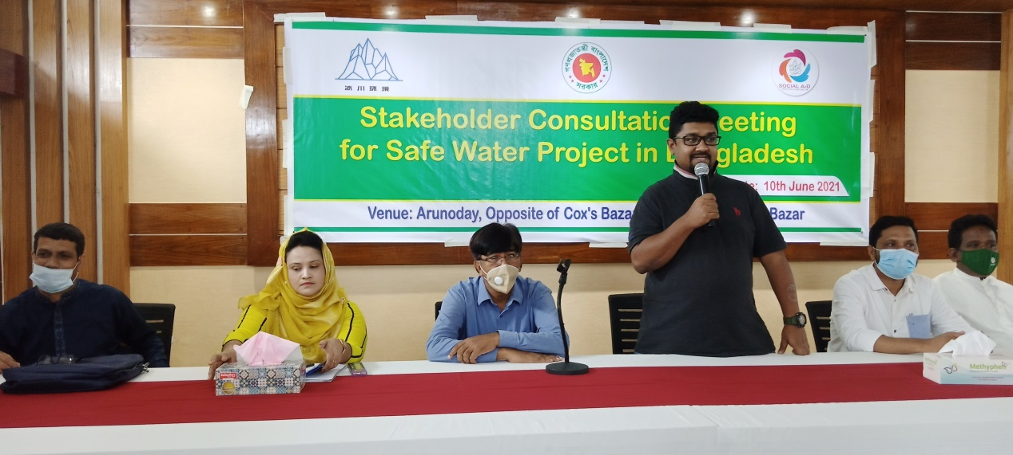
Figure 7 Local Stakeholder Consultation Meeting

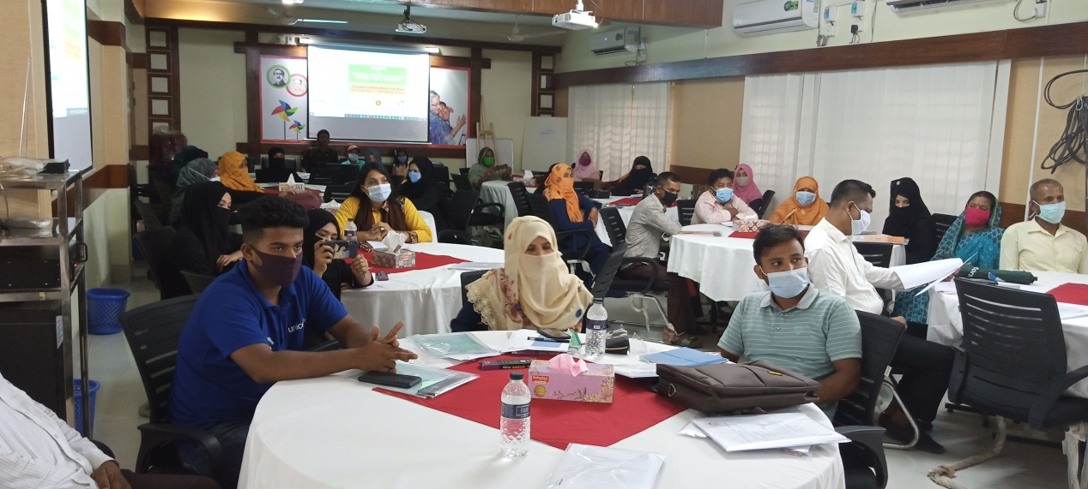
Figure 8 Local Stakeholder Consultation Meeting

  - Minutes of physical meeting(s)
>>
1. Registration
The meeting was held at 09:00 a.m. of 10/06/2021 in Cox’s Bazar District. People from local government of Cox’s Bazar District, local NGO, international NGO and villagers' representatives signed on the meeting attendance on which they registered their names, jobs and contact details with their signatures.

2. Opening of the meeting
In the meeting, after welcoming the participants, all authorized people who were present for the meeting introduced themselves respectively. One representative from SOCIAL AiD, five representatives from local government presented as the authorized people.

Then the Executive Director of SOCIAL AiD welcomed all the participants and especially thanked the CME for the collaboration with the local authorities to implement the project within the district to supply clean water. He told the attendees that the objective of the meeting was to receive feedback about the project from all stakeholders involved so that everybody was free to present his/her opinions concerning the project, which would be considered during the implementation of the project.

In his opening speech the executive director said that this project is very important because of the lack of safe water and firewood in the district and the clean water from boreholes is a solution to both problems. He stated that the collaboration between the local government and partner (Social Aid) is needed in order to reach the objectives of this project

3. Explanation of the project (in non-technical terms)
The explanation of the project was done by Engr. Babul Aktar using the non-technical summary translated into Bengali. Every participant received the copy and so it was easy to follow all explanations in relation to the project. The explanation was focusing on the maintenance of the boreholes to enable people to have access to safe water and to protect environment by reducing wood fuel consumption needed to boil water.

4. Question and answer session about the project
The presentation was followed by a question and answer session about the project. The questions and answers are shown in Section C.3. of this document.

5. Discussion on potential risks of the project (negative and positive impacts)
Potential negative and positive impacts of the project were discussed in this session. The discussion was reflected in Section A.3. of this document.

6. Discussion on monitoring sustainable development

Social Aid explained the following sustainable development goals of the project:
Sustainable Development  Goals Targeted | Most relevant  SDG Target | SDG Impact
Sustainable Development  Goals Targeted | Most relevant  SDG Target | Indicator (Proposed or SDG Indicator)
SDG 13 Climate Action | 13.b: Promote mechanisms for raising capacity for effective climate change-related planning and management in least developed countries and small island developing States, including focusing on women, youth and local and marginalized communities | Reduce emission from water boiling by non-renewable biomass in Bangladesh.
SDG 3 Ensure healthy lives and promote well-being for all at all ages | 3.3: By 2030, end the epidemics of AIDS, tuberculosis, malaria and neglected tropical diseases and combat hepatitis, water-borne diseases and other communicable diseases | Reduce the incidence of waterborne illness within the project area
SDG 5 Achieve gender equality and empower all women and girls | 5.4: Recognize and value unpaid care and domestic work through the provision of public services, infrastructure and social protection policies and the promotion of shared responsibility within the household and the family as nationally appropriate | Reduce the time spent to fetch and purify water by women and girls
SDG6 Ensure availability and sustainable management of water and sanitation for all | 6.b: Support and strengthen the participation of local communities in improving water and sanitation management | Provide safe water to local residents

It was found out that the participants in an overwhelming majority agreed that the sustainable development goals would be achieved by the project.

7. Discussion on Continuous Input/Grievance Mechanism

In this session the participants discussed how to keep contact between the users of boreholes and the Iceberg & SOCIAL AiD. They opted for three ways. The first way is to use the phone and they could report problems concerning the project by phone. The second way is to put a book in the offices of cells and users could report comments in that book. The representatives of SOCIAL AiD will check the books every month to see the problems reported and find solutions with users. The third way is to report through email.

Documents and Feedback Channels for Gold Standard Projects "Safe Water Project in Bangladesh" the following phone number of SOCIAL AiD was left to participants: +8801712080178

The following email addressed will be also used for inquiry or comment on the project
Iceberg: Mr. Ji BAO baoji@icebergchina.com
SOCIAL AiD: Mr. Babul Aktar ed@socialaid.org.bd

Places near the projects sites to put continuous input/grievance expression process books are given below:
(1) Middle Meronglua beside Bypass Bus Station Ramu, Cox's Bazar Upazila (Contact Person: Md Maruf; Cell No.: +8801887670849)
(2) Futkhali, Muhuri Para, behind the Cox's Bazar Govt College, Cox's Bazar Sadar Upazila (Contact Person: Md Rashel; Cell No.:+8801889528429)
(3) 150 ft sculpture, Chabagan, Ramu Upazila (Contact Person: Md Rashed; Cell No.: +8801827-041033)
(4) Deil Para,beside Gonosastho Kendro, khurushkul, Cox's Bazar Sadar Upazila (Contact Person: Nuri Akter; Cell No.: +8801839566480)
(5) Ghunar Para beside Rangkut, Ramu Upazila (Contact Person: Md Kamal Uddin, Cell No.:+8801818138805)

8. Closure of the meeting
At the end of the meeting Engr.Babul ended the meeting by thanking all the participants and wishing everybody a good journey to stay home. The meeting was closed 11:40 PM.

    - Minutes of other consultations
>>
No feedback has been received from other consultations.
  - Assessment of comments from all consultations above
Please complete the table below
Gender of Stakeholder |  | Stakeholder  comment | Was comment taken into account (Yes/ No)? | Explanation (Why? How?)
F | How do you know the water quality is good? |  | Yes |  | The water will be tested according to the related standards of Bangladesh and Gold Standard every quarter.
M |  | How do you know the carbon emission in the environment will be reduced by the project? | Yes |  | Due to reduction of burning the firewood in the household level.
M |  | Why focusing on importance of the boreholes’ maintenance for safe water | Yes |  | Help people to have access to regular safe water and to protect environment by reducing wood fuel consumption for boiling water.
F |  | Is there any need to collaborate with local government and NGO/INGO? | Yes |  | Community leader, local government and NGOs require collaboration due to sharing cross-cutting issues for water and sanitation.
F |  | Is there any need for hygiene campaign in community level? | Yes |  | It is needed and will be conducted in the project. Skill will be developed on reducing waterborne illness, such as diarrhea, typhoid and cholera through hygiene campaign in community level.
F |  | How many districts of Bangladesh will the project cover in the future? | No. |  | It will only cover the whole Cox’s Bazar District according to the present plan. Since the methodology of Gold Standard has been changed and the financial return of this kind of projects will reduce a lot, it is difficult for us to implement similar projects in other districts of Bangladesh unless the carbon price increases a lot.
F |  | After 15 years where the project will be gone? | No |  | The carbon market cannot provide financial support to the project after 15 years according to the regulations of Gold Standard. Maybe we can find other financial sources for the project, or hopefully maybe Bangladesh will develop a lot and has better water supply system in Cox’s Bazar.

    - Evaluation forms (best practice)
Name | Md. Kamal Uddin
Gender – Male/Female: | Male
Organization | Department of Forest
Position | Headman
Contact | +8801818138805
What is your impression of the meeting? | In this meeting discussed about the safe water, which is the good thing of my impression.
What do you like about the project? | I like water quality and bacteria test about the project.
What do you not like about the project? | All discussion issue is good so I like everything activities in this project.
Do you have any question  about the project? | No. Ensure safe water in the community.
Do you have any  suggestion about the project? | Besides the borehole/wells maintenance, I like to request to install iron removal plant and build new tubewell.

Name | Sabekun Naher
Gender – Male/Female: | Female
Organization | Jagorani Chakra Foundation
Position | Teacher
Contact | +8801835090559
What is your impression of the meeting? | Environment will be improved which is my impression of this meeting.
What do you like about the project? | Children will be free from water born disease which I like about this project.
What do you not like about the project? | There is nothing dislike about the project.
Do you have any question  about the project? | Yes. How many districts of Bangladesh to cover in the future?
Do you have any  suggestion about the project? | It will be better to implement for more upazillas and unions.

Name | Lutfur Rahman
Gender – Male/Female: | Male
Organization | Community Development Center-Codec
Position | CEO
Contact | +8801866909218
What is your impression of the meeting? | Very nice meeting. Present context is required.
What do you like about the project? | I like about this project of carbon emission  reducing.
What do you not like about the project? | There is nothing dislike. Everything is important for our environment.
Do you have any question  about the project? | How many Upazillas will be conducted for this project and which unions?
Do you have any  suggestion about the project? | Required Upazilla and Union based committee to to implement this project.

Name | Redoara Nasrin Chowdhury
Gender – Male/Female: | Female
Organization | SHED
Position | Community Nutrition Worker
Contact | +8801815490992
What is your impression of the meeting? | Very good discussion in this meeting and I learnt lot of things from this project.
What do you like about the project? | I like everything about this project, especially carbon emission reducing is the most important.
What do you not like about the project? | I like all activity about the project.
Do you have any question  about the project? | After 15 years where it is going?
Do you have any  suggestion about the project? | I expecting to implement to all Upazilla of Cox’s  Bazar and hoping to work in remote village. I think such type of meeting is required in the future this project.

Name | Rahena
Gender – Male/Female: | Female
Organization | Pulse Bangladesh Society
Position | PSSAO
Contact | +8801837837162
What is your impression of the meeting? | My meeting impression is well.
What do you like about the project? | I like the project because this project removes water pollution.
What do you not like about the project? | I like this project. I do not dislike this project.
Do you have any question  about the project? | I have a question about the project. How long will it last?
Do you have any  suggestion about the project? | I have a suggestion about this project. This project should be done well.

  - Summary of alterations based on comments
>>
Some clarifications about the project were made to stakeholders as shown in Section C.3. No other alterations are required base on the comments.
Please use the table below to report on the methods agreed with stakeholders
- CONTINUOUS INPUT / GRIEVANCE MECHANISM
 | Method Chosen (include all known details e.g. location of book, phone, number, identity  of mediator) | Justification of Choice  (best practice)
Continuous Input / Grievance Expression Process Book (mandatory) | Middle Meronglua beside Bypass Bus Station Ramu  Futkhali,Muhuri Para, behind the Cox's Bazar Govt College.Cox's Bazar Sadar  150ft sculpture, Sa Bagan,Ramu  Deil Para,beside Gonosastho Kendro, khurushkul, Cox's Bazar Sadar  Ghunar Para beside Rangkut,Ramu  SOCIAL AID, Arif Market, 3 rd Floor, Link Road-4701, Cox’s Bazar Sadar, Cox’s Baz | It is convenient for villagers to give their opinions through grievance expression process books in villages
GS Contact (mandatory) | help@goldstandard.org | Required by Gold Standard
Telephone access (optional) | Engr. Md. Babul Aktar: +88-01712080178  Md Maruf: 01887670849  Md Rashel: 01889528429  Md Rashed: 01827-041033  Nuri Akter: 01839566480  Md Kamal Uddin: 01818138805 | For directly connecting with Social Aid
Internet/email access (optional) | Mr. Ji BAO: baoji@icebergchina.com  Engr. Md. Babul Aktar: ed@socialaid.org.bd | For directly connecting with Iceberg and Social Aid
Nominated Independent Mediator (optional)
Other

- STAKEHOLDER FEEDBACK ROUND

Please check this box if the project is retroactive and has done only 1 consultation with a physical meeting intergrated into the SFR.

  - Length of the Feedback Round

Stakeholder Feedback Round |  | Planned | Actual
Start Date | 22/08/2021
End Date | 21/10/2021

  - Summarise how all stakeholders were/will be invited to provide feedback
>>
A linkage (http://www.icebergchina.com/contents/86/237.html) has been created for providing feedback. An email was sent to stakeholders to invite them to provide feedback as the following:
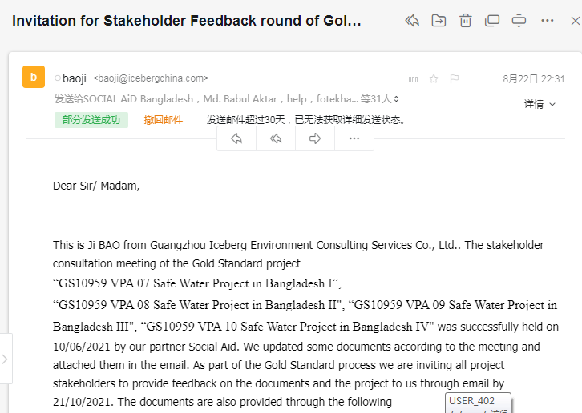
Figure 9 Invitation Email

For those who do not have email, an invitation message was sent to them by cell phone as the following:
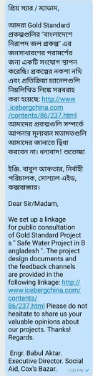
Figure 10 Invitation Message

  - Summarise Feedback received, including if any changes in project design were made
>>

No feedback has been received during the stakeholder feedback round. So no change is project design is required.

Revision History

Version | Date | Remarks
1.1 | x October 2020 | Inclusion of Key Project Information  Restructure, new headings and reorder to better match the steps a developer will follow in consultations.  Removal of some non-mandatory template tables (Blind Sustainable Development Assessment). Clarification of best practice steps that are non mandatory processes, clarification of mandatory discussion points. Clarification regarding publishing names and that original evaluation forms (optional) and attendance lists (mandatory) should be separate documents.  Improved clarity on Stakeholder Feedback round section and procedures for retroactive projects  Provision of an accompanying Guide to help the user understand detailed rules and requirements
1.0 | 14 August 2017 | Initial adoption

https://www.ohchr.org/EN/UDHR/Documents/UDHR_Translations/bng.pdf
https://www.ohchr.org/en/countries/asiaregion/pages/bdindex.aspx
https://mof.portal.gov.bd/sites/default/files/files/mof.portal.gov.bd/budget_mof/799b4a82_f259_4fd4_98ba_a1b17af0e9b5/G-3_17_146_Land_English.pdf
https://mowca.portal.gov.bd/sites/default/files/files/mowca.portal.gov.bd/policies/64238d39_0ecd_4a56_b00c_b834cc54f88d/National-Women%20Development%20Policy-2011English.pdf
https://treaties.un.org/Pages/ViewDetails.aspx?src=IND&mtdsg_no=XVIII-14&chapter=18&clang=_en
https://www.ilo.org/dyn/normlex/en/f?p=1000:11200:0::NO:11200:P11200_COUNTRY_ID:103500
https://www.ilo.org/dyn/normlex/en/f?p=1000:11200:0::NO:11200:P11200_COUNTRY_ID:103500
WHO, Global Water Supply and Sanitation Assessment 2000 Report, 2000, http://www.who.int/docstore/water_sanitation_health/Globassessment/Global1.htm#1.1

