Stakeholder Consultation Report

PUBLICATION DATE 14.10.2020
VERSION v. 1.1
RELATED SUPPORT

- TEMPLATE GUIDE Stakeholder Consultation Report v. 1.1

This document contains the following Sections
Key Project Information
SECTION A - Information made available to Stakeholders
SECTION B - Invitations made to Stakeholders
SECTION C - Report of the Consultation Process
SECTION D - Continuous input / Grievance mechanism
SECTION E – Stakeholder Feedback Round

KEY PROJECT INFORMATION
GS ID of Project | GS 11336
Title of Project | Shuangbaotai Animal Manure Management System GHG Mitigation Project in Guangxi Province
Version number of the SCR | 02
Completion date of version | 24/06/2022
Time of First Submission Date | 26/10/2021
Start Date of the Project | 05/09/2020
Date of Meeting (s) | 15/10/2021
Project Cycle: | Regular  Retroactive

INFORMATION MADE AVAILABLE TO STAKEHOLDERS
        - A non–technical summary of the project
>>
Purpose and general description of project

Shuangbaotai Animal Manure Management System GHG Mitigation Project in Guangxi province introduces new animal waste management systems (AWMSs) to a group of 9 existing swine farms in Guangxi Zhuang Autonomous Region, which are owned by Shuangbaotai Animal Husbandry Group Co., Ltd. (hereinafter called” Shuangbaotai”). The purpose of the project activity is to treat the manure and wastewater to avoid methane emissions generated in the baseline uncovered anaerobic lagoons.

The project activity replaces the current open anaerobic lagoons with new AWMSs, and Each subsidiary swine farm will install one AWMS. All the manure and wastewater are collected and then be separated first. The separated solid are treated in aerobic composting system to produce fertilizer and part of the fertilizer will be distributed to the surrounding farmers free of charge to improve the life condition of farmers and the others will be sold to the market. The separated liquid is treated through anaerobic digestion, the biogas generated during the treatment process is captured for power generation and surplus biogas is destroyed through the flaring system (if any). The electricity generated are all used by the operation of AWMSs and the 9 swine farms. It is estimated that total 25,859,844.12m³ biogas are expected to be generated annually and each generator is installed in each subsidiary swine farm, total installed capacity of the proposed project is 5.2 MW, and the annual electricity production is estimated to be 33,100.60MWh. After anaerobic digestion. The sludge produced from anaerobic digestion will be treated through aerobic composting together with the separated solid and the effluent will be used as a liquid organic fertilizer for the irrigation of agriculture.

Benefited from the “waste-biogas-fertilizer” pattern, harmlessness and ecological utilization of the swine manure can be realized. The power generated are all used by the AWMSs and the 9 swine farms and will not be connected to another user or to the regional power grid and the baseline emissions associated with electricity generation will not be claimed.

The project activity will reduce of GHG in the atmosphere through avoiding methane emissions from anaerobic treatment of swine manure and wastewater. 267,474 tCO₂e emission reductions will be produced annually and total emission reductions are 1,337,370 tCO₂e in the first crediting period. The project activity can contribute to local sustainable development in the following aspects:
- The project activity can enhance the quality of the water, control the odour, and improve the working environment of the workers and the production and living conditions of the farmers.
- The project activity can provide 18 full-time job opportunities for local residents.
- The generated good organic fertilizers are partly supplied to the farmers living around free, they can be used to yield organic products and improve the income of the farmers.
- Biogas technology can capture the methane generated during the treatment process and use biogas to generate electricity which can provide clean energy to substitute some traditional energy resource, thus the project can reduce CH4 emissions more effectively and contribute to the mitigation of global climate change.

Details of technologies
There are 9 existing swine farms for this project, and each AWMS is implemented in each swine farm. The specific process is as follows:

All the manure and wastewater are collected and then be separated first. The separated solid will be treated in aerobic composting system, which will be used as fertilizer. And part of the fertilizer products will be distributed to the surrounding farmers free of charge to improve the life condition of farmers, the others will be sold to the market. The separated liquid will be treated through anaerobic digestion, the biogas generated during the treatment process will be captured for power generation if there is surplus biogas, then the biogas will be flared through the flaring system. The sludge produced from anaerobic digestion will be treated through aerobic composting together with the separated solid and the effluent will be treated aerobically and then used for agriculture irrigation.
Solid-liquid separation
All the manure and wastewater are collected and then be separated first by solid-liquid separator. The separated solid are treated in aerobic composting system and the organic fertilizers are produced. The separated liquid is treated through anaerobic digestion and the biogas generated during the treatment process is captured for electricity generation.
Anaerobic digesters treatment process
Anaerobic tanks adopt Upflow Anaerobic Sludge Bed Reactor (UASB) as its anaerobic digester technology, and the biogas generated from the anaerobic digesters is entered the biogas generator set after desulfurization and purification system. The generated electricity is used for daily operation of AWMSs and the swine farms, and the waste heat of the generator is recycled for increasing the temperature of the anaerobic reactor. At the same time, and the residual biogas is flared through open flaring if there is any surplus biogas. The temperature of the anaerobic treatment unit of the project is designed as medium temperature, and the optimal temperature range is 35 ~ 38 ℃.
Comprehensive utilization of biogas
The biogas just produced by the anaerobic fermentation system is a mixed gas containing saturated steam. In addition to CH₄ and CO₂, it also contains H₂S and suspended particulate impurities. Therefore, desulfurization purification system is required. The purified biogas can enter the generator system for power generation and the electricity generated is used for the operation of AWMS and the 9 existing swine farm and the biogas is flared through the opened flaring if there is any surplus biogas.
Aerobic composting process
The separated solid after solid-liquid separation and the sludge produced from anaerobic digestion are treated through aerobic composting. The aerobic composting process of this project adopts trough composting. The trough composting system combines controlled ventilation and regular turning. The composting process takes place in long and narrow passages called "troughs". The trough composting system is generally equipped with a vent pipe or a gas distribution device installed on the trough. When turning over, the air blower is used to supply the oxygen required for fermentation. The composting cycle of the blast trough composting system is 2-4 weeks.

The proposed project was implemented in 9 existing swine farms and the technology implemented at each swine farm was same. While the treatment capacities of each AWMS and the size of each swine farm and corresponding design of the AWMS was different. The treatment capacity and equipment of the system are designed according to the farming scale. The volume for original uncovered anaerobic lagoons and the equipment parameters used of each swine farm are shown in Table 3 of PDD.

The technical flow of the project activity is shown below:
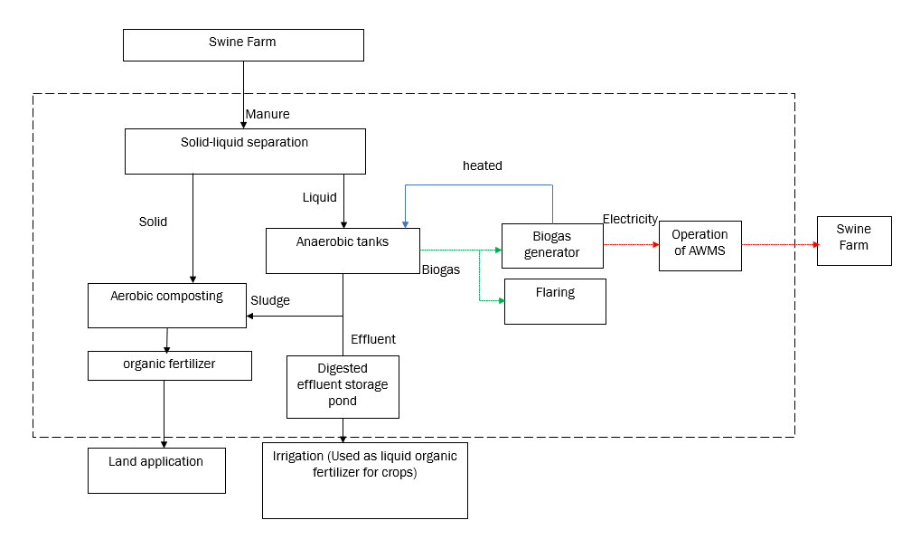
Figure 1 Technical roadmap of the project activity

Location of the project
The proposed project activity is located in Guangxi Zhuang Autonomous Region, China. There are nine subsidiary farms involved in the project. Of which, there are one fatting farm: Debao Chengguan swine Farm, eight swine farm including market swine and breeding swine: Bama Yanyan swine Farm, Chongzuo Zuozhou swine Farm, Tianyang Wucun swine Farm, Quanzhou Dengjiabu swine Farm, Chongzuo Quming swine Farm, Jingxi swine Farm, Liucheng Mashan swine Farm and Tengxian Tianping swine Farm. The specific location of the nine subsidiary farms is shown below:
Table 1. The GPS location of the nine farms
Swine Farm | Location | East longitude | North latitude
Bama Yanyan swine farm （巴马延岩猪场） | Yanyan village, Yandong township, Bama County, Hechi City | 107.231670544° | 23.976710754°
Chongzuo Zuozhou swine Farm（崇左左州猪场） | Quxi village, Zuozhou Town, Jiangzhou District, Chongzuo City | 107.456162364° | 22.648337404°
Tianyang Wucun swine Farm （田阳五村猪场） | Tianyang village, Wucun Town, Tianyang District, Baise City | 106.800232° | 23.501188°
Quanzhou Dengjiabu swine Farm（全州邓家埠猪场） | Dengjiabu Liujia Village, Quanzhou town, Quanzhou County, Guilin City | 111.100142756° | 25.891490360°
Chongzuo Quming swine Farm（崇左渠茗猪场） | Quming Village, Zuozhou town, Jiangzhou district, Chongzuo City | 107.456200450° | 22.686794907°
Jingxi swine Farm（靖西猪场） | Dajin village, Ludong town, Jingxi City, Baise city | 106.315845° | 23.148953°
Liucheng Mashan swine Farm（柳城马山猪场） | Sanle village, Qiaoli Town, Mashan County, Nanning City | 108.054611695° | 23.755085410°
Tengxian Tianping swine Farm（藤县天平猪场） | Xinxing village, Tianping Town, Teng County, Wuzhou City | 110.773228845° | 23.375143765°
Debao Chengguan swine Farm（德保城关猪场） | Nazao village, Chenguan Town, Debao County, Baise City | 106.654436049° | 23.301572413°

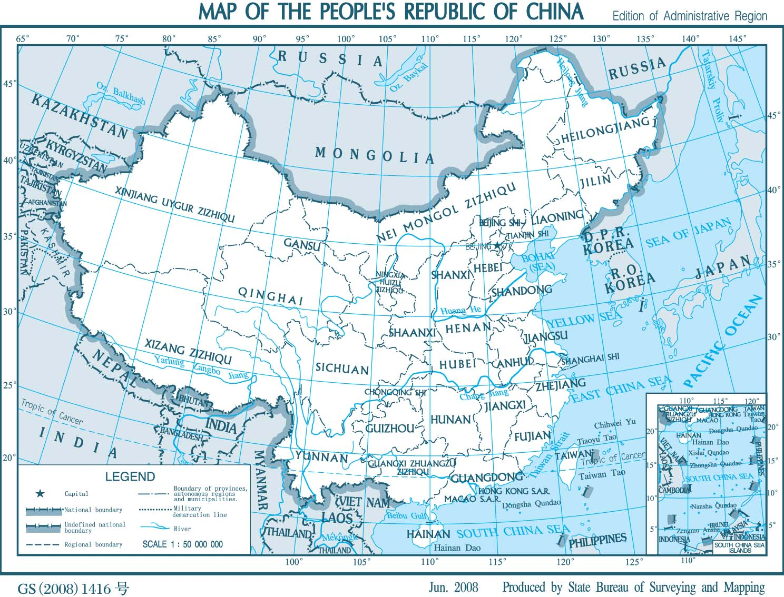
Guangxi Zhuang Autonomous Region
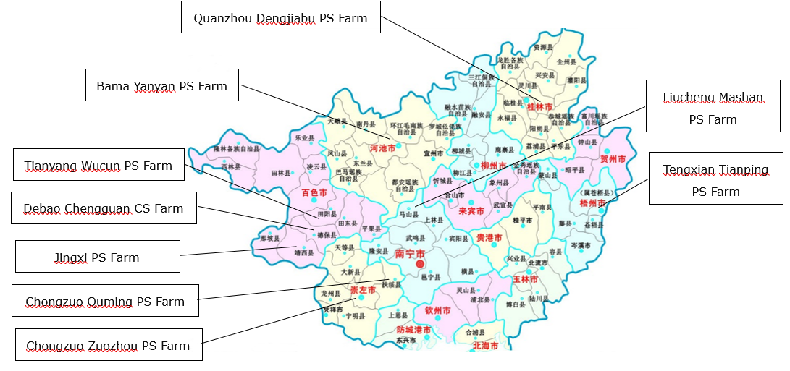
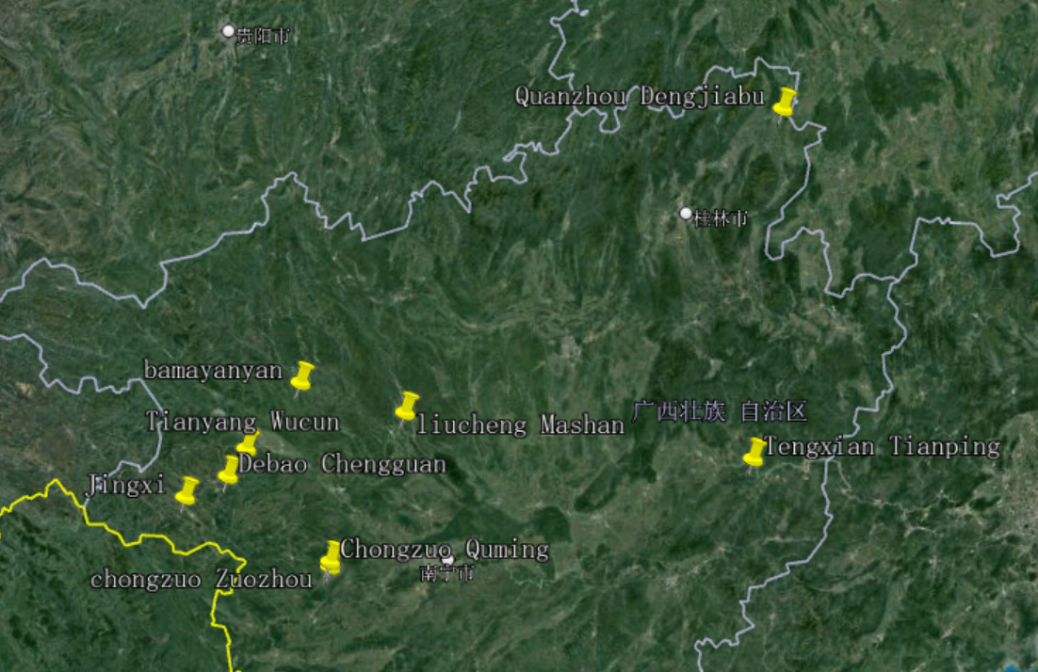
Figure 2 The Geographic Location of the project
Scale of the project
The proposed project intro duces new AWMSs to treat the manure and wastewater. As per section 9.1.2 of GS4GG GHG Emissions Reduction & Sequestration Product Requirements (Version 2.1), it belons to the Type 3: other project activities. The annual emission reductions of the project activity are 267,474 tCO₂e, which is more than 60,000 tCO₂e. Thus, the project does not meet the definition of small-scale projects in section 9.1.2 of GS4GG GHG Emissions Reduction & Sequestration Product Requirements (Version 2.1), Therefore, the project is a large-scale GS VER project.

Proposed timetable
The project had put into operation in the end of 20/01/2020. As per manufacturer specifications of the anaerobic tanks, the lifetime of the anaerobic tank is 20 years which is more than 15 years. The total length of crediting period of the project is 15 years (5 years for each Design Certification Renewal Cycle and in total two Design Certification Renewal Cycles).

        - Contact details to get further technical detail and project information
>>
In case any further questions about the project, stakeholders or any other individuals can contact the project owner or the project developer. Refer to the following table for contact details.

Project owner
Organization name | Shuangbaotai Animal Husbandry Group Co., Ltd.
Registration number with relevant authority | 91360106MA35LB3Q3C
Street/P.O. Box | 201, 2nd Floor, Office Building, No. 799, Torch Street, Nanchang High-paying Technology Industrial Development Zone
City | Nanchang City
State/Region | Jiangxi province
Postcode | 330096
Country | China
Telephone | 136 3668 5354
E-mail | snowgirl1984@hotmail.com
Website | http://www.sbtjt.com/
Contact person | Yuan xue
Title | Deputy General Manager
Salutation | Ms.
Last name | Yuan
First name | Xue
Personal e-mail | snowgirl1984@hotmail.com

Project developer
Organization name | Profit Carbon Environmental Energy Technology (Shanghai) Co., Ltd.
Registration number with relevant authority | 91310115301334442X
Street/P.O. Box | No.2815 Longteng Avenue
Building | Sales Center of Baihuiyuan
City | Shanghai
Postcode | 200232
Country | China
Telephone | +86 21 6127 2386
E-mail | yanan.zhu@profitcarbon.com
Website | www.profitcarbon.com
Contact person | Joanna Zhu
Title | Project Director
Salutation | Ms.
Last name | Joanna
First name | Zhu
Department | Technology Department
Direct tel. | +86 21 6127 2386
Personal e-mail | yanan.zhu@profitcarbon.com

        - Summary of economic, social and environmental impacts of the Project
>>
The project activity can contribute to local sustainable development in the following aspects:

SDG 7 – Affordable and Clean Energy
The project activity replaces the current open anaerobic lagoons with 9 new closed anaerobic digesters. The biogas generated during the treatment process is captured for electricity generation, the electricity generated are all used by AWMSs and the swine farms. In baseline situation, the electricity consumption of the swine farm is supplied by the power grid Company, which is dominated by thermal power. No clean energy can be generated in baseline situation.

SDG 8 – Decent Work and Economic Growth
The project activity will provide job opportunities for all locals during project implementation and monitoring activities irrespective of gender or any other status.

SDG 13 – Climate Action
The project activity is designed to install new animal waste management systems (AWMSs) to a group of 9 existing swine farms to treat the manure and wastewater from the 9 swine farms. Through this technology, the project activity can capture methane generated during the swine manure treatment process and the biogas can be used for power generation and the residual biogas will be flared, which can contribute to the mitigation of global climate change. Besides, the project will provide an opportunity for local residents to learn and raise awareness on climate change and mitigation measures on the stakeholder consultation fiscal meeting.

All assessment questions related to safeguarding principles were discussed during the stakeholder consultation meeting. Refer to the following table for results of the Safeguarding Principal Assessment.

Assessment Questions/  Requirements | Justification of Relevance (Yes/potentially/no) | How Project will achieve Requirements through design, management or risk mitigation. | Mitigation Measures added to the Monitoring Plan (if required)
Principle 1. Human Rights
- The Project Developer and the Project shall respect internationally proclaimed human rights and shall not be complicit in violence or human rights abuses of any kind as defined in the Universal Declaration of Human Rights  - The Project shall not discriminate with regards to participation and inclusion | No | 1.The project activity is designed to introduce new animal waste management systems to treat the manure and wastewater from the 9 swine farms to avoid methane emissions generated in the baseline uncovered anaerobic lagoons. The project is in Guangxi Zhuang Autonomous Region, China. The project is implemented under the laws of China and will not lead to violations or human rights abuses in any kind.  2.All end-users in the project region that respect the principles and values of sustainable development can equally participate and benefit from the project. The project does not discriminate on gender, race, religion, sexual orientation or any other aspect. | Not required
Principle 2. Gender Equality
- The Project shall not directly or indirectly lead to/contribute to adverse impacts on gender equality and/or the situation of women  - Projects shall apply the principles of nondiscrimination, equal treatment, and equal pay for equal work  - The Project shall refer to the country’s national gender strategy or equivalent national commitment to aid in assessing gender risks  - (where required) Summary of opinions and recommendations of an Expert Stakeholder(s) | No | 1.The project will not directly or indirectly reinforce gender-based discrimination and shall not lead to/contribute to adverse impacts on gender equality and/or the situation of women.  In fact, the project increases women’s access to or control of resources, entitlements and benefits by providing easy access to equal job opportunities.  2.The project will not set up any barriers to the employment of women. All employees have benefits based on pregnancy, maternity/paternity leave, or marital status according to the Labour Law of the People's Republic of China, Special provisions on labour protection of female employees and other related regulation and policies.  3. The project complies with the Labor Law and China's gender related policies.  4. There is no opinions and recommendations of an Expert Stakeholder(s). That’s because the project will not directly or indirectly reinforce gender-based discrimination and shall not lead to/contribute to adverse impacts. Therefore, the safeguarding principle related to Gender Equality and Women’s Rights is not triggered during the project design and implementation. | Not required
Principle 3. Community Health, Safety and Working Conditions
- The Project shall avoid community exposure to increased health risks and shall not adversely affect the health of the workers and the community | No | The project activity is designed to introduce new animal waste management systems to treat the manure and wastewater from the 9 swine farms to avoid methane emissions generated in the baseline uncovered anaerobic lagoons. The biogas generated during the treatment process will be captured for power generation. After anaerobic digestion, the fermented sludge will be treated in aerobic composting system, which will be used as fertilizer. The fertilizer can be distributed to the local people for free regularly. So, the Project doesn’t increase the exposure to health risks and adversely affect the health of the workers and the community. In fact, this project can bring benefits to the workers and the community. | Not required
Principle 4.1 Sites of Cultural and Historical Heritage
Does the Project Area include sites, structures, or objects with historical, cultural, artistic, traditional or religious values or intangible forms of culture? | No | The new animal waste management system is not used in sites, structures, or objects with historical, cultural, artistic, traditional or religious values or intangible forms of culture.  The project does not utilise Cultural Heritage, including the knowledge, innovations, or practices of local communities, affected communities. | Not required
>> | No |  | Not required
Principle 4.2 Forced Eviction and Displacement
Does the Project require or cause the physical or economic relocation of peoples (temporary or permanent, full or partial)? | No | The free distribution of the fertilizer produced by this project can help to reduce the costs of purchasing fertilizer for the local people. All the investment for the animal waste management system is provided by project owner. It obviously does not cause physical or economic relocation of peoples. | Not required
>> | No |  | Not required
Principle 4.3 Land Tenure and Other Rights
- Does the Project require any change, or have any uncertainties related to land tenure arrangements and/or access rights, usage rights or land ownership?  - For Projects involving land use tenure, are there any uncertainties with regards to land tenure, access rights, usage rights or land ownership? | No | This project is operated in the swine farm owned by the project owner.so, there is no uncertainties related to land tenure arrangements and/or access rights, usage rights or land ownership.  The project does not require any change to land tenure arrangements and/or other rights such as resource access rights, community-based property rights and customary rights, which is confirmed by an expert invited by the project owner. | Not required
>> | No |  | Not required
Principle 4.4 - Indigenous people
Are indigenous peoples present in or within the area of influence of the Project and/or is the Project located on land/territory claimed by indigenous peoples? | No | Indigenous people have the same and equal opportunity to obtain the fertilizer and they will not be affected directly or indirectly in a negative way by the project.  In addition, there are no indigenous people present within the area of influence nor the project is located on territory claimed by indigenous people. This is confirmed by an expert invited by the project owner. | Not required
>> | No |  | Not required
Principle 5. Corruption
- The Project shall not involve, be complicit in or inadvertently contribute to or reinforce corruption or corrupt Projects | No | The project is implemented on the ground by the social enterprise. The ethical codes of the project partners are against corruption. In addition, the companies comply with all related economic laws and regulations of China.  This Project has a zero tolerance to corruption policy, anything generated as project revenue shall be spent towards the project monitoring, repair and maintenance, project operation and costs against project verification and issuance of the emission reduction credits.  Hence, the project doesn’t involve any transaction of cash and/or kind between the project participant and the beneficiary. | Not required
Principle 6.1 Labour Rights
- The Project Developer shall ensure that all employment is in compliance with national labour occupational health and safety laws and with the principles and standards embodied in the ILO fundamental conventions  - Workers shall be able to establish and join labour organisations  - Working agreements with all individual workers shall be documented and implemented and include:  - Working hours (must not exceed 48 hours per week on a regular basis), AND  - Duties and tasks, AND  - Remuneration (must include provision for payment of overtime), AND  - Modalities on health insurance, AND  - Modalities on termination of the contract with provision for voluntary resignation by employee, AND  - Provision for annual leave of not less than 10 days per year, not including sick and casual leave.  - No child labour is allowed (Exceptions for children working on their families’ property requires an Expert Stakeholder opinion)  - The Project Developer shall ensure the use of appropriate equipment, training of workers, documentation and reporting of accidents and incidents, and emergency preparedness and response measures | No | The project complies with the Labour Law of the People's Republic of China, Special provisions on labour protection of female employees and other related regulation and policies. The project owner will sign contracts with employees. The labor contracts specify working hours, tasks and payments. All employees have benefits based on social security, pregnancy, maternity/paternity leave, or marital status according to the labor laws of China. Besides, the employees also have the right to establish labor unions and to carry on labor union activities.  All employees would provide their age information document, e.g., ID, when signing the labour contract, and the project owner did not and will not employ any child labour. | Not required
Principle 6.2 Negative Economic Consequences
- Does the project cause negative economic consequences during and after project implementation? | No | The equipment procurement cost of the project will be borne by the project owner. The project has positive economic benefits due to the reduced cost of buying fertilizer for local farmer. The project will create fair job opportunities for local people, which is good for the local economy. No risks are foreseen for the local economy through the realization of the project. | Not required
>> | No |  | Not required
Principle 7.1 Emissions
Will the Project increase greenhouse gas emissions over the Baseline Scenario? | No | The project activity is designed to new animal waste management systems to treat the manure and wastewater from the 9 swine farms to avoid methane emissions generated in the baseline uncovered anaerobic lagoons. The project activity will reduce of GHG in the atmosphere through avoiding methane emissions from anaerobic treatment of swine manure and wastewater. | Not required
>> | No |  | Not required
Principle 7.2 Energy Supply
Will the Project use energy from a local grid or power supply (i.e., not connected to a national or regional grid) or fuel resource (such as wood, biomass) that provides for other local users? | No | The project activity will replace the current open anaerobic lagoons with 9 new closed anaerobic digesters. The biogas generated during the treatment process will be captured for power generation. All the power is used by the 9 swine farms and will not be connected to another user or to the regional power grid. Also, the project activity will use electricity from the Southern China Power Grid, which is a reginal grid of China. It will not affect the energy consumptions or power supply or fuel resource supply that provides for other local users. | Not required
>> | No |  | Not required
Principle 8.1 Impact on Natural Water Patterns/Flows
Will the Project affect the natural or pre-existing pattern of watercourses, ground-water and/or the watershed(s) such as high seasonal flow variability, flooding potential, lack of aquatic connectivity or water scarcity? | No | The project will not affect the natural or pre-existing pattern of watercourses, groundwater and/or the watershed(s) such as high seasonal flow variability, flooding potential, lack of aquatic connectivity or water scarcity. This is confirmed by an expert invited by the project owner. | Not required
>> | No |  | Not required
Principle 8.2 Erosion and/or Water Body Instability
- Could the Project directly or indirectly cause additional erosion and/or water body instability or disrupt the natural pattern of erosion?  - Is the Project’s area of influence susceptible to excessive erosion and/or water body instability? | No | All animal manure will be put into the new animal waste management systems to treat and is prohibited to discharge into the Groundwater and surface water. Therefore, AWMSs used in the project area could not directly or indirectly cause additional erosion and/or water body instability or disrupt the natural pattern of erosion. The fertilizer produced in this project meets the relevant Chinese fertilizer implementation standards, so the project also could not directly or indirectly impact on surface and ground waters or soil erosion on slopes. | Not required
>> | No |  | Not required
Principle 9.1 Landscape Modification and Soil
Does the Project involve the use of land and soil for production of crops or other products? | No | Comprehensive utilization and resourceful treatment of the manure waste are encouraged by the local government. All the swine farms of the project have obtained necessary approval from the local government, including Planning Permit on Land for Construction Use, Environmental Impact Assessment etc. Hence, the project does not involve the use of land and soil for production of crops or other products. | Not required
>> | No |  | Not required
Principle 9.2 Vulnerability to Natural Disaster
Will the Project be susceptible to or lead to increased vulnerability to wind, earthquakes, subsidence, landslides, erosion, flooding, drought or other extreme climatic conditions? | No | The new animal waste management systems used in the project area does not involve any land use changes. It would not lead to the exacerbation of impacts caused by natural or man-made hazards, such as landslides or floods. | Not required
>> | No |  | Not required
Principle 9.3 Genetic Resources
Could the Project be negatively impacted by or involve genetically modified organisms or GMOs (e.g., contamination, collection and/or harvesting, commercial development, or take place in facilities or farms that include GMOs in their processes and production)? | No | The project does not involve the use of GMOs, so it will not have negatively impacted by the use of genetically modified organisms or GMOs. | Not required
>> | No |  | Not required
Principle 9.4 Release of pollutants
Could the Project potentially result in the release of pollutants to the environment? | No | The project is designed to introduces new animal waste management systems to treat the manure and wastewater from the 9 swine farms to avoid methane emissions generated in the baseline uncovered anaerobic lagoons. During the treatment process, the biogas was captured for power generation and flared, the fermented sludge was treated in aerobic composting system, the wastewater was treated aerobically and then used for agriculture irrigation, so no pollutants release to the environment. | Not required
>> | No |  | Not required
Principle 9.5 Hazardous and Non-hazardous Waste
Will the Project involve the manufacture, trade, release, and/ or use of hazardous and non-hazardous chemicals and/or materials? | Potential | The project activity will replace the current open anaerobic lagoons with 9 new closed anaerobic digesters. The biogas generated during the treatment process will be captured for power generation or flared. If biogas is not handled properly during the operation period of the project, methane leakage/explosion may be caused. | Required. For this project, the biogas will be generated during the treatment process, if biogas is not handled properly during the operation period of the project, methane leakage/explosion may be caused. So, the Mitigation Measures were needed. In this project, the mitigation measure for safeguarding principles was that project owner will conduct regular training on biogas safety and leakage to project employees to improve their proficiency in the treatment system and ensure that biogas leakage and safety hazards will not occur, and the employee training of biogas safety operation will be monitored through the training record. Also, the Mitigation Measure for Safeguarding Principles, i.e., the parameter of “Employee Training of biogas safety operation” was included in the monitoring plan in section B.7.1 and B.7.3.
>> | Potential
Principle 9.6 Pesticides & Fertilisers
Will the Project involve the application of pesticides and/or fertilisers? | No | The project activity does not involve any application of pesticides and/or fertilizers. | Not required
>> | No |  | Not required
Principle 9.7 Harvesting of Forests
Will the Project involve the harvesting of forests? | No | The project activity does not involve the harvesting of forests. | Not required
>> | No |  | Not required
Principle 9.8 Food
Does the Project modify the quantity or nutritional quality of food available such as through crop regime alteration or export or economic incentives? | No | The project activity does not involve the modification of the quantity or nutritional quality of food available. | Not required
>> | No |  | Not required
Principle 9.9 Animal husbandry
Will the Project involve animal husbandry? | No | The project is designed to introduces new animal waste management systems to treat the manure and wastewater from the 9 swine farms to avoid methane emissions generated in the baseline uncovered anaerobic lagoons, belongs to waste disposal and resource utilization. | Not required
>> | No |  | Not required
Principle 9.10 High Conservation Value Areas and Critical Habitats
Does the Project physically affect or alter largely intact or High Conservation Value (HCV) ecosystems, critical habitats, landscapes, key biodiversity areas or sites identified? | No | The project is not located in an area within a high conservation value area or within critical natural habitats. The project activity does not physically affect or alter largely intact or High Conservation Value (HCV) ecosystems, critical habitats, landscapes, key biodiversity areas or sites identified. In addition, the “Notice of the Measures for the Administration of Livestock and Poultry Production and Operation Licensing” clearly stipulate the prohibited construction area.
>> | No
Principle 9.11 Endangered Species
a. Are there any endangered species identified as potentially being present within the Project boundary (including those that may route through the area)?  - Does the Project potentially impact other areas where endangered species may be present through transboundary affects? | No | There are no endangered species identified as potentially being present within the Project boundary. In addition, the new animal waste management systems used in the project will not pose a threat to any species. | Not required
>> | No |  | Not required

        - Other relevant information to help stakeholders understand the project
>>
During the stakeholder consultation, the draft project design documents, template guide and key project information were provided to help them understand the project better.

INVITATIONS MADE TO STAKEHOLDERS
        - Invitation tracking table
Category Code | Stakeholder Type/Organization (if relevant) | Name of invitee | Male/  Female | Method of invitation | Date of invitation  (>30 days before Meeting)
A/B | Local resident/user | Wang Boyang | male | Email and Notice |  | 08/09/2021
A/B | Local resident/user | Tang Meiru | female | Email and Notice |  | 08/09/2021
A/B | Local resident/user | Liu Jie | male | Email and Notice |  | 08/09/2021
A/B | Local resident/user | Hu Hongyu | male | Email and Notice |  | 08/09/2021
A/B | Local resident/user | Wu Yuetao | female | Email and Notice |  | 08/09/2021
A/B | Local resident/user | Feng Tao | male | Email and Notice |  | 08/09/2021
A/B | Local resident/user | Liu Lu | female | Email and Notice |  | 08/09/2021
A/B | Local resident/user | Zhang Xingbang | male | Email and Notice |  | 08/09/2021
A/B | Local resident/user | Zeng Yanlan | female
A/B | Local resident/user | Liao Yingjie | male
C | Department of Ecology and Environment of Guangxi Zhuang Autonomous Region | Ding Jian | Male | Email |  | 08/09/2021
C | Department of Agriculture and Rural Affairs of Guangxi Zhuang Autonomous Region | Qiu Wei | Male | Email |  | 08/09/2021
C | Guangxi Development and Reform Commission | Qian Yuping | Female | Email |  | 08/09/2021
D | Ministry of Ecology and Environment of the People's Republic of China-Department of Climate Change | Lu Mingyuan | Male | Email |  | 08/09/2021
D | Ministry of Ecology and Environment of the People's Republic of China-Department of Climate Change | Dong Gang | Male | Email |  | 08/09/2021
D | Ministry of Ecology and Environment of the People's Republic of China-Department of Climate Change | Dong Yuanzhou | Male | Email |  | 08/09/2021
E | Women's Federation of Guangxi Zhuang Autonomous Region | Pan Yue | Female | Email |  | 08/09/2021
F | Gold Standard representative | help@goldstandard.org | N/A | Email |  | 08/09/2021
G | Global Offset Research | Siddharth Yadav | N/A | Email |  | 08/09/2021
G | CEDESOL | David Whitfield | N/A | Email |  | 08/09/2021
G | Asociación para la Promoción de Nuevas Alternativas de Desarrollo (APRONAD) | Francisco Rivas | N/A | Email |  | 08/09/2021
G | Proyecto Mirador | Esther Adams | N/A | Email |  | 08/09/2021
G | Lean Management Systems Promotion Society | Raave Jain | N/A | Email |  | 08/09/2021
G | HIVOS | Harry Clemens | N/A | Email |  | 08/09/2021
G | Redemption Research for Health and Educational Development Society | Kennady Pulipati | N/A | Email |  | 08/09/2021
G | NCMA India | Bholendra Singh | N/A | Email |  | 08/09/2021
G | Fundacion de Iniciativas de Cambio Climatico de Honduras (Fundacion MDL de Honduras) | Suyapa Zelaya | N/A | Email |  | 08/09/2021
G | United Purpose | Lloyd Archer | N/A | Email |  | 08/09/2021
G | Concern Health Ghana | Isaac Ampomah | N/A | Email |  | 08/09/2021
G | NOVA | Montagu Murray | N/A | Email |  | 08/09/2021

          - Appropriateness of methods
>>
The Stakeholder Consultation Meeting was held from 9:00 a.m. to 11:30 a.m. on 15/10/2021 at conference room of Quming swine Farm, Zuozhou town, Jiangzhou district, Chongzuo city, Guangxi Zhuang Autonomous Region. Before the meeting, local villagers, relevant local government officials, experts from NGOs, both male and female, were widely invited via email and the public notice on 08/09/2021. In this case, the invitation can cover most of the people who are related to the project regardless of their gender. In addition, the project contact asked all the invitees to reply to confirm whether to attend the meeting before 13/10/2021. In case the invitees could not attend, they were encouraged to invite their colleagues, friends, or families to attend. Females were encouraged to take part in the meeting.

The content of the invitation is in Chinese, which is the official language of China. Since the invitees are local users or other stakeholders of this project, they will have a certain understanding of our project. Therefore, invitations through emails or public notice will not be treated as spam and scammers, so this invitation method of emails and public notice is reasonable.

          - Gender Sensitivity
>>
The invitation methods of this project mainly include email and public notice, etc. The notices posted in public places, and everyone can learn and attend the meeting. When using other forms of invitation, we have considered inviting at least 50% of women to attend meetings or participate in the stakeholder feedback. In addition, in order to invite more people, including marginalized groups, we encourage invitees to invite more people to participate in the stakeholder feedback of the project.

          - Evidence proving invites took place as stated
>>
- Evidence invitation from email:
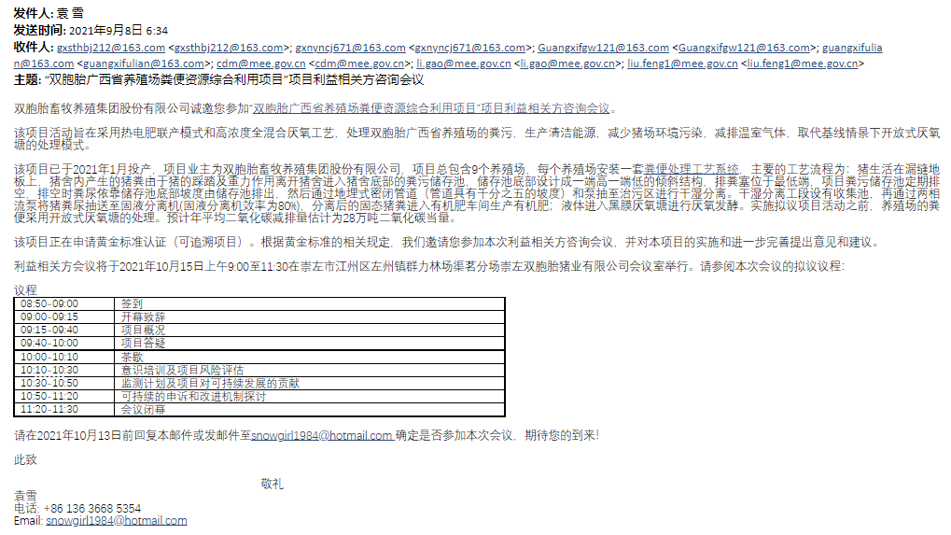

- Evidence invitation from public notice:
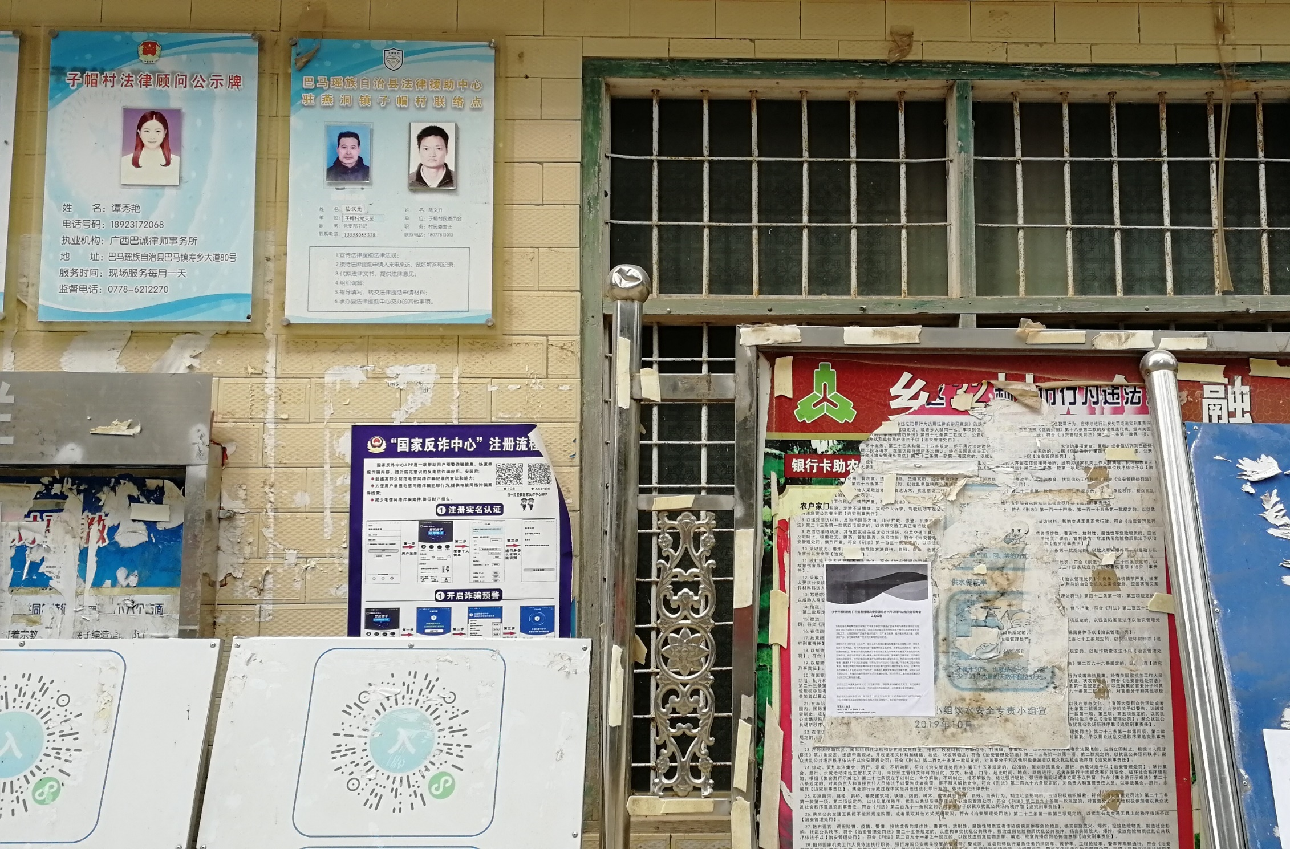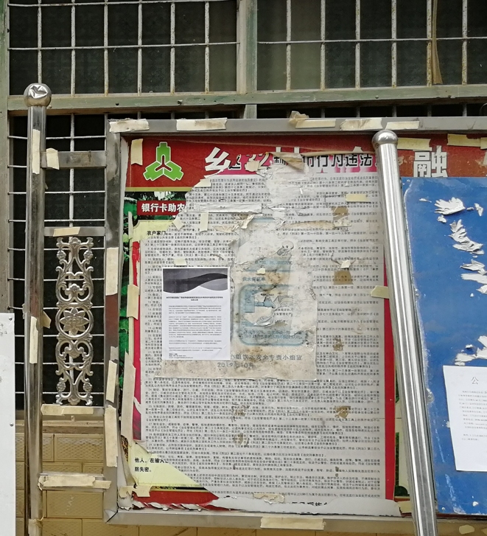
          - Sample content of invites (for each Method above)
>>
- Sample content of invitation from email:
Dear Sir/Madam,
Shuangbaotai Animal Husbandry Group Co., Ltd. is pleased to invite you to a stakeholder’s consultation meeting regarding the project of “Shuangbaotai Animal Manure Management System GHG Mitigation Project in Guangxi Province”.

The objective of the project activities is to treat animals’ manure from swine farms of Shuangbaotai Group in Guangxi Province, using a combined heat, power and fertilizer model and a high concentration mixed anaerobic process, to produce clean energy, reduce environmental pollution on the swine farm and reduce greenhouse gas emissions, replacing the treatment mode of the uncovered anaerobic lagoons under the baseline scenario.

The project was put into production in January 2021. The owner of the project is Shuangbaotai Animal Husbandry Group Co., Ltd. The project consists of a total of 9 swine farms, each of which is equipped with a set of Animal Manure Management Systems (AMMSs). The main technological process is as follows: The project activity uses flushing system to collect the manure automatically. All the manure and wastewater are collected and then be separated first. The solid will be treated in aerobic composting system, which will be used as fertilizer and the fertilizer products will be distributed to the surrounding farmers free of charge to improve the life condition of farmers. The liquid will be treated through anaerobic digestion, the biogas generated during the treatment process will be captured for power generation and the residual biogas will be flared. The sludge produced from anaerobic digestion will be treated through aerobic composting together with the solid and the effluent will be treated aerobically and then used for agriculture irrigation. Prior to the implementation of the proposed project activities, manure from the farm was treated in an open anaerobic pond. Estimated annual average CO₂ reduction is estimated at 280,549tons of CO₂ equivalent.

The project is applying for Gold Standard Certification (Retroactive project). According to the relevant rules of Gold Standard, with this letter, we would like to invite you to participate in this Stakeholder Consultation Meeting and make comments on the project.

The Stakeholder Consultation Meeting held from 9:00 a.m. to 11:30 a.m. on 15/10/2021 at conference room of Quming swine Farm, Zuozhou town, Jiangzhou district, Chongzuo city, Guangxi Province. Please find the proposed agenda of this meeting:

Agenda
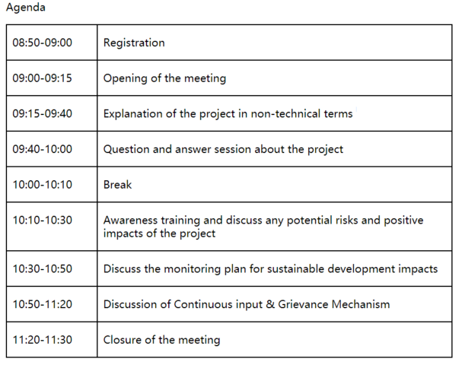
We would be grateful if you could confirm your participation to the local stakeholder meeting before 13/10/2021 by email to snowgirl1984@hotmail.com.

Best regards,
Yuan Xue
Tel: +86 136 3668 5354
Email: snowgirl1984@hotmail.com
Shuangbaotai Animal Husbandry Group Co., Ltd.

- Sample content of public notice:
The public notice has been posted at public places of local governments and the village committee where the most residents can pay attention to it. The detailed content of public notice is shown below:
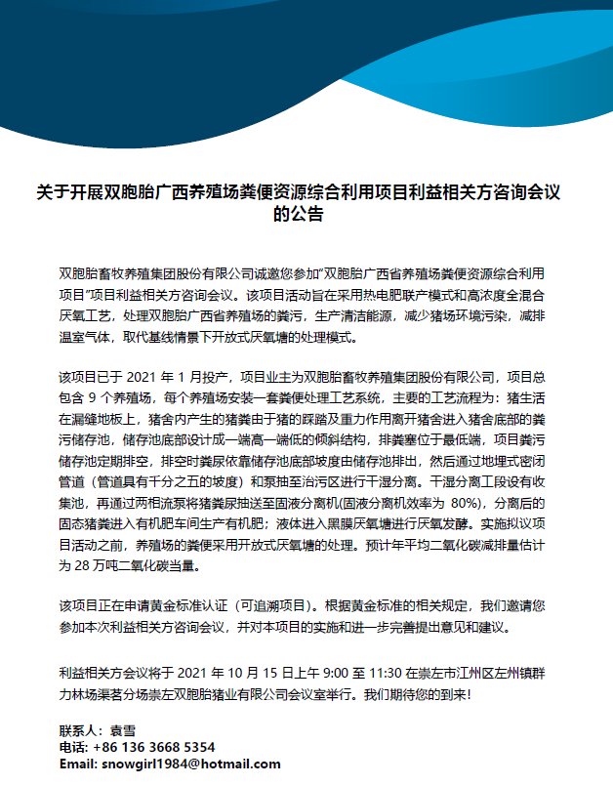

          - Description of other Means and methods to provide feedback for those who are not able to join the consultation meeting
>>
Stakeholders or any other individuals, who couldn’t attend the stakeholder consultation meeting, are able to provide feedback or comments via email or telephone. The email of 2nd feedback round has been sent on 08/09/2021, and the Stakeholder feedback round is held for two months between 10/09/2021 and 09/11/2021. Everyone is welcome to comment on this project.

REPORT OF THE CONSULTATION PROCESS
        - Date of Meeting
          - List of participants
Date and Time | 9:00 a.m. to 11:30 a.m. on 15/10/2021 | Location | Conference room of Quming swine Farm, Zuozhou town, Jiangzhou district, Chongzuo city, Guangxi Zhuang Autonomous Region
Category  Code | Name of participant, job /  position in the community | Male /  Female | Contact details | Organization  (if relevant) | Signature
A/B | Wang Boyang | male | 18978154939 | Chongzuo City
A/B | Tang Meiru | female | 18174758638 | Chongzuo City
A/B | Liu Jie | male | 18878016397 | Chongzuo City
A/B | Hu Hongyu | male | 13977836750 | Hechi City
A/B | Wu Yuetao | female | 13807768188 | Baise City
A/B | Feng Tao | male | 15077312871 | Guilin City
A/B | Liu Lu | female |  | Jingxi City
A/B | Zhang Xingbang | male | 15007829776 | Liuzhou City
A/B | Zhang Hongxia | female | 13687825712 | Liuzhou City
A/B | Wang Lifang | female |  | Liuzhou City
A/B | Feng Jingye | male | 13687825712 | Wuzhou City
A/B | Gao Huilan | female | 15077414734 | Wuzhou City
C | Feng Ying | female |  | Department of Ecology and Environment of Guangxi Zhuang Autonomous Region
C | Dong Haoran | male |  | Department of Agriculture and Rural Affairs of Guangxi Zhuang Autonomous Region
C | Qian Yuping | female |  | Guangxi Development and Reform Commission
E | Pan Yue | female |  | Women's Federation of Guangxi Zhuang Autonomous Region

          - Pictures from physical meeting(s) (best practice)
>>
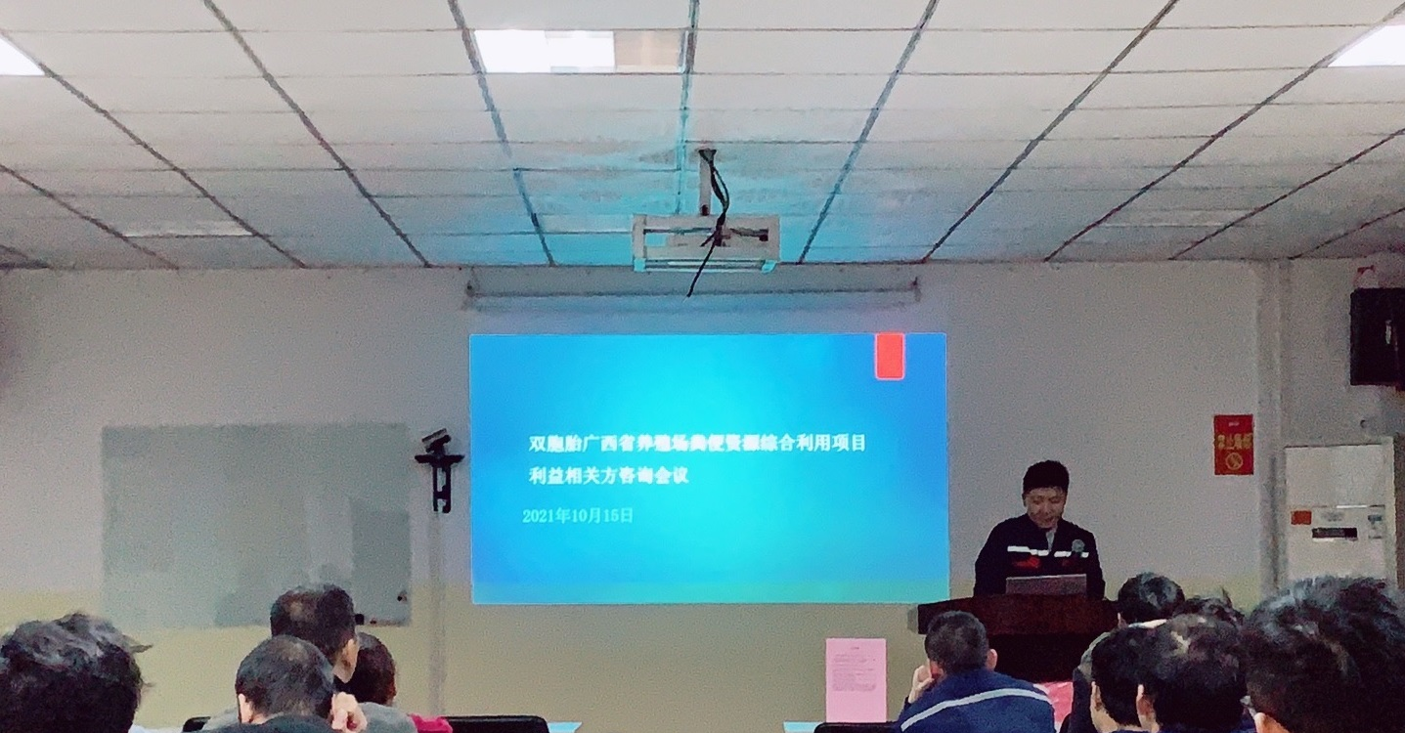
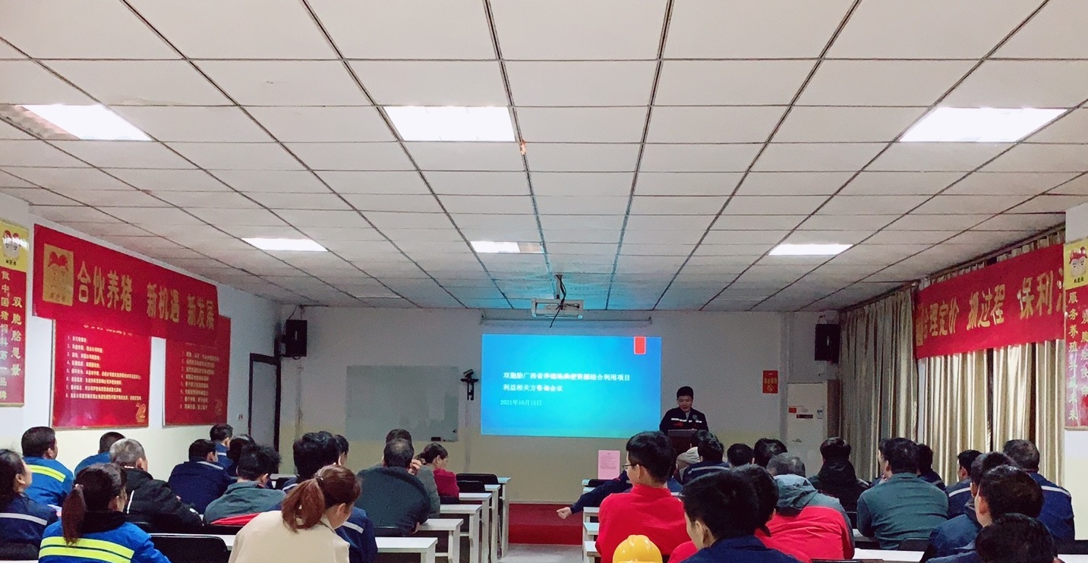
        - Minutes of physical meeting(s)
>>
Date: 15/10/2021
Location: Conference room of Quming swine Farm, Zuozhou town, Jiangzhou district, Chongzuo city, Guangxi Zhuang Autonomous Region.
Time: 9:00a.m. to 11:30 a.m.

Opening of the meeting
The project is applying for registration under GS4GG. The purpose of the meeting is to consult the stakeholders' opinions and feedback on the project, so as to avoid the negative impact on the stakeholders and strengthen the positive impact of the project. 16 people, including local residents and experts from local government attended in the 1st round of Local stakeholder consultation physical meeting held on 15/10/2021.

The meeting is opened with remarks from employee of Shuangbaotai Animal Husbandry Group Co., Ltd. The feedback and comments will be taken into consideration during the implementation of the project.

Explanation of the project in non-technical terms
Yuan Xue from Shuangbaotai Animal Husbandry Group Co., Ltd. introduced the project activity and its social and environmental impacts.

The project activity introduces new animal waste management systems to a group of 9 swine farms in Guangxi Zhuang Autonomous Region. The purpose of the project activity is to treat the manure and wastewater from the 9 swine farms to avoid methane emissions generated in the baseline uncovered anaerobic lagoons. The biogas generated during the treatment process will be captured for power generation, the electricity generated are all used by the swine farms. After anaerobic digestion, the fermented sludge will be treated in aerobic composting system, which will be used as fertilizer. Wastewater from the new animal waste management systems will be treated aerobically and then used for agriculture irrigation.

Question and answer session about the project
After the description of the project, all participants have the opportunity to express their questions and comments. The representative of project owner provided answers to the questions and comments raised by the stakeholders.

Confirmation of the GS VER ownership has also been discussed during this session. All the Animal Waste Management Systems (AWMSs) were invested by the project owner. All the stakeholders who attended the meeting were notified that the project owner has the legal ownership of the carbon credits generated by the project activity.

Discuss any potential risks and positive impacts of the project
Afterwards, the meeting continued with the discussion of the Awareness training and project risk assessment activity. The Awareness training make participants aware of the contribution to the environment and the social, such as this project create jobs opportunities for locals, especially women’s groups or other marginalized groups. During the project risk assessment, participants discussed the difficulties and risks that may be encountered in the process of project development. The comments are summarized in section C.3.

Discuss the monitoring plan for sustainable development impacts
Regarding the monitoring plan, it mainly discusses the practicability and rationality of related parameter monitoring to ensure that it can be successfully registered and issued in GS. Before the stakeholder consultation meeting, the project owner intends to assess the impact of the project on SDG 7, 8 and 13. During the physical meeting, all stakeholders were also invited to discuss the selection of SDG. The SDG outcome forms was given to all participants, explained the exercise and gave them 20 minutes to choose the relevant SDG and give their justification. During the meeting, PP paid more attention to the issues and the chosen of relevant SDG of women and marginalized groups. After discussion, all stakeholders believed that the owner's choice for SDG 7, 8 and 13 was wiser and reasonable and there was no objection. Finally, the impact of SDG7, SDG8 and SDG13 were decided.

Discussion of Continuous input & Grievance Mechanism
After discussions of the impacts and monitoring plan, the host then explained about the Continuous input & Grievance Mechanism which entails how the stakeholders can reach out to the project implementer during the project’s crediting period in case of any questions, comments or suggestions. Also, the contact methods are provided to the attendees to see if the methods are appropriate and easy to access. Refer to section D for more details.

Closure of the meeting
Thank all the attendees for their participation in this meeting. The opinions and comments are very important for the implementation of this project. In addition to this meeting, all stakeholders can also provide us with suggestions through our Continuous input & Grievance Mechanism.

At the end of the meeting, all the evaluation forms filled out by all participants were collected.

          - Minutes of other consultations
>>
Stakeholders who could not attend the physical meeting were encouraged to raise questions by mail or phone calls. However, no questions or comments were received.
        - Assessment of comments from all consultations above
Gender of Stakeholder | Stakeholder  comment | Was comment taken into account (Yes/ No)? | Explanation (Why? How?)
Female | How to dispose or utilize the products after the swine was treated by the animal waste management systems? | Yes | After anaerobic digestion, the fermented sludge will be treated in aerobic composting system, which will be used as fertilizer and the organic fertilizer will be distributed to local farmers for free. Wastewater from the new animal waste management systems will be treated aerobically and then used for agriculture irrigation.
Male | Has your project activity received approval from the local government department? | Yes | Our breeding activity including subsequent manure disposal always will be supervised by the environmental protection authorities.
Male | Will the odour improve after the project is implemented? | Yes | All the manure will be put into closed anaerobic digestion to treat, which will significantly reduce the odour, and improve the working environment of the employees. There will be no odour smell leaking into the environment.

On the aspects of human rights, gender equality and women's rights, community health, safety and working conditions, cultural heritage, indigenous people, displacement and reset, corruption, economic impacts, climate and energy, water, and environment, ecology and land use, the project owner consulted the experts of the Department of Ecology and Environment of Guangxi Province, Department of Agriculture and Rural Affairs of Guangxi Zhuang Autonomous Region, Guangxi Provincial Development and Reform Commission, Ministry of Ecology and Environment of the People's Republic of China, and Women's Federation of Guangxi Zhuang Autonomous Region mainly through email. The project information and Safeguarding principles are provided to the experts during the invitation of feedback ground. The Stakeholder feedback round is held for two months between 10/09/2021 and 09/11/2021. The expert opinions and comments have been summarized in section E.2.

          - Evaluation forms (best practice)
Name | Wang Boyang
Gender – Male/Female: | male
Telephone/Email | 18978154939
Address | Chongzuo City
What is your impression of the meeting? | The Q&A Session of the conference solved many of my concerns.
What do you think of the project? | The project can contribute to GHG emission reductions, and it can be involoved in the carbon trading market.
Do you have any comments on the project? (Please specify) | Nothing

Name | Hu Hongyu
Gender – Male/Female: | male
Telephone/Email | 13977836750
Address | Hechi City
What is your impression of the meeting? | Time of the meeting is limited. I hope there will be more opportunities to learn in the future.
What do you think of the project? | I am also a beneficiary of the project. I am glad to have the opportunity to get free organic fertilizer.
Do you have any comments on the project? (Please specify) | I hope the project can run stably.

Name | Wu Yuetao
Gender – Male/Female: | female
Telephone/Email | 13807768188
Address | Baise City
What is your impression of the meeting? | The meeting was very informative.
What do you think of the project? | The project can generate emission reductions and we can participate in carbon trading market.
Do you have any comments on the project? (Please specify) | N/A

Name | Zhang Hongxia
Gender – Male/Female: | female
Telephone/Email | 13687825712
Address | Liuzhou City
What is your impression of the meeting? | Carbon emission is a new field for me.
What do you think of the project? | Manure can also be a kind of resource.
Do you have any comments on the project? (Please specify) | We hope we can get more projects of this type.
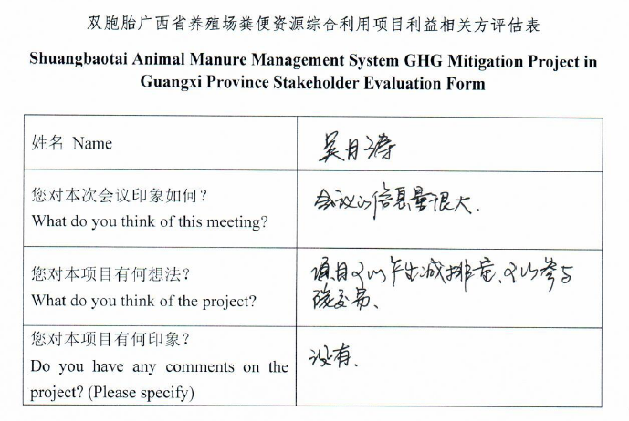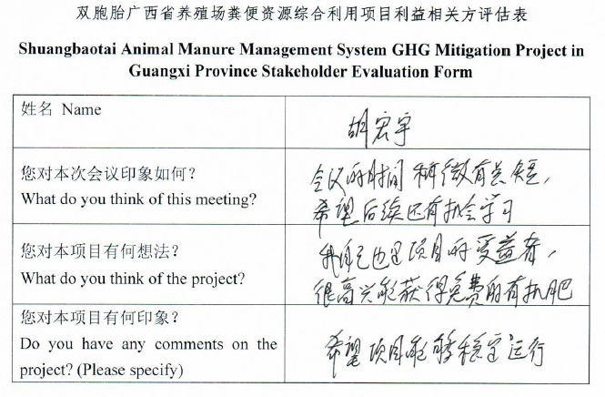
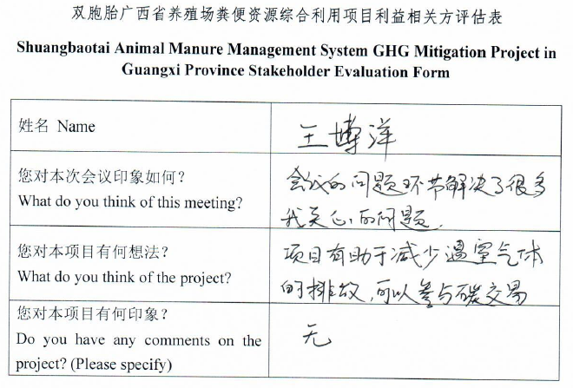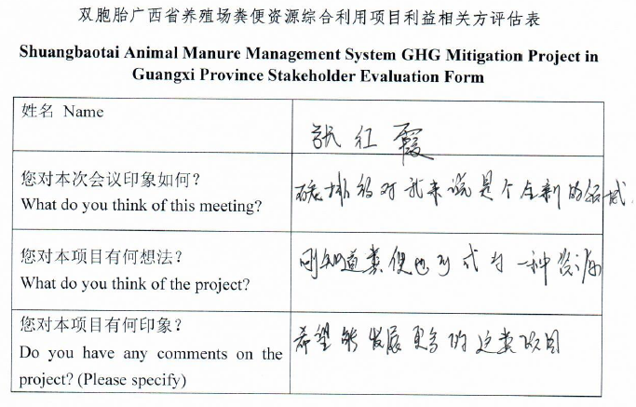
        - Summary of alterations based on comments
>>
In the stakeholder consultation, we have received some feedback and comments, but these feedbacks mainly focus on the questions of project technology and project mechanism operation. There were no comments on project design and monitoring methods. We have responded to the existing feedback one by one when we received the feedback, and no further questions were received. In the project design level, we did not make any alterations, but in the introduction materials of the project, we modified the expression to make the description of the project easier to understand. Therefore, the project would not need to be modified.

CONTINUOUS INPUT / GRIEVANCE MECHANISM
Method |  | Include all details of Chosen Method (s) so that they may be understood and, where relevant, used by readers.
Continuous Input / Grievance Expression Process Book (mandatory) |  | A grievance book was put in each swine farm involved in this project. All stakeholders are allowed to record their grievances or comments in the book. The project owner will assign specific person to deal with related issues. When assessing the relevance and appropriateness of the stakeholders’ comments, the project owner will apply a gender lens.
GS Contact (mandatory) |  | help@goldstandard.org
Other |  | Feedback can be made directly through visiting Shuangbaotai Animal Husbandry Group Co., Ltd. (201, 2nd Floor, Office Building, No. 799, Torch Street, Nanchang High-paying Technology Industrial Development Zone, Nanchang City, Jiangxi Province) or through e-mail snowgirl1984@hotmail.com.

STAKEHOLDER FEEDBACK ROUND

The email of 2nd feedback round has been sent on 08/09/2021, and the Stakeholder feedback round is held for two months between 10/09/2021 and 09/11/2021.

Please check this box if the project is retroactive and has done only 1 consultation with a physical meeting integrated into the SFR.

        - Length of the Feedback Round

Stakeholder Feedback Round |  | Planned | Actual
Start Date | 10/09/2021
End Date | 09/11/2021

        - Summarise how all stakeholders were/will be invited to provide feedback
>>
The Key project information and draft PDD have been sent to all LSC participants and invitees by email. People cannot attend the meeting can make comments via email.

In addition, the hard copies of LSC report and draft PDD can be available in Administration Office of Shuangbaotai Animal Husbandry Group Co., Ltd. And every stakeholder can have access to them and make comments.

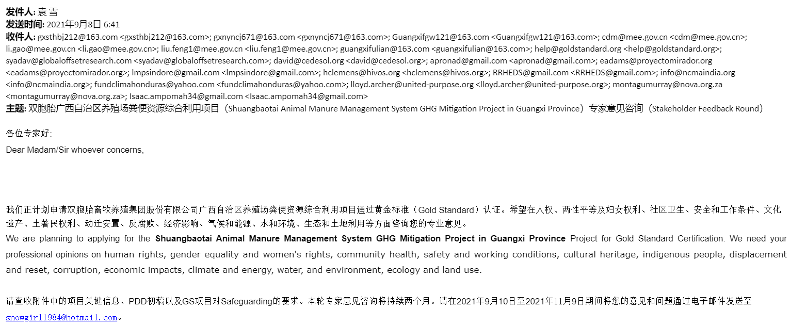
Figure 3 Invitation for stakeholder feedback round through email
        - Summarise Feedback received, including if any changes in project design were made
>>
On the aspects of human rights, gender equality and women's rights, community health, safety and working conditions, cultural heritage, indigenous people, displacement and reset, corruption, economic impacts, climate and energy, water, and environment, ecology and land use, the project owner consulted the experts of the Development & Reform Commission of Guangxi Zhuang Autonomous Region, Ecological Environment Bureau of Guangxi Zhuang Autonomous Region, Agriculture and Rural Affairs Bureau of Guangxi Zhuang Autonomous Region, and Women's Federation of Guangxi Zhuang Autonomous Region mainly through email. These experts affirmed the practice of creating jobs for the local area and encouraging the recruitment of women in the project, and also affirmed the implementation of the project will be no negative impact in these aspects, and there are no comments on project design and monitoring methods. In addition to experts’ responses to safeguarding questions, no other stakeholder feedback was received during the Stakeholder Feedback Round.
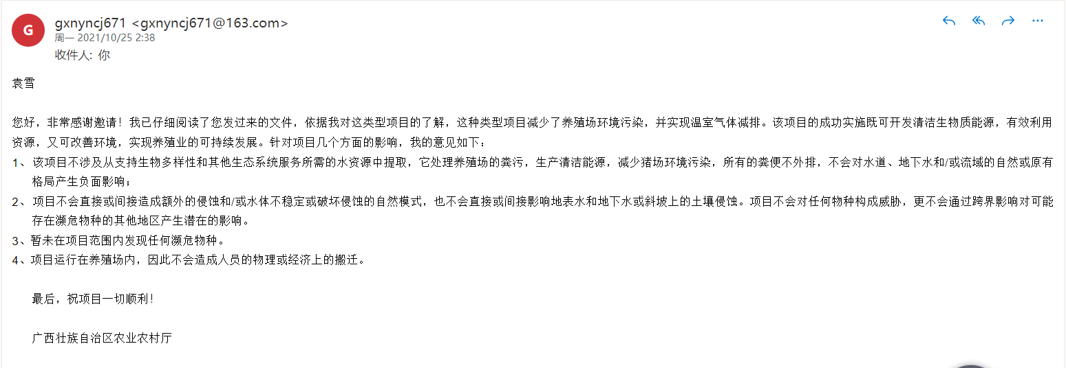
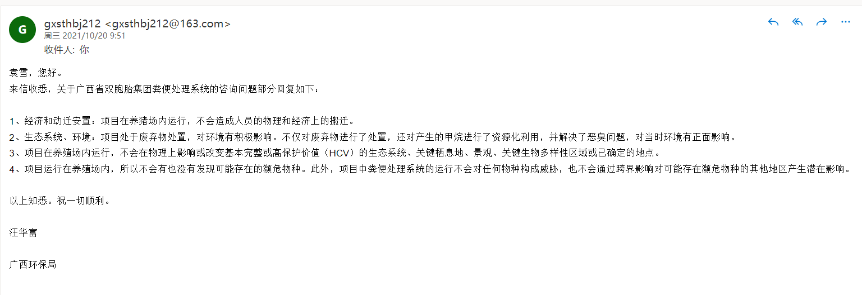
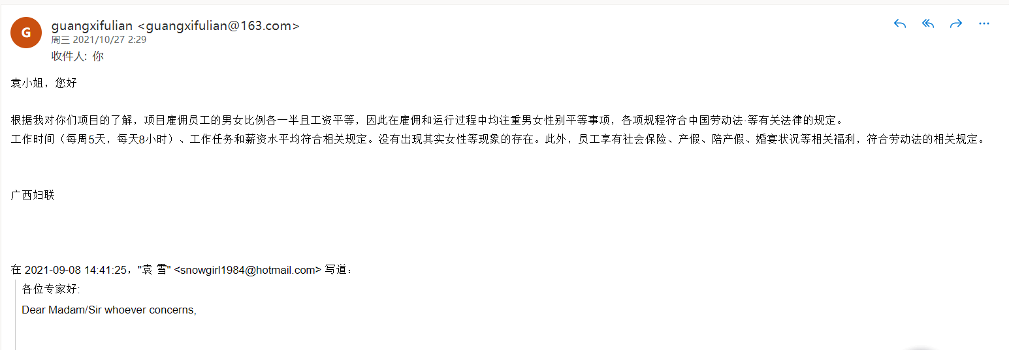
Figure 4 Screenshot of comments received via email

Revision History

Version | Date | Remarks
1.1 | 14 October 2020 | Inclusion of Key Project Information  Restructure, new headings and reorder to better match the steps a developer will follow in consultations.  Removal of some non-mandatory template tables (Blind Sustainable Development Assessment). Clarification of best practice steps that are non mandatory processes, clarification of mandatory discussion points. Clarification regarding publishing names and that original evaluation forms (optional) and attendance lists (mandatory) should be separate documents.  Improved clarity on Stakeholder Feedback round section and procedures for retroactive projects  Provision of an accompanying Guide to help the user understand detailed rules and requirements
1.0 | 14 August 2017 | Initial adoption

http://www.npc.gov.cn/zgrdw/npc/xinwen/2019-01/07/content_2070261.htm
http://www.moa.gov.cn/xw/qg/201904/t20190409_6178435.htm
http://www.gxzf.gov.cn/zfwj/zxwj/t5968075.shtml

