Stakeholder Consultation Report

PUBLICATION DATE 14.10.2020
VERSION v. 1.2
RELATED SUPPORT

- TEMPLATE GUIDE Stakeholder Consultation Report v. 1.2

This document contains the following Sections
Key Project Information
SECTION A - Information made available to Stakeholders
SECTION B - Invitations made to Stakeholders
SECTION C - Report of the Consultation Process
SECTION D - Continuous input / Grievance mechanism
SECTION E – Stakeholder Feedback Round

KEY PROJECT INFORMATION
GS ID of Project | GS 11335
Title of Project | Shuangbaotai Animal Manure Management System GHG Mitigation Project in Guangdong Province
Version number of the SCR | 01
Completion date of version | 25/10/2021
Time of First Submission Date | 26/10/2021
Start Date of the Project | 05/09/2020
Date of Meeting (s) | 14/10/2021
Project Cycle: | Regular  Retroactive

INFORMATION MADE AVAILABLE TO STAKEHOLDERS
        - A non–technical summary of the project
>>
Purpose and general description of project
Shuangbaotai Animal Manure Management System GHG Mitigation Project in Guangdong province introduces new animal waste management systems to a group of 9 swine farms in Guangdong Province, which are owned by Shuangbaotai Animal Husbandry Group Co., Ltd. (hereinafter called” Shuangbaotai”). Each subsidiary swine farm will install one animal waste management system, and the manure is treated on site. The purpose of the project activity is to treat the manure and wastewater to avoid methane emissions generated in the baseline uncovered anaerobic lagoons.

The project activity uses flushing system to collect the manure automatically. All the manure and wastewater are collected and then be separated first. The separated solid will be treated in aerobic composting system to produce fertilizer and the fertilizer will be distributed to the surrounding farmers free of charge to improve the life condition of farmers. The separated liquid will be treated through anaerobic digestion, the biogas generated during the treatment process will be captured for power generation and the Residual biogas (if any) will be flared. The power generated will only be used by the 9 swine farms. The sludge produced from anaerobic digestion will be treated through aerobic composting together with the solid and the effluent will be used as a liquid organic fertilizer for the irrigation of agriculture.

Benefited from the “waste-biogas-fertilizer” pattern, harmlessness and ecological utilization of the swine manure can be realized. Total installed capacity of the proposed project is 5.42 MW with an annual average electricity generation of 29,265 MWh, all of which will be used by the 9 swine farms.

The project activity will reduce of GHG in the atmosphere through avoiding methane emissions from anaerobic treatment of swine manure and wastewater. 240,394 tCO₂e emission reductions will be produced annually. The project activity can contribute to local sustainable development in the following aspects:
- The project activity can enhance the quality of the water, control the odour, and improve the working environment of the workers and the production and living conditions of the farmers.
- The project activity can provide 18 job opportunities for local residents.
- The effluent and slurry are good organic fertilizers which are all supplied to the farmers living around free, they can be used to yield organic products and improve the income of the farmers.
- Biogas technology can capture the methane generated during the treatment process and use biogas to generate electricity which can provide clean energy to substitute some traditional energy resource, thus the project can reduce CH₄ emissions more effectively and contribute to the mitigation of global climate change.

Details of technologies
The proposed project implemented 9 sets of Animal Waste Management Systems (AWMSs) in 9 swine farms involving 139,800 heads of market swine and 97,470 heads of breeding swine.

The project activity uses flushing system to collect the manure automatically. All the manure and wastewater are collected and then be separated first. The solid will be treated in aerobic composting system, which will be used as fertilizer and the fertilizer products will be distributed to the surrounding farmers free of charge to improve the life condition of farmers. The liquid will be treated through anaerobic digestion, the biogas generated during the treatment process will be captured for power generation and the residual biogas will be flared. The sludge produced from anaerobic digestion will be treated through aerobic composting together with the solid and the effluent will be treated aerobically and then used for agriculture irrigation.

The 9 sets of AWMSs in this project activities adopt Expanded Granular Sludge Bed (EGSB) and Internal Circulation Anaerobic Reactor (IC) as its anaerobic digester technologies, the biogas generated during the treatment process will be captured for power generation and will only be used by the 9 swine farms, so this project meet the additional criteria against this methodology stipulated by GS, i.e. Emission reduction associated with methane avoidance (including from the flared biogas fraction) and for substitution of non-renewable shall be eligible if PP demonstrates that the system is designed in a way to at least make use of some of the biogas recovered for energy services (heat & power generation).

This kind of technology can control the flow direction of the pollutants during the production process and prevent the animal themselves from being polluted, then diseases can be controlled, and the “swine-biogas-crops” pattern can be realized without draining of wastewater.

The technical flow of the project activity is shown below:
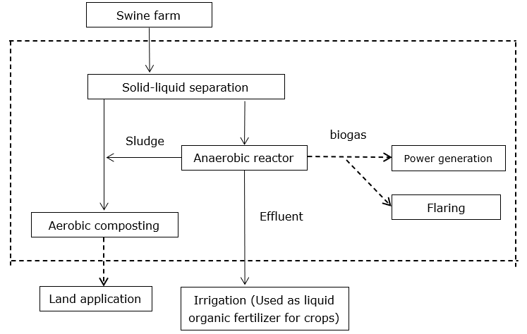
Figure 1 Technical roadmap of the project activity

Solid liquid separation process
For solid-liquid separation, choose a compound screw extrusion solid-liquid separator. The solid-liquid separated water (methane liquid) was put into the anaerobic reactor. The separated biogas residue was aerobic composted to produce organic fertilizer.

Anaerobic digestion process
Anaerobic digesters (AD) are one of the most important processes in animal waste treatment. The anaerobic digesters receive the animal manure and maintain a steady –state population of methanogenic bacteria for degradation. Methanogenic bacteria convert organic manure into biogas in the environment without oxygen. Captured biogas then will be used to generate power and the Residual biogas will be flared (if any). In addition, AD could reduce offensive odors, pathogens from the manure slurry, and GHG emissions during the storage.
The project design adopts semi-underground fully enclosed anaerobic pond (covered with lagoon biogas digester) for anaerobic fermentation treatment of project wastewater. The effluent biogas slurry that has undergone anaerobic fermentation will be used in the project's supporting wasteland for comprehensive utilization during the tillage and fertilization period, and the biogas residue will be put into aerobic composting process;

Comprehensive utilization of biogas
The biogas just produced by the anaerobic fermentation system is a mixed gas containing saturated steam. In addition to CH₄ and CO₂, it also contains H₂S and suspended particulate impurities. Therefore, desulfurization and other purification treatments are required. Biogas was desulfurized by biological desulfurization method. Biological desulfurization method uses colorless sulfur bacteria, such as Thiobacillus thiooxidans and Thiobacillus ferrooxidans, to oxidize H₂S to elemental sulfur or sulfite under micro-oxygen conditions. Its advantages are no catalyst, no chemical sludge treatment, little biological sludge, low energy consumption, 90% H₂S removal rate and high removal efficiency. The purified biogas can enter the power generation system for electricity generation.

Aerobic composting process
The biogas residue after solid-liquid separation and Anaerobic digestion process are transported to the aerobic composting workshop to be mixed with high-efficiency microbial fermentation bacteria. The bottom of the organic fertilizer workshop is embedded with a blast aeration device, which can forcefully ventilate and oxygenate the pile, so that the microorganisms can grow and multiply quickly, so that the temperature of the stack increases rapidly. The compost fermentation process is divided into 4 stages: heating stage (45℃), high temperature stage (60-70℃), cooling stage, and decomposing stage. After 15 days of fermentation in the composting workshop, the manure can form coarse fertilizer.

Location of the project
The proposed project activity is located in Guangdong Province. There are nine subsidiary farms involved in the project. The specific location of the nine subsidiary farms is shown below:
Swine Farm | Location | East longitude | North latitude
Huicheng Hengli PS Farm | Hengli Town, Huicheng District, Huizhou City | 114.56° | 23.29°
Dongyuan Huangtian PS Farm | Huangtian Town, Dongyuan County, Heyuan City | 114.21° | 23.30°
Enping Shahu PS Farm | Shahu Town, Enping City | 112.44° | 22.38°
Langtian Yuehui PS Farm | Langtian Town, Lechang City, Shaoguan City | 113.37° | 25.13°
Qujiang Fengwan PS Farm | Fengwan Town, Qujiang District, Shaoguan City | 113.78° | 24.77°
Pingyuan Zhongshi PS Farm | Pingyuan Town, Meizhou City | 115.89° | 24.56°
Yangchun Tanshui PS Farm | Tanshui Town, Yangchun City | 111.57° | 22.07°
Xinfeng Shatian GGP Farm | Xinfeng Town, Shaoguan City | 113.93° | 23.99°
Kaiping Cangcheng PS Farm | Cangcheng Town, Kaiping City | 112.56° | 22.47°

Scale of the project
The proposed project introduces new AWMSs to treat the manure and wastewater. As per section 9.1.2 of GS4GG GHG Emissions Reduction & Sequestration Product Requirements (Version 2.0), it belons to the Type 3: other project activities. The annual emission reductions of the project activity are 240,394 tCO₂e, which is more than 60,000 tCO₂e. Thus, the project does not meet the definition of small-scale projects in section 9.1.2 of GS4GG GHG Emissions Reduction & Sequestration Product Requirements (Version 2.0), Therefore, the project is a large-scale GS VER project.

Proposed timetable
The project had put into operation in 20/12/2020. As per manufacturer specifications of the heat generator, the lifetime of the equipment is more than 15 years. The total length of crediting period of the project is 15 years (5 years for each Design Certification Renewal Cycle and in total two Design Certification Renewal Cycles).
        - Contact details to get further technical detail and project information
>>
In case any further questions about the project, stakeholders or any other individuals can contact the project owner or the project developer. Refer to the following table for contact details.

Project owner
Organization name | Shuangbaotai Animal Husbandry Group Co., Ltd.
Registration number with relevant authority | 91360106MA35LB3Q3C
Street/P.O. Box | 201, 2nd Floor, Office Building, No. 799, Torch Street, Nanchang High-paying Technology Industrial Development Zone
City | Nanchang City
State/Region | Jiangxi province
Postcode | 330096
Country | China
Telephone | 136 3668 5354
E-mail | snowgirl1984@hotmail.com
Website | http://www.sbtjt.com/
Contact person | Yuan xue
Title | Deputy General Manager
Salutation | Ms.
Last name | Yuan
First name | Xue
Personal e-mail | snowgirl1984@hotmail.com

Project developer
Organization name | Profit Carbon Environmental Energy Technology (Shanghai) Co., Ltd.
Registration number with relevant authority | 91310115301334442X
Street/P.O. Box | No.2815 Longteng Avenue
Building | Sales Center of Baihuiyuan
City | Shanghai
Postcode | 200232
Country | China
Telephone | +86 21 6127 2386
E-mail | shulan.tu@profitcarbon.com
Website | www.profitcarbon.com
Contact person | Tu shulan
Title | Senior Project Manager
Salutation | Ms.
Last name | Tu
Middle name | Shu
First name | Lan
Department | Technology Department
Mobile | 186 9490 7124
Direct tel. | +86 21 6127 2386
Personal e-mail | shulan.tu@profitcarbon.com

        - Summary of economic, social and environmental impacts of the Project
>>
The project activity can contribute to local sustainable development in the following aspects:

SDG 7 – Affordable and Clean Energy
The project activity is designed to introduce new animal waste management systems to treat the manure and wastewater from the 9 swine farms. The biogas generated during the treatment process will be captured for power generation, the electricity generated are all used by the swine farms, which is supplied by the grid company. The grid company is dominated by thermal power generation.

SDG 8 – Decent Work and Economic Growth
The project activities will provide employment opportunities for all local people, regardless of gender or any other status, during the project implementation and monitoring activities. Equal pay for equal work.

SDG 13 – Climate Action
The project activity is designed to introduce new animal waste management systems to a group of 9 swine farms to treat the manure and wastewater from the 9 swine farms to avoid methane emissions generated in the baseline uncovered anaerobic lagoons. Besides, the project will provide an opportunity for local residents to learn and raise awareness on climate change and mitigation measures on the stakeholder consultation fiscal meeting.

All assessment questions related to safeguarding principles have been discussed during the stakeholder consultation meeting. Refer to the following table for results of the Safeguarding Principal Assessment.

Assessment Questions/  Requirements | Justification of Relevance (Yes/potentially/no) | How Project will achieve Requirements through design, management or risk mitigation. | Mitigation Measures added to the Monitoring Plan (if required)
Principle 1. Human Rights
- The Project Developer and the Project shall respect internationally proclaimed human rights and shall not be complicit in violence or human rights abuses of any kind as defined in the Universal Declaration of Human Rights  - The Project shall not discriminate with regards to participation and inclusion | No | 1.The project activity is designed to introduce new animal waste management systems to treat the manure and wastewater from the 9 swine farms to avoid methane emissions generated in the baseline uncovered anaerobic lagoons. The project is in Guangdong Province, china. The project is implemented under the laws of China and will not lead to violations or human rights abuses in any kind.  2.All end-users in the project region that respect the principles and values of sustainable development can equally participate and benefit from the project. The project does not discriminate on gender, race, religion, sexual orientation or any other aspect. | Not required
Principle 2. Gender Equality
- The Project shall not directly or indirectly lead to/contribute to adverse impacts on gender equality and/or the situation of women  - Projects shall apply the principles of nondiscrimination, equal treatment, and equal pay for equal work  - The Project shall refer to the country’s national gender strategy or equivalent national commitment to aid in assessing gender risks  - (where required) Summary of opinions and recommendations of an Expert Stakeholder(s) | No | 1.The project will not directly or indirectly reinforce gender-based discrimination and shall not lead to/contribute to adverse impacts on gender equality and/or the situation of women.  In fact, the project increases women’s access to or control of resources, entitlements and benefits by providing easy access to equal job opportunities.  2.The project will not set up any barriers to the employment of women. All employees have benefits based on pregnancy, maternity/paternity leave, or marital status according to the Labour Law of the People's Republic of China, Special provisions on labour protection of female employees and other related regulation and policies.  3. The project complies with the Labor Law and China's gender related policies.  4. There is no opinions and recommendations of an Expert Stakeholder(s). That’s because the project will not directly or indirectly reinforce gender-based discrimination and shall not lead to/contribute to adverse impacts. Therefore, the safeguarding principle related to Gender Equality and Women’s Rights is not triggered during the project design and implementation. | Not required
Principle 3. Community Health, Safety and Working Conditions
- The Project shall avoid community exposure to increased health risks and shall not adversely affect the health of the workers and the community | No | The project activity is designed to introduce new animal waste management systems to treat the manure and wastewater from the 9 swine farms to avoid methane emissions generated in the baseline uncovered anaerobic lagoons. The biogas generated during the treatment process will be captured for power generation. After anaerobic digestion, the fermented sludge will be treated in aerobic composting system, which will be used as fertilizer. The fertilizer can be distributed to the local people for free regularly. So, the Project doesn’t increase the exposure to health risks and adversely affect the health of the workers and the community. In fact, this project can bring benefits to the workers and the community. | Not required
Principle 4.1 Sites of Cultural and Historical Heritage
Does the Project Area include sites, structures, or objects with historical, cultural, artistic, traditional or religious values or intangible forms of culture? | No | The new animal waste management system is not used in sites, structures, or objects with historical, cultural, artistic, traditional or religious values or intangible forms of culture.  The project does not utilise Cultural Heritage, including the knowledge, innovations, or practices of local communities, affected communities. | Not required
>> | No |  | Not required
Principle 4.2 Forced Eviction and Displacement
Does the Project require or cause the physical or economic relocation of peoples (temporary or permanent, full or partial)? | No | The free distribution of the fertilizer produced by this project can help to reduce the costs of purchasing fertilizer for the local people. All the investment for the animal waste management system is provided by project owner. It obviously does not cause physical or economic relocation of peoples. | Not required
>> | No |  | Not required
Principle 4.3 Land Tenure and Other Rights
- Does the Project require any change, or have any uncertainties related to land tenure arrangements and/or access rights, usage rights or land ownership?  - For Projects involving land use tenure, are there any uncertainties with regards to land tenure, access rights, usage rights or land ownership? | No | This project is operated in the swine farm owned by the project owner.so, there is no uncertainties related to land tenure arrangements and/or access rights, usage rights or land ownership.  The project does not require any change to land tenure arrangements and/or other rights such as resource access rights, community-based property rights and customary rights, which is confirmed by an expert invited by the project owner. | Not required
>> | No |  | Not required
Principle 4.4 - Indigenous people
Are indigenous peoples present in or within the area of influence of the Project and/or is the Project located on land/territory claimed by indigenous peoples? | No | Indigenous people have the same and equal opportunity to obtain the fertilizer and they will not be affected directly or indirectly in a negative way by the project.  In addition, there are no indigenous people present within the area of influence nor the project is located on territory claimed by indigenous people. This is confirmed by an expert invited by the project owner. | Not required
>> | No |  | Not required
Principle 5. Corruption
- The Project shall not involve, be complicit in or inadvertently contribute to or reinforce corruption or corrupt Projects | No | The project is implemented on the ground by the social enterprise. The ethical codes of the project partners are against corruption. In addition, the companies comply with all related economic laws and regulations of China.  This Project has a zero tolerance to corruption policy, anything generated as project revenue shall be spent towards the project monitoring, repair and maintenance, project operation and costs against project verification and issuance of the emission reduction credits.  Hence, the project doesn’t involve any transaction of cash and/or kind between the project participant and the beneficiary. | Not required
Principle 6.1 Labour Rights
- The Project Developer shall ensure that all employment is in compliance with national labour occupational health and safety laws and with the principles and standards embodied in the ILO fundamental conventions  - Workers shall be able to establish and join labour organisations  - Working agreements with all individual workers shall be documented and implemented and include:  - Working hours (must not exceed 48 hours per week on a regular basis), AND  - Duties and tasks, AND  - Remuneration (must include provision for payment of overtime), AND  - Modalities on health insurance, AND  - Modalities on termination of the contract with provision for voluntary resignation by employee, AND  - Provision for annual leave of not less than 10 days per year, not including sick and casual leave.  - No child labour is allowed (Exceptions for children working on their families’ property requires an Expert Stakeholder opinion)  - The Project Developer shall ensure the use of appropriate equipment, training of workers, documentation and reporting of accidents and incidents, and emergency preparedness and response measures | No | The project complies with the Labour Law of the People's Republic of China, Special provisions on labour protection of female employees and other related regulation and policies. The project owner will sign contracts with employees. The labor contracts specify working hours, tasks and payments. All employees have benefits based on social security, pregnancy, maternity/paternity leave, or marital status according to the labor laws of China. Besides, the employees also have the right to establish labor unions and to carry on labor union activities.  All employees would provide their age information document, e.g., ID, when signing the labour contract, and the project owner did not and will not employ any child labour. | Not required
Principle 6.2 Negative Economic Consequences
- Does the project cause negative economic consequences during and after project implementation? | No | The equipment procurement cost of the project will be borne by the project owner. The project has positive economic benefits due to the reduced cost of buying fertilizer for local farmer. The project will create fair job opportunities for local people, which is good for the local economy. No risks are foreseen for the local economy through the realization of the project. | Not required
>> | No |  | Not required
Principle 7.1 Emissions
Will the Project increase greenhouse gas emissions over the Baseline Scenario? | No | The project activity is designed to new animal waste management systems to treat the manure and wastewater from the 9 swine farms to avoid methane emissions generated in the baseline uncovered anaerobic lagoons. The project activity will reduce of GHG in the atmosphere through avoiding methane emissions from anaerobic treatment of swine manure and wastewater. | Not required
>> | No |  | Not required
Principle 7.2 Energy Supply
Will the Project use energy from a local grid or power supply (i.e., not connected to a national or regional grid) or fuel resource (such as wood, biomass) that provides for other local users? | No | The project activity will replace the current open anaerobic lagoons with 9 new closed anaerobic digesters. The biogas generated during the treatment process will be captured for power generation and the residual biogas will be flared. All the power is used by the 9 swine farms and will not be connected to another user or to the regional power grid. If the power generation from the proposed project is not enough, the project activity will use electricity from the Southern Power Grid, which is a reginal grid of China. It will not affect the energy consumptions or power supply or fuel resource supply that provides for other local users. | Not required
>> | No |  | Not required
Principle 8.1 Impact on Natural Water Patterns/Flows
Will the Project affect the natural or pre-existing pattern of watercourses, ground-water and/or the watershed(s) such as high seasonal flow variability, flooding potential, lack of aquatic connectivity or water scarcity? | No | The project will not affect the natural or pre-existing pattern of watercourses, groundwater and/or the watershed(s) such as high seasonal flow variability, flooding potential, lack of aquatic connectivity or water scarcity. This is confirmed by an expert invited by the project owner. | Not required
>> | No |  | Not required
Principle 8.2 Erosion and/or Water Body Instability
- Could the Project directly or indirectly cause additional erosion and/or water body instability or disrupt the natural pattern of erosion?  - Is the Project’s area of influence susceptible to excessive erosion and/or water body instability? | No | All animal manure will be put into the new animal waste management systems to treat and is prohibited to discharge into the Groundwater and surface water. Therefore, AWMSs used in the project area could not directly or indirectly cause additional erosion and/or water body instability or disrupt the natural pattern of erosion. The fertilizer produced in this project meets the relevant Chinese fertilizer implementation standards, so the project also could not directly or indirectly impact on surface and ground waters or soil erosion on slopes. | Not required
>> | No |  | Not required
Principle 9.1 Landscape Modification and Soil
Does the Project involve the use of land and soil for production of crops or other products? | No | Comprehensive utilization and resourceful treatment of the manure waste are encouraged by the local government. All the swine farms of the project have obtained necessary approval from the local government, including Planning Permit on Land for Construction Use, Environmental Impact Assessment etc. Hence, the project does not involve the use of land and soil for production of crops or other products. | Not required
>> | No |  | Not required
Principle 9.2 Vulnerability to Natural Disaster
Will the Project be susceptible to or lead to increased vulnerability to wind, earthquakes, subsidence, landslides, erosion, flooding, drought or other extreme climatic conditions? | No | The new animal waste management systems used in the project area does not involve any land use changes. It would not lead to the exacerbation of impacts caused by natural or man-made hazards, such as landslides or floods. | Not required
>> | No |  | Not required
Principle 9.3 Genetic Resources
Could the Project be negatively impacted by or involve genetically modified organisms or GMOs (e.g., contamination, collection and/or harvesting, commercial development, or take place in facilities or farms that include GMOs in their processes and production)? | No | The project does not involve the use of GMOs, so it will not have negatively impacted by the use of genetically modified organisms or GMOs. | Not required
>> | No |  | Not required
Principle 9.4 Release of pollutants
Could the Project potentially result in the release of pollutants to the environment? | No | The project is designed to introduces new animal waste management systems to treat the manure and wastewater from the 9 swine farms to avoid methane emissions generated in the baseline uncovered anaerobic lagoons. During the treatment process, the biogas was captured for power generation and flared, the fermented sludge was treated in aerobic composting system, the wastewater was treated aerobically and then used for agriculture irrigation, so no pollutants release to the environment. | Not required
>> | No |  | Not required
Principle 9.5 Hazardous and Non-hazardous Waste
Will the Project involve the manufacture, trade, release, and/ or use of hazardous and non-hazardous chemicals and/or materials? | Potential | The project activity will replace the current open anaerobic lagoons with 9 new closed anaerobic digesters. The biogas generated during the treatment process will be captured for power generation or flared. If biogas is not handled properly during the operation period of the project, methane leakage/explosion may be caused. | Required
>> | Potential |  | Required
Principle 9.6 Pesticides & Fertilisers
Will the Project involve the application of pesticides and/or fertilisers? | No | The project activity does not involve any application of pesticides and/or fertilizers. | Not required
>> | No |  | Not required
Principle 9.7 Harvesting of Forests
Will the Project involve the harvesting of forests? | No | The project activity does not involve the harvesting of forests. | Not required
>> | No |  | Not required
Principle 9.8 Food
Does the Project modify the quantity or nutritional quality of food available such as through crop regime alteration or export or economic incentives? | No | The project activity does not involve the modification of the quantity or nutritional quality of food available. | Not required
>> | No |  | Not required
Principle 9.9 Animal husbandry
Will the Project involve animal husbandry? | No | The project is designed to introduces new animal waste management systems to treat the manure and wastewater from the 9 swine farms to avoid methane emissions generated in the baseline uncovered anaerobic lagoons, belongs to waste disposal and resource utilization. | Not required
>> | No |  | Not required
Principle 9.10 High Conservation Value Areas and Critical Habitats
Does the Project physically affect or alter largely intact or High Conservation Value (HCV) ecosystems, critical habitats, landscapes, key biodiversity areas or sites identified? | No | The project is not located in an area within a high conservation value area or within critical natural habitats. The project activity does not physically affect or alter largely intact or High Conservation Value (HCV) ecosystems, critical habitats, landscapes, key biodiversity areas or sites identified. In addition, the “Measures for the Management of Livestock and Poultry Breeding in Jiangxi Province” clearly stipulate the prohibited construction area.
>> | No
Principle 9.11 Endangered Species
a. Are there any endangered species identified as potentially being present within the Project boundary (including those that may route through the area)?  - Does the Project potentially impact other areas where endangered species may be present through transboundary affects? | No | There are no endangered species identified as potentially being present within the Project boundary. In addition, the new animal waste management systems used in the project will not pose a threat to any species. | Not required
>> | No |  | Not required

        - Other relevant information to help stakeholders understand the project
>>
During the stakeholder consultation, the draft project design documents, template guide, emission reduction calculate sheet and key project information were provided to help them understand the project better.

INVITATIONS MADE TO STAKEHOLDERS
        - Invitation tracking table
Category Code | Stakeholder Type/Organisation (if relevant) | Name of invitee | Male/  Female | Method of invitation | Date of invitation  (>30 days before Meeting)
A/B | Local resident/user | Wang likang | Male | Email and Notice | 08/09/2021
A/B | Local resident/user | Zhu Xiaoyu | Female | Email and Notice | 08/09/2021
A/B | Local resident/user | Li Tingting | Male | Email and Notice | 08/09/2021
A/B | Local resident/user | Gu Yuqi | Male | Email and Notice | 08/09/2021
A/B | Local resident/user | Li Dongliang | Female | Email and Notice | 08/09/2021
C | Department of Ecology and Environment of Guangdong Province | Huang Xianming | Female | Email | 08/09/2021
C | Department of Agriculture and Rural Affairs of Guangdong Province | Li Huayong | Male | Email | 08/09/2021
C | Guangdong Provincial Development and Reform Commission | Liu Wei | Female | Email | 08/09/2021
D | Ministry of Ecology and Environment of the People's Republic of China-Department of Climate Change | Sun Zhen | Male | Email | 08/09/2021
D | Ministry of Ecology and Environment of the People's Republic of China-Department of Climate Change | Li Gao | Male | Email | 08/09/2021
D | Ministry of Ecology and Environment of the People's Republic of China-Department of Climate Change | Liu Feng | Male | Email | 08/09/2021
E | Women's Federation of Guangdong province | Yang Jia | Female | Email | 08/09/2021
E | ShenZhen Spring environmental protection volunteer association, SENGO | Xia Huihong | Female | Email | 08/09/2021
F | Gold Standard representative | help@goldstandard.org | N/A | Email | 08/09/2021
G | Global Offset Research | Siddharth Yadav | N/A | Email | 08/09/2021
G | CEDESOL | David Whitfield | N/A | Email | 08/09/2021
G | Asociación para la Promoción de Nuevas Alternativas de Desarrollo (APRONAD) | Francisco Rivas | N/A | Email | 08/09/2021
G | Proyecto Mirador | Esther Adams | N/A | Email | 08/09/2021
G | Lean Management Systems Promotion Society | Raave Jain | N/A | Email | 08/09/2021
G | HIVOS | Harry Clemens | N/A | Email | 08/09/2021
G | Redemption Research for Health and Educational Development Society | Kennady Pulipati | N/A | Email | 08/09/2021
G | NCMA India | Bholendra Singh | N/A | Email | 08/09/2021
G | Fundacion de Iniciativas de Cambio Climatico de Honduras (Fundacion MDL de Honduras) | Suyapa Zelaya | N/A | Email | 08/09/2021
G | United Purpose | Lloyd Archer | N/A | Email | 08/09/2021
G | Concern Health Ghana | Isaac Ampomah | N/A | Email | 08/09/2021
G | NOVA | Montagu Murray | N/A | Email | 08/09/2021

B.1.1 Appropriateness of methods
>>
The local stakeholder consultation meeting was held on 14/10/2021 in the conference room of Shuangbaotai swine Farm, No. 1 dazaozui, Luolang Village, Lianxing Village Committee, Cangcheng Town, Kaiping City, Jiangmen city, Guangdong Province. Before the meeting, local villagers, relevant local government officials, experts from NGOs, both male and female, were widely invited via email, public notice, etc. In this case, the invitation can cover most of the people who are related to the project regardless of their gender. In addition, the project contact asks all the invitees to reply to confirm whether to attend the meeting before 11/10/2021. In case the invitees could not attend, they were encouraged to invite their colleagues, friends, or families to attend. Females were encouraged to take part in the meeting.
The content of the invitation is in Chinese, which is the official language of China. Since the invitees are local users or other stakeholders of this project, they will have a certain understanding of our project. Therefore, invitations through emails or public notice will not be treated as spam and scammers, so this invitation method of emails and public notice is reasonable.

B.1.2 Gender Sensitivity
>>
The invitation methods of this project mainly include email and public notice, etc. The notices will be posted in public places, and everyone can learn and attend the meeting. When using other forms of invitation, we have considered inviting at least 50% of women to attend meetings or participate in the stakeholder feedback. In addition, in order to invite more people, including marginalised groups, we encourage invitees to invite more people to participate in the stakeholder feedback of the project.

B.1.3 Evidence proving invites took place as stated
>>
- Evidence invitation from email:
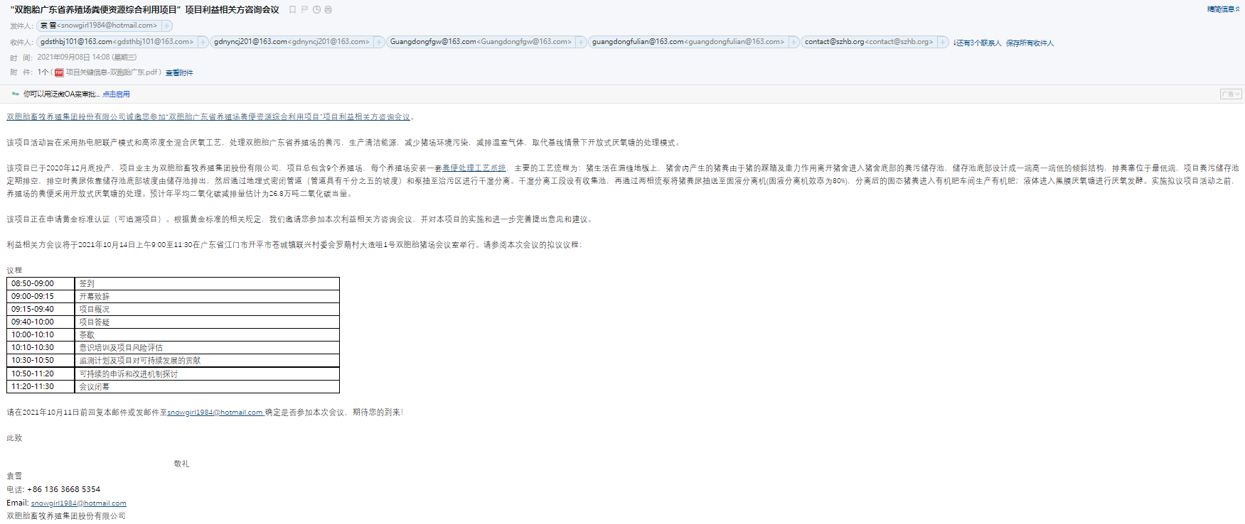

- Evidence invitation from public notice:
This part of the evidence has not been sent by the owner to the project developer. Once the material is available, this part of the content will be updated.

B.1.4 Sample content of invites (for each Method above)
>>
- Sample content of invitation from email:
Dear Sir/Madam,

Shuangbaotai Animal Husbandry Group Co., Ltd. is pleased to invite you to a stakeholder’s consultation meeting regarding the project of “Shuangbaotai Animal Manure Management System GHG Mitigation Project in Guangdong Province”.

The objective of the project activities is to treat animals manure from swine farms of Shuangbaotai Group in Guangdong Province, using a combined heat, power and fertilizer model and a high concentration mixed anaerobic process，to produce clean energy, reduce environmental pollution on the swine farm and reduce greenhouse gas emissions, replacing the treatment mode of the uncovered anaerobic lagoons under the baseline scenario.

The project was put into production in end of 2020. The owner of the project is Shuangbaotai Animal Husbandry Group Co., Ltd. The project consists of a total of 9 swine farms, each of which is equipped with a set of Animal Manure Management Systems (AMMSs). The main technological process is as follows: The project activity uses flushing system to collect the manure automatically. All the manure and wastewater are collected and then be separated first. The solid will be treated in aerobic composting system, which will be used as fertilizer and the fertilizer products will be distributed to the surrounding farmers free of charge to improve the life condition of farmers. The liquid will be treated through anaerobic digestion, the biogas generated during the treatment process will be captured for power generation and the residual biogas will be flared. The sludge produced from anaerobic digestion will be treated through aerobic composting together with the solid and the effluent will be treated aerobically and then used for agriculture irrigation. Prior to the implementation of the proposed project activities, manure from the farm was treated in an open anaerobic pond. Estimated annual average CO₂ reduction is estimated at 268,650tons of CO2 equivalent.

The project is applying for Gold Standard Certification (Retroactive project). According to the relevant rules of Gold Standard, with this letter, we would like to invite you to participate in this Stakeholder Consultation Meeting and make comments on the project.

The Stakeholder Consultation Meeting will be held from 9:00 a.m. to 11:30 a.m. on 14/10/2021 at conference room of Shuangbaotai swine Farm, No. 1 dazaozui, Luolang Village, Lianxing Village Committee, Cangcheng Town, Kaiping City, Jiangmen city, Guangdong Province. Please find the proposed agenda of this meeting:

Agenda
08:50-09:00 | Registration
09:00-09:15 | Opening of the meeting
09:15-09:40 | Explanation of the project in non-technical terms
09:40-10:00 | Question and answer session about the project
10:00-10:10 | Break
10:10-10:30 | Awareness training and discuss any potential risks and positive impacts of the project
10:30-10:50 | Discuss the monitoring plan for sustainable development impacts
10:50-11:20 | Discussion of Continuous input & Grievance Mechanism
11:20-11:30 | Closure of the meeting

We would be grateful if you could confirm your participation to the local stakeholder meeting before 11/10/2021 by Email to snowgirl1984@hotmail.com.

Best regards,

Yuan Xue
Tel: +86 136 3668 5354
Email: snowgirl1984@hotmail.com
Shuangbaotai Animal Husbandry Group Co., Ltd.

- Sample content of public notice:
The public notice has been posted at public places of local governments and the village committee where the most residents can pay attention to it. But the photos as the evidence have not been sent to project developer by project owner. The detailed content of public notice is shown below:

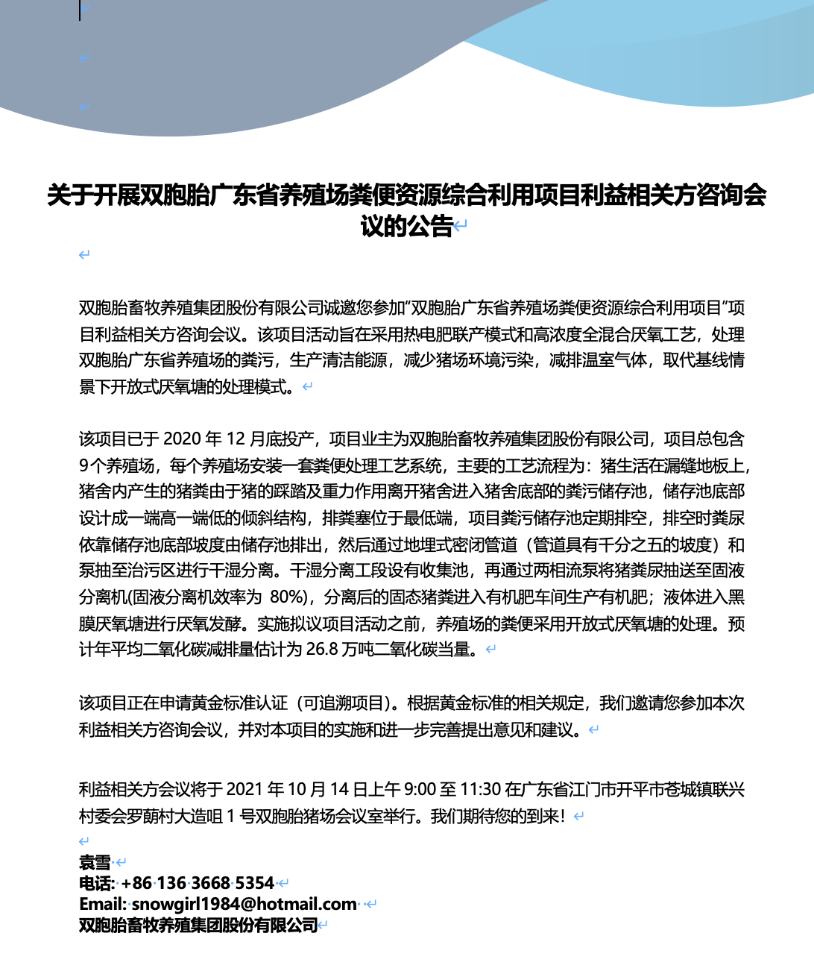

B.1.5. Description of other Means and methods to provide feedback for those who are not able to join the consultation meeting
>>
Stakeholders or any other individuals, who couldn’t attend the stakeholder consultation meeting, are able to provide feedback or comments via email or telephone. The email of 2nd feedback round has been sent on 08/09/2021, and the Stakeholder feedback round is held for two months between 10/09/2021 and 09/11/2021. Everyone is welcome to comment on this project.

REPORT OF THE CONSULTATION PROCESS
        - Date of Meeting

C.1.1 List of participants
Date and Time | 9:00 a.m. to 11:30 a.m. 14/10/2021 | Location | Conference room of Shuangbaotai swine Farm, No. 1 dazaozui, Luolang Village, Lianxing Village Committee, Cangcheng Town, Kaiping City, Jiangmen city, Guangdong Province.
Category  Code | Name of participant, job /  position in the community | Male /  Female | Contact details | Organisation  (if relevant) | Signature
A/B | Cao Xiangtian | male |  | Huizhou City
A/B | Yan Meixue | female | 16603021487 | Heyuan City
A/B | Zhu Guangxi | male | 16676571140 | Enping City
A/B | Shu Fan | male |  | Shaoguan City
A/B | Tong Xiaoting | female | 18316017946 | Shaoguan City
A/B | Duan Yunchang | male | 13147054875 | Meizhou City
A/B | Ye Xiaofu | female |  | Yangchun City
A/B | Zhou Xiaoxiao | male | 13925338551 | Shaoguan City
A/B | Han Di | female | 16603021487 | Kaiping City
A/B | Weng Xue | female | 16676571140 | Meizhou City
C | Huang Xianming | female |  | department of Ecology and Environment of Guangdong Province
C | Li Huayong | male |  | department of Agriculture and Rural Affairs of Guangdong Province
C | Liu Wei | female |  | Guangdong Development and Reform Commissiom
E | Yang Jia | female |  | Women's Federation of Guangdong province

C.1.2 Pictures from physical meeting(s) (best practice)
>>
This part of the evidence has not been sent by the owner to the project developer. Once the material is available, this part of the content will be updated.
        - Minutes of physical meeting(s)
>>
Date: 14/10/2021
Location: Conference room of Shuangbaotai swine Farm, No. 1 dazaozui, Luolang Village, Lianxing Village Committee, Cangcheng Town, Kaiping City, Jiangmen city, Guangdong Province.
Time: 9:00a.m. to 11:30 a.m.

Opening of the meeting
The project is applying for registration under GS4GG. The purpose of the meeting is to consult the stakeholders' opinions and feedback on the project, so as to avoid the negative impact on the stakeholders and strengthen the positive impact of the project. 14 people, including local residents and experts from local government attended in the 1st round of Local stakeholder consultation physical meeting held on 14/10/2021.

The meeting is opened with remarks from employee of Shuangbaotai Animal Husbandry Group Co., Ltd. The feedback and comments will be taken into consideration during the implementation of the project.

Explanation of the project in non-technical terms
Yuan Xue from Shuangbaotai Animal Husbandry Group Co., Ltd. introduced the project activity and its social and environmental impacts.

The project activity introduces new animal waste management systems to a group of 9 swine farms in Guangdong Province. The purpose of the project activity is to treat the manure and wastewater from the 9 swine farms to avoid methane emissions generated in the baseline uncovered anaerobic lagoons. The biogas generated during the treatment process will be captured for power generation, the electricity generated are all used by the swine farms. After anaerobic digestion, the fermented sludge will be treated in aerobic composting system, which will be used as fertilizer. Wastewater from the new animal waste management systems will be treated aerobically and then used for agriculture irrigation.

Question and answer session about the project
After the description of the project, all participants have the opportunity to express their questions and comments. The representative of project owner provided answers to the questions and comments raised by the stakeholders.

Confirmation of the GS VER ownership has also been discussed during this session. All the Animal Waste Management Systems (AWMSs) were invested by the project owner. All the stakeholders who attended the meeting were notified that the project owner has the legal ownership of the carbon credits generated by the project activity.

Discuss any potential risks and positive impacts of the project
Afterwards, the meeting continued with the discussion of the Awareness training and project risk assessment activity. The Awareness training make participants aware of the contribution to the environment and the social, such as this project create jobs opportunities for locals, especially women’s groups or other marginalised groups. During the project risk assessment, participants discussed the difficulties and risks that may be encountered in the process of project development. The comments are summarized in section C.3.

Discuss the monitoring plan for sustainable development impacts
Regarding the monitoring plan, it mainly discusses the practicability and rationality of related parameter monitoring to ensure that it can be successfully registered and issued in GS. Before the stakeholder consultation meeting, the project owner intends to assess the impact of the project on SDG 7, 8 and 13. During the physical meeting, all stakeholders were also invited to discuss the selection of SDG. The SDG outcome forms was given to all participants, explained the exercise and gave them 20 minutes to choose the relevant SDG and give their justification. During the meeting, PP paid more attention to the issues and the chosen of relevant SDG of women and marginalized groups. After discussion, all stakeholders believed that the owner's choice for SDG 7, 8 and 13 was wiser and reasonable and there was no objection. Finally, the impact of SDG7, SDG8 and SDG13 were decided.

Discussion of Continuous input & Grievance Mechanism
After discussions of the impacts and monitoring plan, the host then explained about the Continuous input & Grievance Mechanism which entails how the stakeholders can reach out to the project implementer during the project’s crediting period in case of any questions, comments or suggestions. Also, the contact methods are provided to the attendees to see if the methods are appropriate and easy to access. Refer to section D for more details.

Closure of the meeting
Thank all the attendees for their participation in this meeting. The opinions and comments are very important for the implementation of this project. In addition to this meeting, all stakeholders can also provide us with suggestions through our Continuous input & Grievance Mechanism.

At the end of the meeting, all the evaluation forms filled out by all participants were collected.

C.2.1 Minutes of other consultations
>>
Stakeholders who could not attend the physical meeting were encouraged to raise questions by mail or phone calls. However, no questions or comments were received.
        - Assessment of comments from all consultations above
Gender of Stakeholder | Stakeholder  comment | Was comment taken into account (Yes/ No)? | Explanation (Why? How?)
Female | Will the organic fertilizer produced after the manure treatment be distributed to nearby farmers for free? | Yes | The amount of organic fertilizer produced by the project is determined based on the amount of manure. The organic fertilizer produced will first be distributed to nearby farmers for free. If necessary, please come to receive it. Only surplus fertilizer will be sold externally, and the sales price will be lower than the market price.
Male | Is it possible for the electricity generated by the project to be used by our local residents? | Yes | The electricity generated currently is still not enough to supply to the swine farms. If there is surplus electricity in the future and it will be supplied to local residents within permitted conditions.
Male | Biogas will be produced during the treatment process; I just want to know Whether the process of biogas using is safety? | Yes | It is safety. All the person involved in the project will be trained on the safety operation of the biogas before the project is put into operation and the operation method will be carried out in strict accordance with the rules.

On the aspects of human rights, gender equality and women's rights, community health, safety and working conditions, cultural heritage, indigenous people, displacement and reset, corruption, economic impacts, climate and energy, water, and environment, ecology and land use, the project owner consulted the experts of the Department of Ecology and Environment of Guangdong Province, Department of Agriculture and Rural Affairs of Guangdong Province, Guangdong Provincial Development and Reform Commission, Ministry of Ecology and Environment of the People's Republic of China, and Women's Federation of Guangdong Province mainly through email. The project information and Safeguarding principles are provided to the experts during the invitation of feedback ground. The Stakeholder feedback round is held for two months between 10/09/2021 and 09/11/2021. Once the 2nd round of Stakeholder Consultation completed, PP will update the answer of Safeguarding.

C.3.1 Evaluation forms (best practice)
Name | Yan Meixue
Gender – Male/Female: | Female
Telephone/Email | 16603021487
Address | Heyuan City
What is your impression of the meeting? | The meeting was helpful and I learned a lot on sustainable development.
What do you think of the project? | The project provides good practice for manure utilization of swine farms.
Do you have any negative comments on the project? (Please specify) | N/A

Name | Tong Xiaoting
Gender – Male/Female: | Female
Telephone/Email | 18316017946
Address | Shaoguan City
What is your impression of the meeting? | The meeting has a lot of information and is well organized.
What do you think of the project? | It provides high-quality fertilizer for the surrounding villagers for free.
Do you have any negative comments on the project? (Please specify) | No. We need more projects like this.

Name | Zhu Guangxi
Gender – Male/Female: | Male
Telephone/Email | 16676571140
Address | Enping City
What is your impression of the meeting? | It provides a good opportunity to learn about carbon emissions and carbon neutral.
What do you think of the project? | It will also provide job opportunities for local residents.
Do you have any negative comments on the project? (Please specify) | No

Name | Duan Yunchang
Gender – Male/Female: | Male
Telephone/Email | 13147054875
Address | Meizhou City
What is your impression of the meeting? | I hope more conferences like this will be organized.
What do you think of the project? | The project realizes partial self-generation and self-consumption of electricity, which helps to alleviate the pressure on resources and environment.
Do you have any negative comments on the project? (Please specify) | No. Very good project, I fully support it!
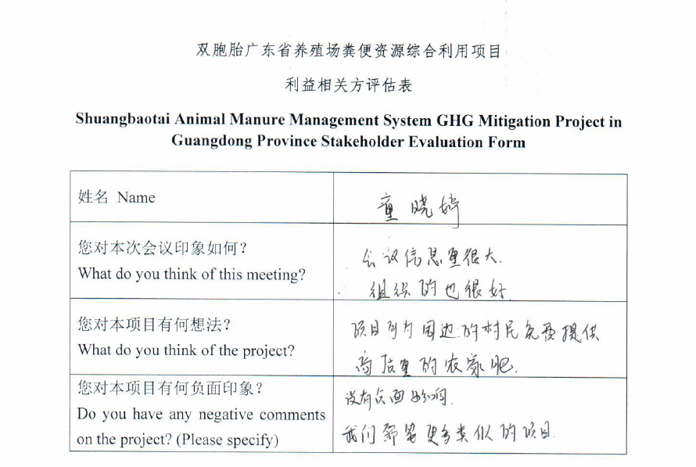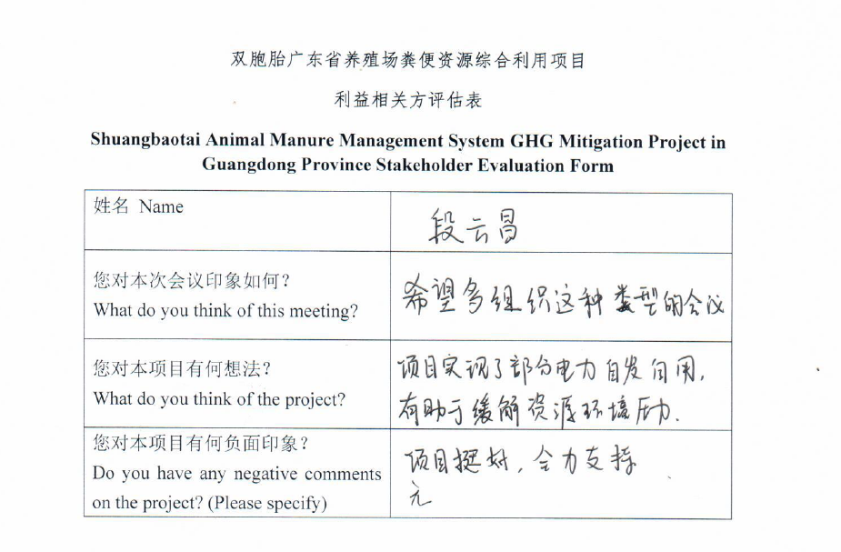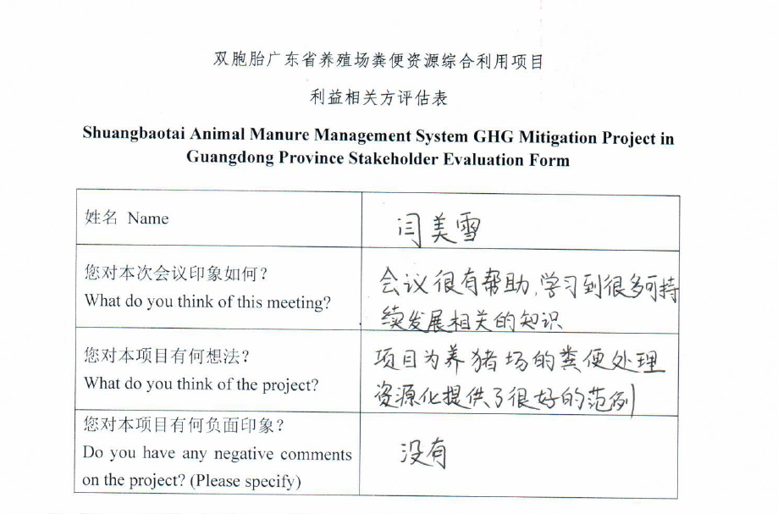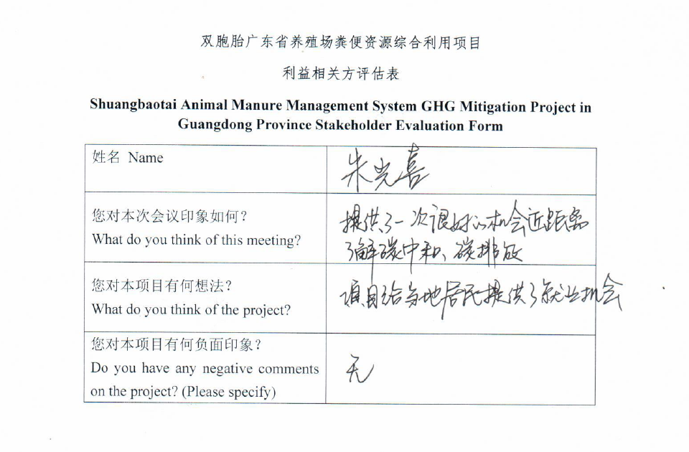
        - Summary of alterations based on comments
>>
From the outcomes of the consultation meeting, we have received some feedback and comments, but these feedbacks mainly focus on the questions of project technology and project mechanism operation. There were no comments on project design and monitoring methods. Therefore, the project would not need to modify.
The Stakeholder feedback round is held for two months between 10/09/2021 and 09/11/2021. Once the 2nd round of Stakeholder Consultation completed, PP will update the Comments of this project received from the 2nd round of Stakeholder Consultation.

CONTINUOUS INPUT / GRIEVANCE MECHANISM
Method | Include all details of Chosen Method (s) so that they may be understood and, where relevant, used by readers.
Continuous Input / Grievance Expression Process Book (mandatory) | A grievance book was put in Administration Office of the project owner. All stakeholders are allowed to record their grievances or comments in the book. The project owner will assign specific person to deal with related issues. When assessing the relevance and appropriateness of the stakeholders’ comments, the project owner will apply a gender lens.
GS Contact (mandatory) | help@goldstandard.org
Other | Feedback can be made directly through visiting Shuangbaotai Animal Husbandry Group Co., Ltd. (201, 2nd Floor, Office Building, No. 799, Torch Street, Nanchang High-paying Technology Industrial Development Zone, Nanchang City, Jiangxi Province) or through e-mail snowgirl1984@hotmail.com.

STAKEHOLDER FEEDBACK ROUND
The email of 2nd feedback round has been sent on 08/09/2021, and the Stakeholder feedback round is held for two months between 10/09/2021 and 09/11/2021. Once the 2nd round of Stakeholder Consultation completed, PP will update this part.

Please check this box if the project is retroactive and has done only 1 consultation with a physical meeting integrated into the SFR.

        - Length of the Feedback Round

Stakeholder Feedback Round |  | Planned | Actual
Start Date | 10/09/2021
End Date | 09/11/2021

        - Summarise how all stakeholders were/will be invited to provide feedback
>>
The Key project information and draft PDD have been sent to all LSC participants and invitees by email. People cannot attend the meeting can make comments via email.

In addition, the hard copies of LSC report and draft PDD can be available in Administration Office of Shuangbaotai Animal Husbandry Group Co., Ltd. And every stakeholder can have access to them and make comments.
        - Summarise Feedback received, including if any changes in project design were made
>>
The 2nd round of Stakeholder Consultation, the Stakeholder feedback round is held for two months between 10/09/2021 and 09/11/2021. Once the 2nd round of Stakeholder Consultation completed, PP will update the summary of comments received from the 2nd round of Stakeholder Consultation.

Revision History

Version | Date | Remarks
1.1 | 14 October 2020 | Inclusion of Key Project Information  Restructure, new headings and reorder to better match the steps a developer will follow in consultations.  Removal of some non-mandatory template tables (Blind Sustainable Development Assessment). Clarification of best practice steps that are non mandatory processes, clarification of mandatory discussion points. Clarification regarding publishing names and that original evaluation forms (optional) and attendance lists (mandatory) should be separate documents.  Improved clarity on Stakeholder Feedback round section and procedures for retroactive projects  Provision of an accompanying Guide to help the user understand detailed rules and requirements
1.0 | 14 August 2017 | Initial adoption

http://www.npc.gov.cn/zgrdw/npc/xinwen/2019-01/07/content_2070261.htm
http://dara.gd.gov.cn/fqwzyhly/content/post_1579078.html
http://dara.gd.gov.cn/gkmlpt/content/2/2710/post_2710498.html#1602

