Sustainable End-of-Life Vehicle Scrapping Program: Government Backed Voluntary Program (India)
Reporting Period – 1st Oct 2023 to 31st December 2023
Report Published on 2nd December 2023 (Q3 FY2023-24)
Contents
Executive Summary 1
ER Inventory 1
Materials Recycled 1
Summary 1
RVSFs in PoA 2
Emission Reduction Attributes 2
By Location 2
By Vehicle Make 3
End-Of-Life Vehicle Attributes 3
By Vehicle Make 3
By Fuel Type 4
Reusable Materials Recovered 4
Project Emissions 4
Electricity Consumption & Emissions 4
Baseline Emissions 5

Executive Summary
India, with its position as the world's second most populous country, is facing a significant challenge with the disposal of end-of-life vehicles (ELVs). With the automotive sector booming, the number of vehicles reaching the end of their service life is escalating. However, the recycling of these vehicles is still not fully developed, and the sector is predominantly run by the informal sector, which often disregards environmental and safety regulations.
The informal recycling facilities have been criticized for contributing to environmental pollution and selling potentially unsafe automotive parts. In response, the Indian government is promoting the establishment of Registered Vehicle Scrapping Facilities (RVSFs) that adhere to stringent environmental norms and compliance. These facilities, however, are struggling to compete with the informal sector, which typically offers quicker and cheaper services.
In the context of these challenges, MMCM, an enviro-tech company, is working to bridge the gap for RVSFs by introducing the concept of carbon credits. By ensuring proper waste management of ELVs, these credits provide an additional revenue stream, making it financially viable for RVSFs to operate within environmental compliance. This initiative by MMCM not only supports the formal sector in overcoming economic hurdles but also encourages sustainable practices in vehicle recycling, aligning with global environmental standards.

ER Inventory
ER Inventory Added Till Q2 FY2023-24 | 0 tCO2e
ER Inventory Retired Till Q2 FY2023-24 | 0 tCO2e
ER Inventory Added in Q3 FY2023-24 | 58.75 tCO2e
Total Inventory as on 25th November 2023 | 58.75 tCO2e

Materials Recycled

Summary
Material Recycled Till Q2 FY2023-24 | 0 MT
Material Recycled in Q3 FY2023-24 | 98.25 MT
Total Material Recycled Till Q3 FY2023-24 | 98.25 MT

 | All Values are in Metric Tons
 | Till Q2 FY2023-24 | In FY Q3 FY2023-24 | Till FY 2023-24
Ferrous | 0 | 68.19 | 68.19
Plastics | 0 | 10.03 | 10.03
Aluminum | 0 | 7.01 | 7.01
Tyres | 0 | 5.02 | 5.02
Glass | 0 | 3 | 3
Others | 0 | 3 | 3
Copper | 0 | 1 | 1
Fluids | 0 | 0 | 0
Precious Metals | 0 | 0 | 0
Total | 0 | 98.25 | 98.25

RVSFs in PoA
RVSF Name | RVSF Address | Country | Coordinates | Material Recycled (Tons) | ELV Count  (Till Date) | ER Contribution (tCO₂e)
MTC Business Private Limited | PLOT NO - 559, BOL GIDC, SANAND - 2 IND ESTATE, SANAND, 382110 | India | 22°58'33.0"N 72°17'15.3"E | 98.25 | 93 | 58.75

Emission Reduction Attributes

By Location
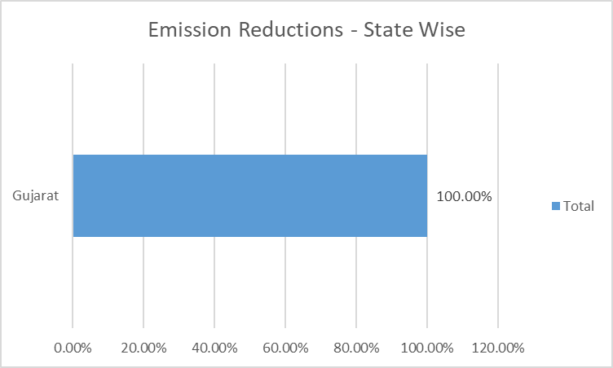

By Vehicle Make
A total of 58.75 tCO₂e was avoided by scrapping ELVs of various OEMs, the share of which is given below.
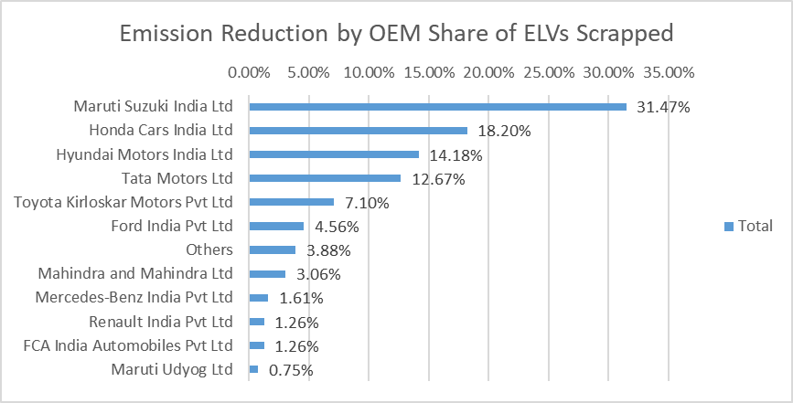

End-Of-Life Vehicle Attributes

By Vehicle Make
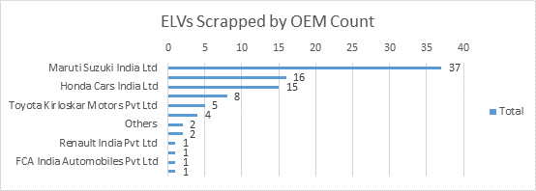

By Fuel Type
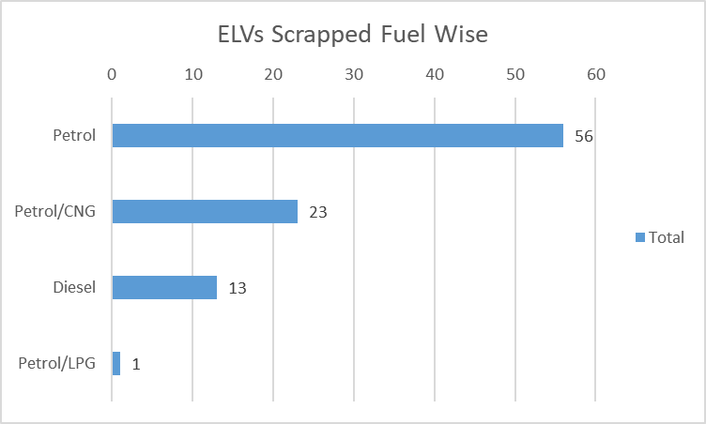

Reusable Materials Recovered

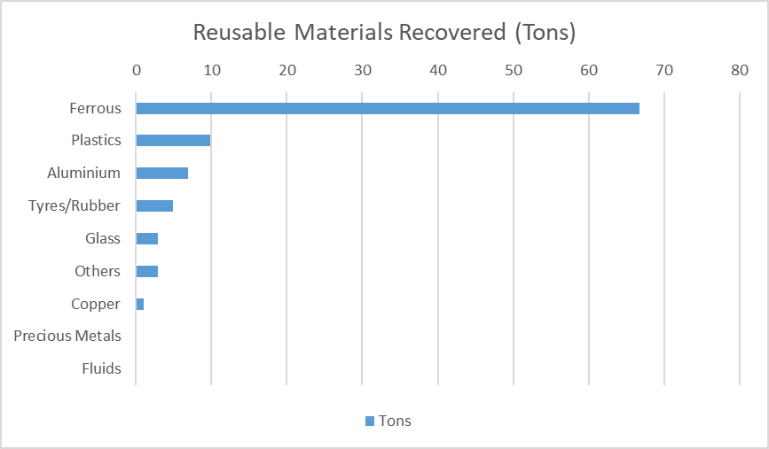

Project Emissions

Electricity Consumption & Emissions
Electricity consumed: 3.38 MWh
Emissions from Electricity Consumption: 2.34 tCO₂e
Emissions from material processing: 51.16 tCO₂e
RVSF | Fuel Consumed (Tons) | Electricity Consumed (MWh) | Emissions from Electricity & Fuel Consumption  (tCO₂e) | Emissions from Material Processing (tCO₂e)
MTC Business Private Limited | 0 | 3.38 | 2.34 | 51.16

Baseline Emissions
Baseline (Metals): 102.21 tCO₂e
Baseline (Plastics): 9.67 tCO₂e
RVSF | Baseline Metal Emissions Avoided (tCO₂e) | Baseline Plastic Emissions Avoided (tCO₂e)
MTC Business Private Limited | 102.21 | 9.67

