Stakeholder Consultation Report

PUBLICATION DATE 14.10.2020
VERSION v. 1.1
RELATED SUPPORT

- TEMPLATE GUIDE Stakeholder Consultation Report v. 1.1

This document contains the following Sections
Key Project Information
SECTION A - Information made available to Stakeholders
SECTION B - Invitations made to Stakeholders
SECTION C - Report of the Consultation Process
SECTION D - Continuous input / Grievance mechanism
SECTION E – Stakeholder Feedback Round

KEY PROJECT INFORMATION
GS ID of Project | GS 11333
Title of Project | Hubei Swine Farm Animal Waste Management System GHG Mitigation Project
Version number of the SCR | 01
Completion date of version | 27/10/2021
Time of First Submission Date | 27/10/2021
Start Date of the Project | 09/09/2020
Date of Meeting (s) | 18/10/2021
Project Cycle: | Regular  Retroactive

INFORMATION MADE AVAILABLE TO STAKEHOLDERS
        - A non–technical summary of the project
>>
Purpose and general description of project
Swine Farm Animal Manure Management System GHG Mitigation Project in Hubei Province introduces new animal waste management systems to a group of 9 swine farms in Hubei Province, which are owned by Jiangxi Zhengbang Breeding Co. Ltd (hereinafter called” Zhengbang”). The project activity has been designed as single project implemented at 9 animal farms. The purpose of the project activity is to treat the manure and wastewater from the 9 swine farms to avoid methane emissions generated in the baseline uncovered anaerobic lagoons.

The project activity will replace the current open anaerobic lagoons with 9 new closed anaerobic digesters. The biogas generated during the treatment process will be captured for power generation, the electricity generated are all used by the swine farms. After anaerobic digestion, the fermented sludge will be treated in aerobic composting system, which will be used as fertilizer. Wastewater from the new animal waste management systems will be treated aerobically and then used for agriculture irrigation.

Benefited from the “waste-biogas-fertilizer” pattern, harmlessness and ecological utilization of the swine manure can be realized. Total installed capacity of the proposed project is 2.30MW with an annual average electricity generation of 28,581.41 MWh, all of which will be used by the 9 swine farms. The electricity generated will not be connected to another user or to the regional power grid.

The project activity will reduce of GHG in the atmosphere through avoiding methane emissions from anaerobic treatment of swine manure and wastewater. 292,339tCO2e emission reductions will be produced annually. The project activity can contribute to local sustainable development in the following aspects:
- The project activity can enhance the quality of the water, control the odour, and improve the working environment of the workers and the production and living conditions of the farmers.
- The project activity can provide 21 job opportunities for local residents.
- The effluent and slurry are good organic fertilizers which are all supplied to the farmers living around free, they can be used to yield organic products and improve the income of the farmers.
- Biogas technology can capture the methane generated during the treatment process and use biogas to generate heat which can provide clean energy to substitute some traditional energy resource, thus the project can reduce CH₄ emissions more effectively and contribute to the mitigation of global climate change.
- Capture of methane will significantly reduce the odor nuisance in the vicinity of the facility.
- The project activity can provide 18 job opportunities for local residents.
- The effluent and fermented sludge are ecological organic fertilizers which are all supplied to the farmers living around for free, which can be used to yield organic products and improve the living conditions of the farmers.
- The project activity can capture methane generated during the swine manure treatment process and the biogas can be used for power generation, which can contribute to the mitigation of global climate change.
Details of technologies
The proposed project implemented 9 sets of Animal Manure Management Systems (AMMSs) in 9 swine farms involving 130,976 heads of commercial pigs, 226,952 heads of breeding pigs. Live pigs are kept for 180 days in the farms and are estimated to produce 297,722tons of manure every year. The raw materials such as pig manure, urine and washing water are collected, and then put into the homogenate regulating tank. After further hydrolysis and grit settling, all were put into the anaerobic tank for fermentation.

The project adopts a fully mixed bag type anaerobic reactor, and the biogas generated will enter the biogas generator set after biological desulfurization and dehydration purification. The generated electricity will be used for daily operation of the swine farms, and the waste heat of the generator will be recycled for increasing the temperature of the anaerobic reactor.

After anaerobic fermentation, the fermentation liquid is separated by solid and liquid, and the biogas residue is used to produce solid organic fertilizer. The biogas slurry is used for organic fertilizer in orchard, feed field and pollution-free vegetable base. In non-fertilizer seasons, the biogas slurry enters the sewage treatment system and oxidation pond for purification treatment and is discharged after reaching the discharge standard of livestock and poultry wastewater. The sludge produced during the aerobic treatment process is used as high-quality fertilizer. The organic fertilizers will be supplied to the farmers living around for free. And the surplus fertilizes will be sold to the end-users at below-market prices. The technical flow of the project activity is shown below:

methane
Mixed manure
Homogenate regulating tank
Anaerobic reactor
Solid liquid separator
Solid organic fertilizer
Used as liquid organic fertilizer for crops, orchards, and feed fields
Biological desulfurization
Gas storage tank
Electric generator
Waste heat utilization
Biogas slurry pool
Oxidation pond
Post fermentation tank

Figure 1 Process flow of biogas project in the swine farms

Pretreatment process
The mixed manure enters the homogenate regulating tank, where the homogenate is further hydrolysed to remove impurities such as mud and sand. The feed solution is heated to 30 °C in the homogenate hydrolysis tank, and then pumped into the anaerobic tank.

Anaerobic digestion process
Anaerobic digestion process consists of feeding unit, anaerobic digestion unit and biogas storage unit.

- Feeding mode
The manure is pumped into the anaerobic digestion unit by a pump and fed continuously.

- Anaerobic reactor process
The project adopts a completely mixed anaerobic reactor. The fully mixed anaerobic reactor is suitable for the fermentation of livestock manure. It uses stirring and heating technology in anaerobic reactor, which is an important technical breakthrough in biogas fermentation process. Mixing and heating can greatly improve the biogas fermentation rate. The fully mixed anaerobic reactor is also called high-speed biogas fermentation pool. It has a high solid concentration (Total Solid 6 - 12%), and can make all livestock manure sewage biogas fermentation treatment. Its advantages are the large treatment capacity, large biogas production, easy management, easy start-up and low operation cost. It is generally suitable for areas where biogas is the main production and uses liquid organic fertilizer (water and fertilizer). Because this process is suitable for the treatment of livestock manure and organic waste with high suspended solids, it has the incomparable advantages of other efficient biogas fermentation processes and is widely used in Europe and other biogas engineering developed areas. Therefore, it is more appropriate to choose a fully mixed anaerobic reactor, which is conducive to saving investment; The longer Hydraulic Retention Time (HRT) is also conducive to the full decomposition and digestion of pig manure, and the biogas production is relatively stable. At the same time, it is more conducive to the smooth implementation and operation management of the project.

- Anaerobic tank configuration
The stirring system is set in the anaerobic reactor to make the feed evenly distributed and fully contact with anaerobic microorganisms and make the temperature of the feed liquid in the anaerobic system uniform, which is conducive to improving the gas production rate. Moreover, it can also break scum and prevent crusting.

A discharge system is set at the upper part of the reactor to overflow into the next treatment unit.

- Heat preservation and warming
Anaerobic digestion reaction process is greatly affected by temperature. The temperature of the anaerobic treatment unit of this project is designed as medium temperature, and the optimal temperature range is 35 ~ 38 ℃. To ensure the normal operation of anaerobic reaction in winter, it is necessary to implement warming and overall insulation measures for the system.

a. Heat preservation
The whole system insulation includes pipeline and valve insulation, Heat preservation system of anaerobic digestion tank.
b. Temperature increase
The temperature increase is mainly carried out in the pretreatment homogenate regulating tank and anaerobic reactor at the same time.

The heat source comes from the waste heat generated by the cogeneration unit; A heating tube is arranged in the pool body, and the heat of the generator is exchanged through the exchange tube to realize the temperature increase of the pool body. After the waste heat of the generator is heated to the anaerobic digestion system, the water after heat exchange returns to the generator system.

Solid liquid separation and biogas residue treatment process
There are a lot of solid substances in the effluent after anaerobic fermentation, so the solid-liquid separation must be carried out. Solid liquid separation chooses compound spiral extrusion solid-liquid separator. The effluent from solid-liquid separation (biogas slurry) overflows into the biogas slurry storage tank. The solid-liquid separator can reduce the moisture content of biogas residue to less than 70% and transport it to the organic fertilizer storage yard for use in farmland and feed fields.

Biogas slurry treatment process
Biogas slurry tank, sewage treatment system and oxidation pond are designed for the project.

Application of biogas slurry: the biogas slurry is used as liquid organic fertilizer through the pipe network to silage corn feed field, orchard, nursery and other fertilization land. At the same time, it is equipped with oxidation pond to purify biogas slurry in non-fertilizer season and meet the discharge standard of livestock wastewater.

Biogas purification process
Biogas was desulfurized by biological desulfurization method. Biological desulfurization method uses colorless sulfur bacteria, such as Thiobacillus thiooxidans and Thiobacillus ferrooxidans, to oxidize H2S to elemental sulfur or sulfite under micro-oxygen conditions. This desulfurization method has been widely used in Europe and has been used in some domestic projects. Its advantages are no catalyst, no chemical sludge treatment, little biological sludge, low energy consumption, 90% H2S removal rate and high removal efficiency. The cost of desulfurization is 0.04 yuan per cubic meter of biogas, which is 70% lower than that of chemical desulfurization.

Biogas storage technology
Membrane gas storage tank is selected to store biogas in this project. The membrane type biogas storage tank is enclosed by an outer membrane and the liquid level in the anaerobic reaction tank to store biogas. The gas storage tank is equipped with an explosion-proof fan, which automatically adjusts the gas delivery volume to the biogas generator according to the requirements, so as to maintain the stability of the air pressure in the gas storage tank. It is equipped with ultrasonic range finder to automatically adjust and control the storage capacity of biogas.

Location of the project
The proposed project activity is located in Hubei Province. The project activity has been designed as single project implemented at nine animal farms. The location of the nine subsidiary farms is shown below:

Swine farm | East longitude | North latitude
Yongjiahe | 114.6616° | 31.1443°
Zhoujiachong | 114.5357° | 31.2839°
Jiucaiyuan | 114.4295° | 31.3581°
Gaoshanmiao | 114.4539° | 31.3487°
Shayang 1st phase | 112.2445° | 30.6289°
Shayang 2nd phase | 112.2456° | 30.6276°
Ezhou | 114.7986° | 30.3922°
Tuchong | 114.2584° | 31.5352°
Sangzihu | 112.5061° | 30.2648°

Scale of the project
The proposed project introduces new animal waste management systems to treat the manure and wastewater. As per section 9.1.2 of GS4GG GHG Emissions Reduction & Sequestration Product Requirements (Version 2.0), it belons to the Type 3: other project activities. The annual emission reductions of the project activity are 292,339tCO₂e, which is more than 60,000 tCO₂e. Thus, the project does not meet the definition of small-scale projects in section 9.1.2 of GS4GG GHG Emissions Reduction & Sequestration Product Requirements (Version 2.0), Therefore, the project is a large-scale GS VER project.

Proposed timetable
The project had put into operation in the end of December 2020. As per manufacturer specifications of the heat generator, the lifetime of the equipment is more than 15 years. The total length of crediting period of the project is 15 years (5 years for each Design Certification Renewal Cycle and in total two Design Certification Renewal Cycles).

        - Contact details to get further technical detail and project information
>>
In case any further questions about the project, stakeholders or any other individuals can contact the project owner or the project developer. Refer to the following table for contact details.

Project owner
Organization name | Jiangxi Zhengbang Breeding Co. Ltd
Registration number with relevant authority | 913601007542124562
Street/P.O. Box | north of Hu Dong 4th Road and east of Chanye Road
Building | /
City | Nanchang City
State/Region | Jiangxi province
Postcode | 330096
Country | China
Telephone | 135 6445 9487
E-mail | 57566640@qq.com
Website | http://www.zhengbang.com/index.html
Contact person | Shen Min
Title | Deputy General Manager
Salutation | Mr.
Last name | Shen
Middle name | /
First name | Min
Department | /
Mobile | /
Direct tel. | +86 0791--8639 7834
Personal e-mail | 57566640@qq.com

Project developer
Organization name | Profit Carbon Environmental Energy Technology (Shanghai) Co., Ltd.
Registration number with relevant authority | 91310115301334442X
Street/P.O. Box | No.2815 Longteng Avenue
Building | Sales Center of Baihuiyuan
City | Shanghai
State/Region | /
Postcode | 200232
Country | China
Telephone | +86 21 6127 2386
E-mail | shulan.tu@profitcarbon.com
Website | www.profitcarbon.com
Contact person | Tu Shulan
Title | Senior Project Manager
Salutation | Ms.
Last name | Tu
Middle name | /
First name | Shulan
Department | Technology Department
Mobile | 186 9490 7124
Direct tel. | +86 21 6127 2386
Personal e-mail | shulan.tu@profitcarbon.com

        - Summary of economic, social and environmental impacts of the Project
>>
The project activity can contribute to local sustainable development in the following aspects:

SDG 7 – Affordable and Clean Energy
The project activity replaces the current open anaerobic lagoons with 9 new closed anaerobic digesters. The biogas generated during the treatment process is captured for heat generation, the heat generated are all used by the swine farms. In baseline situation, the heat consumption of the swine farm is supplied by the Heating Company, which is dominated by Coal fired boiler. No clean energy can be generated in baseline situation.

SDG 8 – Decent Work and Economic Growth
The project activity will provide job opportunities for all locals during project implementation and monitoring activities irrespective of gender or any other status. Equal pay for work of equal value will be made to both men and women.

SDG 13 – Climate Action
The project activity is designed to introduce new animal waste management systems to a group of 9 swine farms to treat the manure and wastewater from the 9 swine farms. Through this technology, the project activity can capture methane generated during the swine manure treatment process and the biogas can be used for heat generation in heating-season and in other seasons, the biogas will be flared, which can contribute to the mitigation of global climate change. Besides, the project will provide an opportunity for local residents to learn and raise awareness on climate change and mitigation measures on the stakeholder consultation fiscal meeting.

All assessment questions related to safeguarding principles were discussed during the stakeholder consultation meeting. Refer to the following table for results of the Safeguarding Principal Assessment.

Assessment Questions/  Requirements | Justification of Relevance (Yes/potentially/no) | How Project will achieve Requirements through design, management or risk mitigation. | Mitigation Measures added to the Monitoring Plan (if required)
Principle 1. Human Rights
- The Project Developer and the Project shall respect internationally proclaimed human rights and shall not be complicit in violence or human rights abuses of any kind as defined in the Universal Declaration of Human Rights  - The Project shall not discriminate with regards to participation and inclusion | No | 1.The project activity is designed to introduce new animal waste management systems to treat the manure and wastewater from the 9 swine farms to avoid methane emissions generated in the baseline uncovered anaerobic lagoons. The project is in Hubei Province, china. The project is implemented under the laws of China and will not lead to violations or human rights abuses in any kind.  2.All end-users in the project region that respect the principles and values of sustainable development can equally participate and benefit from the project. The project does not discriminate on gender, race, religion, sexual orientation or any other aspect. | Not required
Principle 2. Gender Equality
- The Project shall not directly or indirectly lead to/contribute to adverse impacts on gender equality and/or the situation of women  - Projects shall apply the principles of nondiscrimination, equal treatment, and equal pay for equal work  - The Project shall refer to the country’s national gender strategy or equivalent national commitment to aid in assessing gender risks  - (where required) Summary of opinions and recommendations of an Expert Stakeholder(s) | No | 1.The project will not directly or indirectly reinforce gender-based discrimination and shall not lead to/contribute to adverse impacts on gender equality and/or the situation of women.  In fact, the project increases women’s access to or control of resources, entitlements and benefits by providing easy access to equal job opportunities.  2.The project will not set up any barriers to the employment of women. All employees have benefits based on pregnancy, maternity/paternity leave, or marital status according to the Labour Law of the People's Republic of China, Special provisions on labour protection of female employees and other related regulation and policies.  3. The project complies with the Labor Law and China's gender related policies.  4. There is no opinions and recommendations of an Expert Stakeholder(s). That’s because the project will not directly or indirectly reinforce gender-based discrimination and shall not lead to/contribute to adverse impacts. Therefore, the safeguarding principle related to Gender Equality and Women’s Rights is not triggered during the project design and implementation. | Not required
Principle 3. Community Health, Safety and Working Conditions
- The Project shall avoid community exposure to increased health risks and shall not adversely affect the health of the workers and the community | No | The project activity is designed to introduce new animal waste management systems to treat the manure and wastewater from the 9 swine farms to avoid methane emissions generated in the baseline uncovered anaerobic lagoons. The biogas generated during the treatment process will be captured for heat generation. After anaerobic digestion, the fermented sludge will be treated in aerobic composting system, which will be used as fertilizer. The fertilizer can be distributed to the local people for free regularly. So, the Project doesn’t increase the exposure to health risks and adversely affect the health of the workers and the community. In fact, this project can bring benefits to the workers and the community. | Not required
Principle 4.1 Sites of Cultural and Historical Heritage
Does the Project Area include sites, structures, or objects with historical, cultural, artistic, traditional or religious values or intangible forms of culture? | No | The new animal waste management system is not used in sites, structures, or objects with historical, cultural, artistic, traditional or religious values or intangible forms of culture.  The project does not utilise Cultural Heritage, including the knowledge, innovations, or practices of local communities, affected communities. | Not required
>> | No |  | Not required
Principle 4.2 Forced Eviction and Displacement
Does the Project require or cause the physical or economic relocation of peoples (temporary or permanent, full or partial)? | No | The free distribution of the fertilizer produced by this project can help to reduce the costs of purchasing fertilizer for the local people. All the investment for the animal waste management system is provided by project owner. It obviously does not cause physical or economic relocation of peoples. | Not required
>> | No |  | Not required
Principle 4.3 Land Tenure and Other Rights
- Does the Project require any change, or have any uncertainties related to land tenure arrangements and/or access rights, usage rights or land ownership?  - For Projects involving land use tenure, are there any uncertainties with regards to land tenure, access rights, usage rights or land ownership? | No | This project is operated in the swine farm owned by the project owner.so, there is no uncertainties related to land tenure arrangements and/or access rights, usage rights or land ownership.  The project does not require any change to land tenure arrangements and/or other rights such as resource access rights, community-based property rights and customary rights, which is confirmed by an expert invited by the project owner. | Not required
>> | No |  | Not required
Principle 4.4 - Indigenous people
Are indigenous peoples present in or within the area of influence of the Project and/or is the Project located on land/territory claimed by indigenous peoples? | No | Indigenous people have the same and equal opportunity to obtain the fertilizer and they will not be affected directly or indirectly in a negative way by the project.  In addition, there are no indigenous people present within the area of influence nor the project is located on territory claimed by indigenous people. This is confirmed by an expert invited by the project owner. | Not required
>> | No |  | Not required
Principle 5. Corruption
- The Project shall not involve, be complicit in or inadvertently contribute to or reinforce corruption or corrupt Projects | No | The project is implemented on the ground by the social enterprise. The ethical codes of the project partners are against corruption. In addition, the companies comply with all related economic laws and regulations of China.  This Project has a zero tolerance to corruption policy, anything generated as project revenue shall be spent towards the project monitoring, repair and maintenance, project operation and costs against project verification and issuance of the emission reduction credits.  Hence, the project doesn’t involve any transaction of cash and/or kind between the project participant and the beneficiary. | Not required
Principle 6.1 Labour Rights
- The Project Developer shall ensure that all employment is in compliance with national labour occupational health and safety laws and with the principles and standards embodied in the ILO fundamental conventions  - Workers shall be able to establish and join labour organisations  - Working agreements with all individual workers shall be documented and implemented and include:  - Working hours (must not exceed 48 hours per week on a regular basis), AND  - Duties and tasks, AND  - Remuneration (must include provision for payment of overtime), AND  - Modalities on health insurance, AND  - Modalities on termination of the contract with provision for voluntary resignation by employee, AND  - Provision for annual leave of not less than 10 days per year, not including sick and casual leave.  - No child labour is allowed (Exceptions for children working on their families’ property requires an Expert Stakeholder opinion)  - The Project Developer shall ensure the use of appropriate equipment, training of workers, documentation and reporting of accidents and incidents, and emergency preparedness and response measures | No | The project complies with the Labour Law of the People's Republic of China, Special provisions on labour protection of female employees and other related regulation and policies. The project owner will sign contracts with employees. The labor contracts specify working hours, tasks and payments. All employees have benefits based on social security, pregnancy, maternity/paternity leave, or marital status according to the labor laws of China. Besides, the employees also have the right to establish labor unions and to carry on labor union activities.  All employees would provide their age information document, e.g., ID, when signing the labour contract, and the project owner did not and will not employ any child labour. | Not required
Principle 6.2 Negative Economic Consequences
- Does the project cause negative economic consequences during and after project implementation? | No | The equipment procurement cost of the project will be borne by the project owner. The project has positive economic benefits due to the reduced cost of buying fertilizer for local farmer. The project will create fair job opportunities for local people, which is good for the local economy. No risks are foreseen for the local economy through the realization of the project. | Not required
>> | No |  | Not required
Principle 7.1 Emissions
Will the Project increase greenhouse gas emissions over the Baseline Scenario? | No | The project activity is designed to new animal waste management systems to treat the manure and wastewater from the 9 swine farms to avoid methane emissions generated in the baseline uncovered anaerobic lagoons. The project activity will reduce of GHG in the atmosphere through avoiding methane emissions from anaerobic treatment of swine manure and wastewater. | Not required
>> | No |  | Not required
Principle 7.2 Energy Supply
Will the Project use energy from a local grid or power supply (i.e., not connected to a national or regional grid) or fuel resource (such as wood, biomass) that provides for other local users? | No | The project activity will replace the current open anaerobic lagoons with 9 new closed anaerobic digesters. The biogas generated during the treatment process will be captured for heat generation. All the heat is used by the 9 swine farms and will not be connected to another user or to the regional heat grid. Also, the project activity will use electricity from the Northeast China Power Gird, which is a reginal grid of China. It will not affect the energy consumptions or power supply or fuel resource supply that provides for other local users. | Not required
>> | No |  | Not required
Principle 8.1 Impact on Natural Water Patterns/Flows
Will the Project affect the natural or pre-existing pattern of watercourses, ground-water and/or the watershed(s) such as high seasonal flow variability, flooding potential, lack of aquatic connectivity or water scarcity? | No | The project will not affect the natural or pre-existing pattern of watercourses, groundwater and/or the watershed(s) such as high seasonal flow variability, flooding potential, lack of aquatic connectivity or water scarcity. This is confirmed by an expert invited by the project owner. | Not required
>> | No |  | Not required
Principle 8.2 Erosion and/or Water Body Instability
- Could the Project directly or indirectly cause additional erosion and/or water body instability or disrupt the natural pattern of erosion?  - Is the Project’s area of influence susceptible to excessive erosion and/or water body instability? | No | All animal manure will be put into the new animal waste management systems to treat and is prohibited to discharge into the Groundwater and surface water. Therefore, AWMSs used in the project area could not directly or indirectly cause additional erosion and/or water body instability or disrupt the natural pattern of erosion. The fertilizer produced in this project meets the relevant Chinese fertilizer implementation standards, so the project also could not directly or indirectly impact on surface and ground waters or soil erosion on slopes. | Not required
>> | No |  | Not required
Principle 9.1 Landscape Modification and Soil
Does the Project involve the use of land and soil for production of crops or other products? | No | Comprehensive utilization and resourceful treatment of the manure waste are encouraged by the local government. All the swine farms of the project have obtained necessary approval from the local government, including Planning Permit on Land for Construction Use, Environmental Impact Assessment etc. Hence, the project does not involve the use of land and soil for production of crops or other products. | Not required
>> | No |  | Not required
Principle 9.2 Vulnerability to Natural Disaster
Will the Project be susceptible to or lead to increased vulnerability to wind, earthquakes, subsidence, landslides, erosion, flooding, drought or other extreme climatic conditions? | No | The new animal waste management systems used in the project area does not involve any land use changes. It would not lead to the exacerbation of impacts caused by natural or man-made hazards, such as landslides or floods. | Not required
>> | No |  | Not required
Principle 9.3 Genetic Resources
Could the Project be negatively impacted by or involve genetically modified organisms or GMOs (e.g., contamination, collection and/or harvesting, commercial development, or take place in facilities or farms that include GMOs in their processes and production)? | No | The project does not involve the use of GMOs, so it will not have negatively impacted by the use of genetically modified organisms or GMOs. | Not required
>> | No |  | Not required
Principle 9.4 Release of pollutants
Could the Project potentially result in the release of pollutants to the environment? | No | The project is designed to introduces new animal waste management systems to treat the manure and wastewater from the 9 swine farms to avoid methane emissions generated in the baseline uncovered anaerobic lagoons. During the treatment process, the biogas was captured for heat generation and flared, the fermented sludge was treated in aerobic composting system, the wastewater was treated aerobically and then used for agriculture irrigation, so no pollutants release to the environment. | Not required
>> | No |  | Not required
Principle 9.5 Hazardous and Non-hazardous Waste
Will the Project involve the manufacture, trade, release, and/ or use of hazardous and non-hazardous chemicals and/or materials? | Potential | The project activity will replace the current open anaerobic lagoons with 9 new closed anaerobic digesters. The biogas generated during the treatment process will be captured for heat generation or flared. If biogas is not handled properly during the operation period of the project, methane leakage/explosion may be caused. | Required. For this project, the biogas will be generated during the treatment process, if biogas is not handled properly during the operation period of the project, methane leakage/explosion may be caused. So, the Mitigation Measures were needed. In this project, the mitigation measure for safeguarding principles was that project owner will conduct regular training on biogas safety and leakage to project employees to improve their proficiency in the treatment system and ensure that biogas leakage and safety hazards will not occur, and the employee training of biogas safety operation will be monitored through the training record. Also, the Mitigation Measure for Safeguarding Principles, i.e., the parameter of “Employee Training of biogas safety operation” was included in the monitoring plan in section B.7.1 and B.7.3 of the PDD.
>> | Potential
Principle 9.6 Pesticides & Fertilisers
Will the Project involve the application of pesticides and/or fertilisers? | No | The project activity does not involve any application of pesticides and/or fertilizers. | Not required
>> | No |  | Not required
Principle 9.7 Harvesting of Forests
Will the Project involve the harvesting of forests? | No | The project activity does not involve the harvesting of forests. | Not required
>> | No |  | Not required
Principle 9.8 Food
Does the Project modify the quantity or nutritional quality of food available such as through crop regime alteration or export or economic incentives? | No | The project activity does not involve the modification of the quantity or nutritional quality of food available. | Not required
>> | No |  | Not required
Principle 9.9 Animal husbandry
Will the Project involve animal husbandry? | No | The project is designed to introduces new animal waste management systems to treat the manure and wastewater from the 9 swine farms to avoid methane emissions generated in the baseline uncovered anaerobic lagoons, belongs to waste disposal and resource utilization. | Not required
>> | No |  | Not required
Principle 9.10 High Conservation Value Areas and Critical Habitats
Does the Project physically affect or alter largely intact or High Conservation Value (HCV) ecosystems, critical habitats, landscapes, key biodiversity areas or sites identified? | No | The project is not located in an area within a high conservation value area or within critical natural habitats. The project activity does not physically affect or alter largely intact or High Conservation Value (HCV) ecosystems, critical habitats, landscapes, key biodiversity areas or sites identified. In addition, the “Measures of Hubei Province for the administration of breeding livestock and poultry production and operation licenses” clearly stipulate the prohibited construction area. | Not required
>> | No |  | Not required
Principle 9.11 Endangered Species
a. Are there any endangered species identified as potentially being present within the Project boundary (including those that may route through the area)?  - Does the Project potentially impact other areas where endangered species may be present through transboundary affects? | No | There are no endangered species identified as potentially being present within the Project boundary. In addition, the new animal waste management systems used in the project will not pose a threat to any species. | Not required
>> | No |  | Not required

        - Other relevant information to help stakeholders understand the project
>>
The project owner has sent out an invitation email to the stakeholder entity meeting on September 8, 2021. In addition to specifying the time (18/10/2021) and place of the meeting, the email also attached the “KEY PROJECT INFORMATION” and “Draft Project Design Document” to the stakeholders to help stakeholders understand the project.

INVITATIONS MADE TO STAKEHOLDERS
        - Invitation tracking table
Category Code | Stakeholder Type/Organisation (if relevant) | Name of invitee | Male/  Female | Method of invitation | Date of invitation  (>30 days before Meeting)
A/B | Local resident/user | Lu Xuemin | Male | Email and Notice |  | 08/09/2021
A/B | Local resident/user | Hu Yue | Female | Email and Notice |  | 08/09/2021
A/B | Local resident/user | Li Zhengyang | Male | Email and Notice |  | 08/09/2021
A/B | Local resident/user | Song Jianming | Male | Email and Notice |  | 08/09/2021
A/B | Local resident/user | Feng Xiayue | Female | Email and Notice |  | 08/09/2021
A/B | Local resident/user | Liang Zhong | Male | Email and Notice |  | 08/09/2021
A/B | Local resident/user | Huang Hongmei | Female | Email and Notice |  | 08/09/2021
A/B | Local resident/user | Zhou Heng | Male | Email and Notice |  | 08/09/2021
C | Department of Ecology and Environment of Hubei Province | Lu Yi | Female | Email |  | 08/09/2021
C | Department of Agriculture and Rural Affairs of Hubei Province | Fang Zhuo | Male | Email |  | 08/09/2021
C | Hubei Development and Reform Commissiom | Pan Xiaolan | Female | Email |  | 08/09/2021
D | Ministry of Ecology and Environment of the People's Republic of China-Department of Climate Change | Zeng Rong | Male | Email |  | 08/09/2021
D | Ministry of Ecology and Environment of the People's Republic of China-Department of Climate Change | Wu Kangping | Male | Email |  | 08/09/2021
D | Ministry of Ecology and Environment of the People's Republic of China-Department of Climate Change | Liu Zhengqi | Male | Email |  | 08/09/2021
E | Women's Federation of Hubei province | Qiu Lei | Female | Email |  | 08/09/2021
F | Gold Standard representative | help@goldstandard.org | N/A | Email |  | 08/09/2021
G | Global Offset Research | Siddharth Yadav | N/A | Email |  | 08/09/2021
G | CEDESOL | David Whitfield | N/A | Email |  | 08/09/2021
G | Asociación para la Promoción de Nuevas Alternativas de Desarrollo (APRONAD) | Francisco Rivas | N/A | Email |  | 08/09/2021
G | Proyecto Mirador | Esther Adams | N/A | Email |  | 08/09/2021
G | Lean Management Systems Promotion Society | Raave Jain | N/A | Email |  | 08/09/2021
G | HIVOS | Harry Clemens | N/A | Email |  | 08/09/2021
G | Redemption Research for Health and Educational Development Society | Kennady Pulipati | N/A | Email |  | 08/09/2021
G | NCMA India | Bholendra Singh | N/A | Email |  | 08/09/2021
G | Fundacion de Iniciativas de Cambio Climatico de Honduras (Fundacion MDL de Honduras) | Suyapa Zelaya | N/A | Email |  | 08/09/2021
G | United Purpose | Lloyd Archer | N/A | Email |  | 08/09/2021
G | Concern Health Ghana | Isaac Ampomah | N/A | Email |  | 08/09/2021
G | NOVA | Montagu Murray | N/A | Email |  | 08/09/2021

          - Appropriateness of methods
>>
The Stakeholder Consultation Meeting held from 9:00 a.m. to 11:30 a.m. on 18/10/2021 at conference room on the 4th floor of Zhengbang Group, Ziwen Road, Zengdian Town, Yunmeng County, Xiaogan City, Hubei Province. Before the meeting, local villagers, relevant local government officials, experts from NGOs, both male and female, were widely invited via email and the public notice on 08/09/2021. In this case, the invitation can cover most of the people who are related to the project regardless of their gender. In addition, the project contact asked all the invitees to reply to confirm whether to attend the meeting before 15/10/2021. In case the invitees could not attend, they were encouraged to invite their colleagues, friends, or families to attend. Females were encouraged to take part in the meeting.

The content of the invitation is in Chinese, which is the official language of China. Since the invitees are local users or other stakeholders of this project, they will have a certain understanding of our project. Therefore, invitations through emails or public notice will not be treated as spam and scammers, so this invitation method of emails and public notice is reasonable.

          - Gender Sensitivity
>>
The invitation methods of this project mainly include email and public notice, etc. The notices has been posted in public places, and everyone can learn and attend the meeting. When using other forms of invitation, we have considered inviting at least 50% of women to attend meetings or participate in the stakeholder feedback. In addition, in order to invite more people, including marginalised groups, we encourage invitees to invite more people to participate in the stakeholder feedback of the project.

          - Evidence proving invites took place as stated
>>
- Evidence invitation from email:
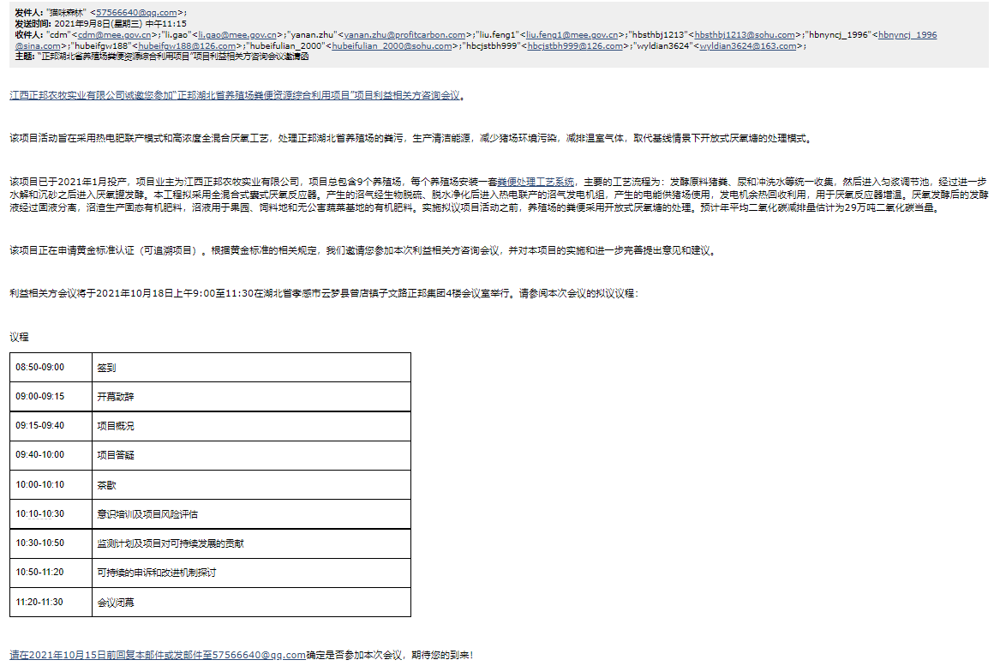
          - Sample content of invites (for each Method above)
>>
- Sample content of invitation from email:
Dear Sir/Madam,
Jiangxi Zhengbang Breeding Co. Ltd is pleased to invite you to a stakeholder’s consultation meeting regarding the project of “Hubei Swine Farm Animal Manure Management System GHG Mitigation Project”.

The objective of the project activities is to treat animals manure from swine farms of Zhengbang in Hubei Province, using a combined heat, power and fertilizer model and a high concentration mixed anaerobic process，to produce clean energy, reduce environmental pollution on the swine farm and reduce greenhouse gas emissions, replacing the treatment mode of the uncovered anaerobic lagoons under the baseline scenario.

The project was put into production in January 2021. The owner of the project is Jiangxi Zhengbang Breeding Co. Ltd. The project consists of a total of 9 swine farms, each of which is equipped with a set of Animal Manure Management Systems (AMMSs). The main technological process is as follows: fermentation raw materials, such as pig manure, urine and washing water, are collected in a unified way, and then entered the homogenate regulating tank. After further hydrolysis and sand settling, they enter the anaerobic tank for fermentation. This project is intended to adopt a full - mixed bag type anaerobic reactor. the biogas generated will enter the biogas generator set after biological desulfurization and dehydration purification. The generated electricity will be used for daily operation of the swine farms, and the waste heat of the generator will be recycled for increasing the temperature of the anaerobic reactor. After anaerobic fermentation, the fermentation liquid is separated by solid and liquid, and the biogas residue is used to produce solid organic fertilizer. The biogas slurry is used for organic fertilizer in orchard, feed field and pollution-free vegetable base. Prior to the implementation of the proposed project activities, manure from the farm was treated in an open anaerobic pond. Estimated annual average CO2 reduction is estimated at 292,339 tons of CO2 equivalent.

The project is applying for Gold Standard Certification (Retroactive project). According to the relevant rules of Gold Standard, with this letter, we would like to invite you to participate in this Stakeholder Consultation Meeting and make comments on the project.

The Stakeholder Consultation Meeting held from 9:00 a.m. to 11:30 a.m. on 18/10/2021 at conference room on the 4th floor of Zhengbang Group, Ziwen Road, Zengdian Town, Yunmeng County, Xiaogan City, Hubei Province. Please find the proposed agenda of this meeting:

Agenda
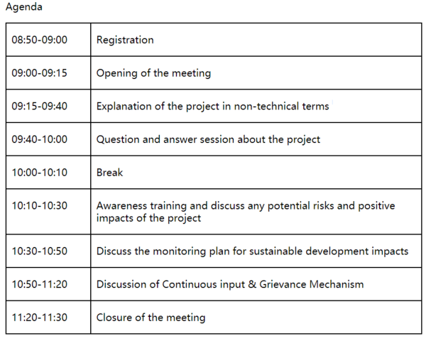
We would be grateful if you could confirm your participation to the local stakeholder meeting before 15/10/2021 by Email to 57566640@qq.com.

Best regards,
Min Shen
Tel: +86 135 6445 9487
Email: 57566640@qq.com
Jiangxi Zhengbang Breeding Co. Ltd

- Sample content of public notice:
The public notice posted at public places of local governments and the village committee where the most residents can pay attention to it. But the photos as the evidence have not been sent to project developer by project owner. The detailed content of public notice is shown below:

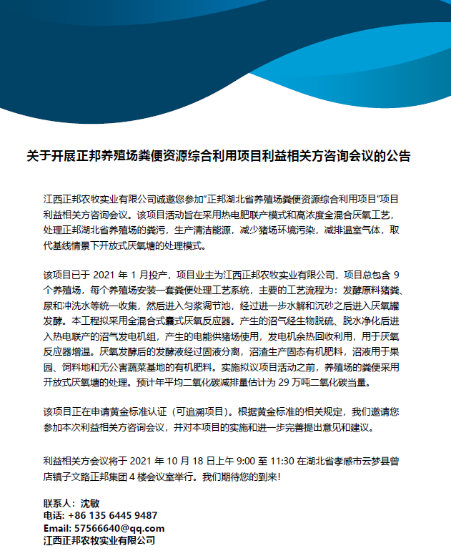

          - Description of other Means and methods to provide feedback for those who are not able to join the consultation meeting
>>
Stakeholders or any other individuals, who couldn’t attend the stakeholder consultation meeting, are able to provide feedback or comments via email or telephone. The email of 2nd feedback round has been sent on 08/09/2021, and the Stakeholder feedback round is held for two months between 10/09/2021 and 09/11/2021. Everyone is welcome to comment on this project.

REPORT OF THE CONSULTATION PROCESS
        - Date of Meeting
          - List of participants
Date and Time | 9:00 a.m. to 11:30 a.m. 18/10/2021 | Location | Conference room on the 4th floor of Zhengbang Group, Ziwen Road, Zengdian Town, Yunmeng County, Xiaogan City, Hubei Province
Category  Code | Name of participant, job /  position in the community | Male /  Female | Contact details | Organisation  (if relevant) | Signature
A/B | Lu Xuemin | Male | 13972895145 | Jingmen City
A/B | Hu Yue | Female | 18872448467 | Jingmen City
A/B | Li Zhengyang | Male | 13581376832 | Shiyan City
A/B | Song Jianming | Male | 13367192017 | Shiyan City
A/B | Feng Xiayue | Female |  | Xianning City
A/B | Zheng Pan | Male | 18827317206 | Xianning City
A/B | Yang Meijuan | Female | 18827317206 | Xianning City
A/B | Huang Hongmei | Female |  | Xiangyang City
A/B | Zhou Heng | Male |  | Xiangyang City
A/B | Luo Xiaochen | Female |  | Xianning City
C | Zhao Donghai | Male |  | department of Ecology and Environment of Hubei Province
C | Pan rong | Male |  | department of Agriculture and Rural Affairs of Hubei Province
C | Xie Guanghua | Male |  | Hubei Development and Reform Commission
E | Qiu Lei | Female |  | Women's Federation of Hubei province

          - Pictures from physical meeting(s) (best practice)
>>
This part of the evidence has not been sent by the owner to the project developer. Once the material is available, this part of the content will be updated.
        - Minutes of physical meeting(s)
>>
Date: 18/10/2021
Location: Conference room on the 4th floor of Zhengbang Group, Ziwen Road, Zengdian Town, Yunmeng County, Xiaogan City, Hubei Province.
Time: 9:00 a.m. to 11:30 a.m.

Opening of the meeting
The project is applying for registration under GS4GG. The purpose of the meeting is to consult the stakeholders' opinions and feedback on the project, so as to avoid the negative impact on the stakeholders and strengthen the positive impact of the project. 14 people, including local residents and experts from local government attended in the 1st round of Local stakeholder consultation physical meeting held on 18/10/2021.

Explanation of the project in non-technical terms
Shen Min from Zhengbang Animal Husbandry Group Co., Ltd. introduced the project activity and its social and environmental impacts.

The project activity introduces new animal waste management systems to a group of 9 swine farms in Hubei Province. The purpose of the project activity is to treat the manure and wastewater from the 9 swine farms to avoid methane emissions generated in the baseline uncovered anaerobic lagoons. The biogas generated during the treatment process will be captured for power generation, the electricity generated are all used by the swine farms. After anaerobic digestion, the fermented sludge will be treated in aerobic composting system, which will be used as fertilizer. Wastewater from the new animal waste management systems will be treated aerobically and then used for agriculture irrigation.

Question and answer session about the project
After the description of the project, all participants have the opportunity to express their questions and comments. The representative of project owner provided answers to the questions and comments raised by the stakeholders.

Confirmation of the GS VER ownership has also been discussed during this session. All the Animal Waste Management Systems (AWMSs) were invested by the project owner. All the stakeholders who attended the meeting were notified that the project owner has the legal ownership of the carbon credits generated by the project activity.

Discuss any potential risks and positive impacts of the project
Afterwards, the meeting continued with the discussion of the Awareness training and project risk assessment activity. The Awareness training make participants aware of the contribution to the environment and the social, such as this project create jobs opportunities for locals, especially women’s groups or other marginalised groups. During the project risk assessment, participants discussed the difficulties and risks that may be encountered in the process of project development. The comments are summarised in section C.3.

Discuss the monitoring plan for sustainable development impacts
Regarding the monitoring plan, it mainly discusses the practicability and rationality of related parameter monitoring to ensure that it can be successfully registered and issued in GS. Before the stakeholder consultation meeting, the project owner intends to assess the impact of the project on SDG 7, 8 and 13. During the physical meeting, all stakeholders were also invited to discuss the selection of SDG. The SDG outcome forms was given to all participants, explained the exercise and gave them 20 minutes to choose the relevant SDG and give their justification. During the meeting, PP paid more attention to the issues and the chosen of relevant SDG of women and marginalised groups. After discussion, all stakeholders believed that the owner's choice for SDG 7, 8 and 13 was wiser and reasonable and there was no objection. Finally, the impact of SDG7, SDG8 and SDG13 were decided.

Discussion of Continuous input & Grievance Mechanism
After discussions of the impacts and monitoring plan, the host then explained about the Continuous input & Grievance Mechanism which entails how the stakeholders can reach out to the project implementer during the project’s crediting period in case of any questions, comments or suggestions. Also, the contact methods are provided to the attendees to see if the methods are appropriate and easy to access. Refer to section D for more details.

Closure of the meeting
Thank all the attendees for their participation in this meeting. The opinions and comments are very important for the implementation of this project. In addition to this meeting, all stakeholders can also provide us with suggestions through our Continuous input & Grievance Mechanism.

At the end of the meeting, all the evaluation forms filled out by all participants were collected.

          - Minutes of other consultations
>>
Stakeholders who could not attend the physical meeting were encouraged to raise questions by mail or phone calls. However, no questions or comments were received.
        - Assessment of comments from all consultations above
Gender of Stakeholder | Stakeholder  comment | Was comment taken into account (Yes/ No)? | Explanation (Why? How?)
Female | Whether your breeding activity is under the supervision and guidance of local environmental protection authorities? | Yes | Yes, our breeding activity including subsequent manure disposal always will be supervised by the environmental protection authorities.
Male | Will the manure be discharged into local river? | Yes | All the manure is put into new animal waste management systems for further treatment. it is prohibited to discharge into any natural water resources without treatment according to Regulations on Prevention and Control of Pollution from Livestock and Poultry Farming.
Male | Is it possible for the electricity generated by the project to be used by our local residents? | Yes | The electricity generated currently is still not enough to supply to the swine farms. If there is surplus electricity in the future and it will be supplied to local residents within permitted conditions.
Male | What is the main energy consumed by the project activity? | Yes | Only electricity will be used for the project activity. No Other fossil fuel is need.
Female | Who is the legal ownership of the products which are generated under Gold Standard Certification? | Yes | The project is invested and constructed by the project owner, therefore the legal ownership of the credits generated under Gold Standard belongs to the project owner.

On the aspects of human rights, gender equality and women's rights, community health, safety and working conditions, cultural heritage, indigenous people, displacement and reset, corruption, economic impacts, climate and energy, water, and environment, ecology and land use, the project owner consulted the experts of the Department of Ecology and Environment of Hubei Province, Department of Agriculture and Rural Affairs of Hubei Province, Hubei Provincial Development and Reform Commission, Ministry of Ecology and Environment of the People's Republic of China, and Women's Federation of Hubei Province mainly through email. The project information and Safeguarding principles are provided to the experts during the invitation of feedback ground. The Stakeholder feedback round is held for two months between 10/09/2021 and 09/11/2021. Once the 2nd round of Stakeholder Consultation completed, PP will update the answer of Safeguarding.

          - Evaluation forms (best practice)
Name | Lu Xuemin
Gender – Male/Female: | Male
What is your impression of the meeting? | The meeting was well organized.
What do you like about the project? | Fertilizer is distributed to nearby villagers free of charge, which is conducive to common prosperity.
What do you not like about the project? | No
Signature | Lu Xuemin

Name | Song Jianming
Gender – Male/Female: | Male
What is your impression of the meeting? | The project introduction was very complete.
What do you like about the project? | Emission reductions can also be traded.
What do you not like about the project? | The concept of carbon assets is relatively new and I am still in the process of learning and understanding.
Signature | Song Jianming

Name | Zheng Pan
Gender – Male/Female: | Male
What is your impression of the meeting? | The meeting time was a little short.
What do you like about the project? | Biogas can also generate electricity, which provides a new idea for power rationing.
What do you not like about the project? | I also want to know more about the operation of the project in the future.
Signature | Zheng Pan

Name | Yang Meijun
Gender – Male/Female: | Female
What is your impression of the meeting? | It was the first time I participated in this type of meeting.
What do you like about the project? | It's amazing that manure can also be used as a resource.
What do you not like about the project? | Nothing
Signature | Yang Meijun

Name | Feng Xiayue
Gender – Male/Female: | Female
What is your impression of the meeting? | Learned a lot of new knowledge.
What do you like about the project? | It has a certain contribution to environmental protection.
What do you not like about the project? | No idea
Signature | Feng Xiayue
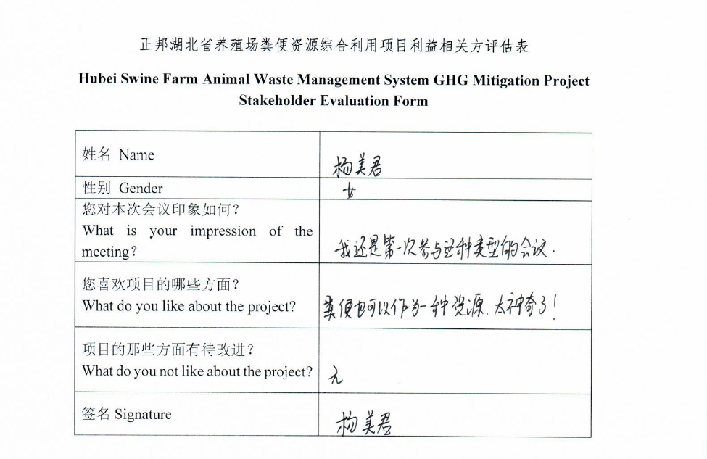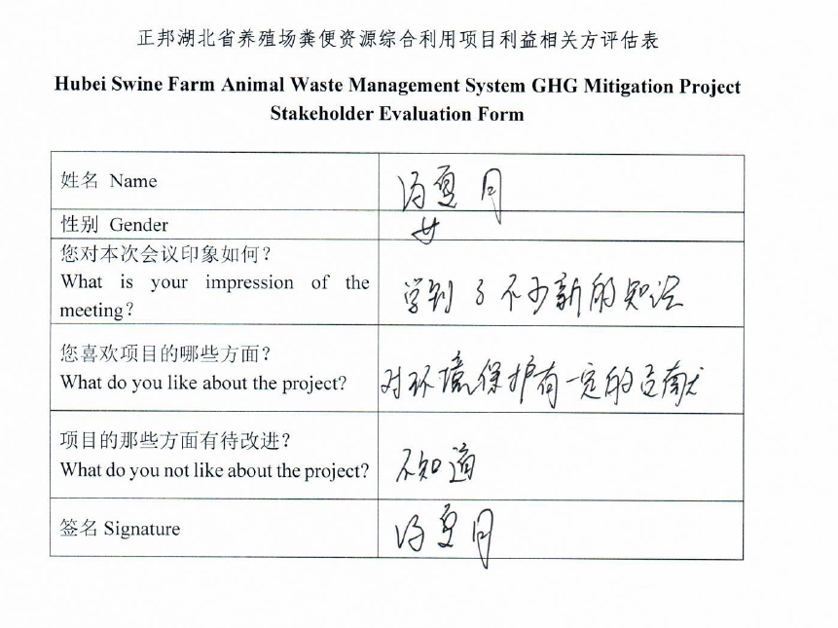
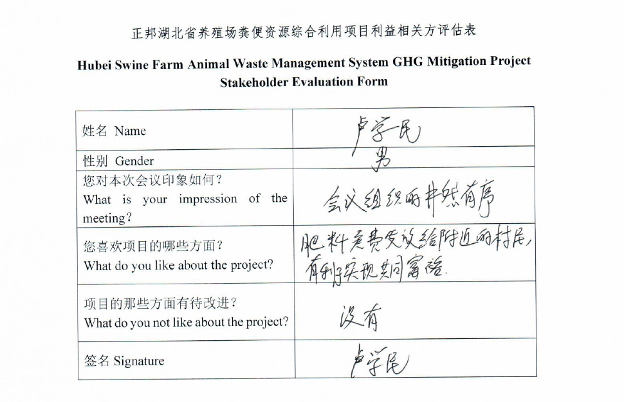
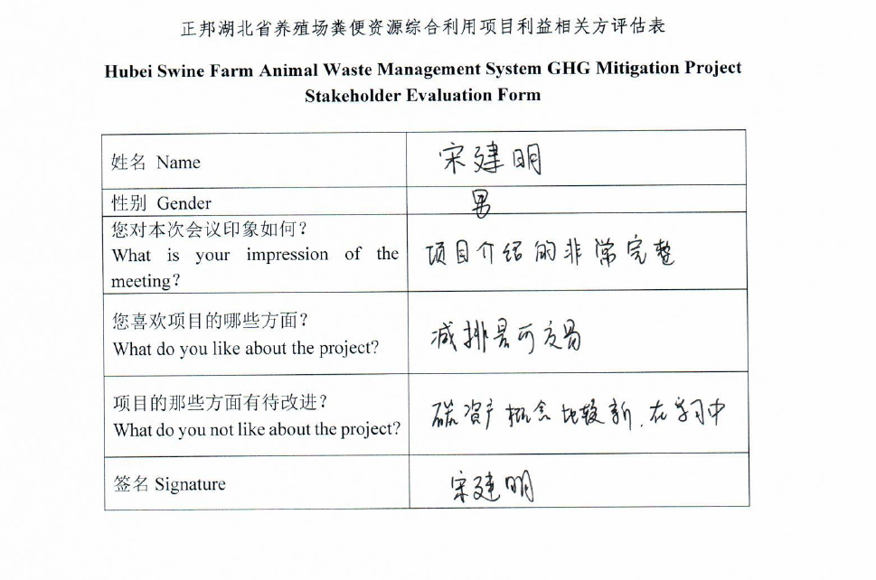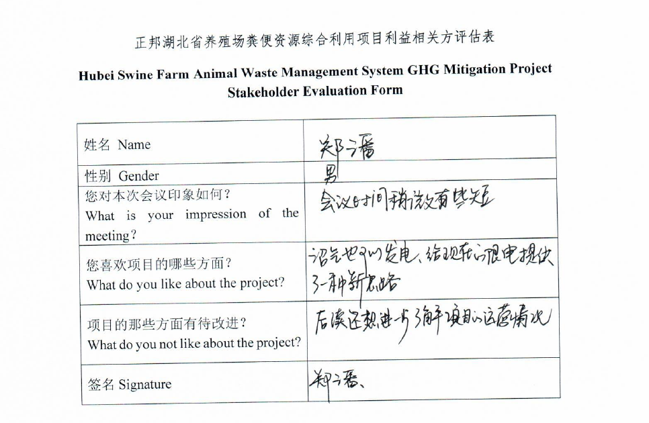
        - Summary of alterations based on comments
>>
From the outcomes of the consultation meeting, we have received some feedback and comments, but these feedbacks mainly focus on the questions of project technology and project mechanism operation. There were no comments on project design and monitoring methods. Therefore, the project would not need to modify.
The Stakeholder feedback round is held for two months between 10/09/2021 and 09/11/2021. Once the 2nd round of Stakeholder Consultation completed, PP will update the Comments of this project received from the 2nd round of Stakeholder Consultation.

CONTINUOUS INPUT / GRIEVANCE MECHANISM
 | Method | Justification of Choice  (best practice)
Continuous Input / Grievance Expression Process Book (mandatory) |  | A grievance book was put in Front Desk Administration of the project owner. All stakeholders are allowed to record their grievances or comments in the book. The project owner will assign specific person to deal with related issues. When assessing the relevance and appropriateness of the stakeholders’ comments, the project owner will apply a gender lens.
GS Contact (mandatory) |  | help@goldstandard.org
Other |  | Feedback can be made directly through visiting Jiangxi Zhengbang Breeding Co. Ltd (north of Hu Dong 4th Road and east of Chanye Road) or through e-mail 57566640@qq.com.

STAKEHOLDER FEEDBACK ROUND

The email of 2nd feedback round has been sent on 08/09/2021, and the Stakeholder feedback round is held for two months between 10/09/2021 and 09/11/2021. Once the 2nd round of Stakeholder Consultation completed, PP will update this part.

Please check this box if the project is retroactive and has done only 1 consultation with a physical meeting integrated into the SFR.

        - Length of the Feedback Round

Stakeholder Feedback Round |  | Planned | Actual
Start Date | 10/09/2021
End Date | 09/11/2021

        - Summarise how all stakeholders were/will be invited to provide feedback
>>
The Key project information and draft PDD have been sent to all LSC participants and invitees by email. People cannot attend the meeting can make comments via email.

In addition, the hard copies of LSC report and draft PDD can be available in Administration Office of Zhengbang Breeding Co. Ltd. And every stakeholder can have access to them and make comments.
        - Summarise Feedback received, including if any changes in project design were made
>>
The 2nd round of Stakeholder Consultation, the Stakeholder feedback round is held for two months between 10/09/2021 and 09/11/2021. Once the 2nd round of Stakeholder Consultation completed, PP will update the summary of comments received from the 2nd round of Stakeholder Consultation.
Revision History

Version | Date | Remarks
1.1 | 14 October 2020 | Inclusion of Key Project Information  Restructure, new headings and reorder to better match the steps a developer will follow in consultations.  Removal of some non-mandatory template tables (Blind Sustainable Development Assessment). Clarification of best practice steps that are non mandatory processes, clarification of mandatory discussion points. Clarification regarding publishing names and that original evaluation forms (optional) and attendance lists (mandatory) should be separate documents.  Improved clarity on Stakeholder Feedback round section and procedures for retroactive projects  Provision of an accompanying Guide to help the user understand detailed rules and requirements
1.0 | 14 August 2017 | Initial adoption

http://www.npc.gov.cn/zgrdw/npc/xinwen/2019-01/07/content_2070261.htm
http://www.moa.gov.cn/xw/qg/201904/t20190409_6178435.htm
http://sft.hlj.gov.cn/web/service/local-law-data-detail/2144.html

