

Tuik Ruch Lew Improved Cookstove Project for Lake Atitlan


Document Prepared by: Ava Scott, Candis Krummel, Andy Pethan
Project Title | Tuik Ruch Lew Improved Cookstove Project For Lake Atitlan
Version | 1.3
Date of Issue | 29-May-2020
Prepared By | Ava Scott, Candis Krummel, Andy Pethan
Contact | Cameron Krummel, Canton Xechivoy, Santiago Atitlan, Sololá Guatemala, +502 7933 - 3061, programdevelopment@trlearth.org

Contents
1 Project Details 4
1.1 Summary Description of the Project 4
1.2 Sectoral Scope and Project Type 4
1.3 Project Eligibility 4
1.4 Project Design 5
Eligibility Criteria 5
1.5 Project Proponent 8
1.6 Other Entities Involved in the Project 8
1.7 Ownership 9
1.8 Project Start Date 9
1.9 Project Crediting Period 9
1.10 Project Scale and Estimated GHG Emission Reductions or Removals 9
1.11 Description of the Project Activity 10
1.12 Project Location 14
1.13 Conditions Prior to Project Initiation 14
1.14 Compliance with Laws, Statutes and Other Regulatory Frameworks 14
1.15 Participation under Other GHG Programs 15
1.15.1 Projects Registered (or seeking registration) under Other GHG Program(s) 15
1.15.2 Projects Rejected by Other GHG Programs 15
1.16 Other Forms of Credit 15
1.16.1 Emissions Trading Programs and Other Binding Limits 15
1.16.2 Other Forms of Environmental Credit 15
1.17 Additional Information Relevant to the Project 15
Leakage Management 15
Commercially Sensitive Information 15
Sustainable Development 15
Further Information 16
2 Safeguards 16
2.1 No Net Harm 16
2.2 Local Stakeholder Consultation 16
2.3 Environmental Impact 21
2.4 Public Comments 21
2.5 AFOLU-Specific Safeguards 21
3 Application of Methodology 21
3.1 Title and Reference of Methodology 21
3.2 Applicability of Methodology 22
3.3 Project Boundary 30
3.4 Baseline Scenario 31
3.5 Additionality 32
3.6 Methodology Deviations 33
4 Quantification of GHG Emission Reductions and Removals 34
4.1 Baseline Emissions 34
4.2 Project Emissions 34
4.3 Leakage 34
4.4 Net GHG Emission Reductions and Removals 34
5 Monitoring 45
5.1 Data and Parameters Available at Validation 45
AMS-II.G Data / Parameters: 45
Tool 30 Data / Parameters: 48
5.2 Data and Parameters Monitored 55
5.3 Monitoring Plan 69
Appendices 72

Project Details

Summary Description of the Project
The Tuik Ruch Lew (TRL) Improved Cookstove (ICS) Project for Lake Atitlán enables community access to sustainable energy technology by providing, installing, and maintaining energy efficient cookstoves at a subsidized rate. This social service directly addresses energy poverty in addition to several other socio-economic challenges facing the indigenous communities in the Sololá Department as a consequence of years of systemic discrimination and neglect. Through the distribution of ONIL stoves, this grouped project reduces demand for wood fuel, slowing local deforestation and empowering the Tz’utujil Maya people of Lake Atitlán, a community disadvantaged daily by extreme economic, environmental, and public health struggles.
The project area is the Sololá Department. The department, located in the western highlands of Guatemala, includes Lake Atitlán and its surrounding communities. In the project area traditional cooking methods use a three-stone hearth to prepare meals, driving unsustainable wood consumption. By replacing open cooking fires with ICS technology and performing energy efficiency improvements in existing biomass fired cookstoves, the project reduces energy demand in the form of wood fuel, thus generating net GHG reductions. Together, the two project activities generate an estimated 12,686 tCO2e GHG emission reductions over the seven-year project crediting period, with an annual average of 1,812 tCO2e GHG emission reductions.

Sectoral Scope and Project Type
The project falls under VCS Sectoral Scope 3: Energy demand, Type II – Energy Efficiency, non-AFOLU, Grouped Project.

Project Eligibility
The VCS Program Guide, V4, section states “The scope of the VCS Program covers all those activities related to the generation of GHG emission reductions and removals, including jurisdictional programs and nested REDD+ projects.” By driving down energy demand, the TRL ICS Project generates net GHG emission reductions and/or removals, as measured in tCO2e. The CDM AMS-II.G. Small-scale Methodology: Energy efficiency measures in thermal applications of non-renewable biomass, Version 11.1, Sectoral scope(s): 03 includes the introduction of high efficiency biomass fired project devices to replace the existing devices and/or energy efficiency improvements in existing biomass fired cookstoves or ovens or dryers. The TRL ICS Project replaces traditional open cooking fires with energy efficient ONIL stoves and performs energy efficiency improvements in existing ONIL stoves. As per the VCS Standard, V4 paragraph 2.1.1, these project activities are eligible.

Project Design
The project has been designed to include two project activities, each with multiple project activity instances. Both project activities apply AMS-II.G V11.1 The project is a grouped project, to allow for additional project activity instances subsequent to validation/verification.

Eligibility Criteria
The project ensures that inclusion of all new project activity instances will abide by the following eligibility criteria:

Project Activity One: Introduction of high-efficiency biomass fired project devices to replace open cooking fires
Criterion |  | Achieved by:
(1) | Meet the applicability conditions as defined in CDM AMS-II.G. Small-scale Methodology: Energy efficiency measures in thermal applications of non-renewable biomass V11.1, Section 2.2. | New instances (e.g. ONIL stove installs) will meet all applicability conditions listed in section 3.2.
(2) | Use the technologies or measures specified in the project description. | At this time and for forecasted instances, no other project device type will be used, other than ONIL stove technology.
(3) | Apply the technologies or measures in the same manner as specified in the project description. | New instances will only apply the ONIL stove technology as specified in section 1.1.
(4) | Are installed within the geographic area specified in Section 1.12, thus subject to the same baseline scenario determined in Section 3.4 | The project shall only add new instances within the Sololá Department.
(5) | Have characteristics with respect to additionality that are consistent with the initial instances for the specified project activity and geographic area. | All new instances will achieve additionality via application of section 5 paragraph 10 of Tool 21: Methodological tool: Demonstration of additionality of small-scale project activities, V13, Option D: “Project participants shall provide an explanation to show that the project activity would not have occurred anyway due to at least one of the following barriers in accordance with the applied methodology.”  All new instances are installed when the baseline is the same (an open cooking fire) for clients facing the specific barriers mentioned in section 3.5: limited information, financial resources, and primarily, capacity to absorb new technologies. Within the project area, the recipients of TRL cookstoves face the same barriers. All clients purchase or collect wood from the forests surrounding Lake Atitlán, cook over open fires that emit dangerous fumes, have limited financial resources, and most importantly, have limited capacity to absorb the technology without the tailored support of TRL’s project. All clients purchase a cookstove at the subsidized price of Q350, with the exception of a few unique circumstances in which clients have alternative payment options (see section 2.2). One cookstove is installed per family, and cookstoves only replace open cooking fires. Every client receives the same cookstove technology and model (ONIL), accompanied with the same, culturally oriented support from TRL’s Outreach Team. New instances are only eligible when added in these conditions.

Project Activity Two: Energy efficiency improvements in existing biomass fired cookstoves
Criterion |  | Achieved by:
(1) | Meet the applicability conditions as defined in CDM AMS-II.G. Small-scale Methodology: Energy efficiency measures in thermal applications of non-renewable biomass V11.1, Section 2.2. | New instances (e.g. energy efficiency improvements in existing ONIL stoves) will meet all applicability conditions listed in section 3.2.
(2) | Use the technologies or measures specified in the project description. | At this time and for forecasted instances, no other measure will be used other than the energy efficiency improvement in an existing ONIL stove as specified in section 1.11.
(3) | Apply the technologies or measures in the same manner as specified in the project description. | New instances will only apply the improved ONIL stove technology as specified in section 1.11.
(4) | Are installed within the geographic area specified in Section 1.12, Project Location, thus subject to the same baseline scenario determined in Section 3.4 | The project will only perform energy efficiency improvements in existing ONIL stoves within the Sololá Department.
(5) | Have characteristics with respect to additionality that are consistent with the initial instances for the specified project activity and geographic area. | All new instances will achieve additionality via application of section 5 paragraph 10 of Tool 21: Methodological tool: Demonstration of additionality of small-scale project activities, V13, Option D: “Project participants shall provide an explanation to show that the project activity would not have occurred anyway due to at least one of the following barriers in accordance with the applied methodology.”.  All new energy efficiency improvements are completed when the baseline is the same (a damaged, old ONIL stove) for clients facing the specific barriers mentioned in section 3.5. Within the project area, families possess damaged cookstoves for several reasons. Most commonly, misuse and/or wear and tear that occurs over time damages existing biomass fired cookstoves. Families in the project area lack the technical knowledge and access to the proper replacement parts to make the improvement without the support of the project. The support and education of our Outreach Team also ensures best use, enabling the improvement to last and continue providing for emission reductions for years.  All clients purchase or collect wood from the forests surrounding Lake Atitlán, cook over damaged devices that inefficiently use wood and expose them to dangerous fumes, have limited financial resources, and most importantly, have limited capacity to absorb the technology without the unique support of our project. Every client receives the same improvement service accompanied with the same, culturally oriented support from TRL’s Outreach Team. All new instances will only be eligible when the original, damaged cookstove that undergoes the energy efficiency improvement belongs to clients facing these barriers and undergoes the same improvement process described in section 1.11.

Project Proponent
Organization name | Tuik Ruch Lew/Helping the Earth (TRL)
Contact person | Cameron Krummel
Title | Administrative Director
Address | Canton Xechivoy, Santiago Atitlan, Sololá 07919, Guatemala
Telephone | +502 7933 - 3061
Email | programdevelopment@trlearth.org

Other Entities Involved in the Project
TRL is the sole entity involved in the project.

Ownership
The Project Proponent is a registered not-for profit association in Guatemala. TRL purchases equipment directly from the manufacturer, HELPs International. Although TRL beneficiaries possess ownership of the equipment, before installation of each project instance, beneficiaries enter into a verbal contractual agreement with TRL. Beneficiaries agree to allow TRL, as a not-for profit association, to:
(1) Claim the GHG emission reductions and/or removals generated by the equipment used in the TRL ICS Project.
(2) Conduct follow-up visits for monitoring purposes.
All communication is conducted in Tz’utujil, the native language of the beneficiary. The verbal agreement is designed by our local Outreach Team to explain the environmental benefits of the ONIL stove and communicate to our beneficiaries how claiming benefits will enable the project to remain financially viable. This verbal agreement vests project ownership in the Project Proponent.

Project Start Date
The Project Start date is Sep 1, 2018. Previously, TRL had focused on providing maintenance to cookstoves installed as part of Journey Latin America’s Environmental Project (whose funding ended in early 2018), and legacy cookstoves installed under the Cojolya Association of Maya Women Weavers. On Sep 1, 2018, TRL began a new series of installations under the new, Improved Cookstove Project, initially funded by the project proponent, with the intention of entering the carbon market to finance installations and energy efficiency improvements.

Project Crediting Period
The project crediting period will be from Sep 1, 2018 - Aug 31, 2025, for a total of seven years, twice renewable.

Project Scale and Estimated GHG Emission Reductions or Removals

Project Scale
Project | X
Large project

Year | Estimated GHG emission reductions or removals (tCO₂e)
Sept 2018 - Aug 2019 | 332
Sept 2019 - Aug 2020 | 923
Sept 2020 - Aug 2021 | 1450
Sept 2021 - Aug 2022 | 1920
Sept 2022 - Aug 2023 | 2336
Sept 2023 - Aug 2024 | 2702
Sept 2024 - Aug 2025 | 3023
Total estimated ERs | 12686
Total number of crediting years | 7
Average annual ERs | 1812

Description of the Project Activity
With over 30 years of combined experience in the community, the TRL team subsidizes the purchase, installation and maintenance of ONIL stoves in Guatemalan homes in the Sololá Department. ONIL stoves cost Q1,200/each, including procurement and installation. However, we make them available to our clients for Q350. In addition to procurement and installation, TRL provides ongoing technological adaptation support, environmental education, and maintenance to all ONIL stove users (see SD VISta Project Description section 1.1.2). These services are delivered across a five-visit schedule during the first year of installation and biennially over the lifetime of the ONIL stove.
Project Activity One: Introduction of high-efficiency, biomass fired project devices to replace existing devices
Beneficiaries who switch from three-stone open cooking fires to ONIL stove use for cooking purposes experience significant reduction in wood use. By replacing open cooking fires with ICS technology, TRL drives down energy demand in the form of wood fuel. Resulting yearly savings in the quantity of woody biomass burned per ONIL stove user generate net GHG emission reductions (see Section 3). The ICS technology complies with all relevant UNFCCC requirements for the Clean Development Mechanism.
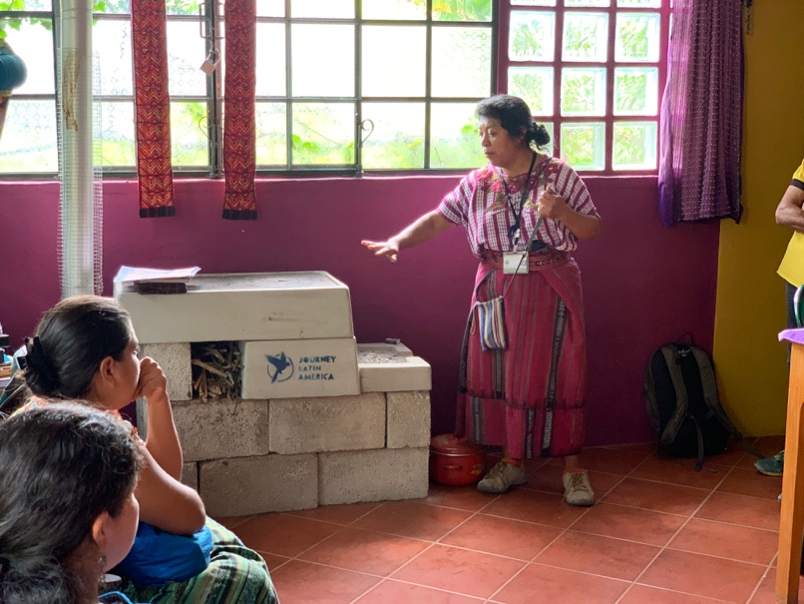
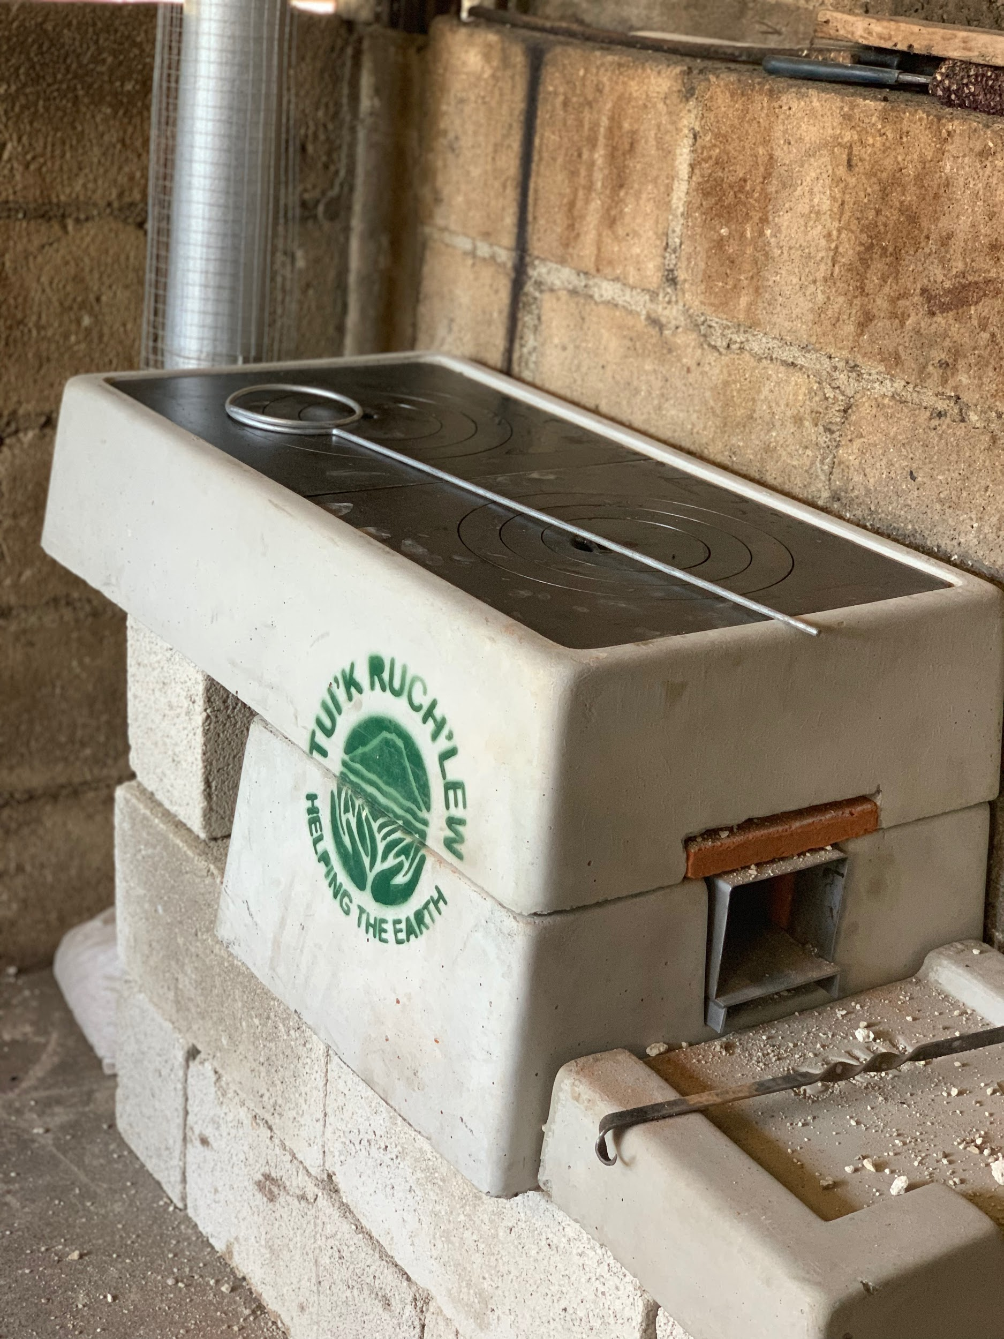
According to manufacturer specifications, the average lifetime of the equipment (see figure 1) is 10 years. The manufacturer certified thermal efficiency is 24% Stoves are manufactured locally in San Antonio Suchitepéquez. TRL purchases equipment directly from the manufacturer, HELPs International.
Figure 2: TRL's TAS presents at a group educational seminar on ICS technology.
Figure 1: ICS Equipment - ONIL Stove
Existing installed capacities since the project start date total 154 cookstoves. Forecast installed capacities total 777 total stoves over the seven-year project crediting period.

Project Activity Two: Provision of energy efficiency improvements in existing biomass fired cookstoves
TRL frequently performs maintenance on ONIL stoves with severely damaged combustion chambers that are performing at subpar efficiency. For beneficiaries who undergo energy efficiency improvements to replace existing damaged ONIL stoves with new combustion chambers, the improved devices provide for significant reduction in wood use. By performing energy efficiency improvements in the existing cookstoves, TRL drives down energy demand in the form of wood fuel. Resulting yearly savings in the quantity of woody biomass burned per improved ONIL stove user generate net GHG emission reductions (see section 3). The ICS technology complies with all relevant UNFCCC requirements for the Clean Development Mechanism.
Based on industry standards, the average lifetime of the equipment is 10 years. Specific Fuel Consumption of a new, repaired stove using a 20-tortilla Clean Cooking Test (see appendix 3 for procedure) is 590g cooked tortillas per kg of wood fuel (1kg/590 g, see appendix 4 for CCT results). Combustion chambers are manufactured locally in El Tejar, Chimaltenango.
Existing capacities since the project start date total 92 improved ONIL stoves. Forecast capacities total 661 additional improved ONIL stoves over the seven-year project crediting period.

Project Location
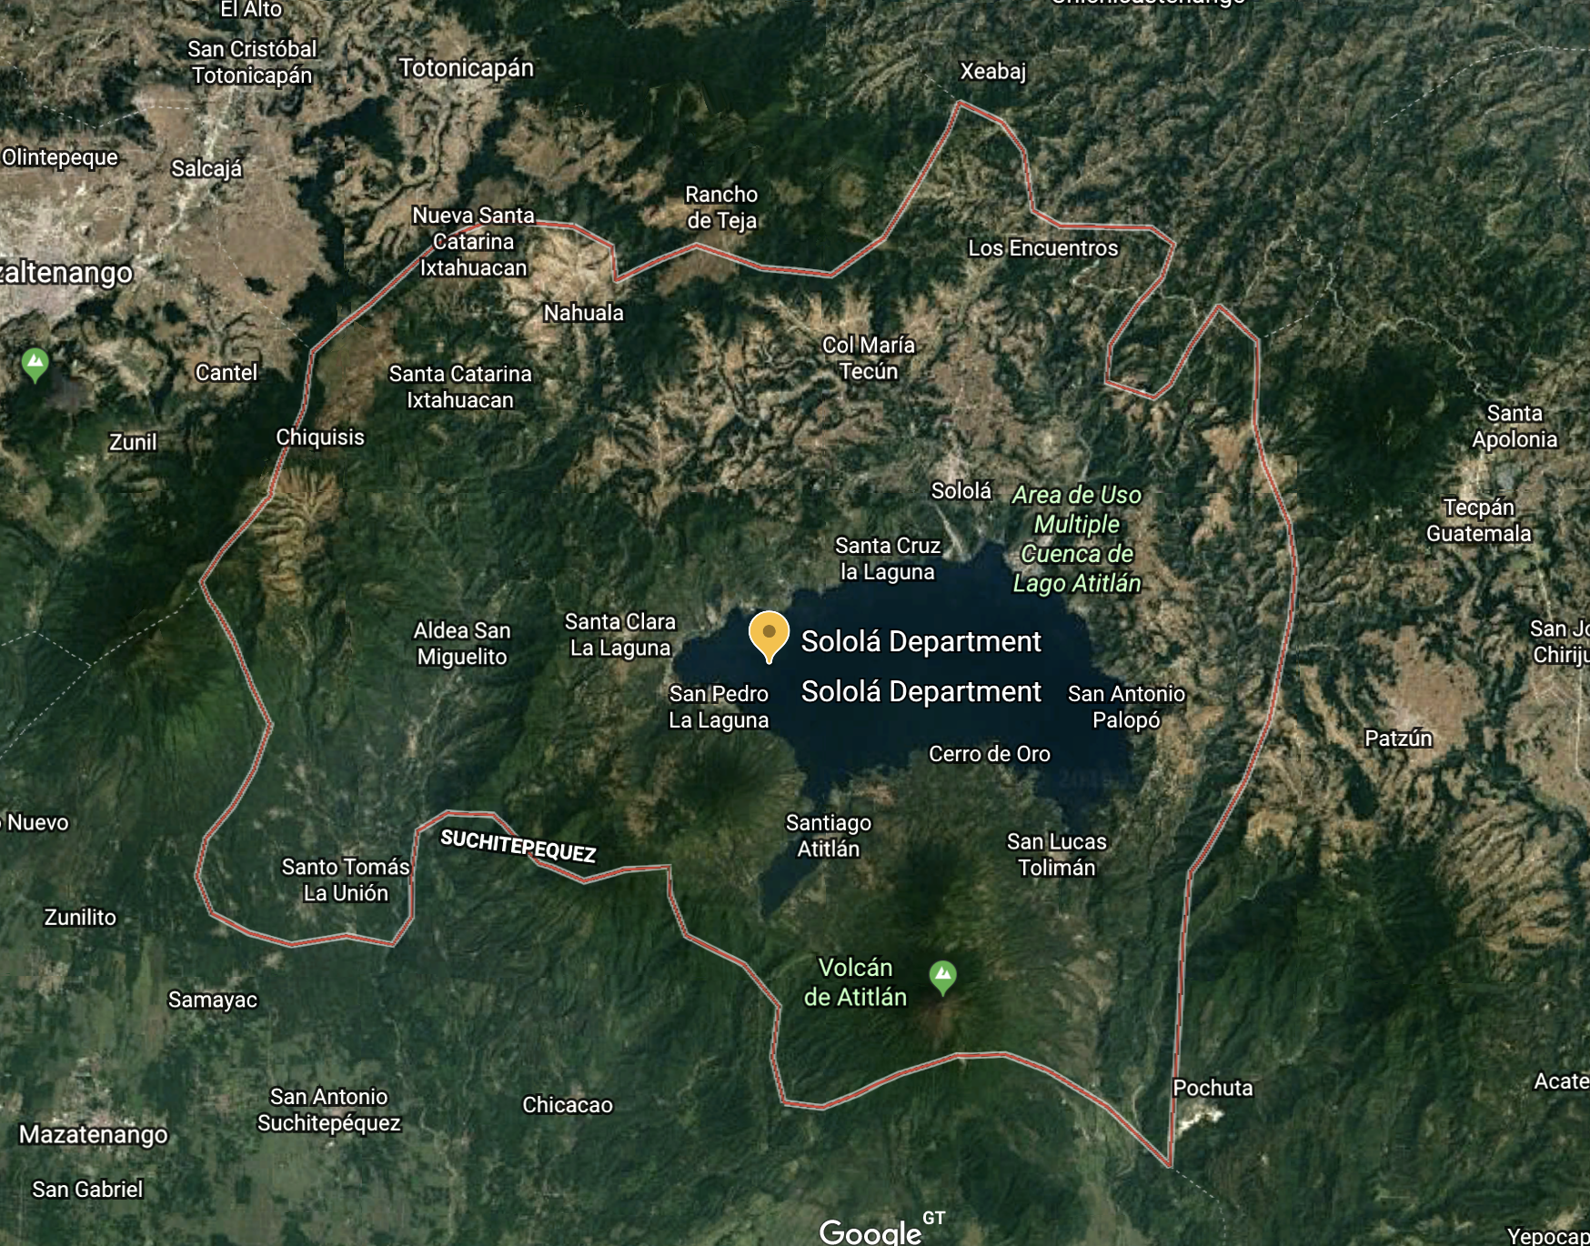
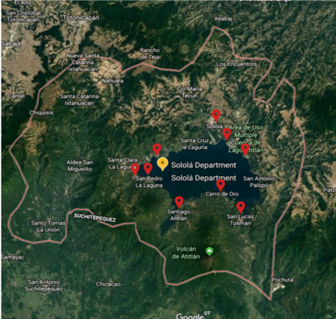
The project takes place within the Sololá Department (14.70°N, 91.25°W), which includes the Lake Atitlán Basin, a nature preserve. 14°38’17.63”N, 91°13’44.44”W are the coordinates of Santiago Atitlán, headquarters of the project. See KML file.
Figure 10: Map of Project Area
Figure 9: Geographic distribution of project devices

Conditions Prior to Project Initiation
The annual wood deficit in Guatemala is 5.7 million tons. In the project location, the Sololá Department, 84% of homes use wood as the primary energy source for cooking. The project objective is to reduce demand for wood fuel by replacing open cooking fires with ONIL stoves and performing energy efficiency improvements in existing cookstoves. Enabling access to ICS technology, the project addresses TRL’s mission, which is to implement solutions to the environmental, health, and development challenges that threaten the livelihood of the Tz’utujil Maya people living in the Lake Atitlán basin.

Compliance with Laws, Statutes and Other Regulatory Frameworks
In 2016 Tuik Ruch Lew became a registered Guatemalan nonprofit, adhering to the registration process and all subsequent local and national laws governing nonprofit activities in the country (see Appendices 1, 5 and 6).

Participation under Other GHG Programs

Projects Registered (or seeking registration) under Other GHG Program(s)
To date, the project has not been registered, nor is it seeking registration under any other GHG program.

Projects Rejected by Other GHG Programs
To date, the project has not been rejected by any other GHG program.

Other Forms of Credit

Emissions Trading Programs and Other Binding Limits
To date, project activities are not included in an emissions trading program or any other mechanism that includes GHG allowance trading.

Other Forms of Environmental Credit
To date, the project has not sought or received any other form of GHG-related environmental credit.

Additional Information Relevant to the Project

Leakage Management
This section is not applicable as the project is not an AFOLU project. Per the VCS Standard V4, the project proponent does not need to present a leakage management plan.

Commercially Sensitive Information
No commercially sensitive information has been excluded from the public version of the project description.

Sustainable Development
Distribution of ICS technology is listed among Guatemala’s stated sustainable development priorities.

Further Information
Not applicable. No additional legislative, technical, economic, sectoral, social, environmental, geographic, site-specific, and/or temporal information is relevant to the quantification of the project’s net GHG emission reductions or removals.

Safeguards

No Net Harm
No potential negative environmental or socio-economic impacts have been identified for the project.

Local Stakeholder Consultation
As this project does not require the approval of any governing body, we have not conducted any town-hall seminars requesting feedback. However, this does not mean that the local community is removed from the process. Our team’s integration into the community has enabled them to gain valuable feedback through community meetings and conferences, as well as in an unofficial capacity, through casual conversations with stakeholders. Examples of TRL’s consultation activities are as follows:
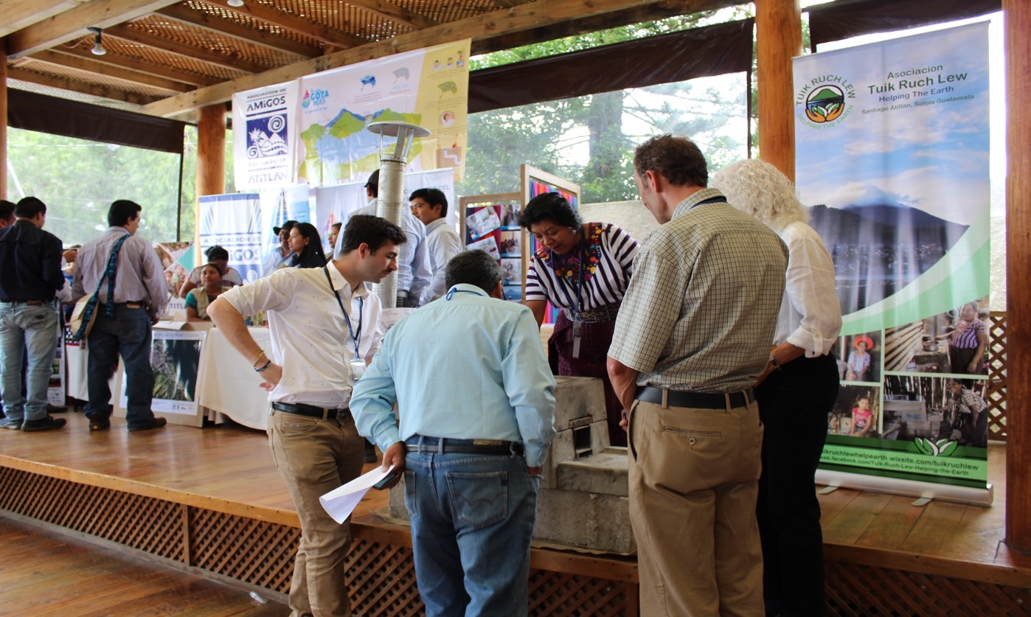
In the past TRL has engaged with residents of more remote villages about the accessibility of stoves at price of Q350. Residents of these areas have reported that the price set by TRL was inaccessible to many, and as a result TRL considered offering stoves at lower price, for residents of this neighborhood. TRL aims to provide similar discounted services in the future, as funding permits. When TRL has access to additional funds that allow for a larger subsidy, or alternative payment options, enabling members of this area with greater accessibility to stoves is now prioritized.
Figure 11: Figure 5: TRL’s Technology Adaptation Specialist explains the ONIL stove technology at the Second Annual International Symposium on Continental Waters of the Americas.
In July of 2018, TRL attended the Second Annual International Symposium on Continental Waters of the Americas held in Panajachel, Sololá at which certain stakeholders were consulted. Hosted by the Centro de Estudios Atitlán - Universidad del Valle de Guatemala, the symposium brought together key stakeholders with vested interest in confronting the ecological threats facing the
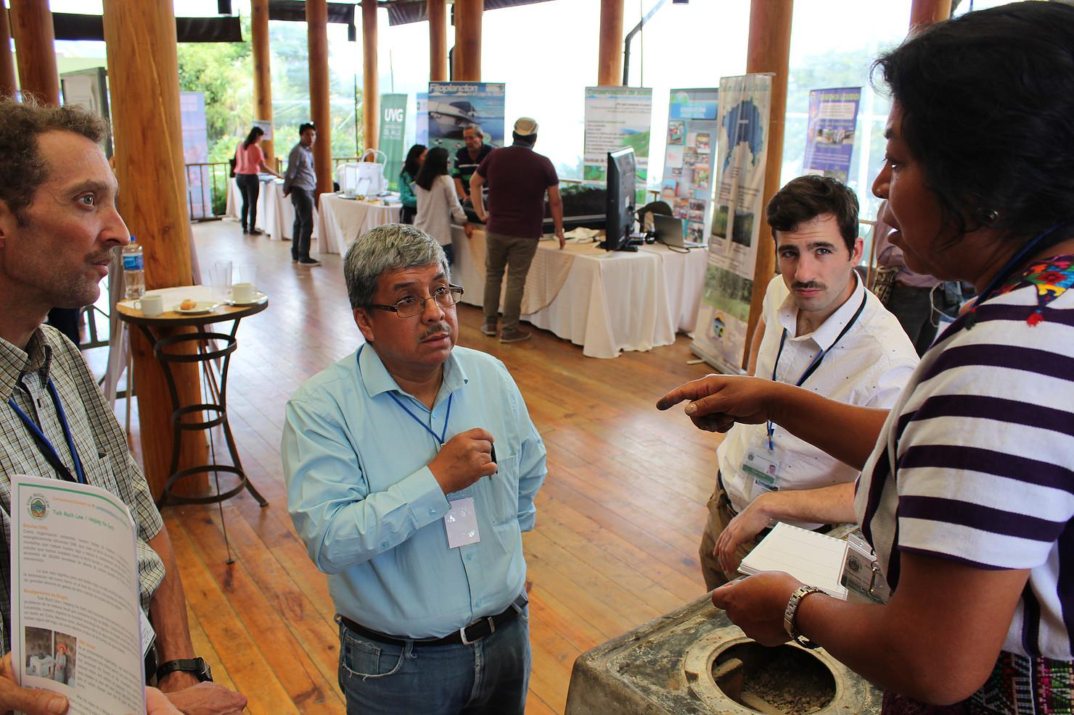
Lake Atitlán basin. Various groups were in attendance, including CONAP, Amigos del Lago de Atitlán,, Legambiante, Africa 70, and ADECCAP, among others. TRL presented the ONIL stove technology and the project design to symposium attendees as part of an exhibition (see figure 11).
Figure 12: TRL consults with a stakeholder at the Second Annual International Symposium on Continental Waters of the Americas.
Here TRL was able to gather useful feedback from several stakeholder groups, including representatives of social and environmental public-sector agencies as well as civil society organizations, and use it to modify the project design. For example, the man pictured above (figure 12) shared positive remarks about the project and the stove technology. He commented to TRL’s TAS on the importance of the decrease in firewood ONIL stoves allow. Other comments included feedback about accessibility of the technology. For example, one comment emphasized how the price to transport a ONIL stove from the manufacturer to remote areas is yet another financial barrier that prevents families from being able to afford a stove. They also emphasized the importance of providing ample education, access to repair parts and maintenance services, given the less successful experiences of cookstove projects they had witnessed elsewhere in country.
TRL’s Administrator spoke with Africa 70’s Mario Zutteroli about the project. He also provided positive comments about the project and its environmental impacts, but noted its reach was limited given the size of the organization. One recommendation was partnering with other organizations to apply for funding at the national level and to expand the reach of the project so that smaller villages would be able to access identical services.
Comments such as these motivated the following actions by TRL: (1) place additional emphasis on seeking funding to provide for larger subsidies for the project area’s most vulnerable families; (2) hire additional field team personnel to increase TRL’s capacity to provide maintenance and educational visits; and (3) hold trainings for other community projects that wish to replicate TRL’s model in areas the project cannot reach. For example, TRL has held two trainings with the Organization for the Development of the Indigenous Maya (ODIM), pictured below (figure 14).
Figure 14: TRL holds a training for ODIM on December 12, 2019
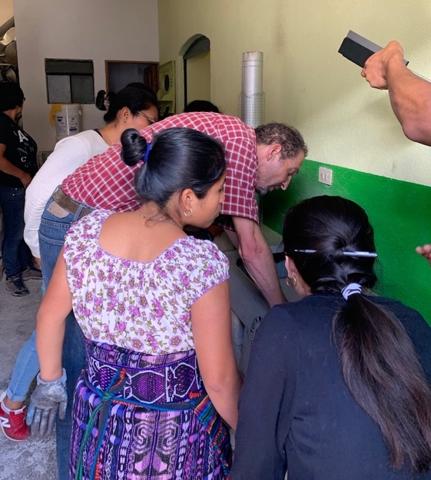
To consult several key stakeholders who were absent at the Symposium, TRL made the decision to expand its informal consultation activities to reach affected parties with limited access to this type of meeting. Various relevant socio-economic and cultural barriers in the project area could impede the participation of marginalized members of the local community (e.g. registration fees, transportation fees, lack of free time). Consequently, TRL seeks consultation from these groups through direct community engagement. Consultation activities have been undertaken on an informal basis using participatory methods with previous, current, and prospective project beneficiaries. TRL staff have worked with beneficiaries, the majority of whom are indigenous women, on cookstove projects for over ten years. Initially approaching the projects as an opportunity for joint experimentation, TRL installed ONIL stoves in the homes of members of the local weaving cooperative, Cojolya, constantly requesting feedback through semi-structured interviews. Leaning on this expertise, TRL has changed and adapted the systems used as well as organizational policies to reflect positive and negative feedback. The outcome of these consultations is evident in current project elements, such as the price structure and multi-visit maintenance and technology adaptation follow-up schedule. TRL also now often provides group educational seminars, most frequently to introduce beneficiaries from lesser frequently served areas to the technology and project design.
This consultation process has been formalized within the current, TRL ICS Project. Before and after installations, beneficiaries are continually consulted through a digital survey platform to gauge successes and challenges associated with technology adoption. These consultations are conducted in the home of the beneficiary, during the morning hours when our female and elderly beneficiaries are most likely to be available. Furthermore, all consultation is conducted in Tz'utujil, by local Outreach Team Members so that beneficiaries are able to openly and clearly communicate constructive feedback and grievances. This model is intended to overcome the above-mentioned barriers to engagement in traditional stakeholder meetings.
Because of the feedback received through these consultations, TRL conducts meetings and demonstrations designed to educate and promote the project several times a year. In September of 2019, TRL solicited feedback from the local community as part of an ICS technology exposition held in the central park. Feedback gathered through expositions such as these inform project design.
TRL solicits direct feedback from various other NGOs in Santiago. Sharing in-depth knowledge about the environmental and social characteristics of the Sololá Department and its diverse communities has supported TRL in its identification of the potential impacts, risks, and opportunities associated with the project activities.
TRL has also learned from others’ experience. For example, certain project donors formerly have bought various, alleged fuel efficient, wood burning stoves, to give to families. However, they completed installations without an educational component or follow-up. TRL’s ICS Project directly consulted with these individuals and groups. Now they are working with TRL to provide highly vulnerable families with the necessary training and education related to stove installation, operation, and maintenance. This is one example of how the behavior of stakeholders has changed with knowledge of the superior results of the TRL ICS project, substituting it for their own, while still providing help for the most marginalized people.
To document consultation outcomes, TRL’s Outreach Team generates internal reports that are shared with all staff at weekly Friday meetings. After discussing the consultation outcomes, if relevant, findings are used to inform modifications to project design. Project design and data are also reported and made public in the project’s annual reports, available on the TRL website.

Environmental Impact
No environmental impact assessments are required for the project.

Public Comments
All comments received during the public comment period will be reviewed by the Program Development and Outreach Team in a timely manner. Once jointly reviewed and discussed at weekly team meetings, TRL staff will determine if comments justify updates to the project design. If comments are deemed insignificant or irrelevant, TRL will provide written documentation of the reasoning discussed. No public comments were received during the 30-day public comment period.

AFOLU-Specific Safeguards
Not required because the project is a non-AFOLU project.

Application of Methodology

Title and Reference of Methodology
CDM AMS-II.G. Small-scale Methodology: Energy efficiency measures in thermal applications of non-renewable biomass, Version 11.1. Tool 30: Calculation of the fraction of non-renewable biomass, Version 2.0. Tool 21: Methodological tool: Demonstration of additionality of small-scale project activities, Version 13.0.

Applicability of Methodology
Project Activity One: Introduction of high-efficiency, biomass fired project devices to replace the existing devices
 | Applicability Condition | Project Justification
 | This methodology comprises efficiency improvements in thermal applications of non-renewable biomass. Examples of applicable technologies and measures include the introduction of high efficiency biomass fired project devices (cookstoves or ovens or  dryers) to replace the existing devices and/or energy efficiency improvements in existing biomass fired cookstoves or ovens or dryers. | The technology and measure used by the project is the introduction of an ONIL cookstove, a high efficiency biomass fired project device.
 | In the case of cookstoves, the methodology is applicable to the introduction of single pot or multi pot portable or in-situ cookstoves with rated efficiency of at least 20 per cent. Refer to the requirements indicated in “Data / Parameter table 12” which details the options for testing and certification as well as supporting documentation (e.g. certificate issued by third party or test results) that needs to be presented to the validating DOE. Data / Parameter table 12 of AMS-II.G. states the following option” The efficiency of the project devices shall be based on certification by a national standards body or an appropriate certifying agent recognized by that body” may be used to measure efficiency. | ONIL cookstoves are multi-pot portable cookstoves with a manufacturer certified thermal efficiency of 24%. The cited Validation Report, completed by TÜV SÜD South Asia Pvt. Ltd., an appropriate certifying agent recognized by the Clean Development Mechanism, states the following conclusion: “The efficiency of an ONIL certified stove is 24% as compared to the 10% (as per the default value of the AMS.II.G) efficiency of the traditional (three stone) open fire stove. The efficiency of the stove has been verified by Aprovecho test results of the ONIL stove done by Aprovecho Research center (ARC). ARC is the third party independent testing center and tested ICS efficiency in the programme. ARC result can be accepted as they have experienced over 30 years in designing and implementing improved and technologies, as well as their testing standard and lab result are globally accepted.” See appendix 2 and footnote 10 for additional references this rated efficiency.
 | The aggregate energy savings of a single project activity will not exceed the equivalent of 60 GWh per year, or 180 GWh thermal per year in fuel input. | Aggregate energy savings do not exceed the threshold due to current and forecasted energy efficiency improvement capacities (see section 1.11). With an overestimate of 3.5 tonnes of woody biomass savings made possible per ONIL stove per year, and 0.0043 GWh thermal energy per tonne, each stove will save a maximum of 0.0546 TJ/year and it would take 11,868 devices operating each year to reach 180 GWh of thermal energy savings.
 | Non-renewable biomass has been used in the project region since 31 December 1989, using survey methods or referring to published literature, official reports or statistics. | Per the following official reports and statistics, non-renewable biomass has been used in the project region since at least 1989:  In the department of Sololá, 84% of homes use wood as the primary energy source for cooking.  The FAO reports that between 1990 and 2010, Guatemala lost an average of 54,550 ha of forest cover (1.15%) per year. In total, between 1990 and 2010, Guatemala lost 23.0% of its forest cover, or around 1,091,000 ha.  According to the FAO report, “State of the World’s Forests,” Carbon stock in living forest biomass were depleting in Guatemala, from 1990 to 2010, demonstrating a negative annual change rate.  Remote sensing data from Global Forest Watch shows that from 2001 to 2018, Sololá lost 2.48kha of tree cover, equivalent to a 3.1% decrease in tree cover since 2000.
  Carbon stock in living forest biomass in Guatemala
  (million tonnes)
  1990 | 2000 | 2005 | 2010
  365 | 324 | 303 | 281
 | When the biomass is sourced from renewable sources, project participants should use a corresponding Type I methodology. | Tool 30 is applied to determine fNRB. Not applicable.
 | If the project device requires a specific fuel for this device (e.g. briquettes, pellets, woodchips), the consumption of the fuel should be monitored during the crediting period. | Not applicable. The project device does not require briquettes, pellets, or woodchips.
 | The CDM-PDD or CDM-PoA-DD/CPA-DD shall explain the proposed method for  distribution of project devices including the method to avoid double counting of emission reductions such as unique identifications of product and end-user locations (e.g.  programme logo). | Each project device (ONIL stove) installed by the project has a TRL Logo and a unique identification number. In addition, all users have a unique identifier (string of numbers and letters referred to as a “client ID”) linked to client information (name, location etc.).
 | The CDM-PDD or CDM-PoA-DD/CPA-DD shall also explain how the proposed procedures  prevent double counting of emission reductions, for example to avoid that project stove manufacturers, wholesale providers or others claim credit for emission reductions from the project devices. | When the stoves are purchased from the manufacturer, they contain no manufacturer logo or unique identification number as described above. TRL adds both after purchase from the manufacturer and prior to installation in the client’s home. At the installation the TAS completes the corresponding form in Kobo Toolbox. Only after the installation has taken place and the equipment’s unique identification number is matched with a client ID are emission reductions from that project device included in the emission reduction calculations.

Project Activity Two: Provision of energy efficiency improvements in existing biomass fired cookstoves
 | Applicability Condition | Project Justification
 | This methodology comprises efficiency improvements in thermal applications of non- renewable biomass. Examples of applicable technologies and measures include the introduction of high efficiency biomass fired project devices (cookstoves or ovens or dryers) to replace the existing devices and/or energy efficiency improvements in existing biomass fired cookstoves or ovens or dryers. | The measure used by the project is an energy efficiency improvement in an existing biomass fired cookstove (existing ONIL stove).
 | In the case of cookstoves, the methodology is applicable to the introduction of single pot or multi pot portable or in-situ cookstoves with rated efficiency of at least 20 per cent. Refer to the requirements indicated in “Data / Parameter table 12” which details the options for testing and certification as well as supporting documentation (e.g. certificate issued by third party or test results) that needs to be presented to the validating DOE. | Project Activity Two does not consist of the introduction of high efficiency biomass fired project devices (cookstoves or ovens or dryers) to replace the existing devices but rather, energy efficiency improvements in existing biomass fired cookstoves. Not applicable.
 | The aggregate energy savings of a single project activity will not exceed the equivalent of 60 GWh per year, or 180 GWh thermal per year in fuel input. | Aggregate energy savings do not exceed the threshold due to current and forecasted energy efficiency improvement capacities (see section 1.11). With an overestimate of 2.8 tonnes of wood saved per improved stove per year, and 0.0043 GWh thermal energy per tonne, it would take 14,835 retrofitted stoves operating to reach 180 GWh of thermal energy savings.
 | Non-renewable biomass has been used in the project region since 31 December 1989, using survey methods or referring to published literature, official reports or statistics. | Per the following official reports and statistics, non-renewable biomass has been used in the project region since at least 1989:  In the department of Sololá, 84% of homes use wood as the primary energy source for cooking  The FAO reports that between 1990 and 2010, Guatemala lost an average of 54,550 ha of forest cover (1.15%) per year. In total, between 1990 and 2010, Guatemala lost 23.0% of its forest cover, or around 1,091,000 ha.  According to the FAO report, “State of the World’s Forests,” Carbon stock in living forest biomass were depleting in Guatemala, from 1990 to 2010, demonstrating a negative annual change rate.  Remote sensing data from Global Forest Watch shows that from 2001 to 2018, Sololá lost 2.48kha of tree cover, equivalent to a 3.1% decrease in tree cover since 2000.
  Carbon stock in living forest biomass in Guatemala
  (million tonnes)
  1990 | 2000 | 2005 | 2010
  365 | 324 | 303 | 281
 | When the biomass is sourced from renewable sources, project participants should use a corresponding Type I methodology. | Tool 30 is applied to determine fNRB. Not applicable.
 | If the project device requires a specific fuel for this device (e.g. briquettes, pellets, woodchips), the consumption of the fuel should be monitored during the crediting period. | The project device does not require briquettes, pellets, or woodchips. Not applicable.
 | The CDM-PDD or CDM-PoA-DD/CPA-DD shall explain the proposed method for  distribution of project devices including the method to avoid double counting of emission reductions such as unique identifications of product and end-user locations (e.g. programme logo). | Each project device (improved existing biomass fired cookstove) added by the project has a TRL Logo and a unique identification number. In addition, all users have a unique identifier (string of numbers and letters referred to as a “client ID”) linked to client information (name, location etc.).
 | The CDM-PDD or CDM-PoA-DD/CPA-DD shall also explain how the proposed procedures prevent double counting of emission reductions, for example to avoid that project stove manufacturers, wholesale providers or others claim credit for emission reductions from the project devices. | When the replacement parts are purchased from the manufacturer, they contain no logo or unique identification number as described above. The existing biomass fired cookstove that is being repaired is assigned a number if it does not already have one. After TRL completes the energy efficiency improvement, the team marks the stove with the TRL logo, and completes the corresponding form in Kobo Toolbox. The improved equipment’s unique identification number is matched with a client ID. Emission reductions generated by that project device are included in calculations from that date onwards.

Project Boundary
The project boundary is defined by AMS-II.G. V11.1 section 5.1 as, “the physical, geographical site of the efficient devices that utilize biomass”. The project boundary is the Sololá Department, as defined by the government of Guatemala. The project devices are located inside the homes of project participants. As described section 1.12, the project takes place within the Sololá Department (14.70°N, 91.25°W), which includes Lake Atitlán. 14°38’17.63”N, 91°13’44.44”W are the coordinates of Santiago Atitlán, headquarters of the project. See KML file.

Source |  | Gas | Included? | Justification/Explanation
Baseline | Source 1 | CO₂ | yes | CO₂ is the primary output of burning wood.
Baseline | Source 1 | CH₄ | x | CH₄ contributes too small of a fraction of the emitted gas and is excluded to make a conservative estimate.
Baseline | Source 1 | N₂O | x | N₂O contributes too small of a fraction of the emitted gas and is excluded to make a conservative estimate.
Baseline | Source 1 | Other | x | There are no other major sources of emissions.
Project | Source 1 | CO₂ | yes | CO₂ is the primary output of burning wood.
Project | Source 1 | CH₄ | x | CH₄ contributes too small of a fraction of the emitted gas and is excluded to make a conservative estimate.
Project | Source 1 | N₂O | x | N₂O contributes too small of a fraction of the emitted gas and is excluded to make a conservative estimate.
Project | Source 1 | Other | x | There are no other major sources of emissions.

Baseline Scenario

Project Activity One: Introduction of high-efficiency, biomass fired project devices to replace the existing devices
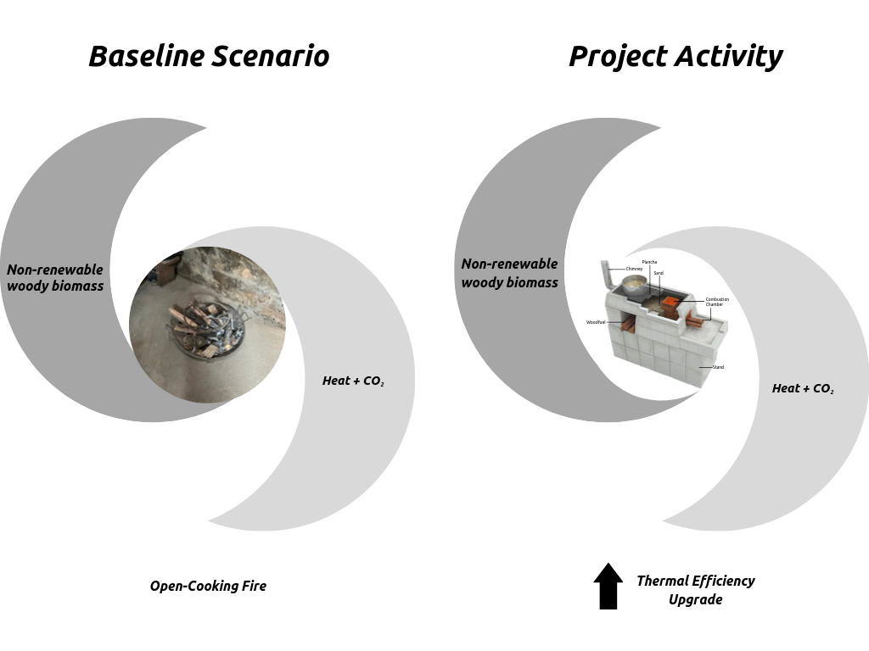
In the absence of the project activity, traditional open fire cooking methods would be used to prepare meals in Guatemalan homes in the project area. The baseline scenario would be the projected use of wood fuel needed for an open cooking fire to meet similar thermal energy needs as those provided by the ONIL stove.
Figure 15: Diagram of energy flows, project activity one

Project Activity Two: Provision of energy efficiency improvements in biomass fired cookstoves

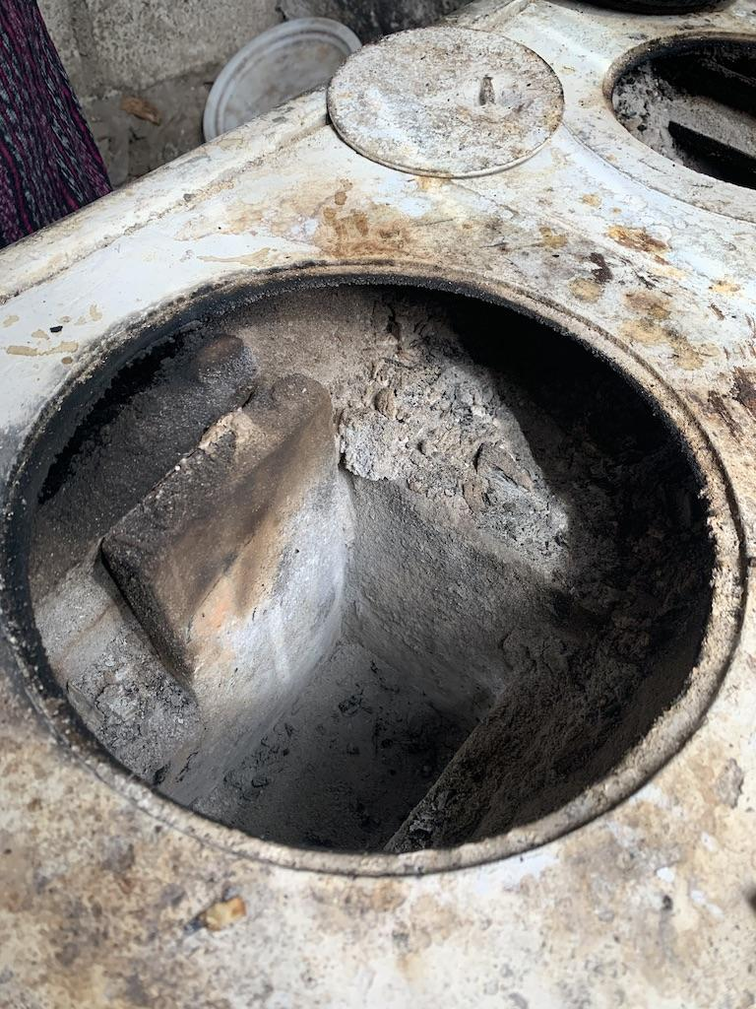
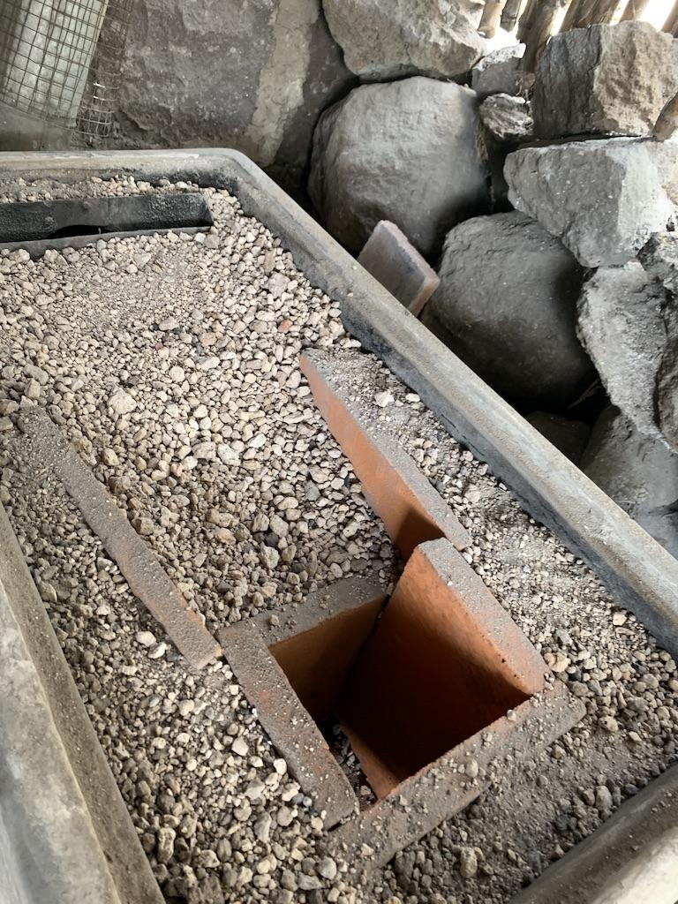
In the absence of the project activity, existing, damaged, inefficient biomass fired cookstoves would be used to prepare meals in Guatemalan homes in the project area. The energy efficiency improvement consists of installing a new combustion chamber and performing the corresponding maintenance to improve the efficiency of the biomass fired cookstove, similar to the method detailed above in which a ONIL stove replaces an open cooking fire. The thermal efficiency upgrade is quantified using a Controlled Cooking Test (CCT) (See appendix 3 for procedure and appendix 4 for results). The baseline scenario would be the projected use of wood fuel needed for the damaged biomass fired cookstove to meet similar thermal energy needs as those provided by the improved ONIL stove.
Figure 17: Project device after energy efficiency improvement
Figure 16: Baseline scenario project activity two

Additionality
Additionality is demonstrated using Option 2 of AMS-II.G. (section 5.2.2.). The following additionality assessment uses section 5 paragraph 10 of Tool 21: Methodological tool: Demonstration of additionality of small-scale project activities, V13, “Project participants shall provide an explanation to show that the project activity would not have occurred anyway due to at least one of the following barriers in accordance with the applied methodology.” This tool was chosen due to the absence of published, credible statistics on the penetration of high efficiency biomass fired devices (e.g. energy efficient cookstoves) available for the project area.
The project activities would not have occurred anyway due to the barrier listed as Option D:
(2) Other barriers: “without the project activity, for another specific reason identified by the project participant, such as institutional barriers or limited information, managerial resources, organizational capacity, financial resources, or capacity to absorb new technologies, emissions would have been higher.”
For both project activities, in addition to procurement of materials and installation/completion of the energy efficiency enhancement, TRL provides ongoing technological adaptation support and maintenance to all ONIL stove users (see SD VISta Project Description section 1.1.2). These services address the barriers associated with limited access to sustainable energy technology present in the communities served. In rural Guatemala, beneficiaries have limited access to information regarding alternative cooking methods and thus limited capacity to absorb ICS technology without support. The project activity couples technological adaptation with environmental education over the first year of stove installation. Our Technological Adaptation Specialist (TAS), an early adopter of ICS technology guides beneficiaries through the adjustment period from a three-stone fire to an ONIL stove based on her own experience. All communication is conducted in the beneficiary's primary language, Tz'utujil, with strong emphasis placed on the relationship between the end user and TRL. This strategic approach provides for sustainable adoption of the technology to ensure lasting environmental benefits for stove owners and the surrounding community. In the absence of support exists the possibility that the technology could go unused post-installation or that frustrations could provoke damage to the technology that would negatively affect efficiency levels. Additionally, due to misuse and/or wear and tear that occurs over time, existing biomass fired cookstoves may deteriorate or undergo damage. In these cases, TRL locally sources replacement parts such as a new combustion chamber, identifies families with inefficient, damaged ONIL stoves, and installs the new combustion chambers to improve cookstove efficiency. Without all these provisions of the project activity, the users would have limited capacity to absorb the new technologies and emissions would be higher.

Methodology Deviations
Not applicable. No methodology deviations were applied.

Quantification of GHG Emission Reductions and Removals

Baseline Emissions
Not applicable. See section 4.4 for the calculation of net GHG emission reductions and removals.

Project Emissions
CDM AMS-II.G. Small-scale Methodology: Energy efficiency measures in thermal applications of non-renewable biomass, V11.1 defines the procedure to calculate emission reductions. The calculation of project emissions separate from baseline emissions is thus not applicable.

Leakage
The project uses a net gross adjustment factor of 95% to account for leakage. Section 5.4 paragraph 34 of AMS-II.G. V11.1 states “Alternatively, By savings, i, j is multiplied by a net to gross adjustment factor of 0.95 to account for leakages, in which case surveys are not required.”

Net GHG Emission Reductions and Removals
Per section 5.3 of CDM AMS-II.G., V11.1, emission reductions are calculated per equation one as:
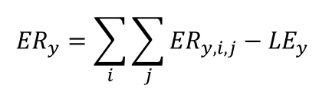

Where:
𝑖 = Indices for the situation where more than one type of project device is introduced to replace the pre-project devices. For Project Activity One, i = 1. For Project Activity Two, i = 2.
j = Indices for the situation where there is more than one batch of project device. There are seven batches.
The methodology defines a batch “as the population of the device of the same type commissioned during a certain period of time (e.g. week or month) in a certain calendar year.” It goes on to state, “To establish the date of commissioning, the Project Participant may opt to group the devices in “batches” and the latest date of commissioning of a device within the batch shall be used as the date of commissioning for the entire batch.”
The project groups all the stoves installed in one year into a batch. For the project, this year runs from September to August. September 1 of 2018 to August 31, 2019 is batch one (j=1), September 1 of 2019 to August 31 of 2020 is batch two (j=2), and so on. For Project Activity One, the installation date (commissioning date) of the cookstove determines its batch. For Project Activity Two, the date on which the device receives its energy efficiency enhancement -- its improvement -- determines its batch. This date is equivalent to the commissioning date as it is the date in which the device is now able to provide for thermal energy savings at the documented, more efficient rate. TRL’s maintenance log, stored in the client database is organized to track project device commissioning dates and assign them to the correct batch.
AMS-II.G. later states in footnote two, “If the efficiency drop of project devices is monitored through the first batch approach (see paragraph 37 below), project participants shall describe in the PDD the measures taken to ensure that all batches receive the same level of quality control in the production, and maintenance/replacements during the crediting period, as the first batch. Monitoring reports shall describe the number of actions taken for maintenance and replacements to all batches separately.”
For Project Activity One, the project ops to account for efficiency per paragraph 37. All batches receive the same five-visit follow up schedule, monitoring and record keeping using a digital platform, and maintenance/replacements as needed. All the equipment is purchased from the same factory (HELPs International) which has quality assurance measures and is certified under the VCS standard. It does not remain in TRL’s warehouse for any longer than one year. Cookstoves are purchased in shipments of 40 (about three per year) and installed (commissioned) as determined by client demand. The technology and quality of the cookstove is equivalent for each stove across all batches, and throughout the monitoring period. This will be corroborated by maintenance records stored in TRL’s client database.
For Project Activity Two, which uses option four and equation nine of AMS-II.G. instead, the above is not required nor applicable. With the use of a controlled cooking test (CCT), the requirements are not applicable because any annual changes of the quantity of woody biomass used and any annual changes in specific fuel consumption will be captured by the CCT.
𝐸𝑅𝑦 = Emission reductions during year y in t CO2e
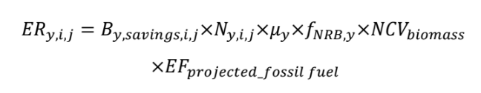
𝐸𝑅𝑦,𝑖,𝑗 = Emission reductions by project device of type i and batch j during year y in t CO2e, as determined by Equation (2). See calculations below. Formula for Equation (2):

𝐿𝐸𝑦 = Leakage emissions in the year y. Not applicable (see section 4.3)
TOOL 30 Calculations
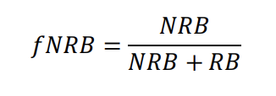

Where:
fNRB = Fraction of non-renewable biomass in the country/region or project area
(fraction or %), determined ex-ante.
NRB = Quantity of non-renewable biomass (t/yr) in the country/region or project
area, determined as per equation (3)
RB = Quantity of renewable biomass in the country/region or project area, determined as per equation (6)

0.9359 = 379939.85 tonnes/yr / (379939.85 tonnes/yr + 26,024.4 tonnes/yr)
Equation (3)
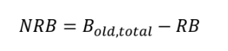
Where
B_{old, total} = Total annual consumption of wood in the project area in the absence of the project activity, as determined per equation (5)

405,964.25 tonnes/yr - 26,024.4 tonnes/yr = 379939.85 tonnes/yr
Equation (5)
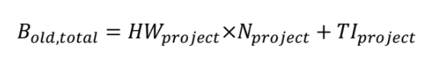

The amount of wood consumed per household in the project region is determined by organizational surveys conducted with clients who used three-stone fires for cooking. The resulting wood use assumes that families have similar wood consumption as our clients throughout the region (based on similar demographics and cultural preferences). The average usage number is 5.6299 tonnes per year per family, option C of the HW_{project} variable.

Variable / Units | Value
HW_{project} (client survey data of pre-project device woody biomass usage per household) | 5.6299 tonnes / family / year
N_{project} (2018 census data of families using wood as cooking fuel source) | 72,109 families
TI_{project} (conservative value -- low commercial woody biomass use in region) | 0 tonnes
B_{old,total} : HW_{project} × N_{project} + TI_{project} | 405,964.25 tonnes / year

Equation (6)
Renewable biomass (RB) in the country/region/project area is estimated using the equation below.
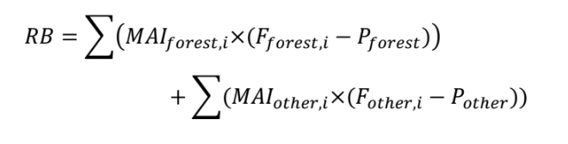
Where:
MAI_{forest,i} = Mean Annual Increment of woody biomass growth per hectare in sub-category i of forest areas (t/ha/yr)
MAI_{other,i} = Mean Annual Increment of woody biomass growth per hectare in sub-category i of other wooded land areas (t/ha/yr)
F_{forest,i} = Extent of forest in sub-category i (ha)
F_{other,i} = Extent of other wooded land in sub-category i (ha)
P_{forest} = Extent of non-accessible area (e.g. protected area where extraction of wood is prohibited, geographically remote area) within forest areas (ha)
P_{other} = Extent of non-accessible area (e.g. protected area where extraction of wood is prohibited, geographically remote area) within other wooded land areas (ha)
i = Sub-category i of forest areas and other wooded land areas
References for all values in the table below can be found in section 5.1 in the corresponding table for each Tool 30 Data / Parameter.

Land Type | Total Amount of Land | Protected Land | Unprotected Land (Total Amount of Land – Protected Land) | Growth Rate MAI | Total Renewable Biomass (Unprotected * MAI)
Forest | F_{forest,i}:  91,100 ha | P_{forest,i}:  77,684 ha  (Conservative estimate only including land in the national forest) | 13,416 ha | MAI_{forest,i} : 0.9 tonnes/ha/yr | 12,074.4 tonnes/yr
Other (Grass and Shrub) | F_{other,i}:  13,950 ha | P_{other,i}:  0 ha  (Conservative estimate) | 13,950 ha | MAI_{other,i} : 1.0 tonnes/ha/yr | 13,950 tonnes/yr
Total |  |  |  |  | RB=26,024.4 tonnes/yr

Project Activity One - Equation (8): Option 3
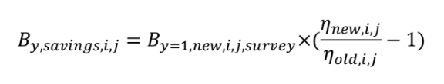

Where:
B_{y=1,new,i,j,survey} = Quantity of woody biomass used by project devices in tonnes per device of type i and batch j. Use a value of 2.3177 tonnes/stove/year.
η_{old,i,j} = 10.0%
η_{new,i,j} = 24% Account for annual efficiency loss per paragraph 37 of AMS-II.G. V11.1.

Age of Project device | η_{new,i,j} = | B_{y,savings,i,j} =
0 | 24.0% | 3.245
1 | 23.6% | 3.152
2 | 23.2% | 3.059
3 | 22.8% | 2.967
4 | 22.4% | 2.874
5 | 22.0% | 2.781
6 | 21.6% | 2.689
7 | 21.2% | 2.596
8 | 20.8% | 2.503
9 | 20.4% | 2.410
10 | 20.0% | 2.318
Equation (2)
Where:
B_{y,savings,i,j} = Quantity of woody biomass that is saved in tonnes per cookstove device of type i and batch j during year y, as determined per Option 3: Equation (8). Use values above.
f_{NRB,y} = Fraction of woody biomass that can be established as non-renewable biomass (fNRB), as determined ex-ante by Tool 30: Methodological tool: Calculation of the fraction of non-renewable biomass, Version 02.0. Use a Value of 0.936, calculated above.
NCV_{biomass} = Net calorific value of the non-renewable woody biomass that is substituted (IPCC default for wood fuel, 0.0156 TJ/tonne, based on the gross weight of the wood that is ‘air-dried’), per AMS-II.G. V11.1.
EF_{projected_fossilfuel} = Emission factor for the fossil fuels projected to be used for substitution of non-renewable woody biomass by similar consumers. Use a value of 68.6 t CO2/TJ, per Table 2 of AMS-II.G.
μ_{y}= Adjustment to account for any continued use of pre-project devices during the year y when applying equations 7 and 9 (fraction). Use 1.0 in other cases. Equation 8 is used.
The following table below demonstrates calculations for equation (2) and how the formula is applied to determine emission reductions by project device of type i and batch j during year y in t CO2e. Operating under the conservative assumption that an estimated five percent of project devices will be decommissioned annually, the number of project devices included in each batch’s calculation fall over time. This is to account for the possibility that project devices might be damaged, destroyed or pending use for a variety of reasons. In monitoring reports, this number will reflect the true number of project devices marked as operating in that year.

Equation (2) Project Activity 1
Age of Project device | 0 | 1 | 2 | 3 | 4 | 5 | 6
B_{y,savings,i=1,j} | 3.245 | 3.152 | 3.059 | 2.967 | 2.874 | 2.781 | 2.689
Ly adjust (.95) | 0.95 | 0.95 | 0.95 | 0.95 | 0.95 | 0.95 | 0.95
f_{NRB,y} | 0.936 | 0.936 | 0.936 | 0.936 | 0.936 | 0.936 | 0.936
NCV_{biomass} | 0.0156 | 0.0156 | 0.0156 | 0.0156 | 0.0156 | 0.0156 | 0.0156
EF_{projected_fossilfuel} | 68.6 | 68.6 | 68.6 | 68.6 | 68.6 | 68.6 | 68.6
μ_{y} | 1 | 1 | 1 | 1 | 1 | 1 | 1
ER per Project Device | 3.087 | 2.999 | 2.911 | 2.823 | 2.734 | 2.646 | 2.558
N(y=2018,i=1,j) | 57
N(y=2019,i=1,j) | 120 | 54
N(y=2020,i=1,j) | 120 | 114 | 51
N(y=2021,i=1,j) | 120 | 114 | 108 | 49
N(y=2022,i=1,j) | 120 | 114 | 108 | 103 | 46
N(y=2023,i=1,j) | 120 | 114 | 108 | 103 | 98 | 44
N(y=2024,i=1,j) | 120 | 114 | 108 | 103 | 98 | 93 | 42
Equation (1) Project Activity 1
𝐸𝑅𝑦,𝑖,𝑗 | Estimated net GHG emission reductions or removals (tCO₂e)
ER(y=2018,i=1,j) | 176
ER(y=2019,i=1,j) | 533
ER(y=2020,i=1,j) | 862
ER(y=2021,i=1,j) | 1166
ER(y=2022,i=1,j) | 1445
ER(y=2023,i=1,j) | 1702
ER(y=2024,i=1,j) | 1938
Total (Sum) | 7822

Year | Estimated baseline emissions or removals (tCO₂e) | Estimated project emissions or removals (tCO₂e) | Estimated leakage emissions (tCO₂e) | Estimated net GHG emission reductions or removals (tCO₂e)
2018 | X | X | X | 176
2019 | X | X | X | 533
2020 | X | X | X | 862
2021 | X | X | X | 1166
2022 | X | X | X | 1445
2023 | X | X | X | 1702
2024 | X | X | X | 1938
Total | X | X | X | 7822

Project Activity Two
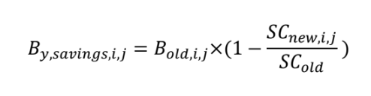
Equation (9): Option 4
Where:
SC_{old} = Specific fuel consumption or fuel consumption rate of the pre-project devices
SC_{new,i,j} = Specific fuel consumption or the fuel consumption rate of the devices of type i and batch j deployed as part of the project
B_{old,i,j} = 5.6299
Based on the Clean Cooking Test, the value of SC_{old} was 1132.3g cooked tortilla per kg of wood fuel based on the average of several trials of stoves before undergoing our improvement procedure and new components. The estimation that the project device for PA 2 will have a similar life span to the project device for PA 1 is based on the assumption that the aging and consequential deterioration of the combustion chamber is the reason for the loss in efficiency over time. The other parts of the project device such as the concrete body can survive much longer. The stoves of certain owners who dedicate meticulous care to maintain the combustion chamber well have continued to function for longer than the manufacturer stated 10-year lifespan. Testimonies and physical evidence seen while our Outreach Team is in the field corroborates this estimation.
The values under the same CCT procedure after improvement, and estimates for the life of the project device are below. However, while the estimated life span is used in the calculation of estimated VCUs, SC_{new,i,j} is a data / parameter that receives ongoing monitoring (see section 5.3). SC_{new,i,j} , or “Specific fuel consumption or fuel consumption rate during year y of the device(s) of type i deployed as part of the project that is fuel consumption per quantity of item(s) processed (e.g. food cooked) or fuel consumption per hour respectively with the age a reflects the actual efficiency of the project device as time progresses. This efficiency will be accounted for in monitoring reports, along with evidence of CCTs executed per the protocol described in appendix three, in accordance with the requirement of AMS-II.G. data / parameter table 14, to determine actual efficiency and resulting VCUs for the monitoring period.

Age of Project device | SC_{new,i,j} = | B_{y,savings,i,j} =
0 | 590.6 | 2.693
1 (estimate) | 644.8 | 2.424
2 (estimate) | 698.9 | 2.155
3 (estimate) | 753.1 | 1.885
4 (estimate) | 807.3 | 1.616
5 (estimate) | 861.5 | 1.347
6 (estimate) | 915.6 | 1.077
7 (estimate) | 969.8 | 0.808
8 (estimate) | 1024.0 | 0.539
9 (estimate) | 1078.1 | 0.269
10 | 1132.3 | 0.000

Equation (2)
Where:
B_{y,savings,i,j} = Quantity of woody biomass that is saved in tonnes per cookstove device of type i and batch j during year y, as determined per Option 4: Equation (9)
f_{NRB,y} = Fraction of woody biomass that can be established as non-renewable biomass (fNRB), as determined ex-ante by Tool 30: Methodological tool: Calculation of the fraction of non-renewable biomass, Version 02.0. Use a Value of 0.936. Calculations are demonstrated above.
NCV_{biomass} = Net calorific value of the non-renewable woody biomass that is substituted (IPCC default for wood fuel, 0.0156 TJ/tonne, based on the gross weight of the wood that is ‘air-dried’), per AMS-II.G. V11.1.
EF_{projected_fossilfuel} = Emission factor for the fossil fuels projected to be used for substitution of non-renewable woody biomass by similar consumers. Use a value of 68.6 t CO2/TJ, per Table 2 of AMS-II.G.
μ_{y}= Adjustment to account for any continued use of pre-project devices during the year y. Use a value of 1 as the energy efficiency improvement performed eliminates the possibility of continued use of pre-project devices.
The following table below demonstrates how equation (2) is applied to determine emission reductions by project device of type i and batch j during year y in t CO2e.

Equation (2) Project Activity 2
Age of Project device | 0 | 1 | 2 | 3 | 4 | 5 | 6
B_{y,savings,i,j} | 2.693 | 2.424 | 2.155 | 1.885 | 1.616 | 1.347 | 1.077
Ly adjust (.95) | 0.95 | 0.95 | 0.95 | 0.95 | 0.95 | 0.95 | 0.95
f_{NRB,y} | 0.936 | 0.936 | 0.936 | 0.936 | 0.936 | 0.936 | 0.936
NCV_{biomass} | 0.0156 | 0.0156 | 0.0156 | 0.0156 | 0.0156 | 0.0156 | 0.0156
EF_{projected_fossilfuel} | 68.6 | 68.6 | 68.6 | 68.6 | 68.6 | 68.6 | 68.6
μ_{y} | 1 | 1 | 1 | 1 | 1 | 1 | 1
ER per Project Device | 2.563 | 2.306 | 2.050 | 1.794 | 1.538 | 1.281 | 1.025
N(y=2018,i=2,j) | 61
N(y=2019,i=2,j) | 100 | 58
N(y=2020,i=2,j) | 100 | 95 | 55
N(y=2021,i=2,j) | 100 | 95 | 90 | 52
N(y=2022,i=2,j) | 100 | 95 | 90 | 86 | 50
N(y=2023,i=2,j) | 100 | 95 | 90 | 86 | 81 | 47
N(y=2024,i=2,j) | 100 | 95 | 90 | 86 | 81 | 77 | 45

Equation (1) Project Activity 2
𝐸𝑅𝑦,𝑖,𝑗 | Estimated net GHG emission reductions or removals (tCO₂e)
ER(y=2018,i=2,j) | 156
ER(y=2019,i=2,j) | 390
ER(y=2020,i=2,j) | 588
ER(y=2021,i=2,j) | 754.
ER(y=2022,i=2,j) | 891
ER(y=2023,i=2,j) | 1000
ER(y=2024,i=2,j) | 1085
Total | 4864

Year | Estimated baseline emissions or removals (tCO₂e) | Estimated project emissions or removals (tCO₂e) | Estimated leakage emissions (tCO₂e) | Estimated net GHG emission reductions or removals (tCO₂e)
2018 | X | X | X | 156
2019 | X | X | X | 390
2020 | X | X | X | 588
2021 | X | X | X | 754
2022 | X | X | X | 891
2023 | X | X | X | 1000
2024 | X | X | X | 1085
Total | X | X | X | 4864

Sum of Project Activity One and Two | Estimated GHG emission reductions or removals (tCO₂e)
Sept 2018 - Aug 2019 | 332
Sept 2019 - Aug 2020 | 923
Sept 2020 - Aug 2021 | 1450
Sept 2021 - Aug 2022 | 1920
Sept 2022 - Aug 2023 | 2336
Sept 2023 - Aug 2024 | 2702
Sept 2024 - Aug 2025 | 3023
Total estimated ERs | 12686

Monitoring

Data and Parameters Available at Validation

AMS-II.G Data / Parameters:

Data / Parameter | 𝑩_{old,HH}
Data unit | tonnes/household/year
Description | Annual quantity of woody biomass that would have been used in the household in the absence of the project activity to generate useful thermal energy equivalent to that provided by the project devices
Source of data | Determined ex ante, as per AMS-II.G. Table 4. Average of wood use survey results, stored in client database.
Value applied | 5.6299
Justification of choice of data or description of measurement methods and procedures applied | Based on the historical data or a sample survey conducted as per the latest version of “sampling and surveys for CDM project activities and programme of activities”. If the monitoring period is shorter or longer than one year, the result may be extrapolated for the monitoring period.
Purpose of Data | - Calculation of baseline emissions
Comments | The value may be derived, based on the historical data or a sample survey conducted as per the latest version of “sampling and surveys for CDM project activities and programme of activities”. Paragraph 23 of “General guidelines for SSC CDM methodologies (version 22.1)” provides guidance on the use of data including historic data to derive parameter values. Values used in other schemes (e.g. registered Gold Standard carbon offset projects) from the same region are acceptable when it is demonstrated to be suitable for use as per the procedures indicated in the above general guidelines.  A registered Gold Standard carbon offset project that defines the project area as Guatemala cites a value for household wood use, demonstrating that the TRL survey results indicate not only a reasonable value for the region but also a conservative one.

Data / Parameter | 𝑩_{old,I,j}
Data unit | tonnes/year
Description | Annual quantity of woody biomass that would have been used in the absence of the project activity to generate useful thermal energy equivalent to that provided by the project device type i and batch j
Source of data | Determined ex ante, as per AMS-II.G. Table 5
Value applied | 5.6299
Justification of choice of data or description of measurement methods and procedures applied | 𝑩_{old,HH} divided by 𝑵𝒅,𝑯𝑯.  There is only one project device operating per household. AMS-II.G. Data / Parameter Table 5 states “Bold,i,j equals 𝐵𝑜𝑙𝑑,𝐻𝐻 when only one project device per household is distributed.”  5.6299 / 1 = 5.6299
Purpose of Data | - Calculation of baseline emissions
Comments | See to Data / Parameter 𝑵𝒅,𝑯𝑯 below

Data / Parameter | ƒ _{NRB,y}
Data unit | Fraction
Description | Fraction of woody biomass saved by the project activity during year y that can be established as non-renewable biomass.
Source of data | Determined ex ante, as per AMS-II.G. Table 6
Value applied | 0.9359 (93.59%)
Justification of choice of data or description of measurement methods and procedures applied | Calculated by “TOOL30: Calculation of the fraction of non-renewable biomass” Calculations are presented to the VVB.
Purpose of Data | - Calculation of baseline emissions
Comments | Determined ex-ante. TOOL 30 Data / Parameters below.

Data / Parameter | Ƞ_{new,i,j}
Data unit | Fraction
Description | Efficiency of the device of each type i and batch j implemented as part of the project activity.
Source of data | “MEXICO - Specific CPA-DD_final” page 3 and 34: “Annex 3C: Efficiency of the system being deployed as compared to the system being replaced. Test performed by the Aprovecho Research Center in Cottage Grove, Oregon, USA”. https://registry.verra.org/app/projectDetail/VCS/1216. Accessed May 7, 2020. See appendix 2.
Value applied | 24%, decreasing through the life span of the project device
Justification of choice of data or description of measurement methods and procedures applied | Efficiency shall be measured/estimated as per the following:  1. The efficiency of the project devices shall be based on certification by a national standards body or an appropriate certifying agent recognized by that body.  2. Alternatively, manufacturer specifications on efficiency based on water boiling test (WBT) may be used. The WBT shall be carried out in accordance with national standards (if available) or international standards or guidelines (e.g. the WBT Protocol 17,18 or ISO 19867-1 listed by Clean Cooking Alliance (See https://www.cleancookingalliance.org/technology-and- fuels/testing/protocols.html)).  The sampling test of stoves by such certification bodies/agents or manufacturers shall be conducted following a 90/10 precision in accordance with the “Standard for sampling and surveys for CDM project activities and programme of activities”.  Aprovecho data, including these WBT results on the thermal efficiency of the ONIL stoves, is widely cited by ICS projects, including those already validated verified to issue VCUs. This value was approved in prior validation reports for currently active VCS projects.  Adjusted for the loss of efficiency per paragraph 37.
Purpose of Data | - Calculation of baseline emissions
Comments | The parameter is considered fixed ex-ante as calculations opt to adjust the value for the loss of efficiency per paragraph 37 of AMS-II.G. V11.1 instead of physically conducting ongoing monitoring.

Data / Parameter | SC_{old}
Data unit | t fuel/unit output
Description | Specific fuel consumption of the pre-project devices.
Source of data | Using the controlled cooking test (CCT) procedure. CCT is conducted on a sample basis (see section 5.3). Cell D22 in Controlled Cooking Test 2019 Data Collection Spreadsheet (see appendix 4). See appendix 3 for procedure.
Value applied | 1132.3 g (tortillas)/kg wood fuel
Justification of choice of data or description of measurement methods and procedures applied | Specific fuel consumption is to be determined using the CCT protocol carried out in accordance with international standards specified by Clean Cooking Alliance.  When the CCT is conducted on a sample basis, the sampling requirements indicated in section 6.2 and guidance provided in the “Standard for sampling and surveys for CDM project activities and programme of activities” will be followed.
Purpose of Data | - Calculation of baseline emissions
Comments | The value is fixed ex-ante. This parameter is only applicable to PA 2.

Tool 30 Data / Parameters:
Data / Parameter | HW_{project}
Data unit | t/yr/household
Description | Average household wood fuel consumption, including fuelwood and charcoal in the project area.
Source of data | Baseline Survey
Value applied | 5.6299
Justification of choice of data or description of measurement methods and procedures applied | Tool 30 V2 permits the use of the results of a sampling survey conducted as per the latest version of “sampling and surveys for CDM project activities and programme of activities”. The TAS surveyed beneficiaries on household wood fuel consumption using an open fire. TRL’s Programs Team conducted data validation after every round of data collection to ensure accuracy. Survey results, stored in client database, are averaged.
Purpose of Data | - Calculation of baseline emissions
Comments | The value is fixed ex-ante

Data / Parameter | TI_{project}
Data unit | t/yr
Description | Non-domestic woody biomass consumption for energy applications (e.g. commercial, industrial or institutional uses of wood in ovens, boilers, etc.) and all woody biomass consumption for non-energy applications (construction, furniture) that are extracted from forests or land areas in the project area for which the estimate of fNRB is to be made.
Source of data | Tool 30 Data / Parameter Table 2 states “For country or region, it may be determined through existing studies or government data or surveys. For the project area, it may be determined through surveys. The most recent available historical data shall be used. The project has decided to employ a low, conservative estimate of 0.
Value applied | 0
Justification of choice of data or description of measurement methods and procedures applied | 0 is a conservative low estimate. Any higher value would increase the value of 𝒇_{NRB}. Given the lack of availability of reliable sources of studies or government data or survey conducted at the department level, and the contextual knowledge that there is little woody biomass extracted from the forests in the project area for use in non-domestic applications and non-energy applications, a reasonable estimate would be very low, thus the value of 0 was chosen to be as accurate and conservative as possible.
Purpose of Data | - Calculation of baseline emissions
Comments | No additional comments.

Data / Parameter | N_{project}
Data unit | Number of households
Description | Number of households consuming wood fuel for thermal applications within the project area.
Source of data | Tool 30 data / parameter table 3 states, “For country or region, it may be determined through existing studies or government data or surveys.” Government Data from the 2018 Census is used.
Value applied | 72109
Justification of choice of data or description of measurement methods and procedures applied | For demographic data, the 2018 Census is timely, relevant, complete, and categorized by department. This source was chosen to accurately demonstrate current demographic statistics reflective of the project area.
Purpose of Data | - Calculation of baseline emissions
Comments | Sheet “B4_1” Cell J16 of the cited table references the number of household’s in the Sololá Department.

Data / Parameter | MAI_{forest,i}
Data unit | tonnes/ha/yr
Description | Mean Annual Increment of woody biomass growth per hectare in subcategory i of forest areas.
Source of data | Option B: 2006 IPCC Guidelines for National Greenhouse Gas Inventories “Above-ground biomass growth rates (t/ha-yr) for different ecological zones” (Chapter 4, Table 4.9).
Value applied | 0.9
Justification of choice of data or description of measurement methods and procedures applied | Per Tool 30 V 2 Table 4 option B, the altitude of the project area categorizes it as a tropical mountain system.  QA/QC procedures state, “If national studies or government data or official statistics are used, compare values with FAO and IPCC defaults and provide justification of differences.”
Purpose of Data | - Calculation of baseline emissions
Comments | The value is fixed ex-ante.

Data / Parameter | MAI_{other}
Data unit | tonnes/ha/yr
Description | Mean Annual Increment of woody biomass growth per hectare in subcategory i of other wooded land areas
Source of data | Option B 2006 IPCC Guidelines for National Greenhouse Gas Inventories “Above-ground biomass growth rates (t/ha-yr) for different ecological zones” (Chapter 4, Table 4.9).
Value applied | 1.0
Justification of choice of data or description of measurement methods and procedures applied | Other wooded land areas include shrubland. Per Tool 30 V 2 Table 4 Option B, the average growth of mature tropical shrubland is taken from table 4.9.  Per Tool 30 V 2 Table 4 Option B, “If national studies or government data or official statistics are used, compare values with FAO and IPCC defaults and provide justification of differences.” Option B IPCC defaults are used.
Purpose of Data | - Calculation of baseline emissions
Comments | The value is fixed ex-ante.

Data / Parameter | F_{forest,i}
Data unit | ha
Description | Extent of forest in sub-category i
Source of data | Tool 30 Data/ Parameter Table 5 Option B: Global Forest Watch Data. Data is for 2015.
Value applied | 91100
Justification of choice of data or description of measurement methods and procedures applied | Global Forest Watch data are timely, accurate, and available by department within Guatemala. Data are specific to the Sololá Department. GFW data were chosen for rigor and advanced monitoring methodology that uses remote-sensing technology to gather near real-time information.
Purpose of Data | - Calculation of baseline emissions
Comments | The value is fixed ex-ante.

Data / Parameter | F_{other,i}
Data unit | ha
Description | Extent of other wooded land in sub-category i
Source of data | Tool 30 Data/ Parameter Table 5 Option B: Global Forest Watch Data. Data is for 2015.
Value applied | 13950
Justification of choice of data or description of measurement methods and procedures applied | Includes total shrubland and total grassland area, per land use data for 2015, the most recent available data.  Global Forest Watch data are timely, accurate, and available by department within Guatemala. Data are specific to the Sololá Department. GFW data were chosen for rigor and advanced monitoring methodology that uses remote-sensing technology to gather near real-time information.
Purpose of Data | - Calculation of baseline emissions
Comments | The value is fixed ex-ante.

Data / Parameter | P_{forest}
Data unit | ha
Description | Extent of non-accessible area (e.g. protected area where extraction of wood is prohibited, geographically remote area) within forest areas.
Source of data | Tool 30 Data/ Parameter Table 6 Option B: National studies or government data or official statistics. Global Forest Watch Data for 2015.
Value applied | 77684
Justification of choice of data or description of measurement methods and procedures applied | Global Forest Watch data are timely, accurate, and available by department within Guatemala. Data are specific to the Sololá Department. GFW data were chosen for rigor and advanced monitoring methodology that uses remote-sensing technology to gather near real-time information.  Value is calculated by first calculating the area of the Sololá Department that doesn’t consist of protected land. This is done using a google maps area calculator. The value is 27366 ha. This step is taken because while the Sololá Department largely consists of protected area, there is a significant portion of the Department that is unprotected. Additionally, the protected area reaches outside of the Sololá Department. Therefore, to calculate a reasonable estimation of the amount of unprotected land, the area calculator was used.  Then add together F_{forest, i} and F_{other, i.} (all of the wooded land in the Sololá Department) and subtract the total unprotected area to determine the total amount of protected wooded area. Next, the conservative assumption was made that all of this unprotected area is forest. GIS mapping of project area demonstrates that this assumption is both conservative and accurate.  This estimation of protected forest is conservative as GIS imaging shows the unprotected area contains a small amount of agricultural land and towns. By operating under the assumption that this land is 100% forest, the resulting calculated amount of renewable biomass in the project area is slightly higher. Therefore, this is a conservative estimate.
Purpose of Data | - Calculation of baseline emissions
Comments | The value is fixed ex-ante.

Data / Parameter | P_{other}
Data unit | ha
Description | Extent of non-accessible area (e.g. protected area where extraction of wood is prohibited, geographically remote area) within other wooded land areas
Source of data | Tool 30 Data/ Parameter Table 6 Option B: National studies or government data or official statistics. Global Forest Watch Data for 2015.
Value applied | 0
Justification of choice of data or description of measurement methods and procedures applied | The assumption is made that all the unprotected wooded area in the Sololá Department was forest area. GIS mapping of project area demonstrates that this assumption is both conservative and accurate.  Global Forest Watch data are timely, accurate, and available by department within Guatemala. Data are specific to the Sololá Department. GFW data were chosen for rigor and advanced monitoring methodology that uses remote-sensing technology to gather near real-time information.
Purpose of Data | - Calculation of baseline emissions
Comments | The value is fixed ex-ante.

Data and Parameters Monitored

Data / Parameter | N_{y,i,j}
Data unit | Number
Description | Number of project devices of type i and batch j operating during year y.
Source of data | Monitoring, inputs entered in beneficiary database that tracks installation, improvement and visit dates
Description of measurement methods and procedures to be applied | Number of new instances measured by TAS. A representative sample will be visited.
Frequency of monitoring/recording | 365 days after installation and ongoing biennial monitoring. Beneficiary database is updated daily.
Value applied | PA 1: 120 (projected)  PA 2: 100 (projected)  Both values decrease annually by 5%
Monitoring equipment | Samsung Tablet, Kobo Toolbox
QA/QC procedures to be applied | TRL’s Programs Team conducted data validation after every round of data collection to ensure accuracy.
Purpose of data | - Calculation of baseline emissions
Calculation method | PA 1: Number of stoves marked as “operating” (see section 5.3).  PA 2: Number of improved devices marked as “operating”.  Both use a 5% estimated decommissioning rate for ER calculations in the PD. Monitoring Reports will reflect actual results based on the monitoring of a representative sample.
Comments | No additional comments.

Data / Parameter | 𝛍_{y}
Data unit | Fraction
Description | Adjustment to account for any continued use of pre-project devices during the year y
Source of data | Adjustment to account for any continued use of pre-project devices during the year y when applying equations 7 and 9 (fraction). Use 1.0 in other cases.
Description of measurement methods and procedures to be applied | PA 1: AMS-II.G. prescribes a default of 1 when applying equation 8, which is used in ER calculations for project activity one.  PA 2: For project activity two, equation 9 is used. AMS-II.G. also states, “If the pre-project devices are decommissioned and no longer used, as determined by the monitoring survey its value is 1.0”. After the energy efficiency enhancement is completed in project activity two, the pre-project device ceases to exist. Thus, the default value of 1 is also applied to reflect consistency and accuracy.
Frequency of monitoring/recording | biennial
Value applied | 1
Monitoring equipment | Samsung Tablet, Kobo Toolbox
QA/QC procedures to be applied | TRL’s Programs Team conducts data validation after every round of data collection to ensure accuracy.
Purpose of data | - Calculation of baseline emissions
Calculation method | No calculation needed.
Comments | After the energy efficiency enhancement is completed in project activity two, the pre-project device is improved and thus ceases to exist. Thus, the default value of 1 is also applied to reflect consistency and accuracy. In follow-up visits it is confirmed and registered in the client database that the pre-project device is no longer in use, as post-energy efficiency enhancement, this would not be possible.

Data / Parameter | NCV_{biomass}
Data unit | TJ/tonne
Description | Net calorific value of the non-renewable woody biomass, briquettes, or charcoal used in project devices
Source of data | IPCC default for wood fuel
Description of measurement methods and procedures to be applied | AMS-II.G. prescribes that the IPCC default for wood fuel, 0.0156 TJ/tonne, based on the gross weight of the wood that is ‘air-dried’ may be used if fuel used in project device is also woody biomass, as is the case for the project.
Frequency of monitoring/recording | Annually.
Value applied | 0.0156
Monitoring equipment | Samsung Tablet, Kobo Toolbox
QA/QC procedures to be applied | TRL’s Programs Team conducts data validation after every round of data collection to ensure accuracy.
Purpose of data | - Calculation of baseline emissions
Calculation method | No calculation needed.
Comments | The value is reviewed yearly, and updated if necessary according to the current IPCC default for wood fuel.

Data / Parameter | SC_{new,i,j}
Data unit | t fuel/unit output or t fuel/hour
Description | Specific fuel consumption or fuel consumption rate during year y of the device(s) of type i deployed as part of the project that is fuel consumption per quantity of item(s) processed (e.g. food cooked) or fuel consumption per hour respectively with the age a.
Source of data | Using the controlled cooking test (CCT) procedure (see section 4.4). CCT is conducted on a sample basis (see section 5.3). Cell G22 in Controlled Cooking Test 2019 Data Collection Spreadsheet (see appendix 4).
Description of measurement methods and procedures to be applied | The CCT is performed by the TAS, M&E Director, and Lead Technician. CCTs are performed per procedures specified by the Clean Cooking Alliance, in accordance with CDM AMS-II.G., Data / Parameter table 14.
Frequency of monitoring/recording | Annually
Value applied | 590.6 g (tortillas)/kg wood fuel (j=0)
Monitoring equipment | Scale, thermometer, timer/stopwatch. See photos of equipment in appendix 4.
QA/QC procedures to be applied | TRL’s Programs Team conducted data validation after every CCT to ensure accuracy.
Purpose of data | - Calculation of baseline emissions
Calculation method | Specific fuel consumption (SC) = Equivalent dry wood consumed (fd)/Total weight of food cooked (Wf) * 1000
Comments | See appendix 3 for CCT procedure. This parameter is only applicable to PA 2.

Data / Parameter | B_{y=1,new,i, j,survey}
Data unit | Tonnes
Description | Quantity of woody biomass used by project devices in tonnes per device of type i.
Source of data | Sample survey of end user at each end user locations. Future inputs will be entered in client database, separating survey responses for PA 1 and PA 2.
Description of measurement methods and procedures to be applied | Determined in the first year of the introduction of the devices (e.g. during the first year of the crediting period, y=1) through a sample survey and biennially after that. The TAS surveys beneficiaries on household wood fuel consumption 365 days post-installation within TRL questionnaires.  AMS-II.G. requires that sample surveys to estimate this parameter, that are solely based on questionnaires or interviews (i.e. that do not implement measurement campaigns) may only be used if the following conditions are satisfied:  “Pre-project devices have been completely decommissioned and only efficient project device(s) are exclusively used in the project households; If multiple devices are used in the project, it is possible from the results of the survey questions to clearly differentiate the quantity of woody biomass being used by each device.”  PA 1: The pre-project device (the open cooking fire) is decommissioned and no longer in use.  PA 2: After the energy efficiency enhancement is completed in project activity two, the pre-project device ceases to exist. Therefore, the pre-project device is decommissioned and no longer in use.  In both cases, no other devices in the project household use biomass, as verified by the TAS.
Frequency of monitoring/recording | First year of installation.
Value applied | 2.3177
Monitoring equipment | Samsung Tablet, Kobo Toolbox
QA/QC procedures to be applied | TRL’s Programs Team conducted data validation after every round of data collection to ensure accuracy.
Purpose of data | - Calculation of baseline emissions
Calculation method | Survey results are averaged.
Comments | No additional comments.

Data / Parameter | Ƞ_{old,i,j}
Data unit | Default 0.1 or 0.2
Description | Efficiency of pre-project device, which is a three-stone fire using firewood (not charcoal), or a conventional device with no improved combustion air supply or flue gas ventilation that is without a grate or a chimney.
Source of data | AMS-II.G. Default
Description of measurement methods and procedures to be applied | AMS-II.G. states” Efficiency of pre-project device, which is a three-stone fire using firewood (not charcoal), or a conventional device with no improved combustion air supply or flue gas ventilation, that is without a grate or a chimney;”. The pre-project device, is a three-stone fire using firewood, and only one type of device is being replaced. Thus, the prescribed default value of .1 was applied.
Frequency of monitoring/recording | The default value, applied to all households, is fixed for each individual household when included in the project activity database.
Value applied | .1
Monitoring equipment | Samsung Tablet, Kobo Toolbox
QA/QC procedures to be applied | TRL’s Programs Team conducted data validation after every round of data collection to ensure accuracy.
Purpose of data | - Calculation of baseline emissions
Calculation method | No calculation needed.
Comments | Monitoring takes place to ensure the pre-project device is a three-stone fire and thus the default value is valid. Pre-project devices that do not meet the criteria are excluded from ER calculations.

Data / Parameter | Life Span
Data unit | Number of years
Description | The operating life time of the project device. The life span should be reported in cases where the PPs are opting to account the efficiency loss as per paragraph 37.
Source of data | Manufacturer (certified by a national standards body or an appropriate certifying agent recognized by that body). The life span is certified by Helps International, the manufacturer of the ONIL stove, with certification under the VCS standard.
Description of measurement methods and procedures to be applied | Calculations for PA 1 do opt to account for the efficiency loss as per paragraph 37. The operating lifetime of the project device is provided by the manufacturer for PA 1.  Each stove enters its first year on the date it is marked as operating. This happens at the installation, when the client ID is matched with the unique stove number (see section 3.2 rows 7-8).
Frequency of monitoring/recording | Fixed and recorded at the time of commissioning/distribution.
Value applied | 10
Monitoring equipment | Samsung Tablet, Kobo Toolbox
QA/QC procedures to be applied | TRL’s Programs Team conducted data validation after every round of data collection to ensure accuracy.
Purpose of data | - Calculation of baseline emissions
Calculation method | The operating lifetime of the project device is provided by the manufacturer for PA 1. For PA 2, it is assumed that the project device for PA 2 will have a similar life span to the project device for PA 1. The estimation that the project device for PA 2 will have a similar life span to the project device for PA 1 assumes that the aging and consequential deterioration of the combustion chamber is the reason for the loss in efficiency over time. The other parts of the project device such as the concrete body can survive much longer. This is clear as stoves of certain owners who dedicate meticulous care to maintain the combustion chamber well have continued to function for longer than the manufacturer stated 10-year lifespan. Testimonies and physical evidence seen while our Outreach Team is in the field supports this assumption.  All project devices begin at age 0. The age increases yearly reflecting the appropriate, annual loss in efficiency over the project lifetime and equipment life span of 10 years.
Comments | Monitoring takes place at the time of purchase to confirm with the manufacturer that the guaranteed lifespan has not changed and is still 10 years.

Data / Parameter | Date of commissioning of batch j
Data unit | Date
Description | To establish the date of commissioning, the Project Participant opts to group the devices in “batches” using the latest date of commissioning of a device within the batch as the date of commissioning for the entire batch.
Source of data | Internal records, client database
Description of measurement methods and procedures to be applied | First, the project identifies the date of commissioning of project device i, (installation date) tracked in the Client Database. All stoves installed between September 1 of the previous calendar year and August 31 of the current calendar year are assigned August 31 of the current calendar year as their date of commissioning of batch j.
Frequency of monitoring/recording | Fixed and recorded at the time of commissioning/distribution of the last project device in the batch.
Value applied | (Aug 31 2019, Aug 31 2020) …
Monitoring equipment | Samsung Tablet, Kobo Toolbox
QA/QC procedures to be applied | TRL’s Programs Team conducted data validation after every round of data collection to ensure accuracy.
Purpose of data | - Calculation of baseline emissions
Calculation method | No further calculation needed.
Comments | Reported in the monitoring report.

Data / Parameter | Date of commissioning of project device i
Data unit | Date
Description | Actual date of commissioning of the project device
Source of data | Internal records, stored in client database.
Description of measurement methods and procedures to be applied | At the time of commissioning (installation), the TAS fills out a questionnaire in Kobo toolbox that is automatically stamped with a date. This date is linked to both the unique stove number and client ID, and stored in the client database.
Frequency of monitoring/recording | Fixed and recorded at the time of commissioning/distribution.
Value applied | Varies, corresponds to the actual dates for hundreds of project devices.
Monitoring equipment | Samsung Tablet, Kobo Toolbox
QA/QC procedures to be applied | TRL’s Programs Team conducted data validation after every round of data collection to ensure accuracy.
Purpose of data | - Calculation of baseline emissions
Calculation method | No calculation needed.
Comments | No additional comments

Data / Parameter | 𝑵𝒅,𝑯𝑯
Data unit | Number
Description | Number of project devices distributed per household
Source of data | Internal records
Description of measurement methods and procedures to be applied | Only one device is distributed per household. The project does not distribute multiple project devices per household.
Frequency of monitoring/recording | Recorded at the time of commissioning/distribution (during the site evaluation and installation) of project devices.
Value applied | 1
Monitoring equipment | Samsung Tablet, Kobo Toolbox
QA/QC procedures to be applied | TRL’s Programs Team conducts data validation after every round of data collection to ensure accuracy.
Purpose of data | - Calculation of baseline emissions
Calculation method | No calculation needed.
Comments | The results of ex post usage/monitoring survey (one-year follow up) are not used to determine the value. Does not appear in monitoring plan because if the household already has a project device, it is not eligible to receive another.

Monitoring Plan
The ICS project uses a results-based framework that allows TRL to track short-term and long-term success and make necessary changes to improve the project results. The TRL ICS Project tracks client information and other indicators (see SD VISta Project Description), B_{y=1,new,i, j,survey,} Date of commissioning of project device i, Date of commissioning of batch j, SC_{new,i,j} and N_{y,i,j}, through the combination of the digital survey platform, KoBo Toolbox, and a cloud-based server. Using in-house designed surveys that account for cultural nuances relevant to our clients, the Outreach Team gathers data in client homes (offline) using a tablet over the course of a multi-year visit follow-up schedule. Maintenance and educational services are also included on these visits, conducted entirely in the native language of the client. Once connected to wifi at the end of each day, an Outreach Team member will sync the tablet, uploading survey results to the cloud. TRL conducts data validation after every round of data collection to ensure accuracy. Additionally, the script that syncs the information flags common problems such as spelling errors, and sends an email notification to the Program Development Team. When non-conformances arise, the Outreach and Program Development team discuss the reasons for such and plan to ensure monitoring activities abide by the validated monitoring plan. For example, there have been rare cases when values are missing a digit (e.g. 35 instead of 350). In these cases, the error is obvious and the Program Development Team flags the data for review. Within one day, a representative of the Program Development Team will meet with the TAS who recorded the value, and the installer who accompanied the TAS to clarify what the correct value should be. In the case of uncertainties, the data is considered invalid and not used. The quality of data collected that coincides with non-conformances is internally evaluated, and excluded if incomplete or inaccurate. The principle of conservativeness is applied in these evaluations.
For the parameter NCVbiomass, the value is reviewed yearly, and updated if necessary according to the current IPCC default for wood fuel. Monitoring plans for other relevant data / parameters are as follows.

Project Activity One: Data / Parameter: B_{y=1,new,i, j,survey}
Method | Stored | Time-Frame | Responsible Party
On the one-year visit, clients are surveyed on monthly wood use. Amounts are synced daily, uploaded and converted to appropriate units. The average value of batch data is used. | Cloud-based Server. Client Database. | 365 days following installation | TAS, M&E Director

To determine the value for By=1,new,i, j,survey Ny,i,j, we survey a representative sample of each batch, biennially (after the first follow-up survey, 365 days post installation), per CDM guidelines (95% confidence, ±10% target precision level). This representative sample is visited 365 days after the installation.

Project Activity One/Two: Data / Parameter: Date of commissioning of project device i
Method | Stored | Time-Frame | Responsible Party
At the completion of each installation/energy efficiency improvement, the TAS completes the corresponding questionnaire in Kobo Toolbox. When uploaded, the time/date stamp of the form is linked to a stove number and a unique client ID. Commissioning dates are stored in the Client Database. | Cloud-based Server. Client Database. | At the time of installation. | TAS, M&E Director

Project Activity One/Two: Data / Parameter: Date of commissioning of batch j
Method | Stored | Time-Frame | Responsible Party
All instances are assigned a batch in the Client Database, based on the date of commissioning of the project device. | Cloud-based Server. Client Database. | At the time of installation. | TAS, M&E Director
Both commissioning parameters are measured directly.

Project Activity One/Two: Data / Parameter: N_{y,i,j}
Method | Stored | Time-Frame | Responsible Party
At the end of each visit, a survey question prompts the TAS to update the stove status. | Cloud-based Server. Client Database. | 365 days after installation and ongoing biennial monitoring for a representative sample | TAS, M&E Director

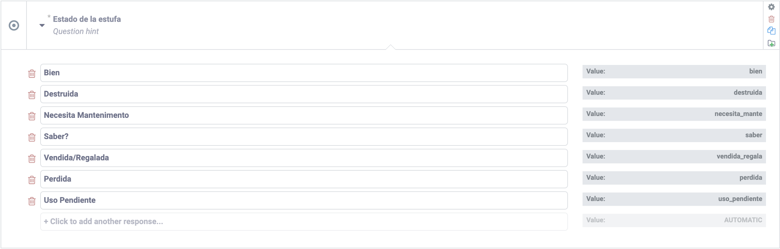
To determine Ny,i,j, (for each project activity) we survey a representative sample of each batch, biennially, per CDM guidelines (95% confidence, ±10% target precision level). This representative sample is visited one, three, five and seven years after installation.
Figure 18: The TAS choses between the options listed in the stove status questionnaire.

Project Activity Two: Data / Parameter: SC_{new,i, j}
Method | Stored | Time-Frame | Responsible Party
The Controlled Cooking Test (CCT), administered per international guidelines. | Cloud-based Spreadsheet. | Ongoing annual monitoring for a representative sample | TAS, M&E Director, Technician
TRL randomly samples three or more families each year from the first batch, with three tests per stove, for a total of at least nine tests, or until sufficient to reach 90% confidence, ±10% target precision level, per CDM guidelines.

Appendices
- TRL Official Government Certification of Non-profit Status
- Aprovecho Test Results
- CCA-CCT Protocol
- Controlled Cooking Test 2019 Data Collection
- Código de trabajo de Guatemala Decreto 1441-1961 (Labor laws for Guatemala)
- Leyes areas protegidas (Laws for protected areas)

"Fiscal Policy, Inequality, and the Ethnic Divide in Guatemala." https://www.cgdev.org/sites/default/files/CGD-Working-Paper-397-Cabrera-Lustig-Moran-Fiscal-Policy-Inequality-Ethnic-Divide-Guatemala.pdf. Accessed 28 Mar. 2019.
The VCS Standard V4 paragraph 2.1.1, states, “4) Project activities supported by a methodology approved under a VCS approved GHG program, unless explicitly excluded under the terms of VERRA approval.”
Developed per requirements detailed in the VCS Standard V4 section 3.5.15
As per the legal deed, Escritura Pública Número 802 (see appendix 1, “TRL Official Government Certification of Non-profit Status) which establishes TRL as registered not-for profit association on September 21, 2015.
According to schedule detailed in Section 1.11
Or, in Spanish, in the rare case that the beneficiary’s native language is such.
Per program ownership requirements 1 and 5 detailed in the VCS Standard V4, section 3.6.1.
As calculated by CDM AMS-II.G. V11.1
However, ONIL stoves installed and maintained by TRL are still functioning correctly after more than 15 years of use.
“MEXICO - Specific CPA-DD_final” pages 3 and 34: “Annex 3C: Efficiency of the system being deployed as compared to the system being replaced. Test performed by the Aprovecho Research Center in Cottage Grove, Oregon, USA”. https://registry.verra.org/app/projectDetail/VCS/1216. Accessed May 7, 2020. See appendix 2.
Given the assumption of a minimum of 120 installations per year.
See section 5.2 data / parameter “life span”
Under the assumption of a minimum of 100 energy efficiency improvements per year
https://www.url.edu.gt/publicacionesurl/FileCS.ashx?Id=40402, page 6
Devised from the data of the Population and Housing Census 2018, Guatemala. “Table B4 – Homes according to type of lighting, primary energy source for cooking, and availability of a room exclusively for cooking” https://www.censopoblacion.gt/explorador.
Note, leakage is accounted for within the methodology applied. AMS-II.G., V11.1, Paragraph 48, Option C, states “As an alternative to subparagraphs (a) and (b) Bold,i,j can be multiplied by a net to gross adjustment factor of 0.9520 to account for both leakages, in which case surveys are not required”. The project uses a net gross adjustment factor of 95% to account for leakage. See section 4.3.
https://sustainabledevelopment.un.org/content/documents/16626Guatemala.pdf, page 96
A local university with a center for environmental studies.
The Consejo Nacional de Áreas Protegidas is the national agency dedicated to the conservation and the sustainable use of the biological diversity and protected areas of Guatemala.
A local environmental NGO that works to educate, investigate, and ensure the conservation of the lake in cooperation with neighbors, scientists, local and national authorities, organizations, and universities.
https://www.legambiente.it/
http://www.africa70.org/
The Asociación de Desarrollo Comunitario del Cantón Panabaj is an organization dedicated to the community development of Panabaj, a neighborhood of Santiago frequently serviced by TRL.
https://www.trlearth.org/2019-annual-report
“Validation of the CDM PoA: Distribution of ONIL Stoves Mexico” page 25. https://cdm.unfccc.int/ProgrammeOfActivities/poa_db/2BH1T0SFERD67JCZXAIWMKLO8PN5UQ/view . See Appendix 2 for Aprovecho Test Results.
Value for By,savings,i,j for Project Activity One, as defined by AMS-II.G. is 3.245 tonnes. Value is from the VCS Calculations Spreadsheet. Spreadsheet is provided to the VVB.
Using a NCV 0.0156 Tj/tonnes, per AMS-II.G.
Devised from the data of the Population and Housing Census 2018, Guatemala. “Table B4 – Homes according to type of lighting, primary energy source for cooking, and availability of a room exclusively for cooking” https://www.censopoblacion.gt/explorador.
“Guatemala Forest Information and Data” https://rainforests.mongabay.com/deforestation/2000/Guatemala.htm
“State of the World’s Forests” http://www.fao.org/3/a-i2000e.pdf, page 125
Global Forest Watch. “Tree Cover Loss in Sololá, Guatemala”. Accessed on 14/04/2020 from www.globalforestwatch.org.
Value for By,savings,i,j for Project Activity Two, is 2.693 as defined by AMS-II.G. Value from the VCS Calculations Spreadsheet. Spreadsheet is provided to the VVB.
Using a NCV 0.0156 Tj/tonnes, per AMS-II.G.
Devised from the data of the Population and Housing Census 2018, Guatemala. “Table B4 – Homes according to type of lighting, primary energy source for cooking, and availability of a room exclusively for cooking” https://www.censopoblacion.gt/explorador.
“Guatemala Forest Information and Data” https://rainforests.mongabay.com/deforestation/2000/Guatemala.htm
“State of the World’s Forests” http://www.fao.org/3/a-i2000e.pdf, page 125
Global Forest Watch. “Tree Cover Loss in Sololá, Guatemala”. Accessed on 14/04/2020 from www.globalforestwatch.org.
Certain stoves that undergo energy efficiency improvements already have numbers in TRL’s database, as the organization continues to monitor certain stoves from previous projects (see section 1.8).
Per procedure set out in section 5 of CDM AMS-II.G. V11.1
Per procedure set out in section 5.3, 33 of CDM AMS-II.G. V.11.1
As deemed acceptable per the options listed in paragraph 19 of AMS-II.G. V11.1
https://www.earthedintl.org/CourseMatls/SustCentralAm/Readings/07_WayForward_RE_in_CentralAm.pdf, pages 53-54
AMS-II.G. V11.1 paragraph 15
VCS Calculations Spreadsheet is presented to the VVB
ibid
Wood use survey results are stored in client database. Client database and VCS calculations spreadsheet are presented to the VVB.
ibid
Devised from the data of the Population and Housing Census 2018, Guatemala. “Table B4 – Homes according to type of lighting, primary energy source for cooking, and availability of a room exclusively for cooking” Cell J16. https://www.censopoblacion.gt/explorador.%20See%20Appendix%206
See data / parameter box below for further justification as to why this value is conservative and acceptable.
Wood use survey results are stored in client database. Client database and VCS calculations spreadsheet are presented to the VVB.
AMS-II.G Data / Parameter table 18 mandates a default of .1 as the efficiency of the pre-project device, which is a three-stone fire using firewood (not charcoal), or a conventional device with no improved combustion air supply or flue gas ventilation, that is without a grate or a chimney”
“MEXICO - Specific CPA-DD_final” page 3 and 34: “Annex 3C: Efficiency of the system being deployed as compared to the system being replaced. Test performed by the Aprovecho Research Center in Cottage Grove, Oregon, USA”. https://registry.verra.org/app/projectDetail/VCS/1216. Accessed May 7, 2020. See appendix 2.
Final year factored into calculation of emission reductions for project crediting period
Wood use survey results are stored in client database. Client database and VCS calculations spreadsheet are presented to the VVB.
Cell D22 in Controlled Cooking Test 2019 Data Collection Spreadsheet (see Appendix 4)
Cell G22 in Controlled Cooking Test 2019 Data Collection Spreadsheet (see Appendix 4)
Operating under the conservative assumption that an estimated five percent of project devices will be decommissioned annually.
Client database and VCS calculations spreadsheet are presented to the VVB.
Monitoring Report_4th monitoring period_04.01.2016 to 03.31.2018_v5.pdf pg. 42. January 24,2019. Survey results indicate a value of 19.77 kg/day equivalent to 7.21605 tonnes/household/year. https://impact.sustain-cert.com/public_projects/201
“Validation of the CDM PoA: Distribution of ONIL Stoves Mexico” page 25. https://cdm.unfccc.int/ProgrammeOfActivities/poa_db/2BH1T0SFERD67JCZXAIWMKLO8PN5UQ/view.
“A default schedule of linear decrease in efficiency up to the terminal efficiency assumed as 20 per cent shall be applied through the lifespan of the project device.” AMS-II.G. V11, paragraph 37.
Client Database and VCS calculations spreadsheet are presented to the VVB.
Per the VCS standard, V.4 section 2.2.1
Devised from the data of the Population and Housing Census 2018, Guatemala. “Table B4 – Homes according to type of lighting, primary energy source for cooking, and availability of a room exclusively for cooking” https://www.censopoblacion.gt/explorador. Cell J16.
https://www.ipcc-nggip.iges.or.jp/public/2006gl/pdf/4_Volume4/V4_04_Ch4_Forest_Land.pdf, page 4.57
https://www.ipcc-nggip.iges.or.jp/public/2006gl/pdf/4_Volume4/V4_04_Ch4_Forest_Land.pdf, page 4.57
Global Forest Watch. “Land cover in Sololá, Guatemala”. Accessed on 20/04/2020 from www.globalforestwatch.org.
Global Forest Watch. “Land cover in Sololá, Guatemala”. Accessed on 20/04/2020 from www.globalforestwatch.org.
Global Forest Watch. “Land cover in Sololá, Guatemala”. Accessed on 20/04/2020 from www.globalforestwatch.org.
https://www.daftlogic.com/projects-google-maps-area-calculator-tool.htm#
Global Forest Watch. “Land cover in Sololá, Guatemala”. Accessed on 20/04/2020 from www.globalforestwatch.org.
AMS-II.G. V11.1 data parameter table 10
Value taken from client database, and updated for each monitoring period. Averages are taken in the VCS Calculations Spreadsheet. Both files are shared with the VVB.
Per the VCS Standard V.4 section 2.2.1
Per AMS-II.G Section 6.2, “When biennial inspection is chosen a 95 percent confidence interval and a 10 percent margin of error shall be achieved for the sampling parameter.”
Per AMS-II.G Section 6.2, “When biennial inspection is chosen a 95 percent confidence interval and a 10 percent margin of error shall be achieved for the sampling parameter.”
Procedures specified by the Clean Cooking Alliance. See appendix 3.

