UNDO FAQs:
Q. How does ERW stack up against the likes of biochar?

- Permanence: With ERW your carbon is removed permanently, 100,000+ years. With biochar, the CO2 is gradually released back into the atmosphere as the product breaks down, eventually all being released.
- Additionality: ERW is fully additional as a carbon removal, with UNDO sourcing basalt that otherwise would not have removed any carbon. With biochar, the process is preventing the release of CO2 back into the atmosphere, which may not have occurred for a number of years.
- Scale potential: The scale of biochar, like DAC, is limited to the rate at which new machinery can be built. ERW harnesses existing resources in basalt and rainwater, which already exist in abundance across the globe, whilst utilising existing farm spreading machinery, meaning million-tonne scale can be reached in weeks and months, and billion-tonne scale in years, not decades.
Q. How does UNDO measure the long term benefits or potential damage of basalt rock spread on agricultural land?

- Before spreading, UNDO tests all new sources of basalt via third party labs. We’re testing initially for the presence of any trace metals that could be harmful to the ecosystem. We check mineralogy levels against Soil Value Guidelines in the region to make sure the rock is safe to spread. Unlike other silicates such as olivine, basalt generally has low levels of heavy metals. Click here for more details on UNDO’s approach to heavy metals.

- After spreading, UNDO carries out regular soil samples to understand any changes to the mineral composition, comparing these with baselines taken prior to basalt application. We are also carrying out research with the likes of Newcastle University to understand the correlation between basalt application and soil health / crop yield. Initial findings in the UK show an increased yield in oat crop of up to 16% since application of basalt in 2022.

Q. How does UNDO’s MRV process work? What are we measuring?

- UNDO’s core MRV approach, approved as part of the Puro methodology, focuses on field-adjacent mesocosms, and soil samples taken from in-field.
Field-adjacent mesocosms, shown below, replicate the complexity of field conditions, with the added ability to take a wider range of measurements on a higher frequency, as well as allowing for greater control of basalt application.
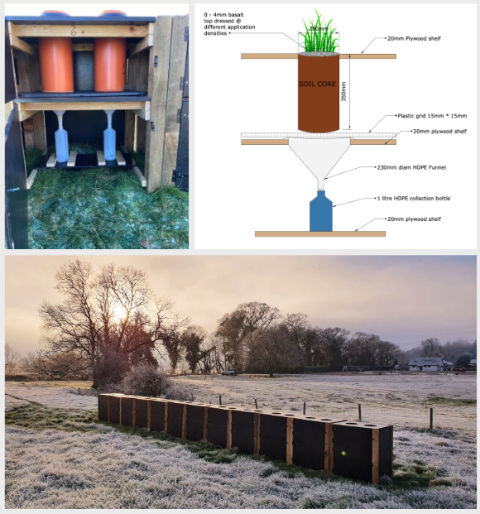

From mesocosms and soil samples, there are several handles to show that weathering has taken place:
- Products of weathering (Ca, Mg, Na, K and increase in pH).
- Fate of the CO2 sequestered through the reaction of carbonic acid and hydroxide ions released during the weathering process.
- Co-benefits like yield

- Alongside our core MRV approaches, UNDO are also gathering project data using a range of other approaches seen across the ERW field, such as remote sensors and TI Cation Ratio.

Q. How does the science behind enhanced rock weathering actually work?
Enhanced rock weathering is simply the speeding up of natural weathering, using basaltic rocks. The process occurs when rainwater combines with CO₂ as it falls through the atmosphere, which forms a weak carbonic acid. When this dilute acid hits the ground, the CO₂ interacts with the surface area of the basalt, breaking it down gradually and forming a solid bicarbonate.

This process happens through the soil and water systems, with the CO2₂ eventually locked up permanently as a bicarbonate (think: shells!) in our oceans for 100,000+ years, where it can help to decrease ocean alkalinity. The ‘enhanced’ part is all about increasing the surface area of the rock, by using basalt rock powder, and ensuring it comes into contact with rainwater or soil moisture.
Q. Around additionally, what tends to happen to any basalt rock that is not used for enhanced rock weathering?

The basalt UNDO source is either a waste product that sits unused at larger mines or quarries, or is used for construction. Where used for construction, no carbon removal impact would take place, resulting in full additionality when used by UNDO. When left onsite at a quarry, UNDO take an estimation of the CO2 that would be removed by the top layer of the deposits, i.e. the basalt that would be in contact with rainwater, and remove this from our calculations, only accounting for the additional carbon that would be removed by our activities.

Q. Where is the sequestered carbon actually stored?

The solid bicarbonate moves through soil and water systems until it is eventually deposited at the bottom of our oceans.

