Key Project Information & Programme Design Document (PoA-DD)

PUBLICATION DATE 31.05.2022
VERSION 2.1
RELATED SUPPORT

Programme of Activity requirements

This document contains the following Sections
Key Project Information

SECTION A – General description of PoA
SECTION B - Management System and Inclusion Criteria
SECTION C – Demonstration of additionality
SECTION D – Duration of PoA
SECTION E - Outcome of Stakeholder Consultations

Appendix 1 – Contact information of coordinating/managing entity and responsible person(s)/ entity(ies)

KEY PROJECT INFORMATION

GS ID of Programme | GS1377
Title of Programme: | Utsil Naj – Casa saludable para todos
Type of PoA | ☒Non – Forestry and/or Non -AGR PoA  ☐Forestry and/or AGR PoA
VPAs scale included in the PoA  Note that same PoA can included VPAs of different scales. Please select all applicable. | ☐Microscale  ☐Small scale  ☒Large scale
Start Date of POA | 26/12/2013
Date of Design Certification | 22/05/2015
Start date of crediting cycle of PoA | CP1: 27/12/2011  CP2: 27/12/2018
Version number of the PoA-DD | 5
Completion date of the PoA-DD | 18/04/2023
Coordinating/managing entity | Microsol SAS
Project Participants and any communities involved | Several as shown in corresponding VPAs, please refer to the corresponding documentation
Host Country (ies) | Guatemala, Honduras, Mexico and Peru
Activity Requirements applied | ☒ Community Services Activities  ☐ Renewable Energy Activities  ☐ Land Use and Forestry Activities/Risks & Capacities  ☐ N/A
Other Requirements applied | N/A
Methodology (ies) applied and version number | Technologies and Practices to Displace Decentralized Thermal Energy Consumption (TPDDTEC) v4.0  Requirements and guidelines: Usage rate monitoring v2.0
Product Requirements applied | ☒ GHG Emissions Reductions & Sequestration  ☐ Renewable Energy Label  ☐ N/A

Real case VPAs (all real case VPAs included in the PoA)
GS2439 | Utsil Naj - Casa saludable para todos VPA2
GS2440 | Utsil Naj - Casa saludable para todos VPA3
GS2441 | Utsil Naj - Casa saludable para todos VPA4

General description of PoA
        - Purpose and general description of the PoA
Poa objective:
The Utsil Naj large-scale Programme of Activities, a Microsol voluntary initiative, was designed as a multi-technology PoA for Latin America, however, it currently only coordinates improved cookstove technology. Safe water supply devices technology is no longer part of this PoA. It aims to disseminate this kind of technology with strong social impacts to poor populations of the continent in order to improve their living conditions in a sustainable way.
Latin American Context:
- Household air pollution
Air pollution within the home endangers human health and harms the environment. The harmful emissions from the incomplete combustion of solid fuels to heat the home and cook can result in indoor concentrations of particulate matter and gases that are 60-fold higher than those in outdoor urban air pollution. Women and children, who spend the greatest amount of time in close proximity to the stove, are most exposed. Indoor air pollution is the third leading environmental risk factor for death and the second leading environmental risk factor for DALYs in middle- and low-income countries in the Americas. Using the latest reliable data available up to December 2019, approximately 87 million people in Latin America and the Caribbean—15.2% of the Region’s population and among them, the poorest in the Americas—burned biomass as their main fuel source.
Acute lower respiratory infections (ALRIs) are the leading cause of death in children under 5 years old in developing countries. If it continues unabated, the exposure to high concentrations of toxic, burnt-biomass particles in the Region may jeopardize the advances made in the Americas on chronic respiratory and cardiovascular diseases, may erode the gains attained in child survival, and may hinder efforts toward health equity. Greater awareness of the social gradient of those who rely on biomass could help define priority areas of action and eventually could influence national energy, housing, and cook stove policies and regulations in the coming years.
There are interventions that can reduce household emissions of air pollution from cook stoves in the Americas. The Global Alliance for Clean Cook stoves was launched precisely to achieve the universal adoption of clean cookstoves and fuels worldwide.
Technologies to be included:
The Utsil Naj PoA is designed to facilitate the meeting of this human basic need by removing indoor air pollution. To reach this target and for this second crediting period, the technology selected in this PoA is improved cook stoves (ICS) according to the Methodology: Improved biomass cookstoves.
- In addition, other technologies could also be added to the PoA (with their own methodologies) through appropriate design change procedures in order to meet the needs of other targeted populations. Cooking: solar cookers, plant oil-fired stoves, ovens, heat-retention cookers.
- Heating: water heaters, thermal insulation, space heaters.
- Electricity: solar lanterns, micro-photovoltaic systems, micro-wind turbine systems, micro-hydroelectric systems.
- Other uses: bio-digesters, solar dryers, greenhouses
Emission reductions:
Initially, the end-users have a device of low quality, or they do not have any. The new technology or practice implemented emits fewer GHGs than the baseline scenario.
Contribution of the PoA project activities:
The principal benefits of the PoA are environmental care, health benefits, and economic or time savings due to the reduction of fuel consumption.
        - Physical/ Geographical boundary of the PoA
The geographical boundary of the Programme corresponds to several countries, as listed in section A.5.
Each project activity implements technology(ies) and/or practice(s) that reduce or displace greenhouse gas emissions from the thermal energy consumption of households and/or non-domestic premises. Each project activity is implemented by one or various LPPs within a designated area that can be located in any part of these countries.
Each VPA includes one or various project activities, implemented in one or various locations of one of the host countries. These locations are described with precision in the corresponding VPA-DDs.
        - Technologies/measures and eligibility under Gold Standard
As part of this second crediting period, the technology used will be improved cookstoves. However, in the future, other types of technology could be added in line with the current methodology or using their own methodologies.
- Improved cookstoves
The technology to be employed in the PoA is the improved cook stove. It implies the implementation of a new technology to cook with wood.
The specific models of ICS that are disseminated may vary in some details, due to the:
- Specific needs of the population
- Ability and experience of each LPP
- Presence and nature of local materials often used in the cook stove construction process.
However, some points do not vary in the stove technology that is being disseminated. In comparison to a stove used in baseline the improved cookstove has a closed combustion chamber which design optimizes air flows enabling more efficient and cleaner wood combustion.
Each VPA-DD specifies the type of improved cookstoves disseminated by each LPP of the VPA. Photos are presented in the VPA-DD.
        - Target/Indicator for each of the minimum three SDGs targeted by the PoA
Sustainable Development Goals Targeted | Most relevant SDG Target | SDG Impact
Sustainable Development Goals Targeted | Most relevant SDG Target | Indicator (Selected in SDG tool)
13 Climate Action (mandatory) | Target 13.2: Integrate climate change measures into national policies, strategies and planning | Number of tCO₂e reduced by the project
1 No poverty | Target 1.4: By 2030, ensure that all men and women, in particular the poor and the vulnerable, have equal rights to economic resources, as well as access to basic services, ownership and control over land and other forms of property, inheritance, natural resources, appropriate new technology and financial services, including microfinance. | Number of poor people benefitting from clean cooking technology
2 Zero hunger | Target 2.1 By 2030, end hunger and ensure access by all people, in particular the poor and people in vulnerable situations, including infants, to safe, nutritious and sufficient food all year round. | Proportion of households that buy food with monetary savings obtained from the purchase of firewood
2 Zero hunger |  | Proportion of households that obtain income from activities developed in their saved time attributed to the use of the ICS, and whose income is used to purchase food
3 Good health and well-being | Target 3.9: By 2030, substantially reduce the number of deaths and illnesses from hazardous chemicals and air, water and soil pollution and contamination. | Proportion of households considering cough occurs less often or no more
3 Good health and well-being |  | Proportion of households considering respiratory diseases occur less often or no more
3 Good health and well-being |  | Proportion of households considering burns occur less often or no more
3 Good health and well-being |  | Proportion of households considering backaches occur less often or no more
4 Quality education | Target 4.5: By 2030, eliminate gender disparities in education and ensure equal access to all levels of education and vocational training for the vulnerable, including persons with disabilities, indigenous peoples and children in vulnerable situations. | Proportion of children having more time to do their class homework
4 Quality education |  | Proportion of children having more time to attend school
4 Quality education | Target 4.7: By 2030, ensure that all learners acquire the knowledge and skills needed to promote sustainable development, including, among others, through education for sustainable development and sustainable lifestyles, human rights, gender equality, promotion of a culture of peace and non-violence, global citizenship and appreciation of cultural diversity and of culture’s contribution to sustainable development. | Proportion of people having received capacity-building on the benefits and adequate use of the ICS
4 Quality education |  | Proportion of beneficiaries who participated in ICS construction
7 Affordable and clean energy | Target 7.1: By 2030, ensure universal access to affordable, reliable and modern energy services. | Number of clean cooking technologies implemented and used by the project population
8 Decent work and economic growth | Target 8.5: By 2030, achieve full and productive employment and decent work for all women and men, including for young people and persons with disabilities, and equal pay for work of equal value. | Number of permanent job positions created thanks to the implementation of the project employing local people with a minimum participation rate in the ICS project of 50%
8 Decent work and economic growth |  | Proportion of job positions of equal value that pay equally women and men
11 Sustainable cities and communities | Target 11.6: By 2030, reduce the adverse per capita environmental impact of cities, including by paying special attention to air quality and municipal and other waste management | Amount of firewood saved per age group per ICS
12 Responsible consumption and production | Target 12.2: By 2030, achieve the sustainable management and efficient use of natural resources | Quantity of savings in fuel that is reduced per ICS-day, comparing the baseline scenario and project scenario with improved cookstoves
12 Responsible consumption and production |  | Proportion of fuel savings achieved by project technologies compared to baseline
15 Life on land | Target 15.2: By 2020, promote the implementation of sustainable management of all types of forests, halt deforestation, restore degraded forests and substantially increase afforestation and reforestation globally. | Number of tons of wood saved by the project
16 Peace and justice strong institutions | Target 16.7 Ensure responsive, inclusive, participatory, and representative decision-making at all levels | Proportion of end-users indicating that they approved the installation of the improved cookstove and that were informed about it
16 Peace and justice strong institutions |  | Proportion of end-users indicating that they are unhappy with their improved cookstoves

        - Coordinating/managing entity
The company MICROSOL is in charge of the coordination of the PoA: it is the managing entity.
MICROSOL is a French company having its central office in Paris, France, and activities occurring in Latin America with local office in Peru. MICROSOL develops and coordinates PoAs with very strong social impacts.
Microsol’s teams:
- Design the PoA;
- Define the program activities alongside with the Local Project Participants (LPPs) of each VPA;
- Adapt project activities to carbon market rules, requirements and processes;
- Redact the PoA-DD, VPA-DD, LSC reports, Monitoring reports, and other documents related to carbon market processes including answers to VVB and Gold Standard;
- Train all the LPPs on monitoring process and the other carbon-related activities;
- Control and compute data produced by the LPPs during carbon monitoring;
- Coordinate locally the whole steps of carbon market process (local stakeholder consultation, monitoring activities, validation, Gold Standard registration, verification, VERs issuance).
Microsol is hence the entity that communicates with the Gold Standard and the VVB.
The proper implementation of the technologies is performed by the LPPs, which are local organizations working on-site and familiar with the specific project’s regions.
They can be, for example:
- Local NGOs;
- Local branch of international NGOs;
- International institutions;
- National, regional, and local authorities (Ministries, regional governments, municipalities, etc.);
- Local manufacturers and distributors;
- International and national companies;
- Inhabitants organized in communities or associations.
A LPP can also be an institution that supports technically and/or financially a local organization working on site.
The LPPs are all trained and assisted by Microsol during the whole crediting period.
- Parties
Name of party involved ((host) indicate a host party) | Private and/or public entity(ies) VPA implementer(s) (as applicable) | Indicate if the party involved wishes to be considered as VPA implementer (Yes/No)
Guatemala (host) | To be defined at VPA level | No
Honduras (host) | To be defined at VPA level | No
Mexico (host) | To be defined at VPA level | No
Peru (host) | To be defined at VPA level | No
France | MICROSOL SAS (private entity) (CME) | Yes
As well as participating in the validation of the Utsil Naj PoA, El Salvador has not participated in any performance review processes. Due to the lack of LPP in this country, it will be removed as part of this POA. The PoA will continue to include Peru, as indicated during validation.
        - Funding sources of PoA
The PoA makes no use of public funding. Microsol has signed the “ODA Declaration form” as presented in Appendix 2.
Whenever a VPA would include activities partially or totally financed through public funding, then an assertion within the VPA will mention that fact and will ensure that the ODA has not been received on the condition that the credits are transferred to the donor country of the assistance.

MANAGEMENT SYSTEM AND INCLUSION CRITERIA
        - Management System
- A clear definition of roles and responsibilities of personnel involved in the process of inclusion of project activities
Two entities are involved in the process of inclusion of project activities: MICROSOL (the CME) and the respective LPP. The following table presents the operational and management arrangements established by the CME for the implementation of the PoA, describing the allocation of the different responsibilities between MICROSOL and the LPP. This organizational scheme corresponds to the standard inclusion conditions that MICROSOL offers to all LPPs:
Task | MICROSOL | LPP
Project Implementation | - Advice and exchange of best practices | - Identification of the end-users  - Sensitization and capacity building of the end-users  - Diffusion of the technology  - Follow-up and maintenance
Stakeholder consultation | - Organization of the Design consultation of the PoA  - Capacity building and support of the LPPs in the organization of the Local Stakeholder consultations  - Quality control of the information supplied by the LPPs | - Organization of the Local stakeholder consultation
Monitoring | - Capacity building and support of the LPPs in the monitoring process  - Quality control of the information supplied by the LPPs | - Implementation of the monitoring process following all the rules and requirements set by MICROSOL
Carbon documentation | - Analysis and quality control of the information supplied by the LPPs  - Implementation of a procedure to avoid double accounting  - Writing of all the carbon documentation (Design consultation report, POA-DD, VPA-DD, Monitoring repots, etc.)  - Management of the validation, registration, inclusion and verification processes including the request of clearance from the VVB and the Gold Standard  - VVB contracting and site-visits. | - Transfer of all the required information regarding its institution and its projects (including the complete list of end users, carbon property evidence, etc.)  - Availability of VVB site-visits
VERs issuance | - Sales of VERs  - Transfer of the revenues from the VERs sale to the LPPs after the deduction of MICROSOL´s share

Even if the organizational scheme is fixed in theory, a degree of flexibility is considered and if needed, will be applied on a case-by-case basis. Thus, a new distribution of roles could possibly be defined between Microsol and an LPP at the moment of signing the contractual agreement and this new organizational scheme would be described in the corresponding VPA-DD. A new task allocation would of course result in an adjustment in the carbon revenues allocation between Microsol and the LPP. This flexibility mechanism was a request addressed during the Design consultation of the PoA.
- Record of arrangements for training and capacity development for personnel
Training is performed at various levels to guarantee the correct application of PoA rules and the efficiency of the projects:
- For each LPP, Microsol conducts various trainings corresponding to each key step of the carbon process. Usually, when a LPP enter in the PoA, it receives two trainings: one on the PoA rules and the eligibility documents to produce and another one on the local stakeholder consultation organization and the baseline monitoring process. Then, before the first verification, a third training is performed by Microsol to prepare the LPP for the verification monitoring activities and the verification documents to produce. Depending on the content, each training can last from one to three days and can include a visit to the field for a better understanding of the monitoring requirements. After the first verification, Microsol reproduces training whenever needs are identified (new rules, new people, etc.).
- Each end user is trained by the LPP’s staff during the technology implementation. The capacity building covers the technology construction/installation, its adequate use, and reparation, as well as sensitization on the benefits of its utilization. This training takes place either in the group during the LPP’s demonstration of the technology in front of the community or during the installation of the technology, in the house of the end user.
- A procedure for technical review of the inclusion of project activities
Microsol is responsible for the technical review of the inclusion of the project activities:
First of all, a Carbon Management staff’s member carries out, based on the documentation produced by the LPP, a preliminary check of the compliance of the project activity with the eligibility criteria established in the PoA-DD. An Eligibility report is written and communicated to the Carbon Management Director.
If the Eligibility report is positive and it is validated by the Carbon Management Direction, a Carbon Management staff’s member writes the corresponding VPA-DD. This comprises a technical review of the project activity documentation to demonstrate its compliance with each eligibility criterion. All necessary evidence to prove the eligibility of the project activity needs to be provided along with the VPA-DD.
Finally, the Carbon Management Director performs a double-check of the technical review made on the project activity and of the VPA-DD documentation. If this assessment is positive, the project activity is submitted to the VVB for inclusion.
- A procedure to avoid double counting
Before the inclusion of project activity in the PoA, Microsol’s Carbon Manage Direction verifies (on the CDM, Gold Standard, and VCS registries) whether there is any other project concerning the same technology registered in the same geographical boundary. If it turns out there is, an assessment is conducted on both project documentation to make sure they correspond to two different project activities.
In any case, to be eligible to the PoA, each LPP has to sign the “LPP eligibility form” (presented in Appendix 3) that contains a specific criterion on the double-counting issue. It says: “The project is not registered as an individual project activity nor is part of another registered PoA on the official or voluntary carbon market (the technology units listed in the “End users list” provided by the LPP have never been presented to any carbon certification process)”.
Finally, internal control is also realized among the PoA’s LPPs to make sure there are no end users in common between them. The software has been designed that enables to cross-reference of two lists of end users from the PoA’s LPPs and suppress all redundant names. This control is conducted whenever two LPPs are implementing the same technology in the same State or Department.
- Records and documentation control process for each VPA under the PoA
Quality control and analysis are performed by Microsol’s staff. All data and documentation produced are centralized by Microsol in general comprehensive databases so as to be easily accessible and for analysis to be more accurate.
Microsol’s leadership of the process, its permanent control of data, and its capacity building to LPPs act as a guarantee for data quality.
All the key documentation related to the PoA is archived electronically on a specific website called “Google Drive”. To avoid unexpected deletion of files backups are saved each month by Microsol’s IT department. This archiving system prevents from potential loss of documents due to the destruction or loss of Microsol’s staff computers. All data and documentation related to the VPAs will be archived at least for a period of 2 years after the end of the crediting period.
- Measures for continuous improvements of the PoA management system
To make the PoA management system more efficient and reliable, Microsol continuously works on improvements of tools and procedures. This comprises for instance the development of an Intranet that will enable each LPP to upload electronically its documentation to Microsol’s central database in order to automate the quality process.
        - Application of methodologies
The methodologies applied in the PoA are:
- Technologies and Practices to Displace Decentralized Thermal Energy Consumption” v.4.0, released on 07/10/2021 (hereafter referred to as the Methodology).
- Requirements and guidelines: Usage rate monitoring” v.2.0., released on 27/10/2020.
They are available on the Gold Standard website: https://globalgoals.goldstandard.org/all-documents/
This methodology was chosen because it does exactly match improved cookstoves technologies and practices.
The first paragraph of the methodology indeed clearly says: “This methodology is applicable to project activities that introduce technologies and/or practices that reduce or displace greenhouse gas (GHG) emissions from the thermal energy consumption of households and/or residential, institutional, industrial, or commercial facilities.”
Therefore, the Methodology is applicable to improved cookstoves technologies.

Applicable conditions | Improved cookstoves
- Project shall choose a technology design that it is proven to be efficient and durable under field conditions; for cookstoves, the rated thermal efficiency shall be at least 20%. | Specific details cannot be done at PoA level since the PoA is designed to include different models of improved cook stoves which will be presented in detail in each VPA. Therefore, compliance with this applicability condition will be demonstrated for each project activity at VPA level.
- The technology shall have continuous useful energy output of less than 150kW per unit, where “continuous useful energy output” is defined above. | Specific calculations cannot be done at PoA level since the PoA is designed to include different models of improved cook stoves which will be presented in detail in each VPA. Therefore, compliance with this applicability condition will be demonstrated for each project activity at VPA level.  Nevertheless, no improved cook stove has a continuous useful energy output superior to 150kW.  The Aprovecho Research Center Water Boiling Tests realized on nine different models of wood-burning improved cook stoves show that the energy output reached during the WBT high power test is between 6.8kW (20L Can Rocket) and 13.3kW (with the ONIL stove).
- The project activity is implemented by a project developer and can include additional project participants listed in Appendix 2 of the PDD template. The individual households and institutions may be represented collectively by community organizations, etc., but do not individually act as project participants. | The project boundary will be clearly defined in each VPA-DD. Before any new project activity is included in the PoA, it will be verified whether there is any other carbon project concerning the same technology registered in the same geographical boundary. To be eligible for the PoA, each LPP has to sign the “LPP Eligibility form” (presented in Appendix 3) that contains a specific criterion on the double-counting issue. It says: “The project is not registered as an individual project activity nor is part of another registered PoA on the official or voluntary carbon market (the technology units listed in the “End users list” provided by the LPP have never been presented to any carbon certification process)”.
- The project developer must design incentive mechanism(s), which should be effective as fast as possible, for the elimination of inefficient baseline stoves that are replaced by the project cooking devices and describe the incentive mechanism(s) in the PDD/VPA-DD at the time of validation. | To be eligible for the PoA, each LPP had to sign the “LPP Eligibility form” (presented in Appendix 3) that contains a specific criterion on the baseline technology issue. The LPP is asked to replace the baseline stove with the improved cook stove, but he cannot make it compulsory. The end users can keep their old stoves as an auxiliary or backup unit. In this case, the corresponding fuel consumption will be accounted as part of the project emissions since field tests are performed on the total fuel consumption of the household. Nevertheless, the LPP will encourage the removal of the old technology and the definitive discontinuity of its use. For the LPP, the carbon mechanism is per se an incentive as whenever the baseline technology is still used, fuel consumption is higher, and therefore, emission reductions and carbon incomes are lower.  The removal of the baseline technology will be monitored in the project surveys and monitoring surveys by asking the end user whether it still uses its baseline stove, has destroyed it, and if not, what it did with it.
- To avoid double counting or double claiming, the project developer must:  - Clearly communicate its ownership rights and intention of claiming the emission reductions resulting from the project activity to the following parties by contract or clear written assertions in the transaction paperwork: all other project participants; project technology manufacturers; and retailers of the project technology or the renewable fuel in use; and  - Inform and notify the end users that they cannot claim emission reductions from the project, and  - Exclude from the project activity, cooking devices included in any other voluntary carbon market or CDM project activity/PoA, and strive not to displace the cooking devices of another CDM or voluntary project/PoA. See data and parameters not monitored, Avoidance of double counting or double claiming with other mitigation actions, for details on this demonstration. | Each LPP of Utsil Naj PoA is considered the owner of the emission reductions resulting from their project activities. The general transfer scheme of the emission reductions ownership is as follows:  End user -> LPP -> CME -> Final buyers  The improved technology end users will be notified that they cannot claim emission reductions from the project: they will be informed of the carbon market certification process occurring and must not have any opposition to it.  Other parts of the carbon property scheme are precisely defined through contracts between Microsol and each LPP or final buyers (available on demand).  Whenever the implementation of a project activity is done as part of government’s programs, as part of NGO’s programs, and/or a mix of government and NGO programs, additional measures will be taken to ensure the LPP’s carbon properties of the emission reductions. Two cases will be distinguished:  - In the case of institutions financing the project activities: the LPP will formally notify each major donor to ensure that no property can be claimed on the carbon credits resulting from the part of the project activities it financed.  - In the case of institutions that purchase the LPP’s technology units to distribute them to the end users: the LPP will provide a statement signed by the institution that ensures that no property on the carbon credits resulting from the technology units it purchased can be claimed.
- Project activities making use of solid fuel in the project scenario or other improved fossil fuel cookstoves meeting certain conditions described in the footnote to Table 1 (Methodology p. 5) (e.g. switch from three-stone fire biomass stoves to LPG stoves) may only claim emission reductions for energy efficiency improvement aspect and shall assume the same baseline and project fuel for emission reduction calculations. | Not applicable. The project activities will not make use of any solid fuel in the project scenario or other improved fossil fuel cookstoves. The only fuel used is biomass as firewood.
- Project activities making use of a new solid biomass feedstock in the project situation (e.g. switch to green charcoal or renewable biomass briquettes) must comply with relevant specific requirements for biomass related project activities, as defined in the latest version of the Community Services Activity Requirements. The specific requirements apply to both plantations established for the project activity and/or existing plantations that will supply biomass feedstock. | Not applicable. The project activities will not make use of any new biomass feedstock in the project situation. The biomass type in the baseline is the same as the biomass type in the project scenario.
- Adequate evidence is supplied to demonstrate that indoor air pollution (IAP) levels are not worsened compared to the baseline, and greenhouse gases emitted by the project fuel/stove combination are estimated with adequate precision. Furthermore, for projects where cooking will move from outdoor to indoor or where the project technology reduces ventilation (for example, changing from a stove with chimney to improved stove with no chimney), indoor air pollution (IAP) levels shall not worsen in the project compared to the baseline, including PM 2.5 and carbon monoxide (CO) emissions. This may be demonstrated before project Design Certification or during project operation using the certification resulting from of a manufacturer’s test, report of field testing of the technology’s PM 2.5 and carbon monoxide (CO) emissions, report of lab testing of the technology, or results of modeling of the technology’s operation under field conditions. If none of these are available, references from published literature or report by independent agencies may be used as evidence, provided it is not more than 5 years old. | Specific details cannot be done at PoA level since the PoA is designed to include different models of improved cook stoves which will be presented in detail in each VPA. Therefore, compliance with this applicability condition will be demonstrated for each project activity at VPA level.
          - Multiple technologies/measures
The only technology applied in the PoA-DD is improved cookstoves. To see specific technology, see section B.2 of the PoA-DD.
        - Eligibility criteria for inclusion of a VPA in the PoA
The eligibility criteria that each project activity has to comply with in order to be included in the PoA are presented in the table below. For each project activity to be included in the PoA, the LPP will need to sign the corresponding “LPP Eligibility form” presented in Appendices 3 and 4 which list all the following eligibility criteria except some of them that will be supported by another type of documentation.

No. | Eligibility Criterion | Description/  Required condition | Means of Verification/Supporting evidence  for inclusion
1 | Boundary and location on the VPA | The project in located within one of the host countries listed in section A.5 of the PoA-DD or another country if an extension of the PoA boundary is approved at a future date. | VPA-DD section A.2
2 | Crediting period of the VPA | The crediting period of the project activity shall not exceed the end date of the PoA. | VPA-DD section C.2
3 | Applicability of the Methodology | Project shall choose a technology design that it is proven to be efficient and durable under field conditions; for cookstoves, the rated thermal efficiency shall be at least 20%. | Specific details will be presented in detail in each VPA-DD
3 | Applicability of the Methodology | The technology shall have continuous useful energy output of less than 150kW per unit, where “continuous useful energy output” is defined above. | VPA-DD section B.2 + Appendix 6 of VPA-DD
3 | Applicability of the Methodology | The project activity is implemented by a project developer and can include additional project participants listed in Appendix 2 of the PDD template. The individual households and institutions may be represented collectively by community organizations, etc., but do not individually act as project participants. | Appendix 2 of VPA-DD
3 | Applicability of the Methodology | The project developer must design incentive mechanism(s), which should be effective as fast as possible, for the elimination of inefficient baseline stoves that are replaced by the project cooking devices and describe the incentive mechanism(s) in the PDD/VPA-DD at the time of validation | LPP Eligibility form
3 | Applicability of the Methodology | To avoid double counting or double claiming, the project developer must:  - Clearly communicate its ownership rights and intention of claiming the emission reductions resulting from the project activity to the following parties by contract or clear written assertions in the transaction paperwork: all other project participants; project technology manufacturers; and retailers of the project technology or the renewable fuel in use; and  - Inform and notify the end users that they cannot claim emission reductions from the project, and  - Exclude from the project activity, cooking devices included in any other voluntary carbon market or CDM project activity/PoA, and strive not to displace the cooking devices of another CDM or voluntary project/PoA. See data and parameters not monitored, Avoidance of double counting or double claiming with other mitigation actions, for details on this demonstration. | LPP Eligibility form (Appendix 5 of the VPA-DD) + VPA-DD section B.2
3 | Applicability of the Methodology | Project activities making use of solid fuel in the project scenario or other improved fossil fuel cookstoves meeting certain conditions described in the footnote to Table 1 (Methodology p. 5) (e.g. switch from three-stone fire biomass stoves to LPG stoves) may only claim emission reductions for energy efficiency improvement aspect and shall assume the same baseline and project fuel for emission reduction calculations. | Not applicable
3 | Applicability of the Methodology | Project activities making use of a new solid biomass feedstock in the project situation (e.g. switch to green charcoal or renewable biomass briquettes) must comply with relevant specific requirements for biomass related project activities, as defined in the latest version of the Community Services Activity Requirements. The specific requirements apply to both plantations established for the project activity and/or existing plantations that will supply biomass feedstock. | Not applicable
3 | Applicability of the Methodology | Adequate evidence is supplied to demonstrate that indoor air pollution (IAP) levels are not worsened compared to the baseline, and greenhouse gases emitted by the project fuel/stove combination are estimated with adequate precision. Furthermore, for projects where cooking will move from outdoor to indoor or where the project technology reduces ventilation (for example, changing from a stove with chimney to improved stove with no chimney), indoor air pollution (IAP) levels shall not worsen in the project compared to the baseline, including PM 2.5 and carbon monoxide (CO) emissions. This may be demonstrated before project Design Certification or during project operation using the certification resulting from of a manufacturer’s test, report of field testing of the technology’s PM 2.5 and carbon monoxide (CO) emissions, report of lab testing of the technology, or results of modeling of the technology’s operation under field conditions. If none of these are available, references from published literature or report by independent agencies may be used as evidence, provided it is not more than 5 years old. | Specific details will be presented in detail in each VPA-DD
4 | Baseline technology | Before receiving Improve Cookstove, the end users were cooking with traditional stoves. A “traditional stove” is an open fire that can have two forms in the PoA host countries:  - A typical three-stone fire (Favours local materials for the cookstove (isolating clay – barro – and traditional adobe in particular))  - An open fire with U-shaped surrounds | Baseline surveys
5 | Project technology | The project activity introduces cookstoves with a closed combustion chamber which enables more efficient and cleaner wood combustion. | LPP Eligibility form + VPA-DD section A.3
6 | Additionality demonstration | The project technology is “first-of-its-kind” as defined in the methodology. Otherwise, the additionality demonstration is done based on the latest UNFCCC “Tool for the demonstration and assessment of additionality”. | VPA-DD section A.1.1
7 | Previous consideration | There is evidence that carbon funding was considered before the implementation of the project activity. | LPP Eligibility form + VPA-DD section B.5.1
8 | Poverty | End users of the project activity are using wood as the main fuel for cooking. | LPP Eligibility form + monitoring survey
9 | Use of carbon revenues | The LPP committed to using future carbon revenues as a priority to ensure the sustainability of the project activity. | LPP Eligibility form
10 | Monitoring | The LPP committed to implementing a long-term monitoring process as described in VPA-DD section B.7.2. | LPP Eligibility form + VPA-DD section B.7.2
11 | Local stakeholder consultation | Local stakeholder consultation has to be carried out by each LPP prior to the inclusion of the VPA unless Microsol can justify that different activity are sufficiently homogenous to organize one LSC for various LPPs or VPAs. | LSC report
12 | Sustainability | The LPP committed to implementing the sustainability monitoring plan. | LPP Eligibility form
13 | Safeguarding principles | The LPP has signed the “Safeguarding declaration”. | Safeguarding declaration
13 | Safeguarding principles | The LPP committed to providing information on the use of its carbon revenues in order to avoid corruption. | LPP Eligibility form
14 | ODA | The LPP has signed the "Official Development Assistance Declaration" which states that ODA was not received under the condition that the credits coming out of the project will be transferred to the donor country. | ODA form
15 | Laws compliance | The LPP declares to be in line with the laws and regulations of the host country available at the time of inclusion of the VPA in the PoA. | LPP Eligibility form
15 | Laws compliance | The LPP has provided evidence that its entity is duly registered/ incorporated by the national authorities of its host country prior to inclusion. | Evidence provided by LPP
16 | Contractual with the CME | The LPP has signed contractual agreements with Microsol to participate in the PoA. These agreements include all rights and responsibilities of both parties. Microsol approved each VPA to be included in the PoA. | Contractual agreement between the LPP and MICROSOL

As presented in the table above, there are several criteria that need to be met to demonstrate the additionality of project activity. One of them concerns the end users of the project technology: wood must be their main fuel for cooking. The target population of any project activity to be included in the PoA will need to comply with this criterion. If it turns out that some end users do not comply with this criterion, the corresponding proportion (calculated through a linear statistical extrapolation) of end users will be removed from the emission reduction calculation.
Finally, some eligibility criteria refer to future actions to be implemented by the LPP at the verification stage. If the LPP does not implement the required actions (ex: monitoring plan) or provide the required information (ex: carbon revenues use report) as described in the eligibility criteria, Microsol will reserve the right not to present the project activity for the verification stage.

DEMONSTRATION OF ADDITIONALITY
This section is an exact replication of the original section submitted during PoA validation.
The following information demonstrate that the proposed PoA is a voluntary coordinated action that would not be implemented in the absence of the PoA.
The PoA has never been publicly announced to be implemented without carbon credits. For each LPP, an assessment is made by Microsol at VPA-DD level in order to demonstrate that carbon revenues were considered before the project activities implementation.
Level of the additionality demonstration
The CME proposes to demonstrate additionality at PoA level only since all project activities to be included in the PoA have the same characteristics:
- Project activities are implemented in one of the host countries of the PoA boundary (which is limited to four countries), that is to say, Latin American developing countries that struggle with poverty.
- Inside these countries, project activities target “poor” households since the main objective of this PoA is poverty reduction. As it is very difficult to monitor households’ revenues, the poverty level of the project activities end users will be determined based on their cooking practice (much easier to monitor). Indeed, it is well established that the fuel used to cook depends on the economic situation of a household. This is why we consider in this PoA that project end users are poor as long as they are cooking with wood.
- Project activities implement improved cook stoves in order to reduce household air pollution.
- Project activities are implemented by LPPs that rely mainly on external funding for the technologies installation and systematically lack resources to guarantee the long-term sustainability of their projects.
Therefore, the information presented below constitutes the demonstration of the additionality of the PoA as a whole. It will include specific criteria for additionality demonstration that will be applied for the inclusion of any project activity.
Tool used to demonstrate additionality
Regular and retroactive project activities can be included in the PoA. In both cases, additionality is demonstrated following the UNFCCC “CDM Tool 01 - Tool for the demonstration and assessment of additionality” (EB 70, Annex 8) according to which a project activity is considered additional if it follows successively the following steps:
Step 0: Demonstration whether the proposed project activity is the first-of-its-kind
Step 1: Identification of alternatives to the project activity consistent with current laws and regulations
Step 3: Barrier analysis (preferred to Step 2: Investment analysis)
Step 4: Common practice analysis
Additionality demonstration
- Demonstration for improved cookstoves project activities
Step 0: Demonstration whether the proposed project activity is the first-of-its-kind
Based on credible sources of information, it is demonstrated that among people using wood for cooking in the PoA host countries improved cook stoves have been adopted in the following proportions:
Host Country | ICS adoption rate
Guatemala | 10.8 %
Honduras | 13.6 %
Mexico | 13.6 %
Peru | 12.7%
Since the improved cookstoves technology has been adopted in each PoA host country by less than 20% of the target population, the technology can be qualified as “first-of-its-kind” according to the Gold Standard methodology “Technologies and Practices to Displace Decentralized Thermal Energy Consumption” v.4 (the methodology applied in the PoA).
Since the improved cookstoves technology is the first-of-its-kind, the additionality of the improved cookstoves project activities is demonstrated for the four PoA host countries. Steps 1, 3, and 4 are therefore not necessary to demonstrate.
The demonstration will be renewed every time a new improved cookstoves project activity will be included in the PoA. Whenever it is not possible to demonstrate that the improved cook stoves technology is “first-of-its-kind”, the additionality of the new project activities will be demonstrated based on the latest UNFCCC “CDM Tool 01 - Tool for the demonstration and assessment of additionality”.
Conclusion
The Gold Standard provides carbon funding that is necessary for the development of this programme. Indeed, a strong particularity of this PoA is to bring carbon revenues to the LPPs to finance the efficiency and sustainability of their project: the natural correlation between carbon revenues and the project efficiency creates a virtuous cycle (the more efficient the project is, the more carbon revenues it gets), giving a strong incentive for LPPs to implement sustainability activities. In addition to this natural incentive, each LPP included in this PoA commits to implement such activities, notably using future carbon revenues. Without support from carbon credits such activities would not be possible.
For ICS project activities the following eligibility criteria have been defined to demonstrate the additionality at the VPA level:
- “There is evidence that carbon funding was considered before the implementation of the project activity”: this criterion ensures the carbon previous consideration of any project to be included in the PoA.
- “End users of the project activity are using wood as the main fuel for cooking”: This criterion guarantees that only poor households are included in the PoA.
- “The LPP will implement a long-term monitoring process as described at VPA level”: this criterion distinguishes the project activity from the other existing projects.

DURATION OF PoA
        - Date of first submission of PoA to Gold Standard
24/01/2013
The Design Consultation Report of the PoA has been submitted to the GS on 24/01/2013.
        - Duration of the PoA
The start date of the crediting cycle is 27/12/2011 and its duration is 28 years 0 months.
The first crediting period of this PoA lasted from 27/12/2011 to 26/12/2018 (7 years).
The second crediting period will last from 27/12/2018 to 26/12/2023 (5 years).

According to “Deviation Request – DEV_256” (partially approved), GS has allowed the start of the renewal of the PoA period on 27/12/2018, however, VERs must be claimed only from 06/04/2020 (inclusive) onwards or three years (retroactive) from the date of remote/physical site visit by a verifying VVB, whichever occurs later. No credits and SDG impacts can be claimed for the period of delay before 06/04/2020.
As the “Deviation Request” is partially approved, PD shall:
- Ensure that continuity in the Project’s monitoring activities is maintained and that PD can justify that no monitoring gaps exist (especially for SDG parameters) within the Monitoring Period(s). However, if gap(s) exist, the project shall justify that conservative approach(es) have been applied in line with section 3 of the Deviation Approval Requirements and Procedures and overarching GS principles (as applicable).
- Document the deviation request, its implications, and GS’ decision in the appropriate section of the PDD/Monitoring Report (for the relevant MP).
In section C.2.1 of each VPA-DD, CME complies with the two points requested by GS.

OUTCOME OF PoA LEVEL STAKEHOLDER CONSULTATION
This section is an exact replication of the original section submitted during PoA validation.
        - Summary of stakeholder consultation at PoA Level
- PoA Design consultation
As the Utsil Naj Programme is a multi-country PoA that currently covers five countries, it has been decided to conduct an online Design consultation to facilitate the process (as a live meeting is not necessarily required).
The Design consultation lasted five weeks, from July 31st, 2012 to September 7th, 2012.
Please refer to the PoA Design Consultation Report for more information.
- Local Stakeholder consultation
The local stakeholder consultation will be conducted at the VPA level as each project activity has its specificities that should be discussed with relevant stakeholders. Therefore, each LPP will organize a local stakeholder consultation as VPA level consultations seem more appropriate. All information about those LSCs (how comments by local stakeholders were invited, a summary of the comments received, and how the due account was taken of any comments received) will be provided in the respective VPA-DDs.
        - Consideration of stakeholder comments received
- Summary of comments received during the PoA design consultation
Please refer to the PoA Design Consultation Report for a full report on stakeholder comments.
Comments on the eligibility criteria to include the PoA:
The assessment of the eligibility criteria of the PoA was largely positive. Some people pointed out that the organization of the local stakeholder consultation, the documentation required and the implementation of monitoring activities represent important costs for the LPPs and that some of them may struggle to bear them.
Comments on the technologies and countries eligible for the PoA:
Generally, all the technologies eligible for the PoA seemed relevant for the participants within the host countries of the PoA. The participants highlighted some important points that helped us to understand the specific needs of each country and region and understand the complementarity of different technologies to meet the needs of end users.
Participants suggested other potential countries that would also need the diffusion of these technologies and could benefit from the Utsil Naj PoA.
Comments on the task allocation between MICROSOL and the LPPs:
The participants were largely satisfied by the task allocation between Microsol and the LPPs. Some participants underlined that Microsol could support more - i.e., provide resources - the LPPs in the organization of the local stakeholder consultation and the implementation of the monitoring activities. The carbon revenues allocation scheme proposed received very little criticism, and the comments raised concern about the fact that the allocation could be defined on a case-by-case basis, depending on the exact role assigned to each of the parties and the characteristics of the project activities.
Comments received on the level of consultation:
Except for the two participants who consider that the cost of the LSC organization is problematic, all the others agree with MICROSOL’s decision to implement LSC at VPA level and not PoA level.
Comments received on the general design of the PoA:
All the participants evaluated the design of the PoA and its organizational scheme as “good” or “very good”. Comments made at this stage were mainly questions for clarification concerning, among other subjects, the specific technology model types that can be implemented, how MICROSOL’s capacity-building sessions for the LPPs are organized, and how the LPPs can use the carbon revenues. Someone suggested that a communication component is added to the PoA design in order to communicate effectively with all the stakeholders program at each stage of the project implementation.
Comments received on the provisional name of the PoA: “Sak Taanah”:
Some participants underlined the consistency of the name with the objective of the PoA and the relevance of using an indigenous language; others stress the fact that the language chosen does not represent all Latin American countries and that the name does not sound like a Latin American name and is not very marketable. Other participants proposed new translations in Maya and Nahuatl, also suggested using a Spanish name because this language would be understood by all and finally also suggested adding "for all" at the end of the name.
- Report on consideration of comments received
Given the high proportion of positive comments for each of the survey questions, we conclude there is a general acceptance of the Programme design. Indeed, to the question “What do you think of the Programme design and its organizational scheme?”, 54% of the participants answered “Very good” and 46% of them said “Good”.
Nevertheless, two issues resulted to be important and sensitive for the participants: the margin practiced by Microsol as well as the task allocation between Microsol and the LPPs.
Concerning the margin that Microsol practices, we decided to be completely transparent on this issue and therefore to include this information, usually confidential, in the PoA-DD so that any stakeholder could have access to it. Concerning the task allocation between Microsol and the LPPs, some participants highlighted the difficulty they would have to finance the implementation of the Local Stakeholder Consultation and the monitoring activities. That is why, even if the organizational scheme is fixed in theory, a degree of flexibility is considered in the PoA-DD and if needed, will be applied on a case-by-case basis. Thus, a new distribution of roles could possibly be defined between Microsol and a LPP at the moment of signing the contractual agreement in order to reduce the work of the LPP. A new task allocation would of course result in an adjustment in the carbon revenues allocation between Microsol and the LPP.
Finally, following the comments received concerning the provisional name of the Programme ("Sak Taanah"), we decided to change it. The new name of the Programme is "Utsil Naj - Casa saludable para todos” (“Utsil Naj – Healthy house for all").
        - Final Continuous Input / Grievance Mechanism at PoA Level

Method | Include all details of Chosen Method (s) so that they may be understood and, where relevant, used by readers.
Continuous Input / Grievance Expression Process Book (mandatory) | The chosen method is the Continuous Grievance Mechanism (Spanish acronym: “MAC”) a notebook that is accessible to all end users to facilitate the contribution and/or complaint writing. LPPs are responsible for leaving the MAC as an area known to all users.  MACs can be found at the following locations:  GUATEMALA  - ECOCOMAL:  Sacatepéquez - 1ra. Avenida 12-10 zona 0 Aldea Santiago Zamora, San Antonio Aguas Calientes Sacatepequez  HONDURAS  - ECOPAN:  Copán - Col. Brisas de Rio, Copán Ruinas, Copán  MEXICO  - GIRA:  Microacan - Km 3 Carretera Pátzcuaro-Erongaricuaro, localidad de Tzentzenguaro, municipio de Pátzcuaro  - FPP:  San Luis de Potosi - Municipal Presidency of Tequila, San Antonio, Tanlajas and Tampamolón Corona  Veracruz - municipality of Tequila  Oaxaca - Municipal Presidency of San Antonino Monteverde and Municipal Presidency of San Juan  - AURA:  Sonora - Carretera Nueva a Campo 19 km. 0.5
GS Contact (mandatory) | help@goldstandard.org
Other | Beneficiaries can contact the project through the book in every strategic point for each LPP.

Appendix 1 - Contact information of coordinating/managing entity and responsible person(s)/ entity(ies)
CME and/or responsible person/ entity | CME  Responsible person/ entity for application of the selected methodology(ies) and, where applicable, the selected standardized baseline(s) to the PoA
Organization | Microsol SAS
Street/P.O. Box | Rue de l’est
Building | 24
City | Paris
State/Region | -
Postcode | 75020
Country | France
Telephone | -
E-mail | alaurent@Microsol-int.com
Website | www.Microsol-int.com
Contact person | Arthur Laurent
Title | President
Salutation | Mr.
Last name | Laurent
Middle name | -

Appendix 2 Affirmation regarding public funding
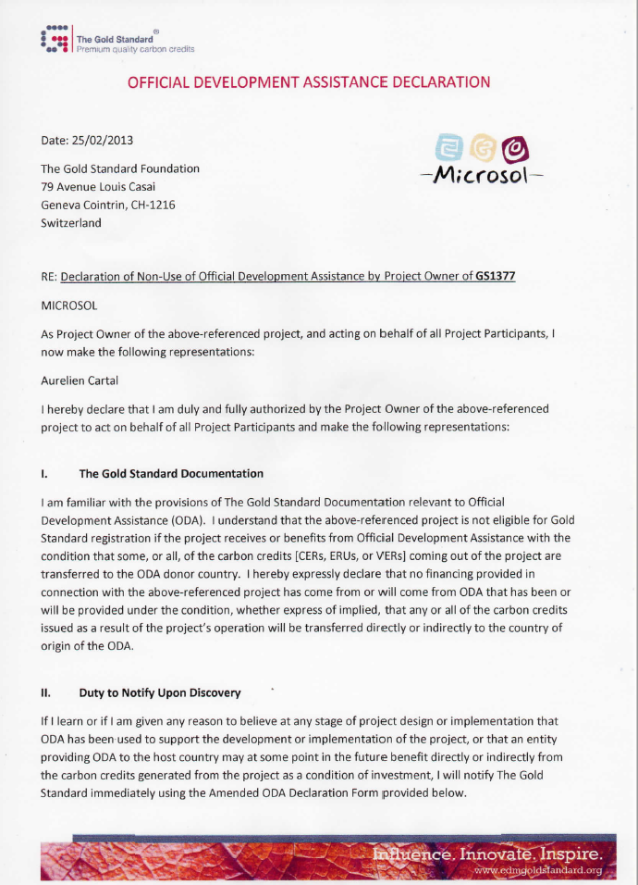
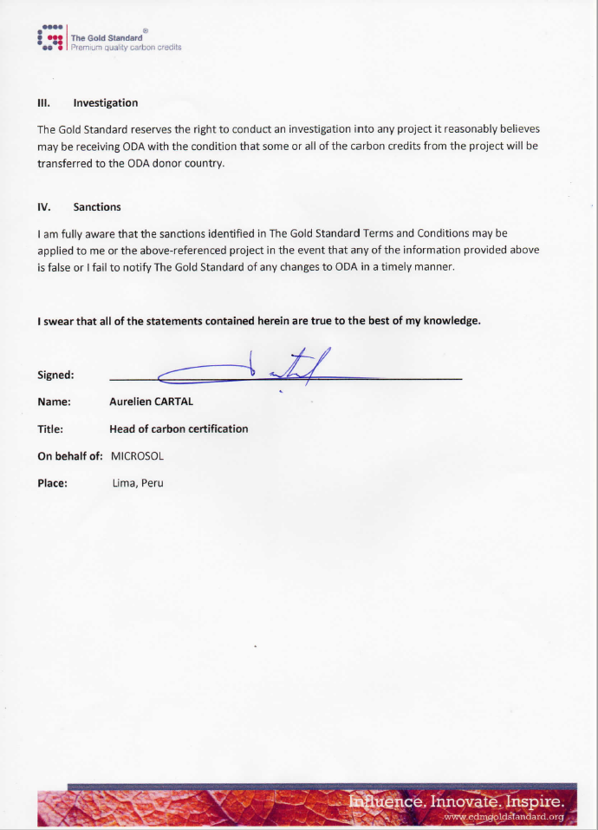

Appendix 3 Utsil Naj – LPP Eligibility form – improved cookstoves
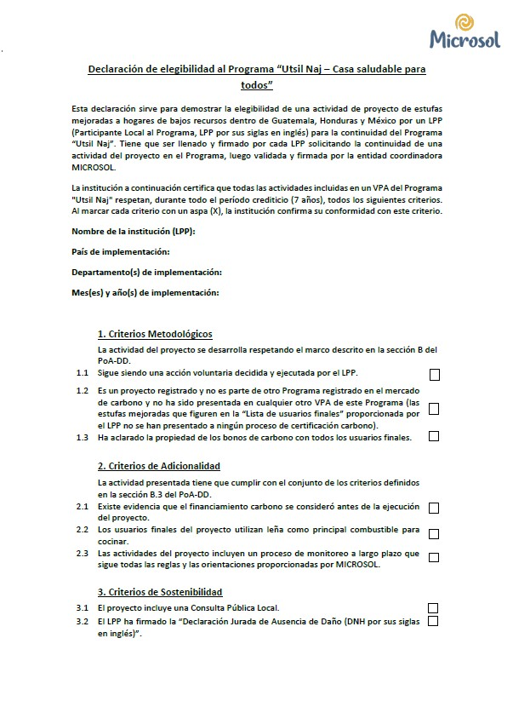
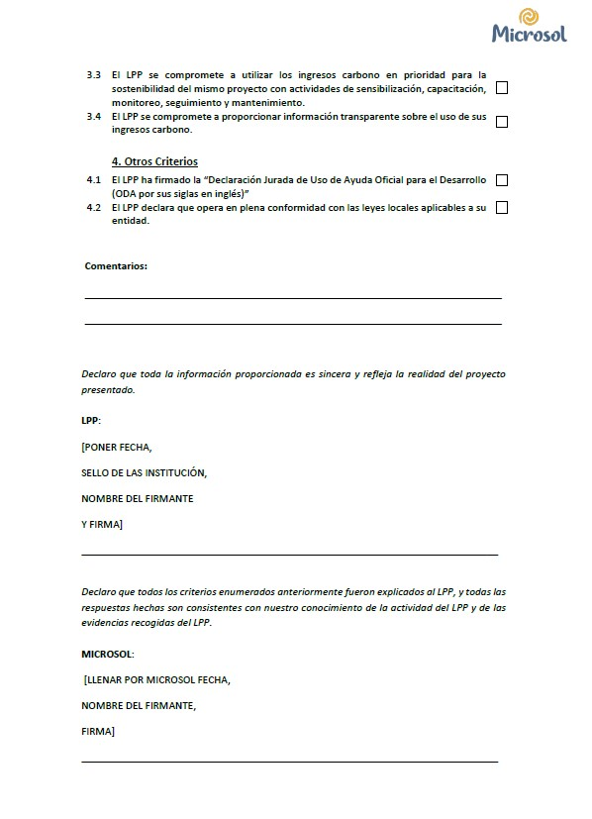

Appendix 4 CORRELATION BETWEEN POVERTY AND COOKING PRACTICE
When the United Nations adopted its Sustainable Development Goals in 2015 (SDGs), the aim was to address poverty, global inequality, and climate change simultaneously through 17 different goals. One of these goals is to achieve access to clean energy (SDG 7) for all. However, an often-overlooked aspect of energy poverty is cooking poverty — the lack of access to modern cooking methods and technologies. According to the World Bank’s 2020 Energy Progress Report, 2.8 billion people across the globe do not have access to clean cooking and instead rely on solid fuels like wood, kerosene, coal, or animal dung.
As shown in the next figure, gas has overtaken unprocessed biomass in low- and middle-income countries since 2010, reflecting its predominance in urban areas. Electricity has also been used more frequently for cooking in urban areas. Rural areas still rely heavily on unprocessed biomass, but its share is falling.
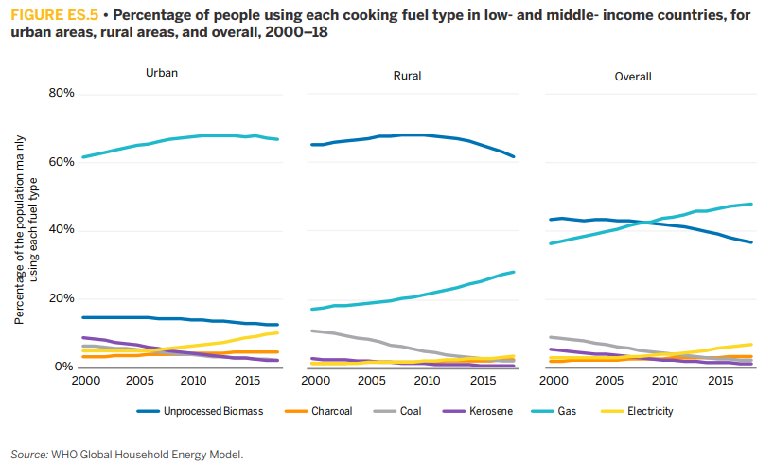
Source: “Tracking SDG 7 – The energy progress report”
Using wood for cooking has many negative impacts for the user: loss of time and risks related to the collection of wood, cooking is longer and less practical, health problems because of the smoke, etc.
For that reason, it cannot be considered a voluntary choice of people, but it is a direct consequence of their low revenues. Energy ladder models show that as income levels increase, people switch from the use of solid fuels (mainly wood in Latin America) to cleaner fuels such as gas and electricity.
Nevertheless, in many developing countries, gas remains inaccessible due to its high price or transportation cost.
In 2018 PoA GS1377 and its VPAs transitioned to the Gold Standard for the Global Goals. In “Principles & requirements rule” is mentioned that: “Section 4.1.51 All Gold Standard Projects (including those that transition from earlier versions) required to demonstrate Financial Additionality, as noted above, shall demonstrate Ongoing Financial Need for such mechanisms.” To be aligned with this point, each VPADD will detail the "Ongoing Financial Need".

Appendix 5 – Additionality supporting information
Excel document attached

Revision History

Version |  | Date |  | Remarks
2.1 |  |  | 31 May 2022 |  | Editorial changes and revisions
2.0 |  |  | 04 May 2022 |  | Key Project Information table revised to cater for the following information:  - Scale of PoA  - Title and GS ID of all real case VPAs included in the PoA  A new Management System section included  Safeguarding Principles Assessment section removed  Outcome of PoA Level Stakeholder Consultation section revised in the following manner:  - Justification for Stakeholder Consultation at PoA Level Only section removed  A new Consideration of Stakeholder Comments Received section added
1.1 |  | 14 October 2020 |  | Hyperlinked section summary to enable quick access to key sections  Improved clarity on Key Project Information  Inclusion criteria table added  Clarification on POA level LSC and Safeguard Principles Assessment  Improved Clarity on SDG contribution/SDG Impact term used throughout  Clarity on Stakeholder Consultation information required  Provision of an accompanying Guide to help the user understand detailed rules and requirements
1.0 |  | 10 July 2017 |  | Initial adoption

All the text comes from the WHO latest publication “Health in the Americas” (2012), Chapter 3. The Environment and the Human security. https://www3.paho.org/salud-en-las-americas-2012/index.php?option=com_content&view=category&layout=blog&id=36&lang=en&Itemid=101
DALY (Disability-Adjusted Life Year): WHO metric system to quantify the burden of disease from mortality and morbidity.
In the case of sale of the technology to organizations that distribute them to the end users, the capacity building can be performed by the organization’s staff that has been trained beforehand by the LPP.
For simplification, every time the word “technology” will be used from now on in this document, it will imply that “technologies and/or practices” are considered.
Page 1 of the Methodology.
Correlation between poverty and utilization of wood for cooking is further demonstrated in Appendix 4.
http://cdm.unfccc.int/methodologies/PAmethodologies/tools/am-tool-01-v7.0.0.pdf
See “Appendix 5– Additionality supporting information – ICS – v4”
https://globalgoals.goldstandard.org/all-documents/
The text comes from the Word Bank publication “Tracking SDG 7: The energy progress report 2020”
The figure comes from the Word Bank publication “Tracking SDG 7: The energy progress report 2020”

