ANNEX AN – THE GOLD STANDARD MICRO-PROGRAMME OF ACTIVITIES DESIGN DOCUMENT TEMPLATE

CONTENTS

- General description of micro-scale programme of activities

- Duration of the micro-scale programme of activities

C. Stakeholder comments

D. Application of a baseline and monitoring methodology to a micro-scale activity (VPA)

Annexes
Annex 1: Contact information on Coordinating/managing entity and participants of micro-scale programme of activities (PoA)

Annex 2: Information regarding public funding

NOTE: At the time of requesting registration, this form must be accompanied by a VPA-DD applying a real case.

SECTION A. General description of micro-scale programme of activities (PoA)

A.1 Title of the micro-scale programme of activities (PoA):
>>
GS 3112 - GHG Emission Reduction through use of Bondhu Chula (Improved Cook Stoves) in Bangladesh
20/01/2015
Version 4.0
A.2. Description of the micro-scale programme of activities (PoA):
>>
Policy / Measure or stated Goal of the PoA
The micro-scale PoA (“mSC-PoA”) involves the installation and maintenance of domestic improved cooking stoves (“ICS” branded as Bondhu Chula) by Partner Organization (“PO”) & Partner Entrepreneurs (PEs) in Bangladesh.
The current cooking practice in Bangladesh is the use of “three-stone” cooking stove, popularly known as traditional stoves. Biomass serves for 90% of Bangladeshi households’ energy needs. Around 95% of rural population uses biomass fuel for cooking with fuelwood being used in around 85% households. Traditional wood-fired cookstoves and open fires emit small particles, carbon monoxide and other noxious fumes in significant quantities. The amounts of carbon mono-oxide and other pollutants released from everyday cooking is highly damaging to indoor air quality. 46,000 women and children die each year and millions suffer from respiratory diseases, tuberculosis, asthma, cardiovascular diseases and eye and skin infections. As per Yale Study in the Proceedings on the National Academy of Sciences, despite these significant health risks, women in rural Bangladesh still prefer inexpensive, traditional stoves for cooking over modern ones. In most rural homes, where there is no electricity, food is cooked over an open fire using wood, agricultural residue, and animal dung, known together as “biomass.” 98% of Bangladesh’s rural population cooks with biomass using traditional stoves, despite years of efforts by governments and health organizations to promote models that are fuel-efficient and have chimneys.
As per World Bank Report, Some 95 percent of Bangladeshi households collect or purchase biomass energy with which to cook all or part of their meals, mainly using fixed clay stoves. The inherent inefficiency of such stoves, combined with the high moisture content of biomass cooking fuels, results in incomplete combustion, producing IAP.
The Bangladesh Department of Environment has a mission to improve indoor air quality reflected in the Country Action Plan for Clean Cookstoves, which aims to achieve to 100% clean cooking solutions by 2030.
The PoA attempts to address these issues by implementing the widespread adoption of energy efficient stoves to households all over Bangladesh. These stoves burn fuel more efficiently and are designed to draw off smoke and toxins, thus creating cleaner indoor air for women and children. They have also been shown to use about 50% less fuel to cook the same amount of food. In the absence of this project households would cook primarily using traditional inefficient stoves, perpetuating environmental and health degradation. The combustion of the non-renewable fraction of woody biomass of the cooking fuel generates a variety of gases including Carbon Dioxide (CO₂) and Methane (CH₄), two of the six Greenhouse Gases (“GHG”) covered under the Kyoto Protocol of the United Nations Framework Convention on Climate Change (“UNFCCC”) as well as under the Gold Standard Foundation carbon standard for energy projects. The replacement of traditional stoves by ICS improves heat transfer, hence reducing the total amount of fuel required for cooking and reducing amount of GHG emitted into the atmosphere. Verified Emission Reductions (“VERs”) are calculated following the “Gold Standard Simplified Methodology for Efficient Stoves” methodology, version February 2013, on the basis of the mass of non-renewable woody biomass saved by the ICS’s.
General Operating and Implementation Framework of the PoA
This program will be managed by SZ Consultancy Services Limited (SZCSL) as the Coordinating/Managing Entity (CME). SZCSL will coordinate the installation of the stoves by local partners, at a subsidized cost for users, in exchange for the rights to the Voluntary Emission Reductions (VERs). It is the revenue from the sale of VERs that will co-fund the installation and after sales service process, through direct subsidy and capacity building measures to train local stove entrepreneurs/ manufacturers.
Each partner will be trained to manufacture the stove to an exact specification. SZCSL will be responsible for ensuring that end user information data is captured at the manufacturing and selling point to facilitate the monitoring of stoves over the PoA crediting period. The partner will be trained to capture this monitoring data from the installation process, identifying each stove by a unique reference number and the location of the stove.
Monitoring data collected during the installation and operation of the stoves will be captured in an electronic data management system, or monitoring database. This system will be available for review during the validation and verification.
For details refer section A.4.4.1 below.
The proposed PoA is a voluntary action by the CME.
A.3. Coordinating/managing entity and participants of PoA:
>>The Coordinating/Managing Entity (CME) of the PoA is SZ Consultancy Services Limited (also the project participant), the entity which communicates with Gold Standard and is the entity responsible for the PoA.

A.4. Technical description of the micro-scale programme of activities:
>>
The project will disseminate ICSs that are constructed individually by local technicians trained and acting under a contractual basis on behalf of SZCSL. The initial ICS installations are constructed from brick and/or concrete and have as accessories - a chimney with a cap and grates. ICSs are designed to increase heat transfer, while also matching traditional utensils and cooking habits of people in Bangladesh. The improvement in efficiency is achieved by properly adjusting the dimensions of the combustion chamber and ensuring effective air flow. In comparison to traditional stoves, the project ICS provide a fuel savings of around 50% to cook the same amount of food. Various models of Bondhu Chulha that are envisaged for dissemination in this PoA are as follows:
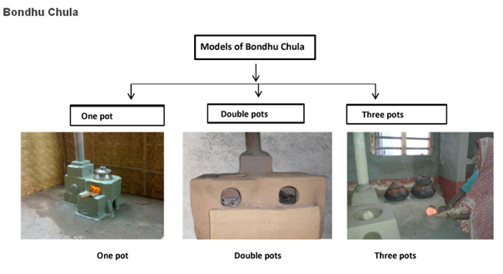
Bondhu Chulha (Design specifications)
 | One Pot Stove |  |  | Two Pot Stove |  |  |  |  |  | Chimney
 | 1st Mouth Diameter (inches) | Depth of Grate  (inches) | Air Inlet Area  (inches²) | 1st Mouth Diameter (inches) | 2nd Mouth Diameter  (inches) | Fuelwood Inlet Path  (inches²) | Depth of Grate  (inches) | Air Inlet Area  (inches²) | Chimney Diameter (inches) |  | Chimney Length
Domestic ICS | 7 | 8.5 | 20.25 | 7 | 6 | 4.5x4.5 | 8.5 | 20.25 | 3 |  | 6-8 ft
Domestic ICS | 8 | 8.5 | 25 | 8 | 7 | 4.5x4.5 | 8.5 | 20.25 | 3 |  | 6-8 ft
Domestic ICS | 9 | 9 | 25 | 9 | 8 | 5x5 | 9 | 25 | 3 |  | 6-8 ft
Domestic ICS | 10 | 9.5 | 30.25 | 10 | 9 | 5.5x5.5 | 9.5 | 30.25 | 3 |  | 6-8 ft
Domestic ICS | 12 | 12 | 42.25 | 12 | 11 | 6.5x6.5 | 12 | 42.25 | 3 |  | 6-8 ft
A three pot stove is a combination of a one pot and a two pot stove.
A.4.1. Location of the micro-scale programme of activities:
>>
The PoA shall be limited to the geographical boundary of People Republic of Bangladesh.
A.4.1.1. Host Party(ies):
>>
People Republic of Bangladesh
A.4.1.2. Physical/ Geographical boundary:
>>
Bangladesh is divided into seven administrative divisions which are subdivided into Districts (64) and these are further subdivided into Upazilas (493).
The geographical area within which all micro scale-VPAs included in this PoA will be implemented is defined as the People’s Republic of Bangladesh. Bangladesh has no law, policy that mandates dissemination of ICS by institutions / companies or adoption of ICS by households. Each ICS installed by a PE under a VPA shall respect the geographical boundary of the micro scale-PoA (i.e. Bangladesh).
Necessary VPA inclusion criteria has been developed in this regard

A.4.2. Description of typical micro-scale programme activity(ies):
>>
A typical VPA under the PoA will consist of the installation and maintenance of ICSs for use of Bangladeshi households in Bangladesh. The types of cookstoves envisaged for distribution have been defined in A.4 above. For a detailed operational and implementation framework of the PoA refer section A.4.4.1
A.4.2.1. First technology or practice to be employed in the PoA and the eligibility criteria for inclusion of the technology or practice in the PoA:
>>Each VPA under the PoA will disseminate ICSs that are constructed individually by local technicians trained and acting under a contractual basis on behalf of SZCSL. The ICS installations are constructed from brick and/or concrete and have as accessories - a chimney with a cap and grates. ICSs are designed to increase heat transfer, while also matching traditional utensils and cooking habits of people in Bangladesh. The improvement in efficiency is achieved by properly adjusting the dimensions of the combustion chamber and ensuring effective air flow. In comparison to traditional stoves, the project ICS provide a fuel savings of around 50% to cook the same amount of food. The technical specifications of various stove models are explained in section A.4 above
The following eligibility criteria are defined for inclusion of a VPA in the PoA:
Eligibility criteria # | Eligibility criteria requirements | Explanation for a typical VPA included in the PoA
- PoA Boundary and automatic additionality with respect to LDC as a region. | The geographical boundary of the VPA including any time-induced boundary consistent with the geographical boundary set in the PoA; | All ICS installed in a VPA shall be within the geographic boundary of Bangladesh
- Methodology applicability criteria 1 | The baseline fuel should be firewood and the baseline stove is a traditional 3 stone fires, open fired cookstove with no grate/chimney / ventilation etc | This has already been substantiated at the PoA level for entire Bangladesh as a whole. Refer section A.2 above which substantiates by means on external studies / published literature that fuel wood is used for cooking in more than 90% households as well as traditional means of cooking are prevalent in almost 100% of rural population.
- Methodology applicability criteria 2 | The ICS shall have a design efficiency of more than 20%. | The design efficiency of each cookstove model envisaged under a given VPA shall be more than 20% as per manufacturer’s specification or as per test report issued by an external agency.
- Methodology applicability criteria 3 | Conditions that avoid double counting of emission reductions like unique identifications of product and end-user locations | All ICS under this SSC-VPA shall be provided with uniquely serial number and address of the cook  stove tracing to its location. A PE shall record the serial number, end user information at the time of sale/installation and submit the information to CME
- Methodology applicability criteria 4 | Transfer of ownership of credits form user to PE and from PE to CME | Each user shall sign a contract with PE at that time of stove installation transferring the ownership of credits from user to PEs. The PEs shall be signing a contract with CME for transfer of credits from PE to ME
- Methodology applicability criteria 5 | Mechanism for Discontinuation of traditional stove by means of either of the following:  - Removal of traditional stove at time of ICS installation  - Offering discount on ICS  - Monitoring of presence of traditional cookstove during monitoring and verification on a sampling basis | A VPA shall describe the mechanism in place to meet this requirement. The preference shall be provided to 1) or 2). In absence of 1) or 2), the monitoring plan of VPA-DD shall include the monitoring of continued usage of traditional cookstove on sampling basis
- Start date of VPA | Start date of a VPA shall be later than the start date of PoA | The start date of a VPA shall be date of sale of first cook-stove included in the VPA.
- Local Stakeholder Consultation | Each VPA/ Group of VPAs shall undergo LSC/SFR as per GS requirements | A VPA shall be listed on GS registry before its inclusion in the PoA as listing of a VPA is subject to GS approval of VPA meeting the stakeholder requirements
- ODA diversion | Conditions to provide an affirmation that funding from Annex I Parties, if any, does not result in a diversion of official development assistance; | Each VPA shall be accompanied with a no – ODA declaration by the VPA implementer
- Micro Scale Limit | Annual ER from each VPA shall be limited to 10,000 tCO₂e | Each VPA shall provide an ex-ante calculation of expected VER volume from the VPA in the VPA-DD which shall be limited to 10000 tCO₂e
- Prior Consideration of Carbon | This shall be demonstrated for all retroactive VPAs in case a new VPA implementer (other than SZSCL) joins the PoA | A new VPA Implementer entering in the PoA shall justify prior consideration of carbon revenues for its first VPA.
A.4.2.2. Second technology or practice to be employed in the PoA and the eligibility criteria for inclusion of the technology or practice in the PoA:
>>NA
A.4.3. Description of how the anthropogenic emissions of GHG by sources are reduced by the technology or practice below those that would have occurred in the absence of the registered PoA (assessment and demonstration of additionality):
>>
The Proposed PoA is a Voluntary Coordinated Action
Bangladesh has no law, policy mandating the distribution of ICS by institutions /agencies or mandates adoption of ICS by households. This proposed micro-scale PoA is a voluntary action by the CME. The additionality is being demonstrated at the PoA level. SZSCL conducted the PoA level LSC before the start of the sale of cookstoves under the PoA. This indicates prior carbon consideration by SZCSL at the PoA level. Eligibility criteria #7 shall ensure that any VPA entering the programme shall not start prior to start date of the PoA. For other VPA implementers joining the PoA (other than SZCSL), eligibility criteria (#11) to demonstrate prior consideration of carbon shall ensure that the VPAs are additional.
The proposed voluntary coordinated action would not be implemented in the absence of the PoA
Annex U: “MICRO-PROGRAMME RULES AND PROCEDURES” para 6 states the following:
Additionality does not need to be demonstrated for a micro-programme that only plans to include activities that are deemed additional as per criteria listed below. This can become the inclusion criteria for future activities.
According to the criteria 1 in the list in Annex U, the PoA is located in a Bangladesh a Least Developed Country (LDC), therefore it is deemed additional. This has been developed as a VPA inclusion criteria in section A.4.2.1 above (refer criteria #1).
A.4.4. Operational, management and monitoring plan for the programme of activities (PoA):

A.4.4.1. Operational and management plan:
>>
Operational and management plan
SZ Consultancy Services Limited develops partner entrepreneurs. These Partner Entrepreneurs (PEs) are responsible for sales and installation of ICSs. The operation of the ICS is carried out by the user, and training of the user on how to operate and maintain the ICS will be provided by the PEs as well by the Field Officers of SZCSL. Physical maintenance of the ICS will be undertaken by the PEs and its associated technicians at a marginal or no payment fee for the users, depending on the nature of maintenance.
The PEs will follow the monitoring plan and procedures - developed by the CME for the identification of stoves sold during the course of the project, as follows:
- A unique serial number is assigned to the ICS. Once the construction of the ICS is finalized and the unit is sold, the PEs technician collects contact information of the user, serial number of stove, installation date. The user also signs an agreement to transfer the ownership of emission reduction credits to the PEs. The PEs and its technicians are responsible to record the information for all ICS purchasers. For each installation of the ICS, the user shall agree, as per the Sales Contract, to the following:
  - Cooperate with the PE and/or the CME for monitoring purposes
  - transfer the ownership of credits from user to PE
The Sales Contract will also contain the following information:
    - Name of customer
    - Address and phone number (if available)
    - Stove model and serial number
    - Installation date
- Each PE and their associated technicians are responsible for the installation and maintenance of ICSs. Users may be offered to pay for the ICS in monthly installments (depending on the area and on the commercial approach adopted by the PE), to overcome the financial constraints. The operation of the ICS is carried out by the user, and training on how to operate and maintain the ICS is given by the PE. Physical maintenance of the ICS will be provided by the PEs and their technicians.
- The information collected by the PEs will be transferred to the CME (the Data Base). All PEs records are screened by the CME, together with cross-checks on the PEs installation records in order to confirm that the installation record is authentic and that no double counting occurs. The electronic files containing each installation record are duplicated by paper documents received from individual householders. The installations record is a key component of the annual monitoring report, since the actual installation date is used to draw samples for monitoring, results from which shall be used to calculate the emission reductions achieved by the ICSs installed.
- The PEs and the coordinating/managing entity shall have signed an agreement including specific provisions and declarations that confirm the micro-scale VPA project proponents agree that their activity is being subscribed under the PoA and transfer of the ownership of credits from PE to CME.
A.4.5. Public funding of the programme of activities (PoA):
>>
There is no public or ODA funding for this PoA, all revenue for the project will be derived from the sales of VERs. Please see the signed ODA declaration form in Annex 2.
SECTION B. Duration of the micro-scale programme of activities (PoA)

B.1. Starting date of the programme of activities (PoA):
>>
26 February 2014, date of PoA level LSC Meeting
B.2. Length of the programme of activities (PoA):
>>
28 years 00 months
SECTION C. Stakeholders’ comments

C.1. Summary of stakeholder comments on the PoA design:
During the design consultation, stakeholders were requested to given their opinion on the PoA design. Overall, the stakeholders were appreciative of the PoA and the health/ environment and development benefits associated with the PoA. In general, stakeholders commented on greater involvement of local administration / local governmental institutions or NGOs in the PoA. The PoA for that matter is open to any party who wishes to join to PoA and get involved into manufacturing and distribution of cookstoves as a partner organization provided they sign an agreement with the CME which define their responsibilities and obligations towards the PoA.
C.2. Please indicate the level at which local stakeholder consultation is conducted. Justify the choice:
- Local stakeholder consultation is done at PoA level
- Local stakeholder consultation is done at VPA level
A PoA level LSC was conducted on 26 February 2014.
VPA level LSC for VPA 01 was conducted on 30 March 2014. For VPA level LSC refer VPA01-DD
C.3. Brief description how comments by local stakeholders have been invited and compiled:
>>
Agenda and Schedule of the PoA level LSC meeting:
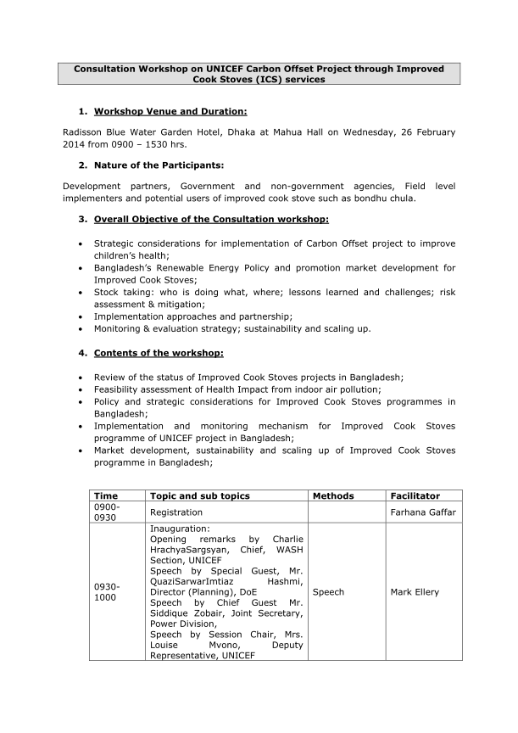
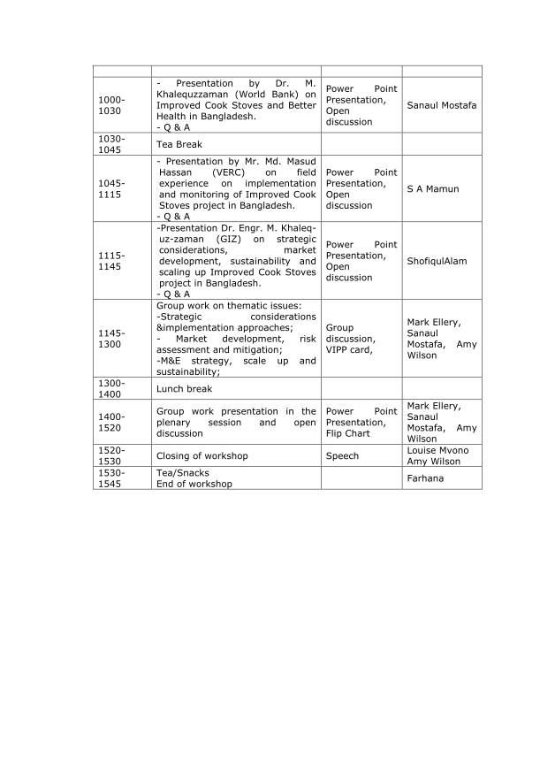
Non-Technical Summary of the Consultation Workshop on UNICEF Carbon Offset Project through Improved Cook Stoves (ICS) services

- Non-Technical Summary of the project:
This PoA involve the distribution of ICS in Bangladesh. The PoA starts with its first VPA envisaging distribution of 40,000 improved cookstoves in the Brahminbaria, Patuakhali, Khulna and Narail districts of Bangladesh initially and shall expand to other districts. The Government of Bangladesh has targeted to improve indoor air quality reflected in the Country Action Plan for Clean Cookstoves, which aims to achieve to 100% clean cooking solutions by 2030. This program is facilitated and supported by GiZ (German Development Cooperation), UNICEF and SZ Consulting Services Ltd.
90% of Bangladeshi households use energy inefficient and poorly ventilated clay stoves and traditional fuels for cooking such as wood, cow dung and other agricultural waste. The amounts of carbon monoxide and other pollutants released from everyday cooking is highly damaging to indoor air quality. 46,000 women and children die each year and millions suffer from respiratory diseases, tuberculosis, asthma, cardiovascular diseases, and eye and skin infections.
This project attempts to address these issues by implementing the widespread adoption of energy efficient stoves to households all over Bangladesh, starting in these four districts. These stoves burn fuel more efficiently and are designed to draw off smoke and toxins, thus creating cleaner indoor air for women and children. They have also been shown to use 50% less firewood to cook the same amount of food. In the absence of this project households would cook primarily using traditional inefficient stoves, perpetuating environmental and health degradation.

Further advantages of these improved cooking stoves are:

- Air quality: Children and mothers will be exposed to fewer air pollutants through reduced emission of CO2, carbon monoxide and harmful toxins, thus reducing childhood pneumonia, many other respiratory diseases and cancer
- Biodiversity will be improved as the programme reduces pressure on remaining forest reserves in Bangladesh
- Employment: the programme gives rise to employment opportunities for new ICS technicians, assistants, office staff and other related jobs in Bangladesh. Over 5,000 entrepreneurs are involved in the manufacture and distribution of these stoves.
- Livelihood of the poor: the circumstances of poor families will be improved since the stoves reduce fuel cost. Reduction in wood consumption implies relief from drudgery and more opportunity for productive activity, arising from less time spent collecting fuel.
- Access to energy services: The ICS require less fuel, which in many areas can be a scarce resource or very expensive to buy; also, users have found ICS more convenient, shortening the cooking time.
- Human and institutional capacity is raised through the business development component of the project. The programme has raised capacity development among the employed staff through trainings and workshops.

The stoves are marketed under the name "Bondhu Chula" meaning friendly stove. Theyare built locally and distributed through local commercial channels, such as sanitary shops, under the guidance of GiZ and SZ Consulting Services Ltd.

Consultation Workshop on UNICEF Carbon Offset Project through Improved Cook Stoves (ICS) services
Invitation tracking table
Sl | Name & Designation | Organization | Phone & Email | Mode of invitation
1. | Dr. Pascal Villeneuve | Representative, UNICEF Bangladesh | ssislam@unicef.org  Tel: (+88) 02 885 2266 Ext 7020, | Email and Phone
2. | Mr. Siddique Zobair  Joint Secretary | Ministry of Power, Energy & Mineral Resources - Power Division | zobair.siddique@giz.de  8802-7174094 | Email and Phone
3. | Mr. QSI Hashmi  Director ( Planning) | Ministry of Environment and Forest - Directorate of Environment (DoE) | quazihashmi@gmail.com  hashmi@doe-bd.org  01711145239 | Email and Phone
4. | Dr. Khalequzzaman  Consultant | World Bank | dkhaliquzzaman@worldbank.org  01817-521635 | Email and Phone
5. | Dr. Engr. M. Khaleq-uz-zaman  Senior Advisor | GIZ | khaleq.zaman@gtz.de  0189499778 | Email and Phone
6. | A.K. D. Sher Mohammad Khan, Senior Energy Advisor & Country Coordinator, SARI/EI | USAID | sherkhan@usaid.gov,  Tel: 8855500 x 2072 | Email and Phone
7. | Md. Saiful Islam  Senior Scientific Officer, Biomass, Bio-fuel, Env. pollution science | Bangladesh Council of Scientific & Industrial Research (BCSIR) | saiful_chem@yahoo.com  01816477161 | Email and Phone
8. | Dr.Dil Afroza Begum  Head & Professor, Chemical Engg. Dept. | Bangladesh University of Engineering and Technology (BUET) | afroza@che.buet.ac.bd  9662365, 9665650, Ext. 7157 | Email and Phone
9. | Prof.Dr.Saiful Huque  Institute of Energy | Dhaka University | saifulhq@yahoo.com  01911340058 | Email and Phone
10. | Dr. Hassan Rashid Khan,  Consultant | Infrastructure Development Company Limited (IDCOL) | drhasanbd@yahoo.com  01817625336 | Email and Phone
11. | Dr. M Shahidul Islam  Consultant | Grameen Shakti | dmsislam@agni.com  dmsislam@gmail.com  +8801713002180; +8801726444595 | Email and Phone
12. | Md. Masud Hassan  Coordinator  Watsan & Technology | Village Education Resource Centre (VERC) | masud@verc.org, verc@bangla.net  Mb: 01713017064 | Email and Phone
13. | Veena Khaleque  Country Director | Practical Action Bangladesh | veena.khaleque@practicalaction.org.bd  01819245883 | Email and Phone
14. | Redwanoor Rahman  Managing Director | Rahman Renewable Energy Company Limited | redwanoor@yahoo.com  01911058095 | Email and Phone
15. | Dr. Animesh K Sarker | SZ Consultancy Services Limited | sz@szbd.info  01823629036 | Email and Phone
16. | Mr. Wahidur Rahman  Unit Head (Technical) | Infrastructure Development Company Limited (IDCOL) | wahid@idcol.org  01556338657 | Email and Phone
17. | Mr. Faruq Al Banna | SZ Consultancy Services Limited | banna@szbd.info  01833-104104 | Email and Phone
18. | Eric Otto Gomm | GIZ | Otto.gomm@giz.de | Email
19. | Ms. Suchitra Hajong | SZ Consultancy Services Limited | sz@szbd.info  01833104103 | Email and Phone
20. | Mr. Mowdudur Rahman | SZ Consultancy Services Limited | sz@szbd.info  01847003739 | Email and Phone
21. | Hrachya (Charlie) Sargsyan  Chief WASH Section | UNICEF Bangladesh | hsargsyan@unicef.org  (88)- 01711820790 | Email and Phone
22. | Shofiqul Alam  Urban Development Specialist | UNICEF Bangladesh | shalam@unicef.org  01762 172217 | Email and Phone
23. | Masroora Haque | Clean Energy Alternative | Masroora.haque@gmail.com  01953567382 | Email and Phone
24. | Sebastian Randig | Clean Energy Alternative | Sebastian.randig@cea-bd.com  01768520012 | Email and Phone
25. | Amy Wilson | UNICEF | awilson@unicef.org.uk | Email
26. | Zunayed Ahmed | GIZ | Zunayed.ahmed@giz.de  01741128820 | Email and Phone
27. | Redwanur Rahman | Rahman Renewable Energy Company | redwanoor@yahoo.com,  01712586110 | Email and Phone
28. | Laila Ishrat Jahan | VERC | laila@verc.org  01716896162 | Email and Phone
29. | Dr. Md. Abdur Rouf | Institute of Fuel Research & Development (IFRD), Bangladesh Council on Scientific and Industrial Research (BCSIR) | roufifrd@yahoo.com  01556318036 | Email and Phone
30. | Khaled Hasan | Department Of Environment | mkhdoe@gmail.com  01711731500 | Email and Phone
31. | Dr. Nasif Shams | University of Dhaka | nasifshams@gmail.com  01983444555 | Email and Phone
Gold Standard staff was not invited in the PoA level LSC meeting because SZSCL was not aware of any GS Secretariat presence in Bangladesh. This was discussed with GS during the PoA listing. As a resolution and corrective action, SZSCL shall invite GS staff during the SFR round for VPAs.
C.4. Summary of the comments received:
>>
List of Participants:
Sl. | Name of participant job / position in the Community | Male/Female | Signature | Organization (if relevant) | Contact details
1 | Sebastian Randig | Male | Y | Clean Energy Alternative | See Original
2 | Masroora Haque | Male | Y | Clean Energy Alternative | See Original
3 | Khaled Hasan | Male | Y | Department Of Environment | See Original
4 | Dr. Engr. M. Khaleq-uz-zaman, Senior Advisor | Male | Y | GIZ | See Original
5 | Eric Otto Gomm | Male | Y | GIZ | See Original
6 | Zunayed Ahmed | Male | Y | GIZ | See Original
7 | Mr. Wahidur Rahman, Unit Head (Technical) | Male | Y | Infrastructure Development Company Limited (IDCOL) | See Original
8 | Dr. Md. Abdur Rouf | Male | Y | Institute of Fuel Research & Development (IFRD), Bangladesh Council on Scientific and Industrial Research (BCSIR) | See Original
9 | Mr. Siddique Zobair, Joint Secretary | Male | Y | Ministry of Power, Energy & Mineral Resources - Power Division | See Original
10 | Redwanoor Rahman, Managing Director | Male | Y | Rahman Renewable Energy Company Limited | See Original
11 | Dr. Pascal Villeneuve | Male | Y | Representative, UNICEF Bangladesh | See Original
12 | Mr. Faruq Al Banna | Male | Y | SZ Consultancy Services Limited | See Original
13 | Shofiqul Alam, Urban Development Specialist | Male | Y | UNICEF Bangladesh | See Original
14 | Dr.Nasif Shams | Male | Y | University of Dhaka | See Original
15 | A.K. D. Sher Mohammad Khan, Senior Energy Advisor & Country Coordinator, SARI/EI | Male | Y | USAID | See Original
16 | Laila Ishrat Jahan | Female | Y | Village Education Resource Centre (VERC) | See Original
17 | Md. Masud Hassan, Coordinator, Watsan& Technology | Male | Y | Village Education Resource Centre (VERC) | See Original
18 | AFM Shahid, Assitant Manager | Male | Y | Infrastructure Development Company Limited (IDCOL) | See Original
19 | Md. Faisal Hossain, Researcher | Male | Y | Dhaka University | See Original
20 | Uttam Kumar Saha, Head | Male | Y | Practical Action Bangladesh | See Original
21 | Farhana Gaffar | Male | Y | UNICEF WASH | See Original
22 | Louise Mrono, Department Representative | Male | Y | UNICEF | See Original
The following photographs show the proceedings of the PoA level LSC meeting:
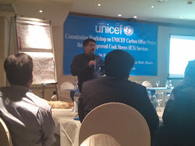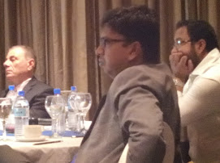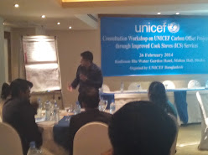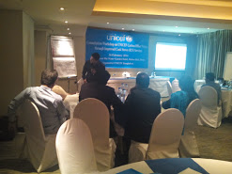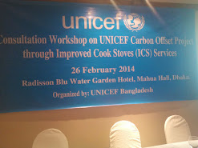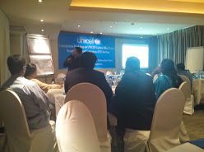
Original list of participants
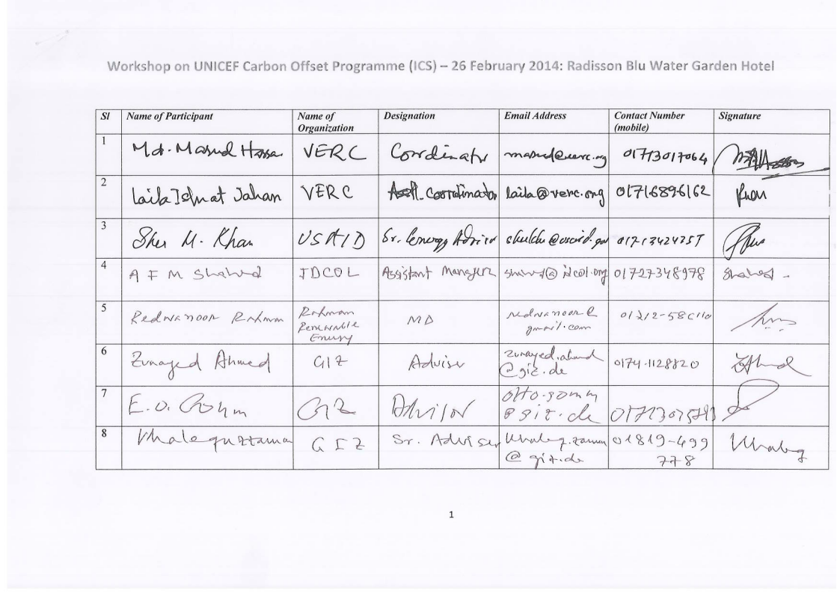
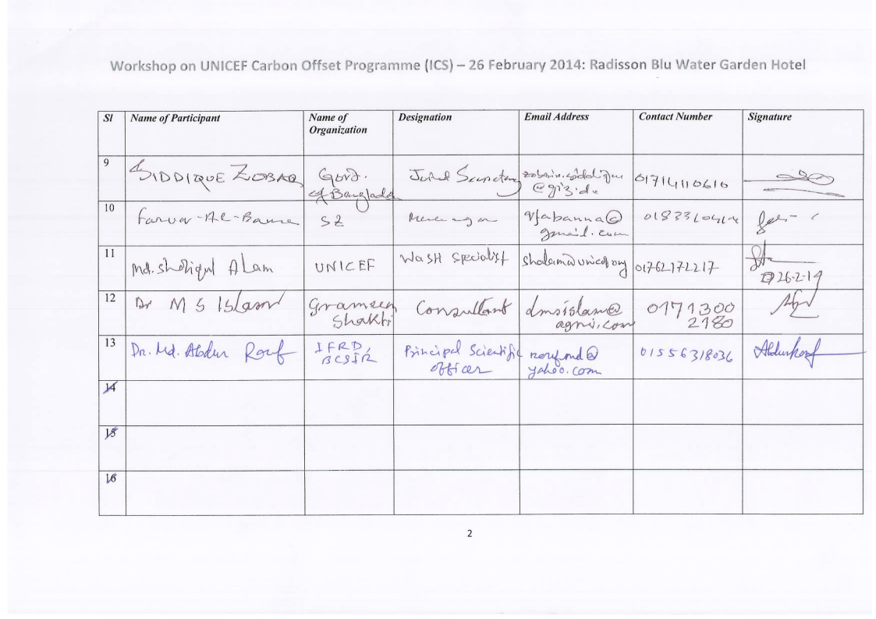
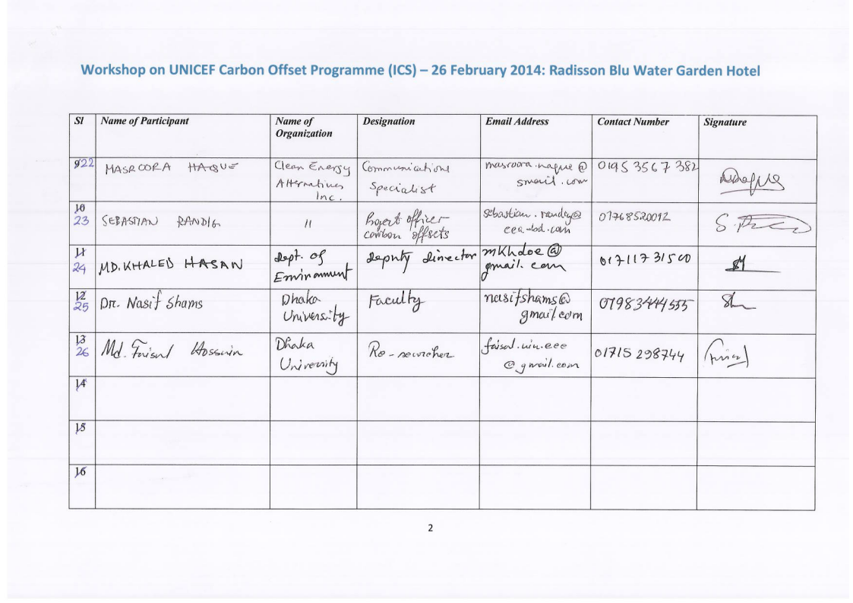
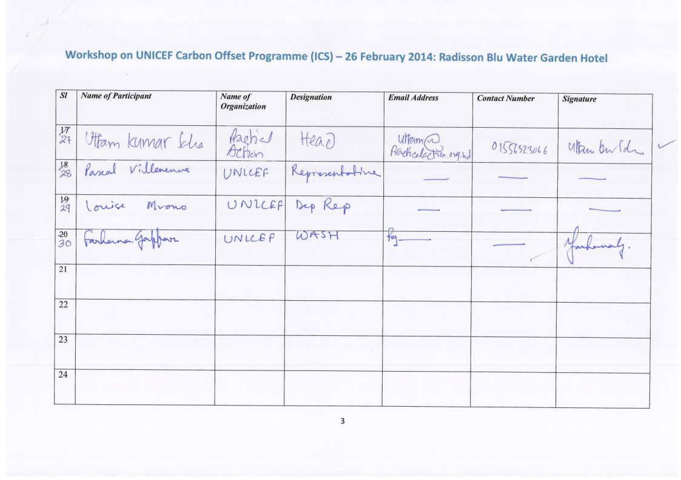
C.5. Report on how due account was taken of any comments received and on measures taken to address concerns raised:
>>
The following table gives the comments received and explanation provided
Stakeholder comment | Was comment taken into account  (Yes/ No)? | Explanation (Why? How?)
How the ICS users will get assurance about the benefit of using disseminated ICS under this project? | Yes | The ICS had been developed by BCSIR (Bangladesh Council of Scientific and Industrial Research) and improved by GIZ/SZ. Its benefit along with its efficiency and environment friendliness is already laboratory tested (BCSIR, Aprovecho Research Center). According to the test report we can say that every user under this project will get the benefit of using ICS.
Why this pro-environment and user friendly project will confine in only four district of Bangladesh? | Yes | First of all, it is the first kind of GIZ-UNICEF-SZ joint venture project in the world. And we are happy that it is going to be started with Bangladesh. We have an enormous challenge to accomplish this project within the time frame accordingly and set an example to replicate it locally or globally. So we have selected these four districts very preciously taking consideration about their demography, geology, climate & Culture to carry on this programme as a pilot project in those areas.
How this program will ensure the proper implementation of the value chain? | Yes | We have four steps administrative setup to ensure the proper and healthy implementation of the value chain. Starting at the bottom with Promotional Volunteer-Asst. District Manager-District Manager-Divisional Manager-AGM Head Office. We have adequate training facility for all level of staff and our value chain partners. We will ensure proper implementation of value chain through this extensive network of staff. This network of office and unit office will perform the following activities;  - Create and ensure functional supply chain  - Training of entrepreneurs and their technicians on marketing, production, installation, maintenance and after sales services  - Awareness building and marketing  - Users’ training  - Monitoring  - Data collection
How awareness making activity will be carried out? | Yes | The market of ICS is very low, although improved over the last few years. Therefore awareness making activity need to carry on in parallel. This is necessary for other reasons also such as:  - People are not aware about effects of indoor air pollution  - Cooking habit – behavioral change (very difficult!)  - Traditional stoves are made by women themselves and do not cost  - ICS costs money; HHs are reluctant to pay  - Traditional stoves are women’s own stoves  - Traditional stoves have to do with tradition of thousands of years  - Biomass fuel is in rural areas mostly collected, in urban areas purchased  And the awareness making program will be carried out by (as possible) following means:  - Leaflets, posters  - Promotional films & commercials  - Film shows and advertisement in electronic / print media  - TV discussion  - TV cooking program  - Exhibitions  - Support from local governments and elites  - Local level promotional meetings / marketing  - Meeting
Will not the subsidy proposed under this program distort the market? | Yes | It is the real fact that in many cases subsidy distorts the market but initially to convert need into demand no other effective tool have been introduced till now in developing world rather than subsidy. The market development will follow the buy down grant as per following rate:  - 250 Taka for general household  - 500 Taka for the poor (VGD card holders, etc.)  And we hope that it will not distort the market rather it will develop the market for a new technology.
What is the future prospect to expand this program in Bangladesh? | Yes | There is a huge prospect for scaling up the program in continuation of the proposed program. The demand of ICS is for 30 million household in all over Bangladesh. And SZ have the capacity to expand the project in other regions also.
How the carbon right will be transferred from end user to the authorized entity under this program? | Yes | During selling the ICS to the customer our partner will make an agreement on transferring the carbon right from end user to the authorized entity. By this agreement carbon ownership will be automatically transferred to the ratified entity of this program.
What about the continuation of Gold Standard fund for this project? | Yes | This project will provide money for the next 10 years for providing necessary after sales service to the disseminated cook stoves. Carbon funds will channel through cook stove entrepreneurs to the end users by providing support to make this project sustainable.
How do you ensure the usage of installed stoves? | Yes | Regular monitoring and training the users properly ensure the usage of the installed stoves. Apart from this our promotional volunteer keep on visiting door to ensure the proper usage of Bondhu Chula.
How do you ensure the continuous receiving of the stakeholder’s feedback/grievance? | Yes | A hard copy of relevant documents and a feedback/grievance book is maintained at the local office in each district. So the scope of input feedback/grievance is wide open for the stakeholders. The can come anytime and submit their feedback/grievances.
Any change in PoA design is not required on account of feedback / comment received during PoA level LSC.
C.6. Discussion on continuous input/grievance mechanism:
>>
 | Method Chosen (include all known details e.g. location of book, phone, number, identity of mediator) | Justification
Continuous Input / Grievance Expression Process Book | Physical documents and input/ grievance process book will be maintained at the each district office and Dhaka main office of SZ Consultancy Services Limited (SZCSL).  Dhaka Office: House# 3/2, Block#B, Lalmatia, Dhaka. Mediator: Faruq Al Banna , Mob: 01833-104104  For district office locations refer VPA-DD | A hard copy of the relevant documents and books are maintained at each of the district offices under a given VPAs.  Besides, as Dhaka Office is our central hub for all activities so input/ grievance expression book will be in our Dhaka Office (Head Office) also. Stake holders are welcome to contact Dhaka office also for input/ grievance.
Telephone access | 0088-02-8154229, 0088-01833-104237, 0088-01833-104104 | Since most stakeholders have a telephone, this will make the input/grievance process quicker and more accessible.
Internet/email access | sz@szbd.info, banna@szbd.info | Email address provided for stakeholders such as local and international NGOs who have access to the internet.

C.7. Report on stakeholder consultation feedback round at the PoA level:
>>
Not applicable
SECTION D. Application of an existing baseline and monitoring methodology or of a new methodology submitted as part of this micro-programme of activities

D.1. Title and reference of an approved baseline and monitoring methodology, or full description of a new methodology, applied to technologies or practices included in the PoA:
>> The Gold Standard Simplified Methodology for Efficient Cookstoves, version 2.2 dated February 2013
D.1.1 Justification of the choice of the methodology and why it is applicable to a considered technology or practice (s):
>>
Applicability condition | Justification
This methodology is applicable to micro scale programmes and micro scale activities that introduce new wood burning cook stoves to reduce the use of non-renewable firewood or switch from non-renewable to renewable firewood to meet thermal energy requirements for household cooking. | The project activity is installation of new improved wood burning stoves which has higher efficiency and will therefore reduce the use of non-renewable firewood. The non-renewable biomass usage is prevalent in Bangladesh. This is substantiated by the default value of f_{NRB} (=0.83) provided by EB67, annex 22 which was approved in EB68
A project proponent implements the activity or Programme of Activities (PoA). The individual households and institutions do not act as project proponents. | The individual households shall not act as project proponents; project proponent is SZ consultancy who is also the project implementer.
The following conditions apply:  - This methodology is applicable, if:  - the baseline fuel is only firewood; and  - the baseline stove is a three stone fire, or a conventional device without a grate or a chimney i.e. with no improved combustion air supply or flue gas ventilation; and  - the project stove is a single pot or multi pot portable or an in situ cook stove with a specified efficiency of at least 20%. | - This has already been substantiated at the PoA level for entire Bangladesh as a whole. Refer section A.2 above which substantiates by means on external studies / published literature that fuel wood is used for cooking in more than 90% households as well as traditional means of cooking are prevalent in almost 100% of rural population.  - Same as above  - The design efficiency of ICS is more than 20%. This has been developed as eligibility criteria for inclusion of a VPA in the PoA
- The project boundary can be clearly identified, and the cook stoves counted in the proposed project activity are not included in any other voluntary market or CDM project activity (i.e. no double counting takes place). The project proponent must have a mechanism in place together with appropriate mitigation measures to prevent double counting. | All ICS under this SSC-VPA shall be provided with uniquely serial number and address of the cookstove tracing to its location. A PE shall record the serial number, end user information at the time of sale/installation and submit the information to CME
- The project proponent must clearly communicate if the entity is claiming the ownership rights to sell the emission reductions resulting from the project activity. This must be communicated to the cookstoves producers, retailers and end users by contract or clear written assertions in the transaction paperwork. | Each user shall sign a contract with PE at that time of stove installation transferring the ownership of credits from user to PEs. The PEs shall be signing a contract with CME for transfer of credits from PE to ME
- The use of the baseline cookstove, as a backup or auxiliary technology, in parallel with the improved cookstove introduced by the project activity is permitted as long as a mechanism is put into place to encourage the removal of the old cookstove (e.g. a discounted price for the improved cookstove) and there is a definitive discontinuity of its use. The project documentation must provide a clear description of the approach chosen and the monitoring plan must provide a good understanding of the extent to which the baseline technology is still in use after the introduction of the improved technology (whether the existing baseline cookstove is not surrendered at the time of the introduction of the improved technology, or whether a new baseline cookstove is acquired and put to use by targeted end users during the project crediting period). The success of the mechanism put into place must therefore be monitored, and the approach must be adjusted if proven unsuccessful. If the baseline cookstove remains in use in parallel with the project cookstove, corresponding emissions must be accounted for as part of the project emissions, using the guidance given in Section III. | A VPA shall describe the mechanism in place to meet this requirement. The old stoves would be disposed of during installation of ICS. Alternatively, the operational status survey on a sample of ICS will also investigate the extent to which traditional stoves are destroyed and no longer used, even in a secondary role, in the houses adopting the ICS. If it is found that a portion of kitchens exists in which a traditional stove is used, even in a secondary role, then emission reductions shall be adjusted taking into account only the portion of the wood used in ICS.

D.1.2 Justification of the choice of the methodology and why it is applicable to another considered technology or practice:
>>
Not Applicable
D.2. Title and reference of another approved baseline and monitoring methodology, or full description of a new methodology, applied to technologies or practices included in the PoA:
>>
Not Applicable
D.2.1 Justification of the choice of the methodology and why it is applicable to a considered technology or practice:
>>
Not Applicable
D.2.2 Justification of the choice of the methodology and why it is applicable to another considered technology or practice:
>>
Not Applicable
D.3. Description of the sources and gases included in the VPA (s) boundary
>>D.3.1 Description of the sources and gases included in the technology or practice boundary
>>
Source |  | Gas | Included? | Justification/Explanation
Baseline | Combustion of  non-renewable  biomass for  cooking | CO₂ | Yes | Major source of emissions
Baseline | Combustion of  non-renewable  biomass for  cooking | CH₄ | Yes | Major source of emissions
Baseline | Combustion of  non-renewable  biomass for  cooking | N₂O | Yes | Major source of emissions
Baseline | Combustion of  non-renewable  biomass for  cooking | Other | No | Neglected for simplicity
Project | Combustion of non-renewable biomass for cooking | CO₂ | No | No project emissions are envisaged
Project | Combustion of non-renewable biomass for cooking | CH₄ | No | No project emissions are envisaged
Project | Combustion of non-renewable biomass for cooking | N₂O | No | No project emissions are envisaged
Project | Combustion of non-renewable biomass for cooking | Other | No | No project emissions are envisaged
The methodology requires that the project boundary be the physical, geographical site of the baseline, project cookstoves and fuel collection area.
D.4. Description of how the baseline scenario is identified and description of the identified baseline scenario for technology(ies) or practice(s):
>>D.4.1 Description of how the baseline scenario is identified and description of the identified baseline scenario for each type of technology or practice:
>>
According to the methodology, in the absence of the programme the baseline scenario would be consumption of non-renewable firewood to meet thermal energy requirements for cooking. As explained in section A.2 above, the current cooking practice in Bangladesh is the use of “three-stone” cooking stove, popularly known as traditional stoves. Biomass serves for 90% of Bangladeshi households’ energy needs. Around 95% of rural population uses biomass fuel for cooking with fuelwood being used in around 85% households. Traditional wood-fired cookstoves and open fires emit small particles, carbon monoxide and other noxious fumes in significant quantities. The amounts of carbon mono-oxide and other pollutants released from everyday cooking is highly damaging to indoor air quality. 46,000 women and children die each year and millions suffer from respiratory diseases, tuberculosis, asthma, cardiovascular diseases and eye and skin infections. As per Yale Study in the Proceedings on the National Academy of Sciences, despite these significant health risks, women in rural Bangladesh still prefer inexpensive, traditional stoves for cooking over modern ones. In most rural homes, where there is no electricity, food is cooked over an open fire using wood, agricultural residue, and animal dung, known together as “biomass.” 98% of Bangladesh’s rural population cooks with biomass using traditional stoves, despite years of efforts by governments and health organizations to promote models that are fuel-efficient and have chimneys. As per World Bank Report, Some 95 percent of Bangladeshi households collect or purchase biomass energy with which to cook all or part of their meals, mainly using fixed clay stoves. The inherent inefficiency of such stoves, combined with the high moisture content of biomass cooking fuels, results in incomplete combustion, producing IAP.
Thus, this baseline of fuel wood usage for cooking via traditional cookstoves is deemed prevalent in entire Bangladesh and hence is being established at the PoA level.
D.5. Description of how the anthropogenic emissions of GHG by sources are reduced below those that would have occurred in the absence of the technology(ies) or practice(s) being included as registered PoA (assessment and demonstration of additionality of VPA):
>>D.5.1. Assessment and demonstration of additionality for a typical technology or practice:
>>
As per the Annex U: “MICRO-­‐PROGRAMME RULES AND PROCEDURES” para 6 “Additionality does not need to be demonstrated for a micro-programme that only plans to include activities that are deemed additional as per criteria listed”. The PoA Boundary is limited to geographical boundary of Bangladesh which is a LDC. Thus, each VPA will be limited within Bangladesh. Bangladesh being a Least Developed Country (LDC), therefore the VPAs within the PoA boundary are deemed automatically additional. The boundary has been included as eligibility criteria for inclusion of VPA in the PoA (refer criteria #1).
D.5.2. Key criteria and data for assessing additionality of a technology or practice:
>>
The PoA includes dissemination of improved cooking stoves. The PoA is deemed automatically additional as per Annex U. The following eligibility criteria are already defined for inclusion of a VPA in the PoA in section A.4.2.1 to ensure that the PoA/VPA only includes micro scale technology in a LDC. This shall ensure that the technology involved in the PoA is additional:
Eligibility criteria # | Explanation for a typical VPA included in the PoA
- All ICS installed in a VPA shall be within the geographic boundary of PoA (Bangladesh) | This shall ensure that the technology spread is limited to LDC as per Annex U of GS rules and requirements
- The baseline technology is open fire, traditional three stone fire wood-fuel stoves | This has already been substantiated at the PoA level for entire Bangladesh as a whole. Refer section A.2 above. This shall ensure that any ICS meets the micro scale methodology requirements
- All ICS shall have a minimum design efficiency of 20% | This shall ensure that any ICS meets the micro scale methodology requirements
D.6. Estimation of Emission reductions of technology(ies) or practice(s):
D.6.1. Explanation of methodological choices, provided in the baseline and monitoring methodology applied, selected for a technology or practice:
>> A typical micro-scale VPA under the PoA consists of the installation of ICS, which by definition are small appliances providing energy efficiency improvements in the thermal applications of non-renewable biomass, in accordance with The Gold Standard Simplified Methodology for Efficient Cookstoves, version 2.2 dated February 2013. In accordance with the methodology, it is assumed that in the absence of the project activity, the baseline scenario would be the use of fossil fuels for cooking.
Option a) of section 4.2 has been used to establish the amount of biomass usage in the baseline.
According to equation (3), the efficiencies of project ICS shall be fixed ex-ante and the default degradation factor shall be applied for subsequent years.
For leakage, a default leakage factor of 0.95 shall be used.
D.6.2. Equations, including fixed parametric values, to be used for calculation of emission reductions of a technology or practice:
>>
The micro-scale VPAs will calculate ex-ante emission reductions through application of the following equations:
${ER}_{y,i}=\sum_{0to1}^{xtoy}{N_{P,y}}×P_{y}×U_{P,y}×\left(f_{NRB,y}× {EF}_{b, fuel, CO 2} + {EF}_{b, fuel, non_{CO}2}\right)*(1-{DF}_{b,Stove,y})$ERy
Where:
N_{P,y} Number of project cookstoves of each age group operational in the year y
P_{y} Quantity of firewood that is saved in the year y (tons per household in year y)
U_{P,y} Usage rate for project cookstoves in year y, based on adoption rate and drop off rate revealed by usage surveys (fraction)
f_{NRB,b,y} Fraction of biomass, used in year y for baseline scenario, which can be established as non-renewable. The project proponents shall estimate project specific national/ regional value or apply the default f_{NRB} value provided by the CDM Executive Board and endorsed by the host country DNA.
EF_{b,fuel,CO2} CO₂ emission factor of firewood that is substituted or reduced. (Default value for wood fuel 1.747 tCO₂/ton of wood)
EF_{b,fuel,non_CO2} Non CO₂ emission factor of firewood that is substituted or reduced. (Default value for wood fuel 0.455 tCO₂/ton of wood)
DF_{b,Stove,y} Usage of baseline cookstove during the year y (fraction) in project scenario
x y – 1
y Year of the crediting period
Determination of quantity of biomass saved (P_{y}):
Quantity of firewood that is saved (P_{y}) is estimated as follows:
$P_{y}=B_{b,y}*\left(1-\frac{η_{b}}{η_{p,y}}\right)*LAF$P
Where:
B_{b,y} Quantity of firewood consumed in baseline scenario during year y (tons per household per year)
η_{p,y} Efficiency of project cookstove in year y (fraction)
η_{b} Efficiency of the baseline cookstove being replaced (fraction). A default value of 10% shall be used if the replaced cookstove is a three stone fire, or a conventional device without a grate or a chimney i.e. with no improved combustion air supply or flue gas ventilation
LAF Default leakage adjustment factor = 0.95
Determination of quantity of fire wood consume in the baseline (B_{b,y}):
The firewood consumed is the estimated average annual consumption of firewood per household (tons/year), which may be derived using any of the following options:
- Historical data; or
- Survey of local usage; or
- Minimum service level; or
- Field performance test (e.g. kitchen performance test (KPT))
Following option (a) of the methodology, B_{b,y} is referenced from historical data as available in published literature. As per table 2.2 of the World Bank Study, Restoring Balance: Bangladesh’s Rural Energy Realities, March 2009, the fuel wood usage per household is 1.06484 tons per annum as follows:
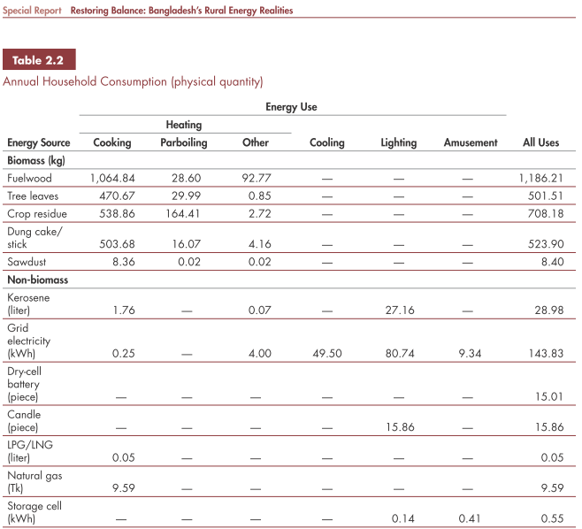
This is further substantiated by a very recent study in Bangladesh (Assessment of the Improved Stove Market in Bangladesh, Winrock International, January 2012) that mentions that household fuelwood consumption is over 1 tons in domestic households in Bangladesh.
This study remains the most comprehensive studies conducted till date to assess the biomass consumption pattern in domestic households and have also been used in other programmes.

Determination of project cookstove efficiency (η _{p,y} ):
$$η_{p,y}=η_{p}*{\left({DF}_{η}\right)}^{y-1}*0.94$$
Where
η_{p,y} Efficiency of project cookstove in year y(fraction)
η_{p} Efficiency of project cookstove (fraction) determined at the start of the project activity. In the situation where project stove efficiency is determined using WBT,this is the value determined annually as a result of the test
DF_{η} Discount factor to account for efficiency loss of project cookstove per year of operation (Fraction).The default value for this parameter is 0.99 i.e. 1% efficiency loss/year
0.94 Adjustment factor to account for uncertainty related to project cookstove efficiency test
The efficiency of the project cookstove needs to be determined by an independent expert or entity, in the field or laboratory, following the Water Boiling Test protocol (available at http://www.pciaonline.org/node/1048).To determine the project cookstove efficiency, three sample runs shall be carried out on at least three randomly selected project cookstoves. The average of the nine results shall be taken as the efficiency for the project cookstove (η_{p}).

D.6.3. Data and parameters that are to be reported in VPA-DD form for a technology or practice:

Data / Parameter: | B_{b,y}
Data unit: | Tons of firewood per household per year
Description: | Quantity of firewood consumed in baseline scenario during year y (tons per household per year)
Source of data used: | World Bank Study , Restoring Balance: Bangladesh’s Rural Energy Realities, March 2009,
Value applied: | 1.06484 tons
Justification of the choice of data or description of measurement methods and procedures actually applied: | The Gold Standard Simplified Methodology for Efficient Cookstoves, option (a), Section 4.2
Any comment: | Fixed for the entire crediting period

Data / Parameter: | f_{NRB,y}
Data unit: | Fraction
Description: | Fraction of biomass in year y that can be established as non renewable using survey methods
Source of data used: | Default Values of Fraction of Non-Renewable Biomass for Least Developed Countries and Small Island Developing States (EB 67 Annex 22)
Value applied: | 0.83
Justification of the choice of data or description of measurement methods and procedures actually applied: | The value is provided by CDM EB as required by the methodology
Any comment:

Data / Parameter: | EF_{b,fuel,CO2}
Data unit: | tCO₂/ton of wood
Description: | CO₂ emission factor of firewood that is substituted or reduced.
Source of data used: | The Gold Standard Simplified Methodology for Efficient Cookstoves
Value applied: | 1.747
Justification of the choice of data or description of measurement methods and procedures actually applied: | Default value as prescribed by methodology applied
Any comment:

Data / Parameter: | EF_{b,fuel,non_CO2}
Data unit: | tCO₂/ton of wood
Description: | Non_CO₂ emission factor of firewood that is substituted or reduced
Source of data used: | The Gold Standard Simplified Methodology for Efficient Cookstoves
Value applied: | 0.455
Justification of the choice of data or description of measurement methods and procedures actually applied: | Default value as prescribed by methodology applied
Any comment:

Data / Parameter: | η_{b}
Data unit: | Fraction
Description: | Efficiency of the cookstove being used in the baseline scenario
Source of data used: | The Gold Standard Simplified Methodology for Efficient Cookstoves
Value applied: | 0.1
Justification of the choice of data or description of measurement methods and procedures actually applied: | Default value as prescribed by methodology applied
Any comment:

Data / Parameter: | η_{p}
Data unit: | Fraction
Description: | Efficiency of the cookstove being used in the project scenario
Source of data used: | Third party test report as per PCIA protocol
Value applied: | 0.2326 (23.26%)
Justification of the choice of data or description of measurement methods and procedures actually applied: | The stove thermal efficiency test reports as provided by University of Dhaka
Any comment:

Data / Parameter: | DF_{η}
Data unit: | Fraction
Description: | Discount factor to account for efficiency loss of project cookstove per year of operation(Fraction)
Source of data used: | The Gold Standard Simplified Methodology for Efficient Cookstoves
Value applied: | 0.99
Justification of the choice of data or description of measurement methods and procedures actually applied:
Any comment:

Data / Parameter: | LAF
Data unit: | Fraction
Description: | Leakage adjustment factor
Source of data used: | The Gold Standard Simplified Methodology for Efficient Cookstoves
Value applied: | 0.95
Justification of the choice of data or description of measurement methods and procedures actually applied: | Default value as prescribed by methodology applied
Any comment:

D.7. Application of the monitoring methodology and description of the monitoring plan:
>>
D.7.1. Data and parameters to be monitored by each technology or practice:

Data / Parameter: | U_{p,y}
Data unit: | Percentage
Description: | Usage rate in project scenario p during year y
Source of data to be used: | Annual usage survey/Monitoring survey
Value of data applied for the purpose of calculating expected emission reductions | 100
Description of measurement methods and procedures to be applied: | Monitoring Frequency: Annual
QA/QC procedures to be applied: | Transparent data analysis and reporting
Any comment: | A usage parameter is derived for each age group of project cookstove being credited.

Data / Parameter: | N_{p,y}
Data unit: | Number of project cookstove credited (units)
Description: | Cookstove in the project database for project scenario p through year y
Source of data to be used: | Total sales record
Value of data applied for the purpose of calculating expected emission reductions | As per ex-post sales and micro scale limit
Description of measurement methods and procedures to be applied: | Monitoring Frequency: continuous
QA/QC procedures to be applied: | Transparent data analysis and reporting
Any comment: | The total sales record is divided based on project scenario to create the project database

Data / Parameter: | DF_{b,stove,y}
Data unit: | Fraction
Description: | Discount factor to account for the baseline stove use in project scenario p during the year y
Source of data to be used: | Monitoring surveys
Value of data applied for the purpose of calculating expected emission reductions | 0 (only for ex-ante calculation purposes, to be determined ex-post via monitoring)
Description of measurement methods and procedures to be applied: | Monitoring Frequency: annual
QA/QC procedures to be applied: | Transparent data analysis and reporting
Any comment: | The discount factor for baseline stove use may be determined based on number of meals cooked using the baseline stove vs total number of meals cooked in the household. The required information shall be captured through sample surveys carried out following a stratified random sampling approach for each age group of the project stove.

Data / Parameter: | ICS condition
Data unit: | dimensionless
Description: | Inspection of physical condition of project stove
Source of data to be used: | Monitoring surveys
Value of data applied for the purpose of calculating expected emission reductions
Description of measurement methods and procedures to be applied: | Monitoring Frequency: annual
QA/QC procedures to be applied: | Transparent data analysis and reporting
Any comment:

Data / Parameter: | ICS replacement
Data unit: | dimensionless
Description: | Replacements of project ICS with new project ICS, if applicable
Source of data to be used: | Sales and warranty replacement records
Value of data applied for the purpose of calculating expected emission reductions
Description of measurement methods and procedures to be applied: | Recording the ICS model replaced as well as ICS model installed as a replacement
QA/QC procedures to be applied: | Transparent data analysis and reporting
Any comment:

D.7.2. Description of the monitoring plan for a technology(ies) or practice(s):
>>D.7.2.1 Description of the monitoring plan for a technology or practice:
- Each PE keeps a record of the date and location of each ICS installation made for each VPA.
- Each PE places a stove serial number with a unique ID number plate in the kitchen as well as in its records, in addition to a record of the location of the stove.
- Other emission reduction parameters required for ex-post measurement by the methodology (numbers of stoves still in operation) is determined by a sampling study
- All PE records are screened by the CME together with cross-checks on the PE installation records in order to confirm that the installation record is authentic and that no double-counting occurs.
- The electronic files holding installation record are duplicated by paper documents received from individual households.
Monitoring procedure
Sales Record:
The PEs will maintain and update the total sales record in project database on an on-going basis. The record will be backed up electronically. The Sales Contract will also contain the following information:
- Name of customer
- Address and phone number (if available)
- Stove model and serial number
- Installation date
The names and telephone numbers or name and addresses collected will commensurate with representative sampling, i.e. the names and addresses or phone numbers where possible) within sales record will be large enough so that surveys will be based on representative, randomly selected samples.
Project database
The project database is derived from the total sales record with project cookstoves. The sampling shall be based on stratified sampling approach (based on age).
Ongoing Monitoring Studies:
Monitoring will consist of checking of a representative sample, once every year (annually) to ensure that project cookstoves are still operating (and discontinuation of baseline stoves) by carrying out the usage survey as per the age categories of cookstoves using a stratified sampling approach. The confidence / precision shall be 90/10 in case of VPA level sampling and 95/10 in case of PoA level sampling (across multiple VPAs).
Where replacements are made for project ICS, monitoring will also ensure that the efficiency of the new cookstove is similar to the appliances being replaced. The project will also monitor the physical conditions of the cookstoves.
Sampling procedure:
For a across PoA level sampling covering multiple VPAs, the confidence level shall be 95% instead of 90% which shall be applied for VPA level sampling. The sampling shall be based on random sampling (simple/stratified) as deemed appropriate.
D.8 Date of completion of the application of the baseline study and monitoring methodology and the name of the responsible person(s)/entity(ies)
>>
10/09/2014
Rohit Lohia
Climate-Secure Services
rohit.lohia@climate-secure.com

Annex 1

CONTACT INFORMATION ON COORDINATING/MANAGING ENTITY and PARTICIPANTS IN THE MICRO - PROGRAMME of ACTIVITIES
Organization: | SZ Consultancy Services Limited
Street/P.O.Box: | N/A
Building: | House # 3/2 (1st Floor), Block # B, Lalmatia
City: | Dhaka
State/Region: | Dhaka
Postfix/ZIP: | 1207
Country: | Bangladesh
Telephone: | 0088-02-9127487
FAX: | 0088-02-8154229
E-Mail: | sz@szbd.info,banna@szbd.info, bondhuchula.mowdud@gmail.com
URL: | www.szbd.info
Represented by:
Title: | Managing Director
Salutation: | Dr. Engr.
Last Name: | Zaman
Middle Name: | Uz
First Name: | Khaleq
Department:
Mobile: | 0088-01819-499778
Direct FAX: | 0088-02-8154229
Direct tel: | 0088-02-9127487
Personal E-Mail: | khaleq.zaman@giz.de

Annex 2

INFORMATION REGARDING PUBLIC FUNDING
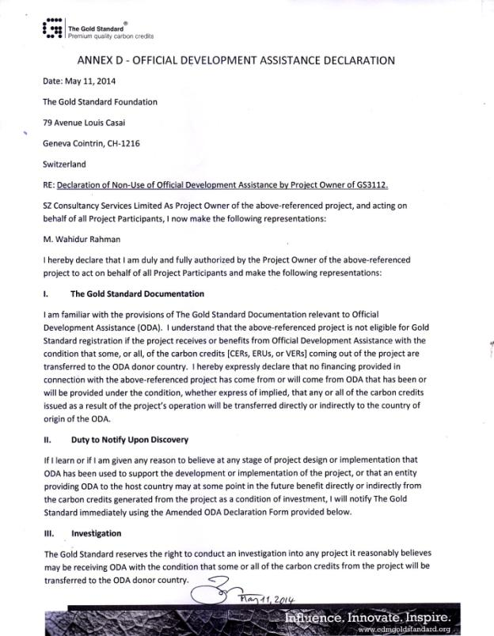

- - - - -

Non domestic (commercial / institutional) improved cookstoves may be added to PoA later through the design change procedure of Gold Standard
Assessment of the Improved Stove Market in Bangladesh, Winrock International, January 2012
Country Action Plan for Clean Cookstoves, November 2013, Power Division, Ministry of Power, Government of the People’s Republic of Bangladesh
http://news.yale.edu/2012/06/29/despite-efforts-change-bangladeshi-women-prefer-use-pollution-causing-cookstoves
http://www.pnas.org/content/109/27/10815.full
Special Report Restoring Balance: Bangladesh’s Rural Energy Realities, page 20
It is not practically possible to collect end user data for all the sales, especially in cases where the sales involve intermediaries or indirect sales through multi-layered distribution channel. In case of distribution of project stoves through intermediaries, the average number of days between the date on which project stoves are delivered to intermediaries and the date on which the project stoves are distributed from the intermediaries to end-users may be determined using survey methods during the first monitoring period and using the established value subsequently as a default. As a minimum, end user details shall be collected for as many end-users as commensurate with representative sampling, i.e. the number of end user names and addresses (and phone numbers where possible) from sales records shall be large enough so that surveys and tests can be based on representative selected samples. In all cases this should not be less than 10 times the survey and field test sample sizes in order to ensure an adequate end user pool to which statistical sampling can be applied.
New models of cookstoves may be launched during the course of PoA. They shall be eligible under the PoA provided, the VPA meets the eligibility criteria for inclusion in the PoA
As VPAs shall be based on time, multiple VPAs may be implemented by same VPA Implementer. In this case prior consideration of Carbon shall be considered at the time of start of stove distribution programme rather than on individual VPA level. Therefore, the aforesaid criteria shall be checked for retroactive VPAs of each new VPA Implementer in the PoA
http://www.un.org/en/development/desa/policy/cdp/ldc/ldc_list.pdf
Assessment of the Improved Stove Market in Bangladesh, Winrock International, January 2012
Country Action Plan for Clean Cookstoves, November 2013, Power Division, Ministry of Power, Government of the People’s Republic of Bangladesh
http://news.yale.edu/2012/06/29/despite-efforts-change-bangladeshi-women-prefer-use-pollution-causing-cookstoves
http://www.pnas.org/content/109/27/10815.full
Special Report Restoring Balance: Bangladesh’s Rural Energy Realities, page 20
http://www.un.org/en/development/desa/policy/cdp/ldc/ldc_list.pdf
This shall also ensure that any retroactive VPA is demonstrated additional as per Guideline: Demonstrating additionality of micro-scale project activities, version 5.0

