Monitoring Report

PUBLICATION DATE 14.10.2020
VERSION v. 1.1
RELATED SUPPORT – TEMPLATE GUIDE Monitoring Report v. 1.1

This document contains the following Sections
Key Project Information
SECTION A - Description of project
SECTION B - Implementation of project
SECTION C - Description of monitoring system applied by the project
SECTION D - Data and parameters
SECTION E - Calculation of SDG Impacts
SECTION F - Safeguards Reporting
SECTION G - Stakeholder inputs and legal disputes

KEY PROJECT INFORMATION

Programme of Activity Information – (delete below table if N/A)
GS ID of Programme | GS5705
Title of Programme | Believe Green Safe Drinking Water PoA
Version of POA-DD applicable to this monitoring report | V15
Name and GS ID of fully Validated CPA/VPAs (i.e. non compliance check) | VPA - Spouts - 2

Key Project Information
GS ID (s) of Project (s) | GS6444
Title of the project (s) covered by monitoring report | VPA - Spouts - 2
Version number of the PDD/VPA-DD (s) applicable to this monitoring report | V06
Version number of the monitoring report | V09
Completion date of the monitoring report | 01/07/2021
Date of project design certification | 15/08/2019
Date of Last Annual Report | N/A
Monitoring period number | 2nd
Duration of this monitoring period | (01/09/2019) to (31/08/2020)
Project Representative | Dr. Federico Gallo  Managing Director of Believe Green LLC
Host Country | Uganda
Activity Requirements applied | Community Services Activities  Renewable Energy Activities  Land Use and Forestry Activities/Risks & Capacities  N/A
Methodology (ies) applied and version number | “Technologies and Practices to Displace Decentralized Thermal Energy Consumption” Version 3.1, August 2017.
Product Requirements applied | GHG Emissions Reduction & Sequestration  Renewable Energy Label  N/A

Table 1 - Sustainable Development Contributions Achieved
Sustainable Development Goals Targeted | SDG Impact | Amount Achieved | Units/ Products
SDG13 Climate Action (mandatory) | Emissions Reductions | 8,528 | tCO2
SDG12 Ensure sustainable consumption and production patterns | Quantity of wood fuel burned avoided | 5,805 | Ton
SDG06 Clean Water and Sanitation | Proportion of population using safely managed drinking water services | 0.05 | %

Table 2 – Product Vintages
 |  | Amount Achieved
Start Dates | End Dates | SDG13 | SDG12 | SDG06
01/09/2019 | 31/12/2019 | 2,843 | 1,935 | 0.04
01/01/2020 | 31/08/2020 | 5,685 | 3,870 | 0.04
 | Total | 8,528 | 5,805 | 0.04

- DESCRIPTION OF PROJECT
  - General description of project
“VPA - Spouts–2” is a Gold Standard micro-programme activity (VPA) which aims to reduce biofuel consumption, such as wood, as is traditionally used to boil water to make it safe to drink. This is done by offering low income populations affordable and easily accessible treated water that is safe to drink. Since these people usually use inefficient cook stoves that cause large amounts of smoke leading to respiratory diseases, the project also has significant health co-benefits. Also, the project generates significant employment and income opportunities for the local villagers, who are invited to join the project across the production and delivery chain.
Believe Green LLC is responsible for coordinating all aspects related to the Gold Standard Certification, as well as designing and managing all the monitoring activities.
Spouts of Water is the local partner in Uganda. Spouts of Water provides Ugandan communities with increased access to safe drinking water by manufacturing and distributing the Purifaaya ceramic water filter, the only locally manufactured water filter in Uganda. The Purifaaya is affordable even to poorer communities at 20 USD, providing a tested solution to people who need it most.
By replacing the common practice of boiling, families and especially women save money, time, and fuel.

  - Location of project
Spouts of Water distributes filters in over 200 communities across all four regions of Uganda. The map and the table below show the distribution points in Region/City:

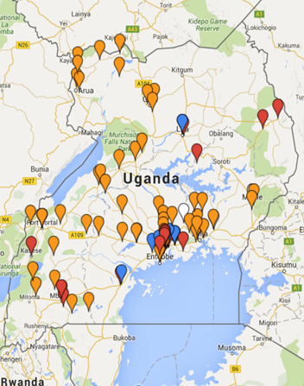

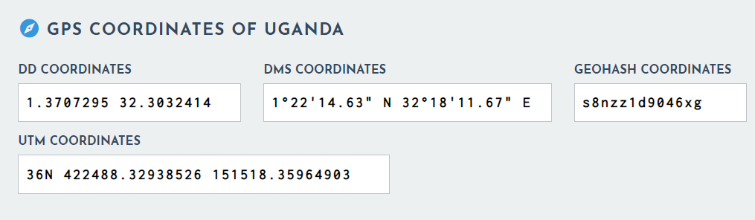

REGIONS OF UGANDA SERVED BY SPOUTS OF WATER

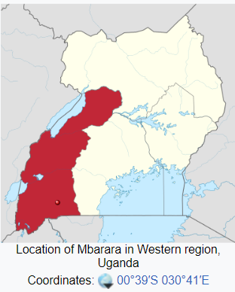
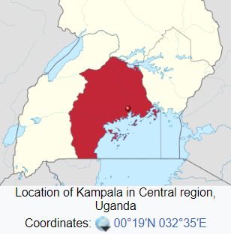
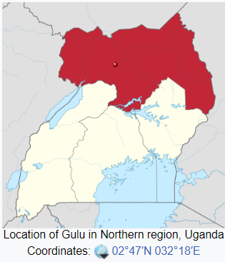
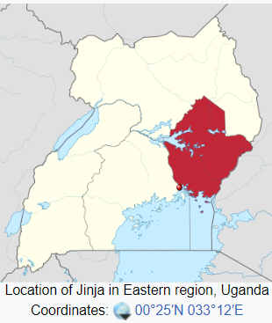

  - Reference of applied methodology
Technologies and Practices to Displace Decentralized Thermal Energy Consumption Version 3.1 (TPDDTEC).

  - Crediting period of project

01/09/2017 31/08/2022

5 years in first crediting period, renewable two times up to 15 years.

- IMPLEMENTATION OF PROJECT
  - Description of implemented project
The Purifaaya water filter uses ceramic filtration technology. Ceramic water filters are an innovative product offered as an appropriate clean water solution in Uganda. An assessment on the use of ceramic water filters in Cambodia by UNICEF states, “[Ceramic] filters have the advantage of being lightweight, portable, relatively inexpensive, chemical-free, low-maintenance, effective, and easy to use.”
To distribute the filters across the entire nation, SPOUTS segments the market by income level, targeting all households while also working with NGOs to provide clean drinking water to refugee camps, schools, prisons, clinics and other public spaces.
In Section B.1, Tab.2 shows the filters quantity sold per Account Type.
‘Spouts -ERC’ spreadsheet, ‘Sales Tracker-Database’ worksheet shows each detail of the filters distribution.
Since the filters have a useful life of two years, for this SECOND Monitoring Period, we take into account the second year of useful life of the filters used in the FIRST Monitoring Period. (See below, Tab A)

Tab A - Correlation between Monitoring Period - Filters sold - Year_Filter
Monitoring Period  (N°) | Monitoring Period  (Data) | Filters Sales Data | Year_Filter
1 | 2017 - 2018 | Set-2017 to May-2018 | 1st
1 | 2018 -2019 | Set-2018 | 1st
2 | 2019 - 2020 | Set-2018 | 2nd

To distribute the filters across the entire nation, Spouts of Water segments the market by income level, targeting all households while also working with NGOs to provide clean drinking water to refugee camps, schools, prisons, clinics and other public spaces.
‘Spouts – ERC’ spreadsheet contains details of filter sales records.

Tab 1 - Filters distribution by City - (Period 2019-2020)

Micro | Spouts-1_3Y
Year_Filter | 2nd
Sum of Quantity | Column Labels
Row Labels | 2018 | Grand Total
Kampala | 57 | 57
Rubaga | 2 | 2
Unrecorded | 3151 | 3151
Grand Total | 3210 | 3210

Tab 2 - Filters distribution by Sale Type - (Period 2019-2020)

Micro | Spouts-1_3Y
Year_Filter | 2nd
Sum of Quantity | Column Labels
Row Labels | 2018 | Grand Total
Aid | 2769 | 2769
Corporates | 13 | 13
D2C Program | 241 | 241
End-User | 140 | 140
Referral program | 16 | 16
Resell | 31 | 31
Grand Total | 3210 | 3210

Hygiene campaigns carried out to raise awareness on hygiene and the benefits of safe drinking water. (See Appendix 4 for details).

Technology
The Purifaaya water filter uses ceramic filtration technology. Ceramic water filters are an innovative product offered as an appropriate clean water solution in Uganda. An assessment on the use of ceramic water filters in Cambodia by UNICEF states, “[Ceramic] filters have the advantage of being lightweight, portable, relatively inexpensive, chemical-free, low-maintenance, effective, and easy to use.”
The base of the filter is a ceramic pot with microscopic holes, which trap bacteria, enabling only clean drinking water to pass through. In order to maximize safety, all of our filters are subjected to strict quality control and then coated with an additional layer of silver nitrate, an effective biocide. Water from any source can be sanitized through the ceramic filtration system and stored at the bottom of the filter ready to drink. At the bottom of the filter is a tap, which makes the clean drinking water easily accessible. The household Purifaaya stores 20 liters of water, whilst the Purifaaya XL stores 60 liters, making it ideal for public spaces such as schools, hospitals and prisons. In 2015 The Ugandan Ministry of Water and Environment tested and approved the filter stating that SPOUTS OF WATER filters are “efficient and effective to produce water that meets the recommended standard of water for human consumption.” Test results conclude that the Purifaaya kills 99.9% of disease-causing bacteria, as well as removing the turbidity of the water, thus producing drinking water that is both safe and clean.

In addition to Purifaaya’s technical excellence, SPOUTS ‘ceramic filters are also culturally and socially acceptable in Uganda due to the long-standing tradition in villages of storing drinking water in clay pots. The local population prefers the taste of the water from ceramic filters and is accustomed to maintaining ceramic products.

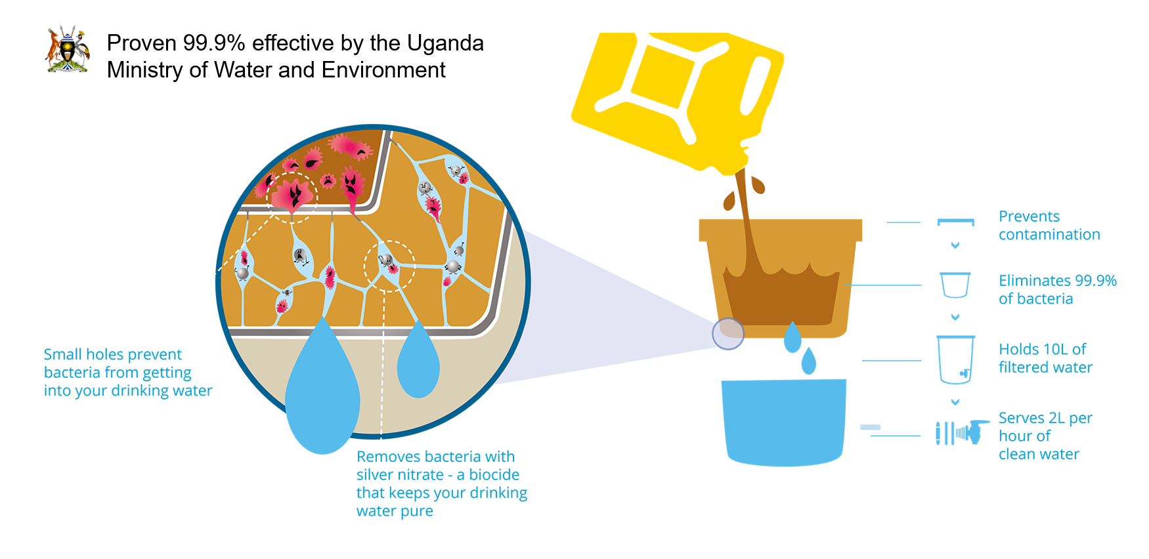

    - Forward Action Requests
N/A

  - Post-Design Certification changes

    - Temporary deviations from the approved Monitoring & Reporting Plan, methodology or standardized baseline
No Temporary deviations from the approved Monitoring & Reporting Plan, methodology or standardized baseline have been introduced.

    - Corrections
No corrections to project information or parameters fixed at validation have been applied

    - Changes to start date of crediting period
No changes to the start date of the crediting period have been introduced.

    - Permanent changes from the Design Certified monitoring plan, applied methodology or applied standardized baseline
No permanent changes from the approved monitoring plan, applied methodologies or applied approaches have been introduced.

    - Changes to project design of approved project
No changes have been made to the project design.

- DESCRIPTION OF MONITORING SYSTEM APPLIED BY THE PROJECT
This project’s monitoring included the following elements:
1. A Total Sales Record
The project proponent continuously maintains an accurate and complete sales record, which is backed up electronically.
‘Spouts -ERC’ spreadsheet, ‘Sales Tracker-Database’ worksheet shows each detail of the filters distribution

Double counting with other carbon standards
The following steps ensure that we are avoiding double counting with other carbon standards:
1. We are only claiming and certifying water purchased from Spring Health, and we are keeping a precise record of this amount, as detailed elsewhere in this monitoring report and VPA.
2. We are only certifying this project with the Gold Standard / SustainCert: we are not certifying it under other standards.
3. Data collected for carbon certification purposes under this project is only shared internally within the team, and with the Gold Standard / SustainCert, so no other third parties can certify this project either.
4. We are not aware of other projects seeking carbon credits in our area of operation.
5. We asked to each customer to inform us about any proposal of participation in another program. (see Appendix 3)

2. Training activities
The team assigned to carry out the surveys carried out the training activities described in:
- Annex A - Training Manual: Teaching a community to use the filter
- Annex B - SPOUTS of Water Usage Study - Surveys and Training Manual

Trained team
- Project Management
- Ivan Ssenkubuge
- Ezra Rwakazooba

- Operations Manager
- Dennis Baliddawa

- Field Supervisor
- David Mugambe

- 5 Enumerators

3. A monitoring survey, including a baseline survey and usage survey.

We have conducted a survey in May-2021, but asking the customer about situation found in Jan-2020.
This section presents the results of the survey. The text includes the questions asked in the questionnaire and, immediately below, the relevant answers. The detailed results from the survey are included in the ‘Survey Jan-2020’ worksheet of the ‘Spouts – ERC’ spreadsheet.
Socio-economic diversity
We have teams set up in each of the four regions in UG and we also have a full-time customer service center to follow up with our customers via mobil phones. We collect all of our customers information through the Salesforce CRM.
Because of our team on the ground and in the customer service center coupled with our partnerships with local leaders on the ground (LCs) we are able to reach all of our customers in all income levels. The partnerships with LCs make it easier to reach our customers in low-income rural areas.

Seasonal variations
Seasonal variations do not typically introduce variations in the monitoring survey.

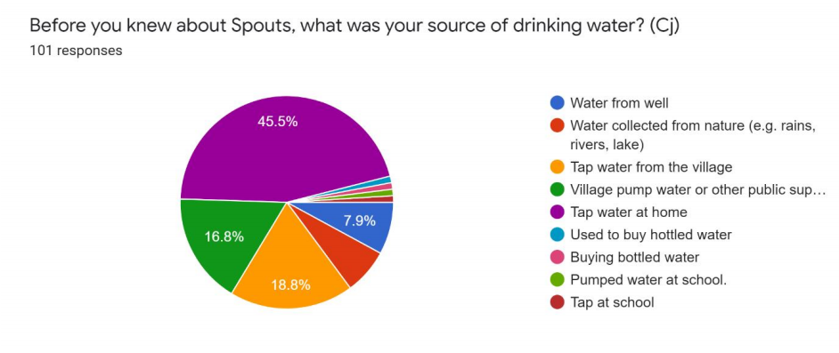

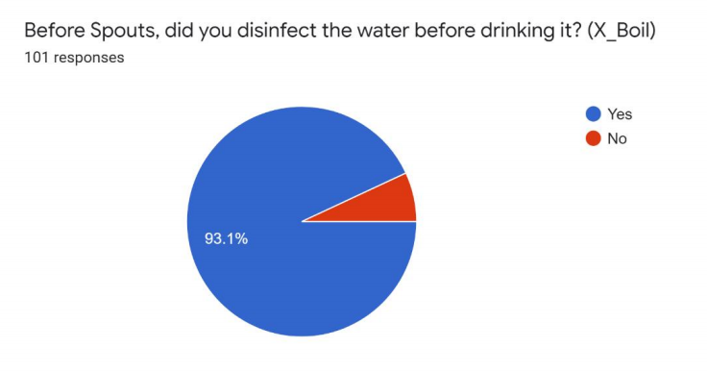

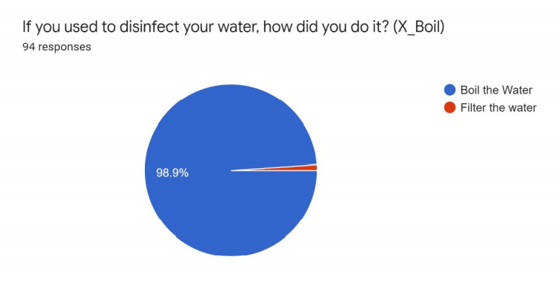

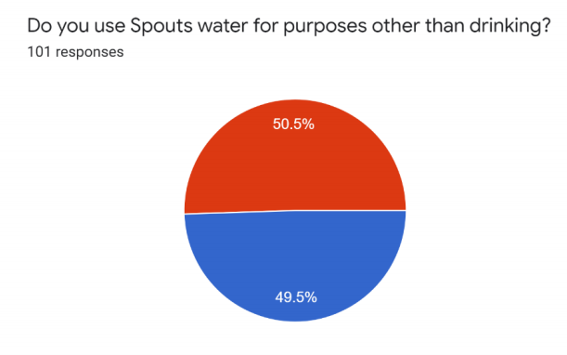

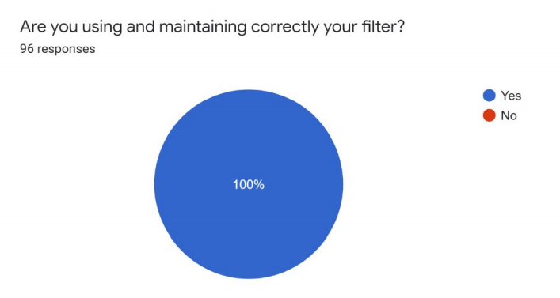

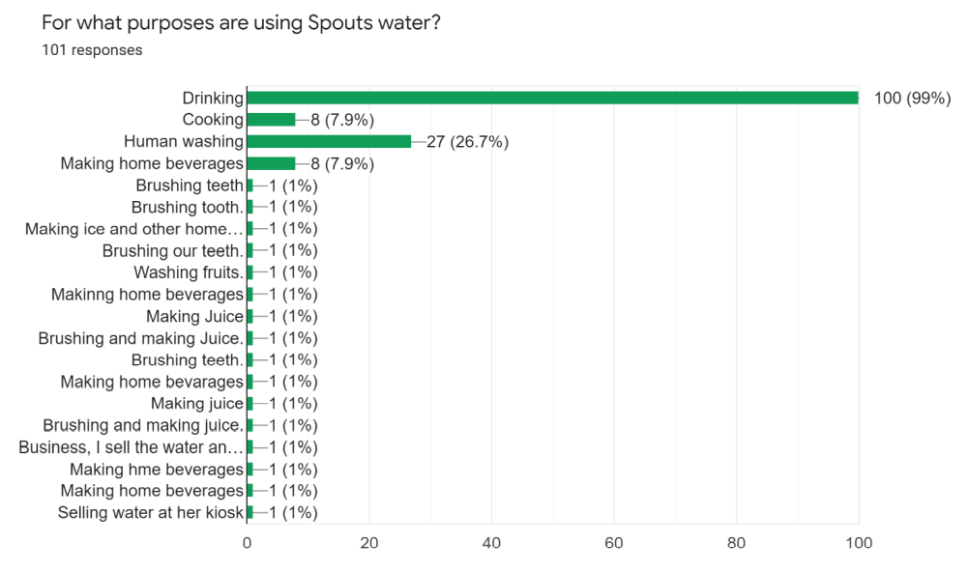

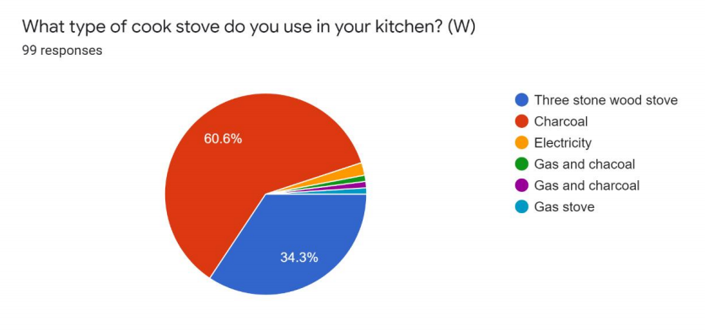

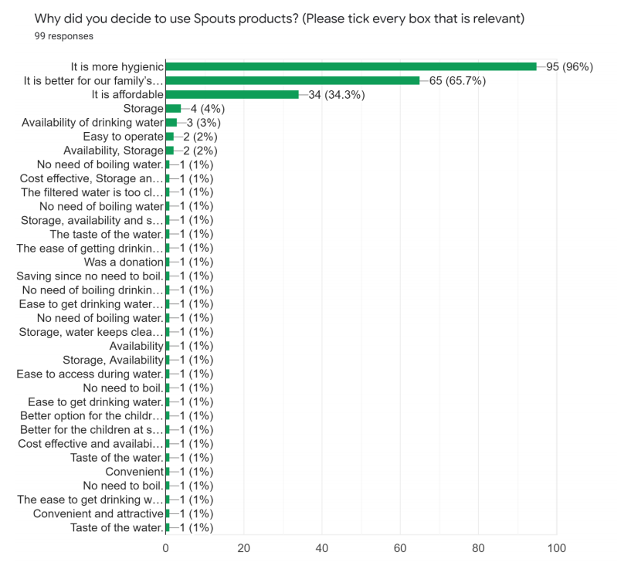

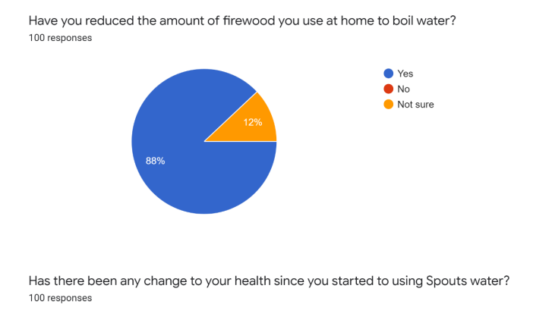

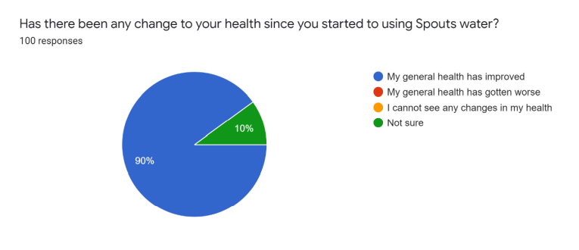

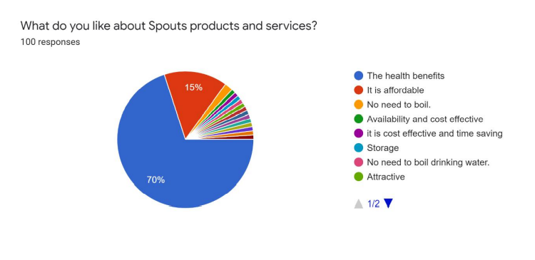

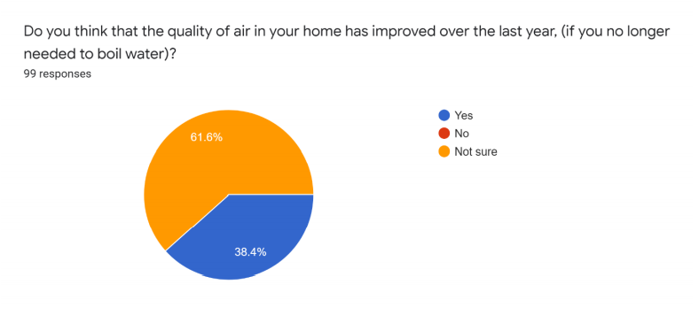

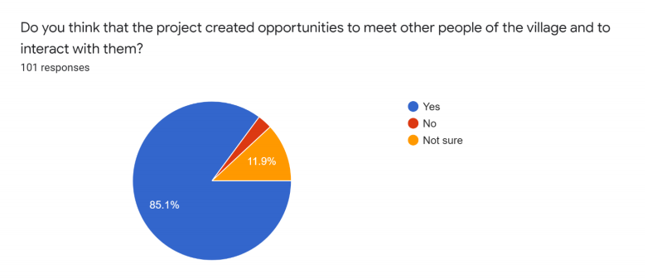

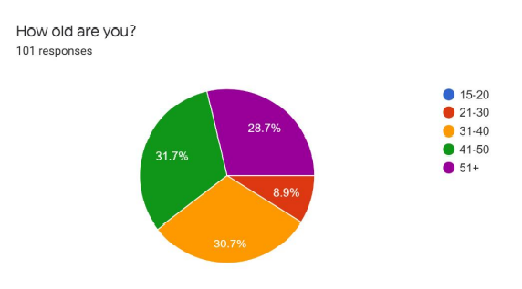

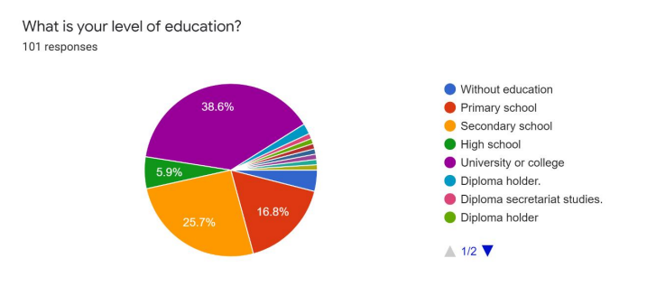

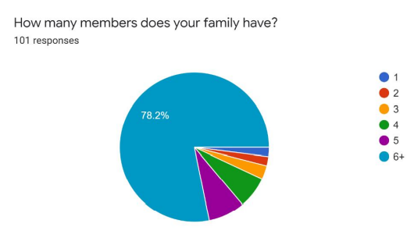

- DATA AND PARAMETERS
  - Data and parameters fixed ex ante or at renewal of crediting period

Relevant SDG | 12 – Ensure sustainable consumption and production patterns
Data / Parameter | W_{b-wood} / W_{b-charcoal} 3-4-nm
Data unit | Tonnes/litre
Description | Quantity of fuel in tons required to treat 1 litre of water using technologies representative of baseline scenario b
Source of data used | Baseline water Boiling test
Value applied | W_{b-wood} = 0.000427 - W_{b-charcoal} = 0.000088
Choice of data  or measurement methods and procedures | The value provided above was derived from water boiling tests as recommended by the GS Methodology.  (See ‘Spouts-ERC’ spreadsheet, ‘Boiling Test parameter W’ worksheet)
Purpose of data | Definition of tCO2 emission reductions and Tons of burnt wood avoided
Any comment | n.a.

Relevant SDG | 13 – ‘Climate Action - Carbon emission reductions’
Data / Parameter | EFb,wood,CO2 5-nm
Data unit | tCO2/TJ
Description: | CO2 emission factor arising from use of fuels in baseline/project scenario
Source of data used | IPCC Guidelines for National Greenhouse Gas Inventories, Volume 2, Energy, Chapter 2, Stationary Combustion, Table 2.5
Value applied | EFb,wood,CO2 = 112  The value of these parameters is included in ‘Spouts-ERC’ spreadsheet.
Choice of data  or measurement methods and procedures | Determined as per IPCC default figures.  The value is the same during both the baseline and project implementation (However, it is noted that during the project there is no fuel being used, as the filters do not require fuel and work on gravity).
Purpose of data | Definition of tCO2 emission reductions
Any comment | n.a.

Relevant SDG | 13 – ‘Climate Action - Carbon emission reductions’
Data / Parameter | EFb,charcoal,CO2 6-nm
Data unit | tCO2/TJ
Description | CO2 emission factor arising from use of fuels in baseline/project scenario
Source of data used | IPCC Guidelines for National Greenhouse Gas Inventories, Volume 2, Energy, Chapter 2, Stationary Combustion, Table 2.5
Value applied | EFb,charcoal,CO2 = 112  The value of these parameters is included in ‘Spouts-ERC’ spreadsheet.
Choice of data  or measurement methods and procedures | Determined as per IPCC default figures.  The value is the same during both the baseline and project implementation (However, it is noted that during the project there is no fuel being used, as the filters do not require fuel and work on gravity).
Purpose of data | Definition of tCO2 emission reductions
Any comment | n.a.

Relevant SDG | 13 – ‘Climate Action - Carbon emission reductions’
Data / Parameter | EFb,wood,nonCO2 7-nm
Data unit | tCO2e/TJ
Description | Non-CO2 emission factor arising from use of fuels in baseline/project scenario
Source of data used | IPCC Guidelines for National Greenhouse Gas Inventories, Volume 2, Energy, Chapter 2, Stationary Combustion, Table 2.5
Value applied | EFb,wood,nonCO2 = 6.424  The value of these parameters is included in ‘Spouts-ERC’ spreadsheet.
Choice of data  or measurement methods and procedures | Determined as per IPCC default figures. The Global Warming Potential (GWP) for CH4 it is 21, while for N2O it is 310. Source: UNFCCC . So, the value was calculated using the following formula:  EFp,wood,nonCO2 = ((CH4=0.3*GWPCH4 25) + (N2O=0.004*GWPN2O 295)) =  = ((CH4=0.3*21) + (N2O=0.004*310)) = 6.424  The value is the same during both the baseline and project implementation.
Purpose of data | Definition of tCO2 emission reductions
Any comment | n.a.

Relevant SDG | 13 – ‘Climate Action - Carbon emission reductions’
Data / Parameter | EFb,charcoal,nonCO2 8-nm
Data unit | tCO2e/TJ
Description | Non-CO2 emission factor arising from use of fuels in baseline/project scenario
Source of data used: | IPCC Guidelines for National Greenhouse Gas Inventories, Volume 2, Energy, Chapter 2, Stationary Combustion, Table 2.5
Value applied | EFb,charcoal,nonCO2 = 4.51  The value of these parameters is included in ‘Spouts-ERC’ spreadsheet.
Choice of data  or measurement methods and procedures | Determined as per IPCC default figures. The Global Warming Potential (GWP) for CH4 it is 21, while for N2O it is 310. Source: UNFCCC . So, the value was calculated using the following formula: ((CH4=0.2*GWP 25) + (N2O=0.001*GWP 295)) = 5.29.  EFp,charcoal,nonCO2 = ((CH4=0.2*GWP_{CH4}) + (N2O=0.001*GWP_{N2O})) =  = ((CH4=0.3*21) + (N2O=0.004*310)) = 4.51
Purpose of data | Definition of tCO2 emission reductions
Any comment | n.a.

Relevant SDG | 12 – ‘Ensure sustainable consumption and production patterns’
Data / Parameter | NCVb,wood 9-nm
Data unit | TJ/ton
Description: | Net calorific value of the fuels used in baseline/ project scenario
Source of data used | Wood fuels handbook – European Biomass Association. Table 2.7.1
Value applied | NCVb,wood = 0.015  The value of these parameters is included in ‘Spouts-ERC’ spreadsheet.
Choice of data  or measurement methods and procedures | Default value used by the European Biomass Association, as described in the above document.  The value is the same during both the baseline and project implementation.
Purpose of data | Definition of tCO2 emission reductions
Any comment: | n.a.

Relevant SDG | 12 – ‘Ensure sustainable consumption and production patterns’
Data / Parameter | NCVb,charcoal 10-nm
Data unit | TJ/ton
Description | Net calorific value of the fuels used in baseline/ project scenario
Source of data used | IPCC Guidelines for National Greenhouse Gas Inventories. Table 1.2
Value applied | NCVb,charcoal = 0.0295  The value of these parameters is included in ‘Spouts-ERC’ spreadsheet.
Choice of data  or measurement methods and procedures | Default value used by the IPCC, as described in the above document.  The value is the same during both the baseline and project implementation.
Purpose of data | Definition of tCO2 emission reductions
Any comment | n.a.

D.2 Data and parameters monitored

Relevant SDG | 6 – ‘Clean Water and Sanitation - Safe drinking water provide’
Data / Parameter |  | Cj 1-m
Data unit |  | Percentage
Description |  | Portion of users of project safe water supply who were already in baseline using a non-boiling safe water supply
Measured methods and procedures |  | Measured  (See ‘Spouts-ERC’ spreadsheet, ‘Survey Jan-2020’ worksheet)
Source of data used |  | Across Uganda drinking water is not safe and is not considered to be safe by the government authorities Cj=0.,,,,,  However, from the survey we found that:  Cj = 18.8%
Value applied |  | C_{j} = 18.8%
Monitoring frequency |  | Annually
Calculation method |  | n.a.
QA/QC procedures |  | Development of surveys and data recording in accordance with the requirements of the Quality Management System.
Purpose of data |  | Baseline definition
Additional comments |  | n.a.

Relevant SDG | 6 – ‘Clean Water and Sanitation - Safe drinking water provide’
Data / Parameter | Xboil 2-m
Data unit | Percentage
Description | Percentage of premises that would have used other non-GHG emitting technologies like chlorine treatment techniques, if available, in the absence of the project activity.
Measured methods and procedures | Measured
Source of data used | (See ‘Spouts-ERC’ spreadsheet, ‘Survey Jan-2020’ worksheet)
Value applied | Xboil= 6.9 %
Monitoring frequency | Annually
Calculation method | n.a.
QA/QC procedures | Development of surveys and data recording in accordance with the requirements of the Quality Management System.
Purpose of data | Baseline definition
Any comment | n.a.

Relevant SDG Indicator | 6 – ‘Clean Water and Sanitation - Safe drinking water provide’
Data / Parameter | Qp,y 11-m
Data unit | Litres per person per day
Description | Quantity of safe water in litres consumed in the project scenario p and supplied by project technology per person per day
Measured methods and procedures | This is a default value recommended by the WHO and approved by the GS: see Annex A.3.2 of the TPDDTEC methodology.
Source of data used | This is a default value recommended by the WHO and approved by the GS: see Annex A.3.2 of the TPDDTEC methodology.
Value applied | Qp,y = 4 L/person.day
Monitoring frequency | Annually
Calculation method | n.a.
QA/QC procedure | Data recording in accordance with the requirements of the Quality Management System.
Purpose of data | Definition of proportion of population using safely managed drinking water services
Any comment | n.a.

Relevant SDG Indicator | 12 – ‘Ensure sustainable consumption and production patterns’
Data / Parameter | ϖ_{W} - ϖ_{C} 12-13-m
Data unit | Percentage
Description | Percentage of people using wood or charcoal to boil water.
Measured methods and procedures | Measured/calculated  (See ‘Spouts-ERC’ spreadsheet, ‘Survey Jan-2020’ worksheet)
Source of data used | Our internal survey.  (See ‘Spouts-ERC’ spreadsheet, ‘Survey Jan-2020’ worksheet)
Value applied | ϖ_{W} = 60.6 % - ϖ_{C} = 34.3 %
Monitoring frequency | Annually
Calculation method | The values were obtained from our internal survey. The graph below shows the obtained results.  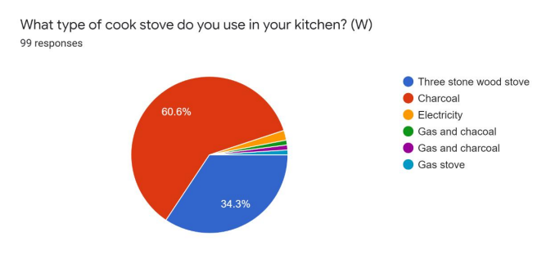  A small fraction of the urban population uses electricity to boil water. For simplicity, we assume that the amount of CO2 emitted in these cases is zero (i.e. we are not counting the emissions reductions from electricity – this reduces the potential carbon credits that we can claim, but we decided to forgo them to simplify the calculations).
QA/QC procedures | Development of surveys and data recording in accordance with the requirements of the Quality Management System.
Purpose of data | Definition of tCO2 emission reductions
Any comment: | n.a.

- Relevant SDG | - 6 - ‘Clean Water and Sanitation - Safe drinking water provide’
- Data / Parameter | - Filters_Y 14-m
- Data unit | - Number of filters.
- Description | - Number of filters sold in years Y and Y-1.  - Since the filters have a lifetime of two years, we consider as ‘active’ only those filters sold that were sold in the two years prior to each year’s VER issuance request. In other words, filters older than two years are not counted towards the carbon emission reductions.
- Measured methods and procedures | - Measured/calculated
- Source of data used | - The data collected continuously by the sales. Each sale is recorded in a cloud based system using SalesForce. Information is collected on the date of sale, specific customer details, location etc. The relevant information is included in the Emissions Reductions spreadsheet.
- Value applied | - 3,210
- Monitoring frequency | - Annually
- Calculation method | The data is gathered continuously as filters are sold, using SalesForce software.
- QA/QC procedure | Development of surveys and data recording in accordance with the requirements of the Quality Management System.
- Purpose of data | Definition of proportion of population using safely managed drinking water services
- Any comment | n.a.

- Relevant SDG | - 6 - ‘Clean Water and Sanitation - Safe drinking water provide’
- Data / Parameter | - nj 15-m
- Data unit | - People per household
- Description | - Average number of people per household.
- Measured methods and procedures | - Measured/calculated
- Value applied | - nj = 5.60
- Monitoring frequency | Annually
Source of data used | (See ‘Spouts-ERC’ spreadsheet, ‘Survey 2020’ worksheet)
Calculation method | The source of this data is our internal survey.  (See ‘Spouts-ERC’ spreadsheet, ‘Survey 2020’ worksheet)  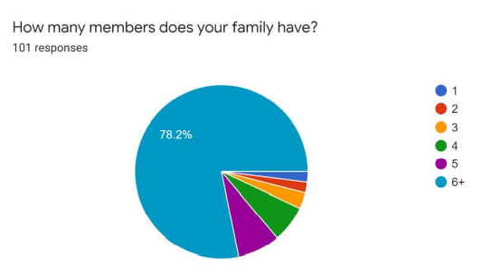  Since generally one filter serves one household, the value nj of the average number of people in each household quantified also the average number of people served by each filter on average.
  Number of people per household
  HH size | Frequency | Weighted HH size
  1 | 1.98% | 0.0198
  2 | 1.98% | 0.0396
  3 | 2.97% | 0.0891
  4 | 6.93% | 0.2772
  5 | 7.92% | 0.396
  6+ | 78.22% | 5.0843
   | Total | 5.906
QA/QC procedure | Development of surveys and data recording in accordance with the requirements of the Quality Management System.
Purpose of data | Definition of proportion of population using safely managed drinking water services
Any comment | n.a.

- Relevant SDG | - 6 - ‘Clean Water and Sanitation - Safe drinking water provide’
- Data / Parameter | - U_{p,y} 16-m
- Data unit | - Fraction
- Description | Cumulative usage rate for technologies in project scenario p during year y, based on cumulative installation rate and drop off rate (Up,y)
- Source of data used | Internal survey, see results below.
- Value applied | - U_{p,y =} 82%
- Measurement methods and procedures | We followed the guidelines in Annex 9 of the TPDDTEC Methodology.  The figure below shows the responses to the questions related to product reach broken down by region. Out of all 155 households surveyed, 90% are using their filter and 90% demonstrate correct use and cleaning protocol, however, only 82% are both using their filter and using and maintaining it correctly.  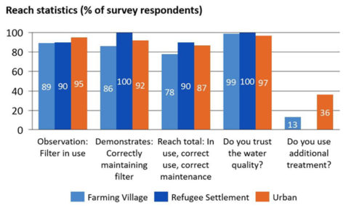
- Any comment: | n.a.

- Relevant SDG | - 6 - ‘Clean Water and Sanitation - Safe drinking water provide’
- Data / Parameter | - Np,y 17-m
Data unit | - Number of Person.days
Description | - Number of person.days consuming water supplied by project scenario p through year y
Measurement methods and procedures | - calculated
Source of data used | - The value is calculated using the monitored data and the following formula:  - Np,y = Filters_Y * nj * 365  - Where Filters_Y and nj are measured empirically, as described above.
Value applied | - Np,y = 6,561,240
Monitoring frequency | Annually
- Calculation method | - The value is calculated using the monitored data and the following formula:  - Np,y = Filters_Y * nj * 365  - Where Filters_Y and nj are measured empirically, as described above.
- QA/QC procedure | Development of surveys and data recording in accordance with the requirements of the Quality Management System.
- Purpose of data: | Ensure that the population consumes drinking water.
- Any comment | n.a.

- Relevant SDG | 12 – ‘Ensure sustainable consumption and production patterns’
- Data / Parameter | - fnrb,bl,y 18-m
Data unit | Fractional non-renewability
Description | Non-renewability of woody biomass fuel during year y
Measurement methods and procedures | calculated
Source of data used | (see ‘Spouts - ERC’ spreadsheet, ‘fNRB Uganda’ worksheet)
Value applied | fnrb,bl,y = 82.0
Monitoring frequency | Annually
Calculation method | (see ‘Spouts - ERC’ spreadsheet, ‘fNRB Uganda’ worksheet)
QA/QC procedure | Development of surveys and data recording in accordance with the requirements of the Quality Management System.
Purpose of data | Definition of the quantity of wood fuel burned avoided
Any comment | n.a.

Relevant SDG | 12 – ‘Ensure sustainable consumption and production patterns’
Data / Parameter | - W_F (Kiln) - (Leakage from filter production in the wood kiln)
Data unit | Tonnes of wood / filter 19-m
Description | Amount of wood used to cook one filter in the wood kiln.
Measurement methods and procedures | Calculated
Source of data used: | The parameter is estimated empirically by measuring the amount of wood used in the kiln.  More specifically, two quantities are measured:  - Amount of wood used as fuel  - Number of filters cooked (this number if fixed)  The parameter W_{F} is calculated by dividing the amount of wood by the number of filters produced.  This measurement is carried out several times to obtain an average.  Detailed data and calculations are presented in the Emission Reduction Calculations spreadsheet.
Value applied | W_F (Kiln) = 4.45E-03
Monitoring frequency | This quantity will be reassessed if and when the technology to produce the filters (i.e. the kiln) is changed.
Calculation method | (see ‘Source of data used’)
QA/QC procedure | Development of surveys and data recording in accordance with the requirements of the Quality Management System.
Purpose of data | This parameter is used in the following formula:  LKiln = Filtersy * WF * ((ʄNRB,p,y * EFp,fuel,CO2) + EFp,fuelnonCO2) * NCVp,fuel
Any comment: | n.a.

Relevant SDG | 6 - ‘Clean Water and Sanitation - Safe drinking water provide’
Data / Parameter | Water Quality (carried by and accredited, ISO certified lab) 22-m
Data unit | The test measures concentrations of several levels of pollutants.  The table below is a screenshot from one example water test. In particular, it shows the units used for each pollutant  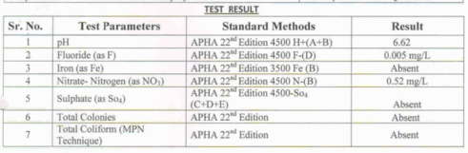
Description | Twice a year a water sample from every village is sent for analysis to an ISO certified lab (this is four times more frequently than the requirement by the Methodology, i.e. once every two years by accredited labs)
Measurement methods and procedures | Measured
Source of data used | The laboratory receives water samples from each village
Value applied | Value applied: Absent (i.e. absence of e.coli and other coliforms).  In all the tests carried out, it has been found that total colonies of e.coli and total coliform were absent. This was expected from the application of chlorine (see box above).
Monitoring frequency | Twice a year in every village (this is four times more frequently than the requirement by the Methodology, i.e. once every two years by accredited labs).
Calculation method | n.a.
QA/QC procedure | The water tests are carried out by a third party lab that is ISO certified.
Purpose of data | To ensure the provision of safe drinking water
Any comment | (See Appendix 2 - Water Quality Test - Results)

Relevant SDG | 6 - ‘Clean Water and Sanitation - Safe drinking water provide’
Data / Parameter | Hygiene Campaigns 26-m
Data unit | Not applicable
Description | Hygiene campaigns carried out to raise awareness on hygiene and the benefits of safe drinking water.
Measurement methods and procedures | See Appendix 4
Source of data used | See Appendix 4
Value applied | Not applicable
Monitoring frequency | Hygiene campaigns are carried out regularly a part of the awareness raising and marketing strategy of the project activity on the ground (for more details see Annex 1 of this monitoring report).
Calculation method  (if applicable) | n.a.
QA/QC procedures | Development of activities and data recording in accordance with the requirements of the Quality Management System
Purpose of data | To raise awareness on hygiene and the benefits of safe drinking water.
Additional comments | n.a.

D.3 Comparison of monitored parameters with last monitoring period

Data/Parameter | Value obtained in this monitoring period | Value obtained last monitoring period
Wb - Quantity of fuel in tons required to treat 1 litre of water using (Baseline) | 0.000427 Ton/litre | 0.000427 Ton/litre
EFb,wood,CO2 - CO2 emission factor arising from use of fuels | 112 Tco2/Tj | 112 Tco2/Tj
EFb,wood,CO2 - Non CO2 emission factor arising from use of fuels | 6.424 Tco2/Tj | 6.424 Tco2/Tj
NCV_{b,wood -} Net Calorific Value wood | 0.015 TJ/Ton | 0.015 TJ/Ton
U_{p,y -} Cumulative usage rate for technologies | 1 (fraction) | 1 (fraction)
Cj - Portion of users of project safe water supply who were already in baseline using a non-boiling safe water supply | 9.5 % | 18.8 %
Xboil - Percentage of premises that would have used other non-GHG emitting technologies like chlorine treatment techniques, if available, in the absence of the project activity. | 6.1 % | 6.9 %
Qp,y - Quantity of safe water in litres consumed in the project scenario p and supplied by project technology per person per day | 4.0 L/person.day | 4.0 L/person.day
ϖw - Percentage using wood | 57 % | 60 %
ϖc - Percentage using charcoal | 43 % | 33 %
nj - Number of persons per household | 5.6 persons/HH | 5.906 persons/HH
Np,y - Number of Persons.day | 19,919 persons.day | 20,479 persons.day
fnrb,bl,y - Fractional non-renewability | 82.0 % | 82.0 %
Leakage (Kiln) Wood required to cook 1 ceramic filter | 4.45E-03 tCO2/Filter | 4.45E-03tCO2/Filter
Water Quality - concentrations of several levels of pollutants | Absent | Absent
tCO₂e/L - Emission Reductions per litre | 3.24 tCO2e/Filter | 3. 004 tCO2e/Filter

D.4 Implementation of sampling plan
The samples are taken randomly from the customers database. First, we randomly select a number of regions served by the project. Then, within each region, we select at random a number of customers to be interviewed to match the sample size required by the methodology.
• Monitoring Survey sample sizing and data collection.
The following guidelines were used to determine the minimum sample size :
i. Group size <300: Minimum sample size 30 or population size, whichever is smaller
ii. Group size 300 to 1000: Minimum sample size 10% of group size
iii. Group size > 1000: Minimum sample size 100.
Since our group size is larger than 1000, we randomly survey at least 100 customers, which meets the requirements shown above in iii.

• Monitoring Survey Representativeness. The TPDDTEC Meth requires that:
“End users from the project scenario are selected using representative sampling techniques to ensure adequate representation. Common sampling approaches such as representative random sampling are allowed and geographic distribution should be factored into selection criteria. End users can be surveyed at any time throughout the year with care taken to collect information pertaining to seasonal variations in technology and fuel use patterns.”
To meet the above requirement, we use a random sampling approach that factors in geographic distribution. This is implemented as follows:
1. To factor geographic distribution, we select separate regions where respondents will then be sampled randomly.
2. In each of the identified regions, we select respondents randomly.
3. The total number of interviewees shall be at least 100 to ensure that the sample size requirement above (case iii) is met.

Detail on the Sampling Process
This section describes in detail how the sampling process was carried out.
The survey was collected using Google Forms.
Spouts of Water maintains a database of all its customers.
In ‘Spouts-ERC’ spreadsheet, ‘Survey Jan-2020’ worksheet we reproduce the entire collected dataset and the original diagram output on Google Forms.
It is deemed that the survey (conducted in Survey Jan-2020) properly responds to the analysed monitoring period.
Our goal was to interview at least 100 respondents. We considered the option of selecting 101 respondents randomly from the above database.
In line with the January 2020 Survey, we have updated the sampling process. (See 'Sampling 2020' worksheet)
In Seccion B.1 the tables Tab 1, Tab 2, show details of the water filters distribution:

- CALCULATION OF SDG IMPACTS
  - Calculation of baseline value or estimation of baseline situation of each SDG Impact

1 – SDG13 – Climate Action

UN Target (13.B) : “Promote mechanisms for raising capacity for effective climate change-related planning and management in least developed countries and small island developing States, including focusing on women, youth and local and marginalized communities”

UN Relevant Monitoring Indicator: Carbon Emission Reductions
In order to calculate the Emission Reduction of CO2 we use the following equations. These equations are presented in detail in the PDD and are also implemented in the Emission Reduction Calculation.

Baseline
BE = Filter_Y * tCO2/Filter
BE = 3,471* 3.004 = 10,428 [tCO2]

Project
PE = L_{Kiln} = Filters_Y * W_{F} * ((_{fNRB} * EFp_{,wood,CO2}) + EF_{p,wood,nonCO2}) * NCV_{p,wood}
PE = L_{Kiln} = 3,471 * 4.45E-03 * ((82% * 112) + 6.424) * * 0.015 = 23 tCO2

Net Benefit
ER = BE * (1-U_{y}) – PE = 10,428 * 82% – 23 = 8,528 [tCO2]

Where:
- BE = Baseline emissions
- PE = Project emissions
- ER = Emission Reduction of CO2
- Filters-Y = N° filters
- W_{F} = The amount of wood used to produce one ceramic filter in the kiln
- tCO2/Filter = Weighted Carbon per filter
- f_{NRB}= % Non Renewable Biomass
- EFp_{,wood,CO2}= CO2 Emission Factor for Wood
- EFp_{,wood,CO2}= Non CO2 Emission Factor for Wood
- NCV_{p,wood} = Net Calorific Value of Wood
- L_{Kiln} = Leakage
- U_{y} = Usage rates

2 – SDG 12 – Ensure sustainable consumption and production patterns

UN TARGET (12.2) : “By 2030, achieve the sustainable management and efficient use of natural resources”

UN Relevant Monitoring Indicator (12.2.1): Domestic material consumption (Quantity of wood fuel burned avoided)

Baseline
BW_{b2} = Ly * W_{b} * ϖ_{W} * Filters-Y = 6,948 * 0.00042687 * 0.60 * 3,471 = 5,818 Ton of wood

Project
BW_{p} = Filters-Y * W_{F *} f_{NRB} = 3,471 * 4.45E-03 * 82%
= 13 Ton of wood

Net Benefit
BW_{NB2} = BW_{b} - BW_{p}
= 5,818 - 13 = 5,805 Ton of wood

Where:
- BW_{b} = Quantity of fuel burned during the baseline
- BW_{p} = Quantity of fuel burned during the project
- BW_{NB} = Net Benefit in the quantity of fuel burned during the baseline
- Ly = Eligible litres per year-hh
- Filters_Y = N° filters
- W_{b} = Fuel required to boil 1 litre of water
- _{W} = Percentage using wood
- f_{NRB}= % Non Renewable Biomass

3 – SDG 6 – Clean Water and Sanitation

UN Target (6.1) : “By 2030, achieve universal and equitable access to safe and affordable drinking water for all”

UN Relevant Monitoring Indicator (6.1.1): Proportion of population using safely managed drinking water services

Baseline
PSWb = Cj = 18.8 %

Project
PSWp= Cj + N_{p} / P_{U}= 18.8 + (20,479/ 44,270,563) = 19.3 %

Net Benefit
PSW_{NB} = PSW_{p} - PSW_{b}
= 18.8 + (20,479/ 44,270,563) – 18.8 = 0.05 %

Where:
- P_{U =} Population of Uganda
- N_{p} = Number of persons consuming water supplied by the project
- PSWb = Proportion of population using safely managed drinking water services in the baseline
- PSWp = Proportion of population using safely managed drinking water services in the project
- PSW_{NB} = Net Benefit in the proportion of population using safely managed drinking water services
- Cj = % users who used clean water prior to the project.

  - Calculation of project value or estimation of project situation of each SDG Impact

The calculation of the net benefit is presented in section E.1

  - Calculation of leakage

Emissions from filter production
The project activity will need firewood to fuel the kilns to fire the ceramic pots that make the key component of the ceramic filters (see pictures below). PP is accounting for the emissions coming from those activities by measuring the quantity of wood used while cooking the ceramic filters in the kilns. The calculations are available in the Emission Calculations spreadsheet.

The above pictures show a) the two kilns and the wood arranged before use in the firings; b) an instance when the wood weight was being measured to estimate the amount of wood used to cook the ceramic pots that make the key component of the filters.

L_{y} = L_{Kiln} = Filters_{y} * W_{F} * ((ʄNRB_{,p,y} * EF_{p,wood,CO2}) + EF_{p,wood,nonCO2}) * NCV_{p,wood}

L_{Kiln} = 3,471 * 0.00445 * ((82.0% * 112) + 6.424) * 0.015 = 23 tCO2

Where:

L_{Kiln} Leakage carbon emitted in the wood kilns during production of the ceramic filters, measured in tCO₂.
Filters_{y} Number of filters sold from 01/09/2019 to 31/08/2020 = 3,210 Filters
W_{F} The amount of wood used to produce one ceramic filter in the kiln = 0.00445 tonnes of wood

fNRB_{,p,y} Non Renewable Biomass = 82.0 %

EF_{p,wood,CO2} CO₂ Emission Factor for Wood = 112 tCO2/TJ

EF_{p,wood,nonCO2} non CO₂ Emission Factor for Wood = 6.424 tCO2/TJ

NCV_{p,wood} Net Calorific Value of Wood = 0.015 TJ/tonne

  - Calculation of net benefits or direct calculation for each SDG Impact

SDG | SDG Impact | Baseline  estimate | Project  estimate | Net  benefit
SDG 13 | Climate Action | 10,428 tCO2 | 23 tCO2 | 8,528 tCO2
SDG 12 | Ensure sustainable consumption and production patterns | 5,818 Ton | 13 Ton | 5,805 Ton
SDG 06 | Clean Water and Sanitation | 18.8 % | 19.3 % | 0.05 %

  - Comparison of actual SDG Impacts with estimates in approved PDD

SDG | Values estimated in ex ante calculation of approved PDD  for this monitoring period | Actual values achieved during this monitoring period
SDG 13 | 9,497 tCO2 | 8,528 tCO2
SDG 12 | 7,081 Tonnes | 5,805 Tonnes
SDG 06 | 0.04 % | 0.05 %

    - Explanation of calculation of value estimated ex ante calculation of approved PDD for this monitoring period
Since the filters considered in this Monitoring Period are the same ones considered in the previous one (see Section A.1.a) then we can make the same considerations here:

- The decrease of reduced tCO2 is due to
- the increase of the Cj parameter (VPA-DD 9.5% - MP 18.8 %)
- the elimination of filters sold abroad, that is, outside of Uganda.

- The decrease in the percentage using wood in relation to that assumed in the VPA-DD (VPA-DD 78% - MP 60 %). Consequently there was also an increase in the number of filters sold to reach the amounts of tCO2 hypothesized in the VPA-DD.

  - Remarks on increase in achieved SDG Impacts from estimated value in approved PDD
Impacts of SDG13, SDG12 and SDG06 are not greater than the amount based on the ex ante estimate in the design certified DDP.

- SAFEGUARDS REPORTING
No safeguarding principles were added to the Monitoring Plan.

- STAKEHOLDER INPUTS AND LEGAL DISPUTES
  - List all Inputs and Grievances which have been received via the Continuous Input and Grievance Mechanism together with their respective responses/mitigations.

During this monitoring period we have received 5 comments:

1) Madam Munira Iman 0702592200.
Happy and excited about the product;
- “Are you doing this project with the hand of the government? It is such a wonderful innovation and I hope that the government doesn’t come in to levy high taxes on you, to throw you out of business,”
- “Where have you been all along? For this is a perfect solution to all the waterborne diseases that my school students always face,”

2) Says Joy Kintu 0757675258
Complaining about the nature of bucket and lid of the Regular Purifaaya. As in, the bucket isn’t good looking and it’s not a perfect fit for her home and place of work.

3) Kinhiriri Emmanuel 0776259251
Complain about the high prices attached to the products yet they are very low-income earners. Clients said,
- ” If it wasn’t for the high prices, they wished to buy for all their relatives and friends as well.”
- “For the product that is at an affordable price (Purifaaya Regular) would have been at least 35liters rather than 20.”

4) Nkwanzi 0706677474
Wish to have a permanent clay scent in water as they continue using the products. On average, most of them are always disappointed after the disappearance of the scent (especially in the central region of Uganda).

5) Abong Sylivia 0712717257.
In addition to all the above, Besides the water Purifaaya, clients also wish SPOUTS to manufacture solar products such that they can have a complete solution to both safe and clean drinking water and electricity at the same time

  - Report on any stakeholder mitigations that were agreed to be monitored.

Generally, they are comments that express satisfaction. However, Spouts takes into account suggestions for future development.

  - Provide details of any legal contest that has arisen with the project during the monitoring period.

We have not received any legal contest from any of our customers or end users.

Appendix 1 – Sample filled questionnaires

We interviewed 110 respondents. We used Google Forms to write the survey and collect the responses. All individual responses are available.
The screenshots below show the entire survey filled by the first respondent.

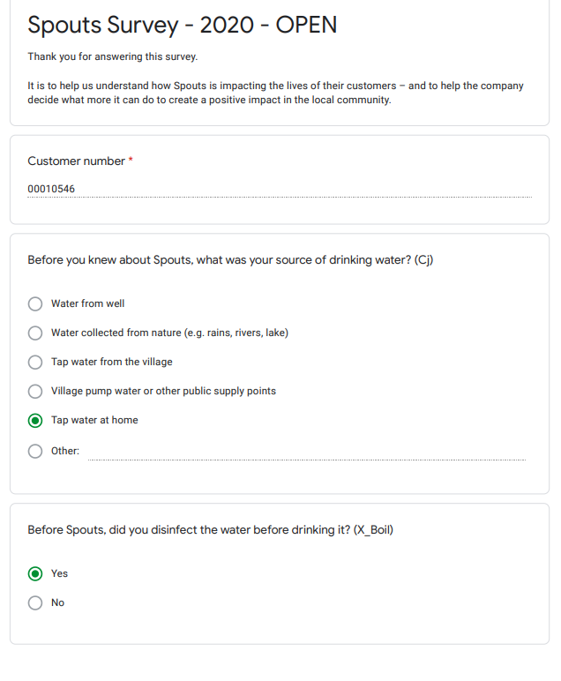

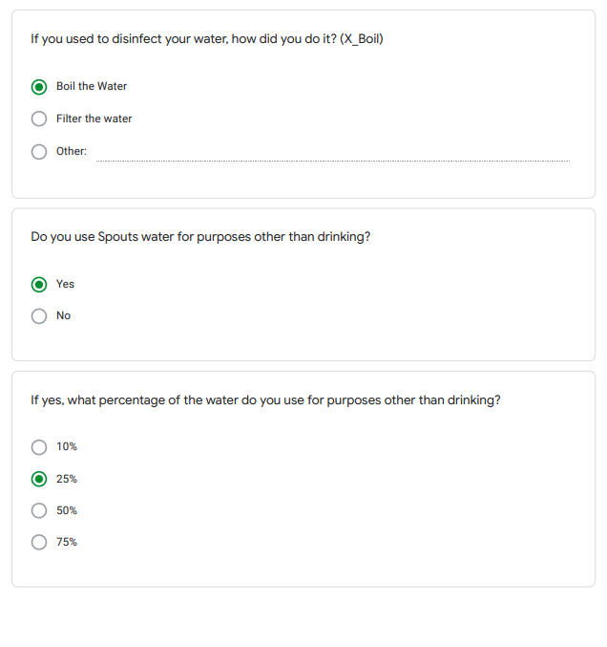

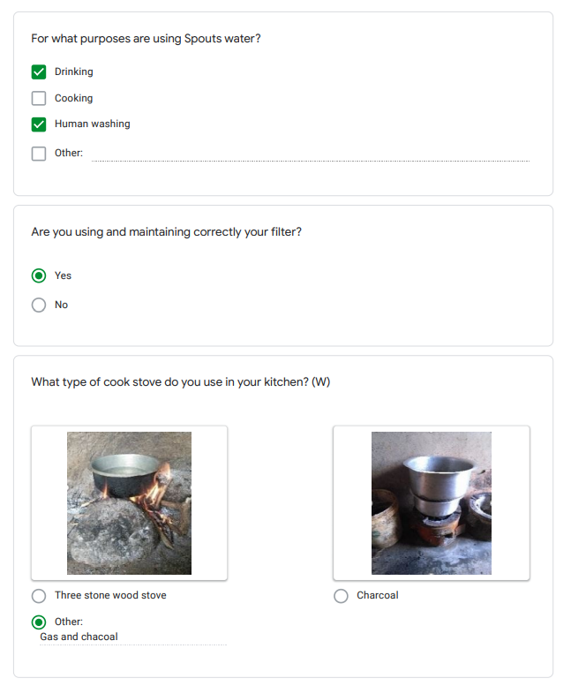

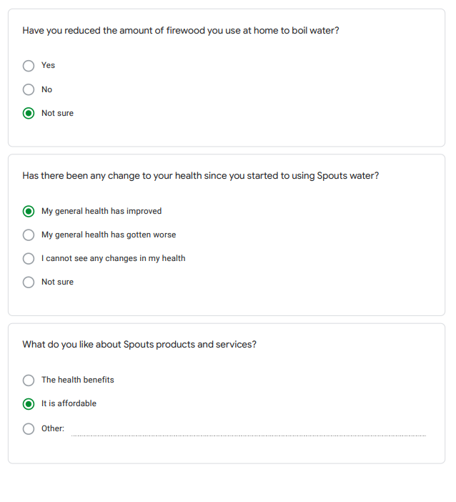

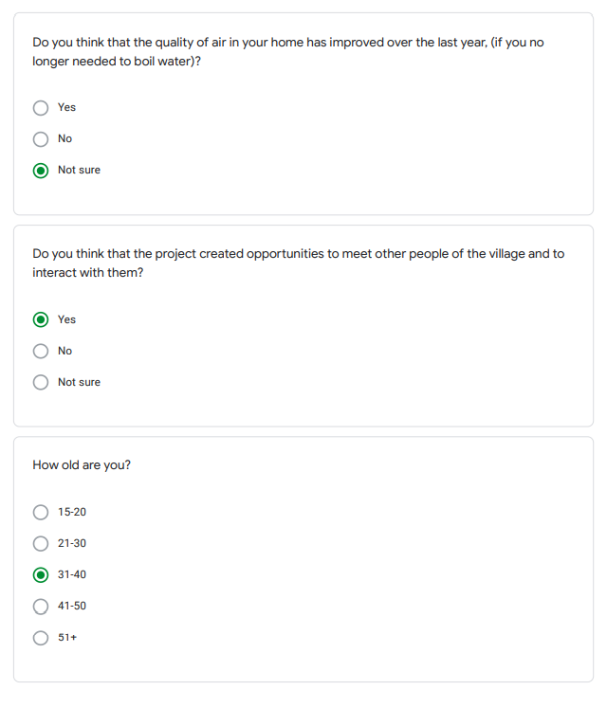

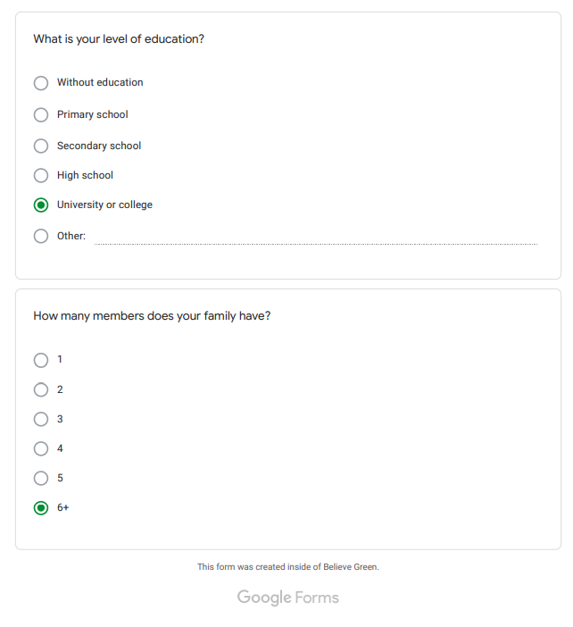

Appendix 2 – Water Quality Test – Results

As per water Quality Test below we can notice absence of e.coli and other coliforms.
In all the tests carried out, it has been found that total colonies of e.coli and total coliform were absent. This was expected from the application of chlorine.

A.1) Ministry of Water & Environmant - (Set-2019)

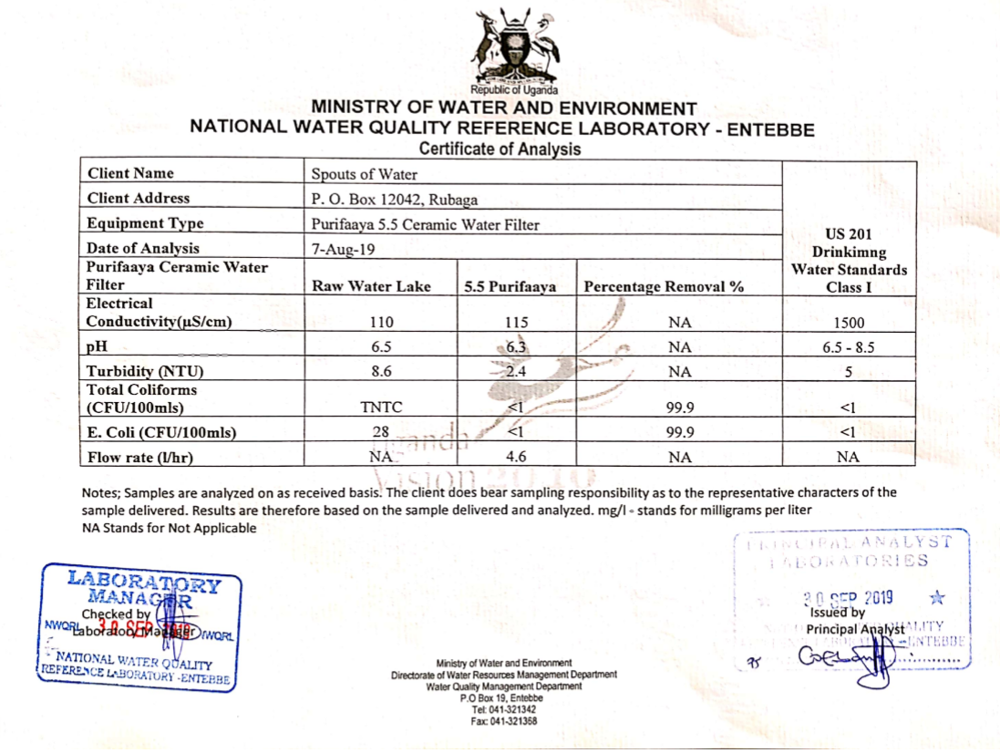

A.2) Ministry of Water & Environmant - (Set-2019)

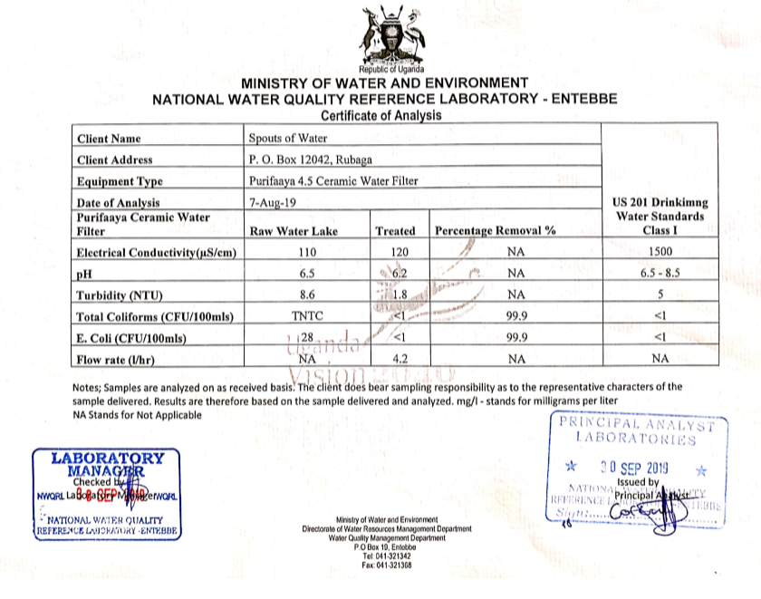

A.3) Chemiphar Laboratory (U) LTD - (September-2020)

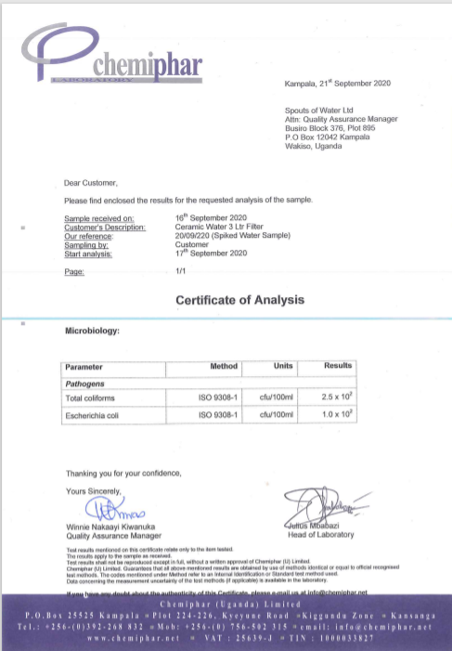

A.4) Chemiphar Laboratory (U) LTD - (September-2020)

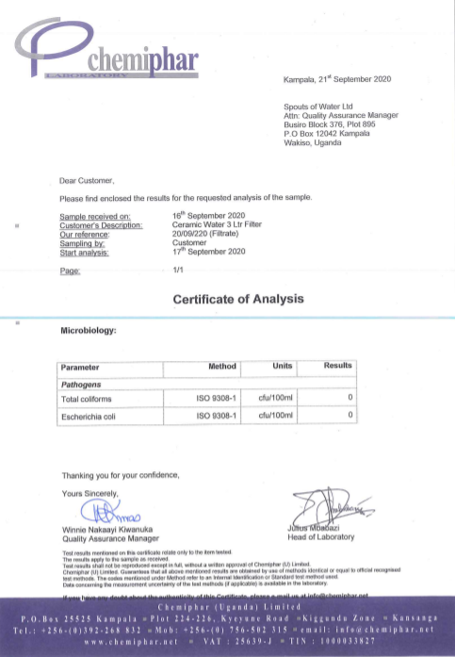

Appendix 3 – Double Counting



December 23th 2019

Dear Customer,
You participate in the Believe Green Safe Drinking Water Carbon Credits Program. This program allows Spouts of Water to provide an affordable, effective and easy-to-use solution for accessing water.
Spouts of Water must strictly avoid ‘double counting’, meaning that you cannot participate in another similar program.
We kindly ask you to inform us promptly if you receive a proposal to participate in another program.
Thank you for your cooperation.

Daniel Yin
Spouts of Water Chief Executive Officer

Appendix 4 – Hygiene Campaigns

We have conducted nearly 50 hygiene campaigns since we made a large-scale installation with the Ministry of Health during the last blockdown.
Each beneficiary who was assigned a filter received WASH training
The installation took over a month and was completed by four separate teams.
Each day a team traveled to a low-income community to install filters and perform WASH training.
See below some photos of our last mile workouts and installations and a tweet from the Ministry of Health covering our project.

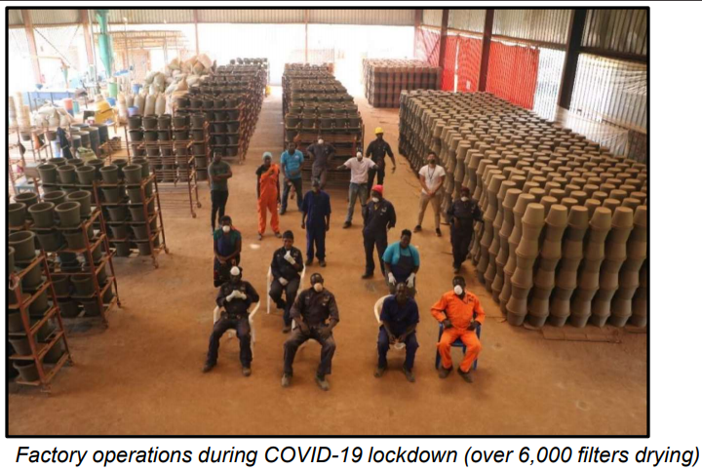

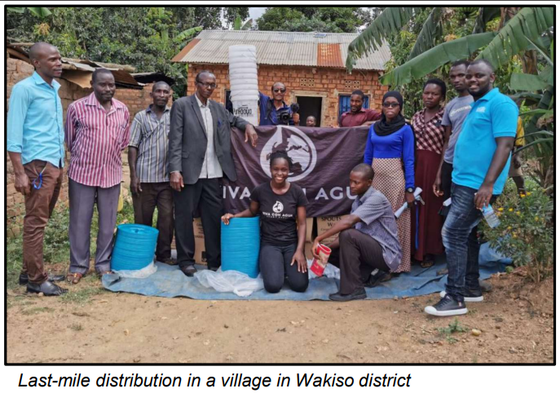

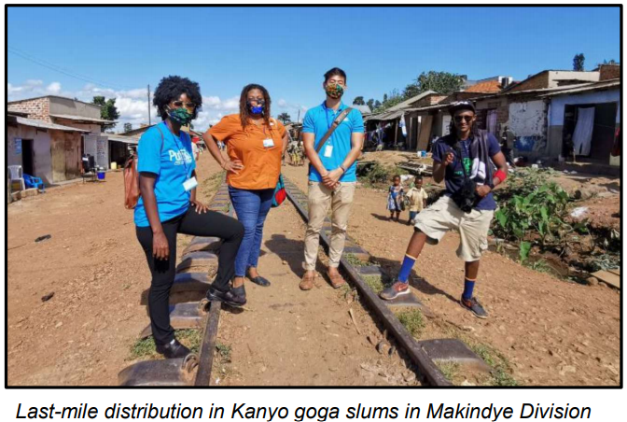

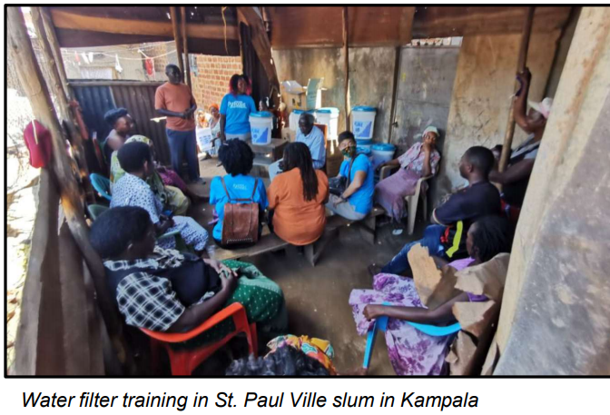

Topics covered in training moments



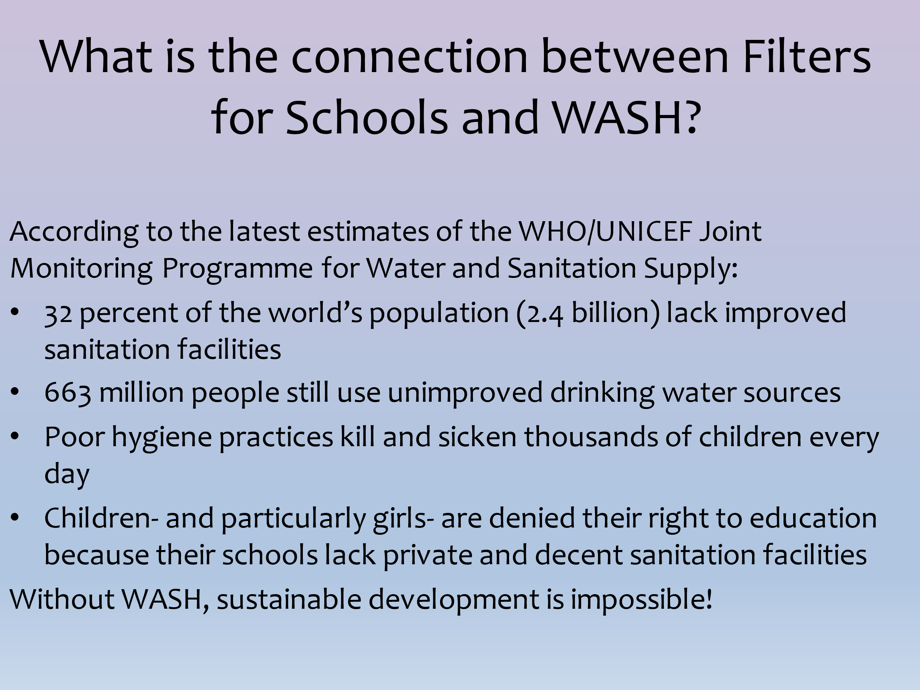





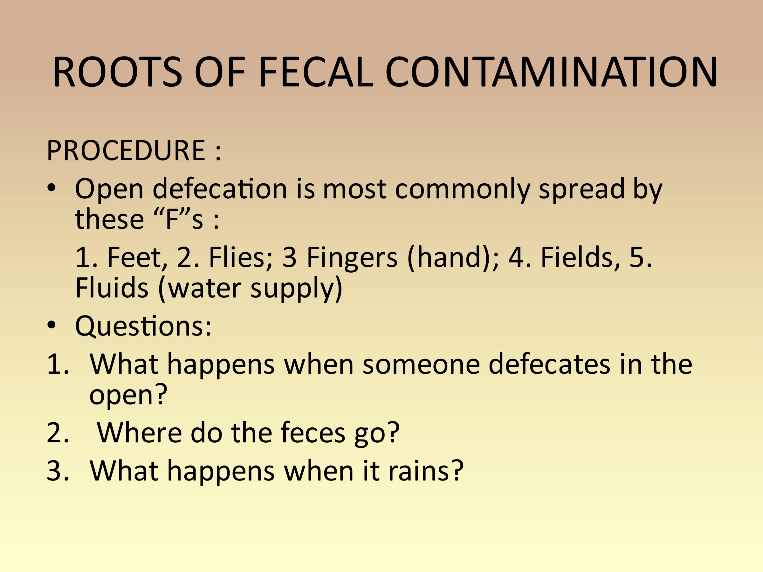

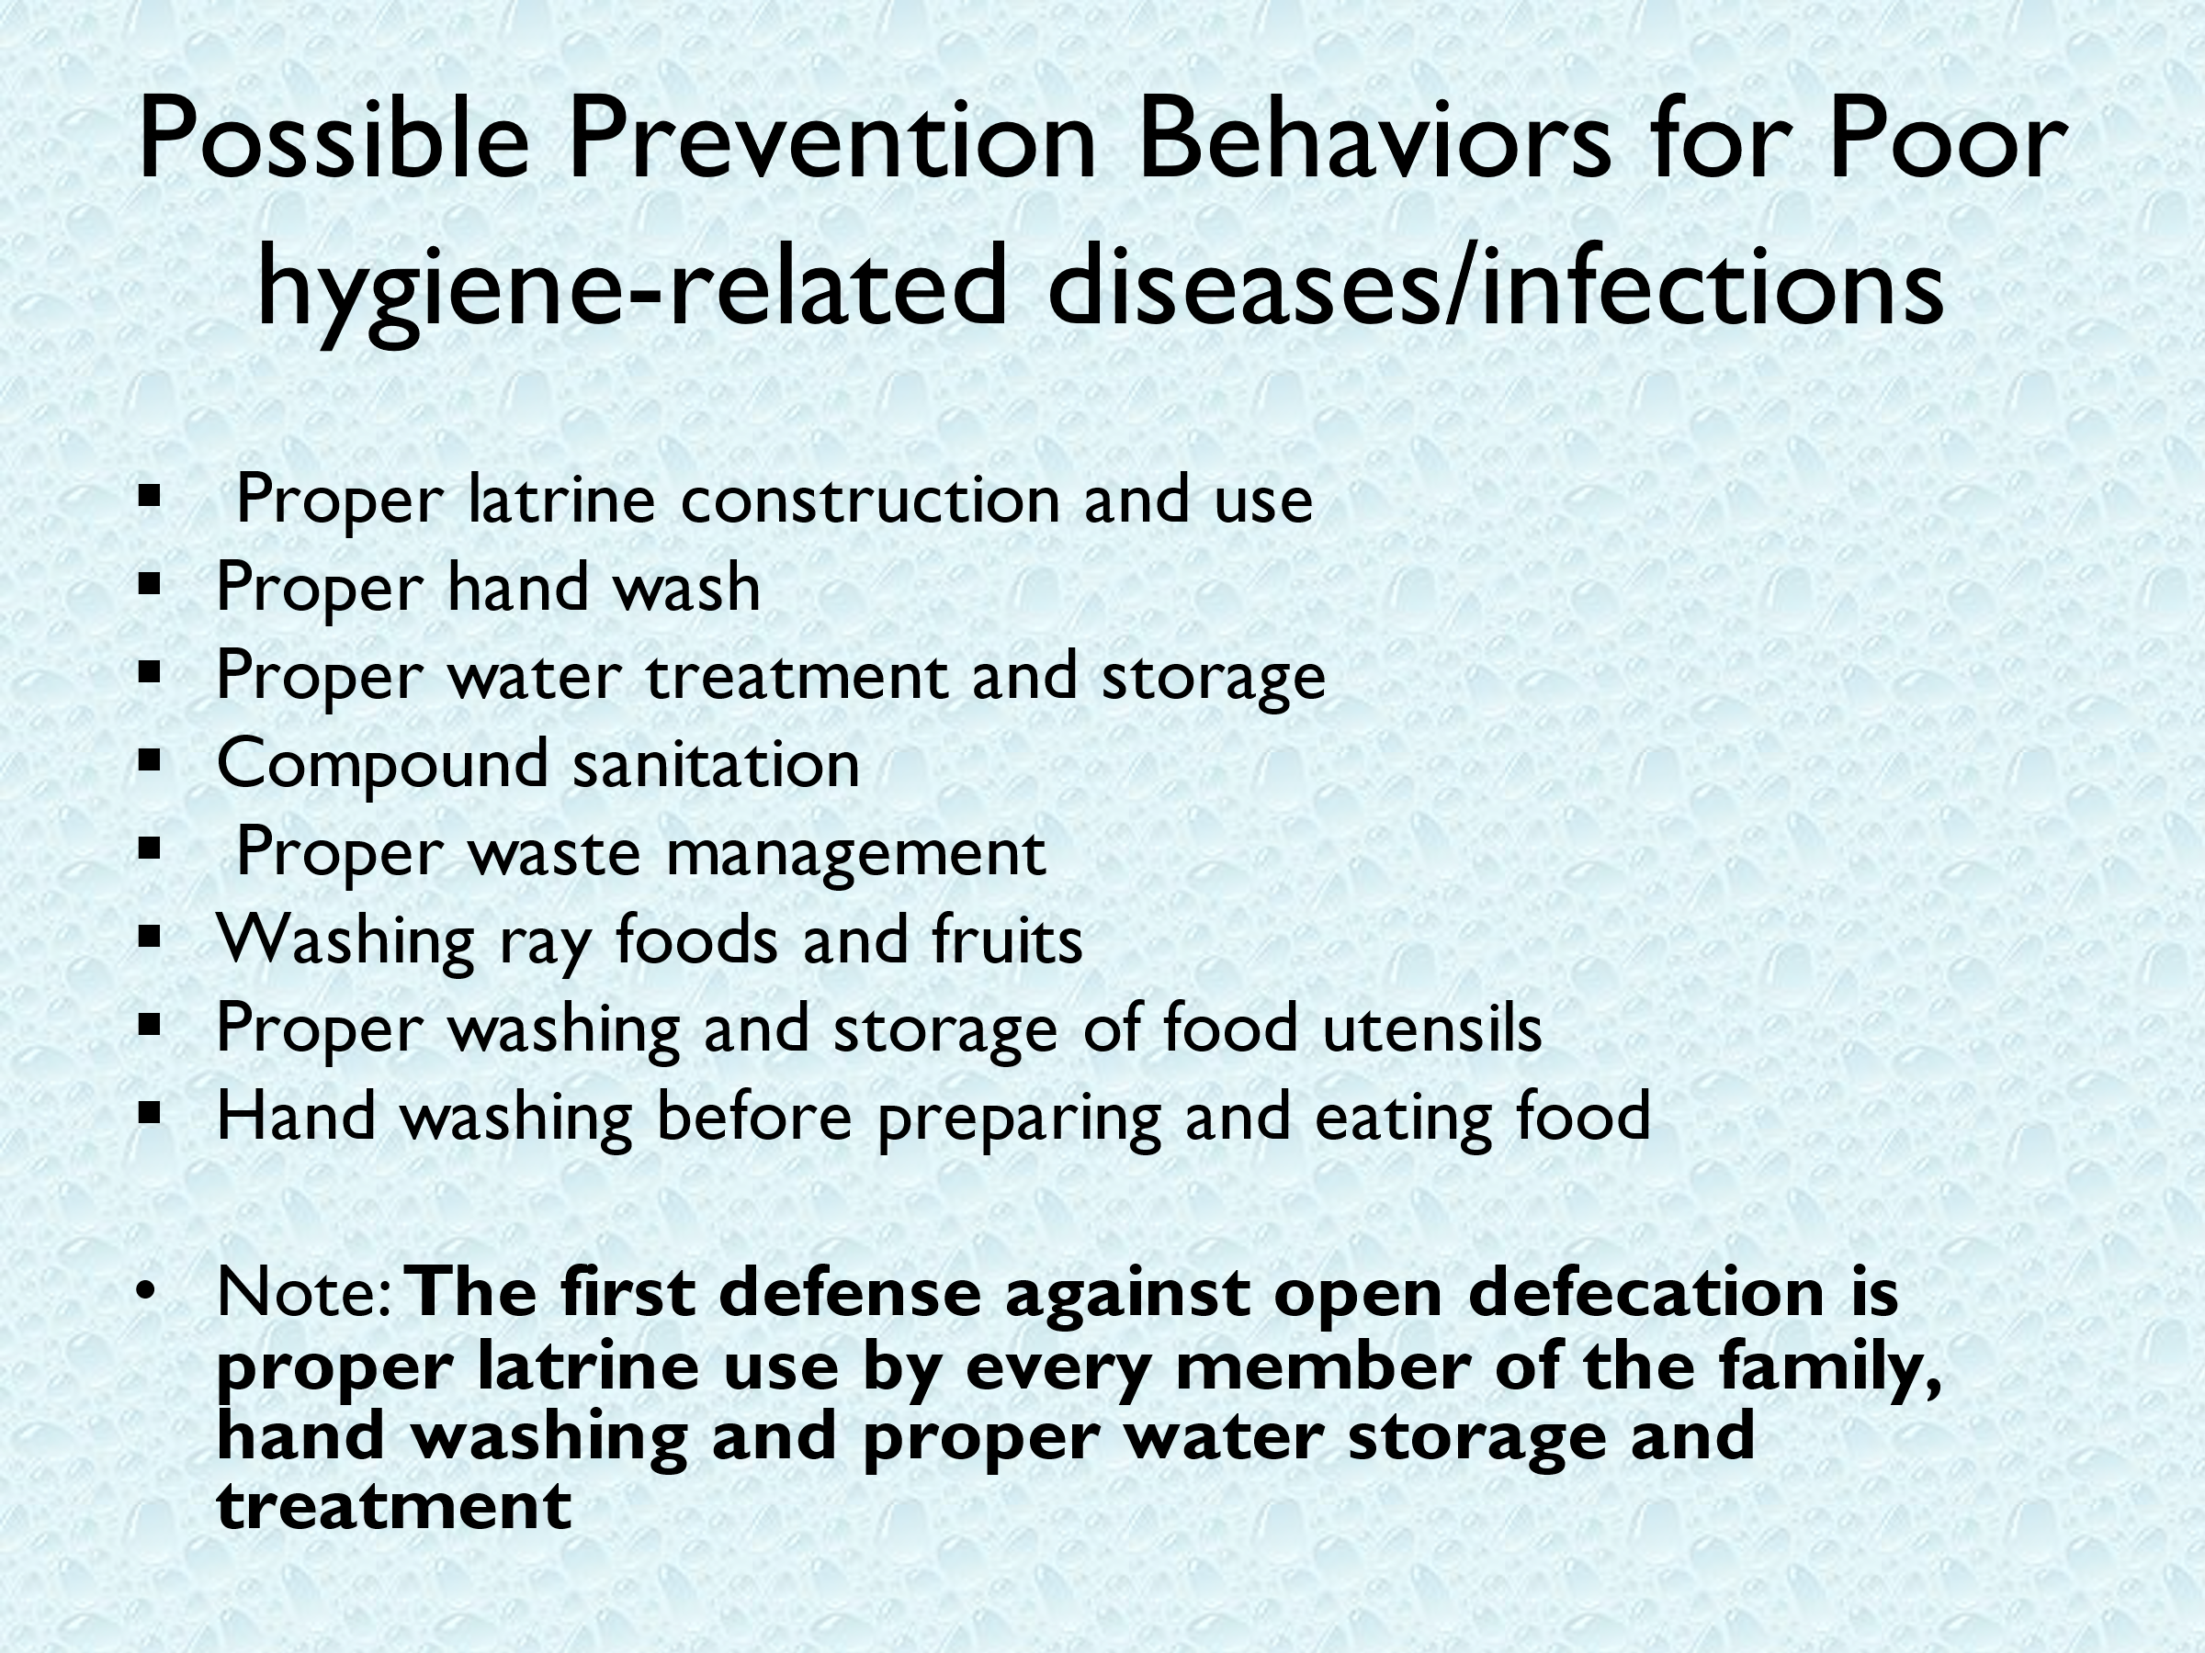

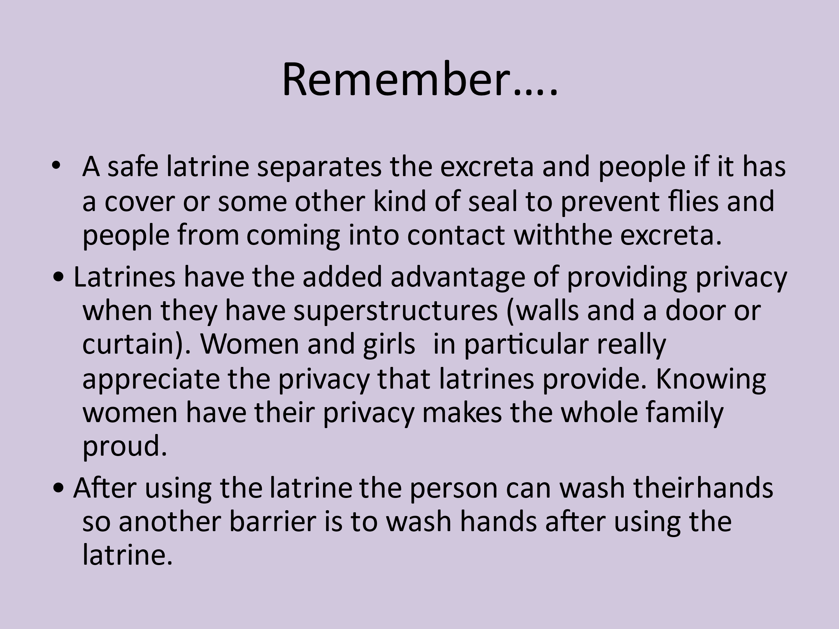

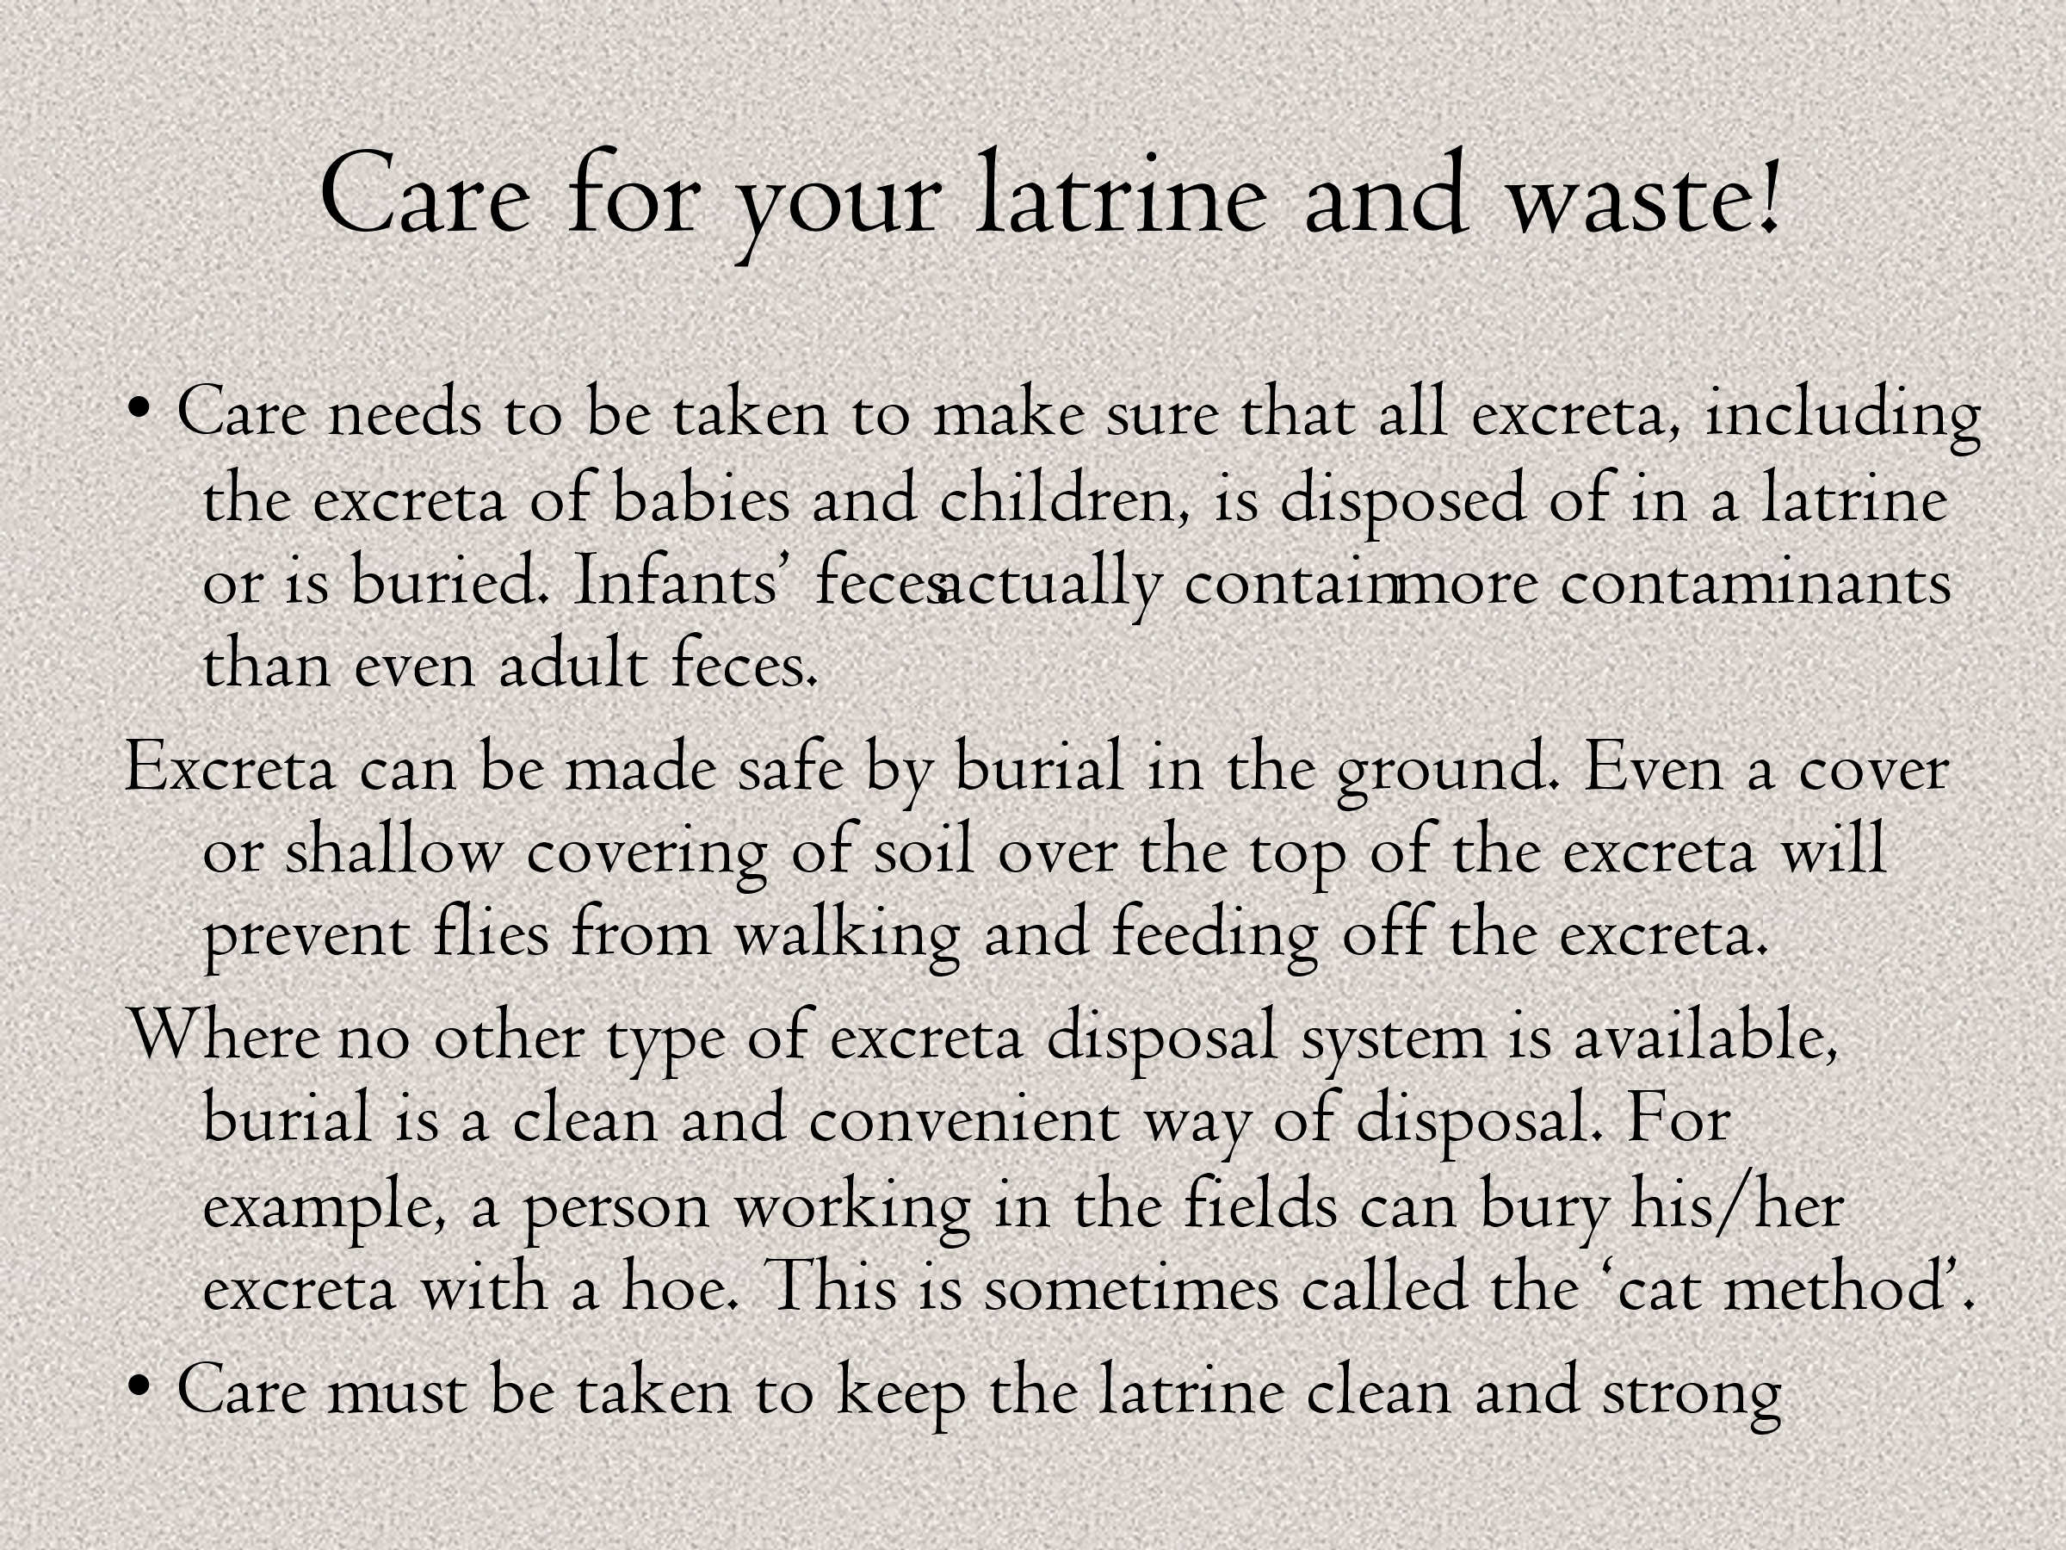

Ù

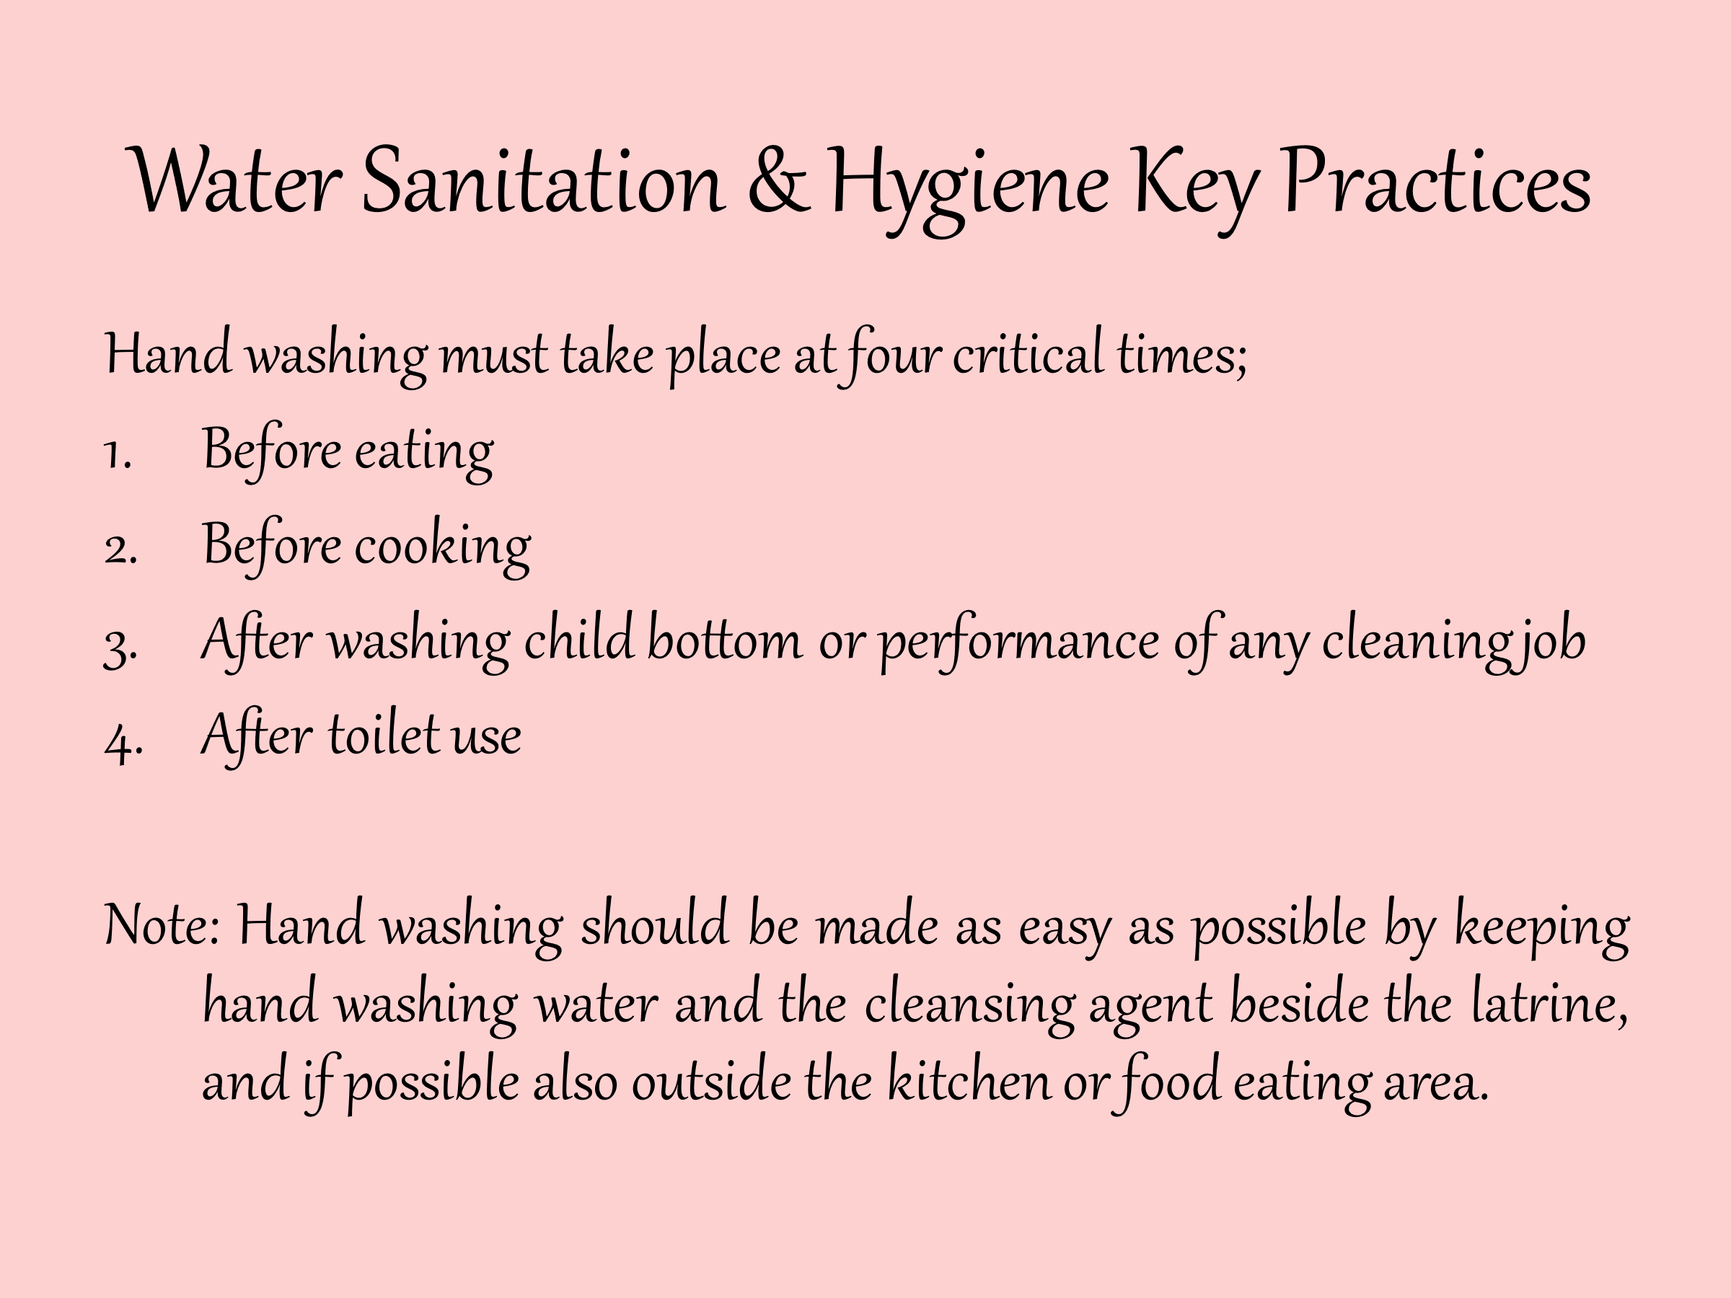

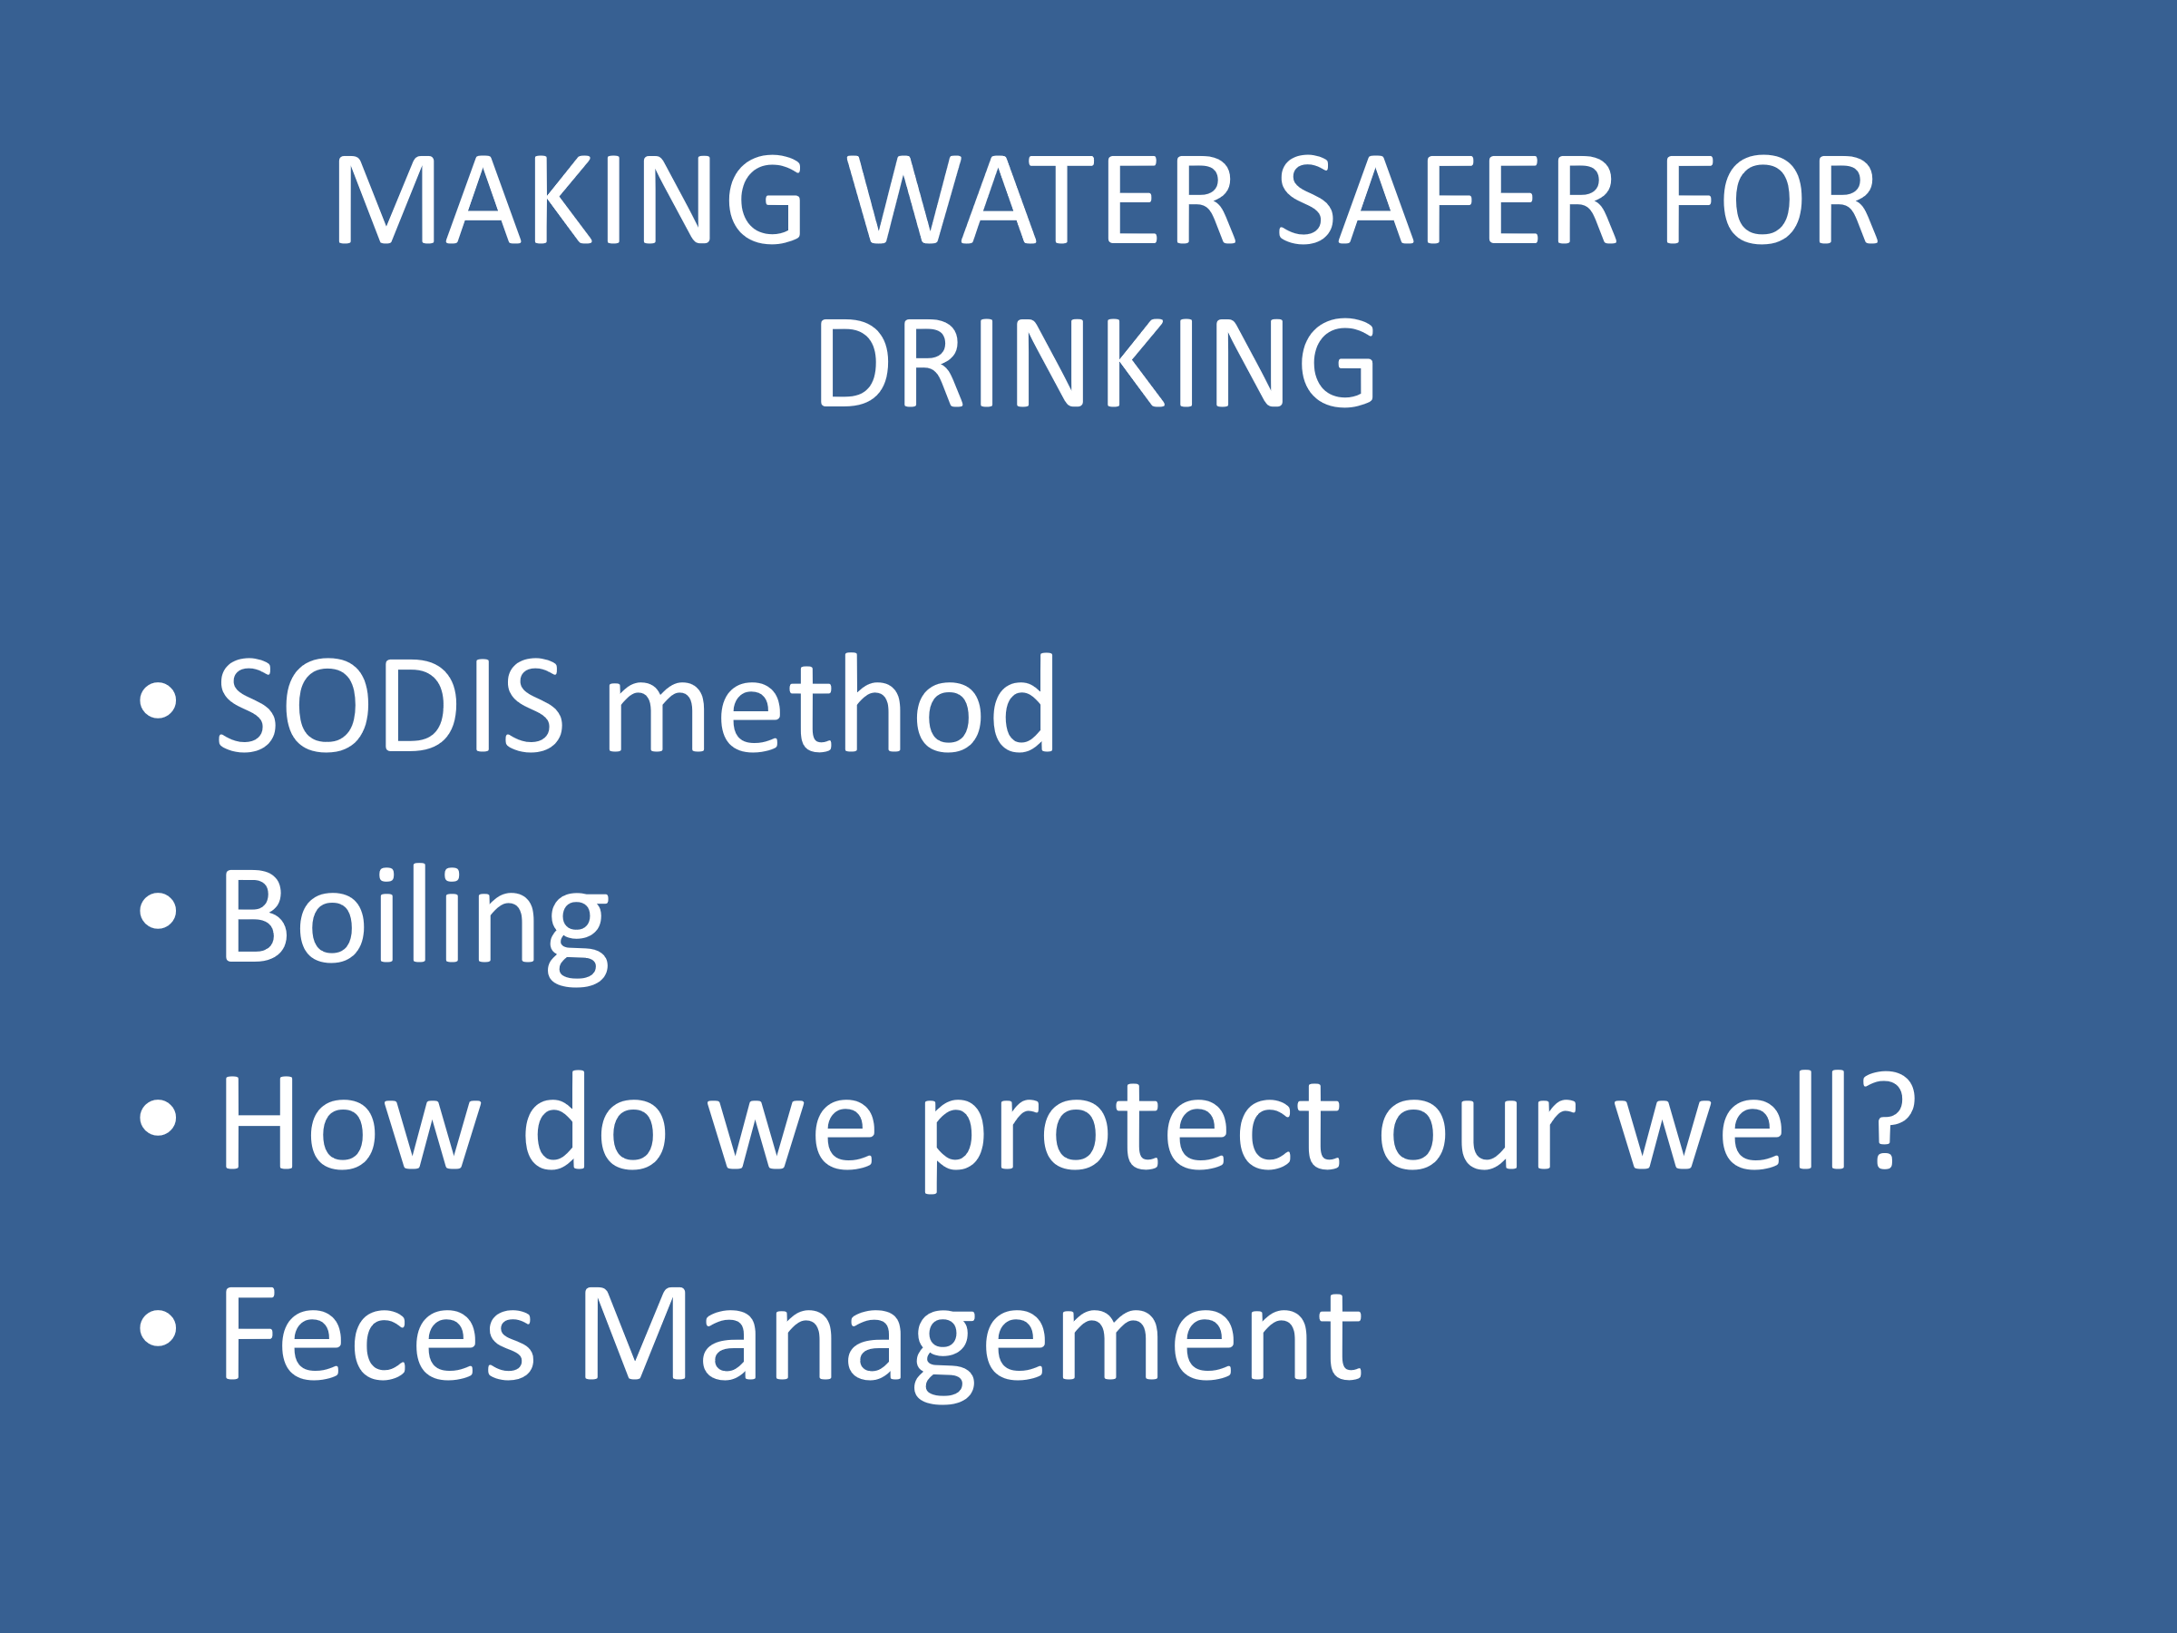

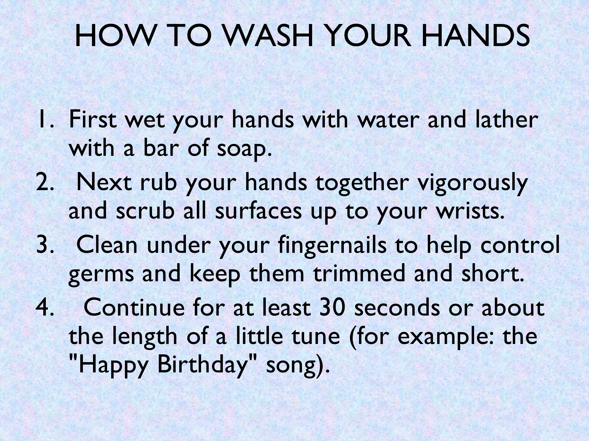

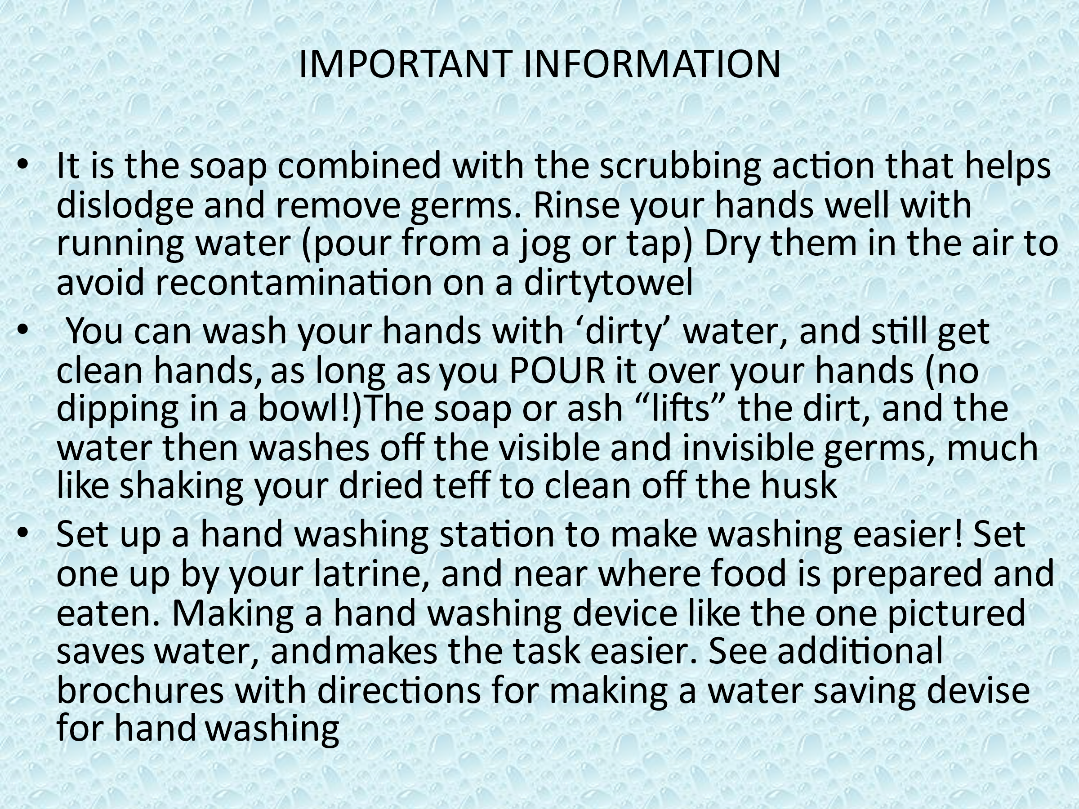

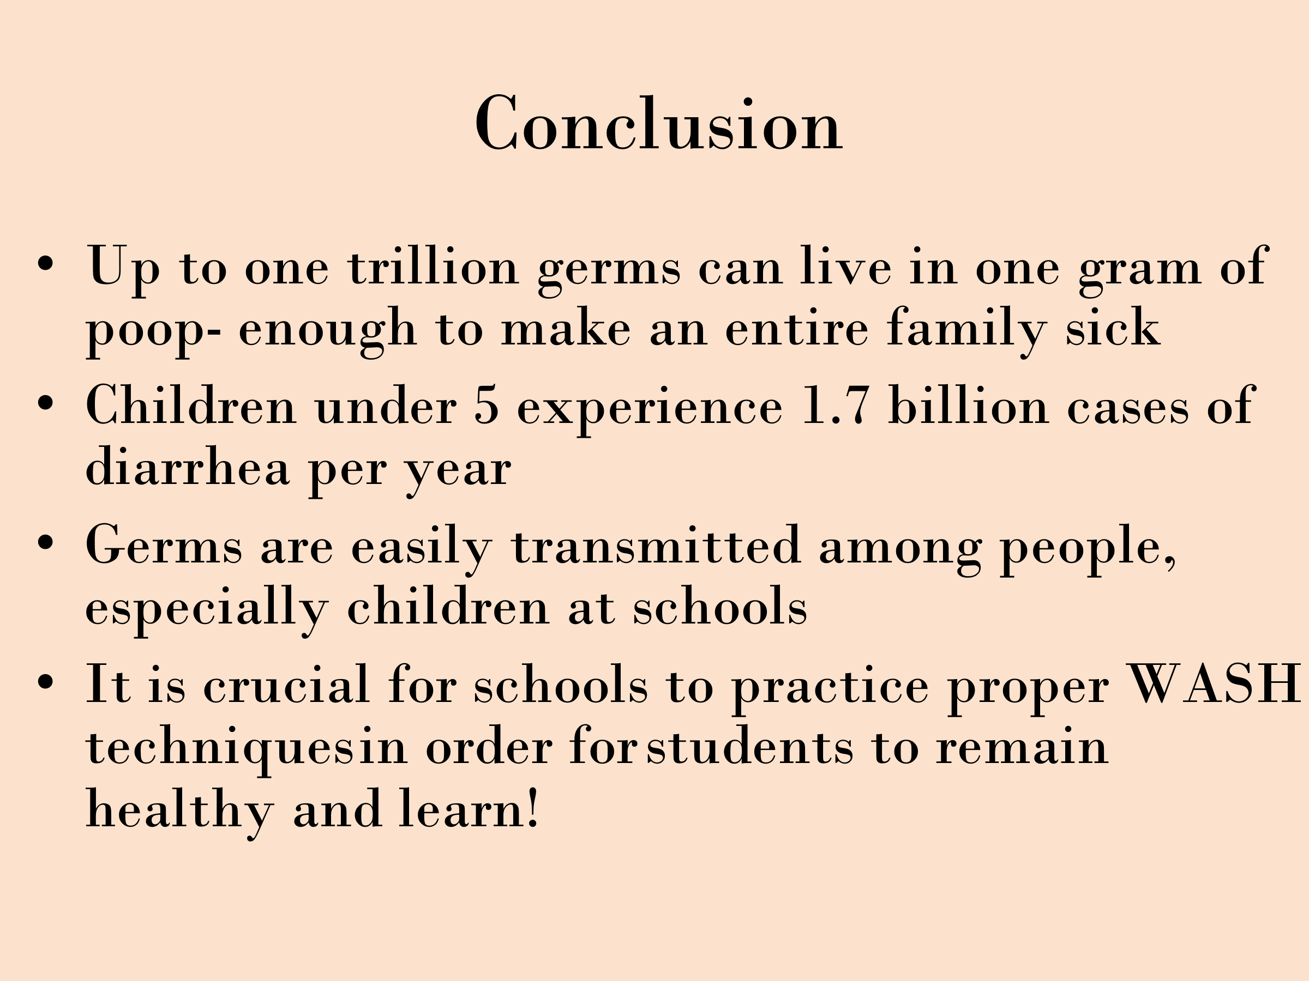

Appendix 5 – Rights of ownership of the GHG reductions
The document below is attached to the filter packaging, visible to all customers buying Spouts of Water filters.

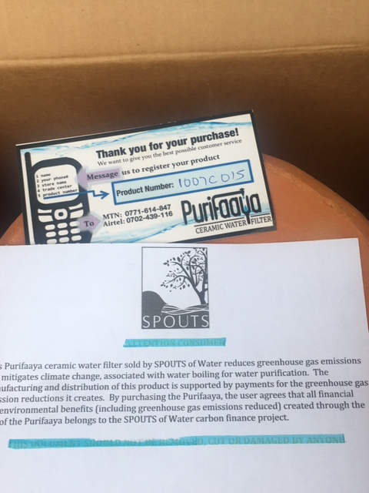

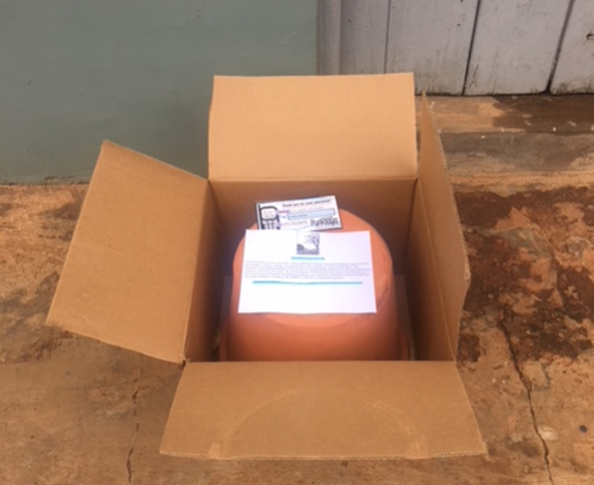

Revision History - (Monitoring Report - Spouts-1 by Believegreen LLC (GS6101)
Version | Date | Remarks
09 | 01/07/21 | Verification – Issuance II – Round 3
08 | 11/06/21 | Verification – Issuance II – Round 2
07 | 06/05/21 | Verification – Issuance II – Round 1
06 | 01/09/20 | Verification – Issuance II
05 | 07/04/20 | Verification – Issuance I – Round 4
04 | 28/03/20 | Verification – Issuance I – Round 4
03 | 24/02/20 | Verification – Issuance I – Round 3
02 | 31/01/20 | Verification – Issuance I – Round 2
01 | 29/11/19 | Verification – Issuance I – Round 1
00 | 10/09/19 | Verification – Issuance I

Revision History - (Template)

Version | Date | Remarks
1.1 | 14 October 2020 | Hyperlinked section summary to enable quick access to key sections  Improved clarity on Key Project Information  Section for POA monitoring  Forward action request section  Improved Clarity on SDG contribution/SDG Impact term used throughout  Clarity on safeguard reporting  Clarity on design changes  Leakage section added for VER/CER projects  Addition of Comparison of monitored parameters with last monitoring period  Provision of an accompanying Guide to help the user understand detailed rules and requirements
1.0 | 10 July 2017 | Initial adoption

Unicef. “Improving Household Drinking Water Quality: Use of Ceramic Water Filters in Cambodia.” August 2007. https://www.unicef.org/eapro/WSP_UNICEF_FN_CWP_Final.pdf
Record of Approval: http://spouts.org/wp-content/uploads/2016/09/SPOUTS_Purifaaya-Intro.pdf
http://www.ipcc-nggip.iges.or.jp/public/2006gl/pdf/2_Volume2/V2_2_Ch2_Stationary_Combustion.pdf
http://www.ipcc-nggip.iges.or.jp/public/2006gl/pdf/2_Volume2/V2_2_Ch2_Stationary_Combustion.pdf
http://www.ipccnggip.iges.or.jp/public/2006gl/pdf/2_Volume2/V2_2_Ch2_Stationary_Combustion.pdf
Http://www.ipccnggip.iges.or.jp/public/2006gl/pdf/2_Volume2/V2_2_Ch2_Stationary_Combustion.pdf
https://unfccc.int/ghg_data/items/3825.php
http://www.biomasstradecentre2.eu/scripts/download.php?file=/data/pdf_vsebine/literature/wood_fuels_handbook.pdf
https://www.ipcc.ch/meetings/session25/doc4a4b/vol2.pdf
Bain, R., Cronk, R., Wright, J., Yang, H., Slaymaker, T., & Bartram, J. (2014). Fecal Contamination of Drinking-Water in Low- and Middle-Income Countries: A Systematic Review and Meta-Analysis. PLoS Medicine, 11(5). http://doi.org/10.1371/journal.pmed.1001644
Haruna, R., Ejobi, F., & Kabagambe, E. K. (2005). The quality of water from protected springs in Katwe and Kisenyi parishes, Kampala city, Uganda. African Health Sciences, 5(1), 14–20.
World Health Organization (WHO), & Unicef. (2012). Uganda WASH Statistics. Geneva. Retrieved from https://www.wssinfo.org/documents
http://www.onewater.org/stories/story/uganda
https://www.monitor.co.ug/News/National/Water-Kampala-safe-WHO/688334-2658314-dbx3ku/index.html
https://www.monitor.co.ug/SpecialReports/How-safe-water-consume/688342-4348206-5y8ijuz/index.html
Sai Biocare Pvt. Ltd.
Prior to the project, Spouts did not provide water filters.
https://en.wikipedia.org/wiki/Uganda
Please refer to the Emission Reductions spreadsheet which includes the data presented here.
Whenever emission reductions are capped, both the original and capped values used for calculations must be transparently reported. Use brackets to denote original values.

