Gold Standard for the Global Goals
Key Project Information & VPA-DD-Spouts 2-GS6444 Design Document (PDD)

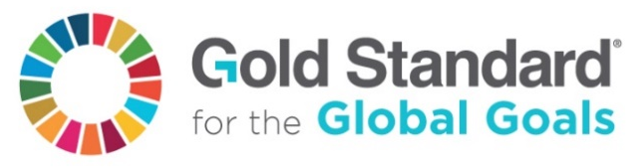

July 2017, Version 1

SECTION A. Description of project 6
A.1. Purpose and general description of project 6
A.2. Eligibility of the project under approved PoA 6
A.3. Legal ownership of products generated by the project and legal rights to alter use of resources required to service the project 7
A.4. Location of project 7
A.4.1. Host Country 7
A.4.2. Region/State/Province etc. 7
A.4.3. City/Town/Community etc. 7
A.4.4. Physical/Geographical location 8
A.5. Technologies and/or measures 8
A.6. Scale of the project 10
A.7. Funding sources of project 10
SECTION B. Application of selected approved Gold Standard methodology 10
B.1. Reference of approved methodology 10
B.2. Applicability of methodology 10
B.3. Project boundary 13
B.4. Establishment and description of baseline scenario 15
B.5. Demonstration of additionality 21
B.6. Sustainable Development Goals (SDG) outcomes 22
B.6.1. Relevant target for each of the three SDGs 22
B.6.2. Explanation of methodological choices/approaches for estimating the SDG outcome 22
B.6.3. Data and parameters fixed ex ante for monitoring contribution to each of the three SDGs 24
B.6.4. Ex ante estimation of outcomes linked to each of the three SDGs 33
B.6.5. Summary of ex ante estimates of each SDG outcome 40
B.7. Monitoring plan 40
B.7.1. Data and parameters to be monitored 40
B.7.2. Sampling plan 46
B.7.3. Other elements of monitoring plan 47
SECTION C. Duration and crediting period 47
C.1. Duration of project 47
C.1.1. Start date of project 47
C.1.2. Expected operational lifetime of project 49
C.2. Crediting period of project 49
C.2.1. Start date of crediting period 49
C.2.2. Total length of crediting period 49
SECTION D. Safeguarding principles assessment 50
D.1. Analysis of social, economic and environmental impacts 50
SECTION E. Local stakeholder consultation 51
E.1. Solicitation of comments from stakeholders 51
E.2. Summary of comments received 56
E.3. Report on consideration of comments received 58
Appendix 1 – Contact information of project participant 59
Appendix 2 – Information Regarding Public Funding 60

Document Control
Rev. | Data | Approved | Description and reason of revision

3 | 10/07/18 | F. Gallo | Preliminary Review
4 | 10/11/18 | F. Gallo | Validation Round I
5 | 11/01/19 | F. Gallo | Validation Round II
6
7

KEY PROJECT INFORMATION
*
Title of Project: | Believe Green Safe Drinking Water – Spouts-2 – GS6444
Title of the PoA: | Believe Green Safe Drinking Water – GS5705
Brief description of Project: | “Believe Green Safe Drinking Water – Spouts-2” is a Gold Standard micro-programme activity (VPA) which aims to reduce biofuel consumption, such as wood, as is traditionally used to boil water to make it safe to drink. This is done by offering low income populations affordable and easily accessible treated water that is safe to drink. Since these people usually use inefficient cook stoves that cause large amounts of smoke leading to respiratory diseases, the project also has significant health co-benefits. Also, the project generates significant employment and income opportunities for the local villagers, who are invited to join the project across the production and delivery chain.
Expected Implemetation Date:  Expected duration of Project: | April 4, 2017  21 years
Project Developer: | Believe Green LLC
Project Representative: | Dr. Federico Gallo
Project Participants and any communities involved: | Believe Green LLC , Spouts of Water
Version of PDD:  Date of Version: | Version 05  January 11th, 2019
Host Country / Location: | Uganda
Certification Pathway (Project Certificatin/Impact Statements & Products | Impact Certification
Activity Requirements applied:  (mark GS4GG if none relevant) | GS4GG
Methodologies applied: | “Technologies and Practices to Displace Decentralized Thermal Energy Consumption” Version 3.1, August 2017 .
Product Requirements applied: | N.A.
Regular/Retroactive: | Retroactive
SDG Impacts: | 1 – SDG 13 – Climate Action  2 – SDG 7 – Affordable and Clean Energy  3 – SDG 6 – Clean Water and Sanitation
Estimated amount of SDG Impact Certified | 1 – SDG 13 – Climate Action: 9,995 tCO2e/year  2 – SDG 7 – Affordable and Clean Energy: 7,295 tonnes of wood fuel avoided  3 – SDG 6  (1) Clean Water and Sanitation: 21,910,842 liters of safe drinking water  (2) Number of persons consuming water supplied by the project: 19,240 persons

  - Description of project
    - Purpose and general description of project

>> (Provide a brief description of the project including the description of scenario existing prior to the implementation of the project.)

“Believe Green Safe Drinking Water – Spouts-2 – GS6444 ” is a Gold Standard micro-programme activity (VPA) which aims to reduce biofuel consumption, such as wood, as is traditionally used to boil water to make it safe to drink. This is done by offering low income populations affordable and easily accessible treated water that is safe to drink. Since these people usually use inefficient cook stoves that cause large amounts of smoke leading to respiratory diseases, the project also has significant health co-benefits. Also, the project generates significant employment and income opportunities for the local villagers, who are invited to join the project across the production and delivery chain.

    - Eligibility of the project under approved PoA

>> (Demonstrate how each VPA meets the eligibility criteria as defined in approved PoA)
These Project Activity fulfil with the GS4GG-100.OR-Programme of Activies Requirements, Section 11.2 Regarding the eligibility criteria to be for included in the PoA:
- Geographic boundary of the activity and whether it is within the boundary of the PoA set at the time of registration;
Answer: this VPA includes villages located in Uganda. As stated in section B.2 of the PoA-DD, therefore this VPA is within the geographic boundary of this PoA.

- Additionality criteria is being met as defined in the registered PoA-DD;
Answer:

In order to demonstrate additionality we use the UNFCCC guidelines: “Annex 27 - Guidelines on the demonstration of additionality of small-scale project activities” .
This requires that “project participants shall provide an explanation to show that the project activity would not have occurred anyway due to at least one of the following barriers:
a) Investment barrier: a financially more viable alternative to the project activity would have led to higher emissions;
b) Technological barrier: a less technologically advanced alternative to the project activity involves lower risks due to the performance uncertainty or low market share of the new technology adopted for the project activity and so would have led to higher emissions;
c) Barrier due to prevailing practice: prevailing practice or existing regulatory or policy requirements would have led to implementation of a technology with higher emissions;
d) Other barriers: without the project activity, for another specific reason identified by the project participant, such as institutional barriers or limited information, managerial resources, organizational capacity, financial resources, or capacity to absorb new technologies, emissions would have been higher.

The PP has chosen the barrier due to prevailing practice to prove additionality.

Prevailing practice: boiling water or not treating at all (suppressed demand)
Many people served by our PoA in Uganda do not purify their water because they are unaware of the health consequences of drinking untreated water.
If they treat it, most often they do so by boiling it with very inefficient and dirty cook stoves, in most cases three-stone stoves, see section A.4.2 of the PoA-DD.
However, if shown the adverse effects of drinking untreated water, people will start choosing to purchase Spouts of Water’s purified water, or to purify it at home, for example with Spouts ceramic water filters.
This is a fact documented and demonstrated by the work of this project, and lies at the core of its business model. Specifically, in order to expand into new communities and new regions in the country, Spouts of Water use complex awareness campaigns and marketing to generate demand for their products.
The success of our business model clearly shows that, through education and awareness, the attitudes towards safe drinking water can change permanently. Specifically, if shown the benefits of safe drinking water, people will choose to purify the water they drink.
The role of our local partner, Spouts of Water, is to ensure that the treatment of the water occurs in a zero carbon way. Without Spouts of Water’ service, people would likely have started to boil the water using the inefficient stoves and fuel at their disposal, which is described in Section A.4.2 of the PoA-DD.
Revenues from carbon credits will be key in supporting the expansion of the reach of our local partners into new villages and regions. Such expansion is very expensive for Spouts of Water, and cannot be achieved without external support. The revenues from the carbon credits would help sustain Spouts of Water growth and help people in Uganda have access to safe drinking water that they can afford and want to buy.
In summary, the additionality criteria are met because without the PoA the project activities would not have occurred because of the barrier due to prevailing practice.

- The activity is in line with the baseline scenario(s) identified in the PoA-DD;
Answer: The activity in this VPA is in line with the baseline scenario identified in the Section A.4 of the PoA-DD.

- Emission reduction calculations are in accordance with the procedures defined in this VPA-DD.
Answer The emission reduction calculations are presented in:
- Section B.6.4
- ‘Spouts - Emissions Reductions Calculations’ Spreadsheet

- The monitoring plan of these activities are designed as per the applied methodology and in accordance with this VPA-DD;
Answer The monitoring plans are presented in Section B.7. Monitoring Plan.

- In the case of DNHA and SD assessments being done at the PoA level, then check the SD monitoring plan is as per the PoA-Passport.
Answer: Not applicable

    - Legal ownership of products generated by the project and legal rights to alter use of resources required to service the project
>> (Justify that project owner has full and uncontested legal ownership of the products that are generated under Gold Standard Certification and has legal rights concerning changes in use of resources required to service the Project for e.g water rights, where applicable.)

Believe Green LLC (BG), which will be leading this project, has been actively involved in the development of national policies on carbon finance, including in the UK and Mexico. It has supported the creation of international institutions such as the Green Climate Fund. It is also involved in the continuous development and improvement of carbon finance mechanisms, such as advising the UNFCCC on the reform of the CDM.
BG will be responsible for coordinating all aspects related to the Gold Standard Certification, as well as designing and managing all the monitoring activities. Also, by leveraging the carbon finance revenues and the findings from the monitoring surveys, BG shall design and implement strategies to maximize uptake of Spouts of Water’s purified water, for example by identifying and resolving barriers, as well as strategies to scale up the distribution of the safe water to areas that currently do not have access to sources of improved water.
SPOUTS of Water is our local partner in Uganda. SPOUTS OF WATER provides Ugandan communities with increased access to safe drinking water by manufacturing and distributing the Purifaaya ceramic water filter, the only locally manufactured water filter in Uganda. The Purifaaya is affordable even to poorer communities at 20 USD, providing a tested solution to people who need it most.
By replacing the common practice of boiling, families and especially women save money, time, and fuel.

The above arrangements and relationbships are formalized under contract between the two parties.

    - Location of project
      - Host Country
>>
Uganda

      - Region/State/Province etc.
>>
The project covers the entire country.

      - City/Town/Community etc.
>>

      - Physical/Geographical location
>> (Include information allowing the unique identification of this project.)

SPOUTS OF WATER distributes filters in over 200 communities across all four regions of Uganda. The map below shows the distribution points:

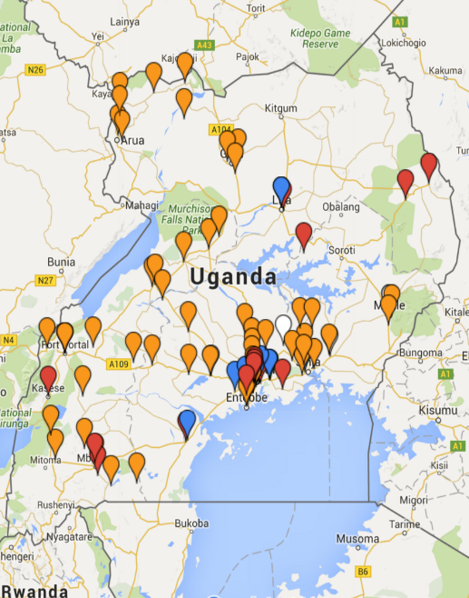

The total number of filters sold in the first monitoring period (April 2017 – March 2018) was around 9,100, which corresponds to around 30,000tCO2. In order to stay within the 10,000tCO2 limit allowed for micro-scale projects, we are only registering 3011 filters in this VPA, corresponding to 9,995 tCO2. We are registering two additional VPAs to include the remaining 5,945 filters. (The above figures may vary each year and will be described in the relevant Monitoring Reports.)

In the future, we plan to continue using the same allocation procedure, dividing the total number of filters sold into the available VPAs. If necessary, we will register additional VPAs to match the eventual growth of Spouts’ operations on the ground.

    - Technologies and/or measures

>> (Describe the technologies and measures to be employed and/or implemented by the project, including a list of the facilities, systems and equipment that will be installed and/or modified by the project. Include information essential to understand the purpose of the project and how it will contribute positively to three SDGs.)

A) Technology

The Purifaaya water filter uses ceramic filtration technology. Ceramic water filters are an innovative product offered as an appropriate clean water solution in Uganda. An assessment on the use of ceramic water filters in Cambodia by UNICEF states, “[Ceramic] filters have the advantage of being lightweight, portable, relatively inexpensive, chemical-free, low-maintenance, effective, and easy to use.”
The base of the filter is a ceramic pot with microscopic holes, which trap bacteria, enabling only clean drinking water to pass through. In order to maximize safety, all of our filters are subjected to strict quality control and then coated with an additional layer of silver nitrate, an effective biocide. Water from any source can be sanitized through the ceramic filtration system and stored at the bottom of the filter ready to drink. At the bottom of the filter is a tap, which makes the clean drinking water easily accessible. The household Purifaaya stores 20 liters of water, whilst the Purifaaya XL stores 60 liters, making it ideal for public spaces such as schools, hospitals and prisons. In 2015 The Ugandan Ministry of Water and Environment tested and approved the filter stating that SPOUTS OF WATER filters are “efficient and effective to produce water that meets the recommended standard of water for human consumption.” Test results conclude that the Purifaaya kills 99.9% of disease-causing bacteria, as well as removing the turbidity of the water, thus producing drinking water that is both safe and clean.
In addition to Purifaaya’s technical excellence, SPOUTS ‘ceramic filters are also culturally and socially acceptable in Uganda due to the long-standing tradition in villages of storing drinking water in clay pots. The local population prefers the taste of the water from ceramic filters and is accustomed to maintaining ceramic products.
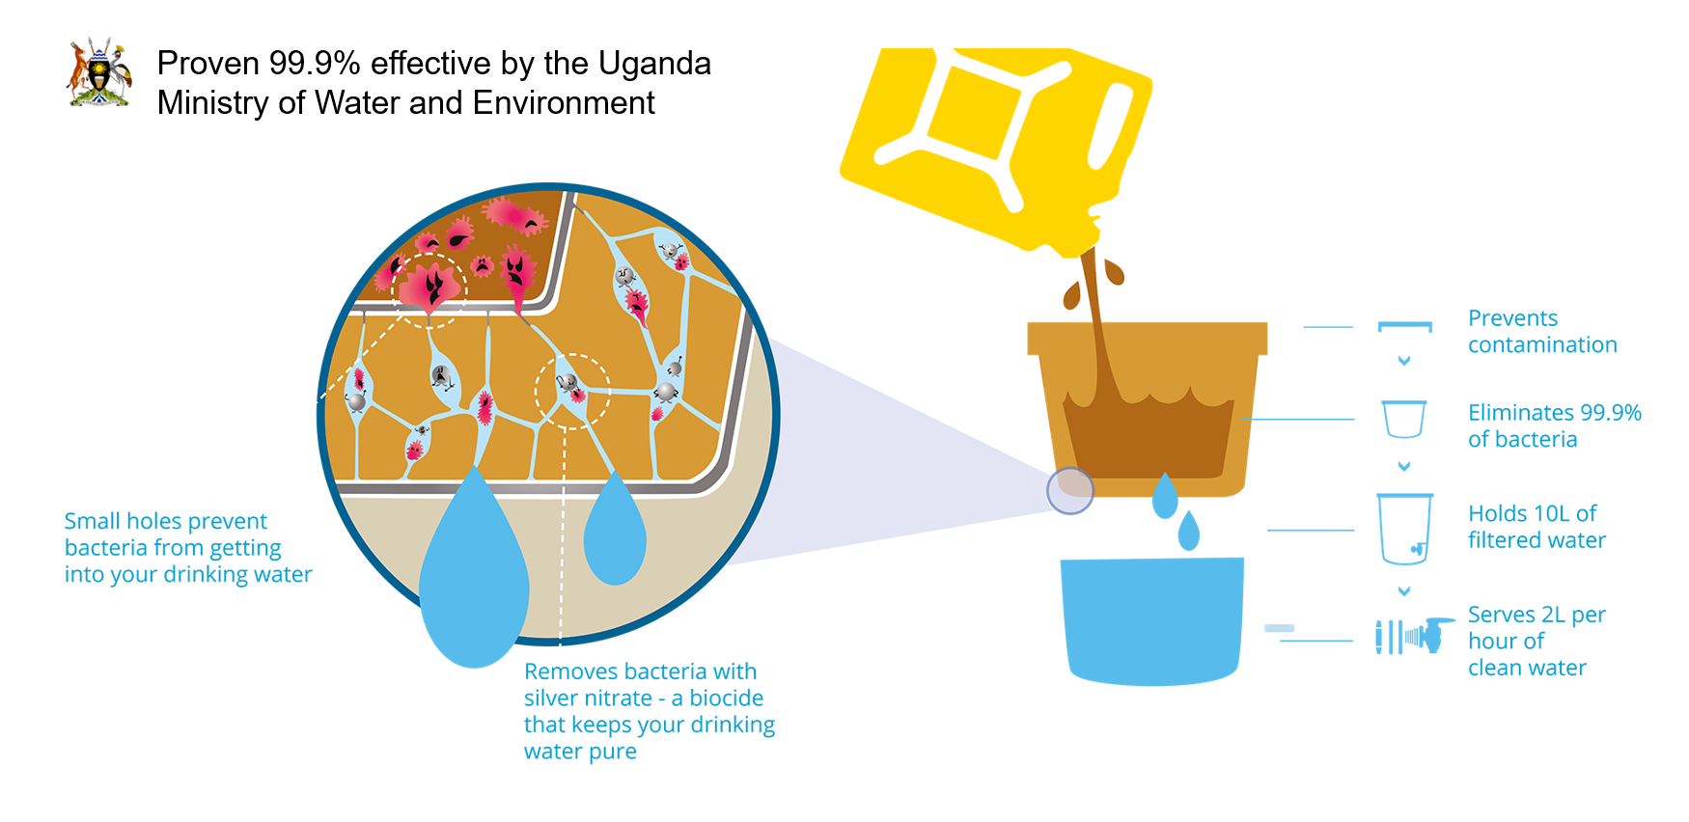
B) Distribution channels/strategy and awareness campaigns
To distribute the filters across the entire nation, SPOUTS segments the market by income level, targeting all households while also working with NGOs to provide clean drinking water to refugee camps, schools, prisons, clinics and other public spaces. In urban and peri-urban areas, SPOUTS products are sold in retails shops, targeting households that can afford the upfront cost of the filter. SPOUTS further reduces the barrier to purchase by providing financing options to customers through partnerships with MFIs and Savings and Credit Cooperatives (SACCOs). SPOUTS’ partners often extend loans to purchase SPOUTS filters over 6 months and allow customers to establish stable long-term access to clean water even if they are unable to afford the upfront cost at once. Given that the average monthly household income is around 128 USD according to the latest national census from 2012-13, the option to buy a SPOUTS filter at 4 USD per month over 6 months is an incredibly affordable price for the vast majority of the population. For the most marginalized segments of the population like refugees in refugee camps, SPOUTS works with aid partner organizations and fundraises to provide access to safe water through installation of filters in public spaces.

SPOUTS has formed long-term partnerships with a diverse set of distribution networks, ranging from NGOs to wholesale retailers, who provide our customers with >200 access points in all four regions of Uganda. Local community banks called SACCOS (Savings and Credit Cooperatives) have embraced our filters, with some selling over 300 filters while offering financing plans enabling end-users who cannot afford the 20 USD to pay in installments. Finca Plus and Pride Microfinance have also provided financing options to our customers. Notably, we have collaborated with United Nations High Commission for Refugees (UNHCR) and Oxfam to provide ceramic water filters in refugee settlements. Retailers, such as Living Goods and BRAC have promoted our filters through an Avon-like distribution network. Prince of Peace Orphans and Widows (POPOW) Vision has distributed our filters to vulnerable women's groups. SPOUTS continues to collaborate with the public sector in Uganda to expand our reach in the region, including programs that install our filters in public prisons.

    - Scale of the project
>> (Define whether project is micro scale, small scale or others. Justify the scale referring to relevant activity requirement.)

The scale of this project is a micro-scale project because it complies with the 10,000tCO2/year limit required by micro-scale projects.

    - Funding sources of project
>> (Provide the public and private funding sources for the project. Confidential information need not be provided.)

See ODA declaration in Appendix 2.

  - Application of selected approved Gold Standard methodology
    - Reference of approved methodology
>>
The Project Activity is associated with the Gold Standard Approved Methodology Technologies and Practices to Displace Decentralized Thermal Energy Consumption Version 3.1 (TPDDTEC)

    - Applicability of methodology
>> (Justify the choice of the selected methodology(ies) by demonstrating that the project meets each applicability condition of the applied methodology(ies))

Accordin to GS4GG Principles & Requirements, Version 1, point 3.1.1, The project is associated with the Approved Methodology Technologies and Practices to Displace Decentralized Thermal Energy Consumption Version 3.1 (TPDDTEC)

The Project Activity is associated with the Gold Standard Approved Methodology Technologies and Practices to Displace Decentralized Thermal Energy Consumption Version 3.1 (TPDDTEC)

This methodology is applicable to programs or activities introducing improved cook-stoves or water treatment technology and practices to households and institutions that result in improved kitchen regimes within a distinct geographical area.
As indicated in section I of the TPDDTEC Methodology, the following conditions apply:
1. The project boundary can be clearly identified, and the technologies counted in the project are not included in another voluntary market or CDM project activity (i.e. no double counting takes place). Project proponents must have a survey mechanism in place together with appropriate mitigation measures so as to prevent double-counting in case of another similar activity with some of the target area in common.
a. The project boundary is clearly identified, as described in sections B.3 of the relevant VPA-DDs.
b. Regarding double counting:
i The technology used in the project is not included in another voluntary market or CDM project activity.
ii. Also, there is no risk of double-counting if a competitor technology enters the same target area. The reason is that we are only counting emission reductions from each litre of purified water sold from Spouts of Water. Therefore, if a competitor takes market share in any of our target areas, this will be automatically registered this in our Record of Sales and Project Database. This in turn will lead to a decrease in the tons of CO2 reduced by our project.

2. The technologies each have a continuous useful energy output of less than 150kW per unit (defined as total energy delivered from start to end of operation of a unit divided by time of operation). For technologies or practices that do not deliver thermal energy in the project scenario but only displace thermal energy supplied in the baseline scenario, the 150kW threshold applies to the displaced baseline technology.
a. Spouts of Water’s purified water does not deliver energy output but only displace thermal energy supplied in the baseline scenario which delivers less than 150kW per technology. The table below shows that typical cook stoves produce energy outputs of well below 150kW: around 5kW on average¹².

3. The use of the baseline technology as a backup or auxiliary technology in parallel with the improved technology introduced by the project activity is permitted as long as a mechanism is put into place to encourage the removal of the old technology (i.e. discounted price for the improved technology) and the definitive discontinuity of its use.
a. The technology used will displace GHG emissions from the use of fuel to boil water.

b. However, by purchasing Spouts purified water, the end customers will reduce their usage of the inefficient cook stoves in proportion to the numbers of litres of cleanwater that they buy, and translated into carbon emission reductions as calculated in section B.6 of relevant VPA-DDs.

4. The project proponent clearly communicates to all project participants the entity that is claiming ownership rights of and selling the emission reductions resulting from the project activity. This is communicated to the technology producers and the retailers of the improved technology or the renewable fuel in use in the project situation by contract or clear written assertions in the transaction paperwork. If the claimants are not the project technology end users, the end users should be notified that they cannot claim for emission reductions from the project.
a. The project proponent has clearly communicated to every end customer that will claim ownership rights. (see Appendix 3)

b. The project proponent has clearly communicated to the other project participants that project proponent will claim ownership rights, including through a formal contract.

5. Project activities making use of a new biomass feedstock in the project situation (e.g. shift from non-renewable to green charcoal, plant oil or renewable biomass briquettes) must comply with relevant Gold Standard specific requirements for biomass related project activities, as defined in the latest version of the Gold Standard rules. If the biomass feedstock is sourced from a dedicated plantation, these criteria must apply to both plantations established for the project activity AND existing plantations that were established in the context of other activities but will supply biomass feedstock.
a. The technology does not make use of any fuel and therefore this condition does not apply to this project.

Furthermore, the following conditions apply:
1. Adequate evidence is supplied to demonstrate that indoor air pollution (IAP) levels arenot worsened compared to the baseline, and greenhouse gases emitted by the project fuel/stove combination are estimated with adequate precision. The project fuel/stove combination may include instances in which the project stove is a baseline stove.
a. The technology does not produce any GHG emissions therefore IAP are not worsened and no GHG arise from the use of the technology.

2. Records of renewable fuel sales may not be used as sole parameters for emission reduction calculation, but may be used as data informing the equations in section II of this methodology if correlated to data on distribution and results of field tests and surveys confirming (a) actual use of the renewable fuel and usage patterns such as average fraction of non-renewable fuels used in mixed combustion or seasonal variation of fuel types, (b) GHG emissions, (c) evidence of CO levels not deteriorating (d) any further factors effecting emission reductions significantly.

    - Project boundary

>> (Present a flow diagram of the project boundary, physically delineating the project, based on the description provided in section A.5 above.)
The project reduces the amount of greenhouse gases (GHGs) emitted during the boiling of water to disinfect it through the use of fuel such as wood and charcoal, by introducing widespread use of zero emission water treatment technology which replaces existing inefficient stoves. To ensure conservative estimates on emission reductions, the project will not account for GHG reductions attributable to production and transportation of fuel wood or charcoal.
1. The project boundary is the physical, geographical sites of the project technologies and potentially of the baseline and project fuel collection and production (e.g. charcoal, plant oil), as well as solid waste and effluents disposal or treatment facilities associated with fuel processing.

The project boundary is delimited by the % of biomass fuel used to boil drinking water and is illustrated in the figure below:
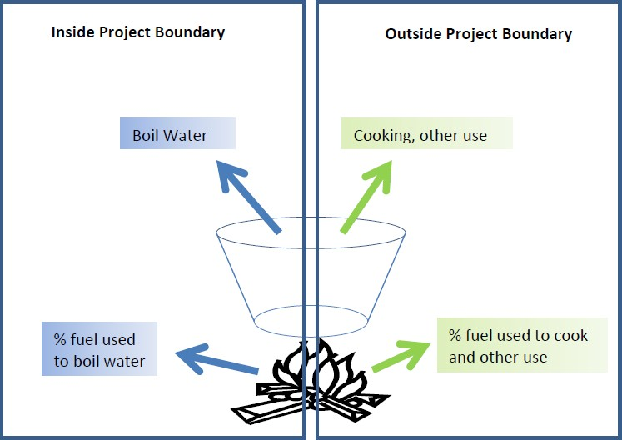

2. SPOUTS OF WATER distributes filters in over 200 communities across all four regions of Uganda. The map below shows the distribution points:

3. In cases where woody biomass (including charcoal) is the baseline fuel, the fuel production and collection area is the area within which this woody biomass can reasonably be expected to be produced, collected and supplied. In cases the project activity introduces the use of a new biomass feedstock in the project situation, the fuel production and collection area is the area within which the biomass is produced, collected and supplied.
  - The baseline as a fuel to boil the water includes woody biomass and charcoal, however for conservativeness, PP will not include the emission arising from the transportation and production of baseline fuels.

The following table shows the sequestered gases GHG mitigation/sequestration
Source |  | GHGs | Included? | Justification/Explanation
Baseline Scenario | Heat delivery from stoves used for boiling water | CO₂ | Yes | Important source of emissions
Baseline Scenario | Heat delivery from stoves used for boiling water | CH₄ | Yes | Important source of emissions
Baseline Scenario | Heat delivery from stoves used for boiling water | N₂O | Yes | Important source of emissions
Baseline Scenario | Production of fuel | CO₂ | No | Not accounted for conservativeness
Baseline Scenario | Production of fuel | CH₄ | No | Not accounted for conservativeness
Baseline Scenario | Production of fuel | N₂O | No | Not accounted for conservativeness
Baseline Scenario | Transport of fuel | CO₂ | No | Not accounted for conservativeness
Baseline Scenario | Transport of fuel | CH₄ | No | Not accounted for conservativeness
Baseline Scenario | Transport of fuel | N₂O | No | Not accounted for conservativeness
Project Scenario | Heat delivery from stoves used for boiling water | CO₂ | Yes | Important source of emissions
Project Scenario | Heat delivery from stoves used for boiling water | CH₄ | Yes | Important source of emissions
Project Scenario | Heat delivery from stoves used for boiling water | N₂O | Yes | Important source of emissions
Project Scenario | Production of fuel | CO₂ | No | Not accounted for conservativeness

    - Establishment and description of baseline scenario
>> (Explain how the baseline scenario is established in accordance with guidelines provided in GS4GG Principles & Requirements and the selected methodology(ies). In case suppressed demand baseline is used then same should be explained and justified.)

A) Overview
The baseline described in this section is to a great extend based on surveys carried out by the Spouts team.
More than 50% of the Ugandan population does not treat their water by any method (Uganda Bureau of Statistics (UBOS) & ICF International Inc. 2012). Given that every study on Ugandan water quality to-date has found that even most improved sources are unsafe for consumption without treatment (Parker et al. 2010; Haruna et al. 2005; Howard & Luyima 1999), this leaves almost 20 million Ugandans without access to clean drinking water (UBOS 2016). This has a major negative health impact on the nation; in Uganda, more children die of waterborne diseases than either malaria or AIDS (World Health Organization & (MCEE) 2015).
Household-level ceramic water filters are considered the most promising option to address drinking water safety in developing countries because they are inexpensive, safe, and straightforward to manufacture and maintain (Mwabi et al. 2011; Simonis & Basson 2011; Hunter 2009; Sobsey et al. 2008). The Purifaaya filter is the only locally manufactured ceramic filtration technology currently used in Uganda. The filter is manufactured by SPOUTS of Water and distributed both commercially through local partnerships and donated through partnerships with community based organizations (CBOs) and non-governmental organizations (NGOs).
“In Uganda, more children die of waterborne diseases than either malaria or AIDS. Household-level ceramic water filters are considered one of the most promising options to address drinking water safety”

Spouts was founded with the goal of offering to all Ugandans safe drinking water that is affordable. The story behind the company is told beautifully in a National Geographic documentary entitled ‘Spouts of Hope’.
Since it’s foundation, Spouts story consists of two phases:
- Phase 1: Study and piloting. This phase starts in 2012 with the foundation of Spouts. This phase involved several years of exploring ideas, raising awareness, obtaining grants, studying the market, designing and building test filters, coming up with a distribution strategy. The pilot phase concluded as a major success: the Purifayaa filter was launched as a new product and some filters where actually sold.
- Phase 2: Launching and Scaling. This phase starts in 04/04/17, when a major investment was made to build two new kilns to cook the ceramic water filters. See Section C.1.1 for more details on the Start Date. This allowed Spouts to launch as a business venture aimimg for scale.
Given the success of the filter since its introduction in 2012, with over 10,000 filters sold, SPOUTS of Water intends to scale operations extensively in coming years. Evaluation of the Purifaaya’s impact and user experiences is critical to identify the challenges and successes of the past four years moving into this scale-up. In order to maintain an unbiased data set, SPOUTS of Water partnered with an external consulting firm, Ignosi, to conduct an extensive usage study across three different populations currently using the filter. The study aimed to answer a range of impact questions across four distinct categories: (1) Reach Impact: How many of those who received or purchased filters are using and maintaining their filter correctly? (2) Health Impact: Is there a perceived reduction in waterborne illness among users? (3) Social Impact: Is there a perceived increase in time or money available for other activities, especially for women? (4) Environmental Impact: Is there a reduction in CO2 emissions from using the filter?
Three methodologies were employed in all three communities:
- observation of filter use and maintenance,
- an extensive survey of one of the heads of household, and
- water quality measurements from the filter.

In total 155 households were surveyed, 96 in a rural farming village called Kaberamaido, 39 in an urban center and surrounding area called Mbarara, and 20 in a refugee settlement called Nakivale. These communities were then divided into rural and urban categories. Rural villages in Uganda are generally sustained by local farming, with houses spaced by agricultural activities. Most rural families make very little money; our results showed that the median income was less than 30USD per month per household. Nakivale refugee settlement operates much like a typical rural village in Uganda. Refugees live in widely spaced houses, mostly farm for a living, and their demographics are very similar to that of the rural villages we surveyed. Urban users were those living in and around Mbarara, the largest urban center outside the Kampala area, with a population of 200,000. We classified urban as having access to city amenities but not necessarily living in the city center. These households had a higher median income of 200USD per month per household and much higher education than those in rural areas.
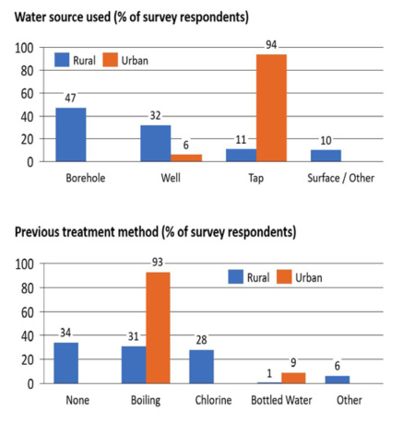
Figure: Source and Previous Treatment Water source and previous treatment methods for rural and urban households. Totals may be greater than 100% as some users report multiple forms of treatment.
“The method of treatment, if any, that the filter replaces is a major determining factor for the likely impact”

Results show that rural users get and treat their water from a much wider variety of sources and methods than urban users (Figure 1). The method of treatment, if any, that the filter replaces is a major determining factor for likely impact. If households were boiling their water there should be social impact – increased time and money – and environmental impact – less burning of fossil fuels – whereas if there was no
treatment previously we would expect large health impacts. Given the variety in water quality from these disparate sources, we hypothesized that health impacts would be more significant in rural areas, especially given that 34% of users were not previously treating their water by any method. Simultaneously, given that most urban users boiled their water before owning a Purifaaya, it is likely that the environmental impact from displaced fuel consumption is substantial.

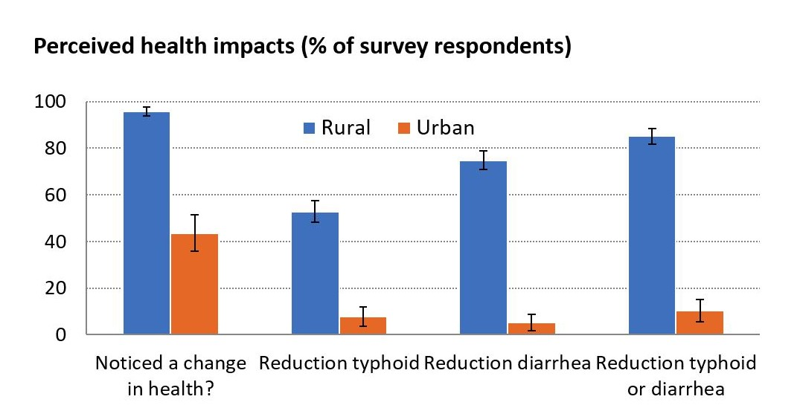

Figure: Perceived Health Impacts Reported impact on health after owning the Purifaaya filter.

The Figure above shows survey results from rural and urban households on the impact to user health after owning the Purifaaya. The vast majority of rural users observe an impact, with 96% self-reporting that they have noticed changes to their health and 85% specifically reporting a reduction in diarrhea or typhoid since owning a filter. Despite the fact that 66% of users report previously treating their water by some method, almost all notice a change in their health after owning the filter. This result may be partially due to contamination of water after treatment during storage because the filter also provides safe storage location. Self- reporting may provide an upper bound on health impacts, but future impact studies will need to undertake the much more involved process of measuring changes in health directly, instead of surveying users, in order to more accurately quantify health impacts. 44% of urban users do notice a change in their health, but reductions in the frequency of more serious waterborne diseases like diarrhea and typhoid are much smaller than the impact in rural communities.
“The vast majority of rural users observe an impact, with 96% reporting a change in health and 85% specifically reporting a reduction in diarrhea or typhoid since owning a filter.”

Figure 3 shows the type of fuel displaced in rural vs. urban households by replacing boiling water with the Purifaaya filter. Only those households that reported boiling their water as their main water treatment method before owning a filter were counted for this analysis. In rural areas, only 31% of users boiled their water previously as compared with 92% in urban areas (Figure 1), so more fuel is displaced in urban areas. Using emissions factors for boiling one liter of water with wood and charcoal stoves (Bhattacharya et al. 2002), and assuming (1) 4.7 people per household (UBOS 2016), (2) each person drinks 4 liters per day, the emission reduction per filter over its 2-year lifetime is 15 tons CO2. If 48% of all Purifaaya owners boil their water than the 10,000 filters sold have mitigated 72,000 tons CO2, which is the equivalent of 3,200 cars driving a lap around the equator. This is an approximation, and likely overestimate, as few families in Uganda drink 4 liters of water per person per day and this does not account for the CO2 emissions in manufacturing the filter. Nevertheless, the CO2 displaced represents another important benefit of the filter.
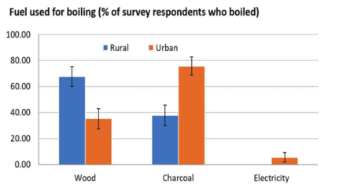
Figure: Fuel Used For Boiling. Type of fuel used for boiling water of those users who previously treated their water by boiling.

To put the above findings and statistics into perspective, the diagram below shows the types of cooking fuel used across rural Uganda from a published survey. The results are consistent.

B) Water boiling and cooking practices in Uganda

The diagram below shows the types of cooking technology used across Uganda.

The pictures below show examples of the most popular types of boiling technology: three stone wood stoves and charcoal stoves.
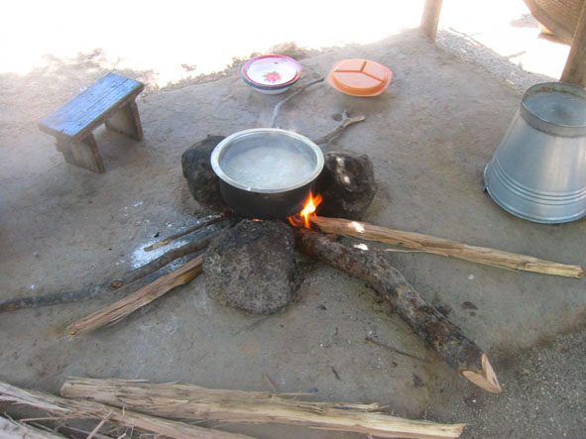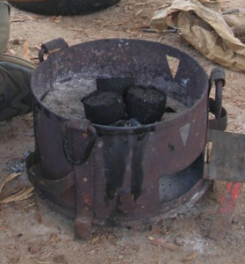

C) The role of Spouts
SPOUTS is the only business to manufacture water filters within Uganda itself, using only local labor and materials for production and distribution. This provides jobs and stimulates the local economy, whilst also avoiding the environmental footprint of importing resources from abroad. Furthermore, given that the average monthly household income in Uganda is around 128 USD (Ugandan National Census, 2012-13), a SPOUTS filter at 20 USD is an affordable option for the vast majority of the population. Therefore, SPOUTS has created a market-driven product that most people can purchase for themselves. This sustainable model differentiates SPOUTS from other non-profits or aid strategies, in which water treatment solutions often a free giveaway to end-users.
In addition, SPOUTS partners with SACCOS and micro-finance institutions who enable end-users to pay for the filters in installments, further reducing the economic barrier to clean water access. Therefore, SPOUTS is unique by designing a holistic model that spans from the production of a cost-efficient household solution for clean water to a contextually integrated distribution method to provide filters to families of different income groups.

D) Suppressed demand
As in many other developing countries, the level of energy service in Uganda is not sufficient to meet human development needs due to lack of financial means and/or access to modern energy infrastructure or resources. As described in Annex 2 of the TPDDTEC Methodology, this concept is known as suppressed demand.
The methodology allows for a baseline scenario to be assessed in terms of suppressed demand, if evidence is provided that the project technology users within the project population are otherwise deprived of a reasonable level of human development (or humanely acceptable benchmark) in comparison to their peers and provided that there is likelihood of avoided future emissions as for example if the standard of living is increasing for some of the project population or their peers outside of the project boundary.
In such case, the level of thermal energy consumption in the baseline scenario will not correspond to the pre-project situation but to a satisfied demand level, which will be equal to or lower than the project level of satisfied demand.
Since, as shown above, the most common and available way of purifying water is by boiling it, here we calculate the baseline based on the boiling practices used in the target area of the project.

    - Demonstration of additionality
>> (If the proposed project is not a type of project that is deemed additional, as stated below, then follow guidelines in section 3.5.1 of GS4GG Principles & Requirements to demonstrate additionality.)

In order to demonstrate additionality we use the UNFCCC guidelines:
TOOL21Methodological tool: Demonstration of additionality of small-scale project activities
This requires that “project participants shall provide an explanation to show that the project activity would not have occurred anyway due to at least one of the following barriers:
- Investment barrier: a financially more viable alternative to the project activity would have led to higher emissions;
- Technological barrier: a less technologically advanced alternative to the project activity involves lower risks due to the performance uncertainty or low market share of the new technology adopted for the project activity and so would have led to higher emissions;
- Barrier due to prevailing practice: prevailing practice or existing regulatory or policy requirements would have led to implementation of a technology with higher emissions;
- Other barriers: without the project activity, for another specific reason identified by the project participant, such as institutional barriers or limited information, managerial resources, organizational capacity, financial resources, or capacity to absorb new technologies, emissions would have been higher.

The PP has chosen the barrier due to prevailing practice to prove additionality.

Prevailing practice: boiling water or not treating at all (suppressed demand)
Many people served by our Project in Uganda do not purify their water because they are unaware of the health consequences of drinking untreated water.
If they treat it, most often they do so by boiling it with very inefficient and dirty cook stoves, in most cases three-stone stoves.
However, if shown the adverse effects of drinking untreated water, people will start choosing to purchase to purify it at home, for example with Spouts ceramic water filters.
The success of our business model clearly shows that, through education and awareness, the attitudes towards safe drinking water can change permanently. Specifically, if shown the benefits of safe drinking water, people will choose to purify the water they drink.
The role of our local partners is to ensure that the treatment of the water occurs in a zero carbon way. Without Spouts’ service, people would likely have started to boil the water using the inefficient stoves and fuel at their disposal, which is described in Section B.4.
Revenues from carbon credits will be key in supporting the expansion of the reach of our local partners into new villages and regions. Such expansion is very expensive for Spouts, and cannot be achieved without external support. The revenues from the carbon credits would help sustain Spouts’ growth and help people in Uganda have access to safe drinking water that they can afford and want to buy.
In summary, the additionality criteria are met because without the PoA the project activities would not have occurred because of the barrier due to prevailing practice.

    - Sustainable Development Goals (SDG) outcomes
      - Relevant target for each of the three SDGs
>> (Specify the relevant SDG target for each of three SDGs addressed by the project. Refer most recent version of targets here .)

1 – SDG13 – Climate Action

UN Target: “Promote mechanisms for raising capacity for effective climate change-related planning and management in least developed countries and small island developing States, including focusing on women, youth and local and marginalized communities”

2 – SDG 7 – Affordable and Clean Energy

UN Target: “By 2030, increase substantially the share of renewable energy in the global energy mix”

3 – SDG 6 – Clean Water and Sanitation

UN Target: “By 2030, achieve universal and equitable access to safe and affordable drinking water for all”

      - Explanation of methodological choices/approaches for estimating the SDG outcome
>> (Explain how the methodological steps in the selected methodology(ies) or proposed approach for calculating baseline and project outcomes are applied. Clearly state which equations will be used in calculating net benefit.)

1 – SDG13 – Climate Action

Relevant Monitoring Indicator: Emission Reduction of CO2
In order to calculate the Emission Reduction of CO2 we use the following equations. These equations are also presented in the ‘Spouts - Emission Reductions Calculations’ spreadsheet:

ER = BE * Uy – L kiln = 12,214[tCO2] * 0.82 – 20 [tCO2] = 9,995 [tCO2]
Where:
- ER = Emission Reduction of CO2
- BE = Baseline emissions
- Uy = Usage rate
- Lkiln (Leakage)

Where:
- BE = Filters_y * WCF
- Lkiln (Leakage) = Wf (wood/charcoal) required to cook 1 ceramic filter) * Filters_y * EF (wood/charcoal emission factor

Where:

- Filters_y = Number of Filters sold - This parameter is measured via the Sales Tracker
- WCF = Weighted_Carbon_per_filter

Where:

- WCF = CL * nj
- CL = Emission Reductions per litre (boiling test)
- nj = number of persons per hh (filter))

2 – SDG 7 – Affordable and Clean Energy

Relevant Monitoring Indicator: Wood Not Burned
In order to calculate the quantity of Wood Not Burned we use the following equations. These equations are also presented in the ‘Spouts - Emission Reductions Calculations’ spreadsheet:

WNB = Wboil * L * R * % = 0.000427 [tonnes_wood/L] * 7,277 [L] * 3,011 [F] * 78 [%]
= 7,295 tonnes of wood

Where:

- WNB = Wood Not Burned
- Wboil = Wood required to boil 1L of water - Its value is measured in the field via Boiling Tests
- L = Eligible litres per year.hh
- F = Number of Filters sold
- % = Percentage using wood

3 – SDG 6 – Clean Water and Sanitation

Relevant Monitoring Indicator: Affordable safe drinking water
In order to calculate the Affordable safe drinking water we use the following equations. These equations are also presented in the ‘Spouts - Emission Reductions Calculations’ spreadsheet:

SDW,y = L * nj * Filters_y * (1-Xboil) * 365 = 4 [L] * 6.39 [persons/hh] * 3,011 [filters] * 0,80 * 365
= 21,910,842 [L]

Where:
- SDW,y = Affordable safe drinking water through year y
- L = litres _of_purified_water per person per holdhouse (filter)
- nj = Number of persons per household
- Filters_y = Number of Filters sold - This parameter is measured via the Sales Tracker
- Xboil = % of premises already purifying water

      - Data and parameters fixed ex ante for monitoring contribution to each of the three SDGs
(Include a compilation of information on the data and parameters that are not monitored during the crediting period but are determined before the design certification and remain fixed throughout the crediting period like IPCC defaults and other methodology defaults. Copy this table for each piece of data and parameter.)

Relevant SDG Indicator | 6 – ‘Clean Water and Sanitation - Safe drinking water provide’
Data / Parameter: |  | Cj
Data unit: |  | Percentage
Description: |  | Portion of users of project safe water supply who were already in baseline using a non-boiling safe water supply
Source of data used: |  | We carried a survey to collect the following data. This shows results for both rural and urban households. Focusing initially on urban households, the bar chart below shows that most urban Ugandans (94%) obtain their water from a tap. The question is whether this water is safe to drink. The second chart answers this question unequivocally with hard data: 93% of households are aware of the risks of drinking untreated, straight from the tap, and boil it to make it safe. The remaining urban population drinks bottled water. The situation is even worse in rural areas, where 34% of the population is not even aware of the problem and don’t treat the water at all, subjecting themselves to all sorts of water born diseases.  In other words, no source of water can be considered to be safe in Uganda.
The above facts, obtained from our own survey and observations, are corroborated by a number of studies and government officials:
- Extensive reviews of water quality studies in developing nations globally shows that access to 'improved' sources of water does not necessarily mean the water is microbiologically safe to drink (Bain et al., 2014). A study of protected springs near Kampala showed that 100% of the springs analyzed were unsafe to drink without treatment,.

- Even government officials admit that they cannot guarantee that water delivered to households is safe. For example, Peter Balimunsi, an engineer and one of the supervisors of the treatment and distribution of drinking water in Kampala, said in a recent interview that he could not “guarantee that the city’s tap water is safe to drink.”. As another example, Dr Asuman Lukwago, the Permanent Secretary, ministry of Health, agreed with the WHO findings, observing that the water table in Kampala and the surrounding areas is highly contaminated.

The situation in rural Uganda is even worse, as development in rural areas lags behind compared to urban areas. Offically, the government cannot guarantee that water will arrive safe to drink at the point of use. For example:
- Mr Sam Apedel, spokesperson at the National Water and Sewage Corporation, says they cannot guarantee the water quality in people’s houses.

In summary, across Uganda drinking water is not safe and is not considered to be safe by the government authorities. Therefore, Cj=0.
Value applied |  | C_{j} = 0  .
Monitoring frequency |  | Only in the baseline study.
QA/QC procedures |  | Transparent data analysis and reporting.

Relevant SDG Indicator | 6 – ‘Clean Water and Sanitation - Safe drinking water provide’
Data / Parameter: | Xboil
Data unit: | Percentage
Description: | Percentage of premises that would have used other non-GHG emitting technologies like chlorine treatment techniques, if available, in the absence of the project activity.
Source of data used: | We carried out our internal baseline survey. We identified differences between people in Urban and Rural areas so, in order to obtain more accurate estimates for the project emission reductions, we decided to specify separate value for Xboil-Urban and Xboil-Rural (as opposed to X_{boil}, as required by the Gold Standard). The diagram below shows the results from our survey.  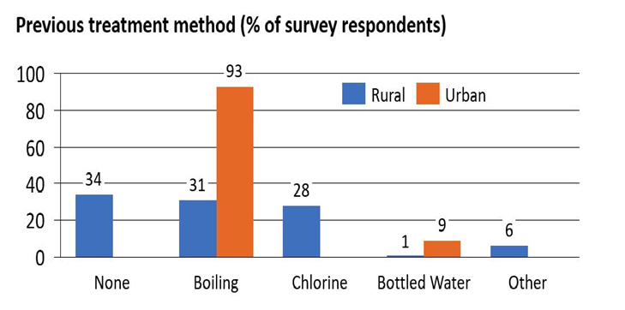  In urban areas, 9% of people drink bottled water, so Xboil-Urban =9%  In rural areas, 28% use chlorine and another 6% use other methods to make their water safe, while 1% drinks bottled water. So, Xboil-Rural =28%+6%+1%=35%.  Now that we know the rural and urban components, we can get the value for Xboil = (Xboil-Urban = Xboil-Rural) / 2 = (9% + 35%)/2= 22%
Value applied | Xboil= 22 %  The value of these parameters is included in ‘Spouts - Emission Reductions Calculations’ spreadsheet.
Justification of the choice of data or description of measurement methods and procedures actually applied: | We carried a tailored survey.
Any comment

Relevant SDG Indicator | 7 – ‘Affordable and Clean Energy - Energy efficiency’
Data / Parameter: | W_{b-wood} / W_{b-charcoal}
Data unit: | Tonnes/litre
Description: | Quantity of fuel in tons required to treat 1 litre of water using technologies representative of baseline scenario b
Source of data used: | Baseline water Boiling test
Value applied: | W_{b-wood} = 0,000427 - W_{b-charcoal} = 0,000088  The value of these parameters is included in ‘Spouts - Emission Reductions Calculations’ spreadsheet.
Justification of the choice of data or description of measurement methods and procedures actually applied : | The value provided above was derived from water boiling tests as recommended by the GS Methodology.  Annex 6 of this PoA-DD shows more details on the Water Boiling Test, including all the results as well as photographic evidence.  The value is the same during both the baseline and project implementation.
Any comment:

Relevant SDG Indicator | 13 – ‘Climate Action - Carbon emission reductions’
Data / Parameter: | EFb,wood,CO2 / EFp,wood,CO2
Data unit: | tCO2/TJ
Description: | CO2 emission factor arising from use of fuels in baseline/project scenario
Source of data used: | IPCC Guidelines for National Greenhouse Gas Inventories, Volume 2, Energy, Chapter 2, Stationary Combustion, Table 2.5
Value applied: | EFb,wood,CO2 = 112  The value of these parameters is included in ‘Spouts - Emission Reductions Calculations’ spreadsheet.
Justification of the choice of data or description of measurement methods and procedures actually applied: | Determined as per IPCC default figures.  The value is the same during both the baseline and project implementation (However, it is noted that during the project there is no fuel being used, as the filters do not require fuel and work on gravity).
Any comment:

Relevant SDG Indicator | 13 – ‘Climate Action - Carbon emission reductions’
Data / Parameter: | EFb,wood,nonCO2 / EFp,wood,nonCO2
Data unit: | tCO2e/TJ
Description: | Non-CO2 emission factor arising from use of fuels in baseline/project scenario
Source of data used: | IPCC Guidelines for National Greenhouse Gas Inventories, Volume 2, Energy, Chapter 2, Stationary Combustion, Table 2.5
Value applied | EFb,wood,nonCO2 = 8.68  The value of these parameters is included in ‘Spouts - Emission Reductions Calculations’ spreadsheet.
Justification of the choice of data or description of measurement methods and procedures actually applied: | Determined as per IPCC default figures. The Global Warming Potential (GWP) for CH4 it is 21, while for N2O it is 310. Source: UNFCCC . So, the value was calculated using the following formula: ((CH4=0.3*GWP 25) + (N2O=0.004*GWP 295)) = 8.68.  The value is the same during both the baseline and project implementation.
Any comment:

Relevant SDG Indicator | 13 – ‘Climate Action - Carbon emission reductions’
Data / Parameter: | EFb,charcoal,nonCO2 / EFp,charcoal,nonCO2
Data unit: | tCO2e/TJ
Description: | Non-CO2 emission factor arising from use of fuels in baseline/project scenario
Source of data used: | IPCC Guidelines for National Greenhouse Gas Inventories, Volume 2, Energy, Chapter 2, Stationary Combustion, Table 2.5
Value applied | EFb,charcoal,nonCO2 = 5.29  The value of these parameters is included in ‘Spouts - Emission Reductions Calculations’ spreadsheet.
Justification of the choice of data or description of measurement methods and procedures actually applied: | Determined as per IPCC default figures. The Global Warming Potential (GWP) for CH4 it is 21, while for N2O it is 310. Source: UNFCCC . So, the value was calculated using the following formula: ((CH4=0.2*GWP 25) + (N2O=0.001*GWP 295)) = 5.29.  The value is the same during both the baseline and project implementation.
Any comment:

Relevant SDG Indicator | 7 – ‘Affordable and Clean Energy - Energy efficiency’
Data / Parameter: | NCVb,wood / NCVp,wood
Data unit: | TJ/ton
Description: | Net calorific value of the fuels used in baseline/ project scenario
Source of data used: | Wood fuels handbook – European Biomass Association. Table 2.7.1
Value applied | NCVb,wood = 0.015  The value of these parameters is included in ‘Spouts - Emission Reductions Calculations’ spreadsheet.
Justification of the choice of data or description of measurement methods and procedures actually applied: | Default value used by the European Biomass Association, as described in the above document.  The value is the same during both the baseline and project implementation.
Any comment:

Relevant SDG Indicator | 7 – ‘Affordable and Clean Energy - Energy efficiency’
Data / Parameter: | NCVb,charcoal / NCVp,charcoal
Data unit: | TJ/ton
Description: | Net calorific value of the fuels used in baseline/ project scenario
Source of data used: | IPCC Guidelines for National Greenhouse Gas Inventories. Table 1.2
Value applied | NCVb,charcoal = 0,0295  The value of these parameters is included in ‘Spouts - Emission Reductions Calculations’ spreadsheet.
Justification of the choice of data or description of measurement methods and procedures actually applied: | Default value used by the IPCC, as described in the above document.  The value is the same during both the baseline and project implementation.
Any comment:

Relevant SDG Indicator | 6 – ‘Clean Water and Sanitation - Safe drinking water provide’
Data / Parameter: | Qp,y + Qp,y -
Data unit: | Litres per person per day
Description: | Quantity of safe water in litres consumed in the project scenario p and supplied by project technology per person per day
Source of data used: | This is a default value recommended by the WHO and approved by the GS: see Annex A.3.2 of the TPDDTEC methodology.
Value applied: | Qp,y = 4 L/person.day  The value of these parameters is included in ‘Spouts - Emission Reductions Calculations’ spreadsheet.
Description of measurement methods and procedures to be applied | This is a default value recommended by the WHO and approved by the GS: see Annex A.3.2 of the TPDDTEC methodology.
QA/QC procedure
Any comment:

Relevant SDG Indicator | 7 – ‘Affordable and Clean Energy - Energy efficiency’
Data / Parameter: | π_{W}, π_{C}
Data unit: | Percentage
Description: | Percentage of people using wood or charcoal to boil water. The values vary by urban and rural population:  - Urban population using wood (π_{UW})  - Urban population using charcoal (π_{UC})  - Rural population using wood (π_{RW})  - Rural population using charcoal (π_{RC})  π_{UW} = 35 - π_{UC}, = 65 - π_{RW}, = 66 - π_{RC}, = 34  Note: The differentiation between rural and urban is not required by GS
Source of data used: | Our internal survey. See monitoring Report.
Value applied | π_{W} = 78%  π_{C} = 22%
Justification of the choice of data or description of measurement methods and procedures actually applied: | The values were obtained from our internal survey. The graph below shows the obtained results.  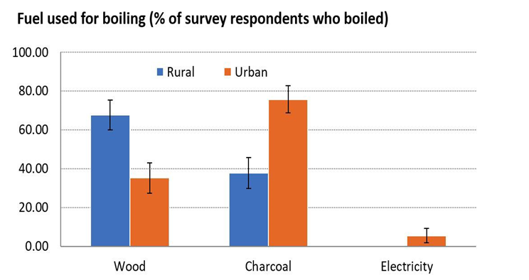  A small fraction of the urban population uses electricity to boil water. For simplicity, we assume that the amount of CO2 emitted in these cases is zero (i.e. we are not counting the emissions reductions from electricity – this reduces the potential carbon credits that we can claim, but we decided to forgo them to simplify the calculations).
Any comment:

Relevant SDG Indicator | 6 – ‘Clean Water and Sanitation - Safe drinking water provide’
Data / Parameter: |  | φ_{U}, φ_{R},
Data unit: |  | Percentage
Description: |  | Fraction of rural and urban sales:  - Urban sales fraction (φ_{U})  - Rural sales fraction (φ_{R})  Note: The differentiation between rural and urban is not required by GS
Source of data used: |  | Uganda Census. 2014. Uganda Bureau of Statistics
Value applied |  | φ_{U}, = 8,8 - φ_{R}, = 91,2
Justification of the choice of data or description of measurement methods and procedures actually applied: |  | The values were obtained from Spouts’ sale records, which can be disaggregated by urban and rural areas.  More details are available in the Emission Reductions spreadsheet.
Any comment:

      - Ex ante estimation of outcomes linked to each of the three SDGs
>> (Provide a transparent ex ante calculation of baseline and project outcomes (or, where applicable, direct calculation of net benefit) during the crediting period, applying all relevant equations provided in the selected methodology(ies) or as per proposed approach. For data or parameters available before design certification, use values contained in the table in section B.6.3 above. For data/parameters not available before design certification and monitored during the crediting period, use estimates contained in the table in section B.7.1 below)

The equations below as from Annex 3 of the TPDDTEC Methodology Version 3.1 of August 2017.
Quantities of fuel consumed in the baseline and project scenarios, Bb,y and Bp,y, respectively, are calculated as shown below. Fuel consumption is calculated (or “back-calculated” in the case of the baseline scenario) by multiplying the safe water consumption of end users observed in the project scenario by the amount of fuel required to boil a specific quantity of water (typically measured as volume per person per day).

B.6.4.1 Baseline Scenario Fuel Consumption Calculation
Bb,y = Number of person-days * Baseline Fuel used to Treat Water (T/L) * Total Safe Water consumed in project scenario (L/p/d)
Bp,y = (1-X_{boil}) * (1-Cj) * Nj,y * Wi,y * (Qj,y + Qj,rawboil,y)
Which is equivalent to:
Bp,y = Filters_Y * (n_{j} * 365) * (1-X_{boil}) * (1-Cj) * Wi,y * (Qj,y + Qj,rawboil,y)
Where we defined:
Nj,y = Filters_Y * (n_{j} * 365)
In words: the number of person.days consuming water supplied by the project is equal to the number of filters (assuming one filter per household), multiplied by the number of people per household, times 365 days per year.
Where:
X_{boil} Percentage of premises that would have used other non-GHG emitting technologies like chlorine treatment techniques, if available, in the absence of the project activity.
Nj,y Number of person.days consuming water supplied by project scenario p through year y.
Cj Expressed as a percentage, this is the portion of users of the project technology j who in the baseline were already consuming safe water without boiling it.
Qp,y Quantity of safe water in litres consumed in the project scenario p and supplied by project technology per person per day
Qp,rawboil,y Quantity of raw water boiled in the project scenario p per person per day
Wb,y Quantity of fuel in tons required to treat 1 litre of water using technologies representative of baseline scenario b during project year y, as per Baseline Water Boiling Test
Filters_Y Number of filters sold in years y and y-1 (i.e. since filters have a lifetime of two years, we discard all filters older than two years). (Also, we assume one filter per household)
n_{j} Average number of people per household

B.6.4.2 Project Scenario Fuel Consumption Calculation

Bp,j = Number of person.days * Project Fuel used to boil water (T/L) * Total volume of water boiled in project scenario (L/p/d)
Bp,y = (1-Cj) * Np,y * Wp,y * (Qp,rawboil,y + Qp,cleanboil,y)
Where:
Np,y Number of person.days consuming water supplied by project scenario p through year y
Cj Expressed as a percentage, this is the portion of users of the project technology j or who in the baseline were already consuming safe water without boiling it
Bp,y Quantity of fuel consumed in project scenario p during the year y in tons
Qp,rawboil,y Quantity of raw water boiled in the project scenario p per person per day
Qp,cleanboil,y Quantity of safe water boiled in the project scenario p per person per day
Wp,y Quantity of wood fuel or fossil fuel in tons required to treat 1 litre of water per day using technologies representative of the project scenario p during project year y
Carbon Emissions in the Baseline and Project Scenarios
BEb,y = Bb,y * ((ʄNRB,b,y * EFb,fuel,CO2) + EFb,fuel,nonCO2) * NCVb,fuel
PEp,y = Bp,y * ((ʄNRB,p,y * EFp,fuel,CO2) + EFp,fuelnonCO2) * NCVp,fuel
Where:
BEb,y Emissions for baseline scenario b during the year y in tCO2e
Bb,y Quantity of fuel consumed in baseline scenario b during year y, in tons, as per by-default factors
ʄNRB,y Fraction of biomass used during year y for the considered scenario that can be established as non-renewable biomass
NCVb,fuel Net calorific value of the fuel that is substituted or reduced (IPCC default for wood fuel,0.015TJ/ton)
EFb,fuel,CO2 CO2 emissions factor of the fuel that it substituted or reduced. 112 tCO2/TJ for Wood/Wood waste, or the IPCC default value of the relevant fuel
EFb,fuel,nonCO2 Non-CO2 emissions factor of the fuel that is substituted or reduced
PEb,y Emissions for project scenario b during the year y in tCO2e. Since no water is boiled in the project scenario, it follows that no fuel is used. Therefore the parameter W_{p,y} = 0, and it follows that PE_{b,y} = 0. However, we need to account for the number of people who have filters but do not use them and still boil the water. This correction is accounted for by the usage rate U_{p,y}, which is described below.
Expanding the summation ∑BEb,y to calculate the Weighted Carbon per Filter
The term ∑BEb,y describes the sum of baseline emissions from various components, including different types of fuels such as wood and charcoal, the usage of which varies for urban and rural populations. Here we specify how the emissions reductions equations accounts for these differences. This will allow us to calculate the ‘Weighted Carbon per Filter’. This is a quantity for the weighted average of carbon emissions per filter, which takes into account variations in usage of stove types (such as wood or charcoal) across population types (i.e. urban or rural).
Our internal survey allows us to specify the summation ∑BEb,y as shown in the diagram below:
In other words, we identified differences in the characteristics of the rural and urban populations, as well as the main types of cook stoves that they use, mainly wood stoves and charcoal stoves.
The parameters in the diagram are as follows:
- φ_{R}, rural sales fraction (i.e. sales made in rural areas)
- φ_{U}, urban sales fraction (i.e. sales made in urban areas)
- π_{R,C}, percentage of rural population that uses charcoal stoves
- π_{R,W}, percentage of rural population that uses wood stoves
- π_{U,C}, percentage of urban population that uses charcoal stoves
- π_{U,W}, percentage of urban population that uses wood stoves

This means that the summation is composed of four terms:

∑BEb,y = Filters_Y * Weighted_Carbon_per_Filter

Where:
Weighted_Carbon_per_Filter = { ( φ_{U} * LF_{Urban} * π_{U,W} * CL_{Wood}) + ( φ_{U} * LF_{Urban} * π_{U,C} * CL_{Charcoal}) + ( φ_{R} * LF_{Rural} * π_{R,W} * CL_{Wood}) + ( φ_{R} * LF_{Rural} * π_{R,C} * CL_{Charcoal} ) }

Where, for conciseness we have grouped the following group of parameters:

LF_{Urban} = (n_{j} * 365) * (1-X_{boil,U}) * (1-Cj,U) * (Qp,y + Qp,rawboil,y)
LF_{Rural} = (n_{j} * 365) * (1-X_{boil,R}) * (1-Cj,R) * (Qp,y + Qp,rawboil,y)
CL_{C} = W_{charcoal} * ((ʄNRB,b,y * EFb,charcoal,CO2) + EFb,charcoal,nonCO2) * NCVb,charcoal
CL_{W} = W_{wood} * ((ʄNRB,b,y * EFb,wood,CO2) + EFb,wood,nonCO2) * NCVb,wood

Where we made a distinction between rural and urban values of the parameters of X_{boil} (i.e. X_{boil},U , X_{boil,R}) and C_{j} (i.e. C_{j,U} , C_{j,R}).
This is the formulation that is used in the Emissions Reductions spreadsheet.

Water consumption (Q_{p,y}, Qp,rawboil,y , Qp,cleanboil,y)
Section 3.2 of the TPDDTEC Methodology states that the default values in the table below can be used. As the methodology states, these are recommended values approved by the WHO.
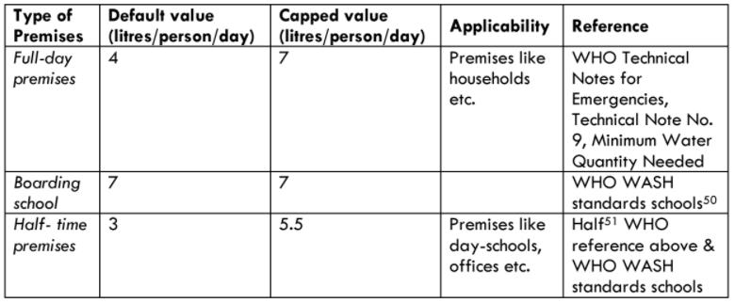
Therefore, we shall adopt the default value:
(Qp,y + Qp,rawboil,y) = litres/person/day

Fraction of population adopting technology (Up,y)
In this subsection we describe the following parameter:
Up,y Cumulative usage rate for technologies in project scenario p during year y, based on cumulative installation rate and drop off rate (See more below in this section)
We use the guidelines of Annex 9 of the TPDDTEC Methodology to design and implement a user survey to estimate the value of Up,y.

Leakage (Ly)
In this subsection we describe the following parameter:
LEp,y Leakage emissions during the project activity (see more below in this section)
The project proponent has investigated the following potential sources of leakage:
- The displaced baseline technologies are reused outside the project boundary in place of lower emitting technology or in a manner suggesting more usage than would have occurred in the absence of the project.
There will be no displaced baseline technology as households will continue to cook using the cook stoves they own. Therefore, there will be no leakage impact to consider for this point.
- The non-renewable biomass or fossil fuels saved under the project activity are used by non- project users who previously used lower emitting energy sources.
The volume of water treated by boiling in the baseline consumes a fractional portion of the biomass used by families. Biomass is currently non-renewable and expensive for families. It is highly unlikely that any biomass saved by the project activity will significantly reduce biomass costs outside the project boundary. Therefore, the project proponent assigns a value of 0 to this leakage parameter.
- The project significantly impacts the NRB fraction within an area where other CDM or VER project activities account for NRB fraction in their baseline scenario
The small size of the project is unlikely to have a significant impact on the NRB fraction. Therefore, the leakage arising from significantly impacting NRB is considered null.
- The project population compensates for loss of the space heating effect of inefficient technology by adopting some other form of heating or by retaining some use of inefficient technology.
In Uganda households rarely, if ever, use stoves for heating as the temperature is rarely below 20C all year long. Therefore, it is unlikely that the project activity will result in increased use of biomass for space heating effects. Thus, the project proponent assigns a value of 0 to this leakage parameter.

- By virtue of promotion and marketing of a new technology with high efficiency, the project stimulates substitution within households who commonly used technology with relatively lower emissions, in cases where such a trend is not eligible as an evolving baseline.
This leakage parameter is not applicable in this project, where the activity is provisioning of a water treatment system. The project proponent will not be involved in promoting any particular stove or fuel type. Therefore, the project proponent assigns a value of 0 to this leakage parameter.
f) Other sources of leakage:
The project activity will need firewood to fuel the kilns to fire the ceramic pots that make the key component of the ceramic filters (see pictures below). PP is accounting for the emissions coming from those activities by measuring the quantity of wood used while cooking the ceramic filters in the kilns. The calculations are available in the Emission Calculations spreadsheet.
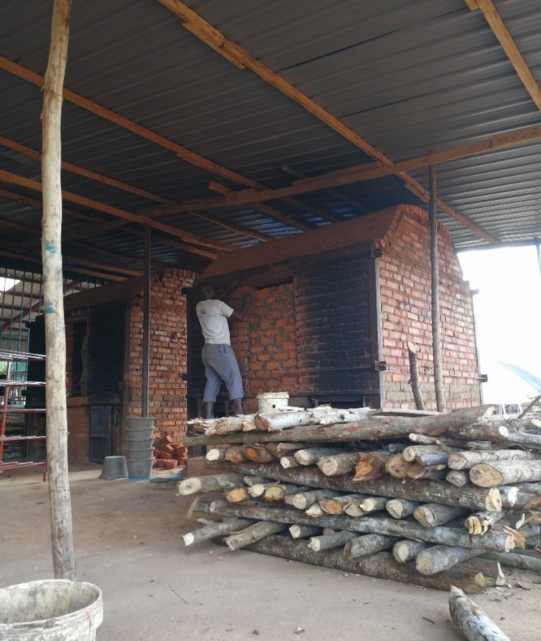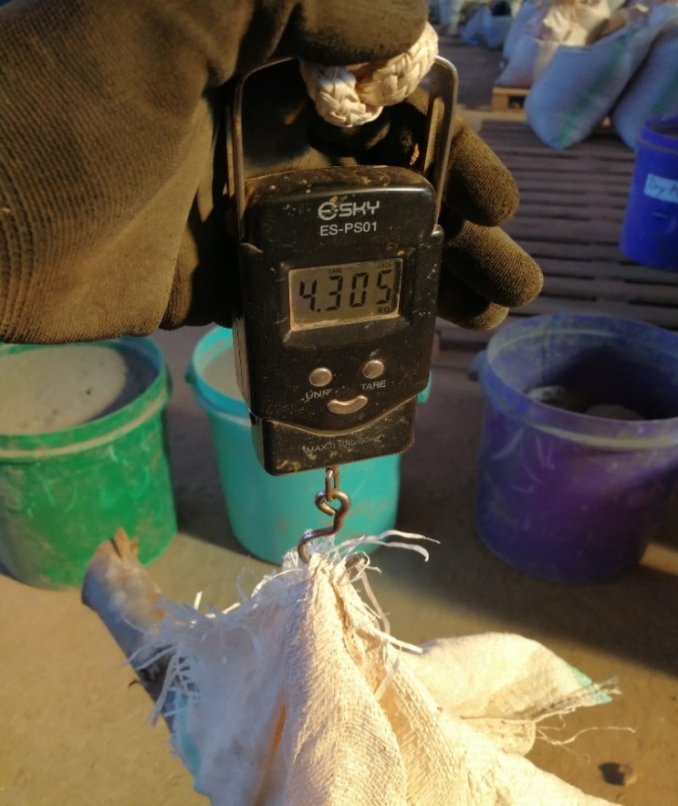
The above pictures show a) the two kilns and the wood arranged before use in the firings; b) an instance when the wood weight was being measured to estimate the amount of wood used to cook the ceramic pots that make the key component of the filters.
L_{y} = L_{Kiln} = Filtersy * WF * ((ʄNRB,p,y * EFp,wood,CO2) + EFp,wood,nonCO2) * NCVp,wood
Where:
L_{Kiln} Leakage carbon emitted in the wood kilns during production of the ceramic filters, measured in tCO2.
Filtersy Number of filters sold in year y.
WF The amount of wood used to produce one ceramic filter in the kiln, measured in tonnes of wood per filter. This is measured empirically in the project kiln. Detailed calculations are provided in the Emission Reductions Calculations spreadsheet.
((ʄNRB,p,y * EFp,fuel,CO2) + EFp,fuelnonCO2) * NCVp,fuel The amount of carbon emitted by the combustion of wood, measured in tCO2/tonne of wood. The individual parameters are as specified in the baseline calculation scenario, which also ensures internal consistency in the model.

B.6.4.2 Conclusion Emission Reductions
This section brings together all the above equations to obtain the equation for the Emission Reductions.
In words, the Emission Reductions are given by the Baseline Emissions minus the Project Emissions and the Leakage Emissions:
ERy = ∑BEb,y - ∑PEp,y - ∑LEp,y
Earlier, we argued that the Project Emissions would be equal to zero if every family that owns a water filter did use it. However, since the usage rate U_{p,y} is less than 100%, there will still be a fraction of people (1-U_{p,y}) who still continue to behave as in the baseline and still boils the water. This allows us to correct our estimate of the Project Emissions: ∑PEp,y = ∑BEb,y*(1-Up,y). If we substitute this into the above equation, we obtain:
ERy = ∑BEb,y – { ∑BEb,y*(1-U_{p,y}) } - ∑LEp,y
which simplifies to the final Emissions Reductions formula:
ERy = ∑BEb,y *Up,y - ∑LEp,y
The ‘Spouts-2 – Emission Reduction Calculations’ spreadsheet shows the resulting calculations.

      - Summary of ex ante estimates of each SDG outcome

We are including the following three SDGs:

1 – SDG13 – Climate Action

UN Target: “Promote mechanisms for raising capacity for effective climate change-related planning and management in least developed countries and small island developing States, including focusing on women, youth and local and marginalized communities”

Relevant Monitoring Indicator: Emission Reduction of CO2 = 9,995 [tCO2/y]

2 – SDG 7 – Affordable and Clean Energy

UN Target: “By 2030, increase substantially the share of renewable energy in the global energy mix”

Relevant Monitoring Indicator: Wood Not Burned = 7,295 tonnes of wood per year

3 – SDG 6 – Clean Water and Sanitation

UN Target: “By 2030, achieve universal and equitable access to safe and affordable drinking water for all”

Relevant Monitoring Indicator (1): Affordable safe drinking water = 21,910,842 [L/y]
Relevant Monitoring Indicator (2): Number of persons consuming water supplied by the project
= 19,240 [persons]

    - Monitoring plan
      - Data and parameters to be monitored
B) Parameters monitored yearly
(Include specific information on how the data and parameters that need to be monitored in the selected methodology(ies) or proposed approaches or as per mitigation measures from safeguarding principles assessment or as per feedback from stakeholder consultations would actually be collected during monitoring. Copy this table for each piece of data and parameter.)

Relevant SDG Indicator | 6 - ‘Clean Water and Sanitation - Safe drinking water provide’
Data / Parameter | Filters_Y
Data unit | Number of filters.
Description | Number of filters sold in years Y and Y-1.  Since the filters have a lifetime of two years, we consider as ‘active’ only those filters sold that were sold in the two years prior to each year’s VER issuance request. In other words, filters older than two years are not counted towards the carbon emission reductions.
Source of data used | The data collected continuously by the sales. Each sale is recorded in a cloud based system using SalesForce. Information is collected on the date of sale, specific customer details, location etc. The relevant information is included in the Emissions Reductions spreadsheet.
Value applied | 3011  The value of these parameters is included in ‘Spouts - Emission Reductions Calculations’ spreadsheet.
Monitoring frequency | Yearly
Description of measurement methods and procedures to be applied | The data is gathered continuously as filters are sold, using SalesForce software.
QA/QC procedure
Any comment

Relevant SDG Indicator | 6 - ‘Clean Water and Sanitation - Safe drinking water provide’
Data / Parameter | nj
Data unit | People per household
Description | Average number of people per household.
Value applied | nj = 6.39  The value of these parameters is included in ‘Spouts - Emission Reductions Calculations’ spreadsheet.
Monitoring frequency | Yearly
Justification of the choice of data or description of measurement methods and procedures actually applied | The source of this data is our internal survey. See the monitoring report form more details.  Since generally one filter serves one household, the value nj of the average number of people in each household quantified also the average number of people served by each filter on average.
QA/QC procedure
Any comment

Relevant SDG Indicator | 6 - ‘Clean Water and Sanitation - Safe drinking water provide’
Data / Parameter: | U_{p,y}
Data unit: | Fraction
Description: | Cumulative usage rate for technologies in project scenario p during year y, based on cumulative installation rate and drop off rate (Up,y)
Source of data used: | Internal survey, see results below.
Value applied: | U_{p,y =} 82%
Monitoring frequency | Yearly
Justification of the choice of data or description of measurement methods and procedures actually applied: | We followed the guidelines in Annex 9 of the TPDDTEC Methodology.  The figure below shows the responses to the questions related to product reach broken down by region. We chose to show these results by region instead of by rural and urban because Nakivale showed exceptionally high reach and had different results than the Kaberamaido farming villages. Out of all 155 households surveyed, 90% are using their filter and 90% demonstrate correct use and cleaning protocol, however, only 82% are both using their filter and using and maintaining it correctly. (More details are available in the monitoring survey report).  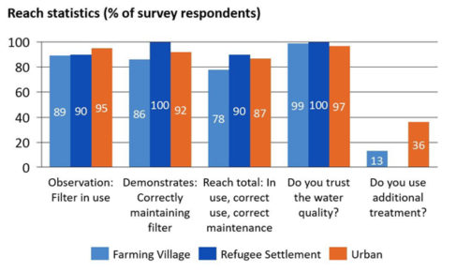
Any comment: | Further details, are included in section D.7.2.1.c of the PoA-DD as well as in the yearly Monitoring Reports.

Relevant SDG Indicator | 6 - ‘Clean Water and Sanitation - Safe drinking water provide’
Data / Parameter | Np,y
Data unit | Number of Person.days
Description | Number of person.days consuming water supplied by project scenario p through year y
Source of data used | The value is calculated using the monitored data and the following formula:  Np,y = Filters_Y * nj * 365  Where Filters_Y and nj are measured empirically, as described above.
Value applied | Np,y = 7,022,706  The value of these parameters is included in ‘Spouts - Emission Reductions Calculations’ spreadsheet.
Monitoring frequency | Yearly
QA/QC procedure
Any comment

Water Quality Testing

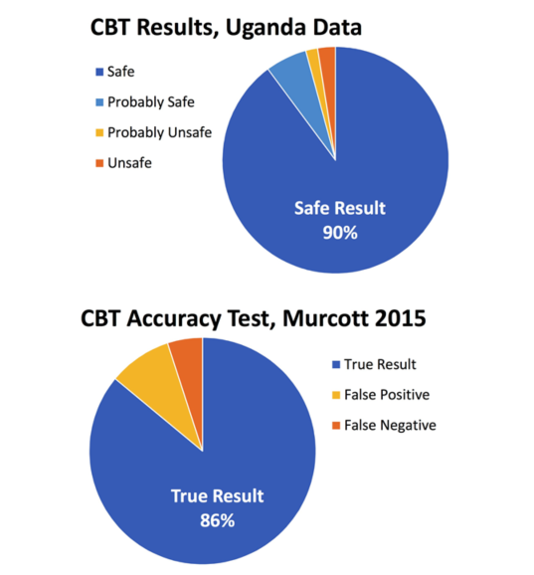
Water quality testing was conducted using the Aquagenx Compartment Bag Test (CBT). This test has been shown to be a viable alternative to formal water quality testing in a lab, which is logistically impossible in the household survey setting. CBT tests for the presence of E. coli bacteria which is an indicator of the presence of faecal contamination, the main cause of waterborne diseases. CBT tests have been directly compared against a H2S test made in a lab, as well as two low-cost, portable methods, Easygel® Cards and Petrifilm™ (Murcott et. al. 2015, Miller). In this study, CBT tests performed better than the lab or other low-cost methods at detecting E. coli out of 135 tests, yielding a true result, correctly identifying contaminated and uncontaminated samples, 86% of the time. As is true in most water quality testing for e-coli, both false negatives and false positives are still possible. Murcott et. al. 2015 show 9% false positive readings from CBT tests and only 5% false negatives, indicating that over-estimating E. coli is more likely than underestimating from CBT tests (Figure 7b). Enumerators were trained on sample collection during their course and results were analyzed by a SPOUTS of Water employee with an engineering degree and experience in careful analysis.

Figure 7a shows the results from the water quality testing. It should be noted that samples were not counted for any household that was not using their filter or was using it incorrectly. Additional samples were excluded from the results if they had clear signs of collection error – torn bag, incorrectly sealed, etc. There was no mechanism to keep samples cool during transport, but CBT tests are reliable, to a lesser extent, in temperatures up to 45°C so this should not substantially affect results (Aquagenex n.d.). In total, 118 samples were included in the water quality analysis results presented below. According to Aquagenx instructions, ‘safe’ water samples measured less than 1MPN (most probable number E. coli colony forming units), ‘probably safe’ measured 1-10 MPN, ‘probably unsafe’ measured greater than 10-100 MPN, and ‘unsafe’ measured over 100 MPN (Aquagenex n.d.).

The quality in the households is very reliable, with the ‘probably unsafe’ and ‘unsafe’ measured results within the 14% range of uncertainty determined by the Murcott et. al. 2015 testing results (Figure 7b). If, in fact, the water tested were 100% safe and the 9% rate of false positives observed in Murcott et. al. 2015 were consistent in our study, than 11 out of our total 118 samples would score unsafe. Only 5 samples scored unsafe or probably unsafe, thus our results show that the filter is 100% effective. There remains a 5% chance of a false negative in the ‘safe’ and ‘probably safe’ results. Overall, tests indicate that if respondents drank water only from the filter they are very likely to ingest only safe water.

B) Parameters monitored less frequently

Relevant SDG Indicator | 7 – ‘Affordable and Clean Energy - Energy efficiency’
Data / Parameter | fnrb,bl,y
Data unit | Fractional non-renewability
Description | Non-renewability of woody biomass fuel during year y
Source of data used | UNFCCC official value. Source: http://cdm.unfccc.int/DNA/fNRB/index.html
Value applied | fnrb,bl,y = 82.0  The value of these parameters is included in ‘Spouts - Emission Reductions Calculations’ spreadsheet.
Monitoring frequency | Fixed by baseline study for a given crediting period.
QA/QC procedure
Any comment:

Relevant SDG Indicator | 7 – ‘Affordable and Clean Energy - Energy efficiency’
Data / Parameter: | W_F (Kiln) - (Leakage from filter production in the wood kiln)
Data unit: | Tonnes of wood / filter
Description: | Amount of wood used to cook one filter in the wood kiln.  This parameter is used in the following formula:  L_{Kiln} = Filtersy * WF * ((ʄNRB,p,y * EFp,fuel,CO2) + EFp,fuelnonCO2) * NCVp,fuel
Source of data used: | The parameter is estimated empirically by measuring the amount of wood used in the kiln.  More specifically, two quantities are measured:  - Amount of wood used as fuel  - Number of filters cooked (this number if fixed)  The parameter W_{F} is calculated by dividing the amount of wood by the number of filters produced.  This measurement is carried out several times to obtain an average.  Detailed data and calculations are presented in the Emission Reduction Calculations spreadsheet.
Value applied | W_F (Kiln) = 4.45E-03  The value of these parameters is included in ‘Spouts - Emission Reductions Calculations’ spreadsheet.
Justification of the choice of data or description of measurement methods and procedures actually applied: | We estimated this parameter empirically so that describes the exact kiln being used to manufacture the ceramic filters.
Monitoring frequency | This quantity will be reassessed if and when the technology to produce the filters (i.e. the kiln) is changed.
Any comment:
      - Sampling plan
>> (If data and parameters monitored in section B.7.1 above are to be determined by a sampling approach, provide a description of the sampling plan.)

The samples are taken randomly from the customers database. First, we randomly select a number of regions served by the project. Then, within each region, we select at random a number of customers to be interviewed to match the sample size required by the methodology.

• Monitoring Survey sample sizing and data collection.
The following guidelines were used to determine the minimum sample size :
i. Group size <300: Minimum sample size 30 or population size, whichever is smaller
ii. Group size 300 to 1000: Minimum sample size 10% of group size
iii. Group size > 1000: Minimum sample size 100.
Since our group size is larger than 1000, we randomly survey at least 100 customers, which meets the requirements shown above in iii.

• Monitoring Survey Representativeness. The TPDDTEC Meth requires that:
“End users from the project scenario are selected using representative sampling techniques to ensure adequate representation. Common sampling approaches such as representative random sampling are allowed and geographic distribution should be factored into selection criteria. End users can be surveyed at any time throughout the year with care taken to collect information pertaining to seasonal variations in technology and fuel use patterns.”
To meet the above requirement, we use a random sampling approach that factors in geographic distribution. This is implemented as follows:
1. To factor geographic distribution, we select separate regions where respondents will then be sampled randomly.
2. In each of the identified regions, we select respondents randomly.
3. The total number of interviewees shall be at least 100 to ensure that the sample size requirement above (case iii) is met.

As a concrete application, in our first survey the three steps above were implemented as follows:
1. To factor geographic distribution as well as to account for socio-economic diversity, interviews were carried in three separate regions with different socio-economic characteristics:
a. A rural region of farming villages (Kaberamaido)
b. An urban region (Mbarara)
c. A refugee settlement (Nakivale)

See map below
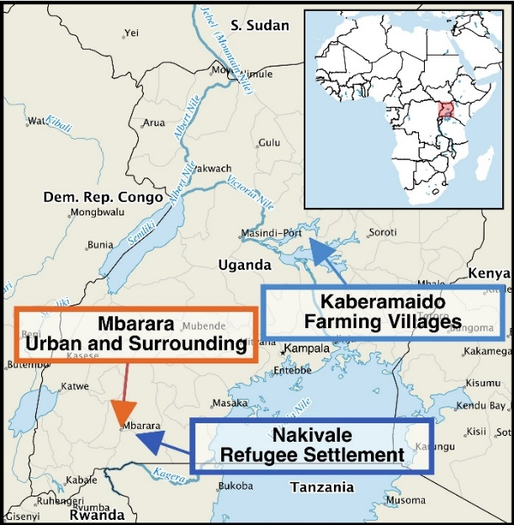

2. In each of these regions, we selected interviewees randomly from customer information.
3. The total number of interviewees was 155, distributed as follows:
a. Rural region of farming villages (Kaberamaido): 96 respondents
b. An urban region (Mbarara): 39 respondents
c. A refugee settlement (Nakivale): 20 respondents
4. The total of 155 respondents meets the goal of at least 100 respondents required in point iii above.

      - Other elements of monitoring plan
>>
The monitoring plan described in this section has been designed to comply with the requirements included in:
- Section III of the TPDDTEC Methodology
- GS4GG-100.C - PRINCIPLES & REQUIREMENTS, point 3.4.2 Development of Monitoring and Reporting Plan

This project’s monitoring shall include the following elements:
1. A Total Sales Record and a Project Database are maintained continuously.
2. A monitoring survey, including a baseline update and usage survey are conducted annually.
3. A Non-Renewable Biomass Assessment Update shall be carried out in case of a renewal of the crediting period
4. A leakage assessment shall be conducted every time the water purification technology

  - Duration and crediting period
    - Duration of project
      - Start date of project
>> (Specify start date of the project, in the format of DD/MM/YYYY. Describe how this date has been determined as per the definition of start date provided in section 3.4.3 of GS4GG Principles & Requirements document and provide evidence to support this date.)
The section 3.4.3 of GS4GG Principles & Requirements prescribes that the Project start date shall be the earliest date on which the Project Developer has committed to expenditures related to the implementation of the Project.
According to this requirement, the starting date of the Project Activity was:

April 4th, 2017

This corresponds to the date when the project committed to expenditures related to the construction of the two kilns used to manufacture the ceramic water filters.
The pictures below show the two kilns during construction.

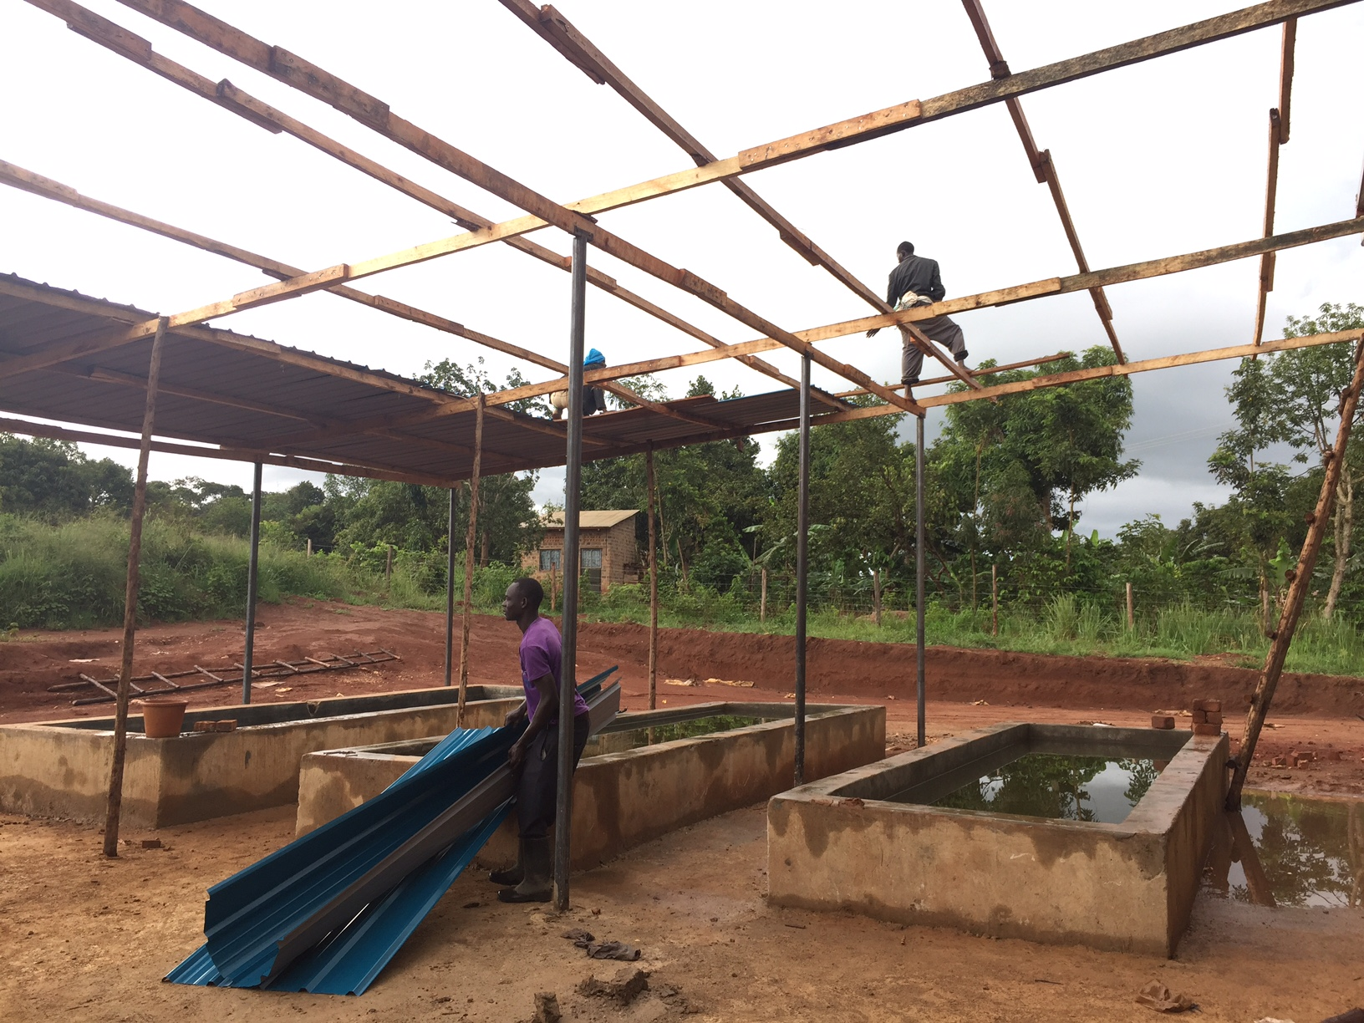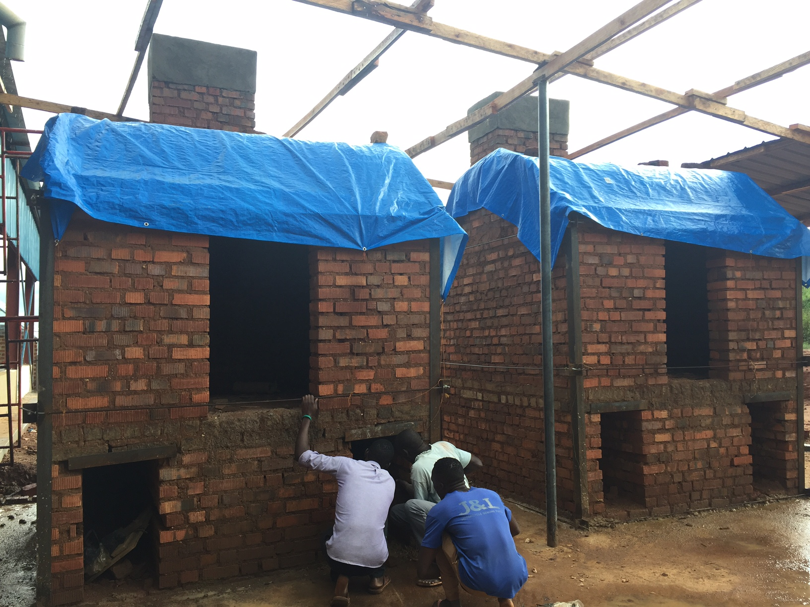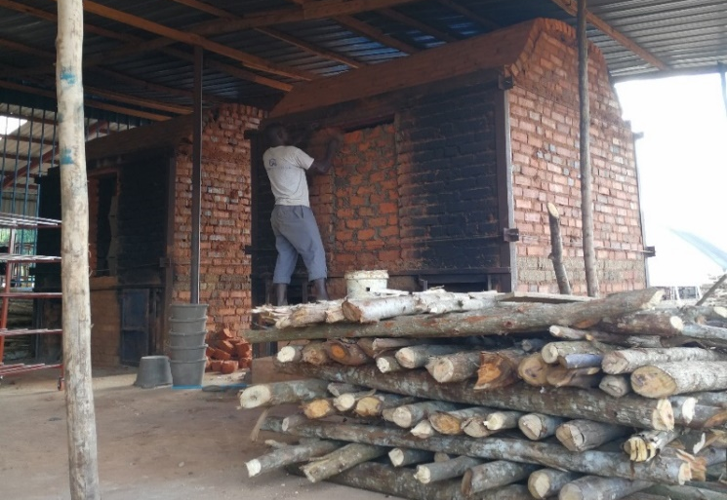

The receipts below show payments made for the materials and services involved in the construction of the kilns. They are dated 4th and 10th of April 2017.

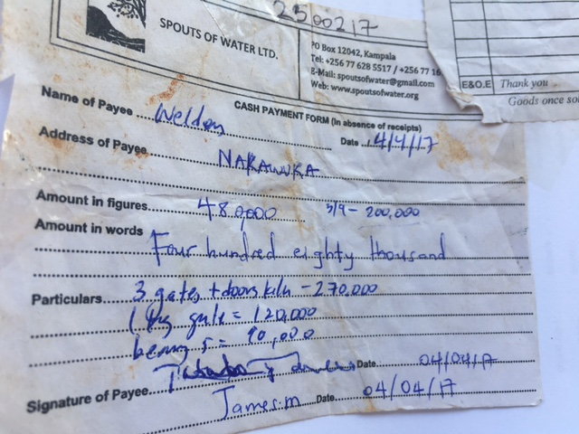

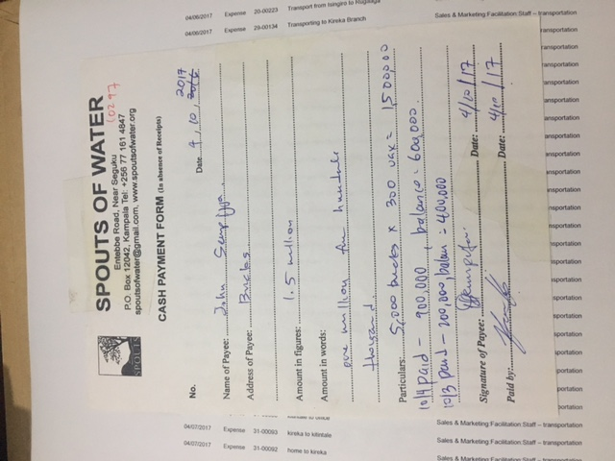

      - Expected operational lifetime of project
>> (Specify in years)

20 years.
    - Crediting period of project

5 years.
      - Start date of crediting period
>> (Specify in dd/mm/yyyy. This can be start of project operation or two years prior to the date of Project Design Certification, whichever is later.)

April 4th, 2017

      - Total length of crediting period
>> (Specify the total length of crediting period sought in line with GS4GG Principles & Requirements or relevant activity requirements.)

5 years)

  - Safeguarding principles assessment
    - Analysis of social, economic and environmental impacts
>> (Refer the GS4GG Safeguarding Principles and Requirements document for detailed guidance on carrying out this assessment.)

Safeguarding principles | Assessment questions | Assessment of relevance to the project (Yes/potentially/no) | Justification | Mitigation measure (if required)
3.2 Gender Equality and Women’s Rights | Does the project have negative impacts on gender equality and women’s rights? | No | The project is an equal opportunity employer and does not discriminate based on gender, race or other. Also, no women’s rights are affected by the project. | Not required
3.4.3 Land Tenure and Other Rights | Does the project affect land tenure and other rights | No | The project does not make use of land and therefore does not affect land tenure and other rights in any way. | Not required
3.6.2 Negative Economic Consequences | Does the project have negative economic consequences? | No | The project actually improves economic conditions by offering new forms of local employment and opportunities for local entrepreneurs. | Not required
4.1.1 Emissions | Does the project cause emissions? | No | The project reduces carbon emissions by eliminating the need to boil water to make it safe to drink. | Not required
4.1.2 Energy Supply | Not applicable | No | The project does not negatively affect energy supply. It may actually produce benefits as it reduces the demand for solid fuels such as wood and charcoal. | Not required
4.2.1 Impact on natural water patterns and flow | Not applicable | No | The project does not impact natural water patterns and flows.  Although the project is producing safe drinking water, no water is being used beyond that consumed for drinking purposes by local people in the baseline. | Not required
4.2.1 Erosion and/or water body stability | Not applicable | No | The project does not cause erosion and/or affect water body stability.  Although the project is producing safe drinking water, no water is being used beyond that consumed for drinking purposes by local people in the baseline. | Not required
4.2.3 Landscapte modification and soil | Not applicable | No | No landscape modifications occur as part of this project | Not required
4.3.2 Vulnerability to Natural Disaster | Not applicable | No | This project does not have any impacts that may affect vulnerability to natural disasters | Not required
4.3.3 Genetic Resources | Not applicable | No | No genetic resources are involved in this project | Not required
4.3.4 Release of pollutants | Not applicable | No | No pollutants are released as part of this project | Not required
4.3.5 Hazardous and Non-hazardous Waste | Not applicable | No | No hazardous or non-hazardous waste is produced as part of this project | Not required
4.3.6 Pesticides and fertilizers | Not applicable | No | No pesticides or fertilizers are used in this project | Not required
4.3.7 Harvesting of forests | Not applicable | No | No forest are negatively impacted by this project. | Not required
4.3.8 Food | Not Applicable | No | No food is involved in this project | Not required
4.3.9 Animal Husbandry | Not Applicable | No | No animal husbandry is involved in this project. | Not required

  - Local stakeholder consultation
    - Solicitation of comments from stakeholders
>> (Describe how stakeholder consultation was conducted in accordance with GS4GG Stakeholder Procedure Requirements and Guidelines.)

We identified over 30 stakeholders. We sent an introductory email to all stakeholders. This included a link to a dedicated webpage with details of the project, including a video and external links with additional information, such as Spouts website.
The webpage included a form allowing stakeholders to submit comments. Comments could also be submitted by email to info@believegreen.org.
Below is the email we sent to the stakeholders:

Dear Stakeholder,
We greatly appreciate your involvement with Spouts. As a next step to
understanding the impact Spouts has on our mission of getting clean water to all
Ugandans we would like you to share your views of the Purifaaya filter and
Spouts.
Please go to the link http://www.believegreen.org/spouts-lsc, and answer the
questions in the form "Stakeholder comments" at the bottom of the page.
We hope you can fill this form out as soon as possible as it will enable us to meet
one of the requirements for carbon credits. The Spouts water filter replaces boiling
water for many families, reducing the amount of wood and charcoal used. This
saves carbon and Spouts hopes to receive carbon credits for this work.
Thank you,
Spouts of Water

Since not all stakeholders responded to the above invitation, we sent the email below to the stakeholders who had not responded in order to increase the response rate:

Dear Stakeholder,
More children in Uganda die from waterborne illness' than either malaria or AIDS
(WHO Child Mortality Estimates 2015) and more than half the population still
leaves their water untreated (Uganda Bureau of Statistics 2014).
SPOUTS of Water directly addresses this need by building ceramic pot filters
costing less than 1/5th of the cost of other filters on the Ugandan market, but we
are currently operating with significant help from donor funding. Combined with
the Gold Standard carbon finance program we can become a unique and
economically sustainable business which improves public health.
PLEASE TAKE 5 MINUTES, click this link, and fill out this very short stakeholder
survey asking for feedback from our valuable supporters and partners. Your
feedback is a critical step to receiving carbon credits for the work we do to
displace burning of charcoal and wood for boiling water.
Thank you so much for your time and continued involvement!
Spouts of Water

The box below shows the form used to obtain the comments by the stakeholders. This is included at the bottom of the stakeholder consultation webpage.

Non-technical summary of the Programme

A webpage was created to provide the non-technical summary of the programme:
http://www.believegreen.org/spouts-lsc.

    - Summary of comments received
>> (Provide a summary of key comments received during the consultation process.)

Surname / Name | Comments
KAYONDO MUGAGGA | The intervention that Spouts of water has come up with, shall help a lot in helping the rural communities adapt to climate change, through reducing on the number of number of trees cut down for wood fuel.
Wabuyi Denis | We are glad to be in collaboration with Spouts of Water and for your being responsive to all the questions at least most of the times
Andrew Bownds | We have been able to buy over 50 20L filters and sell them onto rural based families in Masaka Region. The feedback we have had from the families is that the filters have reduced their daily living costs as they no longer need to use other systems for purifying there drinking water. We have found that Spouts of Water is a great program that can really make a large impact on both the environment and families own sustainability. Thank You
Nyangaro Collins | The purifaaya is such a reliable and cost-saving water dispenser.
Benson Nduhura | The filters you built are fine. My customers really like the product, people are appreciating the product very much. No problem so far for us and I think the product is good.
Robert Kaheebwa | We like the filters. The customers are very thankful, those who have taken filters have no problems.

Humphrey Wamani | The filter is so good and my dad bought one for at home in the village that we use as a family. Whoever comes there and takes water loves it. When I'm marketing it they feel the price is too high, but people who have it love it.
Francis | The customers like what is written on the bucket. Sometimes it is difficult to explain that the filters really do work and remove germs because it is a new technology. We would like to improve that. We would like to put some in public places to help market them because they are a good product.
Julius Mubiru | The Purifaaya has helped families in Western Uganda not only by giving them access to clean and safe water for drinking but also reducing on both fuel costs and time taken boiling water. It's reducing on the deforestation rate in the region by providing the easiest way of making water safe for drinking than boiling it with charcoal and firewood which are the main sources of fuel to most families in the region.
Stella Kivela | We work with SPOUTS to provide water to our clients. Secondly we are selling the filters. The filters are amazing, that's for sure, they are affordable, our clients love them!
Modester | Customers are complaining that the cost has increased. We hoped we would increase our market but our customers are not buying the product, they do not buy the product.
Stephen | My experiences that the SPOUTS are delicate and the filters are sometimes breaking and customers are upset and don't want to pay. The customers like the product, but many of them feel that 75K is too high a price. transportation is difficult, very delicate materials and high selling prices
Julie Mwebesa | First, the initiative is good. Locals need water treatment. Yes, it is a great thing, a great initiative, we like working with Spouts. Based on the reports from the field, people wanted a higher flowrate, so if that can improve it would be better. It is not adequate to provide drinking water for a large family. The affordability is also a challenge when we are dealing with refugees. Some of them are able to afford, especially when saving with a Sacco, but there are others who would need the filters and are not able to afford.
Ringe Florence | The filters in schools enable children not only to take clean and safe water,but also concentrate in class as they do not have to move in and out of class in such of drinking water. Households with Water filters no longer suffer from water Born diseases hence increased production and productivity as a result of hood health.
Ruth Kim | Yes I am very thankful to SPOUTS in Uganda. These people who do not have access to clean water are able to drink clean water. Wonderful. Ideally we pray that many more people will purchase this from Spouts to live a healthy. I hope this continues even in other countries in Africa.
Bagenda Augustine | Purifaayas are impacting greatly to the young people in the schools in areas to do with better health, regarding reduction of water borne diseases, thereby enabling the young people to attend school, and learn better which leads to better performance.
Mariko Fuwa | We are really happy with the filter, both myself and with the project. What works really well was that Spouts came and did the training of the trainer and even now our volunteer is still training so this was helpful. I think we need to figure out how the filter can be maintained sustainably because a few are getting cracked and then do not get used. We need to discuss with the schools to figure out a system to make this more sustainable.
Elinor Awchem | I like the filters very much, I am personally a user and I use it at home. I have told my family and friends and most of them have taken it because it has reduced the cost of buying fuel for boiling water. In addition to the economy they are also very easy to use and clean.
Robert Chanceatenyi | We have no problem because the clients they want more filters. Yes, they actually are all out of stock because people like them so much. It has helped me as well, I have my own filter. The demand is peaking because more people want filters to help them in their home.
Tracy Lamwaka | The filter is very good, especially in emergency situations where there is no safe water points. They can easily access safe water when it is most needed. It is very critical and essential in emergency situations. It is very good that it is a storage device as well. The taps that people withdraw the water from the bucket and there is no way for the water to be contaminated, so it is simple and safe. It also acts as a storage as well, which is very important. Our partnership at Oxfam with Spouts has been very good. We have volunteers who train people on the filter household use and this is very effective. They follow up afterwards as well and people are still using and like their filter.

    - Report on consideration of comments received
>> (Describe how the comments have been addressed by providing a clarification to the stakeholder or by altering the design of the project or by proposing to monitor any anticipated negative impacts etc.)

In our opinion, none of the comments, suggestions or questions received so far requires changes to our Programme design. So we deemed that the Stakeholder Feedback Round (SFR) was not necessary.

The project has no negative impacts on gender equality and women’s rights. The project is an equal opportunity employer and does not discriminate based on gender, race or other. Also, no women’s rights are affected by the project. Furthermore, no gender related comments or concerns were received duing the stakeholder consultation.

    - Report on the Continuous input mechanism selection
>> (Discuss the Continuous input / grievance mechanism expression method and details, as discussed with local stakeholders)

The project has five people dedicated to follow up regularly with customers. She acts as a contact point for customers: they can submit her their questions, comments and complaints
As part of this work she carries a continuous survey, where she checks for Marketing and Customer Satisfaction.

For Marketing, within a couple of weeks after the purchase, the customers are contacted to find out a few facts:
(1) where did they hear first of SPOUTS,
(2) what made them decide to purchase,
(3) how long did it take them from hearing about SPOUTS to make their purchase.

Regarding Customer Satisfaction, they calls the customers one month after they purchased the filter. In this, call she asks:
(1) where the customer purchased it from,
(2) if the filter is working to their satisfaction,
(3) how the Purifaaya is helping them. With this, we want to find out if the product is helping the users and what attribute/factor is the most valuable to them. In both cases, the phone numbers are provided by our sales officers across Uganda and these calls are performed to both our urban and rural customers.

Stakeholder Feedback Round (SFR)
A Stakeholder Feedback Round was carried for the duration of 60 days in the months of September and October 2018 (expecting completion).
The SFR was carried in electronic form by posting the Technical Report (VPA-DD) to Believe Green’s website (https://www.believegreen.org/spouts-sfr; Password: sfr). The webpage includes a brief introduction to the project and the stakeholder feedback round; it then invites the stakeholders to review the VPA-DD and submit any comments or questions via the enclosed comment box.
The invitation to participate to the SFR was sent to all stakeholders who took part in the first stakeholder consultation. See email used below. The electronic consultation was open for 60 days.
Email to stakeholders
Dear Stakeholder in Spouts,
Last year we invited you to review and comment on Spouts activities and its carbon offsets project.
We welcomed your comments and incorporated your recommendations into Spouts operations and we are happy to share with you the new revised Technical Report.
Please visit our project webpage (https://www.believegreen.org/spouts-sfr; password: sfr) to review the new Technical Report and send any additional comments or questions you may have.
We appreciate your support and look forward to hearing from you.
Regards,

List of Requests

Request/Answer N° 01

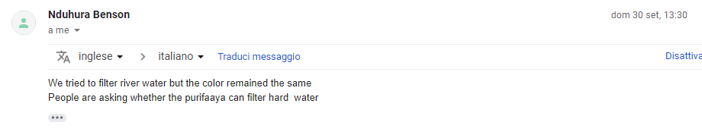

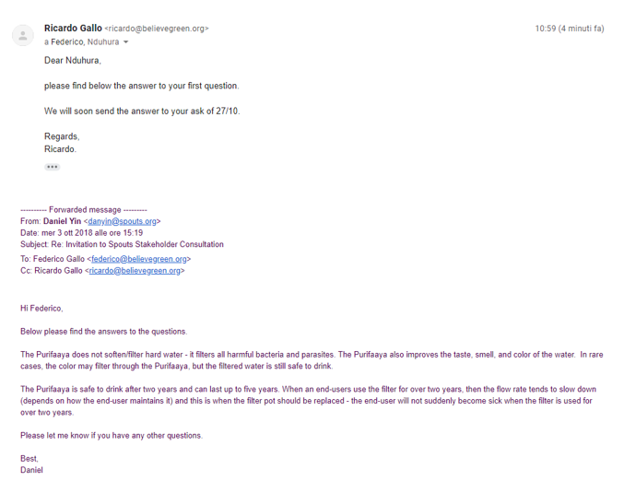

Request/Answer N° 02

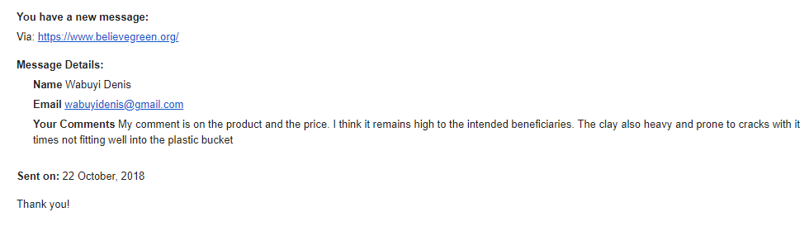

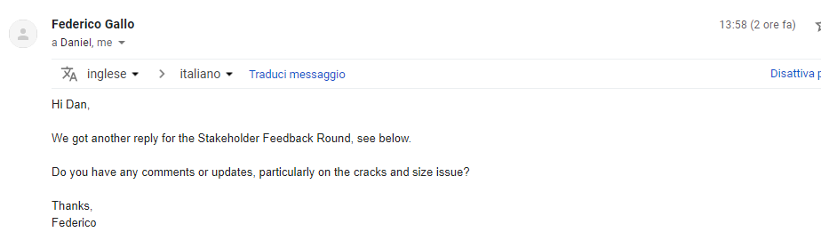

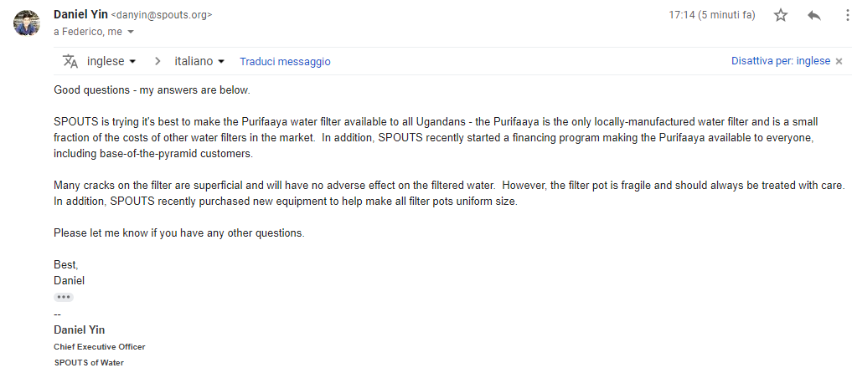

Request/Answer N° 03

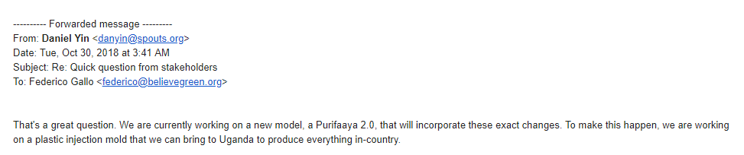
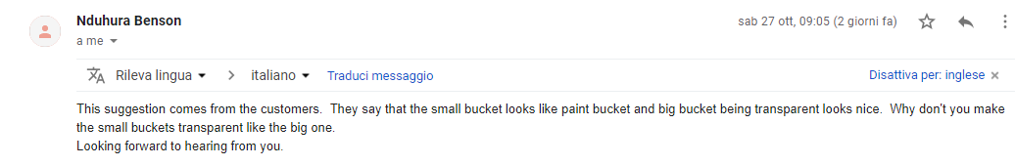

Appendix 1 – Contact information of project participant

Organization name | Believe Green LLC
Registration number with relevant authority
Street/P.O. Box
Building | Willis Tower
City | Chicago
State/Region | Illinois
Postcode | 60606
Country | USA
Telephone | +1 219 455 9076
Fax
E-mail | info@believegreen.org
Website | www.believegreen.org
Contact person | Federico Gallo
Title | Managing Director
Salutation | Dr.
Last name | Gallo
Middle name
First name | Federico
Department
Mobile | +1 219 455 9076
Direct fax
Direct tel. | +1 219 455 9076
Personal e-mail | Federico@believegreen.org

Organization name | SPOUTS of Water Ltd.
Registration number with relevant authority
Street/P.O. Box | PO Box 12042
Building
City | Kampala
State/Region
Postcode
Country | Uganda
Telephone | Uganda
Fax | +256 (0)777 235 530
E-mail | kathyku@spouts.org
Website
Contact person | Daniel Yin
Title | Chief Executive Officer
Salutation
Last name | Yin
Middle name
First name | Daniel
Department
Mobile
Direct fax
Direct tel.
Personal e-mail

Appendix 2 – Information Regarding Public Funding

Date: March 26th, 2018
Declaration of Non-Use of Official Development Assistance (ODA) by Project Owner of Project “GS5705”

Believe Green LLC:
As Project Owner of the above-referenced Project, and acting on behalf of all Project Participants, I now make the following representations:

Dr. Federico Gallo, Managing Director, Believe Green LLC:
I hereby declare that I am duly and fully authorized by the Project Owner of the above-referenced project to act on behalf of all Project Participants and make the following representations:
- The Gold Standard Documentation
I am familiar with the provisions of The Gold Standard Documentation relevant to ODA. I understand that the above-referenced Project is not eligible for Gold Standard registration if the Project receives or benefits from ODA with the condition that some, or all, of the carbon credits [CERs, ERUs, or VERs] coming out of the Project are transferred to the ODA donor country. I hereby expressly declare that no financing provided in connection with the above-referenced Project has come from or will come from ODA that has been or will be provided under the condition, whether express of implied, that any or all of the carbon credits issued as a result of the Project’s operation will be transferred directly or indirectly to the country of origin of the ODA.
In the event the Project is a Programmes of Activities where the CME is also implementing one or more Component Project Activities (CPAs) or Voluntary Project Activities (VPAs), I further acknowledge and understand that this Declaration is applicable to all of the CPAs/VPAs where the CME and the CPA/VPA implementing entity is the same.
- Duty to Notify Upon Discovery
If I learn or if I am given any reason to believe at any stage of project design or implementation that ODA has been used to support the development or implementation of the Project covered by this Declaration, or that an entity providing ODA to the host country may at some point in the future benefit directly or indirectly from the carbon credits generated from the Project as a condition of investment, I will notify The Gold Standard immediately using the Amended ODA Declaration Form provided below.

- Investigation
The Gold Standard reserves the right to conduct an investigation into any project it reasonably believes may be receiving ODA with the condition that some or all of the carbon credits from the Project will be transferred to the ODA donor country.
- Sanctions
I am fully aware that the sanctions identified in The Gold Standard Terms and Conditions may be applied to me or the above-referenced Project in the event that any of the information provided above is false or I fail to notify The Gold Standard of any changes to ODA in a timely manner.
I swear that all of the statements contained herein are true to the best of my knowledge.

Signed: 
Name: Dr. Federico Gallo
Title: Managing Director
On behalf of: Believe Green LLC
Place: Chicago, USA

Appendix 3 – Ownership rights’s claim

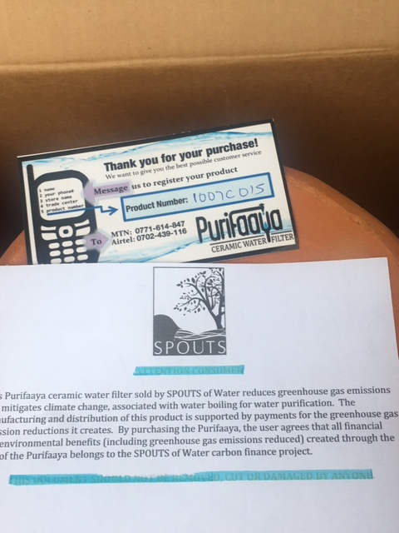

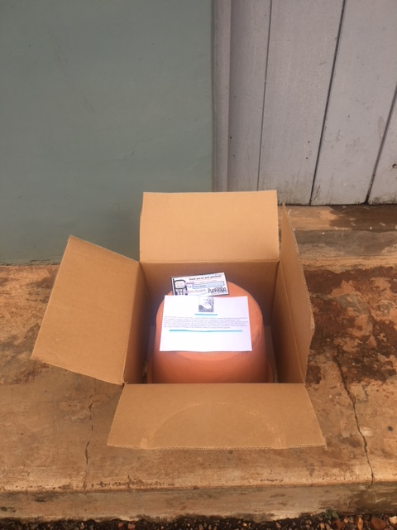

Unicef. “Improving Household Drinking Water Quality: Use of Ceramic Water Filters in Cambodia.” August 2007. https://www.unicef.org/eapro/WSP_UNICEF_FN_CWP_Final.pdf
Record of Approval: http://spouts.org/wp-content/uploads/2016/09/SPOUTS_Purifaaya-Intro.pdf
https://www.youtube.com/watch?v=WLTUNDpb4qw
Uganda National Household Survey Report 2009/2010. Uganda Bureau of Statistics. Weblink: http://www.ubos.org/UNHS0910/chapter9_Domestic%20Energy%20Resources.html
Uganda National Household Survey Report 2009/2010. Uganda Bureau of Statistics. Weblink: http://www.ubos.org/UNHS0910/chapter9_Domestic%20Energy%20Resources.html
Bain, R., Cronk, R., Wright, J., Yang, H., Slaymaker, T., & Bartram, J. (2014). Fecal Contamination of Drinking-Water in Low- and Middle-Income Countries: A Systematic Review and Meta-Analysis. PLoS Medicine, 11(5). http://doi.org/10.1371/journal.pmed.1001644
Haruna, R., Ejobi, F., & Kabagambe, E. K. (2005). The quality of water from protected springs in Katwe and Kisenyi parishes, Kampala city, Uganda. African Health Sciences, 5(1), 14–20.
World Health Organization (WHO), & Unicef. (2012). Uganda WASH Statistics. Geneva. Retrieved from https://www.wssinfo.org/documents
http://www.onewater.org/stories/story/uganda
https://www.monitor.co.ug/News/National/Water-Kampala-safe-WHO/688334-2658314-dbx3ku/index.html
https://www.monitor.co.ug/SpecialReports/How-safe-water-consume/688342-4348206-5y8ijuz/index.html
http://www.ipcc-nggip.iges.or.jp/public/2006gl/pdf/2_Volume2/V2_2_Ch2_Stationary_Combustion.pdf
http://www.ipcc-nggip.iges.or.jp/public/2006gl/pdf/2_Volume2/V2_2_Ch2_Stationary_Combustion.pdf
https://unfccc.int/ghg_data/items/3825.php
http://www.ipcc-nggip.iges.or.jp/public/2006gl/pdf/2_Volume2/V2_2_Ch2_Stationary_Combustion.pdf
https://unfccc.int/ghg_data/items/3825.php
http://www.biomasstradecentre2.eu/scripts/download.php?file=/data/pdf_vsebine/literature/wood_fuels_handbook.pdf
https://www.ipcc.ch/meetings/session25/doc4a4b/vol2.pdf
http://www.ubos.org/2016/03/24/census-2014-final-results/

