Gold Standard for the Global Goals
Key Programme Information & Programme Design Document
(PoA-DD-Believe Green Safe Drinking Water-GS5705)

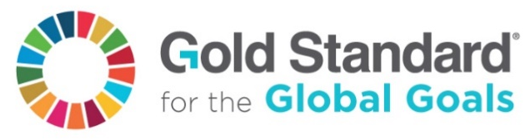

July 2017, Version 1

SECTION A. General description of PoA 7
A.1. Purpose and general description of the PoA 7
A.2. CME and participants of PoA 7
A.3. Physical/ Geographical boundary of the PoA 7
A.3.1 Spring Health-1/2, India 7
A.3.2 Spouts-1/2/3, Uganda 8
A.3.3 Ethiopia-1, Ethiopia 8
A.4. Technologies/measures and eligibility under Gold Standard 9
A.4.1. Spring Health-1/2, India 9
A.4.2. Spouts-1/2/3, Uganda 20
A.4.3. Ethiopia-1, Ethiopia 24
A.5. Funding sources of PoA 29
Spring Health-1-2, India 29
Spouts-1/2/3, Uganda 29
Ethiopia-1, Ethiopia 29
SECTION B. Demonstration of additionality and development of eligibility criteria 29
B.1. Demonstration of additionality for PoA 29
Spring Health-1-2, India 30
Spouts-1/2/3, Uganda 30
Ethiopia-1, Ethiopia 30
B.2. Eligibility criteria for inclusion of a VPA in the PoA 31
Spring Health-1-2, India 31
Spouts-1/2/3, Uganda 31
Ethiopia-1, Ethiopia 31
B.3. Application of technologies/measures and methodologies 35
SECTION C. Management system 37
SECTION D. Duration of PoA 41
D.1. Date of first submission of PoA to Gold Standard 41
D.2. Duration of the PoA 41
SECTION E. Safeguarding principles and SDG outcome assessment 41
E.1. Level at which safeguarding principles and SDG outcome assessment is undertaken 41
E.2. Assessment of safeguarding principles, if undertaken at PoA level 41
E.3. SDG outcomes assessment, if undertaken at PoA level 41
Spring Health-1-2, India 42
Spouts-1/2/3, Uganda 44
Ethiopia-1, Ethiopia 46
SECTION F. Local stakeholder consultation 48
F.1. Level at which stakeholder consultation is undertaken 48
F.2 Solicitation of comments from stakeholders 48
F.3. Summary of comments received, if stakeholder consultation undertaken at PoA level 48
F.4. Report on consideration of comments received, if stakeholder consultation undertaken at PoA level 48
Appendix 1 Contact information of coordinating/managing entity and responsible person(s)/ entity(ies) 49

Overview
This document is the PoA Design Document for the Programme of Activities (PoA) ‘Believe Green Safe Drinking Water’.
The tables below summarizes the VPAs included in this PoA, including the relevant VPA-DDs and annual emission reductions.
PoA - GS5705 - Believe Green Safe Drinking Water
Rev. | Date | Approved | Description and reason of revision
V5 | 30/10/18 | F. Gallo | Spouts_1 – Uganda - Validation Round I
V6 | 06/11/18 | F. Gallo | Spring Health_1 – India - Validation (OO) (1)
V7 | 06/11/18 | F. Gallo | Spring Health_1 – India - Validation (OO) (2)
V8 | 10/11/18 | F. Gallo | Spouts_2/3 - Uganda - Validation Round I
V9 | 10/01/19 | F. Gallo | Spouts_1 – Uganda - Validation Round II
V10 | 11/01/19 | F. Gallo | Spouts_2/3 – Uganda - Validation Round II
V11 | 08/03/19 | F. Gallo | Spouts_1 – Uganda - Validation Round III -  Spouts_2/3 – Uganda - Validation Round II  Ethiopia_1 – Preliminary Review
V12 | 11/04/19 | F. Gallo | Spring Health_1 – India - Validation Round IV
V13 | 15/04/19 | F. Gallo | Spouts_1 – Uganda - Validation Round IV  Spouts_2/3 – Uganda - Validation Round III  Spring Health_2 – India - Preliminar Review
V14 | 02/05/19 | F. Gallo | Spring Health_1 – India - Validation Round V
V16 | 04/05/19 | F. Gallo | Spouts_2/3 – Uganda - Validation Round IV
V17 | 13/05/19 | F. Gallo | Ethiopia_1 – Preliminary Review Round I

VPA
N° | Name | Rev. | Date | Approved | Description and reason of revision
GS6101 | Spouts_1 - Uganda | V06 | 03/05/19 | F. Gallo | Validation Round V
GS6444 | Spouts_2 - Uganda | V08 | 04/05/19 | F. Gallo | Validation Round III
GS6445 | Spouts_3 - Uganda | V08 | 04/05/19 | F. Gallo | Validation Round III
GS6513 | Spring Health_1 - India | V16 | 02/05/19 | F. Gallo | Validation Round V
GS7442 | Ethiopia-1 - Ethiopia | V07 | 13/05/19 | F. Gallo | Preliminary Review Round I
GS10203 | Spring Health_2 - India | V00 | 15/04/19 | F. Gallo | Preliminary Review

Complete list of Project Activities (VPAs) and Local Partners
Local Partner, Country | VPA  name | VPA-DD Document number | Approximate Annual Emission Reductions
Spouts, Uganda Uganda | Spouts - 1 | VPA_DD – Spouts_1 –GS6101 | ~ 10,000tCO2e/year
Spouts, Uganda Uganda | Spouts - 2 | VPA_DD – Spouts_2 – GS6444 | ~ 10,000tCO2e/year
Spouts, Uganda Uganda | Spouts - 3 | VPA_DD – Spouts_3 – GS6445 | ~ 10,000tCO2e/year
Spring Health, India | Spring Health - 1 | VPA_DD – Spring Health_1 – GS6513 | ~ 10,000tCO2e/year
Spring Health, India | Spring Health - 2 | VPA_DD – Spring Health_2 – GS10203 | ~ 10,000tCO2e/year
Aqua for All, Ethiopia | Ethiopia - 1 | VPA_DD – Ethioipia_1 – GS7442 | ~ 10,000tCO2e/year
Total Annual Emission Reductions: |  |  | ~ 60,000tCO2e/year

KEY PROGRAMME INFORMATION

Title of Programme: | PoA-DD-Believe Green Safe Drinking Water-GS5705
Brief description of Programme: | “Believe Green Safe Drinking Water” is a Gold Standard micro scale Programme of Activities (PoA) which aims to reduce biofuel consumption, such as wood, as is traditionally used to boil water to make it safe to drink. This is done by offering low income populations affordable and easily accessible treated water that is safe to drink. Since these people usually use inefficient cook stoves that cause large amounts of smoke leading to respiratory diseases, the project also has significant health co-benefits. Also, the project generates significant employment and income opportunities for the local villagers, who are invited to join the project across the production and delivery chain.
Expected duration of Programme: | 20 years
Coordinating & Management Entity: | Believe Green LLC
Project Representative: | Dr. Federico Gallo
Project Participants and any communities involved: | Believe Green LLC , Spouts of Water
Version of PoA-DD:  Date of Version: | V17  May 13th, 2019
Host Country (ies) / Location: | Orissa, India  Uganda  Amhara Region Ethiopia
Certification Pathway (Project Certification/Impact Statements & Products | Impact certification
Activity Requirements applied:  (mark GS4GG if none relevant) | GS4GG
Methodologies applied: | “Technologies and Practices to Displace Decentralized Thermal Energy Consumption” Version 3.1, August 2017.
Product Requirements applied: | N.A.
Regular/Retroactive: | Retroactive
SDG Impacts: | 1 – SDG 13 – Climate Action  2 – SDG 12 – Ensure sustainable consumption and production patterns  3 – SDG 06 – Clean Water and Sanitation

SECTION A. General description of PoA

A.1. Purpose and general description of the PoA
>> (Provide a brief description of the PoA including information on policy/measure or stated goal that the PoA seeks to promote and framework for the implementation of the proposed PoA.)
“Believe Green Safe Drinking Water” is a Gold Standard micro scale Programme of Activities (PoA) which aims to reduce biofuel consumption, such as wood, as is traditionally used to boil water to make it safe to drink. This is done by offering low income populations affordable and easily accessible treated water that is safe to drink. Since these people usually use inefficient cook stoves that cause large amounts of smoke leading to respiratory diseases, the project also has significant health co-benefits. Also, the project generates significant employment and income opportunities for the local villagers, who are invited to join the project across the production and delivery chain.

The PoA uses a range of technologies to purify water. Specifically,
- Spouts in Uganda uses ceramic water filters that are manufactured in Uganda with local materials and labour.
- Spring Health in India filters and purifies water at kiosks located in villages. The water is then delivered to people’s homes. The water is filtered and disinfected using electro-chlorination technology.
- Aqua for All in Ethiopia partners with a range of manufacturers of filters to offer customers a broad range of filters that end users can choose from.

A.2. CME and participants of PoA
>> (Details of the CME of the proposed PoA, as the entity which communicates with the Gold Standard Secretariat)
The Coordinating/Managing Entity (CME) of the project activity is Believe Green LLC, an American company, which has been actively involved in the development of national policies on the environment and carbon finance.
Name: Believe Green LLC
Location: Chicago, USA
Physical Address: 233 S. Wacker Dr, Suite 84000, Chicago, IL, 60606, USA
Email address: info@believegreen.org

A.3. Physical/ Geographical boundary of the PoA
>> (Provide details of the defined boundary of the proposed PoA in terms of a geographical area e.g. municipality, region within a country, country or several countries within which all VPAs to be included in the PoA will be implemented)

A.3.1 Spring Health-1/2, India
The first set of project activities is operated by our local partner in India, Spring Health. Operations started across hundreds of villages across the state of Orissa, see map below, and are planned to expand to other states in India. The table in section A.2 lists the VPAs included in this region and operated by Spring Health.

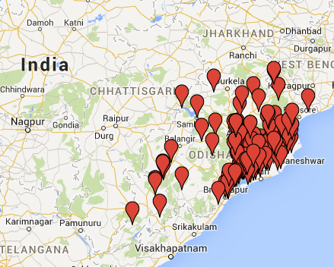

A.3.2 Spouts-1/2/3, Uganda
SPOUTS OF WATER distributes filters in over 200 communities across all four regions of Uganda. The map below shows the distribution points:

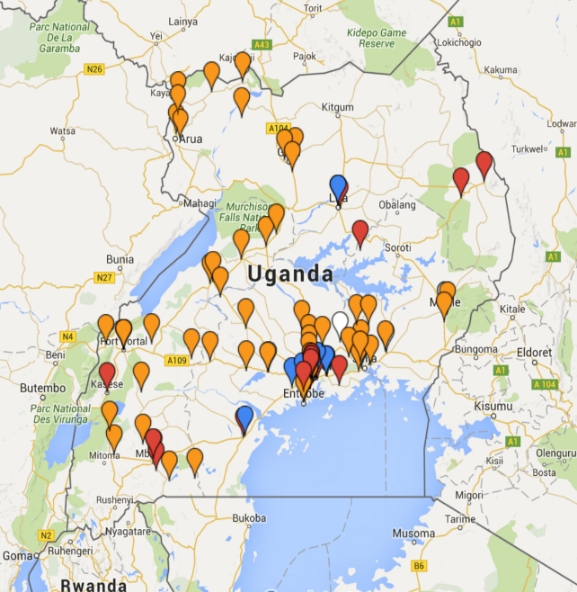

A.3.3 Ethiopia-1, Ethiopia

The project area is East and West Gojjam Zone of Amhara Region, Ethiopia and is expected to expand to other regions (in future the project I slooking to expand to other regions and additional VPAs may be added to match the growth).

The map to the left below highlights the Amhara region in Ethiopia. The red circle in map to the right shows the East and West Gojjam Zone.
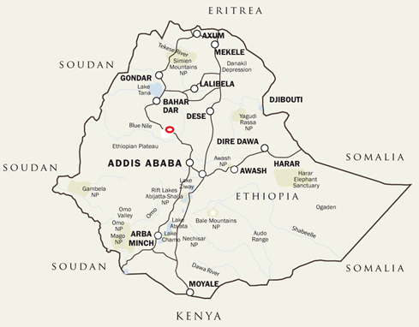
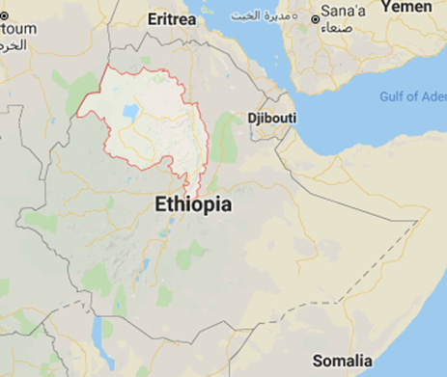

A.4. Technologies/measures and eligibility under Gold Standard
>> (Describe the technologies and/or measures to be employed and/or implemented by the VPAs in the PoA including a list of the facilities, systems and equipment that will be installed and/or modified by the VPA. Include information essential to understand the purpose of the PoA and how it will contribute positively to three SDGs.
Describe how the VPAs meet the eligibility criteria as per section 3.1.1 of GS4GG Principles & Requirements document and the relevant activity requirements document)

A.4.1. Spring Health-1/2, India

a) Overview

The key innovation of Spring Health is its for-profit business model. By charging a small, affordable fee for the water it sells, Spring Health is able to run a sustainable business that does not require donations. This is a breakthrough in rural areas, where earlier government and NGO investments were unable to provide sustainable or scalable solutions to the safe drinking water access problem.

The business model involves creating and managing operations across a large network of rural villages across Orissa. For example, this involves running awareness campaigns about the health risks of drinking un-purified water as well as marketing campaigns about Spring Health products and services. This also entails setting up a number of kiosks in each village that purify the water, as well as running a distribution network which delivers clean water to people’s homes.

As for the technology used to purify the water, Spring Health currently uses two technologies: WATA Electro-chlorination and Auropure.

The rest of this section describes in more detail the water purification technologies as well as the broader business model, including distribution, marketing and awareness campaigns.

b) Technology

Spring Health uses a combination of two technologies to deliver safe drinking water to its customers:

- The WATA Electro chlorination technology is used to eliminate bacteria and other pathogens by producing and adding chlorine to the water. The chlorine dosages are regularly monitored and certified to ensure that they meet safety standards.

- Auropure is a more sophisticated technology that helps also to filter out iron and fluoride impurities.

Both technologies are described in detail below.
1. WATA Electro chlorination technology
Spring Health uses a simple electro-chlorination technology, called WATA, to produce chlorine, which is used to purify the water at the point of sale. The purpose of this technology and practice is to address the major safe drinking water challenge facing India. For more information, see “Annex 7 – Background on safe drinking water in India”.
The WATA technology, developed by Antenna, uses a simple, manageable process of electrolysis to convert a measure of salt and water into sodium hypochlorite. The resulting solution can be used for drinking water chlorination.
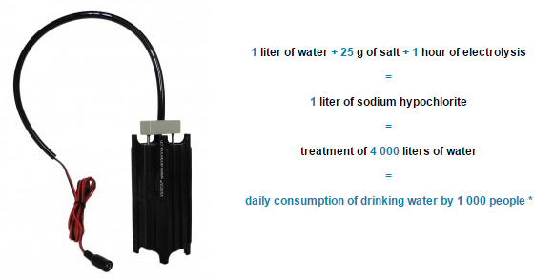
The WATA is specifically designed for use in the context of communities in developing countries (range of 3 devices). With this system, communities can source locally and quickly available chlorine to protect against diarrheal diseases such as diarrhea or dysentery.
The vision of Spring Health is to “provide safe and affordable drinking water to one and all”. In addition, the goal is to reduce the incidence of waterborne diseases and the related expenses for medical treatment. The long-term objective of Spring Health is to have a presence in the entire country.
The enterprise addresses the problem of safe drinking water access in rural India by offering customers a ten-liter jerry can with safe water at a cost that is around sixty times less expensive compared to alternative products, such as bottled water or packet water.
The targeted segment are consumers living at the bottom of the pyramid in small remote villages in the Eastern Indian state of Orissa, where water tables are high and wells are shallow. These people are mostly bypassed by current formal markets and they have specific needs and problems, which had to be taken into account during the business model development process. For example, the product offered needed to be radically affordable due to the customer’s lack of financial means.
This consumer market has been largely unreachable and untapped. The company estimates the potential market at 200 million customers in East India alone (Spring Health, 2012). By chlorinating water at the point of sale and delivering it directly to the home of the customer in a clean jerry can, the company ensures that the likelihood of recontamination is minimized.

2. AuroPure technology
AuroPure is a Low-cost Solar/ Green energy based community water treatment system.
The AuroPure, the low-cost and very low-maintenance green energy based water treatment system has been developed and tested by Affordable Water Solutions, Auroville, Tamil Nadu, to cater to the needs of rural India where there is no electricity and availability of trained manpower is negligible.
The vision is to develop affordable and sustainable technological solution for the provision of safe drinking water in habitations that lack electricity and in absence of trained manpower.
“AuroPure” is automated system including dosing of chemical with automatic switch off button, does not require operator. The system totally runs on minimum solar panel and consumes very less space.

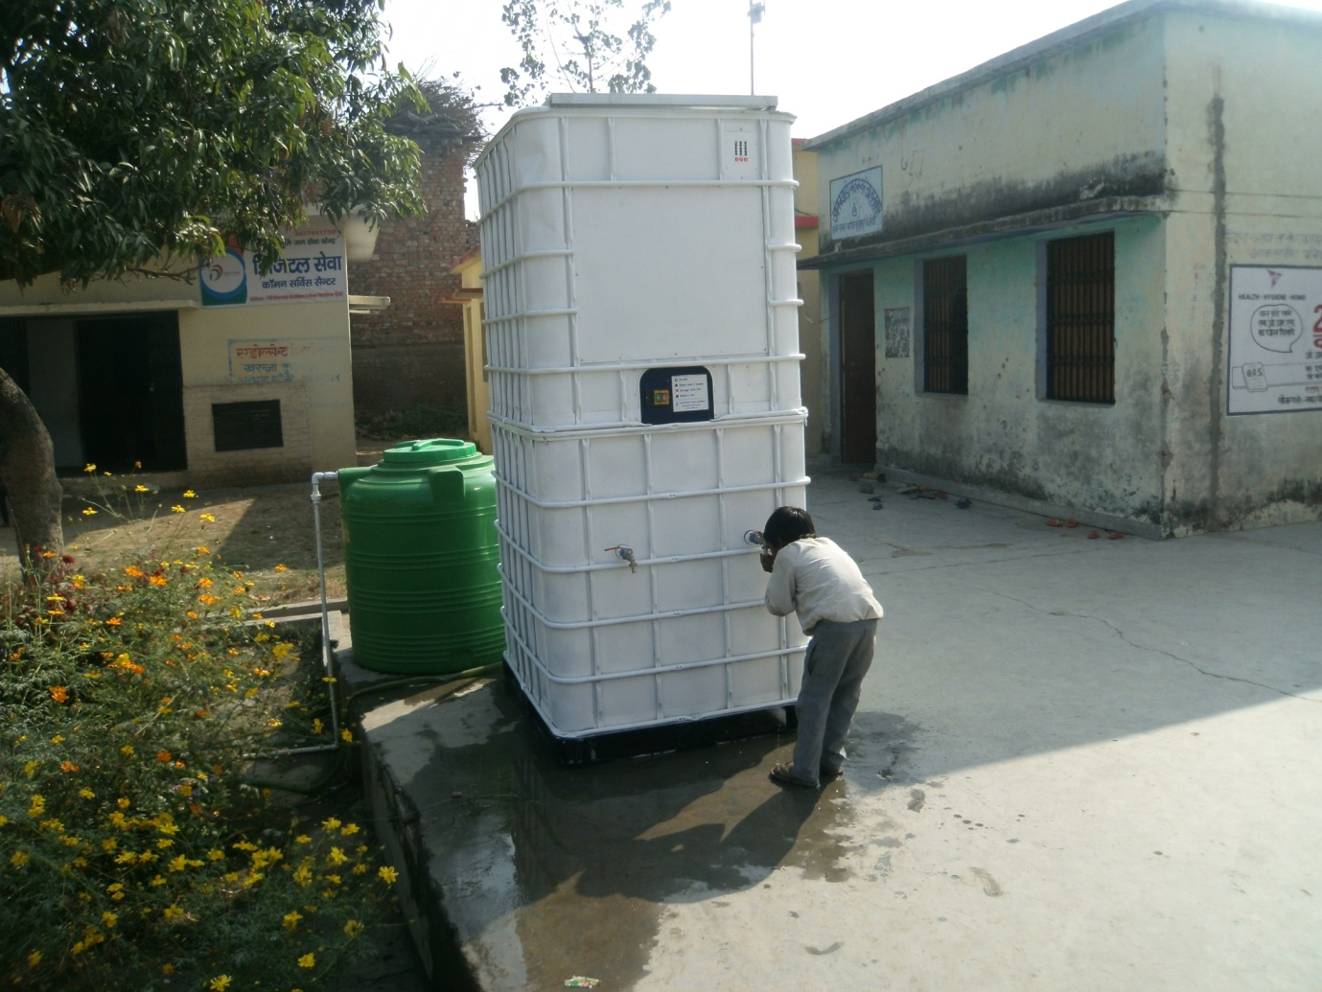

2.1 Technical
The technology will be introduced for the first time in India that is very cost effective operates on the principle of coagulation/flocculation.
- The ‘AuroPure’ system is based on a continuous water treatment process, using innovative coagulation/flocculation and disinfection technologies.
- On site chlorine dioxide generating unit will take care of water disinfection.
- Requisite energy will be delivered by integrated solar panels or wind generator along with battery storage backup.
- Being a fully automated unit, there is no need for a locally skilled operator. Automatic and periodic SMS messages in form of crucial data will be sent by GSM integrated shield connected to group of sensors to the ‘servicing centre’ located regionally which would take care of all operation and maintenance of the system and update of crucial parameters .
- Refilling of treatment chemicals will take place once in- 6 month.

2.2 Specification
Specifications of the system: height - 215 cm, length - 77 cm, depth - 77 cm. Capacity - 180 liters per hour. If connected with bigger storage tank up to 4000 liters of water per day can be treated. Model with treatment capacity up to 500 liters of water per hour or 12000 liters per day as well, will be available.

2.3 How it Works
System works on principle of coagulation/flocculation technology. Coagulant is added with precise dozing pump to the untreated water which gets mixed in mixing chamber. After mixing, water is allowed to flow to precipitation/storage tank. Prior to this disinfectant (chlorine dioxide) is added to the water stream and mixed. Water is passed through activated carbon remove any impurities before consumption.
This system has the capabilities of producing cleaner and safe drinking water from hand pump, stream, pond, well, lake or any fresh water source at a volume production where water purification and electrical power are impractical or unattainable.
2.4 Features:
- Fully automated require no skilled manpower /operator,
- User friendly therefore can be installed anywhere and occupies very less space,
- Automatic removing sediment from precipitation tank,
- Low cost, low maintenance, 12 v required electricity which will be supplied by in-build solar system in the unit or wind generator in the unit,
- System can be easily installed at any sites regardless of terrain in two working days,
- Coagulant, disinfectant (chlorine dioxide) containers and activated carbon filter should be refilled every 4-6 month,
- With inbuilt GSM shield periodical observation of most important parameters like water flow, battery charging level, temperature, humidity, quantity of the coagulant and chlorine dioxide liquids in dozing containers will be sent by SMS message to the centralized operating system.

2.5 Efficiency in removal of contaminant:
- Protozoa 99.99% and better
- Bacteria 99.9999% and better
- Viruses 99.9999% and better
- Removes turbidity from 1000 NTU to less than 5 NTU.
- Removes Iron more than 90%,
- Can remove fluoride and arsenic to permissible level with little modification.

c) Description of the business model

The business model revolves around three key components:

c.1 Build ‘WATA Electro chlorination plants’ in strategic locations
c.2 Set up distribution networks
c.3 Create demand

c.1 The Electro chlorination plant
One key element of the business model is a number of strategically located ‘electro chlorination plants’.
An electro chlorination plant, using Antenna Foundation’s WATA Electro chlorinator, is set up in small market towns to produce chlorine to purify water. Each plant services 50 village kiosks. Four Spring Health Business Associates are linked to each electro chlorination plant and two plants are managed by a Senior Marketing Officer. The 4 business Associates are collectively able to purify water in 50 villages/every 3 days with each having charge of 16-17 villages. Each Business Associate has a daily beat route, covering 5-6 villages in a 20km radius. They purify the water in the 4000 liter plastic tanks located at the village entrepreneurs’ premises (see image below). After dosing the water and waiting for 30 minutes, the water is tested for free residual chlorine to ascertain that it is safe for distribution.
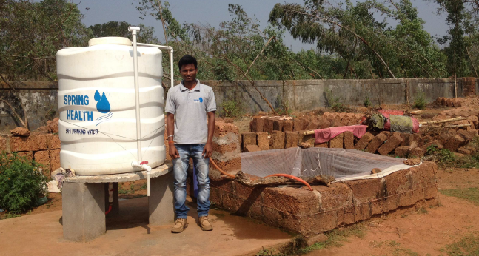

c.2 The distribution network
A central part of the model is the implementation of a profitable last-mile supply chain. Spring Health partners with local entrepreneurs or village shop owners and installs tanks next to their private shallow well at an affordable price.
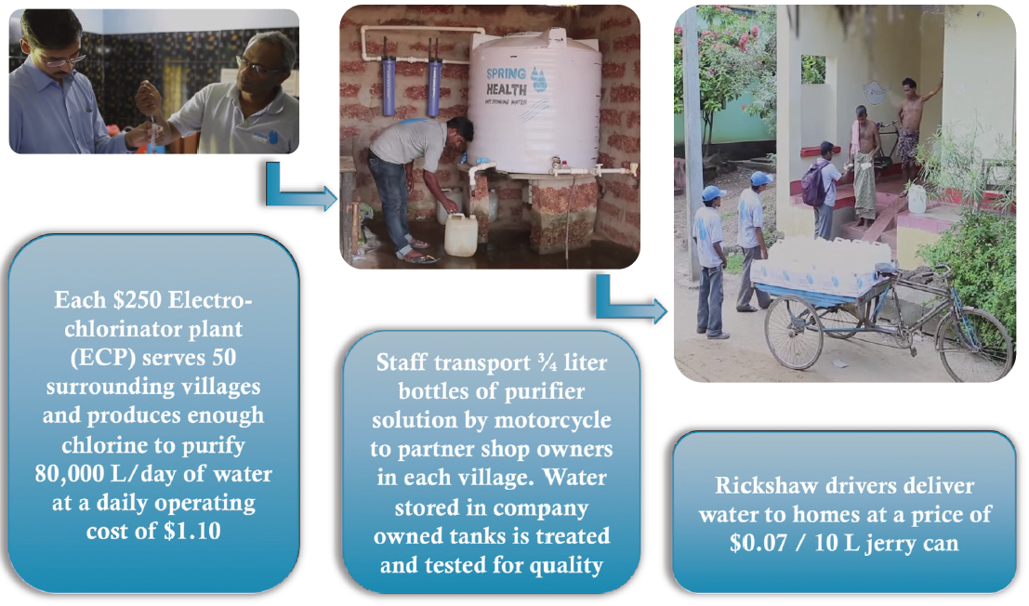
The local entrepreneur then sells the treated water in 10L jerry cans through a home delivery service system. The entrepreneur carries the jerry cans filled with the purified water with a bicycle or a trolley directly to the home of the customers within a radius of several kilometres.
While in the villages, the Business Associate does additional marketing, randomized testing of water samples at the customers’ homes, accounting and data gathering from entrepreneurs.
The data gathering has been set up in such a way that the water usage and hence the carbon emission reductions can be monitored for the purpose of certifying the carbon emission reductions.

c.3 Demand creation
Selling a product to people living at the bottom of the pyramid is not an easy task, because they have to be cautious about where they want to spend the little money they have. Before buying anything, they will critically think about the benefits the product offers.
In other words, the demand for safe drinking water needs to be created by raising the awareness of the dangers of drinking untreated water. Spring Health creates this demand with an innovative mixture of strong social marketing campaigns and innovative designs and aspirational products.

Strong social marketing. A difficult task is to change the behavior of the targeted population. Many poor people are not aware of the benefits of safe water and would not pay anything for it as long as they have water available in their well. Hence, to support the launch of a new safe water entrepreneur a strong social marketing has to be set up. Spring Health invented here a unique strategy to roll out villagers and convince them to buy safe water. First, strong sales promotions gather the village community around ‘Water Melas’ awareness campaign and social entertainment such as theatre drama where the main topic is safe water.
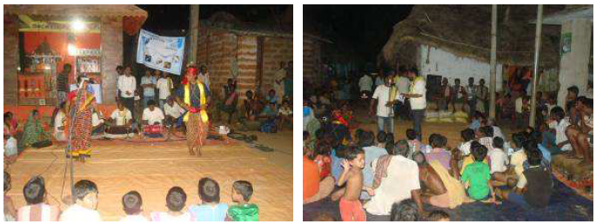
Focus on innovative designs and inspirational products. Building a strong brand identity is another important part of the Spring Health strategy. The target audience in remote villages should recognize and emotionally connect with the company brand. Spring Health’s brand identity is created through a professionally designed logo, recognizable t-shirts and baseball caps worn by company staff members, unique jerry cans and branded posters around and close to the water tank.
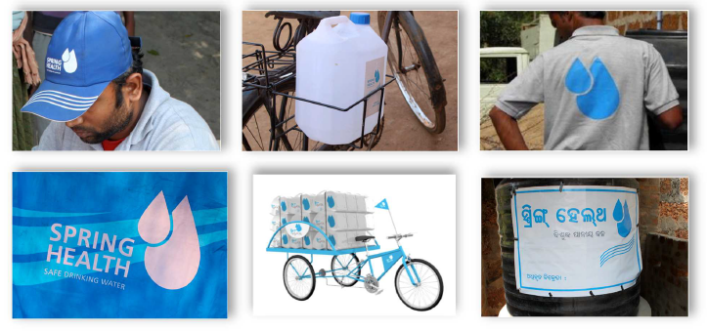

d. Customers and beneficiaries
All villagers can benefit from the village water entrepreneur, purchasing the delivery at home.
The pictures below present several families and show their motives to buy SH water and their satisfaction in a village nearby Bhubaneswar, where most of the men are fishers, as it is located near a large lake. All of the persons interviewed were unanimous on the home delivery, allowing them to save time for work for a relative cheap cost. The 10 L jerry cans water prices were described as affordable by the interviewed people. Some of the interviewed women were concerned by their children and elderly parents’ health. But one woman interviewed mentioned she was purchasing safe water for herself only, as most of her family members did not like the taste of chlorine.

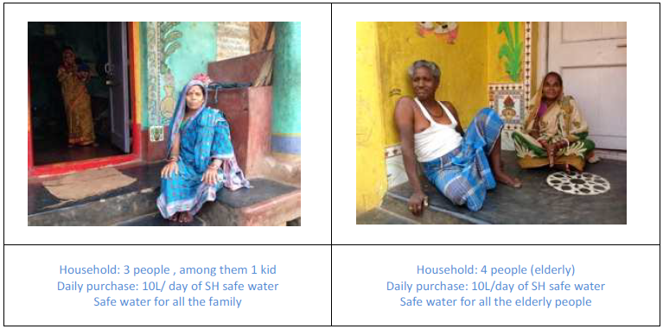
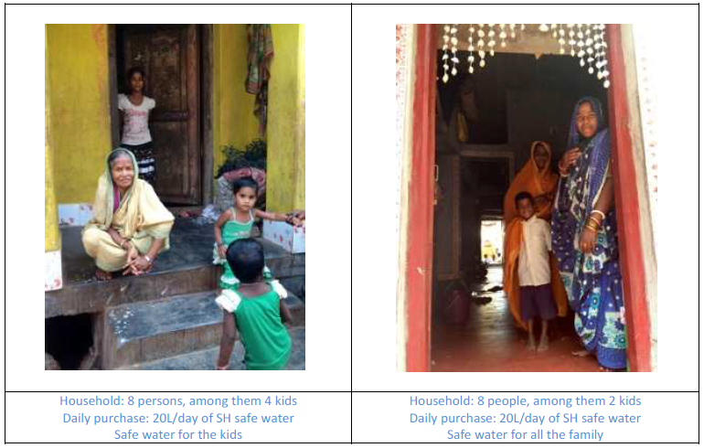

d) Eligibility
This Project Activity is eligible since it fulfil the requirements established in GS4GG Principles & Requirements, Version 1, Sections 3.1.1 and Annex 1:
  - The Project Activity is associated with the Gold Standard Approved Methodology Technologies and Practices to Displace Decentralized Thermal Energy Consumption Version 3.1 (TPDDTEC)

  - The Project Activity reduces the amount of energy required to provide safe drinking water: by using a low energy filtration and electro-chlorination at the point of sale, water no longer needs to be boiled at the point of use, at people’s homes, thus reducing energy use by the end user.

  - The quality of service is not reduced, as end users still have access to safe drinking water.

e) Sustainable Development Goals (SDG) outcomes
We are including the following three SDGs:

1 – SDG13 – Climate Action

UN Target (13.B) : “Promote mechanisms for raising capacity for effective climate change-related planning and management in least developed countries and small island developing States, including focusing on women, youth and local and marginalized communities”

Relevant Monitoring Indicator: Emission Reduction of CO2 = 9,995 [tCO2/y]

2 – SDG 12 – Ensure sustainable consumption and production patterns

UN TARGET (12.2) : “By 2030, achieve the sustainable management and efficient use of natural resources”

Un Relevant Monitoring Indicator (12.2.1) : Domestic material consumption (Quantity of wood fuel burned avoided) = 6,764 Tonnes of wood

3 – SDG 6 – Clean Water and Sanitation

UN Target (6.1) : “By 2030, achieve universal and equitable access to safe and affordable drinking water for all”

UN Relevant Monitoring Indicator (6.1.1) : Proportion of population using safely managed drinking water services = 27.0 %

Explanation of methodological choices/approaches for estimating the SDG outcome
>> (Explain how the methodological steps in the selected methodology(ies) or proposed approach for calculating baseline and project outcomes are applied. Clearly state which equations will be used in calculating net benefit.)

1 – SDG13 – Climate Action

Relevant Monitoring Indicator: Emission Reduction of CO2
Please refer to Section B.6.4 for details on the model used to calculate the carbon emission reductions. The parameters values and their description are included in Section B.6.3 and B.7. The model is implemented in the Carbon Emission Reductions spreadsheet: a screenshot of the relevant worksheet is included below:

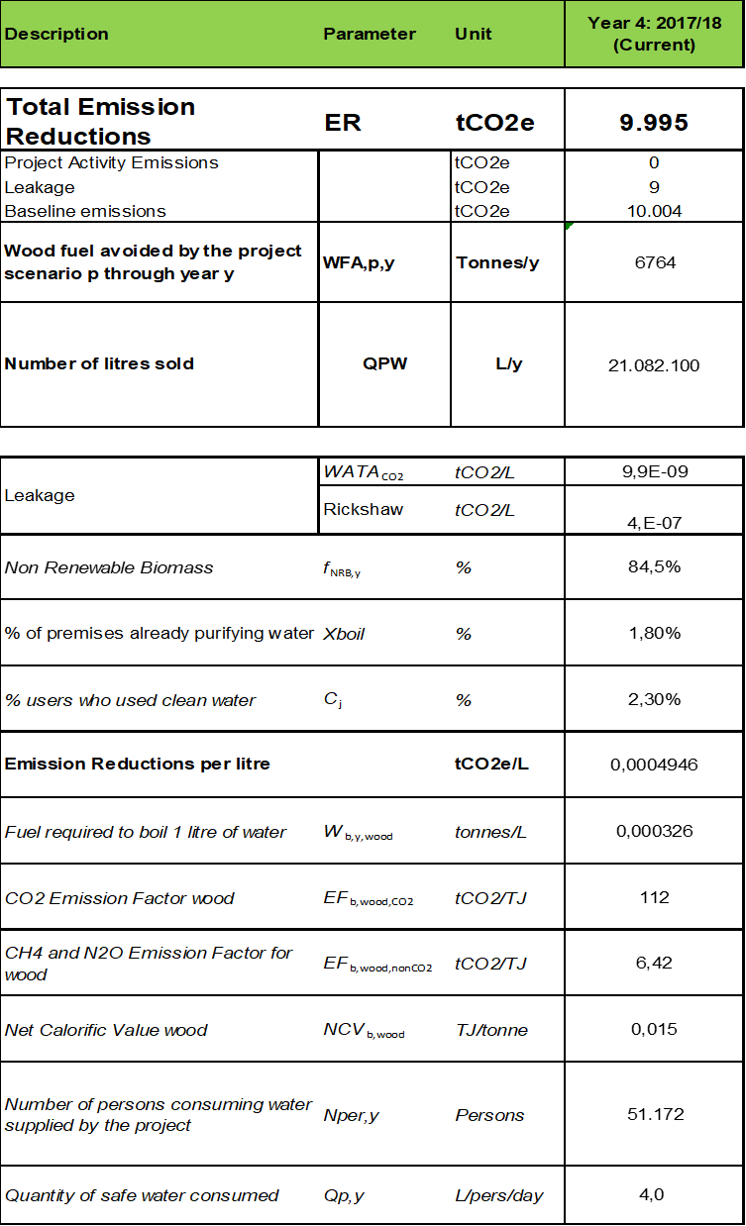

2 – SDG 12 – Ensure sustainable consumption and production patterns

Un Relevant Monitoring Indicator (12.2.1) : Domestic material consumption (Quantity of wood fuel burned avoided) = 6,764 Tonnes of wood

W_{bay} = L * W_{w} * %W = 21,081,870 * 0.000429 * 74.8% = 6,764 Tonnes of wood

Where:
- W_{bay} = Quantity of fuel burned avoided
- L = Litres of purified water
- W_{W} = Fuel required to boil 1 litre of water using wood stoves
- %W = Percentage of people using wood stoves

3 – SDG 6 – Clean Water and Sanitation

UN Relevant Monitoring Indicator (6.1.1): Proportion of population using safely managed drinking water services = 27.0 %
Baseline
PSW = 2.3%

Project:
PSW = Number of customers / Total household =
= 11.644 / 43,084 = 27.0 %

A.4.2. Spouts-1/2/3, Uganda
a) Technology

The third technology and practice is operated by Spouts in Uganda. The table on page 2 of this PoA-DD list the VPAs included under this technology and practice.
The Purifaaya water filter uses ceramic filtration technology. Ceramic water filters are an innovative product offered as an appropriate clean water solution in Uganda. An assessment on the use of ceramic water filters in Cambodia by UNICEF states, “[Ceramic] filters have the advantage of being lightweight, portable, relatively inexpensive, chemical-free, low-maintenance, effective, and easy to use.”
The base of the filter is a ceramic pot with microscopic holes, which trap bacteria, enabling only clean drinking water to pass through. In order to maximize safety, all of our filters are subjected to strict quality control and then coated with an additional layer of silver nitrate, an effective biocide. Water from any source can be sanitized through the ceramic filtration system and stored at the bottom of the filter ready to drink. At the bottom of the filter is a tap, which makes the clean drinking water easily accessible. The household Purifaaya stores 20 liters of water, whilst the Purifaaya XL stores 60 liters, making it ideal for public spaces such as schools, hospitals and prisons. In 2015 The Ugandan Ministry of Water and Environment tested and approved the filter stating that SPOUTS OF WATER filters are “efficient and effective to produce water that meets the recommended standard of water for human consumption.” Test results conclude that the Purifaaya kills 99.9% of disease-causing bacteria, as well as removing the turbidity of the water, thus producing drinking water that is both safe and clean.
In addition to Purifaaya’s technical excellence, SPOUTS ‘ceramic filters are also culturally and socially acceptable in Uganda due to the long-standing tradition in villages of storing drinking water in clay pots. The local population prefers the taste of the water from ceramic filters and is accustomed to maintaining ceramic products.
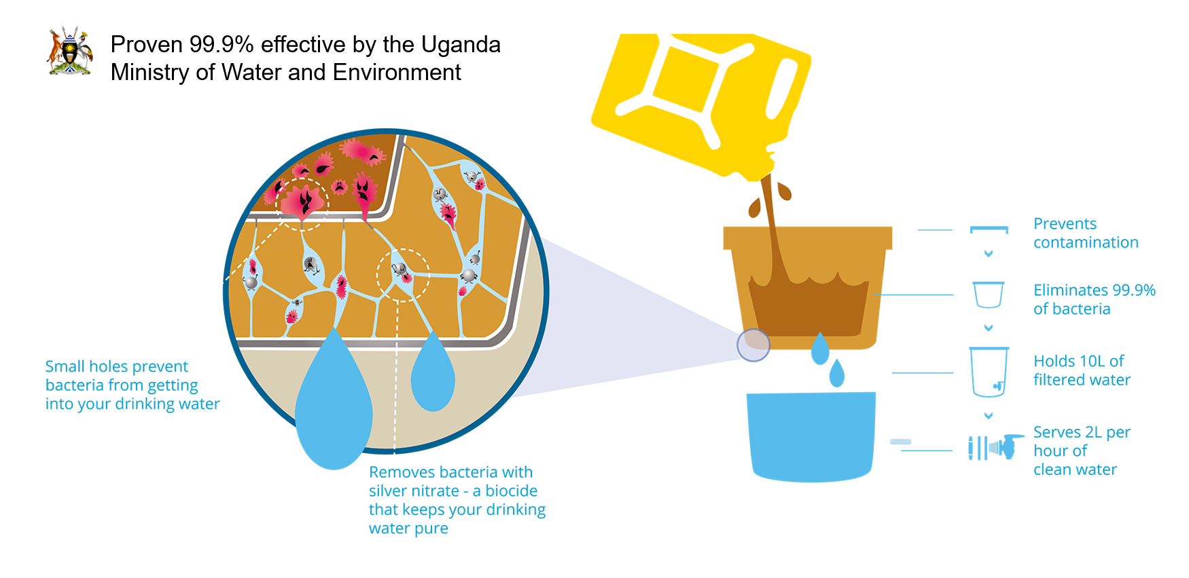
b) Distribution channels/strategy and awareness campaigns
To distribute the filters across the entire nation, SPOUTS segments the market by income level, targeting all households while also working with NGOs to provide clean drinking water to refugee camps, schools, prisons, clinics and other public spaces. In urban and peri-urban areas, SPOUTS products are sold in retails shops, targeting households that can afford the upfront cost of the filter. SPOUTS further reduces the barrier to purchase by providing financing options to customers through partnerships with MFIs and Savings and Credit Cooperatives (SACCOs). SPOUTS’ partners often extend loans to purchase SPOUTS filters over 6 months and allow customers to establish stable long-term access to clean water even if they are unable to afford the upfront cost at once. Given that the average monthly household income is around 128 USD according to the latest national census from 2012-13, the option to buy a SPOUTS filter at 4 USD per month over 6 months is an incredibly affordable price for the vast majority of the population. For the most marginalized segments of the population like refugees in refugee camps, SPOUTS works with aid partner organizations and fundraises to provide access to safe water through installation of filters in public spaces.

SPOUTS has formed long-term partnerships with a diverse set of distribution networks, ranging from NGOs to wholesale retailers, who provide our customers with >200 access points in all four regions of Uganda. Local community banks called SACCOS (Savings and Credit Cooperatives) have embraced our filters, with some selling over 300 filters while offering financing plans enabling end-users who cannot afford the 20 USD to pay in installments. Finca Plus and Pride Microfinance have also provided financing options to our customers. Notably, we have collaborated with United Nations High Commission for Refugees (UNHCR) and Oxfam to provide ceramic water filters in refugee settlements. Retailers, such as Living Goods and BRAC have promoted our filters through an Avon-like distribution network. Prince of Peace Orphans and Widows (POPOW) Vision has distributed our filters to vulnerable women's groups. SPOUTS continues to collaborate with the public sector in Uganda to expand our reach in the region, including programs that install our filters in public prisons.

c) Eligibility criteria
This Project Activity is eligible since it fulfil the requirements established in GS4GG Principles & Requirements, Version 1, Sections 3.1.1 and Annex 1:
  - The Project Activity is associated with the Gold Standard Approved Methodology Technologies and Practices to Displace Decentralized Thermal Energy Consumption Version 3.1 (TPDDTEC)
  - The Project Activity reduces the amount of energy required to provide safe drinking water: by using a low energy filtration and electro-chlorination at the point of sale, water no longer needs to be boiled at the point of use, at people’s homes, thus reducing energy use by the end user.
  - The quality of service is not reduced, as end users still have access to safe drinking water.

d) Sustainable Development Goals (SDG) outcomes
We are including the following three SDGs:

1 – SDG13 – Climate Action

UN Target (13.B) : “Promote mechanisms for raising capacity for effective climate change-related planning and management in least developed countries and small island developing States, including focusing on women, youth and local and marginalized communities”

Relevant Monitoring Indicator: Emission Reduction of CO2 = 9,497 [tCO2/y]

2 – SDG 12 – Ensure sustainable consumption and production patterns

UN TARGET (12.2) : “By 2030, achieve the sustainable management and efficient use of natural resources”

Un Relevant Monitoring Indicator (12.2.2) : Domestic material consumption (Quantity of wood fuel burned avoided) = 7,081Tonnes of wood

3 – SDG 6 – Clean Water and Sanitation

UN Target (6.1) : “By 2030, achieve universal and equitable access to safe and affordable drinking water for all”

UN Relevant Monitoring Indicator (6.1.1) : Proportion of population using safely managed drinking water services = 0.04 %

Explanation of methodological choices/approaches for estimating the SDG outcome

1 – SDG13 – Climate Action

Relevant Monitoring Indicator: Emission Reduction of CO2
In order to calculate the Emission Reduction of CO2 we use the following equations. These equations are also presented in the ‘Spouts-1 - Emission Reductions Calculations’ spreadsheet:

ER = BE * Uy – L kiln = 11,609 [tCO2] * 0.82 – 20 [tCO2] = 9,499 [tCO2]
Where:
- ER = Emission Reduction of CO2
- BE = Baseline emissions
- Uy = Usage rate
- Lkiln (Leakage)

Where:
- BE = Filters_y * WCF
- Lkiln (Leakage) = Wf (wood/charcoal) required to cook 1 ceramic filter) * Filters_y * EF (wood/charcoal emission factor

Where:

- Filters_y = Number of Filters sold - This parameter is measured via the Sales Tracker
- WCF = Weighted_Carbon_per_filter

Where:

- WCF = CL * nj
- CL = Emission Reductions per litre (boiling test)
- nj = number of persons per hh (filter))

2 – SDG 12 – Ensure sustainable consumption and production patterns

Relevant Monitoring Indicator (12.2.1) : Domestic material consumption (Wood Not Burned)
In order to calculate the quantity of Wood Not Burned we use the following equations. These equations are also presented in the Emission Reductions Calculations spreadsheet:

WNB = Wboil * L * F * % = 0.000427 [tonnes_wood/L] * 6,913 [L] * 3,077 * 0.78 = 7,081 tonnes of wood

Where:

- WNB = Wood Not Burned
- Wboil = Wood required to boil 1L of water - Its value is measured in the field via Boiling Tests
- L = Eligible litres per year.hh
- F = Number of Filters sold
- % = Percentage using wood

3 – SDG 6 – Clean Water and Sanitation

UN Relevant Monitoring Indicator (6.1.1): Proportion of population using safely managed drinking water services = 0.04 %
Baseline
PSW = 5.0 %

Project:
PSW= N_{p} / P_{U}= 19,659 / 42,860,000 = 0.04 %

Where:
N_{p} Number of persons consuming water supplied by the project
P_{U} Population of Uganda

A.4.3. Ethiopia-1, Ethiopia
a) Technology

To cater to different needs, the project offers end users a range of filters:

a.1) Sawyer membrane filter

Hollow fiber membrane technology

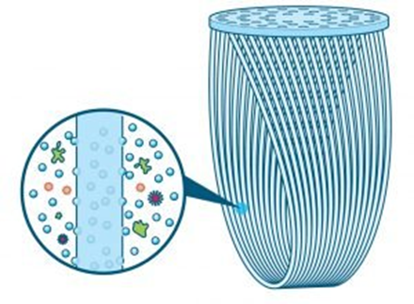

With the technology derived from kidney dialysis, Sawyer Product partnered with a fiber manufacturer to actually improve the hollow fiber membrane technology. In order to improve both the filtration rates and longevity of the filter, our team was dedicated to engineering something even more precise and rugged.To make it a superior solution, the fiber composition had to deliver exactly 0.1 & 0.02 micron filtration 100% of the time to ensure no bacteria would get through. Moreover, the membranes had to be sturdy enough to withstand backwashing which allows the filter to be cleaning and reused.
Sawyer membrane filter are comprised of tiny “U” shaped micro-tubes that allow water to enter into their core through minuscule micro-pores. Contaminates get trapped in the tubes while the decontaminated water passes freely through. The high number of those tiny tubes and their significant surface area allow the filter to have one of the fastest flow rates available in the world. This high flow rate makes our filters easily utilized as point-of-use solutions, which has eliminated the need to store water – one of the leading causes of contaminated water throughout the world.

0.1 and 0.02 microns
Each Sawyer membrane filter is certified for ABSOLUTE microns; that means there is no pore size larger than 0.1 or 0.02 micron in size. This makes it impossible for harmful bacteria, protozoa, or cysts like E. coli, Giardia, Vibrio cholerae and Salmonella typhi (which cause Cholera and Typhoid) to pass through the Sawyer PointONE™ biological filter. At 7 log (99.99999%) the filter attains the highest level of filtration available today.

a.2) Tulip Siphon

The Tulip Siphon is a lightweight portable water purifier that is easy to use and store. It purifies 4–5 liters of water per hour. The filter can be used in emergency situations as well as for daily usage. It has a unique backwash function making sure that the filter stays clean and fit for purification and a fast flow rate. The Tulip Siphon lasts up to 7000 liters. After which the candle can be easily replaced.
Features:
• E-coli bacteria removal: > 99,9%
• Protozoa removal: > 99,99%
• Turbidity removal: 99%
• Flow-rate: 4-5 liters per hour
• Backwash: yes
• Applicability: emergencies, households

a.3) Tulip Table Top

The Tulip Table Top is a two bucket water filter and water storage facility in one. The top bucket is filled with raw water, which is filtered through the Tulip candle filter into the lower bucket. The water in the lower bucket is safe for immediate consumption. The water is also safe for storage in the lower bucket for longer periods. The Tulip Table Top lasts up to 7000 liters. After which the candle can be easily replaced.
Features:
• E-coli bacteria removal: > 99,9%
• Protozoa removal: > 99,99%
• Turbidity removal: 99%
• Flow-rate: 1-3 liters per hour
• Backwash: yes
• Applicability: emergencies, households

b) Business Model - Water Filter distribution through Utilities
Finding Point-of-Use solutions for Ethiopia
Diarrheal risk is especially salient among the <5 population in Ethiopia.
Aqua for All has done an effort to support the Ethiopian government to develop a system approach towards reaching universal access to safe water at point of use. PoU filter intervention proven to be effective.
For reference: Prevalence in medical parlance refers to the number of cases of a disease in a population during a specific period of time. It is used in reference to how widespread a disease has become and the ratio between those who are already infected and those who are at risk. Incidence, on the other hand, refers to the rate of the manifestation of a certain disease. It is used to measure the rate of occurrence of a disease at a given period usually dealing with the number of new cases that are diagnosed within a population during a specific period.

Tackling barriers to scale
- Awareness: people do not always know their drinking water is unsafe;
- Knowledge: filters are largely unknown as HWTS solution;
- Availability: no large network of sales and aftersales points

For Aqua for All, these were reasons to look at innovative distribution channels to tackle barriers to scale HWTS solutions.
We performed a distribution pilot in Finote Selam to test the viability of the approach (see Flowchart)

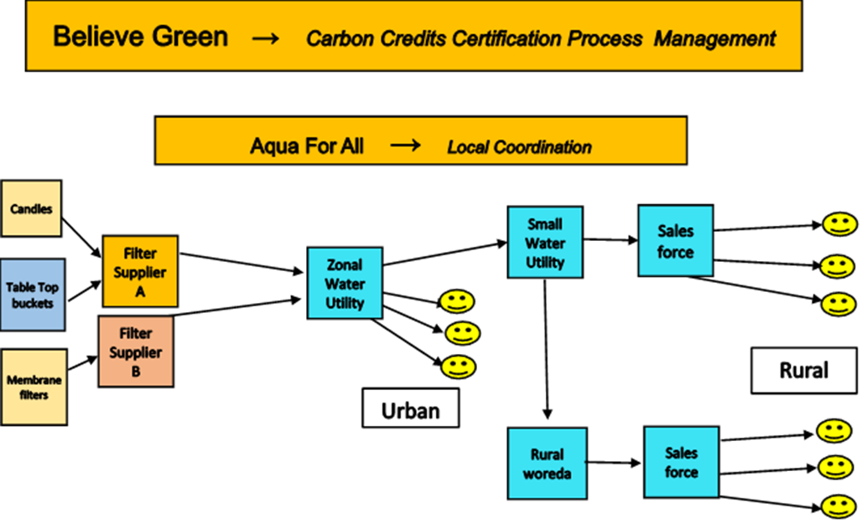
c) Eligibility criteria
This Project Activity is eligible since it fulfil the requirements established in GS4GG Principles & Requirements, Version 1, Sections 3.1.1 and Annex 1:
  - The Project Activity is associated with the Gold Standard Approved Methodology Technologies and Practices to Displace Decentralized Thermal Energy Consumption Version 3.1 (TPDDTEC)
  - The Project Activity reduces the amount of energy required to provide safe drinking water: by using a low energy filtration and electro-chlorination at the point of sale, water no longer needs to be boiled at the point of use, at people’s homes, thus reducing energy use by the end user.
  - The quality of service is not reduced, as end users still have access to safe drinking water.

d) Sustainable Development Goals (SDG) outcomes
We are including the following three SDGs:

1 – SDG13 – Climate Action

UN Target (13.B): “Promote mechanisms for raising capacity for effective climate change-related planning and management in least developed countries and small island developing States, including focusing on women, youth and local and marginalized communities”

2 – SDG 12 – Ensure sustainable consumption and production patterns

UN Target (12.2): “By 2030, achieve the sustainable management and efficient use of natural resources”

3 – SDG 6 – Clean Water and Sanitation

UN Target (6.1): “By 2030, achieve universal and equitable access to safe and affordable drinking water for all”

Explanation of methodological choices/approaches for estimating the SDG outcome
>> (Explain how the methodological steps in the selected methodology(ies) or proposed approach for calculating baseline and project outcomes are applied. Clearly state which equations will be used in calculating net benefit.)

1 – SDG13 – Climate Action

Relevant Monitoring Indicator: Emission Reduction of CO2
In order to calculate the Emission Reduction of CO2 we use the following equations. These equations are also presented in the Emission Reductions Calculations spreadsheet:

ER = BE * Uy – L = 10,751 [tCO2] * 0.93 – 00[tCO2] = 9,999 [tCO2]
Where:
- ER = Emission Reduction of CO2
- BE = Baseline emissions
- Uy = Usage rate
- L = Leakage

Where:
- BE = Filters_y * WCF
- L = Wf (wood/charcoal) required to cook 1 ceramic filter) * Filters_y * EF (wood/charcoal emission factor

Where:

- Filters_y = Number of Filters sold - This parameter is measured via the Sales Tracker
- WCF = Weighted_Carbon_per_filter

Where:

- WCF = CL * nj
- CL = Emission Reductions per litre (boiling test)
- nj = number of persons per hh (filter))

2 – SDG 12 – Ensure sustainable consumption and production patterns

Relevant Monitoring Indicator (12.2.1) : Domestic material consumption (Wood Not Burned)
In order to calculate the quantity of Wood Not Burned we use the following equations. These equations are also presented in the Emission Reductions Calculations spreadsheet:

WNB = Wboil * L * F * % = 0.000428 [tonnes_wood/L] * 6,222 [L] * 2,686 * 0.85 = 6,090 tonnes of wood

Where:

- WNB = Wood Not Burned
- Wboil = Wood required to boil 1L of water - Its value is measured in the field via Boiling Tests
- L = Eligible litres per year.hh
- F = Number of Filters sold
- % = Percentage using wood

3 – SDG 6 – Clean Water and Sanitation

UN Relevant Monitoring Indicator (6.1.1): Proportion of population using safely managed drinking water services (provided by Spouts) = 3.35 %
Baseline
PSW = 3.2 %

Project:
PSW= N_{p} / P_{U}= 12,356 / 368,410 = 3.35 %

Where:
N_{p} Number of persons consuming water supplied by the project
P_{U}, Population of Debre Marcos (262,497) + population of Finote Selam (105,913)

A.5. Funding sources of PoA
>> (Provide the public and private funding sources for the programme. Confidential information need not be provided.)

Spring Health-1-2, India

Spouts-1/2/3, Uganda

Ethiopia-1, Ethiopia

See ODA declaration in Annex 2 of the relevant VPA.

SECTION B. Demonstration of additionality and development of eligibility criteria

B.1. Demonstration of additionality for PoA
>> (Justify why the PoA will not be implemented without revenues from transaction of certified SDG outcomes.)

Spring Health-1-2, India

Spouts-1/2/3, Uganda

Ethiopia-1, Ethiopia

In order to demonstrate additionality we use the UNFCCC guidelines: “Annex 27 - Guidelines on the demonstration of additionality of small-scale project activities”.
This requires that “project participants shall provide an explanation to show that the project activity would not have occurred anyway due to at least one of the following barriers:
- Investment barrier: a financially more viable alternative to the project activity would have led to higher emissions;
- Technological barrier: a less technologically advanced alternative to the project activity involves lower risks due to the performance uncertainty or low market share of the new technology adopted for the project activity and so would have led to higher emissions;
- Barrier due to prevailing practice: prevailing practice or existing regulatory or policy requirements would have led to implementation of a technology with higher emissions;
- Other barriers: without the project activity, for another specific reason identified by the project participant, such as institutional barriers or limited information, managerial resources, organizational capacity, financial resources, or capacity to absorb new technologies, emissions would have been higher.

The PP has chosen the barrier due to prevailing practice to prove additionality.

Prevailing practice: boiling water or not treating at all (suppressed demand)
Many people served by our PoA in rural Orissa, India, as well as Uganda and Ethiopia do not purify their water because they are unaware of the health consequences of drinking untreated water.
If they treat it, most often they do so by boiling it with very inefficient and dirty cook stoves, in most cases three-stone stoves, see section A.4.2.
However, if shown the adverse effects of drinking untreated water, people will start choosing to purchase Spring Health’s purified water, or to purify it at home, for example with Spouts ceramic water filters or Aqua for All’s filters in Ethiopia.
This is a fact documented and demonstrated by the work of this project, and lies at the core of its business model. Specifically, in order to expand into new communities and new regions in the country, Spring Health, Spouts and Aqua for All use complex awareness campaigns and marketing to generate demand for their products; this is described in detail in section A.4.2 of this PoA-DD.
The success of our business model clearly shows that, through education and awareness, the attitudes towards safe drinking water can change permanently. Specifically, if shown the benefits of safe drinking water, people will choose to purify the water they drink.
The role of our local partners, such as Spring Health, Spouts and Aqua for All, is to ensure that the treatment of the water occurs in a zero carbon way. Without Spring Health’s, Spouts’ and Aqua for All’ sservice, people would likely have started to boil the water using the inefficient stoves and fuel at their disposal, which is described in Section A.4.2.
Revenues from carbon credits will be key in supporting the expansion of the reach of our local partners into new villages and regions. Such expansion is very expensive for Spring Health, Spouts and Aqua for All, and cannot be achieved without external support. The revenues from the carbon credits would help sustain Spring Health’s, Spouts’ and Aqua for All’s growth and help people in Orissa, Uganda and Ethiopia have access to safe drinking water that they can afford and want to buy.
In summary, the additionality criteria are met because without the PoA the project activities would not have occurred because of the barrier due to prevailing practice.

Gold Standard For The Global Goals - Community Services Activity Requirements (Version 1.1)
The present is a COMMUNITY SERVICES project because it falls on the Water, Health and Hygiene (WASH) project type.
This CS project, other the Gold Standard for the Global Goals Requirements, applies the following criteria for eligibility:
• The technologies will each have continuous energy outputs of less than 150kW per unit. This will be applied to the baseline technology with regards to the water technology units. Typical cook stoves produce energy around 5kW on average. (see Sect. B.7.2)

• Emission reductions achieved by each one of the activities considered under the microscale programme are limited to a maximum of 10,000 tCO2 in any year of their crediting period.

• Legal ownership
The project proponent clearly communicates to all project participants the entity that is claiming ownership rights of and selling the emission reductions resulting from the project activity. This is communicated to the technology producers and the retailers of the improved technology or the renewable fuel in use in the project situation by contract or clear written assertions in the transaction paperwork. If the claimants are not the project technology end users, the end users should be notified that they cannot claim for emission reductions from the project.
a. The project proponent has clearly communicated to every end customer that will claim ownership rights. (see Appendix 3)
b. The project proponent has clearly communicated to the other project participants that project proponent will claim ownership rights, including through a formal contract.

• Projects may seek Certification for a maximum of two Design Certification Renewal Cycles i.e., a total of 15 years issuance.

• This project is a Microscale Project, hence, it is considered as deemed additional and therefore is not required to prove Financial Additionality at the time of Design Certification.

B.2. Eligibility criteria for inclusion of a VPA in the PoA
>> (Describe the eligibility criteria to be met by VPAs for inclusion in the PoA)

Spring Health-1-2, India

Spouts-1/2/3, Uganda

Ethiopia-1, Ethiopia

The eligibility criteria for inclusion of VPAs defined by the latest version of UNFCCC guidance for “Demonstration of additionality, development of eligibility criteria and application of multiple methodologies for programmes of activities” are fulfilled:
Prescription | Compliance
Prescription | Description | Ref. PoA/VPA
The geographical boundary of the VPA is consistent with the geographical boundary set in the PoA | - Spring Health:  State of Orissa, India | PoA, Sect. A.3.1
- Spouts 1:
Uganda
 | - Ethiopia-1,  Amhara Region, Ethiopia | PoA, Sect. A.3.2
Conditions that avoid double counting of emission reductions like unique identifications of product and end-user locations | The project boundary is clearly identified, as described in sections B.3 of the relevant VPA-DDs. | PoA, Sect. B.3.2.1
The specifications of technology/measure including the level and type of service,  performance specifications including compliance with testing/certifications | We specify each technology/measure exhaustively | PoA, Sect. A.4
Conditions to check the start date of the CPA through documentary evidence | The start date of the project is that on which the Project Developer has committed to expenditures related to the implementation of the Project | VPA, C.1.1
The conditions that ensure that the VPA meets the requirements pertaining to the  demonstration of additionality | In order to demonstrate additionality we use:  - UNFCCC guidelines: “Annex 27 - Guidelines on the demonstration of additionality of small-scale project activities”  - GS4GG Community Services Activity Requirements | - PoA, Sect. B.1  - The projects contents in this PoA are Microscale Project, hence, it is considered as deemed additional and therefore is not required to prove Financial Additionality at the time of Design Certification.
The PoA-specific requirements stipulated by the CME including any conditions  related to undertaking local stakeholder consultations and environmental impact  analysis | We have conducted stakeholder consultation in accordance with GS4GG Stakeholder Procedure Requirements and Guidelines, at VPA level | VPA, Sect. E
Conditions to provide an affirmation that funding from Annex I Parties, if any,  does not result in a diversion of official development assistance | We have provide a declaration on funding sources for the project (ODA) | VPA, Appendix 2
Conditions related to sampling requirements | We have described the sampling plan | VPA, Sect. B.7.2
Requirements for the debundling check | Projects are eligible because they are more than 1km away | - - -
Scale of the Activity | Emission reductions achieved by each one of the activities considered under the micro- scale program are limited to a maximum of 10,000 tCO2 in any year of their crediting period. | PoA, OVERVIEW
Technology and Target Group | Each VPA involve the distribution of affordable and easily accessible treated water that is safe to drink, to households and/or communities currently cooking with firewood on a traditional three-stone stove, for domestic purposes and/or currently boiling water as a treatment method before consumption. | We take into account suppressed demand.  Suppressed demand was determined through a set of questions in the baseline survey. See support documents:  - Spouts - Summary Stats  - Spouts Survey
Technology Output | The technologies will each have continuous energy outputs of less than 150kW per unit. This will be applied to the baseline technology with regards to the water technology units. | Typical cook stoves produce energy around 5kW on average.  VPA, Sect. B.7.2
Types of technologies | To cater to different needs, the project offers end users a range of filters:  a.1) Sawyer membrane filter  a.2) Tulip Siphon  a.3) Tulip Table Top | VPA, Sect. A.4.3
Baseline | Baseline and Project scenarios will be identified | - VPA-DD, Section 6.3  - Relevant Emission Reduction Calculation
Methodology | Each VPA will be in compliance with Gold Standard Approved Methodology Technologies and Practices to Displace Decentralized Thermal Energy Consumption Version 3.1 (TPDDTEC) | The applicability of the methodology is justified in VPA-DD, Section B.2
Carbon Transfer | It will be clearly communicated that Believe Green is the entity that is claiming ownership rights of and selling the emission reductions resulting from the project activity. | Each agreement and relationship are formalized under contract between Believe Green and Spouts.

GOLD STANDARD FOR THE GLOBAL GOALS
COMMUNITY SERVICES ACTIVITY REQUIREMENTS (Version 1.1)
The present is a COMMUNITY SERVICES project because it falls on the Water, Health and Hygiene (WASH) project type.
This CS project, other the Gold Standard for the Global Goals Requirements, applies the following criteria for eligibility:
• The technologies will each have continuous energy outputs of less than 150kW per unit. This will be applied to the baseline technology with regards to the water technology units. Typical cook stoves produce energy around 5kW on average. (see Sect. B.7.2)

• Emission reductions achieved by each one of the activities considered under the microscale programme are limited to a maximum of 10,000 tCO2 in any year of their crediting period.

• Legal ownership
The project proponent clearly communicates to all project participants the entity that is claiming ownership rights of and selling the emission reductions resulting from the project activity. This is communicated to the technology producers and the retailers of the improved technology or the renewable fuel in use in the project situation by contract or clear written assertions in the transaction paperwork. If the claimants are not the project technology end users, the end users should be notified that they cannot claim for emission reductions from the project.
a. The project proponent has clearly communicated to every end customer that will claim ownership rights. (see Appendix 3)
b. The project proponent has clearly communicated to the other project participants that project proponent will claim ownership rights, including through a formal contract.

• Projects may seek Certification for a maximum of two Design Certification Renewal Cycles i.e., a total of 15 years issuance.

• This project is a Microscale Project, hence, it is considered as deemed additional and therefore is not required to prove Financial Additionality at the time of Design Certification.

B.3. Application of technologies/measures and methodologies
>> (Describe the technology/measures and indicate the methodology chosen. In cases where multiple technologies/measures or multiple methodologies are being applied, list all the combinations of technologies/measures and methodologies that will be used in the PoA. If applicable, provide a description of the sampling plan applied for monitoring.)

B.3.1) Technology

Spring Health-1-2, India (see Section A.4.1)
Spouts-1/2/3, Uganda (see Section A.4.2)
Ethiopia-1, Ethiopia (see Section A.4.3)

B.3.2) Methodology

The Project Activity is associated with the Gold Standard Approved Methodology Technologies and Practices to Displace Decentralized Thermal Energy Consumption Version 3.1 (TPDDTEC)

This methodology is applicable to programs or activities introducing improved cook-stoves or water treatment technology and practices to households and institutions that result in improved kitchen regimes within a distinct geographical area.
As indicated in section I of the TPDDTEC Methodology, the following conditions apply:
1. The project boundary can be clearly identified, and the technologies counted in the project are not included in another voluntary market or CDM project activity (i.e. no double counting takes place). Project proponents must have a survey mechanism in place together with appropriate mitigation measures so as to prevent double-counting in case of another similar activity with some of the target area in common.
a. The project boundary is clearly identified, as described in sections B.3 of the relevant VPA-DDs.
b. Regarding double counting:
i The technology used in the project is not included in another voluntary market or CDM project activity.
ii. Also, there is no risk of double-counting if a competitor technology enters the same target area. The reason is that we are only counting emission reductions from the filters sold under this project. If usage rates of the filters sold decreases, this would be accounted by the parameter Up,y (see VPA-DD, Section B.7).

2. The technologies each have a continuous useful energy output of less than 150kW per unit (defined as total energy delivered from start to end of operation of a unit divided by time of operation). For technologies or practices that do not deliver thermal energy in the project scenario but only displace thermal energy supplied in the baseline scenario, the 150kW threshold applies to the displaced baseline technology.
a. Spring Health’s, Spouts’s and Aqua for All’s purified water does not deliver energy output but only displace thermal energy supplied in the baseline scenario which delivers less than 150kW per technology. The table below shows that typical cook stoves produce energy outputs of well below 150kW: around 5kW on average¹².

3. The use of the baseline technology as a backup or auxiliary technology in parallel with the improved technology introduced by the project activity is permitted as long as a mechanism is put into place to encourage the removal of the old technology (i.e. discounted price for the improved technology) and the definitive discontinuity of its use.
a. The technology used will displace GHG emissions from the use of fuel to boil water butwill not replace the cook stoves, which will still be used for other cooking purposes.

b. However, by purchasing Spring Health and Spouts purified water, the end customers will reduce their usage of the inefficient cook stoves in proportion to the numbers of litres of cleanwater that they buy, and translated into carbon emission reductions as calculated in section B.6 of relevant VPA-DDs.

4. The project proponent clearly communicates to all project participants the entity that is claiming ownership rights of and selling the emission reductions resulting from the project activity. This is communicated to the technology producers and the retailers of the improved technology or the renewable fuel in use in the project situation by contract or clear written assertions in the transaction paperwork. If the claimants are not the project technology end users, the end users should be notified that they cannot claim for emission reductions from the project.
a. The project proponent has clearly communicated to the other project participants that the project proponent will claim ownership rights, including through a formal contract.
b. The PP is including a note accompanying each water filter sold stating that the project proponent will claim ownership rights. For more details see relevant VPA-DD, Appendix 3.

5. Project activities making use of a new biomass feedstock in the project situation (e.g. shift from non-renewable to green charcoal, plant oil or renewable biomass briquettes) must comply with relevant Gold Standard specific requirements for biomass related project activities, as defined in the latest version of the Gold Standard rules. If the biomass feedstock is sourced from a dedicated plantation, these criteria must apply to both plantations established for the project activity AND existing plantations that were established in the context of other activities but will supply biomass feedstock.
a. The technology does not make use of any fuel and therefore this condition does notapply to this project.

Furthermore, the following conditions apply:
1. Adequate evidence is supplied to demonstrate that indoor air pollution (IAP) levels arenot worsened compared to the baseline, and greenhouse gases emitted by the project fuel/stove combination are estimated with adequate precision. The project fuel/stove combination may include instances in which the project stove is a baseline stove.
a. The technology does not produce any GHG emissions therefore IAP are not worsened and no GHG arise from the use of the technology.

2. Records of renewable fuel sales may not be used as sole parameters for emission reduction calculation, but may be used as data informing the equations in section II of this methodology if correlated to data on distribution and results of field tests and surveys confirming (a) actual use of the renewable fuel and usage patterns such as average fraction of non-renewable fuels used in mixed combustion or seasonal variation of fuel types, (b) GHG emissions, (c) evidence of CO levels not deteriorating (d) any further factors effecting emission reductions significantly.
a. The technology does not produce any GHG emissions therefore IAP are not worsened and no GHG arise from the use of the technology.

SECTION C. Management system
>>

a) Definition of roles and responsibilities of personnel involved in the process of inclusion of VPAs, including a review of their competencies

Managing Director
- Develop strategic plans for the development of new projects
- Verify and approve the documents issued to the certification bodies
- Interact with Certification Bodies
- Defines the Quality Policy

Body Certification (BC) Compliance
- Processes every document envisaged by the BCs in line with their requirements
- Process the data provided by the Methodology Operator.
- Submit the final documents to the BCs

Methodology Operator (Spouts-1, Uganda) (Ethiopia-1, Ethiopia)
- Manages every phase of the Local Stakeholder consultation
- Supervised filter distribution and installation
- Manage survey and monitoring activities
- Manage sales tracker
- Manage customer grievances

Methodology Operator (Spring Health-1-2, Uganda)
- Manages every phase of the Local Stakeholder consultation
- Supervised the water supply service
- Manage survey and monitoring activities
- Manage sales tracker
- Manage customer grievances

Commercial & PPRR
- Interfaces the subjects of the sectors interested in looking for new projects
- Proposes the development of new projects to the Managing Director

b) Records of arrangements for training and capacity development for personnel

SKILLS MATRIX
Subject  Function | LSC | Survey and monitoring | Sales tracker | Update Methodology | Customer grievances | Filter distribution and installation | Water supply service | Voluntary market trend
Method. Operator (S-1/2/3)  Method. Operator (Ethiopia-1) | 5 | 5 | 5 | 5 | 5 | 5 | 1 | 1
Method. Operator (SH-1) | 5 | 5 | 5 | 5 | 5 | 1 | 5 | 1
BC Compliance | 5 | 5 | 5 | 5 | 5 | 1 | 1 | 1
Commercial PPRR | 1 | 1 | 1 | 1 | 1 | 1 | 1 | 5

 | 1 | Not applicable
 | 2 | Poor
 | 3 | Enough
 | 4 | Discreet
 | 5 | Excellent

The records of each training session are maintained by filling out appropriate forms.
Semi-annually the organization assesses the status of the competences and responsibilities of each function.

c) Procedure for technical review of inclusion of VPAs
The inclusion of a VPA in a PoA will result in the fulfillment of the latest version of UNFCCC guidance for “Demonstration of additionality, development of eligibility criteria and application of multiple methodologies for programmes of activities”:

Prescription | Compliance
Prescription | Description | Ref PoA | Ref VPA
The geographical boundary of the VPA is consistent with the geographical boundary set in the PoA
Conditions that avoid double counting of emission reductions like unique identifications of product and end-user locations
The specifications of technology/measure including the level and type of service,
performance specifications including compliance with testing/certifications
Conditions to check the start date of the CPA through documentary evidence
The conditions that ensure that the VPA meets the requirements pertaining to the
demonstration of additionality
The PoA-specific requirements stipulated by the CME including any conditions
related to undertaking local stakeholder consultations and environmental impact
analysis
Conditions to provide an affirmation that funding from Annex I Parties, if any,
does not result in a diversion of official development assistance
Conditions related to sampling requirements
Requirements for the debundling check
Scale of the Activity
Technology and Target Group
Technology Output
Baseline
Methodology
Carbon Transfer

d.1) Records and documentation control process for each VPA under the PoA

(See overview, pagine 4)

d.2) Records and documentation control process for each document – (inside each document)

Document Control
Rev. | Data | Approved | Description and reason of revision

e) Measures for continuous improvements of the PoA management system

Operative Mode

1. The improvements system mainly from the analysis of the following topics:

- Methodology update
- Outcomes from the Preliminary Review
- Outcomes from the Internal Validation
- Outcomes from the Internal Verifications
- Grievances managements

2. The Head of the BC Compliance, in agreement with the managing director describes the problem in the appropriate space of the Continuous Improvement form indicating the causes identified at the base of the problem encountered

3. The Managing Director, after appropriate staff’s consultations, indicates in detail, the actions to be taken to solve the problem encountered, defining the deadline and responsibilities assigned in the appropriate space of the Continuous Improvemen form.

SECTION D. Duration of PoA

D.1. Date of first submission of PoA to Gold Standard
>> (State the date when PoA design consultation report was submitted to Gold Standard for review)

04/04/2017 (April 4th, 2017)

D.2. Duration of the PoA
>> (State the total duration of the proposed PoA in years.)

20 years

SECTION E. Safeguarding principles and SDG outcome assessment

E.1. Level at which safeguarding principles and SDG outcome assessment is undertaken
>> (Define whether these assessments will be carried out PoA level or VPA level. Justify, if it is done at PoA level.)
Safeguarding Principles and SDGs outcome assessment will be carried out VPA level.

E.2. Assessment of safeguarding principles, if undertaken at PoA level
>> (If safeguards assessment is undertaken at PoA level then refer the GS4GG Safeguarding Principles and Requirements document for detailed guidance on carrying out this assessment. Provide the inclusion criteria to be met by each VPA regarding safeguarding principles in section B.2 above)

We have conducted the safeguarding assessment at VPA level for each activity (Section D)

E.3. SDG outcomes assessment, if undertaken at PoA level
>> (If SDG outcomes assessment is undertaken at PoA level then specify the relevant SDG target for each of three or more SDGs addressed by the PoA. Refer most recent version of targets here. Provide the inclusion criteria to be met by each VPA regarding SDG outcomes assessment in section B.2 above)

Spring Health-1-2, India

We are including the following three SDGs:

1 – SDG13 – Climate Action

UN Target (13.B) : “Promote mechanisms for raising capacity for effective climate change-related planning and management in least developed countries and small island developing States, including focusing on women, youth and local and marginalized communities”

Relevant Monitoring Indicator: Emission Reduction of CO2 = 9,995 [tCO2/y]

2 – SDG 12 – Ensure sustainable consumption and production patterns

UN TARGET (12.2) : “By 2030, achieve the sustainable management and efficient use of natural resources”

Un Relevant Monitoring Indicator (12.2.1) : Domestic material consumption (Quantity of wood fuel burned avoided) = 6,764 Tonnes of wood

3 – SDG 6 – Clean Water and Sanitation

UN Target (6.1) : “By 2030, achieve universal and equitable access to safe and affordable drinking water for all”

UN Relevant Monitoring Indicator (6.1.1) : Proportion of population using safely managed drinking water services = 27.0 %

Explanation of methodological choices/approaches for estimating the SDG outcome
>> (Explain how the methodological steps in the selected methodology(ies) or proposed approach for calculating baseline and project outcomes are applied. Clearly state which equations will be used in calculating net benefit.)

1 – SDG13 – Climate Action

Relevant Monitoring Indicator: Emission Reduction of CO2
Please refer to Section B.6.4 for details on the model used to calculate the carbon emission reductions. The parameters values and their description are included in Section B.6.3 and B.7. The model is implemented in the Carbon Emission Reductions spreadsheet: a screenshot of the relevant worksheet is included below:

2 – SDG 12 – Ensure sustainable consumption and production patterns

Un Relevant Monitoring Indicator (12.2.1) : Domestic material consumption (Quantity of wood fuel burned avoided) = 6,764 Tonnes of wood

W_{bay} = L * W_{w} * %W = 21,081,870 * 0.000429 * 74.8% = 6,764 Tonnes of wood

Where:
- W_{bay} = Quantity of fuel burned avoided
- L = Litres of purified water
- W_{W} = Fuel required to boil 1 litre of water using wood stoves
- %W = Percentage of people using wood stoves

3 – SDG 6 – Clean Water and Sanitation

UN Relevant Monitoring Indicator (6.1.1): Proportion of population using safely managed drinking water services = 27.0 %
Baseline
PSW = 2.3%

Project:
PSW = Number of customers / Total household =
= 11.644 / 43,084 = 27.0 %

Spouts-1/2/3, Uganda
We are including the following three SDGs:

1 – SDG13 – Climate Action

UN Target (13.B) : “Promote mechanisms for raising capacity for effective climate change-related planning and management in least developed countries and small island developing States, including focusing on women, youth and local and marginalized communities”

Relevant Monitoring Indicator: Emission Reduction of CO2 = 9,497 [tCO2/y]

2 – SDG 12 – Ensure sustainable consumption and production patterns

UN TARGET (12.2) : “By 2030, achieve the sustainable management and efficient use of natural resources”

Un Relevant Monitoring Indicator (12.2.2) : Domestic material consumption (Quantity of wood fuel burned avoided) = 7,081Tonnes of wood

3 – SDG 6 – Clean Water and Sanitation

UN Target (6.1) : “By 2030, achieve universal and equitable access to safe and affordable drinking water for all”

UN Relevant Monitoring Indicator (6.1.1) : Proportion of population using safely managed drinking water services = 0.04 %

Explanation of methodological choices/approaches for estimating the SDG outcome

1 – SDG13 – Climate Action

Relevant Monitoring Indicator: Emission Reduction of CO2
In order to calculate the Emission Reduction of CO2 we use the following equations. The equartion below is derived in full detail in Section B.6.4. This includes also details on baseline emissions. These equations are also presented in the Emission Reductions spreadsheet:

ER = BE * Uy – L kiln = 11,609 [tCO2] * 0.82 – 20 [tCO2] = 9,499 [tCO2]
Where:
- ER = Emission Reduction of CO2
- BE = Baseline emissions
- Uy = Usage rate
- Lkiln (Leakage)

Where:
- BE = Filters_y * WCF
- Lkiln (Leakage) = Wf (wood/charcoal) required to cook 1 ceramic filter) * Filters_y * EF (wood/charcoal emission factor

Where:

- Filters_y = Number of Filters sold - This parameter is measured via the Sales Tracker
- WCF = Weighted_Carbon_per_filter

Where:

- WCF = CL * nj
- CL = Emission Reductions per litre (boiling test)
- nj = number of persons per hh (filter))

2 – SDG 12 – Ensure sustainable consumption and production patterns

UN Relevant Monitoring Indicator (12.2.2) : Domestic material consumption (Wood Not Burned)
In order to calculate the quantity of Wood Not Burned we use the following equations. These equations are also presented in the Emission Reductions Calculations spreadsheet:

Baseline:
WBb = Wboil * L * F * %

Emission Reductions:
WNB = WBb – WBp = WBb – 0 =
= Wboil * L * F * % = 0.000427 [tonnes_wood/L] * 6,913 [L] * 3,077 * 0.78 = 7,081 tonnes of wood

Where:

- WNB = Wood Not Burned
- WBb = Wood burned in the Baseline
- WBp = Wood burned in the project. This equal to zero, i.e. WBp
- Wboil = Wood required to boil 1L of water - Its value is measured in the field via Boiling Tests
- L = Eligible litres per year.hh
- F = Number of Filters sold
- % = Percentage using wood

3 – SDG 6 – Clean Water and Sanitation

UN Relevant Monitoring Indicator (6.1.1): Proportion of population using safely managed drinking water services = 0.04 %
Baseline
PSW = 5.0 %

Project:
PSW= N_{p} / P_{U}= 19,659 / 42,860,000 = 0.04 %

Where:
N_{p} Number of persons consuming water supplied by the project
P_{U} Population of Uganda

Ethiopia-1, Ethiopia
We are including the following three SDGs:

1 – SDG13 – Climate Action

UN Target (13.B): “Promote mechanisms for raising capacity for effective climate change-related planning and management in least developed countries and small island developing States, including focusing on women, youth and local and marginalized communities”

2 – SDG 12 – Ensure sustainable consumption and production patterns

UN Target (12.2): “By 2030, achieve the sustainable management and efficient use of natural resources”

3 – SDG 6 – Clean Water and Sanitation

UN Target (6.1): “By 2030, achieve universal and equitable access to safe and affordable drinking water for all”

Explanation of methodological choices/approaches for estimating the SDG outcome

1 – SDG13 – Climate Action

Relevant Monitoring Indicator: Emission Reduction of CO2
In order to calculate the Emission Reduction of CO2 we use the following equations. These equations are also presented in the Emission Reductions Calculations spreadsheet:

ER = BE * Uy – L = 10,751 [tCO2] * 0.93 – 00[tCO2] = 9,999 [tCO2]
Where:
- ER = Emission Reduction of CO2
- BE = Baseline emissions
- Uy = Usage rate
- L = Leakage

Where:
- BE = Filters_y * WCF
- L = Wf (wood/charcoal) required to cook 1 ceramic filter) * Filters_y * EF (wood/charcoal emission factor

Where:

- Filters_y = Number of Filters sold - This parameter is measured via the Sales Tracker
- WCF = Weighted_Carbon_per_filter

Where:

- WCF = CL * nj
- CL = Emission Reductions per litre (boiling test)
- nj = number of persons per hh (filter))

2 – SDG 12 – Ensure sustainable consumption and production patterns

Relevant Monitoring Indicator (12.2.1) : Domestic material consumption (Wood Not Burned)
In order to calculate the quantity of Wood Not Burned we use the following equations. These equations are also presented in the Emission Reductions Calculations spreadsheet:

WNB = Wboil * L * F * % = 0.000428 [tonnes_wood/L] * 6,222 [L] * 2,686 * 0.85 = 6,090 tonnes of wood

Where:

- WNB = Wood Not Burned
- Wboil = Wood required to boil 1L of water - Its value is measured in the field via Boiling Tests
- L = Eligible litres per year.hh
- F = Number of Filters sold
- % = Percentage using wood

3 – SDG 6 – Clean Water and Sanitation

UN Relevant Monitoring Indicator (6.1.1): Proportion of population using safely managed drinking water services (provided by Spouts) = 3.35 %
Baseline
PSW = 3.2 %

Project:
PSW= N_{p} / P_{U}= 12,356 / 368,410 = 3.35 %

Where:
N_{p} Number of persons consuming water supplied by the project
P_{U}, Population of Debre Marcos (262,497) + population of Finote Selam (105,913)

SECTION F. Local stakeholder consultation

F.1. Level at which stakeholder consultation is undertaken
>> (Define whether the stakeholder consultation will be carried out PoA level or VPA level. Justify, if it is done at PoA level.)

The stakeholder consultation was carried at VPA Level.

F.2 Solicitation of comments from stakeholders
>> (Describe how stakeholder consultation was conducted in accordance with GS4GG Stakeholder Procedure Requirements and Guidelines.)
(see VPA, section E.1)

F.3. Summary of comments received, if stakeholder consultation undertaken at PoA level
>> (Provide a summary of key comments received during the consultation process.)
(see VPA, section E.2)

F.4. Report on consideration of comments received, if stakeholder consultation undertaken at PoA level
>> (Describe how the comments have been addressed by providing a clarification to the stakeholder or by altering the design of the PoA/VPA or by proposing to monitor any anticipated negative impacts etc.)
(see VPA, section E.3)

Appendix 1 Contact information of coordinating/managing entity and responsible person(s)/ entity(ies)

 | CME and/or responsible person/ entity | CME  Responsible person/ entity for application of the selected methodology(ies) and, where applicable, the selected standardized baseline(s) to the PoA
Organization |  |  | Believe Green LLC
Street/P.O. Box |  |  | 233 South Wacker Drive, Suite 84,000
Building |  |  | Willis Tower
City |  |  | Chicago
State/Region |  |  | Illinois
Postcode |  |  | 60606
Country |  |  | USA
Telephone |  |  | +1 219 455 9076
Fax
E-mail |  |  | info@believegreen.org
Website |  |  | www.believegreen.org
Contact person |  |  | Federico Gallo
Title |  |  | Managing Director
Salutation |  |  | Dr.
Last name |  |  | Gallo
Middle name
First Name |  |  | Federico

CME and/or responsible person/ entity | CME  Responsible person/ entity for application of the selected methodology(ies) and, where applicable, the selected standardized baseline(s) to the PoA
Organization |  | Spring Health
Street/P.O.Box |  | Joseph Chemmanur Hall, 1st cross, 1st stage, Indiranagar
Building
City |  | Bangalore
State/Region |  | Karnataka
Postfix/ZIP |  | 560038
Country |  | India
Telephone
FAX
E-Mail
URL |  | http://www.springhealth.co.in/
Represented by |  | Kishan Nanavati
Title |  | CEO
Salutation |  | Mr
Last Name |  | Nanavati
Middle Name
First Name |  | Kishan
Department
Mobile |  | (+91) 7894423401
Direct FAX
Direct tel
Personal E-Mail |  | kishan.nanavati@springhealth.in

CME and/or responsible person/ entity | CME  Responsible person/ entity for application of the selected methodology(ies) and, where applicable, the selected standardized baseline(s) to the PoA
Organization: | Spouts of Water Ltd.
Street/P.O.Box: | P.O. Box 12042
Building:
City: | Kampala
State/Region: | Central region
Postfix/ZIP:
Country: | Uganda
Telephone: | +256 (0)771614847
FAX:
E-Mail: | info@spouts.org
URL: | www.spouts.org
Represented by: | Kathy Ku
Title: | Co-Founder and CEO
Salutation: | Ms.
Last Name: | Ku
Middle Name: | Seul
First Name: | Kathy
Department:
Mobile: | +256 (0)77-996-2470
Direct FAX:
Direct tel:
Personal E-Mail: | kathyku@spouts.org

CME and/or responsible person/ entity | CME  Responsible person/ entity for application of the selected methodology(ies) and, where applicable, the selected standardized baseline(s) to the PoA
Organization: | Aqua for All
Street/P.O.Box: | Koningskade 40
Building:
City: | The Hague
State/Region:
Postfix/ZIP: | 2596 AA
Country: | The Netherlands
Telephone: | +31 (0) 70 3519 725
FAX:
E-Mail:
URL: | http://aquaforall.org/
Represented by: | Sjef Ernes
Title: | Managing Director
Salutation: | Mr
Last Name: | Ernes
Middle Name:
First Name: | Sjef
Department:
Mobile:
Direct FAX:
Direct tel:
Personal E-Mail: | s.ernes@aquaforall.org

For more information, visit Antenna’s page dedicated to WATA, including detailed technical specifications: http://www.antenna.ch/en/research/safe-water/wata-description
This corresponds to Cj: please refer to the ER Spreadsheet and Section B.6.3 for the source of the data.
Please refer to the Emission Reductions spreadsheet which includes the data presented here.
Unicef. “Improving Household Drinking Water Quality: Use of Ceramic Water Filters in Cambodia.” August 2007. https://www.unicef.org/eapro/WSP_UNICEF_FN_CWP_Final.pdf
Record of Approval: http://spouts.org/wp-content/uploads/2016/09/SPOUTS_Purifaaya-Intro.pdf
This corresponds to Cj: please refer to the ER Spreadsheet and Section B.6.3 for the source of the data.
Please refer to the Emission Reductions spreadsheet which includes the data presented here.
Prior to the project, Spouts did not provide water filters.
Please refer to the Emission Reductions spreadsheet which includes the data presented here.
https://en.wikipedia.org/wiki/Debre_Marqos
https://en.wikipedia.org/wiki/Finote_Selam
https://cdm.unfccc.int/Reference/Guidclarif/meth/methSSC_guid05.pdf
This corresponds to Cj: please refer to the ER Spreadsheet and Section B.6.3 for the source of the data.
Please refer to the Emission Reductions spreadsheet which includes the data presented here.
This corresponds to Cj: please refer to the ER Spreadsheet and Section B.6.3 for the source of the data.
Please refer to the Emission Reductions spreadsheet which includes the data presented here.
Prior to the project, Spouts did not provide water filters.
Please refer to the Emission Reductions spreadsheet which includes the data presented here.
https://en.wikipedia.org/wiki/Debre_Marqos
https://en.wikipedia.org/wiki/Finote_Selam

