Gold Standard for the Global Goals
Stakeholder Consultation Report

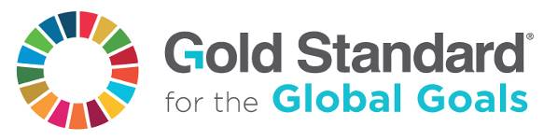

Version 1 – July 2017

SECTION A. PROJECT DESCRIPTION

A. 1. Title of the project
Title: Water for Climate Rwanda
Date: 16/11/2018
Version no.: 2.0

A. 2. Project description and current status

Water Access Rwanda (WAR) together with CO2logic and mkaarbon safari will implement a project to provide safe drinking water to communities in the districts of Rusizi, Ngoma, Rwamagana and Bugesera. The project consists of the repair of damaged and defunct boreholes. Boreholes may be dysfunctional e.g. due to a broken or removed pump or other broken parts like plunger, chain or rising main. The rehabilitation or new drilling of boreholes reduces the need for households to boil water as a means of purification or to consume unsafe water being the scenario prior to implementation of the project activity.
The project reserves as an option to drill new boreholes in case that this would reveal to be more favourable than rehabilitating the existing defunct boreholes.
Many existing boreholes in the districts of Rusizi, Ngoma, Rwamagana and Bugesera have fallen into disrepair because of lack of systematic maintenance programmes and due to insufficient financial means in the districts. CO2logic/mkaarbon safari will work with the local implementing partner Water Access Rwanda to repair and maintain around 50 boreholes across the 4 districts.
The concept of suppressed demand is applied in cases where unsafe water is used because adequate safe water is not available and where treatment is not practiced due to the prevalence of barriers like e.g. the lack of firewood or not enough money to buy firewood.
It is envisaged to start rehabilitation of boreholes in August 2018 and rehabilitate the water points within one to two years. A pre-feasibility assessment has been conducted in 2017 to identify boreholes being appropriate for rehabilitation. WASH Trainings and routine testing will be conducted throughout the project duration.
The project will last for at least 10 years (2 x 5 years renewable crediting period) with the option of another 5-year renewal.

SECTION B. DESIGN OF STAKEHOLDER CONSULTATION PROCESS

B. 1. Design of physical meeting(s)
A separate local stakeholder consultation has been organized in each of the districts included in the project boundary:
- Rwamagana: 12/06/2018
- Ngoma: 13/06/2018
- Bugesera: 14/06/2018
- Rusizi: 19/06/2018

Agenda
The following agenda was used for each of the 4 stakeholder consultation meetings:
- Arrival of Guest and Sign-in
- Official Opening and Introduction of Participants
- Project Presentation
- Question & Answer session
- Health Break
- Safeguarding principles / Sustainable Development Goals (SDG) exercise (including monitoring)
- Discussion on grievance mechanism
- Evaluation forms, follow-up and closure of meeting
- Lunch

- Key project information


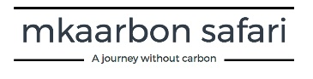
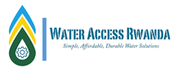

KEY PROJECT INFORMATION
Gold Standard Water for Climate Rwanda project

Project Details and Design
Water Access Rwanda (WAR) together with CO2logic and mkaarbon safari will implement a project to provide safe drinking water to communities in the districts of Rusizi, Ngoma, Rwamagana and Bugesera. The project consists of the repair of damaged and defunct boreholes. Boreholes may be dysfunctional e.g. due to a broken or removed pump or other broken parts like plunger, chain or rising main. The rehabilitation of those boreholes reduces the need for households to boil water as a means of purification.
The project reserves as an option to drill new boreholes in case that this would reveal to be more favourable than rehabilitating the existing defunct boreholes.
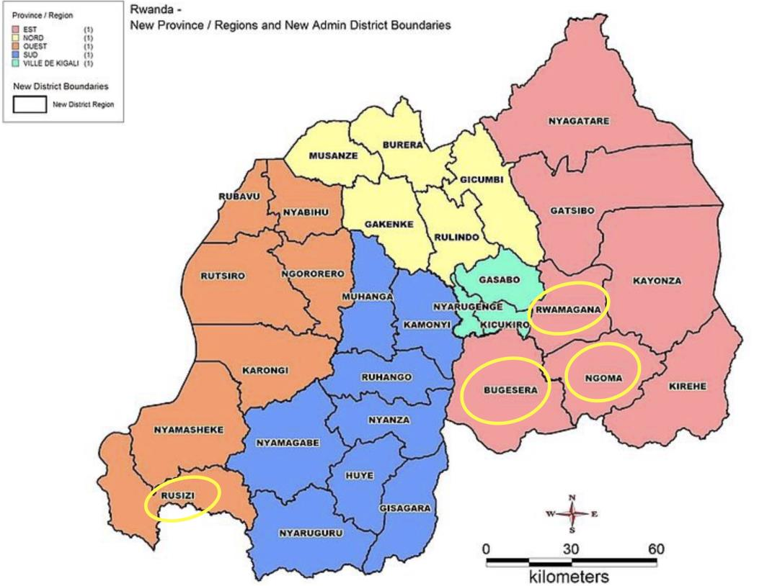

Figure above: District map with the intervention districts encircled
Many existing boreholes in the districts of Rusizi, Ngoma, Rwamagana and Bugesera have fallen into disrepair because of lack of systematic maintenance programmes and due to insufficient financial means in the districts. CO2logic/mkaarbon safari will work with the local implementing partner Water Access Rwanda to repair and maintain around 50 boreholes across the 4 districts.
Any borehole/pump technology can be involved in the project activity. However, it is foreseen that the most common technologies will be of Afridev or India Mark.
The rehabilitated boreholes will be properly maintained in form of both preventive and corrective maintenance and water coming from the water points will be periodically tested for E.coli bacteria in order to guarantee safe and clean water at all times.
It is planned to establish a WASH committee for each borehole. These committees amongst others help to ensure that surroundings of the boreholes are kept clean and protected against animals or vandalism and notify the hand-pump mechanic immediately in case any problem with the borehole occurs.
The project will be certified as Gold Standard carbon project and will generate carbon credits due to less fuelwood consumption needed for boiling water. Carbon credits will be used to pay amongst others for the rehabilitation, maintenance, monitoring of the boreholes and carbon certification costs as well as for awareness raising campaigns amongst the local population.
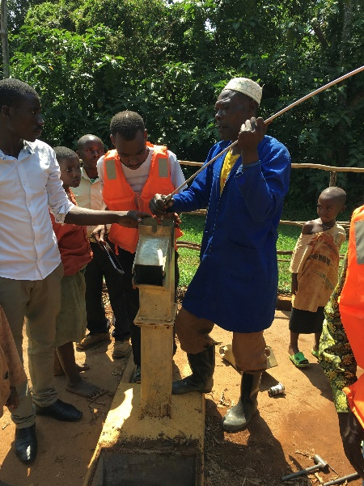
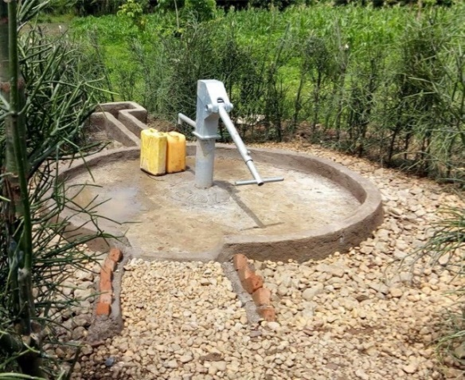

Photo left: Afridev borehole
Photo right: Hand-pump mechanic identifies the issue with a non-functional borehole in Rusizi district
Proposed timetable
It is envisaged to start rehabilitation of boreholes in July or August 2018 and rehabilitate the water points within one to two years. A pre-feasibility assessment has been conducted in 2017 to identify boreholes being appropriate for rehabilitation. WASH Trainings and routine testing will be conducted throughout the project duration of 10 years.
The project will last for at least 10 years with the option of a 5-year renewal.
Social, Economic And Environmental Benefits And Impacts
The project will contribute to social, economic and environmental benefits, the most important illustrated in the following table.

Environmental benefits
Reduces firewood/charcoal consumption for boiling water, hence will preserve forests and biodiversity, avoids soil erosion and water run-off
Reduces CO2 emissions over the project’s lifetime
Social benefits
Saves time for women and children since no fuelwood for water purification has to be collected and boiling of water is not needed anymore. This frees up time for e.g. income generating activities and education.
Reduces the incidence of water borne diseases like e.g. cholera, diarrhea, typhoid fewer or Hepatitis A/E.
Avoids indoor pollution coming from smoke and particulate matters when boiling water, hence benefiting mostly women being the ones in the kitchen
Economic benefits
Provides employment in the rehabilitation, maintenance and monitoring of the boreholes
Decrease in fuel costs allows households to spend more money on e.g. health care, nutrition, education

- Invitation tracking table

The invitation tracking lists for all the 4 local stakeholder consultations conducted in the different districts of the project boundary (i.e. Rwamagana - 12/06/2018, Ngoma - 13/06/2018, Bugesera - 14/06/2018 and Rusizi - 19/06/2018)) can be found in the file “LSC invitation Tracking Lists W4CRwanda_v1.0.xlsx”
Category code | Organization (if relevant) | Name of invitee | Way of invitation | Date of invitation | Confirmation received? Y/N

Care was taken to invite beneficiaries from the villages located near the boreholes identified for rehabilitation during a pre-feasibility assessment and local authorities from each of the districts within the project boundary.

- Text of individual invitations
District of Rwamagana:
Letter sent to District Office of Rwamagana requesting its participation and assistance in planning the local stakeholder consultation meeting, especially with inviting stakeholders from its district to participate:

Radjab Monyumuvunyi
Mayor of Rwamagana District
Western Province , Rwanda

Mr. Radjab Mbonyumuvunyi,

Subject: Borehole Rehabilitation Project Consultation Meeting

Reference is made to the MoU between Water Access Rwanda and your district concerning the rehabilitation and upkeep of non-functional boreholes in your district. The project will be certified as carbon project with the Gold Standard Foundation, and will generate carbon credits due to less fuelwood consumption needed for boiling water. In the context of this certification, a local stakeholder consultation (LSC) meeting in your district is scheduled.
We request your participation and assistance in planning this meeting, especially with inviting stakeholders form your district to participate. The following stakeholders are needed at the meeting for their ideas and inputs to have a successful project:
- Vice Mayor in Charge of Social Affairs
- Vice mayor in Charge of Finance and Economic Development
- President of the Joint Action Development Forum
- Secretary of the Joint Action Development Forum
- Representative of Military at the district
- Immigration at the district
- Representative of Police at the district
- PSF Leader in the district
- Other representatives of security forces at the district
- Members of Joint Action Development Forum active in the water and sanitation sector, the environmental protection sector as well as the health sector.
- Executive Secretary of the district
- Executive Secretary of the following sectors ( Muhazi, Nyakarariro, Gahengera, and Munyaga) in your district:
- Executive Secretary of the following cells ( Kabare, Byeza, Gishore, Rweru, Nkungu, and Ntebe ) in your district
- Village Heads of the following villages ( Urugwiro, Amagaju, Ubwiza, Kabeza, Rugende, Nyamugari, Nyagakombe, Rudashya) in your district:
- Leaders of women groups active in your district
- Leaders of Youth Groups active in your district
- Five residents (of whom three are women) representing the future users of these non-functional boreholes
- Active pump mechanics
- National and International NGOs working in relevant fields
- University leaders in the district
- Hospital leaders in the district
- Health Centre leaders in the district
- Any other important stakeholders we may have omitted.
As relevant stakeholders for this project in your district, we count on their participation to this meeting. Please do find attached the proposed agenda of the meeting
We would be grateful if you could confirm your participation by 11/06/2018 by Email to info@warwanda.com or call/text us on +250 783429172/+250 780303482.
Those who are unable to attend the consultation meeting can let us know their comments on the project and key project information attached with this invitation letter latest by 20/06/2018 to the abovementioned Email or phone number.

Cordially,

Christelle Kwizera
Managing Director
Water Access Rwanda

Some samples of invitations sent by the District Office of Rwamagana to stakeholders can be found in the file “Invitation Samples-Rwamagana” and “Invitation Samples-Rwamagana 2”.

District of Ngoma:
Letter sent to District Office of Ngoma requesting its participation and assistance in planning the local stakeholder consultation meeting, especially with inviting stakeholders from its district to participate:

Aphrodise Nambaje
Mayor of Ngoma District
Eastern Province, Rwanda

Mr. Aphrodise Nambaje,
Subject: Borehole Rehabilitation Project Consultation Meeting
Reference is made to the MoU between Water Access Rwanda and your district concerning the rehabilitation and upkeep of non-functional boreholes in your district. The project will be certified as carbon project with the Gold Standard Foundation, and will generate carbon credits due to less fuelwood consumption needed for boiling water. In the context of this certification, a local stakeholder consultation (LSC) meeting in your district is scheduled.
We request your participation and assistance in planning this meeting, especially with inviting stakeholders form your district to participate. The following stakeholders are needed at the meeting for their ideas and inputs to have a successful project:
- Vice Mayor in Charge of Social Affairs
- Vice mayor in Charge of Finance and Economic Development
- President of the Joint Action Development Forum
- Secretary of the Joint Action Development Forum
- Representative of Military at the district
- Immigration at the district
- Representative of Police at the district
- PSF Leader in the district
- Other representatives of security forces at the district
- Members of Joint Action Development Forum active in the water and sanitation sector, the environmental protection sector as well as the health sector.
- Executive Secretary of the district
- Executive Secretary of the following sectors ( Jarama, Kibungo, Murama, Remera, Rukumberi , Rurenge, Zaza, and Rwikubo) in your district:
- Executive Secretary of the following cells ( Ihanika, Rwikubo, Gahima, Cyasemakamba, Gatonde, Sakare, Ndekwe, Rwintashya, Rwikubo, Rugese, Nyagasozi, and Rubona) in your district
- Village Heads of the following villages ( Kivugiza, Gasoro, Nyamiburu, Rubimba, Rubona, Kavumu, Cyakabili, Maswa 2, Karokora, Rwimongo 1, Ruhuha, Rwakanuma, Akabeza, and Amashya in your district:
- Leaders of women groups active in your district
- Leaders of Youth Groups active in your district
- Five residents (of whom three are women) representing the future users of these non-functional boreholes
- Active pump mechanics
- National and International NGOs working in relevant fields
- University leaders in the district
- Hospital leaders in the district
- Health Centre leaders in the district
- Any other important stakeholders we may have omitted.
As relevant stakeholders for this project in your district, we count on their participation to this meeting. Please do find attached the proposed agenda of the meeting.
We would be grateful if you could confirm your participation by 11/06/2018 by Email to info@warwanda.com or call/text us on +250 783429172/+250 780303482.
Those who are unable to attend the consultation meeting can let us know their comments on the project and key project information attached with this invitation letter latest by 20/06/2018 to the abovementioned Email or phone number.

Cordially,

Christelle Kwizera
Managing Director
Water Access Rwanda

Some samples of invitations sent by the District Office of Ngoma to stakeholders can be found in the file “Invitation Samples-Ngoma”.

District of Bugesera:
Letter sent to District Office of Bugesera requesting its participation and assistance in planning the local stakeholder consultation meeting, especially with inviting stakeholders from its district to participate:

Richard Mutabazi
Mayor of Bugesera District
Eastern Province, Rwanda

Mr, Richard Mutabazi

Subject: Borehole Rehabilitation Project Consultation Meeting
Reference is made to the MoU between Water Access Rwanda and your district concerning the rehabilitation and upkeep of non-functional boreholes in your district. The project will be certified as carbon project with the Gold Standard Foundation, and will generate carbon credits due to less fuelwood consumption needed for boiling water. In the context of this certification, a local stakeholder consultation (LSC) meeting in your district is scheduled.
We request your participation and assistance in planning this meeting.
The following stakeholders are needed at the meeting for their ideas and inputs to have a successful project:
- Vice Mayor in Charge of Social Affairs
- Vice mayor in Charge of Finance and Economic Development
- President of the Joint Action Development Forum
- Secretary of the Joint Action Development Forum
- Members of Joint Action Development Forum active in the water and sanitation sector as well as the environmental protection sector.
- Executive Secretary of the district
- Executive Secretary of the following sectors( Juru, Mwogo, Musenyi, Rweru) in your district:
- Executive Secretary of the following cells( Kabukuba, Juru, Musovu, Bitaba, Rurenge , Gicaca, Nemba) in your district
- Village Heads of the following villages( Majanja, Nyamigende, Cyingaju, Gatwe, Rukoronko, Gitaraga, Migina, Kigina) in your district:
- Leaders of women groups active in your district
- Leaders of Youth Groups active in your district
- Head of WASAC in the district
- Five residents (of whom three are women) representing the future users of these non-functional boreholes
As relevant stakeholders for this project in your district, we count on their participation to this meeting. Please do find attached the proposed agenda of the meeting
We would be grateful if you could confirm your participation by 11/06/2018 by Email to info@warwanda.com or call/text us on +250 783429172/+250 780303482.
Those who are unable to attend the consultation meeting can let us know their comments on the project and key project information attached with this invitation letter latest by 20/06/2018 to the abovementioned Email or phone number.
Cordially,
Christelle Kwizera
Managing Director
Water Access Rwanda

Some samples of invitations sent by the District Office of Bugesera to stakeholders can be found in the file “Invitation Samples-Bugesera”.

District of Rusizi:
Letter sent to District Office of Rusizi requesting its participation and assistance in planning the local stakeholder consultation meeting, especially with inviting stakeholders from its district to participate:

Leoncie Kankindi
Mayor of Rusizi District
Western Province, Rwanda

Mrs Leoncie Kankindi,

Subject: Borehole Rehabilitation Project Consultation Meeting
Reference is made to the MoU between Water Access Rwanda and your district concerning the rehabilitation and upkeep of non-functional boreholes in your district. The project will be certified as carbon project with the Gold Standard Foundation, and will generate carbon credits due to less fuelwood consumption needed for boiling water. In the context of this certification, a local stakeholder consultation (LSC) meeting in your district is scheduled.
We request your participation and assistance in planning this meeting, especially with inviting stakeholders form your district to participate. The following stakeholders are needed at the meeting for their ideas and inputs to have a successful project:
- Vice Mayor in Charge of Social Affairs
- Vice mayor in Charge of Finance and Economic Development
- President of the Joint Action Development Forum
- Secretary of the Joint Action Development Forum
- Representative of Military at the district
- Immigration at the district
- Representative of Police at the district
- PSF Leader in the district
- Other representatives of security forces at the district
- Members of Joint Action Development Forum active in the water and sanitation sector, the environmental protection sector as well as the health sector.
- Executive Secretary of the district
- Executive Secretary of the following sectors( Nkanka and Nkombo) in your district:
- Executive Secretary of the following cells( Kinyaga, Kangazi, Kamanyenga, Bugarura, Bigoga, and Kamagimba) in your district
- Village Heads of the following villages( Rugaragara, Busekanka, Hepfu, Nyakabanda, Gisunyu, Rebero, and Muhora) in your district:
- Leaders of women groups active in your district
- Leaders of Youth Groups active in your district
- Five residents (of whom three are women) representing the future users of these non-functional boreholes
- Active pump mechanics
- National and International NGOs working in relevant fields
- University leaders in the district
- Hospital leaders in the district
- Health Centre leaders in the district
- Any other important stakeholders we may have omitted.

As relevant stakeholders for this project in your district, we count on their participation to this meeting. Please do find attached the proposed agenda of the meeting
We would be grateful if you could confirm your participation by 11/06/2018 by Email to info@warwanda.com or call/text us on +250 783429172/+250 780303482.
Those who are unable to attend the consultation meeting can let us know their comments on the project and key project information attached with this invitation letter latest by 20/06/2018 to the abovementioned Email or phone number.
Cordially,
Christelle Kwizera
Managing Director
Water Access Rwanda

Some samples of invitations sent by the District Office of Rusizi to stakeholders can be found in the file “Invitation Samples-Rusizi”.
The following concept note was sent along with the abovementioned letters to the district offices:
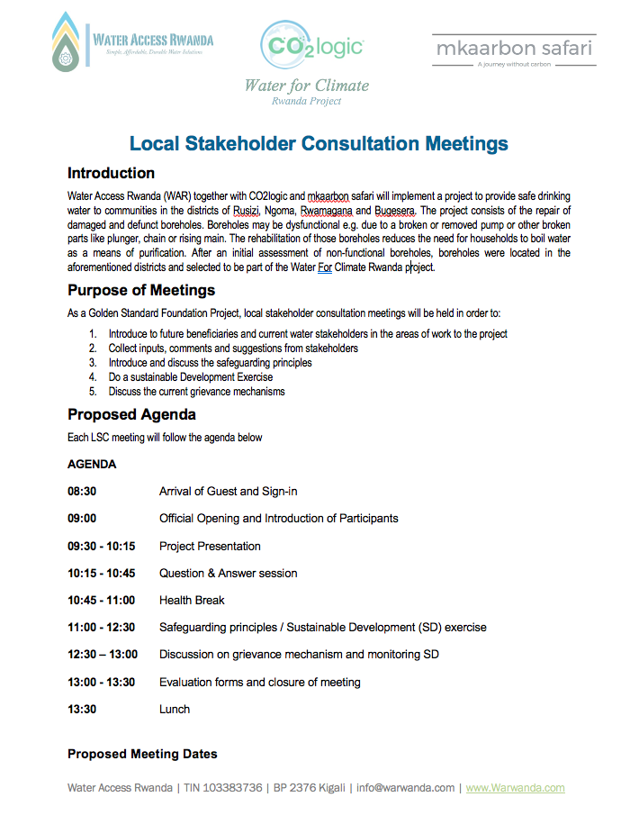
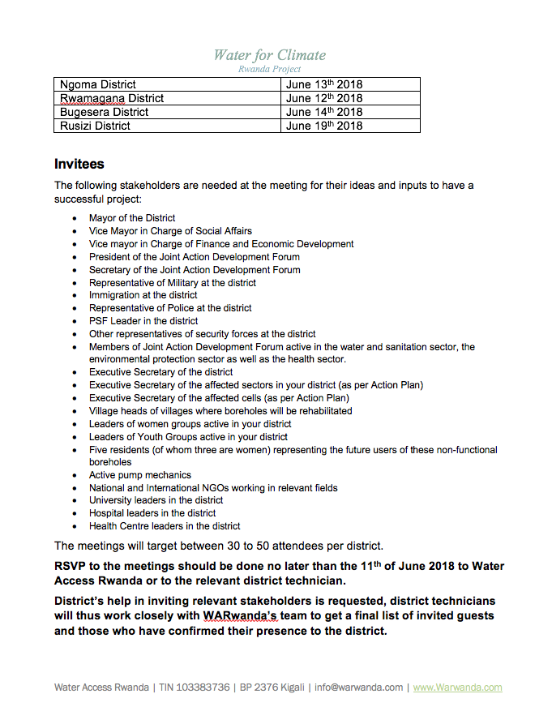

Other invitations:
Invitation sent by email to DNA of Rwanda:
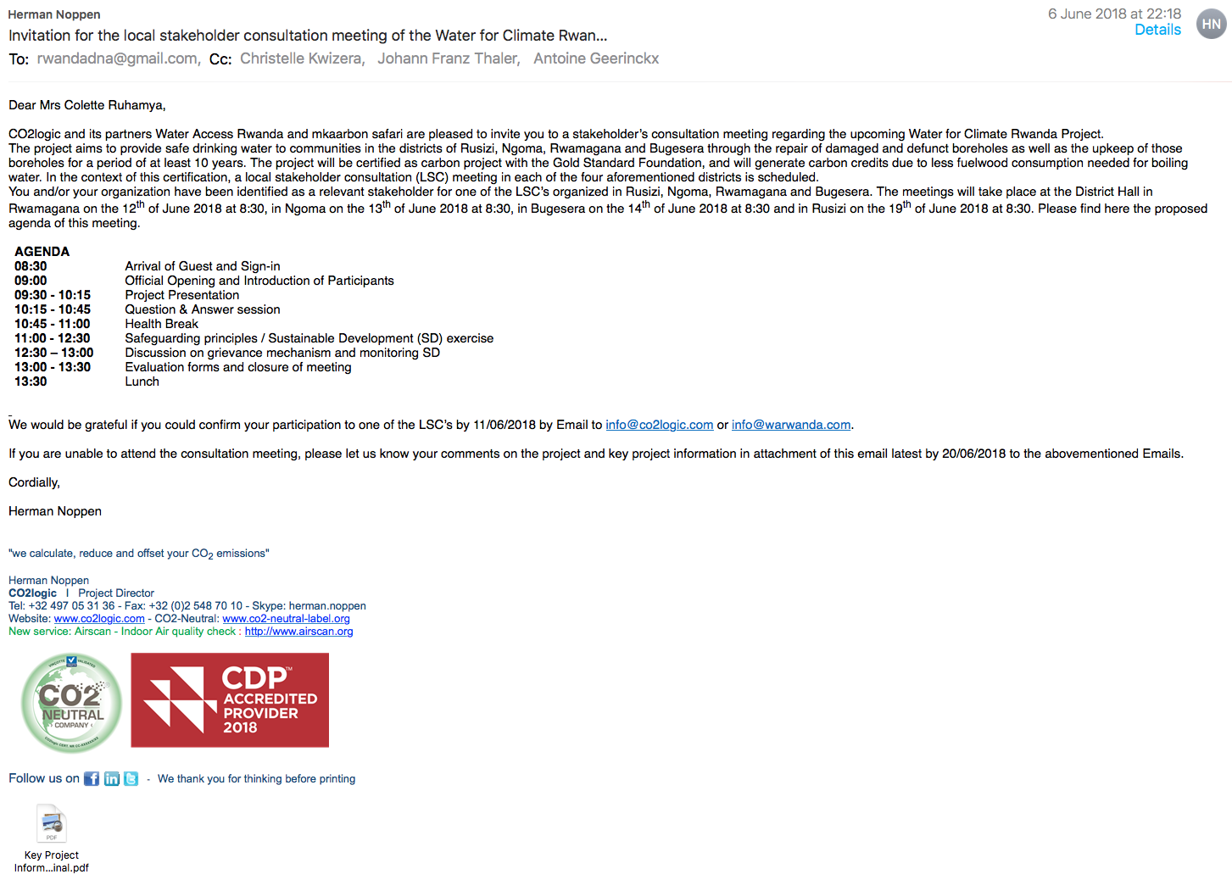
Invitation sent by email to Gold Standard:
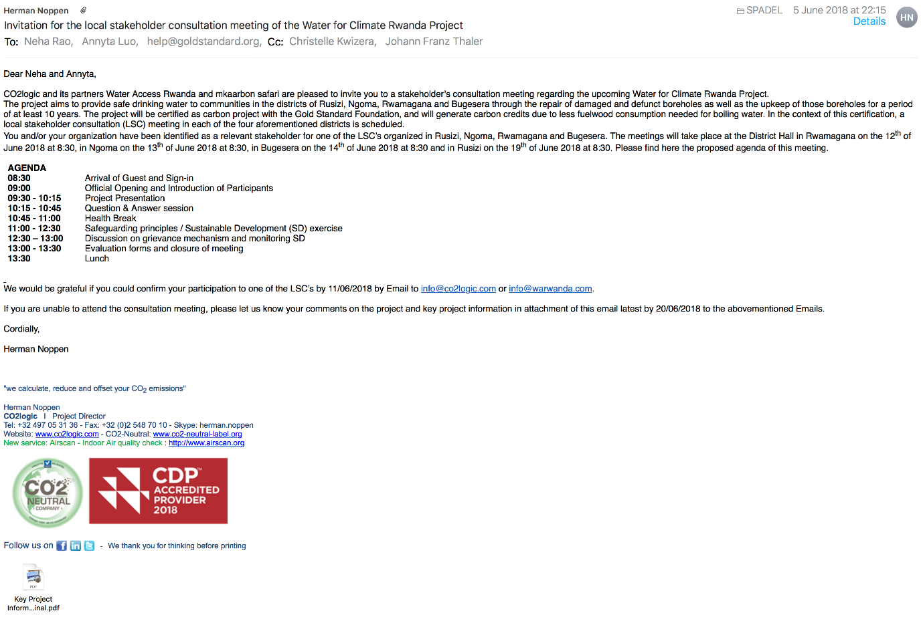

Example of invitation sent to International NGO GS supporter (e.g. of World Vision)
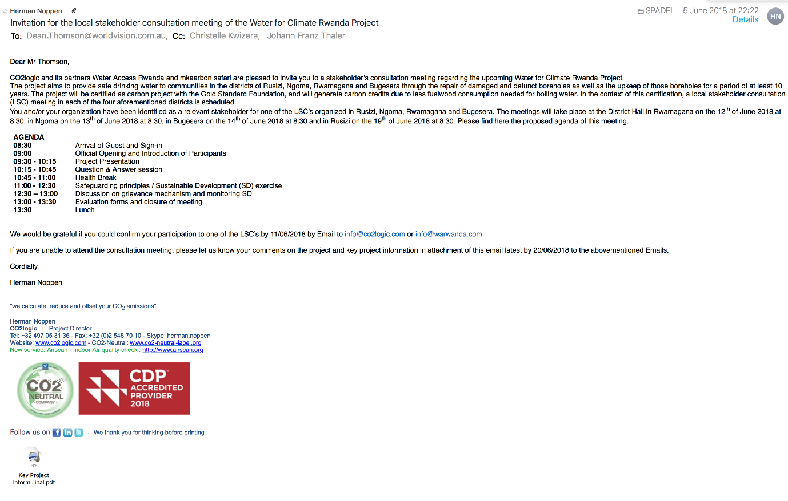
Sample letter issued by district office Ngoma listing the stakeholders invited for the LSC meeting:
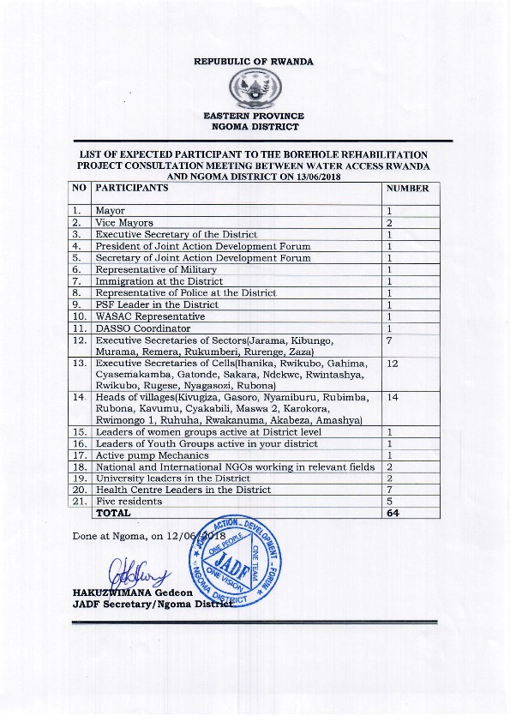

- Text of public invitations

Public announcement in Rwamagana
This public announcement was placed on the announcement board of the District Office of Rwamagana on 11th , June, 2018:

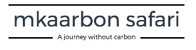
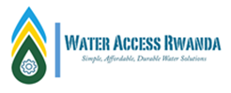

Water Access Rwanda in partnership with CO2Logic will be conducting a Local stakeholders collaboration meeting to present their project to the public and receive their feedback and comments. The project intends to provide services and advice for the rehabilitation, maintenance and upkeep as well as related services for the selected 50 boreholes in Bugesera, Rwamagana, Ngoma and Rusizi Districts.
The meeting in Rwamagana will take place this Tuesday on 12th June, 2018 at the district.
Please feel free to join us by reserving your spot by email to info@warwanda.com or by text message to 0780303482 no later than June 11th 2018.
Thank you,
Christelle Kwizera
Managing Director - Water Access Rwanda

This public announcement was placed on the announcement board of the District Office of Ngoma on 11th , June, 2018:
Water Access Rwanda in partnership with CO2Logic will be conducting a Local stakeholders collaboration meeting to present their project to the public and receive their feedback and comments. The project intends to provide services and advice for the rehabilitation, maintenance and upkeep as well as related services for the selected 50 boreholes in Bugesera, Rwamagana, Ngoma and Rusizi Districts.
The meeting in Ngoma will take place this Wednesday on 13th June, 2018 at the district.
Please feel free to join us by reserving your spot by email to info@warwanda.com or by text message to 0780303482 no later than June 11th 2018.
Thank you,
Christelle Kwizera
Managing Director - Water Access Rwanda

This public announcement was placed on the announcement board of the District Office of Bugesera on 11th , June, 2018:
Water Access Rwanda in partnership with CO2Logic will be conducting a Local stakeholders collaboration meeting to present their project to the public and receive their feedback and comments. The project intends to provide services and advice for the rehabilitation, maintenance and upkeep as well as related services for the selected 50 boreholes in Bugesera, Rwamagana, Ngoma and Rusizi Districts.
The meeting in Bugesera will take place this Thursday on 14th June, 2018 at the district.
Please feel free to join us by reserving your spot by email to info@warwanda.com or by text message to 0780303482 no later than June 11th 2018.
Thank you,
Christelle Kwizera
Managing Director - Water Access Rwanda

This public announcement was placed on the announcement board of the District Office of Rusizi on 11th , June, 2018:
Water Access Rwanda in partnership with CO2Logic will be conducting a Local stakeholders collaboration meeting to present their project to the public and receive their feedback and comments. The project intends to provide services and advice for the rehabilitation, maintenance and upkeep as well as related services for the selected 50 boreholes in Bugesera, Rwamagana, Ngoma and Rusizi Districts.
The meeting in Rusizi will take place this Tuesday on 19th June, 2018 at the district.
Please feel free to join us by reserving your spot by email to info@warwanda.com or by text message to 0780303482 no later than June 11th 2018.
Thank you,
Christelle Kwizera
Managing Director - Water Access Rwanda

Some pictures of the public announcements:
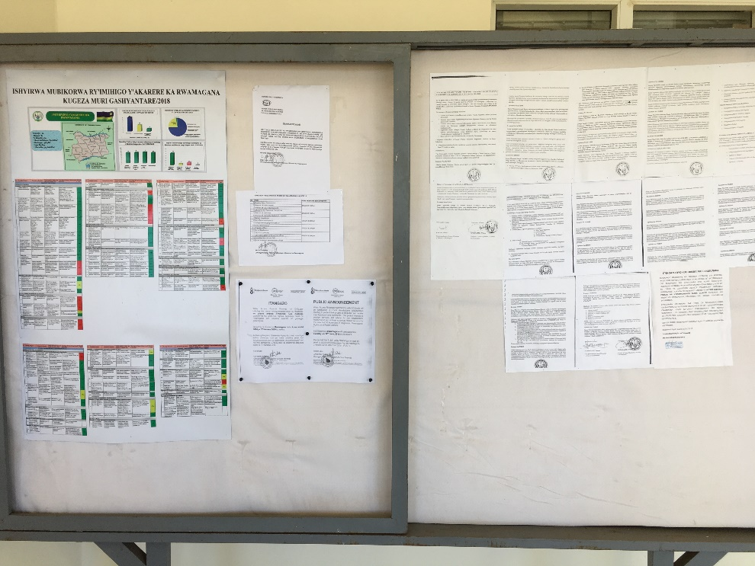

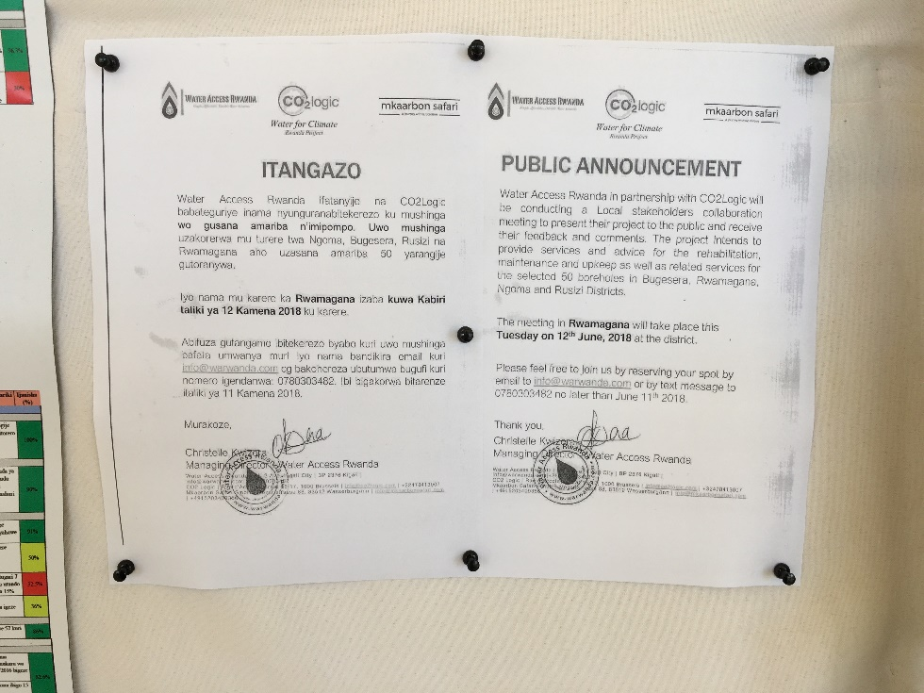
Public announcement of the LSC at the District Office of Rwamagana

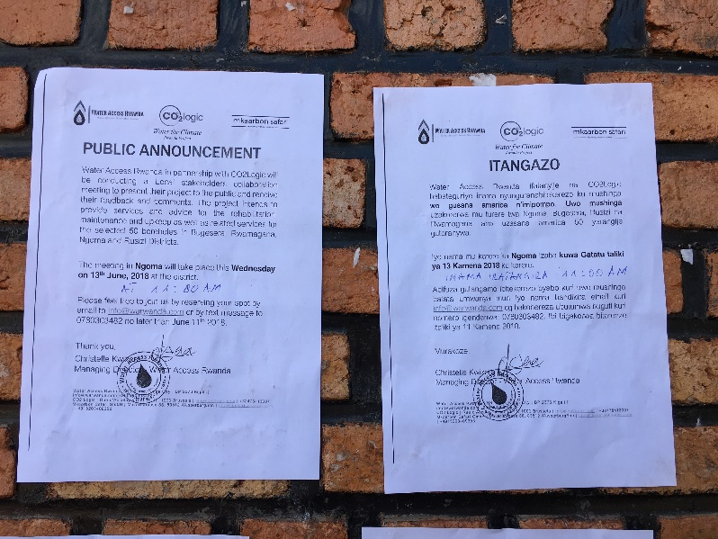
Public announcement of the LSC at the District Office of Ngoma

B. 2. Description of other consultation methods used

>> If individuals and/ or entities (e.g. NGOs) are unable to attend the physical meeting, please discuss other methods that were used to solicit their feedback/ comments (e.g. questionnaires, phone calls, interviews).
Individuals, who couldn’t attend the local stakeholder consultation meeting, were able to comment the key project information note via mail, email or telephone. The stakeholders who didn’t reply to the invitation were reminded on the meeting via telephone.

SECTION C. CONSULTATION PROCESS
C. 1. Participants’ in physical meeting(s)
- List of participants

The participation lists including information of participants and number of participants for all the 4 local stakeholder consultations conducted in the different districts of the project boundary (i.e. Rwamagana - 12/06/2018, Ngoma - 13/06/2018, Bugesera - 14/06/2018 and Rusizi - 19/06/2018)) can be found in the file “LSC Meetings participants Lists W4CRwanda_v1.0” uploaded to the GS registry.
Participants list
Date and time:
Location:
Category Code | Name of participant, job/ position in the community | Male/ Female | Signature | Organisation (if relevant) | Contact details

The original participant lists can be found in Annex 1.

- Evaluation form

District of Rwamagana
The majority of the attendees found the meeting very helpful. They appreciated the fact that the project is not only focused on just rehabilitating boreholes but also train people about proper usage of clean water through WASH trainings. The attendees loved the idea of involving local people in the implementation of the project. However, the attendees pointed out that the concept of carbon credits is very hard for villagers to understand. The people would also like more boreholes than what is planned to be rehabilitated as well so as to serve a great number of households. Evaluation forms from 44 stakeholders have been received.
Examples of evaluation forms (in English):
Name | Hanyurwimfura Egide
What is your impression of the meeting? | The meeting’s atmosphere was good. I appreciated everyone’s participation.
What do you like about the project? | The project is important to the citizens especially in in terms of sanitation and provision of clean water
What do you not like about the project? | Nothing
Signature

Name | Misaki OHASHI
What is your impression of the meeting? | It was good that it touched the SDGs. However I felt the questions had to be specified regarding geographical, historical, political, cultural situations of the districts, villages, sectors.
What do you like about the project? | I like how beneficial this project would be to larger populations. This project not only focuses on water but also sanitation and hygiene, working with WASH committee.
What do you not like about the project? | The concept of carbon credits is very hard to understand for villagers.
Signature

Name | Emmanuel RWAKAYIGAMBA
What is your impression of the meeting? | The meeting was great, well prepared, and it elaborated every detail involved in the project.
What do you like about the project? | Boreholes maintenance for the coming 10 years.
What do you not like about the project? | The fact that no new borehole will be drilled.
Signature

Name | MUKANDAYISHIMIYE Olive
What is your impression of the meeting? | It was a participatory meeting and productive
What do you like about the project? | It will contribute to the District Development and It is in the mandate of the Government
What do you not like about the project? | Nothing
Signature
The original evaluation forms can be found in Annex 2.

District of Ngoma
The majority of the participants pointed out how important and helpful the meeting was. In most of the sectors of Ngoma district, there was no access to safe drinking water. Therefore, implementing the project in this district will be a solution to numerous health issues caused by safe drinking water scarcity. The stakeholders also appreciated the fact that the project will last for at least ten years which guarantees its sustainability. Furthermore, a couple of stakeholders pointed out that the project will lower the number of school dropouts since it will reduce the long distances that children used to walk to get water which was most of the time not safe to drink. Regarding what people did not like about the project and the meeting is that some of discussed concepts such carbon finance will not be understood by local beneficiaries. Evaluation forms from 43 stakeholders have been received.
Name | Ndizera Patrick
What is your impression of the meeting? | The meeting was good because we learned a lot about the project and how beneficial it is to the locals.
What do you like about the project? | The project is going to assist the locals to get clean and enough water.
What do you not like about the project? | Nothing
Signature

Name | Uwamariya Clementine
What is your impression of the meeting? | The meeting was conducted well because we were informed about the project, how important it is to the beneficiaries.
What do you like about the project? | I appreciated the fact people in two of the six villages of my sector are going to get access to safe drinking water.
What do you not like about the project? | Nothing
Signature

Name | Noda Eri
What is your impression of the meeting? | The concept of Carbon Finance is difficult for local people to understand
What do you like about the project? | The project will continue at least for 10 years ( sustainability)  The project will also tackle hygiene issues.
What do you not like about the project? | I did not understand why water from boreholes will not be boiled.
Signature

Name | Iribagiza Chantal
What is your impression of the meeting? | The meeting gave me hope for sustainable future life.
What do you like about the project? | I am going home with a crucial story that I am going to apprise to the rest of village members.
What do you not like about the project? | Nothing
Signature
The original evaluation forms can be found in Annex 2.

District of Bugesera
The Bugesera meeting took place on the 14th June. As it is seen in the attendees comments, the meeting was really helpful as it addressed the issues to be encountered during the implementation and also allowed everybody to share their thoughts and opinions about the project. However, the attendees requested that more boreholes than planned should be rehabilitated as well, and they were also concerned about water produced that may contain salt (in some parts) and no means to remove that salt. Evaluation forms from 35 stakeholders have been received.

Name | Sylvie
What is your impression of the meeting? | The meeting was very helpful as it addresses issues to be conscious about before they actually happen, this facilitates proper planning.
What do you like about the project? | It provides clean water to villagers in an affordable way.
What do you not like about the project? | The project is too small.
Signature

Name | Donath KWITONDA
What is your impression of the meeting? | The meeting was good , everybody had the time to share his/her point of view about the project and this makes people feel like they’re part of the project.
What do you like about the project? | The project will help people get access to clean water in safe way and affordable way.
What do you not like about the project? | We would like the project to rehabilitate as much boreholes as they can.
Signature

Name | William RUKUNDO HAKIZIMANA
What is your impression of the meeting? | The meeting was well prepared.
What do you like about the project? | The project will bring access to clean water at the same time creating job opportunities to local villagers .
What do you not like about the project? | The time was not respected.
Signature

Name | Solange UMUTONI
What is your impression of the meeting? | The meeting was well prepared and the project is really clear.
What do you like about the project? | The fact that water will immediately be used without boiling it first.
What do you not like about the project? | Only a small number of boreholes will be rehabilitated.
Signature

Name | Elie HABIMANA
What is your impression of the meeting? | The meeting was helpful because it created awareness about the project and its contribution to the development.
What do you like about the project? | The project will play a big part in Bugesera’s development and improve good health of the local villages.
What do you not like about the project? | No means were established to handle the problem of salts that may be found in water of some boreholes.
Signature
The original evaluation forms can be found in Annex 2.

District of Rusizi
Fundamentally, the participants appreciated the meeting and the project. For instance, most of the participants said that the project will attenuate waterborne diseases that many beneficiaries used to face. In many of the selected districts, there is no access to safe drinking water, therefore, the project will both increase safe drinking water accessibility and healthy and sustainable life. What a couple of stakeholders did not like about the project is the fact it is only rehabilitating boreholes which are less defunct ( cost less to rehabilitate ) instead of rehabilitating boreholes that will serve a lot of people regardless of how much it costs to rehabilitate them. All in all the stakeholders appreciated the project and promised a good partnership with the project implementer. Evaluation forms from 22 stakeholders have been received.
Name | Uwimana Josephine
What is your impression of the meeting? | I greatly appreciated the meeting because it provided us, stakeholders, a clear and concrete description of Water for Climate project. Moreover, I appreciated how the proponent of the project explained well the pct to us. There also suggestions which were given in the meeting which will facilitate our development and sustainability as a district.
What do you like about the project? | I loved the fact the project is going to provide safe drinking water to people who did not have any source of clean water. It will also increase the accessibility and amount of water to people who did not have enough water.
What do you not like about the project? | I do not have something specific that I did not like about the project. Instead, I am kindly requesting that the project can expand its activities to other places in which the project did not selected boreholes from.
Signature

Name | Sebuntu Justin
What is your impression of the meeting? | The meeting was good.
What do you like about the project? | The project will assist the district to accomplish the SDGs.
What do you not like about the project? | I did not like the fact that the project does not want to spend money on rehabilitating boreholes which are completely defunct instead the project selects boreholes which are cheap to rehabilitate.
Signature

Name | Uwamariya Leatitia
What is your impression of the meeting? | Thank you for having us in your mind, we will not face any more waterborne diseases. We appreciated your description of the project.
What do you like about the project? | The project will attenuate the waterborne diseases that people use to face.
What do you not like about the project? | The partcipants were not given handbooks which they can would have used to take crucial points which were made during the meeting.
Signature

The original evaluation forms can be found in Annex 2.

C. 2. Pictures from physical meeting

District of Rwamagana:
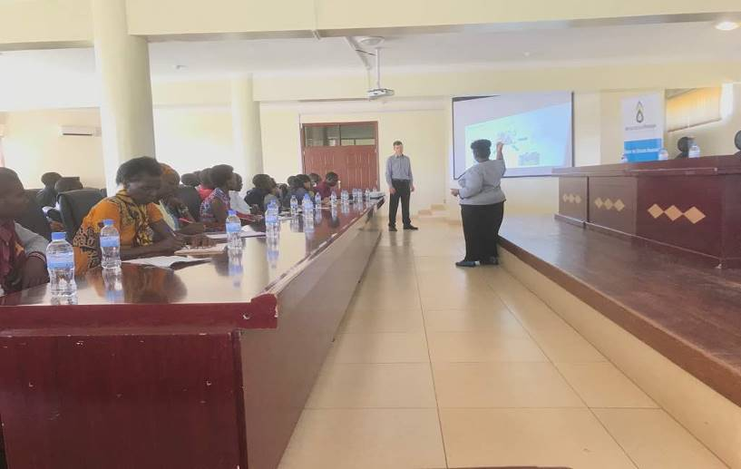
Picture: Christelle Kwizera from WARwanda and Johann Thaler from mkaarbon safari describing Water For Climate Rwanda project to the local stakeholders.

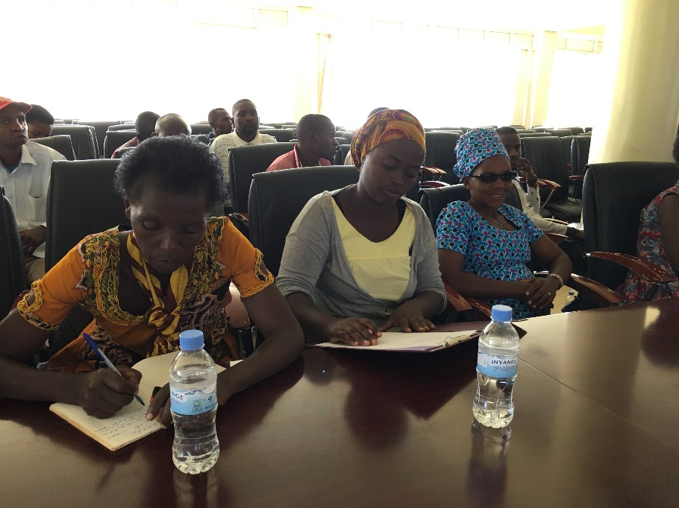

Picture: local stakeholders taking notes during LCS meeting

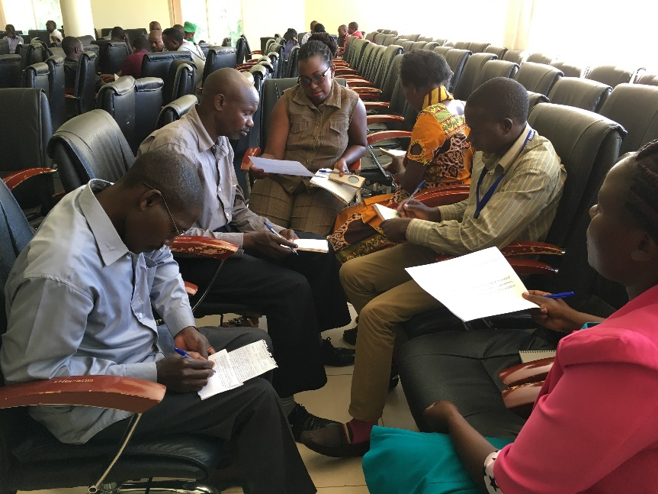
Picture: Stakeholders during the SDG/safeguarding principles blind exercise group discussion

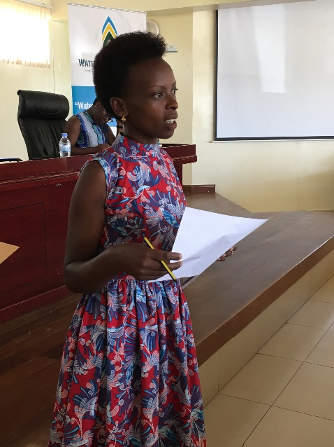
Picture: one of the local stakeholders presenting the results of the SDG/safeguarding principles blind exercise group discussion

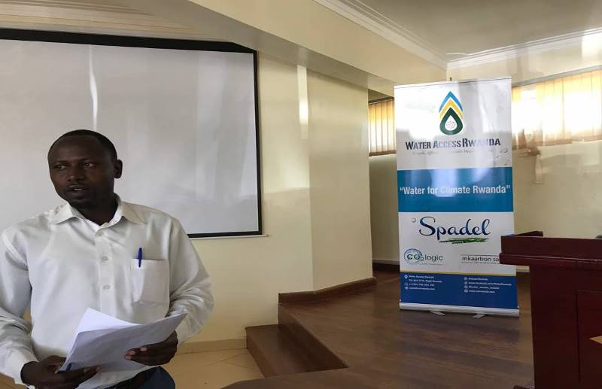
Picture: another local stakeholder presenting the results of the SDG/safeguarding principles blind exercise group discussion
District of Ngoma:
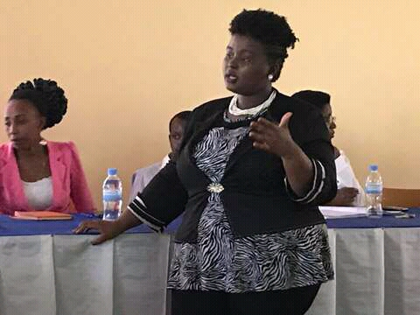
Picture: Christelle Kwizera from WARwanda describing the project activity

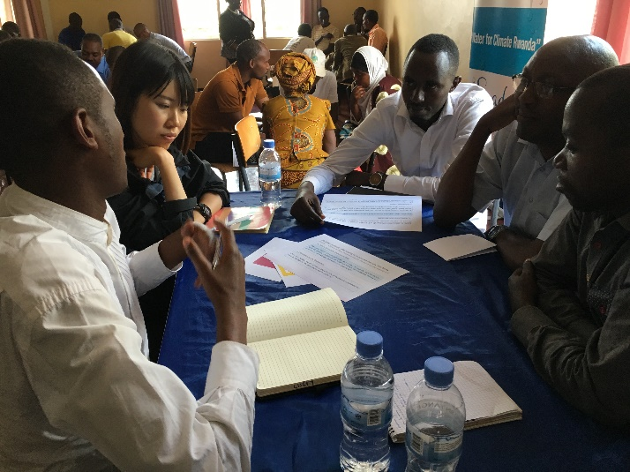
Picture: Stakeholders during the SDG/safeguarding principles blind exercise group discussion

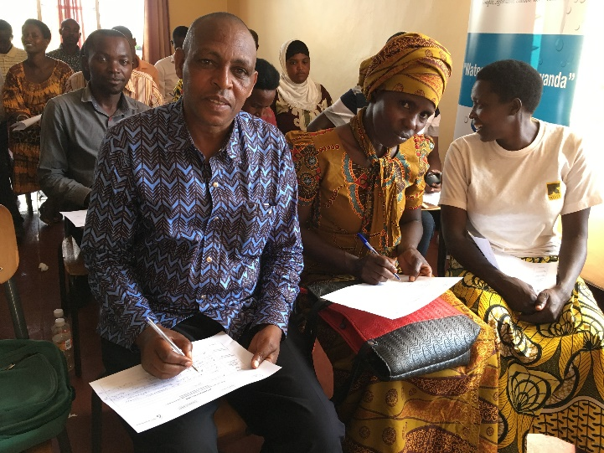
Picture: local stakeholders filling out the evaluation forms

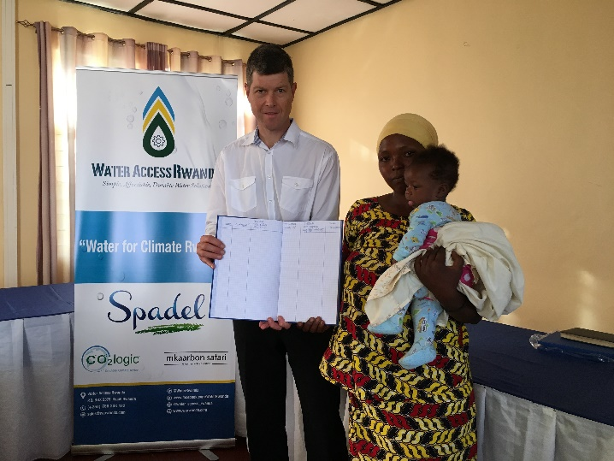
Picture: Johann Thaler (mkaarbon safari) presents the grievance book to local stakeholders

District of Bugesera:
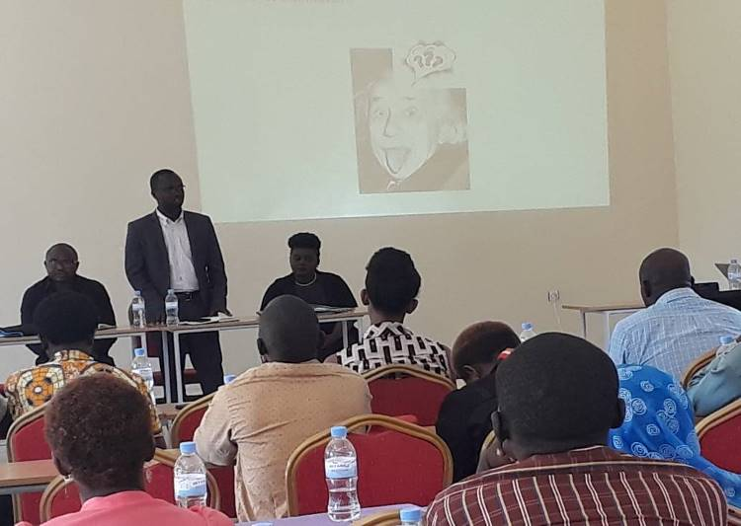
Picture: Bugesera District Secretary giving an opening remark of the LSC meeting
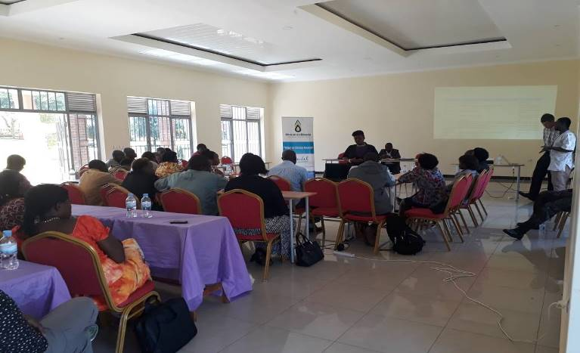
Picture: local staleholders following the presentation of Water for Climate project in Bugesera district.

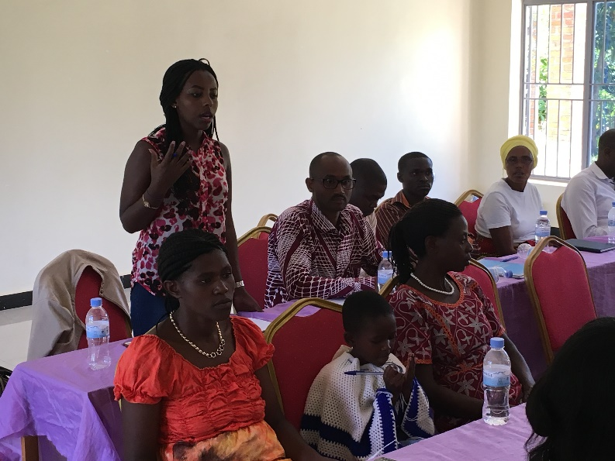
Picture: one of the local stakeholders presenting the results of the SDG/safeguarding principles blind exercise group discussion

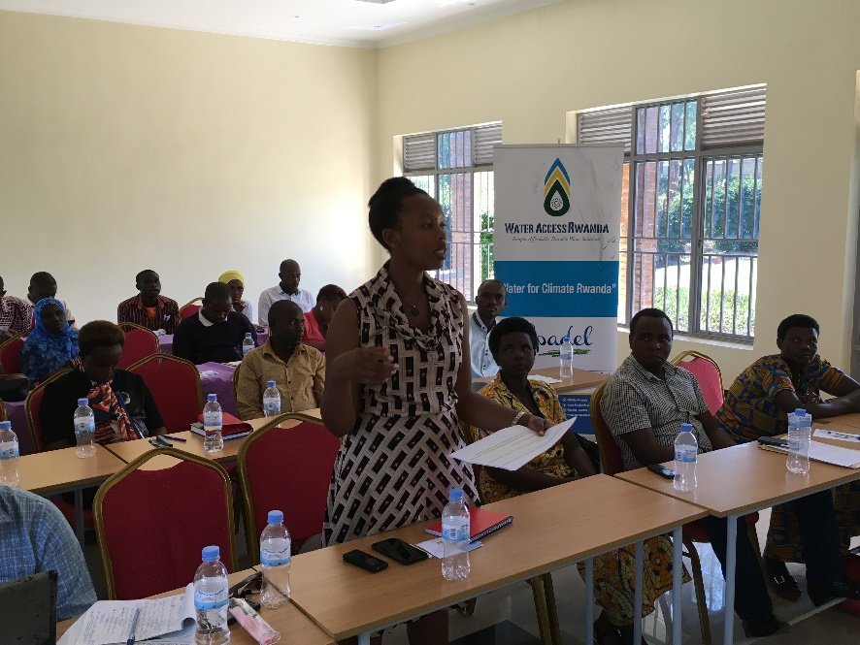
Picture: another local stakeholder presenting the results of the SDG/safeguarding principles blind exercise group discussion

District of Rusizi:
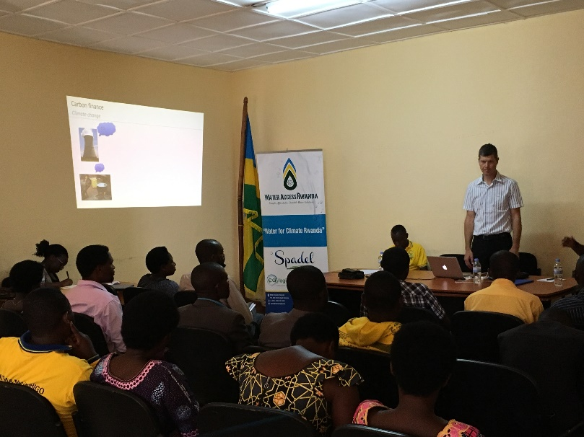

Picture: Johann Thaler (mkaarbon safari) describing to the local stakeholders the concept of carbon finance including transfer of carbon credit ownership

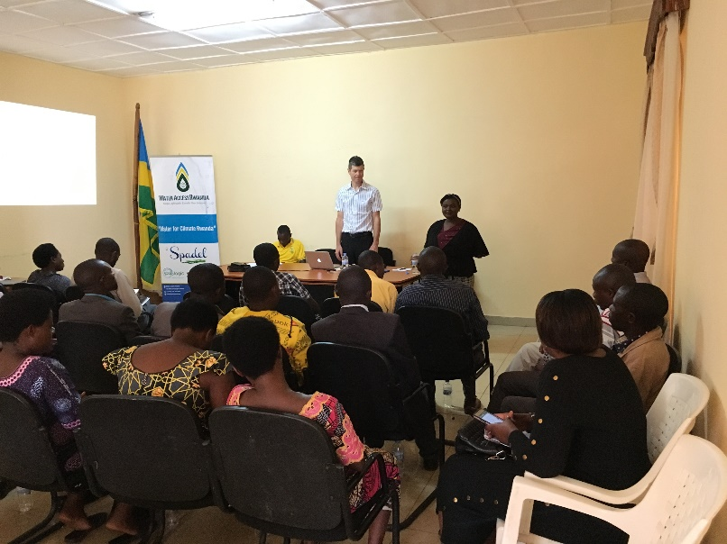
Picture: Christelle Kwizera and Johann Thaler responding questions from local stakeholders

C. 3. Outcome of consultation process

- Minutes of physical meeting(s)

LSC meeting minute in Rwamagana on 12/06/2018:
The physical local stakeholders’ consultation meeting took place on the 12 of June, 2018 in the Conference hall of Rwamagana district. A power point presentation was given during the meeting. The powerpoint slides being in English were presented and the meeting discussions were held in the local language Kinyarwanda, so that it was ensured that local stakeholders could fully follow the explanations and discussions. The meeting started with a quick introduction, appreciations and a welcoming note by the vice mayor of the district after which he requested the WASH technician at the district level to introduce all the invitees. Afterwards, the team from Water Access Rwanda and Johann Thaler from mkaarbon safari introduced themselves which formally marked the starting of the presentation of the project.
After the introduction session, the proponent briefed the participants about the mission and the goals of Water Access Rwanda. Christelle Kwizera, WAR’s managing director, emphasized on the role that Inuma Kiosks are playing in increasing the accessibility of safe drinking water in the districts that Water Access Rwanda is currently working with. She pointed out that the role that boreholes rehabilitation project will also significantly play in providing safe drinking water in Rwamagana. Moreover, one of the goals of Water Access is to integrate youth in the working environment. Therefore, the borehole rehabilitation project will open employment opportunities to youth in the districts.
The introduction of Water Access Rwanda was followed by an introduction of the other implementing partners CO2logic and mkaarbon safari and their activities. Spadel was shortly introduced as the company being the investor into the project.
After the description of each of the project partners, Christelle Kwizera from WAR provided a short description of the project in the four districts of Rwanda. Mainly, the project will rehabilitate around 50 damaged and dysfunctional boreholes in 4 districts which are Rusizi, Bugesera, Rwamagana, and Ngoma. The project will last for at least 10 years, and monthly follow up will be planned to assure a good state of the selected boreholes. Moreover, to maintain the proper functionality of the boreholes, there will be a WASH committee trained and assigned in each district to do conduct frequent boreholes checkup and visits. The proponent emphasized that in addition to the fact that the project will be providing clean water, there will be no need of boiling that water which will in return reduce the CO2 emitted. In case the boreholes cannot be repaired, the proponent said that new boreholes could be constructed. The proponent went on to brief the participants how by boiling water, the CO2 emitted can pollute the climate which can in effect lead to climate change. Therefore, if the people are provided with safe drinking water with no E.coli, there will be no need of boiling water before drinking.
Johann Thaler from mkaarbon safari went on to explain to the participants about climate change, the concept of carbon finance and carbon credits and how a zero emission technology like rehabilitated boreholes can positively contribute to mitigate GHG emissions. The transfer of carbon credit ownership was explained as well as how end-users benefit from the carbon finance. Johann further mentioned that the project will be certified as Gold Standard project, making it necessary to monitor, report and verify besides the emission reductions as well the contribution to sustainable development goals. After the description of the project, the proponent opened the floor for questions, clarifications, and suggestions. Johann and Christelle provided answers to the questions and comments raised by the stakeholders.
Afterwards, the participants were divided into nine groups to discuss in a ‘blind exercise’ about different Safeguarding assessment questions, the SDGs (a short description to each SDG was provided to stakeholders) and their monitoring. Each group presented their responses to the safeguarding principles assessment questions and their opinion on how the project contributes to the SDGs, whether there are any risks involved and how positive impacts can be monitored or possible risks mitigated at the end of the group discussion.
After group discussions and presentations, Johann from mkaarbon safari explained about the grievance mechanism which entails how the stakeholders can reach out to the project implementing companies during the project’s crediting period in case of any questions, comments or suggestions. Johann further presented the outline for the stakeholder feedback round, which will follow the local stakeholder consultation meeting.
The meeting was concluded by the vice mayor of the districts who promised a good and long-lasting partnership that the district will have in the project implementation.
After the meeting, stakeholders were requested to fill out the evaluation forms. Afterwards, lunch was served to the participating stakeholders.

LSC meeting minutes in Ngoma on 13th, June,2018:
The LSC meeting took place on 13th, June, 2018 in the conference hall of Ngoma District. A power presentation in English was used during the meeting and the meeting discussions were held in the local language Kinyarwanda, which ensured that participants could fully follow the explanations and discussions. The meeting started by a welcoming note from Christelle Kwizera, WARwanda’s managing director, and she requested all the invited stakeholders and participants from the project implementing companies to introduce themselves. Afterward, a Water Sanitation and Hygiene (WASH) technician from the district gave a short introduction of the meeting and the project and encouraged all the present stakeholders to facilitate the project implementation and maintain the boreholes that will be rehabilitated.
After the introduction of all participants in the meeting, Christelle Kwizera explained to the participants the mission, goals, and services of the company. She focused on the fact that WARwanda is striving to provide safe drinking water to population while integrating youth in the work environment through employment of a high number of youth. In addition she explained to the stakeholders some of the products of WARwanda such as INUMA water and water filters and both national and international awards that the company has won.
Johann Thaler from mkaarbon safari went on to giving an overview of the other partners involved in the Water for Climate Rwanda project:
-CO2logic: provides climate & energy advisory services to corporates and organizations in order to reduce its climate impact ad develops with local partners climate projects
-mkaarbon safari: consultancy company which provides technical assistance to the development of projects
-Spadel: main investor in the project
After description of the partnering companies, Christelle Kwizera went on to provide a full description of the Water for Climate Rwanda project. Mainly, the project will be implemented in 4 districts of Rwanda which are Bugesera, Ngoma, Rusizi, and Rwamagana, and its main goal will be to provide safe drinking water by rehabilitating defunct boreholes. Districts in which boreholes cannot be rehabilitated, the project could construct new ones. There was an emphasis on the fact that the rehabilitated boreholes will be maintained for at least ten years, and WASH committees will be nominated to follow up with the safety and maintenance of the boreholes.
Furthermore, Johann Thaler from mkaarbon safari went on to explain to the participants carbon finance, climate change, zero emission technology, concept of carbon credits, climate security and sustainable development for all. The facilitator placed great emphasis on the contribution of reforestation in reducing the emitted CO2 in the atmosphere. However, the facilitator explained the project is not going to invest in reforestation instead it will invest in boreholes rehabilitation. By repairing boreholes, the project will provide safe drinking water that people can drink without boiling. As a result, the project will generate carbon credits under Gold Standard that the investor requires through investment in the boreholes rehabilitation project. The transfer of carbon credit ownership was explained as well as how end-users benefit from the carbon finance. In addition the necessity to monitor, report and verify the emission reductions as well as the contribution to sustainable development goals was explained. After the description of the project, the Christelle Kwizera opened the floor for questions, clarifications, and suggestions. Answers were provided to the questions and comments raised by the stakeholders.
Afterwards, the participants were divided into nine groups to discuss in a ‘blind exercise’ about different safeguarding assessment questions and SDGs (after short description to each SDG) and their monitoring. Each group presented their responses to the safeguarding principles assessment questions and their opinion on how the project contributes to the SDGs, whether there are any risks involved and how positive impacts can be monitored or possible risks mitigated at the end of the group discussion.
After group discussions and presentations, Johann from mkaarbon safari explained about the grievance mechanism which entails how the stakeholders can reach out to the project implementing partners during the project’s crediting period in case of any questions, comments or suggestions. In addition the organization of the stakeholder feedback round following the local stakeholder consultation meeting has been explained.
The meeting was concluded by the vice mayor of the district who promised a good and long-lasting partnership that the district will have during the implementation of the project. After the meeting the stakeholders were requested to fill out the evaluation forms. Lunch was served to the participants of the stakeholder meeting.

LSC meeting minutes in Bugesera on 14th, June, 2018
The LSC meeting took place on ¹4th, June, 2018 in the conference hall of Bugesera District. A power presentation in English was used during the meeting and the meeting discussions were held in the local language Kinyarwanda, which ensured that participants could fully follow the explanations and discussions. The meeting started by a welcoming note from Christelle Kwizera, managing director of Water Access Rwanda., She requested all the invited stakeholders and participants from the project implementing companies to introduce themselves. Afterward, a WASH technician gave a short introduction to the meeting and encouraged all the present stakeholders to facilitate the project implementation and maintain the boreholes that will be rehabilitated.
After the introduction of all participants in the meeting, Christelle Kwizera explained to the participants the mission, goals, and services of the Water Access Rwanda. She focused on the fact that WARwanda is striving to provide safe drinking water to population while integrating youth in the work environment through employment of a high number of youth.. In addition some of the products of WARwanda such as INUMA water and water filters were explained to the stakeholders and both national and international awards that the company has won.
Johann Thaler from mkaarbon safari gave an overview of the other partners involved in the Water for Climate Rwanda project:
-CO2logic: provides climate & energy advisory services to corporates and organizations in order to reduce its climate impact and develops with local partners climate projects;
-mkaarbon safari: consultancy company which provides technical assistance to the development of projects;
-Spadel: main investor in the project.
After description of all the partnering companies, Christelle Kwizera went on to provide full description of the Water for Climate Rwanda project. Mainly, the project will be implemented in 4 districts of Rwanda which are Bugesera, Ngoma, Rusizi, and Rwamagana, and its main goal will be to provide safe drinking water by rehabilitating dysfunctional boreholes. Districts in which boreholes cannot be rehabilitated, the project could construct new ones. Emphasis was placed on the fact that the rehabilitated boreholes will be maintained for ten years, and WASH committees will be nominated to follow up with the safety and maintenance of the boreholes.
Furthermore, Johann Thaler from mkaarbon safari went on to explain to the participants carbon finance, climate change, zero emission technology, concept of carbon credits, climate security and sustainable development for all. The role of reforestation through the absorption of emitted CO2 in the atmosphere was explained. However, Johann explained that the project is not going to invest in reforestation, instead it will invest in boreholes rehabilitation. By repairing boreholes, they will provide safe drinking water that people can drink without boiling, As a result, the project will generate carbon credits under the Gold Standard that the investor needs through investment in the boreholes rehabilitation project. The transfer of carbon credit ownership was explained as well as how end-users benefit from the carbon finance. In addition the necessity to monitor, report and verify the emission reductions as well as the contribution to sustainable development goals was explained.
After the description of the project, the Christelle Kwizera opened the floor for questions, clarifications, and suggestions. Answers were provided to the questions and comments raised by the stakeholders.
Afterwards, the participants were divided into different groups to discuss in a ‘blind exercise’ about different safeguarding assessment questions and SDGs (after short description to each SDG) and their monitoring. Each group presented their responses to the safeguarding principles assessment questions and their opinion on how the project contributes to the SDGs, whether there are any risks involved and how positive impacts can be monitored or possible risks mitigated at the end of the group discussion.
After group discussions and presentations, Johann from mkaarbon safari explained about the grievance mechanism which entails how the stakeholders can reach out to the project implementing partners during the project’s crediting period in case of any questions, comments or suggestions. In addition the organization of the stakeholder feedback round following the local stakeholder consultation meeting has been explained.
The meeting was concluded by the vice mayor of the district who promised a good and long-lasting partnership that the district will have during the implementation of the project. After the meeting the stakeholders were requested to fill out the evaluation forms. Lunch was served to the participants of the stakeholder meeting.

LSC meeting minutes in Rusizi on 19th, June, 2018
The Stakeholders consultation meeting took place on ¹9th, June, 2018 in the conference hall of Rusizi district. A power presentation in English was used during the meeting and the meeting discussions were held in the local language Kinyarwanda, which ensured that participants could fully follow the explanations and discussions. The meeting was initiated by a welcoming note from the vice mayor of the district. After the note, the mayor proceeded to introduce all the participants including both the stakeholders and the team from Water Access Rwanda and Mkaarbon. The vice mayor opened the floor to the Water Access Rwanda and mkaarbon safari to present the agenda to the participants.
The meeting proceeded with a quick description of the mission and objective of each of the project implementing companies (WARwanda, CO2logic, mkaarbon safari and Spadel). Christelle Kwizera, managing director of WARwanda, pointed out that the mission of the company is to provide sustainable and accessible water. Moreover, the company strives to integrate young people in the working environment which can be indicated by the fact that above 90% people that they employ are youths. In addition emphasis was placed on INUMA water which the company is known for.
Johann Thaler from mkaarbon safari took the floor to provide an overview of the other project implementing partners:
-CO2logic: provides climate & energy advisory services to corporates and organizations in order to reduce its climate impact and develops with local partners climate projects
-mkaarbon safari: provides technical assistance toward the certification of Gold Standard process
-Spadel: the main investor in the Water for Climate Rwanda project
After presentation of all project partners, Christelle Kwizera gave an overview of the project. In summary, Water for Climate Rwanda project will be implemented in four districts of Rwanda including Rusizi, Rwamagana, Ngoma and Bugesera in a period of at least 10 years. The main mission of the project is to rehabilitate damaged boreholes in the aforementioned districts. The project implementers mainly pointed out the main reasons the boreholes get damaged are because of poor maintenance, poor rehabilitation, and poor technical skills. In addition, where the boreholes are completely damaged, new boreholes could be constructed. The project will mainly use AFRIDEV and INDIA MARK pumps since they are the long lasting ones. The project will carry out preventive and protective maintenance, water testing, water purification, and will set up WASH committees.
Furthermore, the concepts of Carbon Finance, climate change, zero emission technology, concept of carbon credits, climate security and sustainable development for all were explained to the stakeholders. The role of reforestation through the absorption of emitted CO2 in the atmosphere was explained. However, the project is not going to invest in reforestation, instead it will invest in boreholes rehabilitation. By repairing boreholes, they will provide safe drinking water that people can drink without boiling. As a result, the project will generate carbon credits under the Gold Standard that the investor needs through investment in the boreholes rehabilitation project. The transfer of carbon credit ownership was explained as well as how end-users benefit from the carbon finance. In addition the necessity to monitor, report and verify the emission reductions as well as the contribution to sustainable development goals was explained.

After the description of the project, the Christelle Kwizera opened the floor for questions, clarifications, and suggestions. Answers were provided to the questions and comments raised by the stakeholders.
Afterwards, the participants were divided into different groups to discuss in a ‘blind exercise’ about different safeguarding assessment questions and SDGs (after short description to each SDG) and their monitoring. Each group presented their responses to the safeguarding principles assessment questions and their opinion on how the project contributes to the SDGs, whether there are any risks involved and how positive impacts can be monitored or possible risks mitigated at the end of the group discussion.
After group discussions and presentations, Johann from mkaarbon safari explained about the grievance mechanism which entails how the stakeholders can reach out to the project implementing partners during the project’s crediting period in case of any questions, comments or suggestions. In addition the organization of the stakeholder feedback round following the local stakeholder consultation meeting has been explained.
The meeting was concluded by the vice mayor of the district who promised a good and long-lasting partnership that the district will have during the implementation of the project. After the meeting the stakeholders were requested to fill out the evaluation forms. Lunch was served to the participants of the stakeholder meeting.

- Minutes of other consultations
Persons who could not attend the meeting were able to raise questions by mail. However no questions or observations were received by mail.
- Assessment of all comments
LSC meeting in Rwamagana on 12/06/2018:
Stakeholder comment | Was comment taken into account (Yes/ No)? | Explanation (Why? How?)
1. Reforestation is an easy approach to CO2 emission reduction, why not investing in reforestation instead of drilling and rehabilitating boreholes since it is more complicated? | Yes | There are other projects investing in reforestation. Moreover, the reforestation projects normally take 30 to 50 years. However, boreholes rehabilitation project will only take 10 years.
2.A. How will the project partner with WASAC (as WASAC was invited in the stakeholders consultation meeting)  B. Does RURA(Rwanda Utilities Regulatory Authority). Have technicians who have a good background in monitoring and measuring the co2 emitted in the atmosphere? | Yes | A. WASAC is a government company and it mainly works under the government policies. Therefore, the project will not partner with WASAC instead it was only invited in the LSC meeting to be informed about the project and provide some suggestions about the project.  B. yes, RURA does have trained technicians about emitted CO2 monitoring.
3. How are the WASH committees which are selected in the project different from the regular community health workers committee? | Yes | There will not be a selection of another committee instead they will use the existing community health workers committees. Moreover, some additional members will be added and will receive WASH and borehole maintenance and rehabilitation of boreholes trainings.
4. The role of all the meeting attendees in obtaining the CO2 credits? | Yes | Gold Standard requires the invitation and participation of stakeholders in the stakeholders consultation meetings.  Everyone who is present in the meeting will definitely benefit from the project by ensuring the maintenance and monitoring of the rehabilitated boreholes.
5. Why is the project specifically going to maintain and rehabilitate boreholes instead of springs which are usually many and easy to maintain? | Yes | The reason is to decrease CO2 emissions as the water from the rehabilitated boreholes will not need to be boiled compared to the water fetched from a rehabilitated spring.  Moreover, boreholes can be easily protected and maintained (for instance adding chlorines) while springs are hard to control.
LSC meeting in Ngoma on 13/06/2018
Stakeholder comment | Was comment taken into account (Yes/ No)? | Explanation (Why? How?)
1. What is INUMA? | Yes | It is a kiosk of WARwanda which provides safe drinking water to people in different districts of Rwanda.  The proponent encouraged the participants to visit one the Inuma Kiosks in the district.
2. Will the beneficiaries pay for the water from the boreholes ? | Yes | The beneficiaries will be given six months of fetching the water free of charge. After the six months period, the selected committee in each districts will be the one to decide on how much the beneficiaries will pay the water.
3. There are many projects working on reducing CO2 and climate change for instance reforestation and draft systems. Why can’t this project invest in municipal water CO2 reduction?  Did the project implementer first consulted the locals to know what they need more? | Yes | There are many projects implemented to reduce CO2 such cook stoves, solar system, hydroelectricity, and reforestation. Therefore, we can not all invest in the same projects.  Moreover, all those projects are expensive but boreholes rehabilitation project is relatively affordable and impactful.  It is not easy to convince the European investor to invest in other projects without first completing Water for Climate Rwanda project. If this project is first successfully implemented, other European companies can invest in municipal water projects.
4. Most of the existing boreholes are constructed in valleys, and the Rwandan government is re-allocating people from valleys to safe settlements due to the problem of heavy rains, and other disasters. Why not building boreholes in settlements which are safe according to the Rwandan policy? | Yes | The project will monitor the boreholes which will be rehabilitated and constructed. Depending on the budget, the project will also react directly in case there is a problem of disasters which can impel people to move.  All in all, the project sustainability and success depend on rehabilitating boreholes which are in one kilometer from households.
5. One of the water project done by JICA, villagers are given water but they do not give the water contribution “charge”. How will this project assure that the beneficiaries pay the charge imposed on water services? | Yes | The fact that villagers are not paying the water contribution collection is not because they do not have money but there is no local team mobilizing the locals to pay.  Therefore, there should be a local team assigned to mobilize the money collection from their fellow locals.  The project implementors should not ignore beneficiaries instead they should involve them in all stages of the project.
6. There are villages which already have working on clean water springs, and the project is going to rehabilitate additional boreholes in those villages. There are other villages which do not have any source of safe drinking water.  Why not constructing a new borehole in a village which does not have any sources of drinking water? | Yes | When the project implementers selected the boreholes to rehabilitate, they assumed that people who used to fetch on those defunct boreholes are at this time getting water from a dirty source.  The project implementers will possibly revise the plan and check if some boreholes can be constructed in most settled places with no access to safe drinking water.  The project plan can also change depending on people’ needs.
7. One of the village’s heads informed the project implementers that his village does not have access to clean water, and all the boreholes that the project selected, none is his village. | Yes | There is a borehole from this village that the LSC participant is mentioning which is already on the list of boreholes to be rehabilitated.
8. If the project selects committees to collect money of fetched water from the rehabilitated boreholes, how will the committee work with money in term of sustainability? | Yes | The money is going to be deposited on a bank to keep track of how much money is collected and spent.

LSC meeting in Bugesera on 14/06/2018
Stakeholder comment | Was comment taken into account (Yes/ No)? | Explanation (Why? How?)
1. Regarding CO2 finance, how does CO2 credits have value? | Yes | The amount of CO2 emission reduced will be converted into credits/value by selling them to a company which is interested in compensating their CO2 footprint.
2. For people who do not understand reforestation, can the team help us to understand how reforestation reduce CO2 in the atmosphere? | Yes | By photosynthesis and sequestering CO2, trees reduce CO2 from the atmosphere.
3. Some villages do not have any sources of clean water, can we as stakeholders give suggestions of a borehole to rehabilitate ? | Yes | The project has already selected 40 boreholes to rehabilitate, and it will add 10 to 15 more boreholes later. Moreover, the project followed certain criteria such as the number of people using the boreholes and communities without any source of clean water.  Although the project implementers have already selected boreholes to rehabilitate, they can always make some changes to meet people’s needs.
4. Which kind of people are going to be trained as WASH committees ? | Yes | The project is going to train households representatives and other taught people.
5. The stakeholders requested if they can be told about the list of selected boreholes in their districts. | Yes | The project implementer read out the list of selected boreholes.
6. From the list of the selected of boreholes, there is a sector which only has one borehole which was mentioned of list of boreholes to be rehabilitated, can project consider rehabilitating more in that sector since it is water scarcity? | Yes | The project implementer emphasized on the fact that some of the boreholes that the participants are requesting are located in valleys and there might be problems of contamination which is the reason that project did not select those boreholes.
7. Where will the maintenance fees come from? | Yes | The beneficiaries will be given six months fetching water free of charge. After the six months, the appointed WASH committees will set a price for water fetched from the rehabilitated boreholes.  After the ten years of the project, the beneficiaries will be in charge of the boreholes maintenance and safety.
8. After the ten years, where will the beneficiaries get boreholes reparation materials from ? | Yes | Water Access Rwanda has those reparation materials and the company plans to buy more varieties of those materials.
9. Some of the selected boreholes have salty water. Is there a possibility of desalinating water from those boreholes? | Yes | The ones that the project selected do not have salty water because the project does not have means of desalinating water.
10. Boreholes are usually constructed in valleys and locals live far from them. How will the project that it is serving people’s need? | Yes | While selecting boreholes, we selected the ones which are in 1 kilometer from households and which a lot of people are fetching from.
11. What were the criteria that you used to select boreholes? | Yes | The criteria were:  1. Boreholes with a large number of people living within one kilometer radius  2. Boreholes with no or less salt in water.  3. No or very few safe water supply sources close by
12. Why will the project only rehabilitate defunct boreholes and not construct new ones? | Yes | Based on the project’s budget, it can only afford to mostly rehabilitate boreholes. However, some few new boreholes might be drilled (still to be decided). Moreover, there are other projects such Gasore Serge Foundation which are constructing new boreholes.
13. Will the company rehabilitate all the boreholes even the ones with salt? | Yes | It will depend on the type of salt that the boreholes have. If the salt does not cause health problems, yes, the project can plan on rehabilitating those boreholes. However, rehabilitating boreholes with any type of salt is expensive.
14. Are there some existing projects which train people to sustain and maintain water and valleys? | No | The project implementers are not aware of any. Moreover, this information is not part our scope.
LSC meeting in Rusizi on 19/06/2018
Stakeholder comment | Was comment taken into account (Yes/ No)? | Explanation (Why? How?)
1. The boreholes that you selected are within 15 meters depth close to a lake, and the water might be infiltrated?  How will you fight against E.Coli in infiltrated water. | Yes | During our assessment, we selected boreholes with no E. coli. Moreover, we have hydrologists who will work on regulating E.coli in case E.coli might be present. We can also use chlorine tablets to kill any stain of E. coli which might be present in our water.
2. Why did you choose to rehabilitate boreholes not springs which most of the time has clean water and no E.coli ? | Yes | During rainy season, surface water with wastes flow into springs and make spring water not safe to use or drink. Moreover, purifying spring water using chlorine tablets is tough as the water is not static. However, if the boreholes get polluted, they can be cleaned easily.
3. How will beneficiary get carbon credits by not boiling water from the rehabilitated boreholes? | Yes | First, if a person is fetching clean water from a rehabilitated borehole, that is a benefit and the project may generate carbon credits.  Second, if carbon credits are not generated, the investor will not invest in the project.
4. After the ten years of project implantation, what will happen to the carbon credits that the project will be generating? | Yes | The contract with the investor to invest into the project is for ten years, and after that period it can continue to generate carbon credits although the investor might decide not to buy them.  The investor has also the possibility to expand its contract depending on how good the project was done during the ten years.  The project can also find another partner to invest in the business by buying its carbon credits.
5. Will the project rehabilitate all of the non- functioning boreholes and build new ones in NKANKA (a sector in one of the areas of implementation)? | Yes | The project will only rehabilitate the selected boreholes plus possibly some other 10 to 15 additional boreholes. The project keeps the option to drill a few new ones.
6 A. There is a borehole located next to a port and it is used by a lot of people, however, it was not selected. Why not dropping one of the selected ones in that sector and select that suggested since it is used by a lot of people? | Yes | We did not select the borehole that you are suggesting because it was totally damaged and it would cost us a lot to reconstruct it. Moreover, the majority of people who use that borehole that you are suggesting are not from its neighborhood instead they come from another sector as the borehole is located at a port. One of the criteria to select a boreholes is that it should be used by a lot of people living within one kilometer.
6. If the district provides extra money to add on the budget of the project in order to reconstruct this non selected borehole which the majority of participants are suggesting, would the project implementor accept ? | Yes | If the extra budget is given, we can reconstruct the suggested borehole. Moreover, the project will have to doublecheck the number of people living in one kilometer of the borehole.
6.C Since the district is willing to intervene, why not sit together with the district committee and discuss about what you can be able to do and what you need the district to help you with ? | Yes | Yes, we will sit together with the district committee, and evaluate the suggested borehole.
7. People should be given basic trainings about water tests in order to sustain the quality of water that the project is providing them. The project implementer’s role should only be to assist and teach the beneficiaries how to conduct water tests. | Yes | The cost of water quality test is prohibitive.

- Revisit sustainability assessment

Are you going to revisit the SDG and safeguards assessment?  Please note that this is necessary when there are differences between your own assessment and feedback collected during stakeholder consultation. | Yes | No

Some differences are observed between own safeguard assessment and stakeholder’s Blind safeguard assessment, but the concerns expressed by the stakeholders are already taken into account in the design of the Project:
Safeguarding principle – Assessment question
Own safeguard assessment | Stakeholder’s Blind safeguard assessment | Comment
1. Human Rights - 2. The Project shall not discriminate with regards to participation and inclusion.
The project will not discriminate with participation and inclusion as the safe water points can be used by everybody. However, in case that the borehole becomes too crowded and people have to wait for a long time to access water, the project might decide to exclude those households which live more than 1 km from the waterpoint. Anyway, the applied carbon methodology TPDDTEC only allows households to be credited which live within 1 km walking/pedalling distance from the water point. | Every person should have access to the project boreholes, also persons with disabilities. WASH committees should organize themselves that people with disabilities are not left behind by the project. | WASH Committees were trained on inclusion and sensitized to guarantee that all people have equal access to water. It is part of Rwandan culture to care for the weak but this will be monitored during pump visits and during annual refresher trainings to ensure that no one is left out and that there are existing efforts to take care of the weak.
3. Community Health, Safety and Working Conditions - 1. The Project shall avoid community exposure to increased health risks and shall not adversely affect the health of the workers and the community.
The project activity doesn’t expose the community to increased health risks and is not adversely affecting the health of workers and the community.  For example the workers participating in the project activity are not exposed to unsafe or unhealthy work environments as the rehabilitation or maintenance of boreholes or the monitoring activities of the project will not include any hazardous chemicals or other hazardous material. | The project employees might encounter accidents while working. The project should ensure employee honour code. | Workers of WARwanda have the necessary tools and working equipment to realize their tasks in a safe work environment.
4. Cultural Heritage, Indigenous Peoples, Displacement and Resettlement - Forced Eviction and Displacement Does the Project require or cause the physical or economic relocation of peoples (temporary or permanent, full or partial)?
The project activity consists of introducing clean and safe water sources and therefore no physical or economic relocation of people is involved. The use of a clean/safe water source is voluntarily. | In case, new boreholes are constructed, this can lead to people’s displacement.  The project implementer should consult land use surveys at districts. | A borehole only sits on a few square meter plot. When sitting a borehole, it would be of no benefit to the project to displace a person.
4. Cultural Heritage, Indigenous Peoples, Displacement and Resettlement - Land Tenure and Other Rights 1. Does the Project require any change to land tenure arrangements and/or other rights?
The project doesn’t require any change to land tenure arrangements and/or other rights. | If new boreholes are going to be constructed, land tenure arrangement will change.  In case, there is a change in land tenure arrangement, the land owners must get compensation. | In case of new drilling of boreholes, as the borehole becomes a public asset for the users, an agreement is reached between the owner of the land where the borehole will be placed and the community at large. This agreement transfers the small piece of land into public ownership of all the residents in the area and allows users to have access to the plot at anytime. The land taken by a borehole is very small and will generally not affect the value of the original landowner’s remaining land, rather it will increase the value as the landowner of the remaining land lives nearby the borehole. During this land agreement, a small payment may be given for any crops destroyed in the process of sitting the borehole.
All SDG outcomes identified by PP (SDG1, SDG3, SDG5, SDG6 and SDG13) were confirmed by the stakeholders. In addition stakeholders mentioned other SDG outcomes like SDG2, SDG4, SDG9, SDG11, SDG15 and SDG16. As the PP judges that the link between the project activity and the contribution to these SDG’s are indirect, no changes have been done on the first sustainable development matrix.
- Summary of alterations based on comments

>> If stakeholder comments have been taken into account and any aspect of the project modified, then please discuss that here.
All the questions and comments raised by the stakeholders during the consultation have been discussed with the participants and project developers, and answered. Since no major negative comment has been raised. The stakeholder’s comments did not lead to major changes in the project design.

SECTION D. SUSTAINABLE DEVELOPMENT ASSESSMENT

D. 1. Own sustainable development assessment

- Safeguard assessment

Safeguarding principles | Assessment questions | Assessment of relevance to  the project  (Yes/  potentially/  no) | Justification | Mitigation measure (if required)
Social & Economic Safeguarding Principles
1. Human Rights | 1. The Project Developer and the Project shall respect internationally proclaimed human rights and shall not be complicit in violence or human rights abuses of any kind as defined in the Universal Declaration of Human Rights. | No | The project is implemented on the ground by the social enterprise Water Access Rwanda (www.warwanda.com) in collaboration with CO2logic and mkaarbon safari, both specialised companies in carbon project development.  The project developers take care that the project respect internationally proclaimed human rights and is no complicit in violence or human rights abuses of any kind as defined in the Universal Declaration of Human Rights. Rwanda has ratified many UN Human Rights Conventions. | N/A
1. Human Rights | 2. The Project shall not discriminate with regards to participation and inclusion. | No | The project will not discriminate with participation and inclusion as the safe water points can be used by everybody. However, in case that the borehole becomes too crowded and people have to wait for a long time to access water, the project might decide to exclude those households which live more than 1 km from the waterpoint. Anyway, the applied carbon methodology TPDDTEC only allows households to be credited which live within 1 km walking/pedalling distance from the water point.  In terms of disabled people, in Rwanda as per its tradition and culture, disabled people are supported and taken care by their family/relatives/neighbours and it is them who make sure that disabled people get access to water of the rehabilitated or newly drilled boreholes. | N/A
2. Gender Equality and Women’s Rights  Requirement 1 | 1. The Project shall complete the following gender assessment questions in order to inform Requirements 2-4, below:  Is there a possibility that the Project might reduce or put at risk women’s access to or control of resources, entitlements and benefits? | No | The project activity doesn't endorse any form of discrimination based on gender. Rwanda has ratified ILO Conventions 100 (Equal Remuneration Convention) and 111 (Discrimination (employment and occupation) Convention). All inhabitants of Rwanda may turn to ECOSOC for women’s rights violations.  The safe water points can be used by everybody and will therefore not put at risk women’s or any other marginalised groups access to or control to water resources. It’s not foreseen either any reduction or risk related to any other resource, entitlement or benefit.  On the contrary, women/children (being the ones mostly fetching the water) are able to reach the water point at a shorter time since the distance is shorter than before. | N/A
 | Is there a possibility that the Project can adversely affect men and women in marginalised or vulnerable communities (e.g., potential increased burden on women or social isolation of men)? | No | It is not either foreseen that the Project would adversely affect man and women in marginalised or vulnerable communities. | N/A
 | Is there a possibility that the Project might not take into account gender roles and the abilities of women or men to participate in the decisions/designs of the project’s activities (such as lack of time, child care duties, low literacy or educational levels, or societal discrimination)? | No | The Project takes into account gender roles and the abilities of women and men to participate in the decision/designs of the project activities. For example the stakeholder consultation made in the project design phase included both women and men participating in the consultation meeting. Moreover, for example, the future annual hygiene campaigns will be planned and organized in the way to avoid any discrimination of women or other marginalized groups. Infact, the women’s participation will be essential for guaranteeing the success in improving the hygiene. The objective is to reach a 30% minimum participation for either gender for the annual hygiene campaigns. | N/A
 | Does the Project take into account gender roles and the abilities of women or men to benefit from the Project’s activities (e.g., Does the project criteria ensure that it includes minority groups or landless peoples)? | No | In addition, the design of the hygiene campaigns as well as other project activities will take into account gender roles and the abilities of women and men to participate and benefit from the project activities. | N/A
 | Does the Project design contribute to an increase in women’s workload that adds to their care responsibilities or that prevents them from engaging in other activities? | No | The project is not contributing to an increase in women’s workload or preventing them from engaging in other activities. In fact, the availability of clean water in a reasonable distance is foreseen to reduce women’s work load related to water purification, collection of fuel needed for boiling water and caring activities as the risk for water born diseases will be reduced. | N/A
 | Would the Project potentially reproduce or further deepen discrimination against women based on gender, for instance, regarding their full participation in design and implementation or access to opportunities and benefits? | No | The project is not foreseen to reproduce or depend discrimination against women. The women will have the same possibilities to access clean and safe drinking water, the hygiene campaigns and for giving feedback regarding the project as any other community member. | N/A
 | Would the Project potentially limit women’s ability to use, develop and protect natural resources, taking into account different roles and priorities of women and men in accessing and managing environmental goods and services? | No | The project is not foreseen to limit women’s ability to use, develop and protect natural resources. Instead the project gives an easy access to clean and safe drinking water. | N/A
 | Is there a likelihood that the proposed Project would expose women and girls to further risks or hazards? | No | It’s not either likely that the project activity would expose women or girls to further risks or hazards as the project boreholes are located in quite easily accessible locations and to be reached within a reasonable amount of time. Moreover, the clean/ safe water and improved hygiene are foreseen to improve the conditions of women and girl. The use of a clean/safe water source is voluntarily. | N/A
Requirement 2 | 2. The Project shall not directly or indirectly lead to/contribute to adverse impacts on gender equality and/or the situation of women. Specifically, this shall include (not exhaustive):  Sexual harassment and/or any forms of violence against women - address the multiple risks of gender-based violence, including sexual exploitation or human trafficking. | No | The Project will not directly or indirectly lead or contribute to adverse impacts on gender equality or the situation of women. In fact, the access to clean and safe water are foreseen to improve the general conditions of women and not to lead to any risk of contributing issues like sexual harassment/ exploitation, violence or human trafficking. | N/A
 | Slavery, imprisonment, physical and mental drudgery, punishment or coercion of women and girls. | No | The Project will not directly or indirectly lead or contribute to adverse impacts on gender equality or the situation of women. In fact, the access to clean and safe water are foreseen to improve the general conditions of women and not to lead to any risk of contributing issues like slavery, imprisonment, drudgery or coercion of women and girls. | N/A
 | Restriction of women’s rights or access to resources (natural or economic). | No | The project’s boreholes can be accessed by everybody. It will not restrict women’s rights or access to the safe/clean water points. | N/A
 | Recognise women’s ownership rights regardless of marital status – adopt project measures where possible to support to women’s access to inherit and own land, homes, and other assets or natural resources. | No | It will not have any impact on women’s ownership rights to inherit and own land, homes and other assets. Rwanda's progressive land ownership policy will be applied to everybody irrespective of gender. | N/A
Requirement 3 | 3. Projects shall apply the principles of non discrimination, equal treatment, and equal pay for equal work, specifically:  Where appropriate for the implementation of a Project, paid, volunteer work or community contributions will be organised to provide the conditions for equitable participation of men and women in the identified tasks/activities. | No | The Project applies the principles of non discrimination and equal treatment and, in fact, the access to clean and safe water is given to everybody. | N/A  N/A
 | Introduce conditions that ensure the participation of women or men in Project activities and benefits based on pregnancy, maternity/paternity leave, or marital status. | No | For rehabilitation, maintenance work and for any other eventual paid or volunteer work the principle of the equal pay for equal work will be applied and organized in way to provide the conditions for equitable participation of men and women. | N/A
 | Ensure that these conditions do not limit the access of women or men, as the case may be, to Project participation and benefits. | No | Project activities, like using the clean and safe water and participating in the annual hygiene campaigns, are planned in way that the participation of both women and men is guaranteed. There are no limitations on participation or benefiting from the Project depending on the pregnancy, maternity/paternity leave or marital status. | N/A
Requirement 4 | 4. The Project shall refer to the country’s national gender strategy or equivalent national commitment to aid in assessing gender risks. | No | The Project will not include any specific gender related risks.  Rwanda ranked fifth (!) on the World Economic Forum’s Global Gender Gap Index 2016. Rwanda has ratified an Equal Rights Amendment into their respective constitution (Article 9), which guarantees equal gender rights. It will be ensured that the project is committed to equal gender rights following article 9 of the constitution. | N/A
Requirement 5 | 5. Based on the Preliminary Review assessment of Requirement 1, above, Gold Standard may require that the Project seek the input of an Expert Stakeholder and to include their recommendations in the Project design. | No | Not applicable. | N/A
3. Community Health, Safety and Working Conditions | 1. The Project shall avoid community exposure to increased health risks and shall not adversely affect the health of the workers and the community. | No | The project activity doesn’t expose the community to increased health risks and is not adversely affecting the health of workers and the community.  For example the workers participating in the project activity are not exposed to unsafe or unhealthy work environments as the rehabilitation or maintenance of boreholes or the monitoring activities of the project will not include any hazardous chemicals or other hazardous material.  Accidents on fields during rehabilitation process | N/A
4. Cultural Heritage, Indigenous Peoples, Displacement and Resettlement | Sites of Cultural and Historical Heritage  Does the Project Area include sites, structures, or objects with historical, cultural, artistic, traditional or religious values or intangible forms of culture (e.g., knowledge, innovations, or practices)? | No | The project activity doesn’t include sites, structures or objects with historical, cultural, artistic, traditional or religious values or intangible forms of culture. The Project will introduce clean and safe water sources in several villages across four districts in Rwanda and it does not require alteration, damage or removal of any historical, artistic, traditional, religious or cultural heritage issues. | N/A
 | Forced Eviction and Displacement Does the Project require or cause the physical or economic relocation of peoples (temporary or permanent, full or partial)? | No | The project activity consists of introducing clean and safe water sources and therefore no physical or economic relocation of people is involved. The use of a clean/safe water source is voluntarily. | N/A
 | Land Tenure and Other Rights  1. Does the Project require any change to land tenure arrangements and/or other rights?  2. For Projects involving land-use tenure, are there any uncertainties with regards land tenure, access rights, usage rights or land ownership? | No | The project doesn’t require any change to land tenure arrangements and/or other rights in case of rehabilitation of boreholes.  In case of new drilling of boreholes, as the borehole becomes a public asset for the users, an agreement is reached between the owner of the land where the borehole will be placed and the community at large. This agreement transfers the small piece of land into public ownership of all the residents in the area and allows users to have access to the plot at anytime. The land taken by a borehole is very small and will generally not affect the value of the original landowner’s remaining land, rather it will increase the value as the landowner of the remaining land lives nearby the borehole. During this land agreement, a small payment may be given for any crops destroyed in the process of sitting the borehole. | N/A
 | Indigenous Peoples  Are indigenous peoples present in or within the area of influence of the Project and/or is the Project located on land/territory claimed by indigenous peoples? | No | There are no indigenous people present within the area of influence nor the project is located on territory claimed by indigenous people. | N/A
5. Corruption | 1. The Project shall not involve, be complicit in or inadvertently contribute to or reinforce corruption or corrupt Projects. | No | The Project doesn’t involve, be complicit in or inadvertently contribute to or reinforce corruption or corrupt Projects.  The project is, in fact, implemented on the ground by the social enterprise Water Access Rwanda (WAR) in collaboration with CO2logic and mkaarbon safari. The ethical codes of WAR and other project partners are against corruption. Moreover, Rwanda has ratified the UN Convention against Corruption. | N/A
6. Economic Impacts | Labour rights  1. The Project Developer shall ensure that there is no forced labour and that all employment is in compliance with national labour and occupational health and safety laws, with obligations under international law, and consistency with the principles and standards embodied in the International Labour Organization (ILO) fundamental conventions. Where these are contradictory and a breach of one or other cannot be avoided, then guidance shall be sought from Gold Standard. | No | The project is implemented on the ground by the social enterprise Water Access Rwanda (WAR) in collaboration with CO2logic and mkaarbon safari.  The employees' rights are a cross-cutting issue and respected in all of the projects of WAR and other project partners. Rwanda has ratified many ILO Conventions, amongst others convention 87 (Freedom of Association and Protection of the Right to Organise Convention) and convention 98 (Right to Organise and Collective Bargaining Convention).  All employees will work voluntarily for the project, no forced labour is used and all employment is in compliance with national laws and consistence with the principles and standards of the ILO conventions. In fact, Rwanda has ratified many ILO Conventions, amongst others convention 29 (Forced Labour Convention) and 105 (Abolition of Forced Labour Convention). | N/A
6. Economic Impacts | 2. Workers shall be able to establish and join labour organisations. | No | The workers are able to establish and join labour organizations. | N/A
6. Economic Impacts | 3. Working agreements with all individual workers shall be documented and implemented. These shall at minimum comprise:  (a) Working hours (must not exceed 48 hours per week on a regular basis), AND  (b) Duties and tasks, AND  (c) Remuneration (must include provision for payment of overtime), AND  (d) Modalities on health insurance, AND  (e) Modalities on termination of the contract with provision for voluntary resignation by employee, AND  (f) Provision for annual leave of not less than 10 days per year, not including sick and casual leave. | No | The working agreements with the individual workers will be documented and implemented and the minimum requirements stated in section 3.6.1. of GS4GG Safeguarding Principles & Requirements (version 1.1) will be respected whenever applicable. | N/A
6. Economic Impacts | 4. The Project Developer shall justify that the employment model applied is locally and culturally appropriate. | No | The employment model applied will be also locally and culturally appropriate. | N/A
6. Economic Impacts | 5. Child labour, as defined by the ILO Minimum Age Convention is not allowed. The Project Developer shall use adequate and verifiable mechanisms for age verification in recruitment procedures. Exceptions are children for work on their families’ property as long as:  (a) Their compulsory schooling (minimum of 6 schooling years) is not hindered, AND  (b) The tasks they perform do not harm their physical and mental development, AND  (c) The opinions and recommendations of an Expert Stakeholder shall be sought and demonstrated as being included in the Project design. | No | Moreover, all the possible staff hired has a minimum age of 18. Rwanda has ratified ILO Conventions 138 (Minimum Age Convention) and 182 (Worst Forms of Child Labour Convention). | N/A  N/A
6. Economic Impacts | 6. The Project Developer shall ensure the use of appropriate equipment, training of workers, documentation and reporting of accidents and incidents, and emergency preparedness and response measures. | No | All the works will be made by using appropriate equipment, training of workers, documentation and reporting of accidents and incidents, and emergency preparedness and response measures. | N/A
6. Economic Impacts | Negative Economic Consequence  1. The Project Developer shall demonstrate the financial sustainability of the Projects implemented, also including those that will occur beyond the Project Certification period. | No | Project activity related costs, like e.g. for rehabilitation, maintenance of the water points, hygiene campaigns, monitoring etc. will be covered by an European company being the investor into the project. The use of the safe and clean water is free for the first few months and once the WASH committees are established, a system of revenue collection will be set-up. This system will be discussed with the district taking into account local context. A monthly minimal usage fee will be collected and somebody stationed at the borehole to make sure that the borehole is not getting harmed.  The fee would be used to keep the borehole and its surroundings clean and protected (e.g. through a fence). The fee is in line with Rwanda’s most recent policy to charge a minimal fee for water. The price setting will be done in consultation with the districts and will make sure that no one is excluded.  The safe water supply and the foreseen improved hygiene knowledge via the annual campaigns are assumed to last beyond the Project Certification period. | N/A  Employment guide code to protect the locals
6. Economic Impacts | 2. The Projects shall consider economic impacts and demonstrate a consideration of potential risks to the local economy and how these have been taken into account in Project design, implementation, operation and after the Project. Particular focus shall be given to vulnerable and marginalised social groups in targeted communities and that benefits are socially-inclusive and sustainable. | No | The use of clean and safe drinking water is accessible to everybody and therefore the project benefits can be considered socially-inclusive. Water is pumped manually from the rehabilitated boreholes and operated by the local population. No electricity/fossil fuels have to be used, hence not causing additional costs and can be considered sustainable.  There are not expected any direct economic impact or potential risks to the local economy. | N/A  N/A
Environmental & Ecological Safeguarding Principles
1 – Climate and Energy | Emissions  Will the Project increase greenhouse gas emissions over the Baseline Scenario? | No | The project will reduce the GHG emissions as it will be monitored and verified in line with the GS4GG. | N/A  N/A
1 – Climate and Energy | Energy Supply  Will the Project use energy from a local grid or power supply (i.e., not connected to a national or regional grid) or fuel resource (such as wood, biomass) that provides for other local users? | No | Water is pumped manually from the rehabilitated boreholes and operated by the local population and therefore no electricity/fossil fuels have to be used, hence neither energy nor fuel resources are necessary. | N/A
2. Water | Impact on Natural Water Patterns/Flows  Will the Project affect the natural or pre-existing pattern of watercourses, ground-water and/or the watershed(s) such as high seasonal flow variability, flooding potential, lack of aquatic connectivity or water scarcity? | No | The rehabilitated water points will use groud-water but will not negatively affect natural or pre-existing pattern of watercourses, ground-water and/or watersheds. | N/A
2. Water | Erosion and/or Water Body Instability  1. Could the Project directly or indirectly cause additional erosion and/or water body instability or disrupt the natural pattern of erosion? If ‘Yes’ or ‘Potentially’ proceed to question 2. | No  NO | The project will not cause additional erosion and/or water body instability of or disrupt the natural pattern of erosion. | N/A
2. Water | 2. Is the Project's area of influence susceptible to excessive erosion and/or water body instability? | N/A | N/A | N/A
3 – Environment, ecology and land use | Landscape Modification and Soil  Does the Project involve the use of land and soil for production of crops or other products? | No | The Project provides safe and clean water and doesn’t involve the use of land and soil for production of crops ar other projects. | N/A
3 – Environment, ecology and land use | Vulnerability to Natural Disaster  Will the Project be susceptible to or lead to increased vulnerability to wind, earthquakes, subsidence, landslides, erosion, flooding, drought or other extreme climatic conditions? | No | The Project provides supply of safe and clean water and is not susceptible to or will lead to increased vulnerability to any extreme climatic conditions. | N/A
3 – Environment, ecology and land use | Genetic Resources  Could the Project be negatively impacted by the use of genetically modified organisms or GMOs (e.g., contamination, collection and/or harvesting, commercial development)? | No | The Project provides safe and clean water and doesn’t involve / or be negatively impacted by the use of genetically modified organisms or GMOs. | N/A
3 – Environment, ecology and land use | Release of pollutants  Could the Project potentially result in the release of pollutants to the environment? | No | The Project is not potentially resulting in release of pollutants to the environment. | N/A
3 – Environment, ecology and land use | Hazardous and Non-hazardous Waste  Will the Project involve the manufacture, trade, release, and/ or use of hazardous and non-hazardous chemicals and/or materials? | No | The Project is not involving the manufacture, trade, release, and/or use of hazardous chemicals and or materials. | N/A
3 – Environment, ecology and land use | Pesticides & Fertilisers  Will the Project involve the application of pesticides and/or fertilisers? | No | The Project doesn’t involve the application of pesticides and/or fertilisers. | N/A
3 – Environment, ecology and land use | Harvesting of Forest  Will the Project involve the harvesting of forests? | No | No harvesting of forests is involved. | N/A
3 – Environment, ecology and land use | Food  Does the Project modify the quantity or nutritional quality of food available such as through crop regime alteration or export or economic incentives? | No | The Project doesn’t modify the quantity or nutritional quality of food available. | N/A
3 – Environment, ecology and land use | Animal husbandry  Will the Project involve animal husbandry? | No | The Project doesn’t involve animal husbandry. | N/A
3 – Environment, ecology and land use | High Concervation Value Areas and Critical Habitats  Does the Project physically affect or alter largely intact or High Conservation Value (HCV) ecosystems, critical habitats, landscapes, key biodiversity areas or sites[12] identified? | No | The project is not located in an area within a high conservation value area or within critical natural habitats. Furthermore, the aim of the project is to reduce the quantity of firewood consumed in the project area for boiling the water (for purifying) which may save the natural resources. | N/A
3 – Environment, ecology and land use | Endangered Species  1. Are there any endangered species identified as potentially being present within the Project boundary (including those that may route through the area)? | No | The project boundary is the physical, geographical sites of the project technologies, in other words, the physical location of the rehabilitated boreholes. There are no endagered species identified as potentially being present the project boundary. | N/A
3 – Environment, ecology and land use | 2. Does the Project potentially impact other areas where endangered species may be present through transboundary affects? | No | The safe water supply points are not expected either potentially impact other areas where endangered species may be present through transboundary affects. | N/A

- Sustainable Development Goals (SDG) outcome
>> (Specify the relevant SDG target for each of three SDGs addressed by the project. Refer most recent version of targets here .)

SDG | Positive / Neutral / Negative | Chosen SDG target | Indicator defined for the project | Justification information
Goal 1 – No poverty | Positive | 1.4. By 2030, ensure that all men and women, in particular the poor and the vulnerable, have equal rights to economic resources, as well as access to basic services, ownership and control over land and other forms of property, inheritance, natural resources, appropriate new technology and financial services, including microfinance. | Quantity of safe water in litres supplied by the rehabilitated boreholes of the project to the communities | The project will provide safe drinking water as a basic service to communities in the districts of Rusizi, Ngoma, Rwamagana and Bugesera. The project consists of the repair of damaged and defunct boreholes. The rehabilitated boreholes will be properly maintained in form of both preventive and corrective maintenance and water coming from the water points will be periodically tested for E.coli bacteria in order to guarantee safe and clean water over the time.
Goal 2 – Zero hunger | Neutral | N/A | N/A | Project has no direct impact on this SDG
Goal 3 – Good health and well being | Positive | 3.9. By 2030, substantially reduce the number of deaths and illnesses from hazardous chemicals and air, water and soil pollution and contamination. | Measurement through household surveys of user perceptions before and after the start of the project: perceived incidence of water borne diseases like cholera, diarrhea, typhoid fewer or Hepatitis A/E. | Prior to the implementation of the project activity, unsafe water was consumed from unprotected water sources containing E.coli bacteria. Access to safe drinking water without E.coli bacteria will reduce the incidences of water borne diseases.
Goal 4 – Quality education | Neutral | N/A | N/A | The personnel involved in the project will receive quality training to undertake various roles such as among others WASH trainers, borehole technicians, monitoring surveyors. However the overall goal of these trainings is to enable people working in the project to undertake their roles and increase access to safe drinking water for households. Therefore the training impacts will not be monitored.
Goal 5 - Gender | Positive | 5.4. Recognize and value unpaid care and domestic work through the provision of public services, infrastructure and social protection policies and the promotion of shared responsibility within the household and the family as nationally appropriate. | a) Measurement through household surveys of user perceptions before and after the start of the project: Perception of time and effort spent collecting water and wood fuel.  b) Gender participation of hygiene campaigns | a) The availability of clean water in a reasonable distance will reduce women’s time and effort in collecting water, collecting wood for purification of water and caring activities as the risk for water born diseases will reduce. Saved time can be used by women for other activities (like income generating activities or education) or their own purposes.  b) Women’s participation is essential for guaranteeing the success in improving the hygiene through the project. It is foreseen to plan and organize the annual hygiene campaigns in the way to avoid any discrimination of women or other marginalized groups. The objective is to reach a 30% minimum participation for either gender for the annual hygiene campaigns.
Goal 6 – Clean water and sanitation | Positive | 6.2. By 2030, achieve access to adequate and equitable sanitation and hygiene for all and end open defecation, paying special attention to the needs of women and girls and those in vulnerable situations. | Number of organized Water Sanitation and Hygiene trainings | Water Sanitation and Hygiene (WASH) trainings will be organized within the communities served by the rehabilitated boreholes in order to increase access to safe water and sanitation services. The trainings will be focused on: (i) transformation and community development; (ii) WASH-related diseases and transmission; (iii) cleaning latrines; (iv) hand-washing at critical time and effective hand-washing; (v) keeping water, food and utensils safe and clean; and (vi) environmental hygiene. WASH trainers within the communities will be appointed and the “Train the Trainer” approach will allow keeping discussion around WASH active.
Goal 7 - Affordable and clean energy | Neutral | N/A | N/A | Project has no direct impact on this SDG
Goal 8 – Decent work and economic growth | Neutral | N/A | N/A | Project has no direct impact on this SDG
Goal 9 - Industry, innovation and infrastructure | Neutral | N/A | N/A | Project has no direct impact on this SDG
Goal 10 – Reduced inequalities | Neutral | N/A | N/A | The project will not have an influence on national political level.
Goal 11 - Sustainable cities and communities | Neutral | N/A | N/A | The project does not have a direct impact on municipal policy making and urban/municipal planning targets.
Goal 12 – Responsible consumption and production | Neutral | N/A | N/A | Project has no direct impact on this SDG
Goal 13 - Climate | Positive | 13.5 Promote mechanisms for raising capacity for effective climate change-related planning and management in least developed countries and small island developing States, including focusing on women, youth and local and marginalized communities | Amount of GHG emissions saved annually | The project will allow the reduction of GHG emissions due to less fuelwood consumption needed for boiling water.
Goal 14 – Life below water | Neutral | N/A | N/A | Project has no direct impact on this SDG
Goal 15 - Life on land | Neutral | N/A | N/A | Project has no direct impact on this SDG
Goal 16 – Peace justice and strong institutions | Neutral | N/A | N/A | Project has no direct impact on this SDG
Goal 17 - Partnership for the goals | Neutral | N/A | N/A | Project has no direct impact on this SDG

D. 2. Stakeholders’ Blind sustainable development assessment

- Safeguard assessment

Safeguarding principles | Assessment questions | Assessment of relevance to  the project  (Yes/  potentially/  no) | Justification | Mitigation measure (if required)
Social & Economic Safeguarding Principles
1. Human Rights | 1. The Project Developer and the Project shall respect internationally proclaimed human rights and shall not be complicit in violence or human rights abuses of any kind as defined in the Universal Declaration of Human Rights. | No | Rwamagana: Care must be taken that every person has the right to provide suggestions and can be part of the WASH committees which will be selected.  Ngoma: It will be necessary that WASH committees ensure safety of children playing around the borehole during borehole rehabilitation activities or while pumping water from borehole.  Bugesera: It will be necessary that WASH committees ensure safety of children playing around the borehole during borehole rehabilitation activities or while pumping water from borehole.  Rusizi: The project employees might encounter accidents during the implementation and thus need appropriate working equipements. | N/A
1. Human Rights | 2. The Project shall not discriminate with regards to participation and inclusion. | Rwamagana: No  Ngoma: Yes  Bugesera: Yes  Rusizi: Yes | Rwamagana: Every person will have a right to provide suggestions and be part of the WASH committees which will be selected  Ngoma: Every person should have access to the project boreholes, also persons with disabilities. WASH committees should organize themselves that people with disabilities are not left behind by the project.  Bugesera: Care must be taken that people with disabilities are not left behind by the project.  Rusizi: The pumps need physical energy, therefore, people with disabilities might be not included in the project. | N/A  Ngoma: Monitoring and regulating boreholes functions will ensure that people with disabilities are not left out.  Bugesera: Monitoring and regulating boreholes functions.  Rusizi: N/A
2. Gender Equality and Women’s Rights  Requirement 1 | 1. The Project shall complete the following gender assessment questions in order to inform Requirements 2-4, below:  Is there a possibility that the Project might reduce or put at risk women’s access to or control of resources, entitlements and benefits? | No | It will facilitate women since it will reduce the time that they spend while boiling water and firewood used to boil water | N/A
 | Is there a possibility that the Project can adversely affect men and women in marginalised or vulnerable communities (e.g., potential increased burden on women or social isolation of men)? | No | The gender inequality will be reduced | N/A
 | Is there a possibility that the Project might not take into account gender roles and the abilities of women or men to participate in the decisions/designs of the project’s activities (such as lack of time, child care duties, low literacy or educational levels, or societal discrimination)? | No | To maintain the equality, women should be included in the wash committees which will be selected in the project. | N/A
 | Does the Project take into account gender roles and the abilities of women or men to benefit from the Project’s activities (e.g., Does the project criteria ensure that it includes minority groups or landless peoples)? | No | The project empowers both genders | N/A
 | Does the Project design contribute to an increase in women’s workload that adds to their care responsibilities or that prevents them from engaging in other activities? | No | The project reduces the workload since it is makes water easily accessible. Therefore, women will not have long distances to find water. | N/A
 | Would the Project potentially reproduce or further deepen discrimination against women based on gender, for instance, regarding their full participation in design and implementation or access to opportunities and benefits? | No | The project will significantly reduce discrimination as women will have the same access to safe drinking water and other project activities. | N/A
 | Would the Project potentially limit women’s ability to use, develop and protect natural resources, taking into account different roles and priorities of women and men in accessing and managing environmental goods and services? | No | The project will not limit women’ability especially that some women will be included in the WASH committees | N/A
 | Is there a likelihood that the proposed Project would expose women and girls to further risks or hazards? | No | It’s not likely that the project will expose women and girls to further risks or hazards as the objective of the project is to ease the task of collecting water | N/A
Requirement 2 | 2. The Project shall not directly or indirectly lead to/contribute to adverse impacts on gender equality and/or the situation of women. Specifically, this shall include (not exhaustive):  Sexual harassment and/or any forms of violence against women - address the multiple risks of gender-based violence, including sexual exploitation or human trafficking. | No | The Project will not directly or indirectly lead or contribute to adverse impacts on gender equality or the situation of women. | N/A
 | Slavery, imprisonment, physical and mental drudgery, punishment or coercion of women and girls. | No | The Project will to lead to any risk of contributing issues like slavery, imprisonment, drudgery or coercion of women and girls. | N/A
 | Restriction of women’s rights or access to resources (natural or economic). | No | The Project will not restrict women’s rights or access to resources. | N/A
 | Recognise women’s ownership rights regardless of marital status – adopt project measures where possible to support to women’s access to inherit and own land, homes, and other assets or natural resources. | No | The Project will not have any impact on women’s ownership rights to inherit and own land, homes and other assets. | N/A
Requirement 3 | 3. Projects shall apply the principles of nondiscrimination, equal treatment, and equal pay for equal work, specifically:  Where appropriate for the implementation of a Project, paid, volunteer work or community contributions will be organised to provide the conditions for equitable participation of men and women in the identified tasks/activities. | No | The Project applies the principles of non-discrimination and equal treatment. | N/A
 | Introduce conditions that ensure the participation of women or men in Project activities and benefits based on pregnancy, maternity/paternity leave, or marital status. | No | The Project should ensure the participation of women or men based on equal conditions. | N/A
 | Ensure that these conditions do not limit the access of women or men, as the case may be, to Project participation and benefits. | No | The Project will take care that women and men may participate and benefit from it. | N/A
Requirement 4 | 4. The Project shall refer to the country’s national gender strategy or equivalent national commitment to aid in assessing gender risks. | No | No specific gender risks were identified. | N/A
Requirement 5 | 5. Based on the Preliminary Review assessment of Requirement 1, above, Gold Standard may require that the Project seek the input of an Expert Stakeholder and to include their recommendations in the Project design. | No | No comments were received | N/A
3. Community Health, Safety and Working Conditions | 1. The Project shall avoid community exposure to increased health risks and shall not adversely affect the health of the workers and the community. | No  Ngoma: Yes  Bugesera: Yes | Rwamagana: There will be no danger to people in implementation area.  Ngoma: The project employees might encounter accidents while working.  Bugesera: The project employees might encounter accidents while working.  Rusizi: Acccidents on fields during rehabilitation process | N/A  Ngoma: The project should ensure employee honour code.  Bugesera: The employee honour code.
4. Cultural Heritage, Indigenous Peoples, Displacement and Resettlement | Sites of Cultural and Historical Heritage  Does the Project Area include sites, structures, or objects with historical, cultural, artistic, traditional or religious values or intangible forms of culture (e.g., knowledge, innovations, or practices)? | No | There are some sites in the area of implementation although the participants pointed out the rehabilitation of the boreholes will not have any major effects on those sites. | N/A
 | Forced Eviction and Displacement  Does the Project require or cause the physical or economic relocation of peoples (temporary or permanent, full or partial)? | No  Ngoma: Yes  Bugesera: Yes | Rwamagana: No justification was mentioned  Ngoma: In case, new boreholes are constructed, this can lead to people’s displacement.  Bugesera: People’s displacement could be necessary in case of new boreholes to be drilled.  Rusizi: No justification was mentioned | N/A  Ngoma: The project implementer should consult land use surveys at districts.  Bugesera: The project implementer should consult land use surveys at districts.
 | Land Tenure and Other Rights  1. Does the Project require any change to land tenure arrangements and/or other rights?  2. For Projects involving land-use tenure, are there any uncertainties with regards land tenure, access rights, usage rights or land ownership? | No  Bugesera: Yes | Rwamagana: Most of the boreholes are located in valleys. Therefore, there will be any change om the land tenure arrangements  Ngoma: N/A  Bugesera: If defunct boreholes are going to be rehabilitated, land tenure arrangement will not change.  However, if new boreholes are going to be constructed, land tenure arrangement will change.  Rusizi: Most of the boreholes are located in valleys. Therefore, there will be any change from the land tenure arrangements | N/A  Bugesera: In case, there is a change in land tenure arrangement, the land owners must get compensation.
 | Indigenous Peoples  Are indigenous peoples present in or within the area of influence of the Project and/or is the Project located on land/territory claimed by indigenous peoples? | No | There are no indigenous people present in the area of boreholes rehabilitation. | N/A
5. Corruption | 1. The Project shall not involve, be complicit in or inadvertently contribute to or reinforce corruption or corrupt Projects. | No | Rwamagana: If the boreholes are rehabilitated, there will no corruption. However, if the boreholes are newly constructed, there will be corruption. For instance, if the project implementor are deciding on where the boreholes is going to be constructed. Some people might offer corruption so that the bores can be constructed close to their households.  If the project work with large WASH committees, there might be no corruption. Smaller committees probably leads to corruption  Ngoma: For both boreholes rehabilitation and construction, the people in charge might be corrupt. Some locals might be willing to offer money to people in charge so that they can place the new constructed boreholes close to their households. In order to avoid this WARwanda should be in charge of the project, which is the case. | N/A
6. Economic Impacts | Labour rights  1. The Project Developer shall ensure that there is no forced labour and that all employment is in compliance with national labour and occupational health and safety laws, with obligations under international law, and consistency with the principles and standards embodied in the International Labour Organization (ILO) fundamental conventions. Where these are contradictory and a breach of one or other cannot be avoided, then guidance shall be sought from Gold Standard. | No | The permanent workers will be from Water Access Rwanda, so no forced labour will occur. In case, the project employees short term workers not from Water Access Rwanda, it should respect labor right and contract. | N/A
6. Economic Impacts | 2. Workers shall be able to establish and join labour organisations. | No | Workers are able to establish and join labour organisations. | N/A
6. Economic Impacts | 3. Working agreements with all individual workers shall be documented and implemented. These shall at minimum comprise:  (a) Working hours (must not exceed 48 hours per week on a regular basis), AND  (b) Duties and tasks, AND  (c) Remuneration (must include provision for payment of overtime), AND  (d) Modalities on health insurance, AND  (e) Modalities on termination of the contract with provision for voluntary resignation by employee, AND  (f) Provision for annual leave of not less than 10 days per year, not including sick and casual leave. | No | Working agreements with all individual workers will be documented in an appropriate way. | N/A
6. Economic Impacts | 4. The Project Developer shall justify that the employment model applied is locally and culturally appropriate. | No | The employment model applied will be also locally and culturally appropriate. | N/A
6. Economic Impacts | 5. Child labour, as defined by the ILO Minimum Age Convention is not allowed. The Project Developer shall use adequate and verifiable mechanisms for age verification in recruitment procedures. Exceptions are children for work on their families’ property as long as:  (a) Their compulsory schooling (minimum of 6 schooling years) is not hindered, AND  (b) The tasks they perform do not harm their physical and mental development, AND  (c) The opinions and recommendations of an Expert Stakeholder shall be sought and demonstrated as being included in the Project design. | No | The project will instead facilitate child education because it assists children not to work long distances to go get water. | N/A
6. Economic Impacts | 6. The Project Developer shall ensure the use of appropriate equipment, training of workers, documentation and reporting of accidents and incidents, and emergency preparedness and response measures. | No | The Project Developer should ensure that all work activities are done according the National Labour Standards. | N/A
6. Economic Impacts | Negative Economic Consequence  1. The Project Developer shall demonstrate the financial sustainability of the Projects implemented, also including those that will occur beyond the Project Certification period. | No | No except if the project is well implemented and maintained. The Project should avoid bringing foreigners who might impregnate our women. | N/A
6. Economic Impacts | 2. The Projects shall consider economic impacts and demonstrate a consideration of potential risks to the local economy and how these have been taken into account in Project design, implementation, operation and after the Project. Particular focus shall be given to vulnerable and marginalised social groups in targeted communities and that benefits are socially-inclusive and sustainable. | No | There are no expected economic risks. | N/A
Environmental & Ecological Safeguarding Principles
1 – Climate and Energy | Emissions  Will the Project increase greenhouse gas emissions over the Baseline Scenario? | No | The Project will reduce greenhouse gases since it will be providing water which will not have to be boiled before drinking it. | N/A
1 – Climate and Energy | Energy Supply  Will the Project use energy from a local grid or power supply (i.e., not connected to a national or regional grid) or fuel resource (such as wood, biomass) that provides for other local users? | No | .  The project will not use any energy from the local grid. | N/A
2. Water | Impact on Natural Water Patterns/Flows  Will the Project affect the natural or pre-existing pattern of watercourses, ground-water and/or the watershed(s) such as high seasonal flow variability, flooding potential, lack of aquatic connectivity or water scarcity? | No | The project will be only using a small amount of water from natural sources. | N/A
2. Water | Erosion and/or Water Body Instability  1. Could the Project directly or indirectly cause additional erosion and/or water body instability or disrupt the natural pattern of erosion? If ‘Yes’ or ‘Potentially’ proceed to question 2. | No | The project can cause land sliding due to soil digging but with limited impact. | N/A
2. Water | 2. Is the Project's area of influence susceptible to excessive erosion and/or water body instability? | No | The project can cause land sliding due to soil digging but with limited impact | N/A
3 – Environment, ecology and land use | Landscape Modification and Soil  Does the Project involve the use of land and soil for production of crops or other products? | No | The boreholes only occupy a very small portion of land, which could be used for the production of crops or other projects. | N/A
3 – Environment, ecology and land use | Vulnerability to Natural Disaster  Will the Project be susceptible to or lead to increased vulnerability to wind, earthquakes, subsidence, landslides, erosion, flooding, drought or other extreme climatic conditions? | No | The Project will not lead to any vulnerability to wind, earthquakes, erosion, etc. | N/A
3 – Environment, ecology and land use | Genetic Resources  Could the Project be negatively impacted by the use of genetically modified organisms or GMOs (e.g., contamination, collection and/or harvesting, commercial development)? | No | The Project provides safe and clean water and doesn’t involve the use of GMOs | N/A
3 – Environment, ecology and land use | Release of pollutants  Could the Project potentially result in the release of pollutants to the environment? | No | The Project is not potentially resulting in any release of pollutants to the environment. | N/A
3 – Environment, ecology and land use | Hazardous and Non-hazardous Waste  Will the Project involve the manufacture, trade, release, and/ or use of hazardous and non-hazardous chemicals and/or materials? | No | No hazardous chemicals and or materials will be released during the project. | N/A
3 – Environment, ecology and land use | Pesticides & Fertilisers  Will the Project involve the application of pesticides and/or fertilisers? | No | The Project doesn’t involve the application of pesticides and/or fertilisers. | N/A
3 – Environment, ecology and land use | Harvesting of Forest  Will the Project involve the harvesting of forests? | No | The project will not involve any harvesting of forests. | N/A
3 – Environment, ecology and land use | Food  Does the Project modify the quantity or nutritional quality of food available such as through crop regime alteration or export or economic incentives? | No | The Project doesn’t modify the quantity or nutritional quality of food available. | N/A
3 – Environment, ecology and land use | Animal husbandry  Will the Project involve animal husbandry? | No | The Project doesn’t involve animal husbandry. | N/A
3 – Environment, ecology and land use | High Concervation Value Areas and Critical Habitats  Does the Project physically affect or alter largely intact or High Conservation Value (HCV) ecosystems, critical habitats, landscapes, key biodiversity areas or sites[12] identified? | No | There are no effects on ecosystems. | N/A
3 – Environment, ecology and land use | Endangered Species  1. Are there any endangered species identified as potentially being present within the Project boundary (including those that may route through the area)? | No | There are no endangered species in the area of implementation | N/A
3 – Environment, ecology and land use | 2. Does the Project potentially impact other areas where endangered species may be present through transboundary affects? | No | The Project doesn’t have any impact on other areas where endangered species may be present through transboundary affects. | N/A

- Sustainable Development Goals (SDG) outcome
>> (Specify the relevant SDG target for each of three SDGs addressed by the project. Refer most recent version of targets here .)

SDG | Positive / Neutral / Negative | Chosen SDG target | Indicator defined for the project | Justification information
Goal 1 – No poverty | Positive | 1.4. By 2030, ensure that all men and women, in particular the poor and the vulnerable, have equal rights to economic resources, as well as access to basic services, ownership and control over land and other forms of property, inheritance, natural resources, appropriate new technology and financial services, including microfinance. | Rwamagana: (i) The number of people getting waterborne diseases; and (ii) The savings that people are doing because there won’t be too much expenses  Ngoma: (i) The reduction of waterborne diseases cases; and (ii) The increase in salaries to the employees.  Bugesera: (i) How far is the water source from households; and (ii) The number of people who go the hospital will reduce  Rusizi: (i) The money used to buy water and fetch water; and (ii) The savings that people are doing because they won’t be too much expenses. | Rwamagana: The project reduce illness hence less money will be spent on medications thus reduces proverty. The project will reduce the amount of firewoods used thus reducing the money spent on firewoods. The time used for fetching water and boling water can be reduced.  The level of chorela will reduce thus no money will be spent on medications  Ngoma: The access to clean water will reduce waterborne diseases, thus there will be less money spend on medications.  Bugesera: People will save money that could be spend on buying firewoods to boil water. Reduction of water borne diseases, thus no money will be spend on medications  Rusizi: The project will provide employment to locals. The level of chorela will reduce thus no more spent on medications.
Goal 2 – Zero hunger | Rwamagana: Positive  Ngoma: Neutral  Bugesera: Neutral  Rusizi: Positive | 2.3 By 2030, double the agricultural productivity and incomes of small-scale food producers, in particular women, indigenous peoples, family farmers, pastoralists and fishers, including through secure and equal access to land, other productive resources and inputs, knowledge, financial services, markets and opportunities for value addition and non-farm employment | Rwamagana: Time to go fetch water will reduce.  Ngoma: N/A  Bugesera: N/A  Rusizi: Time used to go fetch water will reduce | Rwamagana: The water from the borehole can be used for irrigation hence high crop production. Clean water from the boreholes can be used to prepare food. Money to buy water can be used to buy food instead.  Ngoma: Project has no direct impact on this SDG.  Bugesera: Project has no direct impact on this SDG.  Rusizi: The water from the borehole can be used for irrigation hence high crop production. Clean water from the boreholes can be used to prepare food. Money to buy water can be used to buy food instead. Farm small fields for vegetables and use water from the boreholes to irrigate.
Goal 3 – Good health and well being | Positive | 3.9 By 2030, substantially reduce the number of deaths and illnesses from hazardous chemicals and air, water and soil pollution and contamination | Rwamagana: (i) The number of people going to the hospital; (ii) The reduction of waterborne diseases; and (iii) Long life expectancy.  Ngoma: The number of people getting sick  Bugesera: The number of people who go the hospital will reduce  Rusizi: (i) The reduction of waterborne diseases; and (ii) Long life expectancy | Rwamagana: If you have clean water, you have good health  Ngoma: The number of people getting waterborne diseases will reduce. Clean water leads to good health  Bugesera: Reduction of water borne diseases.  Rusizi: If you have clean water, you have good health
Goal 4 – Quality education | Rwamagana: Positive  Ngoma: Positive  Bugesera: Neutral  Rusizi: Positive | 4.2 By 2030, ensure that all girls and boys have access to quality early childhood development, care and preprimary education so that they are ready for primary education | Rwamagana: (i) The performance of kids in school; and (ii) The number of kids in school  Ngoma: Measuring the dropout rates since children will not walk long distances to get water and skip classes.  Bugesera: (i) Level of education that people are getting; and (ii) Reduction in the distance asked to fetch water.  Rusizi: (i) The performance of kids in school; and (ii) The number of kids in school | Rwamagana: Children who go to get water in further places, if there is water in the neighborhood, the children will get water easily. The water from the project will provide cleaner and better learning environment of students.  Ngoma: Reduction in the distance asked to fetch water  Bugesera: The personnel involved in the project will receive quality training to undertake various roles such as among others WASH trainers, borehole technicians, monitoring surveyors.  Measuring the dropout rates since children will not be walking long distances to get water.  Rusizi: The project has a training aspect in it, so it will enhance knowledge in people.
Goal 5 - Gender | Positive | 5.4. Recognize and value unpaid care and domestic work through the provision of public services, infrastructure and social protection policies and the promotion of shared responsibility within the household and the family as nationally appropriate. | Rwamagana: Women domestic work  Ngoma: The number of women domestic work.  Bugesera: The reduction in women domestic chores  Rusizi: Reduction rate of women domestic works which require water. | Rwamagana: The project will reduce the women domestic work hence improving equality  Ngoma: Women will no more have to walk long distances to get water.  Bugesera: The project will reduce the women domestic work hence improving equality.  Rusizi: The project will reduce the women domestic work hence improving equality.
Goal 6 – Clean water and sanitation | Positive | 6.2. By 2030, achieve access to adequate and equitable sanitation and hygiene for all and end open defecation, paying special attention to the needs of women and girls and those in vulnerable situations. | Rwamagana: The number of people get waterborne diseases will reduce.  Ngoma: The number of people who suffer from waterborne diseases.  Bugesera: The number of people get waterborne diseases.  Rusizi: The number of people get waterborne diseases. | Rwamagana: The main goal of the project is to provide clean water, and sanitation can be achieved through the WASH trainings which will be offered.  Ngoma: The project will provide safe drinking water to people.  Bugesera: The main goal of the project is to provide clean water, and sanitation can be achieved through the WASH trainings which will be offred.  Rusizi: The main goal of the project is to provide clean water, and sanitation can be achieved through the WASH trainings which will be offered.
Goal 7 - Affordable and clean energy | Neutral | N/A | N/A | Project has no direct impact on this SDG
Goal 8 – Decent work and economic growth | Neutral | N/A | Rwamagana: N/A  Ngoma: No indicator was mentioned  Bugesera: No indicator was mentioned  Rusizi: The indicator was mentioned | Rwamagana: Project has no direct impact on this SDG.  Ngoma: The project will provide employment to people that it will be employing.  Bugesera: The project will increase the economy of the country by providing clean water to citizen.  Rusizi: It is good for water access Rwanda employees. Even people who will be short term workers can also benefit.
Goal 9 - Industry, innovation and infrastructure | Positive | 9.1 Develop quality, reliable, sustainable and resilient infrastructure, including regional and transborder infrastructure, to support economic development and human well-being, with a focus on affordable and equitable access for all | Rwamagana: The number of boreholes rehabilitated.  Ngoma: The number of boreholes rehabilitated and reconstructed.  Bugesera: The number of rehabilated boreholes  Rusizi: The number of boreholes rehabilitated. | Rwamagana: The project promotes innovation of turning CO2 into credits. Moreover, boreholes are infrastructures.  Ngoma: The project promotes innovation of turning Co2 into credits. Moreover, boreholes are infrastructures.  Bugesera: It will allow new infrastructures such as rehabilitated boreholes. Roads will be cleaned and taken care of.  Rusizi: Water is a public infrastructure
Goal 10 – Reduced inequalities | Neutral | N/A | Rwamagana: N/A  Ngoma: No indicator was mentioned  Bugesera: No indicator was mentioned  Rusizi: N/A | Rwamagana: N/A  Ngoma: It will reduce inequality by providing water to both poor and rich people  Bugesera: It will reduce inequality by providing water to both poor and rich people  Rusizi: Project has no direct impact on this SDG.
Goal 11 - Sustainable cities and communities | Positive  Rusizi: Neutral | 11.5 By 2030, significantly reduce the number of deaths and the number of people affected and substantially decrease the direct economic losses relative to global gross domestic product caused by disasters, including water-related disasters, with a focus on protecting the poor and people in vulnerable situations | Rwamagana: Population growth in the project area.  Ngoma: Increase in life expectancy  Bugesera: People that the boreholes are serving life expectancy.  Rusizi: N/A | Rwamagana: All people will be living close to boreholes which will ensure security and safety in their residential place.  Ngoma: The project will make the local communities in which boreholes are going to be rehabilitated more sustainable  Bugesera: The life expectancy of people who are getting safe drinking water  Rusizi: Project has no direct impact on this SDG.
Goal 12 – Responsible consumption and production | Neutral | N/A | N/A | Project has no direct impact on this SDG.
Goal 13 - Climate | Positive | 13.5 Promote mechanisms for raising capacity for effective climate change-related planning and management in least developed countries and small island developing States, including focusing on women, youth and local and marginalized communities. | The amount of CO2 wil be reduced | The project will reduce deforestation since water from boreholes will not need to be boiled thus reducing use of firewood.
Goal 14 – Life below water | Neutral | N/A | Rwamagana: N/A  Ngoma: No indicator was mentioned  Bugesera: No indicator was mentioned  Rusizi: Number of people fetching from the boreholes | Rwamagana: N/A  Ngoma: The project will reduce water pollution since people will not be fetching from lakes and rivers. The project will reduce killings of animals that live in water  Bugesera: Reduce water pollution due to people who go to fetch. Reduce killings on animals that live in water  Rusizi: People who used to fetch from the lake will fetch from boreholes hence protecting life below water
Goal 15 - Life on land | Rwamagana: Neutral  Ngoma: Positive  Bugesera: Positive  Rusizi: Positive | By 2020 promote the implementation of sustainable management of all types of forests, halt deforestation, restore degraded forests and substantially increase afforestation and reforestation globally | Rwamagana: N/A  Ngoma: No indicator was mentioned  Bugesera: No indicator was mentioned  Rusizi: Reduction of firewood usage | Rwamagana: N/A  Ngoma: Reduce the damage of vegetations on shore  Bugesera: Reduce the damage of vegetations on shore  Rusizi: Boreholes are small, therefore, they will have no effect on the ecosystem. People were using firewood to boil water, so if the water is given, they will not need to boil it hence no trees cut. People can plant trees using the water from the boreholes
Goal 16 – Peace justice and strong institutions | Positive | 16.1 Significantly reduce all forms of violence and related death rates everywhere | Rwamagana: No indicator was mentioned  Ngoma: The queue of people at the water points, time people spend at the water points  Bugesera: The queue of people at the water points, time people spend at the water points  Rusizi: If there is clean water, there is peace, not figting. Referred to the civil war in Sudan | Rwamagana: The project will promote peace in households since they will not be misunderstandings in family debating on who to send to fetch water.  Ngoma: Reduce conflicts based on water at water points  Bugesera: Reduce conlficts based on water at water points  Rusizi: The project will promote peace in households since they will not be misunderstandings in family debating on who to send to fetch water.
Goal 17 - Partnership for the goals | Neutral | N/A | N/A | Project has no direct impact on this SDG.

>>Give analysis of difference between own sustainable development assessment and the one resulting from the blind exercise with stakeholders. Explain how both were consolidated.
Some differences are observed between own safeguard assessment and stakeholder’s Blind safeguard assessment, but the concerns expressed by the stakeholders are already taken into account in the design of the Project:
Safeguarding principle – Assessment question
Own safeguard assessment | Stakeholder’s Blind safeguard assessment | Comment
1. Human Rights - 2. The Project shall not discriminate with regards to participation and inclusion.
The project will not discriminate with participation and inclusion as the safe water points can be used by everybody. However, in case that the borehole becomes too crowded and people have to wait for a long time to access water, the project might decide to exclude those households which live more than 1 km from the waterpoint. Anyway, the applied carbon methodology TPDDTEC only allows households to be credited which live within 1 km walking/pedalling distance from the water point. | Every person should have access to the project boreholes, also persons with disabilities. WASH committees should organize themselves that people with disabilities are not left behind by the project. | WASH Committees were trained on inclusion and sensitized to guarantee that all people have equal access to water. It is part of Rwandan culture to care for the weak but this will be monitored during pump visits and during annual refresher trainings to ensure that no one is left out and that there are existing efforts to take care of the weak.
3. Community Health, Safety and Working Conditions - 1. The Project shall avoid community exposure to increased health risks and shall not adversely affect the health of the workers and the community.
The project activity doesn’t expose the community to increased health risks and is not adversely affecting the health of workers and the community.  For example the workers participating in the project activity are not exposed to unsafe or unhealthy work environments as the rehabilitation or maintenance of boreholes or the monitoring activities of the project will not include any hazardous chemicals or other hazardous material. | The project employees might encounter accidents while working. The project should ensure employee honour code. | Workers of WARwanda have the necessary tools and working equipment to realize their tasks in a safe work environment.
4. Cultural Heritage, Indigenous Peoples, Displacement and Resettlement - Forced Eviction and Displacement Does the Project require or cause the physical or economic relocation of peoples (temporary or permanent, full or partial)?
The project activity consists of introducing clean and safe water sources and therefore no physical or economic relocation of people is involved. The use of a clean/safe water source is voluntarily. | In case, new boreholes are constructed, this can lead to people’s displacement.  The project implementer should consult land use surveys at districts. | A borehole only sits on a few square meter plot. When sitting a borehole, it would be of no benefit to the project to displace a person.
4. Cultural Heritage, Indigenous Peoples, Displacement and Resettlement - Land Tenure and Other Rights 1. Does the Project require any change to land tenure arrangements and/or other rights?
The project doesn’t require any change to land tenure arrangements and/or other rights. | If new boreholes are going to be constructed, land tenure arrangement will change.  In case, there is a change in land tenure arrangement, the land owners must get compensation. | In case of new drilling of boreholes, as the borehole becomes a public asset for the users, an agreement is reached between the owner of the land where the borehole will be placed and the community at large. This agreement transfers the small piece of land into public ownership of all the residents in the area and allows users to have access to the plot at anytime. The land taken by a borehole is very small and will generally not affect the value of the original landowner’s remaining land, rather it will increase the value as the landowner of the remaining land lives nearby the borehole. During this land agreement, a small payment may be given for any crops destroyed in the process of sitting the borehole.
All SDG outcomes identified by PP (SDG1, SDG3, SDG5, SDG6 and SDG13) were confirmed by the stakeholders. In addition stakeholders mentioned other positive SDG outcomes like SDG2, SDG4, SDG9, SDG11, SDG15 and SDG16. As the PP judges that the link between the project activity and the contribution to these SDG’s are indirect, no changes have been done on the own sustainable development matrix.

SECTION E. SUSTAINABILITY MONITORING PLAN

E. 1. Discussion on Sustainability monitoring Plan

>>Discuss stakeholders’ ideas on monitoring sustainable development indicators. Do people have ideas on how this could be done in a cost effective way? Are there ways in which stakeholders can participate in monitoring?

The importance of monitoring the sustainable development indicators was also explained to the participants and some examples were given. The participants didn’t raise any issues or objections nor did they provide any additional ideas on SD monitoring to those which were presented by the project developer.

E. 2. Discussion on continuous input / grievance mechanism
>> Discuss the Continuous input / grievance mechanism expression method and details, as discussed with local stakeholders.
Regarding the grievance mechanism expression method, the stakeholders appreciated all the methods which were proposed by the project implementers.

District of Rwamagana
 | Method Chosen (include all known details e.g. location of book, phone, number, identity of mediator) | Justification
Continuous Input / Grievance Expression Process Book | Rwamagana District Office, Kigabiro Neighborhood/sector, Eastern Province | A continuous input and grievance books will be provided in the District Office. The book gives access to a large number and wide range of stakeholders. Those ones who do not have access to the books, can provide their comments or other queries through telephone or Email (see below).
Telephone access | Mukandayishimiye Olive: +250 783701390 | Stakeholders can call during business hours Mukandayishimiye Olive, In Charge of Infrastructure.  Stakeholders may also directly call the Gold Standard Foundation.
  Gold Standard: +41 22 788 70 80
Internet/email access | Mukandayishimiye Olive: olivelord2010@gmail.com  Gold Standard: info@goldstandard.org | Stakeholders can email at any time Mukandayishimiye Olive.  Stakeholders may also directly email the Gold Standard Foundation.
Nominated Independent Mediator (optional) | Not used | Not applicable
Other | Not used | Not applicable

District of Ngoma
 | Method Chosen (include all known details e.g. location of book, phone, number, identity of mediator) | Justification
Continuous Input / Grievance Expression Process Book | Ngoma District Office, Kibungo Neighborhood/sector, Eastern Province | A continuous input and grievance books will be provided in the District Office. The book gives access to a large number and wide range of stakeholders. Those ones who do not have access to the books, can provide their comments or other queries through telephone or Email (see below).
Telephone access | Uwiduhaye Patrick: +250 782218419  Gold Standard: +41 22 788 70 80 | Stakeholders can call during business hours Uwiduhaye Patrick, Water and Sanitation Officer  Stakeholders may also directly call the Gold Standard Foundation.
Internet/email access | Uwiduhaye Patrick: uwiduhayea@gmail.com  Gold Standard: info@goldstandard.org | Stakeholders can email at any time Uwiduhaye Patrick.  Stakeholders may also directly email the Gold Standard Foundation.
Nominated Independent Mediator (optional) | Not used | Not applicable
Other | Not used | Not applicable

District of Bugesera
 | Method Chosen (include all known details e.g. location of book, phone, number, identity of mediator) | Justification
Continuous Input / Grievance Expression Process Book | Bugesera District Office, Kinazi Neighorhood, Nyamata Sector, Eastern Province | A continuous input and grievance books will be provided in the District Office. The book gives access to a large number and wide range of stakeholders. Those ones who do not have access to the books, can provide their comments or other queries through telephone or Email (see below).
Telephone access | Kananga Jean Damscene: +250 788560800  Gold Standard: +41 22 788 70 80 | Stakeholders can call during business hours Kananga Jean Damscene, Water and Sanitation Officer.  Stakeholders may also directly call the Gold Standard Foundation.
Internet/email access | Kananga Jean Damscene: damascenekana@gmail.com  Gold Standard: info@goldstandard.org | Stakeholders can email at any time Kananga Jean Damscene.  Stakeholders may also directly email the Gold Standard Foundation.
Nominated Independent Mediator (optional) | Not used | Not applicable
Other | Not used | Not applicable

District of Rusizi
 | Method Chosen (include all known details e.g. location of book, phone, number, identity of mediator) | Justification
Continuous Input / Grievance Expression Process Book | Rusizi District Office, Kamembe neighborhood/sector, Western Province RW | A continuous input and grievance books will be provided in the District Office. The book gives access to a large number and wide range of stakeholders. Those ones who do not have access to the books, can provide their comments or other queries through telephone or Email (see below).
Telephone access | Kwihangana Jean Nepo: +250 788870053  Gold Standard: +41 22 788 70 80 | Stakeholders can call during business hours Kwihangana Jean Nepo, Water and Sanitation Officer.  Stakeholders may also directly call the Gold Standard Foundation.
Internet/email access | Kwihangana Jean Nepo: Kwine81@gmail.com  Gold Standard: info@goldstandard.org | Stakeholders can email at any time Kwihangana Jean Nepo.  Stakeholders may also directly email the Gold Standard Foundation.
Nominated Independent Mediator (optional) | Not used | Not applicable
Other | Not used | Not applicable

All issues identified during the crediting period through any of the Methods shall have a mitigation measure in place. The identified issue should be discussed in the monitoring report and the corresponding mitigation measure should be added to sustainability monitoring plan.

SECTION F. DESCRIPTION OF THE DESIGN OF THE STAKEHOLDER FEEDBACK ROUND
The LSC report along with the draft PDD will be sent to all LSC participants and invitees by email (if available) or stakeholders will be informed about the locations where hard copies of LSC report and draft PDD will be available.
The Local Stakeholder Consultation report along with PDD will be published on the website of WARwanda and/or CO2logic and a few hard copies will be made available at the District Offices. It will be ensured that stakeholders have at least two months to provide their comments and that the SFR will be completed prior to finalization of the DOE validation.

ANNEX 1. ORIGINAL PARTICIPANTS LIST
The original participant lists can be found in following files:
- “List of Participants – Rwamagana”;
- “List of Participants – Ngoma”;
- “List of Participants – Bugesera”;
- “List of Participants – Rusizi”;

ANNEX 2. ORIGINAL EVALUATION FORMS

The original evaluation forms can be found in the following files:
- “Evaluation forms_Rwamagana”;
- “Evaluation forms_Ngoma”;
- “Evaluation forms_Bugesera”;
- “Evaluation forms_Rusizi”;

This may also include wells.
The final number of boreholes to be rehabilitated/newly drilled may be lower or higher. The exact number will be decided at a later stage depending on the available budget and investor’s need on ERs.
This may also include wells.
The final number of boreholes to be rehabilitated may be different. The exact number will be decided at a later stage.
Water can be used either for free in the first few months and after having established the WASH committees against payment of a minimal fee. However, the same rules for everybody apply and there is no discrimination with regards to participation and inclusion.
WARwanda is committed to increasing access to clean water for all Rwandan people.
http://www.claiminghumanrights.org/rwanda.html?&L=0
Water can be used either for free in the first few months and after having established the WASH committees against payment of a minimal fee. However, the same rules for everybody apply and there is no discrimination with regards to participation and inclusion.
http://www.ilo.org/dyn/normlex/en/f?p=NORMLEXPUB:11200:0::NO::P11200_COUNTRY_ID:103460
http://www.claiminghumanrights.org/rwanda.html?&L=0
http://rema.gov.rw/rema_doc/Policies/National_land_policy_english_version_.pdf
http://reports.weforum.org/global-gender-gap-report-2016/rankings/?doing_wp_cron=1527781422.3775660991668701171875
https://www.ilo.org/dyn/natlex/docs/ELECTRONIC/64236/90478/F238686952/RWA64236.pdf
https://treaties.un.org/Pages/ViewDetails.aspx?src=IND&mtdsg_no=XVIII-14&chapter=18&clang=_en
http://www.ilo.org/dyn/normlex/en/f?p=NORMLEXPUB:11200:0::NO::P11200_COUNTRY_ID:103460
http://www.ilo.org/dyn/normlex/en/f?p=NORMLEXPUB:11200:0::NO::P11200_COUNTRY_ID:103460
http://www.ilo.org/dyn/normlex/en/f?p=NORMLEXPUB:11200:0::NO::P11200_COUNTRY_ID:103460
http://www.mininfra.gov.rw/fileadmin/user_upload/new_upload/NATIONAL_WATER_SUPPLY_POLICY__DECEMBER_2016.pdf, see page 12, which mentions the following: ‘Cost recovery and financial sustainability: Operation and maintenance costs of water supply infrastructure shall be borne by the users, in order to ensure sustainable service delivery. Affordability shall be addressed by the choice of appropriate technologies and by enhancing efficiency, not usually by granting subsidies.’
If no district is mentioned the outcome is applicable for the four districts
If no district is mentioned the outcome is applicable for the four districts
Water can be used either for free in the first few months and after having established the WASH committees against payment of a minimal fee. However, the same rules for everybody apply and there is no discrimination with regards to participation and inclusion.

