PoA Design Consultation Report

PUBLICATION DATE 14.10.2020
VERSION v. 1.1

KEY PROJECT INFORMATION

GS ID of PoA | GS5658
Title of PoA | PoA – Climate Finance for Sustainable Development
GS ID (s) of C/VPA (s) submitted at PoA  Preliminary Review | GS5230, GS5812
Version number of the DCR | 01
Completion Date of version | 31/12/2020
Time of First Submission Date | 04/08/2016
Tentative Implementation date of the Programme | 06/06/2020  (tentative implementation date for activities in Uganda 01/01/2020)
Design Consultation Start and End Date | 30/10/2020 – 30/11/2020
Date of any Physical Meeting (s) | Not applicable

SECTION A. DESIGN OF STAKEHOLDER CONSULTATION

A.1. Description of the consultation methods used

This additional PoA Design Consultation was made for purpose of PoA design change i.e. including a country of Uganda within the PoA boundary. The feedback was collected electronically (via email). The electronical consultation was considered more functional than physical meetings taking into the consideration the geographical extension covered by the proposed boundary extension (whole country of Uganda) and vast number of different kind of stakeholders both from cookstove as well as from WASH sectors.

The consultation period was 30/10/2020 - 30/11/2020. The invitation for the consultation were sent via email on 30th of October 2020 with the key programme information note and the Feedback form attached in each invitation. The stakeholders were also encouraged to share the consultation opportunity with other organizations or individuals that could be interested in participating.

Additional remainders of the consultation were sent on 16th of November (i.e. 2 weeks before the consultation period end date) via email to the persons who had not yet replied. Also, some telephone calls were made to remind the upcoming consultation deadline and to confirm that the invitation had been received. All the received feedbacks were obtained via mail and each received feedback was also separately responded via email by CME on 18th of December.

Below are presented as an example one of the sent invitation emails and one of the reminder emails. Moreover, one example of the reply email with detailed comments on the received feedback is shown below.

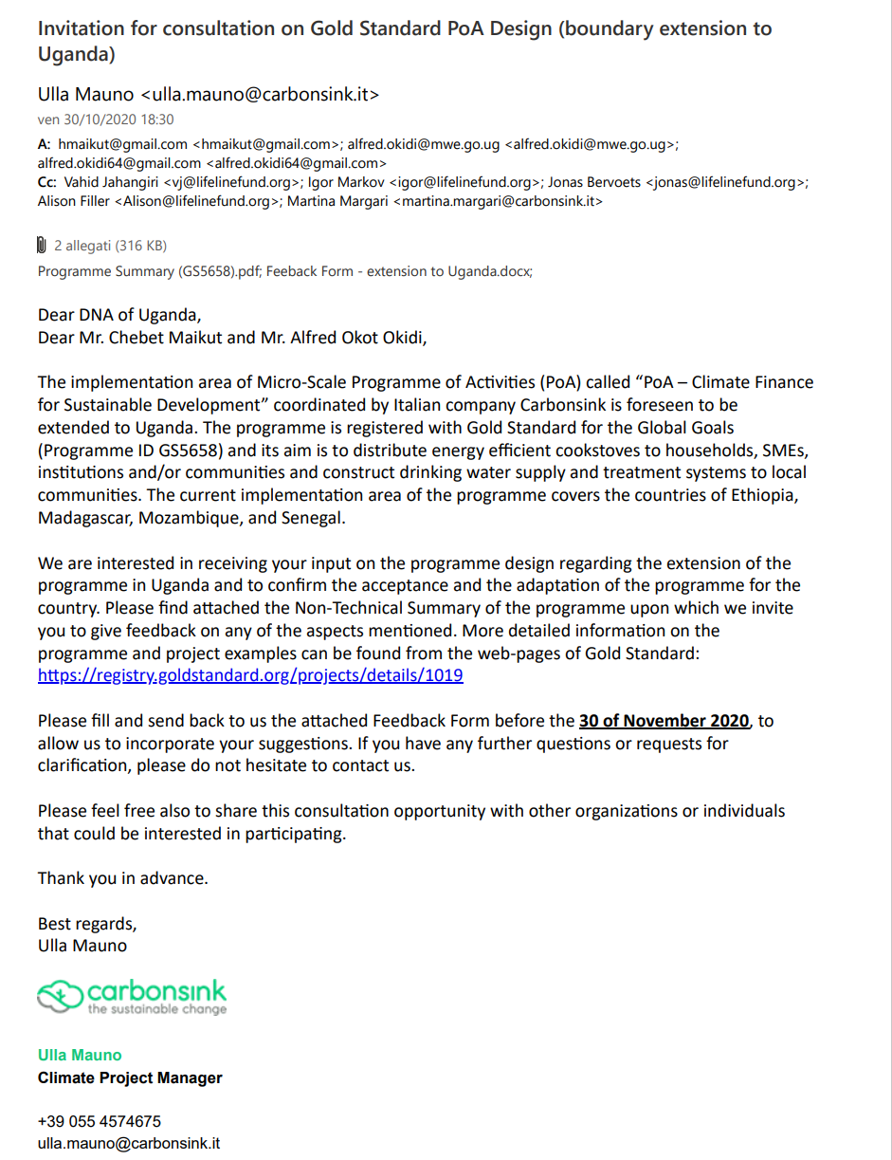
Figure 1. Example of the sent invitation email

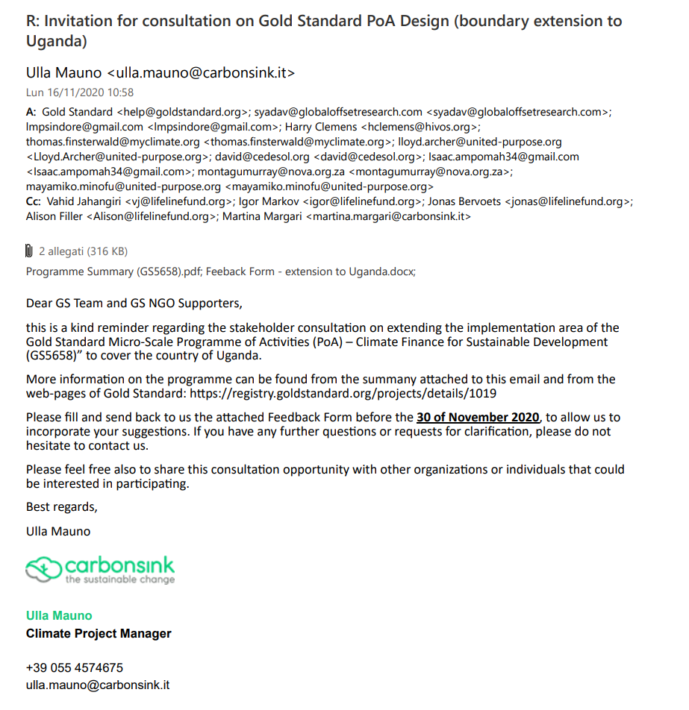
Figure 2. Example of the sent reminder email

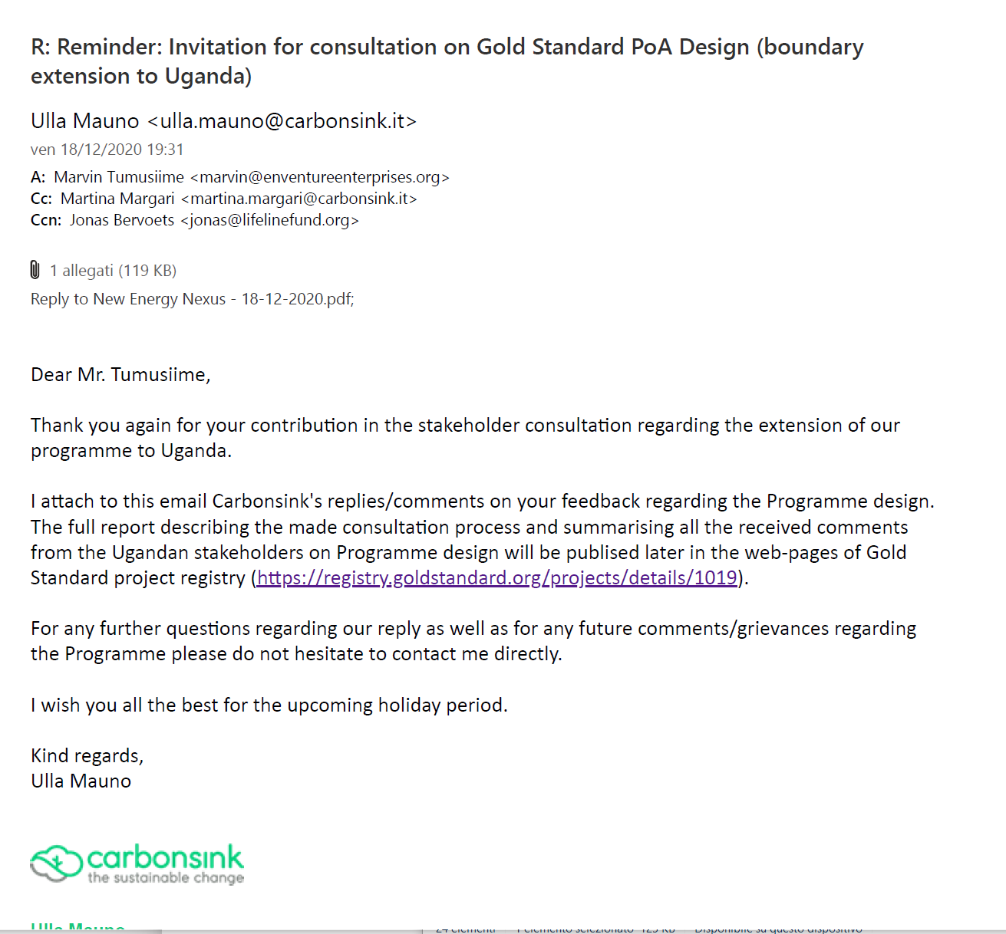
Figure 3. Example of the reply email

A. 2. Information Made Available to Stakeholders

Below is copied the key programme information note which was attached in each invitation.

Non-Technical Summary
“PoA – Climate Finance for Sustainable Development (GS5658)”

Introduction
In many developing countries cooking is done by using thermally inefficient cookstoves or three stone fires consuming lots of fuels, especially non-renewable firewood and charcoal. Additionally, more than one billion people worldwide do not have access to safe drinking water and a high percentage of them boil their water to purify it for consumption.

The high level of firewood collection and charcoal production is leading to deforestation and land degradation especially when coupled with the high population densities and high population growth rates. Biomass combustion is also a significant source of greenhouse gas emissions responsible for the enforcement of the climate change. In addition to the environmental consequences, there are serious health implications related with the inefficient cooking/water boiling methods through the exposure on the smoke and other emission as well as with the consumption of non-safe drinking water. Lastly, families spend a lot of time collecting firewood or spend a lot of money in buying charcoal or other fuels.

Description of the Programme of Activities (PoA)
Carbonsink Group S.r.l. (Carbonsink), an Italian based consultancy company, has established a Programme of Activities (PoA) and registered it under Gold Standard for the Global Goals in Spring 2018. In its initial phase, the programme area covered the countries of Madagascar, Mozambique, Ethiopia and Senegal. Currently Carbonsink is seeking to extend the programme boundary to include also Uganda.

The aim of this micro-scale Programme of Activities is to distribute energy efficient cookstoves at a subsided rate to households, SMEs, institutions and/or communities cooking with non-renewable biomass or fossil fuels and to construct safe water supply and treatment systems in areas lacking access to safe water. These technologies will reduce greenhouse gas emissions by allowing the end-users to cook the same amount of food using less non-renewable biomass, and by removing the need to boil water as a form of purification before consumption.

Technology Implemented
The selection of the type of the technologies to be applied in each area will be based on the local conditions and made in consultation with relevant stakeholders. Carbonsink as the programme owner and Coordinating/Managing Entity (CME), will collaborate with various local partners to implement the activities within the countries included in the programme. The first activities foreseen to be implemented under the PoA within the foreseen extended implementation area of Uganda will include the manufacture and distribution/sale of improved cookstoves (ICS) for local communities. The stoves will be manufactured in Uganda by Lifeline’s social enterprise, EcoEnergy. In addition to the distribution of the improved cookstoves made by EcoEnergy, in the future, other implementing partners and activities – such as the installation of drinking water supply systems – might be implemented in Uganda under the same programme.

The applied technologies can include, but are not limited to:

- Improved cookstoves (ICS), e.g. portable ICS for households and institutional ICS. Technologies of the improved cookstoves may vary under this PoA and they can be fired, for example, on charcoal or wood.
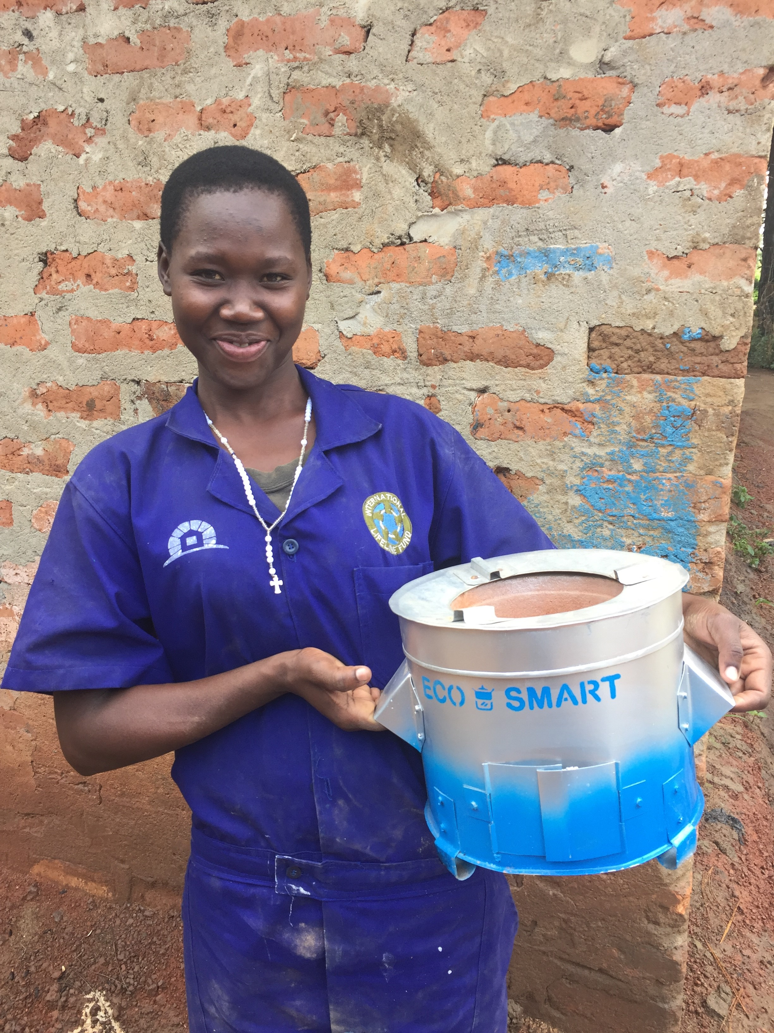
Imagine 1. Example of possible portable improved cookstove to be distributed to households under this PoA

- Community level boreholes and/or clean water systems and their repair/maintenance/operation and/or distribution of household level water filters or chlorine dispensers. Technologies of the boreholes may vary under this PoA and they can be based, for example, on hand pumps or solar powered pumps.
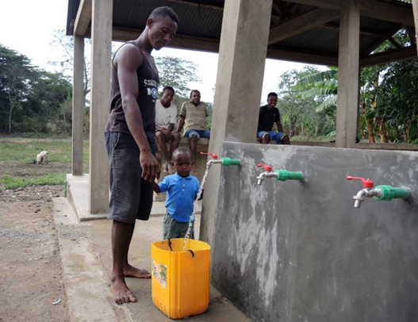
Imagine 2. Example of possible clean water system constructed under this PoA

Carbon Credits
Greenhouse gas (GHG) emission reductions achieved through saving of non-renewable wood and charcoal and/or fossil fuels will be accounted as carbon credits in line with the Gold Standard for the Global Goals rules and procedures. The revenues from sale of these credits can be used to subside the distributed technologies and making them thus more affordable for use in households, SMEs, institutions and communities enabling the scale-up and expansion of the programme and its benefits for new areas.

Contribution to Sustainable Development
Besides reducing GHG emission in line with the UN’s Sustainable Development Goal (SDG) number 13, this programme will also seek to increase other long-term sustainability benefits for the local families, SMEs, institutions and communities. Depending on the specific technology(ies) to be implemented by each activity under this PoA, the contribution on sustainable development may include:

- SDG 3 (Good Health and Well-being): Many improved cookstoves are associated with reduced smoke, which can lessen exposure to dangerous indoor air pollution and thereby may increase respiratory health of the end-users. Similarly, easy access to clean and safe water will help to combat adverse health effects related to water-borne diseases associated with unsafe water usage.
- SDG 6 (Clean Water and Sanitation): Enhanced access to safe and affordable drinking water.
- SDG 7 (Affordable and Clean Energy): Increased penetration of efficient cooking technologies and clean and reliable energy services (like solar energy powered water pumps).
- SDG 12 (Responsible Consumption and Production): Increased awareness for sustainable development including themes like climate change and hygiene.
- SDG 15 (Life on Land): Reduced deforestation and forest degradation in the areas where non-renewable biomass is used as a fuel source for cooking and water boiling purposes. This will contribute to the overall stability of forest ecosystems which supports biodiversity, watersheds and soil conditions.
- SDG 1 (No Poverty) and SDG 5 (Gender Equality): Reduced expenses and time needed for fuel purchase and/or for fuel collection, thus more time is available for other tasks especially for woman who are traditionally responsible for cooking activities and water supply.
- SDG 8 (Decent Work and Economic Growth): New working opportunities created through recruitment of locals for project related activities like e.g. stove distribution, maintenance or monitoring activities.

Joining the PoA
Individual projects (VPAs) interested in joining this PoA will be considered. Contractual agreements between the CME and the VPA implementing entities will cover all the requirements for joining the PoA. These agreements will clearly define, among other things, the need for VPA implementing entity to pay a joining fee.

For more information or for providing feedback please contact:
Ulla Mauno
Project Manager
Carbonsink Group s.r.l.
Email: ulla.mauno@carbonsink.it
Tel. +39 055 4574675
www.carbonsink.it

A.3. Invitation/consultation tracking table

The below tables show the invitation tracking of the made invitations. The invitations were sent covering following key stakeholder groups:
- Gold Standard and Gold Standard NGO Supporters
- Host country DNA
- National agencies who have the mandate to set the quality criteria for a technology type in a Uganda
- Ugandan national level authorities working with the relevant sectors
- Research organizations/institutes working on the particular technologies
- Technology suppliers
- Implementation agencies of the earlier programmes/projects
- Other relevant local/international NGOs working in Uganda

Organisation  (if relevant) | Name of invitee | Method of invitation | Date of invitation (>30 days before any meeting or e-consultation) | Date of Follow up  (essential for e-consultations)
Gold Standard (help@goldstandard.org) | N/A | Email | 30/10/2020 | 16/11/2020
Relevant Gold Standard NGO supporters | N/A | Email | 30/10/2020 | 16/11/2020
DNA Uganda | Chebet Maikut, Alfred Okot Okidi | Email | 30/10/2020 | N/A (feedback was received on 04/11/2020)
Uganda National Bureau of Standards (UNBS) | Ebong Richard | Email | 30/10/2020 | 16/11/2020
Ministry of Energy and Mineral Development | John Tumuhimbise | Email | 30/10/2020 | 16/11/2020
Ministry of Gender, Labor and Social Development | Permanent Secretary | Email | 30/10/2020 | 16/11/2020
Ministry of Gender, Labor and Social Development | Angela Nakafeero | Email | 30/10/2020 | 16/11/2020
Uganda National Renewable Energy and Energy Efficiency Alliance (UNREEEA) | Grace Aldon Walukamba | Email | 30/10/2020 | 16/11/2020
Ministry of water and environment | Deza Twebembeire | Email | 30/10/2020 | 16/11/2020
Ministry of health | Permanent Secretary | Email | 30/10/2020 | 16/11/2020
Biomass Energy Technologies Association | Virginia SSemakula | Email | 30/10/2020 | 16/11/2020
Centre for Research in Energy and Energy Conservation (CREEC) | Agnes Naluwagga | Email | 30/10/2020 | 16/11/2020
Center for Integrated Research and Community Development Uganda (CIRCODU) | Joseph Arineitwe Ndemere | Email | 30/10/2020 | 16/11/2020
Nyabyeya Forestry College | Kisakye Richard | Email | 30/10/2020 | 16/11/2020
Nyabyeya Forestry College | Jackson Mutegeki | Email | 30/10/2020 | 16/11/2020
Environmental Conservation Trust of Uganda (ECO Trust) | Namuyemba Priscilla | Email | 30/10/2020 | 16/11/2020
World Food Program (WFP) | Marta Ortiz | Email | 30/10/2020 | 16/11/2020
Association of Volunteers in International Service (AVSI) | John Makoha | Email | 30/10/2020 | 16/11/2020
Food and Agriculture Organization (FAO) | Sergio Acha Rivero | Email | 30/10/2020 | 16/11/2020
GIZ Energising Development (EnDev) | Anja Rhode | Email | 30/10/2020 | 16/11/2020
New Energy Nexus Uganda | Julius Mujuni | Email | 30/10/2020 | 16/11/2020
Uganda Network on Law Ethics and HIV/AIDS (UGANET) | N/A | Email | 30/10/2020 | 16/11/2020
Up Energy Uganda | Mitch Sauers | Email | 30/10/2020 | 16/11/2020
Water For people | Achiro Brenda | Email | 30/10/2020 | 16/11/2020
Energy Without Borders | Ismail Muyinda | Email | 30/10/2020 | 16/11/2020
BM Energy Saving Equipments | Hanifer Namutebi | Email | 30/10/2020 | 16/11/2020
Green Bio Energy | Ziwa Hillington | Email | 30/10/2020 | 16/11/2020
Masupa Enterprices | Agnes Nanvuma | Email | 30/10/2020 | 16/11/2020
Uganet | N/A | Email | 18/11/2020 | 27/11/2020
Uganda National Alliance on Clean Cooking (UNACC) | N/A | Email | 17/12/2020 | N/A
Biomass Energy Efficiency Technologies Association (BEETA) | N/A | Email | 17/12/2020 | N/A

SECTION B. OUTCOME OF THE CONSULTATION PROCESS

B.1. Assessment of comments received
Organization |  | Stakeholder comment | Was comment taken  into account (Yes/ No)? | Explanation (Why? How?)
Question from Feedback Form: What are in your opinion the right actors/institutions to be involved by the Coordinating and Managing Entity (Carbonsink) as part of the programme?
DNA Uganda (Climate Change Department (CCD), Ministry of Water and Environment) | Ministry of Environment and Water, specifically:  CCD and water quality Department, NEMA  Uganda National Bureau of Standards (UNBS),  Ministry of Energy and Mineral Development |  | Yes | The indicated entities were invited to participate in this PoA design consultation.
Green Bio Energy Ltd | - Technology and research institutions like CREEC, CIRCODU  - Briquettes and stove manufacturing companies  - Energy consortiums (UNACC, UNREEA, BEETA)  - Civil society organisation / NGOs have substantial market linkage and can be relevant in managing projects like the borehole implementation |  | Yes | The entities like CREEC, CIRCODU and UNREEA together with civil society organizations/NGO etc. were invited to participate in this PoA design consultation.  Moreover, based on the suggestion, also UNACC and BEETA has been contacted.
MASUPA Enterprises | Testing Centers Gcreec, circodu, UNBS |  | Yes | Testing centres of CREEC, CIRCODU and UNBS were invited in this PoA design consultation.
Lutheran World Federation | You can consider non-governmental organisations like Lutheran World Federation which is already on ground sensitizing communities about ICS. Due to our reach to the wider community, together with other Civil Society Organisations, we play a key role in behavioural Change campaigns  Secondly, private sector players can also be involved |  |  | The Lutheran World Federation and other NGOs have been invited in the project level consultation process for the mentioned reason. For the moment, the implementation partner for the cookstove activities planned to be made under the Programme in Uganda is LIFELINE. In future other implementation partners may be evaluated.
Nyabyeya Forestry College | - Stove testing agencies in Uganda such as Nyabyeya Forestry College, CIRCODU, CREEC (for stove use monitoring and evaluation)  - Association of stove providers in Uganda such as Biomass Energy Efficient Technology association (BEETA); Uganda National Alliance on Clean Cooking (UNACC) – as potential partners  - Directorate of water resources – Ministry of water and environment - for water monitored water extraction especially when the water extraction project comes onboard |  | Yes | The indicated entities and relevant ministries were invited to participate in this PoA design consultation.
New Energy Nexus | Involve consultations with the key stakeholder across the cookstove value chain. These are manufacturers to gauge pricing and competitive analysis. The clean cookstove sector in Uganda is now competitive both by for-profits and non-profits. Look at distribution capacity of distributors particularly last mile distributors. |  | Yes | This PoA design consultation as well as the future project level stakeholder consultations will include actors from cookstove supply chain. Our current implementation partner (LIFELINE) who will implement the first cookstove activities under this PoA in Uganda is also responsible of the cookstove supply chain and hiring and training of venders.
UpEnergy (U) Ltd | Climate Change Department, Community Based Organization (CBO’s) |  | Yes | The Climate Chane Department was invited to participate in this PoA design consultation. The relevant community-based Organizations will be invited at programme level stakeholder consultations.
Question from Feedback Form: Are you aware about any other similar ongoing and/or planned activities in Uganda? Does this Programme of Activities have any potential synergies and/or conflicts with those other ongoing and/or planned activities Uganda?
DNA Uganda (Climate Change Department (CCD), Ministry of Water and Environment) | Yes, there is Korea East West Power Company LTD dealing with improved cook stoves and water purifiers. Covering Central, Western, Eastern and Northern region but started with the Central region. No conflict since both projects are aimed at improving the livelihood of Ugandans. |  | Yes | CME agrees that there are no conflicts with contemporary cookstove programmes.
Green Bio Energy Ltd | I am not very certain but there are indeed other carbon credit programs. It might be ideal for you to check Potential Energy Uganda, UpEnergy Ltd, ECO-TRUST, I think such institutions are part of carbon credit programs that might have similar features like Carbonsink |  | Yes | Some Cookstove Programmes developers were contacted already for this PoA consultation. The comment is well noted for planning of the future projects under this PoA.
Lutheran World Federation | LWF is already implementing various programs aimed at increasing access to sustainable, affordable, and clean energy. These include;  - The Mutual and Interrelated Resilience Program (MIRP) in Kikuube District – this is a 4 year consortium project that started in November 2019, with funding from SIDA, LWF implements the Energy/ Environment and WASH component.  - Energy and Environmental Initiatives in Moyo, Adjuman, and Lamwo districts with funding from UNHCR and Bread for the World. |  | Yes | The LWF was invited for this consultation because on their experience on the sector.
Nyabyeya Forestry College | Yes, Uganda Carbon Bureau had similar planned activities. I completely don’t foresee any potential conflict with them. |  |  | CME agrees that there are foreseen no conflicts with contemporary cookstove programmes.
New Energy Nexus | Study the existing Results Based Financing programs currently happening in-country. |  | Yes | The comment is well noted for planning of the future projects under this PoA.
UpEnergy (U) Ltd | Yes, I’m aware of other similar ongoing activities, and yes there is room for potential synergies with other projects. I don’t envision any conflicts with other ongoing projects. |  | Yes | CME agrees that there are foreseen no conflicts with contemporary cookstove programmes. Potential synergies/collaboration possibilities may be evaluated case-by-case when planning new project activities under this PoA.
Question from Feedback Form: Is there any national gender strategy or other public policy for gender equality and women’s empowerment which should be considered in the design of the activities to be implemented under this programme?
DNA Uganda (Climate Change Department (CCD), Ministry of Water and Environment) | No specific policy on gender and climate change but gender is embedded in the national climate change policy,2015. There is a national gender policy under ministry of gender and labour. |  | Yes | The referred Uganda National Climate Change Policy as well as National Gender policy will be referred when planning the activities for Uganda under this PoA.
Green Bio Energy Ltd | You could refer to the clean cooking alliance resources, and also feel free to reach out to Value 4 women, they have vast experience in the East African market when it comes to gender issues. |  | Yes | The referred sources will be consulted in case any further supporting needs regarding the gender issues are identified when planning the specific project activities under this PoA.
Lutheran World Federation | Uganda has a number of policy instruments for mainstreaming gender in all development programs. Some of these policy instruments include; the Uganda Gender Policy, 2007 which recognises equality between men and women. |  | Yes | The Uganda Gender Policy, 2007, will be consulted when planning the project activities under this PoA.
Nyabyeya Forestry College | There is the Uganda Gender policy 2007 whose timeframe was 10 years (2007-2017) |  | Yes | The Uganda Gender Policy, 2007, will be consulted when planning the project activities under this PoA.
New Energy Nexus | There are many gender think-tanks that focus on women empowerment for cookstove distribution. A good example is Uganet Uganda, a local organisation well versed in existing and and studied trends. |  | Yes | Based on the comment we have expanded the invitation to participate within this PoA design consultation to Uganet.
Question from Feedback Form: Are there negative or positive impacts from the Programme of Activity that should be taken into consideration?
DNA Uganda (Climate Change Department (CCD), Ministry of Water and Environment) | EIA is a requirement before issuance of an LoA. This is done by NEMA and its only then that a bold statement on the positive or negative impact can be stated. However, since this project is likely not to have a negative environmental impact, I would say that the proposed project is likely to cause positive impacts in terms of helping households to reduce on how much they spend on charcoal while using the ordinary stove (Livelihood improvement) reduce on degeneration since less charcoal will be required for boiling water and cooking food. |  | Yes | This programme is a voluntary programme under the Gold Standard scheme and not implemented under the CDM scheme. For this reason, it is not foreseen to ask LoA from DNA of Uganda. However, DNA of Uganda has participated actively for this PoA design consultation as well as in the first project level stakeholder consultation. Moreover, the impacts (both negative and positive) will be evaluated before including any new activity under this PoA in line with the Gold Standard safeguarding principles.
Green Bio Energy Ltd | It is important to similarly analyse the institutional capacities of businesses to register and also implement such a programs (in house capacity – human resources and finances) |  | Yes | The referred aspects are evaluated when the new partners are selected for implementing the project activities under this PoA as these aspects impacting the success of the projects.
Lutheran World Federation | Positively, the program will increase sustainable access to clean, affordable and efficient energy technologies. |  | Yes | The evaluation is in line with the auto-evaluation made by CME regarding the future cookstove activities implemented under this PoA.
Nyabyeya Forestry College | No negative impacts foreseen; Positive impacts: Reduced cost of cookstoves, increased adoption, more biomass savings, emissions reduced. |  | Yes | The evaluation is in line with the auto-evaluation made by CME.
UpEnergy (U) Ltd | I’m not aware of any negative impacts from the PoA, I believe all of them are positive |  | Yes | The evaluation is in line with the auto-evaluation made by CME.
Question from Feedback Form: For this Programme it has been chosen to conduct the Stakeholder Consultation at VPA level (i.e. conducting a stakeholder consultation always before starting a new activity or a group of activities if those are homogenous). This is also suggested by Gold Standard as the default approach. According to your opinion is this approach good or would you prefer that only one unique stakeholder consultation at PoA (programme) level would be conducted?
DNA Uganda (Climate Change Department (CCD), Ministry of Water and Environment) | Since you will be in different geographical locations and different technologies will be appropriate as you had informed, then it is important that Stakeholder consultations are done before starting a new activity. |  | Yes | CME agrees that the best approach is to make the consultations at project level.
Green Bio Energy Ltd | Stakeholder consultations can allow you receive better insights |  | Yes | CME agrees on the comment, the consultations at project level will be organized.
MASUPA Enterprises | Good. |  | Yes | CME agree that the best approach is to make the consultations at project level.
Lutheran World Federation | It think it is a very good approach |  | Yes | CME agrees.
Nyabyeya Forestry College | The approach of conducting the stakeholder consultation before a new activity is okay according to me |  | Yes | CME agrees that it is good to make the consultations at project level before starting the activities. This approach will be applied for the activities under the PoA.
New Energy Nexus | The former is a better option. Involving all stakeholders is key |  |  | CME agrees on the importance of the stakeholder inclusion and that project level consultation being better approach.
UpEnergy (U) Ltd | In my opinion the approach is good enough |  | Yes | CME agrees with the comment.
Question (Feedback Form): Do you have any other comments, suggestions or grievance regarding the programme?
DNA Uganda (Climate Change Department (CCD), Ministry of Water and | Ensure that the quality of water purifier is approved by UNBS.  The project is welcome. |  | Yes | The advice to refer UNBS is well noted for future planning of safe water supply activities. In all the cases, the water purification equipment selected for the eventual future safe water supply activities implemented within the PoA in Uganda will be selected to be applicable in local contexts. Moreover, the quality of the provided water will be monitored regularly to be in line with the national water quality requirements.
MASUPA Enterprises | It is new, I need to learn |  | Yes | The stakeholder consultation is functioning also as information sharing.
Lutheran World Federation | When is the program likely to start, and you partner with us (LWF) to create synergies between our existing programs and the ICS project. |  | Yes | For the first cookstove activities foreseen for Uganda under this PoA we have already the implementation partner (LIFELINE). LWF has been contacted by Carbonsink for evaluating synergies and eventual future collaboration possibilities.
Nyabyeya Forestry College | There is need to ensure good quality durable cookstoves are disseminated and consider provision of aftersale services in different regions where the stoves will be disseminated. |  | Yes | These aspects will be considered when planning the project activities under the PoA.

The above table summaries all the received feedback which was composed of totally 7 filled feedback forms received via email during 04/11/2020-17/12/2020. Few feedback forms were received after the originally set consultation period end date i.e. after 30/11/2020. All the feedbacks were however welcomed and included within this report.

B.2. Report on Level of consultations

In line with the originally registered PoA-DD the stakeholder consultation is to be carried out at activity level.

The current design consultation made for extending the PoA boundary to covert Uganda re-confirmed the choice of carrying out the stakeholder consultations at activity level being appreciated by the stakeholders. All the feedback obtained from Ugandan stakeholders (totally 7 feedbacks) on this issue stated that the stakeholder consultation made at the activity level is a good choice. There were no respondents who would have preferred the consultation to be made only at the programme level. In conclusion, the received feedback supports the decision of the CME to make the stakeholder consultations at activity level for each VPAs/or groups of VPAs.

B.3. Summary of changes to the Programme design based on stakeholder feedback received.

Based on the received comments no need for changes on the PoA level design was identified. Several similar programmes are known to be active in Uganda, for example, under Gold Standard. No one of the stakeholders foresee conflicts between the existing programmes, neither any specific synergies to be considered at PoA design were noted.

Revision History

Version | Date | Remarks
1.1 | 14 October 2020 | Addition of version history table  Removal of Section A which repeats information in the POA-DD  Clarification on reporting information made available for stakeholders  Clarity on minimum period for invitation and consultation and that follow up is necessary for e-consultations  Clarity that a GS representative should be invited
1.0 | 10 July 2017 | Initial adoption

First VPAs registered under this PoA
The date when the PoA design consultation report was submitted for the first time for listing under the Gold Standard version 2.2.
The starting date of the first VPA (GS5230) under this PoA
http://www.who.int/mediacentre/factsheets/fs292/en/
http://www.un.org/sustainabledevelopment/water-and-sanitation/
https://sustainabledevelopment.un.org/?menu=1300
The invitation to Uganet was sent as per advised by one of the feedback received during the consultation process and, thus the invitation was sent only on 18/11/2020.
The invitation to UNACC was sent as per advised by one of the feedback received during the consultation process and, thus the invitation was sent only on 17/12/2020.
The invitation to BEETA was sent as per advised by one of the feedback received during the consultation process and, thus the invitation was sent only on 17/12/2020.
All the received feedback forms together with the reply of Carbonsink on each of them have been uploaded to SC (“GS5658_.Feedback forms PoA design consultation Uganda”) The feedback of different entities may be found from the following pages of the documents: DNA Uganda (pages 1-3), Green Bio Energy Ltd (pages 4-5), MASUPA Enterprises (pages 6-7), Lutheran World Federation (pages 8-9), Nyabyeya Forestry College (pages 10-11), New Energy Nexus(pages 12-13) and UpEnergy (U) Ltd (pages 14-15).

